TRIBHUWAN UNIVERSITY
INSTITUTE OF ENGINEERING
DEPARTMENT OF ARCHITECTURE
PULCHOWK, LALITPUR


A THESIS REPORT
ON
SQUATTER RELOCATION AND DEVELOPMENT CENTRE

May 24, 2023

SUBMITTED IN PARTIAL FULFILLMENT OF THE REQUIREMENT OF THE DEGREE OF BACHELORS IN ARCHITECTURE

SUBMITTED BY
AAYUSH BISTA
074-BAE-202

DECLARATION

I declare that this dissertation has not been previously accepted in substance for any degree and
is not being concurrently submitted in candidature for any degree. This document is to be
submitted for the Bachelors of Architecture degree from the Tribhuvan University. I state that
this dissertation is the result of my own independent investigation/ work, except were
otherwise stated. I hereby give consent of my dissertation, if accepted, to be available for
photocopying and understand that any reference to or quotation from my thesis will receive an
acknowledgement.

……………….
AAYUSH BISTA
074-BAE-202

CERTIFICATE

This is to certify that this Thesis entitled “Squatter relocation and development centre” at Kirtipur,Kathmandu, Nepal submitted by Mr. Aayush Bista(074Bae202) has been examined and it has been declared successful for the partial fulfilment of the academic requirement towards the completion of the degree of Bachelors of Architecture.

…..…………………
Asso. Prof. Luna Bajracharya (Thesis supervisor)
Date……………
Department of Architecture
Institute of Engineering
Pulchowk Campus
Tribhuwan University

ACKNOWLEDGMENTS

I would, firstly, like to thank my thesis supervisor Associate Prof. Luna Bajracharya for her exhaustive guidance on every step of the research to produce this holistic report on strategies for relocation of squatter settlements of Kathmandu Valley. My sincere gratitude for his invaluable guidance, comments and suggestions to widen the horizon of knowledge in report writing, citations, methodologies in finding and referring to journal articles and addressing the issues related to slums and squatters of Nepal. I would like to extend my sincere thanks to Prof. Bharat Sharma, PHD, for his feedbacks in initial presentation of this research, to Asso. Prof. Prajwal Hada and Prof. Dr. Asim Bajracharya for their comments on literature and site, Ar. Batuk Parajuli for their suggestions on concept development. I am thankful to Department of Architecture, Pulchowk Campus for the assistance provided with various resources and information. I am forever thankful for all the help and cooperation extended to me by Lumanti Joshi and Lumanti Organization.
Also, I would like to extend my sincere thanks to all those friends, seniors, juniors who have lent their help directly and indirectly during my project. I will always appreciate their support, guidance and encouragement that bolstered me to achieve my goal.

Aayush Bista, 2023

ABSTRACT

This report was prepared as a documentation of the research carried out for thesis regarding the topic of “Squatter Relocation”. The research addresses the problems of slum generation in the cities of the world, especially the growth of squatter settlements along the banks of Bagmati River in Kathmandu Valley of Nepal. The research was based on finding suitable strategies for solution of slums and squatters, and their relocation, providing affordable housing in a better-built environment for the squatters and including them in the urban fabric with all the required infrastructures, facilities and spaces.. The research also seeks to adopt these strategies in designing an affordable housing for the squatters in Balkhu area of Kathmandu, with active community participation and holistic design of housing as well as public space.
The relocation site is located at kirtipur because of various reasons. Firstly, lumanti had already located a community in the area. The area is close to balkhu and also has a good vehicular access which makes this a good place to resettle the community as they are dependent on the job. The community relocated by lumanti also lacks various interacting spaces as well as learning centres. Thus, my research addresses the need of skill development centers for both of the communities to be benefitted from.
The case studies of international, regional and national social housings show that housing is not just the careful placement of housing blocks together but also the planning and design of space, its geometry, planning of infrastructures, careful combination of materials, counteractive strategies in design as well as socio-cultural aspects of the housing. The inference of case study is that the concept of affordable housing with better-built environment can have multiple façade and careful planning can allow highlighting each of them. Affordability and better-built environment prevail in spaces and places that directly serve the needs of the people. The research recorded in this report shows that slums are major issues in the cities around the world and several strategies are adopted in the past for their solution. However, at the present context, there seems to be a need to introduce better strategies for solutions rather than following the old established strategies. The significance of the findings is that these could help in successful rehabilitation in the informal settlements of Kathmandu Valley and hopefully, in all such settlements of Nepal in the future, taking this research report as reference.
Key Words: Squatters, Squatter Settlement, Squatter Upgrading, Squatter relocation, Affordability, holistic approach.

Contents
1. 1
2. DECLARATION 2
3. CERTIFICATE 3
4. ACKNOWLEDGMENTS 4
1. Introduction 11
5.1 Background of the study 11
5.1.1 Nepalese Context 12
5.2 Rationale 13
5.3 Importance of the Research 14
5.4 Problem Statement 14
5.5 Research questions 14
5.6 Objectives 15
5.7 Methodology 15
5.7.1 Methodology for Literature review 15
5.7.2 Case study 16
5.7.3 Site analysis and study 16
5.7.4 Methodology for Design 17
5.8 Scope of the study 17
5.9 Research limitations and challenges 17
6. Literature review 18
6.1 Urbanization 18
6.2 History of planning practices in Kathmandu 20
6.3 Current trends in residential development 21
6.4 Population trend in Kathmandu valley 22
6.5 Types of settlement in Kathmandu valley 23
6.6 Slums and Squatters 25
6.6.1 Slums 25
6.6.2 Squatters 26
6.6.3 Evictions, upgrading and resettlement: “Squatters’ problems” or “squatter the problem” 29
6.6.4 Planning Background 30
6.6.5 Governmental interventions to manage squatter settlement 33
6.7 Urban Morphology 35
6.8 Low cost strategies 35
6.8.1 Building Materials: 35
6.8.2 Design and Layout: 35
6.8.3 Public-Private Partnerships: 35
6.8.4 Financing: 35
6.8.5 Government Subsidies: 36
6.9 Energy efficiency 36
6.10 Sustainability 36
6.11 House: Architecture and Space 39
6.11.1 Influential factors in shaping home 39
6.11.2 Elements of a home 40
6.12 Principles of housing 41
6.13 Affordable Housing 42
6.14 Affordability 43
6.14.1 Sustainability 44
6.14.2 Flexibility 44
6.15 Strategies for Affordable Housing Development: 46
6.15.1 Multi-family development 46
6.15.2 High-rise and high-density development 46
6.15.3 Mixed-use development 47
6.15.4 Infrastructure 48
6.15.5 Circulation 49
6.16 Strategies for housing design 49
6.16.1 Open space design 49
6.16.2 Flexibility and adaptability 50
6.16.3 Affordable interior space 50
6.17 Community development center 50
6.17.1 Community Participation 51
6.18 Energy Efficiency 52
6.19 Bye laws, Acts and Policies 52
7. Definitions of public space 53
7.1 CONDITION OF PUBLIC SPACE IN KATHMANDU 54
7.2 Dimensions of public space 55
7.3 Key qualities of successful public spaces 56
8. Community 57
8.1 Membership 57
8.2 Shared Emotional Connection 58
8.3 Community and Community Architecture Concept 58
8.4 Community Center 59
8.4.1 Types of community center 60
9. Case study 61
9.1 International Context: A case of Half a House by Alejandro Aravena 61
9.2 International Context: Dortheavej Residence by Bjarke Ingels Group 63
9.3 Introduction 63
9.4 Regional Context 66
9.4.1 A case of Belapur Incremental Housing (Artist Village) by Charles Correa 66
9.5 National Context 68
9.5.1 Relocation of the squatters: A case of Kirtipur Housing by Lumanti 68
9.6 National context: Ichangu Narayan housing complex by The Government of Nepal 71
10. Proposed study context 73
10.1.1 Site selection criteria 73
10.2 Architecture within the settlement 75
10.3 Infrastructures 76
10.4 Community services 76
10.5 Population Background 77
10.6 Social composition in the settlement 77
10.7 Fear of eviction 77
10.8 Open Space 77
11. Proposed Site for Design 78
11.1 SITE SURROUNDING 78
11.2 Physical and Climatic data 78
12. Program formulation 83
12.1 CONCEPT AND DESIGN DEVELOPMENT 86
12.2 Strategies 86
12.3 Concept Development: 86
12.4 SITE ZONING 90
12.5 Project Development and Design Output 94
12.5.1 2.1. Open Floor Plan 94
12.5.2 Flexibility 94
12.5.3 Shared infrastructures 94
12.5.4 Privacy 94
12.5.5 Design of roof 94
12.5.6 Material and construction technology 94
12.6 Structure and materials 96
12.7 Utilities and services 96
13. REFERENCES 98
14. Bibliography 100

LIST OF FIGURES AND TABLES

Figure 3: Expansion of built-up area in Kathmandu Valley 19
Figure 4: Urbanization in Kathmandu 19
Figure 5: Population Growth trend in Kathmandu valley 22
Figure 6: Population Characteristics in Kathmandu valley 23
Figure 7: Squatter settlements at various locations observed in 2013 24
Figure 8: Process of slum formation 26
Figure 9: Principles of housing Error! Bookmark not defined.
Figure 10: Housing Typologies 47
Figure 11: Sense of Community 52
Figure 12: Half a house 61
Figure 13: Dortheavaj Resdence Error! Bookmark not defined.
Figure 14: Stacking module 64
Figure 15: Design Development 65
Figure 16: Belapur Housing 66
Figure 18: Ichangu Narayan Housing project 71
Figure 19: Density of squatter settlement at balkhu 74

LIST OF CHARTS
Chart 1: Sun path diagram ( source: gaisma) 78
Chart 2: Average temperatures and precipitation (source: meteoblue) 79
Chat 3: Cloudy, sunny and precipitation days (source:meteoblue) 79
Chrt 4: Maximum tempetures (source: meteoblue) 80

CHAPTER I: Overview

Introduction
This chapter introduces the thesis statement, i.e. the topic of the research as well as the purpose of the study. It deals with the vulnerability of the squatter as an effect of urbanization in Nepal. The contents are the cause of rapid urbanization at an alarming rate and squatter as a problem that needs attention and the vulnerability of living in the squatter areas. It also gives an overview of the study by problem statements, research questions, aims, and objectives of the study.

Background of the study
The rate of urbanization around the world is at an all-time high. By 2030, there will be approximately 5 billion people living in towns and cities, which currently account for more than half of the world's population. A significant portion of this urbanization will take place in Africa and Asia, resulting in profound social, economic, and environmental changes. The advent of urbanization holds the promise of a new era of prosperity, resource efficiency, and economic expansion. However, poverty is also very prevalent in urban areas.
Urban areas, where wealthy neighborhoods coexist alongside and separate from slums and informal settlements, are the places where the rise in inequality is most obvious. Slowly but surely, the situation gets worsens since there are not enough decent housing options and there are too many people. Slum regions eventually develop because of the overused and underdeveloped infrastructures, which further deteriorate because of negligence. Slums are an issue, and even industrialized nations are not immune to them. Slums can develop everywhere, though their scope and makeup may vary depending on the location. According to research, the majority of slum communities are lacking in essential utilities including reliable electricity, clean water supply, and sanitation facilities.
According to UN-Habitat, around 33% of the urban population in the developing world in 2012, or about 863 million people, lived in slums. The proportion of the urban population living in slums in 2012 was highest in Sub-Saharan Africa (62%), followed by Southern Asia (35%), Southeastern Asia (31%), Eastern Asia (28%), and Western Asia (25%), followed by Oceania (24%), Latin America and the Caribbean (24%), and North Africa (13%).

Nepalese Context
According to the Nepalese government Central Bureau of Statistics (CBS), there is a 10.18% percent increase in the population of Nepal as of January 2022, since the last census was taken in the year 2011. With 66 percent of the country's population now residing in urban areas compared to only 17.07 percent just 10 years ago, the country’s urban demographic has drastically changed. Although the federalization of the country contributes greatly to the preceding numbers, migration is a key contributor.
Kathmandu, one of South Asia's fastest-growing cities, is rapidly urbanizing. According to the World Bank (2013), Nepal is in the process of shifting from a largely rural to an urbanizing economy, which would be followed by widespread rural-to-urban migration. People are drawn to the capital city of Nepal by the availability of jobs, security, and socioeconomic mobility. Urban sprawl, increased living expenses, exclusive housing markets, a lack of cheap housing, diminished livability, and a loss of open space are all results of Kathmandu's unplanned urban expansion (Bajracharya et al. 2015).In the end, the effects of uncontrolled urban growth contribute to the growth of squatter-dominated informal settlements in urban areas.
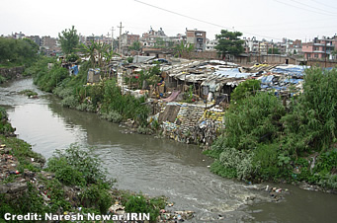
Figure 1-1: Squatter settlement

Source: Naresh Newar

Figure 1-1 shows the existing condition of squatter settlement in Kathmandu

Squatters, or sukumbasi in Nepali, reside on land without legal rights. By living in informal settlements, they are excluded from basic rights, social services, and land security typically protected by the government because of their landlessness (Acharya 2010). Without basic infrastructure and services provided by the government, urban squatter settlements are commonly characterized as slums due to their impoverished living conditions, highly congested spaces, and an absence of public facilities such as education, health, safe drinking water, sanitation and waste management (Khatiwada 2013). Residents of these settlements are also highly vulnerable to eviction because of insecure residential status, deprived of their right to security of tenure (Shrestha 2010). Therefore, the growth of squatter settlements is not just a negative byproduct of urbanization, but also a failure of the government to manage urban development and ensure basic human rights through inclusionary policies and protection of the right to adequate housing
Table 1: Urban growth in Nepal
Year | Urban Population | % of the urban population | Change
2015 | 5,013,180 | 18.56 | 2.45%
2016 | 5,164,239 | 18.94 | 2.97%
2017 | 5,343,055 | 19.34 | 3.40%
2018 | 5,546,094 | 19.74 | 3.73%
2019 | 5,765,514 | 20.15 | 3.88%
2020 | 5,995,190 | 20.58 | 3.91%
2021 | 6,234,107 | 21.01 | 3.91%

Source: World Bank

Rationale
Assuring urban squatters in Kathmandu their right to sufficient accommodation and security of tenancy is essential to Nepal's political institutions' ability to build a diverse, resilient, and sustainable capital city and economic hub. The government has made numerous unsuccessful attempts to address urban squatter communities encroaching on public land through eviction and, more recently, through resettlement to the city's outskirts (Tandan 2016). Despite the municipality having several policies at the planning level, it does not have any policies for creating affordable housing for the squatters, which can cater to the socio-cultural need for space, infrastructure, and cost. If this problem is neglected, the entire riverside of Kathmandu will be filled with such informal settlements, which will degrade the valuable public space and the environment. As squatters are also a part of the urban fabric, they deserve social justice and the right to the city.

Importance of the Research
The research is crucial for the squatters who have been living in constant fear of eviction, natural calamities, and unhealthy living condition for decades. In the meanwhile, the municipality may also find it significant because the government has spent decades attempting to resolve the squatters' issue. The action plan to drive out the squatters by bulldozing their encampment was put on hold due to political concerns. Since then, no actions have been taken.
The simple removal of squatters from their home on public property and placement in social housing on the outskirts of the city may not be the best course of action. The research helps to identify better and more efficient strategies for the rehabilitation of the squatters.

Problem Statement
As we already know, squatting and slumming are not new. Even in developed countries, the issue exists. Several attempts have been done to resolve the issue but the right approach seems to be lacking. The increase in the prices of land and affordability of housing will increase slumming and squatter formation.
As the problem of squatting is expanding along the riverside. Now, it is a big issue to find the best solution from a planning perspective. Even though the government thinks that evicting, the squatters into the outskirts may be a better option but is that the only approach? What are the positive and negative effects of this? A sensitive and responsive approach with public participation to promote cultural diversities, which will help them to improve their lifestyle cost-effectively, and contribute to their socioeconomic value, is the way to go.

Research questions
The research will try to find answers to the following questions based on the problem statement and will give the direction of the methodology of the expected outcome-
What will be the approach for the squatters at balkhu to rehabilitate through a responsive and affordable design? How can this be achieved?
To find the approach, the research also intends to find the answers to the following sub-questions;
- What is the best idea required for the relocation of the settlement with holistic approach?
- How will the strategy improve the lifestyle of the squatters and how can this approach contribute to the city on a large scale?

Objectives
The main aim of the study is to study various planning strategies and affordable housing approaches to rehabilitate the squatter dwellers and provide space for their development so that they can improve their living conditions themselves.
Thus, the objectives of the study can be listed as:
- To design a space that is affordable, sustainable, and healthy for the squatters.
- To provide a better-built environment for the squatters through proper planning and create spaces that would increase social interactions.
- To provide spaces for the development of skills and knowledge for the children and the adults that would help them sustain and grow.

Methodology
A literature review is an initial step in every research project. By reading academic articles for a literature review, we can learn a lot about the issues and solutions related to our topic. A quality literature review includes several research stages. The literature evaluation must, first and foremost, concentrate on identifying the issues that exist in the discipline of architecture. Following the problem's discovery, it's important to pinpoint the key areas it affects and the best course of action for each.

Methodology for Literature review
Reviewing studies on the issues with slums and squatters and ways to address them in general, as well as the supply of incremental affordable housing in particular,
A field study of a sample of a few homes in a slum region, specifically in the Balkhu squatter colony, documentation in graphic and visual form, As an efficient way for conducting a literature review, the case studies' record of changes and the questionnaire were both used in this study.

Framework for literature review
1. Study of the present context of Urbanization and types of settlement in Kathmandu Valley
2. Problems regarding slums and squatters
3. Housing Inequality and loss of Public Space
4. Approaches for the solution to this problem
5. Strategies for the best solution to provide affordability and better-built infrastructures
6. Strategies for affordable development and design of housing
7. Building a narrative of slum
8. Energy Studies of Kathmandu
9. Separate proposed sites of study and design
10. Possible outcomes

Case study
The best way to conduct case studies is to develop selection criteria based on the literature study. This can assist in ensuring that the case studies have exactly the information needed, neither more nor less. Case studies allowed for the noting of distinct characteristics, solution methodologies employed in successful projects, as well as praise and criticism.
Table 2 : Methodology of research

Site analysis and study
For site analysis and study, site visits, information about the site from websites, news, and climatic data analysis of the site were all completed. Frequent site visits, and documentation in the form of photos, graphics, recordings, and questionnaires, as well as those, were key assets in the analysis of the site. Additionally, the informal and unplanned interviews with the squatter settlement's residents were very helpful in comprehending the perspectives of the locals.

Selection criteria for the site
Table 3: Selection criteria for the site
Criteria
Availability
Accessibility
Acceptability
Affordability
Mixed used development
zoning

Methodology for Design

Scope of the study
The study focuses on the vulnerable living conditions of the squatter dwellers and critically analyses the current policy to solve the vulnerability and search for a sustainable policy. Furthermore, the study is defined within strategies that are taken for the development of skills, solving vulnerable livelihood, finding out challenges of the current strategy, and affordable housing strategies practiced all over the world. It mainly deals with the squatters, but it also solves the surrounding problems like neighborhood exclusion and squatters’ expansion.
Additionally, the study area is chosen as balkhu; one of the core areas of the city. Geographically, the area is along the riverfront of Bagmati. The major cause of selecting the area is that the area itself is very critical and people residing there lack basic skills and have to depend on their Physical strength for survival.

Research limitations and challenges
Squatter development is one of the study's biggest obstacles because it doesn't adhere to any rules or regulations and instead depends only on individual needs, cultural norms, and economic circumstances, making it exceedingly challenging to come up with a standard solution. Additionally, there aren't many national case studies of squatter rehabilitation.

CHAPTER II- LITERATURE REVIEW

Literature review

Urbanization
Urbanization describes how cities change in terms of size, density, and heterogeneity. Urbanization is typically accompanied by other factors, such as population mobility, segregation, and industrialization. Simply put, urbanization is the process that results in the birth and expansion of cities. As a result, the dynamics of population agglomeration rather than the definition of urban per se determine the process of urbanization. For instance, urbanization may involve the construction of new structures or neighborhoods, the creation of transportation systems, and the inflow and outflow of population, all of which affect the racial and ethnic makeup of a region (Vlahov & Galea, 2002).
Urbanization is necessary for a nation's development and is a key factor in improving and enhancing people's quality of life. According to the State of the World Population (2011), Nepal has a high annual urban growth rate of 8% and a 29% urbanization rate (low). This level of urbanization is insufficient for a developing nation like Nepal to keep up with the nearby urban growth rate. Housing issues exist in urban settings, particularly as a result of evictions following the earthquake in April 2015.
There can be found different patterns of urban conglomeration in the cities. The high-density developments in the center of the city such as the Thamel area, high-value property development in core areas, malls and shopping complexes, planned formal settlement areas in many parts of the city, the sparse residential housing development in the outskirts of the city, etc. Each composition asserts certain values of the place on the people.

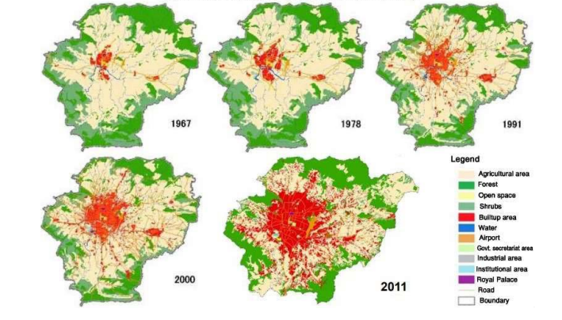
Figure 6-1: Expansion of built-up area in Kathmandu Valley
Source: Fig 5, Pg. 21, Timsina et al., 2020, Trend of urban growth in Nepal with a focus in Kathmandu Valley: A review of processes and drivers of change
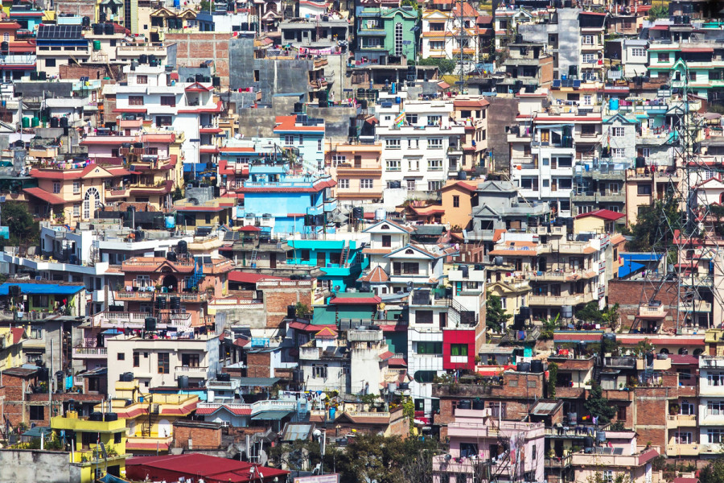

Figure 6-2: Urbanization in Kathmandu
Source: The Kathmandu post
Figure 6-3 Shows the existing urbanization trend in Kathmandu valley

History of planning practices in Kathmandu
In an effort to solve expanding urban concerns and direct urban growth, the physical development of the Kathmandu Valley has also been tackled with a variety of strategies and plans. The Kathmandu Valley has frequently been planned as one cohesive area rather than as a collection of separate communities. There are numerous planning documents available. One of the earliest attempts to plan the development of the valley was the Physical Development Plan of the Kathmandu Valley, published in 1969. By directing growth to the western and south-western sectors, it aimed to relieve population pressure in the centre and eastern parts while protecting the valley's ecosystem and fertile agricultural land. The Kathmandu Valley Physical Development Plan, published in 1972, is another important planning document that was created in response to the geographical features of the valley.
It suggested preserving wetlands for agriculture while still allowing for plains development (tar). It was followed by the Land-use Plan of Kathmandu Valley, 1976, which enacted strict building codes and broad land-use zoning for the valley. The inner core, its surrounding area, and the sparsely populated new settlement area were therefore split into three sections of the valley. The creation of the Kathmandu Valley Town Development Committee, which is still in existence as the Kathmandu Valley Development Authority, was one of the document's major outcomes.
Under the direction of the Ministry of Housing and Physical Planning, the Urban Development and Conservation Scheme, 1988, was adopted, which brought land pooling and land development programs in the valley. The densification of the Kathmandu and Lalitpur municipalities was emphasized in the Kathmandu Valley Urban Development Plans and Programmes, 1991, along with the construction of an inner ring road to protect agricultural land and lessen the effects of urban sprawl. Similar goals were expressed in the Environment Plan and Management of Kathmandu Valley, 1999, which envisioned Kathmandu as an eco-town. It intended to redraw Kathmandu's geographic limits, protect traditional settlement, and improve and expand the city's road and sewerage systems.
The Long Term Development and Conservation Plan of Kathmandu Valley, 2000, the most recent key planning document, took into account the regional context of the Kathmandu Valley, treating it as a development node and looking ahead to 2020. The goal was to support an integrated approach to urban development that effectively integrated planning for land use and transportation, protected public lands and agricultural land by drawing a growth boundary around the city, and provided the necessary infrastructure to support the valley's increased carrying capacity.
Despite the fact that numerous planning documents have been created, virtually little of what was intended by them has come to pass. Due to its delicate geological circumstances, the Kathmandu Valley's ecology and agricultural land preservation have been emphasized in the majority of publications; yet, these plans have mostly existed on paper. Lack of coordination between projects and plans, incoherence between building regulations and land-use planning, and a lack of a solid legal foundation, political will, and institutional ability have all been major barriers to plan implementation.

Current trends in residential development
With changing urban form and growth in residential units, a number of identifiable housing trends have emerged in the valley.
They are:
• Class-based gated communities and group housing, including high-rise apartments targeted to uppermiddle and higher-income groups

• The rapid decay of the historic core area, with an influx of low-income migrant renters and the relocation of natives to peripheral/suburban areas • Urban sprawl and rapid unplanned development of peripheral/suburban areas, including an increase in mixed residential units • Initiation of land pooling projects in some areas to adjust the configuration of land and provides services, and
• The undocumented rise in squatter settlement along the river banks and public land, due to migration of the rural poor in search of a better life.
These development trends reflect failing land-use control and building regulations, declining living conditions among particular segments of the urban poor, emerging segregated class-based settlements, and rising demand for rental housing to accommodate the growing migrant population.

Population trend in Kathmandu valley
Urban population growth has maintained its pace at 3.4 percent per year from 2001 to 2011, compared to 3.6 percent per year from 1991 to 2001, even if overall population growth has slowed since 2001. The only metropolitan area in Nepal with a population of over 1 million, Kathmandu Metropolitan City, is expanding at a rate of 4.0 percent annually (Timsina et al., 2020).
In many of the cities in Nepal, urban forms are becoming increasingly disorganized. Unplanned land use, shrinking open spaces, and haphazard construction willow-quality services have been the major urban forms in the recent past. This has affected both the social and cultural environment in both existing and emerging cities. The traditional core area of the city consisted of a densely built area comprising of narrow streets. The traditional core areas are quickly occupied by the newly built multi-story concrete buildings (particularly, after the earthquake of 2015). These multi-story buildings are occupied either by multiple families or by businesses and offices. The large cities, the land use functions are becoming specific and specialized (Timsina et al., 2020).

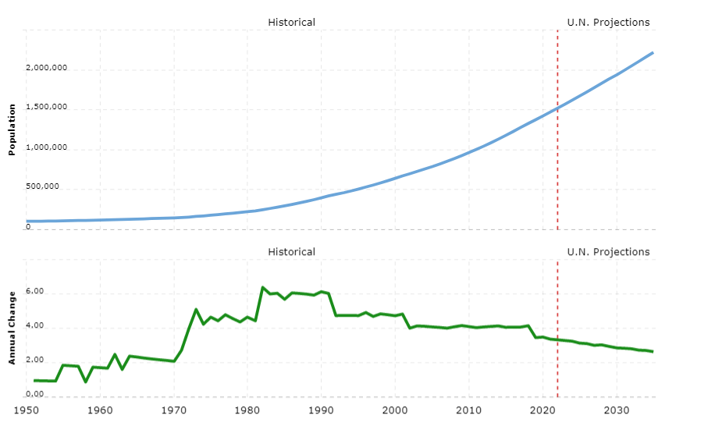
Figure 6-4: Population Growth trend in Kathmandu valley
Source: United Nations - World Population Prospects

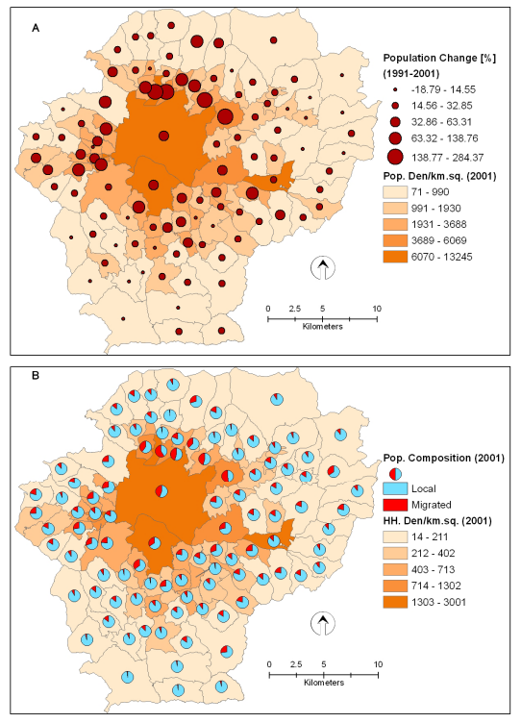
Figure 6-5: Population Characteristics in Kathmandu valley
Source: Data source: CBS, (2001); ICIMOD/UNEP (2001).

Types of settlement in Kathmandu valley
With changing urban form and growth in residential units, several identifiable housing trends have emerged in the valley. They are:
• Class-based gated communities and group housing, including high-rise apartments targeted at upper-middle and higher-income groups
• The rapid decay of the historic core area, with an influx of low-income migrant renters and the relocation of natives to peripheral/suburban areas
• Urban sprawl and rapid unplanned development of peripheral/suburban areas, including an increase in mixed residential units
• Initiation of land pooling projects in some areas to adjust the configuration of land and provides services, and
• The undocumented rise in squatter settlement along the river banks and public land, is due to the migration of the rural poor in search of a better life (Bajracharya et al., 2015).

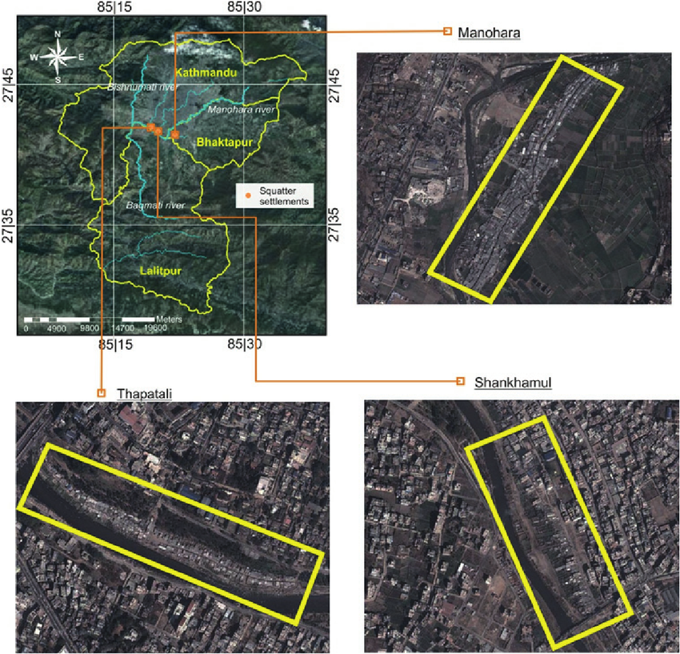
Figure 6-6: Squatter settlements at various locations observed in 2013
Source: https://www.researchgate.net/profile/Udo_Nehren/publication/236109514/figure/fig8/AS:29929191563 6746@1448368161947/Location-of-the-three-squatter-settlements-from-the-household-survey-Sourceof-the.png

Slums and Squatters

Slums
Understanding the intricate political, economic, legal, cultural, and social dynamics of slums, along with the approaches used to address the multiplicity of barriers to creating quality affordable housing, is difficult. As Bajor and Pastor note, “the issue of slums is very complex. It cuts across numerous disciplines. It concerns hundreds of millions of slum dwellers directly— and it indirectly concerns all the local and national economies and societies in which slums exist. It is one of the fundamental global challenges of our times”.
Conditions within slums vary among the poorer countries of the developing world and middle-income and higher income nations in terms of quality of housing and severity of conditions, particularly with relation to access to water and sanitation. (Habitat, 2007)
UN-Habitat  (2007) | Housing areas…. Which deteriorated after the original dwellers moved on to the new and better parts.
UN-Habitat  (2008) | An area with:  - Poor structural quality and durability of housing  - Insufficient living areas (more than three people sharing a room)  - Lack of secure tenure  - Poor access to water  - Lack of sanitation facilities
UN-Habitat  (2013) | The UN definition of a slum household is a household that lacks “access to sanitary water, improved sanitation.”(Shekhar,2013,p.55)

The definitions have core implications for conceptualizing the problem, understanding the scope of the problem, and the allocation of resources. Using the 2008 UN-Habitat definition of slums, the following sections explore the background and prevalence of the manifestation of slums in the developing world. The 2007 definition, which allows the consideration of slums in the non-developing world, will be explored later in this entry The Migrants course identified as the microcosms of the Metropolis they are set in. A Metropolis is guided by its social economic and political institutions. The occupants of the place make it what it is, the commerce of the place tribes on the availability of resources that is both skilled labor and natural. The society is born out of its inhabitant’s cultures and traditions and this forms the native identity of the area. (Laing, 2014)
Migrants, when traveling down these areas in search of new opportunities going to different circumstances, find it difficult to observe themselves in the atmosphere for n short period. This gives rise to pockets of new communities at concentrated in areas of metropolis and area which reflects the commercial fabric of the metro itself and its type or logic and drop for graphical and architectural features but very deeply in terms of social structure.

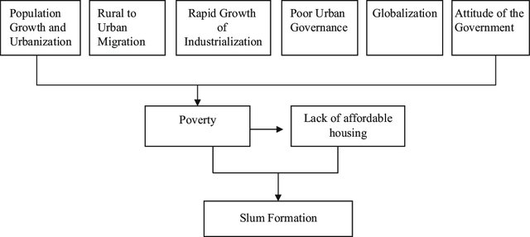
Figure 6-7: Process of slum formation

Squatters
Little (2012) argues there is a fundamental difference between slums and squatter settlements in Kathmandu Valley. Although the inhabitants of both types of communities suffer from multiple deprivations, a basic lack of land rights for people who live in squatter settlements makes their living conditions much less secure (ibid). Brooks (2016) clarifies squatters are the individuals that do not have legal rights to the land where they are settled while “slum” refers to the living conditions and physical and social characteristics of a settlement. Without basic infrastructure and services provided by the government, urban squatter settlements are commonly characterized as slums due to their impoverished living conditions, highly congested spaces, and absence of public facilities such as education, health, safe drinking water, sanitation, and waste management (ibid).
A study by Lumanti (2008) identified 45 impoverished communities, of which 40 communities were considered “squatter settlements” because of a fundamental lack of land rights. The other five were considered “slums” because of their status as permanent indigenous settlements. The squatter settlements in Kathmandu started in the early1950s when rural migrants moved into cities looking for employment (Toffin, 2010). There were only 17 squatter settlements in the valley in 1985. By 2000, there were 61 squatter settlements with 2,031 households and 11,851 people which increased to 64 by 2003, increasing the squatter households to 2,134 and the population to 14,500 (ibid; Lumanti, 2003 as cited in ADB, 2010). In 2008, Lumanti, a non-governmental organization working for improving housing for informal settlements, identified 45 informal settlements, of which 40 recognized themselves as squatter. These 40 squatter settlements included 726 people (6,612 male and 6,114 female) living in 2,735 households (Lumanti, 2008). At least 24 of these 40 squatter settlements are located along the five rivers of the valley: Bagmati, Bishnumati, Hanumante, Tukcha, and Dobikhola. The other five settlements recognized themselves as swabasi in Nepali, which translates to “dwellers staying by themselves” because these residents are not willing to be identified as squatters (ibid)
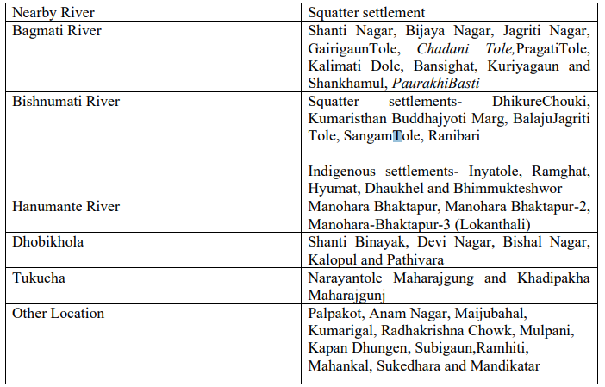
Table 4: Squatter settlements in Kathmandu valley
Source: Adapted from Lumanti, 2008 and phuyal et al., 2019
Table 4 shows the existing squatter settlement in kathmandu
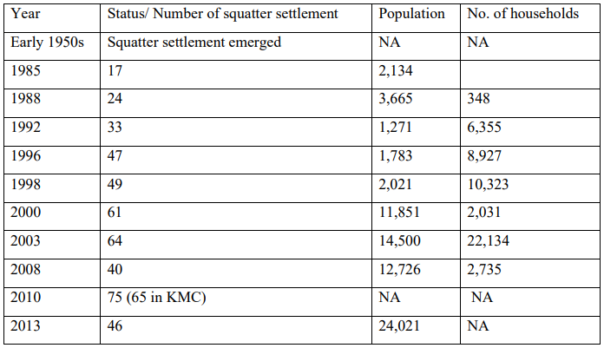
According to UN-Habitat (2010), Kathmandu Valley had more than 12,000 squatters in more than 40 settlements. An additional 40 percent of squatters were estimated to be occupying public buildings making the total squatter population number up to nearly 20,000 (Paudel et al., 2014). Toffin (2010) reports 75 squatter settlements have been identified in Kathmandu Valley, out of which 65 are located in Kathmandu Metropolitan City. A survey conducted by two informal settlers’ organizations reported 24,021 settlers were living in 46 informal settlements in Kathmandu in 2013 (Dangol and Day, 2017). The number of settlements and their population has further increased. However, there is no updated documentation of their origin, number, location, population, and overall situation and those existing are incomplete and even conflicting (see Table 3). Furthermore, their dynamic nature, through internal and external migration, makes accurate documentation a challenge. It is however clear that accelerating rural-urban migration in seeking for better access to basic facilities and amenities, institutional facilities and a better income and lifestyle have made urban centers enclaves of economic activities which depend on migrated labor.

Table 5: Demographic status of squatter settlement in Kathmandu Valley
(Source: compiled based on Lumanti, 2008; Tanaka, 2009; Toffin, 2010; Dangol and Day, 2017)
As mentioned above, the majority of squatter settlements in the valley are located along the river banks or in public lands with limited or no access to basic services. Sengupta (n.d.) marks this is “a need to avoid attracting public attention” in the process of occupying land with dubious or no land titles. The riverbanks are prone to natural hazards such as seasonal flooding and landslides. Squatters pile up sandbags to protect them from the rising level of the river (Dangol and Day, 2017; Nehren et al., 2013).
Toffin (2010) notes that the living conditions in squatter settlements are poor with houses having corrugated iron sheets and sometimes even plastic tarpaulins held down by stones to cover the roof. The walls are generally made of poor-quality bricks. Among the very poorest dwellers, the walls are made of bamboo and mud and the lanes separating the long rows of shelter are very narrow. But, some of the squatter settlements have house grocery shops or teashops. Most dwelling places have electricity, sometimes even television, while water supply and sanitation and solid waste management services are extremely shoddy.
Water quality assessment in 37 squatters and 5 indigenous communities by Phuyal et al., (2019) showed that 90% of the domestic water usage is contaminated in both biological and chemical way (the health risks are not only posed in the case of drinking water, but also in other domestic usages like washing and bathing), which means the majority of people living in this area are vulnerable to health hazards. Some squatter settlements are inhabited by permanent residents, with second and even third generations sharing the same shelter (Lumanti, 2008).
Some shanties are partly or totally rented to newcomers or fresh immigrants. Majorities of squatter residents are laborers working in factories, restaurants and offices on a daily wage basis. Enlarging and increasing squatter settlements demonstrate a high rate of illegal construction and informal housing development as well as the growing urban poverty in the valley (Toffin, 2010). It is, however, important to be aware that Kathmandu’s squatter settlements are heterogeneous not only in terms of the ethnicity or caste of their residents, age, and population of the settlements or neighborhood facilities but also in terms of their socio-economic and political relations and reasons for squatting (Sengupta, various; Gallagher, 2016; Moffat and Finnis, 2005).

Evictions, upgrading and resettlement: “Squatters’ problems” or “squatter the problem”
The Nepali term for a squatter, "sukumbasi," essentially denotes a person who lacks a place to reside, private land to cultivate, and other ways of supporting themselves (Karki) (2002). According to Tanaka (2009), the phrase was used to describe a person lacking farmland who would find it difficult to support a family in this agrarian society. It is important to note that the name "it" is externally imposed and often derogatory, not a self-asserted identity, according to the author. Since persons who have legal ownership of even a very tiny piece of land in their place of origin, which is frequently co-owned and insufficient for survival, are not officially covered by rules intended for squatters, this causes some misunderstanding in discussions about squatters' rights in Nepal (ibid).
However, in actuality, sukumbasi are squatters occupying unpermitted space in urban areas even though they may still own land elsewhere in the nation (UN-Habitat, 2010). This explains a generally negative perception of squatter settlements in Kathmandu, as many residents view these inhabitants with “fear, anxiety, suspicion and misconceptions” as “invaders” (Toffin, 2010: 159), “putting immense pressure on the economic and environmental structure of the city” (Sengupta and Sharma, 2006).
These illegal settlers are supposed to be “puppets” of political parties, ready to be summoned at any time to participate in demonstrations and rallies organized by such parties as to the huge demonstrations that succeeded in abolishing the monarchy in 2006 (Toffin, 2010). Additionally, the idea prevails that these people own land in their home districts and are not “genuine sukumbasi”, rather helped unjustifiably by local bodies and foreign agencies. Such negative Working report. Information included in this report is subject to change, correct, and edit. 15 impressions of squatters have resulted in the term “hukumbasi” which is “someone who pretends to be a sukumbasi in order to obtain a land title as well as advantages granted to underprivileged” (ibid: 160). This discourse renders the squatters’ claim to be relocated illegitimate, sharpens suspicion about them as well as distrust and conflicts among squatters (see Toffin, 2010).

Planning Background
The Physical Development Plan of the Kathmandu Valley, 1969 was one of the initial attempts to plan the development of the valley. It sought to preserve the valley’s environment and rich agricultural land by guiding development to the western and 18 south-western areas, thereby reducing population pressures in the central and eastern regions. Another significant planning document, the Kathmandu Valley Physical Development Plan, 1972, was formulated to respond to the geographical structure of the valley. It proposed development in the plains (tar) and the preservation of wetlands (dol) for agriculture.
It was followed by the Land-use Plan of Kathmandu Valley, 1976, which introduced extensive land-use zoning for the valley together with building regulations. This divided the valley into three categories: the inner core, its adjacent area, and the sparse new settlement area. One of the significant outputs of the document was the establishment of the Kathmandu Valley Town Development Committee, which still exists in the form of the Kathmandu Valley Development Authority. The Urban Development and Conservation Scheme, 1988, was launched under the leadership of the Ministry of Housing and Physical Planning, which introduced land pooling and land development programs in the valley. The Kathmandu Valley Urban Development Plans and Programs, 1991, stressed the densification of the Kathmandu and Lalitpur municipalities, with the development of an inner ring road to preserve agricultural land and reduce the impacts of urban sprawl. The Environment Plan and Management of Kathmandu Valley, 1999, had a similar intent; and envisioned Kathmandu as an ecotown. It proposed to redefine Kathmandu’s physical boundaries, conserve traditional settlements, and upgrade and extend the road and sewerage network.
The latest significant planning document, the Long-Term Development and Conservation Plan of Kathmandu Valley, 2000, considered the regional context of the Kathmandu Valley, treating it as a development node and looking forward to 2020. The intention was to support a holistic approach to urban development, with efficient integration of land-use and transportation planning, conservation of agriculture and public land through the demarcation of a city growth boundary, as well as adequate infrastructure facilities supporting the increased carrying capacity of the valley. Though many planning documents have been prepared, they have not achieved anything like their ambitions and have had very few impacts. Most of the documents have stressed the preservation of agricultural land and the ecology of the Kathmandu Valley, due to its fragile geological conditions, but these plans have existed mainly on paper. Major impediments to planning implementation have included: a lack of synchronization between projects and plans; lack of coherence between building regulation and land-use planning; and lack of a strong legal basis, political will, and institutional capacity for plan implementation (Bajracharya, et al., June 2015).
The Long-Term Development Plan (LTDP) 2002 envisioned conserving the river in the valley by recognizing the right for river and delineating river land on the basis of 100 years’ return flows. It prohibited squatter settlements along with other river degrading activities such as sand extraction, solid waste dumping, and sewage discharge. The government has made frequent attempts of evictions, either in response to public concerns about increasing encroachment on public land or because of real estate pressure. Tandan (2016) notes twenty-one commissions have been formed to handle encroachment, but none have managed to develop effective housing solutions (cited in Brooks, 2016). More recently, urban squatter settlements have been evicted through resettlement to the periphery of the city (see Lumanti, 2005). The resettlement attempts are ongoing, yet, not all of such plans have succeeded as informal settlers refused to move into such settlements.
Following the first workshop on squatters in Nepal organized in 1990, a non-governmental organization, the Lumanti Support Group for Shelter was formed in 1993, which has continued advocating for addressing urban poverty and the right to shelter. The National Plan of Action (NPA) of 1996 was the first housing sector plan in Nepal, prepared for the UN-Habitat II Summit. The NPA proposed that squatter settlements should be upgraded to create a safe environment (Tanaka, 2009). The tenth national plan (2002-2007), the “Poverty Reduction Strategic Paper” of Nepal, also included squatter issues among the prioritized projects and aimed to “prepare plans to systematize the unplanned and squatters’ settlements of the Kathmandu Valley with the coordination of all concerned stakeholders” (NPC, 2002). The 2015 Constitution of Nepal recognizes the issue of squatters in relation to social justice and inclusion and aims to identify landless and squatters, rehabilitate them, and states that it shall be the responsibility of the state to guarantee the provision of social and economic security including the land for those groups who are socially and economically backward. However, the government response to squatters has remained a mixture of assisting in increasing the quality of life in these areas, occasionally demolishing settlements, and most often neglected these communities (Brooks, 2016).
Nepal is revising its first National Shelter Policy of 1996 and has initiated the Janata Awas Karyakram (People's Housing Program). The program aims to provide planned housing by relocating the informal settlement families living along the river bank. Squatters are resisting resettlement, preferring to acquire land ownership to the residential spaces. The national government has recently adopted numerous international agendas concerning the right to housing. Squatter settlements are addressed in SDG Goal 11, which aims to make cities and human settlements inclusive, safe, resilient, and sustainable. The government's New Urban Agenda identifies the key urban issues and provides an action plan for addressing them.
Although the squatter population in Nepal is small by international standards, their population and influence on the city’s socio-political landscape are growing along with their claims on urban space, which shows that their strengths and strategies have changed (Sengupta, n.d). Two informal settlements federations, Nepal Basobas Basti Samrakchan Samaj (NBBSS) and Nepal Mahila Ekta Samaj (NMES) were registered in Nepal in 1998 and 2000 respectively, under the initiation of Lumanti (Tanaka, 2009). NBBSS focuses on the rights to shelter and security of tenure issues, while the NMES concentrates on saving and credits, infrastructure, an women rights issues (UN-Habitat, 2010; Tanaka, 2009). Both these federations have grown over the years. NMES is a network organization of landless women residing in forty districts in Nepal settlements include forming an “Organized Settlement Commission” to manage and upgrade informal settlements, develop planned and systematic settlements and prevent encroachment of government, public, and trust land.
One of the missions of both NBBSS and NMES is to identify squatters through surveys, and the distribution of family identity cards. The identification of squatters is the highest priority issue both for the squatters themselves and for local authorities, who are often suspicious that those claiming to be squatters actually own land and houses in other places (Tanaka, 2009). For example, KVDA claims “only five percent of those living on the riverside are real landless squatters, others are wealthy fake squatters” and blames Ministry for Land Management, Cooperative and Poverty Alleviation for the “politics in the name of squatters”. The latter argues Ministry of Urban Development has to take the responsibility to find out genuine squatters.

Governmental interventions to manage squatter settlement
In January 2002, the government published a notice for the clearance of the road construction site. The planned evictions would have been the largest scale in Nepal’s modern history, leaving homeless as many as 10,000 people squatting alongside the banks of the Bagmati River – with no clear plans for their relocation or alternative accommodation. In response to this notice, the affected informal settlers with the support from Lumanti support group (NGO), squatter federations, other NGOs, and civic groups resisted for the demolition plan of the government of their houses without an alternative resettlement plan. The government eventually decided to halt the planned evictions due to pressure from various political parties and collectively lobbying from the above group. This also succeeded to make the “landmark agreement” which stated that the informal settlers identified as “genuine settlers” would be provided with financial support for rental accommodation for three months and thereafter they would be provided with alternative housing (Shrestha et al., 2018). In April 2002, the settlements were demolished. The informal settlers moved to the rental houses in a nearby area. During the process, Lumanti had frequent contacts with the informal settlers to plan for the relocation. Unfortunately, in June 2002, political upheavals in the government system led to the dissolution of all the elected local bodies and the dismissal of the Mayor. This affected the implementation of the “landmark agreement” for the relocation. Unfortunately, in June political upheavals in the government system led to the dissolution of all the elected local bodies and the dismissal of the Mayor. This affected the implementation of the “landmark agreement”. Lumanti worked with the Department of Urban Development and Building Construction (DUDBC) in Nepal over the last few years on plans to safely rehouse the riverbank families. DUDBC had even purchased land for the relocation project and Lumanti organized various meetings with the communities and government and had begun working with the families to create house designs.
In 2012, the government demolished 251 huts of landless squatters on the Bagmati banks in
Thapathali, mobilizing more than 2,000 security personnel. Only 46 families received Rs 25,000 to relocate themselves. The eviction resulted in a violent clash between the settlement’s residents and police as residents attempted to resist the eviction. The government action was widely condemned by rights bodies and civil society organizations, including Human Rights Watch, who had previously written to the government, expressing concern over the planned evictions. Following the backlash, Prime Minister visited the families a week after the demolitions, offered them cash immediate relief, and promised to arrange alternative housing for them, which began the Ichangu Narayan Housing Project for Squatters and the Urban Poor. Between 2010 and 2012, the Department of Urban Development and Building Construction purchased over eight ropanis of land from the Ichangu Narayan Land Pooling Committee. Construction began in July 2012 and was completed in September 2014.
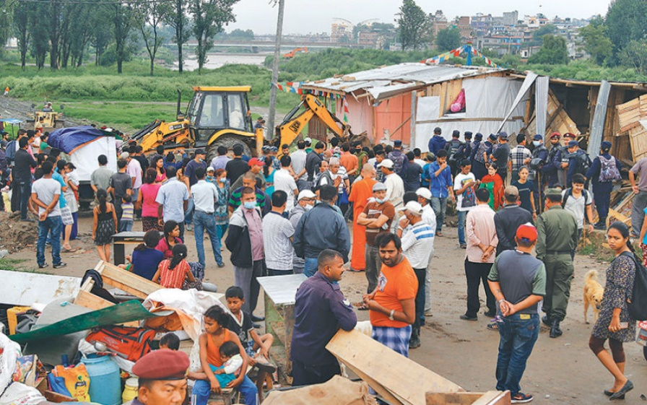
Figure 6-8: Demolishing squatter settlement
(Source: https://kathmandupost.com/valley/2017/07/16/squatter-settlement-demolished)
Figure 2-8 shows dozers demolishing squatter settlements Banshi Ghat, Tripureshwor.
It includes 227 housing units, across two locations in Ichangu Narayan. However, except with a ward office and temporary police unit on the ground floor, it remains deserted as the squatters evicted from Thapathali refused to move to these buildings. Each housing unit in Ichangu Narayan around 200 square feet in size and was priced at Rs1.2 million, to be sold to squatters at low-interest loans or to charge them rent. Squatters claimed high prices, distance from the city center where a majority of the work, and no public transportation or schools for their children as the main reason for the refusal (see footnote 5, 8, also Brooks, 2016).Recently, mayor Balendra shah tried demolishing the squatter settlement in thapathali which resulted into the clash between the municipality and the squatters.

Urban Morphology
Urban morphology is an approach to studying and designing urban forms which considers both the physical and spatial components of the urban structure. It is the study of the form of human settlements and their process of formation and transformation.(Surjyatapa, 2016).

Low cost strategies

Building Materials:
One of the primary reasons for the high cost of housing is the cost of building materials. Low-cost housing strategies focus on using alternative materials that are more affordable and locally available. For example, in India, bamboo is increasingly being used as a construction material, as it is cheap, abundant and has a low carbon footprint. Similarly, compressed stabilized earth blocks (CSEB) have been used in many low-cost housing projects in Africa and South America, as they are made from locally available soil and require minimal processing.

Design and Layout:
Design and layout of low-cost housing can also impact its cost. One of the strategies is to use a modular design that can be easily assembled and disassembled. This approach has been used in several countries, including Mexico, where a modular housing project was built using prefabricated panels that could be assembled in a few days. Another strategy is to use compact and efficient designs that make the best use of available space. For example, micro-apartments have been increasingly used in cities like New York, Tokyo and Hong Kong.

Public-Private Partnerships:
Many low-cost housing projects involve public-private partnerships, where the government provides land and infrastructure, while the private sector develops and manages the housing. In South Africa, for example, the government has partnered with private developers to build low-cost housing projects. This approach can help reduce the cost of housing and ensure that it is sustainable and well-managed.

Financing:
Financing is another critical factor in the affordability of housing. Low-cost housing strategies involve innovative financing models, such as microfinance, where small loans are given to low-income households to build or improve their homes. In addition, community-based financing models, where residents pool their resources to build their homes, have also been successful in some countries.

Government Subsidies:
Finally, government subsidies play a crucial role in making housing affordable. Many low-cost housing projects are subsidized by the government to reduce the cost of construction and make the homes affordable for low-income households. For example, in Brazil, the government's Minha Casa Minha Vida program provides subsidies to low-income families to build or purchase their homes.
Low-cost housing strategies involve a range of approaches, including alternative building materials, innovative design and layout, public-private partnerships, financing models and government subsidies. These strategies have been successful in various parts of the world, and their adoption can help address the global housing crisis. However, successful implementation requires a collaborative effort from all stakeholders, including government, the private sector and communities.

Energy efficiency
Energy efficiency over the entire life cycle of a building is the most important goal of sustainable architecture. The concept of energy studies is to provide economy and comfort to people. Energy efficient buildings (new constructions or renovated existing buildings) can be defined as buildings that are designed to provide a significant reduction of the energy need for heating and cooling, independently of the energy and of the equipment that will be chosen to heat or cool the building.
However, buildings can be designed to meet occupant’s need for thermal and visual comfort at reduced levels of energy & resources consumption. Energy resource efficiency in new constructions can be affected by adopting an integrated approach to building design. Thus, in brief, an energy efficient building balances all aspects of energy use in a building: lighting, space-conditioning, and ventilation, by providing an optimized mix of passive solar design strategies, energy-efficient equipment and renewable sources of energy. Use of materials with low embodied energy also form a major component in energy-efficient building design.

Sustainability
“With the right design, sustainability is nothing more than a rigorous use of common sense.” Figure 9: Adaptable modification of a home 15 -Alejandro Aravena The term sustainability, as it refers to architecture, must be defined so that a subsequent conversation can progress with a full understanding of its meaning. More than just energy efficiency, it is an ecological approach to design. All the resources that go into a building: materials, fuels, and the understanding of the user’s needs, must be considered to create a sustainable building. While there are many definitions of sustainability, it seems to be more of a process than a set of concrete ideas. The basic principles evolve as conditions, ideals, and technological capabilities change. It is the belief carried throughout this thesis that the aim of sustainable architecture is to construct a well-designed building and site environment that is healthy for the occupants, has minimal undesirable impact upon the environment, is effective in the use of natural resources, and is economical and durable.

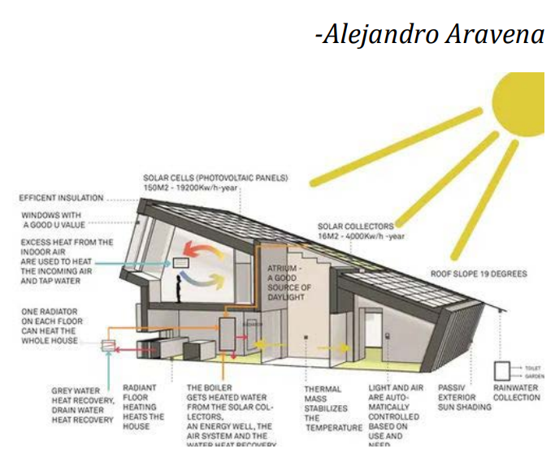
Figure 6-9: Architectural sustainability
Source: https://www.archdaily.com/780203/alejandro-aravena-wins-2016-pritzker-prize
Sustainable design means looking at the building process and design in a holistic manner because each design decision affects another. For example, the choice early in schematic design to use natural ventilation and daylighting will affect the capacity of the HVAC unit specified. In turn, these decisions all have local, global, natural resource, indoor environmental quality, and cost implications. While they all have slightly different meanings, for the purposes of clarity, the terms "sustainable architecture", "green building", " high-performance buildings" and "environmentally conscious design" will all be used interchangeably. The intangible dimensions of sustainability are:

Social sustainability:
Social inclusion and cohesion, social diversity are the important aspects of sustainability regarding social housing. This can be achieved by urban infill thus creating social mix, by compact multifunctional development with public spaces, and by involvement of community and future residents. The applicants for the social housing can be very diverse: those, who want but cannot substantially improve their living conditions because of various reasons and those, who do not want to put any effort and take the social care for granted. The involvement of the applicants in the design and construction of social housing could be a good means for social cohesion and inclusion and help distinguishing between these two groups.

Cultural sustainability:
High quality aesthetics, psychological acceptability, identification with the living environment, contextuality, cultural continuity and evolution are important for sustainable social housing designs. Cultural continuity and evolution can be maintained through the regionalist designs, involvement of local materials and craftsmanship. Involvement of artist into social projects and creating unique expressive designs are good ways to create a cultural phenomenon out of a social housing.
Economic sustainability:
Energy efficiency, sustainable consumption and production are equally important for economic and environmental sustainability. Even if achieving high energy efficiency or constructing a passive social housing require more costs, this would allow to spend from 3 to 5 times less on maintenance (SF 2012). The affordable housing projects aimed at improving the quality of life of the poor can require some contribution – financial or in a form of work – by its intended beneficiaries
Environmental sustainability:
Climate change, sustainable energy and transport, preservation and sustainable management of natural resources are important ecological aspects that can be addressed in the social housing projects. The use of local and renewable resources, technological improvements, application of ecological technologies can become an integral part of the social housing design. The use of shipping containers in the temporary housing projects currently is trendy and environmentally sustainable practice (Grazuleviciute-Vileniske, 2013.

House: Architecture and Space
The terminology utilized to define the residential built space has a significant role in linking one’s thoughts of space with its physical materiality. To call such spaces a house or dwelling simply detracts from the emotion driven association one feels when the title of home is mentioned. A house draws association to the physical nature of the built space, the materials from which it is constructed and to a lesser extent the layout from which the inside spaces take form. This is not to say that a house may not be a home, or even psychologically become one through personalization, time and experience but at a simplistic terminological basis, the house lacks emotional response (Stoneham & Smith, 2015a, 2015b).

Influential factors in shaping home
Physical Factors:
Usually, a form of the house is guided by the climatic aspect and weather location of the residential space. Houses with steep roof in rainy climates, houses with sunshades and thick 9 walls in cold climate, houses with domed roofs in the scorching deserts, etc. are all climate responsive forms of a house (Zadeh & Jamshidi, 2017).
Building and construction technology:
Local materials such as wood, brick, stone, clay, mud, etc. can be used to build houses. But in special cases such as ceremonial and ritual building, specific purpose materials have been imported from other locations. Culture is rather seen as the major determining factor.
Site and Location:
Geography and topography are the major factors in shaping a house. Location also bring variety in building styles.
Defense:
Initially, houses were built as a defense mechanism from harsh weather and wild animals. But later, social factors led to the construction of fences, hedges, high walls and so on to prevent others from entering the building.
Economy:
Economy acts as one of the most important factors in shaping the buildings. Evidence shows that human has made houses according to the way of living and economic affordability of himself. The point is that luxury building is a symbol of prestige, or social capital of the owner and not necessarily economic capital of him. With a look at the list of the tallest buildings in the world, we find that most of these towers require spending very high fees, they are made in developing countries and not developed ones.
Cultural and social factors:
Where the architecture is not influenced by climate, the houses seem to have been shaped by cultural and social factors. In cases of places having moderate climate, same locality might have variety of shapes of the homes. The need for public and private spaces, social interactions and, family structures and traditions often govern the shapes of a home. This is one of the non-materialist influences on shaping architecture of a house. Thus, non-material factors such as religious beliefs, rituals, features of social classes, culture and traditions of a community, the society and the family often govern the aspects of a home beyond the guiding physical factors.
Religion:
The most significant non-physical form of coercion is commitment to religious beliefs. The most extreme view about the role of religion on the facet of home is that they consider home as a temple and a place for praying. These views consider house as an organization of space in to two sections of sacred and non-sacred.

Elements of a home
Aesthetics:
A home often has some essence of belongingness due to the aesthetics of little elements within it. The colors of the walls, doors and windows, the furniture, etc. and their combination within the housing environment create certain aesthetics of the home. Windows and other openings: In attempts to bring light into the interiors effortlessly, the small windows and dark rooms have been replaced by light and airy rooms. The use of glass windows, skylight, solar tubes and translucent glass for privacy have allowed for the architecture to improve significantly.
Colors:
According to one of the articles about elements of a home, the use of neutral tomes of gray, brown, and blacks and whites for flooring, furnishings, lighting fixtures and textiles are common practices for improving aesthetics of a home. Contemporary colors leave the details of the furniture.

Materials:
The use of natural materials in homes enhance the character. Apart from wood furniture, use of natural and organic materials, leather furniture, etc. can be done for the interiors. Organic materials for homes range from wood, rock, slate, teak, cotton, wool and other textiles, that deviate from traditional homes.
Texture:
The use of hardwoods, ceramic and porcelain tiles, travertine stone and marble have made way for textures to define a home. Open floor plan: Open floor plans often have the character of uniting all of the interior spaces into one grand experience. The term ‘great room’ has been used to signify a blurring of the distinct walls and boundaries of living spaces with the kitchen, family room, etc.
Exteriors:
Exteriors that are free from heavy ornamentation, that have distinct rooflines – cantilevers and large overhangs, materials of the exterior blending with the nature around the home adds to the aesthetics of a home.

Principles of housing
There exist basic five-A principles of housing:

Figure 6-10Figure 0 10: Principles of housing

Affordable Housing
Affordable housing is a term introduced to cater to a large group of people living in a diversified condition with low to modest incomes. Affordable housing varies among people and among regions. The term refers to the housing type for low to medium income groups (Chohan, et al., 2015). The United States Department of Housing and Urban Development (2004) defines the term affordable housing as, "the housing that costs no more than 30% of a household's monthly income." The definition indicates that to be affordable, the rental and utilities in an apartment or monthly mortgage 41 payment and housing expenses for a homeowner should be less than 30% of a household's monthly income.
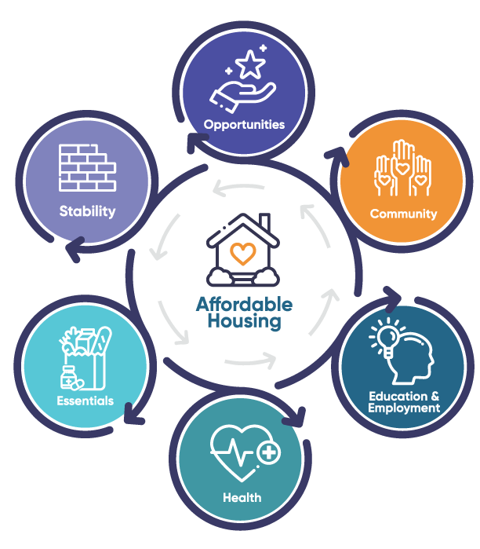
Figure 6-11: Benefits of affordable housing
Source: https://forwardhousing.ca/the-benefits-of-affordable-housing/
The City Council of Calgary (2002) approved and defined affordable housing as housing that adequately suits the needs of low- and moderateincome households at costs below those generally found in the market. Affordable housing may take on a number of forms that exist along a continuum, from emergency shelters, to transitional housing, to non-market rental (also known as social or subsidized housing), to formal and informal rentals and ending with affordable home ownership. Communities and Local Government of the United Kingdom (2006) published the guidelines for "affordable housing" as follows:
1. Affordable housing includes social rented and intermediate housing, provided to specific eligible households whose needs are not met by the market;
2. Affordable housing meets the needs of eligible households. These needs include availability at a cost low enough for them to afford, determined with respect to local incomes and local house prices;
3. Affordable housing includes provisions for the home to be retained for future eligible households;
4. If these restrictions are lifted, any subsidy should be recycled for alternative affordable housing provision.
The above guidelines reveal that different government groups and organizations recognize the importance of outlining the housing typology in the modern world. Only recently, housing used to be categorized as low, medium and high cost. However, the basic understanding of these terms has changed because of the influence of a complex set of economic conditions such as high land value, growing inflation and higher housing demands. These housing categories have failed to match the contemporary world. World forums and housing experts have coined the relatively new term of "affordable housing" to replace the old terms of low- and medium-cost housing. Analysis of the term affordable housing reveals that this new concept is not only capable of defining the range of housing but also contributes to the development and refinement of the demands of housing ranging from low- to medium-cost housing. The term enables designers and developers to understand the basic needs of housing and to adopt the benchmarks of quality set for the range of housing (Chohan, et al., 2015)

Affordability
To discuss housing affordability, clarification of definitions is needed. The words ‘affordability’ and ‘affordable housing’ can be understood differently under different housing circumstances. Affordability is based on the total household income that a single family would spend on their home regardless of home ownership types; therefore, it is a relative term to each household’s economic circumstance (An, 2003).
According to the statement by the U.S. Department of Housing and Urban Development in 2012, affordable housing is commonly defined as a house for which a household pays no more than 30% of its annual household income spending on housing. “Walkable communities are also affordable communities, and often promote local businesses and services. Innovative uses of: materials, cost-effective construction 47 methods, efficacy of shared or private outdoor spaces (Affordable Housing Sustainable Communities, 2019).” Can affordability mean free energy? Energy from the sun, like solar energy and rain water harvesting, can reduce cost in energy.

Sustainability
Sustainability means to create homes that have lower construction, maintenance, and energy costs. Using local, recycled and durable materials, incorporating passive and active heating, cooling and water use systems (ibid). “Sustainability also includes preserving and supporting a diversity of cultural histories and character, and the provision of community services (ibid).” “Comprehensive, community-based planning can effectively structure and support the communities in which we live. Any comprehensive or small area plan depends on substantial and sustained community participation to be successful (ibid).”

Flexibility

Incremental Housing
Posited against finished, turnkey housing, incremental housing refers to an abundance of housing supply mechanisms in which housing units grow incrementally over time as the incomes of their owners increase and/or their household members increase in number or age. Thus, it offers the homeowners a wide range of flexibility whereby they could enlarge and improve the size and standard of their dwellings in response to changes in their demographics and economic status (Hamidi & Elhassanii, October 26 – 29, 2010, pp. 1-2). The novelty of the housing produced through this incremental mechanism lies in the process itself rather than its outcome. Incremental growth can be related to flexibility. We can create compact but spatially rich units that can change over time to accommodate changing or new family members (ibid, 2019).
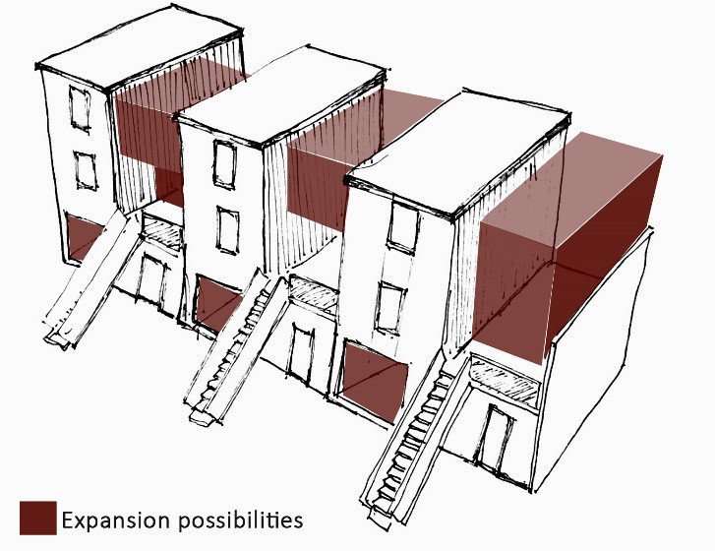
Figure 6-12: Incremental housing
(Source:https://www.researchgate.net/publication/351594155_Adaptability_of_Buildings_A_Critical_Review_on_the_Concept_Evolution/figures?lo=1,)

Modification
People often tend to modify the spaces they inhabit. The terraces are turned into roof gardens, open air-cinema, or extra rooms are added in later years due to larger space demands of the growing family. The question of service requirement, “is the full unit provided in the housing enough for the poor who has a growing family?” can be answered by providing incremental unit free for modification. The properties of the modifications are that they are self-built components, they denote equity in housing environment and they are often need-specific for each family. The problem with building homes on housing plots is that these houses cannot be built as final houses because as the needs of the family increase, they will want bigger area for addition of living spaces. As adopted solution in Charles Correa’s Belapur Housing, incremental housing might be one of the methods. When the needs of the family grow, they can add more rooms in the remaining site area left for future expansion.
But as of today, after decades of its construction, the middle-class families have totally demolished the original homes and built entirely new homes that match in no way to the original housing blocks, making them 3-4 stories high, higher that the remaining original houses. Now, the problem here is, if people are going to completely change the look of the original intended housing architecture designed, what is the point of putting 49 so much effort into designing those houses? Designing only the infrastructures and roads with basic public facilities and allocate certain housing plots for the people to build houses themselves sounds like a better alternative. But this is not the motto; it is to change the way people view their homes once and for all.
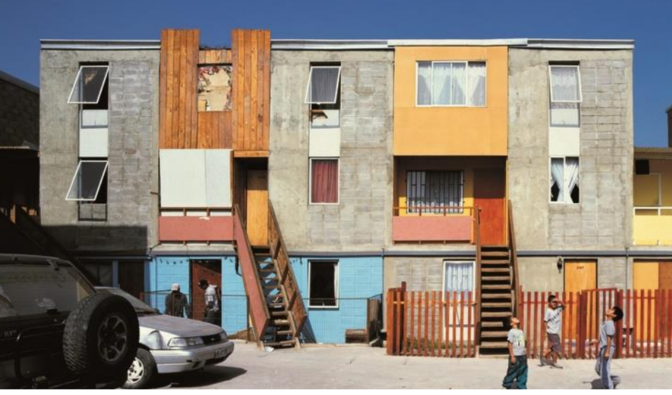
Figure 6-13: Modification
(Source: https://dornob.com/wp-content/uploads/2016/02/ARA-MON-004_full.jpg)
Figure 2-10 shows the modification done by the users in incremental housing

Strategies for Affordable Housing Development:

Multi-family development
Multi-family housing can be defined as any building that contains more than one dwelling unit, and it can be stacked or stand side by side with a shared exterior wall. Regardless of dwelling connection types, ownership of the multi-family home comprises three types; condominium, which has individual ownership of each unit with some shared communal elements in the property, cooperative, a non-profit corporation and purchase shares, and timeshare ownership, which has right of use during a specified period of time each year. Although large-scale multi-family housing development can help to intensify population in urban areas and is considered to be an important means of achieving housing affordability, zoning rules in many cities prohibit the multi-family development in designated urban areas (Kwon, 2012).

High-rise and high-density development
The modernist architects Le Corbusier, Mies van der Rohe and Walter Gropius tried to find a universal answer to urban housing and social problems introducing high-rise and highdensity housing strategy in the twentieth century. This strategy can be provided for housing the urban poor who live under extreme conditions including lack of fresh air, natural light, and basic utilities. It can provide affordable housing within a healthy environment that allows low-income households to enjoy natural sunlight, ventilation to fresh air and large open spaces. In the industrializing Asian metropolises such as Seoul, Tokyo, Hong Kong, and Taipei, high-rise and high-density lifestyle is accepted as the affordable housing typology. This strategy can considerably cut off the loss of area in circulation and open spaces. The multilevel housing can have shared stairs and open spaces so that more area can be freed for housing (ibid).

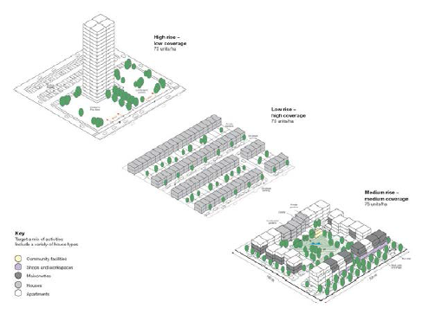
Figure 6-14: Housing Typologies

Mixed-use development
Mixed-use development can be defined as a mixture of different functions and activities in a single architectural structure. It has been the predominant means of natural development in most cities throughout history. The typical mixed-use development 54 style comprises commercial or community space on the ground floor, which is more accessible for public use, and residential space on the upper floors. Under mixed-use development, residents can enjoy amenities in close proximity, reducing traveling distance and providing a walkable, pedestrian-friendly environment. The latter reduces individual dependence on automobiles and fuel, and it contributes to a healthy lifestyle through community engagement. It ultimately reduces environmental impacts in urban areas. The biggest advantage of mixed-use development in old urban centers is the urban revitalization that improves livability of the area through enhanced walkability from one space to another. If working places, commercial spaces, services, and recreational spaces are close to homes, people prefer to leave their car and walk to their destination; this naturally creates an economic boost in the area (ibid). If we can accommodate the markets within responsibly designed social housing, we can bring the home and work of the people together to introduce rather simple solution to economic problems of the people. The architecture of dwelling can be merged dynamically with the market-architecture. Possibilities can be to devote ground floor to the public for strong connection and transparency between the surrounding urban spaces through markets and events.

Infrastructure
Efficient use of infrastructure, which is defined as tangible and intangible systems including roads, transportation systems, running water, storm drainage, sewers, electricity and communications systems to provide necessary utilities and comfort, is also one of the cost reduction strategies for affordable housing. These systems are always installed in multi-layer systems, usually with roads and streets. Almost all buildings today are connected with improved and new kinds of infrastructures, and these infrastructures are maintained and installed by tax paid by the residents in the area. Therefore, avoiding extension of the infrastructure can decrease the cost per dwelling, and a compact development shares out these infrastructure costs to improve housing affordability.
For example, a simple installation retaining pond or rainwater storage through a green roof system can save the costs of storm water drainage. Multiconnection of sanitary sewers and water lines for multi-dwelling units can save construction time and piping cost. Shared infrastructures reduce the cost of housing. With reference to the design of Belapur Housing by Charles Correa, it can be noted that the toilet blocks of two adjacent houses are placed alongside each other. This allows 55 for reducing the cost of pipelines that would have definitely gone up if they were placed separately. Providing party walls can also be an alternative to reduce the cost of the structure (ibid).

Circulation
Road and street systems play an important role in housing affordability, as they are constructed with funds collected from residents' taxes and other infrastructures are installed. A circulation system for residential development needs to be carefully designed to reduce construction costs and aesthetic appeal. Human traffic must be considered prior to vehicular traffic to reduce automobile dependence and safety. Traffic speed, parking, bicycle paths and sidewalks are the elements that influence cost-effective factors in the design of local streets. In streetscape design, cost-reduction design strategies can be considered in terms of pavement materials, curb design and landscaping.

Strategies for housing design

Open space design
As Le Corbusier’s Plan Voisin suggested, as housing density increases, the spaces between individual dwelling units need to be increased as well for functional and psychological health. Open spaces need to incorporate existing natural features to reduce costs through conservation design which saves costs for changing existing natural environment. All homes and all residents have to have equal access to open spaces to enjoy sunlight and fresh air; this can also reduce the need for artificial lighting and air conditioning. Open spaces need to become the green lungs and play area for residents to insure both active recreation and passive recreation. Also, open green spaces can function as integrated storm-water management systems. Most importantly, open spaces have to be designed to contribute to the health and well-being of the community (ibid).

Innovative landscaping reduces costs for dwelling units. Rather than using lawns, the water-efficient local plants can be used for ground cover multi-vegetation to save irrigation and use of fertilizer. A mix of hard landscape with low or no maintenance native trees and plant helps achieving affordability. These local trees are used for sunshades preventing heat gaining during the summer and passive solar gaining during the winter; grouping of trees can be used for protecting and redirecting winter wind to reduce heating costs. Need to incorporate existing natural features to reduce costs through conservation design which saves costs for changing existing natural environment. The open-to-sky spaces can provide a connection of the individual unit with the outdoor environment and nature, creating an open environment within each unit (ibid).

Flexibility and adaptability
The Modern concept of ‘flexibility’ in space was suggested for the first time in 1927 by Mies Van der Rohe when he introduced an inner moving wall in an apartment at an exhibition in Stuttgart, Germany (ibid). The concept of flexibility in architecture is described as “the capacity designed into buildings and building programs or technologies to provide an effective initial fit and to facilitate response to future change. Flexible design in affordable housing can accommodate changes to the units and allows for maximum space utilization; therefore, residents are able to adjust and participate in the design of their own space, and they can have control of construction cost as their lifestyle changes.
In other words, the user of a house not only gains a voice in the design process but also retains the power to change their space throughout the lifespan of the house. In this case the user or owner rather than the architect takes responsibility for the design. The concept of flexibility best fits with a compact housing style, in which users choose to adapt their small house in response to changes in their lives and households (ibid).

Affordable interior space
A good, affordable interior design can only be achieved if the function of the space integrates with the sense of the space. There are essential design principles that make it possible, such as zoning of interior space, access and circulation, spatial configuration, space-making devices, and finishes. To reduce interior walls and make small spaces feel larger, one way to do this is to have an open floor plan or minimize interior partition walls. Other strategies for achieving affordability include proper planning, efficient use of materials, providing thermal comfort to the inhabitants, and producing free energy in the housing.

Community development center
Community development seeks to empower individuals and groups of people with the skills they need to effect change within their communities. These skills are often created through the formation of social groups working for a common agenda. Community developers must understand both how to work with individuals and how to affect communities' positions within the context of larger social institutions.
Communal Space
Communal spaces are basically a more regulated and organized version of public spaces because they provide all the benefits of public spaces while subtracting the side-effects like crime, garbage piles, etc. (arch20, 2019).
Importance:
1. Functionality: User comfort is a basic measure for functionality of any building. Communal spaces facilitate users to enjoy, socialize and relax
2. Aesthetics: Effective communal spaces would have a strong aesthetic appeal to invite the users to spend time in them (ibid). Open-air communal areas make the outdoor area of the buildings look better and livelier.
3. Social interaction: Apart from providing space for daily activities, communal spaces bring people together. Having co-working areas, party spots, walking tracks, playgrounds, coffee shops, community centers, or a common courtyard encourage social interaction.
4. Sharing of knowledge and ideas: Communal spaces become the main host for spontaneous knowledge-sharing in the building. People from diverse backgrounds get to know one another while spreading a wide range of ideas and open-mindedness (ibid). 5. Removing racism and inequality: If your building could accommodate for interaction between different social and ethnic groups, it may inspire equality and tolerance in society (ibid).

Community Participation
“Slums were an issue in the past, they are a challenge in the present and they will continue to be a great concern in the future (Cavalcanti, 2016).” The slum growth is caused due to the migration of people from rural areas to the urban areas and these very group of migrants is the makers for the labor of the slum. “Research has shown that favelas have a different land status, different patterns of urban conglomeration and parceling. However, when compared to formal urban planning the same logic of investment and housing commodification applies (ibid, 2016).” A block of the house may be owned by multiple owners, living in the different divided portions of the block or who might be living on different floors of the same house. The alleys and stairways are used as shared spaces. “Labor produces a particular urban porosity that conjunctionally addresses the informal city and the formal city, the low-income groups and higher income groups (ibid, 2016).” Labor provides a synthesis for the design of slums.
The participation of the people in the process create a sense of place attachment.

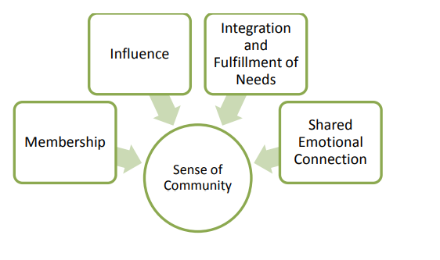
Figure 6-15: Sense of Community

Energy Efficiency

Bye laws, Acts and Policies
Planning standard guidelines by Kathmandu Valley Town Development Committee (KVTDC) are as follows:
• The road joining the planning areas should be 7m wide.
• The road joining the blocks should be 5m wide.
• The roads joining the plots should be 4m wide.
• The width of the plot should be minimum 6m.
• The minimum area of the plot should be 2-2.
• There should be a provision for about 5% open space in the area of 5-10 planning, 4% in 10-25, 3.5% in 25-100 and 2.5% open spaces above 100 of planning areas.
•There should be provision for various facilities like accessibility to drinking water, electricity, sewage system, telephone connection and roadways able to carry the traffic of fire-fighting vehicles.
Source: KVTDC

Definitions of public space
In defining public space, it is essential to consider the meaning of the term “public”. Madanipour (2010, p. 8) suggests that “the word public originates from the Latin and refers to people, indicating a relationship to both society and the state”. This suggests that “public” may be any entity, regardless of whether tangible or not, that relates to people and is shared by and open to them in a community as a whole. The concern here is space as the physical entity that is linked to the term “public”. This provides a basic understanding of public space as the space that concerns people and may be interpreted “as [the space] open to people as a whole” (Madanipour, 2010, p. 8). These ideas are echoed in the various definitions of public space. Carr et al. (1992, p. xi) define public space as the “common ground where people carry out the functional and ritual activities that bind a community, whether in the normal routines of daily life or in periodic festivals”. Madanipour (1996, p. 148) defines public space as a “space that allows all the people to have access to it and the activities within it, which is controlled by a public agency, and which is provided and managed in the public interest”. Tibbalds (2001, p. 1) sees the public realm (and space) as “all the parts of the urban fabric to which the public have physical and visual access. Thus, it extends from the streets, parks and squares of a town or city into the buildings which enclose and line them”. He further argues that the public realm is “the important part of our towns and cities” where the significant amount of human contact and interaction takes place (p. 1). Gehl et al. (2005, p. 2) explain that “public space is understood as streets, alleys, buildings, squares, bollards; everything that can be considered part of the built environment”.

In these definitions, public space is characterised as a space owned and controlled by public agency or a community. However, due to the increasing level of public life use the concept of public space in a slightly varied way. Public space in this research will mean any physical space with a potential to develop social interaction regardless of ownership and control. It can be in both outdoor and indoor locations (Woolley, 2003), but it needs to be accessible to the users.

CONDITION OF PUBLIC SPACE IN KATHMANDU

The current urban growth and change in the Kathmandu Valley pose a number of problems in the planning and design of urban areas (Adhikari, 1998; Thapa, Murayama, & Ale, 2008). Some of these problems have been manifest in the nonconductive physical environment of new neighbourhoods that affects the quality of life and social well-being. A problem central to this research is the loss of public space and its consequences on the opportunity for social contact and interaction. Observations indicate that public spaces in the valley’s new neighbourhoods have been reduced dramatically, resulting in a low provision of communal meeting areas (Adhikari, 1998). Although the loss of public space is a recent phenomenon, it tends to have significant consequences for public life and activity. The residents of new neighbourhoods most often find it difficult to find places where they can meet and interact with neighbours; children do not find places to play; and without places for social gathering, the new neighborhoods lack a sense of community (Shrestha,
2001).
Studies on the urbanization of the Kathmandu Valley indicate that in addition to urban change, the unplanned growth is one of the primary reasons for the loss of public space (see Adhikari, 1998; ICIMOD, UNEP, & Government of Nepal, 2007; KMC/World Bank, 2001; Pradhan, 2003; Shah & Pant, 2005; Shrestha, 2005; Shrestha & Shrestha, 2006; Shrestha, 2001; Tiwari, n.d.). Scholars argue that public spaces have almost vanished from contemporary urban neighbourhoods. However, little attention has been paid to examining how and why such a loss is occurring. In addition, the current development of public space has not been explored in detail in the context of the growth of diverse urban form, including land pooling and private housing development schemes. Moreover, there is a lack of research to explain the nature of changes with the use of public space, due to the changing provision and their impact of changes on developing social interactions and fostering a sense of community among the neighbourhood residents.

Dimensions of public space
Public space is a multidisciplinary domain of research focus as it concerns not only the physical but also the non- physical dimensions with a significant amount of overlap among them. These manifold dimensions have drawn wide attention from a diverse range of academic disciplines besides architects, urban planners and designers. This research focuses on physical, social and psychological dimensions of public space as shown in Figure 2.1.
The physical dimension refers to the physical environment or “provision” of public space which provides a setting for social interaction, whereas the social dimension refers to the “use” or activities occurring in the space (Carmona et al., 2010). The psychological dimension relates to the perception of public space, which may be expressed in terms of how people interpret the space and give “meaning” to it, and
how such meaning helps develop a sense of community or place. These dimensions are important to this research, because they form the units of analysis in the investigation of public space in urban neighbourhoods.
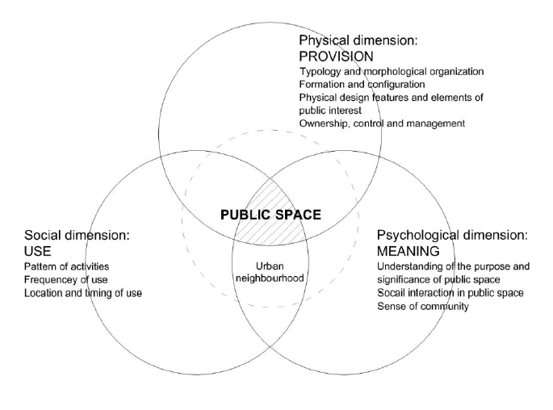
Figure 7-1- Dimention of public space pps, 2000
Figure 7-2Dimention of public space pps, 2000

Studies have shown that there exists a strong relationship between the physical qualities of public space and its use. Gehl (1987) suggests that the physical design and condition of public space can largely influence the pattern of use. He argues that a good quality public space can attract a range of activities, making it lively and vibrant. The quality of public space may be assessed in terms of its provision, the physical features and design elements and the degree of accessibility. Similarly,
Whyte (1980) argues that most sociable spaces are the ones which are easily accessible to the users, both physically and visually, with plenty of amenities to
support the activities occurring in them. According to Lynch (1981), an accessibility
of urban space is crucial to public life and thus, should include human concerns.

Key qualities of successful public spaces
Successful public spaces are designed and developed in such a way that they are accessible and can attract a range of use and activities, providing an opportunity for socialization among the users. The Project for Public Spaces (PPS) (2000) outlines four key qualities of successful public spaces: a) access and linkages; b) comfort and image; c) use and activities; and d) sociability (see Figure 2.2). It explains that “a successful public space is easy to get to, and is visible as well” so that it is convenient for the people to use different parts of the space with easy circulation within it (p. 18). Activity is another key quality of public space and it is the reason why people come to the space. The PPS (2000, p. 18) also points out that the use of public space is determined by its image and the level of comfort it offers because “perceptions about safety and cleanliness, the scale of adjacent buildings, and a place’s character or charm are often foremost in people’s minds in deciding whether to use a place”. While people use public spaces, they tend to socialize with each other. Whyte (1988) writes:

What attracts people most is other people. Many urban spaces are being designed as though the opposite were true and what people like best are places they stay away from (p. 9).

Therefore, the opportunity for socialization also makes a huge impact in the success of public space. The PPS (2000, p. 19) argues that “when people see friends, meet and greet their neighbors, and feel comfort able with strangers [in public space], they tend to feel a stronger sense of place or attachment to their community”

Community
The term “community” is derived from Latin communis which means “common”. A community is a social unit with shared characteristic like standards, religion, qualities, customs, or personality. It may share a feeling of place situated in a given geological region like a nation, town, neighborhood or in virtual space through communication platforms. In sociology, community is defined as a group who follow a social structure within a society (culture, norms, values, status). They may work together to organize social life within a particular place, or they may be bound by a sense of belonging sustained across time and space (Zevallos, 2013). 2.1.1 Sense of Community In a seminal 1986 study, McMillan and Chavis identified four elements of "sense of community".
They are:
• Membership
• Influence
• Integration and Fulfillment of Needs: Reinforcement
• Shared Emotional Connection

Membership
Membership is the feeling of belonging or of sharing a sense of personal relatedness and one should be invested and mostly bounded for emotion, safety with its certain boundaries to belong. Thus, Sense of membership is mainly determined by contribution and togetherness of determined boundaries, emotional safety, developed sense of belonging and identification, personal investment, and a common symbol system that they have developed. 2.1.1.2 Influence Being bidirectional concept, one should have notion to be attracted to group which is determined by influence that group does or on another way the group should have ability to influence its member with their certain goal and objectives. People acknowledging other’s needs, values, and opinions rather than pushing and dominating are more influential and attractive group. Thus, both conformity and community influence on members indicate the strength of the bond. The pressure for conformity and uniformity comes from the needs of the individual and the community for consensual validation.

Shared Emotional Connection
A shared emotional connection is based, in part, on a shared history and not necessary that group members have participated in the history in order to share it, but they must identify with it. The interactions of members in shared events and the specific attributes i n h i b i t s t h e s t r e n g t h o f c o m m u n i t y w h i c h c a n b e d e p i c t e d t o m e m b e r s f a c e w h i l e t a l k i n g o f m o t h e r la n d , f a m i l y in summary, strong communities are those that offer members positive ways to interact, important events to share and ways to resolve them positively, opportunities to honor members, opportunities to invest in the community, and opportunities to experience a spiritual bond among members (David W. McMillan, 1986). Thus, with better understanding of sense of community, the foundation of lawmakers and planner can develop programs that meet their stated goals by strengthening and preserving community which we can facilitate free, open, and accepting communities are based on faith, hope, and tolerance, rather than on fear, hatred, and rigidity.

Community and Community Architecture Concept
As of now, the architectural discourses generally start from the contemporary society premises. It is about the society that we live in, about the communicational, modernized society and about the engineering that needs to meet the general public's demands the subject of a design for local 9 area, of a Community Architecture is moved toward all the more sometimes, and in any event, when it is drawn closer, there isn't yet a strong theoretical base or well-founded concept. The pessimism of the contemporary philosophers and sometimes the mathematical solutions given by the sociologists or the excessive psychologization of the relations between individuals close the hesitant picture that is rising above over the community. However, certain criteria can unite communities such as location, values, interests, age, spirituality, even if this is done in a new way.
In attempting to conceptualize the community architecture, it is argued that the rapid flow of information, globalization must be seen as resources and not as obstacles. Architecture will never lose its value if it is designed for and with people. Communication is the virtual environment comprises of designing networks, connections between individuals. Architecture for the community is design that considers every one of these contemporary real factors. Community Architecture refers to the built environment that is advertised for the utilization of the local area or that energizes local area investment, in a profound and comprehensive social sense. This means permanent and temporary developments both at the urban level- public spaces, squares, fairs and architectural objects, town halls, libraries, stages, social establishments, clubs, gymnasiums, extracurricular facilities, conversion training centers, spa centers, Community centers.
The needs of the community architecture concept as indicated are:
• To give a proper answer to the contemporary needs. • To create tools for an architecture dedicated to community.
• To be aware of the need for interdisciplinary approaches in community architecture and to form interdisciplinary teams.
• To generate a community theory in order to shape and build community architecture. (Zamfir, 2015) The expression of a contemporary humanized society and the architecture that addresses it discovered it resources in the existence of the constituent communities and in the set-up relations between their individuals.
Without a doubt, the architecture mirrors the government assistance condition of a general public, administering approaches, however without community component it remains unsustainable. Community addresses the profound layer of society, the spirituality, the intrinsic upsides of these and architecture is in a permanent interdependency with community. Architecture and community characterize one another, 10 potenting their own characteristics, incorporating in this globalization measure and saving in a similar time their individual uniqueness. The community coagulation seems to be very difficult in the contemporary urban society. The lack of time, the infinite delaying of the direct contact, the reversal of the pyramid of values have led to the late formulation of an actual concept dedicated to the community architecture.

Community Center
Community center is public places, where people gather together to share time for all sorts of reasons such as:
• to socialize
• for events, recreation and entertainment;
• to attend groups and meetings and
• taking part in activities like sport, arts and crafts and gardening.

Types of community center
All over the world there are four types of community center based on the way of ownership and organization.
They are:

Community owned
This type of center is directly owned and run by the local community through an organization separate from the official (local) governmental institutions of the area, but with the full knowledge and sometimes even funding from (local) government institutions.

Government owned
This type of center is a public (local) government facility, though it is mostly used for nongovernment community activities and may even have some kind oflocal leadership elected from its community. e.g., Kominkan in Japan

Sponsored
This type of center is owned by a rich citizen or commercial corporation and donates its use to the community for reasons of charity or public relations.

Commercial
This type of center is a purely commercial entity which aims to profit from renting its facilities to various community groups on terms suitable for such use.

CHAPTER III- CASE STUDIES

Case study

International Context: A case of Half a House by Alejandro Aravena
Introduction
-Designed by architect Alejandro Aravena in Chile, this housing was targeted for the middle-class families. With an area of 80 sqm for middle-income family and 40 sqm for a low-income family, the housing is designed in such a way that there exists equity for all income-groups.
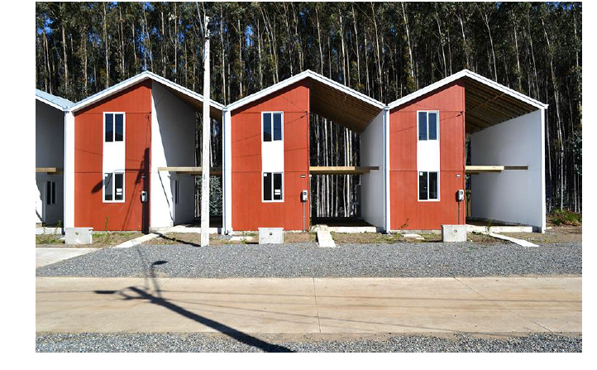
The vision is that residents end up with a much more pleasant house than what they could have built completely on their own or received from ordinary state funding. Juan Ignacio Cerda, one of Elemental’s principal architects, said that even if money were not an issue, the firm would build the same homes. Any extra funding would go into improving the surrounding space and uplifting the neighborhood, embodying the firm’s social approach.
Figure 9-1: Half a house
(Source:https://www.archdaily.com/797779/half-a-house-builds-a-whole-community-elementals-controversial-social-housing )

Objectives
The objective of this case study is to see ways of providing equity and flexibility in housing design.
Project Description
(Text description provided by the architects) Elemental, led by Alejandro Aravena, evolved this idea when commissioned to draw up a new master plan for Constitución, Chile, after it was hit by an earthquake of magnitude 8.8; the second largest in the world during the last 50 years, killing over 500 people and destroying 80% of the buildings in the city. Elemental had already experimented with unfinished low-income houses in Iquique, Chile, which were to be built at $7,500 per unit, for 100 families. The future inhabitants threatened even the proposal of a housing block with a hunger strike, but building individual houses would simply cost too much. Instead, Elemental provided the residents with just enough to meet the Chilean legal requirements for low-income housing, allowing them to expand the rest. In Constitución, the plans for Villa Verde, an entire area populated by two-story half houses, the visual design of the buildings are different, but the concept is the same; half of the houses are identical and the other halves are completely unique.
The first floor of the finished half is made up of unfinished concrete floors, and the second is covered in unfinished plywood. There is only one sink in the kitchen, with no other appliances, but the house is cheap, practical and well insulated. Everything that families wouldn’t have an easy time building alone, such as concrete foundations, plumbing, and electricity, has been finished for them. The Chilean government pays for roads, drainage, sewage, garbage collection, buses, and any other necessary infrastructure, to focus on building a good community. Residents just have to provide their time, labor and any extra materials. Building half a house might just be the best way to make a community whole. Give half of a good house rather than a finished smaller house. Struggle laid in making lowincome houses affordable, and the incremental building was the answer.

Analytical reviews
Although building half a house provided equity to all income groups in the settlement, half of the area in each house goes completely unused for a long time, until and unless the owner gathers enough money to build the rest of the house and make it whole. The modifications on the buildings, which is actually a feature of the incremental housing, can sometimes degrade the look of the housing due to modifications from original-intended architecture.
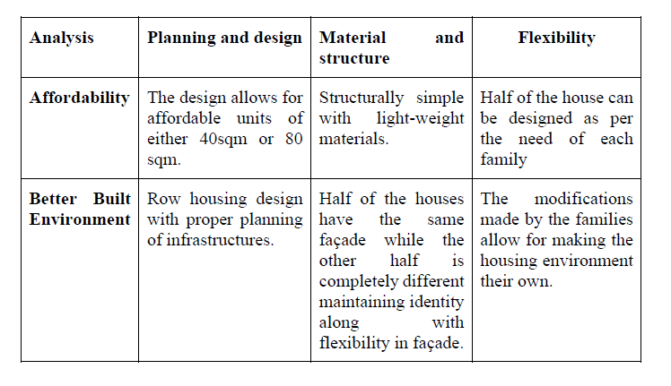
Table 6 : Inference of case study of half a house

International Context: Dortheavej Residence by Bjarke Ingels Group

Introduction
Designed by the architects Dortheavej Residence and Bjarke Ingels Group, this social housing is located in Copenhagen, Denmark and completed in 2018. The housing extends in an area of 6800 sqm.
Project Description
((Text description provided by the architects) Named after its Dortheavej address in the northwestern part of Copenhagen, the 5-story building winds through the area characterized by car repair shops, storage and industrial buildings from the 1930s–50s.

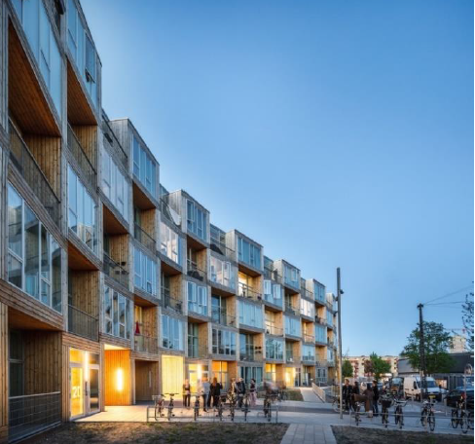

Figure 9-2: Dortheavaj Residence
Source: https://www.archdaily.com/903495/homes-for-all-dortheavej-residence-bjarke-ingels-group
BIG was commissioned to design Dortheavej in 2013 by Danish non-profit affordable housing association Lejerbo, whose mission is drafted by Danish urban space designer Jan Gehl. BIG was asked to create much needed affordable housing and public space in the area while keeping the pedestrian passageways open and the adjacent green yard untouched. Earlier this spring, BIG and Lejerbo were honored by the Danish Association of Architects with the Lille Arne Award for prioritizing the spatial qualities of the residences and the building strategy on a strict affordable housing budget. “Our ambition was to create affordable apartments by the world’s leading architects. Together with BIG, we
have succeeded in creating sustainable, safe and functional homes that see eye to eye with the people who live in them.” Jan Hyttel, President, Lejerbo Copenhagen.

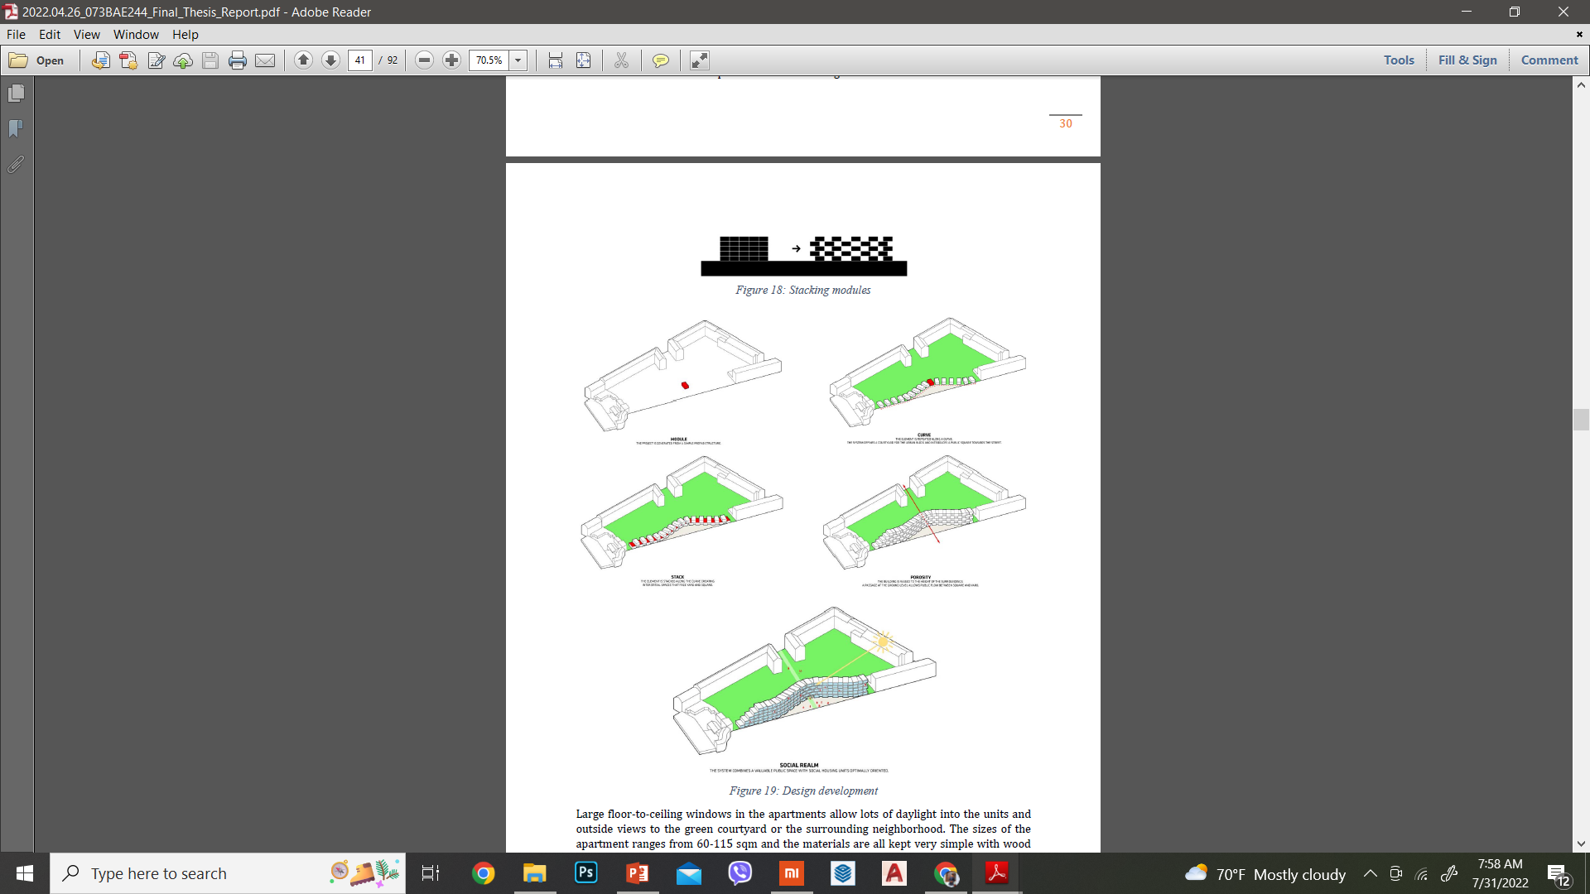
Figure 9-3: Stacking module
Source: https://www.archdaily.com/903495/homes-for-all-dortheavej-residence-bjarke-ingels-group
Figure 3-4 shows stacking of modules to create porosity.
Figure 9-4: Design Development
Source: https://www.archdaily.com/903495/homes-for-all-dortheavej-residence-bjarke-ingels-group
Table 7: Inferences of Dortheavaj Residence
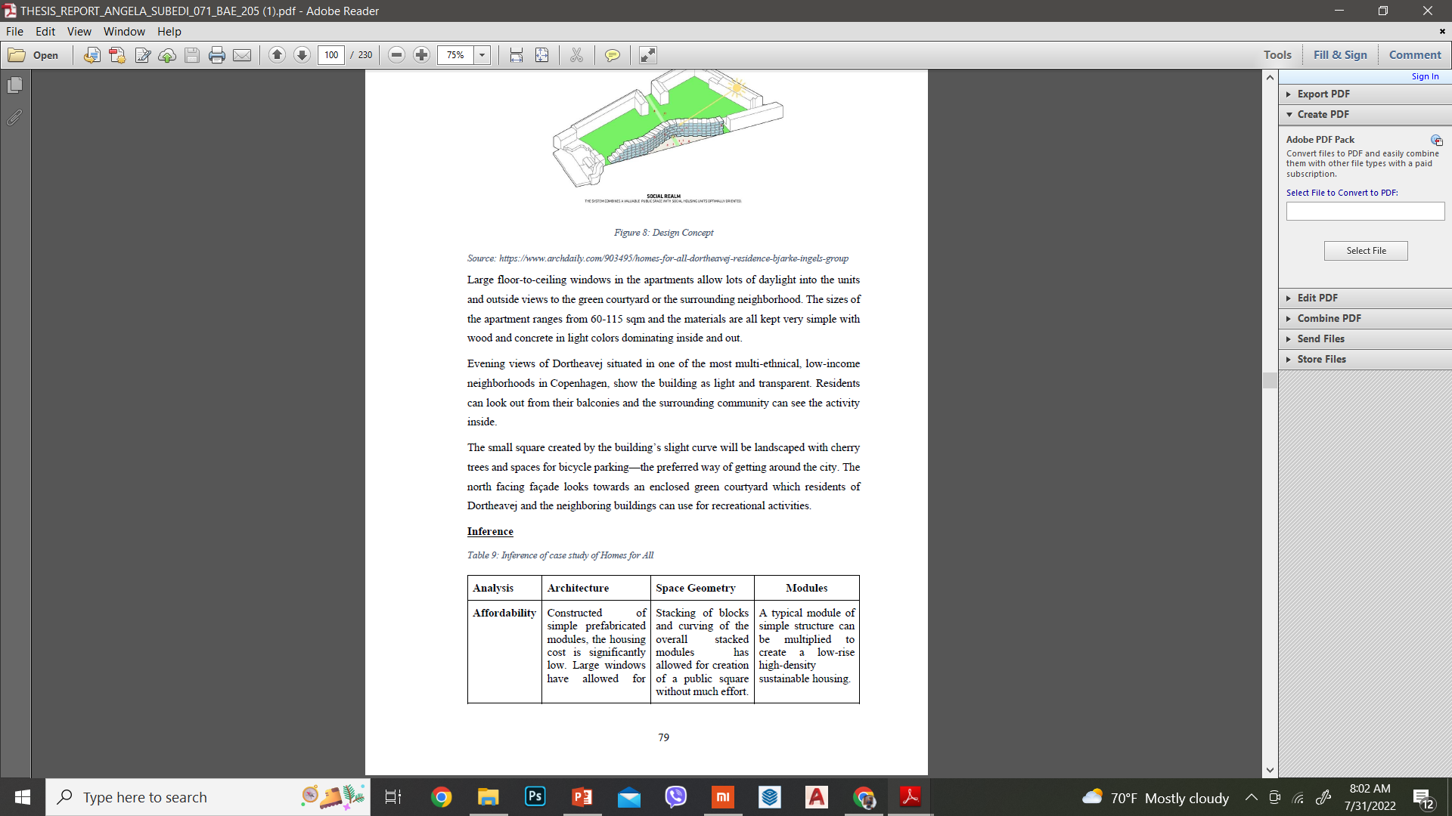
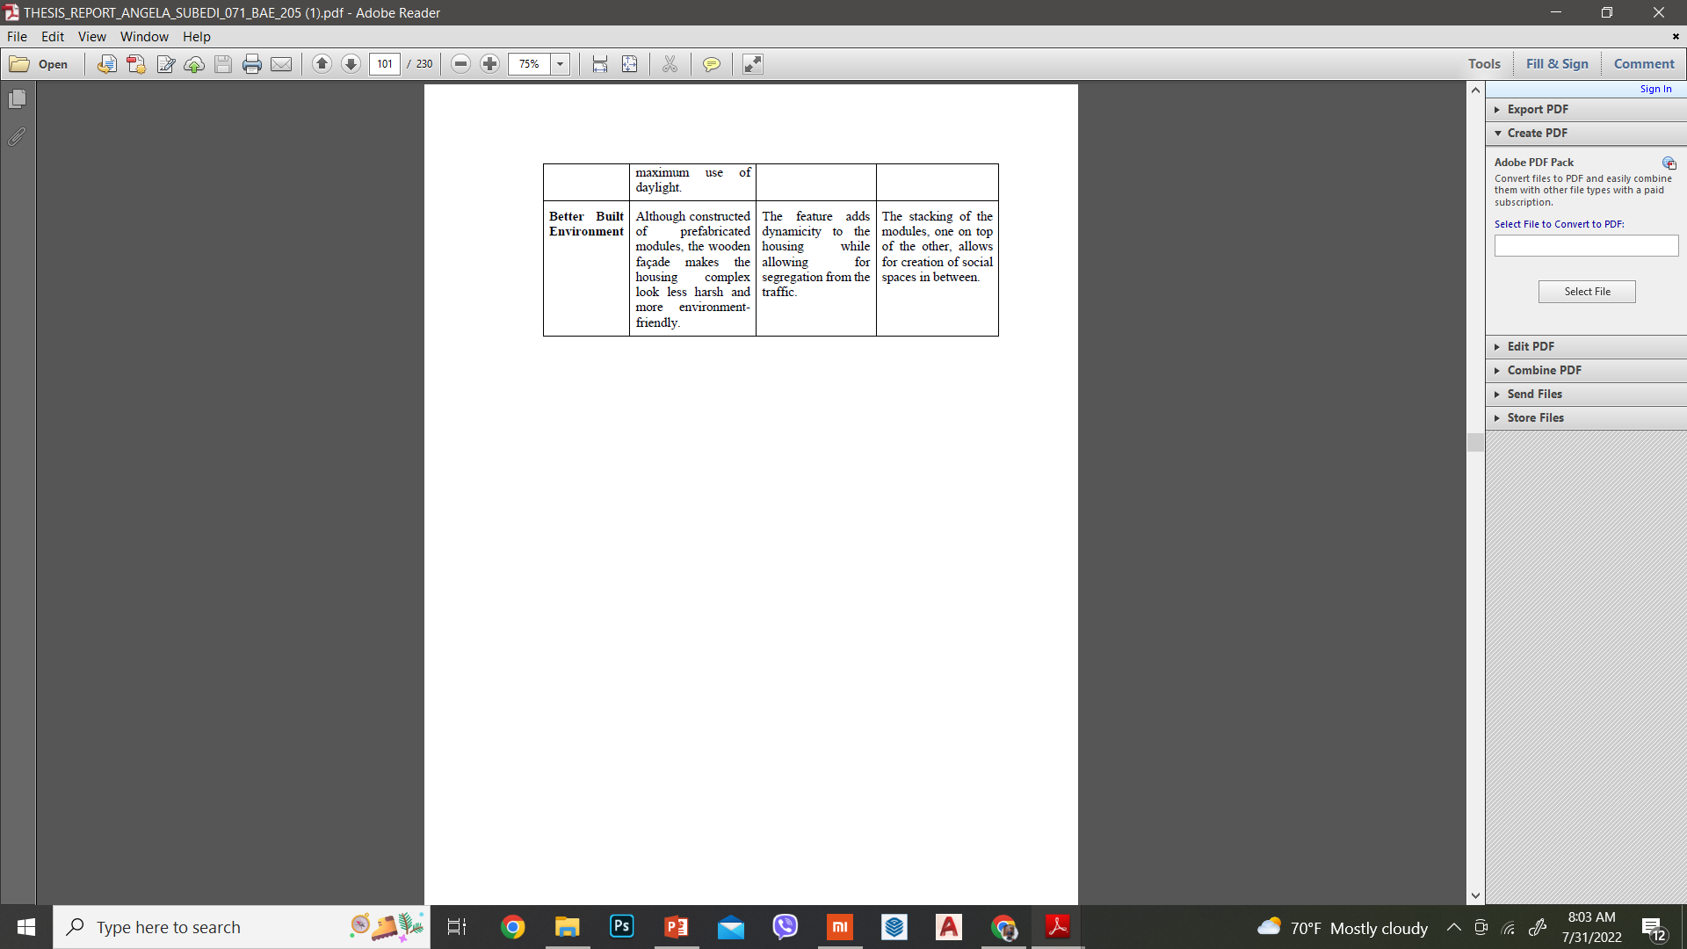

Regional Context

A case of Belapur Incremental Housing (Artist Village) by Charles Correa
Introduction
Located in Sector 8, Belapur, Navi Mumbai, Maharashtra
Designed by: Charles Correa,
Constructed in: 1983-1986,
Targeted for all types of income groups, especially Low-Income Groups (low: Rs. 20000, middle: Rs. 30000-50000, upper income: Rs. 180000).
It was designed to accommodate more than 90% of Navi Mumbai’s low-income profile. The village was originally built for artists but very few reside there currently. There can be seen mixed occupancy at present. There is a population of 550 families, with the (high) density of 500 people per hectare. The total area of the village is 5.4 hectare (54,000 sqm).
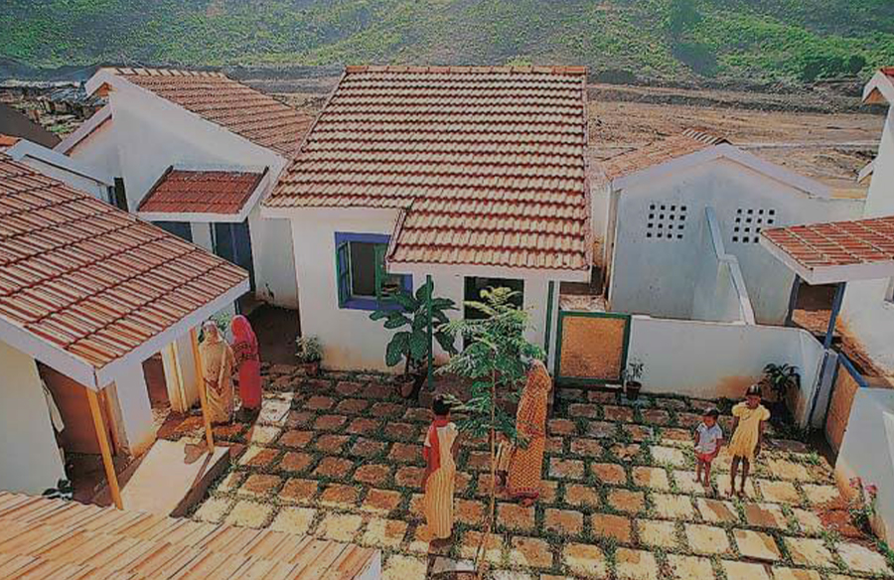
Figure 9-5: Belapur Housing
Source: https://www.re-thinkingthefuture.com/case-studies/a3735-belapur-housing-by-charles-correa-a-sense-of-home-and-community/

Objectives
The residential neighborhood surrounded by driveways and located in a border area between the fabric of the city to the south and the wide hills that open to the north. In 90 the central area is crossed by a stream. The objectives of studying this housing are to know how affordability can allow a better-built environment for low-income groups and to know about the pros and cons of incremental attributes of housing design.
Project Description
Located at Latitude 19° 01'56.47" N, Longitude 73° 02'4.90" E, the climate area of the housing is Tropical climate with an average annual temperature of 26.7 ° C. The temperatures are moderated by the proximity of the sea and do not undergo major changes during the course of the year. The coldest month is January, with an average of 23.9 ° C in the middle of the month. The monsoon influences both the temperature and the climate. The monsoon season normally goes from the beginning of June to the end of September. The precipitation reaches, during these months, 95% of the annual total. The months of October and November are just as warm, although with little rainfall. With maximum daytime temperatures of around 28 ° C, the months from December to February are dry and slightly less warm than in the period March-May 92 when the maximum average temperatures reach up to 33 ° C and increases the humidity. The housing orientation is such that it is developed mainly along the north-south axis.
The planning of the housing village settlement can be seen as cluster settlement accommodated by open-to-sky spaces. There are service blocks created to reduce the cost of infrastructures such as water supply and sewerage. There are shared courtyards in each housing cluster along with schools, community wells in the settlement. The architecture of the houses can be seen as having pitched roof that has good climate response to deal with heavy rainfall in monsoon. The material for construction is brick perimeter walls along with plaster of white color. There are colorful wooden fixtures along with the roofing done with a wooden structure covered with tiles. There is external outdoor stone paving with simple floor plans and building methods. The composition of accommodation has 5 different types of houses which are all fenced, independent and including indoor spaces (real house), covered areas (verandas) and outdoor spaces (private courtyard or terraces).
Analytical reviews
the lack of provision of parking spaces inside individual condominiums have caused the public spaces to be converted into community parking areas. Encroachment of open space due to parking is a rising problem and the social spaces dedicated to people’s interaction have been taken over by cars.
The geometry of cluster housing has caused chaotic drainage and electrical system. There are no provisions of a gas pipeline or any rainwater harvesting projects.
Most of the houses have been remodeled or destroyed and rebuilt due to the impractical design of placing toilets outside the house.
Due to lack of commercial spaces, the houses facing streets have been transformed into shops illegally.. The character of housing is lost due to urbanization.
Table 8: Inferences from the Belapur Housing
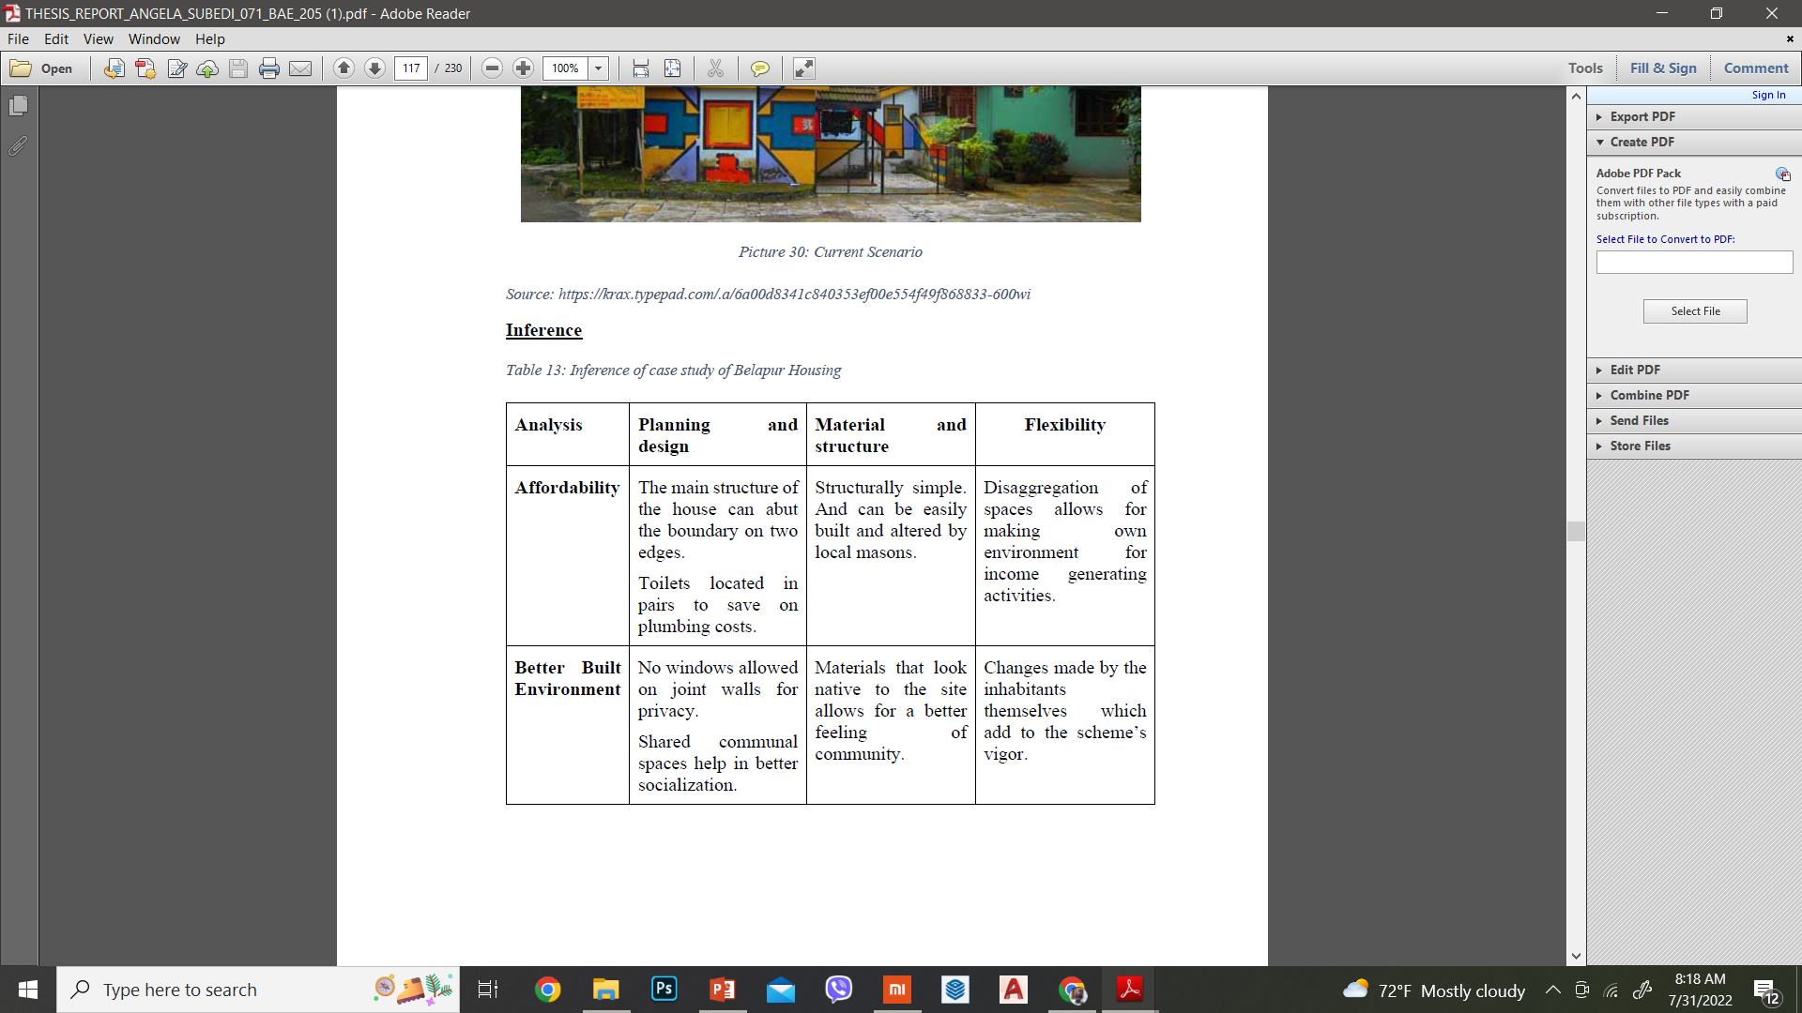

National Context

Relocation of the squatters: A case of Kirtipur Housing by Lumanti
Introduction
Situated in Kirtipur, Kathmandu, this housing is one of the housing schemes that have sheltered the squatters of Kathmandu Valley by relocation strategy. The houses are built with low cost techniques with native materials and efficient planning.
Objectives
The objectives of this case study were to know the condition of relocation housing in Kathmandu.

Description
The location for the housing project was decided after lengthy discussions with the affected families as to their needs and visions for their new community. Affordability also had to be taken into consideration given that the families must make monthly repayments to the fund. The housing design was chosen by the community from several alternatives presented, and a total of 44 homes are constructed. The houses will remain owned by UCSF until the loans are repaid by the recipient families. The land for the new houses is located at Paliphal- 6 in Kirtipur. This land was advertised by Nepal Sri-Lankan Merchant Bank. The tender was submitted. And fortunately we got the land.
Through the entire planning process, poor people have demonstrated their capacity to develop viable solutions and to prepare themselves to fight for housing rights and security of tenure by organizing themselves, saving money, planning houses, developing management skills, and remain firmly committed to building a better life for their families and communities.
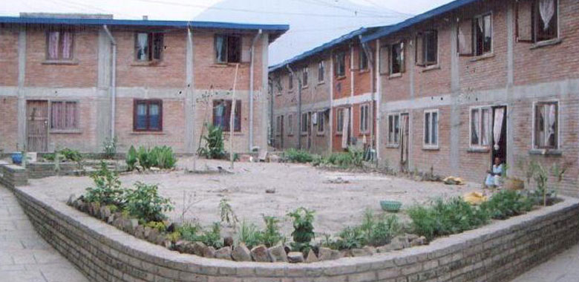
Since only 30 housing units are required for the VLR affected families, it was decided that the remaining houses would be given to other needy urban poor. 3 families from Kalanki requested for the housing. They were affected by the road built in Kalanki. Also, settlers from Kirtipur itself joined the community. This has help the community feel anchored in their housing site.
Figure 9-6: Kirtipur housing
Source: http://lumanti.org.np/program/details/kirtipur-housing.html
In order to insure that the process of distributing the houses remains unbiased, we have placed responsibility in the hands of the Kirtipur Housing Management Committee to allot houses based on a lottery system. The success of this project is also very important for Lumanti since we have been working with the urban poor for almost a decade now and during this period we have seen and made changes in the way squatters are treated. In order to advance progress in favor of the urban poor, Lumanti hopes to continue to collaborate with the most disadvantaged segment of society in order to advocate their cause in a public forum and develop strategies to explore ways to relieve urban poverty.
Analytical Review
Upon observation, it can be seen that here is somehow chaotic electrical system in the settlement because the wires for all the houses have been distributed from one single pole. Although it might not look chaotic in terms of planning, it looks chaotic architecturally, creating a web-like envelope over the open space which in otherwise case, might have looked clearer. Due to absence of terraces over houses to make the housing low-cost, the only outdoor space is the central community space that are divided into two pockets. There exists no space for drying the clothes in individual houses so all are brought down in the same central space. Most of the activities such as sunbathing, drawing water from the well, drying clothes, plantation, animal husbandry (if any) such as rearing chicken and all other community activities take place on a single site outdoors within the settlement. Within the individual houses, there seems to be no foyer space. The doors of the houses directly open to the main stone-paved pathway in the center. This has created transparency in privacy of the residents allowing for equity to prevail within the settlement.
Table 9: Inferences of case study of kirtipur housing
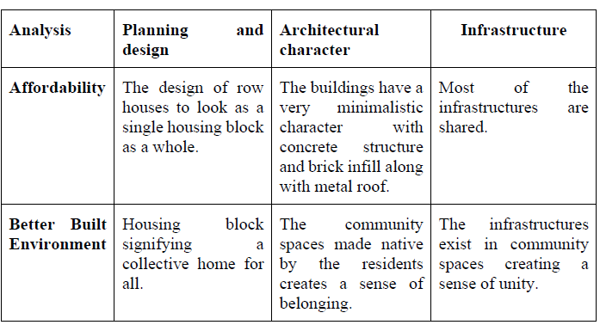

National context: Ichangu Narayan housing complex by The Government of Nepal
Introduction
The Government of Nepal aimed to resettle and rehabilitate hundreds of squatters who had been living along the Bagmati river. Construction began in July 2012 and was completed in September 2014, according to documents provided to the Post by the department. In total, the project, which spreads across two locations in Ichangu Narayan and includes 227 housing units, cost an estimated Rs120 million.
From a distance, the buildings look grand, similar in style to the dozens of housing colonies that have sprung up across the Valley in the past decade. On closer inspection, signs of abandonment come into view: fading paint, moldy ceilings, and hastily plastered cracks on the walls. There’s no electricity, no running water and no occupants.
But even nearly seven years after completion, the housing complex in Ichangu Narayan, built to house squatter families, remains vacant, except for the ground floor where a ward office and temporary police unit have taken up residence.

Objectives
The objectives of this case study were to know the condition of relocation housing in Kathmandu.
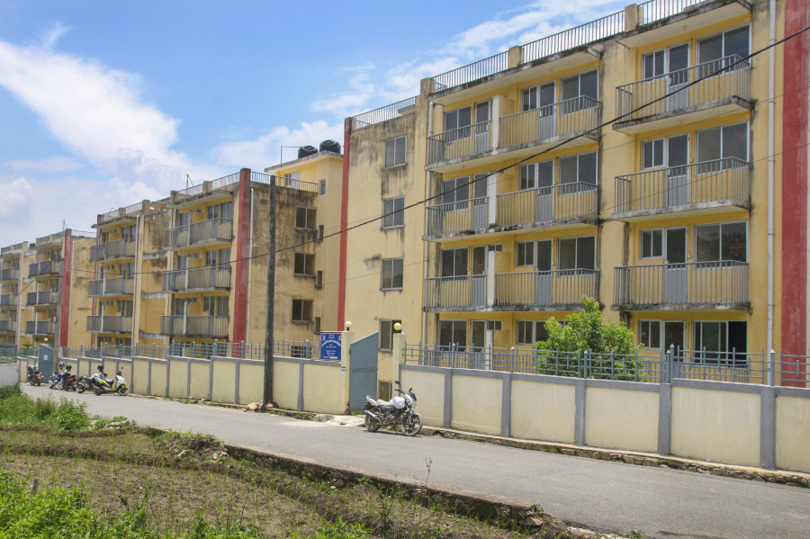
Figure 9-7: Ichangu Narayan Housing project
(Source:https://kathmandupost.com/national/2019/07/25/the-government-spent-rs230-million-on-buildings-for-squatters-nobody-moved-in)

Analytical Review
Some of the reasons for failure of this project:
1. There was no public transit that reached the settlement. Hence making it unaffordable for the residents to travel to the city for employment.
2. The dwelling units were only a little over 200sq ft, which was even smaller than the squatter dwelling they had been living in. Hence it was considered too small and unlivable.
3. The neighborhood residents lacked social inclusion. The so called “high class” or “VIP” residents of the area didn’t want squatters to live and interreact with them and their children.

CHAPTER IV- SITE

Proposed study context

Site selection criteria

Proposed site
Location: Kirtipur, Kathmandu
Topography: Contoured
Access: Major access from east and south sides of the site
Area: near to the existing relocated squatter settlement by lumanti
Criteria
Availability | Temporary structures on lease
Accessibility | Access to social, recreational, educational, commercial, and health facilities and services, public transportation(rapid transit), and employment centers
Location | Within the Kathmandu valley, close to ringroad
Affordability | Long term sustainability
Mixed used development | Appropriate for community and residential developments

Existing settlement
The squatter settlement at Balkhu is the second largest squatter settlement along the bank of Bagmati River in Kathmandu. A sense of community prevails within the settlement and the bond seems to be very strong between the inhabitants such that they 112 have established numerous political bodies to manage and maintain the activities within the settlement. As can be seen through observation, the settlement is directly below the bridge, on a significant location with respect to the economic activities of the valley.

Location and Position
The squatter settlement at Balkhu, Kathmandu; a locality in Jagaran Tole, Ward No. 14, West Sector of Kathmandu, situated along the banks of Bagmati river, is one of the squatter settlements lying in the center of the city. It has a large fruit market and the Vayodhya Hospital next to the bridge. The land along Bagmati River is designated as UN Park.

Access
Through direct observation, one can see that the first look of the site from the bridge is not appealing. The squatter settlements along the banks of Bagmati River have created an uninviting riverfront. This has caused massive degradation of public space. Via Ring Road, the squatter settlement can be accessed through a road on the western part of the bridge. Below the bridge the road runs through the west side of the whole settlement. There are hundreds of informal alleyways created within the dense settlement to reach into the individual units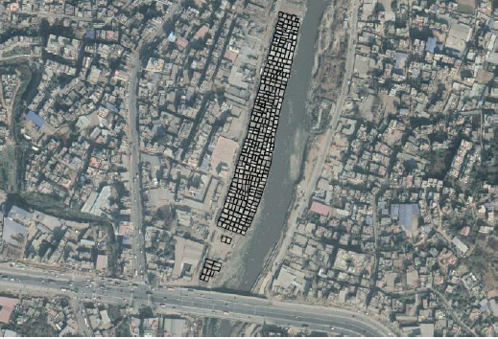
Figure 10-1: Density of squatters at balkhu settlement
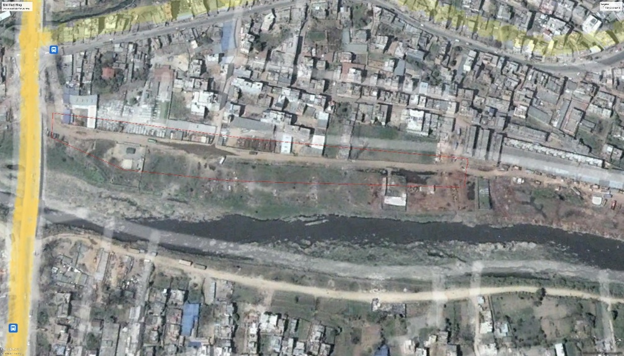

Figure 10-2: Google map of balkhu squatter settlement taken on 2007

(source: Google Earth)
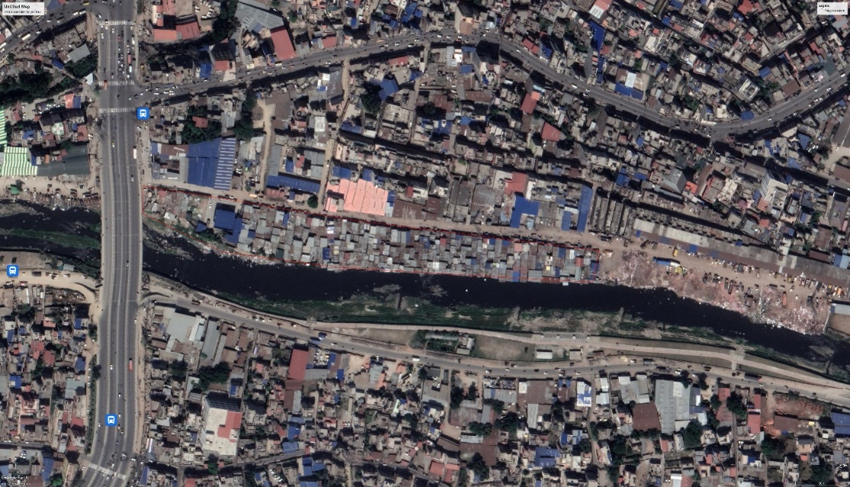
Figure 10-3: Google map of balkhu taken on 2022
(source: Google Earth)
Above images shows the development and changes on the area since 2007
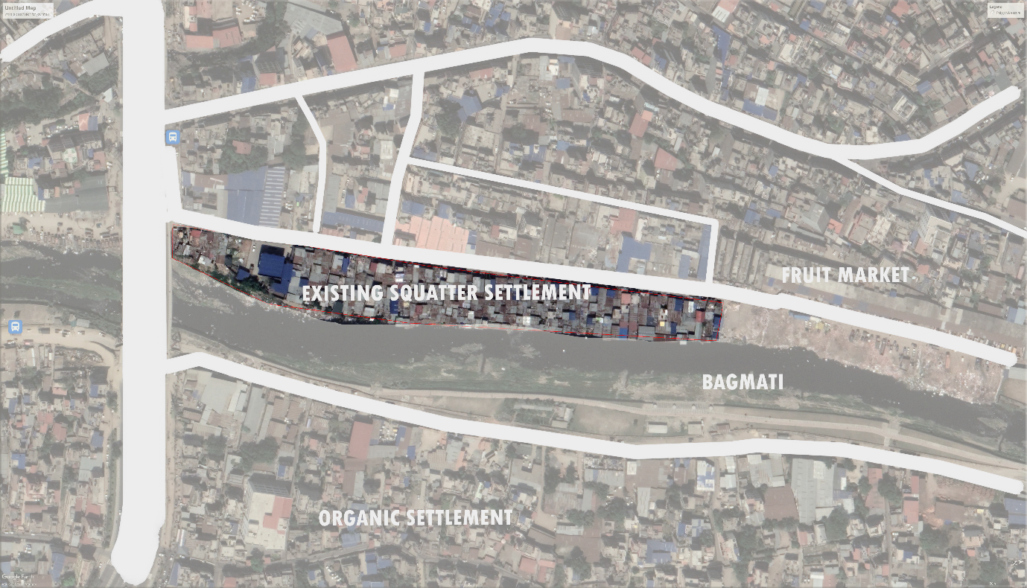
Figure 10-4: Figure 24: Prevailing squatter settlement area at balkhu

Architecture within the settlement
The buildings are very much similar to the homes of rural Nepal. Some are built of low-cost hollow concrete blocks; some houses are built with bricks and cement mortar with exposed walls and no plaster. Some of the houses have cement plaster but without paint. Some have paints too. Although the walls are made of concrete, the roof are CGI roofs dominantly. Other houses are built with bamboo structures, wooden structures, and also thin metal sheets or CGI sheets with metal posts for frame. The houses that have walls, roof, partition walls and doors and windows, everything built out of CGI sheets can also be found.
fenestrations are small openings in the walls allowing little to no light inside the buildings.

Infrastructures
The access road to the settlement is in worse condition. The electricity has all been derived from nearby electric poles haphazardly. There are no provisions of proper drinking water and waste disposal system. There are a few large water tanks used for water distribution in the community.

Community services
There isn’t any community space in the settlement. The houses are closely packed with narrow alleys. However, the churches of the settlement act as communal space for the Christians.
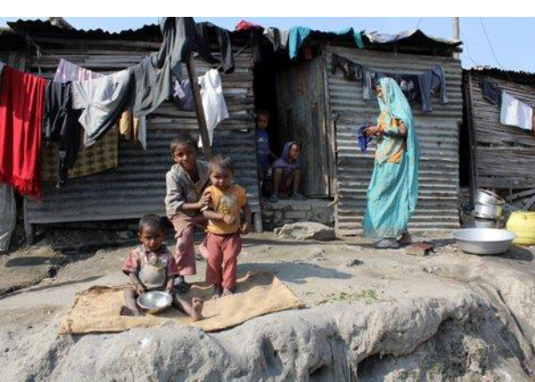
Figure 10-5: Existing condition
Source: The kathmandu post
Figure shows the existing conditions of squatter settlements

Population Background
Through observation, assuming that every family has a population of 5 members on average:
Population of Balkhu Squatter Settlement: 5x400 = 2000

Social composition in the settlement
The income groups of the community are low income groups and economically weaker section. They are usually working-class people. There are ethnic groups of all types in the settlement. There are religious groups of Hindus, Christian, Buddhist and others with Hindus in highest number, Christians second highest and so on.

Fear of eviction
The site is illegal and belongs to the government. The land along Bagmati River is designated as UN Park. The people living there don’t have any land so they are forced to dwell in such public lands. Many of the houses in the squatter settlement were 120 bulldozed in 2015. The people don’t have any idea when such actions will be implemented by the government next. They are always living with the fear of eviction.

Open Space
As per the report EMI © 2010, p. 131, there exists a Risk Sensitive Land Use Plan (RSLUP) in which the river side areas of Kathmandu Valley have already been considered as riverside development areas and to form part of a network of open spaces (Bagmati River). According to the report again, in the section, River Easements: As required by law, the 25-meter easements along the city’s seven main rivers and tributaries will be recovered and will be strictly enforced. A program to develop linear parks along river easements will help protect them from illegal structures. Illegal settlements lining the rivers will be resettled to safer grounds. More information can be obtained from the River Development Plan of 2007 particularly for the Bagmati, Bishnumati and the Dhobi Kola Rivers crossing Kathmandu City.
ORGANIC SETTLEMENT

Proposed Site for Design
- Proposed site Area: 15800 sq.m
- Location: Kirtipur, Kathmandu
- Topography: contoured towards west
- Access: east and south

SITE SURROUNDING
East- access road and green views
West- Open agriculture areas
North: Warehouses
South: access road and growing organic settlements

Physical and Climatic data

- Sun path Diagram

Chart 1: Sun path diagram ( source: gaisma)
Through the analysis of sun path, we can gain passive heating and cooling in the building design. The latitude of Kathmandu is 27o40’38” N, which gives the highest solar altitude angle of 86o in Summer and lowest solar altitude angle of 40 o in winter.
- Average Temperatures and Precipitation
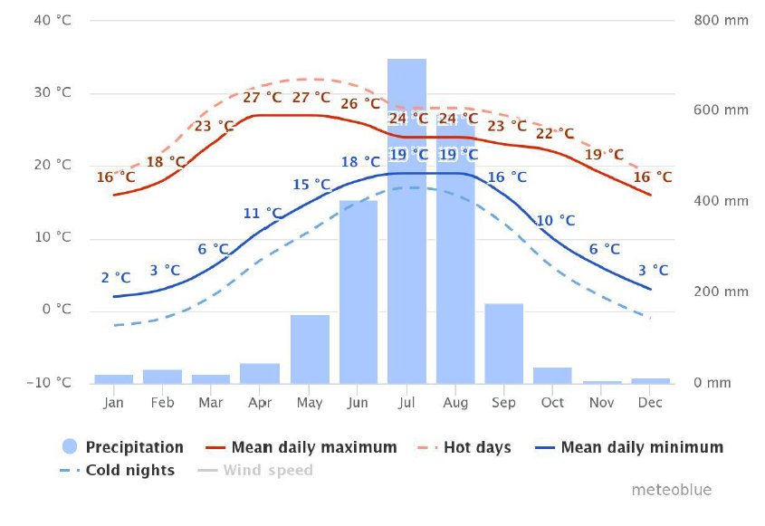
Chart 2: Average temperatures and precipitation (source: meteoblue)
- Cloudy, sunny and precipitation days
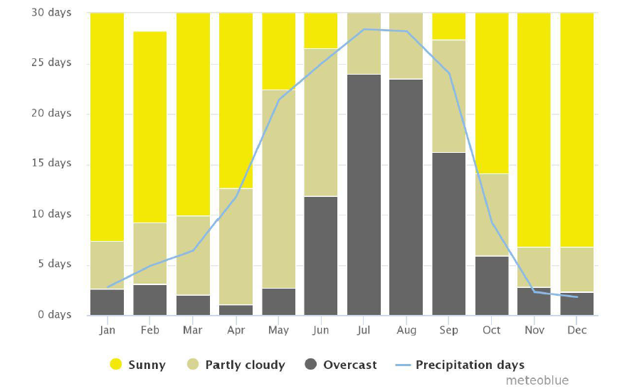
Chart 3: Cloudy, sunny and precipitation days (source:meteoblue)

- Maximum temperatures
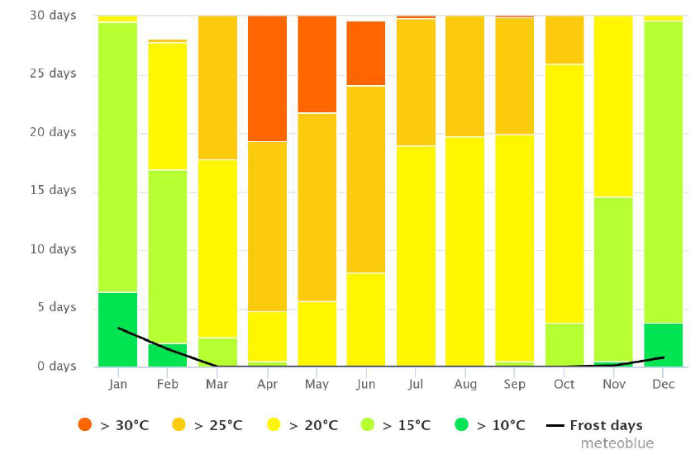
Chart 4: Maximum temperatures (source: meteoblue)

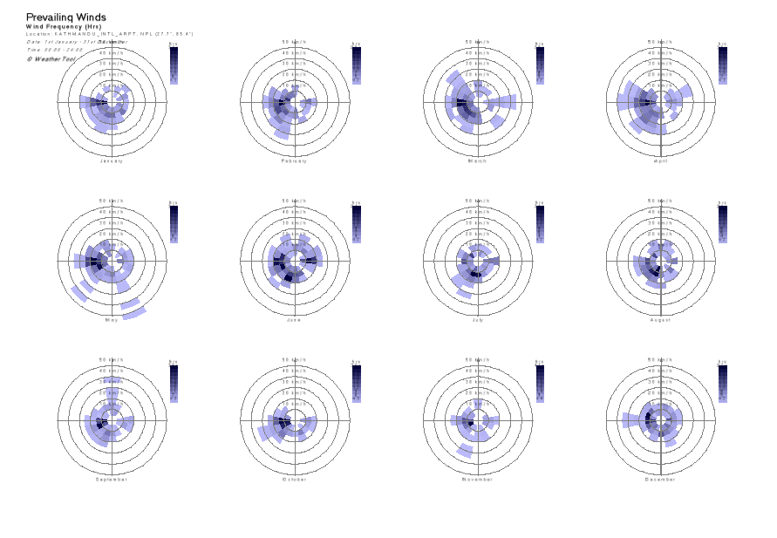
- Wind rose diagram and Wind speed
Chart 5: Wind rose diagram and Wind speed (Source: Energyplus)

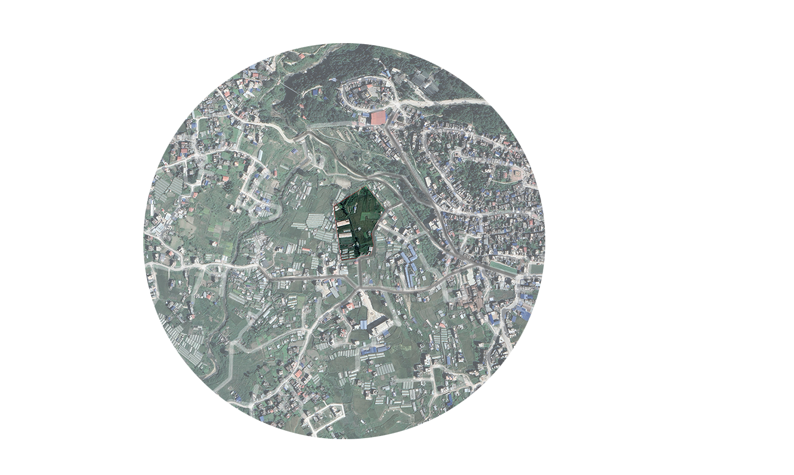
PROPOSED SITE
RELOCATED
COMMUNITY
AGRICULTURAL COLLEGE
ORGANIC SETTLEMENTS
KIRTIPUR SETTLEMENT
TINTHANA BRIDGE
NAIKAP
KIRTIPUR MONASTRY
Faith hospital

Figure 11-1: Fig: SITE SURROUNDING AND LANDMARKS

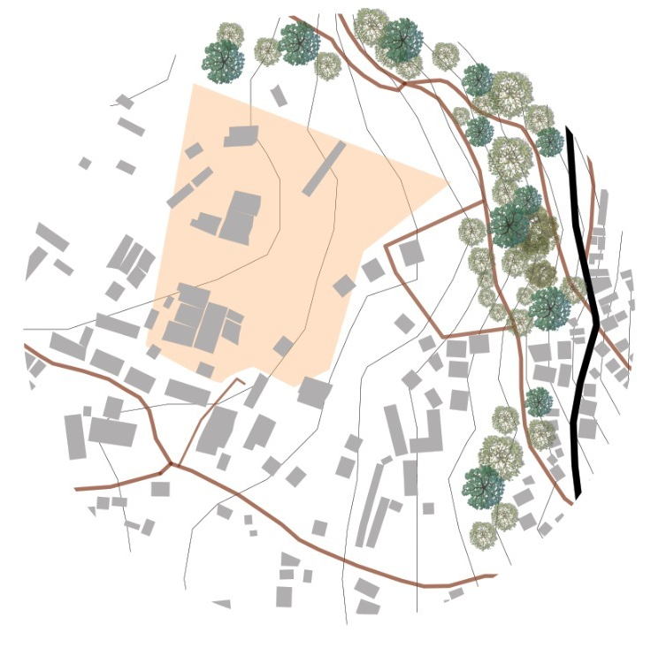
N
Figure 11-2: PROPOSED SITE
GREEN VIEWS

PROPOSED SITE

GREEN VIEWS

RELOCATED SETTLEMENT

Chart 6: SWOT Analysis

CHAPTER V- PROGRAM Formulation

Program formulation
The Rehabilitation program will accommodate about 400 families living as squatters. The families will be provided of the two modules according to the family size. The spaces for skills development programs will be provided specially focusing on the children and the adult. Different interacting spaces will be provided to increase the community bonding. The spaces for commercial functions such as groceries and stores will be provided. The religious spaces too will be addressed.
Table 10: Program development

S.N. | Components | Standard | Capacity | Area | Unit
 | Amenities
 | Admin
 | Office spaces |  |  | 50 | Sq.m
 | Multipurpose hall | 0.6sq.m/p | 200 people | 140 | Sq.m
 | store |  |  | 25 | Sq.m
 | Sub-total carpet area |  |  | 175 | Sq.m
 | 35% for circulation and structure
 | Preschool kinder garden
 | Classrooms-4 |  |  | 360 | Sq.m
 | Toilet-2 nos. |  |  | 40 | Sq.m
 | Staff room |  |  | 45 | Sq.m
 | Meeting hall |  |  | 35 | Sq.m
 | Store and utility |  |  | 10 | Sq.m
 | Lobby reception |  |  | 50 | Sq.m
 | 35% for circulation and structure |  |  | 220 | Sq.m
 | Library | 2.5-3.6 p/p | 50 | 160 | Sq.m
 | Market area/retail store fronts |  |  | 200 | Sq.m
 | Housing
 | LIG –TYPE 1(28 sq. m)
 | Bedroom |  | 3.2mx3.1m | 9.12 | Sq.m
 | Living+kitchen+Dining |  | 4.6mx3m | 13.8 | Sq.m
 | Toilet |  | 2.6mx1.9m | 4.94 | Sq.m
 | Total area |  |  | 28 | Sq.m
 | LIG TYPE-2 (28 sq m+ 14sq. m)
 | Bedroom 1 |  | 3.2mx3.1m | 7 | Sq.m
 | Bedroom 2 |  | 2.55m x2.72 m | 7 | Sq.m
 | Living+kitchen+Dining |  | 4.6mx3m | 18 | Sq.m
 | Toilet |  | 2.6mx1.9m | 5 | Sq.m
 | Total Area |  |  | 42 | Sq.m
 | EWS
 | Bedroom |  | 2.7mX2.7m |  | Sq.m
 | Multi purpose space |  | 4.45mx1.7m |  | Sq.m
 | Toilet |  | 1.3mx1.6m |  | Sq.m
 | Kitchen-open |  | 1.6mx1.6m |  | Sq.m
 | Total area |  | 21 sq.m |  | Sq.m
 | MEZZANINE UNIT
 | Bedroom |  | 3.2mx3.1m | 9.12 | Sq.m
 | Living+kitchen+Dining |  | 4.6mx3m | 13.8 | Sq.m
 | Toilet |  | 2.6mx1.9m | 4.94 | Sq.m
 | Loft space |  | 6.1mx3.1m | 18.9 | Sq.m
 | Total area |  |  | 42 | Sq.m
 | Other amenities
 | Church | 1.2 sq./seat | 120 people | 140 | Sq.m
 | Gumba | 0.4-0.5 sq./seat |  | 50 | Sq.m
 | Day care centre |  |  | 50 | Sq.m
 | Temple
 | Parking
 | car |  |  | 30 in numbers | Sq.m
 | Bike |  |  | 200 in numbers | Sq.m
 | Open areas |  |  | 5% of total site area | Sq.m

CHAPTER VI- DESIGN PHASE

CONCEPT AND DESIGN DEVELOPMENT

Strategies
The strategies for affordability with better-built environment can be through:
Planning:
Compact, High Density, Shared infrastructures, Shared spaces, Connection of spaces.
Design:
Modular, Optimum design of interior space, Open floor plan, Flexibility, Equity.
Energy:
Exposure to the sun and natural light, Free wind path, Collection of rainwater.
Material:
Low-cost, Reusable, Low maintenance, Mass production. For energy efficiency and to use maximum solar energy for passive heating and cooling of the building.

Concept Development:
An approach to translation of Site and the community observations into design. The proposed site is located at kirtipur where a relocated community already exists. The site is chosen over there because of its proximity to all the infrastructures needs for the holistic approach to cater the physical, social, cultural and economic needs. The site itself is near to their current squatter settlement, which caters the economical attributes.
-The idea is to provide a better-built environment for the community through proper planning and create spaces that would increase social interactions and also provide spaces for the development of skills and knowledge for the children and the adults catering both the communities that would help them sustain and grow.

UPRISING
-Uprising in the sense that the dwellers get the freedom to expand according to their needs and to provide spaces for their overall growth. (INCREMENTAL).
STACKING OF CLUSTERS
-ENCOURAGING HORIZONTAL AND VERTICAL INTERACTIONS
-PROVIDES SAFE OUTDOOR SPACE
-BUILDS COMMUNITY RELATIONSHIPS THROUGH SHARED SPACES
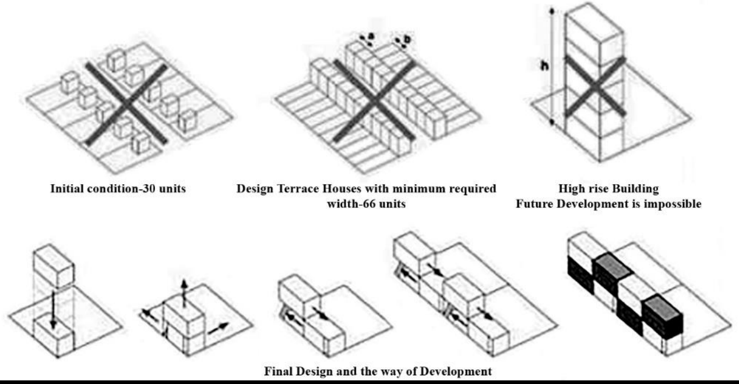
EWS- (5 MX4.2 M)
Figure 12-1: STACKING OF VOLUMES TO CREATE FLEXIBLE SPACES
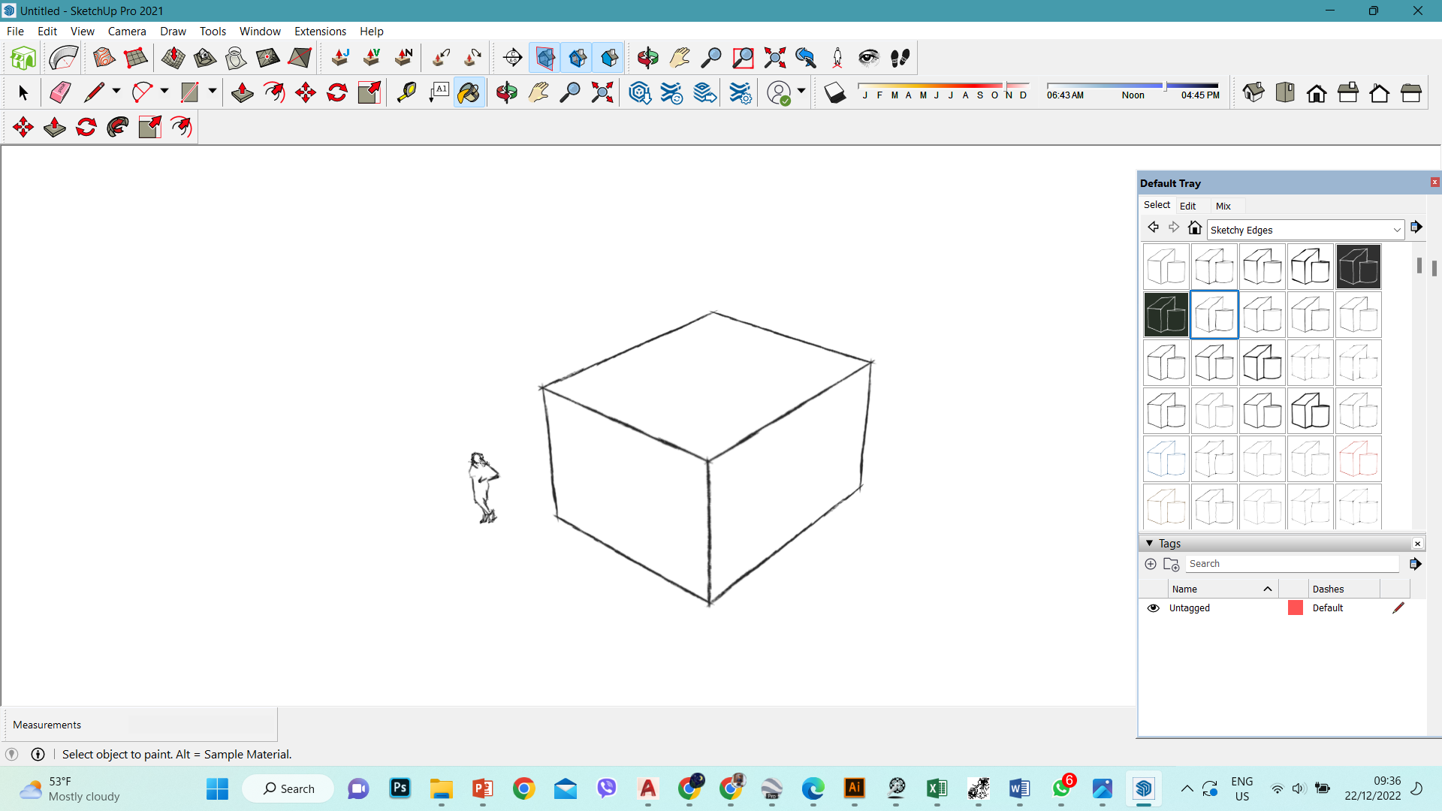
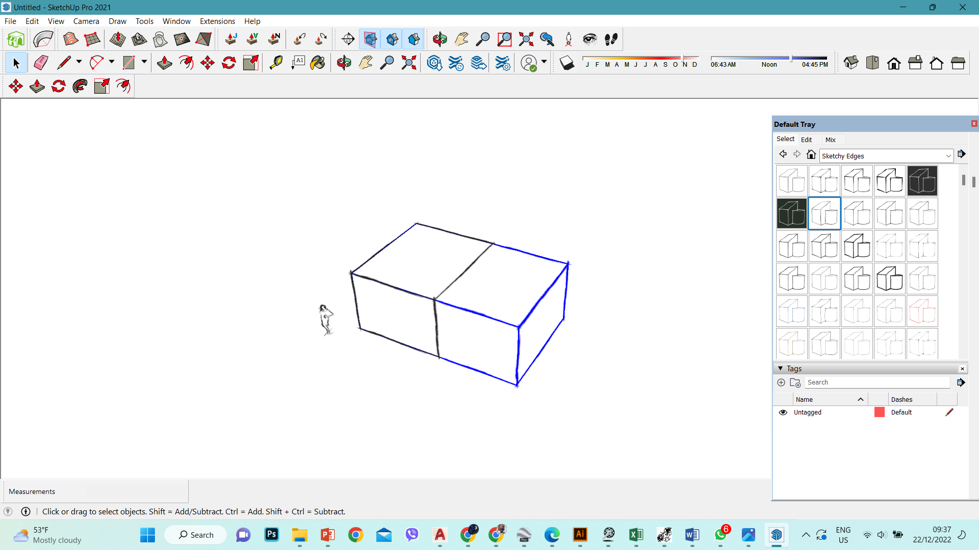
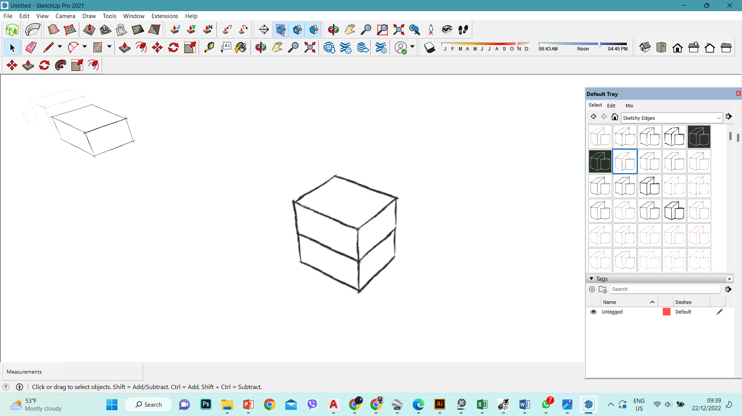
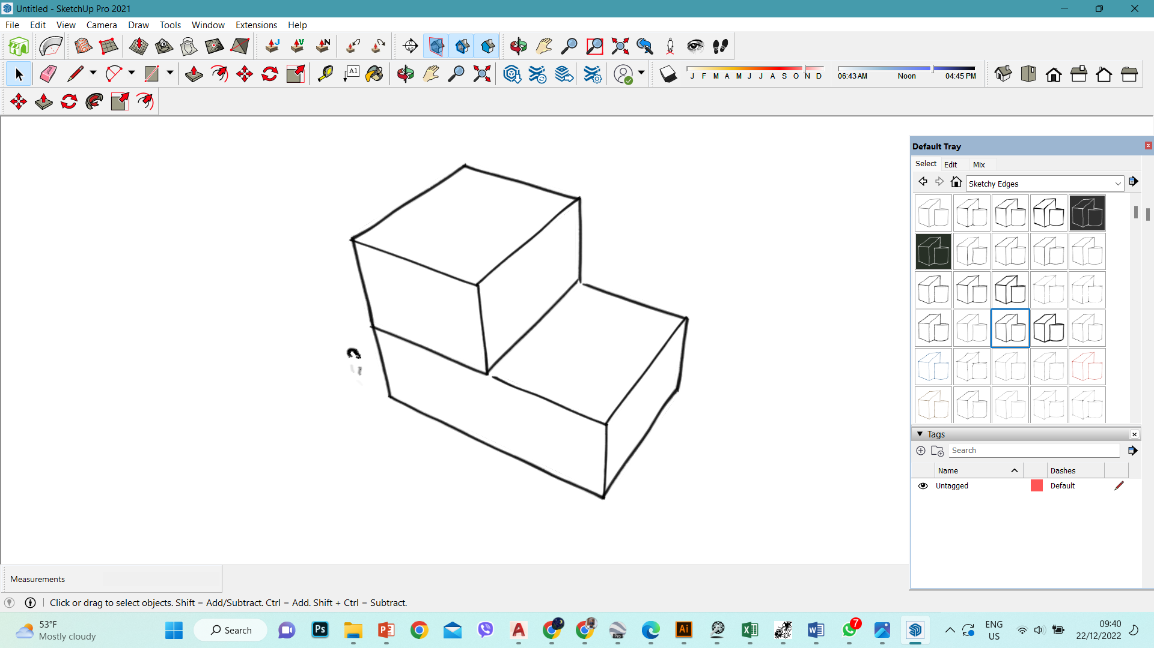
Module 2
Module 4
Module 3
Module 1

Figure 12-2: Different modules

The given different volumes are then stacked as such that they create a socializing space in between where various activities can be done. The Point of departure for the design is to look out for a holistic approach for relocating the community. Various observations and interviews with the people who were relocated earlier resulted into the development of various modules where one can expand the space as per his economic and family needs.

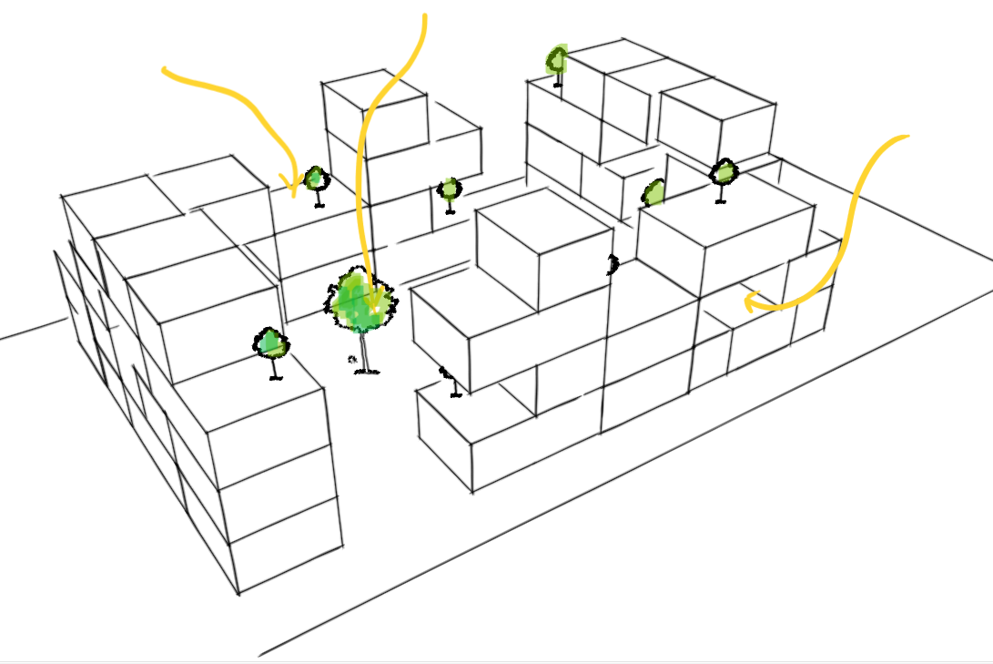
Permanent socializing space
Courtyard space
Temporary socializing space
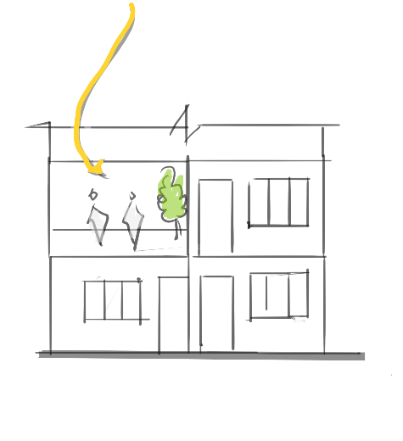
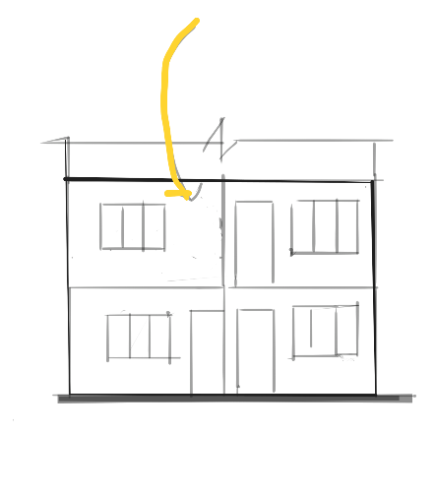
Figure 12-3: Before expansion
Figure 12-4: After expansion
TEMPORARY SOCIALIZING SPACE
INCREMENTED SPACE-MODIFIED BY THE USERS
Figure 12-5: Conceptual design development- residential units
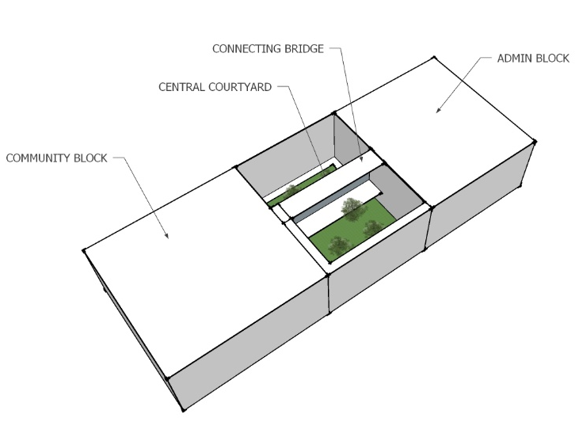
CONNECTING BRIDGES-FOR INTERESTING SPACES AND INTERACTING SPACES
VOLUME DIVIDED INTO CENTRAL COURTYARDS
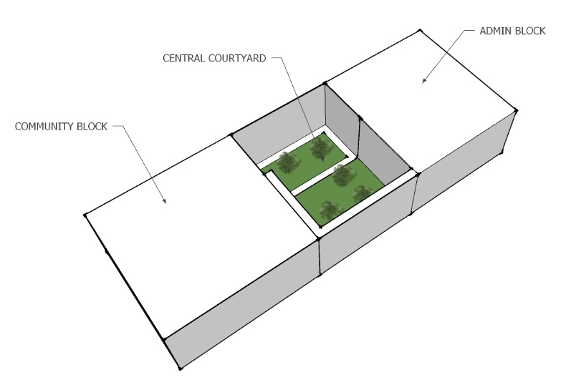


CENTRAL COURTYARD DIVIDES SPACES INTO TO WINGS
CUBOID VOLUME AS PER REQUIREMENTS

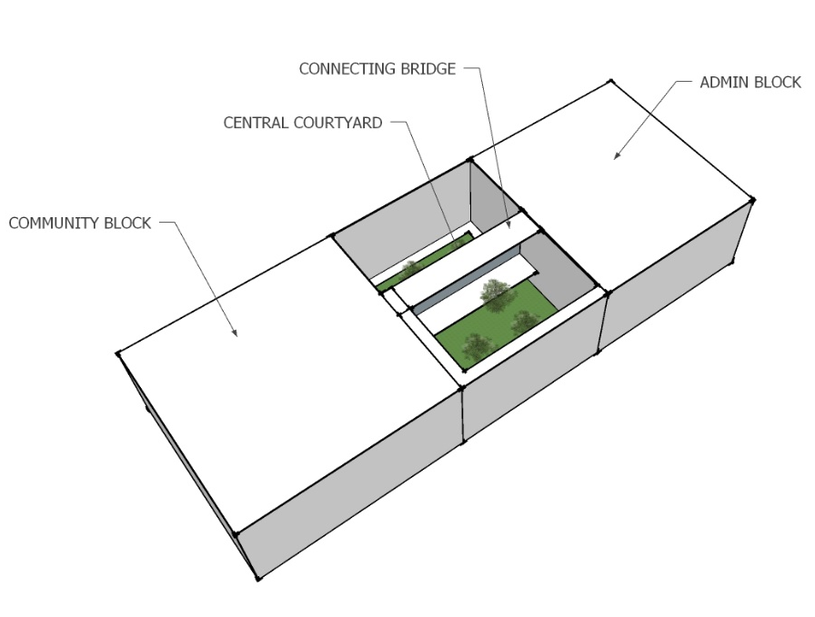

A CONNECTING BRIDGE CONNECTS TWO WINGS.

For the community centre, The volume is divided into two portions where one is community block and another is the admin block and recreation block.The community block includes activities necessary for the community such as classrooms, library, multipurpose hall where as the recreational block includes public space and markets in the ground floor, cafeteria in the first floor and training blocks in the top floor.

SITE ZONING

The site is divided into three zones as per the requirements. The active courtyard space is zoned at the centre where various activities takes place. The community space is placed at the eastern side so that it is close to the residential units and the relocated community. The community space is designed in such a way that both of the communities could use it. The residential units are placed around the southern sides such that it gets enough sunlight and privacy as needed.

CENTRAL ACTIVE COURTYARD
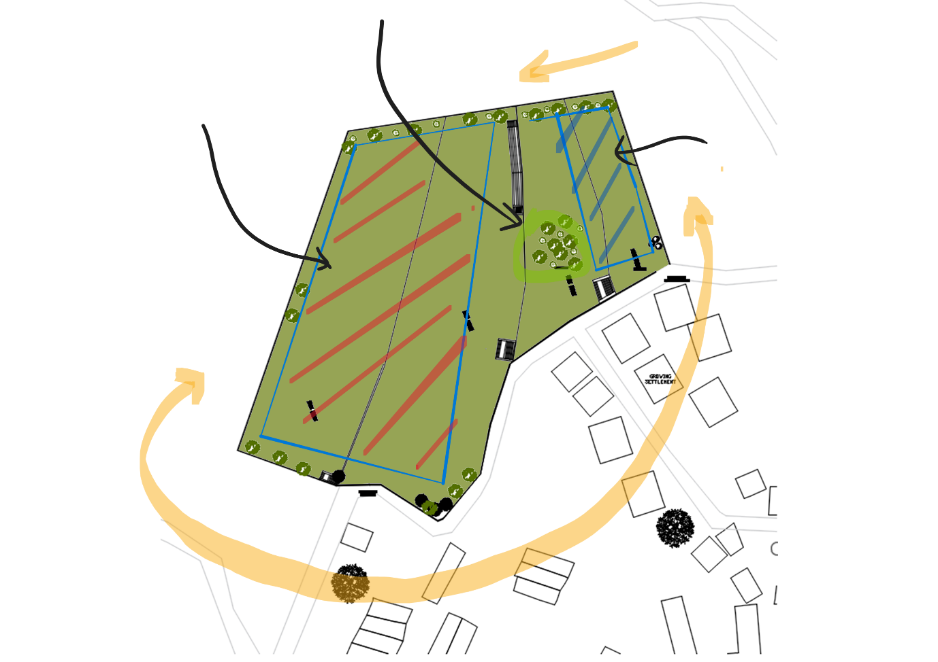
N
PRIVATENESS INCREASES

`RESIDENTIAL PLOCKS-PRIVATE
COMMUNITY BLOCK

Figure 12-6: SITE ZONING
ACTIVE COURTYARD SPACE
COMMUNITY BLOCK
RESIDENTIAL UNITS
EXTRANCE FOR THE COMMUNITY BLOCK

-The building units are rotated at certain angles to allow the natural light and ventilation inside the blocks. Similarly, the pocket spaces are created in between the units for the circulation from each units. The blocks are also connected to each other through a connecting bridge to foster the social interaction between the inhabitants.

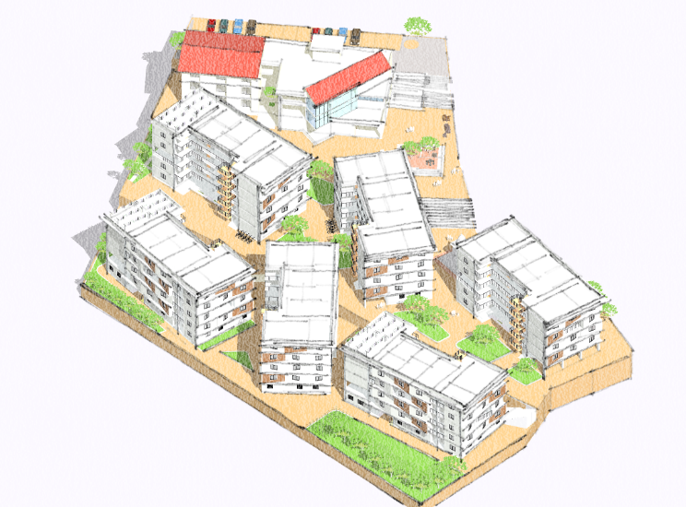
Plots for farming
parking
Figure 12-7- BIRDS EYE VIEW
Plots for farming
Breakout spaces
Residential blocks
Residential blocks
Community centre
Active public courtyard

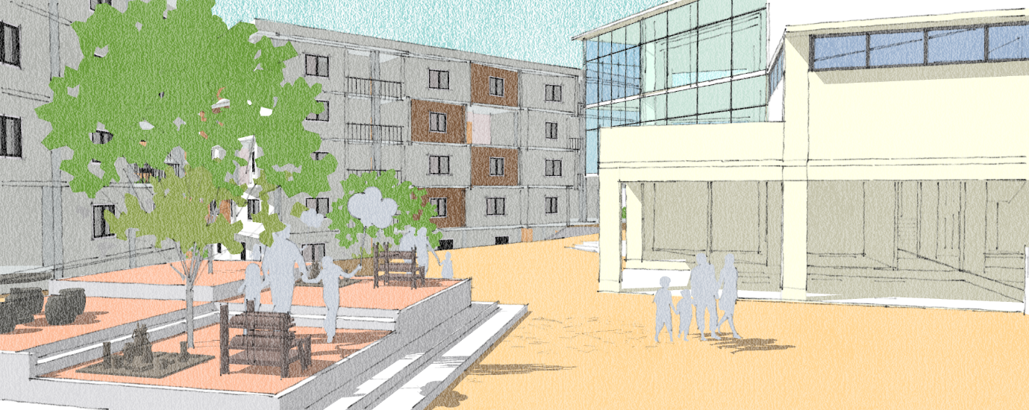
Figure 12-8: Active public courtyard
The active courtyard acts as a space for various activities such as gathering, morning and evening markets, place for social interaction,etc. The space connects to the permanent market shops provided on the community block.

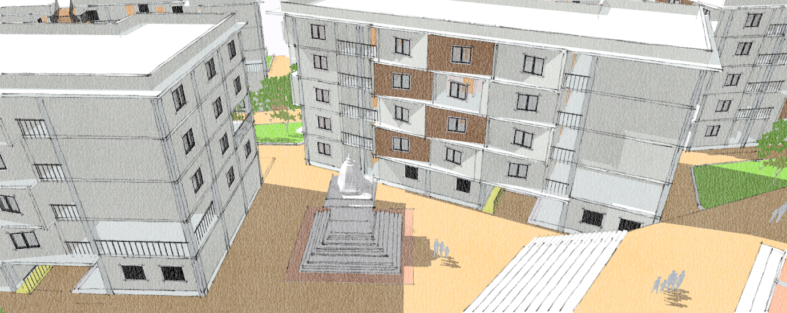
Figure 12-9- Temple complex

The residential blocks are rotated at certain angles for allowing the light to penetrate inside the building and also to create a pocket of spaces for relious purpose as strong sense of religion exists in the community,

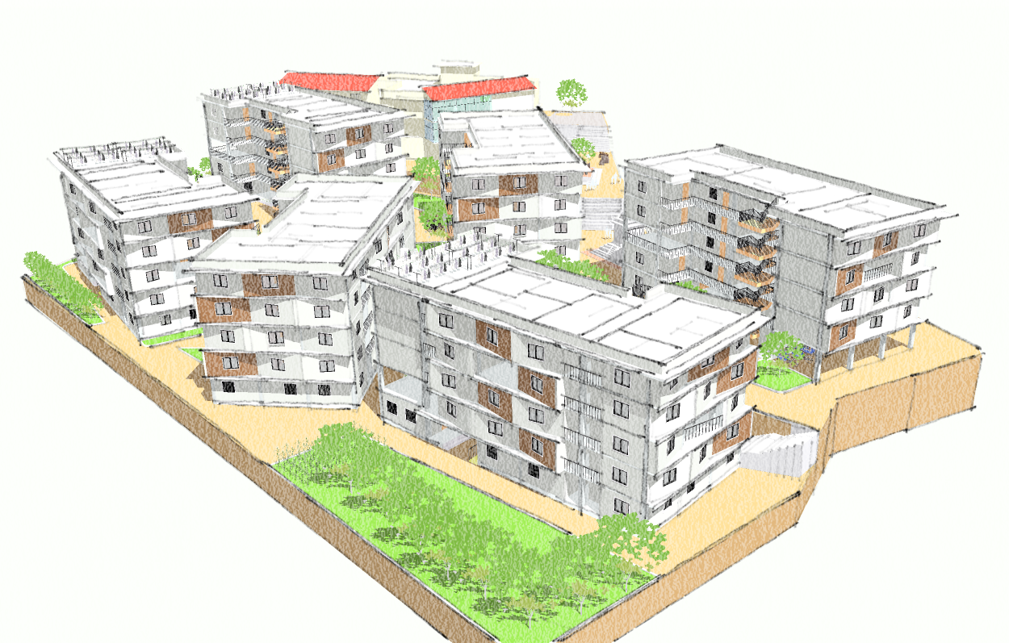
Figure 12-10: View of building from the south east corner
Inclined walls placed alternatively.

RATTRAP BOND
The Use of hollow bricks is used as infill walls and the structure is reinforced cement concrete. The Use of bricks using rat trap bond creates a contrast on the building façade. Als0, The inclined walls has been inccoporated in the eastern and southern facades which creates a intresting play of shadows through out the day in summer while allowing light to penetrate through the walls in the winter.

Project Development and Design Output

2.1. Open Floor Plan
The floor plans of each unit are designed in such a way that the living spaces such as
living room, dining and kitchen exist in a single hall with open plan. This helps in
reducing the cost of building material used for partition walls and doors.

Flexibility
The units in this proposed housing range from 35-45 sqm. However, through case study,
it can be seen that a mid-rise high-density housing provided by Lumanti at Dhobighat
has individual unit of only 16 sqm. The possibility of the families to use that amount of
area allows for the families the flexibility to split up the units in half in this proposed
housing.

Shared infrastructures
The units share infrastructures like service and circulation. In the design of individual
units, two of the units at same level share a single duct.

Privacy
Since there can be concern of privacy in ground floor, low cost privacy screens are
designed on the façade with perforated walls of concrete blocks.

Design of roof
The roof is often an asset for any building, especially a high-density housing. The roof
can be used as a multi-purpose space. Firstly, it can be used for farming of vegetables
that need full day solar exposure. Secondly, solar panels can be installed in the roof for
energy efficiency.

Material and construction technology
Structure
Since the design is a mid-rise apartment, the structure system of the building is RCC
frame structure. The columns, beams and slabs of the buildings are RCC. To reduce the
cost of slabs, they can be designed as filler slabs because they have no effect on the
strength of the slabs whilst considerably reduce the cost of the material used.
Infill
Hollow Concrete Blocks:
A concrete block is a mixture of powdered Portland cement, water, sand and gravel. It
is known that hollow concrete blocks as building material improve sustainable
performance and save energy. They are fire resistant. There is design flexibility with
the use of concrete blocks. The reduced volume of concrete saves cost in material. The
blocks are larger in size than bricks so there is reduced use of mortar. These blocks are
light weight and provide better insulation. Water pipes and electrical conduits can run
through the gaps decreasing cost of external ducts and also providing aesthetic looks
within each unit. Since the need to plaster the walls is eliminated by the use of the
concrete blocks, it can be economically more efficient.
Doors and Windows
Although uPVC doors and windows cost less in international market, in Nepali market,
uPVC tend to cost higher than wood or aluminum. Since wood costs more than
aluminum in Nepal, the doors and windows are designed of aluminum.
For this, considering every unit has approx. four rooms, 8 doors and windows are
required altogether. This might be very expensive to the people of the community.
To reduce cost on doors and windows, the doors are designed in such a way that they
have enough glazing on the shutters to allow natural light to enter the rooms. Moreover,
since the halls are narrow and long in each unit, a vertical opening allows the natural
light to enter further into the rooms. On the other hand, the upper part of the door is
designed to have an operable window shutter within the door shutter to allow for natural
ventilation

Structure and materials
The structural system used is RCC with infill hollow blocks of size (400x200x200) for the outer face and (400x100x200) for the partition. The use of hollow brick reduces the need to plaster the walls and also uses less mortar and carries less weight.The development is composed of lowrise incremental housing units having column sizes (450x350)mm with (300x400)mm beam size. Similarly, The community block consists of column size (450x600)mm and beam of (300x350)mm.

Utilities and services
The sources of water supply for the site are municipal line and water tanks . The water collected from the roof of the buildings are stored in a underground harvest tank and supplied whenever required for uses in kitchen, toilet and Farmlands.
Water demand calculation
S.N | Building | Min. requirement(LPCD) | No. of people | Total Demand
1 | Incremental block –T1 | 100 | 784 | 78400
2 | Incremental block-T2 | 100 | 670 | 67000
3 | Community development centre
 | Preschool | 45 | 50
 | Library | 15 | 20
 | Market | 15 | 20 | 6480
 | Multi purpose hall | 15 | 100
 | Training hall | 45 | 30
4 | Admin | 45 | 20
 | Total |  |  | 151880

Total water demand=151 cu.m/day
Size of water tank=151*3= 453 cu.m
Height of tank= 3 m
Considering 2 tanks in different locations
Size of tank= 453/2= 226.5
Area= volume/height
226.5/3=75.5 sq.m

Conclusion and recommendation
The resettlement of squatters into low-rise urban neighborhoods offers a solution to improve the quality of life for both squatters and the larger community by providing safer and more livable living quarters with infrastructure. Additionally, the move process offers a chance for social empowerment and integration. Squatters frequently experience marginalization and lack access to social services including job, education, and housing. They can be incorporated into existing communities and increase their chances of getting access to healthcare, employment prospects, and educational opportunities by moving to cities with low-rise apartment buildings. They may be able to break the cycle of poverty and improve their general quality of life as a result of increased social mobility.

The opportunity for urban renewal is a significant advantage of squatter transfer to low-rise apartments. Squatter communities frequently occupy prime real estate in urban areas, resulting in traffic jams, environmental damage, and obstructions to deliberate urban progress. It is important to note, too, that squatter relocation is not without its difficulties. Planning is essential for the process, which must take into account the socioeconomic demands of the relocating people as well as issues like the availability of suitable land and infrastructural development. To guarantee that their opinions are heard and their concerns are addressed, it is also crucial that the affected squatters have enough consultation and participation throughout the process.

In conclusion, moving squatters to low-rise dwellings in metropolitan locations offers a thorough solution to the issues brought on by squatter settlements. This strategy can support inclusive and sustainable urban development by enhancing living circumstances, fostering social integration, and assisting in urban rejuvenation. Although it is a complicated process that necessitates carefully taking into account numerous elements, with appropriate planning and community involvement.

REFERENCES
ADB, 2010. Safer and affordable housing for urban poor: A case for Kathmandu Valley. Asian Development Bank.
Affordable Housing Sustainable Communities. (2019). Affordable Housing Terms & Strategies. Retrieved from NC STATE Design: https://design.ncsu.edu/ah+sc/?page_id=341
Bajracharya, A., Pradhan, P., Amatya, P., Khokhali, B. B., Shrestha, S., & Hasan, A. (June, 2015). Planning of affordable housing during densification in Kathmandu. Nepal: International Institute for Environment and Development (IIED).
Baker, D., & Patel, A. P. (2015, February 13). 11 Strategies for Building Community with Affordable Housing . Retrieved from Urban Land: https://urbanland.uli.org/planning-design/11-strategies-building-communityaffordable-housing/
Brooks, R. (2016). Relocation, Resistance and Resilience: Squatter Community Responses to Government Intervention for Urban Development in Kathmandu. Independent Study Project (ISP) Collection.
CBS, 2011. Nepal Living Standards Survey (2010/11). Government of Nepal, Central Bureau of Statistics, Kathmandu, Nepal.
CBS, 2012. National population and housing census (Village development committee/ Municipality). Government of Nepal, Central Bureau of Statistics, Kathmandu, Nepal.
Davey, P. (2015, June 14). Belapur Housing in Navi Mumbai, India by Charles Correa. Retrieved from The Architectural Review: https://www.architecturalreview.com/essays/belapur-housing-in-navi-mumbai-india-by-charlescorrea/8684855.article
Energy efficiency in architecture: An overview of design concepts and architectural interventions. (n.d.).
Hamidi, G. M., & Elhassanii, A. A. (October 26 – 29, 2010). Incremental Housing: Its Potentials and Limitations Evidence from Khartoum State. XXXVII IAHS World Congress on Housing, (pp. 1-7). Santander, Spain
Khan, H.-U. (1987). "Belapur Housing". Retrieved from Archnet: https://archnet.org/publications/7087
Kwon, H. (2012). Designing Affordability: Innovative Affordable Housing Design Strategies for Post-Industrialized Seoul. Seoul.
Kirtipur Housing. Retrived from: http://lumanti.org.np/program/details/kirtipur-housing.html
Local Government Operation Act 2017
Lumanti, 2005. New beginnings: housing the urban poor. A case study of Kirtipur Housing Project. Lumanti Support Group for Shelter.
Lumanti, 2008. Status of squatter communities along Bagmati River and its tributaries in Kathmandu Valley. GTZ, GoN, Lumanti Support Group for Shelter.
Ragheba, G., El-Shimya, H., & Raghebb, A. (2016). Improving Sustainability Concept in Developing Countries. Land for Poor: Towards Sustainable Master Plan for Sensitive Redevelopment of Slums, 414-427
The World Bank Group. (1999-2001). What is Urban Upgrading? Retrieved from Upgrading Urban Communities - A Resource Framework: http://web.mit.edu/urbanupgrading/upgrading/whatis/what-is.html
Toffin, G. (July 2010). URBAN FRINGES: SQUATTER AND SLUM SETTLEMENTS IN THE KATHMANDU VALLEY (NEPAL). CNAS Journal, Vol. 37, No.2, 151-168.
UN-Habitat. 2003. The challenge of slums global report on human settlements 2003. United Nations Human Settlements Programme. Earthscan Publications Ltd, UK and USA.
UN-Habitat, 2010. Nepal urban housing sector profile. United Nations Human Settlements Programme.

UN-HABITAT. (2005). State of the world's cities 2006/7. Retrieved from UN-HABITAT: http://mirror.unhabitat.org/documents/media_centre/sowcr2006/SOWCR%205.pdf

Bibliography

https://www.raonline.ch/pages/np/soc/npsoc10a.html
https://link.springer.com/referenceworkentry/10.1007/978-3-319-71061-7_49-1
Himalayan News Service. (2016, November 27). Relocation of squatters in Valley in limbo. Retrieved from The hImalayan Times: https://thehimalayantimes.com/kathmandu/relocation-squatters-valley-limbo/
Himalayan News Service. (2017, April 13). ‘Slums continue to grow in urban areas’. Retrieved from The Himlayan Times: https://thehimalayantimes.com/kathmandu/slums-continue-grow-urban-areas/
https://kathmandupost.com/national/2022/02/03/not-all-66-percent-urban-residents-have-access-to-even-minimum-urban-amenities
Rastriya Samachar Samiti. (2017, October 01). 40 houses destroyed in Balkhu blaze. Retrieved from The Himalayan Times: https://thehimalayantimes.com/kathmandu/40-houses-destroyed-in-balkhu-blaze/
THT Online. (2016, July 26). Hundreds affected as swollen Bagmati gushes into slums. Retrieved from The Himalayan Times: https://thehimalayantimes.com/kathmandu/hundreds-affected-as-swollen-bagmati-river-gushes-into-kathmandu-valley-slums/
THT ONLINE/RSS. (2018, January 13). Bagmati River gets polluted yet again; fish start dying. Retrieved from The Himalayan Times: https://thehimalayantimes.com/kathmandu/bagmati-clean-up-campaign-river-gets-polluted-yet-again/

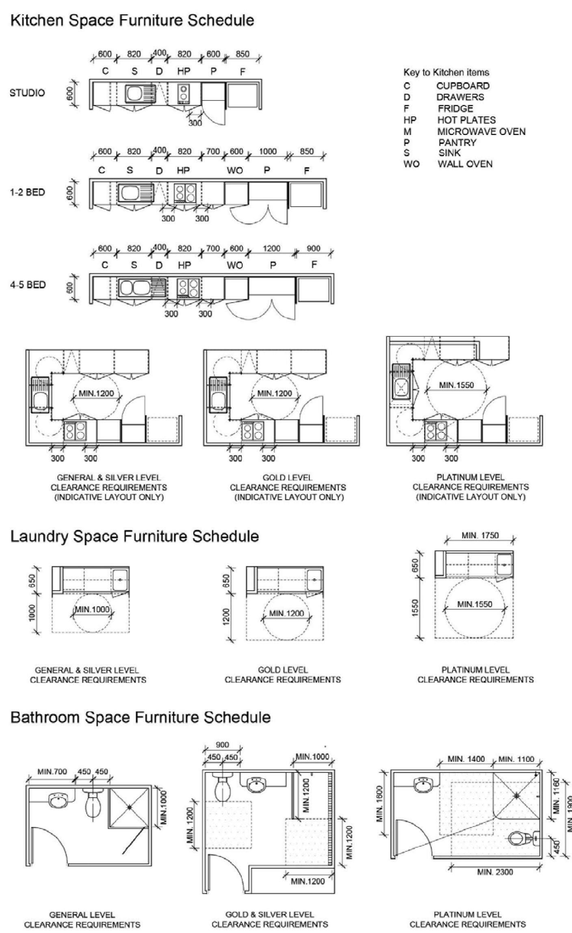
Figure 15-1Figure: Social housing design guide: Minimum standards and requirements
Source:https://www.chde.qld.gov.au/__data/assets/pdf_file/0035/18998/social-housingdesign-guideline.pdf

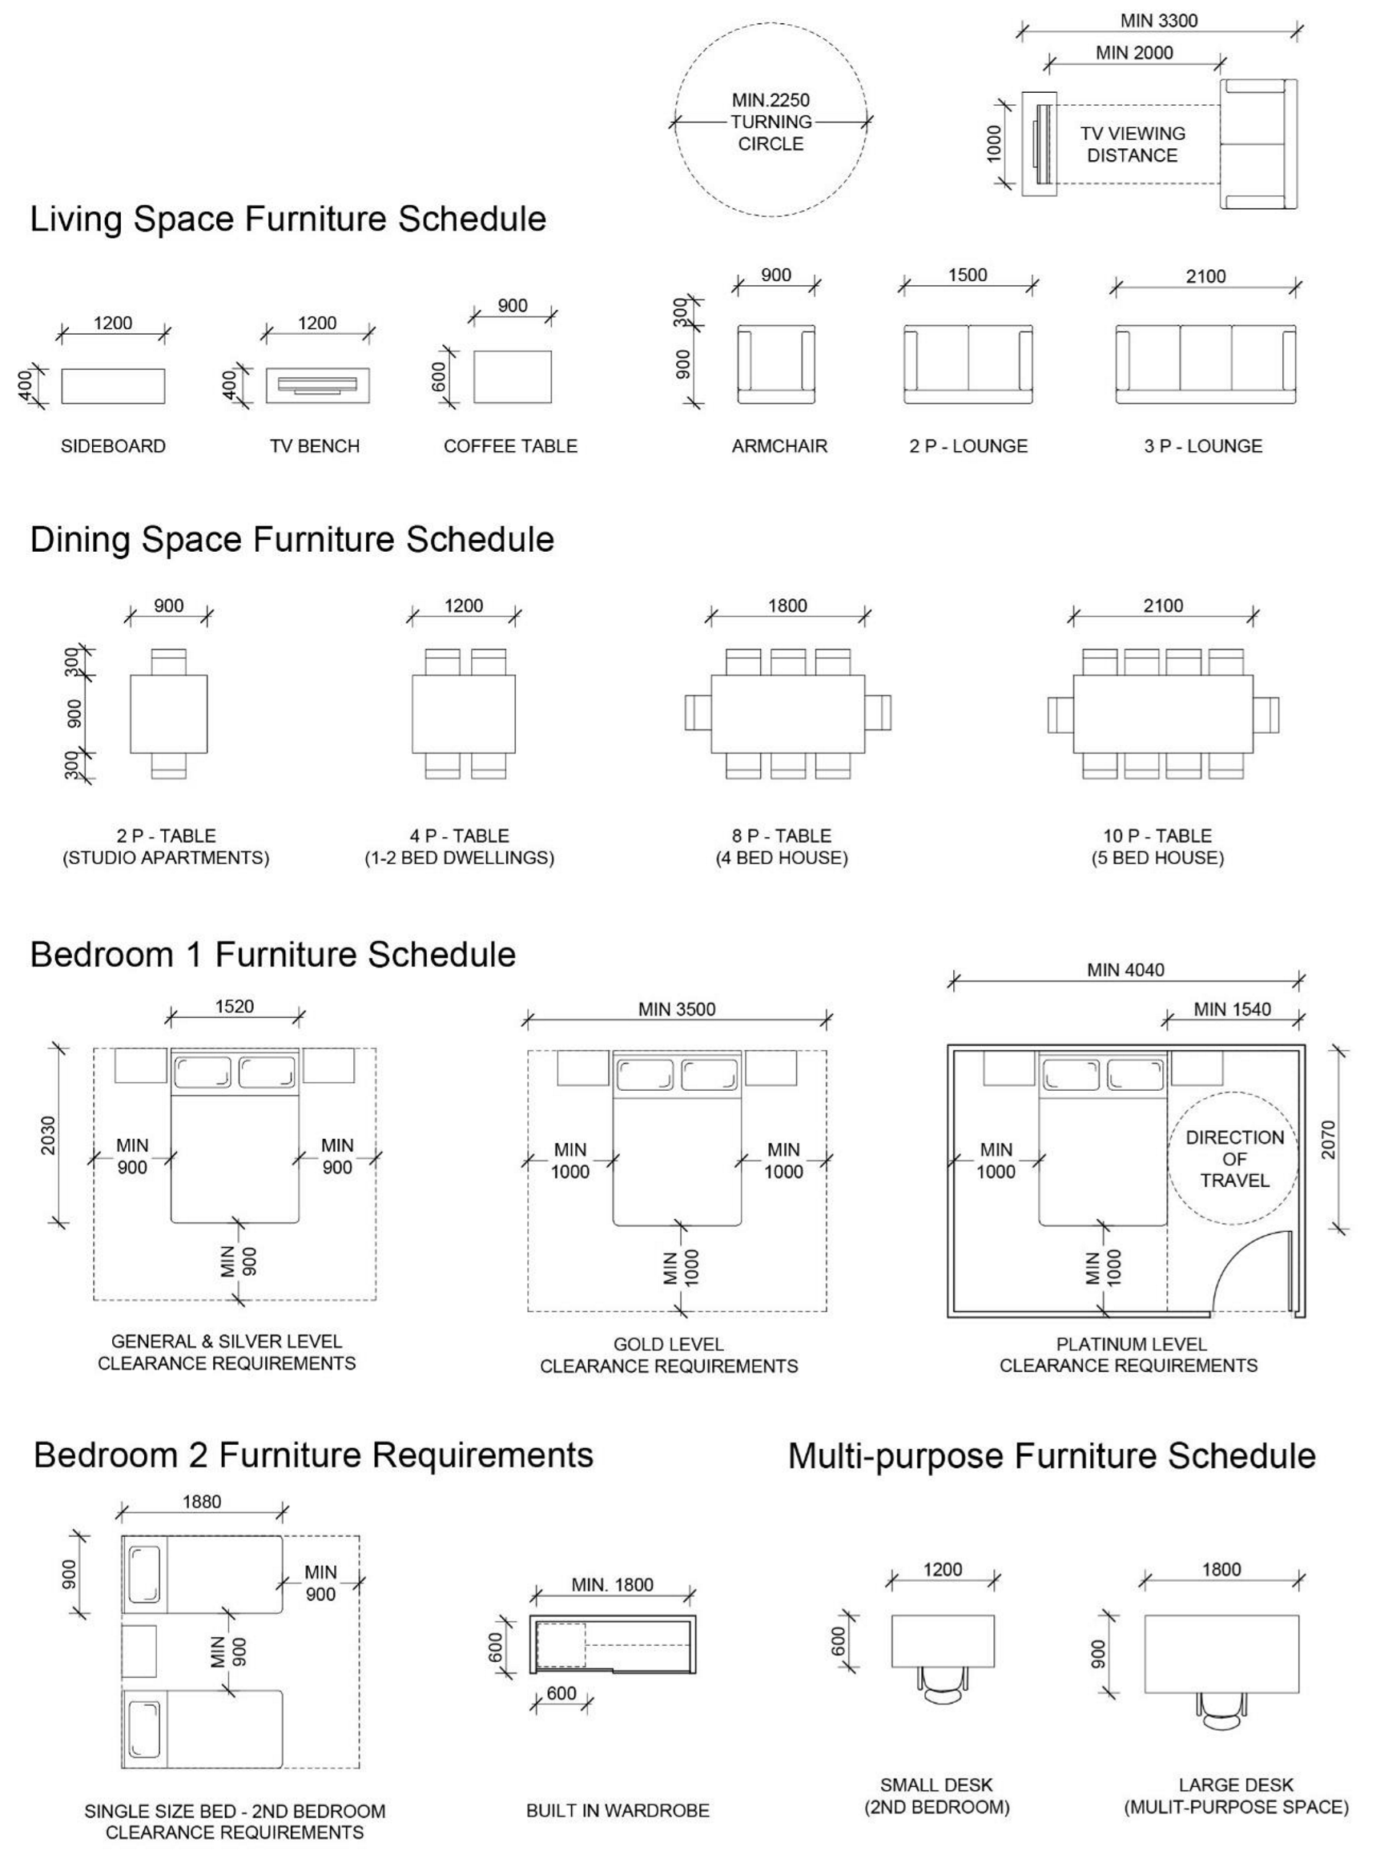
Figure 15-2Figure: Social housing design guide: Minimum standards and requirements
Source:https://www.chde.qld.gov.au/__data/assets/pdf_file/0035/18998/social-housingdesign-guideline.pdf

