COPYRIGHT
The author has agreed that the library, Department of Civil Engineering, Pulchowk Campus, Institute of Engineering may make this thesis freely available for inspection. Moreover, the author has agreed that permission for extensive copying of this thesis for scholarly purpose may be granted by the professor(s) who supervised the work recorded herein or, in their absence, by the Head of the Department wherein the thesis was done. It is understood that the recognition will be given to the author of this thesis and to the Department of Civil Engineering, Pulchowk Campus, Institute of Engineering in any use of the material of this thesis. Copying or publication or the other use of this thesis for financial gain without approval of the Department of Civil Engineering, Pulchowk Campus, Institute of Engineering and author’s written permission is prohibited. Request for permission to copy or to make any other use of the material in this thesis in whole or in part should be addressed to:

________________________
Head of Department
Department of Civil Engineering
Institute of Engineering, Pulchowk Campus
Lalitpur, Nepal

APPROVAL PAGE
TRIBHUVAN UNIVERSITY
INSTITUTE OF ENGINEERING
PULCHOWK CAMPUS
DEPARTMENT OF CIVIL ENGINEERING

The undersigned certify that they have read and recommended to the Institute of Engineering for acceptance, a final thesis entitled “Effect of Adding Waste Crushed Glass to Asphalt Mix” submitted by Abiral Aashish in partial fulfillment of the requirements for the degree of Master of Science in Transportation Engineering, Nepal is a record of works carried out by him under my supervision and guidance.

_______________________________________
Supervisor: Gautam Bir Singh Tamrakar
Professor
Pulchowk Campus, Nepal

_______________________________________
External Examiner: Dr. Biswa Ranjan Singh Shahi
Consultant

_______________________________________
Committee Chairperson: Anil Marsani
Programme Coordinator:
M.Sc. in Transportation Engineering
Department of Civil Engineering

_______________________________________
Date

ACKNOWLEDGEMENT
Different people were responsible for the completion of the thesis work. Their contribution was extremely valuable for this successful endeavor. I would to like to thank Department of Civil Engineering, Institute of Engineering, Pulchowk Campus for giving me this opportunity to carry out this thesis work.
I would like to thank my supervisor Professor Gautam Bir Singh Tamrakar for all his support and guidance throughout the period of my work. Likewise, I would like to express my deepest gratitude to Program Coordinator of Transportation Engineering Er. Anil Marsani for believing in me and giving me the opportunity to carry out with this thesis work.
I would like to acknowledge all the staff of Quality Research and Development Center, Department of Roads (DoR), Pulchowk for the support in conducting my laboratory tests. Specially, I would like to acknowledge Mr. Jay Syangtan of Central Lab, DoR for helping me conduct the tests.
I would also like to express my gratitude to Mr. Samir Baidya for his valuable inputs and efforts during the course of my research. Finally, I would also like to thank all my colleagues and friends for their valuable support and motivation to perform such type of works and expect the same level of support and motivation from them in my future endeavours.

Abiral Aashish
2073/MSTR/251
December, 2019

ABSTRACT
Glass is widely used in our daily life, and with the continuously increased consumption, a large amount of waste glass is generated annually. The best way to deal with these wastes is to recycle and reuse them as raw materials or modifiers. This thesis aims to study the performance of asphalt concrete pavement in which a fraction of aggregate is replaced with waste crushed glass.
In order to meet the objectives a total of 60 samples were prepared by adding crushed glass to the mix with 5%, 10%, and 14% by aggregate weight meeting the standard DoR gradation specifications. The fine aggregates have been replaced as per proportion of the glass particles added. With the increase in glass content the optimum binder content of the mix decreased.
The stability values increased upto 10% glass content and decreased when the glass content was further increased to 14%. The maximum increase in stability value was found to be 12.9% at 10% glass content. Flow values decreased at higher glass contents. Slight decrease in bulk density of the mix was noted. Air voids increased and voids filled with bitumen decreased at higher glass content due to decrease in binder content and flow values but the values were found to be within range.
As per the cost estimate maximum cost saving was possible at 14% glass content. Despite decrease in Marshall stability value, the decreased value was within the specifications and hence the use of this glass content was found economically viable. A maximum cost saving of NRs. 1020.45 per cu m was estimated at 14% glass content.
Key words: Waste Glass, Asphalt Concrete, Stone Dust, Marshall Stability, Flow

.

TABLE OF CONTENTS

COPYRIGHT i
APPROVAL PAGE ii
ACKNOWLEDGEMENT iii
ABSTRACT iv
LIST OF FIGURES vii
LIST OF TABLES ix
LIST OF ABBREVIATIONS x

CHAPTER 1: INTRODUCTION 1
1.1 Background 1
1.2 Problem Statement 2
1.3 Objectives 2
1.4 Significance of the Study 3

CHAPTER 2: LITERATURE REVIEW 4
2.1 Introduction 4
2.2 Aggregates 4
2.3 Bitumen 9
2.3 Glass 12
2.4 Past Researches 13

CHAPTER 3: METHODOLOGY 15
3.1 Introduction 15
3.2 Materials 17
3.2.1 Bitumen 17
3.2.2 Aggregates 17
3.2.3 Glass 18
3.3 Mix Design 23
3.3.1 Laboratory Apparatus 23
3.3.2 Preparation of Asphalt Concrete Mix Specimen 23
3.3.3 Test Procedure 25

CHAPTER 4: RESULTS AND ANALYSIS 26
4.1 Mix Design Results of Normal AC Mix 26
4.2 Mix Design Results of AC Mix with 5% Glass 29
4.3 Mix Design Results of AC Mix with 10% Glass 33
4.4 Mix Design Results of AC Mix with 14% Glass 36
4.5 Cost Estimate 40
4.6 Summary and Analysis of Results 42
4.6.1 Glass Percentage vs Stability 42
4.6.2 Glass Percentage vs OBC 42
4.6.3 Glass Percentage vs Flow and Voids 42
4.6.4 Glass Percentage vs Bulk density 43
4.6.5 Glass Percentage vs Cost per cu m 43
4.7 Limitations of Study 45

CHAPTER 5: FINDINGS AND CONCLUSIONS 46
CHAPTER 6: REFERENCES 47
APPENDIX-I: SIEVE ANALYSIS 49
APPENDIX-II: AGGREGATE TESTS 52
APPENDIX-III: BITUMEN TESTS 55
APPENDIX-IV: MIX DESIGN CALCULATIONS 56
APPENDIX-V: CERTIFICATION 68

LIST OF FIGURES
Figure 2.1: Gradation Analysis During the Study 6
Figure 2.2: Shape Tests Conducted During the Study 7
Figure 2.3: LAA Apparatus Used During the Study 8
Figure 2.4: AIV Conducted During the Study 9
Figure 2.5: Penetration Test Conducted During the Study 10
Figure 2.6: Viscosity Test Conducted During the Study 10
Figure 2.7: Softening Point Test Conducted During the Study 11
Figure 2.8: Safety Tests Conducted During the Study 12
Figure 3.1: Flowchart of Methodology 16
Figure 3.2: Glass Samples Used for Study 18
Figure 3.3: Gradation Envelope of Normal AC Mix 20
Figure 3.4: Gradation Envelope of AC Mix with 5% Glass 21
Figure 3.5: Gradation Envelope of AC Mix with 10% Glass 22
Figure 3.6: Gradation Envelope of AC Mix with 14% Glass 23
Figure 3.7: Sample Preparation 24
Figure 3.8: Automatic Compactor Used for Compaction of Sample 24
Figure 3.9: Thickness and Weight Observations 25
Figure 4.1: Bitumen Content vs Stability for Normal AC Mix 26
Figure 4.2: Bitumen Content vs Flow for Normal AC Mix 27
Figure 4.3: Bitumen Content vs Bulk Density for Normal AC Mix 27
Figure 4.4: Bitumen Content vs VTM for Normal AC Mix 28
Figure 4.5: Bitumen Content vs VFB for Normal AC Mix 28
Figure 4.6: Bitumen Content vs Stability for Mix with 5% Glass 30
Figure 4.7: Bitumen Content vs Flow for Mix with 5% Glass 30
Figure 4.8: Bitumen Content vs Bulk Density for Mix with 5% Glass 31
Figure 4.9: Bitumen Content vs VTM for Mix with 5% Glass 31
Figure 4.10: Bitumen Content vs VFB for Mix with 5% Glass 32
Figure 4.11: Bitumen Content vs Marshall Stability for Mix with 10% Glass 33
Figure 4.12: Bitumen Content vs Flow for Mix with 10% Glass 34
Figure 4.13: Bitumen Content vs Bulk Density for Mix with 10% Glass 34
Figure 4.14: Bitumen Content vs VTM for Mix with 10% Glass 35
Figure 4.15: Bitumen Content vs VFB for Mix with 10% Glass 35
Figure 4.16: Bitumen Content vs Marshall Stability for Mix with 14% Glass 37
Figure 4.17: Bitumen Content vs Flow for Mix with 14% Glass 37
Figure 4.18: Bitumen Content vs Bulk Density for Mix with 14% Glass 38
Figure 4.19: Bitumen Content vs VTM for Mix with 14% Glass 38
Figure 4.20: Bitumen Content vs VFB for Mix with 14% Glass 39

LIST OF TABLES
Table 2.1: Typical Chemical Composition of Glass 13
Table 3.1: Details of Bitumen Used in the Test 17
Table 3.2: Details of Aggregates Used in the Test 18
Table 3.3: Details of Glass Used in the Mix 18
Table 3.4: Sieve Analysis Results of Glass Used in the Mix 19
Table 3.5: Gradation of Coarse and Fine Aggregates of Normal AC Mix 19
Table 3.6: Combined Gradation of AC Mix with 5% Glass 20
Table 3.7: Combined Gradation of AC Mix with 10% Glass 21
Table 3.8: Combined Gradation of AC Mix with 14% Glass 22
Table 4.1: Marshall Parameters for Normal AC Mix 26
Table 4.2: Calculation of OBC of Normal Mix 29
Table 4.3 Marshall Parameters at OBC for Normal Mix 29
Table 4.4: Marshall Parameters for AC Mix with 5% Glass 29
Table 4.5: Marshall Parameters for AC Mix with 5% Glass 32
Table 4.6: Marshall Parameters at OBC for 5% Glass 32
Table 4.7: Marshall Parameters for AC Mix with 10% Glass 33
Table 4.8: Marshall Parameters for AC mix with 10% Glass 36
Table 4.9: Marshall Parameters at OBC for 10% Glass 36
Table 4.10: Marshall parameters for AC Mix with 14% Glass 36
Table 4.11: Marshall Parameters for AC Mix with 14% Glass 39
Table 4.12: Marshall Parameters at OBC for 14% Glass 39
Table 4.13: Cost Estimate of AC Mix without Glass 40
Table 4.14: Cost Estimate of AC Mix with 5% Glass 40
Table 4.15: Cost Estimate of AC Mix with 10% Glass 41
Table 4.16: Cost Estimate of AC Mix with 14% Glass 41
Table 4.17: Summary of Results 42
Table 4.18: Financial Evaluation of Glass Crushing and Sorting Plant 44

LIST OF ABBREVIATIONS
AC Asphalt Concrete
DOR Department of Roads
OBC Optimum Binder Content
VFB Voids Filled with Bitumen
VMA Voids in Mineral Aggregate
OBC Optimum Binder Content
VTM Voids in Total Mix
G Specific gravity/Unit weight
VG Viscosity Grade

CHAPTER 1: INTRODUCTION

Background
Topography, hydrography and climate are the primary constraints to the transportation system in Nepal. Due to challenging topography, geological terrain and massive cost involved in construction of other modes of transportation system, road transport remains the most popular mode of transportation in our country. Road networks cover wide geographical area, provide door-to-door service and can be developed with comparatively low capital investment. They have high utility value in hauling commodities and passengers over short and long distances. In the context of Nepal, many construction projects are being undertaken in order to address the transportation demand of people. There are various types of flexible pavement constructed over the country depending upon the traffic volume, durability, design life, maintenance, cost of construction etc. Recently the government has been upgrading the major highways and the feeder roads to the asphalt concrete, so the construction of the asphalt concrete has been widely increased throughout the country. Since the asphalt concrete is more costly than other types of flexible pavement, various factors should be taken into the consideration during the construction work.
Asphalt is a composite material composed of an aggregate framework bound together by bituminous binder with the use of filler materials. It is largely used in paving road surfaces, airport runways, taxiways and parking lots. The AC provides a waterproof surface with good resistance against the deformation, rutting and will provide good smooth surface with good skid resistance. A good AC should have sufficient resistance to plastic deformation and cracking when subjected to the expected traffic loading, should have acceptable grading and strength of aggregate with sufficient air voids to avoid bleeding and should be workable for efficient laying and compaction. The mineral aggregate comprises the huge bulk of the composite mixture and hence play a significant role in the engineering properties of the mixture.
Asphalt modification can be made at different stages of its usage, from binder production to asphalt pavement production, and can be made by using different modifiers. Glass is considered a potentially promising modifier to asphalt. It is a non-metallic and inorganic material. Glass can be recycled without changing its composition and properties. Glass industry has been part of human history for thousands of years. Glass is widely used in our daily life, and with the continuously increased consumption, a large amount of waste glass is generated annually. The best way to deal with these wastes is to recycle and reuse them as raw materials or modifiers. (Issa, 2016)

Problem Statement
The trend of the asphalt concrete pavements is increasing in the context of Nepal. It is relatively expensive than other paved roads. The durability of pavement is affected by several factors such as poor quality of aggregates, inferior binder, poor workmanship seepage, freezing and thawing action and others (Parsaila, 2017). This results in large maintenance costs of highway systems. Likewise, a large amount of glass waste from industry has been an urgent subject at both national and global levels. Glass recycling can save energy and decrease environmental waste. (Salem et al. 2017)
In the context of Nepal, nearly 15.3 tonnes of glass waste is deposited per day in three principle landfill sites of Nepal at Sisdole, Pokhara and Karaute Danda (Thapa et al. 2011). The growing quantities of waste materials, lack of natural resources and shortage of landfill spaces represent the importance of finding innovative ways of reusing and recycling waste materials. (Tahmoorian et al. 2018) One of the innovative way of recycling glass materials is by using it in road construction as a substitute of aggregates. In this study, a fraction of aggregate has been replaced with crushed glass. Some important properties of asphalt mix, including stability, flow, specific gravity and air voids have been investigated. The original sample has been prepared without adding glass for different percentages of bitumen. Other samples have been prepared by adding crushed glass to the mix with 5%, 10%, and 14% by aggregate weight meeting the standard DoR gradation specifications.

1.3 Objectives
This thesis aims to study the performance of asphalt concrete pavement in which a fraction of aggregate is replaced with crushed glass. The main objective of this study is to study the change in asphalt mixture properties after adding crushed glass. The tests were conducted using the standard Marshall Apparatus. Stability, flow, specific gravity and air voids of the prepared samples were recorded.
The specific objectives include:
- To compare the Marshall characteristics of a normal AC mix with the mix where certain portion of fine aggregate is replaced by crushed glass.
- To determine the optimum glass content for the mix.
- To compare the optimum binder content of a normal AC mix with the mix where certain portion of fine aggregate is replaced by crushed glass.

Significance of the Study
The main significance of this study is to study the use of the glass to modify the properties of asphalt concrete. Glass is widely used in our daily life, and with the continuously increased consumption, a large amount of waste glass is generated annually. Solid waste management (SWM) is one of the major environmental issues in cities of many developing countries, including Nepal. Urban population growth and economic development lead to increasing generation of municipal solid waste (MSW) (ADB, 2013). The best way to deal with these wastes is to recycle and reuse them as raw materials or modifiers. Similarly, the demand for bitumen is increasing tremendously and this trend is expected to continue in our country (Humagain, 2016). This study is also helpful to study effect of adding glass particles in the binder content of the mix. So, the study of this topic is extremely significant and relevant to the modern trends.

CHAPTER 2: LITERATURE REVIEW

2.1 Introduction
The major objective of this thesis is to compare the Marshall characteristics of a normal AC mix with the mix where certain portion of fine aggregate is replaced by crushed glass. It is important to understand the properties of aggregates, bitumen and the effect of glass particles in their behavior in the mix.

2.2 Aggregates
Stone aggregates are the principle material that are used in all forms of pavement whether it is flexible pavement, rigid pavement or of any type. It is responsible for bearing stresses occurring on roads and also resisting wear due to abrasive actions of traffic. Some desirable properties of aggregates are as follows:
- Strength:
The aggregates used for the construction of roads must be strong enough to handle the compressive stresses generated by moving traffic. It should have high resistance to crushing.
- Hardness:
Aggregates must be hard enough to withstand the abrasive action due to moving traffic.
- Toughness:
The irregularities of the road surface cause impact action on road surface due to the movement of traffic. The aggregate used in road construction must be tough enough to resist fracture under such impact loads.
- Durability:
Durability refers to the characteristics by which an aggregate resists disintegration due to the action of weather. The adverse action of weather is termed as soundness. Aggregates must be sound enough to withstand the weathering action.

- Shape of Aggregate:
The shape of aggregates may be classified as: rounded, cubical, angular, flaky or elongated. Flaky and elongated are less strong and durable than other aggregates. Rounded aggregates possess good workability but have poor interlocking capability and hence not suitable for WBM and bituminous road construction.
- Adhesion with Bitumen:
Aggregates may be classified as hydrophilic and hydrophobic depending upon the affinity for water as compared to that of bitumen. Hydrophobic aggregates are more suitable for road construction as they resist the stripping off the bitumen in the presence of water.
- Cementation:
Aggregates the powder of which possess the binding property in the presence of moisture are considered suitable for road construction.
Aggregates obtained from different sources possess different properties which may or may not be suitable for road construction. It is imperative to conduct certain tests in order to prevent the use of any undesirable material for pavements and to ensure the use of best available aggregates.
The tests can be divided into four main groups:
- Descriptive tests
- Nondestructive quality tests
- Destructive tests
- Durability tests and specific gravity tests
- Descriptive Tests:
These tests are extremely useful in classifying aggregates. They are usually described in terms of shape and texture of particles. The shape can be defined in terms of rounded, irregular, flaky, angular, elongated and both flaky and elongated. Likewise, surface texture may be defined in terms of glossy, smooth, granular, rough, crystalline, honeycombed and porous.
- Non Destructive Quality Test
The results obtained by these tests are compared to standard specifications to confirm their suitability in pavement construction. The tests include: gradation, water absorption and shape tests.
- Gradation Test: It refers to the quantity expressed in percentages by weight of the various sizes of which a sample of aggregate is composed. They are determined by dividing aggregate into certain portions which are retained in a set of sieves or screens with opening size specified. Eventually, a graph is plotted with total percentage passing and sieve size in a logarithmic scale. The gradation of aggregates is extremely important because it directly influences construction quality and cost of the pavement. The aggregates must confer to the standard specifications which depends upon the type of pavement and use intended.
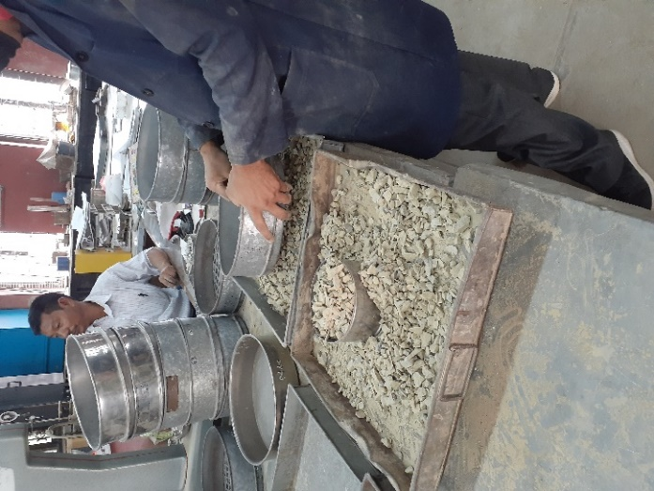
Figure 2.1: Gradation Analysis During the Study

- Shape Test: The shape of an aggregate can be defined in terms of flakiness index, elongation index and angularity number.
Flakiness Index of an aggregate can be defined as percentage by weight of particles whose lease thickness is less than the three fifth of their mean dimension. They are determined after passing at least 200 particles from elongated slots.
Total original weight of the aggregate sample of various fractions = W1+W2+W3+……
Total weight of the aggregate passing the various thickness gauges = w1+w2+w3+…….
Flakiness Index (FI) = $\frac{w1+w2+w3}{W1+W2+W3}$
Elongation Index can be defined as the percentage by weight of particles whose greatest length is greater than 1.8 times their mean dimension. It can be determined by metal length – gauge.
Total original weight of the aggregate sample of various fractions = W1+W2+W3+….
Total weight of the aggregate retained on the various length gauge = x1+x2+x3+……
Elongation Index (EI) = $\frac{x1+x2+x3}{W1+W2+W3}$
Shape tests are important because it helps to determine the interlocking of particles and the surface friction between adjacent surfaces.
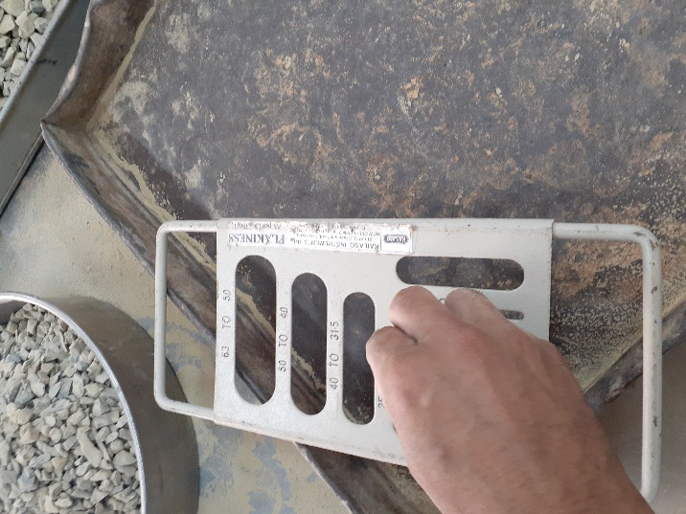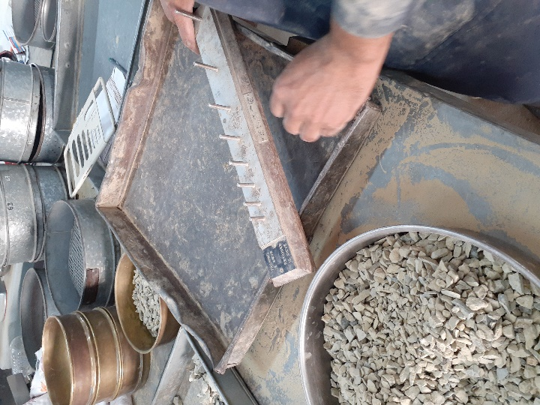
Figure 2.2: Shape Tests Conducted During the Study

- Water Absorption Test: This test can be conducted along with specific gravity test. The entire process consists of soaking the aggregate sample in distilled water for 24 hours, surface drying and weighing in air again. Water absorption can be determined by using:
$$Wa=\frac{w1-w2}{w2} x 100\%$$
Wa = Water absorption
W1 = Weight of surface dried aggregate in air
W2 = Weight of oven dried aggregate in air
- Durability Tests:
Different types of tests are conducted in road construction. Following tests have been conducted in the study:
Abrasion Test: Aggregates are placed in standard Los Angeles abrasion test cylinder (70 cm diameter and 50 cm long and 8.8 cm steel plate projection shelf inside) along with 4.8 cm diameter steel spheres. The number of spheres used depends upon the gradation of aggregates. The cylinder is roated for 500-1000 revolutions depending upon the gradation of group. The test sample is sieved through 1.7 mm sieve and materials passing through the sieve is weighed and percentage loss in weight is calculated.
Original weight of the oven dry aggregate sample = W1
Weight of the aggregate retained on 1.70 mm IS sieve after test = W2
$$Los Angeles Abrasion Value \left(LAA\right)=\frac{W1-W2}{W2}x 100\%$$
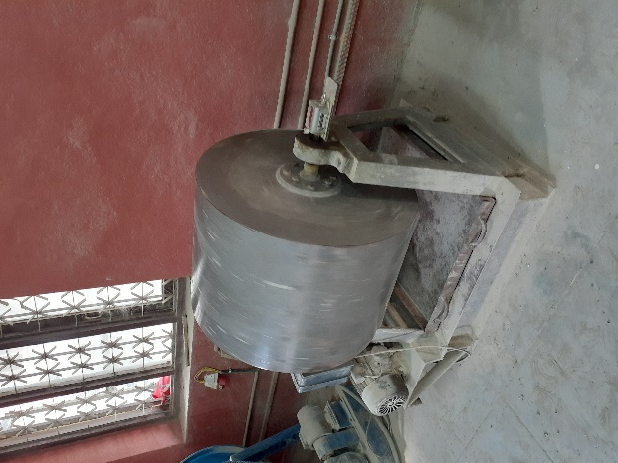
Figure 2.3: LAA Apparatus Used During the Study

Aggregate Impact Value: Aggregate impact value is a measure of resistance to sudden load or impact. A rammer weighing 13.6 kg to 14.1 kg is allowed to fall through a height of 381 mm. After impact the test aggregate is sieved through 2.36 mm sieve and is expressed as a percentage of the total weight of the original sample.
Total weight of the oven dry aggregate sample = W1
Weight of the crushed material passing 2.36 mm IS sieve after test = W2
$$Aggregate Impact Value \left(AIV\right)=\frac{W2}{W1}x 100\%$$

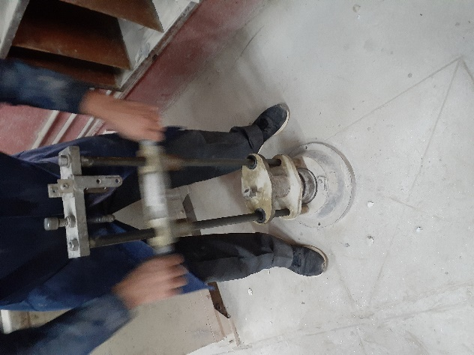
Figure 2.4: AIV Conducted During the Study

Specific Gravity Test: The sample is soaked in distilled water for 24 hrs. The oven dry aggregate sample is weighed in air and water. It is then surface dried and weighed and specific gravity is measured by using formula:
$$Specific gravity=\frac{W}{W2-W1}x 100\%$$
Where,
W = Weight of oven dry sample in air
W2 = Weight of saturated sample in air
W3 = Weight of saturated sample in water
The specific gravity of fine aggregates can be determined by using Pycnometer.

2.3 Bitumen
The selection of binder directly affects the properties of the mix. Bitumen is a viscous liquid which if of solid black or brown in colour. Different tests are done to confirm their quality before use:
Penetration Test: This determines the hardness or softness of bitumen. Bitumen is first poured into a test container at pouring consistency. The depth must be 15 mm more than the expected penetration. The sample is placed in a temperature control bath at 25 degree Celsius for one hour. The dial gauge is set to zero and the needle is released for 5 seconds. The final reading is noted. This test is extremely important for grade classification of bitumen.
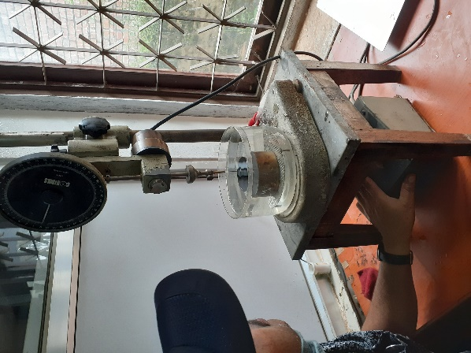
Figure 2.5: Penetration Test Conducted During the Study

Ductility Test: A binder is said to be ductile if it elongates in tension. The ductility value gives the measure of adhesiveness and elasticity of bitumen. Ductility test can be carried out in standard ductility apparatus which has 8 sided mould with standard dimension, a water bath and a pulling device. The bitumen is heated at pouring consistency, stirred and poured in the apparatus. Two clips are then pulled at a certain specified speed. The temperature during the test must be 25°C and the pull rate of the pulling device should be 50 mm/min.
Viscosity Test: Viscosity of the binder affects quality of mixing, lubrication, compaction effort and workability. This test measures the time under which a 50 ml of binder liquid flows from a cup through a standard under the above specified test conditions. Figure 2.6 presents the viscosity test arrangement used in the study.
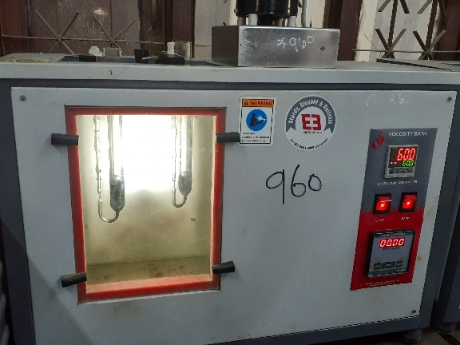
Figure 2.6: Viscosity Test Conducted During the Study
Softening Point Test: This test indicates the susceptibility of the binder to variation of temperature. It can be done by Ring and Ball apparatus. The apparatus consists of a brass ring and steel ball. The ring is plugged with bitumen and it is heated at 5°C per minute. The temperature at which the bitumen touches the plate at standard distance below the ring is called the softening point of the bitumen.
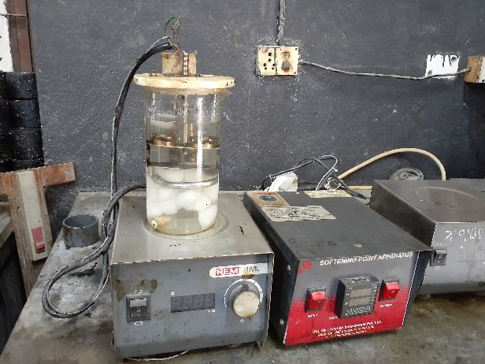
Figure 2.7: Softening Point Test Conducted During the Study
Loss on Heating Test: This test measures the loss in weight and penetration value during heating. The loss in penetration value should not be more than 40%. 50gm of sample is heated for 5 hours in a revolving aluminium shelf oven at 165°C. Then, it is cooled to the room temperature and weighed. The loss in weight is expressed in terms of percentage of weight loss to the weight of original sample and then penetration test is conducted to determine the loss in penetration value.
Solubility Test: This test is used to determine the amount of impurities in bitumen. The solubility requirement is 99.5% in CS2. Different kinds of solvent may be used for this test but normally carbon disulphide is accepted. A specified quantity of bitumen is dissolved in the solvent through filter paper. The residue retained is oven dried and weighed. The percentage of solubility is then determined by difference in weight of residue and original sample.
Specific Gravity Test: It is defined as the ratio of weight of bitumen at certain specified volume to that of equal volume of water at standard temperature.
Pycnometer Method:
$$Specific gravity=\frac{w3-w1}{\left(w2-w1\right)-(w4-w3)}x 100\%$$

Where,
W1 = weight of specific gravity bottle
W2 = weight of specific gravity bottle filled with bottle
W3 = weight of the specific gravity bottle about half filled with bitumen
W4 = weight of the specific gravity bottle, half filled with bitumen and the remaining part filled with water
Safety Test: The volatile materials in the binder catch fire in the form of flash when it is heated to certain temperature. The maximum temperature up to which the binder can be heated with safety is determined by flash and fire point test. The binder is gradually heated and different higher temperature. The temperature at which the binder first burns as brief flash of blue flame is called flash point. The temperature is further increased and the temperature at which the binder burns for at least 5 seconds is called the fire point.
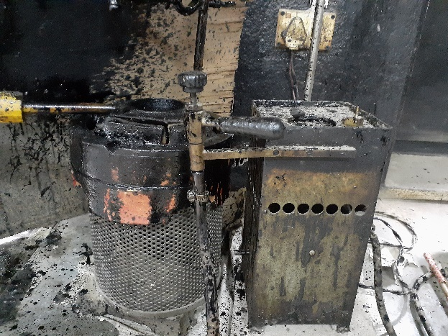
Figure 2.8: Safety Tests Conducted During the Study

2.3 Glass
Common glass contains about 70% silica which also acts as fluxing agent during the manufacturing process. Melting point and viscosity of the formed glass is lowered in the process. It also released carbon dioxide and helps in stirring the melted product. Different additives can be added to increase different characteristics like: strength, color etc. (Salem et al. 2017) The asphalt concrete mix with added glass have many beneficial characteristics like: low absorption, low specific gravity and low thermal conductivity. Following table presents the constituents of glass. The constituents react with the asphalt mix to produce a more stable and durable mix.

Table 2.1: Typical Chemical Composition of Glass
Constituent | Borosilicate | Lead | Soda-Lime
SiO2 | 60 - 80 | 60 - 70 | 70 - 73
Al2O3 | 1 - 4 | - | 1.7 - 2.0
Fe2O3 | - | - | 0.06 - 0.24
Cr2O3 | - | - | 0.1
CaO | - | 1 | 9.1 - 9.8
MgO | - | - | 1.1 - 1.7
BaO | - | - | 0.14 - 0.18
Na2O | 45 | 7 - 10 | 13.8 - 14.4
K2O | - | 7 | 0.55 - 0.68
PbO | - | 15 – 25 | -
B2O3 | 10 – 25 | - | -
Source: Salem et al. 2017

2.4 Past Researches
Salem et. Al (2017) studied the effect of waste glass on properties of asphalt concrete mixture. He determined that with the increase in glass percentage by weight of fine aggregate a more economical mix was prepared which was significantly more durable. The optimum glass content was determined to be 10% by weight of fine aggregates. He determined that optimum binder content for the mix with 10% glass decreased by 0.4% compared to a normal AC mix. Similarly, an increase of approximately 10% in Marshall Stability values was determined.
Y. Issa (2015) performed a similar test on 70/100 penetration grade bitumen and laminated glass obtained from car windshields. In his study he monitored the change in stability and flow values of the mix after the introduction of the glass. It was found that the average stability increased (increase of 10%) with glass addition until the maximum level (approximately 10% of glass) then it started to decrease. Average stability of asphalt without glass is higher in comparison with the asphalt with 5%, and 20% glass, but lower than 10%. The average flow of asphalt without glass was found to be higher in comparison with the glass-asphalt.

Farag Khodary (2018) conducted an experimental study of using waste glass as additives in asphalt concrete. He concluded that there was significant improvement in the compressive strength and rutting resistance of the mix upon the addition of glass particles. Similarly, Dr. Hassan H. Jony et. Al (2010) performed a research by using glass powder as filler material in the asphalt concrete mix. An average increase of 13% was observed in stability whereas an average decrease of 39% was observed in Marshall flow values.
Different researches have been conducted to determine the change in other asphalt characteristics due to introduction of glass. Shafabaksh and Sajed (2014) conducted several tests on dynamic properties of asphalt concrete containing glass. The research showed there was significant improvement in fatigue life, stiffness modulus and creep compliance as compared to normal asphalt concrete mix. Likewise, Khateeb et. Al (2019) conducted a study on shear properties of waste glass asphalt mastics and concluded that the addition of waste glass improved the shear properties of mix and also had positive impact on rutting and fatigue resistance of the mix.
Talking about economics of the use of glass particles, the economic feasibility of using waste glass as an aggregate in asphaltic concrete is dependent primarily upon the development of resource recovery systems which can seperate glass along with other recyclable components and generate enough revenues from their sale plus disposal and processing fees to produce an acceptable return on equity (Malisch et al., 1975). Shaopeng et al. (2004) performed experiments on Glass-Asphalt Concrete and determined that the use of waste glass in asphalt concrete was feasible. A method of economizing the entire operation is also presented in this study. Similarly, increasing energy cost and environmental concerns have encouraged the development of using pollution-free, recyclable engineering materials that consume less energy to manufacture (Chiu, 2008). So, the use of glass particles is an efficient way of recycling glass waste particles and solid waste disposal.

CHAPTER 3: METHODOLOGY

3.1 Introduction
Methodology of any study starts with statement of problem, definition of objectives, literature studies and then the experimental procedure. The methodology used in the thesis follows the flowchart Figure 3.1.
The work was carried out with a two month work plan for collection of aggregates, glass and binder sample, performing initial tests on them, performing the Marshall mix design and then the detailed calculations. Appropriate literature was reviewed at each stage of the study, during the calculations and report preparation.
In order to meet the objectives of the thesis work the following steps were followed.
- Selection of materials such as aggregates, dust, glass and VG-30 bitumen.
- Mechanical tests on bitumen like: Penetration test, softening point test, viscosity test etc.
- Preliminary tests on aggregates as per asphalt concrete mix requirements.
- Determination of optimum binder content (OBC) of the mix without glass.
- Sample preparation by replacing fine aggregate with 5%, 10% and 14% by weight of glass.
- Perform marshall stability test on samples containing different proportion of glass.
- Computation of all marshall stability parameters like: Marshall stability, flow, VFB, VMA, air voids and bulk density.
- Preparation of cost estimate of asphalt mix at different proportions of glass.

Statement of Problem

Setting Measurable Objectives

Collection of Sample

Preliminary Tests on VG-30 Bitumen and Aggregate Sample

LITERATURE REVIEW
Marshall Mix Design of a Normal Asphalt Concrete Mix

Marshall Mix Design of a Mix Containing Various Proportion of Glass Particles

Comparison of the Marshall Parameters and Preparation of Cost Estimate

Figure 3.1: Flowchart of Methodology

3.2 Materials
The different type of materials used in the study are aggregates, dust, glass and bitumen. They can be described as follows:

3.2.1 Bitumen
VG-30 bitumen was used during the course of the study. The bitumen was Durapave by Indian Oil. It is currently being used in Panchkhal Road Project, Melamchi. Table 3.1 presents the details of bitumen used in the test.
Table 3.1: Details of Bitumen Used in the Test
S.N | Name of Tests | Unit | Test Values | Specifications
1 | Penetration at 25°C | 1/10 mm | 59.33 | Min 45
2 | Specific gravity |  | 1.032
3 | Softening Point | °C | 48.6 | Min 47
4 | Ductility at 25°C | cm | >100 | >100
5 | Solubility in Trichloroethylene | % | 99.5 | 99
6 | Loss on heating for 5 hours at 163°C | % | 0.263% | <0.5%
7 | Flash Point | °C | 280 | 220
7 | Fire Point | °C | 318
8 | Kinematic Viscosity at 135°C | Cst | 359 | Min 350
9 | Absolute Viscosity at 60°C | Poise | 2522 | 2400-3600

3.2.2 Aggregates
The source of the aggregate was Abiral Stone Crusher Pvt. Ltd, Tikabhairab, Lalitpur district. Aggregates can be grouped as coarse aggregates and fine aggregates. Coarse aggregates are the aggregates retained on 4.75 mm sieve, entirely crushed, free from clay and other deleterious materials. Likewise, fine aggregates pass through 4.75 mm sieve. It must be free from clay, silt, organic materials, any deleterious materials and non-plastic. Table 3.2 presents the details of aggregates used in the test.

Table 3.2: Details of Aggregates Used in the Test
S.No. | Aggregate Test | Test Values | Specification
1 | Specific gravity of coarse aggregates | 2.61 | 2.5 to 3
2 | Specific gravity of fine aggregates | 2.62 | 2.5 to 3
3 | Los Angeles Abrasion Value | 15.36% | Max 30%
4 | Aggregate Impact Value | 10.84% | Max 24%
5 | Flakiness Index | 23.39% | Max 25%
6 | Elongation Index | 24.16% | Max 25%
7 | Stripping Test | >95% | >95%
8 | Water Absorption Test | 0.54% | Max 2%

3.2.3 Glass
The size of the glass particles used in the study was selected such that it satisfied standard DoR combined gradation specifications. Table 3.3 presents the details of the glass used in the mix shown by Figure 3.2. The specific gravity of glass particles was measured by Pycnometer method. Likewise, Table 3.4 presents the sieve analysis results of the glass particles used in the mix. The size of the glass particles ranges from 0.15mm to 0.6mm and plays a crucial role in improvement of strength parameters of the mix.
Table 3.3: Details of Glass Used in the Mix
S.No. | Aggregate Test | Test Values | Specification
1 | Specific gravity of glass | 2.49 | NA

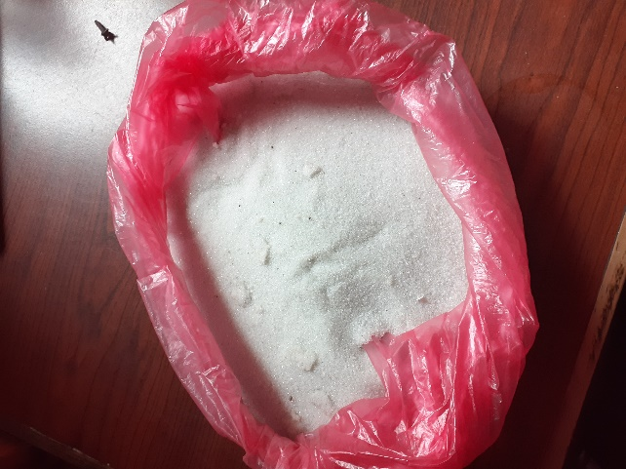
Figure 3.2: Glass Samples Used for Study

Table 3.4: Sieve Analysis Results of Glass Used in the Mix
Sieve Size (mm) | Wt.Retained (gm) | % Retained | Cumulative % Retained | Cumulative % Passing | Remarks
1.18 | 0 | 0.00% | 0.00% | 100.00%
0.6 | 40.12 | 8.32% | 8.32% | 91.68%
0.3 | 311.58 | 64.60% | 72.92% | 27.08%
0.15 | 128.1 | 26.56% | 99.48% | 0.52%
0.075 | 1.7 | 0.35% | 99.83% | 0.17%
Pan | 0.8 | 0.17% | 100.00% | 0.00%
Total weight | 482.3

3.2.4 Gradation of Aggregates
The gradation of the aggregate was done by trial and error method. Aggregates were classified into four groups. The classification of aggregates into groups were done on the basis of aggregate size. The mixing of aggregate was done by mixing appropriate percentage of aggregate of each group. The gradation of the combined mix must confer to the standard specifications. DoR standard specifications was used for the combined mix of aggregates.
Table 3.5: Gradation of Coarse and Fine Aggregates of Normal AC Mix
Percentage used | 40% | 14% | 46% | % passing | Specification
Sieve size | 20mm | 10mm | Dust | % passing | Specification
20 | 40.00% | 14.00% | 46.00% | 100.00% | 90-100
16 | 26.24% | 13.87% | 46.00% | 86.12%
13.2 | 16.76% | 13.58% | 46.00% | 76.34% | 59-79
10 | 8.69% | 11.94% | 46.00% | 66.63% | 52-72
4.75 | 3.04% | 2.42% | 39.04% | 44.49% | 35-55
2.36 | 2.24% | 1.64% | 28.33% | 32.21% | 28-44
1.18 | 0.00% | 0.00% | 22.14% | 22.14% | 20-34
0.6 | 1.09% | 0.58% | 14.33% | 16.00% | 15-27
0.3 | 0.00% | 0.00% | 11.99% | 11.99% | 10-20
0.15 | 0.00% | 0.00% | 9.21% | 9.21% | 5-13
0.075 | 0.33% | 0.07% | 6.10% | 6.50% | 2-8

Figure 3.3: Gradation Envelope of Normal AC Mix
Different portion of fine aggregate was replaced by glass of already mentioned specifications. The combined gradation of aggregate is under specifications.
Table 3.6: Combined Gradation of AC Mix with 5% Glass
Percentage used | 40% | 14% | 41% | 5% | % passing | Specification
Sieve size | 20mm | 10mm | Dust | Glass | % passing | Specification
20 | 40.0% | 14.00% | 41.00% | 5.00% | 100.00% | 90-100
16 | 26.2% | 13.87% | 41.00% | 5.00% | 86.12%
13.2 | 16.8% | 13.58% | 41.00% | 5.00% | 76.34% | 59-79
10 | 8.7% | 11.94% | 41.00% | 5.00% | 66.63% | 52-72
4.75 | 3.0% | 2.42% | 34.79% | 5.00% | 45.25% | 35-55
2.36 | 2.2% | 1.64% | 25.25% | 5.00% | 34.13% | 28-44
1.18 | 0.0% | 0.00% | 19.73% | 5.00% | 24.73% | 20-34
0.6 | 1.1% | 0.58% | 12.77% | 4.58% | 19.03% | 15-27
0.3 | 0.0% | 0.00% | 10.69% | 1.35% | 12.04% | 10-20
0.15 | 0.0% | 0.00% | 8.21% | 0.03% | 8.24% | 5-13
0.075 | 0.3% | 0.07% | 5.43% | 0.01% | 5.84% | 2-8

Figure 3.4: Gradation Envelope of AC Mix with 5% Glass

Table 3.7: Combined Gradation of AC Mix with 10% Glass
Percentage used | 40% | 14% | 36% | 10% | % passing | Specification
Sieve size | 20mm | 10mm | Dust | Glass | % passing | Specification
20 | 40.0% | 14.0% | 36.0% | 10.0% | 100.00% | 90-100
16 | 26.2% | 13.9% | 36.0% | 10.0% | 86.12%
13.2 | 16.8% | 13.6% | 36.0% | 10.0% | 76.34% | 59-79
10 | 8.7% | 11.9% | 36.0% | 10.0% | 66.63% | 52-72
4.75 | 3.0% | 2.4% | 30.6% | 10.0% | 46.01% | 35-55
2.36 | 2.2% | 1.6% | 22.2% | 10.0% | 36.05% | 28-44
1.18 | 0.0% | 0.0% | 17.3% | 10.0% | 27.32% | 20-34
0.6 | 1.1% | 0.6% | 11.2% | 9.2% | 22.06% | 15-27
0.3 | 0.0% | 0.0% | 9.4% | 2.7% | 12.09% | 10-20
0.15 | 0.0% | 0.0% | 7.2% | 0.1% | 7.26% | 5-13
0.075 | 0.3% | 0.1% | 4.8% | 0.0% | 5.19% | 2-8

Figure 3.5: Gradation Envelope of AC Mix with 10% Glass

Table 3.8: Combined Gradation of AC Mix with 14% Glass
Percentage used | 40% | 14% | 32% | 14% | % passing | Specification
Sieve size | 20mm | 10mm | Dust | Glass | % passing | Specification
20 | 40.0% | 14.0% | 32.0% | 14.0% | 100.00% | 90-100
16 | 26.2% | 13.9% | 32.0% | 14.0% | 86.12%
13.2 | 16.8% | 13.6% | 32.0% | 14.0% | 76.34% | 59-79
10 | 8.7% | 11.9% | 32.0% | 14.0% | 66.63% | 52-72
4.75 | 3.0% | 2.4% | 27.2% | 14.0% | 46.61% | 35-55
2.36 | 2.2% | 1.6% | 19.7% | 14.0% | 37.59% | 28-44
1.18 | 0.0% | 0.0% | 15.4% | 14.0% | 29.40% | 20-34
0.6 | 1.1% | 0.6% | 10.0% | 12.8% | 24.48% | 15-27
0.3 | 0.0% | 0.0% | 8.3% | 3.8% | 12.13% | 10-20
0.15 | 0.0% | 0.0% | 6.4% | 0.1% | 6.48% | 5-13
0.075 | 0.3% | 0.1% | 4.2% | 0.0% | 4.66% | 2-8

Figure 3.6: Gradation Envelope of AC Mix with 14% Glass

3.3 Mix Design
The normal asphalt mix along with the mix with different proportion of glass were designed by Marshall Method. A total of 4 sets of mix design containing 60 samples were prepared during the thesis work. All the samples were prepared at Quality Research and Development Center, Department of Roads (DoR), Pulchowk. Each set of mix design had 15 samples.

3.3.1 Laboratory Apparatus
Following laboratory apparatus are required for Marshall test:
- Weighing machine
- Hot Air Oven
- Water Bath
- Automatic Compactor
- Sample Extractor
- Marshall apparatus

3.3.2 Preparation of Asphalt Concrete Mix Specimen
Standard Marshall moulds of 101.6 mm diameter and 63.5 mm thickness were used in order to prepare the specimens. Appropriate correction factors were used in case of thickness variation of the specimens. The designed weight of aggregates as per proportion in the combined gradation was weighed and blended with VG 30 bitumen at increments of 0.5%. In case of the mix containing glass particles, different proportions of glass particles were added and the equal proportion of fine aggregates were removed. The aggregate pre heated at 150°C to 155°C was blended with the pre heated bitumen. The total weight of the mix was kept 1200 gm. The mix was heated thoroughly at 165°C and uniformly mixed before placing in the compaction mould. The mix was then compacted by automatic compactor with height of drop 457 mm by applying 75 blows on either side. The samples were allowed to cool down and carefully extracted using a sample extruder.

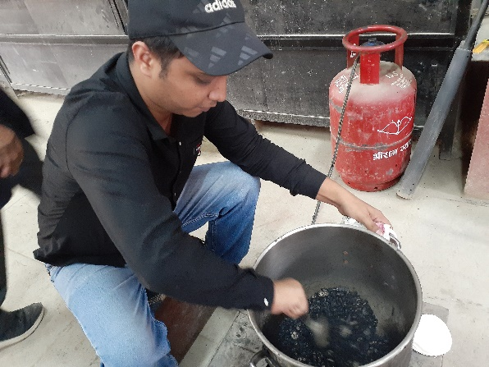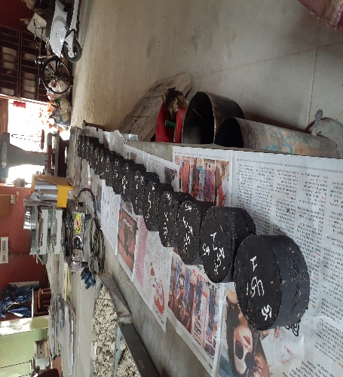
Figure 3.7: Sample Preparation
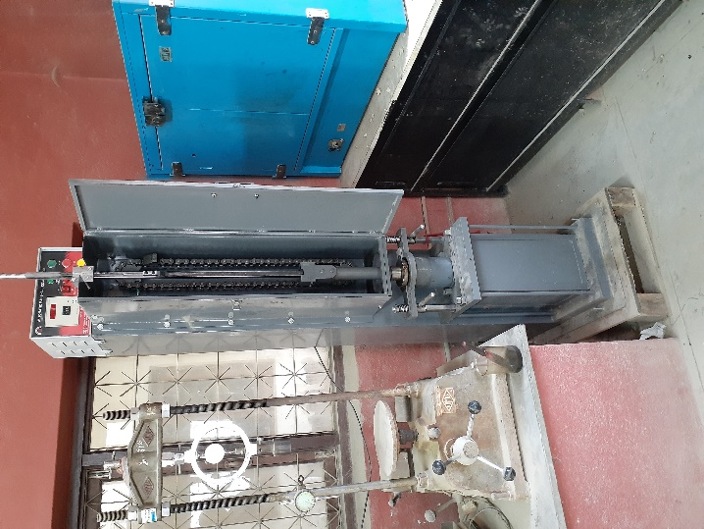
Figure 3.8: Automatic Compactor Used for Compaction of Sample

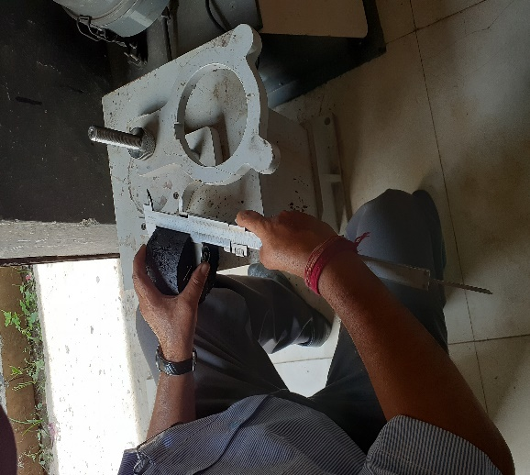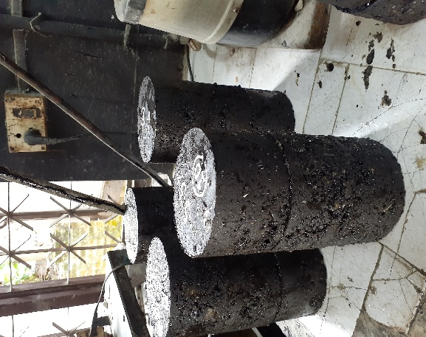
Figure 3.9: Thickness and Weight Observations

3.3.3 Test Procedure
The samples were allowed to cool down for 24 hours. The thickness of the sample were taken at three equal distances to measure the mean thickness of the sample. The thickness measurements are required for thickness corrections in case of any thickness variations in the sample. Then, the weight of the samples in air was taken and the samples were soaked in water for more than 15 minutes. The samples were weighed in water and surface dry condition. Such measurements are done to calculate the bulk unit weight and voids in the sample. Then, the samples were submerged in the water bath at 60°C for 30 minutes. Finally, the sample was placed in Marshall Stability testing machine. The load was applied at the constant deformation of 50 mm/min. The maximum load and flow were recorded. The broken samples were removed and the procedure was repeated again. Three samples were prepared for each proportion of bitumen for a set of mix design.
The results of the test were expressed in following terms:
- Marshall stability – kN
- Flow value – in mm
- Percentage of air voids – %
- Voids in Mineral Aggregate (VMA) – %
- Voids Filled with Bitumen (VFB) – %
- Unit weight of specimen (G) – gm/cm³

CHAPTER 4: RESULTS AND ANALYSIS

4.1 Mix Design Results of Normal AC Mix
The marshall parameters used to calculate OBC for the normal mix (mix not containing glass particles) is given in Table 4.1. The calculation of OBC is based on marshall stability, bulk density and 4% air voids as shown in Table 4.2. Different properties like Marshall Stability, Flow, VFB, air voids and bulk density at OBC is shown in Table 4.3.
Table 4.1: Marshall Parameters for Normal AC Mix
S.NO | % Bitumen | Stability (KN) | Flow (mm) | Bulk Unit Weight (gm/cc) | VTM% | VFB%
1 | 4.0% | 11.57 | 2.11 | 2.339 | 7.18% | 55.81%
2 | 4.5% | 13.46 | 2.39 | 2.384 | 4.71% | 68.84%
3 | 5.0% | 15.54 | 2.59 | 2.397 | 3.48% | 76.92%
4 | 5.5% | 14.70 | 2.74 | 2.408 | 2.30% | 84.80%
5 | 6.0% | 13.49 | 2.86 | 2.412 | 1.44% | 90.71%
6 | 6.5% | 9.36 | 3.00 | 2.400 | 1.18% | 92.78%

Figure 4.1: Bitumen Content vs Stability for Normal AC Mix

Figure 4.2: Bitumen Content vs Flow for Normal AC Mix

Figure 4.3: Bitumen Content vs Bulk Density for Normal AC Mix

Figure 4.4: Bitumen Content vs VTM for Normal AC Mix

Figure 4.5: Bitumen Content vs VFB for Normal AC Mix

Table 4.2: Calculation of OBC of Normal Mix
Item | Value
Bitumen content at maximum density | 5.90%
Bitumen content at maximum stability | 5.10%
Bitumen content at 4% air voids | 4.67%
Proposed optimum binder content | 5.22%

Table 4.3 Marshall Parameters at OBC for Normal Mix
Parameter | Value | Unit
Stability | 15.5 | kn
Air voids | 3 | %
Flow value | 2.7 | mm
Bulk density | 2.4 | gm/cc
VFB% | 80 | %

4.2 Mix Design Results of AC Mix with 5% Glass
The marshall parameters used to calculate OBC for mix containing glass particles 5% by weight of aggregates is given in Table 4.4. The calculation of OBC is based on marshall stability, bulk density and 4% air voids as shown in Table 4.5. Different properties like Marshall Stability, Flow, VFB, air voids and bulk density at OBC is shown in Table 4.6.
Table 4.4: Marshall Parameters for AC Mix with 5% Glass
S.NO | % Bitumen | Stability (KN) | Flow (mm) | Bulk Unit Weight (gm/cc) | VTM% | VFB%
1 | 4.0% | 12.8 | 2.17 | 2.34 | 6.76% | 57.33%
2 | 4.5% | 14.0 | 2.29 | 2.36 | 5.41% | 65.53%
3 | 5.0% | 16.1 | 2.42 | 2.39 | 3.61% | 76.23%
4 | 5.5% | 11.6 | 2.68 | 2.41 | 2.08% | 86.05%
5 | 6.0% | 10.9 | 2.74 | 2.39 | 2.00% | 87.43%

Figure 4.6: Bitumen Content vs Stability for Mix with 5% Glass

Figure 4.7: Bitumen Content vs Flow for Mix with 5% Glass

Figure 4.8: Bitumen Content vs Bulk Density for Mix with 5% Glass

Figure 4.9: Bitumen Content vs VTM for Mix with 5% Glass

Figure 4.10: Bitumen Content vs VFB for Mix with 5% Glass

Table 4.5: Marshall Parameters for AC Mix with 5% Glass
Item | Value
Bitumen content at maximum density | 5.50%
Bitumen content at maximum stability | 4.90%
Bitumen content at 4% air voids | 4.80%
Proposed optimum binder content | 5.07%

Table 4.6: Marshall Parameters at OBC for 5% Glass
Parameter | Value | Unit
Stability | 16.1 | kn
Air voids | 3.5 | %
Flow value | 2.4 | mm
Bulk density | 2.39 | gm/cc
VFB% | 77.5 | %

4.3 Mix Design Results of AC Mix with 10% Glass
The marshall parameters used to calculate OBC for mix containing glass particles 10% by weight of aggregates is given in Table 4.7. The calculation of OBC is based on marshall stability, bulk density and 4% air voids as shown in Table 4.8. Different properties like Marshall Stability, Flow, VFB, air voids and bulk density at OBC is shown in Table 4.9.
Table 4.7: Marshall Parameters for AC Mix with 10% Glass
S.NO | % Bitumen | Stability (KN) | Flow (mm) | Bulk Unit Weight (gm/cc) | VTM% | VFB%
1 | 4.0% | 15.0 | 2.01 | 2.36 | 5.95% | 60.59%
2 | 4.5% | 17.6 | 2.21 | 2.38 | 4.40% | 70.21%
3 | 5.0% | 15.8 | 2.35 | 2.41 | 2.35% | 83.29%
4 | 5.5% | 12.7 | 2.64 | 2.41 | 1.86% | 87.37%
5 | 6.0% | 11.4 | 2.73 | 2.41 | 1.16% | 92.34%

Figure 4.11: Bitumen Content vs Marshall Stability for Mix with 10% Glass

Figure 4.12: Bitumen Content vs Flow for Mix with 10% Glass

Figure 4.13: Bitumen Content vs Bulk Density for Mix with 10% Glass

Figure 4.14: Bitumen Content vs VTM for Mix with 10% Glass

Figure 4.15: Bitumen Content vs VFB for Mix with 10% Glass

Table 4.8: Marshall Parameters for AC mix with 10% Glass
Item | Value
Bitumen content at maximum density | 5.00%
Bitumen content at maximum stability | 4.60%
Bitumen content at 4% air voids | 4.60%
Proposed optimum binder content | 4.73%

Table 4.9: Marshall Parameters at OBC for 10% Glass
Parameter | Value | Unit
Stability | 17.52 | kn
Air voids | 3.7 | %
Flow value | 2.25 | mm
Bulk density | 2.39 | gm/cc
VFB% | 76 | %

4.4 Mix Design Results of AC Mix with 14% Glass
The marshall parameters used to calculate OBC for mix containing glass particles 14% by weight of aggregates is given in Table 4.10. The calculation of OBC is based on marshall stability, bulk density and 4% air voids as shown in Table 4.11. Different properties like Marshall Stability, Flow, VFB, air voids and bulk density at OBC is shown in Table 4.12.
Table 4.10: Marshall parameters for AC Mix with 14% Glass
S.NO | % Bitumen | Stability (KN) | Flow (mm) | Bulk Unit Weight (gm/cc) | VTM% | VFB%
1 | 4.0% | 12.8 | 2.06 | 2.33 | 6.84% | 56.93%
2 | 4.5% | 15.5 | 2.16 | 2.39 | 3.94% | 72.54%
3 | 5.0% | 12.4 | 2.36 | 2.40 | 2.81% | 80.54%
4 | 5.5% | 10.5 | 2.47 | 2.39 | 2.42% | 84.06%
5 | 6.0% | 9.4 | 2.64 | 2.38 | 1.98% | 87.49%

Figure 4.16: Bitumen Content vs Marshall Stability for Mix with 14% Glass

Figure 4.17: Bitumen Content vs Flow for Mix with 14% Glass

Figure 4.18: Bitumen Content vs Bulk Density for Mix with 14% Glass

Figure 4.19: Bitumen Content vs VTM for Mix with 14% Glass

Figure 4.20: Bitumen Content vs VFB for Mix with 14% Glass

Table 4.11: Marshall Parameters for AC Mix with 14% Glass
Item | Value
Bitumen content at maximum density | 4.70%
Bitumen content at maximum stability | 4.49%
Bitumen content at 4% air voids | 4.30%
Proposed optimum binder content | 4.50%

Table 4.12: Marshall Parameters at OBC for 14% Glass
Parameter | Value | Unit
Stability | 15.5 | kn
Air voids | 3 | %
Flow value | 2.15 | mm
Bulk density | 2.4 | gm/cc
VFB% | 78 | %

4.5 Cost Estimate
The cost estimate for AC mix with different portion of glass particles are presented in Table 4.13 to Table 4.16.
Table 4.13: Cost Estimate of AC Mix without Glass
Bulk Density without glass | 2.4 | ton/cu m | Proportion | With Dust
S.N | Material | Unit | Proportion | Quantity | Rate (NRs.) | Amount (NRs.)
1 | Aggregate | ton | 94.78% | 2.275 | 716.48 | 1,629.79
2 | Bitumen | ton | 5.22% | 0.125 | 81,000.00 | 10,147.68
3 | Glass | ton |  |  |  | -
 | Total |  |  |  |  | 11,777.47

Table 4.14: Cost Estimate of AC Mix with 5% Glass
Bulk Density with 5% glass | 2.39 | ton/cu m | Proportion | With glass (5%)
S.N | Material | Unit | Proportion | Quantity | Rate (NRs.) | Amount (NRs.)
1 | Aggregate | ton | 90.18% | 2.155 | 716.48 | 1,544.29
2 | Bitumen | ton | 5.07% | 0.121 | 81,000.00 | 9,815.01
3 | Glass | ton | 4.75% | 0.113 | 2,000.00 | 226.88
 | Total |  |  |  |  | 11,586.19

Table 4.15: Cost Estimate of AC Mix with 10% Glass
Bulk Density with 10% glass | 2.39 | ton/cu m | Proportion | With glass (10%)
S.N | Material | Unit | Proportion | Quantity | Rate (NRs.) | Amount (NRs.)
1 | Aggregate | ton | 85.74% | 2.049 | 716.48 | 1,468.25
2 | Bitumen | ton | 4.73% | 0.113 | 81,000.00 | 9,156.81
3 | Glass | ton | 9.53% | 0.228 | 2,000.00 | 455.39
 | Total |  |  |  |  | 11,080.45

Table 4.16: Cost Estimate of AC Mix with 14% Glass
Bulk Density with 14% glass | 2.39 | ton/cu m | Proportion | With glass (5%)
S.N | Material | Unit | Proportion | Quantity | Rate (NRs.) | Amount (NRs.)
1 | Aggregate | ton | 82.13% | 1.963 | 716.48 | 1,406.38
2 | Bitumen | ton | 4.50% | 0.108 | 81,000.00 | 8,711.55
3 | Glass | ton | 13.37% | 0.320 | 2,000.00 | 639.09
 | Total |  |  |  |  | 10,757.02

4.6 Summary and Analysis of Results
Table 4.17 presents the summary of results. Variation in glass proportions in the mix brings changes in different Marshall characteristics. The changes in the characteristics are dependent upon the type and gradation of aggregate, type of binder, type of glass used and size of glass used.
Table 4.17: Summary of Results
Test Parameters | Unit | Percentage of glass |  |  |  | Limit
Test Parameters | Unit | 0% | 5% | 10% | 14% | Limit
OBC | % | 5.22% | 5.07% | 4.73% | 4.5%
Stability | KN | 15.5 | 16.1 | 17.5 | 15.5 | >9
Air voids | % | 3 | 3.5 | 3.7 | 4 | 3-5
Flow value | mm | 2.7 | 2.4 | 2.3 | 2.15 | 2-4
Bulk density | gm/cc | 2.4 | 2.39 | 2.39 | 2.39
VFB% | % | 80 | 77.5 | 76 | 72.5 | 65-75
Cost per cum | NRs. | 11,777.47 | 11,586.19 | 11,080.45 | 10,757.02

4.6.1 Glass Percentage vs Stability
Overall, Marshall stability value of the mix is improved by addition of glass particles. Slight increment is observed at 5% glass whereas significant increment can be observed at 10% glass content. The stability value decreases when the glass content is further increased. A maximum increment by 12.9% in stability was recorded at 10% glass. Hence, 10% can be termed as optimum glass content from the stability point of view.

4.6.2 Glass Percentage vs OBC
Upon increasing the glass percentage the optimum binder content up the mix decreases. At maximum stability there is 0.49% decrease in the binder content which refers to the fact that less amount of binder is required to make a more durable mix. This makes the mix economical.

4.6.3 Glass Percentage vs Flow and Voids
The flow values and air voids exhibit a complex relationship. The flow value decreases with the increase in glass content. This causes an increase in air voids. Due to decrease in flow value all the voids in the aggregate framework cannot be filled hence VFB decreases upon increment in the glass content in the mix. However, the values are within range and specificiations.

4.6.4 Glass Percentage vs Bulk density
Glass is the lighter material as compared to the aggregate displaced as it has lesser specific gravity. This caused slight reduction in bulk density of the mix.

4.6.5 Glass Percentage vs Cost per cu m
The addition of glass particles yields a lighter, durable and more economical mix. As per the results of the study, large amount of cost cutting can be achieve from the materials employed in the mix.
The increment in glass content causes decrease in optimum binder content and bulk density which causes decrement in the cost of materials. The detailed cost estimate is presented in Table 4.13 to Table 4.16. At optimum glass content, the asphalt mix with glass was found to be NRs. 697.02 per cum cheaper than the mix without glass particles. On increasing the glass content further to 14% there was reduction in Marshall stability but the decreased value is within the specifications so the proportion could still be economically viable. At 14% glass content the asphalt mix with glass was found to be NRs. 1020.45 per cum cheaper than the mix without glass particles. The rate used in the analysis is the district rate of Nuwakot 076/077.
Glass Production and Manufacturing Cost
Thapa et. Al (2011) determined that about 15 ton/day glass is deposited in the form of waste at three principle landfill sites of Nepal at Sisdole, Karaute and Pokhara. However, according report of Kathmandu Post dated June 25, 2019, 800 ton/day of waste is deposited at Sisdole itself. Thapa et. Al (2011) also determined 3.31% of total waste at Sisdole contains glass as the waste which gives 26.48 ton/day of glass. The glass production and manufacturing cost can be cut down if we reuse and recycle this waste glass by establishment of a glass sorting and glass crushing plant at Sisdole. A cost estimate of a crushing and sorting plant is presented in Table 4.18. The return period of the plant would be 1.81 years which is a feasible time frame for a plant. The obtained mix is therefore durable and more economic than conventional asphalt mix.
Table 4.18: Financial Evaluation of Glass Crushing and Sorting Plant
Description | Unit | Quantity | Remarks
Asphalt Concrete Plant | ton/hr | 60
Asphalt Concrete Plant | cum/hr | 25
Working hr per day of plant | hr | 10
Asphalt concrete capacity per day | cum | 250
Asphalt concrete demand per day (assumed) | cum | 40
Glass required (10%) | ton | 9.12
Initial investment in crushing plant and sorting plant | NRs. | 5,000,000.00
Land Acquistion Cost | NRs. | 2,500,000.00
Manpower cost | NRs. | 500,000.00 | 10% of plant
Operation and maintenance cost | NRs. | 500,000.00 | 10% of plant
Total cost | NRs. | 8,500,000.00
Transportation cost per day | NRs. | 15,000.00 | As per DoR norms
Normal Asphalt concreting per day | NRs. | 471,098.86
Asphalt concreting with glass | NRs. | 443,217.99
Saving per day | NRs. | 27,880.87
Net profit | NRs. | 12,880.87
Pay back period | year(s) | 1.81

4.7 Limitations of Study
The results obtained during the study depends upon the gradation of aggregate and glass used. It is also dependent upon the type of glass and type of binder used. Likewise, several researchers has raised the questions over accuracy of Marshall Stability test and more advanced method has been postulated. However, it is still used in Nepal and different countries as a principle method for mix design.
The comprehensive study of asphalt mix with glass particles require sample sections of the road to be constructed and their performance to be monitored. But due to limited time frame and budget of the thesis work only Marshall characteristic have been analysed. In case of real field, different parameters like tensile strength, rutting resistence, creep etc. should be also taken into account before selection of glass as a substitute material for aggregate.

CHAPTER 5: FINDINGS AND CONCLUSIONS
The aim of this study is to evaluate the change in Marshall characteristics by introduction of glass in the normal asphalt mix. According to various testing results, following conclusions can be derived:
- Crushed glass can be used in asphalt pavement with optimum replacement ratio of 10 % weight of total aggregates.
- The value of OBC at optimum glass content is 4.73% which is 0.49% lesser than the original AC mix.
- The stability values increases upto 10% glass content and decreases when the glass content is increased further to 14%. The maximum increase in stability value was found to be 12.9% at 10% glass content. Flow values decrease at higher glass contents.
- Slight decrease in bulk density of the mix was noted. Air voids increase and voids filled with bitumen decrease at higher glass content due to decrease in binder content and flow values but the values are within range.
- As per the cost estimate maximum cost saving was possible at 14% glass content. Despite decrease in Marshall stability value, the decreased value is within the specifications and hence the use of this glass content is economically viable. A maximum cost saving of NRs. 1020.45 per cu m was estimated at 14% glass content.

CHAPTER 6: REFERENCES
- Zaydeun T. Abu Salem, Taisir S. Khedawi, Musa Bani Baker and Raed Abendeh, 2017 “Effect of waste glass on asphalt concrete mixtures”, Jordan Journal of Civil Engineering, Volume 11, No.1
- Y.Issa, 2016, “Effect of adding crushed glass to asphalt mix”, Archives of Civil Engineering, Volume LXII, Issue 2
- Dr. Hassan H. Jony, Mays F. Al-Rubaie and Israa Y. Jahad, 2011 “The effect of using glass powder filler on Hot Asphalt Concrete Mixture Properties”, Eng. & Tech Journal Vol.29
- Farzaneh Tahmoorian, Bijan Samali, John Yeaman and Russell Crabb, 2018, “The Use of Glass to Optimize Bitumen Absorption of Hot Mix Asphalt Containing Recycled Construction Aggregates”, Materials 2018, Volume 11
- Bijay Thapa and Ajay K.C, 2011, “Solid waste management at landfill sites in Nepal”, Indian Journal of Science and Technology, Volume 4, Issue 3
- Ashutosh Parsaila, 2017, “Evaluation of Antistripping Asphalt Concrete Mix Properties”, M.Sc. Thesis, Department of Civil Engineering, Pulchowk Campus
- G.H. Shafabakhsh and Y. Sajed, 2014, “Investigation of dynamic behavior of hot mix asphalt containing waste materials; case study: Glass cullet”, Faculty of Civil Engineering, Semnan University, Semnan, Islamic Republic of Iran
- Malisch, W. R., Day, D. E., and Wixon, B. G., 1975, “Use of Domestic Waste Glass for Urban Paving”, National Environmental Research Center, Office of Research and Development, Cincinnati, Ohio.
- Chiu, C. t., 2008, Life Cycle Assessment on Using Recycled Materials for Rehabilitating Asphalt Pavements., Resources Conservation and Recycling
- ADB, 2013, “Solid Waste Management in Nepal Current Policy and Recommendations”, ADB.
- Prasanna Humagain, 2016, “Investigation of Properties of Crumb Rubber Modified Bitumen and its Comparison with 80/100 Penetration Grade Bitumen”, M.Sc. Thesis, Department of Civil Engineering, Pulchowk Campus, Lalitpur, Nepal
- Farag Khodary, 2018, “Experimental Study of using Waste Glass as additives in Asphalt Concrete Mixtures”, International Journal of Advances in Scientific Research and Engineering, Volume 4, Issue 12
- Al-Khateeb G. Gazi, Khedaywi S. Taisir and Irfaeya F. Motaz, 2019, “Shear properties of waste glass-asphalt mastics”, International Journal of Pavement Research and Technology
- Wu Shaopeng, Yang Wenfeng and Xue Yongjie, 2004, “Preparation and Properties of Glass-asphalt Concrete”, Key Laboratory for Silicate Materials Science and Engineering of Ministry of Education, Wuhan University of Technology

APPENDIX-I: SIEVE ANALYSIS
- Coarse Aggregate ( Size 20mm – 10mm)
Sieve Size (mm) | Wt.Retained (gm) | % Retained | Cumulative % Retained | Cumulative % Passing | Remarks
20 | 0 | 0.00% | 0.00% | 100.00%
16 | 2899 | 34.39% | 34.39% | 65.61%
13.2 | 1998 | 23.70% | 58.09% | 41.91%
9.5 | 1702 | 20.19% | 78.28% | 21.72%
4.75 | 1191 | 14.13% | 92.41% | 7.59%
2.36 | 167 | 1.98% | 94.39% | 5.61%
0.6 | 243 | 2.88% | 97.27% | 2.73%
0.075 | 160 | 1.90% | 99.17% | 0.83%
Pan | 70 | 0.83% | 100.00% | 0.00%
Total weight | 8430

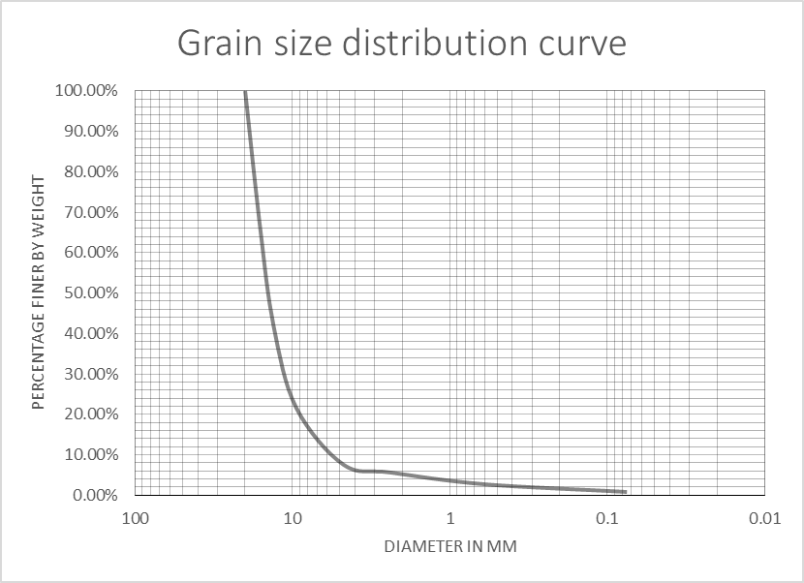
- Coarse Aggregate ( Size 10mm – 4.75 mm)
Sieve Size (mm) | Wt.Retained (gm) | % Retained | Cumulative % Retained | Cumulative % Passing | Remarks
16 | 100 | 0.90% | 0.90% | 99.10%
13.2 | 234 | 2.12% | 3.02% | 96.98%
9.5 | 1294 | 11.71% | 14.73% | 85.27%
4.75 | 7514 | 67.99% | 82.72% | 17.28%
2.36 | 618 | 5.59% | 88.31% | 11.69%
0.6 | 832 | 7.53% | 95.84% | 4.16%
0.075 | 406 | 3.67% | 99.51% | 0.49%
pan | 54 | 0.49% | 100.00% | 0.00%
Total weight | 11052

- Stone Dust
Sieve Size (mm) | Wt.Retained (gm) | % Retained | Cumulative % Retained | Cumulative % Passing | Remarks
9.5 | 0 | 0.00% | 0.00% | 100.00%
4.75 | 92.32 | 15.14% | 15.14% | 84.86%
2.36 | 141.98 | 23.28% | 38.42% | 61.58%
1.18 | 82.1 | 13.46% | 51.88% | 48.12%
0.6 | 103.5 | 16.97% | 68.85% | 31.15%
0.3 | 30.99 | 5.08% | 73.93% | 26.07%
0.15 | 36.85 | 6.04% | 79.97% | 20.03%
0.075 | 41.37 | 6.78% | 86.75% | 13.25%
pan | 0.36 | 0.06% | 86.81% | 13.19%
Total weight | 529.47
Total weight before washing | 609.9

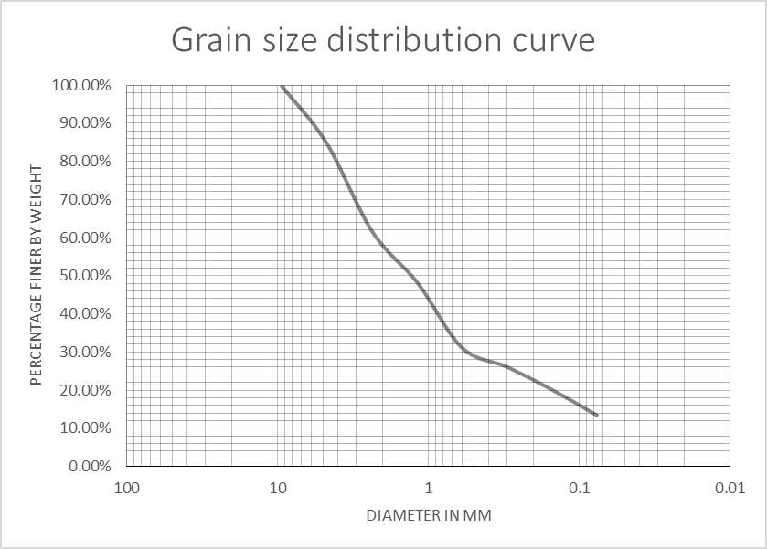

APPENDIX-II: AGGREGATE TESTS
- SPECIFIC GRAVITY TESTS
- Specific Gravity of Coarse Aggregate
 | Determination Number | 20mm | 10mm
B1 | Wt. of pan + Saturated surface dry sample | 2308.5 | 2038.4 | gm
B2 | Wt. of pan | 404.8 | 408.7 | gm
B=B1-B2 | Wt. of saturated surface dry sample | 1903.7 | 1629.7 | gm
C1 | Wt. of basket + sample in water | 1737.3 | 1562.5 | gm
C2 | Wt. of basket in water | 547.7 | 547.7 | gm
C=C1-C2 | Wt. of sample in water | 1189.6 | 1014.8 | gm
A1 | Wt. of panoven dry sample | 2280.72 | 2004.73 | gm
A2 | Wt. of pan | 404.8 | 408.7 | gm
A=A1-A2 | Wt. of oven dry sample | 1875.92 | 1596.03 | gm
 | Bulk gravity (Oven dry) = A/(B-C) | 2.63 | 2.60
 | Bulk gravity (SSD)= B/(B-C) | 2.67 | 2.65
 | Apparent Gravity= A/(A-C) | 2.73 | 2.75

- Specific Gravity of Fine Aggregate and Glass
 | Determination Number | Dust | Glass
A | Wt. of Pycnometer + water (Full) | 680.9 | 742.5 | gm
B | Wt. of Pycnometer empty and dry | 154.9 | 219.9 | gm
T1 | Temperature of Water | 25 | 25 | °C
C | Wt. of Pycnometer + Oven dry sample | 465.1 | 805.6 | gm
D=C-B | Wt. of Oven dry sample | 310.2 | 585.7 | gm
E | Wt. of Pycnometer + Sample + Water (Full) | 872.9 | 1093.69 | gm
T2 | Temperature of Water | 25 | 25 | °C
Gw | Relative Density of Water at temperature T2 | 0.997 | 0.997
 | Specific gravity = Gw x D/(D+A-E) | 2.62 | 2.49
- LOS ANGELES ABRASION TEST
S.NO | Description | Quantity | Remarks
1 | Wt. of specimen W1 (gm) | 5000
2 | Wt. of specimen after abrasion test, coarser than 1.70mm IS sieve, W2 (gm) | 4232
3 | Percentage Wear = (W1-W2)/W1 | 15.36%

- AGGREGATE IMPACT VALUE TEST
A1 | Wt. of Measure + Compacted Sample | 2319.9 | gms
A2 | Wt. of Measure | 1846.2 | gms
A | Wt. of Compacted Sample = A1-A2 | 473.7 | gms
TEST PROCEDURE
 | Determination No. | 1
B | Wt. Passing 2.36mm Sieve | 51.3 | gms
C | Wt. Retained on 2.36mm Sieve | 421.6 | gms
D | Total = B+C | 472.9 | gms
 | AIV | 10.84%
 | *If D more than 1g different to A then REPEAT TEST.

- WATER ABSORPTION TEST
S.No. | Description |  | Unit | Quantity | Remarks
1 | Wt. of pan + Saturated surface dry sample | A1 | gm | 5987.7
2 | Wt. of pan | A2 | gm | 408.7
3 | Wt. of saturated surface dry sample | A=A1-A2 | gm | 5579
4 | Wt. of pan oven dry sample | B1 | gm | 5957.7
5 | Wt. of pan | B2 | gm | 408.7
6 | Wt. of oven dry sample | B=B1-B2 | gm | 5549
 | Water Absorption | (A-B)/B | % | 0.54

- FLAKINESS INDEX TEST
C | D | E | F
Flakiness Slot Size Identification | Wt. Retained on flakiness plate (Grams) | Wt. Passing on flakiness plate (Grams) | Total Weight Tested
mm |  |  | D+E
25 to 19 | 0 | 0 | 0
19 to 16 | 394 | 100 | 494
16 to 12.5 | 570 | 146 | 716
12.5 to 9.5 | 530 | 206 | 736
9.5 to 6.3 | 380 | 120 | 500
Total | 1874 | 572 | 2446
FI= | E/F | %
 | 23.39%

- ELONGATION INDEX TESTS
C | D | E | F
Elongation Slot Size Identification | Wt. Retained on elongation plate (Grams) | Wt. Passing on elongation plate (Grams) | Total Weight Tested
mm |  |  | D+E
25 to 19 | 0 | 0 | 0
19 to 16 | 116 | 374 | 490
16 to 12.5 | 168 | 548 | 716
12.5 to 9.5 | 162 | 424 | 586
9.5 to 6.3 | 70 | 180 | 250
Total | 486 | 1526 | 2012
FI= | D/F | %
 | 24.16%

APPENDIX-III: BITUMEN TESTS
- SOLUBILITY TEST
Wt of filter paper | 0.575 | gms
Wt. of sample on filter paper | 2 | gms
Wt. of filter paper after washed by chemical and oven dried | 0.585 | gms
Total solubility | 99.5%

- SPECIFIC GRAVITY TEST OF BITUMEN
 | Determination Number | 1
 | Temperature | 25 | °C
A | Wt. of Pycnometer | 33.99 | gm
B | Wt. of Pycnometer + Sample | 59.518 | gm
C=B-A | Wt. of Sample | 25.528 | gm
D | Wt. of sample + pycnometer + water | 85.533 | gm
E | Wt. of pycnometer + water | 84.737 | gm
C/(C+E-D) | Specific gravity | 1.032

- LOSS ON HEATING
S.No | Description |  | Unit | Quantity | Remarks
1 | Wt. of sample + Container before heating | (a) | gm | 99.538
2 | Wt. of Container + Sample after heating (5 hrs at 163º C) | (b) | gm | 99.394
3 | Wt. of loss (a-b) | (c) | gm | 0.144
4 | Wt of Container | (d) | gm | 44.705
5 | Loss on Heating % (c/a-d x 100) |  |  | 0.263

APPENDIX-IV: MIX DESIGN CALCULATIONS
- MIX DESIGN RESULTS FOR NORMAL MIX
Marshall Test Data
S.NO | % Bitumen | Thickness (mm) |  |  | Mean Thickness (mm) | Flow (mm) | Average Flow (mm) | Stability (KN) | Correction Factor | Corrected Stability | Average Stability (KN) | Remarks
1 | 4.0% | 65.2 | 65.3 | 65.4 | 65.3 | 1.98 | 2.11 | 11 | 0.96 | 10.52 | 11.57
2 | 4.0% | 62.8 | 63.7 | 62.8 | 63.1 | 2.24 | 2.11 | 12.5 | 1.01 | 12.63 | 11.57
3 | 4.5% | 62.6 | 62.3 | 63.7 | 62.9 | 2.44 | 2.39 | 13.7 | 1.02 | 13.92 | 13.46
4 | 4.5% | 62.5 | 63.1 | 62.4 | 62.7 | 2.39 | 2.39 | 14.6 | 1.02 | 14.90 | 13.46
5 | 4.5% | 64.2 | 64.3 | 64.5 | 64.3 | 2.33 | 2.39 | 11.8 | 0.98 | 11.55 | 13.46
6 | 5.0% | 61.9 | 61.4 | 60.5 | 61.3 | 2.53 | 2.59 | 14.1 | 1.06 | 14.94 | 15.54
7 | 5.0% | 63.2 | 62.7 | 62.6 | 62.8 | 2.67 | 2.59 | 16.1 | 1.02 | 16.37 | 15.54
8 | 5.0% | 62.8 | 63.4 | 62.6 | 62.9 | 2.57 | 2.59 | 15.1 | 1.01 | 15.31 | 15.54
9 | 5.5% | 62.8 | 62.2 | 62.2 | 62.4 | 2.69 | 2.74 | 14.1 | 1.03 | 14.49 | 14.70
10 | 5.5% | 62.3 | 62.7 | 62.1 | 62.4 | 2.84 | 2.74 | 15.6 | 1.03 | 16.04 | 14.70
11 | 5.5% | 61.6 | 62.1 | 62.4 | 62.0 | 2.68 | 2.74 | 13.1 | 1.04 | 13.58 | 14.70
12 | 6.0% | 63.1 | 63.3 | 62.8 | 63.1 | 2.87 | 2.86 | 11.1 | 1.01 | 11.22 | 13.49
13 | 6.0% | 60.7 | 60.6 | 60.5 | 60.6 | 2.83 | 2.86 | 13.1 | 1.08 | 14.16 | 13.49
14 | 6.0% | 62.2 | 62.2 | 62.1 | 62.2 | 2.87 | 2.86 | 14.6 | 1.03 | 15.09 | 13.49
15 | 6.5% | 62.2 | 62.5 | 62.4 | 62.4 | 3.00 | 3.00 | 9.1 | 1.03 | 9.36 | 9.36
Calculation of Unit Weight
S.NO | % Bitumen | Wt. of compacted A/C sample (gm) |  |  | Bulk density of compacted A/C mix in gm/cc | Average bulk density of compacted A/C mix in gm/cc | Remarks
S.NO | % Bitumen | Wt. of A/C comp. in air | Wt. of A/C comp. in water | Wt. of A/C comp. SSD in air | Bulk density of compacted A/C mix in gm/cc | Average bulk density of compacted A/C mix in gm/cc | Remarks
1 | 4.0% | 1190.3 | 688.3 | 1202.2 | 2.32 | 2.339
2 | 4.0% | 1175.1 | 689.1 | 1186.5 | 2.36 | 2.339
3 | 4.5% | 1190.1 | 700.2 | 1196.1 | 2.40 | 2.384
4 | 4.5% | 1185.9 | 694.5 | 1191.2 | 2.39 | 2.384
5 | 4.5% | 1197.1 | 701.7 | 1208.1 | 2.36 | 2.384
6 | 5.0% | 1170.6 | 685.7 | 1173 | 2.40 | 2.397
7 | 5.0% | 1191.9 | 695.3 | 1196 | 2.38 | 2.397
8 | 5.0% | 1205.6 | 706.3 | 1207.2 | 2.41 | 2.397
9 | 5.5% | 1194.9 | 699.5 | 1196.7 | 2.40 | 2.408
10 | 5.5% | 1191.7 | 699.1 | 1193.3 | 2.41 | 2.408
11 | 5.5% | 1187.4 | 695.8 | 1188.6 | 2.41 | 2.408
12 | 6.0% | 1200.8 | 702.8 | 1201.7 | 2.41 | 2.412
13 | 6.0% | 1168.7 | 686.3 | 1169.5 | 2.42 | 2.412
14 | 6.0% | 1189.3 | 696.3 | 1189.9 | 2.41 | 2.412
15 | 6.5% | 1186.8 | 693.3 | 1187.7 | 2.40 | 2.400

Volumetric Analysis
S.NO | % Bitumen | Sp. Gravity of agg. Mix | Sp. Gravity of Bitumen | % Aggregate Mix | Density of compacted A/C mix in gm/cc | Max. sp. Gr | Air Voids % | VMA % | VFB % | Remarks
1 | 4.0% | 2.681 | 1.032 | 96.0% | 2.339 | 2.520 | 7.179% | 16.24% | 55.81%
2 | 4.5% | 2.681 | 1.032 | 95.5% | 2.384 | 2.501 | 4.705% | 15.10% | 68.84%
3 | 5.0% | 2.681 | 1.032 | 95.0% | 2.397 | 2.483 | 3.482% | 15.09% | 76.92%
4 | 5.5% | 2.681 | 1.032 | 94.5% | 2.408 | 2.465 | 2.301% | 15.13% | 84.80%
5 | 6.0% | 2.681 | 1.032 | 94.0% | 2.412 | 2.447 | 1.435% | 15.45% | 90.71%
6 | 6.5% | 2.681 | 1.032 | 93.5% | 2.400 | 2.429 | 1.177% | 16.29% | 92.78%

- MIX DESIGN RESULTS OF THE MIX CONTAINING 5% GLASS
Marshall Stability Test Data
S.NO | % Bitumen | Thickness (mm) |  |  | Mean Thickness (mm) | Flow (mm) | Average Flow (mm) | Stability (KN) | Correction Factor | Corrected Stability | Average Stability (KN) | Remarks
1 | 4% | 63.90 | 64.40 | 63.98 | 64.09 | 2.19 | 2.17 | 12.3 | 0.985 | 12.1 | 12.8
2 | 4% | 64.22 | 64.00 | 63.84 | 64.02 | 2.17 | 2.17 | 13.6 | 0.987 | 13.4 | 12.8
3 | 4% | 64.50 | 64.22 | 63.64 | 64.12 | 2.15 | 2.17 | 13.1 | 0.985 | 12.9 | 12.8
4 | 4.5% | 64.00 | 63.98 | 63.60 | 63.86 | 2.42 | 2.29 | 13.1 | 0.991 | 13.0 | 14.0
5 | 4.5% | 63.64 | 62.46 | 63.80 | 63.30 | 2.24 | 2.29 | 14.1 | 1.005 | 14.2 | 14.0
6 | 4.5% | 62.90 | 63.10 | 62.80 | 62.93 | 2.21 | 2.29 | 14.5 | 1.014 | 14.7 | 14.0
7 | 5.0% | 63.00 | 62.44 | 62.56 | 62.67 | 2.46 | 2.42 | 15.8 | 1.021 | 16.1 | 16.1
8 | 5.0% | 64.60 | 64.52 | 65.00 | 64.71 | 2.44 | 2.42 | 16.2 | 0.970 | 15.7 | 16.1
9 | 5.0% | 62.88 | 62.16 | 62.36 | 62.47 | 2.36 | 2.42 | 16.0 | 1.026 | 16.4 | 16.1
10 | 5.5% | 62.66 | 62.98 | 62.58 | 62.74 | 2.66 | 2.68 | 11.6 | 1.019 | 11.8 | 11.6
11 | 5.5% | 62.58 | 62.60 | 62.16 | 62.45 | 2.70 | 2.68 | 11.1 | 1.026 | 11.4 | 11.6
12 | 5.5% | 64.12 | 63.84 | 63.80 | 63.92 | 2.68 | 2.68 | 11.8 | 0.990 | 11.7 | 11.6
13 | 6.0% | 63.12 | 62.56 | 62.56 | 62.75 | 2.73 | 2.74 | 9.0 | 1.019 | 9.2 | 10.9
14 | 6.0% | 62.98 | 62.36 | 62.16 | 62.50 | 2.71 | 2.74 | 11.8 | 1.025 | 12.1 | 10.9
15 | 6.0% | 62.18 | 62.30 | 62.96 | 62.48 | 2.78 | 2.74 | 11.1 | 1.026 | 11.4 | 10.9

Calculation of Unit Weight
S.NO | % Bitumen | Wt. of compacted A/C sample (gm) |  |  | Bulk density of compacted A/C mix in gm/cc | Average bulk density of compacted A/C mix in gm/cc | Remarks
S.NO | % Bitumen | Wt. of A/C comp. in air | Wt. of A/C comp. in water | Wt. of A/C comp. SSD in air | Bulk density of compacted A/C mix in gm/cc | Average bulk density of compacted A/C mix in gm/cc | Remarks
1 | 4.0% | 1185.6 | 685.4 | 1195.6 | 2.324 | 2.345
2 | 4.0% | 1190.9 | 694.8 | 1196.6 | 2.373 | 2.345
3 | 4.0% | 1186.7 | 684.7 | 1192.4 | 2.337 | 2.345
4 | 4.5% | 1187.5 | 687.3 | 1190.3 | 2.361 | 2.361
5 | 4.5% | 1191.3 | 696.1 | 1196.6 | 2.380 | 2.361
6 | 4.5% | 1188.9 | 698.7 | 1206.3 | 2.342 | 2.361
7 | 5.0% | 1182.3 | 678.7 | 1182.5 | 2.347 | 2.388
8 | 5.0% | 1197.8 | 692.5 | 1198.5 | 2.367 | 2.388
9 | 5.0% | 1180.8 | 699.4 | 1181.1 | 2.451 | 2.388
10 | 5.5% | 1200.1 | 703.4 | 1200.3 | 2.415 | 2.409
11 | 5.5% | 1182.8 | 690.6 | 1184.9 | 2.393 | 2.409
12 | 5.5% | 1184.1 | 695.9 | 1185.7 | 2.418 | 2.409
13 | 6.0% | 1176.1 | 681.6 | 1176.2 | 2.378 | 2.393
14 | 6.0% | 1187.3 | 692.4 | 1192.4 | 2.375 | 2.393
15 | 6.0% | 1197.5 | 704.3 | 1197.8 | 2.427 | 2.393

Volumetric Analysis
S.NO | % Bitumen | Sp. Gravity of agg. Mix | Sp. Gravity of Bitumen | % Aggregate Mix | Density of compacted A/C mix in gm/cc | Max. sp. Gr | Air Voids % | VMA % | VFB % | Remarks
1 | 4.0% | 2.675 | 1.032 | 96.0% | 2.345 | 2.515 | 6.763% | 15.85% | 57.33%
2 | 4.5% | 2.675 | 1.032 | 95.5% | 2.361 | 2.496 | 5.414% | 15.71% | 65.53%
3 | 5.0% | 2.675 | 1.032 | 95.0% | 2.388 | 2.478 | 3.608% | 15.18% | 76.23%
4 | 5.5% | 2.675 | 1.032 | 94.5% | 2.409 | 2.460 | 2.081% | 14.91% | 86.05%
5 | 6.0% | 2.675 | 1.032 | 94.0% | 2.393 | 2.442 | 1.999% | 15.91% | 87.43%

- MIX DESIGN RESULTS OF THE MIX CONTAINING 10% GLASS
Marshall Stability Test Data
S.NO | % Bitumen | Thickness (mm) |  |  | Mean Thickness (mm) | Flow (mm) | Average Flow (mm) | Stability (KN) | Correction Factor | Corrected Stability | Average Stability (KN) | Remarks
1 | 4% | 62.20 | 63.54 | 62.18 | 62.64 | 2.03 | 2.01 | 14.5 | 1.02 | 14.8 | 15.0
2 | 4% | 61.78 | 62.40 | 61.28 | 61.82 | 2.01 | 2.01 | 14.2 | 1.04 | 14.8 | 15.0
3 | 4% | 62.76 | 63.98 | 61.68 | 62.81 | 2.00 | 2.01 | 15.1 | 1.02 | 15.4 | 15.0
4 | 4.5% | 62.76 | 62.08 | 62.08 | 62.31 | 2.27 | 2.21 | 16.9 | 1.03 | 17.4 | 17.6
5 | 4.5% | 60.40 | 62.98 | 61.38 | 61.59 | 2.29 | 2.21 | 16.7 | 1.05 | 17.5 | 17.6
6 | 4.5% | 63.14 | 62.00 | 63.40 | 62.85 | 2.06 | 2.21 | 17.5 | 1.02 | 17.8 | 17.6
7 | 5.0% | 60.70 | 61.90 | 60.00 | 60.87 | 2.31 | 2.35 | 14.1 | 1.07 | 15.1 | 15.8
8 | 5.0% | 61.78 | 62.90 | 61.18 | 61.95 | 2.32 | 2.35 | 16.6 | 1.04 | 17.2 | 15.8
9 | 5.0% | 61.38 | 61.38 | 61.38 | 61.38 | 2.41 | 2.35 | 14.3 | 1.06 | 15.1 | 15.8
10 | 5.5% | 61.00 | 61.48 | 61.38 | 61.29 | 2.65 | 2.64 | 11.3 | 1.06 | 12.0 | 12.7
11 | 5.5% | 61.00 | 61.28 | 60.40 | 60.89 | 2.64 | 2.64 | 13.0 | 1.07 | 13.9 | 12.7
12 | 5.5% | 62.00 | 62.00 | 61.78 | 61.93 | 2.63 | 2.64 | 11.8 | 1.04 | 12.3 | 12.7
13 | 6.0% | 60.80 | 60.10 | 61.58 | 60.83 | 2.72 | 2.73 | 10.8 | 1.07 | 11.6 | 11.4
14 | 6.0% | 61.38 | 62.56 | 61.58 | 61.84 | 2.72 | 2.73 | 10.3 | 1.04 | 10.7 | 11.4
15 | 6.0% | 61.00 | 62.36 | 62.16 | 61.84 | 2.75 | 2.73 | 11.5 | 1.04 | 12.0 | 11.4

Calculation of Unit Weight
S.NO | % Bitumen | Wt. of compacted A/C sample (gm) |  |  | Bulk density of compacted A/C mix in gm/cc | Average bulk density of compacted A/C mix in gm/cc | Remarks
S.NO | % Bitumen | Wt. of A/C comp. in air | Wt. of A/C comp. in water | Wt. of A/C comp. SSD in air | Bulk density of compacted A/C mix in gm/cc | Average bulk density of compacted A/C mix in gm/cc | Remarks
1 | 4.0% | 1179.9 | 685.9 | 1185.4 | 2.362 | 2.360
2 | 4.0% | 1171.2 | 679.7 | 1176.6 | 2.357 | 2.360
3 | 4.0% | 1188.3 | 689.2 | 1192.4 | 2.361 | 2.360
4 | 4.5% | 1184.8 | 689.4 | 1190.2 | 2.366 | 2.381
5 | 4.5% | 1181.9 | 695.1 | 1187.2 | 2.402 | 2.381
6 | 4.5% | 1204.5 | 703.4 | 1210.3 | 2.376 | 2.381
7 | 5.0% | 1171.0 | 690.3 | 1174.6 | 2.418 | 2.415
8 | 5.0% | 1192.7 | 700.4 | 1195.9 | 2.407 | 2.415
9 | 5.0% | 1191.6 | 702.4 | 1195.0 | 2.419 | 2.415
10 | 5.5% | 1195.1 | 703.7 | 1198.6 | 2.415 | 2.409
11 | 5.5% | 1184.5 | 699.2 | 1187.9 | 2.424 | 2.409
12 | 5.5% | 1175.0 | 686.8 | 1178.7 | 2.389 | 2.409
13 | 6.0% | 1172.6 | 690.2 | 1176.2 | 2.413 | 2.409
14 | 6.0% | 1200.2 | 705.4 | 1203.4 | 2.410 | 2.409
15 | 6.0% | 1195.2 | 701.4 | 1198.8 | 2.403 | 2.409

Volumetric Analysis
S.NO | % Bitumen | Sp. Gravity of agg. Mix | Sp. Gravity of Bitumen | % Aggregate Mix | Density of compacted A/C mix in gm/cc | Max. sp. Gr | Air Voids % | VMA % | VFB % | Remarks
1 | 4.0% | 2.669 | 1.032 | 96.0% | 2.360 | 2.510 | 5.950% | 15.10% | 60.59%
2 | 4.5% | 2.669 | 1.032 | 95.5% | 2.381 | 2.491 | 4.405% | 14.79% | 70.21%
3 | 5.0% | 2.669 | 1.032 | 95.0% | 2.415 | 2.473 | 2.346% | 14.04% | 83.29%
4 | 5.5% | 2.669 | 1.032 | 94.5% | 2.409 | 2.455 | 1.856% | 14.69% | 87.37%
5 | 6.0% | 2.669 | 1.032 | 94.0% | 2.409 | 2.437 | 1.162% | 15.16% | 92.34%

- MIX DESIGN RESULTS OF THE MIX CONTAINING 14% GLASS
Marshall Stability Test Data
S.NO | % Bitumen | Thickness (mm) |  |  | Mean Thickness (mm) | Flow (mm) | Average Flow (mm) | Stability (KN) | Correction Factor | Corrected Stability | Average Stability (KN) | Remarks
1 | 4% | 63.24 | 63.00 | 63.64 | 63.29 | 2.03 | 2.06 | 12.8 | 1.01 | 12.9 | 12.8
2 | 4% | 62.76 | 61.00 | 61.00 | 61.59 | 2.16 | 2.06 | 12.3 | 1.05 | 12.9 | 12.8
3 | 4% | 63.74 | 63.70 | 63.70 | 63.71 | 2.00 | 2.06 | 12.6 | 0.99 | 12.5 | 12.8
4 | 4.5% | 61.78 | 61.88 | 61.78 | 61.81 | 2.17 | 2.16 | 13.5 | 1.04 | 14.1 | 15.5
5 | 4.5% | 61.38 | 62.26 | 61.08 | 61.57 | 2.26 | 2.16 | 16.7 | 1.05 | 17.5 | 15.5
6 | 4.5% | 61.40 | 62.56 | 61.38 | 61.78 | 2.06 | 2.16 | 14.3 | 1.04 | 14.9 | 15.5
7 | 5.0% | 61.38 | 62.40 | 61.28 | 61.69 | 2.73 | 2.36 | 11.5 | 1.05 | 12.0 | 12.4
8 | 5.0% | 60.70 | 61.00 | 60.70 | 60.80 | 2.12 | 2.36 | 11.8 | 1.07 | 12.7 | 12.4
9 | 5.0% | 61.00 | 58.70 | 59.22 | 59.64 | 2.24 | 2.36 | 11.1 | 1.11 | 12.3 | 12.4
10 | 5.5% | 63.96 | 62.16 | 63.14 | 63.09 | 2.36 | 2.47 | 9.8 | 1.01 | 9.9 | 10.5
11 | 5.5% | 62.10 | 62.66 | 62.36 | 62.37 | 2.70 | 2.47 | 10.3 | 1.03 | 10.6 | 10.5
12 | 5.5% | 61.90 | 62.90 | 62.36 | 62.39 | 2.34 | 2.47 | 10.6 | 1.03 | 10.9 | 10.5
13 | 6.0% | 62.56 | 61.48 | 62.56 | 62.20 | 2.54 | 2.64 | 7.9 | 1.03 | 8.2 | 9.4
14 | 6.0% | 61.18 | 62.16 | 61.00 | 61.45 | 2.91 | 2.64 | 10.3 | 1.05 | 10.9 | 9.4
15 | 6.0% | 61.78 | 61.58 | 61.50 | 61.62 | 2.47 | 2.64 | 8.8 | 1.05 | 9.2 | 9.4

Calculation of Unit Weight
S.NO | % Bitumen | Wt. of compacted A/C sample (gm) |  |  | Bulk density of compacted A/C mix in gm/cc | Average bulk density of compacted A/C mix in gm/cc | Remarks
S.NO | % Bitumen | Wt. of A/C comp. in air | Wt. of A/C comp. in water | Wt. of A/C comp. SSD in air | Bulk density of compacted A/C mix in gm/cc | Average bulk density of compacted A/C mix in gm/cc | Remarks
1 | 4.0% | 1182.5 | 675.1 | 1185.4 | 2.317 | 2.334
2 | 4.0% | 1166.8 | 675.5 | 1172.0 | 2.350 | 2.334
3 | 4.0% | 1195.3 | 690.2 | 1202.3 | 2.334 | 2.334
4 | 4.5% | 1188.2 | 691.4 | 1190.0 | 2.383 | 2.389
5 | 4.5% | 1187.5 | 693.2 | 1188.2 | 2.399 | 2.389
6 | 4.5% | 1186.6 | 690.3 | 1188.0 | 2.384 | 2.389
7 | 5.0% | 1189.2 | 693.4 | 1190.1 | 2.394 | 2.398
8 | 5.0% | 1188.3 | 694.3 | 1189.1 | 2.402 | 2.398
9 | 5.0% | 1151.0 | 673.2 | 1152.4 |  | 2.398
10 | 5.5% | 1224.5 | 712.2 | 1225.4 | 2.386 | 2.391
11 | 5.5% | 1196.0 | 696.6 | 1196.7 | 2.392 | 2.391
12 | 5.5% | 1194.7 | 696.8 | 1195.3 | 2.397 | 2.391
13 | 6.0% | 1185.0 | 688.4 | 1185.7 | 2.383 | 2.385
14 | 6.0% | 1181.7 | 686.2 | 1182.3 | 2.382 | 2.385
15 | 6.0% | 1186.0 | 690.2 | 1186.6 | 2.389 | 2.385

Volumetric Analysis
S.NO | % Bitumen | Sp. Gravity of agg. Mix | Sp. Gravity of Bitumen | % Aggregate Mix | Density of compacted A/C mix in gm/cc | Max. sp. Gr | Air Voids % | VMA % | VFB % | Remarks
1 | 4.0% | 2.664 | 1.032 | 96.0% | 2.334 | 2.505 | 6.843% | 15.89% | 56.93%
2 | 4.5% | 2.664 | 1.032 | 95.5% | 2.389 | 2.487 | 3.942% | 14.36% | 72.54%
3 | 5.0% | 2.664 | 1.032 | 95.0% | 2.398 | 2.469 | 2.863% | 14.48% | 80.23%
4 | 5.5% | 2.664 | 1.032 | 94.5% | 2.391 | 2.451 | 2.417% | 15.16% | 84.06%
5 | 6.0% | 2.664 | 1.032 | 94.0% | 2.385 | 2.433 | 1.982% | 15.84% | 87.49%

APPENDIX-V: CERTIFICATION 

