CAUSES OF THE STUDENTS ERROR IN SOLVING VERBAL PROBLEM ON FRACTION: A CASE STUDY

A
THESISL
BY
HARI KHATRI

IN THE PARTIAL FULFILLMENT OF THE REQUIREMENT FOR THE
DEGREE OF MASTER'S IN MATHEMATICS OF EDUCATION

SUBMITTED
TO
DEPARTMENT OF MATHEMATICS EDUCATION
CENTRAL DEPARTMENT OF EDUCATION
UNIVERSITY CAMPUS, KIRTIPUR
TRIBHUVAN UNIVERSITY
KATHMANDU, NEPAL
2021

Recommendation for Acceptance
This is certify that Mr. HariKhatri has completed his thesis entitled"Causes of the Students Error in Solving Verbal Problem on Fraction: A Case Study"under my supervision during the period prescribed the rules and regulations of Tribhuvan University, Nepal. I recommended and forward his thesis to the Department of Mathematics Education to organize final viva-voce.

…………………………..
Dr. Ganesh Prasad Adhikari
Supervisior
Date: 7th April, 2021

Letter of Approval
This thesis entitled on "Causes of the Students Error in Solving Verbal Problem on Fraction: A Case Study" submitted by HariKhatri in partial fulfillment of the requirements for Master's Degree in Mathematics Education has been approved.

Committee for the Viva-voce Signature

Prof. Dr. Bed Raj Acharya ……………….
(Chairman)

Assoc. Prof. Laxmi Narayan Yadav …………………
(External)

Dr. Ganesh Prasad Adhikari ………………..
(Member)

Date: 7th April, 2021

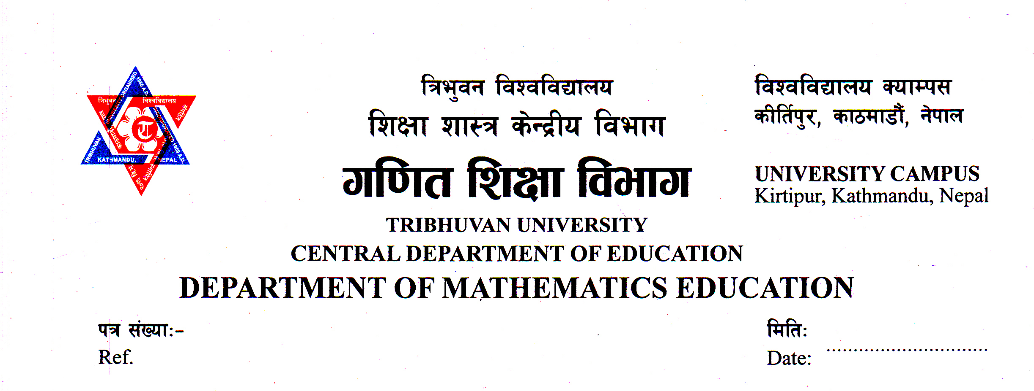

Letter of Certificate
This is certify that Mr. HariKhatri, student of academic years 2071/74 with campus Roll No 247/071, thesis No. 1617, Exam Roll No 28710282 and TU Registration No: 9-2-50-255-2010 has completed his thesis under my supervision for the period prescribed by the rules and regulation of Tribhuvan University, Nepal. The thesis entitled"Causes of the Students Error in Solving Verbal Problem on Fraction: A Case Study" has been prepared based on the results of his investigation conducted during the period of December 2018 to February 2021 under the Department of Mathematics Education, University Campus, Tribhuvan University KirtipurKathmandu. I hereby, recommend and forward that this thesis to be submitted for the evaluations as the partial requirements to award the degree of Master of Education.

…………………………………
(Prof. Dr. Bed Raj Acharya)
Head
Date: 31st March, 2021

© 2021

Copyright
HariKhatri
This document is copyright material. Under the law, no parts of this document may be reproduced without the expressed permission of the researcher.
Defense Date: 7th April, 2021
All Right Reserved

Dedication

To my family

Declaration
This dissertation contains no material which has been accepted for the award of other degree in any institutions. To the best of my knowledge and belief, this thesis contains no material previously published by any authors except due acknowledgement has been made.

…………………………
HariKhatri
Date: 7th April, 2021

Acknowledgements
Firstly, I would like to express my sincere gratitude to my research supervisor Dr. Ganesh Prasad Adhikari Department of Mathematics Education, Tribhuvan
University, Kritipur, providing his valuable time for all sorts of ideas, techniques and information during the research work from the beginning to ending. His enthusiasm, patience, kindness and generosity are over memorable.
I would like to express my greatest gratitude to Prof. Dr. Bed Raj Acharya, Head, Department of Mathematics Education, Tribhuvan University, Kritipur, for his valuable suggestion to accomplish this research work.
Furthermore, I am very much thankful to Assoc. Proof. Laxmi Narayan Yadavfor his valuable suggestion to form this research more academic as an external evaluator.
I am equally thankful to all the teachers of Department of Mathematics Education, University campus, for their valuable comments and suggestion to compute this research work in the present form.

…………………………
HariKhatri

Abstract
This is a study on "Causes of the students error in solving verbal problem on fraction: A case study". The main objective of the study was to explore the causes of error made by students and find the ways to minimize the errors on solving verbal problem on fraction. Class seven 'A' students (6 students) of H. S. S were case students selected by convenience sampling. The qualitative case study was used as a research design and open ended unstructured interview and observation guideline were major tool of this study. Newman's Theory was used as theoretical framework. Causes of students errors was found as lack of motivation, lack of fundamental concepts of fractions, lack of language skill, carelessness and laziness of the students. Causes of reading errors were lack of linguistic knowledge, lack of knowledge to recognize the symbol use in solving verbal problem on fraction. Causes of comprehension errors are students pay only partial attention to the teacher explanation, students often mix-up the rules, students unable to identify the correct operation. The causes of transformation error were lack of concept and meaning of mathematical words/ terms, focuses only the calculation.Causes of process skill error were focus on finding the answer of the problem, lack of use of teaching materials, revision and practice at home. The causes of encoding error was found as due to the carelessness of students, lack of examination and providing feedback. The causes of carelessness error were found as student's ignorance, copying the problem wrongly and dropping alternate sign.
Improve language skill of students, provide fundamental knowledge, appropriate used of teaching materials to develop the concept, more practice during home as well as school, teacher and parents should help to reduce the students error that help to minimize the errors in solving verbal problem on fraction.

Table of Contents
Letter of Certificate i
Letter of Approval ii
Recommendation for Acceptance iii
Declaration iv
Copyright v
Dedication vi
Acknowledgements vii
Abstract viii
Table of Contents ix
Chapters
I Introduction 1-8
Background of the Study 1
Statement of the Problem 4
Research Questions 5
Objective of the Study 5
Rational of the Study 6
Delimitation of the Study 6
Operational Definition of Related Terms 7
II Review of Related Literature 9-25
Empirical Review of Literature 9
In International Context 9
Summary Literature Review 18
In Nepalese Context 19
Summary of Literature Review 21
Reflection 22
Theoretical Literature 22
Newman Criteria for Error Analysis 22
Conceptual Framework of the Study 24
III Methods and Procedures 26-30
Design of the Study 26
Study Side 26
Selection of Participant 26
Tools of the Study 27
Data Collection Procedures 27
Quality Standard 28
Data Analysis Process 29
Ethical Consideration 30
IV Analysis and Interpretation 31-56
Introduction of Sample School 31
Introduction of Case 32
Classification of Errors 34
Causes of Error Committed by Students while Solving Verbal Problem on Fraction 45
Causes of Reading Error 47
Causes of Comprehension Error 48
Causes of Transformation Error 49
Causes of Process Skill Error 51
Causes of Encoding Error 52
Causes of Carelessness Error 53
Pre-requisite Knowledge of Students as Causes of Error 54
Language 55
IV Summary, Findings, Conclusions and Recommendations 57-61
Summary 57
Findings 58
Implications of Study 61
References
Appendices

