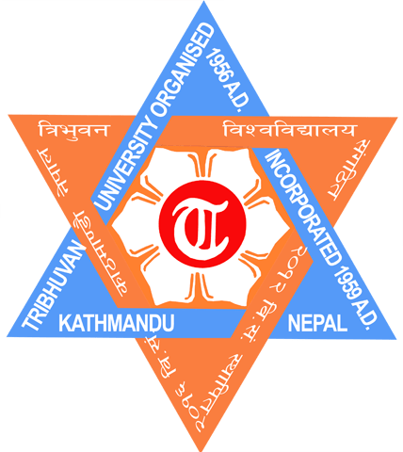

TRIBHUVAN UNIVERSITY

INSTITUTE OF ENGINEERING

PULCHOWK CAMPUS

THESIS NO: 073/MSU/220

Agri/Agro Tourism Planning of Municipalities of Nepal: A Case of
Thaha Municipality, Makwanpur

By:

Suraj Shahi

A THESIS

SUBMITTED TO THE DEPARTMENT OF ARCHITECTURE
IN PARTIAL FULFILLMENT OF THE REQUIREMENT
FOR THE DEGREE OF MASTER OF SCIENCE IN
URBAN PLANNING

DEPARTMENT OF ARCHITECTURE
LALITPUR, NEPAL

AUGUST, 2020
COPYRIGHT

The author has agreed that the library, Department of Architecture, Pulchowk Campus, Institute of Engineering may make this report freely available for inspection. Moreover, the author has agreed that permission for extensive copying of this thesis report for scholarly purpose may be granted by the professors who supervised the thesis work recorded herein or, in their absence, by the head of the Department wherein the thesis report was done. It is understood that the recognition will be giving to the author of this report and to the Department of Architecture and Urban Planning, Pulchowk Campus, Institute of Engineering in any use of the material of this report. Copying or publication or use of this report for financial gain without the approval of the Department of Architecture and Urban Planning, Pulchowk Campus, Institute of Engineering and authors written permission is prohibited. Request for permission to copy or to make a use of material in this in whole or part should be addressed to:

……………………..
Head of Department
Department of Architecture
Pulchowk Campus, Institute of Engineering
Lalitpur, Nepal

APPROVAL

TRIBHUVAN UNIVERSITY
INSTITUTE OF ENGINEERING
PULCHOWK CAMPUS
DEPARTMENT OF ARCHITECTURE

The under signed certify that they have read, and recommended to the Institute of Engineering for acceptance, a thesis entitled “Agri/Agro Tourism Planning of Municipalities of Nepal : A Case of Thaha Municipality, Makwanpur” submitted by Mr. Suraj Shahi (073/MSU/220) in partial fulfilment of academic requirement towards the completion of Master of Science in Urban Planning.

Course Coordinator
Dr. Ajay Chandra Lal
M.Sc. Urban Planning
Department of Architecture

Supervisor
Prof.Dr. JIba Raj Pokharel
M.Sc. Urban Planning
Department of Architecture

External Examiner
Mr. Suresh Prakash Acharya

External Examiner
Prof. Dr. Bharat Sharma

Date: 7th August 2020

ABSTRACT

People engaged in agriculture has decreased from 94.4 (1971) to 65.7 (2001 AD) in Nepal. In Thaha municipality about 51.48 % of agriculture land and 65.52 % involved in agriculture profession. Tourism is now well recognized as an engine of growth in the various economies of the world. Nepal has potential in being one of several other countries that have transformed their economies by developing their tourism potential. Tourism has greater capacity to generate large-scale employment and additional income sources to the skilled and unskilled workforce. Today the concept of traditional agriculture has been changed like the emergence of Agri-Tourism Organic agriculture. Agri-tourism is a way of sustainable tourist development opportunity, alternative sources of income for farmer and multi-activity in rural areas through which the visitor has the opportunity to get close awareness with agricultural areas, agricultural occupations, local products, traditional food and the daily life of the rural people, as well as the cultural elements and traditions of the local communities. A survey method, field studies ,sustainable livelihood assessment and strategic management (SWOT) are utilized in this study to determine the strengths, weaknesses, opportunities and threats in the transition from conventional farming in Thaha municipality and a questionnaire survey based Kobo collect tool and SPSS for analyzing data. This study attempted to discuss the relationship between the environment, social benefits, and facilities as the relevant construct by observing their significant role in assessing Agri Tourism Potential. All the related information to address the objective of the study was extracted through the survey conducted at the potential site involving the residents, entrepreneurs and the farmers. Through analysis the result revealed that all the eight constructs found to be related in promoting the Agri tourism potential at Thaha Municipality Makawanpur.
The purpose of this study is to find out the contextual situation of main Criteria for the destination selection from the group discussion and individual interview survey of the Thaha municipality area among 8 variable as , attraction ,accessibility ,accommodation ,facility ,tourist activities ,actors, affinities-guest-host relationship, management of 8 places Daman, Mulabari, Kunchal, Dadabas, Kotathumki, Indrayanichaura, Chitlang, Lemphu. Total point get from group discussion and interview of eight tourist destination of Thaha municipality that can be identify that weakness and strength of area. It reflects the present situation of Thaha municipality tourism. Thaha municipality is rich tourist attraction point of view. In attraction sector total highest point of 193 obtained. It is nearby capital city Kathmandu and first highway Tribhuwan highway passes from it. Genesh man high way is under construction from where it is 13 km away from Kathmandu. It is found that Thaha is accessible point of view get easily of total point 100. It is found that tourist and business relation very weak and threat for both tourist and hotel, resort owner. In prioritization list Chitlang got good position in compare with other places. Thaha municipality situated in the Mahabharata range there has lot of valley, plain land, hill, (Laka,Besi,Kachhad). Main principle of Planning of Agri tourism based on Traditional System in Hill and mountain region on LAKA< BESI <KACHHAD. Plain region (BESI) of land mainly agriculture production, Middle land (KACHHAD) house build for people, and High land (LAKA) for animal grazing. Planning is done on shareholder basis for the area.
Agricultural irrigated land (Percent of total) 29.74 Percent in 2010 of Nepal’s territory, providing 65. 7 Percent of Agriculture profession. To improve agricultural, agri-tourism in municipalities’ planning and development, a wide range of positive measures should be undertaken. Agri tourism in agricultural lands, when properly managed and developed, plays a major part in agri-tourism and supporting those working in and around agri tourism through jobs and increasing incomes. Based on the analysis of agri-tourism in Thaha municipality, the paper discusses the current status, obstacles and countermeasures for agri-tourism in municipality. Lack of capacity of receiving tourists, 34.52 Percent of Thaha population not involved in agriculture profession and well-educated practitioner are barriers to effective development of agri-tourism in Municipalities. The challenges faced by the operators include expense, lack of capital, interaction with public, marketing, availability of skill labor, training of employees, health, record keeping, and weather and liability issues. In consideration of Agri tourism characteristics, these barriers can be overcome with government rational plans, and professional practitioner’s cultivation.

Thaha municipality found that 75 percentage of respondent aware of word agri tourism. The ways and means of increasing awareness to the farmers, residents and investors skill enhancement and trainings, local guide and tour leader’s trainings, upgrade the origination and management capacity of local lodge/hotel/home stays, training on language and interaction with tourist, training on organic farming.
In this study I have found that awareness and opinion regarding agri-tourism in Thaha municipality. Status of agri-tourism indentified by general situation, SWOT analysis and livelihood assessments of Thaha municipality by qualitative method and eight variables used in quantitative analysis. The proposal of zoning according to Leka,kachhad and besi concept in land use planning and prepare Strategy to promote and sustain Agri tourism in Thaha.

ACKNOWLEDGEMENTS

At first I would like to convey my special appreciation to the Architecture Department of Pulchwok Campus, Lalitpur. I would like to acknowledge my gratitude towards Prof. Dr. Jiba Raj Pokharel for his constant guidance and support throughout this Thesis.

Through the completion of this report, I would like to extend my sincere thanks and heartily gratitude to Mayor Labaser Bista,Thaha Municipality , for his invaluable contribution and also to all other concerned authorities who have helped me directly and indirectly throughout the process.
My special thanks go to all respondents of Thaha municipality and Suraj Kumar Bhujel who were kindly enough to cooperate with me and share their invaluable experiences and perception. I would like to thank Dr Taralal Shrestha, Sujan Bista, Umesh Karki, Srijana Chand for their meaningful time during field visit and data collection.
Last but not the least; I’m very much grateful to my family and thesis Supervisor Prof. Dr. Jiba Raj Pokharel for becoming my pillar of strength during the preparation of this research.

Suraj Shahi
August 2020
TU, IOE

TABLE OF CONTENTS

COPYRIGHT………………..…..…………………………………………………………....I
APPROVAL………….……………………………………………………………………….II
ABSTRACT………………………………………………………………………….…........III
ACKNOWLEDGEMENTS….…………………………………………………….…….......V
LIST OF TABLES …………………………………………………………….…………...XII
LIST OF FIGURES………….……………………………………………….……...….....XIII
LIST OF ACRONYMS…………………………………….………………………….....…XV

CHAPTER ONE: INTRODUCTION
1. INTRODUCTION 1
1.1. Background 1
1.2. About study area 3
1.3. Need of research 5
1.4. Importance of research 7
1.5. Problem statement 8
1.6. Research purpose 10
1.7. Conceptual framework 11
1.8. Data collection approach 14
1.9. The sustainable livelihood framework 14
1.10. Five types of assets or capital 15
1.11. Methodology 16
1.12. Method 18
1.13. Scope 18
1.14. Expected output 18
CHAPTER TWO: LITERATURE REVIEW
2. LITERATURE REVIEW 19
2.1. Tourism 19
2.1.1. Introduction to global tourism 19
2.2. Impact of Tourism 20
2.3. Evolution of tourism 21
2.3.1. Mass tourism 21
2.3.2. Alternative tourism 21
2.4. Sustainable tourism 21
2.5. Planning 22
2.6. Physical development plan 23

2.6.1. The Kathmandu valley physical development plan 24
2.7. History of Agriculture 28
2.7.1. Integrated farming system 30
2.7.2. Integrated crop livestock farming system 30
2.7.3. Animal Husbandry 31
2.7.4. Mixed Crops and Livestock 33
2.7.5. Urban Farming 34
2.8. Agri- Tourism 36
2.8.1. Definition 36
2.8.2. A typology agro-tourism 37
2.8.3. History of agro tourism 39
2.9. Introduction to Tourism in Nepal 39
2.9.1. History 39
2.9.2. Current status 40
2.9.3. Purpose tourist of visit in Nepal 41
2.9.4. Nepal: Total contribution of travel & tourism to GDP 41
2.9.5. Nepal: Total contribution of travel & tourism to employment 42
2.10. Farming system 44
2.10.1. Agri biodiversity 44
2.10.2. Plant diversity 44
2.10.3. Animal diversity 44
2.10.4. Agritourism knowledge 44
2.11. Tourism Act, 2035 (1978) 44
2.12. Tourism Policy 2065 44
2.13. Features of Tourism 47
2.14. Umbrella organization to tourism 47
2.15. Status 48
2.16. Obstacles of agri-tourism development 48
2.17. Countermeasure of agri-tourism development 48
2.18. Issues needing attention for the promotion of Agri-Tourism 48

2.18.1. Publicity 48
2.18.2. Transport 48
2.18.3. Accommodation 48
2.18.4. Networking 49
2.18.5. Safety of tourists, Capacity building of farmers 49
2.18.6. Public-Private partnership 49
2.19. Means and ways for the promotion of agri-tourism. 49
2.19.1. Increase awareness 51
2.19.2. Capacity building 51
2.19.3. Promotion of Agri -tourism 51
2.20. Case study 52
2.20.1. An Overview to Agri-Tourism sector in Poland 52
2.20.2. Agri-tourism Development in Lublin Region 53
2.20.3. The Planning Mechanisms of the Agri- Tourism Development Process 55
2.21. Agri-tourism in Italy 56
2.21.1. An Overview for Agri-tourism Sector in Italy 56
2.21.2. Agri-tourism Development in the Tuscany Region 57
2.22. Conclusion 59
2.23. Agri-Tourism Tourism Centre in India 63
2.23.1. Case Study of Baramati Agri-Tourism Tourism Centre 63
2.23.2. 1971 (Agriculture Development Trust) 64
2.23.3. Present Model Demonstration farm encloses 64
2.23.4. Prioritization of destination 65
2.23.5. Discussions 67
2.23.6. Suggestion 68
2.23.7. Conclusion 68
2.24. Selection of variables 70
2.24.1. Resources collection indicators 70
2.24.2. Resources distribution indicators 70

2.24.3. Management indicators 71
2.24.4. Sustainable tourism indicators 71
CHAPTER THREE: BACKGROUND OF TOURISM IN THAHA
3. Background of tourism in Thaha municipality 73
3.1. Climate and geography 73
3.2. Historical heritage 73
3.3. Religious heritages 74
3.4. Availability of Hiking/Trekking 74
3.5. Place to stay night 74
3.6. Effort of tourism development 76
3.6.1. Private sector 76
3.6.2. Local institution and club 76
3.6.3. Local bodies 76
3.6.4. National bodies 76
3.6.5. Agricultural Products in Thaha municipality 76
CHAPTER FOUR: DATA COLLECTION AND ANALYSIS
4. DATA COLLECTION 78
4.1. Selection of survey 78
4.2. Prioritization of destination 79
4.3. Chitlang 82
4.4. Kunchhal Gaun 86
4.5. Indrayanichaura 87
4.6. Daman-Simbhanjyang 88
4.7. Dadabas –Agra 90
4.8. Mulabari-Mankamana 91
4.9. Lemphu Chiya Bagan 92
4.10. Kotathumki 93
4.11. Socio-personal characteristics of the respondents 94
4.12. Awareness of term Agri-tourism the respondents 95
4.13. Assessment of Activities 96
4.13.1. Financial asset 96
4.13.2. Social asset 98
4.13.3. Human asset 100

4.13.4. Natural asset 101
4.13.5. Physical asset 103
4.14. SWOT Analysis in general 104
4.14.1. Municipal Opportunities 104
4.14.2. Strength 105
4.14.3. Threat 105
4.14.4. Weakness 106
4.15. SWOT Analysis in particular Agri tourism 107
CHAPTER FIVE: FINDINGS
5. FINDINGS 109
5.1. From literature review on Agri-tourism and agri- tourism potential of site 109
5.2. Regarding the agri tourism planning 109
5.3. Regarding the livelihood assessment 110
5.4. Regarding the promotion and awareness of agri tourism 110
CHAPTER SIX: RECOMMENDATION
6. RECOMMENDATION 112
6.1. Planning 112
6.1.1. Proposed zoning of THAHA municipality 112
6.2. Strategy to promote and sustain Agri tourism in Chitlang 113
6.3. Proposal for Agri tourism 113
6.3.1. Route to Agri touristic area 113
6.3.2. Narayanhiti / Tupikhel Area – centerpoint 115
6.4. Capacity building Community level 117
6.5. Hiking/Trekking 117
6.6. Reducing adverse social impacts 120
6.7. Management 120
6.8. Agri based industry 120
6.9. Policy level 121
CHAPTER SEVEN: CONCLUSION
7. CONCLUSION 123

REFERENCES 125
APPENDICES 128

APPENDIX A: Photograph of Thaha municipality………………………..………………………..128
APPENDIX B: Settlement of Thaha municipality………………………….……………………....129
APPENDIX C: Existing land use map……………………………………………….……….…….129
APPENDIX D: Existing Road Networks……………………………….…………….…….………130
APPENDIX E: Existing Map…………………………………………….…………..……………..131
APPENDIX F: Planning Leka,Besi,Kachhad………………………………..……....……….…….132
APPENDIX G: Thaha municipality leka,kacchad and besi conceptual……………..……….…….133
APPENDIX H: Proposed Zoning of Thaha municipality…………………………..…....………….134
APPENDIX I: Existing map of Chitlang ward no 9 Thaha municipality……….…...……….……..135
APPENDIX J: Proposal for Agri tourism area……………………………………………........…...136
APPENDIX K: Agri tourism farm planning…………………………………………….….….……137
APPENDIX L: Questionnaire Survey…………………….………………….…….…….……..…..142
APPENDIX M: Data Group Discussion…………….……………………….…….….…………….149
APPENDIX N: Article………………..…………….……………………………..………………...150

LIST OF TABLES

Table 1.Tourist arrival in Nepal 2017-2018 40
Table 2.Purpose tourist of visit in Nepal 41
Table 3.Economic Growth in Decade (2005/15) Fiscal Year 45
Table 4.The sector wise allocation of total development investment in the Tenth Plan (At the constant price of 2001/02, for the growth rate of 6.2 ) 46
Table 5.The sector wise allocation of total development investment 46
Table 6.SWOT Analyses for Lublin Region 54
Table 7.present Tuscany in numbers 57
Table 8.Differences and similarities between Lublin and Tuscany Regions 59
Table 9.Agri-tourism development and management process 60
Table 10.Tourist views of destination prioritization 68
Table 11.Historical and religious places of Thaha 73
Table 12.Place for Stat night in Thaha municipality 75
Table 13.Schematic view of priotization of destination 79
Table 14.Prioritization of destination 80
Table 15. Schematic view of prioritization of variable 85
Table 16.Schematic view of prioritization of variable 87
Table 17 .Schematic view of prioritization of variable 88
Table 18.Schematic view of prioritization of variable 89
Table 19.Schematic view of prioritization of variable 90
Table 20.Schematic view of prioritization of variable 91
Table 21..Schematic view of prioritization of variable 92
Table 22.Schematic view of prioritization of variable 93
Table 23.Age group 94
Table 24.Family background 94
Table 25.Type of Family. 94
Table 26.Marital Status. 94
Table 27.Total number of family members 95
Table 28.Aware of term Agri - tourism 95
Table 29.To go visit an Agri-tourism farm 95
Table 30.Major Occupation 96
Table 31.Tourism related activities 96
Table 32.Willingness of respondents regarding their participation in agricultural activities on an agri-tourism area 97
Table 33.Educational Qualification 100
Table 34. SWOT Analysis 107
Table 35.Stakeholders analysis 108

LIST OF FIGURES

Figure 1.Thaha municipality slogan of Agriculture, agri –tourism and infrastructure 4
Figure 2.Record of tourist 4
Figure 3.Thaha municipality 4
Figure 4.News of Tistung Mahotsab 4
Figure 5.Map of Thaha Municipality 4
Figure 6.News of Daman travel and tour year 2075 4
Figure 7.DFID 1999, sustainable livelihoods frameworkhttps://www.soas.ac.uk/cedep-demos/000_P528_RF_K3736-Demo/unit1/page_22.htm 14
Figure 8 Generalized land use 27
Figure 9.Tourist arrival in Nepal 2009-2018 40
Figure 10.Nepal: Total contribution of travel & 42
Figure 11.The direct contribution of Travel & Tourism to GDP 42
Figure 12.The total contribution of Travel & Tourism to employment 43
Figure 13.The direct contribution of Travel & Tourism to employment 43
Figure 14. Economic Growth in Decade 2005/15 Fiscal Year 45
Figure 15.Map of the Lublin- Lubelska Region 53
Figure 16.Agri-tourism Development Processes in Lublin Region 56
Figure 17.Tuscany Map 57
Figure 18.Sheme of Agri-tourism Development Processes in Tuscany Region 58
Figure 19. Schematic diagram on prioritization of destination 81
Figure 20.Schematic view of prioritization of variable 81
Figure 21.Group discussion 81
Figure 22. Schematic diagram on prioritization of destination 82
Figure 23.Map of Chitlang 82
Figure 24.Rest house of Rana 83
Figure 25.King rest house 83
Figure 26.Stone temple with nest shape with three Gajur. 83
Figure 27.Chitlang organic resort 84
Figure 28.First goat cheese home stay 84
Figure 29.Alpaka 84
Figure 30.Olive oil farm 84
Figure 31.Schematic view of prioritization of variable 85
Figure 34.Schematic view of prioritization of variable 86
Figure 32.Kunchhal village 86
Figure 33.Kunchhal village 86
Figure 37.Schematic view of prioritization of variable 87
Figure 35.Indrayanichaura Thaha mahostab 87
Figure 36.Overall view of Indraynichaura 87
Figure 38.Schematic view of prioritization of variable 88
Figure 39.Daman 89
Figure 40.Daman view tower 89
Figure 41.Rare bird gray saidead thrass 89
Figure 42.Risheswor Mahadev 89
Figure 43.Schematic view of prioritization of variable 90
Figure 44.Dadabas 90
Figure 45.Gumba 90
Figure 46:Mulabari chaura 91
Figure 48.Schematic view of prioritization of variable 91

Figure 47.Mulabari range 91
Figure 49.Schematic view of prioritization of variable 92
Figure 51:Narbe dunga 92
Figure 50.Surrounding of Lemphu, Jagdada,Liti 92
Figure 52.Schematic view of prioritization of variable 93
Figure 53: Pataleshor cave 93
Figure 54.Kotathumki 93
Figure 55.To go visit an Agri-tourism farm 95
Figure 56.Aware of term agri tourism 95
Figure 58.occupation trend 96
Figure 59.Annual family income 98
Figure 60.Political participation 98
Figure 66.Social participation 99
Figure 61.Religious participation 99
Figure 62.NGO participation 99
Figure 63.Sport club participation 99
Figure 64.Health participation 99
Figure 65..Social club participation 99
Figure 67.Educational Qualification 100
Figure 68.Zoning 112
Figure 69. map of One night two days tour 117
Figure 70.Two/three nigh three /four days tour 118
Figure 71.Four/five night five /six days tour 118
Figure 72.Cycling route 119
Figure 73.(High land)Lake ,Middle Land(Kachhad), Low land(Besi) 121

LIST OF ACRONYMS

CBO-community Based organizations
DFID- Department For International Development
GDP- Gross Domestic Product
NGO-Non government organizations
NWF-Non working farm
MoCTCA -Ministry of Culture, Tourism and Civil Aviation
VDC-Village Development Committee
WFDCA-working farm direct contact, authentic
WFDCS-Working farm direct contact, staged
WFIC-Working farm, indirect contact
WFPC-working farm, passive cont

INTRODUCTION
CHAPTER ONE: INTRODUCTION

Background
People travel for many reasons- for trade or business, for pilgrimage, for recreation, due to war and so on. Tourism becoming hugely popular as a global leisure travel – activity. By 2023 WTTC forecasts that travel and tourism’s total economic contribution will account for 10.4% of global GDP, $10.5 trillion US dollars and 1 in 10 jobs. Over the past five years, one in five jobs were created by the sector, making Travel & Tourism the best partner for governments to generate employment. Travel and Tourism employment is forecast to add over 70 million jobs over the next decade, with two-third of those additional jobs in Asia. Asia will continue to lead growth of the industry, with annual average growth of over 6 %.(http://www.wttc.org/news-media/news-archuve/2018)
WTTC works to raise awareness of Travel & Tourism as one of the world's largest economic sectors, supporting one in 10 jobs (313 million) worldwide and generating 10.4% of world GDP. WTTC conducts research on the Economic Impact of Travel & Tourism in 185 countries for over 25 years. In 2017, the Travel & Tourism industry experienced 4.6% growth, compared to the global economy (3%). One in five new jobs was created by the industry, and is why WTTC is the best partner for governments to create jobs. (https://www.wttc.org/ WTTC 2018, acceded date 2018 -12 -2)
It is quite evident that tourism is an attractive tool for economic development especially to the developing world for its capacity to bring in needed foreign exchange, earning, income and development and employment. Nepal has comparative advantage for tourism development based on its spectacular natural landscapes, geographical differences, and unique cultural, social heritage. Because of its high geological difference, huge mass of people enrolment in agriculture and agriculture land areas of our country are one of the world’s greatest Agri –Tourism attractions. These attractions consists of well –established nature, livelihood and local product, Overnight stays: Lodging and camping ,Bed and breakfast ,Camp sites ,Youth camp ,Farm stays, feeding animals, picking fruit/vegetables ,Rental cabin for day trips / picnics Weddings, receptions, honeymoons, Special events and festivals, Music festivals, Harves festival ,Off the farm, Farmer’s market, Fairs, Roadside stands ,Recreation activities and events, Fee fishing, Biking, Corn maze, Horseback riding, Bird watching, Hiking, Rock climbing ,Fresh products and value-added products: Tourism enhanced direct marketing, Pick your own fruits/vegetables, selling canned foods on farm, selling herbal/organic products ,Youth and/or adult education, Organized tours, Agricultural education programs, Nature education programs , Demonstrations such as wine making, honey making or heritage crafts.
Tourism is major contributor to Nepal’s economy and is widely considered to be one economic activity that has the potential to bring considerable benefits to Nepal. With a rapid increase in population and slow economic development, people are being pressured into exploiting the natural fertile land in a unsustainable manner to meet the immediate needs especially in the rural areas where people depend on the nature for their daily sustenance. Around 66 percent people are engaged in agriculture sector. The percentage of people involved in non-agricultural sectors has reached 34.3% while the percentage of people engaged in agriculture has decreased from 94.4 (1971) to 65.7 (2001 AD).
Agricultural irrigated land (% of total agricultural land) in Nepal was reported at 29.74 % in 2010, according to the World Bank collection of development indicators, compiled from officially recognized sources.
Rural tourism, a type of nature-based tourism, developing on the rural regions makes the sector gain many tourism facilities through the cultural, environmental and historical richness of the rural areas. In a rural context, the growing pressure emerging from the development-intensive nature of tourism, and the expansion of mass tourism, has introduced many new pressures as ‘new tourism’ discovers the qualities of rural environments (Hall&Page, 2002). Agri-tourism is a new type of rural tourism, which is generally implemented in disadvantaged agricultural lands. It is developed as a sector with the aim of not only a development instrument for local people who are dependent on agricultural production but also for sustaining the agricultural lands.
Agri-tourism is defined as a combination of natural settings and products of agricultural operations combined within a tourism experience (Williams et al., 2001): It is developing into a large part of the tourism industry. It is one of the important types of tourism in Germany (Oppermann, 1995).The symbiotic relationship between tourism and agriculture that is found in agritourism is a key element of an environmentally and socially responsible tourism (Kuo and Chiu, 2006).In Nepal, tourism was estimated to contribute about 4 percent of the GDP and about 7 percent of the foreign exchange earnings and has multiplier effects on the economy. The government has come up with new tourism policy 2065 to make tourism industry as one of the major sources of national economy and by tourism vision 2020 by niche production –agri-tourism, community-based tourism, village tourism, eco-tourism etc. (MoTCA, 2009).

Essentially, rural tourism contains agri-tourism. The indicative distinction between these two terms is the implementation areas. While rural tourism enterprises take place generally on rural lands; agri-tourism activities take place on agricultural lands. However, ‘not all tourism which take place in rural areas is definitely rural, it can be urban in form, and merely be located in a rural area’ (Ivona, 2003). Inskeep (1991) categorizes tourism planning approaches in eight groups as continuous, incremental, and flexible approach, systems approach, comprehensive approach, integrated approach, environmental and sustainable development approach, community approach, and implemental approach. In these approaches agri-tourism provides the principles of community approach with its feature of maximum in Agri-tourism are evaluated as one of the main elements of regional tourism plans.

There has been lot of researches in global context on whether economic improvements in local community happen or not after Agri-tourism planning of the certain areas. Although it might be too late to expect major improvements in the case of municipalities in Nepal or Thaha municipality for the agri –tourism planning. The potential of agri tourism in different sector of the Thaha municipality can be identify though this research.

About study area
There are 6 metropolis, 11 sub-metropolis, 276 municipal councils and 460 village councils declared on September 2017 by Government of Nepal in a booklet named "A Brief Introduction to Village Councils & Municipal Councils in Nepal 2017". Municipalities in Nepal are cities and towns meeting minimum criteria set out by the government. These criteria include a certain population, infrastructure and revenues etc. Among these Thaha Municipality selected for case study.
Thaha Municipality is located in the northern part of Makwanpur District in Bagamsti Province. It borders the Kathmandu Valley to the northwest. It has an area of 191.2 km2. The municipality was formed in May 2014 by amalgamating Bajrabarahi, Daman, and Palung village development committees. In 2016/17 Agara, Chitlang and Tistung VDCs were added to form the present day Thaha Municipality. The Naubise–Hetauda part of the Tribhuvan Highway runs through the municipality and provides the main access from neighboring areas. The municipality is named after the Thaha (to know RupachandaBista) Movement, a political movement associated with the area.

Thaha Municipality is known for its climatic variation, biodiversity, fertile lands and tourist places. Simbhanjyang, Daman, Palung and Tistung offer beautiful landscapes. Daman is popular among domestic tourists to enjoy its winter snow and for the spectacular views along the Himalayan range as far as Mount Everest. Thaha also has important Hindu and Buddhist religious sites. The recent opening of the cable car up Chandragiri Mountain in the north of the municipality provides easy access to the Chitlang Valley for tourists
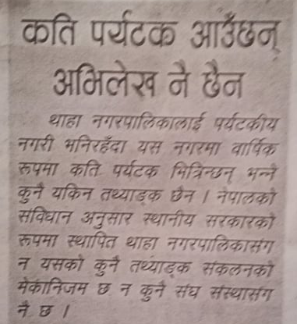
In 2011, the population of Thaha Municipality (current municipal area of 191.2 km2) stood at 41,623.Population loss was highest in Chitlang with an average decline of 1.5% per annum. The main rivers in the municipality are the Shankhamul, Bhadratirtha, Triveni, Rikheshwor, and Gharti rivers. Some of these rivers are important culturally important Indrasarobar.The main occupation of most households in is agriculture (70%) followed by tourism (10%), trade and business (10%) and foreign employment (5%). Vegetables worth about $10 million are exported annually from the area to markets across Nepal and as far afield as India. Thaha is famous for potato growing with much of each year’s crop bought by middlemen. Some farmers have started the commercial farming of kiwi fruits. In some areas urbanization and the resulting loss of farmlands is contributing to locals switching to non-farm occupations. Trade and business has yet to pick up momentum in the municipality.
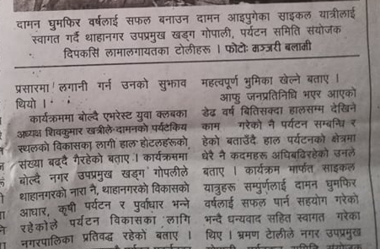
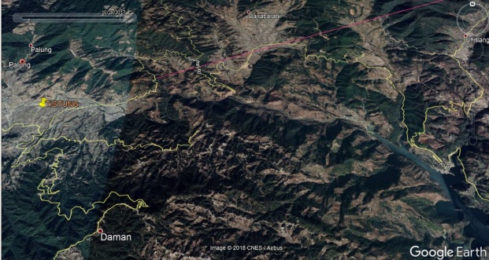

Figure 1.Thaha municipality slogan of Agriculture, agri –tourism and infrastructure
Figure 2.Record of tourist
Figure 3.Thaha municipality

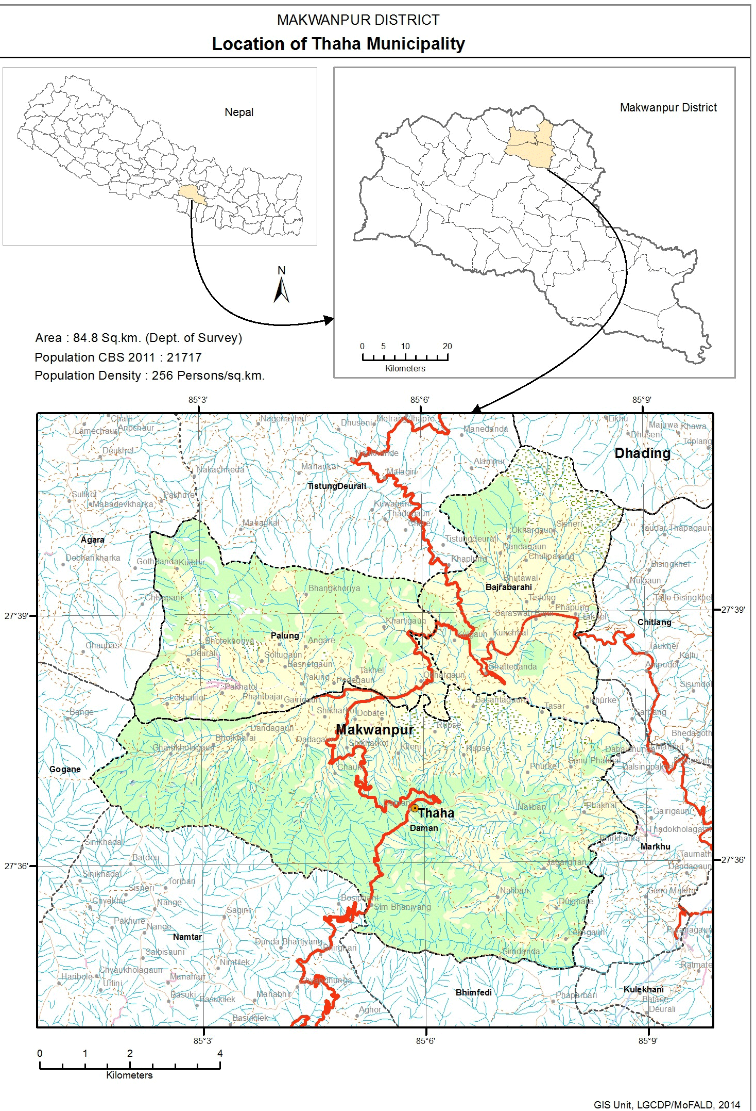
Source: Bikash khabar.com
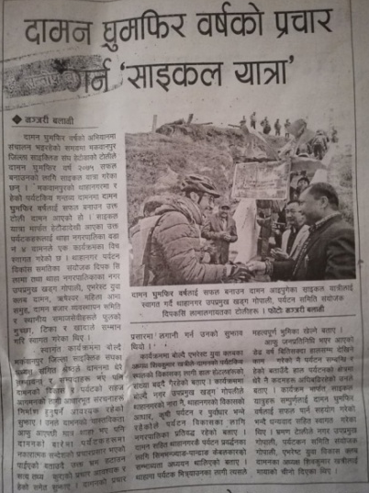
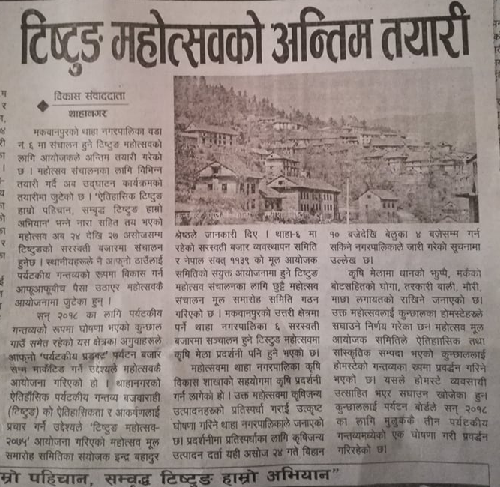

Figure 4.News of Tistung Mahotsab
Figure 5.Map of Thaha Municipality
Figure 6.News of Daman travel and tour year 2075
Source: Thaha Municipality
The area has a number of hotels including large investments in new hotels. Easy accessibility from the Kathmandu Valley means that many of these Cheeses factory, Wine factory and Allo factory are engaging many people in this area. Vedechaura (GOAT development farm) horse riding, picnic spots etc are other part of people interesting in that area.Kotathumki historical place from where Dharahara can easily viewed before destroy in earthquake 2015.The govt. officials as well as experts highlighted and stressed on the importance of preserving the Tangible & Intangible Cultural Heritages of Kunchhal and its surroundings so as to develop it as a tourist destination.
Bajrabarahi lately is being developed as a worthy travel and tourism destination. Specially because it is located ideally and gives easy and fast access to other major tourist destinations here like - Daman, Chitlang, Kulekhani etc.
Research study of Agri-tourism in Thaha will help in highlighting such as economic and social development of the tourism areas benefits. Existence and growth of Agri-tourism business is associated with and driven by both the sides of supply (farmers) and demand (tourists). To overcome the problems of lower income from farming through the related and unrelated diversification strategy farmers (supply side), are forced to supplement their income. Along with this tourists (demand side) increased income and demand for more specialized forms of vacation to experience the environment and nostalgia associated with a working farm enterprise has stimulated growth for tourism activities in case study areas. Pandurang Taware (2008) said about Agri-tourism scope, “The urban population which is having roots in villages always has the curiosity to learn about rural life regarding sources of food, plants, animals, handicrafts, languages, culture, tradition, dresses and rural lifestyle. Agri-tourism has the capacity to satisfy the curiosity of this segment of population.” The need of this study is to understand Agri-tourism from both sides of Agri-preneurs and tourists and thereby to promote agricultural economic development in Thaha municipality.

Need of research
Agri-tourist desires to learn about farm life but as all tourists wants to have confidence, comfort and looks for hygiene rules, desires to taste or buy high quality local products (especially food), has emphasize on environmental protection. A survey study done in Kansas State shows the American agri-tourist behaviors effects on planning of agri-tourism because the farms located close to population centers clearly have a location advantage and tourists are more likely to travel to a destination if there are several tourist stops to visit (Bernardo et. al., 2004).
The major issue is implementing price of vegetable in the market. Farmer who involve in the production of vegetable and fruits cannot got reasonable price. There are different sector which influence the price of local products. There is a demand for new change and the prevailing system cannot address the current issue. Tourist comes to the local area to stay and increase people lifestyle.
In the context of agri-tourism, farmers are searching for an additional source of income to their traditional agricultural practices. While many modern tourists lack an understanding of farming system and farm life. Their desire to be addressed and an appreciation for agritourism as an exciting and unique experience have given farmers an opportunity to support their livelihood and continue to be a part of tourism industry (Curtis and Monson, 2005). The comparative advantages of horticulture, floriculture, and tourism in Nepal are being developed rapidly (Banskota et al., 2000). Nepal is a potential destination for launching agritourism (Dangol, 2007) as various tourism activities are associated in agritourism and the country can avail a lot if its potentials are explored and brought into practice (Singh, 2004).
Hundreds of farmers today staged protest at the Kalimati Fruits and Vegetable Market urging the government to ensure that farmers can fetch better price for vegetables. “Majority of vegetables are rotting in the farmlands owing to low demand in the market. Similarly, farmers are paid very low rates for vegetables, which is insufficient to even cover the production cost,” said TikaAbiral, coordinator of the protest committee.(The Kathmandu post,July 26 2018,).
Locals have supported the idea of developing agriculture tourism at a discussion programme organised by the Thaha Chamber of Commerce and Industries (TCCI) recently. A concept of producing one agriculture item in one village is planned for the development of agriculture tourism in Thaha. (The Himalayan times, December 07, 2018). LabeshorBista, Mayor of Thaha municipality announce concept of Agri –tourism to alleviate poverty and market for products. The most important plan is to make Nepal the number one mountain tourism destination in world as envisioned by the brand and to maximize the tourism benefits by developing Nepal as a premier holiday destination by following the spirit of ‘inclusiveness and sustainable tourism for greater harmony and equitable distribution of income (Cf Nepal tourism sector analysis, 2008).
It has said that Thaha municipality as tourism area but there is no any record of tourist entered in annum. There are no such mechanism found and no such institution management.(Bikash weekly newpaper,26,Nov 2018). Daman and Indrasarobar of Thaha Municipality are listed in 100 tourist destination of Nepal in fiscal year 2075/2076 for the additional promotion of destination for visit Nepal 2020. Daman travel and tour year 2075 have opportunity for the local product which is given priority.
Village Tourism Promotion Forum (VITOF) - Nepal organized a 1 night/2days FAM trip to Kunchhal of Makwanpur district on February 17 & 18, having a motto “every village must be a tourism destination”. Kunchhal Village has also been declared as a tourism destination by Nepal Tourism Board. The trip was supported by Nepal Tourism Board (NTB), Trekking Agencies Association of Nepal (TAAN) Nepal Mountaineering Association (NMA), Gurung Tourism Entrepreneur’s Association (GTEA) and community home stays and local clubs. (http://www.taan.org.np/news/2312-taan-participates-to-promote-kunchhal-as-new-tourism-destination).
District Mayor Ram Krishna Thapa enlightened the potentiality of Agri tourism at Kunchhal village. He said infrastructural development and trainings is must in order to increase the flow of tourist in the upcoming year. He also stated to get a handful support from all local people for developing Kunchhal Village as a tourism destination. Thaha municipality have slogan of Agriculture, tourism, agri-tourism and development which committed in municipal council.
“Agriculture will be given a top priority in budget. It is the back-bone of Nepal’s economy. We have to adopt 21st century agricultural model,” Minister Khanal said (Ibid, May 15, 2018)

Importance of research
Agri- tourism policy taken by the Government of Nepal and seeks to find how much it has been able to solve the problems of rural –urban people. The research results will be useful for analyzing implications in planning of services that have occurred because of agriculture and tourism. It will help local authority in permanent prevention and promotion for Agri tourism.. The knowledge produced from this research will contribute to the policy formulation for agri based community. If looked at the bigger picture, the research findings will help city authority to integrate strategic tools to enhance desirable agri urban design and tourism in urban development plans. Moreover, ultimate objective of policy is capability enhancement, as said by Sen (2000), so more considerations are needed in building meaningful participation. Once the Agri tourism planning assigned to them it will help them to improve their quality of life as they easily get to services.

The findings of the study will help us to give a vivid picture about the kind of farmers who generally go for agri-tourism. Furthermore the study will throw light on the potential entrepreneurs who are willing to increase agri-tourism activities and offer agri products which will be of interest to the tourists and from which they will benefits the maximum. The study will also facilitate in identification of the various problems associated with agri-tourism. Further the present study will act as a good role model to various others farmers who are willing to go for agri-tourism business. Moreover the results of the study will also be helpful to the planners, policies makers and extension personnel to plans necessary policies and programmes on how to promote agri-tourism in Thaha municipality and necessary measures needed to overcome the problems by the farmers can be made accordingly.

Problem statement
Agri-tourism is defined as providing urban visitors a service in the form of accommodation, activities and entertainment in rural or peri-urban farms. It is a form of agricultural multi functionality, which enables rural farmers to provide urban visitors a flavour of rural life – through recreation, farming activities, rural products, farmers are promoting and conserving certain values, and earning additional income (Sonnino, 2004, Barbieri and Mshenga, 2008, Bernardo et al., 2004, Bruch and Holland, 2004, McGehee et al., 2007, Tew and Barbieri, 2012, Veeck et al., 2006).
But the issues are, will Agri Tourism cause pollution to the environment due to the unawareness about the physical development of the agriculture activities. Other than that, do the facilities provided in municipalities are adequate and convenient enough for the tourist to meet the needs and wants. In addition will the Agri Tourism activities be able to provide better employment opportunities among the society itself. With the potential opportunities that can be captured through Agri Tourism activities such as improving the income of small agricultural households and other economic growth (Dorra, 2006), not much attention has been given to agricultural runoff (pesticides and fertilizers) and treatment of urban area sewage entering the river system; causing severe water pollution. The issues of polluted drinking water supply, the severity of several chemicals effects like fecal bacteria, organic pollution, erosion and runoff, solid waste, remained questionable due to lack of management supervision.
For farmers to carry on farming is increasingly difficult as they are facing harsh policies in the context of market reforms and capitalism. Firstly, unpredictable commodity prices in the markets are combining with the rising input costs to make farmers access to credit crucially important for farming. Secondly, the pressure on land from industry, housing and other uses is raising land prices within the peri-urban region, municipalities, and often this makes farming non viable altogether (Munster and Munster, 2012). Thirdly, also, the policies are increasingly favorable to industrial development at the cost of the agricultural sector, and this is leading to a shift of the employment base from farming into manufacturing (Roy, 2009). In this context, agri-tourism is viewed, by policymakers and academics alike, as a way of diversifying farming incomes which enables farmers to potentially remain in agriculture. At the same time, we have argued that agri-tourism's motivations go beyond being purely economic - that they are also incentivized by desires to preserve the cultural and environmental heritage (McIntosh and Bonnemann, 2006), and also maximize environmental benefits for the wider community and future generations.
While urbanization is facilitating agri-tourism, a number of factors are also responsible for a shift towards non-farming employment and declining farming activities within the country. The area suffers from characteristics of unpredictable rainfall, irregular access to irrigation for farmers, inconsistent soil fertility - factors which have traditionally led to the loss of farming livelihoods (Ray, 2009).
Organic local product got market in urban areas. Thaha municipality export organic vegetable and fruits but not get fair price to market due to have middle man in agriculture product. It should have avoided syndicate in Vegetable and fruits.
If farmers have not been pushed out of agriculture altogether, they are forced through structural and political factors to shift into more capital oriented and energy intensive, farming. These trends of disproportionate growth in municipalities are common across several levels, but are especially visible within the divides between the city and countryside. These urban pressures are leading to high levels of agricultural intensification and consolidation into larger farms, which are reliant on high energy inputs and credit based agriculture. Even though, with the aid of green revolution technologies such as HYVs, artificial fertilizer, chemical pesticides, and fossil fuels, the levels of per-hectare production and farming income have risen, this is also leading to the increased dependency of farmers on credit.
The distress within agriculture from higher risk, brought about from unpredictable markets and agri-climactic uncertainties, price of land etc.Increasing trends of counter-urbanization are resulting in the growth of commuter and holiday homes within the peri-urban areas, along with increased connectivity through the growth of transport linkages into the city.
Other activities such as industry, the service sector, education and commercial offices are relocating into agriculture areas to take advantage from cheaper land, resources and infrastructure. These systemic shifts in the control of land are also connected with visual changes, which are increasingly apparent within the landscape. The increasing levels of population-density and construction in agriculture region, makes the urban visually almost indistinguishable from the urban itself.
A wide range of barriers operate to prevent farmers accessing justice on an equal basis with others. These include barriers in the form of laws denying them legal standing; inadequate information or advice, insufficient resources, inaccessible technological design, inaccessible information or communication methods. Of all the barriers facing farmers in accessing justice, perhaps the most prominent are those created by laws which disproportionately affect people perceived to be farmer. (ibid)
Main problem of implementation of plan due to lack of planning initiation in local bodies, geographic conflict, economic activities, employees, tax, offices, culture and ethnical conflict, land development, policy. When we saw the lack of coordination between different department, authorities, administrations in planning implementation they are neglected plan policy which make very bad condition in many areas. The effect of failure can be seen as the haphazard growth of the city and problems that arises due to it in different sectors.

When flooding of 2050 many farmers lost their land and Thaha became poor. With a population today of about 42,000, problems of the Thaha Municipality and its 12 wards are legion. The differential between the poor and the wealthy is becoming more and more serious at the sight of the yearly per capita income in Nepal of currently about $1004.Thaha lost its original economic activities, rather than growing vegetations and food supplies they started growing buildings on their land. Hence, it was necessary to view and protect Thaha through agriculture point of view.

Research purpose
- The main purpose of research is what Agri –tourism is and why it is necessary in Nepal?
- What is Status of agri-tourism in Nepal in general and Thaha municipality in particular?
- Which Ways and means agri-tourism can be promoting through proper planning or physical planning?

Support Questions
- How the existing government policy, legal and institution framework help in implementation process of planning for it?
- What is the potential of Agri –tourism in Nepal in general &Thaha municipality in particular?
- What are the local people’s perceptions of Argi –Tourism?
- What are the contribution, opportunities and threats of Agri –tourism in the context of Daman, Palung. Simbhanjyan, Tistung,Chitlang and Agra.
- How Nepal‘s municipalities can be planned along the following concept of agri-tourism?

Conceptual framework
Blaikie (2000) defined the ontology of a paradigm as the assumptions that are made about the nature of a social reality and what constitute the social reality. Ontology can be defined as “the science or study of being” which deals with the nature of reality exist. It is a system of belief that reflects an interpretation of an individual/ researcher about what constitutes a fact. Thus, ontology is deals with the idea of social realities and how they are perceived as viz. subjective or objective manner. Argi- tourism planning is an evident phenomenon in our context. Factors of agri –tourism are in state of continuous change through time. Marginalized people after agri-tourism and policy can be roughly predicted by understanding the social realities. This researches deals with social scenario of our context in present or in near future. To understand such issues, it is vital to study the social context. The context and time frame of study are vital for development of useful knowledge. So, it is impossible to differentiate the case from the social reality. Issues like agri-tourism are value bond and researcher can’t be separated from the context. This research will be done with inductive logic. The social reality this research is examining is found to be affected by the context of the place. The output of the study of social phenomenon can’t be universal. The research subject will be observed and interpreted with the help of literature and cases. Interpretation will thus be a tool to explain the reality in certain context. This refers the study to be in the scope of interpretivism paradigm. Present context of municipalities of land use change can be studied with the help of various books, articles, journals etc. published by many organizations. It would provide the basic guideline to study the various aspects of agri-tourism like service pattern, structure, infrastructure in different context. By such studies, quantitative and qualitative data regarding municipalities could be interpreted.
The research is both the qualitative research and the quantitative research following descriptive case study strategy. The case study is conducted to the answer the questions like ‘how’ and ‘why’. I have select one of municipalities to know how the Agri-tourism for Thaha municipality and implication of planning in that area. The qualitative research is conducted through the direct observations and the interactive interviews with different stakeholders like the local communities, experts, community-based organizations (CBO), legal authorities, I/NGOs, etc. Simple random sampling probability and non probability purposive sampling are used for sample size determination. The interviews are unstructured interviews with open ended questions. The questionnaire is rechecked after 5 to 6 interviews. Another research strategy is the survey research which was the quantitative research. The survey is the purposive survey for the municipalities, communities of that area. The structured questionnaire survey was carried on location covering ward no 9 Chitlang of the municipality’s communities. It is not possible to conduct sample survey of whole because every ward household ranges from 525 to 919 numbers. In each ward it sample minimum 60 to 105 household. So I have done survey on in each ward of 5 number of household in which represent resident, entrepreneur and farmer of total number of 60 respondents.
To achieve the above mentioned research activities like desk study, field based research, policy dialogues, media related activities and others will be conducted involving concerned stakeholders, experts, researchers etc. After exploring and identifying evidences and promoting evidence-based policy debates with these diverse stakeholders, it will foster common understanding and social learning on ‘how resource is being utilized and exploited, who is being/to be benefited from large scale. On the one hand, it will facilitate informed policy reform in context of agri -tourism. Not only policy reform, it will also inform ongoing social movements with substance and evidence on grabbing and then these movements will further be shaped to respond to minimize any risks in future on the other hand. Hence, it would create a valid bases and evidence to debate of tourism and agri-tourism of different municipalities in Nepal.

Conceptual framework
Sustainable planning and development
Non working farms, working farms
Agriculture product

Improved livelihood

Sustainable (Green tourism), organic agriculture, cultural evolution

Agri –Tourism in Nepal

Tourism Linkage

Municipality/village
Agriculture area
Farmers

Livelihood assets
Human capital
Physical capital
Natural capital
Financial capital
Social capital

Conceptual framework

As seen in the diagrammatic conceptual framework above, this study touches four different scales. The farmer’s condition of communities inside the municipalities triggered my interest in this topic. This condition of the farmers was mainly of limitation of market for products and middleman in agriculture product. Now tourist the tourists coming in from the city have given an opportunity of alternative sources of income. However farmer has not been able to profit from it. If the farmers can be involved in the agro tourism planning they can work for their upliftment with more awareness towards farm works, non - farm works and agriculture products and thus contributing to the sustainable planning ,development and green tourism, organic agriculture and cultural revolution.

Data collection approach
The main issue in the settlement located inside the Thaha municipality is issue of livelihood based on agriculture. The local people living in most of settlement of these area (Palung, Tistung, Daman,Chitlang Bajrabarahi, Agra and Simbhanjyang) are agriculture pron area have economically weak. Due to lack of awareness and alternative means of livelihood these settlements have alcohol prepared from vegetable and grains, increase in use of insecticides and chemical fertilizers in farming, very low price of vegetables. Till date it is assumed that vegetable from these area are organic vegetable but get low price by middlemen.
Agri-tourism has been a priority as a means of improving the livelihood of agriculturist developing countries. They found that on the production side, farmers seem to benefit from the existence of an active farm. A farm producing agricultural goods and tourism services appears to use its production factors in producing tourism firms managed by non-farmers. This context made assessment of the livelihood assets of Thaha municipality the Sustainable livelihood framework given by DFID, 1999 was used for data collection.

The sustainable livelihood framework
The sustainable livelihoods framework in is an effort to conceptualize livelihoods in a holistic way, capturing the many complexities of livelihoods, and the constraints and opportunities that they are subjected to. These constraints and opportunities are shaped by numerous factors, ranging from global or national level trends and structures over which individuals have no control, and may not even be aware of, to more local norms and institutions and, finally, the assets to which the households or individual has direct access.
www.soas.ac.uk/cedep-demos/000_P528_RF_K3736-Demo/unit1/page_22.htm
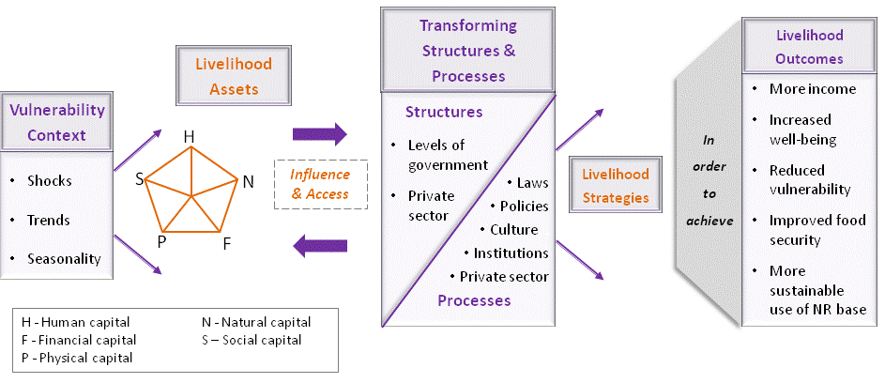

Figure 7.DFID 1999, sustainable livelihoods framework

The vulnerability context refers to the external environment in which people live. This includes trends (such as national or international economic trends, changes in available technology, political systems), shocks (such as illness or death, conflict, weather), and seasonality (of prices, production cycles and so on). The vulnerability context is important because the three factors have a direct impact on the possibilities that farmers have to earn a living now and in the future. Wider economic conditions can create more or fewer opportunities; an illness in the family can deprive a family of an important source of income and can force them to sell important assets that they have built up. Seasonal shifts in prices, production and employment opportunities are one of the most enduring sources of hardship for agri based poor people all over the world.

The transforming structures and processes box refers to the institutions and policies that affect farmer’s lives, from public and private entities to national policies and local culture. All of these can change both the vulnerability context and the assets to which agri based people have access. The record of tourist visit in Thaha has not worked so I have used tool for gravity model for the flow of tourist in municipality and agriculture product which is generated in municipality. The idea of assets is central to the sustainable livelihoods approach. Rather than understanding poverty as simply a lack of income, the sustainable livelihoods approach considers the assets that farmers need in order to sustain an adequate income to live.
Based on those assets, and shaped by the vulnerability context and the transforming structures and processes, farmers are able to undertake a range of livelihood strategies - activities and choices - that ultimately determine their livelihood outcomes. Agri based poor people are usually obliged to combine a range of strategies in order simply to survive; individuals may engage in multiple activities, and the different members of a household may live and work in different places. The outcomes that they may achieve, all being well, could include more income, increased well-being, reduced vulnerability and greater food security.

Five types of assets or capital
These are the following:
- Human capital: skills, knowledge, the ability to work and good health. Good health is not simply a means to earning a livelihood; it is of course an end in itself.
- Social capital: the social resources that people draw on to make a living, such as relationships with either more powerful people (vertical connections) or with others like themselves (horizontal connections), or membership of groups or organizations. Generally relationships of trust, reciprocity and exchange that the poor can draw on in times of need, and that lower the costs of working productively together. Like human capital, social capital has an intrinsic value, good social relationships are not simply a means, and they are an end in themselves.
- Natural capital: the natural resource stocks that people can draw on for their livelihoods, including land, forests, water, air and so on.
- Physical capital: the basic infrastructure that people need to make a living, as well as the tools and equipment that they use. For example, transport and communication systems, shelter, water and sanitation systems, and energy.
- Financial capital: savings, in whichever form, access to financial services, and regular inflows of money.

Methodology
The location of this research is “Agri-tourism” in Palung,Tistung ,Daman,Chitlang,Bajrabarahi,Agra and Simbhanjyang in Thaha municipality of Makawanpur district. The agri-tourism destination offers visiting view tower, cheese factory, wine factory, vegetable gardens, Kotathumki, Goat development farm, cottage industries, and other supporting attractions. Primary and secondary data was collected by conducting in-depth interview with key informants. The data are agri-tourism environment (area, agricultural uniqueness, number of farmer, existing institution), history of agri-tourism development (policy, stage, stakeholders contribution, supporting fund and source), requirement of agri-tourism development (location, attractions, infrastructure and facilities, marketing target), benefit, and barriers of agri-tourism development. These key informants include representatives from government, tourism industries and NGOs, local communities, tourists or visitors. Existing literatures within the agri-tourism development context were critically reviewed. Qualitative and quantitative method is used to analyze the data descriptively and analytical.
Interpretivist/constructivist approaches to research have the intention of understanding "the world of human experience" (Cohen & Manion, 1994, p.36), suggesting that "reality is socially constructed" (Mertens, 2005, p.12) c.f. (Mackenzie & Knipe, 2006). The choice of explanatory research approach for this study was influenced by the goal of the study; which is to seek a better understanding of the current situation of agri –tourism planning. It is an exploratory research focused on determining the major issues underlying agri-tourism planning, as well as on analyzing the strength, weakness, opportunity and threat factors related to the agri-tourism development in Thaha municipality. Research paradigm used as Interpretivist/constructivist and
research strategy follow as Questionnaire survey/ Case study in which Combination of both qualitative and quantitative methods (mixed methods).
SAMPLE SIZE DETERMINATION
Total population: 41623
Total household: 8929
Total number of ward:12
Group discussion three group A<B <C total 78 number from each group 26 and individual discussion: 12 X5 =60, 12 ward of Thaha municipality in which 5 people from each ward (Purposive sample)
Particular (Chitlang Ward no 9) | Ward no 9
Total household(N) | 525
confidence level (z) | 90%
Margin of Error (e) | 10%
Sample Size(n) | 60
Ward | Individual | Total
12 | 5 | 60

Group A | Group B | Group C | Total
26 | 26 | 26 | 78

Method

Scope
Lots of interest of people on agriculture can be revived, if higher economic potential is seen in this field. This study will help in providing the path that can be taken to develop the area from agricultural tourism perspective.
The investigation was carried out only in the Thaha municipality Bagamati province; therefore the results of the study can be generalized for other districts of the country because Nepal is Agriculture based.
Although every effort has been made to get unbiased responses from the respondents, psychological behaviour of not revealing the truth cannot be completely ruled out.
Being a student’s project, it has all the limitations which are common i.e. the limitation of time, money and other resources. The findings of the study are based solely on the expressed opinion of the respondents, field study and the objective to the desired level might not be achieved for extrapolation.

Expected output
- Understanding of agri-tourism planning of municipalities and development of agri –tourism in Nepal and Potential of agri-tourism in municipalities of Nepal
- The data which collected from Thaha municipality will help the agri –tourism potential, means ,ways of promoting of study areas.

LITERATURE REVIEW
CHAPTER TWO: LITERATURE REVIEW

Tourism

Introduction to global tourism
Tourism history starts with the history of mankind. In the past a very concise definition for tourism could be “travelling for pleasure”. However people travel for a wide variety of reasons- religious, for research, for adventures, for business and so on. And thus with time and advancement, tourism is no longer a simple concept. It has become a complex phenomenon. The world tourism organization defines tourist as people “traveling to and staying in places outside their usual environment for not more than one consecutive year for leisure, business and other purpose” (Wikipedia –Tourism).
Over the last six decades tourism has experienced continued expansion and diversification and has become one of the largest and fastest growing industries and economic sector of the world. Despite occasional disturbance, there has been an uninterrupted growth in international tourist arrivals - from 25 million in 1950, to 278 million in1980, 528 million in 1995, 1035 million in 2012 and million in 2017.
In 2017, Travel & Tourism’s direct, indirect and induced impact accounted for: US$8.3 trillion contribution to the world’s GDP, 10.4% of global GDP, 313 million jobs, 1 in 10 jobs around the world US$1.5 trillion exports (6.5% of total exports, 28.8% of global services exports), US$882 billion investment (4.5% of total investment.
The research shows that 2017 was a bumper year for the global Travel & Tourism sector, which grew at 4.6%, much faster than the economy as a whole (3% growth during 2017). Its role as a driver of prosperity is clear, as the sector created 7 million new jobs in 2017, 1 in 5 of all new jobs across the world.
By 2023, WTTC forecasts that Travel and tourisms total economic contribution will account for 10% of global GDP, $10.5 trillion US$ and 1 in 10 jobs. Total travel and tourism employment is forecasts to add over 70 million jobs over next decade, with two –third of those additional jobs in Asia. Asia will continue to lead growth of the industry, with annual average growth of over 6%.
It is quite evident that tourism is an attractive tool for economic development especially to the developing world for its strong multiplier effect and capacity to bring in needed foreign exchange earnings, promoting income and employment in various sectors of the industry.
According to Sharpley (2009) the fact that tourism development is often based on already existing attraction such as wildness area, heritage sites, and beaches, it means that tourism frequently has relatively low start –up costs compared to other industries. Therefore it has been able to grow as a principal economic sector in a significant portion of the developing world – including countries like Nepal, Costarica and Jmaica where finances, skilled labor, and capital resources necessary to establish new industries are scarce. (Khatri,n.d.)
Also because of lack of knowledge and skills most if the developing nation despite having promising economic potential from tourism industry, are still dependent on more affluent nations and have not been able to take full advantage. Most of the profit from tourism I the world usually go back to Honey and Stewart refer to as “the country of departure, “the more affluent nations from which as much as 85 percent of international tourists originate (Khatri,n.d) .Therefore because of this inequitable nature of global distribution of benefit from tourism ,this industry is becoming a target of substantial controversy and criticism. Nonetheless in many cases of developing world, tourism has come to become a vital ingredient of their development policies (Sharpley 2009), as not many other options for development area available to them. And tourism has undoubtedly contributed to their overall socio-economic development.

Impact of Tourism
Tourism is a goose that not only lays a golden egg, but also fouls its own nest.
(Hawkins, 1982 cf Kreag, 2001)
Like most other industries .tourism industry also has both positive and negative impacts. And especially since tourism is about visitors from different places travelling to other places including different social interaction, learning, spending, and earning in this process, tourism in bound to have an impact on the various aspects of a society.
On one hand tourism contributes to an increase in employment opportunities and thus improves the local and national economy. However it is also responsible for the increased price of goods and services causing a significant rise in the cost of living. Although tourism claims to be a “clean “industry,as it does not include any sort of directly polluting element like the furnaces and flues. While it is quite evident that tourism is an attractive tool for economic development. Tourism is also very volatile industry. The visitors quickly abandon the places they formerly visited if they sense any sort of threats to health or security. Tourism affects the economic, socio- cultural and environmental aspects both positively and negatively.

Evolution of tourism

Mass tourism
Mass tourism is a form of tourism that involves tens of thousands of people going to the same resort often at the same time of year. It is the most popular form of tourism as it is often the cheapest way to holiday, and is often sold as a package deal. A package deal is one in which all of the tourists needs are catered for by one company. These needs include travel/flights, activities, accommodation and sometimes food .These types of holiday are often the opposite of sustainable tourism, extreme tourism and ecological tourism.

Alternative tourism
Alternative tourism involves travel that is personal and authentic and encourages interaction with the local environment, people and communities. Alternative tourism includes package tours and individual tourist services in the followingareas : Nature-based tourism - tourism in natural environments, ecotourism, outdoors and adventure including biking, horseback riding, skiing, snow shoeing, rafting, diving, caving and hiking, Culture tourism – rural, cultural heritage, ethnic, religious, wine, cuisine, music and crafts.

Sustainable tourism
Sustainable development is” a process to meet the need of present without compromising the ability of future generation to meet their own needs”.
In 1987: Brundtland Commission/ sustainable development as a superior principle for long-term political choices – Sustainable development requirement: justice to present as well as future societies and within limitations of what nature can bear – Environment/ecology focused objectivities, Distributive justice within and between societies in the present generation, Distributive justice with future generations.
Sustainability: It is the capacity of the responsible entity, be it a family or a local or national government, to service debt, operate, maintain, renew, and/or expand its shelter or service delivery system and pro-poor infrastructure. Sustainability also calls for access to the technical, financial, and human support required for shelter and service delivery through ongoing systems and programs.
Sustainable tourism refers to every form of tourist activity that respects and preserves the natural, cultural and social integrity of the area in the long-term and contributes in a positive and fair way to economic development and to the well-being of the people who live and work in these areas (WTO1998)
Sustainable tourism is the concept of visiting a place as a tourist and trying to make a positive impact on the environment, society, and economy. All tourism activities of whatever motivation – holidays, business travel, conferences, adventure travel and ecotourism – need to be sustainable. Sustainable tourism is defined as “tourism that respects both local people and the traveller, cultural heritage and the environment”. It seeks to provide people with an exciting and educational holiday that is also of benefit to the people of the host country. (http://www.unesco.org/education/tlsf/mods/theme_c/mod16.html)

Planning
Planning is the process of thinking about the activities required to achieve a desired goal. It is the first and foremost activity to achieve desired results. It involves the creation and maintenance of a plan. Globally planning is in a state of flux and is reinventing itself to incorporate many of the characteristics. Traditionally, urban planning has been seen as a means to control and regulate the development of towns and cities. In the cities of the developing world as well as in the post-conflict and post-disaster context, however, these traditional planning approaches have failed to address the challenges of rapid urbanization and the poverty, exclusion, informality and vulnerability which it brings in its wake. At the third session of the World Urban Forum held in Vancouver 2006, discussions on a renewed role for planning in ensuring sustainable urbanization generated enormous interest. Several events brought to the fore several innovative cases and examples of how things are changing.
To plan, very simply, is to arrange beforehand – To arrange Designing Activities Allocating Resources, Implementation Strategy – Beforehand, Clear future vision, objectives and goals setting, Anticipation: fore-casting, Impact Analysis
Deliberate activity of developing an optimal strategy of future action towards a desired set of objectives and goals – Intention to commit resources act as necessary to implement the chosen strategy, No agreement on even what constitutes planning – Planning as definition of end product-description of objectives and benefits (Land use planning, environmental planning, ecological planning, sustainable development planning etc.) – Planning as methodology (participatory planning, strategic planning etc.) – Planning as a process of decision making (Rational planning, ‘muddling through’ etc.).
Planning is a crucial element for long term success because not only it defines the aims, required instruments, time, resources and costs before the realization of the phenomenon but also foresees the required controls and provides the opportunities for revising (Gürsoy, 2006) Generally, planning is a continuous process and must be flexible, depending on changing circumstances, but it should still achieve the basic development objectives (Inskeep, 1991, p: 25-45). Tourism planning system is crucial for ensuring the tourism industry that can develop and thrive, with the aim of maximizing the valuable economic, social and environmental benefits. In other words tourism planning is a disciplinary regulation of the instruments that may be utilized and the opportunities, responsibilities, respondents and timing issues. Tourism plan is also used to gain the targeting benefits in the most sustainable manner possible.
Planning studies for developing a type of tourism in a region or area are first of all dependent on tourism policies of the country. Tourism policy is the whole of the precautions and interventions that are determined by the public administrative units through the general economy politics of the country for developing.

It is aimed to introduce agri-tourism as a planning acting as rural development instrument. Also it is accepted as the sub-sector of rural tourism having its own dynamics operating distinctively from rural tourism. With its two dimensional structure, it combines the various principles of sustainable tourism and sustainable agriculture.
Sustainable Tourism

Sustainable Rural Development

Agri-tourism

Sustainable Agriculture

Two components of sustainable rural development constitute agri-tourism

Physical development plan

A conceptual tool or instrument to respond to the emerging problems of urban growth and development. Organising physical environment to serve development goals, providing spatial structure for different social and economic activities, and formulation of control mechanisms. Guided by the trinity of objectives – economic efficiency, equity and beauty. Multidimensional, Multi-objectives and Multi-disciplinary planning.
Physical planning deals with developing and changing the physical environment into predetermined arrangement of land and resources to facilitate social and economic development. A physical development plan is an adopted statement of policy, in the form of text, maps, and graphics, used to guide public and private actions that affect the future. It provides decision makers with the information they need to make informed decisions affecting the long- range, social, economic and physical growth of a community.
Types of Physical development plan

- Regional physical development plan
- Local physical development plan

Physical planning is done in local or regional level while economic and social planning in national level.

STEPS IN PHYSICAL DEVELOPMENT PLAN

- Portrait of region’s important problem
- Formation of possible solutions
- Solutions proposed by the plan then takes the form of spatially allocated sectoral and cross sectoral programs and projects
- Short term and long term comprehensive plan

The Kathmandu valley physical development plan

Among the many stories regarding the origin of Kathmandu Valley, the most popularly accepted mythological as well as geological evidence is that the Valley once used to be a huge circular lake. Legends relate to Manjushree who drained the water of the lake and established a town between Swayambhu hill and Guhyeshwari.(KVDA, 2013) The planning development in Kathmandu valley was started with the establishment of Town Planning Office in 1962. Lefvert, a town planner, came to work under a UNTA program; in his final report of 1964 he stressed the need to introduce” monumental areas” in the master plan as area for “governmental protection and responsibility”. This was attempt to make master plan of Kathmandu valley. After that in 1967 Carl Pruscha began his study of physical planning for the Kathmandu valley as U.N. town planning expert, giving conservation planning a major impetus.1969 saw the first major result of Mr. Pruscha’s work with the town planning department, the physical development plan for the Kathmandu valley, a policy statement of crucial importance that dealt at length with the need for an integrated conservation plan concerned not only with individual monuments but the entire physical and spiritual environment of Kathmandu valley.(Sekler, 1977) This break the bottleneck on planning approach which leads to plan such as Land Use Plan of the Kathmandu Valley (1976), Bhaktapur Town Development Plan (1977), Beginning of Site and Service Scheme (1979) Strategic Development Master Plan (2015-2035).(Goverment of Nepal, 2014)
The Kathmandu Valley Physical Development Plan was prepared and published officially in 1969 and was the first authentic physical planned prepared for Kathmandu valley. The plan started in the regional context and represented a comprehensive document dealing with legislation, participation of well-informed public, and cultural heritage of the city, integrated development of basic services, amenities, and infrastructure. (Joshi, 1997, p. 77)
The Master Plan is aimed primarily at the documentation and conservation of cultural heritage of the Kathmandu Valley and will attempt to conform to international principles and legislation adopted in the field, but it must also fit fully the pattern of economic and social development of the people of Nepal. Conservation of the cultural heritage, must never be an impediment in the struggle for better condition of human existence. Rather it will enhance existence by investing it with that additional dimension of cultural richness and identify which is indispensable for a ‘good life” in the fullest sense of the term. In addition conservation will create substantial economic benefit because it preserves and enhance features which are important attraction for tourists. Though the Master Plan is restricted to the Kathmandu valley, it was hoped that many of its recommendations are also find applicable in the whole of Nepal.(Eduard F. Sekler et al Raymonf Allchin, 1977)
The physical development plan mainly focused on the land use and infrastructure management. The following objectives were taken in preparing the physical development plan of Kathmandu Valley:
- To preserve the historic and present image of the valley
- To preserve valuable agricultural land, in so far as possible
- To develop an efficient transportation system for the valley
- To reduce the densities of congested areas in the cities
- To try to raise low density city areas to more efficient densities.
- To propose an effective urban renewal programs
- To formulate programs for the development of the villages in the valley
- To prepare a land map use map to be useful over the next 20 years.
The physical development plan for Kathmandu Valley is premised upon two functional objectives: the plan must serve directly as a development tool for the region to which it applies and indirectly as a program positively affecting the socio-economic development of the entire country and the plan is to be a pilot program – a regional physical planning model which will provide the relevant experience necessary for future regional planning efforts in other areas of Nepal. As a development tool for Kathmandu valley, it seeks to capitalize on the man power resources, location, man-made and natural features of the environment and historic legacies of the region in providing a focusing framework for orderly, balanced growth. The plan made an account of the population, settlement pattern, roads, and assessed land use.
The plan proposed land use for Kathmandu Valley with an intensive use of available land and the optimum development pattern for the future so that it should not allow sprawling expansion of existing urban areas but should be one of strengthening and improving existing rural centers and developing new centers on their fringes. The valley shouldn’t only maintain a subsistence level of food production but actually achieve agricultural surplus. Hence, effective land use controls must be enacted to protect present lands under cultivation.
Other land use measures taken were to delineate, protect, preserve, and redevelop the historic cores of Kathmandu, Patan, and Bhadgaon together with those of compact settlements such as Kirtipur, Chapagaon, Thaiba, Khokana, Sankhu etc. Similarly, the plan also proposed to establish new settlement areas of adequate population density standards in Kathmandu and Patan to provide living space for new migrants while alleviating as much as possible. Zoning was done to specify particular land uses, population capacities, and an urbanization sequence. (Joshi, 1997, pp. 158-159)
It also presented the immediate action plan and program such as land use plan for the government center with the provisions of the road use and allocation of office spaces for different departments like electricity, hydrology, meteorology, aviation and taxation. A comprehensive plan for the development of Tribhuvan University was prepared based on a projected figures for students and staffs for 1975. A strong land use control policy to ensure orderly growth was proposed by imposing different levels of interventions in the monument zones, historic district, and areas designated for urban renewal.
The plan also addressed norms for infrastructure development and planning. The roads were categorized into primary circulation roads, access roads, pedestrian circulation system, and public transport. Upgrading and systemization of utilities like water supply, drainage, sewage, and electricity were too proposed.

GENERALIZED LAND USE

Core settlement with scattered
pockets of small settlement

Forest around the periphery
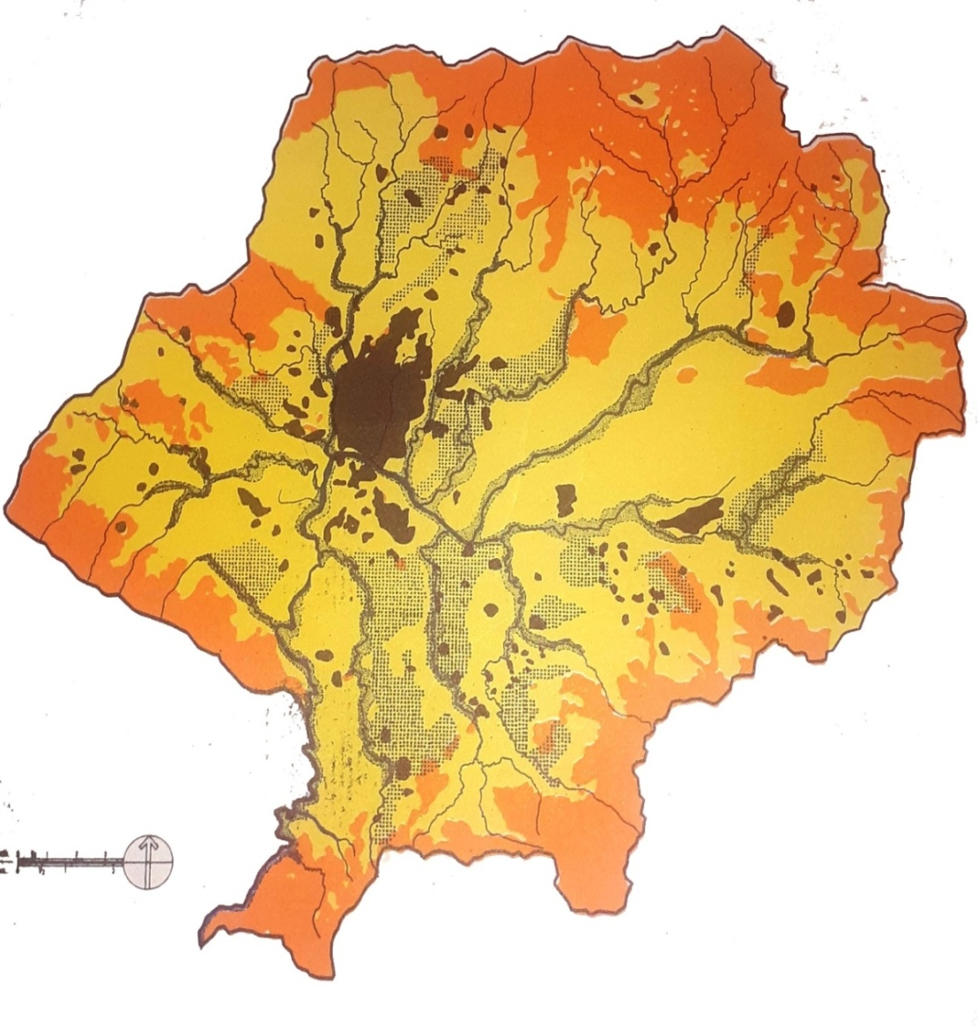

Cultivated land in between
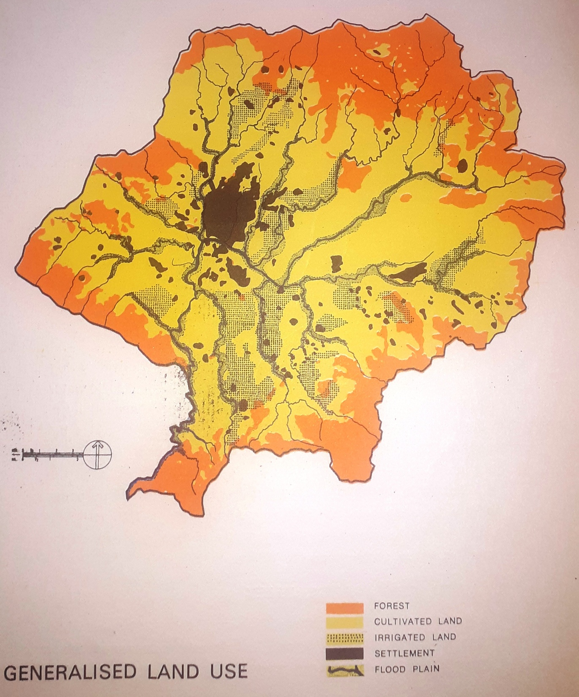

Irrigated land along side
of river and flood plain
Figure 8 Generalized land use

History of Agriculture
Excavations, legends and remote sensing tests reveal that agriculture is 10,000 years old. Women by their intrinsic insight first observed that plants come up from seeds. Men concentrated on hunting and gathering (Paleolithic and Neolithic periods) during that time. Women were the pioneers for cultivating useful plants from the wild flora. They dug out edible roots and rhizomes and buried the small ones for subsequent harvests. They used animal meat as main food and their skin for clothing.
A.Shifting Cultivation
A primitive form of agriculture in which people working with the crudest of tools, cut down a part of the forest, burnt the underneath growth and started new garden sites. After few years, when these plots lost their fertility or became heavily infested with weeds or soil-borne pests, they shifted to a new site. This is also known as Assartage system (cultivating crops till the land is completely worn-out) contrary to the fallow system. Fallow system means land is allowed for a resting period without any crop.
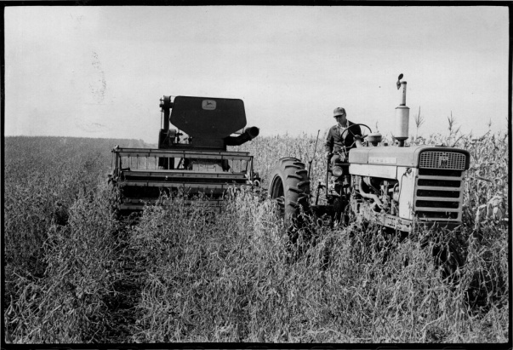
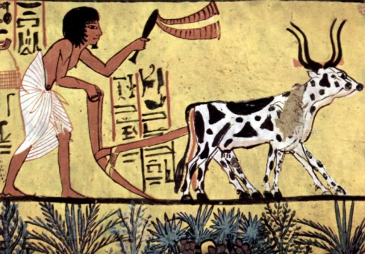

B. Subsidiary Farming
Rudimentary system of settled farming, which includes cultivation, gathering and hunting. People in groups started settling down near a stream or river as permanent village sites and started cultivating in the same land more continuously; however the tools, crops and cropping methods were primitive.
C. Subsistence Farming
Advanced form of primitive agriculture i.e., agriculture is considered as a way of life based on the principle of “Grow it and eat it” instead of growing crops on a commercial basis. Hence, it is referred as raising the crops only for family needs.
D. Mixed Farming
It is the farming comprising of crop and animal components. Field crop-grass husbandry (same field was used both for cropping and later grazing) was common. It is a changing from food gathering to food growing.
E. Advanced Farming
Advanced farming practices includes selection of crops and varieties, seed selection, green maturing with legumes, crop rotation, use of animal and crop refuse as manures, irrigation, pasture management, rearing of milch animals, bullocks, sheep and goat for wool and meat, rearing of birds by stall feeding etc.
F. Scientific Agriculture (19th Century)
During 18th century, modern agriculture was started with crop sequence, organic recycling, introduction of exotic crops and animals, use of farm implements in agriculture etc. During 19th century, research and development (R&D) in fundamental and basic sciences were brought under applied aspects of agriculture. Agriculture took the shape of a teaching science. Laboratories, farms, research stations, research centres, institutes for research, teaching and extension (training and demonstration) were developed. Books, journals, popular and scientific articles, literatures were introduced. New media, and audio-visual aids were developed to disseminate new research findings and information to the rural masses.
G. Present Day Agriculture (21st Century)
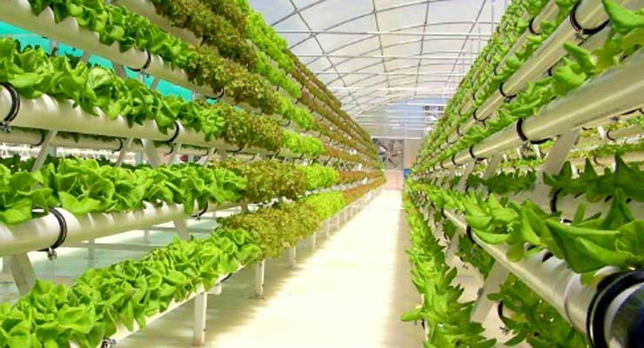
Today agriculture is not merely production oriented but is becoming a business consisting of various enterprises like livestock (dairy), poultry, fishery, piggery, sericulture, apiary, plantation cropping etc.Now, a lot of developments on hydrological, mechanical, chemical, genetical and technological aspects of agriculture are in progress. Governments are apportioning a greater share of national budget for agricultural development. Small and marginal farmers are being supplied with agricultural inputs on subsidy. Policies for preserving, processing, pricing, marketing, distributing, consuming, exporting and importing are strengthening. Agro-based small scale industries and crafts are fast developing. Need based agricultural planning, programming and execution are in progress.

H.Global Agriculture
Advancement of civilization is closely related to agriculture, which produces food to satisfy hunger. The present food production must double to maintain the status quo. However, nearly one billion people are living below poverty line and civilized society should ensure food for these people. Some allowance should be made for increased consumption as a consequence of raising incomes in third world countries. Therefore, the increased food production should aim at trebling food production in the next century

Integrated farming system
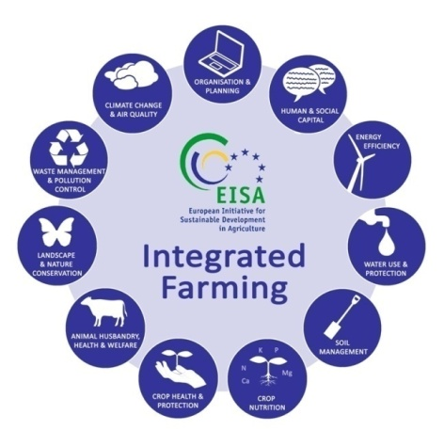
Integrated Farming- UNI 11233-2009 new European agriculture organic standard (IF) or integrated production is a whole organic farm management system which aims to deliver more sustainable agriculture. It is a dynamic approach which can be applied to any farming system around the world. It involves attention to detail and continuous improvement in all areas of a farming business through informed management processes. Integrated Farming combines the best of modern tools and technologies with traditional practices according to a given site and situation. In simple words, it means using many ways of cultivation in a small space or land.
The concept of sustainability is an important element in the development of integrated systems. The MEA (2005) defined it as a characteristic or state whereby the needs of the present and local population can be met without compromising the ability of future generation or population in other locations to meet their needs. Developing countries around the world are promoting sustainable development through sustainable agricultural practices which will help them in addressing socioeconomic as well as environmental issues simultaneously. Within the broad concept of sustainable agriculture “Integrated Farming Systems (IFS)” hold special position as in this system nothing is wasted, the by-product of one system becomes the input for other. Sustainable development in agriculture must include integrated farming system with efficient soil, water crop and pest management practices, which are environmentally friendly and cost effective. Integrated farming system are often less risky, if managed efficiently, they benefit from synergisms among enterprises, diversity produce environmental soundness (Lightfoot, 1990). Moreover, based on the principle of enhancing natural biological processes above and below the ground, the integrated system is the combination that reduces erosion, increases crop yields, soil biological activity and nutrient recycling, helps in efficient use of water, reduces pest and diseases, intensifies land use, improving profits and can therefore help reduce poverty and malnutrition and strengthen environmental sustainability.

Integrated crop livestock farming system
An integrated farming system consists of a range of resource-saving practices that aim to achieve acceptable profits and high and sustained production levels, while minimizing the negative effects of intensive farming and preserving the environment (Lal and Miller, 1990; Gupta et al., 2012). Within this framework, an integrated crop-livestock farming system represents a key solution for enhancing livestock production and safeguarding the environment through prudent and efficient resource use. In integrated crop livestock farming system the waste of one enterprise becomes the input of another for making better use of resources (Tiwari, 1993). For example, crop residues can be used for animal feed, while manure from livestock can enhance agricultural productivity by intensifying nutrients that improve soil fertility as well as reducing the use of chemical fertilizers (Gupta et al ., 2012).

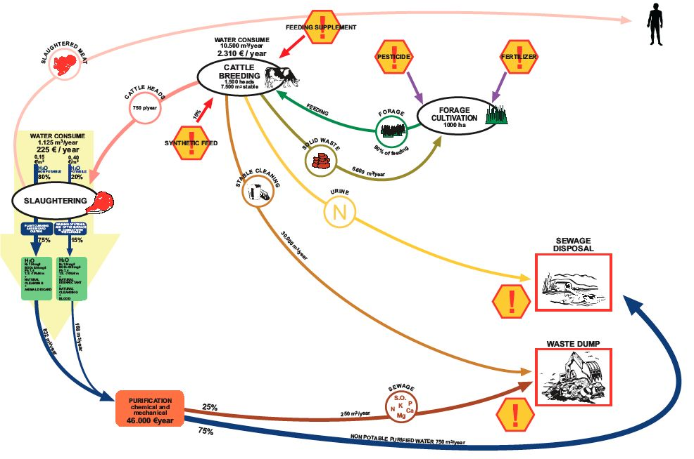

Animal Husbandry
The terms animal husbandry and animal welfare are often interchangeable. Animal welfare is defined by the American Veterinary Medical Association as the “human responsibility that encompasses all aspects of animal well-being, including proper housing, management, nutrition, disease prevention and treatment, responsible care, humane handling, slaughter and, when necessary, humane euthanasia.”
Cows are most productive when their needs are provided for in optimal ways. Cows thrive with comfort and consistency. While dairy farmers inherently know that animal welfare should be a top concern, significant pressure to increase profits may encroach on this consideration as a trade-off for short-term gain. To be successful in the long term, a farmer must provide for appropriate animal health, as “any animal will perform well below potential wherever under nutrition or stress is present.”
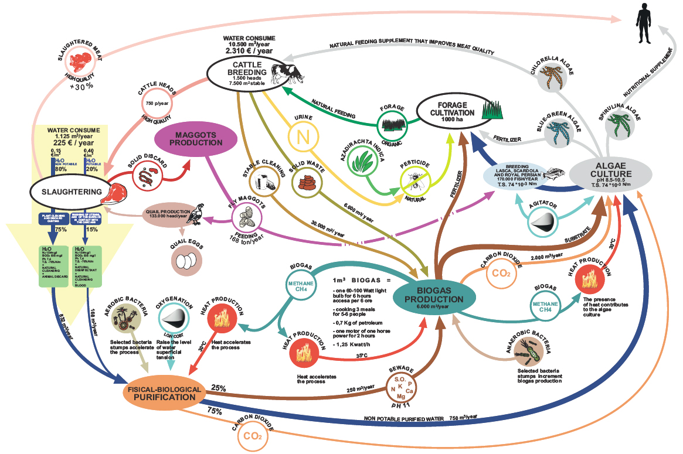
In most cases a farmer only makes a decision that decreases animal well-being under one of two conditions: he/she doesn't have time to do the right thing for the animal or he/she lacks the resources (financial or physical) to improve the situation. This may present a bit of a catch 22 since the farmer needs to build up resources to make structural changes. On the way to building a better-designed facility, the cows are going to be overcrowded in the current facility.
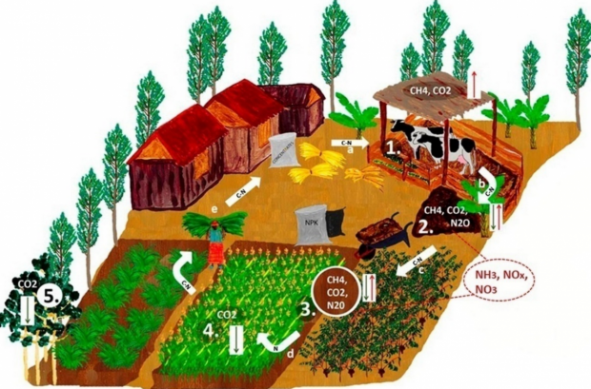
Three main areas should be reviewed in order to ensure optimal performance: nutrition, living conditions, and overall health. Animal nutrition refers to the type and quality of feed that are provided to the dairy cows. They should receive a well-balanced portion of grain to ensure enough energy for milk production and fiber to en sure proper digestion. An imbalance will result in poor milk production and/or health concerns. Living conditions refer to the general comfort of the animal. This includes the quality, size, and cleanliness of the living and milking space. The frequency in incidence of diseases, such as mastitis, lameness, infertility, and certain metabolic disorders can be used as a way to assess impacts on herd health. Nutritional intake an d living conditions are important determinants of herd health. Optimal well-being manifests as good health and high productivity. The ration fed certainly plays a role in the maintenance of health and well-being. Sufficient fiber is required to maintain the health of the rumen. Fiber that is more digestible can be consumed in greater quantities and support higher levels of milk production. The protein and non-protein nitrogen sources must be balanced to match the digestibility of the carbohy- drates in the ration. Acidosis, ketosis, milk fever and other metabolic disorders are usually related to dietary formulation. Mastitis may reflect overall immune status but is usually related to cleanliness of stall bedding and sometimes to milking routine. Heat stress can contribute to depression of immune function and an increase in mastitis, reduction in feed intake and consequent reduction in milk production and potentially a higher incidence of metabolic disease, and also lower fertility. Retained placenta and infertility may also have nutritional causes. Incidences of lameness and displaced abomasums are among the best indicators of herd nutritional health. Lameness may have infectious causes and foot bath management is critical to controlling this problem in many herds.

Mixed Crops and Livestock
It is the most common means of commercial agriculture. It's when you have crops and animals on the same farm. In most cases the animals will be fed some of the crops produced at that location. Once they eat, their manure is used for fertilizer. The crops produced. Some of the crops produced are Wheat, Maize, Rice, Potatoes, Soybeans, and Corn etc. Commercial agriculture is produce or livestock that is sold, rather than fed to the family tending to it. All things grown or raised are sold, then the family later buys their food at the market. Subsistence agriculture rather is when the farmer grows or/ and raises enough for his family to eat on a daily basis, none of it is sold to anyone. It is only used for the purpose of the family. In this case this type of farming is commercial, they will sell their products for money. The some of the livestock produced are pigs, cows, chickens and goats etc.

Urban Farming
Urban farming is distinguished from community gardening or conventional subsistence farming on the level of commerce, the growing of product to be sold as opposed to being grown for personal consumption or sharing; in short it assumes a commercial role absent in the other. Urban agriculture has become a means to increase access to locally grown food and a way of reintroducing the public to the many aspects of food that we have lost as a culture. How food grows, what grows regionally and seasonally are all important lessons and make a better informed urban consumer. Urban farms can be the front line of the food system.
The most striking feature of urban agriculture, which distinguishes it from rural agriculture, is that it is integrated into the urban economic and ecological system: urban agriculture is embedded in -and interacting with- the urban ecosystem. Such linkages include the use of urban residents as labourers, use of typical urban resources (like organic waste as compost and urban wastewater for irrigation), direct links with urban consumers, direct impacts on urban ecology (positive and negative), being part of the urban food system, competing for land with other urban functions, being influenced by urban policies and plans, etc. Urban agriculture is not a relic of the past that will fade away (urban agriculture increases when the city grows) nor brought to the city by rural immigrants that will lose their rural habits over time. It is an integral part of the urban system.
Site
There is no single characterization of size or placement; some are on rooftops, on landfills, brown fields, or areas where housing or industry may have been demolished. Some cities are giving up part of their park systems to allow urban farmers to plant their seeds. Every urban farm is different just as every rural farm is different.
Urban farms can be as simple as traditional small outdoor community gardens, or as complex as indoor vertical farms in which farmers think about growing space in three-dimensional terms. These complex, futuristic farms can be configured in a number of ways, but most of them contain rows of racks lined with plants rooted in soil, nutrient-enriched water, or simply air. Each tier is equipped with UV lighting to mimic the effects of the sun. Unlike the unpredictable weather of outdoor farming, growing indoors allows farmers to tailor conditions to maximize growth.
Benefits of urban farming
- More Productive: Since urban farming can assume vertical direction it can produce as much as 100 times more food than with regular farming. As most urban farms are designed vertically, that allows growing produce in as many levels as possible on a square foot. Weather is a actually a very, very minor factor for food production via urban farming, since it usually takes place indoors and relies on the water system installed, artificial lighting, and nutrients already worked-in in the soil.
- Sustainable: Most urban gardening systems lead to considerable water, power and space savings.
- Organic produce: The main reason something isn't organic is because the farmer is forced to use chemical pesticides to ensure a good yield when the environmental factors are not crop-friendly. Since the weather, the environmental factor is reduced to minimum in urban farming, so there is no actual need for using chemical growth regulators.
- Space friendly: Most of them are compact, neatly-designed "closets" with several shelves, able to grow tens of different plant on each shelf.

Agri- Tourism

Definition
Since, now days the major development in Agri-tourism is taking place all around the world, different forms of Agri-tourism are seen. Agri-tourism gives people the chance to breathe fresh air, learn about rural environment, ride horses, pick fruits, feed animals, milk cows and participate in actual work of farm and buy produce directly from a farm. Agri-tourism helps preserve rural lifestyles and landscape and also offers the opportunity to provide sustainable or green tourism.
Worldwide many terms have been used to convey the idea of Agri-tourism. It is multifaceted and may entail agricultural tourism, agro tourism, farm tourism, farm vacation tourism, wine tourism, agri-tourismo, as well as some related terms that are used interchangeably with Agri-tourism or that are complementary to Agri-tourism include nature tourism, rural tourism, alternative farming, wildlife enterprises, ecotourism, agritainment, heritage tourism, agri education and value added agriculture (Brant and Rhoades, 2007, Cf Walke S.G.)
Since agri-tourism is a new tourism development model. Agri-tourism contributes a lot to the improvement of economic life of the local communities. The contributions are in the form of agricultural products sales, various hand-made souvenirs or handicrafts sold to tourists, opportunities for establishment of food stalls or restaurants and certain types of accommodation such as home-stay, bungalow, villa, and hotel, as well as village development (Utama, 2007).
Sharpley and Sharpley (1997) ‘‘tourism products which are directly connected with the agrarian environment, agrarian products or agrarian stays.”World Tourism Organization (1998) involves accommodation being offered in the farmhouse or in a separate guesthouse, providing meals and organizing guest’s activities in the observation and participation in the farming operations. Agri-tourism for tourists is considered as “anything that connects tourists with the heritage, natural resource or culinary experiences unique to the agricultural industry or a specific region of the country’s rural areas” (Cf Walke,S.G). Agri tourism is a composite of agriculture product, co-product and cultural product, which bears such diverse function as economic, social, educational ,environmental, recreational, therapeutic, etc. agri tourism enables us to rediscover the values of rural resources disregarded in the modernization process of a national economy, giving insights to both farmers and policymakers to adopt a wider perspective than the hither to agricultural product oriented mentality of rural development.( Ohe,2006)
Basic Principles of Agri-tourism: Researcher from Srilanka Dr. S.M.P Senanayke, Rev. Dr. Wijitapure Wimalaratana (2005) also describes the characteristics as a Basic Principles of Agri-tourism which must
- Have something for Tourists to see: Animals, birds, farms, culture of the village, dress and festivals.
- Have something for Tourists to do: Participating in agricultural operations, riding horse, buffalo, cooking and participating in the rural games.
- Have something for Tourists to buy: Rural crafts, fresh vegetables, food are few items.
Non working farm agro-tourism - e.g. accommodation in a converted farmhouse, farm heritage attraction, walking where working farm is not central to tourist activity

A typology agro-tourism
IS THE TOURIST ACTIVITY BASED ON A WORKING FARM?
No

Working farm, passive contact agro-tourism - e.g. farmhouse bed and breakfast

Yes Passive
WHAT IS THE NATURE OF TOURIST CONTACT WITH AGRICULTURAL ACTIVITY?

Working farm, indirect contact agro-tourism - e.g. farm produce served in tourist meals (visiting a winery, crispy chips and/or butter making demonstration)
Indirect

Direct

Working farm, direct contact, staged agro-tourism – e.g. farming demonstration (milking cows, cattle drives, feeding or petting animals)
No
DOES THE TOURIST EXPERIENCE AUTHENTIC AGRICULTURAL ACTIVITY?

Yes
Working farm, direct contact, authentic agro-tourism – e.g. participation in farm tasks (willing workers on organic farming)

A typology for defining agro-tourism (Phillip et al., 2009)

Relation between Agriculture and Agri-tourism As listed in the article entitled, “Alternative forms of occupation and continuous educational training in Agriculture” published by module organization of agro-farms Corporate and Development Center Rzeszow-Poland relations between farm tourism sections and the agricultural ones can be
- Complementary
- Supplementary
- Competitive
- Antagonistic

By considering activities and products systematically according to these five discrete types of agro-tourism can be identified. Non working farm (NWF) agro-tourism could actually be identified as generic rural tourism, realized through agricultural heritage or imagery (e.g. accommodation in the converted farm house), farm heritage attraction (e.g. horse riding), and arguably include farmers markets and farmland access (e.g. walking where the working farm is not central tourist activity). In the working farm, passive contact (WFPC) agro-tourism, the working farm provides the context for tourism but the relationship between tourism and agriculture goes no deeper than that (farmhouse bed and breakfast; outdoor activities). Working farm, indirect contact (WFIC) agro-tourism begins to integrate agriculture on the farm with the tourism product (e.g. visiting a winery or butter-making demonstration). Working farm direct contact, staged (WFDCS) agro-tourism realized through reproduction and/or organization of agriculture for tourism (e.g. farming demonstration). Under working farm direct contact, authentic (WFDCA) agro-tourism tourists experience physical agricultural activities first-hand, for example, pick your own facilities or participation in farm tasks (Phillip et al., 2010).
Agri-tourism supply varies according to the policies, touristic demand, the features of the geography that the tourism activity takes place in and the creativity of the farm operator. In the base of the tourism product there is agricultural production and traditional life style (food, health, handicrafts, house holdings and housekeeping). Blacka et. al.(2001), categorizes the agri-tourism activities in USA into six groups:
Overnight stays:
• Lodging and camping • Bed and breakfast • Camp sites • Youth camp • Farm stays, feeding animals, picking fruit/vegetables • Rental cabin for day trips / picnics • Weddings, receptions, honeymoons
Special events and festivals
• Music festivals • Harvest festival
Off the farm
• Farmer’s market • Fairs • Roadside stands
Recreation activities and events
• Fee fishing • Biking • Corn maze • Horseback riding • Bird watching • Hiking • Rock climbing
Fresh products and value-added products:
• Tourism enhanced direct marketing • Pick your own fruits/vegetables • Selling canned foods on farm • Selling herbal/organic products
Youth and/or adult education
• Organized tours • Agricultural education programs • Nature education programs • Demonstrations such as wine making, honey making or heritage crafts

History of agro tourism
USA - According to the Utah State University Cooperative Extension, visiting family and friends' fields grew in popularity in the1920s, after the invention of the automobile. In the 1930s and 1940s country recreation was seen as a way to get away from the stress brought on by the Great Depression and World War II. As of 2010, an increased interest in food production and organic practices brings travellers out to till the soil.

Introduction to Tourism in Nepal

History

Nepal with rich ancient cultures set against the most dramatic scenery in the world is a land of discovery and unique experience. For broad minded individuals who value an experience that is authentic and mesmerizing, Nepal is the ideal destination. It is unsurpassed that the sheer diversity Nepal boasts, from steamy jungle and Terai to the icy peaks of the world’s highest mountains means that the range of activities on offer. Trekking, mountaineering, rafting in spectacular scenery are just three things Nepal is famous for. Activities as diverse as Elephant Polo and a micro-light flight through the Himalayas show that in Nepal, the only boundary is your imagination. With 15 National & Wildlife Parks (two are UNESCO Heritage sites) Nepal is one of the last places on earth you can spot the Asiatic rhinoceros and the Royal Bengal Tiger.
Tourism is one of the mainstays of Nepalese economy. It is also a major source of foreign exchange and revenue. Possessing 8 of the 10 highest mountains in the world, Nepal is a hotspot destination for mountaineers, rock climbers and people seeking adventures. The Hindu, Buddhist and other cultural heritage sites of Nepal, Nepal is the country of the Mount Everest, the highest mountain peak in the world, and the Birthplace of Gautama Buddha- Lumbini, Mountaineering and other types of adventure tourism.
Only after the introduction of democracy in Nepal in 1950, with the conquest of Mount Everest on 29th May 1953 by Tenzing Norge and Edmund Hillary, Nepal caught the attention of an international audience. The department of Tourism was established in 1978 under the tourism development act. Nepal started its efforts towards a systematic tourism from 1966 with the establishment of a few hotels, travel agencies and other tourism –related infrastructure along with a tourism master plan (Thapa 2012). With the establishment of Nepal tourism board in 1997 and its coordination with Ministry of Culture, Tourism and Civil Aviation (MoCTCA), and other organizations and local bodies, Nepal has tried to improve its image in the tourist market as a destination for holiday, pleasure, adventure and pilgrimage.

Current status
Nepal has tourism growth due to crisis at global level (Gulf war in 1990, crisis in different period) and domestic problems like moist insurgency, political imbalance and earthquake in 2015. There was decreased percentage of tourist during the civil war and earthquake in Nepal. It was reached tourist 1000000 in 14th December 2018.
Table 1.Tourist arrival in Nepal 2017-2018
Tourist Arrival | 2017 | 2018 | %
Air | 760577 | 9692282 | 27.44
Land | 179641 | 203785 | 13.44
Total | 940218 | 1173072 | 24.77
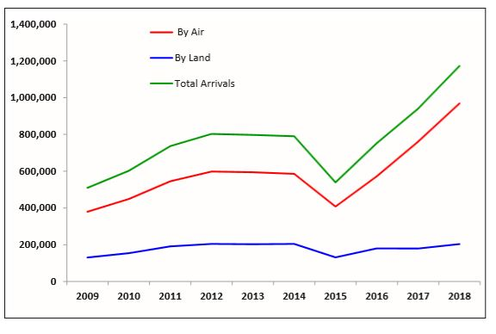

Figure 9.Tourist arrival in Nepal 2009-2018

Three year development plan (2017-2018) aimed to increase the length of stay to 14 days by 2018. It was ranging from 8 to 13.5 days in the past. The analysis of length of stay of 400,000 tourists estimated it as 12.6 days in the year 2017 and in year 2018 as 12.4 stay of 6,53,605 tourists.

Purpose tourist of visit in Nepal
Table 2.Purpose tourist of visit in Nepal
Purpose of visit | 2017 | 2018 | % |  | %
Holiday Pleasure | 658153 | 703843 | 70 | 60 | 6.49
Trekking & Mountaineering | 75217 | 169180 | 8 | 16 | 55.54
Pilgrimage | 141033 | 187692 | 15 | 14.4 | 24.86
Others | 65815 | 112357 | 7 | 9.6 | 41.42
Total | 940218 | 1173072 | 100
Sources: Ministry of culture, Tourism and civil aviation
Number of tourist by purpose of visit is a major indicator for tourism sector output. This indicator is very useful for evaluation of characteristics, type and economic and social contributions made by tourists and to plan and manage infrastructure, services and market economy accordingly. It also shows inflow of high value tourists. Historical data shows more than 50 percent of the tourist arrived with purpose of holiday celebration and pleasure. Year 2017 shows higher proportion (70 %) visited Nepal for holiday and pleasure followed by pilgrimage (15%), adventure (8%) and other purpose (7%).
Tourism industries play pivotal roles in tourist service, service management, increasing revenue. All total 1101 (star and tourist standard hotels) are operated in 2017, with bed capacity 39833 per day. Travel agency, tour guide, tour operators, rafting agencies, trekking agencies and guides all are in increasing number of trend. In 2017 the number of registered Travel agencies reached up to 3824 and Trekking agencies are 2637.

Nepal: Total contribution of travel & tourism to GDP
The direct contribution of Travel & Tourism to GDP in 2017 was NPR99.8bn (4.0% of GDP). This is forecast to rise by 4.9% to NPR104.7bn in 2018. This primarily reflects the economic activity generated by industries such as hotels, travel agents, airlines and other passenger transportation. The direct contribution of Travel & Tourism to GDP is expected to grow by 3.8% pa to NPR152.4bn (4.2% of GDP) by 2028.
The total contribution of Travel & Tourism to GDP (including wider effects from investment, the supply chain and induced income impacts was NPR195.0bn in 2017 (7.8% of GDP) and is expected to grow by 5.2% to NPR205.2bn (7.9% of GDP) in 2018.It is forecast to rise by 3.9% pa to NPR299.5bn by 2028 (8.2% of GDP).

Nepal: Total contribution of travel & tourism to employment
Travel & Tourism generated 497,500 jobs directly in 2017 (3.2% of total employment) and this is forecast to grow by 3.9% in 2018 to 517,000(3.2% of total employment).By 2028, Travel & Tourism will account for 638,000 jobs directly, an increase of 2.1% pa over the next ten years. The total contribution of Travel & Tourism to employment (including wider effects from investment, the supply chain and induced income impacts, was 1,027,000 jobs in 2017 (6.6% of total employment). This is forecast to rise by 4.2% in 2018 to 1,070,500 jobs (6.7% of total employment).By 2028, Travel & Tourism is forecast to support 1,323,000 jobs (7.0% of total employment), an increase of 2.1% pa over the period.

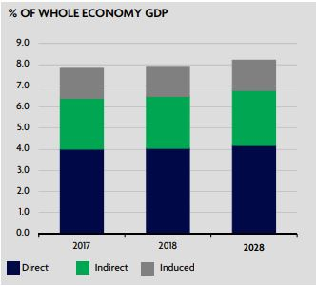
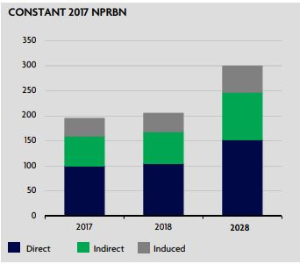

Figure 10.Nepal: Total contribution of travel &
Tourism to GDP

Figure 11.The direct contribution of Travel & Tourism to GDP

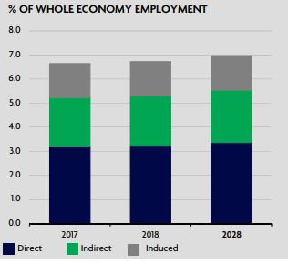
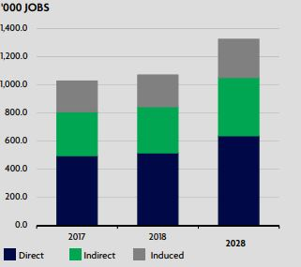

Figure 12.The total contribution of Travel & Tourism to employment
Figure 13.The direct contribution of Travel & Tourism to employment

Nepal’s tourism sector generated Rs240.7 billion in revenue and supported more than 1.05 million jobs directly and indirectly last year, according to the annual World Travel and Tourism Council research report. The country’s gross domestic product stood at 7.9 percent last year, up 3.6 percent.
The Travel and Tourism Economic Impact 2019 report released last month said the industry was expected to create more than 1.35 million jobs directly and indirectly by 2029. The total contribution of the travel and tourism industry to the gross domestic product was Rs195 billion in 2017. The report said that domestic tourists spent 56 percent of the total Rs240.7 billion revenue generated by the tourism industry last year.
Foreign arrivals crossed the one-million mark for the first time in 2018 when the country hosted 1.17 million visitors from abroad. The number of tourists visiting Nepal recorded a 24.77 percent growth over last year. According to the report, leisure travel spending (foreign and domestic) generated 87 percent of the direct travel and tourism gross domestic product in 2018. Business spending accounted for 13 percent of the direct travel and tourism gross domestic product. The Travel and Tourism Economic Impact report said that Nepal is expected to receive 1.2 million foreign visitors this year.

Farming system
The farming system and its relationship with tourism is necessary because farming, fishing and animal husbandry are the principal tourism activities for agritourism.

Agri biodiversity
The components of agriculture that is crop plants and livestock along with their gene providing wild relatives and landraces, bio-control agents and those offering vital ecosystem services such as pollinators, decomposers and which recycle nutrients, is known as agri biodiversity (Thapa, 2006). A study on agri biodiversity was carried out in farmers’ fields to document the diversity of domesticated plants and animals.

Plant diversity
Nepalese home garden are largely vegetable-based, followed by fruits, fodders, medicinal and ornamental plants.

Animal diversity
The main agricultural animals found in comprised of domesticated mammals, birds, fishes and insects.

Agritourism knowledge
All categories of people perceived the term agritourism of including all in their own way. Agritourism knowledge has giving to farmers, visitors and locals.

Tourism Act, 2035 (1978)
It is expedient to make necessary arrangement of health, facility and interest of tourists and Nepalese tourist who visit one place to another place of Nepal and to make economic interest of general people through tourism development.

Tourism Policy 2065
Tourism policy has been formulated with the aims of: increasing national productivity and income; increasing foreign currency earnings; creating employment opportunities; improving regional imbalances and projecting the image of Nepal more assertively in the international arena, through the development and diversification of the travel and tourism industries.
13th and 14th Fiscal year plan motto as attraction and safeguard tourist destination to increase tourist.

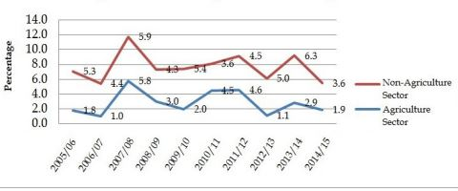

Figure 14. Economic Growth in Decade 2005/15 Fiscal Year

Table 3.Economic Growth in Decade (2005/15) Fiscal Year
 | 2005/6 | 2006/7 | 2007/8 | 2008/9 | 2009/10 | 2010/11 | 2011/12 | 2012/13 | 2013/14 | 2014/15 | Average
Agriculture | 1.8 | 1 | 5.8 | 3 | 2 | 4.5 | 4.6 | 1.1 | 2.9 | 1.9 | 2.9
Non Agriculture | 5.3 | 4.4 | 5.9 | 4.3 | 5.4 | 3.6 | 4.5 | 5 | 6.3 | 3.6 | 4.8
Industry | 4.5 | 3.9 | 1.7 | ,-.6 | 4 | 4.3 | 3 | 2.7 | 6.2 | 2.6 | 3.2
Service | 5.6 | 4.5 | 7.3 | 6 | 5.8 | 3.4 | 5 | 5.7 | 6.3 | 3.9 | 5.4
Economic Growth(Basic Prices) | 3.7 | 2.8 | 5.8 | 3.9 | 4.3 | 3.8 | 4.6 | 3.8 | 5.1 | 3 | 4.1
Source: Central Bureau of Statistics

Table 4.The sector wise allocation of total development investment in the Tenth Plan (At the constant price of 2001/02, for the growth rate of 6.2 )
Sectors | 2001 | 2002 | 2003 | 2004 | 2005 | 2006 | Ave contri of the 10th plan
Agriculture, fishery and forestry | 37 | 37 | 36 | 35 | 34 | 33 | 35
Non agriculture | 63 | 63 | 64 | 65 | 66 | 67 | 65
Industry, geology and mines | 9 | 9 | 9 | 8 | 8 | 8 | 8
Electricity, gas and water | 2 | 2 | 2 | 2 | 2 | 2 | 2
Construction | 7 | 7 | 7 | 7 | 7 | 7 | 7
Business, hotels and restaurants | 16 | 16 | 17 | 16 | 16 | 15 | 16
Transport and communications | 8 | 8 | 9 | 9 | 10 | 12 | 10
Finance and real estate | 11 | 11 | 10 | 12 | 12 | 12 | 11
Community and social service | 10 | 11 | 11 | 11 | 12 | 12 | 11
Gross domestic production | 100 | 100 | 100 | 100 | 100 | 100 | 100

Table 5.The sector wise allocation of total development investment
 | (Rs in million) Amount | Percentage
Agriculture Irrigation and forest | 84400 | 13.84
Non-Agriculture | 525423 | 86.16
 | Purposed in Ninth Plan | Achieved in Ninth Plan | Purposed in Tenth Plan
Agriculture Irrigation and forest | 67438.0 27.1 | 32674.0 19.2 | 56210.0  24.0
Non-Agriculture | 181859.0 72.9 | 137099.0 80.8 | 177819.0  76.0
 | 2069/70 | 13th plan | progress
Agriculture Irrigation and forest average | 1.1 | 4.5 | 2.2
Non-Agriculture average | 4.6 | 6.7 | 3.4
Average economic increase | 3.5 | 6 | 2.9

Features of Tourism
- Nature: The Himalaya Range, hills, Snow Fed Rivers, National Parks and Wildlife Reserves etc.
- Culture: UNESCO Heritage Sites, Living Goddess, 101 ethnic groups and their distinct cultures and traditions, Lumbini, the birth place of Lord Buddha, Events and festivals etc.
- Adventure: Mountaineering, Trekking, Rafting and Kayaking, jungle safari, paragliding, Bungy Jumping, Canyonning, Mountain Biking et.
- Others: Mountain Flights, Ultra light aircrafts, Casinos, Volunteer tourism, Eco-tourism, Green tourism, Sustainable tourism, Bird watching, Sports tourism, Religious Tourism, Yoga and Meditation, Rural Tourism, Community-based tourism, Home-stay etc

Umbrella organization to tourism
Trekking agencies association of Nepal (TAAN),Hotel association of Nepal (HAoN),Nepal association of tour operators (NATO),Nepal association of travel and tour operators (NATTO),Pacific Asia travel association Nepal Chapter (PATA),Tourist guide association of Nepal (TORGAN), Nepal mountaineering association (NMA), Himalayan rescue association ((HRA), Airlines operators association of Nepal (AOAN), Society of travel and tours operators (SOTTO), Nepal mountaineering instruction association (NMIA), Nepal Nation Mountain guide association (NNMGA), Restaurant and bar association of Nepal (REBAN), Nepal air sports association (NASA) ,Nepal Rafting association (NARA)

Status
- Condition, position, state,
- General Situation
- Agri –tourism resource
- Recent Activities

Obstacles of agri-tourism development
- Deficient capacity of receiving tourists
- Deficiency of viewable product processing and valuable farm commodities
- Deficiency of well-educated practitioner

Countermeasure of agri-tourism development
- Making rational plans to improve the capacity issues
- Building visit able plants and providing take-away commodities
- Cultivating professional practitioners

Issues needing attention for the promotion of Agri-Tourism

Publicity
It is difficult to provide publicity to a remote Agri-tourism unit. Hence, either collectively such Agri-tourism operators can provide publicity or organizations like ITDC, State tourism development corporations, NGOs, press and tour operators can take up this responsibility. Information technology can play very important role in promotion of Agro-tourism. An interactive website containing all details about Agro-tourism locations and a toll free 24 hours help line can provide necessary information to Agro-tourists.

Transport
Reaching the remote Agro-tourism units is the greatest challenge due to lack of approach roads and poor transportation facilities in rural areas. Tele connectivity is must which is yet to reach villages. Government should play important role in creating these facilities namely roads, transport and telecommunication to rural areas especially where Agro-tourism units are established on priority basis. These efforts could be effective with private participation in partnership mode.

Accommodation
Safe and clean accommodation is must in Agri-tourism. Urban and foreign tourists look for these minimum facilities. Orienting Agro tour operators on one hand and providing incentive to such efforts on other hand is necessary. Regular clean water supply and neat toilets are important. At the same time, it is necessary to limit modern facilities in which Agro-tourist is not interested.

Networking
Networking public and private stakeholders at national and state level to assist the Agri-tourism operator at remote place is necessary. This network can get policy support, infrastructure and publicity to Agro-tourism units.

Safety of tourists, Capacity building of farmers
Agri-tourism units are located in remote areas which lack roads, medical facilities, telecommunication and sometimes threat from theft and wild animals. Hence, support of local population is must besides facilities for emergency medical care. Farmer need to be oriented on maintenance of facilities, hospitality and public relation which he is not aware.

Public-Private partnership
Agri preneurs, farmers' organizations, cooperatives, NGOs and agribusiness companies can take up these ventures with the help of farmers and government agencies tour operators. Transporters and hospitality industry would also benefit in the process.

Means and ways for the promotion of agri-tourism.
Anonymous (2008) reported the Governments should recognized the importance of rural tourism as a priority and help in creating healthy competitive business environment. Government should try to generate data for decision-making bodies investing for developing the human resources, create adequate facilities and suitable infrastructure like accommodation, roads, airport facilities, rail facilities, local transport, communication links and other essential amenities become essential for development of agri tourism.
A well-trained staff will create most important first impressions for visitors. Clean and attractive grounds, smiling faces, pre planned ways of handling emergencies, and flexibility in arrangements, and a willingness to let the customer be right will create experiences that visitors will remember in a positive way. The best marketing is word of mouth. Visitors who have negative experiences will tell seven other people about that experience. Hospitality training is often available through local extension offices
Regarding marketing strategies Martha (2008) suggested that one can start off with a one page flyer for special events. Important information can be given for example name of any farm, activities or events, hours of operation, location, map, simple drawing or text directions, package etc. The internet is definitely growing as a popular way to advertise. If possible, develop a website. Press releases are useful depending on the media market. There may be local writers who can create attractive press releases at very low cost. Consider special events featuring natural holidays or other local interests. Gift shops are fun for visitors. Even if the inventory is small, attractive settings are a must. Pleasant but not overpowering scents such as cinnamon, apples, pumpkin pie or fresh lemon are attractive draws. A guest book can be an invaluable tool for newsletters and mailings and tracking demographics. Coupons are good giveaways. For an unexpected rainy day, give away plastic bags or disposable hats or even inexpensive umbrellas to visitors who may be inconvenienced by the weather.
Increased marketing may interfere with normal farm activities, and hosting visitors requires dealing with the public, which increases risk and liability. The business operator must be well informed of the many aspects surrounding the safety and liability of starting a new operation or expanding an existing one. Such aspects include understanding and following local, state, and federal regulations regarding zoning, signage, food service, animal exhibits, and health. In order to begin an agri-tourism business, protocol must be met and laws should be carefully followed throughout the lifespan of the business.
The advertising program may include print advertisement s relevant targeted publications, radio advertisement s on targeted stations with specific targeted messages for specific programs, agri-tourism specific television advertisements featuring the businesses and experiences, Google, face book, social media advertising program specifically targeted advertisement s to attract niche audiences for agriculture products.
Online marketing opportunity has to be equally applied for the agritourism sector. Each program has been assigned a website development and maintenance budget, hence developing an online presence for the agri-tourism sector with particular focus on the programs is an important step moving forward. Depending on available budget and resources, the board should consider developing either an agri-tourism website or portal. A portal has many advantages including lower costs as compared to a standalone website and its integration with the regional tourism websites database. In addition, the agri-tourism portal would be in essence part of the regional tourism website yet an independent site capable of answering the needs of the specific target markets.
Government should recognize the importance of farm tourism as a priority and helped in creating healthy and competitive business environment. It should be involved in securing market and price regulations for the various agri-products.

Increase awareness
- Enhance participant’s knowledge and appreciation of the concept of agri-tourism for the increasing farm productivity and creating economic opportunities in rural areas through press release and advertisement.
- Broadcasting of agri-tourism programme through radio and television at least once a week.
- Distribution of brochures with contact information to all other tourism centers, tourist sites, railway stations and bus stand.
- Holding of seasonal events such as festivals.

Capacity building
- Educational programme for farmers entering into farm-based tourism through workshops held by agri-tourism board or state agriculture boards etc. Workshops should be recommended for anyone seeking a loan or grant from any government entity.
- Equip participants with knowledge of the tools and techniques to enhance their skills in planning, management, promotion, and marketing of agri tourism projects and products.
- Conduct outreach activities for agri-tourism operators to promote the tourism calendar of events.
- Training courses should follow a modular approach and consist of lectures, hospitality training, case studies, seminars etc.

Promotion of Agri -tourism
- Subsidy or grants should be given to agri-tourism owners for infrastructure facilities and agri-tourism development
- Accessibility to agri-tourism farms through proper road ways, transportation facilities etc.
- State government and other policy makers should play more emphasis on acquiring more markets and price regulation for agri products.
- Extension personnel should involve in the promotion of agri-tourism in organizing field days.
- Incorporate agri-tourism as a course.

Case study

An Overview to Agri-Tourism sector in Poland
Poland is one of the EU members since 1 May 2004 and it includes the 8,4% of total population of EU with 38.2 millions of population. Poland, the ninth larger country of EU with 312700 square kilometers, with 16 provinces (voivodships), 314 counties (poviats) and 2478 communes (gminas) is an underdeveloped country with a dominant agriculture sector in the whole economy and approximately, 93% of the total territory of Poland is rural (Data is taken from the web site of Polish Ministry of Agriculture).
In Poland, agri-tourism facilities had started to take place as a rural tourism development element in 1990s under the policies of rural tourism development and rural tourism has been an element of the rural development program of the Polish government and the national policy support rural families adjusting to change resulting from economic restructuring (ruraltourisminternational.org).
1990s were the years of adopting the EU market economy criteria and Poland was a weak country with its economy that is dependent on its traditionally agriculture sector after falling down the socialist regime. EU supported Poland not only by financial resources also lead the process of transformation on rural tourism sector to develop as an alternative solution way for the rural families.
In Poland rural tourism organizations are supported by “two funding organizations supporting the rural development: The Agency for Restructuring and Modernization of Agriculture and the Foundation of Assistance - Programs for Agriculture (ruraltourisminternational.org). The Ministry of Agriculture and Rural Development of Poland estimated that “The total number of agri-tourism farms (farm-stays), rural tourism (rural homestays), and eco-tourism accommodation in 2002 as 13154 units, comprising 137164 beds which accommodated 960132 visitor (Hegarty and Przezborska, 2005).
Tourism Administration and experts from EU member states analyzed the tourism potential of Poland and identified five alternative types of tourism products for Poland.
- City and cultural tourism
- Active tourism
- Rural tourism and agri-tourism
- Transit tourism
- Border-zone weekend tourism ( Hegarty and Przezborska, 2005)

Agri-tourism Development in Lublin Region
Lublin Region is one of the eastern Poland regions with the agricultural structure. 57% of the total lands of Lublin Region are agricultural, 23% is forests and %20 is other land. According to the Ministry of Agriculture and Rural Development, there are about 246.000 small farms with the average land area of 6.9ha per farm and sector is in the tendency of development with the encouragements of EU financial support programs.
In Lublin Region, there are 11 associations and 300 agri-tourism farms offer 2500 beds for tourists per year (Szymoniuk, 2003). As it is said above, in Poland Rural Tourism has a women initiative characterization and in Lublin Region about 75% of the agri-tourism farms are owned or managed by rural women.

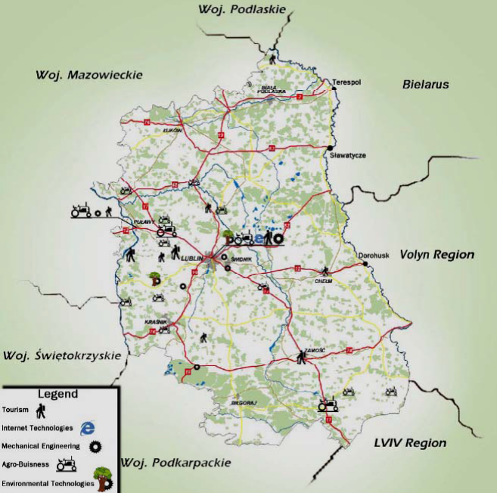

.

Figure 15.Map of the Lublin- Lubelska Region

Source: Map is taken from Sector Profile Report of INTERREG IIIC Project.
Map shows the distribution of the sectors that are tourism, internet technologies, mechanical engineering, agro-business and environmental technologies. ‘According to the Main Statistical Office, 278.600 people are working in the agriculture sector at the end of the 2004’ (Sector profile report of INTERREG IIIC Project). The report also exposes the strengths, weakness, opportunities and threats of the region through a SWOT analyses study in Table.

Table 6.SWOT Analyses for Lublin Region
STRENGHTS | WEAKNESS
- Extremely favorable conditions for agricultural production in the region  - Dominant position in agricultural production of many goods in Poland  - Relatively strong support from sector institutions and organization  - Well developed sphere of agricultural sciences in the region | - High fragmentation of agriculture  - Low qualifications of farmers  - High level of employment in agricultural sector  - Low agricultural productivity  - Insufficient support from food industry  - Rural mentality - reluctance towards change and modernization
OPPORTUNITIES | THREATS
- Good assessment of Polish food products in EU states  - Increase in extra-regional export and in export to international markets  - Expected considerable funds transfers (direct subsidies and resources for investments)  - Rise in income for people employed in this sector | - Competitive products from other EU markets  - Migration from rural areas  - Necessity to adjust agricultural production to EU and international standards

Poland, agri-tourism clusters constitute the core of the agri- tourism development in the local level and the agri-tourism clusters constitute the local associations representing their benefits and rights at the regional and national level. By the way of clustering, the farmers offering agri-tourism services aim to cooperate for their benefits.
Szymoniuk, (2003), categorizes the objectives of the clusters which justify the need to integrate, such as:
- Joint marketing projects
- Supervision of the quality of the services
- Lobbying
- Applications for subsidies
At the regional level there is no regulation or regional law regulating the agri- tourism services.

The Planning Mechanisms of the Agri- Tourism Development Process
Lublin Region
At the regional level, Regional Chamber of Tourism and Consortium of the Tourist Organization are the responsible institutions for the development of tourism in the Region. However, in Poland all types of tourism is planning and managing by the national administration, therefore the role of the regional institutions are not regulative; they provide the information for local people that they need.
Four main mechanisms are described as:
- Legislative-Regulative Support Mechanism: UKFIT’s laws and EU PHARE Program act as the legislative support mechanism. EU PHARE program is a financial and informational support program for the candidate members for EU.
- Financial Support Mechanism: In the Lublin example EU is the only financial supporter mechanism of the development projects, which are developed by the Poland’s national government.
- Monitoring Mechanism: National administrative units implement the monitoring mechanism in addition to the legislative-regulative support role.
- Action Mechanism: Agri-tourism clusters acts as the action mechanism by the supports of the mechanism listed in figure.
- Human Resources Mechanism: The general status of the region members.
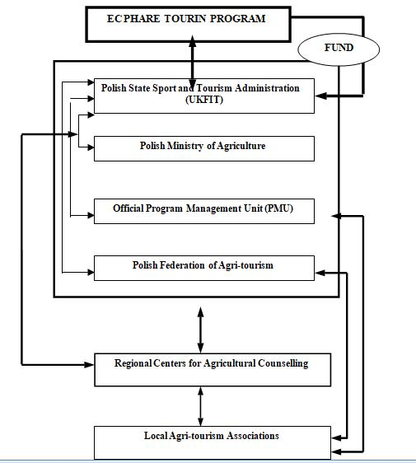

Figure 16.Agri-tourism Development Processes in Lublin Region

Agri-tourism in Italy

An Overview for Agri-tourism Sector in Italy
Italy is known as one of the countries, which have strong agricultural economy in the world. Also, agri-tourism is the fastest growing form of tourism in Italy (Veer and Tuunteer, 2005).
The first and main knowledge about Italian agri-tourism model is its agricultural based dimension. In other words, in Italy agri-tourism is not a tourism activity according to the national law, but an agricultural event because it is aimed to protect the agricultural lands. In Italy, national government acts as one of the three legislative mechanisms with the national law for agri-tourism in Italy. Italian National Framework Law n 730of 5 December 1985 defines the agri-tourism activity as a complementary element to agriculture sector. The law was updated and developed as Law No 96 of 20 February 2006. According to the 2005’s numbers, “the number of farms offering some kind of tourist services has doubled to 12.500 units in 2003 with a turnover of 750 million euros. 10.000 units accommodation, 7.500 units of restaurants, 930 units of camping facilities and 1.520 units of horse riding” (OECD, 2005b).
Italy is known with wine, oil, traditional foods and life styles. For achieving the regional development, structural funds utilized to improve awareness of local people, environmental and cultural values. Tuscany Region has the biggest economy and service on agri-tourism. Region is known in the world by its wines and wine-path tourism.

Agri-tourism Development in the Tuscany Region
“Tuscany is situated in Central Italy and has a population of three and half million people and a geographical extension of about 23 thousand square kilometre, with a density of about 155 inhabitants per square kilometer” (OECD, 2005b).
Tuscany Region attracts tourists by its historical, cultural and environmental properties for the very long times. Regional administrators preferred to develop agri-tourism in the region, although the presence of touristic demand. Tuscany divided into seven territorial systems with 287 municipalities, 10 provinces and 20 mountain communities. (EC, 2006).
Table 7.present Tuscany in numbers
TUSCANY | NUMBER
Population (inhabitants) | 3.565.00
Provinces | 10
Mountain Communities | 20
Communes | 287
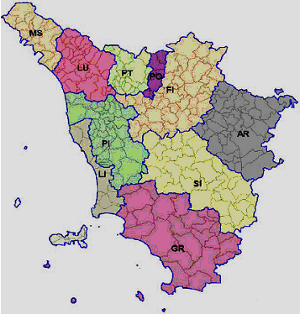

Source: (OECD, 2005b)

Figure 17.Tuscany Map
In Tuscany, agri-tourism activities are planned, managed and financed under the encouragement of the European Rural Development Policies. Agri-tourism sector is developed under the Local action program –LEADER- according to the incitements of the local participation and local responsibilities those also lead to increase in the effects of farm level in the process. Agri-tourism is developed in the region as complementary element for the income. Agricultural product diversification, adding value to the products and direct marketing constitutes the cores of agri-tourism in Tuscany and the regional law introduces the notion as an opportunity and a challenge for rural areas (Sonnino, 2004).
It is seen that the planning process mechanisms work good as a coordination success of the national, regional and local units. Good-working coordination among the different levels; is Scheme in particularly, underlines in the Tuscany model the collaboration of EU and the regional government. Also establishment of LAG (Local Action Groups) make understand the roles of local people in a bottom-up approach of sustainable development process.
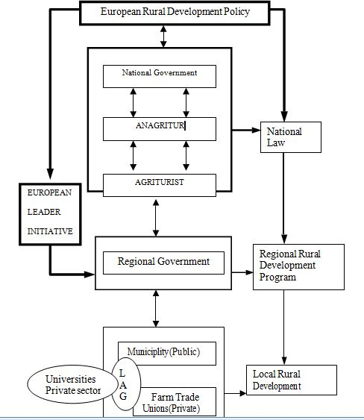
Regional administration has relations within all the levels of Tuscan’s agri-tourism development process. It also makes understand the importance of bottom-up approaches in the development of private sector through the relations for benefits of each group. Therefore, as a general understanding, sustainable tourism development needs the coordination of common benefits of different groups, in other words it encourages a co-operative manner for the competitive groups because of their common benefits.

Figure 18.Sheme of Agri-tourism Development Processes in Tuscany Region

In Tuscan model, there are three political support mechanisms: EU-LEADER Program, Italian National Law, Framework Law n 730of 5 December 1985, as the first one, The Agriculture Sector Orientation and Modernization Law of 15 June 2001 and Regional Laws, Regional Law 5/95, Regional Law 53/ 1997, Regional Law 41/1998, Regional Law 01/2005.
The financial support mechanisms of the process are EU LEADER program. Program provides the financial resource to local projects and directs the regional administration for distribution of the financial resources. Also the National Law n 423 of 30 December 1991 regulates the fiscal regime for the farms serving agri- touristic services through not to reducing but simplification of the taxes.

Conclusion
The types of developmental structure for agri-tourism are examined under the two comparative examples above.
According to the data that is given in above case study the most effective criteria for agri- tourism development should be listed as:
- Bottom-up approach that allows the participation of the local people to the process
- Linking with agriculture sector provides sustainability of agricultural lands and agricultural production
- Advertisement of the sector as a regional/local image
- Specific legislations and regulations for the sector
- Small size of farms are more appropriate for agri-tourism development
- Tourism conscious and culture of the local people effects on the sector positively

Table 8.Differences and similarities between Lublin and Tuscany Regions
CRITERIA/ DIFFERENCES | POLAND -Lublin Region | ITALY-Tuscany Region
Bottom-up approach | Weak | Strong
Linking tourism with agriculture | Weak | Strong
Regional Image | Weak | Strong
Diversification in tourism product | Low | High
Share of agricultural tourism in  overall tourism sector | Very low | Moderate/increasing
Legislative-Regulative  Mechanism | Specialized for tourism  sector | Specialized for agriculture  sector
Financing mechanism | EU-PHARE Program+  National Government | EU- LEADER program +  National Government
Monitoring Mechanism | Central Monitoring | Local Monitoring
Action Mechanism | Weak | Strong
Human Resources Mechanism | Weak | Strong
CRITERIA/ SIMILARITIES | POLAND –Lublin Region | ITALY-Tuscany Region
Size of agri-tourism farms | Small | Small
Tradition of rural tourism | Long | Long

Agri-tourism planning process should be analyzed in five steps.

Table 9.Agri-tourism development and management process
STEPS | PROCESS
1.Identifying the objectives | Identifying the objectives  Comparing the objectives  Integration of the objectives with the more
2. Researches | Quantitative data  Qualitative data  Social, economic, political and environmental factors
3.Analyses and Synthesis | Evaluating the data  Reflection to future of the necessities and capacities
4. Suggestions | Preparation of alternative plans  Deciding upon the most appropriate policies
5.Implication and Management | Implication  Monitoring  Evaluating process

Source: Table that is adopted from Shapley and Sharpley, (1997) is taken from Gündüz, (2004)

Planning processes are:
Legislative-Regulative Support Mechanism

Among the five mechanisms of agri-tourism planning, legislative and regulative mechanism may be evaluated as the primary one because of its directory role on defining the action, determining the activity area, determining the legislative rights, status and the responsibilities of the people in relation with the law, encouragement of the society for the entrepreneurship and gaining the control on the action. Laws on agri-tourism must serve equivalent opportunities and prevent the unfair competitiveness for the benefit groups.
Financial Support Mechanism

This mechanism is the mechanism that constitute of internal and external financial resources that provide the financial requirements of the implementing process. Determining the needed financial amounts and sharing of the funds fairly is crucial and must be regulated in the planning studies. Nowadays there are various institutions providing funds for the development projects in the world. Especially the underdeveloped countries need to benefit from these funds.
Monitoring Mechanism

The overall aim of the monitoring mechanism, that may be identified national, regional and local level, is controlling the established agri-tourism system whether the implementations are appropriate for the rules.

Action Mechanism

Implementing an agri-tourism development plan is dependent on the existence of the determination of the necessities for the action and the required roles. The actors acting on the implementation process, such as NGOs, municipalities, universities, farmer unions and local people, constitute the action mechanism. Action mechanism includes the activities such as innovation on infrastructure, education, and restoration of the accommodation units, advertisement of the project. This mechanism may work in various forms according to the undertaking responsibility of the process and the democracy culture of the societies.
Human Resources Mechanism

Human Resources Mechanism may be identified as the human skills of the community and its relations and socio-economic effects on the market economy.

Agri-Tourism Tourism Centre in India

Village in Khera district of Gujarat to know and participate in milk production, collection, and it’s processing, is something for which both international and inland tourists are always be ready to pay. Farm house in Kashmir valley to be acquainted with the cultivation of saffron and to feed and shear sheep. A grape farmhouse in Maharashtra to see its cultivation, harvesting, and in-house preparation in wines. Organic cultivation of wild turmeric by aboriginals in Kandhamal hills of Orissa are the subjects which will interest many of the tourists particularly those who are urban and are from developed country.

Case Study of Baramati Agri-Tourism Tourism Centre
Name: - Baramati Agri-Tourism tourism Centre, Baramati.
Owner: - Pandurang Taware
Year of Establish:-2004
Area:-110 acre
Total Investment: - 40 lakhs
Subsidy: - 30%
Total Visitors: - 50000(up till 2011)
Visitors in 2010:-9500
Charges: - Rs 500/person/day
Total Revenue 2010:- Rs. 28 lakhs Baramati today is considered as the hub of Co-operative Sugar factories and a place, which receives a strong political back up.
Facts 40 years back
Only 22 villages in the tehsil received water from Neera river left bank canal, and few more villages were fed water from Karha River which presents a picture of prosperity and happiness.
Year 1967
Group of farmers came together to do some concrete rural development work in the Baramati tehsil. Their development work was construction of percolation tanks, providing loans for digging wells, supply of seeds and fertilizers of improved variety and also agricultural equipments. Baramati receives on an average, just 16 -18mm of rainfall for the whole year. Further the entire water is lost due to poor storage facilities. Farmers were restless, they started exploring the ways and solutions and thus the idea of percolation tanks came up. Drought sufferers came forward to share the dream of self-sufficiency.
Year 1968
Tandulwadi village: 1st percolation tanks were constructed providing irrigation to thousand areas of
agricultural land. 250 percolation tanks were executive and computed. To give an impetus to the work accomplish by these group of farmer, the trust was formed on June 22.

1971 (Agriculture Development Trust)
The objective of the Agriculture Development Trust was:-

- To popularize and spread the actual demonstration and cultivation of new varieties of crops.

- To test and spread the use of improved seed varieties.
- To improve methods of crop cultivation.
- To develop vocations supplementary to Agriculture.
- To undertake various projects of water supply.
- To train the farmers for the vocational projects.
- To undertake aforestation in barren and fallow land.
- To educate and provide facilities to poor, promising and deserving women for earning their livelihood.
- Agricultural research laboratory to guide farmers to built library providing books to update farmers knowledge.
- To organize seminars, workshop related to agricultural activities.

Present Model Demonstration farm encloses

- Horticulture Unit.
- Dairy Division.
- Sericulture unit.
- Bee Hive Unit.
- Alternative Energy Unit.
- Krishi Vigyan Kendra.

Analytical Laboratory - Provides farmers about weather, forecast, velocity of wind, and maximum and minimum temperature and undertakes analysis of soil, water, fertilizers animal.
As years passed by Agriculture as a business was becoming more and more expensive that many farmers were not able to afford it. To add to this there was gradual loss of fertility of land giving the farmers to brainstorm to meet the expense by retaining the farm and opening supplementary business unit.

Prioritization of destination

Connectivity
The Agri tourism unit in Malegaon is well connected by Airways; Railways and Roadways. Nearest International Airport: Pune Airport 102 kms. Nearest Railhead: Baramati 10 kms.
Roadways: Mumbai - Pune - Hadapsar - Saswad - Jejuri - Morgaon -Karhawagaj Chowk – Malegaon Kurd - Agri Tourism Destination ,(Malegaon Sheti Farm) Total distance: 95 kms

Attractions
Agri Tourism activities include farm tours, tractor and bullock cart rides, grapes, mangoes, and other horticulture farms and by-product farms, birds and animal farms. The added attractions here are the poultry farm, dairy farm, goat farm and most visited point silk processing unit. The visitors here can also visit the gram panchayat village office and school, village fairs and markets, Jaggery making unit, Emu bird Farm, Sugar factory, Taluka Milk Collection Centers and some of the oldest religious temples and also Museum.

Accommodation
The overnight stay arrangement is at the farm itself, there are 12 rooms and 1 big hall. The occupancy is quadruple sharing every room having 4 single beds. One Room is allotted to each Family.
The accommodation facilities are basic but very hygienic neat and clean. Two toilets (one western style) (and one bathroom attached to block of every three rooms, this arrangement is purposely kept to experience the joint family atmosphere. The Solar Water heaters at the rooftop are fitted to provide the running hot water for bathing in the morning. There is also the facility of dormitory hall, wherein more than 250 people can easily accommodate.

Outdoor Recreational Activities
The outdoor recreational activities for children and adults during day time are farm tours and agricultural education programs, how to grow sugarcane, grapes, pomegranate, guava, watermelon, other fruits and what the food values of each fruits are.
How to take care of the cattle, nature education programs, domestic animals and emu bird farms visits and education of the different trees, demonstrations such as goat and cow milking, honey making, silk making, jaggery making, rural games that they can play as gotya, bovhra,Kabadi, Buffalo ride, bullock cart ride, tractor rides; watching domestic animals, clay molding, painting the nature scenery, tree climbing or simply run with the cycle tree.

Entertainment Programs
The Evenings are generally fun filled, star gazing activity and the rural Maharashtra folk dances and folksong programs is organized. Bonfire/campfire during winter seasons, family games, children games, and lots of fun filled programs.

Meals for Tourists
The food served is pure vegetarian Maharashtrian style, for breakfast Poha, Upma, or Shira, for the lunch usually jawar or bajra bhakri,chapattis, rice, Dal, pickle, papad, kurdaya, bhaji, thecha, wangechebharit, jhunka/pitla, any fresh green vegetable sabji, matki/ chawli usual shabji, etc.

Safety & Security Aspects
The Agri Tourism unit at Malegaon is very safe and secure for all the guests and visitors, there is only one main entrance gate, during daytime almost 400 people work in the farm, plus the entire area of 110 acres is barbed wire fenced and over and above there is adequate 24 hours security persons at the main entrance gate and for the entire area.

Medical Facilities
This Agri Tourism unit is just 1 km from the Malegaon village. Apart from the onsite medical doctor there are specialist doctors available 24hours on call.

Risk and Liability In Case Of Accidents
ATDC has examined the risks associated with some of the activities of agri-tourism.For example: one may decide to ride the bullock cart ride or tractor tailor ride which is not risk free, since there is always a possibility that a guest will fall off the bullock cart or the tractor tailor, however ATDC has established rules and regulations that protects the guests from potential risks.
Sometimes accidents cannot be avoided during agri tourism visits at the farms, However, ATDC makes sure that the operations and the farm activity and the sightseeing tours at the farm and outside the farms to sugar factory, jaggery making unit is safe as possible and they have taken appropriate safety precautions.

Discussions
Based upon a detailed analysis of the case, the following positive outcomes at the Malegaon Village Khurd
- Lives of the farmers changed considerably with the agri-tourism destination venture.
- The farmers today have developed themselves into entrepreneurs.
- They have learned soft skills to handle customer service and to market their product.
- The entire agri-tourism venture has raised the self-esteem of the farmers.
- The agri-tourism venture has a positive effect among the community from a drought prone area where the suicide cases were increasing.
- Today the Agri-Tourism destination has more than 4,300 tourists from urban cities every year from 2005. Besides the year end of 2006 also saw Korean companies coming to enjoy the destination.
- Efficient utilization of the existing natural resources.
A careful analysis and observation of the Case Study of Baramati brings to light certain issues and challenges which need to be addressed by any agri-tourism development body.
These are:
- Danger of over exploitation of natural resources.
- Uncertainty of demand for agri Tourism especially in the light of the fact that other type’s tourism are becoming popular.
- Providing and maintaining hygienic conditions in the agri-tourism destination.
- Danger to Plant life in the form of infectious diseases.
- Lack of sufficient government support.
- Training the farmers.
- Large scale power-cuts.
- Security aspects.

Suggestion

A complete tourism package can be provided through initiation by the local government bodies of activities such as beautification campaigns, sponsorship of special events that tie in with local tourist attractions and participation of all businesses in the area. Good community leadership: Successful tourism promotion and development requires good leadership by open minded and enthusiastic persons from local government, community groups, the business community and non-profit organizations such as chamber of commerce and convention and visitor bureaus.
Support and participation of local government: The role of local government is especially important in the following areas, funding for tourism development and promotion, creating and maintenance of infrastructure necessary for tourism, zoning and maintenance of the community so that it looks clean and appealing to tourists and educational support for farmers.

Conclusion
- India has a great potential to the development of Agri-tourism, because of natural conditions and different types of Agri products as well as variety of rural traditions, festivals.
- Indian tourism industry is growing rapidly. By introducing Agri tourism concept the value addition contributes to future growers.
- Through Agri tourism development farmer can develop themselves into entrepreneur.
- Agri tourism contributes to rural development by creating employment opportunity and empowerment of rural people.
Table 10.Tourist views of destination prioritization
 | Places | Attraction | Connectivity (0-10) | Accommodation (0-10) | Facility (0-10) | Tourist Activities (0-10) | Security (0-10) | GT
1 | Malegaon | 28 | 27 | 23 | 21 | 24 | 25 | 148
2 | Sayogaon | 23 | 21 | 24 | 19 | 23 | 25 | 135

Swot analysis
Strength | Weakness
Un-polluted environment.  High quality of natural attraction. | Poor infrastructure.  Damaged natural and cultural heritage.
Historical background.  Favorable climate. | Lack of financial resources.  No standards, Lack of awareness.
Opportunity | Threats
Development of Agri-Tourism destinations and creation of Agri-Tourism products | Lack of intermediate structures at regional level
Agro-Tourism as a tool for branding local, organic and traditional products | Dominating development of mass tourism
State financial support, Diversification of tourism sector

Selection of variables

The variables for the present study were selected after reviewing the related literature studies the following variables were finally selected for conducting the present study:
Age
Marital status
Type of family
Family back ground
Family size
Educational qualification
Occupation
Social participation
Annual income
Awareness
Opinion
Strategies

Resources collection indicators
Fees taken by tourism board from outgoing tourist
Fees taken by tourism board Padayatri information management system
Airport tax and fees
Hotel, restaurant, tour or trekking, bus fare register fees
Business and personal income tax
Tax or costume for imported good for tourist
Local input tax
Recreational tax
Entry fees
Municipality tax

Resources distribution indicators
Transportation
Lodging
Food
Agriculture
Environment
Attraction
Local people
Culture,Heritages

Management indicators
Quality improvement and supervision, evaluation in between different institution
Activities related to recreational and tourist related activities to coordinate with their ministries for permission, evaluation and supervision
Hotel resort home stay category and rate fixed, policy relates to this
Home stays management karyabidhi
Food security and health inspection from agriculture ministry food technology and quality department periodic lab test

Sustainable tourism indicators
Effective sustainable management | Social ,economical benefit enough participation for community | Development and reduce negative effect for cultural property | Reduce negative effect for environment and environmental protection
Effective sustainable management strategies work plan construction and implementation | High public participation in plan formulation process | Fundamental and special byelaws follow for tourist and local | Practicable and enforceable protection policy construction and implementation to utilize local resources

Evaluate main tourist destination in Thaha municipality according to priority of following variables.
- Attraction (0-10)
- Accessibility (0-10)
- Accommodation (0-10)
- Facility (0-10)
- Tourist Activities (0-10)
- Actors(0-10)
- Affinities-Guest-Host relationship(0-10)
- Management(0-10)

- Environment
- Facilities
- Social benefit
- Agri-tourism potential

Environment
- Nature based river, water fall, flora and fauna
- Historical site
- Socio- economic status
- Level of education
- Age
- Gender
- Ethnic background
Facilities
- Accommodation
- Transportation
- Pace of attraction
- Shopping center
- Food

Social benefit
- Skills
- Experience and career
- Awareness
- Attitude
- Traditional folk/culture

Agri-tourism potential
- Construction
- Hospitality
- Job
- Income
- Service

Background of tourism in Thaha municipality
CHAPTER THREE: BACKGROUND OF TOURISM IN THAHA MUNICIPALITY

Climate and geography
Thaha municipality situated in the Mahabharata range .there has lot of valley, plain land,hill, (Lake,Besi,Kachhad). Agriculture product develops easily due to cold Shitosna climate in this region. Fertile land present in the area of surrounding Thaha. Enough amount of fertile land gift for the agri tourism in this area. Specially vegetable ,fruits, Nagade Bali etc of price of 1 billion rs expert to the main cities and even in India. It is the place for knowing about unseasonal vegetables.70% of population engaged in this field. From 2051 commercial agriculture started mainly in potatoes, cauliflower, cabbage, carrots etc. For the livelihood of the families they also have livestock as cows, buffalos, goat, and cock etc. nowadays lot of people have involved in production of KIBI in this region. Use of fertilizer in the vegetable is the main problem for the people. So municipalities encouraged the organic production from IPM. It can be a model municipality in developing the agri tourism. It can be success in farmer to engaged in employment generate from agri tourism and minimize the problem getting from foreign employment.

Historical heritage
Thaha municipality had connection toward ancient history. According to mentioned in Nepal MAHATMAYA granth palung area consisted as PARAM PAWAN KSHETRA. It was proved that to find ancient inscription in this area. First tourist in Nepal considered as Manjusri, In Thaha municipality Chinese’s tourist Bauddha BHICCHU HWAYAN Sang,Wang huyan,Swang chang was listed. HWAYAN Sang planted tree of MAYAl in this area. In this area we found that inscription and stone inscription from Ansubarma period.
Table 11.Historical and religious places of Thaha
 | place | Features
Ashok chaitya | Chitlang | Samrat Ashok established ashok chaitya
palace | Chitlang | King,rana and special persons ,padal yatra stay,food ,
Syada ghar | Chitlang | Stay room for potters
Ancient Tistung palace | Thah chwok Bajrabarahi | Lichhabi period, Gorkha Army when conqueror devast the palace
Ansubarma inscription | Bhatuwal village Koltar | 31 Bs Swasti Nepalebhya word ,Ansubarma’s Palchok 2 inscription,and 1 in chitlang,in Lichhabi period its main costume border
Udayadev inscription | Chitlang | Majh Gau
Parti,pauwa | Chitlang | Gurjudhara 1500 old 2 no pari pauwa
Sitako Paila | Chitland and Tistung | Top of hill of Chitlang 3 no of foot print of Sitaand Tistung MALAGIRI khola
Rani pkhari | Tistung | Historical pond for bathing of queen
Kot dada | Bajra barahi | Ancient palace
Halthung | Bajrabarahi | Weapon stored
Kot Ghar | Palung | Historical place
Kotthumki | Palung | Historical place
Sulikot | Agra | Historical place where Muktan king hanged
Damgade | Agra | Historical place where before gold, silver etc hide Muktan king hanged
Sangram khola | Palung | In 1819 two time Prithi Narayan Shah fight in this Khola with Sena, nobodies drink water of this Khola because of blood of sena mixed in .Only one house remain at that time which is in decay stage at present time

Religious heritages
Thaha municipality is rich in cultural heritage. Thaha municipality have both tangable and intangible historical and cultural heritage.

Availability of Hiking/Trekking
Thaha municipality can be hub of hiking and trekking. It can be easily formulated plan and package of the tourist from Chandragiri to Markhu,Bisinkhel,Taukhel,Bajrabarahi,Kunchal,Palung, Daman etc. it can be one day, two day, three day, four day ,five day and six day package for the tourist.

Place to stay night
It will increase in facilities in accommodation as home stay, hotel, lodge, resort in Chitlang,Kunchhal, Palung,Daman and Simbhanjyang.Tisting,Dadabas,Agra region of municipality lie in backward in tourist activities and accommodation. It is seemed that fundamental infrastructure, facilities are in medium stage. Municipality manage the facilities of telephone, electricity, water supply, solid waste management, daily traffic and public vehicles, fuel, market, bank, police, army, hospital, health post etc. Infact development in the tourism, agri tourism friendly is needed facilities. There are situated in household in scattered way in LAKE <BASI<KACHHAD. It is too late for land use planning and zoning of municipalities. It is necessary to development of aggregate resident area, agriculture zone, industry zone, commercial zone according to map and zoning. It is implemented that land use planning and zoning from municipal council.

Table 12.Place for Stat night in Thaha municipality
Name | Address | Number of room | Features
Him sikhar hotel | Simbhanjang | 10 | 2 other small hotel
Everest Panaroma | Daman | 35 | 3 star resort,70 seat hall, helipad
Daman view tower | Daman | 10 | Resort, 10 no other small hotel lodge
Gaurisankar | Daman | 20 | General hall, attached room with good management
Sungabha | Naya gau | 8 | Cottage, from trainer youth club
Hotel sankar | Shikharkot | 19 | Parking,hall and attached toilet ,90 seat hall,
Family hotel | Palung | 4 | Attached bathroom ,facilities other than 3 hotel in okharbazzar
Ayodyaya resort | Bajrabarahi | 16 room in building, cottage, tent total 130 | Tistung Chitlang,bajrabarahi,kunchhal region model resort, trained guide and staff, total 32000 tourist in year ,Saraswati bazzar , Raj hotel and lodge 5 room and HS hotel 6 room
Home stay | Chitlang | 15 no without home stay register and renew | Many homestayin Chitlang have their brand ,how many tourist to come ,stay,income there are no data ,record about it, said community home stay chairman ,There are more than 15 homestay but only 2 resort and 7 homestay (Chandragiri,Goat cheese,Bhimsensthan,Narayanhiti,Gurjudhara,Chitlag Kaji,Chitrapur found in Website.)
Indreni mushroom resort | Tupikhel,Chitlang | 20 room | Good management with room and tent house, dishes of 80 from mushroom only,. it can be model resort
Chitlang organic village resort | Chitlang | 27 room,cottage /tent | 120 no of tourist can stay,open ground with Naspati
Hotel ganga | Dadabas | Family type | Hotel and lodge ,no home stay in this area ,its only the place for stay
Tistung hotel | Naukhande | Only fast food and food | Only food no lodge, No home stay near by

Effort of tourism development

Private sector
Private sector has done lot of work in tourist activities. All the work relates to accommodation, facilities, homestay, and resort. Different package gives by private sector for tourist. Community home stays in Chitlang area provide more and more tourist in this area.

Local institution and club
Local institution and club have not active role in developing the tourism in this area. Different association as Thaha municipal chamber of commerce, Hotel association, Home stay association etc take active role in Tourism development.

Local bodies
From 2066 to 2070 district and municipality tourism committee formulation, training, infrastructure developments in tourist destination, home stay financial and training, footpath development, signage development, and Allo clothes industry.

National bodies
Tourism board, department of archaeology, and ministry of tourism, culture and aviation have not take active role for the Thaha municipality.

Agricultural Products in Thaha municipality
Annual production (2073-2074)
Production group | Annual production (2073-2074)
Production group | Area(Ropani) Production(Qn)
Cereals
Paddy | 6541 | 128022
Maize | 23788 | 366155
Kodo | 8455 | 1220516
Wheat | 6980 | 113450
Barley | 32 | 260
Millet | 564 | 3133
Total | 52901 | 1959559
Pulses
Masa,Bodi,Simi, Gahat,Musuro,Bhatmas | 25118 | 12560
Oil seeds(mustard) | 1686 | 8520
Vegetable crops
Potatoes, onion, cauliflowers, cabbage, tomato, capsicum | 15399 | 1205570
Spices
Ginger, turmeric, garlic,cardamom,chilli | 411 | 31290
Fruit
Banana, pear, orange | 1187 | 32845

Municipality profile 2074
- Markets and shopping areas are concentrated in the core area and its peripheries
- Vegetables market around the Shikharkot during morning (Generally 5 am to 9 am)
- About 27% of Thaha Municipality is agricultural land and agricultural products occupy a major portion of market trade.
- However, Now agricultural products are being exported to Kathmandu,Pokhara,Chitwan and Birganj
- Chitlang agricultural land to Government for the purpose of building Madan bhandari University and the Horticultural Research station – main cause
- Land acquired for brick kilns, mostly towards the Bajrabarahi – reduced agricultural land
- The land use changing rapidly in the main access point part from agricultural to residential
- Urban sprawl towards Shikharkot, Bajrabarahi and Palung is making the traditional core vulnerable towards gentrification
- Employment pattern of Thaha is slowly shifting from agriculture to service and others
- In fiscal year 2076/077 potatoes of total amount 220,000,000 Rs was exported from Thaha. Thaha main production this fiscal year.

DATA COLLECTION
CHAPTER FOUR: DATA COLLECTION AND ANALYSIS

Selection of survey
In Thaha municipality total population of 41623 among them 19811 male and 21821 female and total 8929 household in 12 wards. It is not possible to conduct sample survey of whole because every ward household ranges from 525 to 919 numbers. In each ward it sample minimum 60 to 105 household. So I have done survey on in 12 ward of each five number of household in which represent resident, entrepreneur and farmer of total number of 60 respondents. A total of 60 respondents from ward no 9 Chitlang were selected to explore their wiliness to participate in agritourism.
I have done field study, personal interview, group discussion and consulting with Mayor Labsher bista Subjective matter of Thaha municipality resources collection indicators, resources distribution indicators, management indicators, sustainable tourism indicators, attraction ,accessibility ,accommodation ,facility ,tourist activities ,actors, affinities-guest-host relationship, management. It also consisted of socio-personal characteristics of the respondents. It included age, marital status, type of family, family background, size of family, education, service experience, social participation and annual income, consisted of statements regarding the willingness of the respondents to go for agri-tourism, respondents regarding their opinion on various aspects of agri-tourism.
The sample size is calculated by using standard sample size calculation formula with confidence 90 % and margin of error or confidence interval of 10%.
Confidence level: 90 (Generally used 95- 99)
Confidence interval: 10
Sample Size maximum 105 for 919
Sample Size minimum 60 for 525 In ward no 9 Chitlang
Part I: It consisted of socio-personal characteristics of the respondents. It included age, marital status, type of family, family background, size of family, education, social participation and annual income.
Part II: This part consisted of statements regarding the willingness of the respondents to go for agri-tourism. It included statements like: visit an agri-tourism farm with various agricultural resources.
Part III: It dealt with the strategies suggested by the respondents to promote agri-tourism.

Criteria for the destination selection from the group discussion and individual interview survey of the Thaha municipality area among 8 variable as , attraction ,accessibility ,accommodation ,facility ,tourist activities ,actors, affinities-guest-host relationship, management of 8 places Daman, Mulabari, Kunchal, Dadabas, Kotathumki, Indrayanichaura, Chitlang, Lemphu. In this group discussion three group A<B <C are divided with provide number 0 to 10 for the place with variable. In this group discussion Mayor of Thaha municipality, 12 ward chairpersons, members, teachers, Thaha municipality subjective department head, other political members represent in total 78 people participates for selection was finalized. In this individual discussion 12 ward of Thaha municipality in which 5 household from each ward are divided with provide number 0 to 10 for the place with variable on the random basis (Purposive survey). A total of 60 respondents from ward no 9 Chitlang were selected to explore their wiliness to participate in agritourism. Besides, for examining knowledge of awareness and activities for agr-itourism. This research started with theoretical, descriptive knowledge of agri tourism .Explanatory research focused on determining the major issues underlying agri-tourism planning, as well as on analyzing the strength, weakness, opportunity and threat factors related to the agri-tourism development in Thaha municipality. It will be more based on: Interpretivism / Constructivist belief. Research strategy is Case studies approach both qualitative and quantitative methods (mixed methods).

Prioritization of destination
Table 13.Schematic view of priotization of destination
Group Rating to each listed Tourist Destination by 3 groups -Group A+B+C= total (T)+Grand Total(GT)
 |  | Attraction (0-10) |  |  |  | Accessibility (0-10) |  |  |  | Accommodation (0-10) |  |  |  | Facility (0-10)
 | Places | A | B | C | T | A | B | C | T | A | B | C | T | A | B | C | T
1 | Daman | 10 | 10 | 8 | 28 | 5 | 5 | 7 | 17 | 5 | 5 | 8 | 18 | 3 | 3 | 5 | 11
2 | Mulabari | 10 | 10 | 8 | 28 | 2 | 2 | 3 | 7 | 0 | 1 | 0 | 1 | 0 | 1 | 0 | 1
3 | Kunchal | 10 | 7 | 9 | 26 | 8 | 5 | 7 | 20 | 8 | 4 | 7 | 19 | 5 | 3 | 5 | 13
4 | Dadabas | 7 | 8 | 7 | 22 | 5 | 2 | 7 | 14 | 3 | 2 | 3 | 8 | 4 | 1 | 4 | 9
5 | Kotathumki | 10 | 7 | 7 | 24 | 0 | 1 | 2 | 3 | 0 | 1 | 0 | 1 | 0 | 1 | 0 | 1
6 | Indrayani | 6 | 8 | 7 | 21 | 6 | 5 | 5 | 16 | 8 | 1 | 2 | 11 | 8 | 5 | 6 | 19
7 | Chitlang | 8 | 10 | 9 | 27 | 8 | 4 | 7 | 19 | 8 | 5 | 9 | 22 | 6 | 3 | 7 | 16
8 | Lemphu | 1 | 10 | 6 | 17 | 0 | 2 | 2 | 4 | 0 | 3 | 3 | 5 | 0 | 3 | 2 | 5
 |  |  |  |  | 193 |  |  |  | 100 |  |  |  | 85 |  |  |  | 75
Table 14.Prioritization of destination
Group Rating to each listed Tourist Destination by 3 groups -Group A+B+C= total (T)+Grand Total(GT)
Tourist Activities (0-10) |  |  |  | Actors(0-10) |  |  |  | Affinities-Guest-Host relationship(0-10) |  |  |  | Management(0-10) |  |  |  | GT
A | B | C | T | A | B | C | T | A | B | C | T | A | B | C | T
2 | 2 | 5 | 9 | 2 | 2 | 7 | 11 | 3 | 1 | 3 | 7 | 5 | 2 | 8 | 15 | 101
0 | 1 | 5 | 6 | 0 | 5 | 7 | 12 | 0 | 1 | 0 | 1 | 0 | 1 | 5 | 6 | 62
8 | 3 | 8 | 19 | 8 | 2 | 2 | 12 | 8 | 5 | 5 | 18 | 5 | 2 | 6 | 13 | 140
0 | 2 | 5 | 7 | 0 | 4 | 2 | 6 | 0 | 2 | 2 | 4 | 4 | 1 | 5 | 10 | 80
0 | 1 | 5 | 6 | 0 | 4 | 4 | 8 | 0 | 1 | 0 | 1 | 0 | 1 | 5 | 6 | 50
8 | 5 | 4 | 17 | 8 | 6 | 5 | 19 | 4 | 2 | 5 | 11 | 10 | 2 | 5 | 17 | 131
5 | 4 | 9 | 18 | 8 | 4 | 7 | 19 | 9 | 3 | 5 | 17 | 6 | 2 | 7 | 15 | 153
0 | 2 | 5 | 7 | 0 | 3 | 7 | 10 | 0 | 1 | 4 | 5 | 0 | 1 | 5 | 6 | 59
 |  |  | 89 |  |  |  | 97 |  |  |  | 64 |  |  |  | 88
Source: Group discussion A,B,C
Total point get from group discussion of eight tourist destination of Thaha municipality that can be identify that weakness and strength of area. It reflects the present situation of Thaha municipality tourism. First of all in total point get from discussion Thaha municipality is rich tourist attraction point of view. In attraction sector total highest point of 193 obtained. It is nearby capital city Kathmandu and first highway Tribhuwan highway passes from it. Geanesh man high way is under construction from where it is 13 km away from Kathmandu. It is found that Thaha is accessible point of view get easily of total point 100. In tourism industry many people involve to encourage it obtain actor of 97 point. It is found that touristic activities, management medium type. Tourist activities got 89 and accommodation 88 points. It is found that tourist and business relation very weak and threat for both tourist and hotel, resort owner. It is found very low point 64 in the compare with attraction 193. Recreation activities in Thaha municipality not found satisfactory only 75 points

Figure 19. Schematic diagram on prioritization of destination
Source Group discussion

Figure 20.Schematic view of prioritization of variable

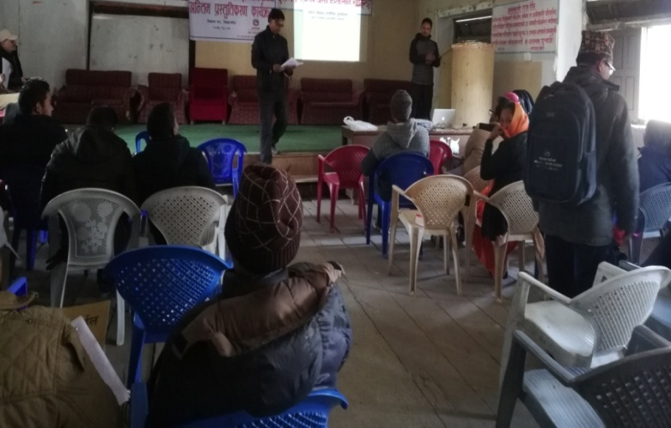
Figure 21.Group discussion

Figure 22. Schematic diagram on prioritization of destination
Source Individual survey
Individual survey done in this area Chitlang get first position and but in second position found that Daman instead of Kunchhal village from group discussion. Kunchhal in third position and Indrainichaura fourth place. In individual survey Kotathumki and Lemphu interchange position.

Chitlang
Chitlang is historical important place. It is main border to entry in Chitlang to Kathmandu in which following route scattered as
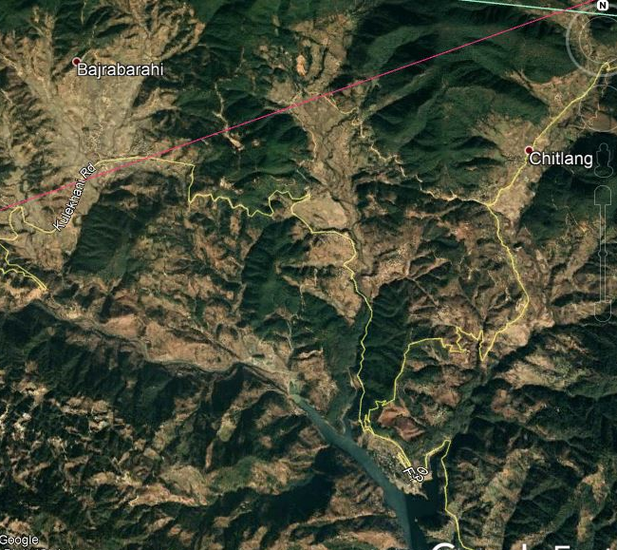
Thankot Chandragiri to Chitlang(18km)
Matatirtha Chakhel to Chitlang(27km)
Dakshinkali Pharphing to Chitlang (52km)
Naubise to Chitlang(75km)
Hetauda kulekhani to Chitlang(40km)
Godam to Chitlang(12km)
Godam Chandragiri Bhanjyang (6km)
Macchegau Bhasmeshor to Chitlang(11km)
Figure 23.Map of Chitlang
Source: Google earth
Thaha municipality belong to main tourist destination in Chitlang area as House of king and Rana ,historical Satadhara, goat cheese, Ashok Stamba(273 bc),Swachchhandra Bhairab,Chamero cave,Syatha Ghar, Indrasarobar nearby Chitlang,Bajrabarahi,Kunchhal border)
Two house found in Chitlang which build in the by Rana and king for rest and stay While travel from this place which is main route for all the people before Tribhuwan highway construct in 2013 BS.
From 2014 after construction of Highway these house use as School building. This tradition types of building before that used by king,Rana, and Angrej when travel through this way.

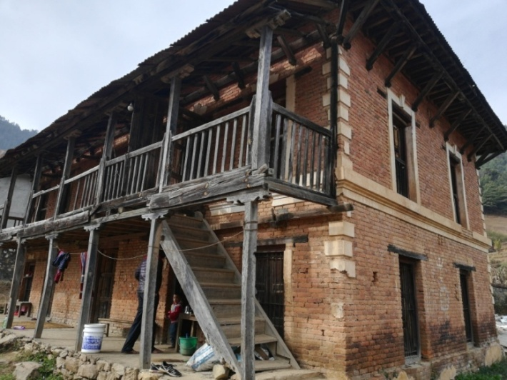
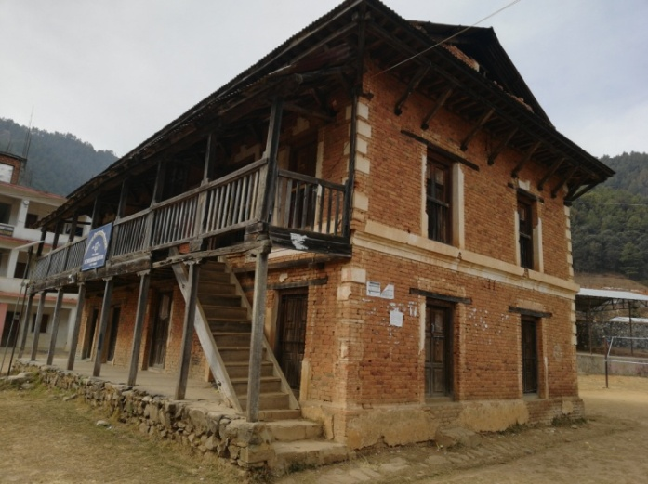

Figure 24.Rest house of Rana
Figure 25.King rest house

Ashok chaitya found in Majhagau which is build by his daughter Charumati when travel in Nepal. This chaitya location in Newari called Chaity la, which further called named as Chitlang. From that before it is called Chitrapur.
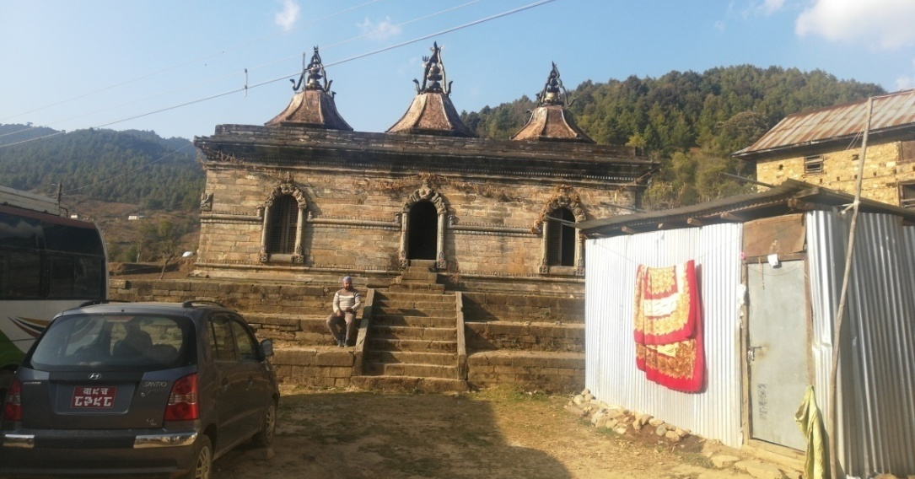

Figure 26.Stone temple with nest shape with three Gajur.
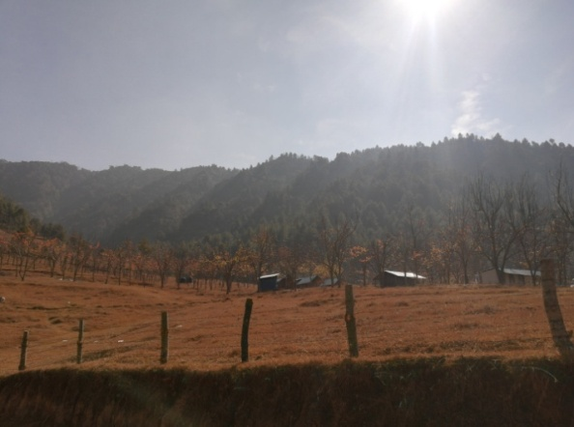
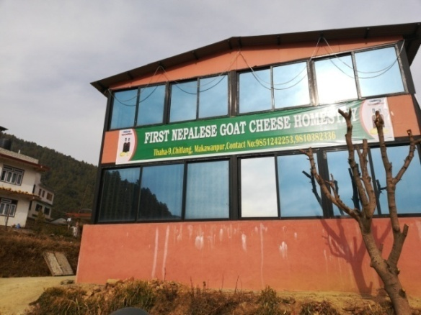

Figure 27.Chitlang organic resort
Figure 28.First goat cheese home stay

Stone inscription of Ansubarma situated in Taukhel. It has length of 2m in which Bangali language. Swanchand bhairab temple,Taleju temple ,chamkeshor mahadeb temple ,Sitako paila situated in Bisinkhel. Nepal first goat cheese and goat cheese industry and home stay. Cheese industry generate income of 20 lakh per year.
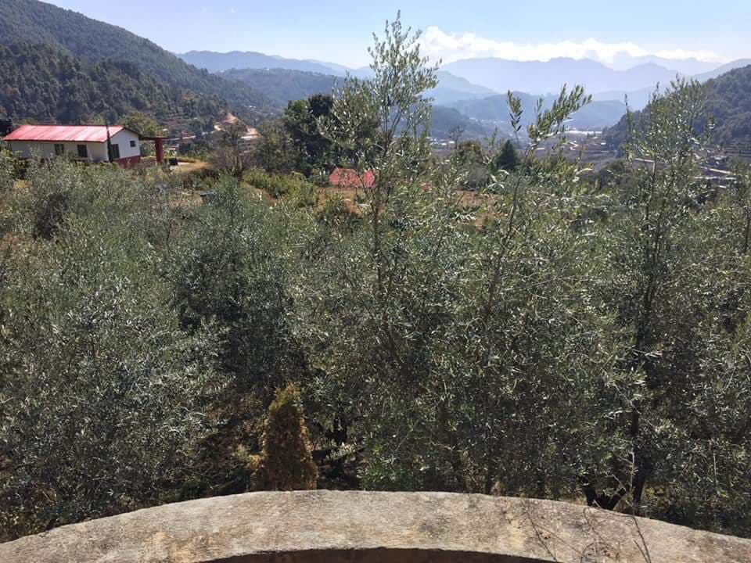
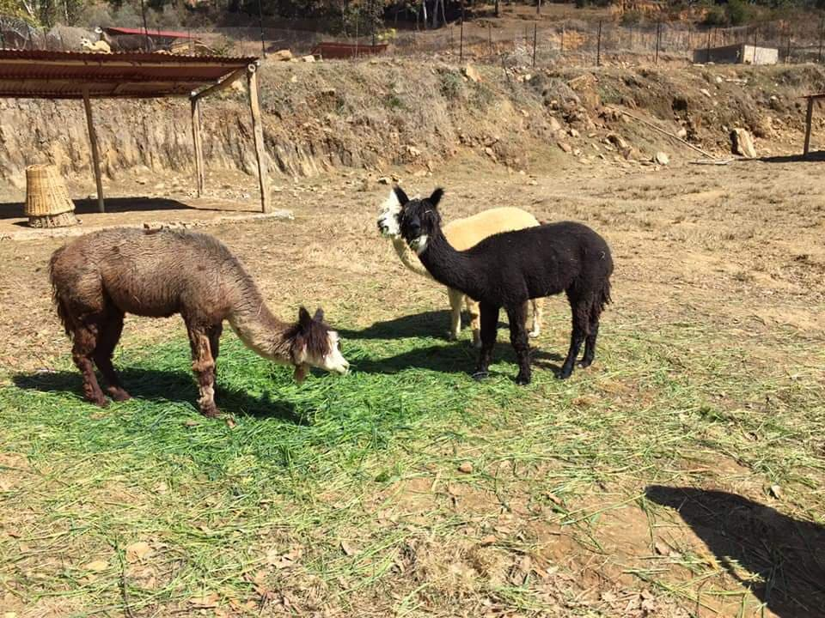

Figure 29.Alpaka
Figure 30.Olive oil farm

Figure 31.Schematic view of prioritization of variable
Source Group discussion
In prioritization list Chitlang got good position in compare with other places. In total point 30, attraction 27, accessibility 19, accommodation 22, facility 16, tourist activities 18, actors 19, affinities-guest-host relationship 17, management 15 in total 153 point obtain in first position.

Table 15. Schematic view of prioritization of variable
Chitlang
 | Chitlang @ Attract | Chitlang @ Acceptability | Chitlang @ Accommodation | Chitlang @ Facility | Chitlang @ Tourist Activities | Chitlang @ Actors | Chitlang @relationship | Chitlang @ Management | Total
Mean | 8.43 | 7.57 | 8.90 | 7.55 | 8.55 | 7.25 | 8.17 | 8.53
Sum | 506 | 454 | 534 | 453 | 513 | 435 | 490 | 512 | 3897
Source: Survey done in 60 respondent wards

Kunchhal Gaun
It is said that Bajrabarahi Kul Gau as Kunchhal. Majority of Newar community settlement in Kunchhal. Gopal dynasty was first king ruled in history of Nepal. Bagh bhirab jatra donot start till the Gopali of Machchhegaun not present. Historical place of hundreds percentage of gopali settlement in Kunchhal. kunchhal gaun can brand and hub of home stay. 250 number group of similar traditional house can be started home stay. Pandulipi of Ansubarma found in this area where patipauwa as element of attraction.
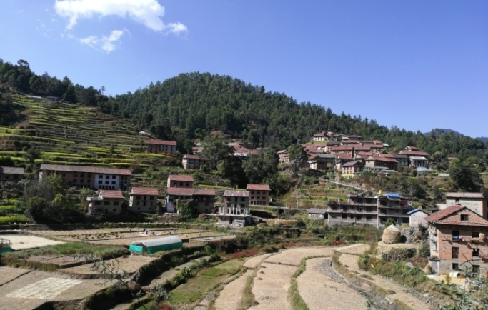
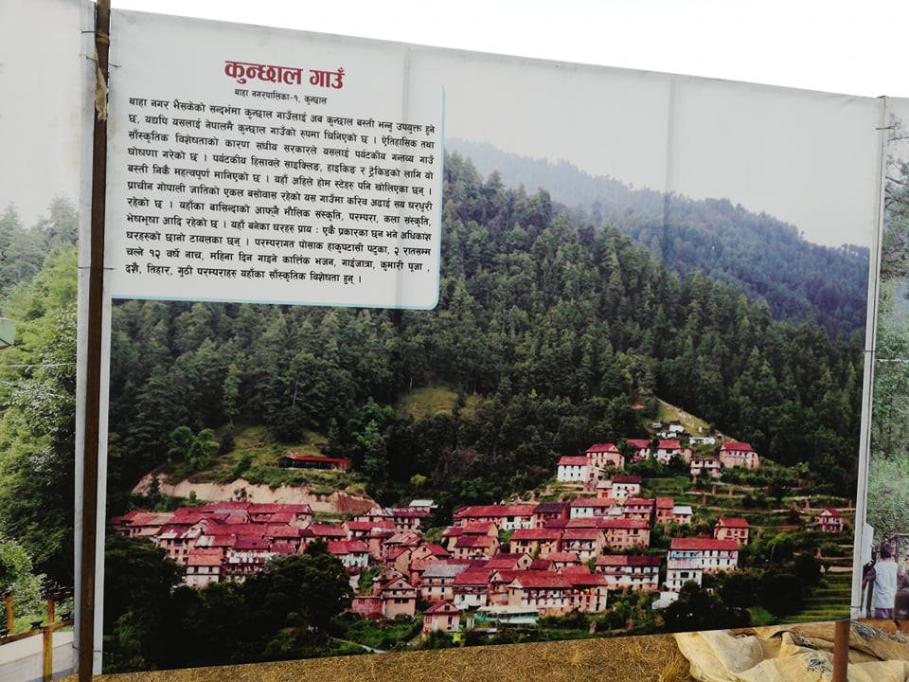

Figure 32.Kunchhal village
Figure 33.Kunchhal village

Source Group discussion
Figure 34.Schematic view of prioritization of variable

Table 16.Schematic view of prioritization of variable
Kunchal
 | Kunchal @ Attract | Kunchal @ Acceptability | Kunchal @ Accommodation | Kunchal @ Facility | Kunchal @ Tourist Activities | Kunchal | Kunchal @relationship | Kunchal @ Management | Total
Mean | 7.15 | 7.70 | 7.02 | 6.78 | 6.43 | 6.17 | 6.97 | 6.70
Sum | 429 | 462 | 414 | 407 | 386 | 370 | 418 | 402 | 3288
Source: Survey done in 60 respondent wards

Indrayanichaura
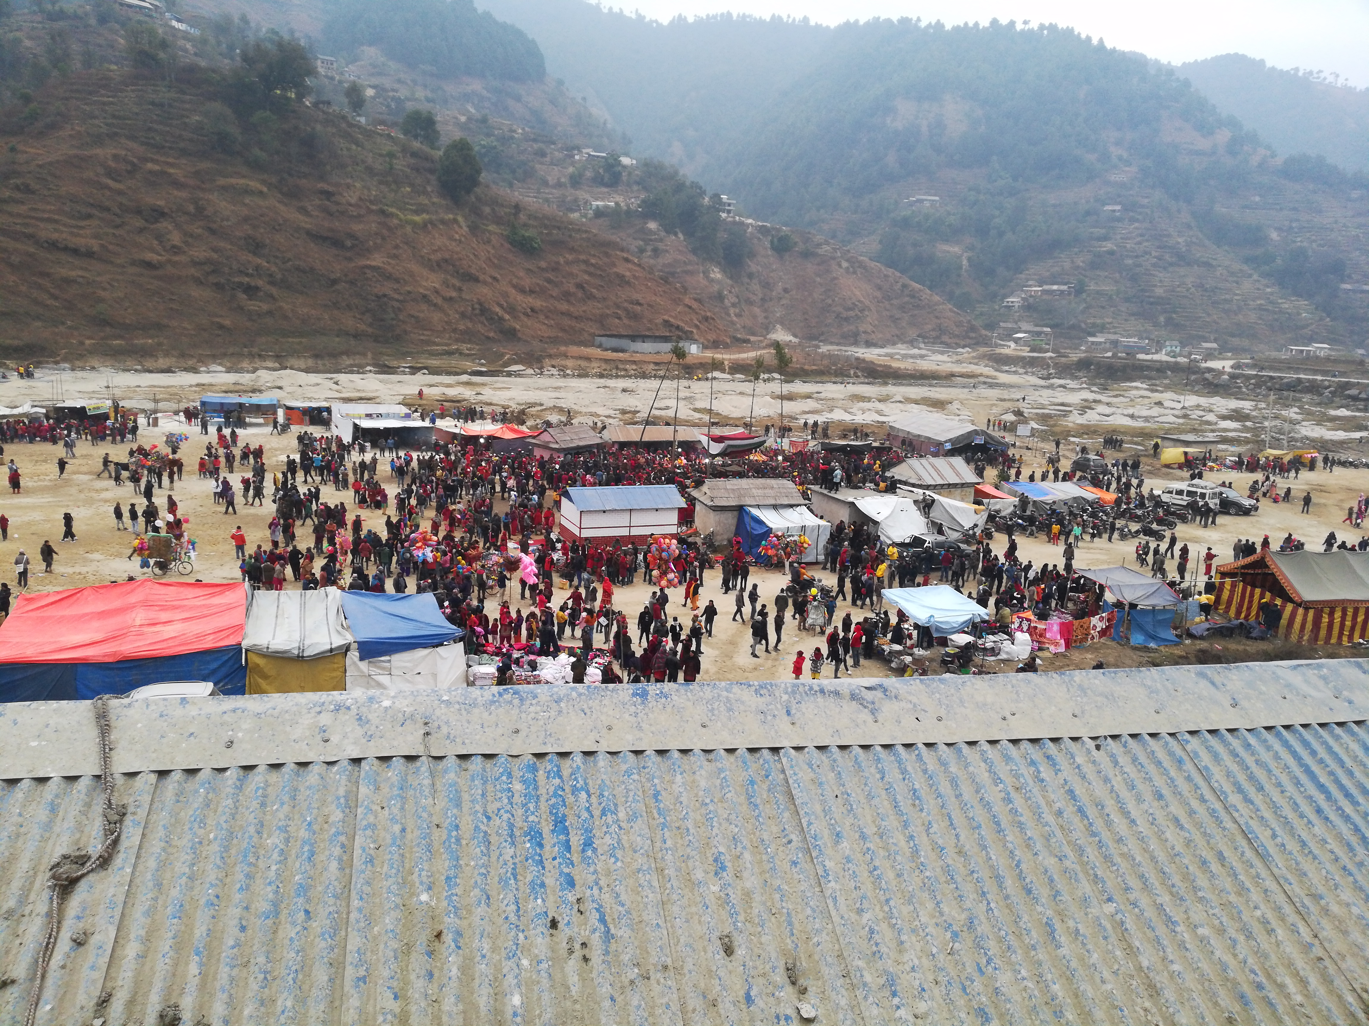It is situated near Palung and nearby municipality office. It can be developed different recreational, sports, attraction activities meeting, training, occasion, Mela, Jatra etc. Pandukeshor forest lies in Pataleshor cave.
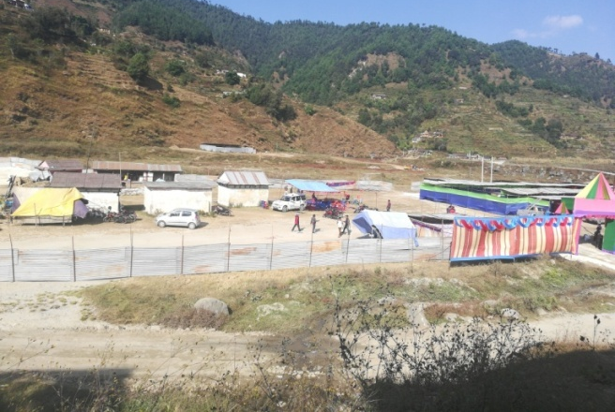
Figure 35.Indrayanichaura Thaha mahostab

Figure 36.Overall view of Indraynichaura

Source Group discussion
Figure 37.Schematic view of prioritization of variable

Table 17 .Schematic view of prioritization of variable
Indrainichaura
 | Indrainichaura @ Attract | Indraini@ Acceptability | Indraini @ Accommodation | Indraini @ Facility | Indraini @ Tourist Activities | Indraini @ Actors | Indrai @relationship | Indraini@ Management | Total
 | 60 | 60 | 60 | 60 | 60 | 60 | 60 | 60
Mean | 6.05 | 7.62 | 7.37 | 6.27 | 5.93 | 5.95 | 6.22 | 6.23
Sum | 363 | 457 | 442 | 376 | 356 | 357 | 373 | 374 | 3098
Source: Survey done in 60 respondent wards

Daman-Simbhanjyang
Daman has high possibilities in Tourism development. In this place Daman view tower, Shitosna Horticulture, Botanical garden, rare birds, Risheswor mahadeb, view of different mountain etc.

Source: Group discussion
Figure 38.Schematic view of prioritization of variable

Table 18.Schematic view of prioritization of variable
Daman
 | Daman @ Attract | Daman @ Acceptability | Daman @ Accommodation | Daman @ Facility | Daman @ Tourist Activities | Daman@ Actors | Daman@relationship | Daman @ Management | Total
N | 60 | 60 | 60 | 60 | 59 | 60 | 59 | 60
Mean | 7.92 | 7.77 | 7.93 | 7.20 | 7.80 | 6.15 | 6.73 | 7.27
Sum | 475 | 466 | 476 | 432 | 460 | 369 | 397 | 436 | 3511
Source: Survey done in 60 respondent wards
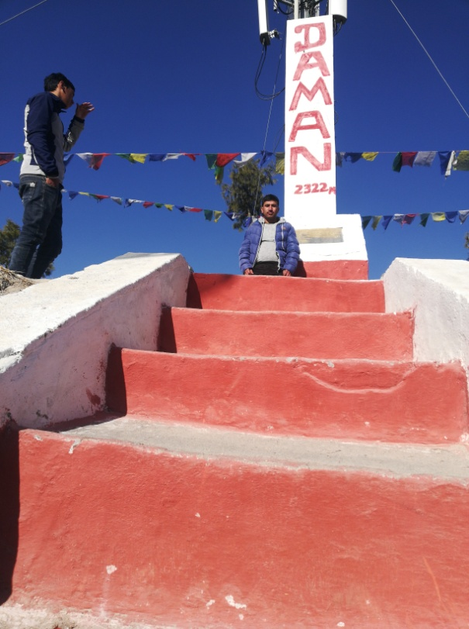
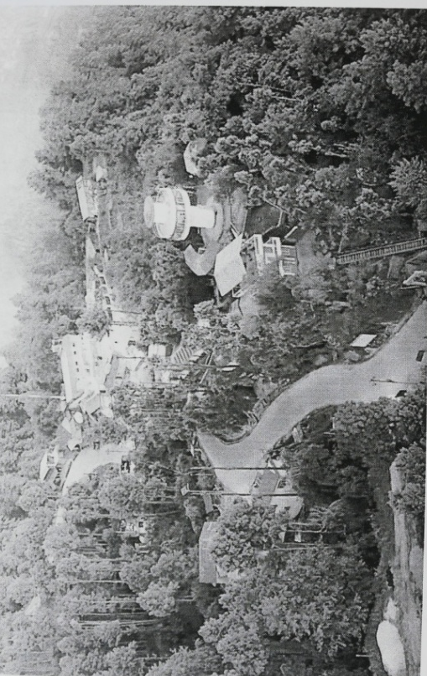

Figure 39.Daman
Figure 40.Daman view tower
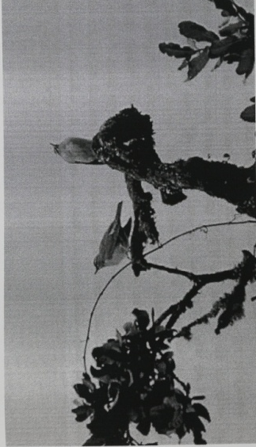
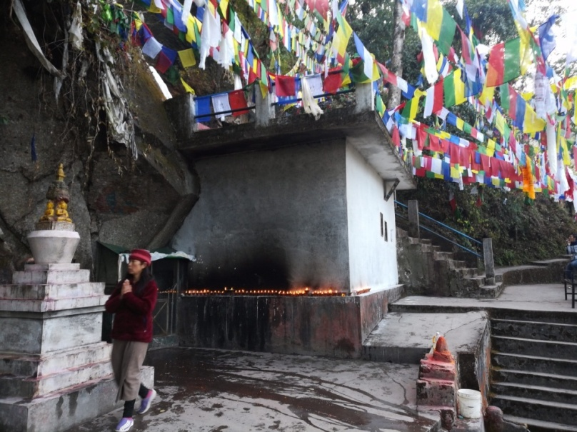

Figure 41.Rare bird gray saidead thrass
Figure 42.Risheswor Mahadev

Dadabas –Agra
It has lot of possibilities in tourism development where 160 household of Tamang caste. Eco and agri tourism possible destination where only vegetable plantation and place where it act as natural view tower, different temple gumba as Kuteshor Mahadev, Pasupati temple, Sambi,Pema, and Meduk gumba etc .

Source Group discussion
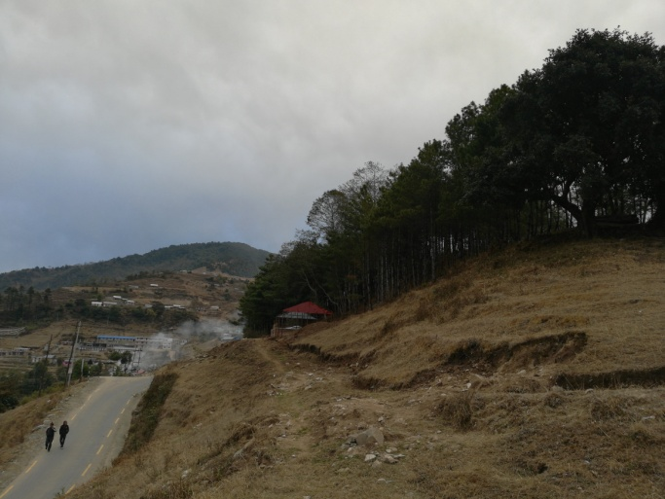
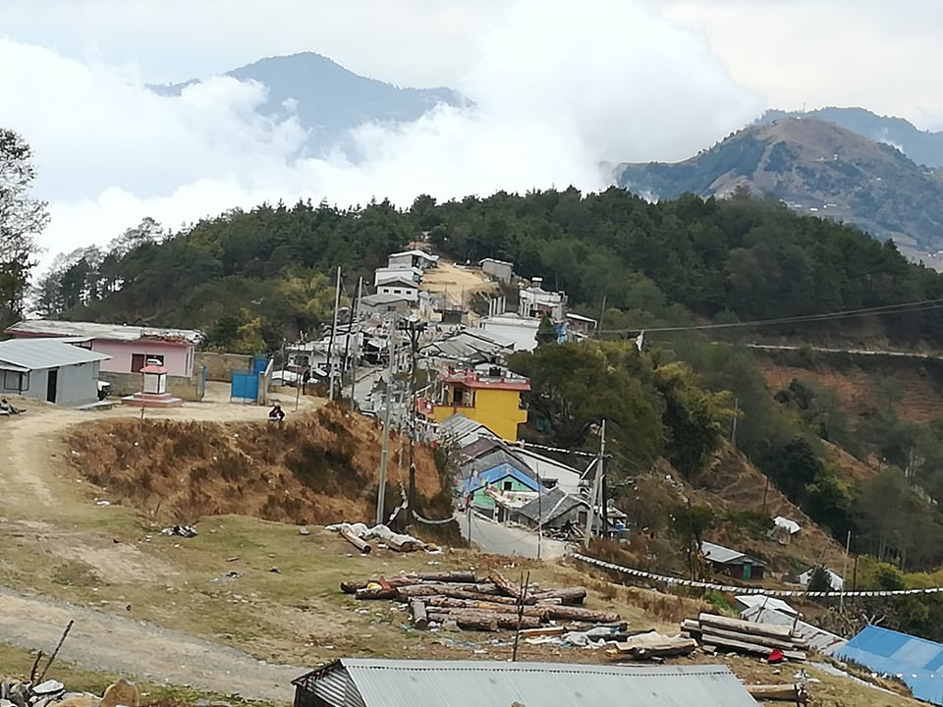
Figure 43.Schematic view of prioritization of variable

Figure 44.Dadabas
Figure 45.Gumba

Table 19.Schematic view of prioritization of variable
Dadabas
 | Dadabas @ Attract | Dadabas @ Acceptability | Dadabas @ Accommodation | Dadabas @ Facility | Dadabas @ Activities | Dadabas@ Actors | Dadabas @relationship | Dadabas @ Management | Total
N | 60 | 60 | 60 | 60 | 60 | 60 | 60 | 60
Mean | 6.08 | 7.32 | 5.80 | 5.42 | 5.28 | 4.63 | 5.23 | 5.52
Sum | 365 | 439 | 348 | 325 | 317 | 278 | 314 | 331 | 2717
Source: Survey done in 60 respondent wards

Mulabari-Mankamana
Two grass ground found in near Tistung and Bajrabarahi. It will take 3 hour travel from Deurali .Tistung to deurali has track for earthen road. Mulabari have following features as
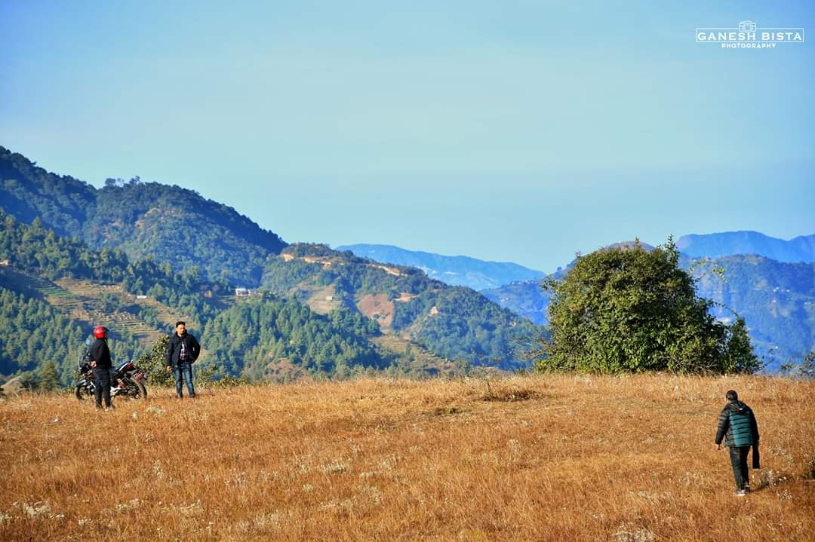Meditation centre
Sports
Hiking
Forest Hiking
Film shooting
Scene views
Sunrise and sunset
Bird viewing

Figure 46: Mulabari chaura
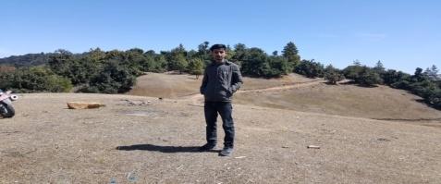
Figure 47.Mulabari range
Source Group discussion
Figure 48.Schematic view of prioritization of variable
Table 20.Schematic view of prioritization of variable
Mulabari
 | Mulabari @ Attract | Mulabari @ Acceptability |  | Mulabari @ Accommodation |  | Mulabari @ Facility |  | Mulabari @ Tourist Activities | Mulabari@ Actors |  |  | Mulabari @relationship | Mulabari @ Management | Total
N | 60 | 60 |  | 58 |  | 60 |  | 60 | 60 |  |  | 60 | 60
Mean | 4.82 | 3.13 |  | 2.59 |  | 2.87 |  | 3.15 | 2.90 |  |  | 3.18 | 3.20
Sum | 289 | 188 |  | 150 |  | 172 |  | 189 | 174 |  |  | 191 | 192 | 1545
Source: Survey done in 60 respondent wards

Lemphu Chiya Bagan
Lemphu Chiya bagan situated in Tistung ward no 11. It will develop the area as centre for Jagadad 30 Magar household,Dadighat mixed settlement 38 household, Malagiri and Liti total 350 Tamang household.

Source Group discussion
Figure 49.Schematic view of prioritization of variable

Table 21..Schematic view of prioritization of variable
Lembhu
 | Lemphu @ Attract | Lemphu @ Acceptability | Lemphu @ Accommodation | Lemphu @ Facility | Lemphu @ Tourist Activities | Lemphu@ Actors | Lemphu @relationship | Lemphu @ Management | Total
N | 60 | 59 | 60 | 60 | 60 | 60 | 60 | 60
Mean | 3.45 | 2.07 | 1.83 | 2.22 | 2.35 | 2.05 | 2.37 | 2.15
Sum | 207 | 122 | 110 | 133 | 141 | 123 | 142 | 129 | 1107
Source: Survey done in 60 respondent wards
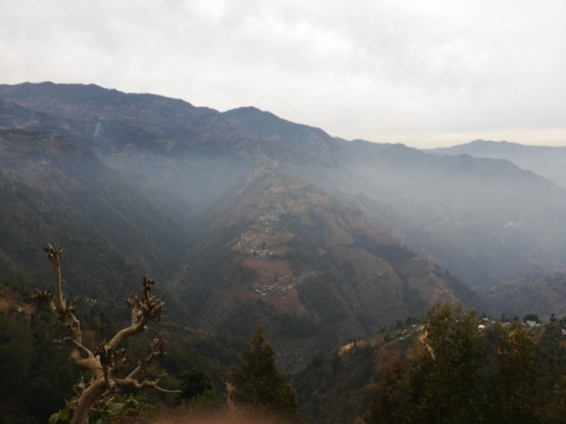
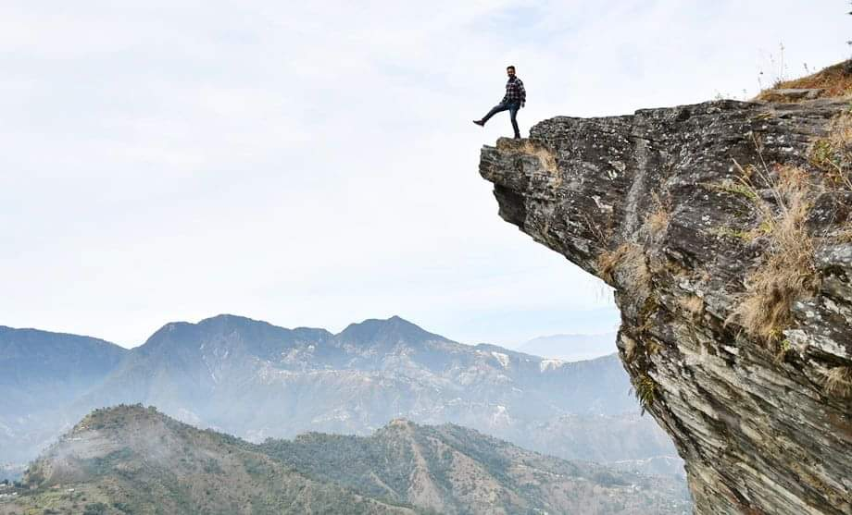

Figure 51:Narbe dunga
Figure 50.Surrounding of Lemphu, Jagdada,Liti

Kotathumki
Kotathumki is lied on ward no 2 Thaha municipality. From Kotathumki many mountain ranges can be vied. Sunset and sunrise viewing from this place easily. We can see top view of Dharhara of Kathmandu before it destroyed in Earthquake.

Source Group discussion
Figure 52.Schematic view of prioritization of variable

Table 22.Schematic view of prioritization of variable
Kotathumki
 | Kotathumki @ Attract | Kotathumki @ Acceptability | Kotathumki @ Accommodation | Kotathumki @ Facility | Kotathumki @ Tourist Activities | Kotathumki @ Actors | Kotathumki @relationship | Kotathumki @ Management | Total
N | 60 | 60 | 59 | 60 | 59 | 59 | 60 | 60
Mean | 4.90 | 2.70 | 2.32 | 2.65 | 2.78 | 2.73 | 2.98 | 2.65
Sum | 294 | 162 | 137 | 159 | 164 | 161 | 179 | 159 | 1415
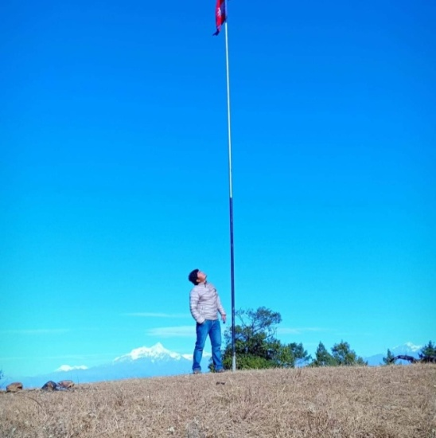
Source: Survey done in 60 respondent wards
Figure 53: Pataleshor cave
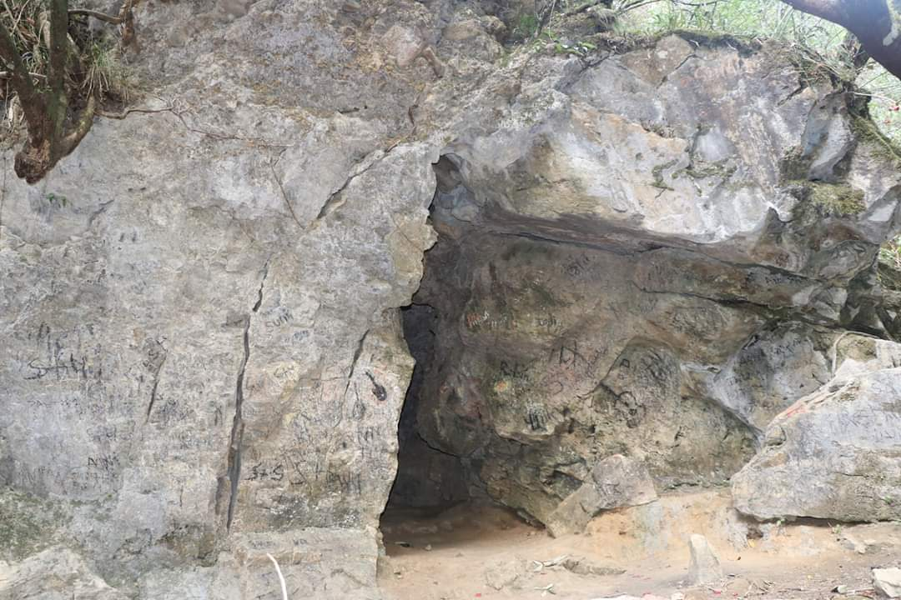

Figure 54.Kotathumki

Socio-personal characteristics of the respondents

Based on criterion, the respondents were classified into the following four categories by using range method, marital status was categorized into two categories i.e. married, unmarried. It has found that 33.3 percentage of total respondent are single.

Table 23.Age group
Table 24.Family background

Age group
 | Frequency | Percent
20-35 years | 34 | 56.7
36-49 years | 17 | 28.3
50-59 years | 7 | 11.7
Above 60 years | 2 | 3.3
Total | 60 | 100.0
Family background
 |  | Frequency | Percent
 | Rural | 37 | 61.7
 | Urban | 23 | 38.3
 | Total | 60 | 100.0

Table 25.Type of Family.
Type of Family.
 |  |  | Frequency | Percent
 |  | Joint | 43 |  |  | 71.7
 | Nuclear |  | 17 |  | 28.3
 | Total |  | 60 |  | 100.0
Table 26.Marital Status.
Marital Status.
 |  | Frequency | Percent
 | Single | 20 | 33.3
 | Married | 40 | 66.7
 | Total | 60 | 100.0

Respondent are found to be 61.7% rural area background and 71.7%vare living in joint family.

Awareness of term Agri-tourism the respondents

Table 27.Total number of family members
Table 28.Aware of term Agri - tourism

Total number of family members
 | Frequency | Percent
Small(2-4) | 12 | 20.0
Medium(5-7) | 24 | 40.0
Large(>8) | 24 | 40.0
Total | 60 | 100.0
Aware of term Agri - tourism
Category |  | Frequency | Percent
Aware | 45 | 75.0 | 75.0
Not Aware | 15 | 25.0 | 25.0
Total | 60 | 100.0 | 100.0

Awareness was taken up as to whether the respondents knew about agri-tourism and agri-tourism farms in Thaha. There response was taken in a dichotomous form i.e. aware or unaware and was expressed in terms of frequency and percentage. The data in revealed that more than one fourth of the total respondents were not aware of agri-tourism i.e. 25 per cent It may be due to the reason that agri-tourism is a new venture, nor is very common inThaha and not so much publicized.

Figure 55.To go visit an Agri-tourism farm
Figure 56.Aware of term agri tourism

Table 29.To go visit an Agri-tourism farm
To go visit an Agri-tourism farm
 | Frequency |  |  | Percent
Yes | 55 |  |  | 91.7
No | 5 |  |  | 8.3
Total | 60 |  |  | 100.0
The response was taken in a dichotomous form i.e. aware or unaware and was expressed in terms of frequency and percentages. The respondent’s willingness to visit in agri tourism farm is 91.7 percentages.

Major Occupation
 | Frequency | Percent
Agriculture | 30 | 50.0
Government Job | 10 | 16.7
Hotel | 2 | 3.3
Goat farming | 1 | 1.7
Resort/homestay | 2 | 3.3
Business | 3 | 5.0
Dairy product | 1 | 1.7
Cow farming | 1 | 1.7
Private job | 2 | 3.3
Farm | 5 | 8.3
Other | 3 | 5.0
Total | 60 | 100

Assessment of Activities
Table 30.Major Occupation

Financial asset
- Occupation trend
Agriculture product develops easily due to cold Shitosna climate in this region. Fertile land present in the area of surrounding Thaha. Enough amount of fertile land gift for the agri tourism in this area.. From 2051 commercial agriculture started mainly in potatoes, cauliflower, cabbage, carrots etc. For the livelihood of the families they also have livestock as cows, buffalos, goat, and cock etc. nowadays lot of people have involved in production of KIBI in this region
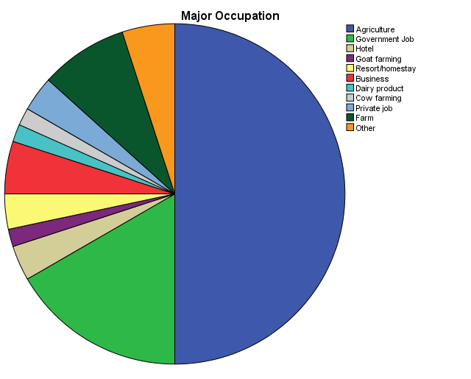
- Agriculture as main occupation

Figure 57.occupation trend
- Tourism related activities

Table 31.Tourism related activities
Sr,No | Agriculture product | Respondents N=60
Sr,No | Agriculture product | F | %
 | Ready to purchase | 51 | 85
 | Kind of agri products | N1=51
I | Fresh vegetables | 7 | 13,7
II | Fruits | 5 | 9.8
III | Dairy products(milk,cheese,butter etc) | 8 | 15.6
IV | Honey | 6 | 11.7
V | Meat &poultry products | 3 | 5.8
VI | Organic products(fruit, grains) | 7 | 13.7
VII | Medical herbs | 4 | 8.2
VIII | Handicraft | 5 | 9.8
IX | Processed products(jam,pickles,tea) | 6 | 11.7
X | Any others

Survey done in 60 respondent wards

- Tourism related activities
Table 32.Willingness of respondents regarding their participation in agricultural activities on an agri-tourism area
Sr. | Agricultural activities | Respondent N=60
No | Agricultural activities | F |  | %
1 | Participate in agricultural activities | 52 |  | 86.7
2 | Kind of activities | N1=52
a | Production activities | Alone  f | Family  f |  | Friends  f
 | Production activities | % | % |  | %
i | Milking of buffalos | 12 | 16 |  | 24
i | Milking of buffalos | 23 | 30.8 |  | 46.2
ii | Feeding of animals | 22 | 17 |  | 13
ii | Feeding of animals | 42.3 | 32.7 |  | 25
iii | Gardening | 13 | 17 |  | 22
iii | Gardening | 25 | 32.7 |  | 42.3
iv | Ploughing fields | 16 | 17 |  | 19
iv | Ploughing fields | 30.8 | 32.7 |  | 36.5
v | Harvesting of crops | 15 | 16 |  | 21
v | Harvesting of crops | 28.8 | 30.8 |  | 40.4
vi | Picking of fruits &vegetables | 15 | 17 |  | 20
vi | Picking of fruits &vegetables | 28.8 | 32.7 |  | 38.5
b | Processing activities
i | Processing of dairy products | 16 | 13 |  | 23
i | Processing of dairy products | 30.8 | 23 |  | 44.2
ii | Fruit processing | 16 | 13 |  | 23
ii | Fruit processing | 30.8 | 25 |  | 44.2
iii | Vegetable processing | 16 | 14 |  | 22
iii | Vegetable processing | 30.8 | 26.9 |  | 42.3

- Financial services and institution

Survey done in 60 respondent wards
Figure 58.Annual family income

Social asset

- Trend of population change
- Out migration
- Abroad work
- Population increase
- Social networks institution
- 45 numbers of NGO
- Women groups –Collect money from members-loan Small interest
- Tole development committee- Socio –cultural events- Ghewa(feast on death), Bartabandha
- Krishak Samuha- Assistance in agricultural matter
- Community center
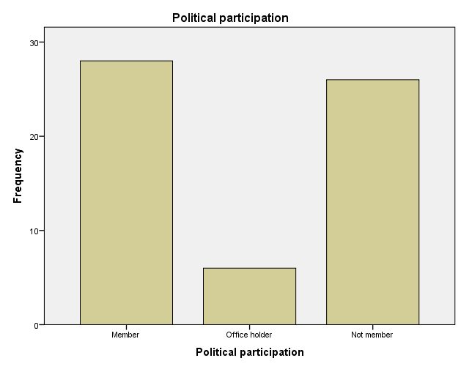
- Bikash ghar –place for development meetings, women’s groups, youth groups, and training programs

- Trend of population change
Out migration
Abroad work
- Social networks institution
Figure 59.Political participation
It was taken as the status of the respondents in any formal or informal organization. The respondents were asked about their participation in social organization as a member or an office bearer. Score of two was given to office bearer, one was given to a member and zero was given to not a member. The total score for each individual was calculated.
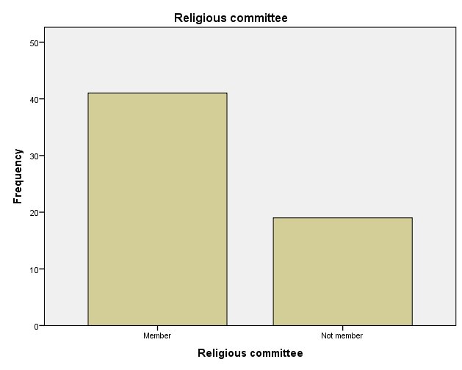
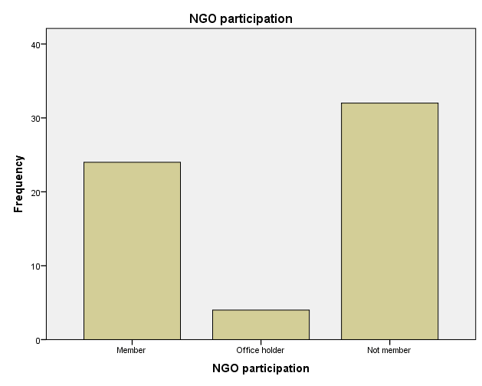

Figure 60.Religious participation

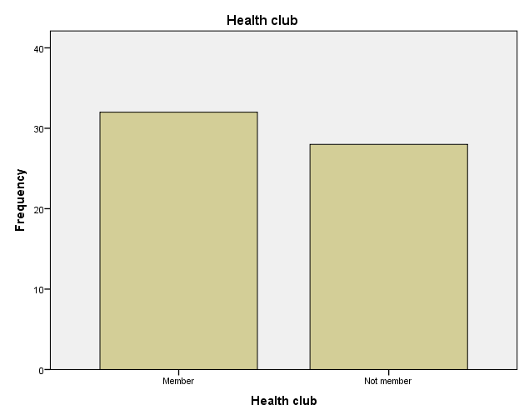
Figure 61.NGO participation
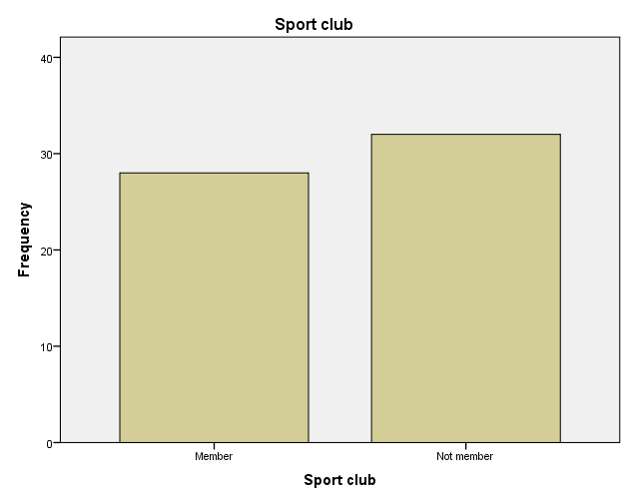

Figure 62.Sport club participation
Figure 63.Health participation
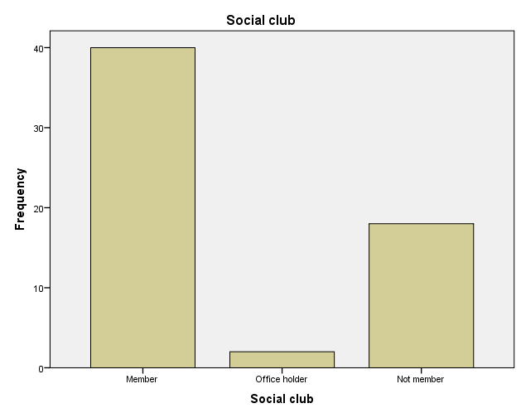

Figure 64..Social club participation
Figure 65.Social participation
Survey done in 60 respondent wards

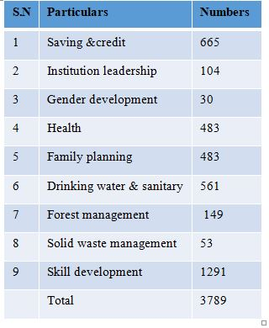
Human asset
- Education level
- 73.01 percentage of people literate
- Class have been discontinued
- 65 no's of School, 3218 no's of students,
- 455 no's of teachers
- Agriculture technical school- Jankanyan HSS
- Training and Ngo activities
- Organic farming course,
- Briquette making trainings
- Corn –husk doll making for woman
- Lodge management , mushroom & off-seasonal vegetable cultivation training
- Home –stay development training
Table 33.Educational Qualification
Figure 66.Educational Qualification
Educational Qualification
 | Frequency | 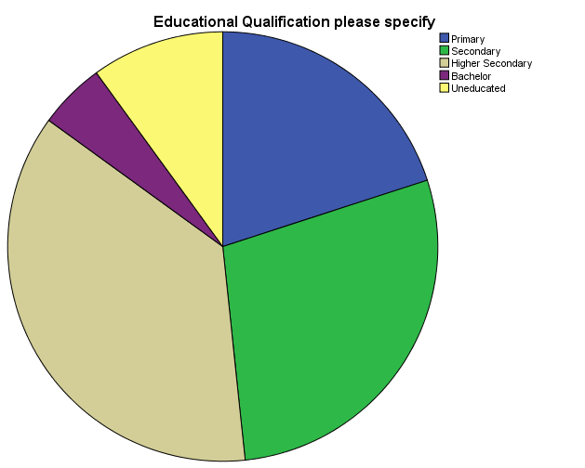  Percent
Primary | 12 | 20.0
Secondary | 17 | 28.3
Higher Secondary | 22 | 36.7
Bachelor | 3 | 5.0
Uneducated | 6 | 10.0
Total | 60 | 100.0
Survey done in 60 respondent wards

Natural asset
- Land use change
- Land ownership
- Access to natural resources

Municipality profile 2074

S.N | Particulars | Area (Ha)
1 | irrigation land | 381
2 | Rain water | 517
3 | Total irrigation land | 898
4 | Drop irrigation land | 1744
5 | Total Agricultural land with barren | 2687
7 | Agricultural land (Farmable land) | 4649

District Agriculture development office, Makwanpur

Survey done in 60 respondent wards

Physical asset
- Thaha seemed to be quite satisfied with infrastructure facilities like road, water supply and electricity.
- Thus most of the major health problems the villagers had to travel up to Kathmandu valley,Chitwan.Makawanpur
S.N | Particulars | Numbers
1 | Pipeline & natural tapstone | 7122
2 | Tub well/Hand pump | 98
3 | Well | 285
4 | Water resources | 1075
5 | River/Stream | 69
 | Total | 8649
Municipality profile 2074
The respondent of Chitlang seemed to be quite satisfied with infrastructure facilities like road, water supply and electricity. There seemed to be internet access at this area. Thus most of the major health problems the villagers had to travel up to Kathmandu valley.

SWOT Analysis in general
Based on collection of different data, observation and interviews with the concerned people I have been able to come up with a Swot analysis of Agri tourism planning inside the Thha Municipality which is as in the followings.

Municipal Opportunities
- The potential of developing this area is likely to be the basis of development of this area, if the advanced skinny paddy maize or vegetable farming can be made available with pre-modernization of skill-training.

- It can be possible to make more income from this business, able to manage the business like skill and training like advanced buffalo, cattle, got, goose, gooseberry, local chicken, chicken, bee keeping.

- Abundance of geographical diversity is in large quantities to develop tourism sector, able to develop this area by utilizing source tools and skills and techniques, such as homestay, opening hotel business, and managing a managed manufacture, according to the geographical structure of different areas.

- It is possible to conduct various types of resources and labor-based businesses in the process of developing this sector by utilizing source tools and skills and skills. Such as bamboo swallow work, incense candles, make candles, bamboo rope, top business, pickle.

- Daman and Indrasarobar of Thaha Municipality are listed in 100 tourist destination of Nepal in fiscal year 2075/2076 for the additional promotion of destination for visit Nepal 2020.

- Village Tourism Promotion Forum (VITOF) - Nepal organized a 1 night/2days FAM trip to Kunchhal of Makwanpur district on February 17 & 18, having a motto “every village must be a tourism destination”. Kunchhal Village has also been declared as a tourism destination by Nepal Tourism Board. The trip was supported by Nepal Tourism Board (NTB), Trekking Agencies Association of Nepal (TAAN) Nepal Mountaineering Association (NMA), Gurung Tourism Entrepreneur’s Association (GTEA) and community home stays and local clubs.

Strength
- Proximity to Kathmandu city
- Historically and religiously important places
- Transit route to Kathmandu valley from outside before Tribhuwan highway started.
- People aware of working in local group.
- People aware of Tourism, agri tourism
- Thaha municipality have slogan of Agriculture, tourism, agri-tourism and development which committed in municipal council.
- The touristic approach is considered to be excellent
- Announcement as a tourist city on the announcement program with the identity of Nepal government
- The old highway of the country, Tribhuwan Rajpath, goes through this municipality
- Growth oriented as a seed pocket area for agriculture
- Naturally delightful
- Increase in the municipal education level

Threat
- The municipal sector's income is low
- Most of the municipalities have been living in rural areas
- Agriculture could not be modernized and commercialized
- Unable to bind the program and program to be operated by the private and non-profit organizations working within the municipality area.
- To improve the situation of planning and program implementation, not to make monitoring and evaluation system a productive and productive model
- Unable to Control the out migration order of settlements
- Repetition of plan and program
- The work of changing thoughts and rites for development
- There is no playground, bus park, land filling site and public toilets etc arrangement for area.
- People's Awkward
- Relocation of the settlement, if the zoning and land use planning
- Unmanaged development of tourism infrastructure and services
- Urban sprawl

Weakness
- There is a major problem of drinking water in most of the places of municipalities
- Stage of irrigation in most parts of the municipal area has declined in agricultural crops.
- The child is forced to take several times because of lack of access to the problem of school access
- Unemployment problem, out migration of indigenous population for employment.
- Due to the lack of awareness, people in most areas of the city have consumed the time consuming Alcohal and exploiting time, which has the potential to spread social sales.
- Agriculture cannot be modernized and problem of market
- Problems in reaching the news of health services in most areas of municipalities
- Reducing public awareness in public interest and lack of public interest
- It is too late for land use planning and zoning of municipalities. It is necessary to development of aggregate resident area, agriculture zone, industry zone, commercial zone according to map and zoning. It is implemented that land use planning and zoning from municipal council.
- Delay in declare and implement land use plan and zoning

SWOT Analysis in particular Agri tourism
Table 34. SWOT Analysis
Strength | Weakness:
Extremely favourable conditions for agricultural production in the region | High fragmentation of agriculture
Dominant position in agricultural production of many goods in Thaha | Low qualifications of farmers
Relatively strong support from sector institutions and organization | High level of employment in agricultural sector  Low agricultural productivity
Insufficient support from food industry
Rural mentality - reluctance towards change and modernization

Opportunities | Threats
Good assessment of Agriculture products in Market | Competitive products from other markets
Increase in extra-regional export and in export to international markets | Necessity to adjust agricultural production to other standards
Expected considerable funds transfers, Rise in income for people

Agri-Tourism as a tool for branding local, organic and traditional products

Table 35.Stakeholders analysis
SN | Stakeholders | Main contribution/interest
1 | Government Lines Agencies(MoCTA) | government budget,plans,
 |  | programs and policy,
 |  | Building of infrastructure,Facilitation role
2 | Municipalities | protection,evalution,enforcement of rule
 |  | and regulation
3 | INGOs ,Donors | Financial,technical assistance
4 | National NGOs(NTB,TAAN,HAN) | promotion and product development
5 | Municipalities representatives | Social mobilization, national mainstream,
 |  | decision making
6 | Local club members | Social services , mobilizations , leadership
 |  | opportunities
7 | local residents | Positive response
8 | Entrepreneur | tourism business ,services , livelihood
9 | Farmers | Alternative livelihood opportunities
10 | Lodge owners,homestays,resort | Accommodation, information services, business
 |  | livelihood
11 | Internal visitors | Entry fees, Employment creation , recreation,
 |  | Awareness, religious tour
12 | International visitors | Entry fees, Employment creation ,recreation,
 |  | Awareness

FINDINGS
CHAPTER FIVE: FINDINGS

From literature review on Agri-tourism and agri- tourism potential of site
- Agri-tourism is a rapidly expanding sector of the tourism industry especially popular in agriculture land areas and alternative source of income areas of developing countries.
- 60 percentage of tourist purpose of visit in Nepal for holiday and recreation.
- Agri tourism based in community is all about – maximizing benefits and minimizing impact.
- Bottom-up approach that allows the participation of the local people to the process.
- Linking with agriculture sector provides sustainability of agricultural lands and agricultural production
- Tourism has a women initiative characterization and about 75% of the agri-tourism farms are owned or managed by rural women.
- Specific legislations and regulations for the sector
- Small sizes of farms are more appropriate for agri-tourism development
- Tourism conscious and culture of the local people effects on the sector positively
- Thaha offers a rich agriculture land with different attraction around and has an increasing numbers of domestic and international tourists every year.
- The community of Thaha is heterogeneous and member of all groups seem to be enthusiastic about agri-tourism development.
- They are also already being familiarized about the benefits of responsible tourism through NGO works. The top down approach ends up only in ‘dependency thinking ‘(Cater,1996) and hence it is essential to break away from this approach and just facilitate the community to think, decides and works for itself.

Regarding the agri tourism planning
- The delay in preparing tourist development strategic master plan.
- The delay in land use plan and zone declaration hasn’t been proper management of agri-culture land.
- Land use and zoning not easy to implement every people own 5-6 Ropani land.
- Every people have concept of main property is land.
- Nowadays rural development issue is one of the most important problem of the countries for increasing the unbalanced economies between urban and rural geographies, agri-tourism gains an attractive role with its structure that is depend on local dynamics.
- Main principle of Planning of Agri tourism based on Traditional System in Hill and mountain region on LAKE< BESI <KACHHAD( Plain region (BESI) of land mainly agriculture production, Middle land (KACHHAD) house build for live, and High land ( LAKE ) for animal grazing .

Regarding the livelihood assessment
- The local people living in most of settlement of these area (Palung, Tistung, Daman,Chitlang,Bajrabarahi, Agra and Simbhanjyang) are agriculture pron area have economically weak. Due to lack of awareness and alternative means of livelihood these settlements have alcohol prepared from vegetable and grains, increase in use of insecticides and chemical fertilizers in farming, very low price of vegetables.
- The city has been attracting the local people gets access to higher education facilities and employment opportunities.

Regarding the promotion and awareness of agri tourism
- The advertising program may include print advertisement s relevant targeted publications, radio advertisement on targeted stations with specific targeted messages for specific programs, agri-tourism specific television advertisements featuring the businesses and experiences, Google, face book, social media advertising program specifically targeted advertisements to attract niche audiences for agriculture products.
- Subsidy or grants should be given to agri-tourism owners for infrastructure facilities and agri-tourism development
- Accessibility to agri-tourism farms through proper road ways, transportation facilities etc.
- Generally agri-tourism activities tend to develop in closer agricultural areas (Thaha municipality near to Kathmandu valley) to urban areas. Additionally, agri-tourism develops in the agricultural areas that have tourism potential in their closer environment.
- Thaha municipality has high value of tourism point of views. Thaha where 25 percent of people have not aware of Agri tourism It may be due to the reason that agri-tourism is a new venture, nor is very common in Thaha and not so much publicized. Priority list of the place for the access to implement, formulation of plan and allocation of budget in this area.
Some tourism related organizations such as Nepal Tourism Board (NTB), Tourism for Rural Poverty Alleviation Programme (TRPAP), Nepal Academy of Tourism & Hotel Management (NATHAM), Namsaling Community Development Center (NCDC), Local Initiatives for Biodiversity, Research and Development (LIBIRD) have positively collaborated and contributed in the promotion and development of agritourism by providing platform in teaching learning process.
It will increase in facilities in accommodation as home stay, hotel, lodge, resort in Chitlang,Kunchhal, Palung,Daman and Simbhanjyang.Tisting,Dadabas,Agra region of municipality lie in backward in tourist activities and accommodation. It is seemed that fundamental infrastructure, facilities are in medium stage. Municipality manage the facilities of telephone, electricity, water supply,solid waste management,daily traffic and public vehicles ,fuel, market, bank,police, army,hospital, health post etc. Infact development in the tourism, agri tourism friendly is needed facilities. There are situated in household in scattered way in LAKE <BASI<KACHHAD.
Thaha municipality can be hub of hiking and trekking. It can be easily formulated plan and package of the tourist from Chandragiri to Markhu,Bisonkhel ,Taukhel ,Bajrabarahi, Kunchhal,Palung,Daman etc. It can be one day, two day, three day, four day ,five day and six day package for the tourist.

RECOMMENDATION
CHAPTER SIX: RECOMMENDATION

Planning

Proposed zoning of THAHA municipality

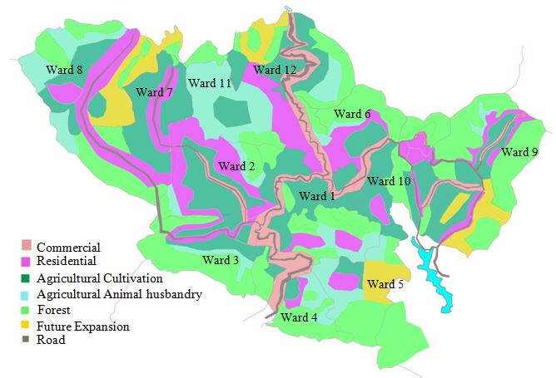

Ward 5

Figure 67.Zoning

Six zones have been proposed for the agri-tourism sustainability namely commercial, residential, agricultural cultivations, agricultural animal husbandry, forest, future expansion zone. Agri tourist farm and Cottage industries are not given separate area as the industries are spread in around many areas of agricultural land.
Zoning is done according to traditionally based Leka,Kacchad and Besi of traditional Hill ,mountain and plain area settlement.

Strategy to promote and sustain Agri tourism in Chitlang

- Local Government and agri tourist operation committee (representative of local people of Chitlang) are the main stakeholders for promotion and management of agri tourism.
Agri Tourism Tour
Tourists
Travel Agencies / Media
Hotels, Restaurants, Farmhouse, resort, Souvenir Shops etc
Tourist Spots
Home stay Program
Farming educational Tour
Fishing
Self Picking etc
Local Government
Agri Tourist Operation Committee (Representative of local people of Chitlang)
- Travel Agencies and Medias will be the stakeholder for flowing the information and attracting tourist about the educational tours and other workshops.
- Assumptions are that Local Government will provide subsidies to the people residing in the agri touristic area to conduct the urban farming programs, participate in training programs etc.
- Participation in the training programs and developing skills will automatically increase the knowledge of the people living in the areas.
Agriculture promotion center, Cottage industry, handicraft
Strategy chart

Proposal for Agri tourism

Route to Agri touristic area

Route 1: After entering from Chandragiri to Gurjudhara area whrere Laxmi Prasad devkota wrote Yatri poem of the hill top, the tourist will come to Ganeshman Highway to pass Sathaghar,three gajur Mahadev ,Traditional pati, and pass through Narayanhiti area where found Ashok chitya and traditional King And Rana building then to the Agri touristic area proposed between Narayanhiti area and Tupikhel area.

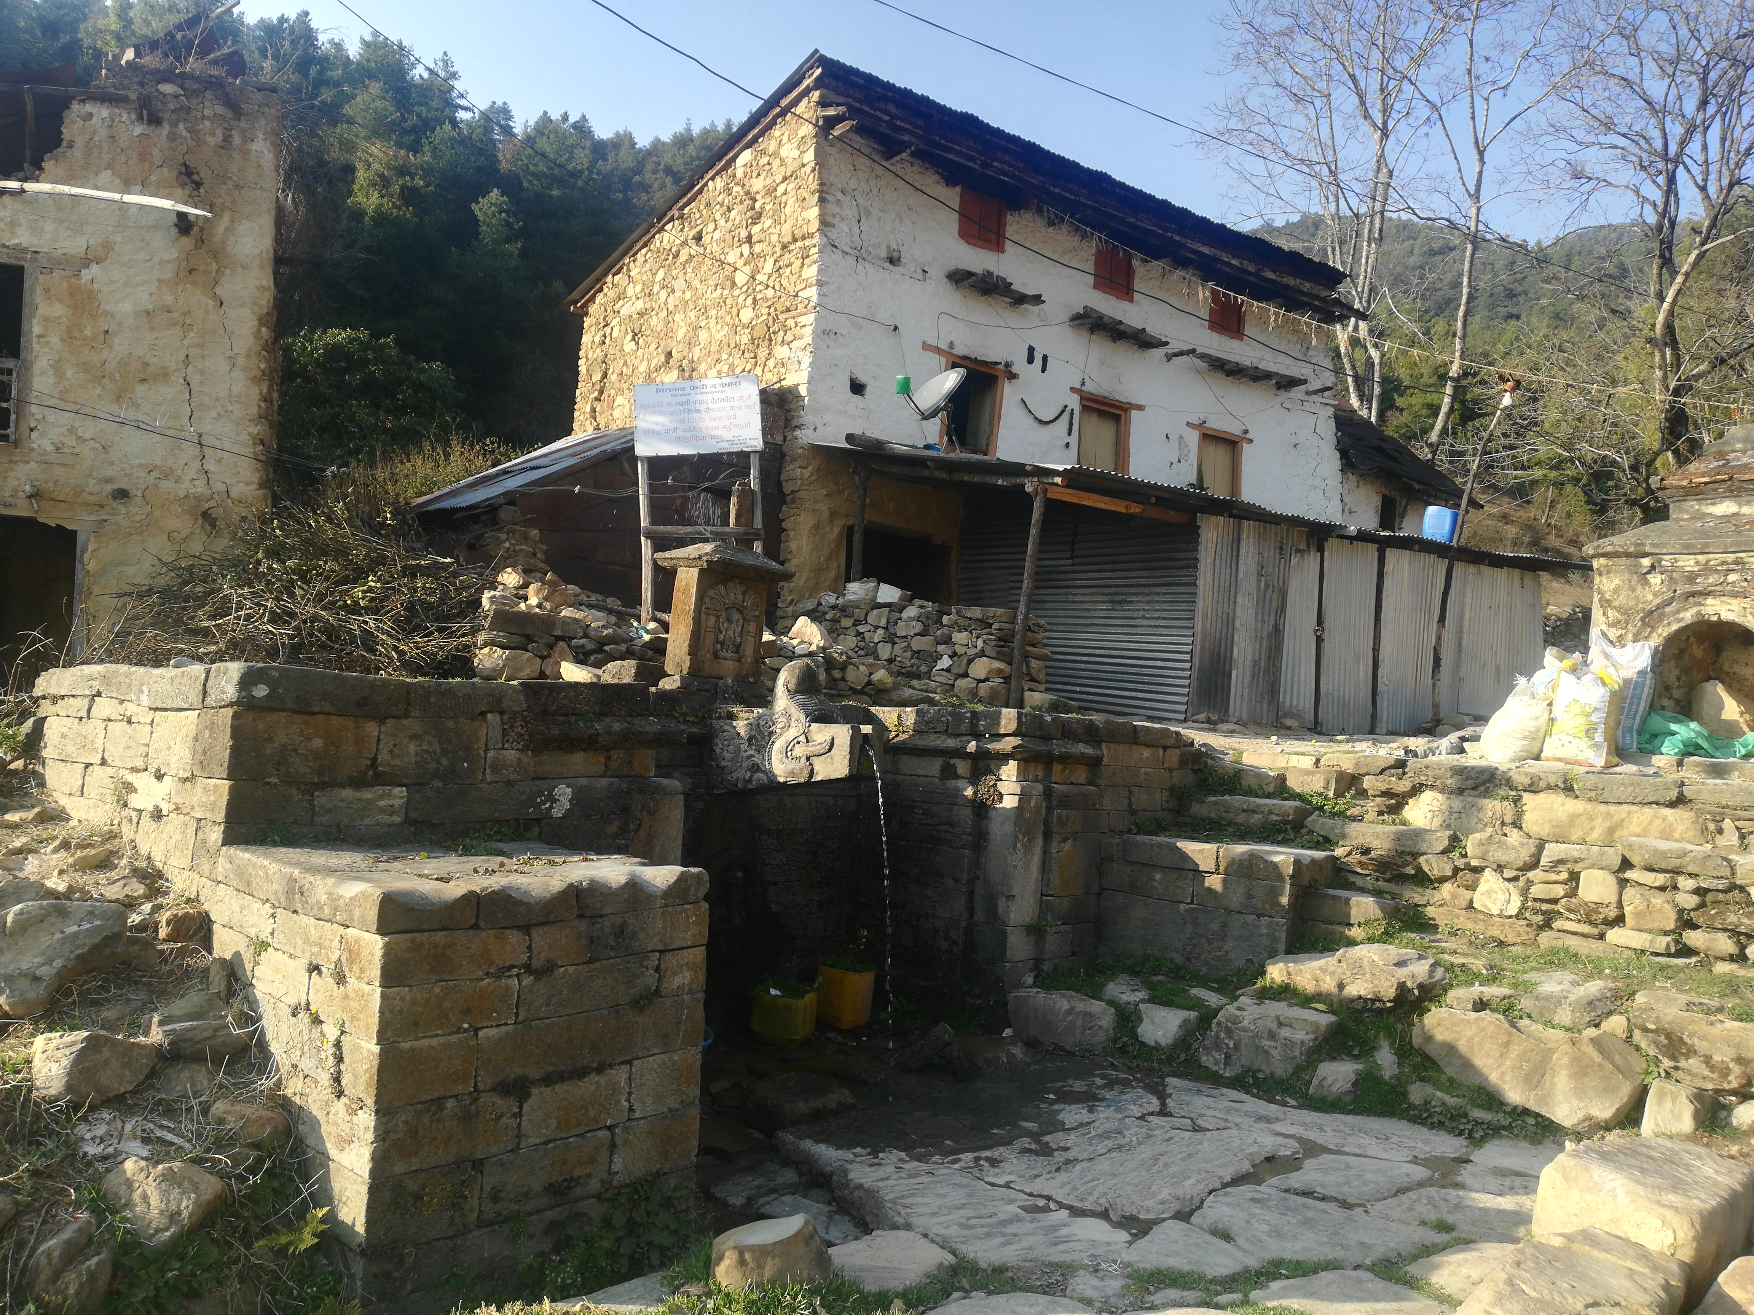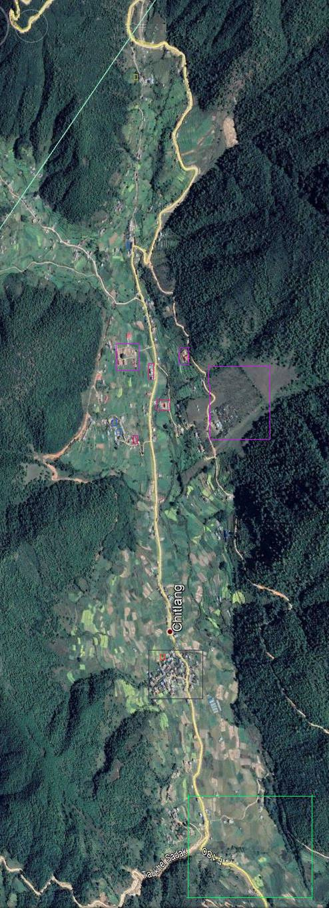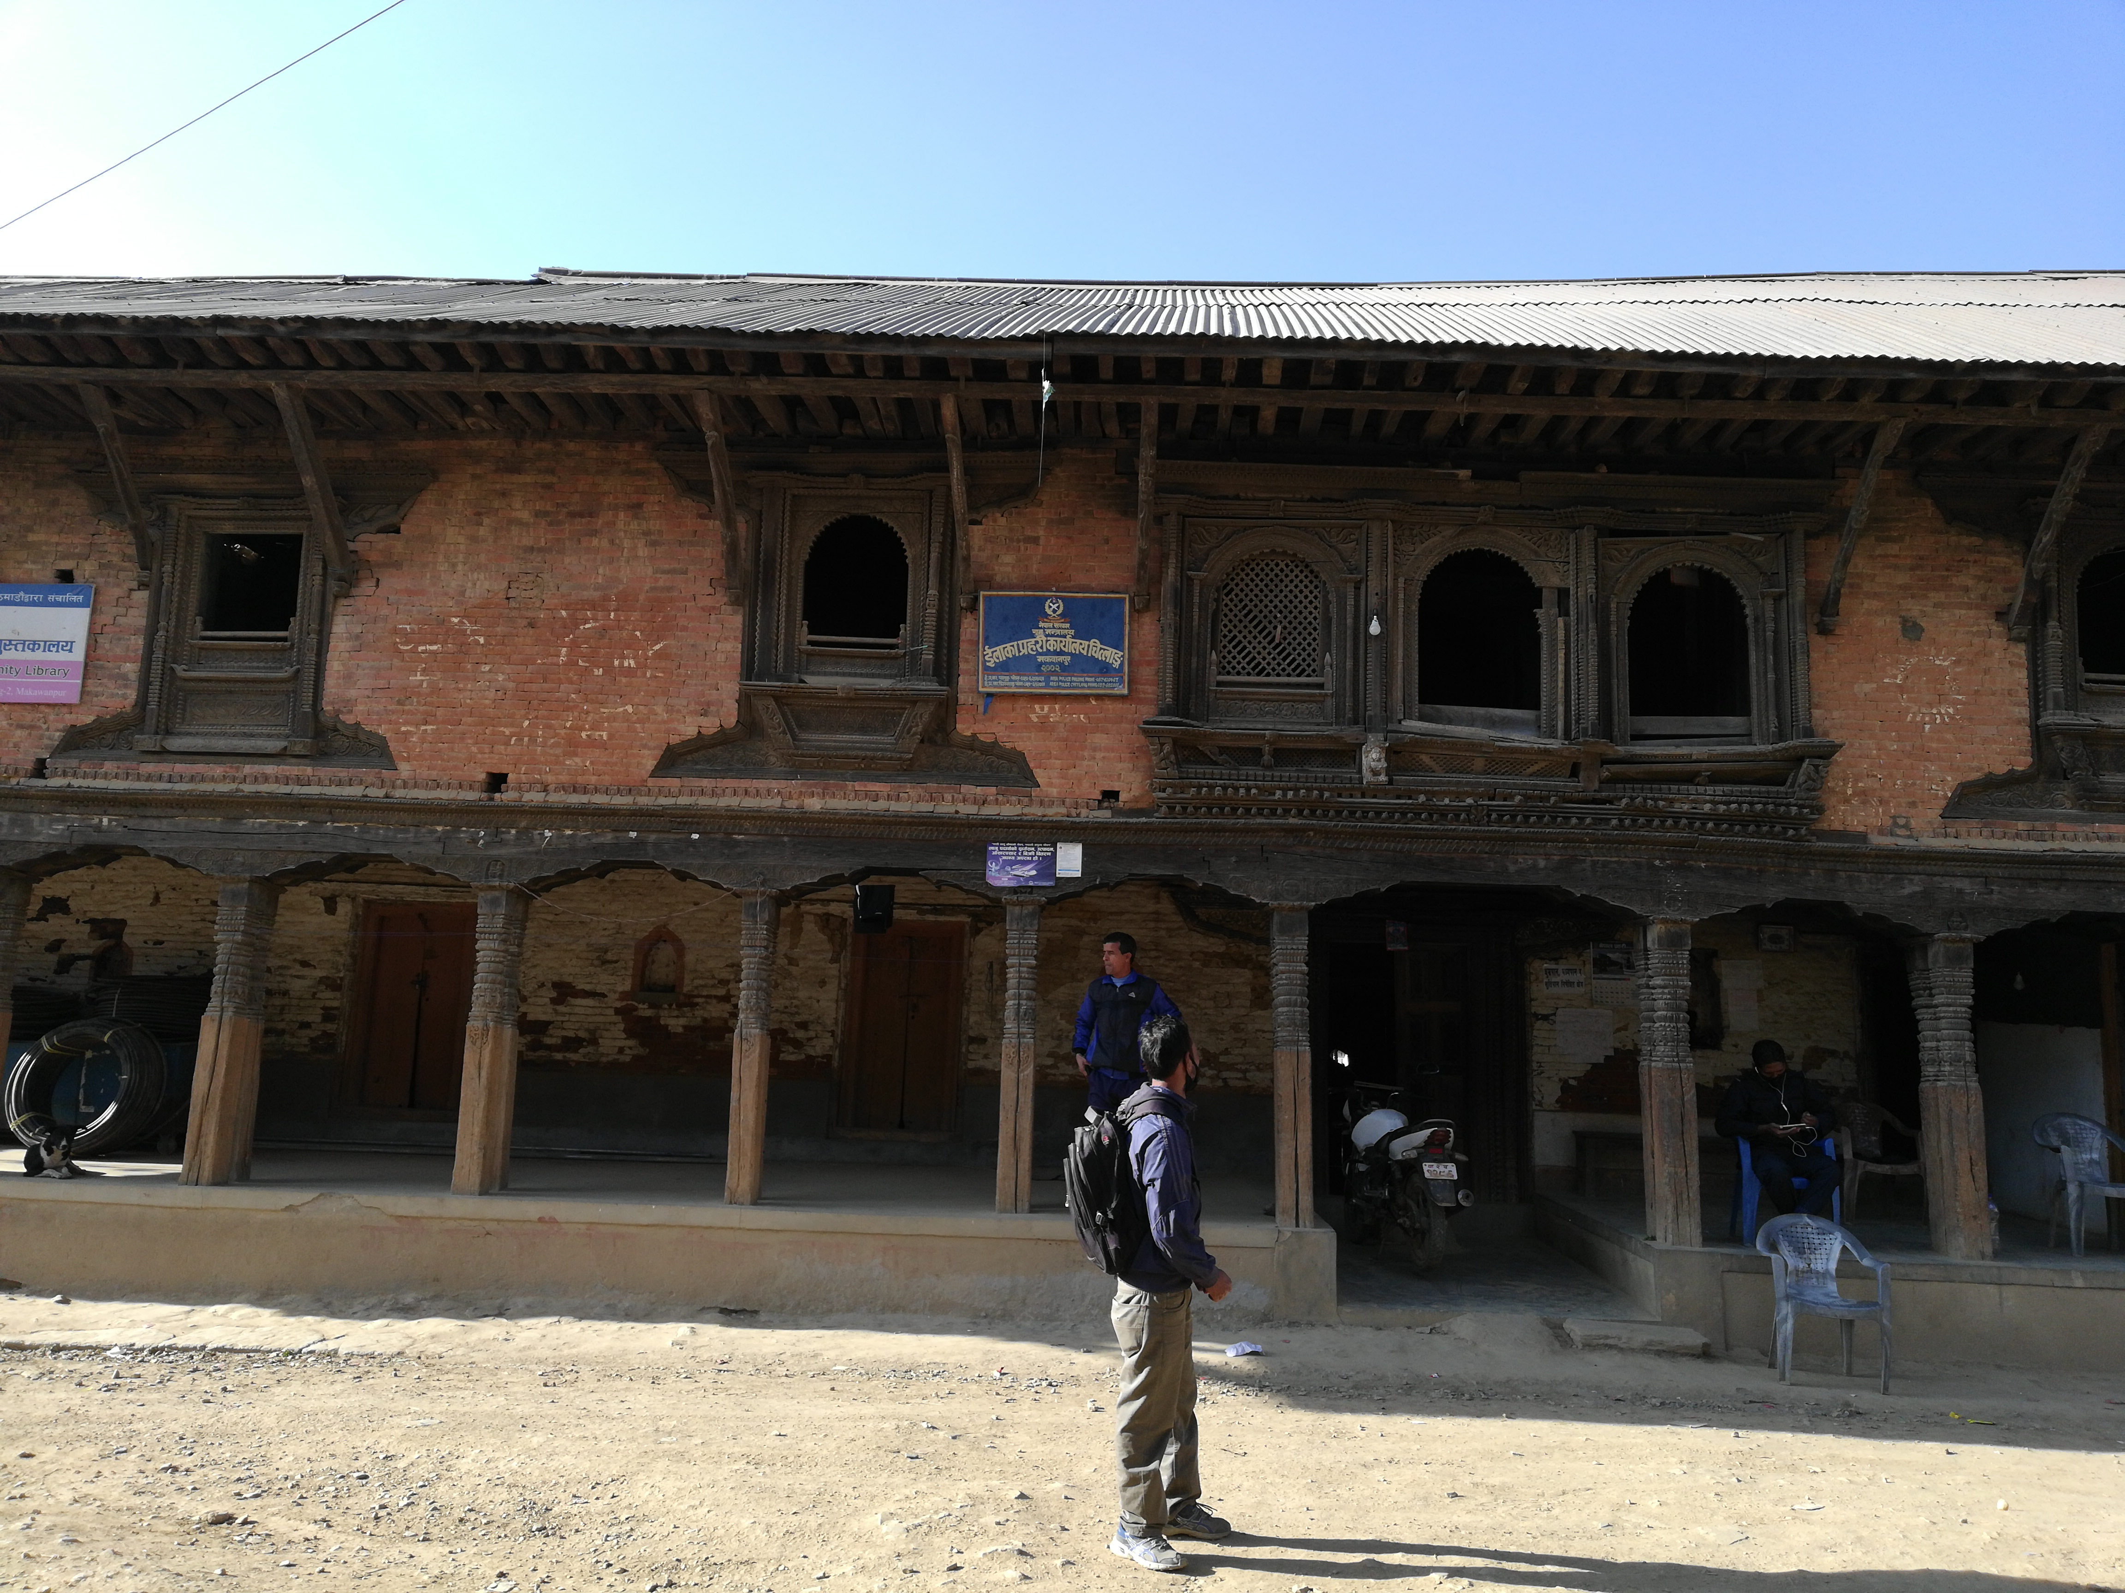
Existing map of Chitlang

Wrote Yatri poem by Mahakabi
Patipauwa
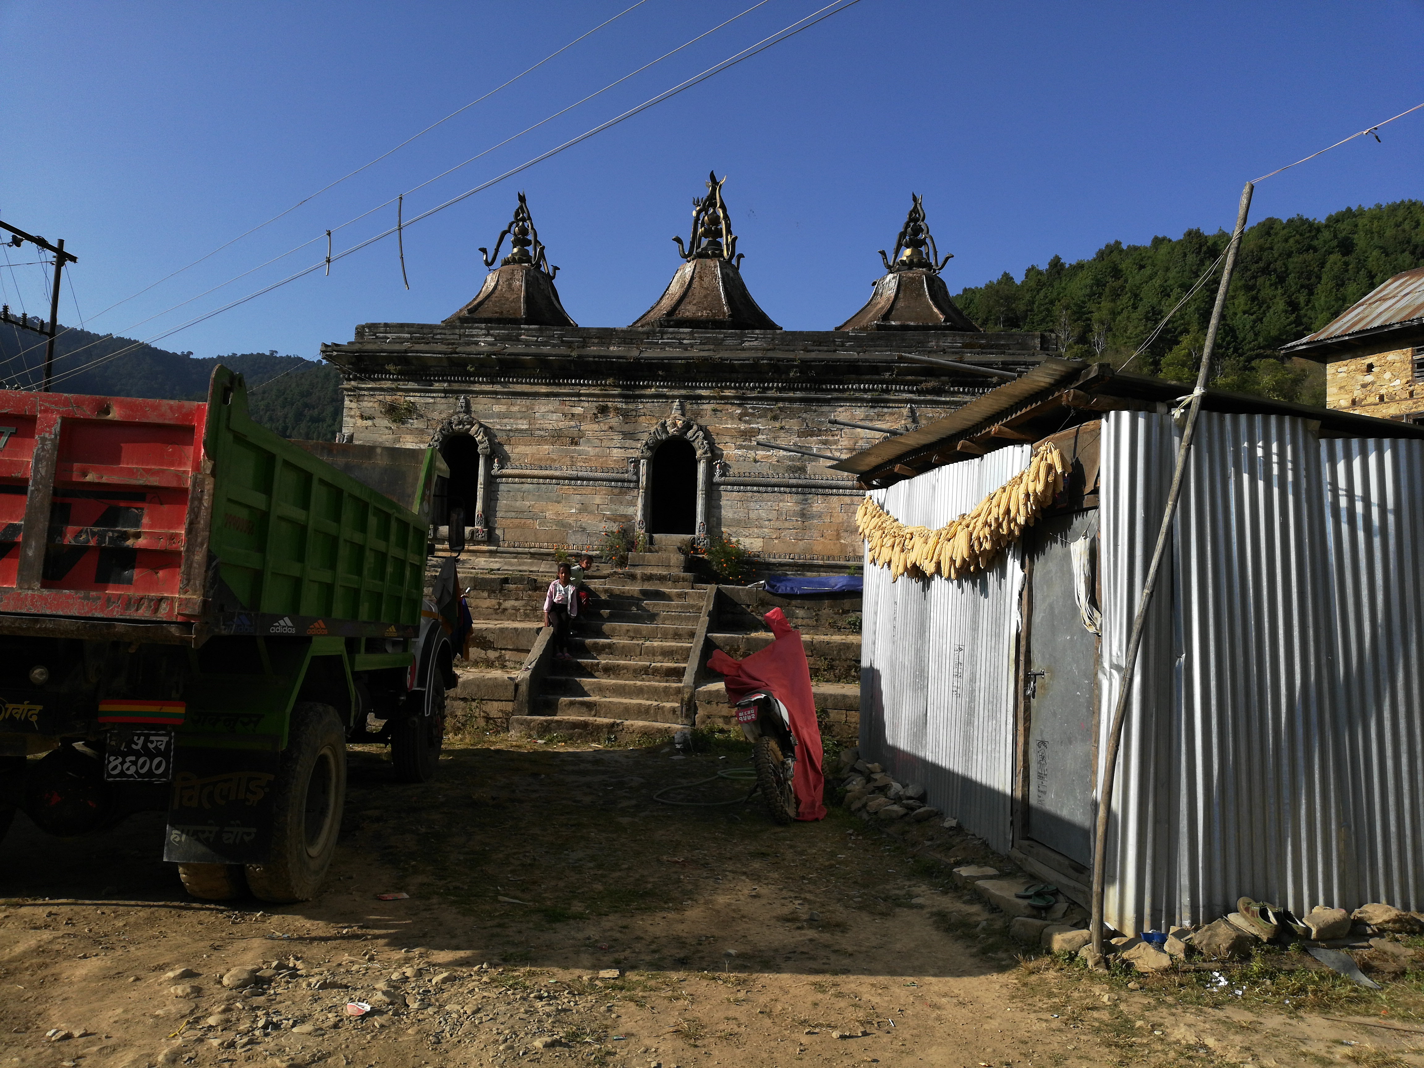
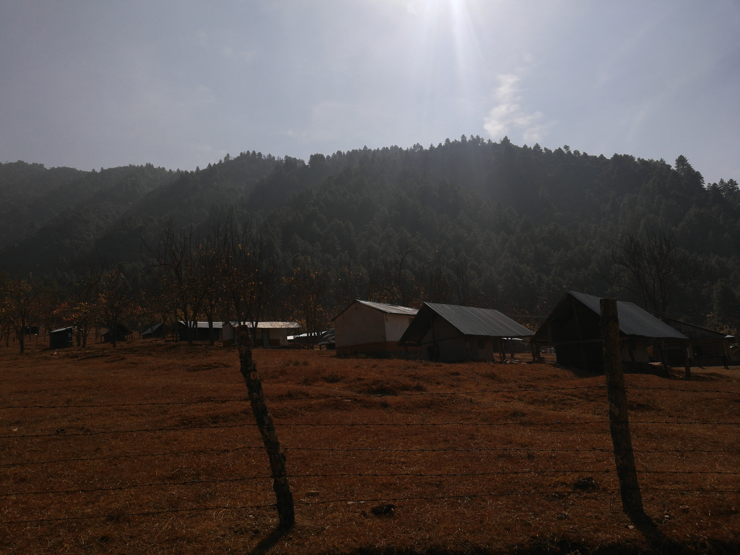

Resort
3 gajur mahadev

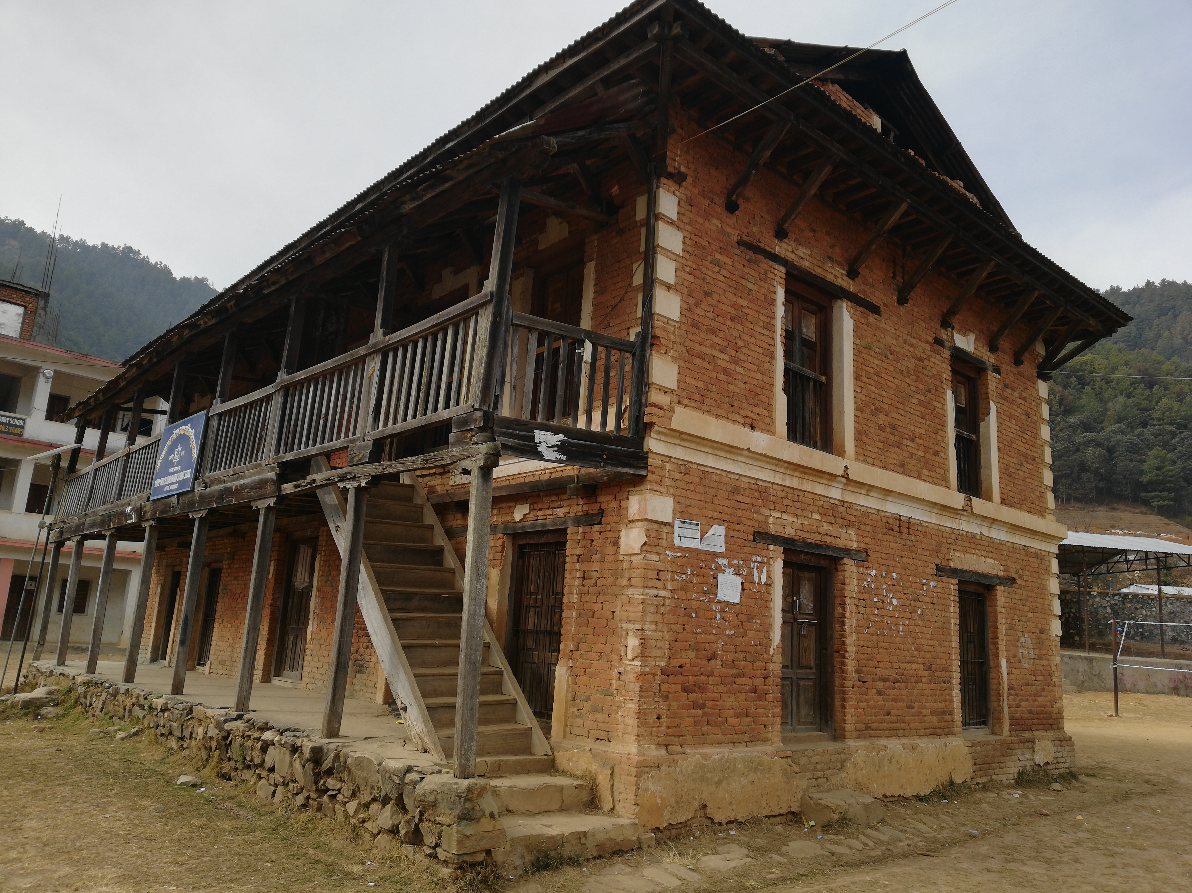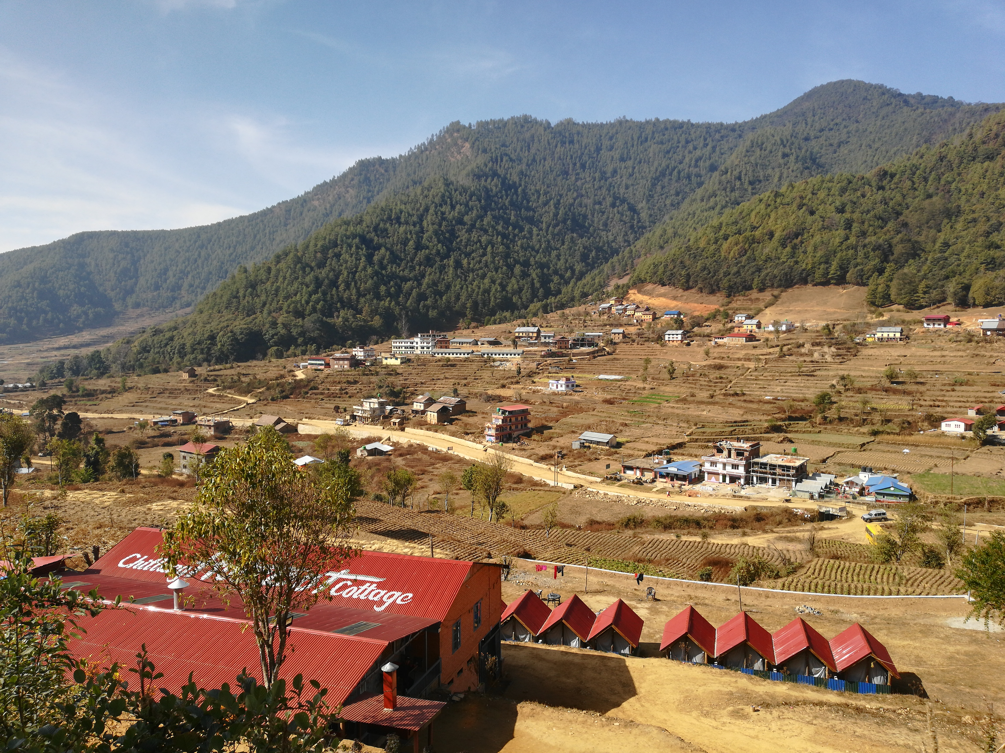

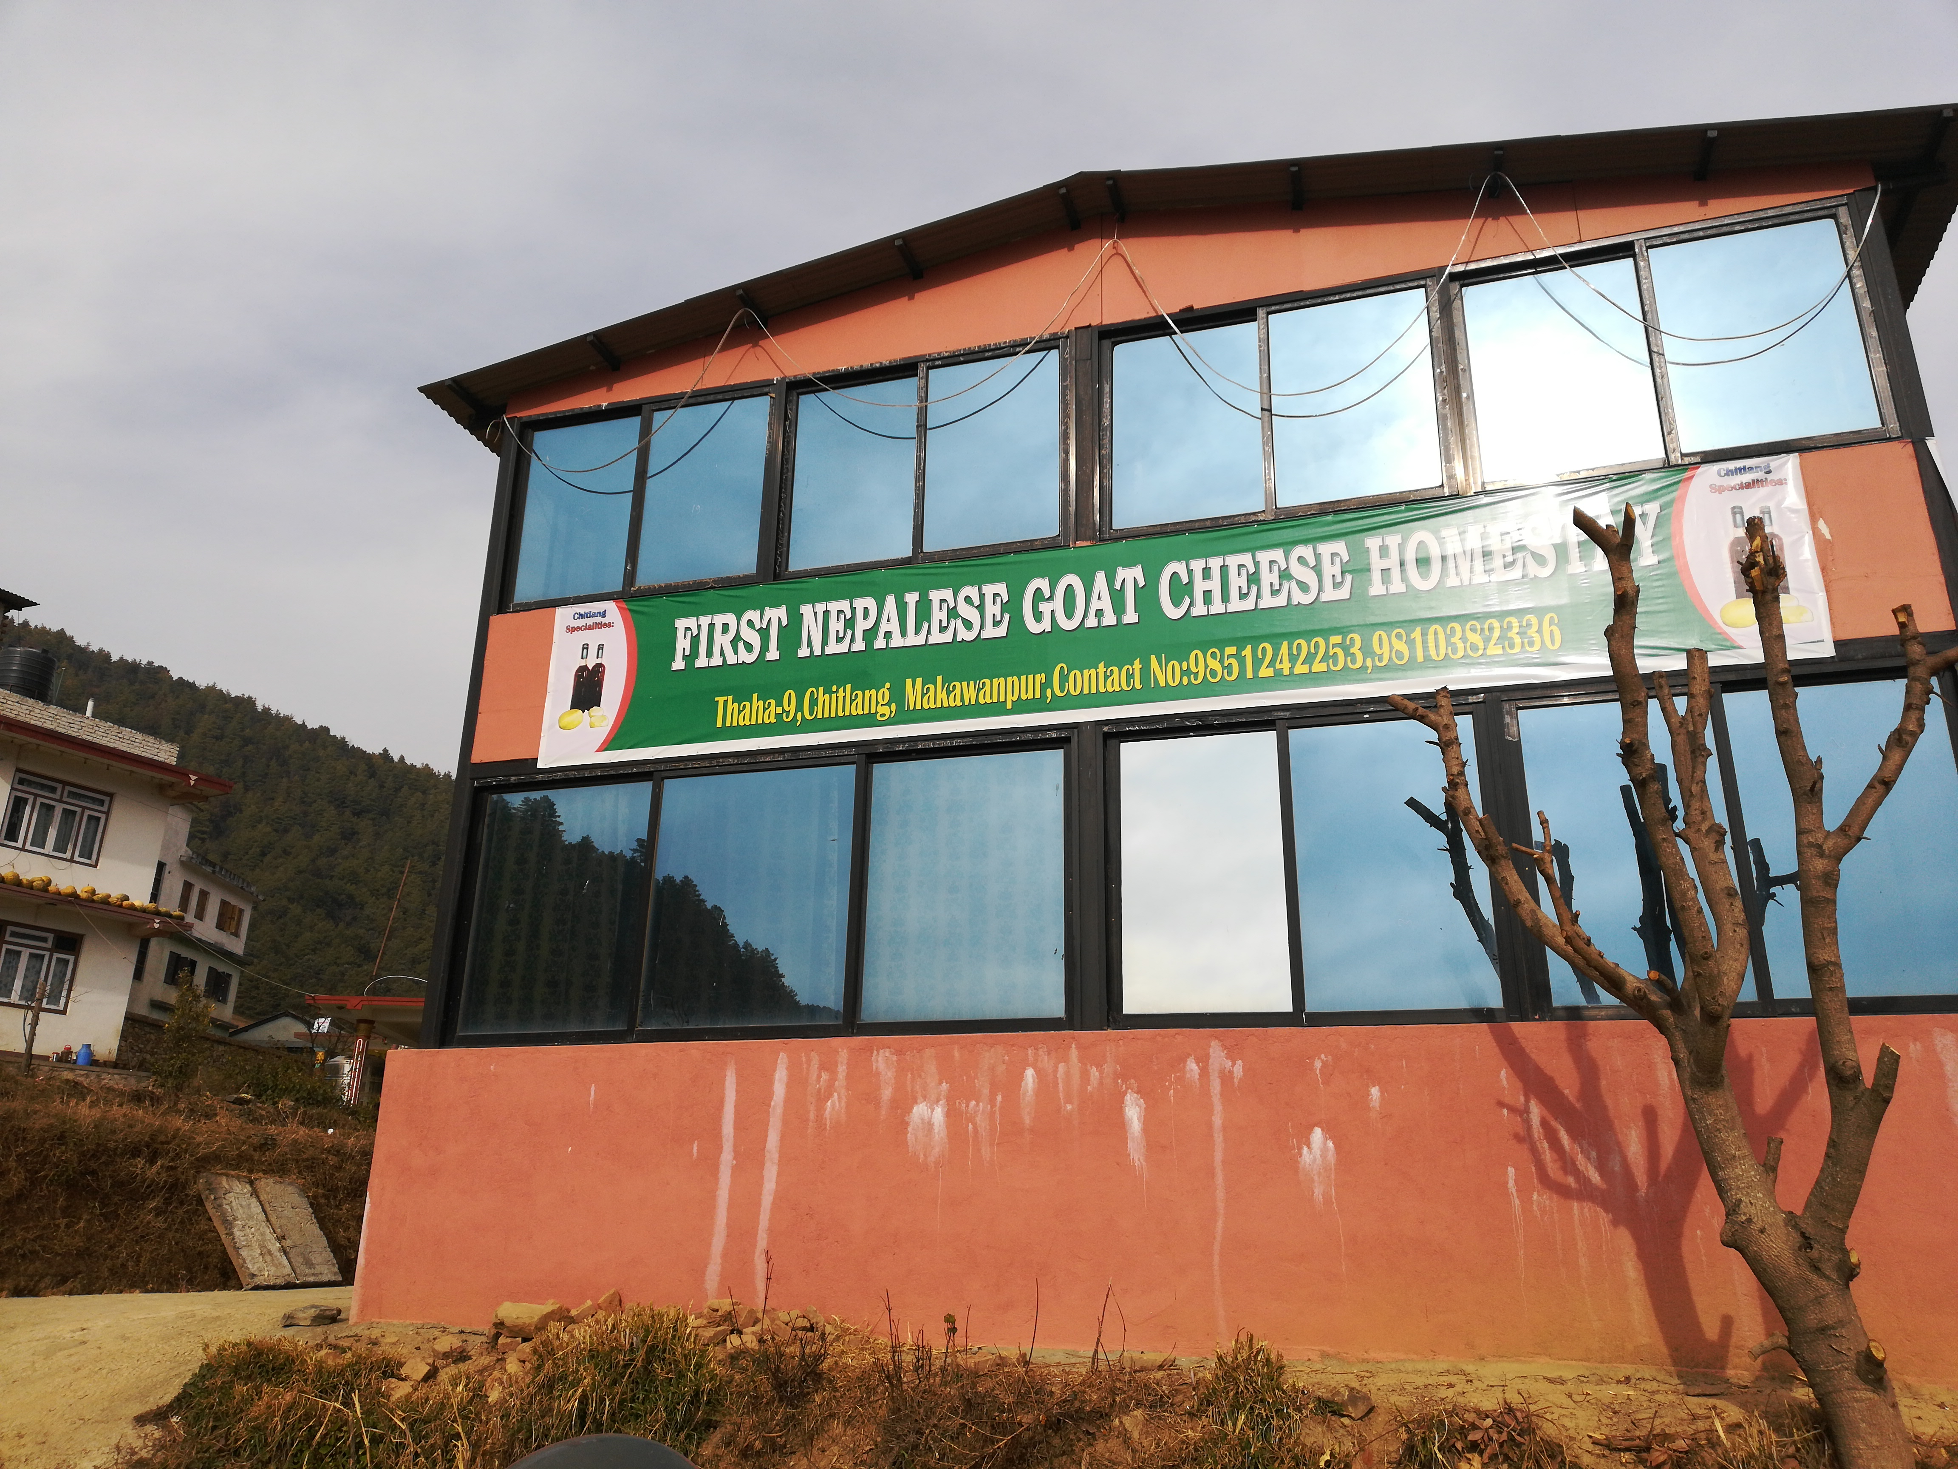
King rest house

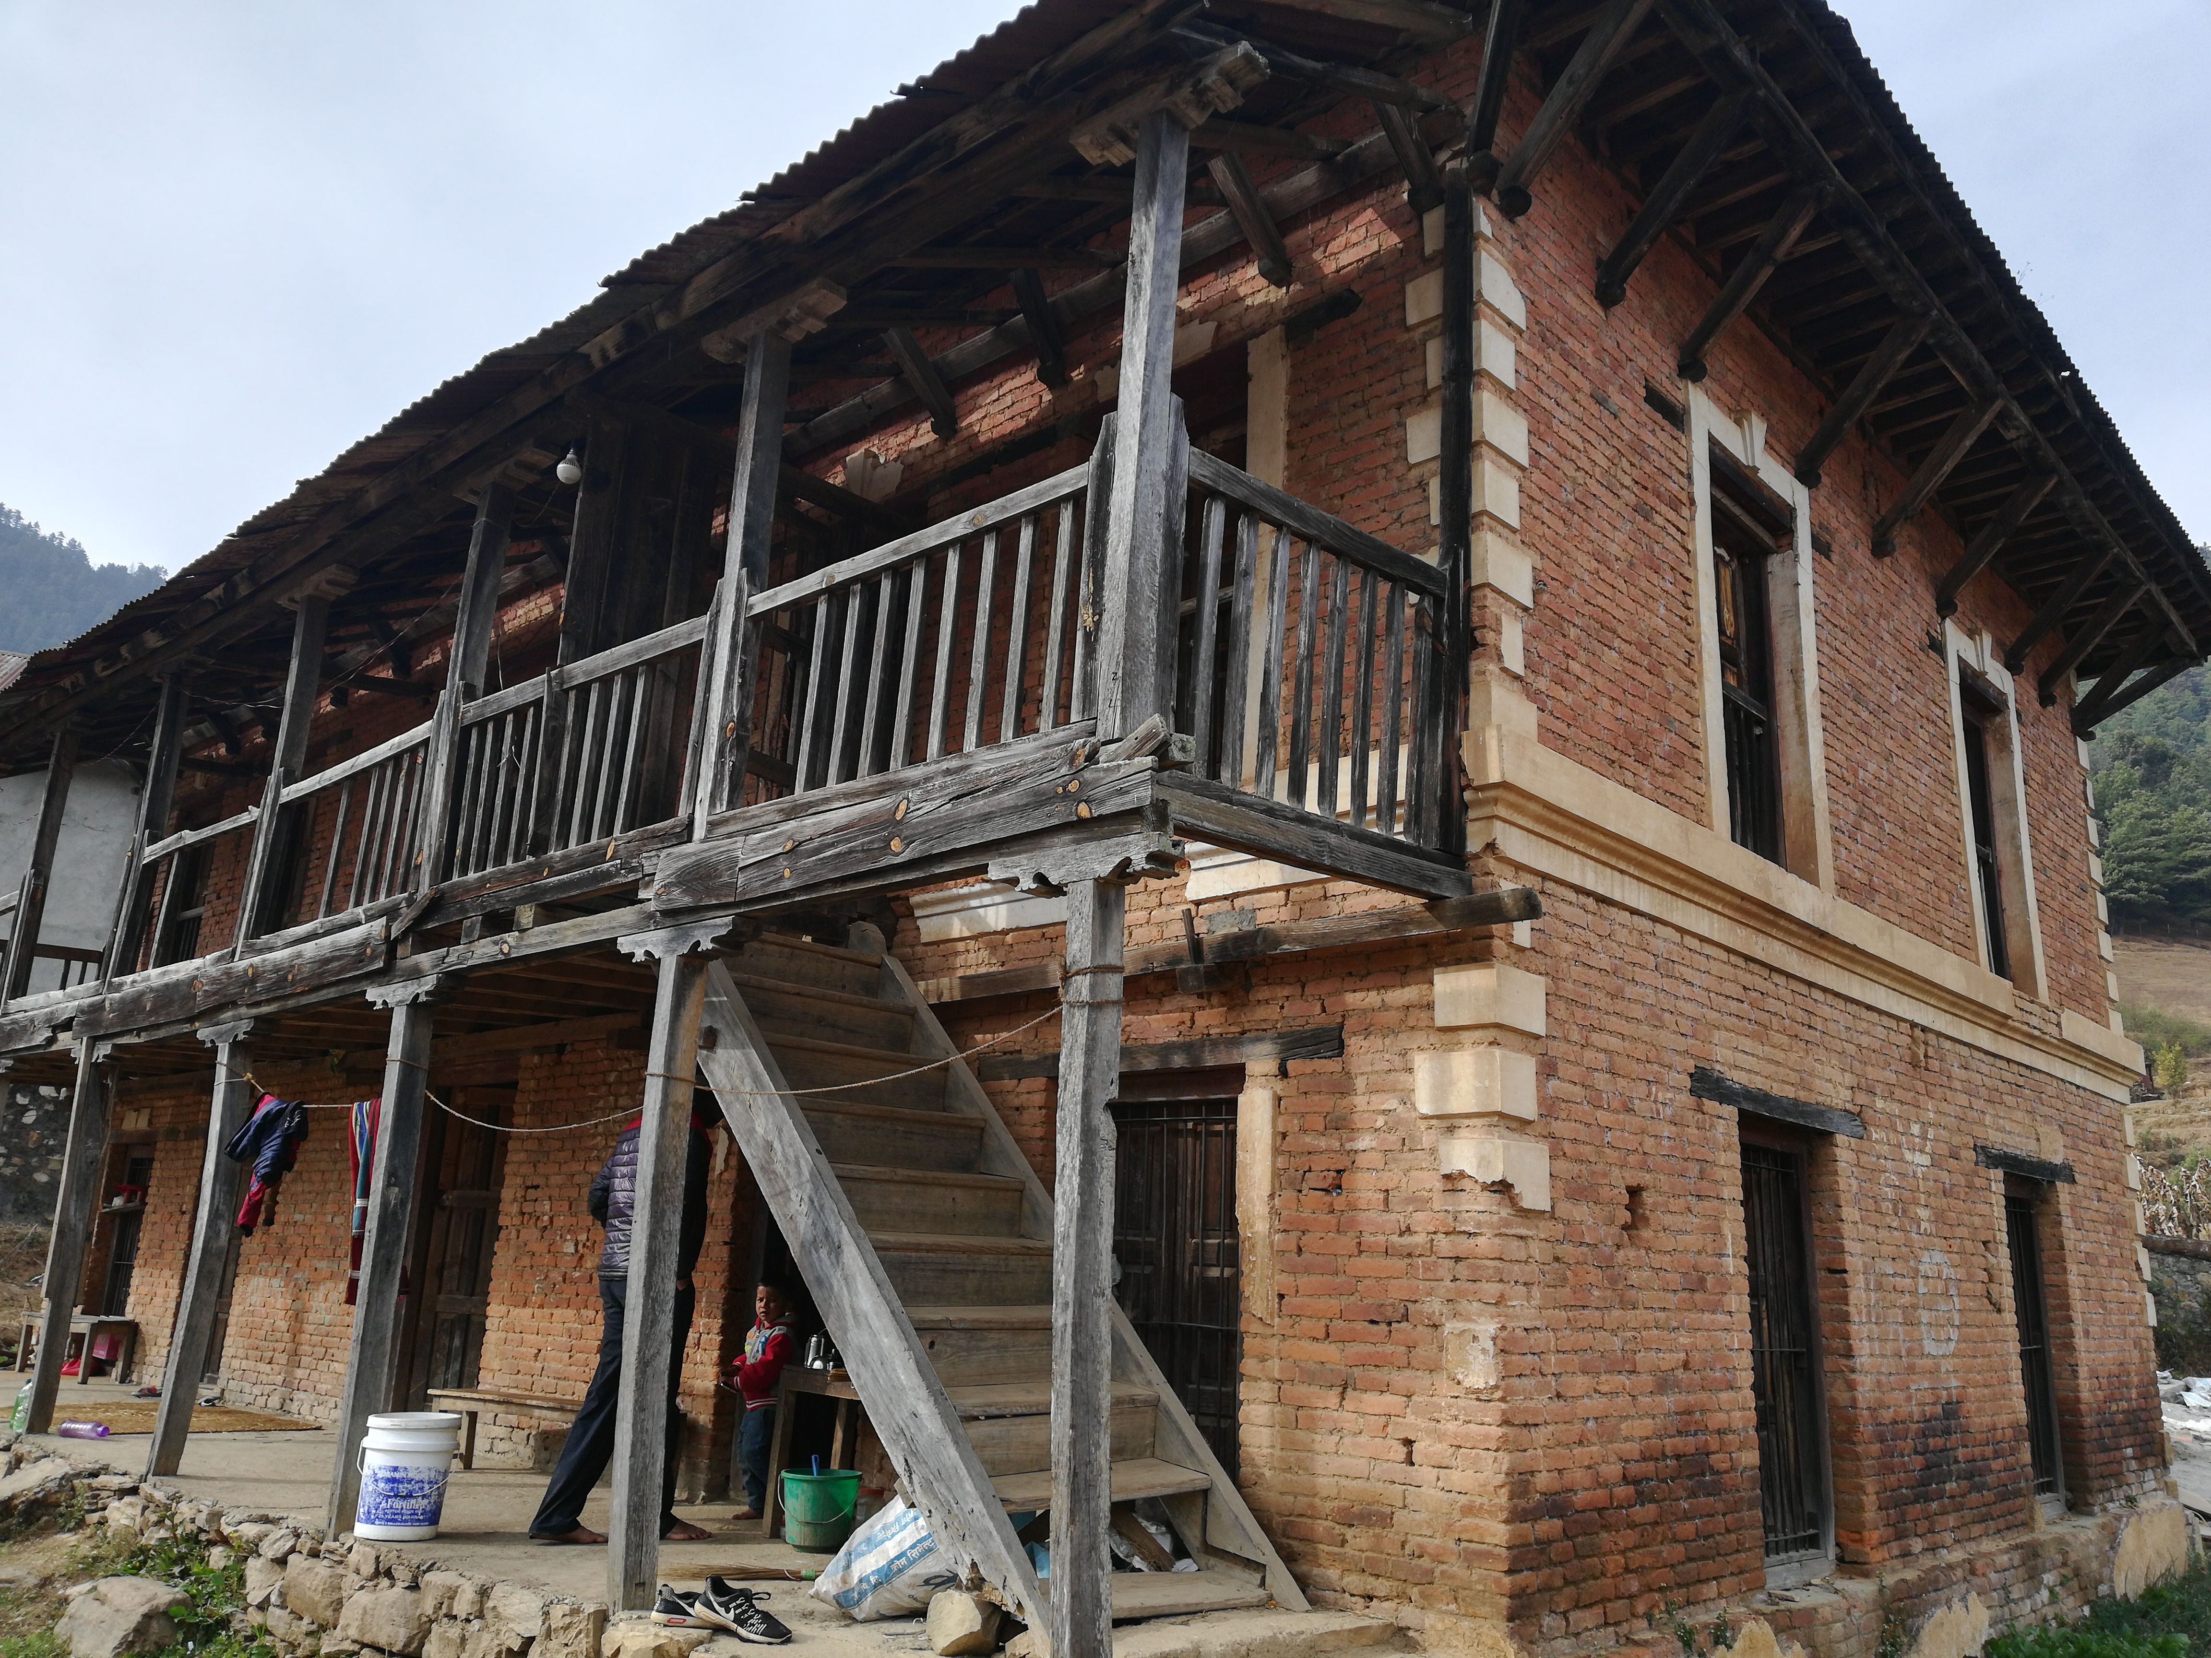

Homestay

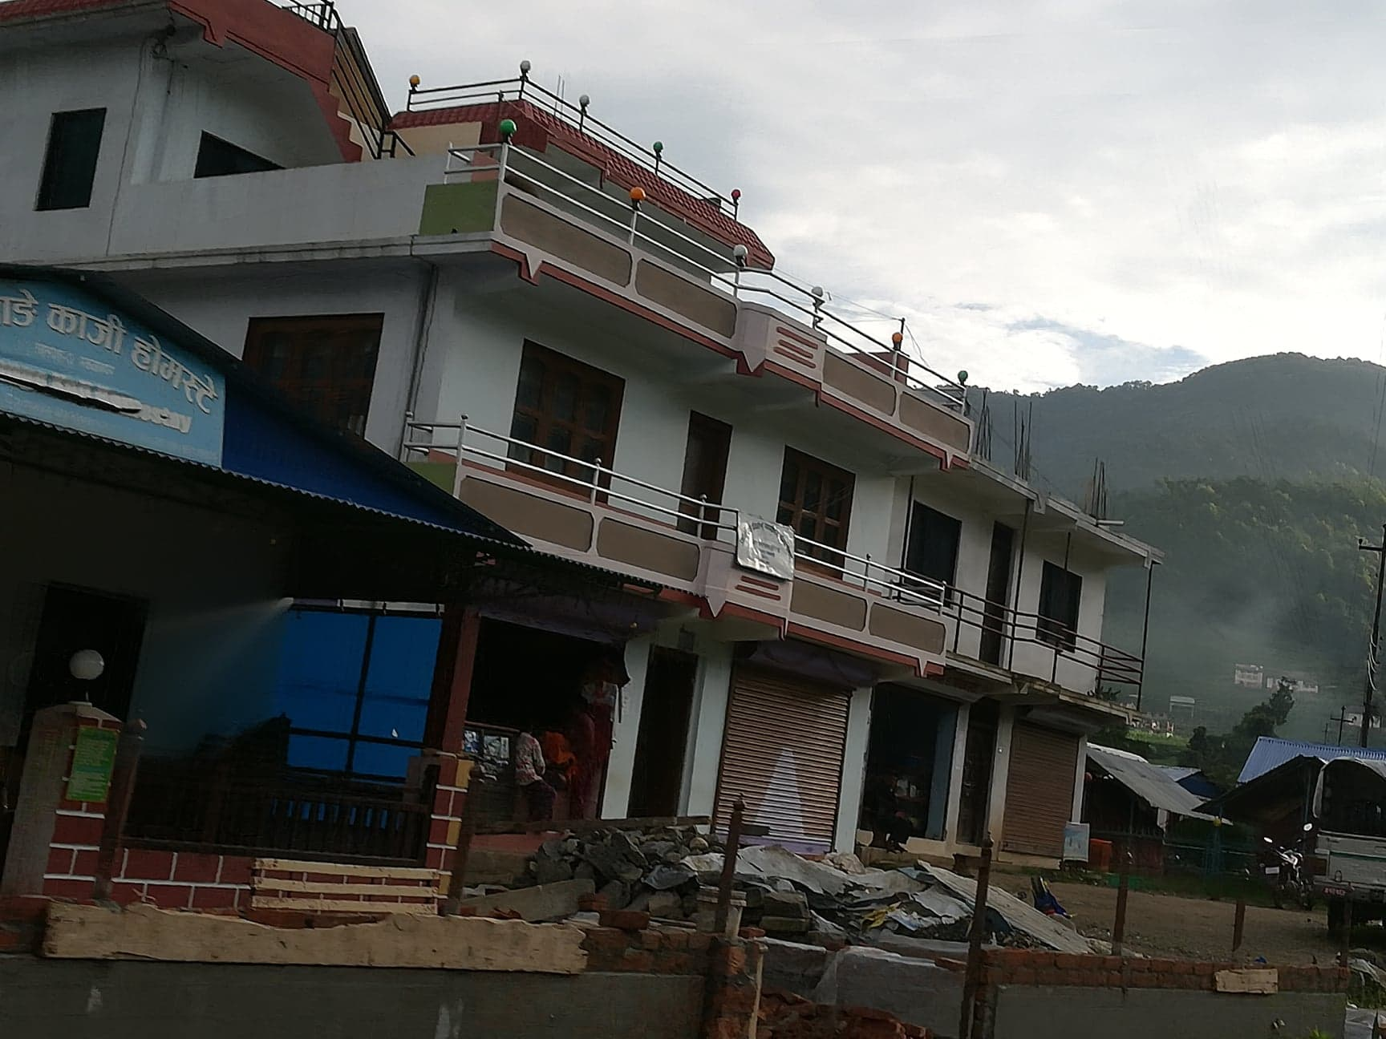

Rana rest house

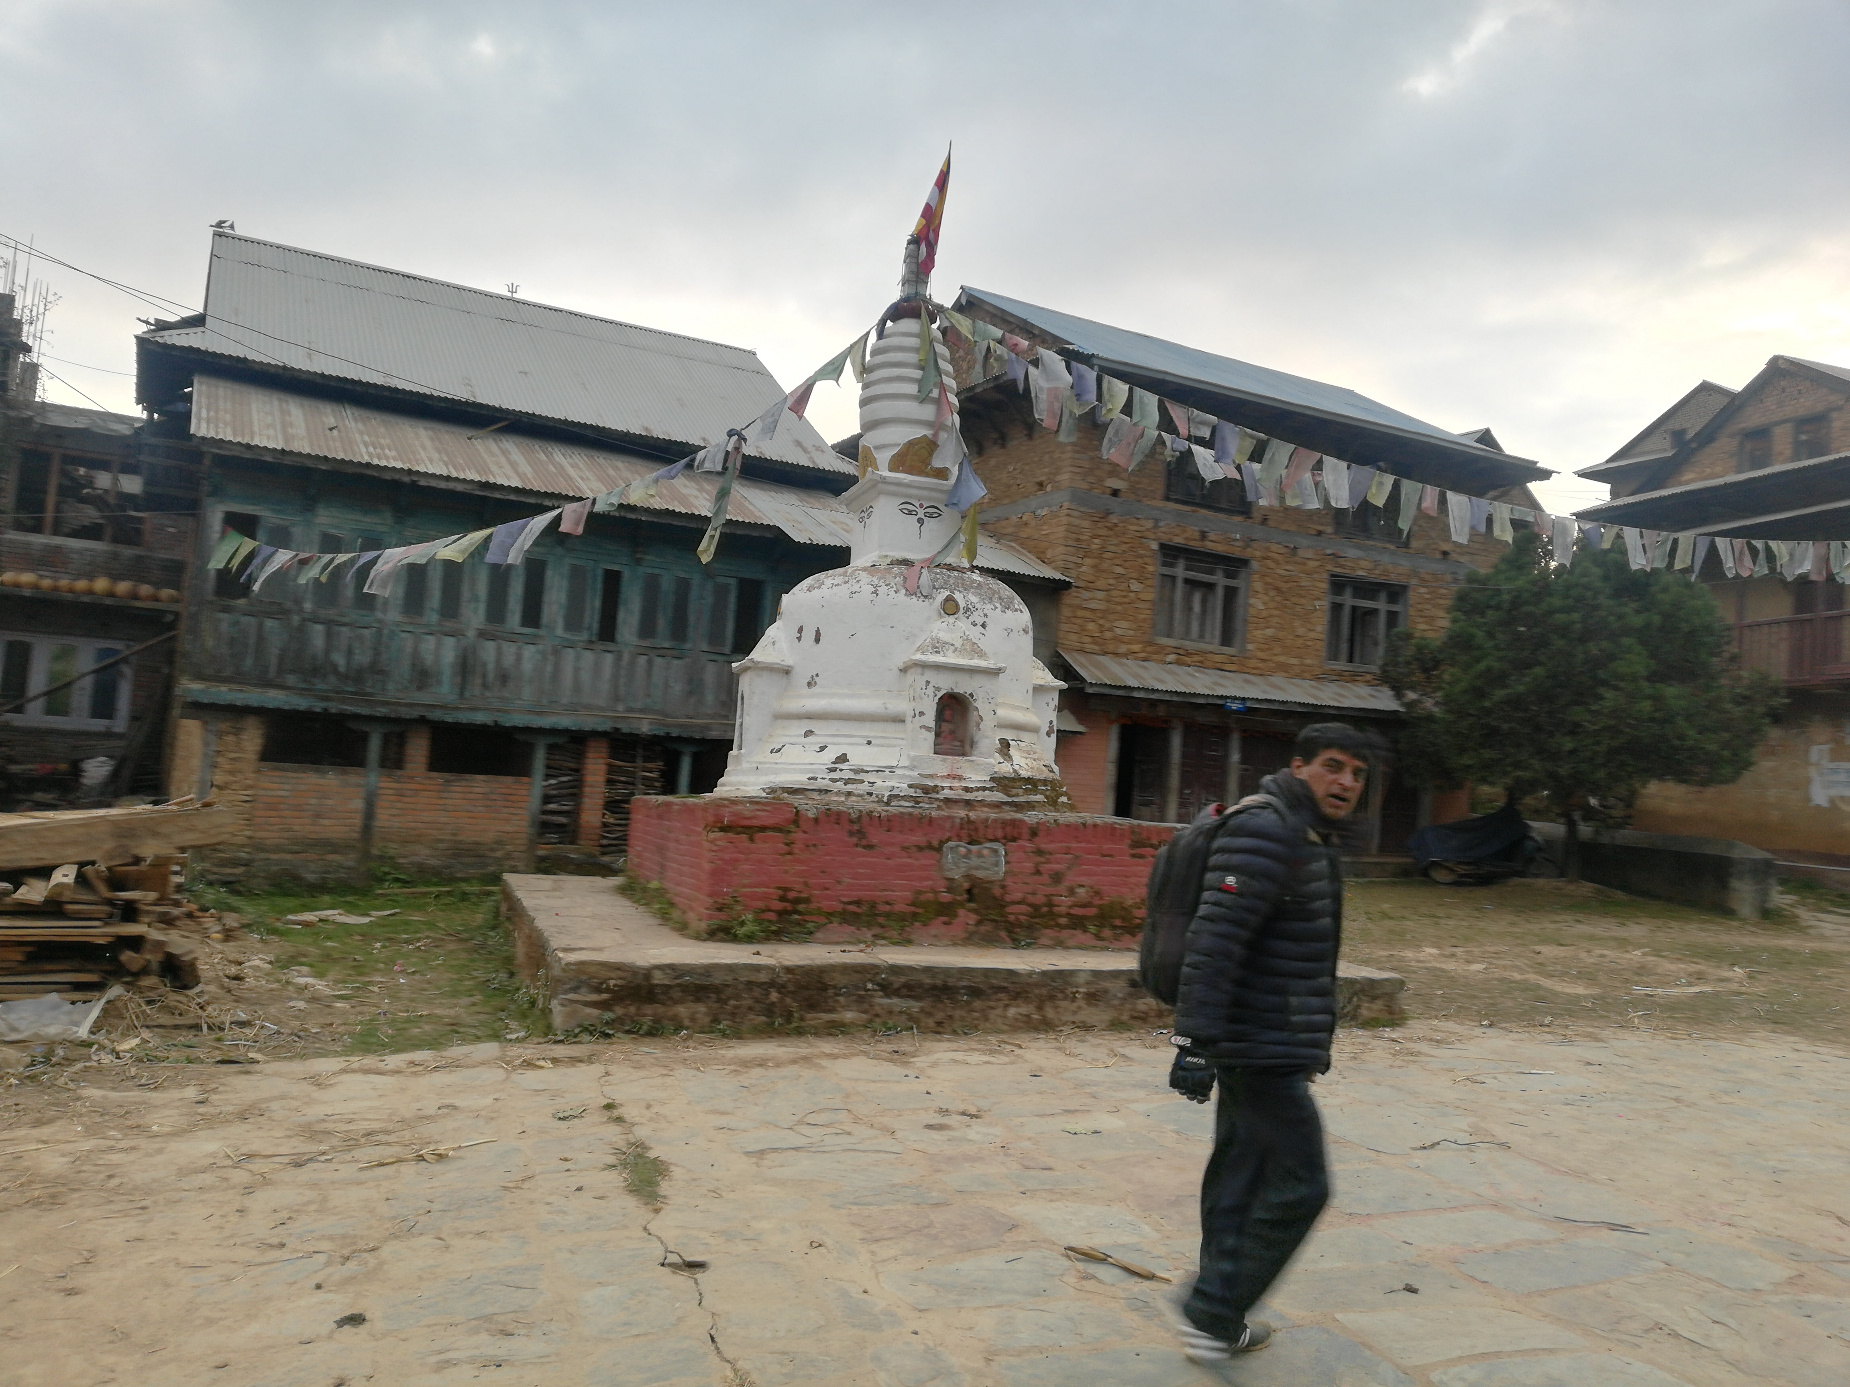

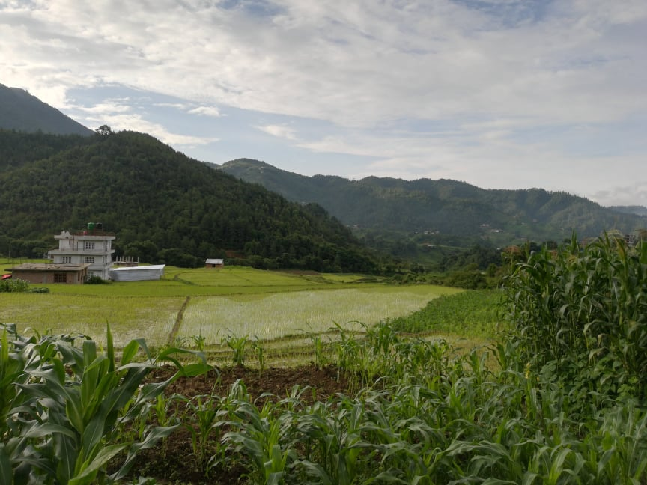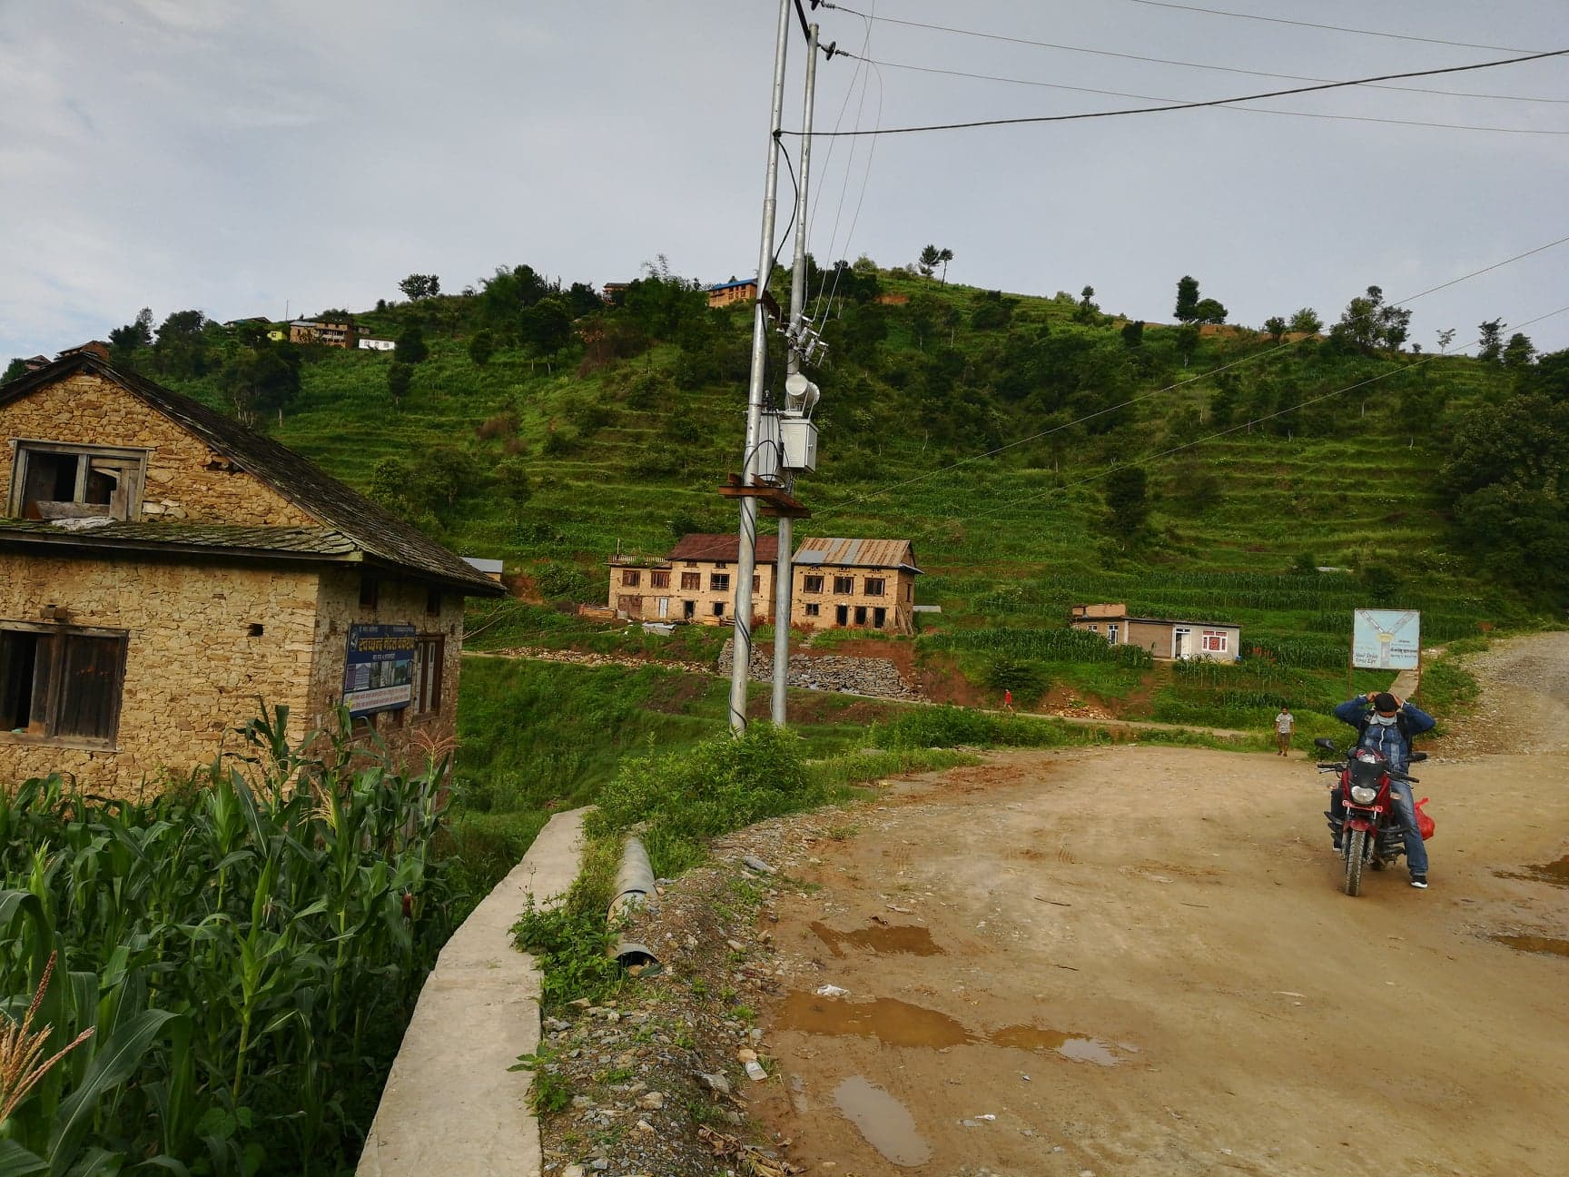

Ashok Chaitya
Proposed Agri tourism farm

Entrance
Entrance from route i.e. from Narayanhiti area. The program that are proposed area:

Cycle hiring Station
Cycling is environment friendly and hence, the tourist can hire the cycle in some payments for certain period of time

Floral Garden
The floral garden around is proposed in the route to the Tupikhel from Narayanhiti. The floral garden is spread around for 5 hectors. It occupies the children playground and picnic spots. The floral garden can be used as the rent for film shootings and picnic spots. The educational tours can also be preferred as there will be many type of flowers.

Narayanhiti / Tupikhel Area – centerpoint
Tupikhel is proposed as the center point for the agritouristic farms. The streetscapes are proposed to be traditional and the projects like homestays, cottage industry, agriculture training center etc are proposed in the area

Cottage industry cum handcraft
The cottage and handicrafts which are made by the local crafts person need to be promoted and sold so the building is proposed.

Community Hall
Community building is proposed along with the market area. Community building can be used for many purposes like party, meetings etc.

Homestay Cum Restaurant
The existing housing is proposed as homestay cum Restaurant.

Farmer vegetable Market: Farmer can sell their product in weekly bazzar held in this area.

Agriculture promotion centre
Agriculture production enhance by providing seeds and organic, inorganic fertilizers. Training provided to the farmer in this centre.

Farm house : used for tourist for stay in farm tent/farm house.

Farmer’s Market
Farmer’s Market is proposed near the agriculture field. The advantage is that the crops from field can be directly taken to the nearby market and sell.

Nursery and green house
Nurseries and green house are proposed in the farmers’ market area so that the people coming to the farmers’ market can come to nurseries and can buy the plants and flowers.

Agricultural farm near the Farmers’ Market
The farm is proposed near the market area. The products from the farm are sold to many areas in Thaha as well as other areas of the Kathmandu, Chitwan, Pokhara etc
.
Place where Laxmi pr Devkot wrote Yatri poem

3 Gajur Shibalaya
Patipawa
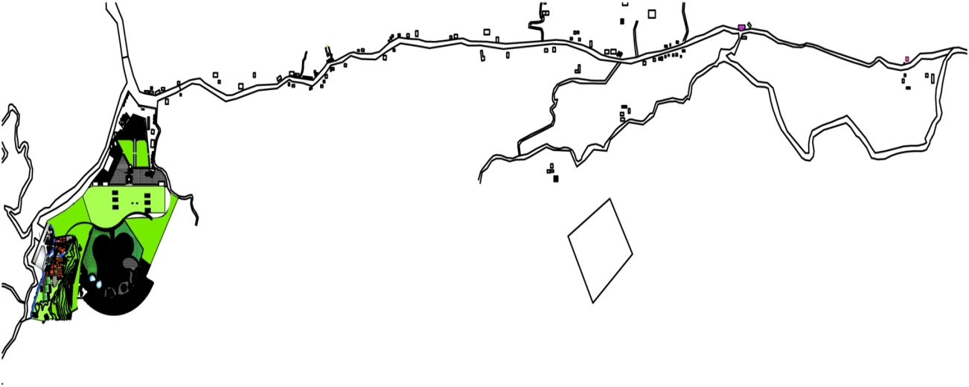

Rest house for King and Rana

Ashok Chaitya

Proposed agri tourism area

Capacity building Community level

- Skill enhancement and trainings
- Local guide and tour leader’s trainings
- Upgrade the origination and management capacity of local lodge/hotel/homestays
- Training on language and interaction with tourist
- Training on organic farming
- Diversification of agri –tourism
- Village tours
- Cultural tours(to religious sites)
- Medical herb tour/bird watching/adventures

Hiking/Trekking
Thaha municipality can be hub of hiking and trekking. It can be easily formulated plan and package of the tourist from Chandragiri to Markhu,Bisinkhel,Taukhel,Bajrabarahi,Kunchal,Palung, Daman etc. it can be one day, two day, three day, four day ,five day and six day package for the tourist.

- One night two days tour
Walking from Kathmndu to Chitlang and stay in Chitlang and village tour and return back.

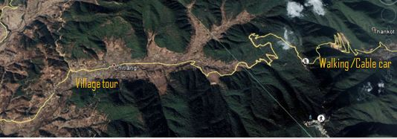
Figure 68. map of One night two days tour

- Two nigh three days tour
Walking from Kathmndu to Chitlang and stay in Chitlang and next day village tour to Vedefarm(goat farm),boat in in Indrasarobar, stay at Markhu and return back third day from Fakhel .

- Three night four days tour
Walking from Kathmndu to Chitlang and stay in Chitlang and next day whole Chitlang village tour ,Stay in Chitlang and day village tour to Vedefarm(goat farm),boating in Indrasarobar, stay at Markhu in third day and return back fourth day from Fakhel.
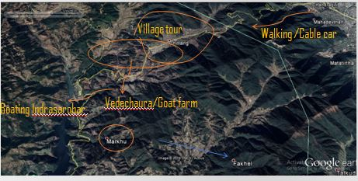
Figure 69.Two/three nigh three /four days tour

- Four night five days tour
Walking from Kathmndu to Chitlang and stay in Chitlang in two night and next two night village tour to Bajrabarahi,Kunchal,Taukhel,Tistung and return back third day from Naubise.

- Five night six days tour
Walking from Kathmndu to Chitlang and stay in Chitlang in two night and next two night village tour to Bajrabarahi,Kunchal,Taukhel,Tistung and stay at Palung and return back sixth day from Naubise
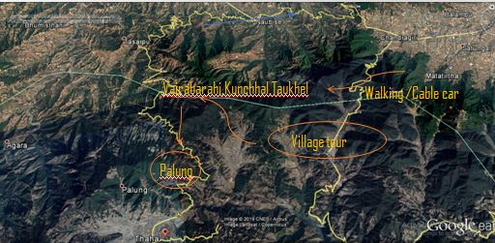

Figure 70.Four/five night five /six days tour
In additional above new form of sports such as trail running, off-road running, mountain biking etc have also been gaining popular in Nepal.
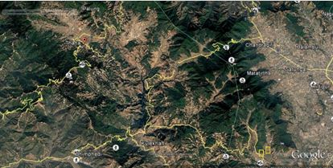
Figure 71.Cycling route

Home stays accommodation needs to be encouraged within existing community.
The alcohol making though is illegal practiced by local people if not commercially, for their own use. With proper regulation of agriculture product, if resident can still produces alcohol, then proper management of local liquor business by making it legal in controlled way can help in diversification of activities and attract more tourists who are interested in local flavour.
The illegal alcohol making can otherwise be discouraged by engaging the community in other potential income generating activities such as
- Basket and basketry(Bamboo and nigalo)
- Horticulture (mostly lime,lemon,pear,orange)
- Animal husbandry and poultry for different products
- Noodle making (from local wheat)
Religious ceremonies and cultural practices should be institutionalized and enthusiastically celebrated for attracting the attention of cultural tourist. The community must be made aware of the essences of Tamang culture, heritage, and historical inscription of Ansubarma.
Small scale enterprises in itself with several self-sustaining activities like floriculture, handicraft making, organic food production etc. that can make the community financially more independent.

Reducing adverse social impacts
- Preparing code of conduct for tourist and visitors
- List of Do’S and Don’ts
- Language sheet
- Introduction of page/brochure
- Newsletter/webpage/documentary films

Management
- Tribhuwan highway easy access but Chitlang chandagri Ganeshman High way under construction from where only 13 km to travel.
- Tourism master plan can be prepared with the support of expert and Tourism board in future
- Infrastructure Thaha cultural museum in Bajrabarahi ,Thaha smarak Park in Naugau,Tourist information centre in Chitlang under construction and tender process.
- Religious region Pandukeshor, one of Sankhamul dham of other two Kathamandu and India.
- The signage and location boards on the area of municipalities established. The resting stations and waste collection bin also needed.

Agri based industry
Wastage of agriculture product prevent, cold store established, Potatoes chips production, Rice research centre, Potato research centre, Vegetable research centre, Handicraft centre.

Policy level
- Separate agri tourism plan should be prepared on national level and then for separate agri tourism destination
- Regulation and guidelines for home –stays,tour operators and trekking guides should be prepare and and distribute to communities.
- Provides subsidies/special financial incentives for people
- There are situated in household in scattered way in LAKE <BASI<KACHHAD. It is too late for land use planning and zoning of municipalities. It is necessary to development of aggregate resident area, agriculture zone, industry zone, commercial zone according to map and zoning. It is implemented that land use planning and zoning from municipal council.

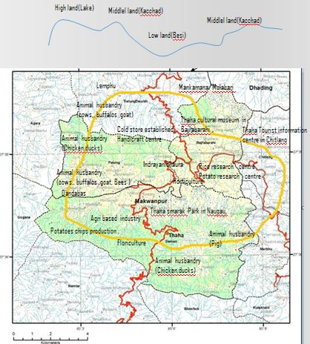
Figure 72.(High land)Lake ,Middle Land(Kachhad), Low land(Besi)

Thaha municipality leka,kacchad and besi conceptual frameworks
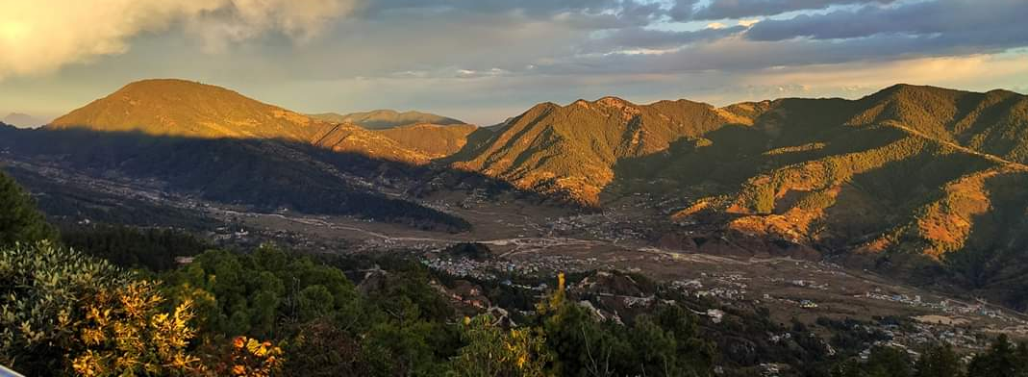

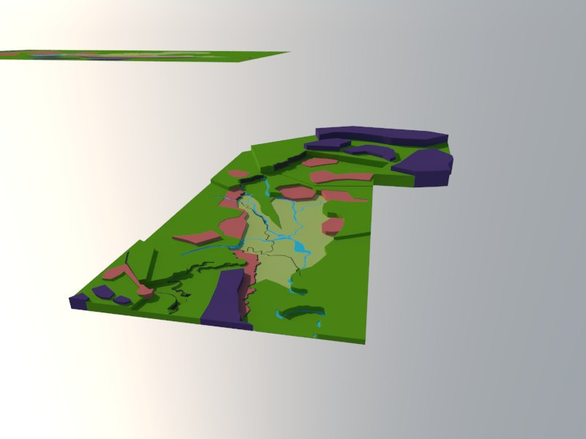

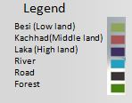

CONCLUSION
CHAPTER SEVEN: CONCLUSION
Expansion of destination, diversification and specialization for the long stay in development of Tourism in Thaha municipality. It is necessary to provide package for tourist in this area. It is implemented that tax, fees from different sector involves in tourism activities. There are formulated committees in ward level for the development, management from public participation process. It is kept in high priorities that agri tourism in municipality. Agritourism has been rapidly expanding at the international level and to some extent in Nepal as well. Farmers learned many innovative and life skills under to seek fund support for research, writing and publishing articles, participating different seminars, training and workshops, networking with different organizations and so on.
First, tourism plans should be made within the whole Thaha municipality by government. Relying on Thaha center, market town, leisure agriculture service center should be constructed. Around Thaha Avenue, the development plan of leisure agriculture can be divided into eight places to form a development ring. Simultaneously, each place is a relative independent Agriculture production underlying a circular economy model to minimize resources waste and protect the Thaha environment. Making rational plans to improve the capacity issues of tourist.
There should building a folklore theme street is benefit to agri-tourists. At the entrance of the street, tourist service center is easily seen by a strange visitor. It provides delicate services such as map, tour consultation, restroom, nursing, information, tickets, transportation and mailing. Alongside the street, local culture museum, food courts, specialties shopping street. A successful agri-tourism can hardly do without the collaboration of operators and local residents. Different level training would be conducive to agri-tourism in Thaha municipality.
The town is not only of historic importance but is also important from the artistic point of view. Some of the finest temples, Chaityas and Stupas of the Chitlang are scattered through typically built traditional City. Enhancing all the positive aspects and overcoming the flaws that can be seen in case of transition of tourism activities. I proposed a plan that will not only help in boosting the agri-tourism aspect of the area but will also promote valuable agricultural land and develop the area in a planned way. Various techniques has been used such as urban farming, agri-tourism, animal husbandary, training centers which will help in developing the agricultural economic activities.
This reoprts deals with overall development of Thaha municipality from argi-tourism aspects. However, other aspects are also being taken care of, they are not neglected during preperation of this report.

Topic for further research

- Similar studies have to be done in other geographic areas of Nepal to evaluate various other areas of tourism and relation between potential of different parameters as Services, facilities and environment.
- It can be done in other branches of tourism as eco –tourism, rural tourism, sustainable tourism etc.
- The sustainable development in agri –tourism from a circular economy perspective.

REFERENCES

Banskota, M.,S. Trilok and J. Richter (eds.), 2000. Growth, poverty alleviation and sustainable resource management in the mountain areas of South Asia. In: Proceedings of the International Conference held from January 31st– February 4th 2000 in Kathmandu, Nepal. Pp.332-349.
Bhatta .T, Agri –tourism in municipalty. The Himalayan times, December 7, , 2018.
BhujelS.k, 2018, No record of Tourist in Thahamunivipality.Bikash weekly newpaper, Nov 26, 2018
Che, D., Veeck, A., Veeck, G., Sustaining Production and Strengthening the Agritourism Product: Linkage Among Michigan Agritourism Destinations, Agriculture and Human Values, Vol 22, Pages 225-234, 2005.
Curtis, K.R. and J.Monson. 2005. Agritourism: Opportunity for farm diversification in Nevada. University of Nevada.
Dangol, D.R. 2007. Prospecting agritourism in Nepal: Concepts, opportunities and challenges. Namaste Nepal, 15(5): 72-76.
DFID.(1999).Sustainable livelihood guidance sheet. From https://www.soas.ac.uk/cedep-demos/000_P528_RF_K3736Demo/unit1/page_22.htm
Dennis, M.B., and Richard J. R., (2004) ‘Agro-tourism Offers Opportunities for Farm Operators’ London. Waterloo and Sons. Ltd.
Dorra, A.H. (2006) Agri-Tourism: A New Agricultural Business Enterprise Community Rural Development. London: Oxford University.
Eduard F. Sekler et al Raymonf Allchin, P. B. (1977). Master Plan for the Conservation of the Cultural Heritage in Kathmandu Valley. France: United Nations Educations, Scientific and Cultural Organization.
George. H, (2008). Agritourism Enterprises on your Farm or Ranch: Where to Start, UCANR Publication, Oakland, California
Greag G.(2001) The impact of Tourism .University of Minnesota accessed at Dec,2,2018.
Hall, M. C., Page, S. J., The Geography of Tourism and Recreation, Printed By Routledge Taylor and Francis Group, 2nd Edition, Eastbourne, 2002
Government of Nepal, K. V. (2014). KVDA. Retrieved from http://www.kvda.gov.np/Planning-Effort.aspx
Hawkins,DE.(ED),1982. Social and Economic impact of Tourism on Asia pacific Regions. Tokyo: Asian productivity Orgazation ,p.iii.
https://wikivisually.com/wiki/Thaha_Municipality
https://mofa.gov.np/about-nepal/tourism-in-nepal/
https://www.welcomenepal.com/
http://www.businessdictionary.com/definition/planning.html
https://en.wikipedia.org/wiki/Planning
https://www.wttc.org/-/media/files/reports/economic-impact-research/regions-2018/world2018.pdf
https://www.wttc.org/-/media/files/reports/economic-impact-research/countries-2018/nepal2018.pdf
https://www.soas.ac.uk/cedep-demos/000_P528_RF_K3736-Demo/unit1/page_22.htm
(http://www.unesco.org/education/tlsf/mods/theme_c/mod16.html)
http://www.taan.org.np/news/2312-taan-participates-to-promote-kunchhal-as-new-tourism-destination
https://www.wttc.org/economic-impact/country-analysis/
Ivona, A., Farm Tourism and Rural Development, A successful Combination? A Local Experience, 200
Joshi, J. (1997). Planning for sustainable development: urban management in Nepal and South Asia. L. Joshi.
KVDA. (2013). History of urbanizing Kathmandu. Kathmandu Valley Development Authority.
Munster, D. and Munster, U. (2012) Consuming the Forest in an Environment of Crisis: Nature Tourism, Forest Conservation and Neoliberal Agriculture in South India Development and Change, 43 , 205–227.
Ohe ,Y. 2006.Concept and approaches in the development of Agri-Tourism.paper presented at the Asian productivity Orgazation Seminar .june 20-27,Taiwan,ROC.
Oppermann,M., Holidays on the Farm: A Case Study of German Hosts and Guests, Journal of Travel Research, Vol.34, No.1, Pages.63-72, 1995
Phillip, S., C. Hunter and K. Blackstock. 2010. A typology for defining agritourism. Tourism Management 31: 754-758.
RAY, S. (Ed.) (2009) Handbook of Agriculture in India. New Delhi: Oxford University Press India.
ROY, T. (2009) Factor markets and the narrative of economic change in India, 1750-1950. Continuity and Change, 24 , pp. 137-167.
Sharpley R. (2002): Rural tourism and the challenge of tourism diversification: the case of Cyprus. Tourism Management, 23, pp. 233–244.
Sharpley, R(2009). Tourism Development and the Enviroment:Beyond Sustainability?
Sharpley and Sharpley (1997) ‘‘tourism products which are directly connected with the agrarian environment, agrarian products or agrarian stays.”
Shrestha ,k. 2018 ,”Syndicate in vegetables by middleman”,The Kathmandu post,July 26 2018
Singh, S. 2004. Tourism in agriculture. Nepal Travel Trade Reporter 9(34): 30-31.
SONNINO, R. (2004) For a ‘Piece of Bread’? Interpreting Sustainable Development through Agritourism in Southern Tuscany. SociologiaRuralis, 44 ,pp. 285-300
Synopsis On“Critical Study of Agritourism Industry in Maharashtra”By Shrikrishna gulabrao walke
Thapa,M.B,(2012). Tourism and Sustainable Community Development in Nepal.(Thesis –central Ostrobothina University of applied Sciences)
Utama, I G.B.R. 2007. Agro-tourism as an Alternative Form of Tourism in Bali, Case Studies: BayungGede, Candikuning, Blimbing Sari, and Pelaga Villages. Published Master Thesis. CHN University Netherlands. http://tourismbali.wordpress.com/ tag/agrotourism. Downloaded on Dec 12th 2018
WTO1998, tourism heightlights 2018 edition .(more wto.org)

APPENDICES
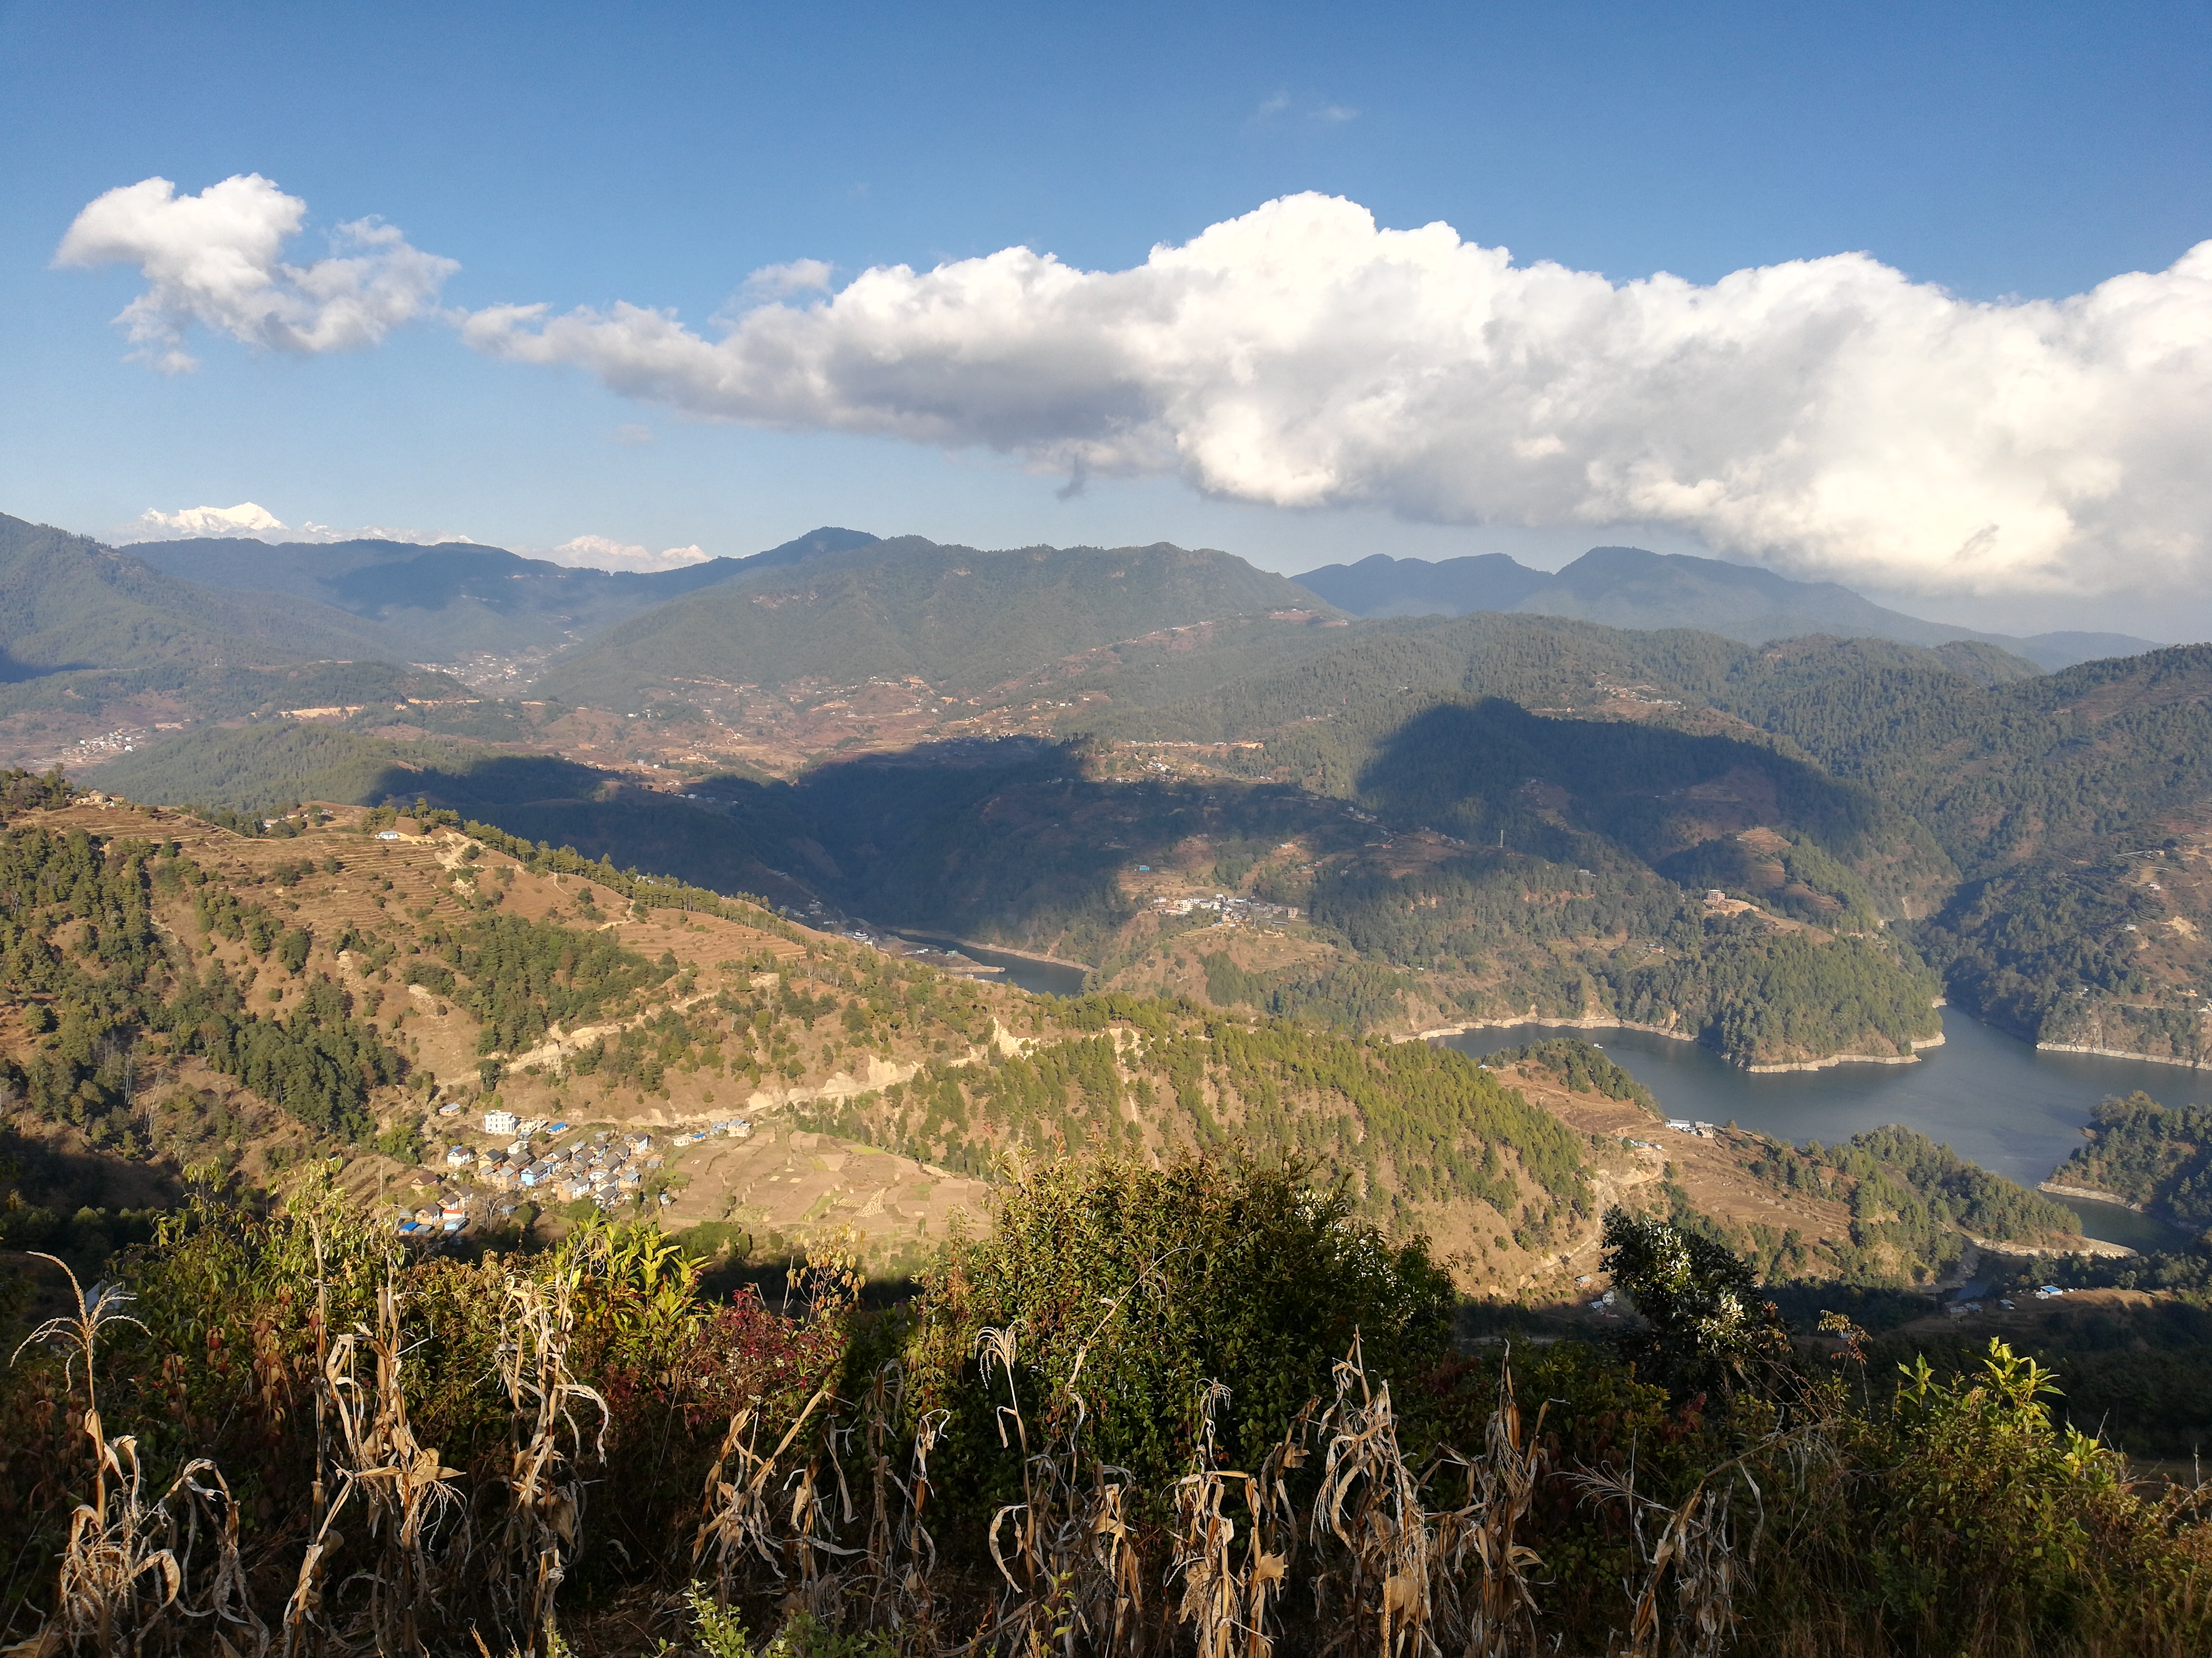APPENDIX A: Photograph of Thaha municipality
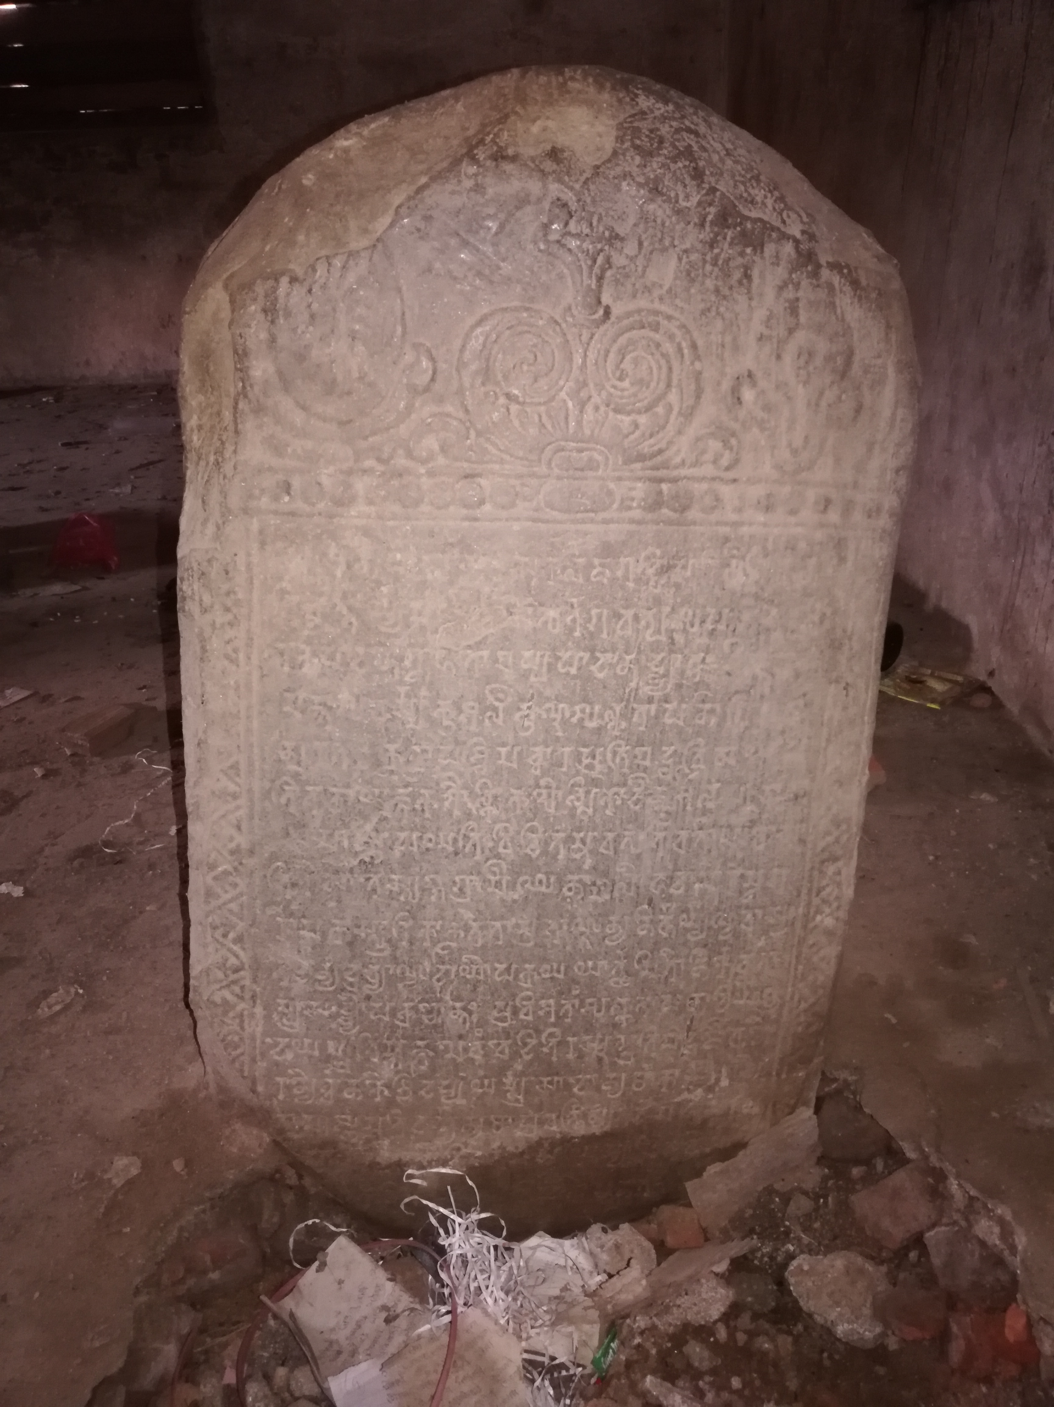
Ansubarma Inscriptions

Indrasarobar Pond view from Daman Side

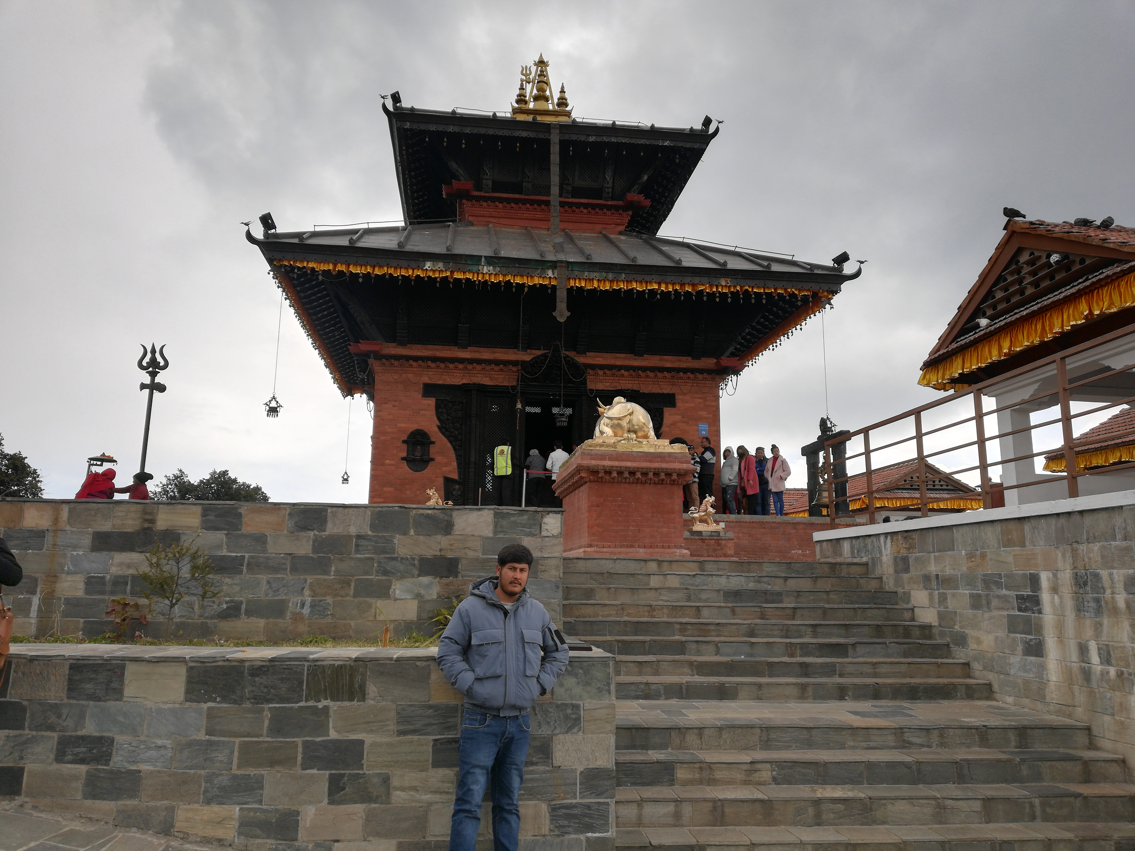

Bhaleshor Mahadev Chandragiri
Ashok stupa
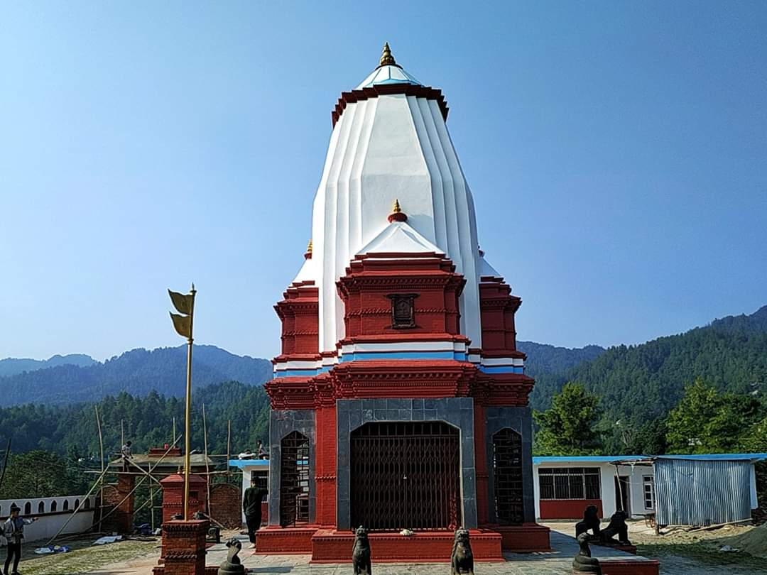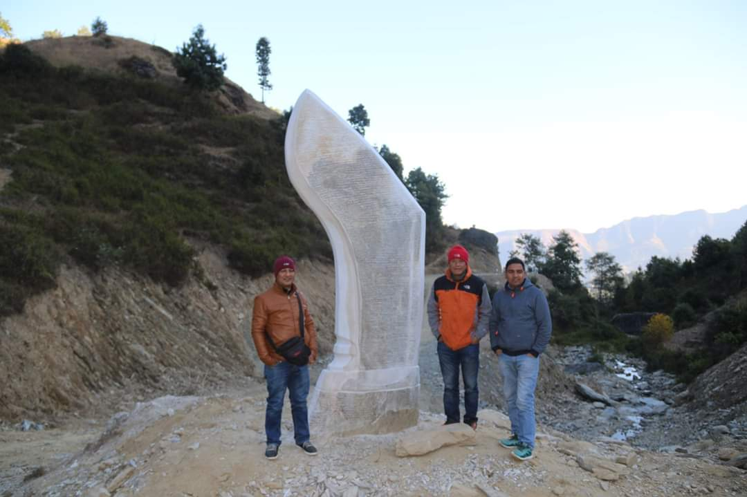

Khukuri dunga
Gorakhanath Temple
APPENDIX B: Settlement of Thaha municipality
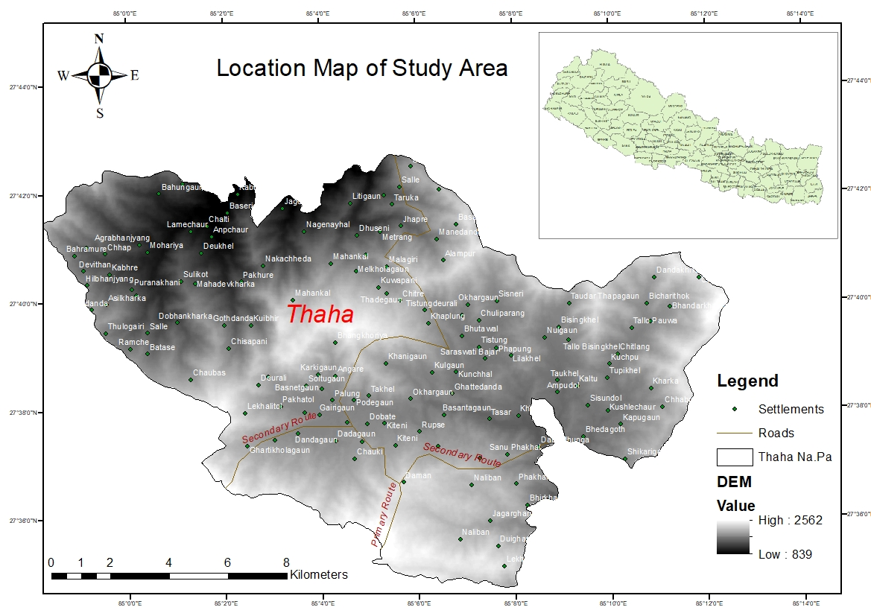

APPENDIX C: Existing land use map
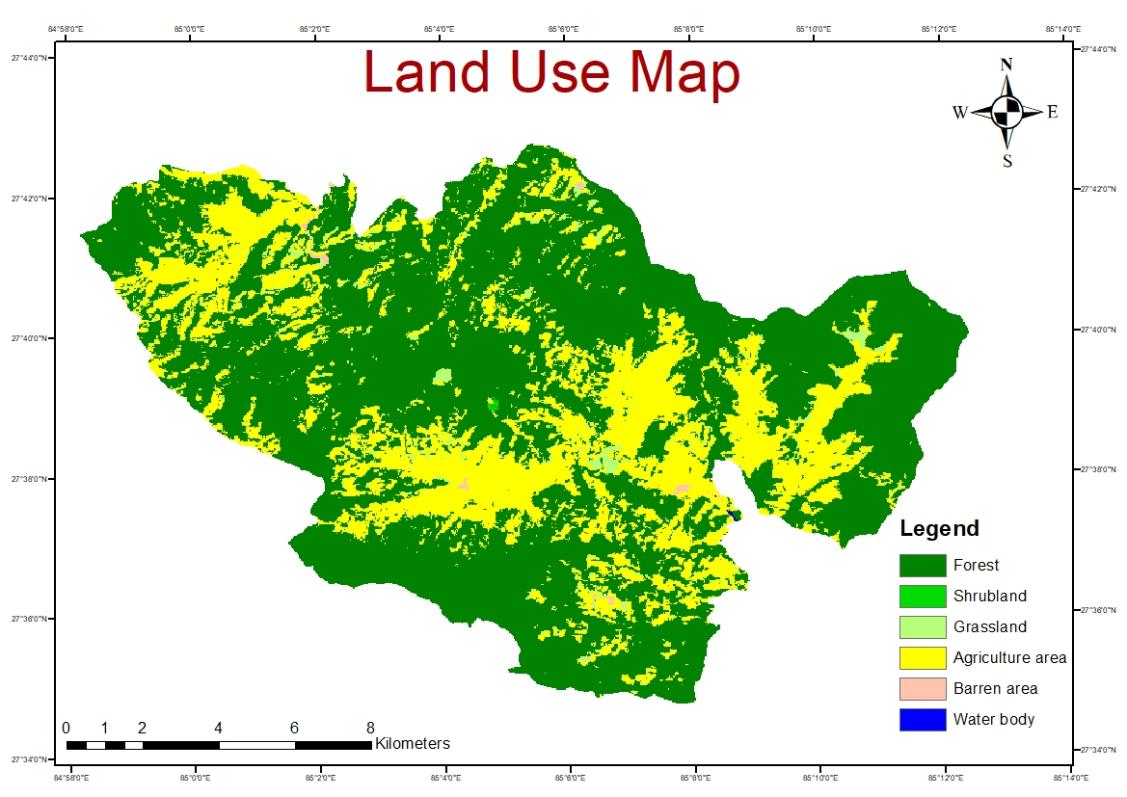

APPENDIX D: Existing Road Networks

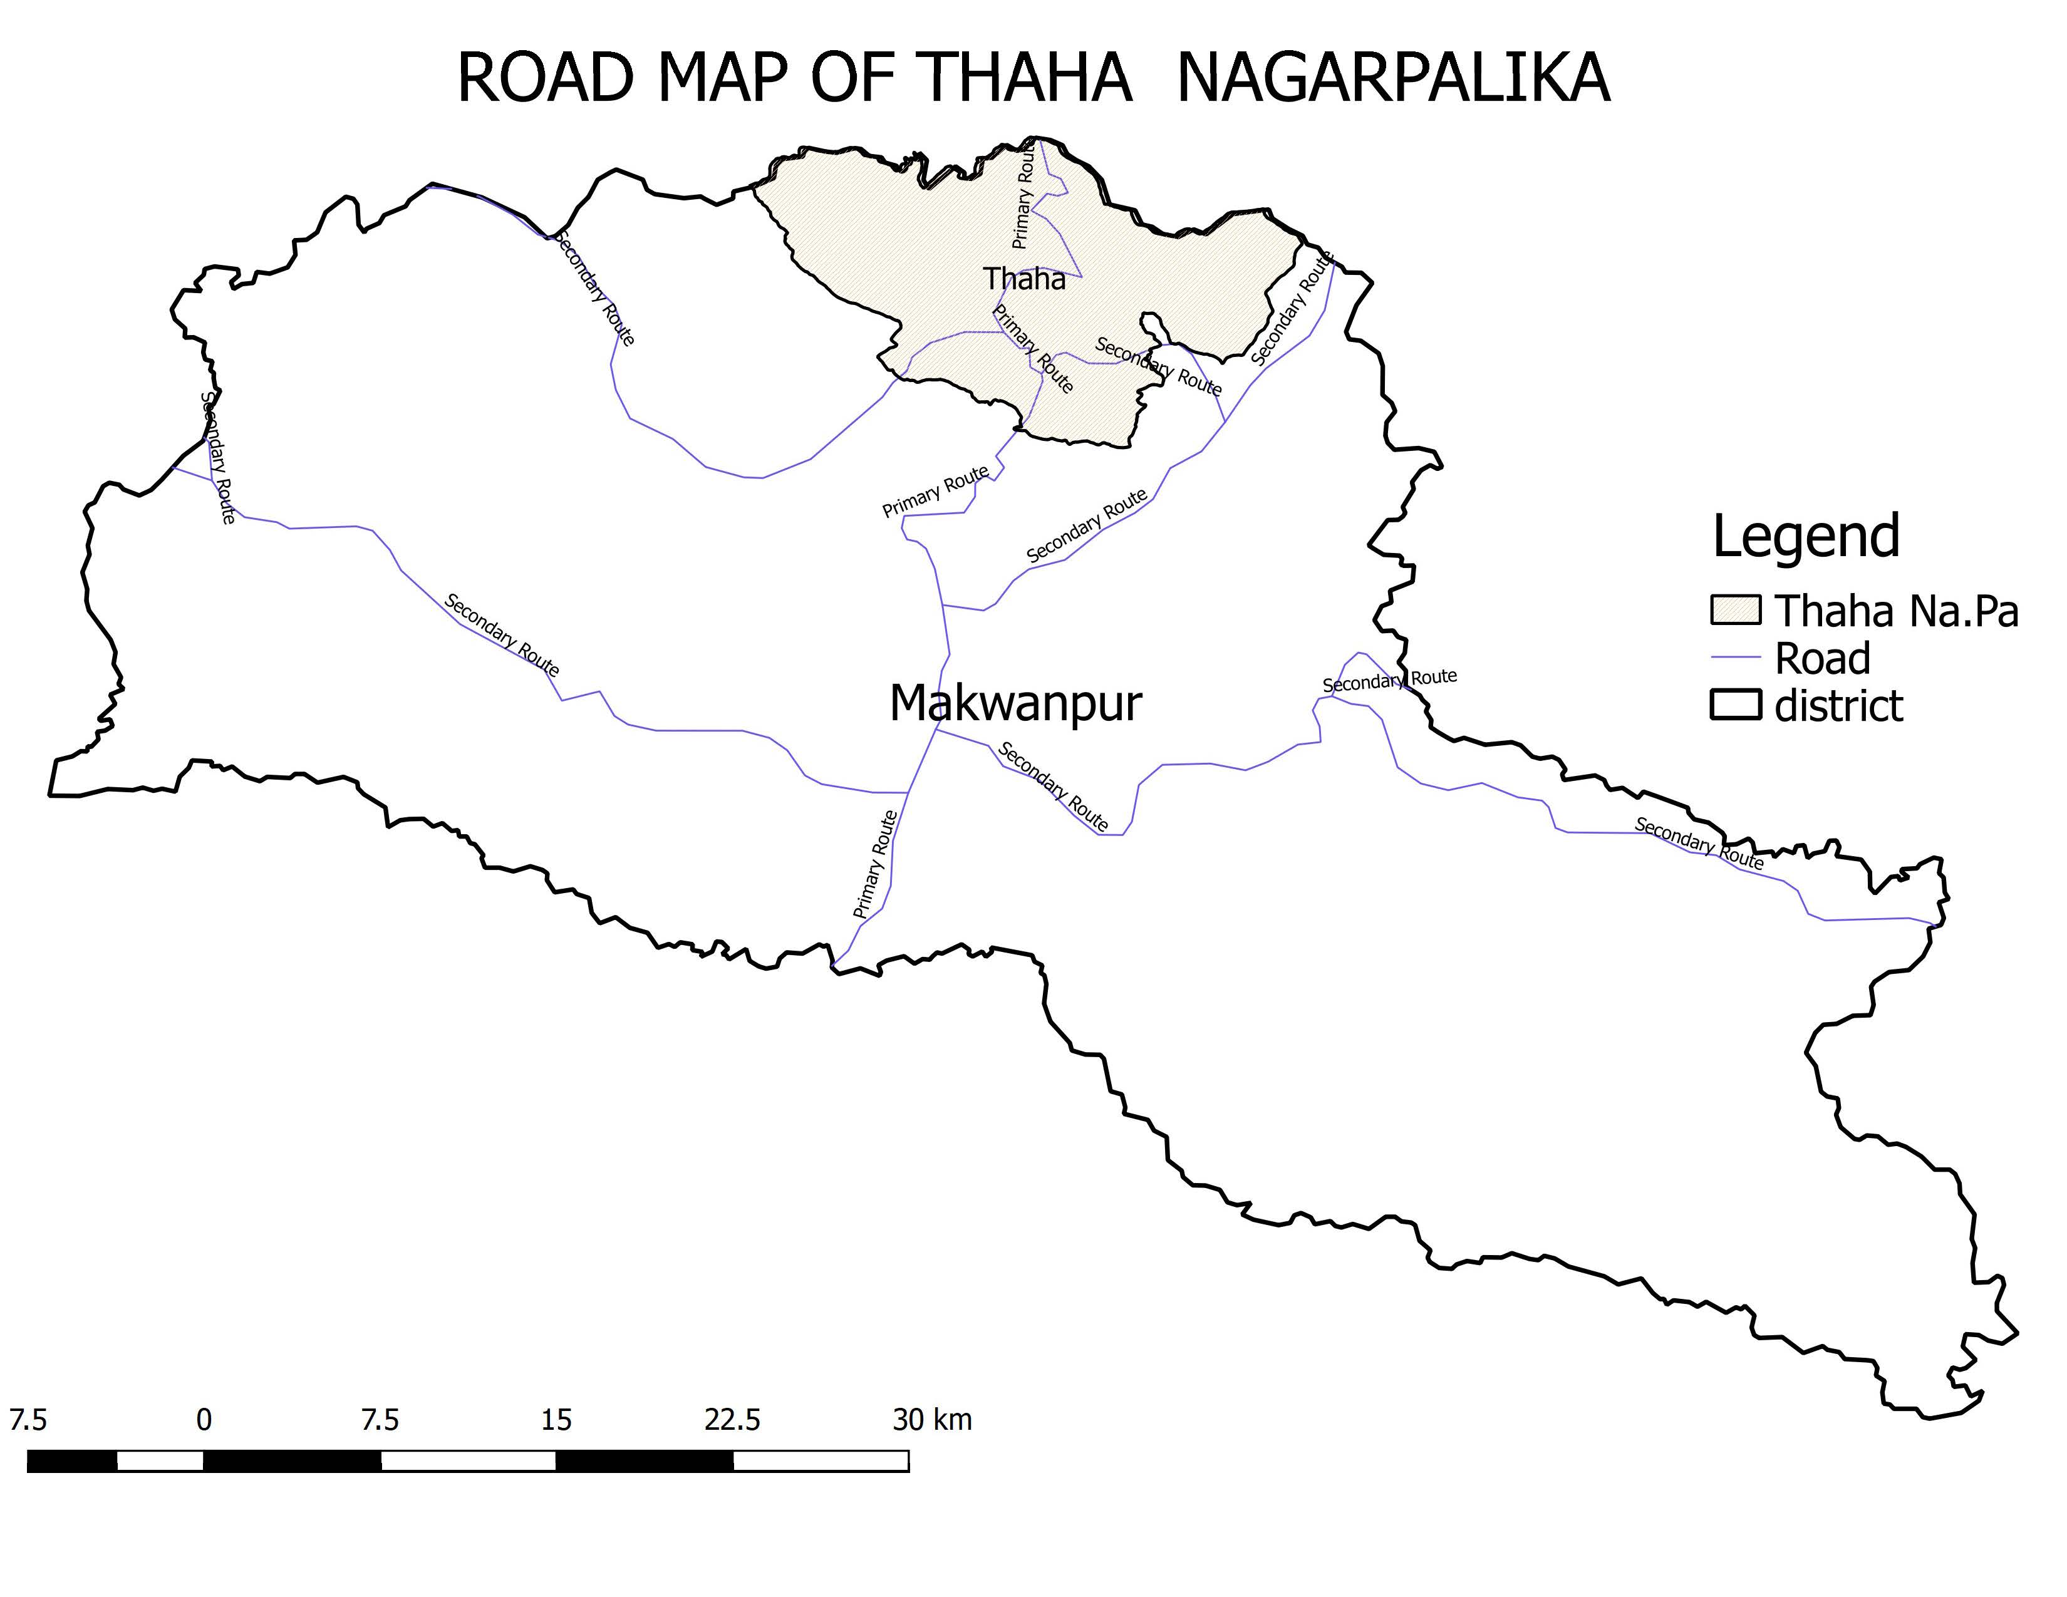

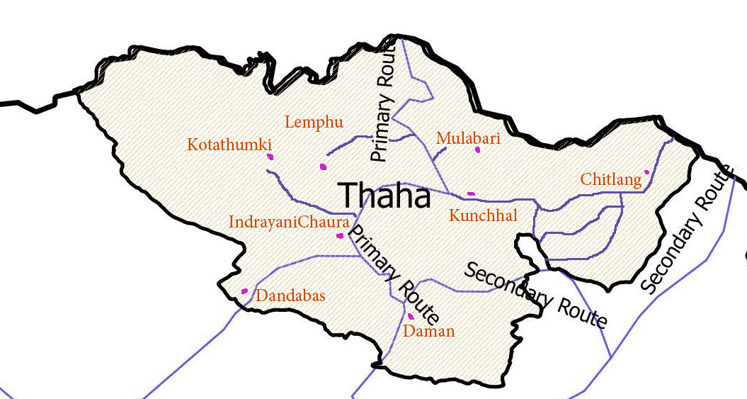

Eight Destination of Thaha municipality with Road Networks

APPENDIX E: Existing Map

APPENDIX F: Planning Leka,Besi,Kachhad

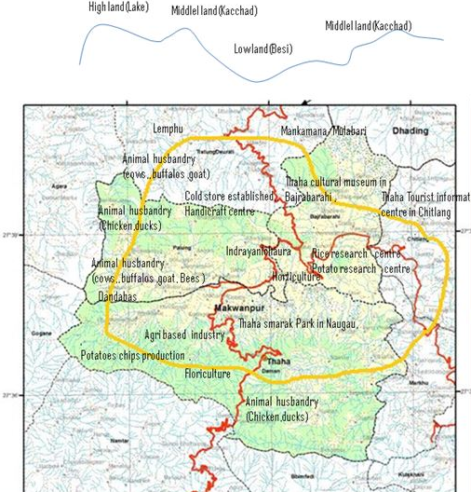

APPENDIX G: Thaha municipality leka,kacchad and besi conceptual frameworks

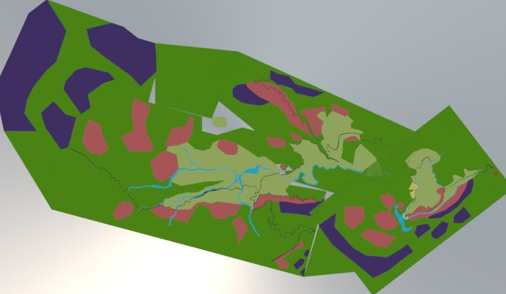

APPENDIX H: Proposed Zoning of Thaha municipality

Zoning

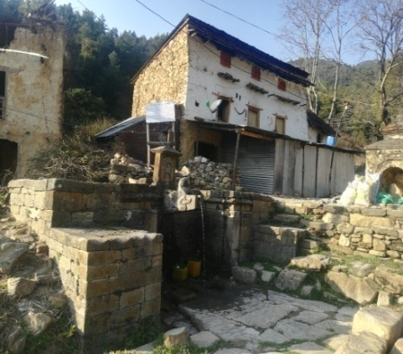
APPENDIX I: Existing map of Chitlang ward no 9 Thaha municipality
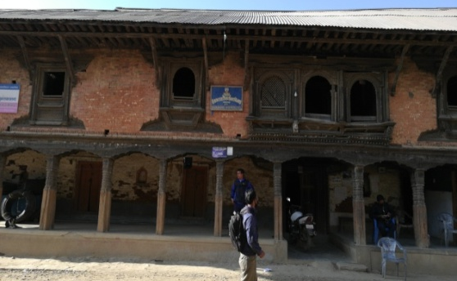

Wrote Yatri poem by Mahakabi
Bahal
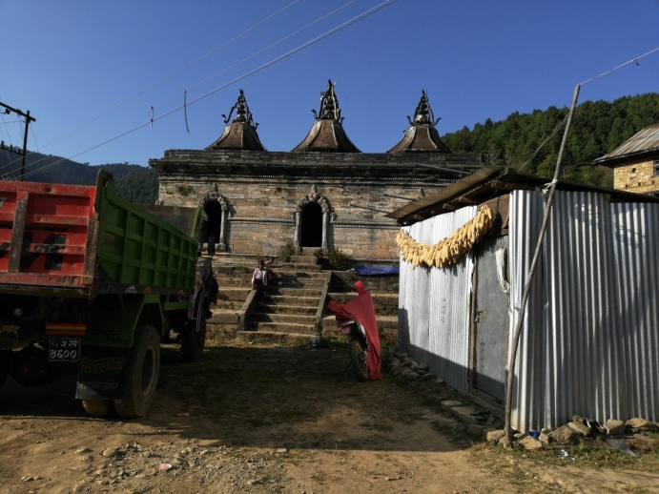
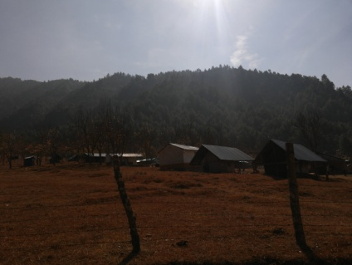

Resort
3 gajur mahadev

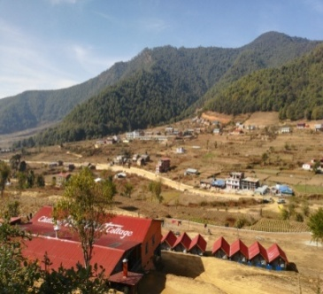
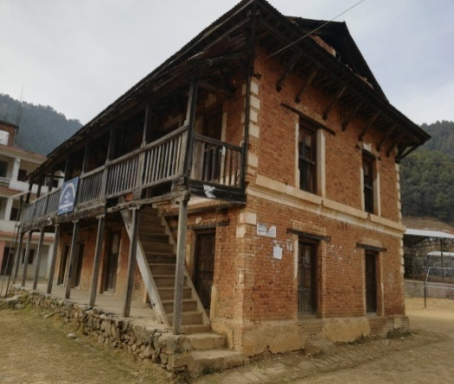

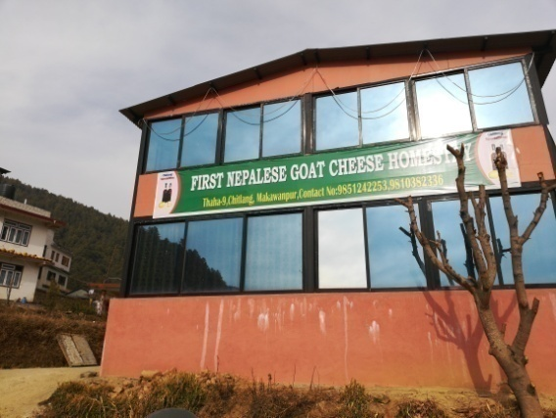
King rest house

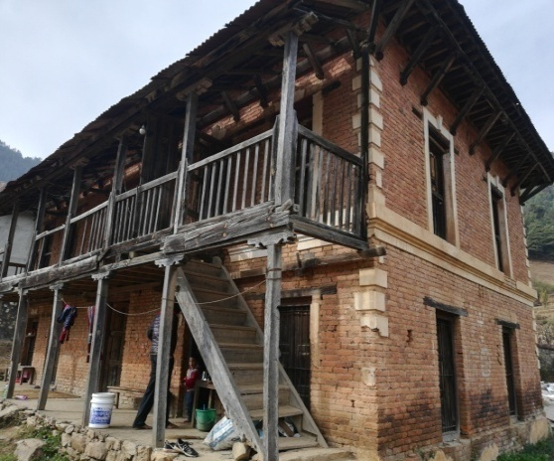

Homestay

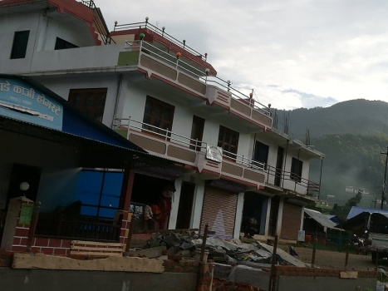

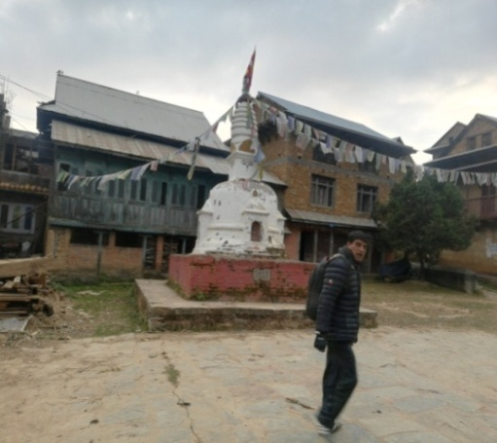
Rana rest house

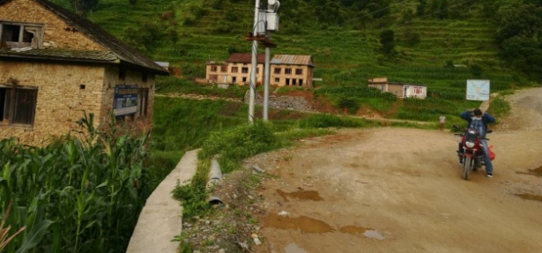
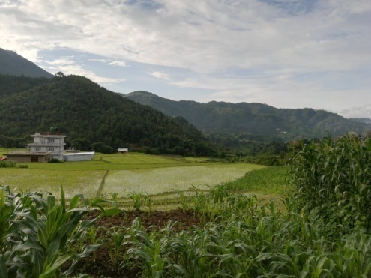

Proposed Agri tourism farm
Ashok chiatya
APPENDIX J: Proposal for Agri tourism area

Route to Agri touristic area
Chandragiri to Gurjudhara area where Laxmi Prasad devkota wrote Yatri poem

Place where Laxmi pr Devkot wrote Yatri poem

3 Gajur Shibalaya

Patipawa
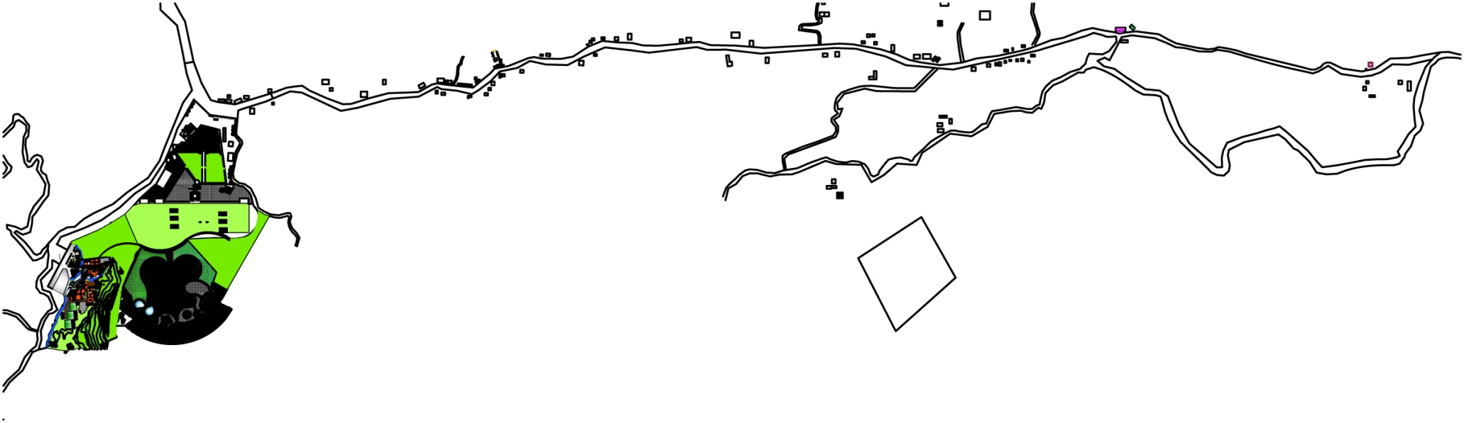

Rest house for King and Rana

Ashok Chaitya

Proposed agri tourism farm

APPENDIX K: Agri tourism farm planning
1-ENTRANCE
2-INFORMATION CENTER
3-SOUVENIR SHOP
4-EXISTING HOUSE CONVERTED FOR HOMESTAY
5-HANDICRAFT AND COTTAGE CENTER
6-FARMHOUSE
7-AGRICULTURE PROMOTION AND TRAINIG CENTER
8-VEGETABLE MARKET
9-COMMUNITY BUILDING
10-FARM STAY
11-NURSERY
12- BOTANICAL/FLORAL GARDEN
13-HERTICULTURE CENTER
14-FARMING LAND
15-TERRACE FARMING LAND
16-GREEN HOUSE

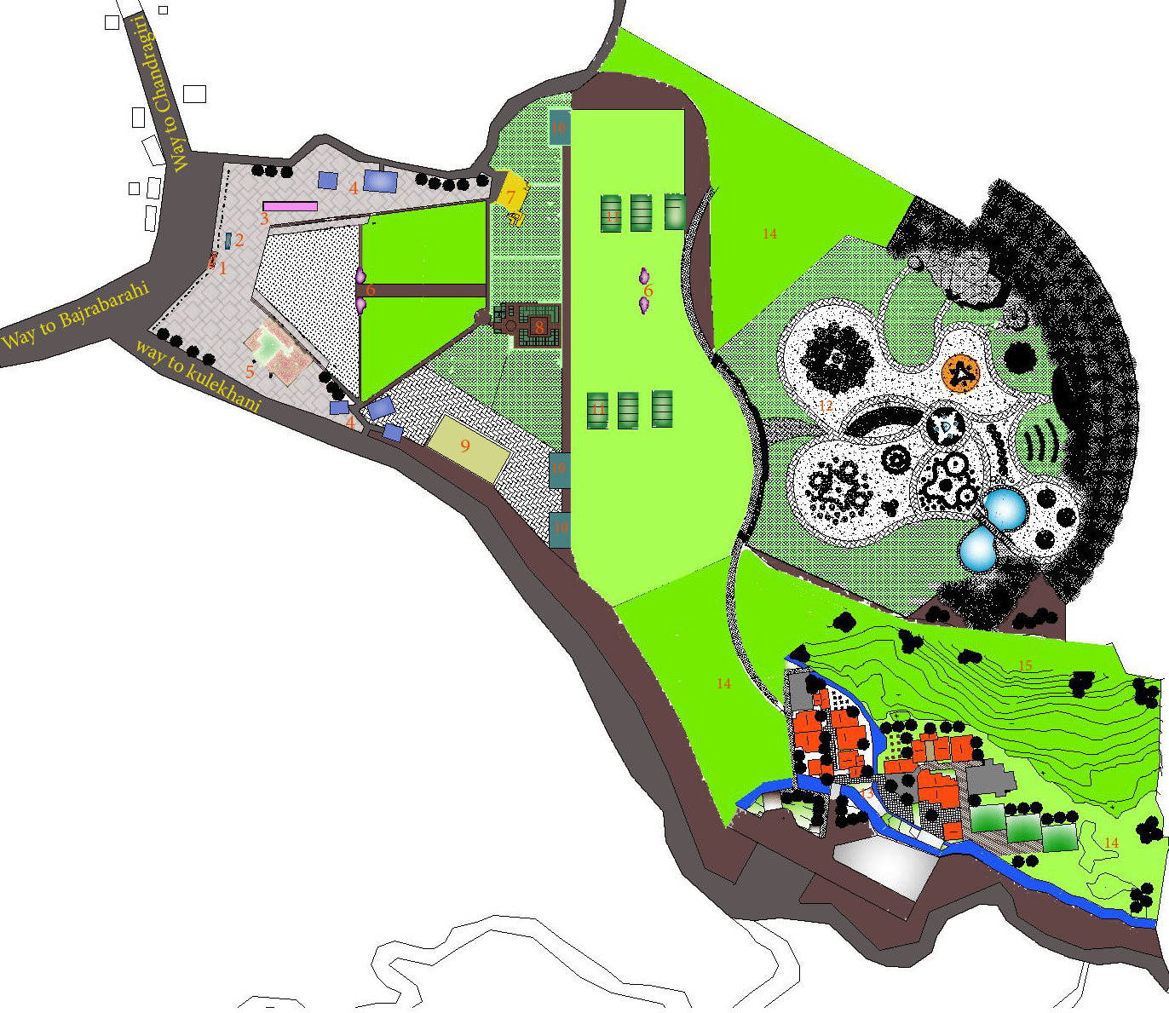

Plan
Agri tourism farm planning
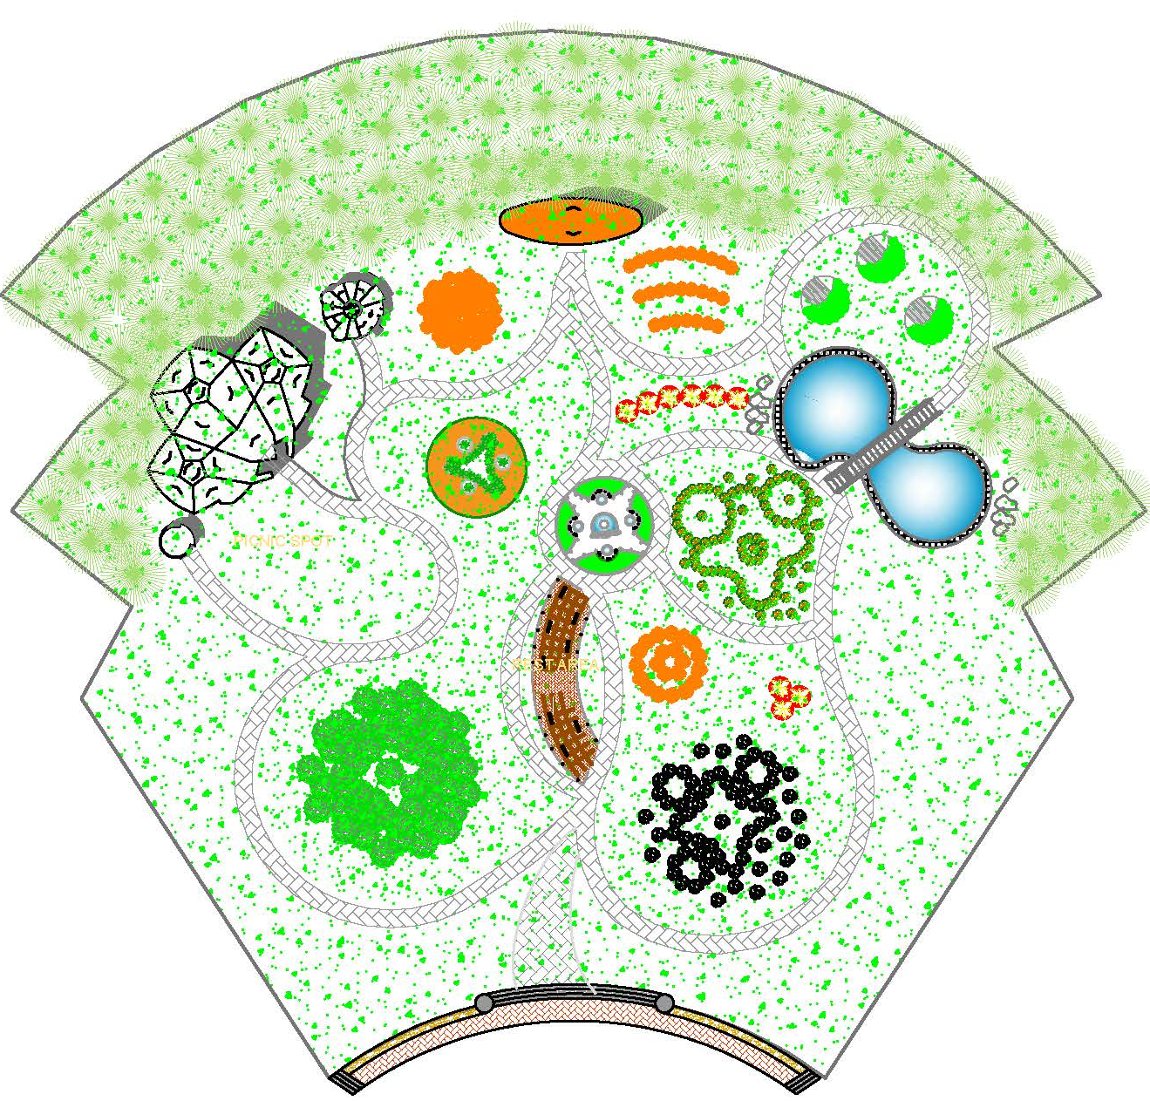
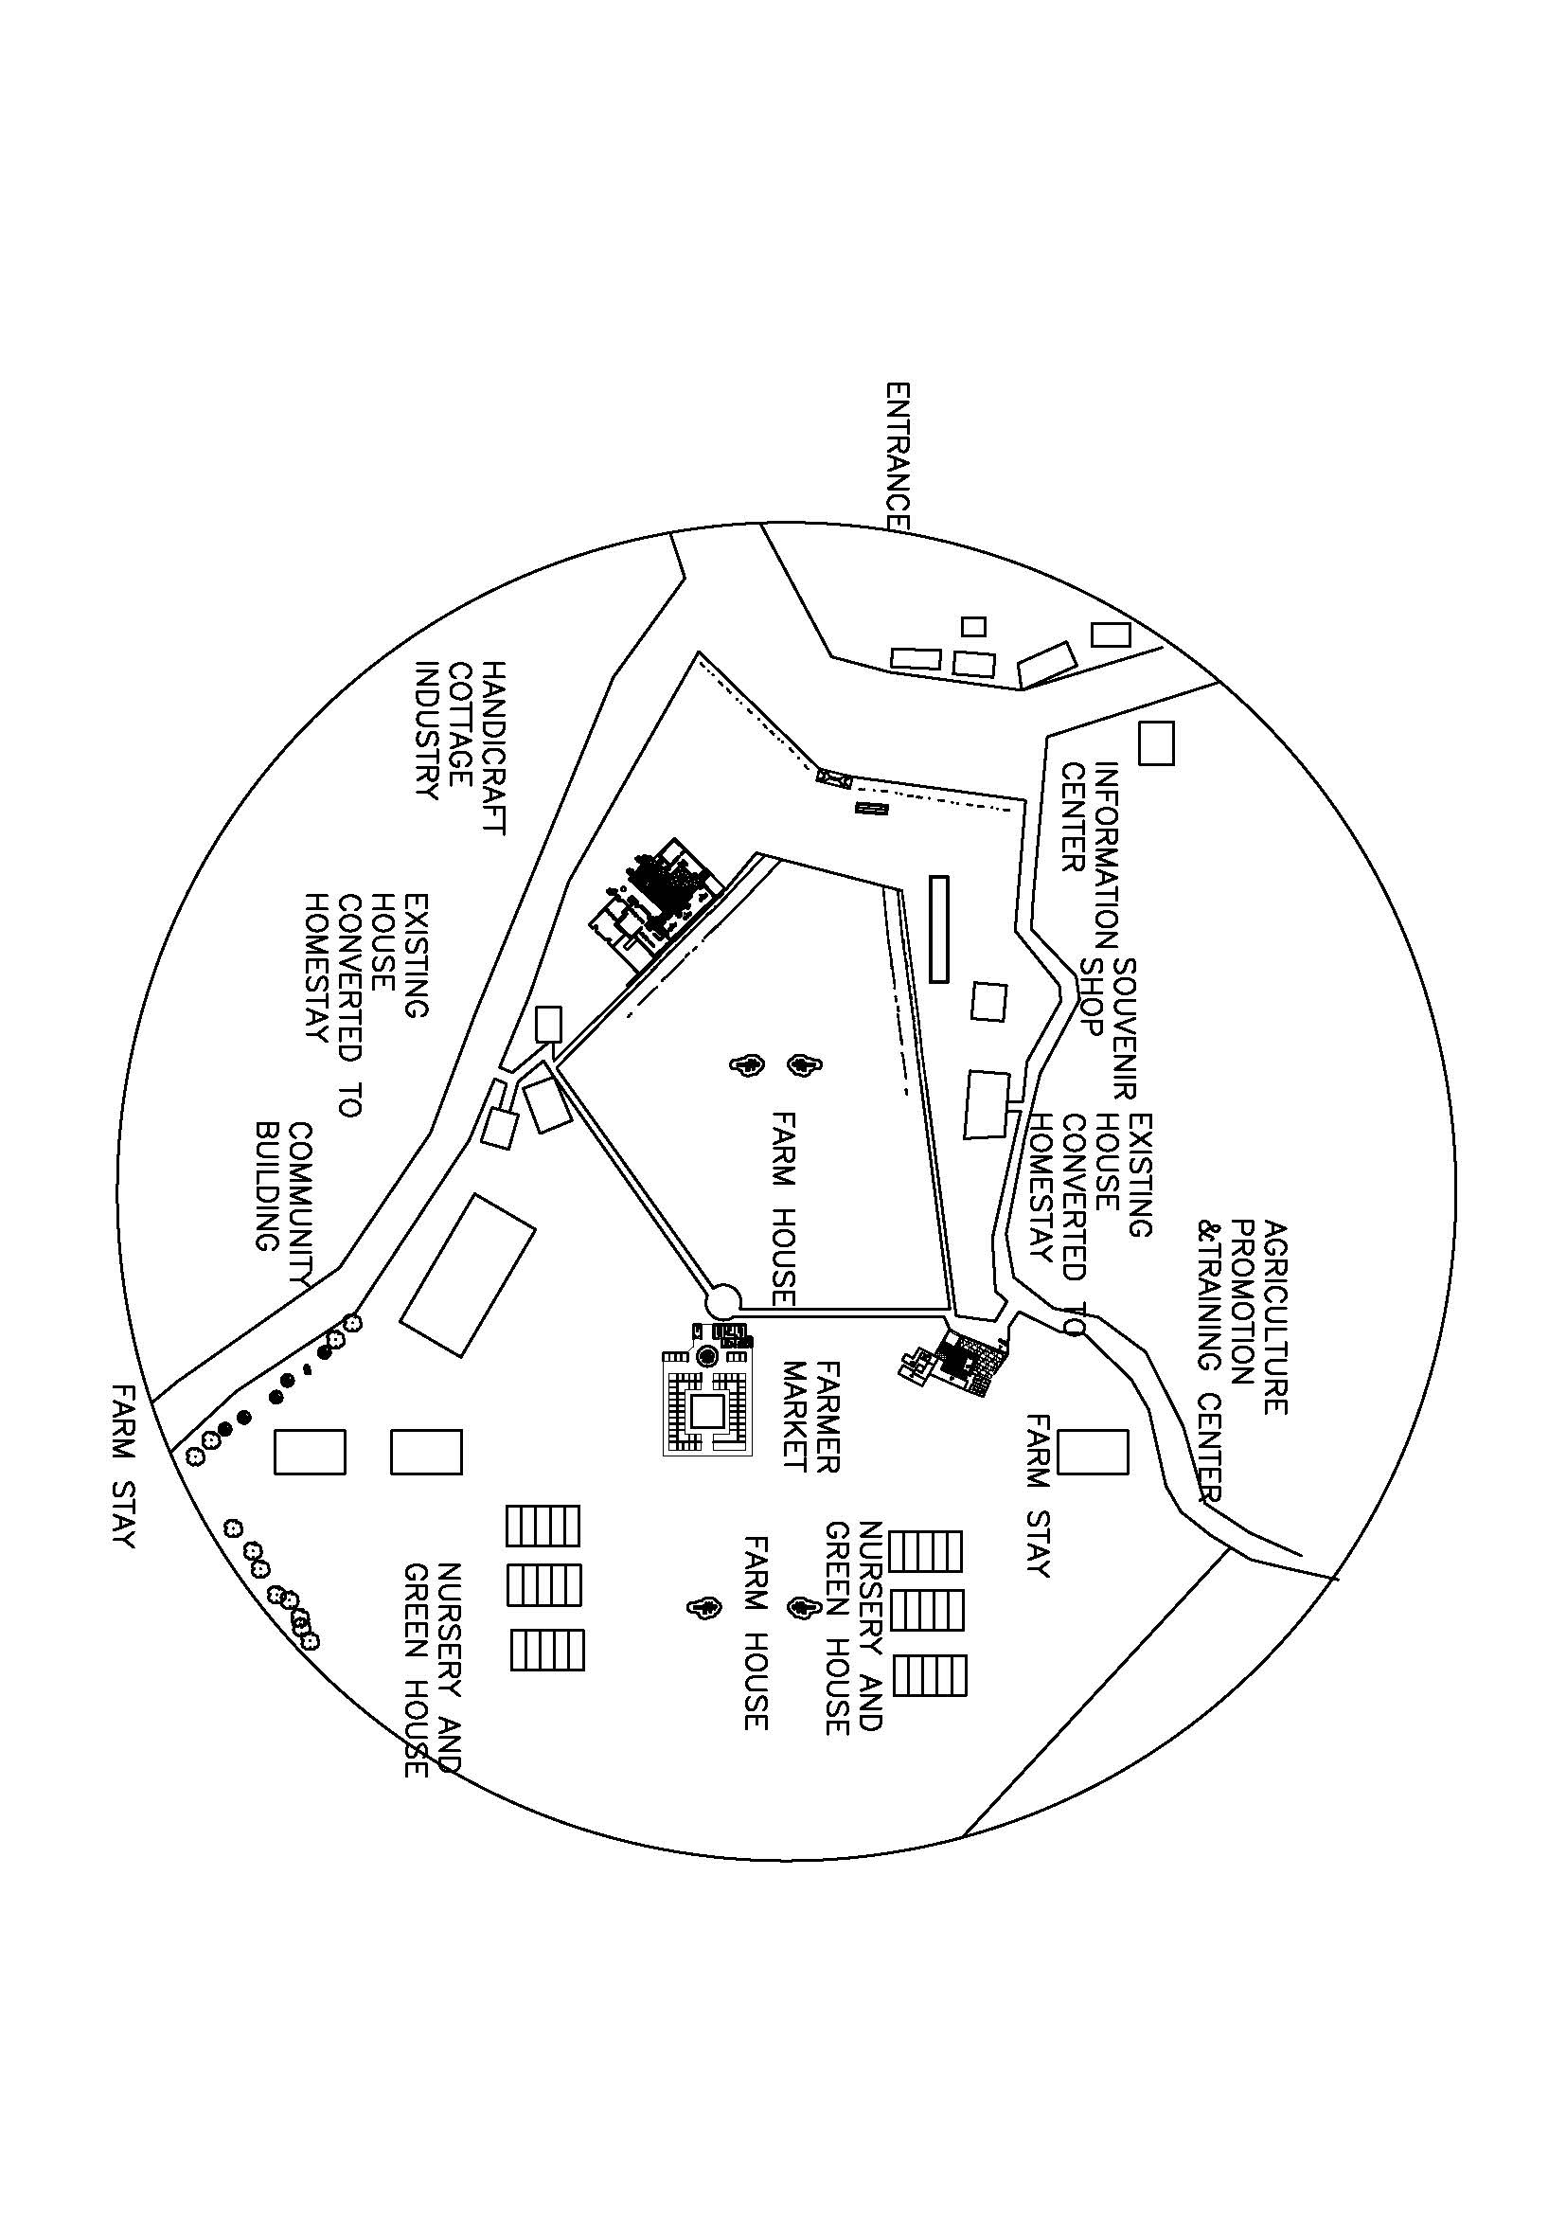

Blow up

Garden

Cottage industry cum handicraft Farmer vegetable Market

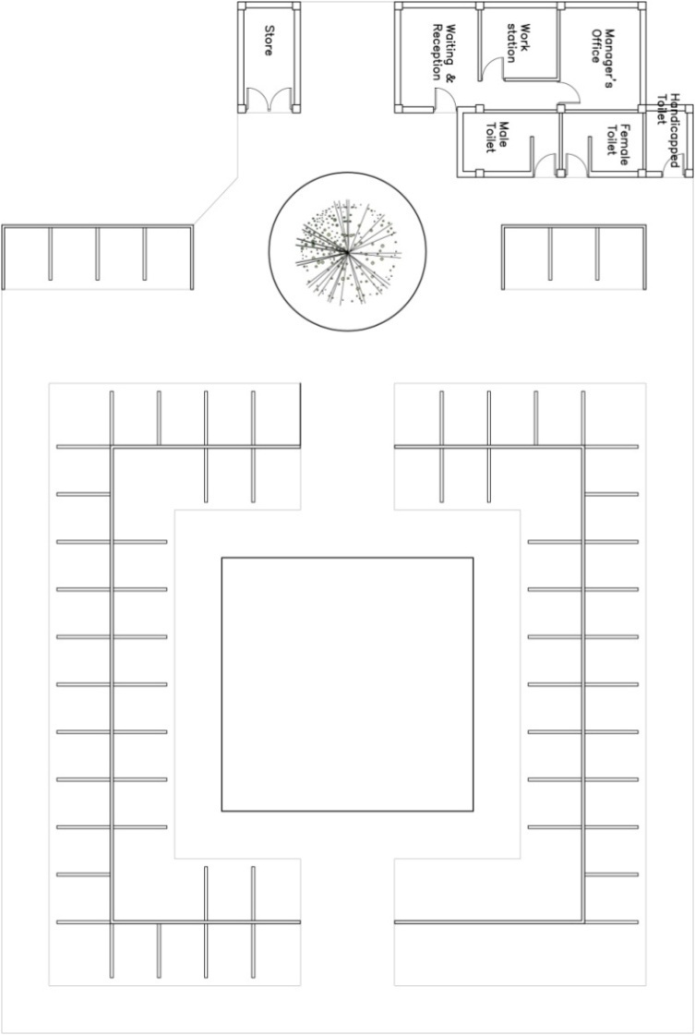
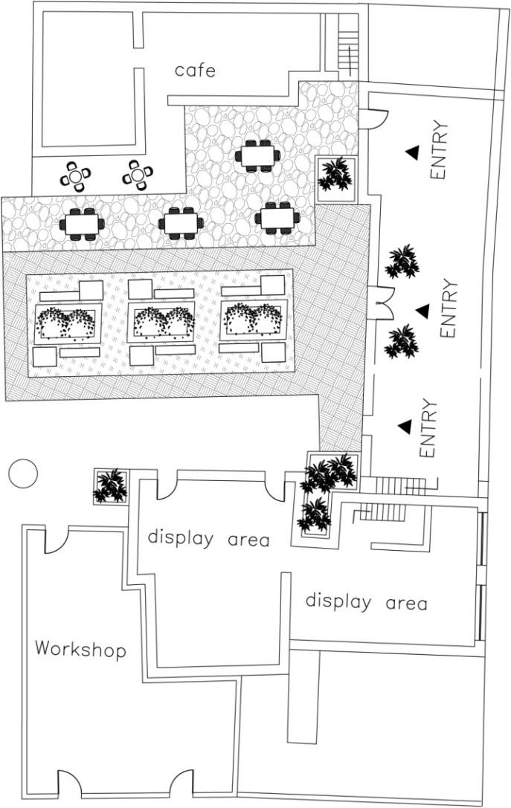

Agriculture promotion centre
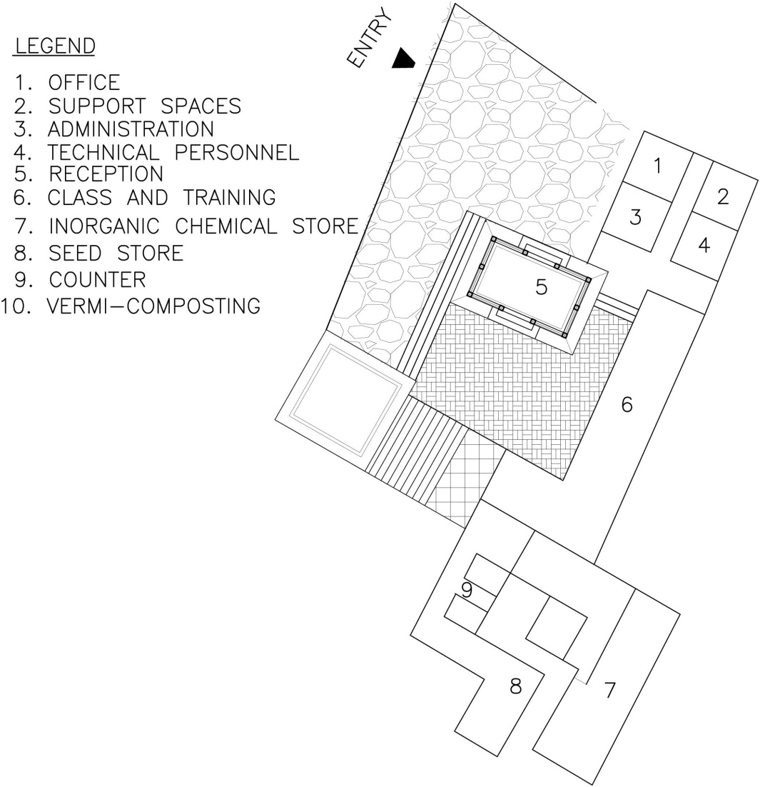

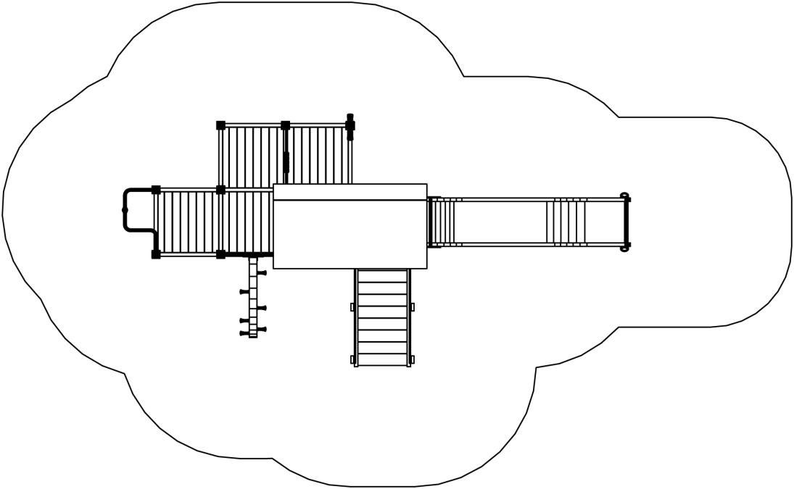

Farm house

Nursery and green house

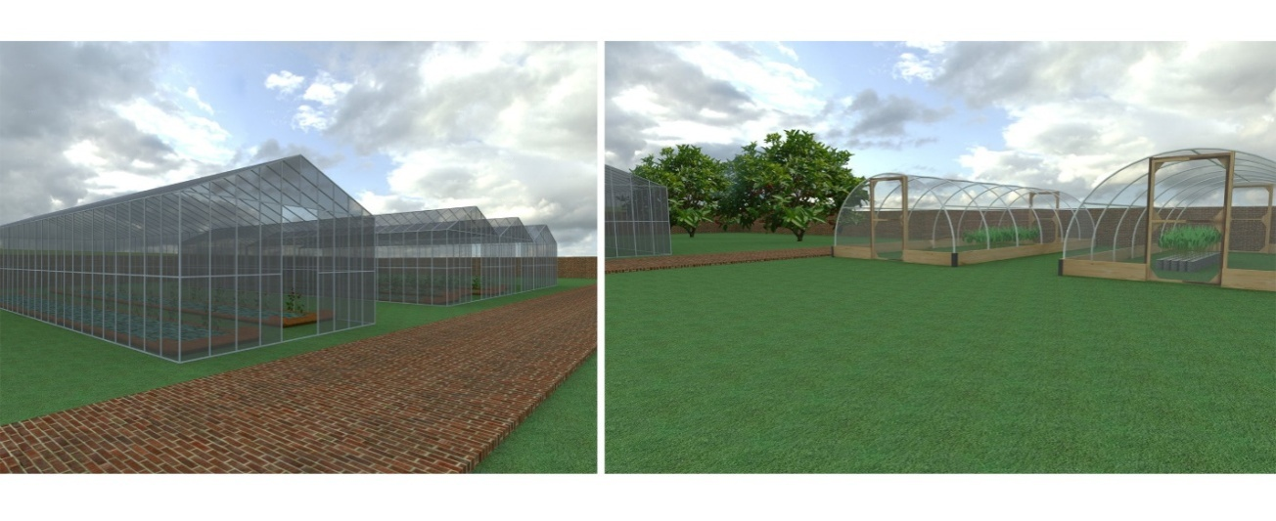

Agriculture Farm

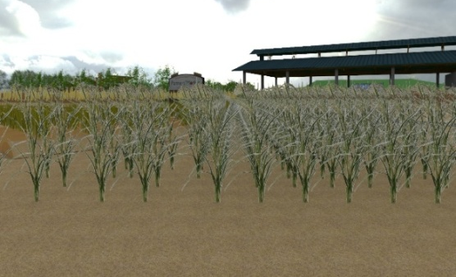
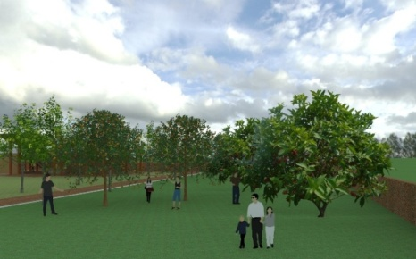

APPENDIX L: Questionnaire Survey
TRIBHUWAN UNIVERSITY
INSTITUTE OF ENGINEERING
PULCHWOK CAMPUS
AGRI TOURISM PLANNING OF MUNICIPALITIES OF NEPAL –A CASE OF THAHA MUNICIPALITY, MAKWANPUR

Part I
Social personal characteristics of respondent
- Name of respondent…………………
- Locality……………….
- Age(year)……….
- Education qualification ………..Primary, Secondary, Higher Secondary, Bachelor, Uneducated…..
- Marital Status……………i.Single………ii. Married…………..iii other………
- Types of Family………….. i.Joint…………… ii. Nuclear………..
- Family Background………i. Rural…………..ii.Urban…………..
- Size of Family……………I .No of children……………ii Total member…….
- Occupation …………. i. Major occupation ……….ii Subsidiary occupation……….
- Social participation
Organization | Office holder | member | Not a member
Political participation
NGO participation
Religious participation
Sport club participation
Health club participation
Social club participation
others

- Annual income………………………Rs/yr

Part II

Willingness of the respondent to go for Agri tourism.
- Are you aware of term agri-tourism?....i Aware …… ii . not aware………….
- Do you go for vacation? …….i .Yes ……..ii. No………………
- With whom do you go for vacation?........Alone, Family, Relatives,Friends
- Would you like to visit agri-tourism area?..........i.Yes…………ii. No………
- Do you know any agri tourism farm in Thaha?.......if yes Where………….
- Would you like to participate in agricultural activities on the area?.... if yes what sort of activities you participates in?
Sr. | Agricultural activities | Respondent N
No | Agricultural activities | F | %
1 | Participate in agricultural activities
2 | Kind of activities | N1
a | Production activities | Alone  f | Family  f | Friends  f
 | Production activities | % | % | %
i | Milking of buffalos
ii | Feeding of animals
iii | Gardening
iv | Ploughing fields
v | Harvesting of crops
vi | Picking of fruits &vegetables
b | Processing activities
i | Processing of dairy products
ii | Fruit processing
iii | Vegetable processing
- During your visit would you like to purchase agriculture product from the farm directly? ….Yes…………….No…………..if yes what are the product would you like to purchase?

Sr,No | Agriculture product | Respondents N=60
Sr,No | Agriculture product | F | %
 | Kind of agri products
I | Fresh vegetables
II | Fruits
III | Dairy products(milk,cheese,butter etc)
IV | Honey
V | Meat &poultry products
VI | Organic products(fruit, grains)
VII | Medical herbs
VIII | Handicraft
IX | Processed products(jam,pickles,tea)
X | Any others

- Give your suggestion what measures should be taken by department of tourism, agriculture or government to promote agri tourism?
- What role tourism board can play to promote agri tourism?

Part III
Assessment of livelihood activities
Financial Asset
- Were there any major changes in your family occupation during the years at THAHA Municipality?
- What was your family engaged in the past?
- What is present livelihood activities your are engaged in and why?
If agriculture
Which Crops?
How Important is each crops to the livelihood of the groups that produce it? What proportion of output is marketed?
Does Price fluctuation/seasonality affect your livelihood?
What proportion of household food needs is met by own consumption and what portion is purchased?
- Which activities relates to tourism or agri –tourism?
- How long you have been involved in theses livelihood activities?
- What is the younger generation of your family involved in?
- Any Income from Remittance? About how much? How do you use it?
- Do people have access to appropriate financial services to enable them to save for the future?
- Have you taken loan? For what purpose? Has agri- tourism positive impact?
- Has agri –tourism at municipalities had positive or negative impact on your financial status?
Social asset
- What is the trend of population change in the village? How do you think this will affect in your life?
- How is your relationship to other people in the community and people from nearby?
- What makes your village different or unique from other in terms of tangible and intangible cultural recourses?
- What sort of network developed?
- Have you even take participate in meeting, planning, discussion etc?
- How many government agencies and NGOS /INGOS working in your place?
Physical asset
- What types of infrastructure development have you observed in your community?
- What do you think is lacking and needs to be addressed to immediately? Road, water supply, health services
Human asset
- What is highest level of school in your family?
- Is there tradition local skills and innovation?
- Do people feel that they are particularly lacking in certain types of information?
- Have obtained any training?

Natural Asset
- Do you own any land? How much?
- How has the use of land been affected by nowadays?
- What kind of regulation and restriction do you need follow to access and use natural resources?
- In what way using natural resources, land soil water forest?
- Do you think availability of natural resources is decreasing in your community?
- Any natural calamities flood, landslide, fire etc? Any health hazards or epidemics

Part IV

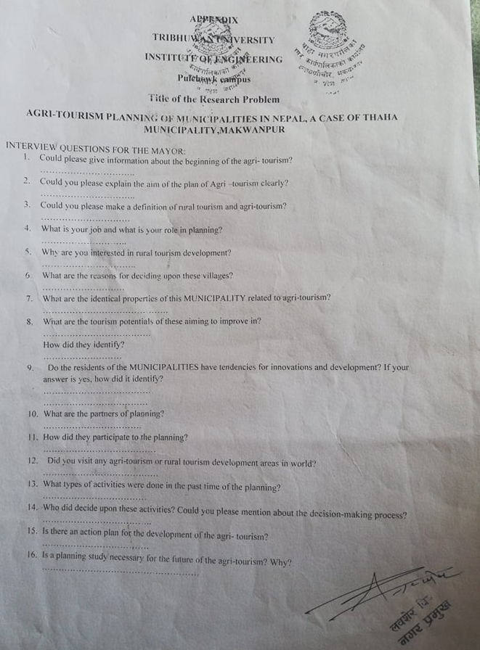

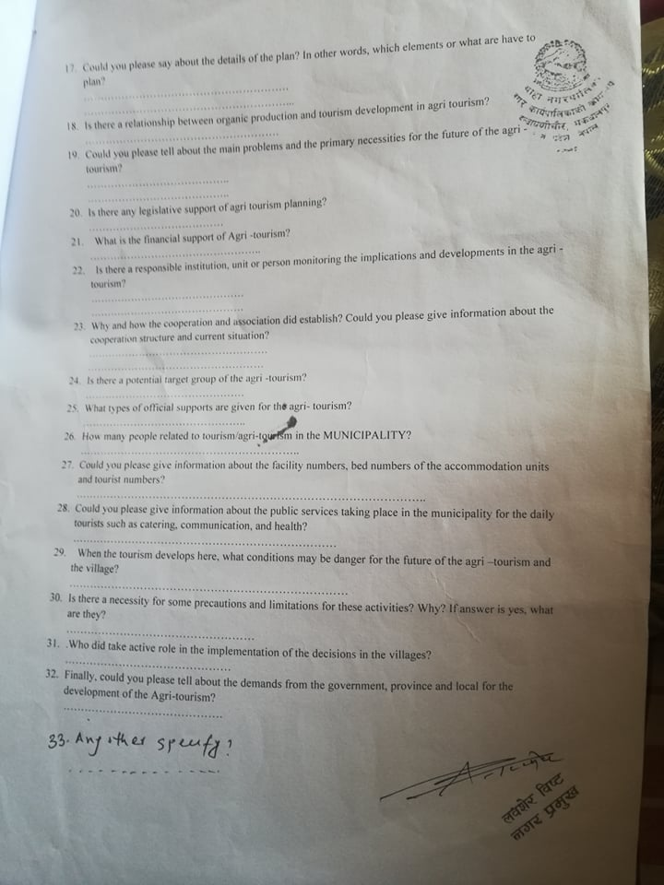

Part V
Give the appropriate number
Evaluate main tourist destination in Thaha municipality according to priority of following variables?
- Attraction (0-10)

Chitlang | Kunchhal | Indraiyanichore | Daman | Dadhabar | Mulabari | Lemphu | Kotthumki | Remark
- Accessibility (0-10)

Chitlang | Kunchhal | Indraiyanichore | Daman | Dadabas | Mulabari | Lemphu | Kotthumki | Remark
- Accommodation (0-10)

Chitlang | Kunchhal | Indraiyanichore | Daman | Dadabas | Mulabari | Lemphu | Kotthumki | Remark
- Facility (0-10)

Chitlang | Kunchhal | Indraiyanichore | Daman | Dadabas | Mulabari | Lemphu | Kotthumki | Remark
- Tourist Activities (0-10)

Chitlang | Kunchhal | Indraiyanichore | Daman | Dadabas | Mulabari | Lemphu | Kotthumki | Remark
- Actors(0-10)

Chitlang | Kunchhl | Indraiyanichore | Daman | Dadabas | Mulabari | Lemphu | Kotthumki | Remark
- Affinities-Guest-Host relationship(0-10)

Chitlang | Kunchhal | Indraiyanichore | Daman | Dadabas | Mulabari | Lemphu | Kotthumki | Remark
- Management(0-10)

Chitlang | Kunchhal | Indraiyanichore | Daman | Dadabas | Mulabari | Lemphu | Kotthumki | Remark

APPENDIX M: Data Group Discussion
Group Rating to each listed Tourist Destination by 3 groups -Group A+B+C= total (T)+Grand Total(GT)
 |  |  |  |  | Attraction (0-10) |  |  |  |  |  |  |  | Accessibility (0-10) |  |  |  |  |  |  |  |  |  | Accommodation (0-10) |  |  |  |  |  |  |  | Facility (0-10)
 | Places |  |  |  | A |  | B |  | C | T |  |  | A |  |  |  | B |  | C | T |  |  | A | B |  | C |  |  | T |  | A |  | B |  | C |  | T
1 | Daman |  |  |  | 10 |  | 10 |  | 8 | 28 |  |  | 5 |  |  |  | 5 |  | 7 | 17 |  |  | 5 | 5 |  | 8 |  |  | 18 |  | 3 |  | 3 |  | 5 |  | 11
2 | Mulabari |  |  |  | 10 |  | 10 |  | 8 | 28 |  |  | 2 |  |  |  | 2 |  | 3 | 7 |  |  | 0 | 1 |  | 0 |  |  | 1 |  | 0 |  | 1 |  | 0 |  | 1
3 | Kunchal |  |  |  | 10 |  | 7 |  | 9 | 26 |  |  | 8 |  |  |  | 5 |  | 7 | 20 |  |  | 8 | 4 |  | 7 |  |  | 19 |  | 5 |  | 3 |  | 5 |  | 13
4 | Dadabas |  |  |  | 7 |  | 8 |  | 7 | 22 |  |  | 5 |  |  |  | 2 |  | 7 | 14 |  |  | 3 | 2 |  | 3 |  |  | 8 |  | 4 |  | 1 |  | 4 |  | 9
5 | Kotathumki |  |  |  | 10 |  | 7 |  | 7 | 24 |  |  | 0 |  |  |  | 1 |  | 2 | 3 |  |  | 0 | 1 |  | 0 |  |  | 1 |  | 0 |  | 1 |  | 0 |  | 1
6 | Indrayani |  |  |  | 6 |  | 8 |  | 7 | 21 |  |  | 6 |  |  |  | 5 |  | 5 | 16 |  |  | 8 | 1 |  | 2 |  |  | 11 |  | 8 |  | 5 |  | 6 |  | 19
7 | Chitlang |  |  |  | 8 |  | 10 |  | 9 | 27 |  |  | 8 |  |  |  | 4 |  | 7 | 19 |  |  | 8 | 5 |  | 9 |  |  | 22 |  | 6 |  | 3 |  | 7 |  | 16
8 | Lemphu |  |  |  | 1 |  | 10 |  | 6 | 17 |  |  | 0 |  |  |  | 2 |  | 2 | 4 |  |  | 0 | 3 |  | 3 |  |  | 5 |  | 0 |  | 3 |  | 2 |  | 5
 |  |  |  |  |  |  |  |  |  | 193 |  |  |  |  |  |  |  |  |  | 100 |  |  |  |  |  |  |  |  | 85 |  |  |  |  |  |  |  | 75
Tourist Activities (0-10) |  |  |  |  | Actors(0-10) |  |  |  |  | Affinities-Guest-Host relationship(0-10) |  |  |  |  |  |  |  |  | Management(0-10) |  |  |  |  |  |  |  | GT
A | B | C | T |  | A | B |  | C | T | A |  | B |  |  | C |  |  | T | A |  | B |  | C |  | T
2 | 2 | 5 | 9 |  | 2 | 2 |  | 7 | 11 | 3 |  | 1 |  |  | 3 |  |  | 7 | 5 |  | 2 |  | 8 |  | 15 |  | 101
0 | 1 | 5 | 6 |  | 0 | 5 |  | 7 | 12 | 0 |  | 1 |  |  | 0 |  |  | 1 | 0 |  | 1 |  | 5 |  | 6 |  | 62
8 | 3 | 8 | 19 |  | 8 | 2 |  | 2 | 12 | 8 |  | 5 |  |  | 5 |  |  | 18 | 5 |  | 2 |  | 6 |  | 13 |  | 140
0 | 2 | 5 | 7 |  | 0 | 4 |  | 2 | 6 | 0 |  | 2 |  |  | 2 |  |  | 4 | 4 |  | 1 |  | 5 |  | 10 |  | 80
0 | 1 | 5 | 6 |  | 0 | 4 |  | 4 | 8 | 0 |  | 1 |  |  | 0 |  |  | 1 | 0 |  | 1 |  | 5 |  | 6 |  | 50
8 | 5 | 4 | 17 |  | 8 | 6 |  | 5 | 19 | 4 |  | 2 |  |  | 5 |  |  | 11 | 10 |  | 2 |  | 5 |  | 17 |  | 131
5 | 4 | 9 | 18 |  | 8 | 4 |  | 7 | 19 | 9 |  | 3 |  |  | 5 |  |  | 17 | 6 |  | 2 |  | 7 |  | 15 |  | 153
0 | 2 | 5 | 7 |  | 0 | 3 |  | 7 | 10 | 0 |  | 1 |  |  | 4 |  |  | 5 | 0 |  | 1 |  | 5 |  | 6 |  | 59
 |  |  | 89 |  |  |  |  |  | 97 |  |  |  |  |  |  |  |  | 64 |  |  |  |  |  |  | 88

APPENDIX N: Article

