

Tribhuvan University
Institute of Engineering
Pulchowk Campus

Thesis No: IC065616

Network Planning for Re-Configurable Networks-Cognitive System Design

Submitted by
Shraddha Manandhar
(065/MSI/616)
Thesis
Submitted to
Masters of Science in Information and Communication Engineering
(MSICE) Committee
(Department of Electronics and Computer Engineering)

Thesis No: IC065616
Network Planning for Re-Configurable Networks-Cognitive System Design

By
Shraddha Manandhar
(065/MSI/616)

Thesis Supervisor
Asst Prof Sharad Kumar Ghimire

A thesis submitted in partial fulfillment of the requirements for the degree of Master of Science in Information and Communication Engineering.

Department of Electronics and Computer Engineering
Institute of Engineering, Pulchowk Campus
Lalitpur, Nepal

March 2011

COPYRIGHT ©

The author has agreed that the library, Department of Electronics and Computer Engineering, Institute of Engineering, Pulchowk Campus, may make this thesis freely available for inspection. Moreover the author has agreed that the permission for extensive copying of this thesis for scholarly purpose may be granted by the professor, who supervised the thesis work or, in his absence, by the head of the institute in which the thesis work was done. It is understood that the recognition will be given to the author of thesis and to the Department of Electronics and Computer Engineering, Pulchowk Campus in any use of the material of this thesis. Copying of publication or other use of this thesis for financial gain without approval of the Department of Electronics and Computer Engineering, Institute of Engineering, Pulchowk Campus and author’s written permission is prohibited.

Request for permission to copy or to make any use of the material in this thesis in whole or part should be addressed to:

Head of the Department
Department of Electronics and Computer Engineering
Institute of Engineering
Pulchowk Campus
Lalitpur
Nepal

Tribhuvan University
Institute of Engineering
Pulchowk Campus

DEPARTMENT OF ELECTRONICS AND COMPUTER ENGINEERING
RECOMMENDATION

The undersigned certify that the thesis that they had read and recommended to the Department of Electronics and Computer Engineering for the acceptance of the thesis entitled “Network Planning for Re-Configurable Network-Cognitive System Design”, submitted by Shraddha Manandhar in partial fulfillment of the requirement for the award of the degree of “Master of Science in Information and Communication Engineering” as a bonafide work carried out by her.

…………………………………
Sharad Kumar Ghimire
Assistant Professor
Department of Electronics and
Computer Engineering,
Institute of Engineering (IOE),
Pulchowk, Nepal
(Thesis Supervisor)

DEPARTMENTAL ACCEPTANCE

The thesis entitled “Network Planning for Re-Configurable Network-Cognitive System Design”, submitted by Shraddha Manandhar in partial fulfillment of the requirement for the award of the degree of “Master of Science in Information and Communication Engineering” has been accepted as a bonafide record of work carried out by him in our department.

……………………………………….
Dr. Shashidhar Ram Joshi
Professor and Head of Department
Department of Electronics and Computer Engineering,
Institute of Engineering,
Pulchowk, Nepal
(Head of Department)

ACKNOWLEDGEMENT

It is a pleasure that Department of Electronics and Computer Engineering, IOE, Pulchowk has granted me an opportunity to develop the Thesis entitled “Network Planning for Re-Configurable Network-Cognitive System Design”, as a practical subject in its M.Sc (Information and Communication) curriculum.

I would like to thank Department of Electronics and Computer Engineering for providing me this opportunity. I would like to extend my sincere gratitude to my project Supervisor Assistant Professor Sharad Kumar Ghimire, Program coordinator of Master of Science in Information and Communication Engineering of Pulchowk Campus. I would also like to thank my supervisors of Aalborg Univesity Professor Dr. Neeli Parasad,, Assistant Professor Nuno Pratas, Assistant Professor Nicola Marchetti for their valuable suggestions and guidelines.

I am highly obliged to Prof. Dr. Shashidhar Ram Joshi, Head of the Department of Electronics and Communication Engineering for his guidance and advice.

I am also thankful to my friends Andrei Lucian Stefan, Juras Klimasaukas, Cyril Rota, and Vikramajeet Khatri for their helpful contribution in every possible way.

Abstract
In the past, spectrum allocation to various service providers was based on the specific band assignments for a particular service. This method of frequency allocation shows inefficiency in the optimum utilization of available spectrum. Thus inefficiency due to fixed spectrum allocation can be improved through opportunistic access to spectrum by users. Cognitive Radio(CR) is a technology that implements dynamic spectrum access which provides capacity to share the wireless channel with the licensed user in an opportunistic way. Networks based on CR has reconfigurable capabilities in terms of frequency usage, transmit power, modulation schemes, etc. The work presented in this report can be divided into two features both of which are the part of a network planning tool referred to as Cognitive radio Network Planning Tool (CNPT). It is developed with two features: first feature determines coverage of a deployed WRAN base station (IEEE 802.22 standard), and calculate number of base stations required to serve the area; second features estimates the price of the unused spectrum of the TV broadcasters that is to be sold to WRAN operators. This feature also calculates the service tariff defined for WRAN operator to be charged to it’s subscriber such that the WRAN operator maximizes his profit.
Table of Contents

ACKNOWLEDGEMENT vi
ABSTRACT vii
TABLE OF CONTENT viii
LIST OF FIGURES xi
LIST OF TABLES xiii
LIST OF ACRONYMS xiv

1. INTRODUCTION 1
1.1 Background 1
1.2 Objective 2
1.3 Methodology 4
References for Chapter 1 6
2. LITERATURE REVIEW 7
2.1 Introduction to Cognitive Radio 7
2.1.1 Overview of Advance Spectrum Management 9
2.1.2 Challenges for Advance Spectrum Management 10
2.2 IEEE 802.22 Standard 11
2.2.1 Overview 11
2.2.2 802.22 Vs Competing Stardards 12
2.2.3 A new working group for VHF/UHF bands ..................................13
References for Chapter 2 14
3. NETWORK PLANNING TOOL 15
3.1 Examples of successful commercial entities 15
31.1 LS Telcom 15
3.1.2 Hnit-Baltic 17
3.2 Comparision between various tools 19
3.3 Propagation Model 20
3.3.1 ITU-R P.1546-1 20
References for Chapter 3 21
4. DEVELOPMENT OF A NETWORK PLANNING TOOL 22
4.1 Introduction 22
4.2 Coverage Dimensioning 22
4.3 Capacity Dimensioning 22
4.4 Network Dimensioning 23
4.5 Traffic Analysis 23
4.6 Financial Analysis 23
References for Chapter 4 25
5. GAME TEORY 26
5.1 Introduction to Game Theory 26
5.2 Demand function 28
5.2.1 Different kind of goods 29
5.2.2 Cross elasticity price of demand 30
5.3 Different types demand functions 31
5.4 Objective of using Game theory 33
References for Chapter 5 34

6. Competition Simulator 35
6.1 Features of Competition Simulator 35
6.2 Description of a Game 35
6.3 Implementation of Game Theory 37
6.4 Profit Function 38
6.5 Demand function 39
6.5.1 Elasticity of Price 39
6.5.2 Constant determination 40
6.6 Cost Function 41
6.7 Estimation of original cost of spectrum: 42
6.8 Nash Equilibrium 44
6.9 Estimating the price of a channel 44
6.10 Scenario utilized for determining the price of the service 50
6.11 ServiceTariff 52
6.12 Demand function for the service tariff 53
6.12.1 Types of demand function 53
6.13 Demand function builder 55
6.14Estimating the service tariff 58
References for Chapter 6 65
7. RESULT AND CONCLUSION 68
7.1 Results 68
7.2 Conclusion 73
Appendix A 74

LIST OF FIGURES
Figure 2.1: Generic Cognitive radio…………………………………………………………. 8
Figure 2.2: Cognitive Cycle…………………………………………………………………. 8
Figure 2.3: White Spaces……………………………………………………………………. 9
Figure 3.1: Functionalities of LS Telcom planning tool.…………………...…...……….. 18
Figure 4.1: Flow of developed Network Planning Tool…………………..….…………... 19
Figure 5.1 (a): Linear demand function in 2D ……………………………………............ 31
Figure 5.1 (b): Linear demand function in 3D……………………………………….…… 31
Figure 5.2 (a): Power demand function in 2D ……………………………………….…… 32
Figure 5.2 (b): Power demand function in 3D ………………………………………........ 32
Figure 5.3 (a): Exponential demand function in 2D ……………………...………........... 33
Figure 5.3 (b): Exponential demand function in 3D ………………………………..……. 33
Figure 6.1: 70 channels divided into 7 groups ……………………….……………...…… 36
Figure 6.2: Price variation considering a uniform distribution of channels in each group……………………………………………………………………..……………..…… 45
Figure 6.3: Price variation considering an increasing/decreasing distribution of channels in each group ................................................................................................................... 46
Figure 6.4: Price variation considering a random distribution of channels in each group ………………………………………………………………………..……… 47
Figure 6.5: Effect of ν on prices ………………………………………..………..……… 48
Figure 6.6: Effect of changing the original cost of channel…………………….…..…… 49
Figure 6.7: Overlapping service areas of WRAN operators .......………….....………….. 51
Figure 6.8: Amount of data used as function of best price ………………..……...……. 58
Figure 6.9: 3D relationship between best price, price of rival and percentage of area under competition using exponential demand function………………………...… 59
Figure 6.10: 3D relationship between best price, price of rival and percentage of area under competition using linear demand function ………………………..………. 60
Figure 6.11: 3D relationship between average profit, price of rival and area under competition using exponential demand function ……………………………………… 61
Figure 6.12: 3D relationship between average profit, price of rival and area under competition using linear demand function ……………………………………………... 62
Figure 6.13: Best price as a function of area under competition for the two demand functions ………………………………………………………….………….……….. 62
Figure 6.14: Average profit as a function of area under competition for the two models ………………………………………………………………………………….63
Figure 6.15: Best price as a function of the rival’s price …………………..…….............. 64

Figure 6.16: Average profit as a function of the rival’s price ……………………………. 64
Figure 7.1: Selecting a certain region in WWJ…………….…..…………………………...68
Figure 7.2: Input for the position of the base stations...………………….…………..….. 69
Figure 7.3: Placing a Base Station on the map ………………………...…………............. 69
Figure 7.4: Context Menu for a Base Station ……………………………………...……… 70
Figure 7.5: Illustrating the maximum coverage of a Base Station ……………………….. 71
Figure 7.6: Entering the position of a node ……………………………………………..… 71
Figure7.7: Path profile for a random node ………………………………………….…….. 71
Figure 7.8: Overlapping service areas of WRAN operators …………………………..…. 72

LIST OF TABLES
Table: 2.1 Comparision between 802.16 and 802.22………………………………………13
Table 3.1: Cellular Expert capabilities …………………...………………………………….18
Table 3.2: Comparison of functional characteristics between ArcGIS, LSTelcom and Developed tool……………………….……………………………...……………………….19

LIST OF ACRONYMS

3D – 3 Dimensional
BS – Base Station
CAPEX – Capital Expenditure
CDMA – Code Division Multiple Access
CNPT – Name of developed Cognitive radio Network Planning Tool
CR – Cognitive Radio
DL - Downlink
DTM – Digital Terrain Model
ERP – Effective Radiated Power
FCC – Federal Communications Commission
FDD – Frequency Division Duplex
FTP – File Transfer Protocol
GIS – Geographic Information System
GPRS – General Packet Radio Service
GUI – Graphical User Interface
IEEE – Institute of Electrical and Electronics Engineers
ITU – International Telecommunication Union
LOS – Line of Sight
LTE – Long Term Evolution
MAPL – Maximum Allowed Path Loss
MCS – Modulation and Coding Schemes
NASA – National Aeronautics and Space Administration
NGN – Next Generation Networking
NLOS – Non Line of Sight
OFDM – Orthogonal Frequency Division Multiplexing
OPEX – Operating Expense
QoS – Quality of Service
R&D - Research and Development
RF – Radio Frequency
SDR – Software-defined radio system
SNR – Signal to Noise Ratio
UHF – Ultra High Frequency
UL - Uplink
VHF – Very High Frequency
WCDMA – Wideband Code Division Multiple Access
TV – Television
Tx - Transmission
WiMAX – Worldwide Interoperability for Microwave Access
WRAN – Wireless Regional Access Network
WWJ – World Wind Java

CHAPTER 1. INTRODUCTION

Background
The success of a new technology is influenced by a number of factors such as interests from major players (stakeholders), market possibilities, user side demands (or the possibilities of creating an “artificial” demand function) as well as other aspects. This report is trying to present such a technology, namely cognitive radio as well as the means through which a network operator can prepare its strategy for deploying such a network. This is a completely new field, and this report represents just the beginning of the research work holding a commercial exploitation in the field of Cognitive radio network deployment. Among a very few standards based on cognitive radio technology, IEEE 802.22 Working Group(WG) is one such standard that is chartered with the development of a CR-based Wireless Regional Area Network (WRAN) for use by license-exempt devices in the spectrum that is currently allocated to the Television (TV) service[1]. 802.22 (WRAN) (referred to as secondary operators) is based on reusing the vacant TV spectrum (UHF/VHF band) without causing any interference to the TV receivers (referred to as primary operators). IEEE 802.22 is still in the standardization process. Predicted reasons for this could be the lack of proper regulatory acts in the spectrum management and re-farming, technical and financial issues related to the telecom equipment developers, conflicts between the different stakeholders (may be TV operators, WRAN operators, and equipment developers).

Many research and preliminary works are ongoing in this emerging field. Secure Cognitive Network Laboratory (S-Cogito Lab) of Aalborg Univerty, Denmark is one such entity that has established a universal test bed for the innovation research in the field of Cognitive network. S-Cogito testbed has provided a platform for determining the simulations and results presented further in this report. As the work presented in this report is related to network planning of reconfigurable network, such a network based on cognitive technology – IEEE 802.22 (WRAN) is introduced here. For analyzing the technical and economical aspects for such cognitive system network, this research work is inspired by the, “Case Study of an 802.22 network deployment”, developed by Andrei Stefan Lucian, Juras Klimasauskas and Milan Bako. In this case study, Romania has been selected as an area of deployment of such network. Hence, the estimated technical (capacity and traffic parameters) and economical (service tariff, capex and opex) outcomes of this case study forms the basis of the Simulations and results presented in this report.

  - Objective

The 802.22 IEEE standard for cognitive radio networks, which at the moment of writing this report is still at the stage of draft. As it appears, the demand for standardization and cognitive radio from manufacturers such as Nokia and Ericsson is quite high [2] [3] and investments for research on this technology are actively being granted [2]. In one of their presentations called Cognitive Radio in Europe [2], Ericsson researchers are actually expressing their desire for harmonized spectrum and standards. The benefits resulting from this harmonization are related to a “successful response to national policy goals, economies of scale (based on a mass market, easy cross-border coordination, cross-border operation, global roaming capabilities, interoperability choice and convenience, efficient use of spectrum” [2]. Moreover it can be predicted that financial aspects weigh more than the technical aspects. Ericsson claims that “there are still no valid business models at the date” and facts presented in [4] support this statement. Hence, it appears that some means is required that helps to present the scenario for the co-existence between network operators and TV broadcasters, as well as identifying and researching possible interest from network operators in this new technology.
Considering all the above issues and a detail research work, resulted in the following objectives:
- To study the technical features and parameters required for analyzing the feasibility of the deployment of a reconfigurable network. Hence, developing a Network Planning Tool referred to as CNPT (Cognitive radio Network Planning Tool) for IEEE 802.22(WRAN) network is an objective as it can provide stakeholders a platform or overview of the technical feasibility of the deployment of such kind of network.
- Incorporate concept of game theory to develop Competition Simulator which uses the basic concepts of economics considering demand analysis, CAPEX, and OPEX to serve the following two functions:
Estimated price for a TV channel: CNPT1 utilizes the technical and economic concept of leasing licensed spectrum band by the primary operator to the secondary operator. When the allocated spectrum is not fully utilized, the spectrum owner (or primary operator) has an opportunity to sell the spectrum opportunities to secondary operator, and thereby, generate revenue. This is referred to as the spectrum trading mechanism which involves spectrum selling and buying processes. For spectrum trading, one of the challenging issues is pricing, for example, how to set the spectrum price in a competitive environment where multiple sellers (or primary operators) offer spectrum to multiple buyer (or secondary operator), so that the sellers and buyers are satisfied. As a result, an economic model is required for the spectrum sellers and the spectrum buyers such that the competitive environment among them can be addressed to maximize their revenue (i.e. profit).
Profit maximization for a network operator: This feature of Competition Simulator determines the optimal tariff or best price that a WRAN operator can charge to its customer that ensures gaining maximum profit under the situation of competition. In circumstances where competition between two or more WRAN operators exists, the tariff scheme and revenue of one operator depends upon the other operators’ tariff schemes, QoS and type of services provided. The customers are attracted to the service provider that provides best quality service and who offers lesser tariff. This being the case, the WRAN operator can use this feature of the competition simulator to determine the best price that can be charged to its users given that the rivals’ tariff schemes are known. In the competition simulator, the CAPEX and OPEX of the network operator are used to calculate the profit that can be achieved over a period of 5 years. Detail about this feature of the Competition Simulator is discussed further in the report.

1.3. Methodology
Building a network planning tool for an emerging technology requires software development to be combined with new research ideas and this section is meant to explain the steps that were taken in order to reach the final outcome.
A thorough investigation of some existing network planning tools has been performed and the results of this investigation are presented in section 3.1. Existent software that could help or constitute the basic requirement for this presenting tool has been researched and the options that were considered during development have been explained.
After establishing the differentiating aspects, the next logical step was the investigation of the ways through which these aspects can be applied in the software. Thus, game theory aspects and models have been analyzed and presented to the reader in chapter 5. Further on, means of applying game theory for completing the CAPEX and OPEX analysis have been identified and the financial part could thus, be divided into two distinct parts – the first one dealing with the price that a network operator would have to pay for a TV channel while the second dealt with the means of setting the prices for the user, in order to maximize profit. Both of these scenarios have been analyzed under the assumption that, in the area considered, namely Romania, already is a WRAN operator. The results are presented in chapter 6.
CNPT tool is implemented by using JAVA programming language and the economic and mathematical models have been developed using MAPLE programming language. MATLAB has been used for performing traffic calculations, capacity calculation, and CAPEX and OPEX analysis.
As for the game theory aspects that has been implemented for economic analysis, the most important papers that have to be mentioned being the following:
- Mohammad Manshaei, “Spectrum Sharing Games of Network Operators and Cognitive Radios”
- Dusit Niyato, “Competitive Pricing for Spectrum Sharing in Cognitive Radio Networks: Dynamic Game, Inefﬁciency of Nash Equilibrium, and Collusion”.
- Beibei Wang, “Game Theory for Cognitive Radio Networks: A Tutorial Survey”.
- Nirvikar Singh, “Price and Quantity Competition in a Differentiated Duopoly”.
- Ekram Hossain, ”Game theory for Cognitive Radio Networks”.

References for Chapter 1
[1]. Carlos, C. et. Al. (2006). IEEE 802.22: An Introduction to the First Wireless Standard based on Cognitive Radios.
[2]. Holland, J. (2010, August 11). Ericsson Presentation: Cognitive Radio in Europe. Retrieved October 16, 2010, from 3G and 4G Wireless Blog: http://3g4g.blogspot.com/2010/08/ericsson-presentation-cognitive-radio.html
[3]. Cognitive Radio. (2010). Retrieved October 18, 2010, from Nokia Research Center: http://research.nokia.com/cognitive_radio
[4]. Stefan, A.L, et. Al. (2010). Case study of an 802.22 network deployment. ICTE 8th semester project report, CTiF, Aalborg University.

CHAPTER 2. LITERATURE REVIEW
2.1. Introduction to Cognitive Radio
As stated in [1], “Cognitive Radio is the key technology that will enable flexible, efficient and reliable spectrum use by adapting the radio’s operating characteristics to the real-time conditions of the environment. CRs have the potential to utilize the large amount of unused spectrum in an intelligent way while not interfering with other incumbent devices in frequency bands already licensed for specific uses.”
There are a number of scientists that consider the paper of Mitola “Cognitive Radio: Making Software Radios More Personal” [2] the beginning of cognitive radio research. In paper [2], Mitola is trying to define a way by which the radio can “know what it knows”-referring to its internal structure and providing intelligence to the existing software design radios.
Thus, a cognitive engine on top of the software defined radio is introduced. An illustration of generic cognitive radio architecture is presented in figure 2.1. The role of the cognitive engine is to use external observations (context awareness) to modify its internal parameters. “Cognitive radio that matches its internal models to external observations to understand” provides one of the first observations over the cognitive radios – radios that learn by understanding from the actions of its user. On the other hand, a cognitive radio must also benefit from a policy engine that should be capable of localizing external regulations (such as those given by the regulatory bodies) and create a second bridge between the internal communication system and the external world. Moreover, Cognitive Radios can be seen as the solution to optimize underutilization of the radio spectrum.

External Regulations
Policy
Engine
Internal communication system
External parameters

Cognitive
Engine

Figure 2.1: Generic Cognitive Radios [4]

Alongside a generic architecture for a cognitive radio, Mitola also describes the so called cognition cycle that such a device needs to be able to implement: observe – orient – plan – decide- act, having the learning capability as a key central feature. The cognition cycle is illustrated in figure 2.2.
Act
Outside World
Plan
Learn
Decide
Orient establish priority
Observe

Figure2.2: Cognitive Cycle [4]
The current idea behind cognitive radios is to allow secondary users to make use of licensed spectrum with the sole requirement that interference to the licensed devices is avoided. This requirement can be addressed by following the next 4 steps, known as Advanced Spectrum Management (ASM) [3]:
- Spectrum sensing - determine the portion of spectrum that is free as in Fig 2.3
- Spectrum decision – select the best available channel
- Spectrum sharing – coordinate access to this channel with other users
- Spectrum mobility – vacate the channel when a licensed user is detected
Figure2.3: White Spaces [4]
2.1.1. Overview of Advanced Spectrum Management
Spectrum sensing is focusing on determining primary signals in a wide-band. Among the spectrum sensing mechanisms we can name the primary transmitter detection, the primary receiver detection and the interference temperature management. Each of the above methods relies on a number of sub-methods, well presented in [3]. In order to select the best available channel, each spectrum band needs to be characterized through the perspective of a number of parameters like interference, path loss, error rate of the channel [3]. The decision of selecting one of the available channels could be considered an example of cross-layer design considering that in this scenario the QoS requirements of different users are affected by the physical layer.
Spectrum sharing deals with the issues of the Media Access Control (MAC) protocol in the cognitive radio networks. Several important issues are of importance for spectrum sharing:
- distributed versus centralized spectrum sharing – referring to the number of entities that perform spectrum sharing, centralized assumes one entity in charge, while the distributed scheme permits more nodes to assume a role in spectrum sharing.
- cooperative spectrum sharing versus non-cooperative spectrum sharing – cooperation is referring to ways of combining the relayed signal with the original direct signal and could lead to e.g. higher data rates.
- overlay versus underlay spectrum sharing - the overlay technique allows primary and secondary users to transmit at same signal levels, while the underlay presumes that secondary users will make use of signal level below the interference margin for the primary users
Finally, the spectrum mobility refers to the necessity of changing the operating frequency due to the primary user’s activity.
2.1.2. Challenges for Advanced spectrum management
In the view of Mitola, cognitive radio had to be constructed around the software defined radio, providing more flexibility in changing internal parameters according to the external observations. At the present time, flexibility for the cognitive radios can lead to a number of alternative issues such as the the wideband range of frequencies which the RF transceiver should be able to cover in order to realize spectrum sensing. This requirement affects hardware devices like the antenna, power amplifier, and the adaptive filters.
Another major challenge for ASM is related to what is commonly known as the hidden node problem. This happens when the secondary users are not able to detect the primary usage of a frequency channel. The incapability of detecting the primary users might be explained by a number of reasons. Out of these the most common one is probably “shadowing”, which means that the primary user is not sensed by the secondary users because of the obstructions that might appear in the path. In this case the sensitivity of the cognitive radios must outperform the one of the primary devices, in the sense that lower signal levels should be detected by the secondary devices. [5].
2.2. IEEE 802.22 Standard
2.2.1. Overview
IEEE 802.22 Working Group (WG) is a standard that is chartered with the development of a CR-based Wireless Regional Area Network (WRAN) for use by license-exempt devices in the spectrum that is currently allocated to the Television (TV) service [1]. 802.22 (WRAN) is based on reusing the vacant TV spectrum (UHF/VHF band) without causing any interference to the TV receivers. The draft version of 802.22 [6] defines this standard as a standard for a network product that is designed to facilitate competition in broadband access by providing alternatives to wireline broadband access. The service based on this standard is expected to operate in rural areas where there is low population density and provide broadband access to data networks using vacant TV channels in the VHF and UHF bands allocated to the Television Broadcasting Service in the frequency range between 23 MHz and 862 MHz while avoiding interference to the broadcast incumbents in these bands [6]. The draft defines the coverage in the rural area within the radius of 17 Km to 30 Km based on EIRP of the base station using adaptive.

2.2.2. 802.22 Standard Vs Competing Standards
In order for the deployment of the 802.22 standard to be a success, a thorough analysis of competing standards needs to be done. The closest competing standard of 802.22 standard is IEEE 802.16 family i.e., WiMax. The following paragraphs compares the different aspects that these competing standards (802.16 and 802.22) present.
In early days, WiMAX technology was regarded as a mean of replacing DSL and cable modem [3] which can also be true in case of 802.22 standard. But as stated in the current draft of 802.22 [6], the IEEE body in charge of this standard claims that the targeted market is different [7]. While WiMAX covers a radius of about 1-5 km aiming to improve coverage for urban zones, the 802.22 extends the coverage to somewhere between 17 km and 100 km [8] in the rural areas.
WiMax has been deployed in different frequency bands in different zones of the world (e.g. 2.3 -2.5 GHz band in the US, 2.3 – 2.4 GHz in Korea, both for Mobile WiMax). The 802.16 standard supports both line-of-sight (LOS) as well as non line of sight (NLOS) propagation characteristics in order to deploy broadband Internet to zones where deployment of other technologies would not be possible, where as the 802.22 standard has a similar scope, relies on a single version, and operates in the VHF and UHF bands, ranging from 54 to 862MHz depending on regulations worldwide, with very good non-line of sight propagation characteristics and channel bandwidths of 6,7 or 8 MHz (the bandwidth of a TV channel). Since the coverage radius depends upon the frequency used, the capacity and the data rates of these competing standards has been summarized below:

 | Channel’s Width | Data Rate | Frequency Band | PHY layer | Targeted Market
802.16 | 20, 25, 28 MHz | 75Mbps | 10-66 GHz LOS | OFDM-SC | Enterprise-class  Fixed Wireless Access  Urban zones
802.16a/d | 1,5 to 20 MHz | 75Mbps | 2-11 GHz, NLOS  10-66 GHz, LOS | OFDM-SC,  OFDM, OFDMA | Consumer-class  Fixed Wireless Access  Urban zones
802.16e | 1,5 to 20 MHz | 180 Mbps | 2-11 GHz, NLOS | OFDM-SC,  OFDM, OFDMA | Consumer-Class  Semi-Mobile Wireless Access
802.22 | 6, 7, 8 MHz | 5 to 70 Mbps | 54-862 MHz, NLOS | OFDM, OFDMA | Consumer-Class  Fixed Wireless Access  Rural, Remote areas

Table2.1: Comparison between 802.16 and 802.22.
The unique characteristic of the 802.22 draft lies in the cognitive capabilities. The 802.22 devices aim to use a part of the TV spectrum, which means that spectrum sharing with the primary devices needs to be assured. As 802.22 deals with the use of unlicensed frequency band, the cost related to spectrum licensing and other regulatory charges can be neglected but as the devices are based on cognitive capabilities, the equipment cost is expected to be higher than that of the WiMax devices.
2.2.3. New Working Group in UHF/VHF Bands
Even though the targeted market for cognitive radio is relatively small, IEEE has appointed a new working group 802.11-TGAF to deliver a standard meant to deal with the problem of using Wi-Fi (802.11) in the same bands mentioned for 802.22. This creates a conflict and a question mark in the success of 802.22 standards.
References for Chapter 2
[1]. Carlos, C. et. Al. (2006). IEEE 802.22: An Introduction to the First Wireless Standard based on Cognitive Radios.
[2]. “Cognitive Radios: Making software radios more personal” (1999), J.Mitola, G.Maguire
[3]. “NeXt Generation/Dynamic Spectrum Access/Cognitive Radio Wireless Networks: A Survey”, I. F. Akyildiz et al., Comp. Networks J., (2006)
[4]. “Cognitive radio networks” (2009), K. Chen, R. Prasad
[5] “Cognitive Radio technology: A study of Ofcom, volume 1” (2007)
[6]. IEEE P802.22™/ DRAFTv2.0 Draft Standard for Wireless Regional Area Networks Part 22: Cognitive Wireless RAN Medium Access Control (MAC) and Physical Layer (PHY) specifications: Policies and procedures for operation in the TV Bands Prepared by the IEEE 802.22 Working Group of the LAN/MAN Standards Committee.
[7]. “IEEE 802.22: An Introduction to the First Wireless Standard based on Cognitive Radios” (2006), Carlos Cordeiro, et. all
[8]. “IEEE 802.22 Wireless Regional Area Networks (WRANs)” (2008), Raj Jain

CHAPTER 3. NETWORK PLANNING TOOL

Examples of successful commercial entities
In order to be able to set up the requirements for a commercial network planning tool, the analysis of the existent solutions or possibilities needs to be done. The following sections show the main findings of this research analysis.

LS Telcom
The first network planning tool that was analyzed was coming from LS Telcom [1]. The information gathered were given in a presentation named “Radio Network Planning Tools Basics, Practical Examples & Demonstration on NGN Network Planning” prepared for a ITU conference [1]. The main areas covered by LS Telcom are spectrum management systems, consulting services & training, engineering services (Radio Network Planning), RF engineering software tools.
In regards to the radio network planning and Engineering Services, it is mentioned that LS Telcom provides the following features [1]:
- Coverage analysis and studies
- Frequency planning & coordination services
- Network design (cellular and transmission)
- Network optimization: coverage, interferences, capacity
- Geo data: consulting, generating, conversion & acquisition
- Network calculations (dimensioning and analysis)
- Market opportunity simulations
- Database for existing radio sites
- Management of sites and network elements
- Terrain and field-strength profiles
In regards to the types of radio network planning tools, LS Telcom is involved in planning for mobile networks (such as 2G, CDMA, 2.5G, 3G, WCDMA), microwave networks and broadcast networks such as DAB, DVB, etc. [1].
The capabilities of the radio network planning tool from LS Telcom are synthesized in figure 3.1 [1].
Data/Result Output
Graphical User Interface
Network Processor
Interference Analysis
Propagation Prediction
Data management
Geo Information System

Figure 3.1: Functionalities of LS Telcom planning tool [1]
In regards to the data formats used, LS Telcom utilizes two types – the vector format and the raster format. In the vector format the features are described as points and lines as for the raster format, a certain region is divided in equally spaced areas (pixels) and each one of these pixels is described by information such as elevation, clutter type, etc. [1]. As for the propagation models implemented, the solution from LS Telcom presents no less than 17 propagation models ranging from 10 kHz to 70 GHz.

Hnit-Baltic
The second company whose solutions were analyzed was Hnit-Baltic. The core of the company is development of software solutions for telecommunication companies, including network planning tools. The solution proposed by Hnit-Baltic is called Cellular Expert[2] and the approach of the company is to make use of a powerful GIS platform (Geographic information system), namely ArcGIS [3].

The planning tool offered by Hnit Baltic can be applied to radio links (point to point, or point to multipoint), 2G, 2.5G, UMTS and WiMAX.

The functionalities provided in Cellular expert can be divided in a number of sections [2]:
- Radio Equipment Data Management: This is where the parameters of the equipment are modified – antenna patterns, channels allocation, frequency plans, radio models, etc.
- Nominal Planning – it is used basically for creating frequency reuse plans, cell placement patterns and displaying nominal cells on the map.
- Coverage Prediction – The algorithms used for prediction and modeling include microwave point-to-point, point-to-multipoint, fixed and mobile radio systems. Cellular Expert offers the possibility of calibrating the models by using drive test data, customized for certain types of terrain. The range covered by the propagation models extends from 100MHz up to 40 GHz and the number of propagation models available is 4.
- Interference Analysis –possibility of calculating interference between sectors and coverage interference for each channel is granted to the user of the software tool, as well as the possibility of identifying the interferer on the map.
- Path Profiling –it is the capability of evaluating the terrain and multiple layers of obstacles, as well as using several diffraction calculation methods.
- 3D Analysis – this category of features allows the user to visualize different antenna patterns in 3D.
- Adaptive Modulation – Using this modulation user is able to define modulation parameters for every radio device model and obtain data rate distribution as well as throughput.
- Automated Cell Planning – Here the user is able to calculate the number of sites and sectors to be used followed by transmitter power and antenna type.
- Automated Site Candidates Selection – the best server connection for a user is established, by criteria of visibility of signal quality requirements.
The capabilities of Cellular Expert are synthesized in Table 3.1 [2].
FunctionalityLicense | Radio Links | WiMAX
Radio Path Profiling | ×
Network and Equipment Data Management | × | ×
Radio Link Budget, Performance and Availability | ×
Visibility Area Calculation and Analysis | × | ×
Field Strength and Best Server Coverage Prediction |  | ×
Automated Frequency Planning | × | ×
Automated Cell Planning |  | ×
Drive Test Data Analysis and Model Calibration |  | ×
WiMAX Network Planning |  | ×
Traffic Planning and Analysis | × | ×
Table 3.1 Cellular Expert capabilities [2]

Comparison between various tools
The purpose of this analysis was to insure that the features that were envisioned for New Network planning Tool were valid and as well that there are a number of differentiating aspects that could be exploited at a later stage. Table 3.2 presents the main features of the tools listed above and cross-checks the existence in CNPT.
Functionality of other network planning tools | LS Telcom | Hnit Baltic | CNPT
Coverage analysis | yes | yes | yes
Frequency planning/reuse | yes | yes | X
Network optimization: coverage, interferences, capacity | yes | yes | X
Geo data: consulting, generating, conversion & acquisition | yes | ? | yes
Network calculations (dimensioning and analysis) | yes | yes | yes
Market opportunity simulations | yes | X | yes
Database for existing radio sites | yes | ? | X
Management of sites | yes | yes | X
Terrain and field-strength profiles | yes | yes | yes
Range of Propagation Models | 10 kHz - 70 GHz | 100MHz - 40 GHz | 400KHz - 1GHz
Data formats | Vector/Raster | ? | Raster
Calibration of the propagation models using drive test data | ? | yes | X
Automated planning | ? | yes | X
3D vector building databases | ? | ? | X
OFDM parameters | ? | ? | yes
Traffic Analysis | ? | ? | X
Game Theory aspects applied to price setting | X | X | yes

Table 3.2: Comparison of functional characteristics between ArcGIS, LSTelcom, and CNPT.

A few conclusions can be drawn from table 3.2. It is obvious that the new tool lack some features such as the frequency reuse and planning sections as well as the interference analysis and network optimization. However, economic aspect is highlighted in this new tool by the implementation of the Competition Simulator. One out of two of the presented tools do not offer any kind of market opportunity simulations or financial reasoning which is offered by CNPT.
3.3 Propagation Models
The propagation model can give an estimation of the performance of a network before it is built. Factors that influence the selection of propagation model are frequency range, link length, radio environment, antenna chosen height and the available data. The proposed propagation model that has been used in this work is the ITU-R P.1546.
3.3.1 ITU-R P.1546-1
In general, the ITU-R P.1546 is a composite model given by the ITU-R P.370 and Okumura Hata model. To determine the field strength for different areas is a complex task. The ITU-R P.1546-1 proposes correction factors regarding:
1. effective transmission based on the transmitter antenna height (BS)
2. correction for reception based on the mobile antenna height (CPE)
3. terrain clearance angle (TCA) correction
The ITU-R P.1546-1 model provides a set of curves and tables which help to estimate the field strength level at the receiver side. The corresponding function depends on frequency, distance, transmitting antenna height, receiving antenna height, time variability, location variability, and path type (it can be land, cold sea, warm sea, and mixed path) [7].

References for Chapter 3

- Regional Seminar on Evolving Network Infrastructures to NGN and related Planning Strategies and Tools for the CEE, CIS and Baltic States. (2005, August 7). Retrieved December 2, 2010, from International Telecommunication Union (ITU): http://www.itu.int/ITU-D/tech/network-infrastructure/Belgrade-05/Day%204/Belgrade_6_5.pdf
- Literature - GIS for Telecommunications. (n.d.). Retrieved December 2, 2010, from Esri - The GIS Software Leader | Mapping Software and Data:
http://www.esri.com/industries/telecom/pdf/cellular-expert.pdf
- Overview of ArcGIS. Retrieved October 16, 2010, from http://www.esri.com/software/arcgis
- Holland, J. (2010, August 11). Ericsson Presentation: Cognitive Radio in Europe. Retrieved October 16, 2010, from 3G and 4G Wireless Blog: http://3g4g.blogspot.com/2010/08/ericsson-presentation-cognitive-radio.html
- Stefan, A.L, et. Al. (2010). Case study of an 802.22 network deployment. ICTE 8th semester project report, CTiF, Aalborg University.
- Ostlin, E., et al. Comparison and Evaluation of ITU-R Recommendation P.1546 Versions, IEEE Vehicular Technologies Conference, 2006.
- “Evaluation of the Propagation Model Recommendation ITU-R P.1546 for Mobile Services in Rural Australia” (2008), Erik Östlin, et. all

CHAPTER 4. DEVELOPMENT OF A NETWORK PLANNING TOOL
4.1 Introduction
The traffic requirements and coverage parameters like field strength, SNR, noise sensitivity, path loss has been a part of work in [1] as of the case study in the targeted area of Romania has been done without considering the actual geographical terrain and 3D elevation which has been now implemented in the S-cogito Test bed resulting in CNPT. The network design process includes a number of aspects, such as the coverage requirements, capacity requirements, data rates of offered services, locations of base stations, traffic and traffic growth estimations as well as the quality of service parameters. As mentioned previously, the traffic requirement analysis, CAPEX and OPEX calculation for the deployment of 802.22 network and capacity dimensioning is based on the case study for deployment of such network in Romania[1].
4.2 Coverage dimensioning
    - Calculating a radio link budget in order to compute the maximum allowed path loss
    - Applying a propagation model, namely ITU-R P.1546-1, in order to compute the maximum coverage for a base station
    - Coverage analysis – a 3D has been implemented in S-Cogito test bed to determine the actual coverage of a base station for a given transmission parameters.

  - Capacity dimensioning
    - Defining different modulation and coding schemes (MCS), as well as their associated signal to noise ratio values
    - Throughput calculation per base station (BS)
    - Computing the maximum capacity that the base stations deployed in the selected area can achieve.

  - Network dimensioning
- Determining the required number of base stations (BS) for a certain area.
- The dimensioning of a network is highly related to the expected number of users in the selected area, thus the tool is able to offer a market forecast by using a Gompertz analysis and defining different types of user categories.

  - Traffic analysis
- Defining different classes of service, based on similarity to WiMAX [1]
- Defining the subscribers distribution by time
- Possibilities of defining a static overbooking factor using predefined values
- Possibilities of defining a dynamic overbooking factor based on the subscribers’ distribution and utilization of the Internet connection

  - Financial analysis
- Determining the investment required in order to deploy such a 802.22 network
- Capital expenditures (CAPEX) based on the number of equipment that was determined through the calculations above
- Operational expenditures (OPEX)
- Possibilities of performing the financial calculations given a varying number of TV channels available
- Implementing the concept of game theory to estimate the price of the TV spectrum and estimate the price of the service for the WRAN operator who is the CNPT user.

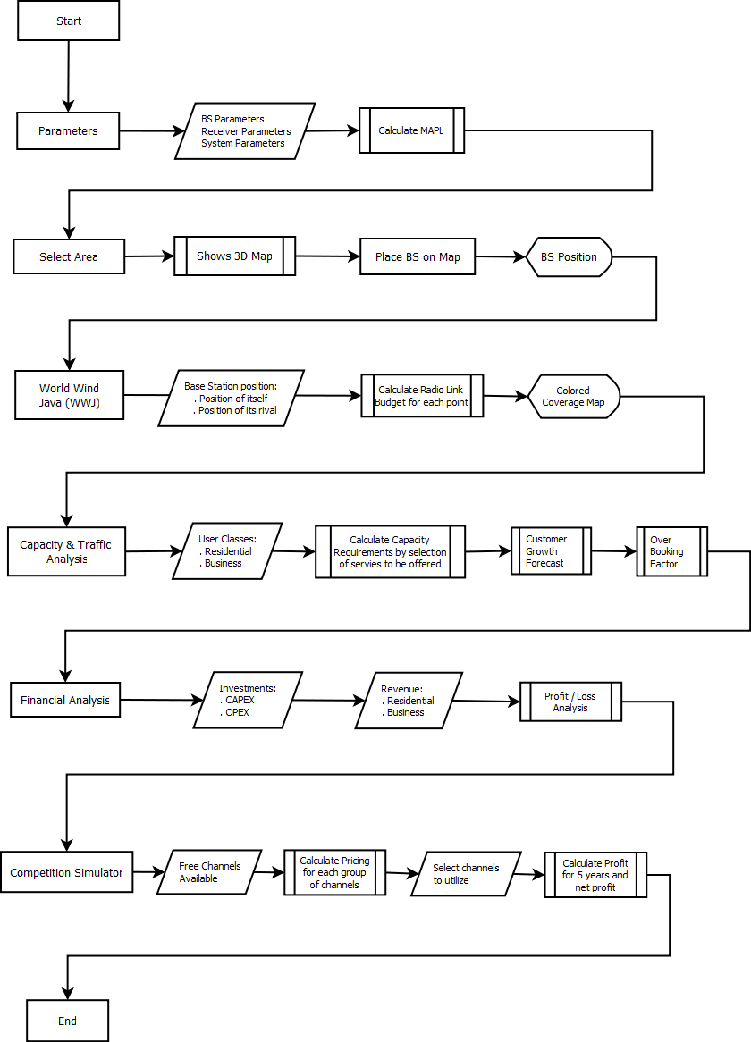

Fig: 4.1 Flow of CNPT
References to chapter 4
[1] Stefan, A.L, et. Al. (2010). Case study of an 802.22 network deployment. ICTE, CTiF, Aalborg University.

CHAPTER 5. GAME THOERY

Introduction to Game Theory
Game theory has been defined in [1] as a mathematical study of interaction among independent self-interested agents where self-interested agents are those agents who have the description of their own preferences. The several players participating in a game choose an action or strategy which ultimately aims to maximize their payoff. In the following section, the most important concepts of game theory are defined, concepts which will provide the support for enhancing the financial analysis performed in CNPT.

Representation of Game Theory
A game, G can be represented as: G = (P, S, U)

Where, P = Set of all players
S = Joint set of strategies
U = set of payoff functions of all players

Basically we observe that a game constitutes of a set of players who choose different strategies with an aim to achieve certain payoff. Here the players are the TV operators, the payoff is the amount of profit that benefits each player and strategy is to sell the spectrum as expensive as possible.
Game can be described depending upon the level of details like the nature of players and situations that occurs between them. The most classic example of the application of game theory is the case of “Prisoner’s Dilemma” which was developed by Merrill and Melvin Dresher at R&D in 1950[2].

Cooperative and Non Cooperative Game Theory

In a cooperative approach, each player aims to maximize the common benefit for the set of players. Cooperative game theory is based on the concept of playing with cooperation rather than competition. The players bargain with each other to collectively arrive at a desirable outcome. In contrast, in a non-cooperative game, each player is selfish and unconcerned about all the other players’ utility. Players are continually reacting to other players’ actions to maintain the maximum utility possible. The players tend to make the decisions in an effort to fulfill their own goal. In a cooperative game, if the players fail to reach an agreement, then players act in a non-cooperative way.

Strategic and extensive form Game
Strategic form (or normal game) represents a simple game that consists of a number of players, their possible strategies and their possible outcomes for the certain combination of action. The outcome is represented as a payoff of each player. This form of game represents simultaneous interaction between players where all the players perform their actions at the same time.
However, extensive form games represent a game in a form of tree. The action taken by one player is guided by the previous action of other players. Hence, this form of game depends on the order in which any player takes the action and the level of information that a player has while taking that action.
Profit Function
Profit function gives the relationship between the profit and the quantity of the good that is produced or sold. It is defined as the difference between the total revenue obtained on selling a product and the total cost incurred in producing that product.
Total revenue is obtained by selling the demanded quantity of a product at a defined price. The demand of a product can be predicted by using a demand function which can be chosen depending upon the requirement.
Cost function summarizes all the values of the quantity that is given up in the process of selling, exchange or development. It comprise of sum of fixed cost and variable cost. The fixed cost usually represents the investment cost of a quantity that is independent of the output and remains constant throughout some relevant range whereas the variable cost changes as the condition changes.
Nash Equilibrium
Nash Equilibrium is a fundamental concept in the field of games. Games involving two or more players are played with certain strategies which ultimately lead to certain outcomes. In such situations, Nash equilibrium is used to find the equilibrium point where all the players improve their individual payoff. If any player in a game changes his own strategy to increase his own payoff, he cannot assume that other players will not change their strategy. The other players will too want to change their strategy to earn more profit. But in this case when all the players change their strategies, no players can achieve the maximum benefit as it deviates from the Nash equilibrium. A game can have multiple Nash equilibrium or none at all. Nash Equilibrium tells us what would be the outcome but does not tell how to obtain this.

5.2. Demand function
To forecast the profit of any players the game, CNPT has to predict their revenues and expenditures. In order to quantize the effect of a variation of price over the quantity sold, a demand needs to be defined. The demand for any good is the amount that consumers want to buy and are able to buy in a particular period of time. The basic model of demand says that the amount demanded of any good depends on the good’s own price, consumer income, the price of substitutes and complements, consumer preferences, and perhaps other factors. The high numbers of unknown features like income, advertisements etc. which affects the demand make it hard to be as close as possible as reality. Still we can express the demand as, for example, as a linear function of all this features.

$Q_{i}=A{.P}_{i}+\sum_{j≠i}{B_{j}.P_{j}}+ C.Income$ (5.1)

Usually, the most important variables which affect the demand functions are prices, even if it depends on which kind of goods the demand is evaluated for. Several examples are required in order to understand this concept.

Different kind of goods
The first one is basic goods, as food or water for example. The most important feature of this type of good is, whatever the situation, people have to eat and drink. In the case, where there is only one provider of water, which means a monopoly market, and whatever the price he chooses to charge the customers, the customer have no choice but to buy the product. When there are several providers of water, the demand for water of one of the producer is straight affected by its price and by the price of its rival. Looking into equation (5.1), if the provider “i” increase its price, the demand for his product is going to decrease, and, on the contrary, if rival provider “j” increases its price, “i”‘s demand is going to increase. Thus the constant “A” should be negative and “B_{j}” should be positive. We notice that the sum of the demand functions of all the producers is independent of price, because this sum is equal to the demand function in the case of a monopoly market.

$\sum{Q_{i}=constant over price=Q_{monopoly}}$ (5.2)

Another kind of product is luxury products. In this case, the demand decreases with the decrease in price because in the mind of users, if the price decreases it means that the quality follows the same pattern.

Cross elasticity price of demand
The cross elasticity of demand is an economic concept that measures the responsiveness in the quantity demand of one good when a change in price takes place for another good. The measure is calculated by taking the percentage change in the quantity demanded of one good, divided by the percentage change in price of the substitute good:

$ν_{i,k}= \frac{\% change in demand of product "i"}{\% change in price of product "j"}$ (5.3)

$ν_{i,k}= \frac{∂Q_{i}}{∂P_{k}}* \frac{P_{k}}{Q_{i}}$ (5.4)
The cross elasticity of demand for substitute goods will always be positive, because the demand for one good will increase if the price for the other good increases. For example, if the price of coffee increases, but everything else stays the same, the quantity demanded for tea, a substitute beverage, will increase as consumers switch to an alternative.

On the other hand, the coefficient for compliments will be negative. For example, if the price of a car increases, the quantity demanded for gas will drop as consumers will purchase fewer cars. If the coefficient is 0, then the two goods are not related.

Different types demand functions
Basically a demand function is built from surveys or market analysis, which means that the challenge is to find the equation of such a curve. To interpolate a curve obtained from the survey or market analysis, we have to choose a model of equation, and use a regression method to find the required coefficients. Among many demand functions defined in economics, the linear model, the power model and the exponential model[2] are used here.
- Linear model:
$q_{1}= α- βp_{1}+γp_{2}+θR$ (5.5)

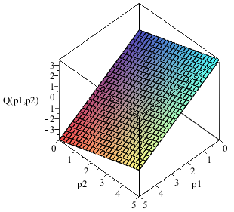
In the above equation, α, β, γ and θ are constants, p₁is the price related to quantity,q₁, p₂is the price of the rival of the producer of q₁and R is a parameter that represents other features like income or advertisement that affects the demand. With this function we have a constant marginal effect,which means if the price increase by 1 unit, the demand decrease by b unit. In each case of different types of demand function, we always choose α = 1, β = -1 and γ = 1.
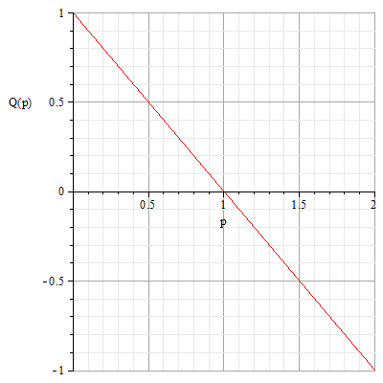

Figure 5.1 (a): Linear demand function in 2D Figure 5.1 (b): Linear demand function in 3D
- Power model:

$q_{1}= α {p_{1}}^{-β} {p_{2}}^{γ} R^{θ}$ (5.6)

Equation 5.6 can be further written as,

${ln⁡(q}_{1})=\ln\left(α\right)-β\ln\left(p_{1}\right)+γ\ln\left(p_{2}\right)+θln⁡(R)$ (5.7)

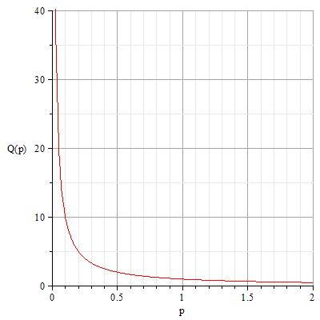 | 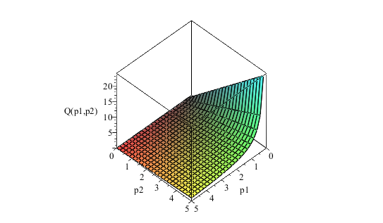
Figure 5.2 (a): Power demand function in 2D | Figure 5.2 (b): Power demand function in 3D

- Exponential model:

$q_{1}= α e^{-βp_{1}} e^{γ p_{2}} e^{θR}$ (5.8)

 | 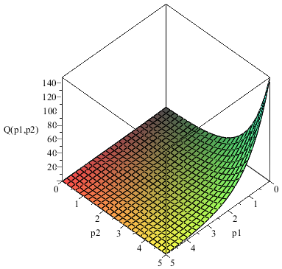
Figure 5.3 (a): Exponential demand function 2D | Figure 5.3 (b): Exponential demand function 3D

5.4 Objectives of using Game theory
While trying to meet the requirements, game theory was found as a powerful tool that models the interactions of agents with conflict interests. Game theory employs games of strategy (such as chess) but not of chance (such as rolling a dice). It is more likely in this case that two or more players are faced with choices of action, by which each may gain or lose, depending on what others choose to do or not to do. The final outcome of a game, therefore, is determined jointly by the strategies chosen by all players. These are also situations of uncertainty because no player knows for sure what the other players are going to decide. The uncertainty regarding values to both sellers and buyers is an inherent feature of auctions. So the estimation of the benefit is also not certain. In our case, the availability of free channels of different TV operators is also uncertain. In such case, the method of auction may not be appropriate. The process of auctions may result in time consuming and can lead to an overestimated price due to strong competition [4]. Hence, the rules for designing and conducting spectrum auctions has evolved towards more efficient mechanisms inspired by principles of game theory. The outcome is determined by the actions that are taken independently by multiple decision makers.

References to Chapter 5
- Yoav Shoham, K. L.-B. (2009). Multiagent Systems: Algorithmic, Game-Theoretic, and Logical Foundations. Cambridge University Press.
- Hirschey, P. M. (2009). Managerial economics (12th Edition ed.). Cengage Learning.

Chapter 6. COMPETETION SIMULATOR
6.1 Features of Competition Simulator
As discussed in section 1.2, Competition Simulator has two features,

Estimated price for a TV channel

Profit maximization for a network operator

Description of the Game
Consider a radio network with multiple primary and secondary users in a region. The cognitive radio concept exploits the technique of spectrum sensing. The proper spectrum detection techniques are employed for the detection of the white spaces (i.e. unused/ vacant spectrum) owned by the primary operator in a dynamic manner which can be accessed and assigned to the secondary user dynamically for a different service. However, for illustration purpose, we can assume that each TV operator has an unused spectrum bandwidth for certain duration of time in a day which it would like to sell to a secondary user so as to maximize his profit. Hence, we assume the availability of unused spectrum is certain and fixed over time – still, this does not mean that the availability of channels cannot be modified in the program. The availability illustrated is used just as an example.

The 802.22 standard has a good non LOS propagation in the UHF band frequencies ranging from 470MHz-890MHz. We consider a channel bandwidth of 6MHz (the bandwidth of a TV channel). Thus for the given frequency band and given channel bandwidth, we have 70 channels available. 70 channels are divided into 7 groups with each group having 10 channels each. The purpose of grouping the channel in this way is meant to illustrate the fact that the propagation characteristics at lower frequencies are better than propagation characteristics at higher frequencies [1]. This propagation characteristic of lower frequencies channels is reflected on the price causing it to increase. Hence, we can say that price of frequency channels follows this pattern:

P_{G1,j}> P_{G2,j}>P_{G3,j}>P_{G4,j}>P_{G5,j}>P_{G6,j}>P_{G7,j}
Where P_{Gi,j} represents the price of j^{th} channel of group i. where i $∈\{1,2,…,7\}$ and $j∈\{1,2,…,10\}$

G 1 |  | G 2 |  | G 3 |  | G 4 |  | G 5 |  | G 6 |  | G 7

7 Groups = 70 Channels of 6 MHz each

Figure 6.1: 70 channels divided into 7 groups

The free space propagation model, Friis equation (6.1) gives the relation between received power and the transmitted power.
$Pr=Pt Gt Gr{\left(\frac{λ}{4π}\right)}^{2}$ (6.1)
Where P_{r} is the received power, P_{t} is the transmit power, G_{t} and G_{r} is the antenna directivity gains of transmitter and receiver respectively, $λ=c/f$ is the wavelength.
From equation (6.1), we observe that the received power, Pr has an inverse relationship with the square of the frequency of transmission. The received power decreases by a square factor of the operating frequency. Following this simple reasoning we can consider that the prices of the frequency groups follow a similar square factor pattern.
However in our case while analyzing spectrum trading, many facts need to be considered:
- Multiple numbers of services and multiple numbers of operators
- Different strategies of different operators (malicious, cooperative, selfish etc.)
- Demand and supply of white spaces
- Mobility issues of the users
- Competition between operators for spectrum buying and selling
All these situations cause a scenario where the competitive game is difficult to analyze and solve. These factors create a situation where there are number of strategic agents that are trying to follow the same interest and hence find themselves in a competitive situation.

Implementation of game theory
CNPT1 makes use of two demand fuctions, one to predict the demand of WRAN operator for the TV channels and another one to predict the willingness to pay of internet users for one Mb of data exchanged.
Following what has been presented in the previous paragraphs these two demand functions should follow the same pattern - whenever the price increases, the demand should decrease. The common demand function can be given by [2]:
$Q_{i }\left(P_{1, }P_{2, }P_{3, }, …., P_{M, }\right)=Ф_{i }+ ΨP_{i }+\sum_{i≠k}{ν_{i,k }P_{K }}$ (6.2)
Where,
ν _{i, k}: Substitutability constant = $\frac{change in demand of product "\text{i"}}{change in price of product "k"}$
Ψ : $\frac{\% ofchange in demand of product "\text{i"}}{\% ofchange in price of product "i"}$ = Constant
$$Фi :Constant$$

Our case represents an oligopoly market where there are two or more players participating in the competition. If any of the players in oligopoly market change the price, then response of other players has to be taken into account. The Cournot game and the Bertand game are two basic models widely used in oligopolies for studying the competitive behavior between the sellers [3] where they make decisions independently and simultaneously. In the Cournot model [4], the seller sets the quantity of the selling goods that affects the price of the good. Stackelberg game is another game that is used in oligopoly market where the sellers choose the quantities of the good as in Cournot game but they make decisions sequentially rather than simultaneously. However, in Bertrand model, the seller to specify the price of the goods, which affects the market demand. So in this case, the demand function is dependent on the price of goods. The demand function in this case is represented as Q(p). Bertrand model is used in this case as it accomplish our aim which is to set the price of the spectrum of the primary operator (TV operator) considering the overall demand of the market. Now our aim is to find the demand function, Q (p).

Profit Function
Profit function is the total revenue minus the total cost. Profit function is given by,
$\prod_{i}{\left(P_{1}, { P}_{2},…….., P_{M}\right)}= {Revenue}_{i}-{Cost}_{i}$ (6.3)
For our case,
$\prod_{i}{\left(P_{1}, { P}_{2},…….., P_{M}\right)}$ is the profit of ‘i^{th}’ operator that depends upon the price of all the M operators in the competition where i є {1,2, …..,M}
${Revenue}_{i}$is the income generated after selling $Q_{i}$ spectrum at $P_{i}$ price by i^{th} TV operator and $Q_{i}$ is the quantity of channels demanded.
${Revenue}_{i}= P_{i}*Q_{i}\left(P_{1}, { P}_{2},…….., P_{M}\right)$ (6.4)

Demand Function
Section 5.2 has already introduced the concept of demand, thus, every time a demand function is used, the question of which model is the best or the most fitted to the study case. The problem of setting price of white spectrum using game theory has been widely examined by researcher ([5], [6], [7], [8], [9]), and a linear demand function has always been chosen.

Elasticity of prices
To understand and forecast as best as possible the demand of one good, we have to study the impact of prices on demand.
The elasticity of demand, ψ_{i}, represents the evolution of the demand when the price increases by one, and the cross elasticity of demand, ν_{i,k}, the evolution of demand for product “i” when the rivals’ price increases by one.
Basically, a channel can be considered as being a substitutable product, meaning that ψ_{i} is negative and ν_{i,k} are all positive. If we consider that for all the channels the quality to price ratio is equal, (and this is generally the economic rule for a fair market), then ψ_{i}= -1 and all the ν_{i,k} are equal.
Moreover the value of the ν_{i,k} depends on how we consider the need of channel for operators. Let us consider the total demand.
$Q_{total}=\sum{Q_{i}}= \sum_{k=1}^{M}{(Ф_{i}})+\left[\left(M-1\right)ν-1\right]\sum_{k=1}^{M}{p_{k}}$ (6.5)
First of all it could be considered that the WRAN internet provider absolutely needs some channels in order to have its business running, meaning that we can assume the total demand to be independent of price, so $,k = \frac{1}{M-1}$ , where M is the number of players of the game.

Constant determination
To evaluate φ_{i}, the factors that have an impact on the demand need to be considered. To keep the assumption that all channels have the same quality to price ratio, the frequency of channel has to influence the demand in a quadratic manner. Another factor that has to be taken into account for the demand is how sparse channels are in certain parts of the UHF spectrum. As it has already been explained, UHF band is divided in sevens parts which constitute the layers of our Bertrand game. In the case where there are only a few channels available in one part of the spectrum, demand for channels in this part should be high. On the contrary, if a lot of channels are available the demand for these channels should be low.
To build φ_{i}, we have to take into account a factor proportional to frequency “i”, the number of channels available in the “i^{th}” group, the number of channel available in the previous groups, and the total number of channels available. Thus φ_{i} is defined with the following formula.

$Ф_{i }≡\left(\left(m_{k.max}+1\right)- m_{i}\right). \frac{1}{i^{2 }} .\sum_{k=1}^{i}{\left(\left(m_{k.max}+1\right)- m_{k}\right) . \frac{1}{\sum_{k=1}^{M}{\left(\left(m_{k.max}+1\right)- m_{k}\right)}}}$ (6.6)
Where “m_{k}” is the number of channels available in the “k^{th}” group at a given time, “m_{k,max}” is the maximum number of channels available in k^{th} group and “M” is the total number of groups.

To express the impact of these factors we have to consider that:
- The first factor expresses the fact that if the number of channels in the “i^{th}” group is low, φ_{i}, has to be high. The choice to subtract m_{i} from m_{k,max}”+1” is due to the fact that if m_{i} is equal to m_{i,max}, φ is automatically equal to zero.
- The second factor represents the decreasing due to the frequency increase;
- The third factor expresses the fact that if the number of channels available in previous groups is high, then the demand for the channels in the “i^{th}” group is low;
- The last factor represents the fact that when the total number of channels available is high the demand will decrease. The “+1” is meant for avoiding the division by zero.
In our case, M=7, and the number of channels available is defined by the user through a graphic user interface.

Cost Function
The cost function is defined by the TV operator in our case. Cost function includes cost for the quantity of spectrum to be shared which is determined by the original cost price of the spectrum when it was licensed and some additional value added by the TV operator. The additional value added by the TV operator depends on the fact that price of all TV channels is not equal. In fact, as it was mentioned in section 4.5, the price of lower frequency bands is higher than that of the higher frequency bands. So the seller (TV operator) will increase the price for the lower frequency band to maximize its profit.
This can be further explained. If a TV operator bought two or more frequency channels several years before for the same price, and now wants to sell it to the WRAN operator(s), it would prefer to sell the lower frequency channel at more expensive price than the others. This is the reasoning that led us into considering the original cost of spectrum as in (6.7):
${Px= Py\left(\frac{lower frequency of band y}{high frequency of band x}\right)}^{2}$ (6.7)
Where P_{x} is the price of channel in lower frequency band and P_{y} is the price of a channel in an immediately consecutive higher frequency band.

Estimation of original cost of spectrum:
The cost of the spectrum is charged to the TV operator by the regulator as a license for using the spectrum for the purpose of broadcasting service. Some references have been taken to choose the original price of spectrum for the TV operator. It can be observed from the references that the license for using the spectrum for TV broadcasting services depends upon the factors like transmitted power, frequency used, antenna height and area of coverage. The reference to the cost of spectrum has been found from different countries like United Arab Emirates and Nigeria (unfortunately, references for other countries have not been so easy to find). As per the Telecommunication Regulatory Authority, United Arab Emirates, the annual spectrum fees for 8MHz channel for one individual Broadcasting Station shall be calculated as follows [10]:
$Spectrum Fees \left(per Station\right)= B+(P*ST*SZ*H*C)$ (6.8)
Where, B = Basic Fee = є 7,772, P = Power Factor representing power in KW, ST = Service type factor, SZ = Service Zone, H = Antenna Height Factor, C = Correction Factor.
If we consider the case of digital TV broadcasting in a highly dense and populated city and 6 Base stations are deployed to have a complete coverage in the same type of area and with same transmission properties, then for a channel with 8 MHz bandwidth channel, we define,
B= є 7,772, P= 10KW, ST = 68, SZ = 1, H = 75m, C = 1
Hence using equation (4.16), we can calculate
Annual Spectrum fee per 8 MHz (in euro) = $7772 + \left(10*68*1*75*1\right)* 6=€313772$/per year
Therefore, spectrum fee for 6 MHZ per hour = $\frac{313772*6 }{8*365*24}$=$€26.86404$/hour
What can be observed from this calculation is that the spectrum fee charged for the TV broadcasting service in the UHF band is very cheap as compared to what is observed from the FCC (Federal Communications Commission) frequency re farming policy in 700 MHZ band [11]. Important part of the spectrum range of our concern lies in the FCC 700 MHz band which is being auctioned at higher prices as the reserved price has been set to as high as $10million for the whole 62 MHZ spectrum in 700 MHz band [12]. The reason behind the over hyped price for this spectrum is probably due to a competitive scenario among the operators as this band is best suited for broadband data transmissions in long range which can be implemented using the emerging technologies of WiMAX and LTE (Long Term Evolution). In our case, it is assumed that all the TV operators purchased the license from the regulator long time ago at a non-competitive and cheaper price.

Nash Equilibrium
With the available linear demand function, a linear system of equation needs to be solved to find the set of prices which represent the Nash equilibrium. Because of the linearity of this system a literal solution can be easily found.
After calculus, the solution set of price could be expressed such as:
$Nash _Eq≡P={{(p}_{i})}_{iє1,…7}⇔p_{i, iє1,…..7}= \frac{1}{2} . \left[\frac{\left(5ν-2\right)\left(Ф_{i}+C_{i}\right)-ν\sum_{j≠i}{(C_{j}+Ф_{j})}}{\left(ν+2\right)(3ν-1)}\right]$ (6.9)
From the above value we can conclude that in order to have a positive price (a negative one does not make any sense), we need some conditions on ν.

Estimating the price of a channel
Input that the user will be asked to give while using CNPT is the following:
- The availability of channels in each group.
- The cross elasticity of price.
The following charts displays two sets of curves, each set is plotted in red or green for different values of number of available channels in the groups.
For each set of curves, there are three plots:
- Solid circles represent how many channels are available in each group.
- Continuous lines are built from seven points which are the price per channel for each group. The choice of continuity was done to underline the evolution.
- Dotted line represents the relative difference between consecutive prices, in percentage.
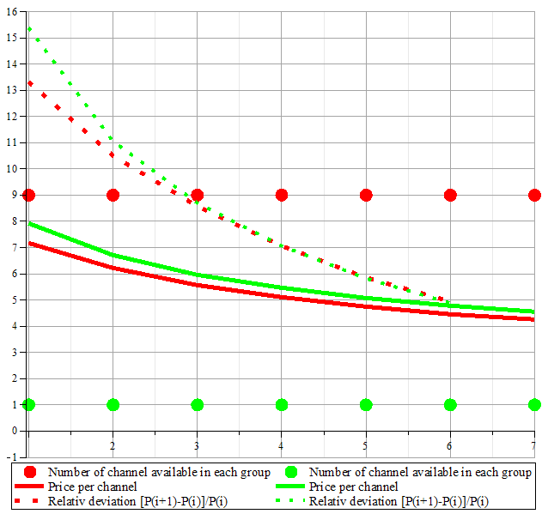
Figure 6.2: Price variation considering uniform distribution of channels in each group
The figure 6.2 shows the case where all the groups have the same number of channel available. Two cases are displayed, in the red curve there are nine of the ten channels available and in the green set only one channel is available in each group. The main observation is that when there are more channels available in a group then the price is lower.
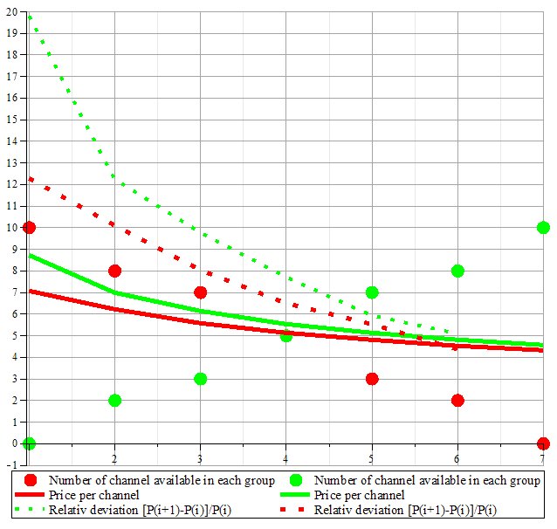
Number of available channels
Number of groups

Figure 6.3: Price variation considering an increasing/decreasing distribution of channels in each group
The figure 6.3 displays the results for a situation in which availability of TV channels decreases or increases in a smooth way between consecutive groups of TV channels. In the red set, the price curve is flatter than in the green set. The reason for this is the two contradictory effects present in the red set. When the frequency increases, prices have to decrease, but in this particular case, availabilities also decrease with frequency, so prices have to increase.
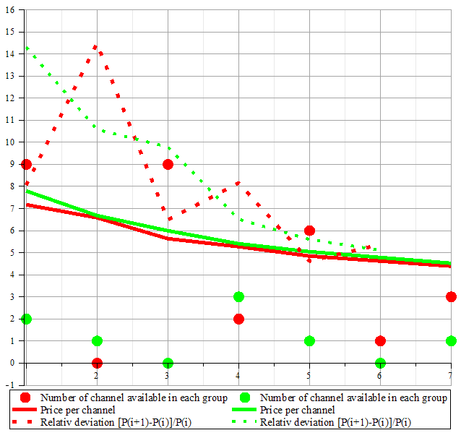
Number of available channels
Number of groups
Figure 6.4: Price variation considering a random distribution of channels in each group.

All the examples presented have been simulated with ν=1/6. Nevertheless, a different value could also be chosen. To underline the effect of changing the values of ν, we choose to display the set of curves considering the same number of available channel but different values of ν i.e. ν=1/6 and ν =1/4. We can observe from figure 6.4 that when ν increases, the price per channel also increases. To explain this phenomenon lets come back to the definition of ν.
$\% change in price of product \text{j}=\frac{1}{ν_{i,k}}.\% change in demand of product \text{i}(6.10)$
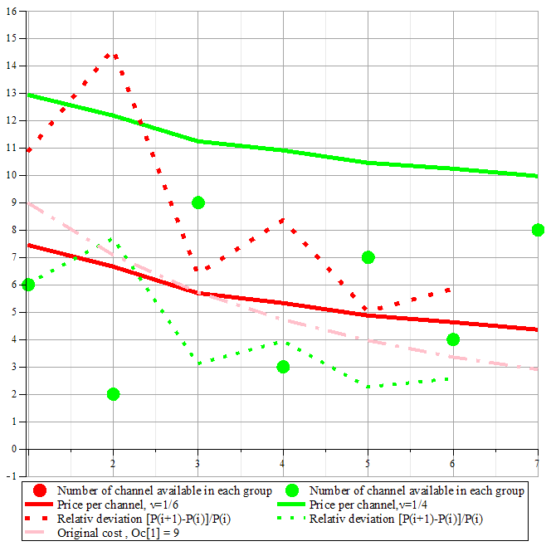
Number of available channels channels
Number of groups

Figure 6.5: Effect of ν on prices.
Repercussion in demand for variation of price is inversely proportional to ν. This means that if ν is low, impact in demand for a variation of price will be high. In other words, the market is more competitive when ν is low (and in a high competition situation prices are low). The figure 6.5 confirms this trend; the equilibrium price obtained is higher when ν is higher.
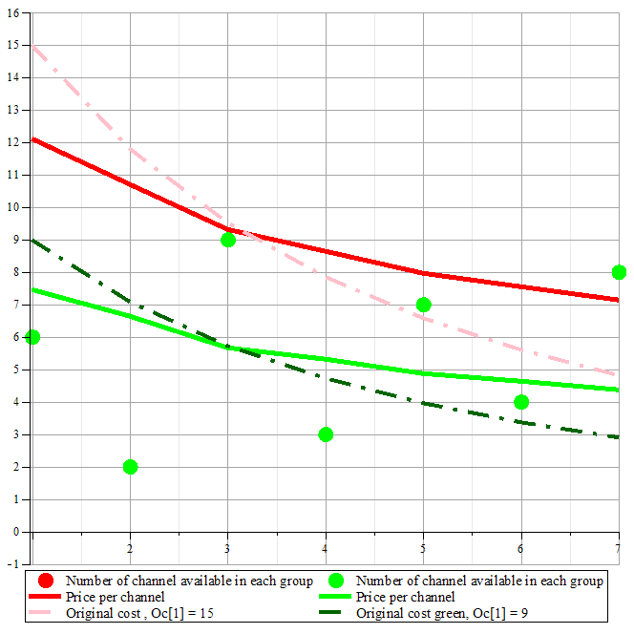
Number of available channels
Number of groups

Figure 6.6: Effect of changing the original cost of channel.

Figure 6.6gives prominence to the effects of the channel’s original cost on the final price. From the results of this figure, we can conclude that the final price of the channels can be above or below the original cost as the final price of a channel depends on the number of available channels in a group and the group to which the channel belongs.

Scenario utilized for determining the price of the service
The first part of this chapter was focused on determining the price that a WRAN operator should pay for a TV channel. Following part deals with the second feature of the Competition simulator – determining the price that the users should pay for the WRAN service.

Two WRAN operators, WRAN1 and WRAN2 are considered trying to serve the same geographical area. Here it is assumed that WRAN1 has already deployed its network and WRAN2 (the user of the software) wants to penetrate the market in the same area. Throughout this report, WRAN1 is referred as rival and WRAN2 as the operator who uses this software or for whom this CNPT tool is implemented. Hence aim of this part of the competition simulator would be to find the best charging price per Mb of data for WRAN2 operators’ users ensuring that this price maximizes his profit which would be the final output of this simulator.
In our case, the geographical area of approximately 7500 Km² is selected. To determine the network coverage of the existing WRAN operator, the radio coverage computation feature of the CNPT tool is used. Using this feature we are able to place the base stations of WRAN1 (we assume that WRAN2 has the means to determine the position of its rival’s base stations) to find the existing coverage of its network.
Knowing the information about the exiting coverage of the rival network, the new market player, WRAN2 needs to deploy its own base station in the appropriate location. The proper planning before the deployment of the base station is of paramount importance. The coverage of the rival’s BSs can be computed through the means presented in chapter 4. It is obvious that WRAN2 can choose to have no overlap between the coverage of its BSs positions and those of its rival, as well as it can choose a certain degree of overlapping. Figure 6.7 shows a possible overlapping case. In this case, the user that resides in the overlapping area can choose service from either of the two operators. This certainly gives rise to competition between operators in order to increase the number of subscribers. The users in the remaining area under the coverage of only one operator have no choice but to subscribe to the operator that provides the coverage in that region. Hence the operators need not compete in such region.

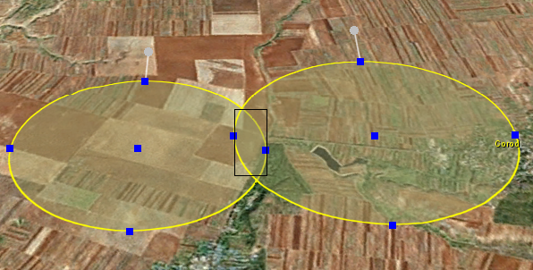
Figure 6.7 Overlapping service areas of WRAN operators
Thus, CNPT needs to calculate the percentage of the overlapping area as this is helpful in estimating the number of subscribers for which the two operators will be competing. In order to obtain this number of subscribers starting from an area, formula (6.11) is used:
Nr_subscribers_for_which_to_compete=avg_density_population*overlapping_area (6.11)
Unfortunately, CNPT does not offer the possibility of using different clutter maps, and the user is required to enter the average density of population in the selected area, without any means of differentiating between different clutters.

Service Tariff
In the CAPEX and OPEX analysis performed for the 802.22 deployment case study [13], it was said that the revenue mainly depends upon two important factors: the forecasted number of subscribers and the service tariff. The service tariff is a basic factor that decides the level of competition between the operators. This is obvious because most of the potential subscribers will tend to subscribe to the operator who offers lower service tariff. Considering the present market trend of the usage pattern of internet service, it is observed that the average internet usage is 2.5 hours per day [14]. Our objective would be to find the acceptable price for 1 Mb of data demanded for the service. Hence in order to determine the acceptable value, we need to analyze the current market trend and refer to the statistics provided by some performed surveys. Calculations are performed on the basis of the data and figures available for internet service which is quite similar to our case as the objective of a WRAN operator is provide broadband internet connectivity to its users. For obtaining the accurate results, the data and statistics needs to be obtained by carrying out surveys defining the technology and application offered and in the targeted geographical location.
As mentioned above, the average internet usage per day as 2.5 hours is considered. From the results of [13], the price demanded for the service to the residential users as no more than 5€ per month and business users as no more than 15€ per month considering the overall CAPEX and OPEX cost is obtained. Therefore, the acceptable price per hour for the residential category as 0.06575€ and for the business category as 0.19726€ can be calculated. This information can be combined with the traffic requirements in Mbps per hour (obtained from the traffic modeling part)

Demand function for the service tariff
In order to prove the functionality of the second feature of the competition simulator we use a demand function to predict the willingness of a subscriber to pay for every MB of data exchanged.
As mentioned in section 5.3 about the different forms of demand function, in this case two types of demand functions: linear and exponential [15] is used to represent the nature of the demand which varies with the price for 1 MB of data.
For this feature, CNPT1 takes into account that for an area that is not under competition, the demand of a product is a function of one’s own product price where as in the area of competition, the demand of your product is a different function of one’s price as well as the rival’s price.

Types of demand function
- Linear Demand Function: This form of demand function is the simplest and is given by the expression:
Q=$\left\{\begin{aligned}A1 – B1*PMb2 for an area with no competition \\ A2 – B2*PMb2+C2*PMb1; for an area with competition\end{aligned}\right. (6$.12)

Where, A₁, B₁, A_{2,}B₂ , C₂ are the positive constants and P_{Mb1} and P_{Mb2} is price per Mb offered by the WRAN1 and WRAN2 operators.
The nature of this demand function is decreasing with P_{Mb} which represents the fact that the demand of the service decreases as the service price increases. The linear demand function, for certain values of P_{Mb} can be zero or less than zero. But in the case of setting the price for the users, the demand function should not reach zero neither a negative value. In linear demand function, there is always a constant difference between the demand at two different values of price, may it be at the lower ranges of price or at the higher ranges of price and does not seems practical in our case. This can be explained by an example. Consider a property being sold that is just 10m away from the main highway. It is obvious that the property that is near to the main highway will be of more value than the one very far away say 50 Km. And it is also true that the difference between the price of the properties that are closer to the main highway should not be same as the difference between the price of the properties that are located 50 Km away. So similar is our case. This effect of constant marginality is not a good way of representation of demand function in our case
- Exponential demand function:
This kind of demand function gives the exponential relation between demand and price.
$Q_{1}=A_{1}* \exp^{-B_{1}*P_{Mb2}};demand when there is no competition$ (6.13) $Q_{2}=A_{2}* \exp^{-B_{2}*P_{Mb1}}*\exp^{-C_{2}*P_{Mb2}} ;$ $demand when there is competition$ (6.14)

Where, A₁, B₁, A₂, B₂, C₂ are the positive constants and PMb₁ and PMb₂ is price per Mb offered by the WRAN1 and WRAN2 operators.
Two aspects that model our situation quite accurate stand out - when PMb₂ decreases the demand increases and when PMb₂ increases the demand tends to zero which is a true representation of our case since considerable increase in price can result in no demand of the service and a low service price can increase demand. Hence, exponential demand function gives a good representation of our case.

Demand function builder
The aim of this part is to find some numeric values for the constants terms in the demand functions given in section 6.12.1.
Initially, constants A₁ and B₁of the demand function without competition will be determined followed by the determination of constants A₂, B₂ and C₂ for demand functions with competition. To determine both unknown constants A1 and B1, we need two equations. With the traffic requirements and assuming the overbooking factor from [13], we are able to estimate the average traffic requirement of users (for both residential and business) in one hour which can be calculated as 82.76 Mb/hour for residential users and 247.31Mb/hour for business users. Acceptable maximum prices considered per month are 5€ for residential users and 15€ for business users, as assumed in [13].
Dividing the average amount of data used in one hour by the acceptable price per hour, we can find an acceptable price for one megabit of data (7.945.10⁻⁴ €/Mb for residential and 7.97610⁻⁴ €/Mb for business). The ratio between these two values being 1.004,lead us to conclude that the thresholds of 5 and 15 are quite accurate, as they offer the same price per megabit.
To determine the other equation needed to resolve the system, refering to [16] where it is claimed that almost 100% of people interviewed are ready to subscribe for mobile internet if the cost is 5€/month, and only 50% of the people are ready to subscribe if the price is increased to 25 €/month. This means that if the price suffers a 5 times increase, twice less people are ready to subscribe as a result of which twice less data is going to be used. This conclusion gave us our second equation.
$\left\{\begin{aligned}Q_{1}\left(AccPrice_{1MB}\right)=AverageTraffic in one hour \\ Q_{1}\left(AccPrice_{1MB}*5\right)=AverageTraffic in one hour/2\end{aligned}\right.$ (6.15)
To determine A₂, B₂ and C_{2,} we consider a different approach. If both prices P_{Mb1} and P_{Mb2} are equal, the sum of the demand functions for both operators should be the same as that of the case where only one operator is in the market. Moreover, the demand for each operator should be equal.
Mathematically we can express these conditions as follows:

$pMb1=pMb2→\left\{\begin{aligned}{ Q}_{withoutCompetition}=Q_{WRAN1_{withCompetition}}+Q_{WRAN2_{withCompetition}} \\ Q_{WRAN1_{withCompetition}}=Q_{WRAN2_{withCompetition}}\end{aligned}\right.$ (6.16)

Using these conditions we obtain:
$A_{1}=2{.A}_{2}$ for both demand functions (linear and exponential)
$B_{1}=2.\left(C_{2}-B_{2}\right)$ for linear case (4.25)
$B_{1}=\left(C_{2}-B_{2}\right)$ for exponential case
C₂ = αB₂

Where α є [0,1] because two WRAN operators provide substitutable products (which also means that α is positive).
Since there are only two service providers, this service could be considered as inelastic in price [17] which means that the rival’s price affects the demand less than the own price of the new operator. Here we choose α = 0.5 but any other can be implemented as well.
With these relations, we can compute the following for the non-competitive case:
Linear demand function
- For residential users A₁ = 93.103 and B₁ = 13019.960
- For business users A₁ = 278.227 and B₁ = 38758.103
Exponential demand function
- For residential users A₁ = 98.416 and B₁ = 218.100
- For business users A₁ = 294.106 and B₁ =217.257
Based on these values and the relations above, we are now able to find the expressions of the demand functions in case of competition as well.
To build the total demand function (and this is illustrated in figure 6.8 for WRAN2), we sum the four demand functions weighted by their corresponding fractions.

$TotalDemand(pMb1,pMb2)=\%WithoutCompetition . (\%residential . Q_residentialWitoutComp+\%business . Q_businessWithoutComp )+\%UnderCompetition . (\%residential . Q_residentialUnderComp+(\%business . Q_businessUnderComp )$ (6.17)
“Best price” refers to the best choice of price meant to optimize the profit of the WRAN operator, but this does not mean that the WRAN operator is always able to make profit, but at least, the best price can minimize the losses.
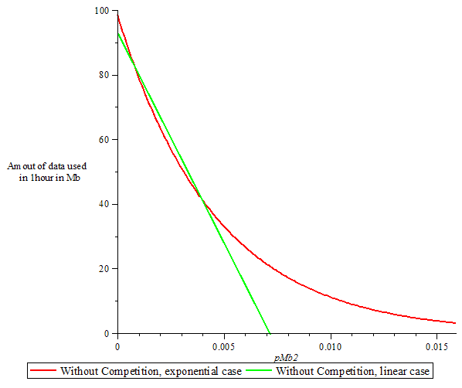
Figure 6.8: Amount of data used as function of best price

Estimating the service tariff
This part of the report explains the results displayed by the competition simulator. To have a clear overview of the results, let us recall the inputs of the simulator:
- Number of potential subscribers
- Gompertz coefficients “a” and “b” to forecast the evolution of subscriptions over time
- The minimum number of BSs, this value comes from the coverage calculations.
- The number of channels used and their prices
- The price that the rival has chosen to charge its users.
- The percentage of WRAN2’s potential users who are in a competition area and have a choice to choose the service between the service providers.
- The type of demand function (linear or exponential), and their related coefficients.
The results are calculated with the following input values:
- Minimum 6 Base Station
- One channel at 16€/hour
- 150000 potentials subscribers in the area under consideration
- Gompertz coefficients (a=0.8 and b=3.5)
Figure 6.9 gives the outcome for an exponential demand function and figure 6.10 gives the outcome for a linear demand function.
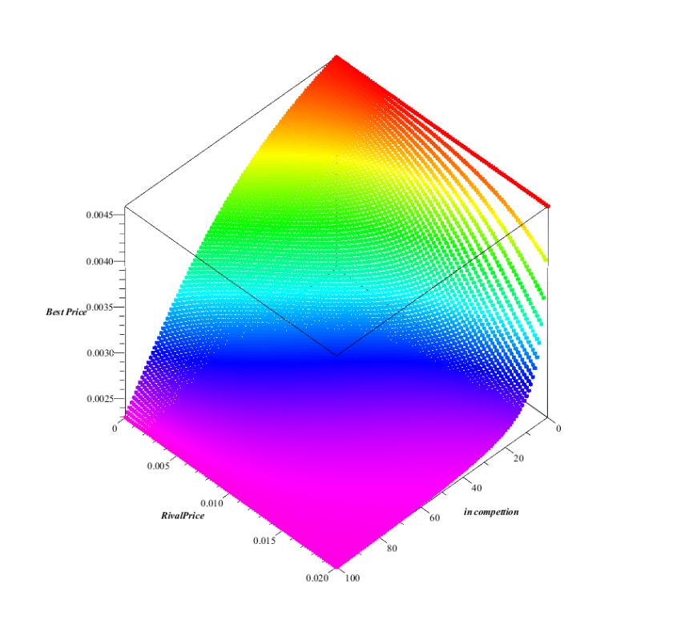

Figure 6.9: 3D relationship between best price, price of rival and percentage of area under competition using exponential demand function

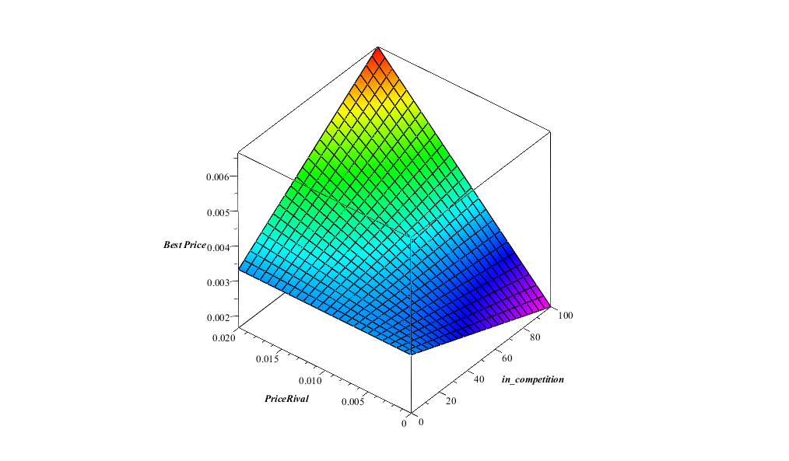

Figure 6.10: 3D relationship between best price, price of rival and percentage of area under competition using linear demand function
From figures 6.9 and 6.10, some conclusions can be drawn:
- With the exponential model the minimum best price is obtained for a high level of competition and a high rival’s price as seen in figure 6.9.
- Whereas with the linear demand function, the minimum best price is obtained for a high level of competition and low rival’s price as seen in figure 6.10.
Profit is computed based on the proportion of users that choose to subscribe to the WRAN’s operator services, and since this is a decision based on price, the profit can be computed as a function of the price of WRAN1 operator and the level of competition. The profit represented in figures 6.11 and 6.12 is the average profit per year over a period of five years.
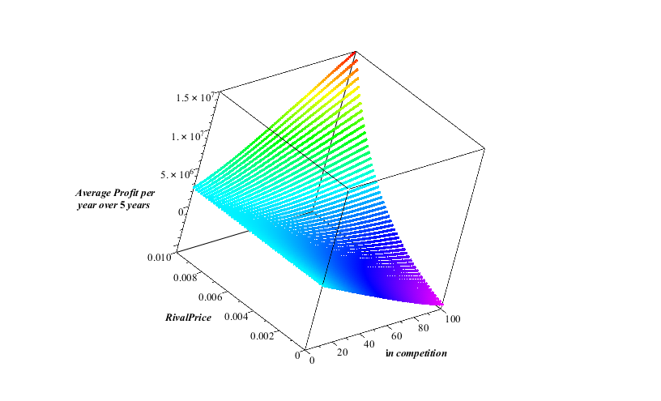

Figure 6.11: 3D relationship between average profit, price of rival and area under competition using exponential demand function

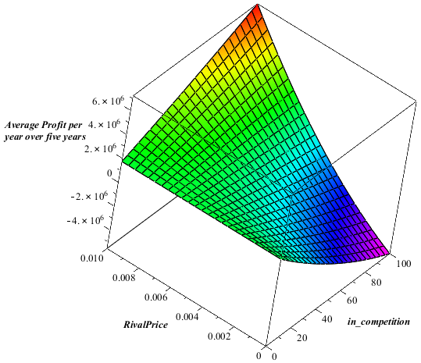

Figure 6.12: 3D relationship between average profit, price of rival and area under competition using linear demand function
The results correspond to a simple statement – when the rival operator (WRAN1) increases its prices, the profit for the WRAN2 operator tends to increase (and this is valid for both models of demand functions). To highlight these observations, some sections of these 3D graphs are going to be displayed where the price of the rival is kept constant and the percentage of competition varies.
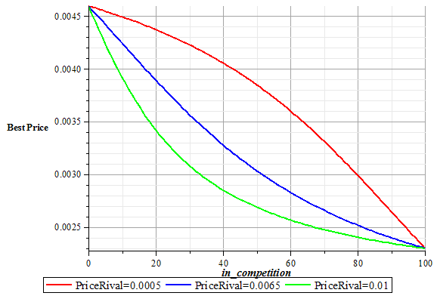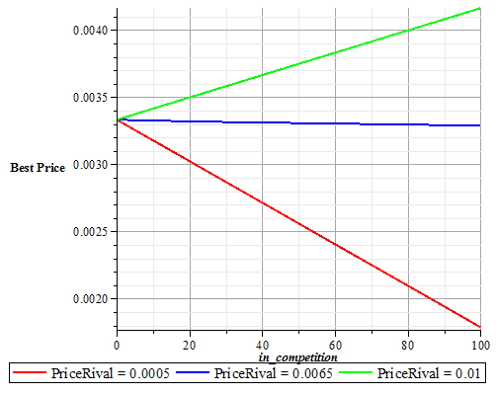
Figure 6.13: Best price as a function of area under competition for the two demand functions

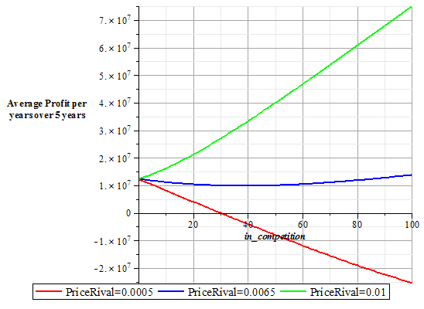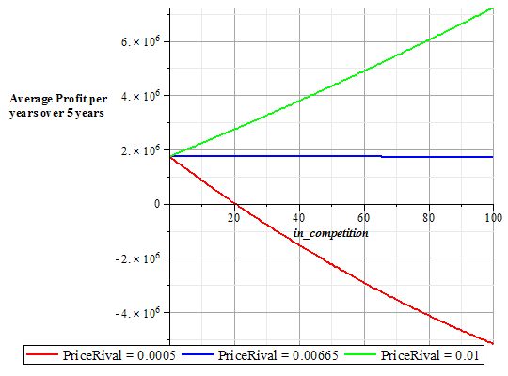
Figure 6.14: Average profit as a function of area under competition for two models
Considering figures 6.13 and 6.14, it can be noticed that:
- With both models, if the rival charges its users with a low price (red curve) (meaning that the competition increases), the best price for the WRAN2 operator decreases, as an attempt to attract more users.
But still it is impossible for WRAN2 to use prices as low as the prices as the WRAN1 operator. The conclusion is clear – under heavy competition, the WRAN2 operator should expect to lose money (a better idea would be not to invest in such an area).
- With the linear demand function, if your rival chooses to charge its user with a price of 0.0066 €/Mb (blue curve), the best price of WRAN2 operator is going to be independent of the level of competition, thus the profit would be constant. Nevertheless with the exponential demand function, it is impossible to obtain a flat curve for best price in function of the level of competition.
  - If the WRAN1 operator uses a high price (more than 0.007€/Mb), with both models, the profit of WRAN2 is going to increase when the competition increases, but we can notice an interesting difference between both models. Profit is higher with exponential model than with the linear one. This is due to the fact that with the linear model, demand becomes negative after a given price, whereas with the exponential model demand is still positive for whatever value of price.
  - With the exponential case, the best price of WRAN2 decreases when the competition increases.
To have a better understanding of the effect of the price of the rival WRAN1 operator on the best price of WRAN1 and its profit, figures 6.15 and 6.16 are presented.
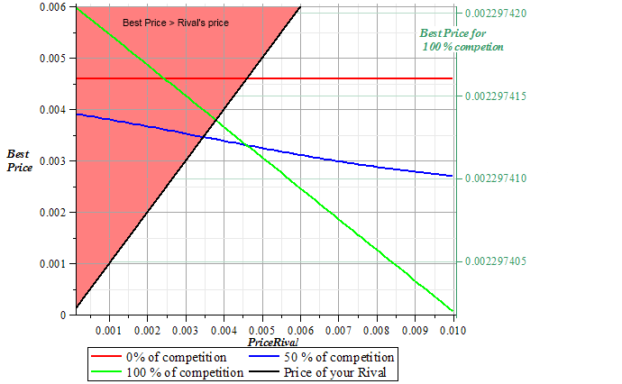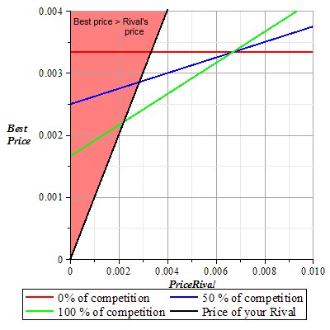
Figure 6.15: Best price as a function of the rival’s price
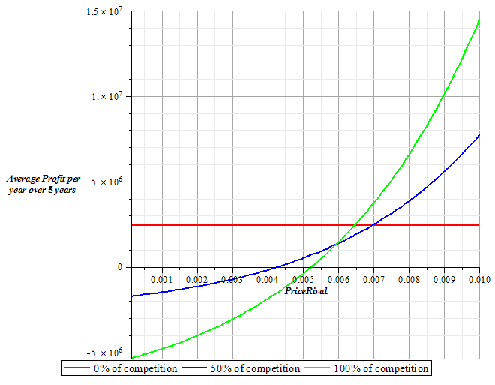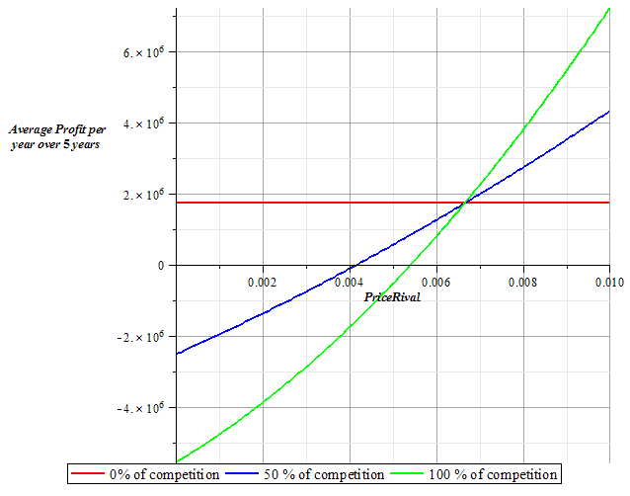
Figure 6.16: Average profit as a function of the rival’s price
Considering figures 6.15 and 6.16, we can conclude:
- In 6.15, the black curve represents the first angle bisector (i.e. f(x)=y), so if the best price is in the light red area, the interest of WRAN2 operator is to have as less as possible competition.
- When there is no competition, obviously, the best price and profit are independent of the price of the rival.
- The profit of WRAN2 is increasing when the price of the rival increases. If the rival is financially able to charge its user with a low price, it can prevent the WRAN2 operator to make any profit over five years, and it would be economically infeasible for WRAN2 operator to deploy and launch such a network.
- Competition can impact the profit in two ways – the WRAN2 operator earns more money if WRAN1’s price is high or loss more money if the rival’s price is low.

References for Chapter 6
[1]. Performance of different frequency bands, Cooper Crouse-Hinds, Technical Artical http://crouse-hinds.com/wirelessIO/PDF/White%20Paper/white_paper_frequencies.pdf
[2]. Topics in Multivariate Regression Analysis. (n.d.). Retrieved November 10, 2010, from MyWebSpace at Quinnipiac University:
- Drew Fudenberg, J. T. (1991). Game Thoery. Cambridge: The MIT Press.
- Fischer, I. (1971). Researches into the mathematical principles of the theory of wealth. A. M. Kelley.
- Dusit Niyato, E. H. (2008). Competitive Pricing for Spectrum Sharing in Cognitive Radio Networks: Dynamic Game, Inefﬁciency of Nash Equilibrium, and Collusion. IEEE Journal on Selected Areas in Communications, 26 (1), 192-202.
- Beibei Wang, Y. W. (n.d.). Game Theory for Cognitive Radio Networks: A Tutorial Survey. Retrieved November 17, 2010, from University of Maryland:
http://terpconnect.umd.edu/~bebewang/tutorial_draft.pdf
- Nirvikar Singh, X. V. (1984). Price and Quantity Competition in a Differentiated Duopoly. The RAND Journal of Economics, 15 (4), 546-554.
- Ekram Hossain, Z. H. (4 Dec 2009). Game theory for Cognitive Radio Networks. IEEE GLOBECOM 2009 Workshop. Honolulu, Hawaii.
- Juncheng Jia, Q. Z. (2008). Competitions and dynamics of duopoly wireless service providers in dynamic spectrum market. MobiHoc '08 Proceedings of the 9th ACM international symposium on Mobile ad hoc networking and computing, (pp. 313-322).
- Spectrum Fees Regulations. (2009, December 30). Retrieved November 17, 2010, from Telecommunication Regulatory Authority (TRA), UAE:
www.tra.ae/download.php?filename=spectrum_affairs/Spectrum%20Fees%20Regulations%20v2.0_En.pdf
- FCC Auctions: Factsheet: Auction 73 - 700 MHz Band. (2008, March 20). Retrieved November 17, 2010, from FCC: http://wireless.fcc.gov/auctions/default.htm?job=auction_factsheet&id=73
- A Primer on the FCC's 700MHz Auction. (2007, December 4). Retrieved November 17, 2010, from PCWorld: http://www.pcworld.com/article/140245/a_primer_on_the_fccs_700mhz_auction.html
- Andrei Lucian Stefan, J. K. (2010). Case study of an 802.22 network deployment., CTiF, Aalborg University.
- Media Use Statistics. (n.d.). Retrieved November 8, 2010, from Media Literacy Clearing house (MLC): http://www.frankwbaker.com/mediause.htm
- Maija Gao, A. H. (2006, November 10). Demand for and Pricing of Mobile Internet: Evidence from a Real-World Pricing Experiment. Retrieved November 20, 2010, from University of Helsinki: http://ethesis.helsinki.fi/julkaisut/eri/hecer/disc/122/
- Paul Rappoport, L. D. (2004). WTP (Willingness-to-Pay) Analysis of Mobile Internet Demand. Frontiers of Broadband, Electronic and Mobile Commerce, Cooper, Russel and Gary Madden (eds.) , 165-180.
- Economics Interactive Class Notes - Chapter 19. Elasticity of Demand Effects Total Revenue. (n.d.). Retrieved November 14, 2010, from Business Book Mall:
http://www.businessbookmall.com/Economics_19_How_Elasticity_of_Demand_Affects_Total_Revenue.html

Chapter 7. Results and Conclusion
7.1. Results
Snapshots of the developed network Planning tool, CNPT has been explained below:

Figure 7.1 shows the region in Romania which has been extracted from WWJ application implemented in the test bed. The CNPT user selects the area of concern for the deployment of his network.

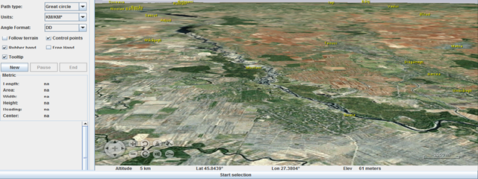

Figure 7.1: Selecting a certain region in WWJ/CNPT
The next step after selecting a region and extracting the elevations is to place the base stations. CNPT assumes that the operator has knowledge about the location of the rival’s base station and thus prompts the user for the latitude and longitude coordinates of the rivals’ base station, followed by the coordinates of its own base station (figure 7.2).
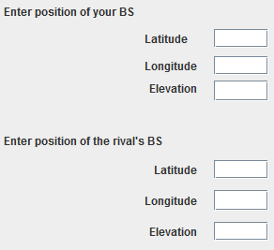
Figure 7.2 Input for the position of the base stations
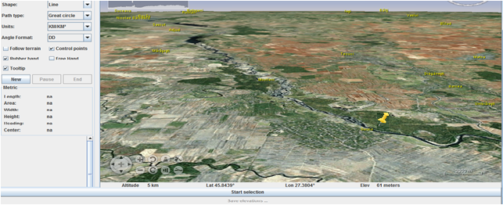

Figure 7.3: Placing a Base Station on the map
The next step in the design of CNPT has included a custom menu for the base station. Number of menu Items are presented in the following figure 7.4.
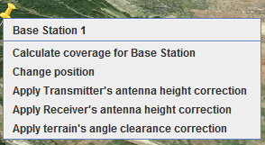
Figure 7.4: Context Menu for a Base Station
By using the items in this custom menu, the user can select the new location for the base station as well as its elevation, can calculate the coverage of the selected base station and, after this last step, apply the different correction factors that are specified by the propagation model utilized.
In regards to the correction factors offered by the propagation model deployed, these take into account the following [1]:
- The effective height of the transmitting/base antenna
- Receiving/mobile antenna height
- Terrain Clearance Angle (TCA)
Appendix A details the steps concerned with the correction factors. In order to plot the coverage of a base station, a number of steps are followed: from the coverage and capacity planning, the number of base stations required to serve an area is computed. For these base stations, the maximum distance that can be covered is calculated. Based on this input, the user of CNPT can create a new Surface Image representing this coverage.
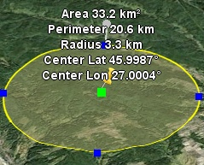
Figure 7.5: Illustrating the maximum coverage of a Base Station
After reaching this point next step would be entering the input location of a node (figure 7.6), the user can visualize the profile up to that path and the predicted signal strength (with or without correction factors applied)
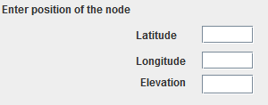
Figure 7.6: Entering the position of a node
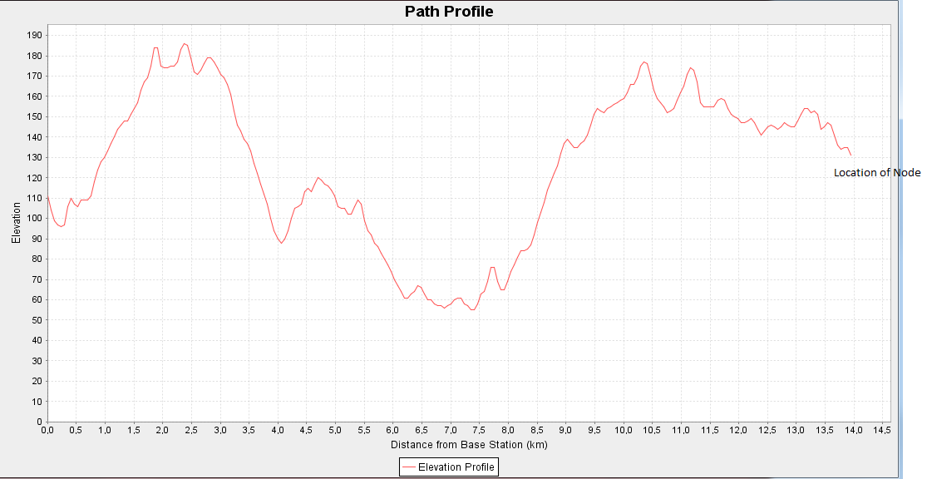
Figure 7.7: Path profile for a random node
One of the items created under the Context Menu referred to “Analyze coverage of the base station”. By selecting this feature, the user can observe the signal strength profiles at different distances from the base station.
For calculating the overlapping coverage area between different operators, it is the job of the network operator utilizing the CNPT to enter the parameters of the base station used by the competitor, but here similar parameters for the base stations of both operators are assumed. With this assumption, the overlap percentage between operators can be easily estimated.
Figure 7.8: Illustration of overlapping area between two rival WRAN operators

7.2 CONCLUSION
Throughout this report, a combination of software development and research studies has been conducted. The goal was to obtain an enhanced version of a cognitive radio network planning tool. CNPT uses elevations and Digital Terrain Maps in order to achieve more accurate results for coverage and signal strength prediction. It incorporates financial details (estimating the price that a WRAN operator has to pay for using the spectrum belonging to the TV operators as well as estimating the prices that users should pay for the WRAN service, both features required in order to make valid considerations regarding the potential profit that a WRAN operator could benefit from).
In regards to overall analysis of the work presented in this report, a simple straightforward conclusion can be drawn – the results from CNPT show that the more TV channels are available, the less a WRAN operator would have to pay for these channels.
The second part reveals extremely interesting things – even if a WRAN operator would choose to deploy its network so that it overlaps with the network of the rival WRAN operator, using certain price strategies profit could still be obtained.
As the major objective of the work presented in this report was to exploit emerging cognitive technology and provide a platform to give the stakeholders the analytical results regarding the deployment of a cognitive network, which has been fulfilled to some extent.

APPENDIX A
The first correction concerns the effective antenna height (heff). For this factor, two cases are considered:
- The first, where the distance d is less than 15 km
- The second, where the distance d is greater than 15 km.
In the first case, the height considered is the height of the Base Station averaged by the elevations between the distances 0.2 * d and d, where d represents the maximum coverage of the base station, while in the second case, the height considered is the height of the Base Station averaged by the elevations between the distances 3km and 15km.
Depending on the terrain height, there are three heights that can be used as reference for the second correction factor, the receiving antenna height. These are:
- 30m for dense urban areas
- 20m for urban areas
- 10m for suburban and rural areas
In case that the receiving antenna height is different than these reference heights, a correction needs to be applied. The correction corresponding to the receiving antenna height is given as a curve based on empirical results and this is the case as well for the correction corresponding to the terrain clearance angle. In both cases, these have been implemented in CNPT1 as look-up tables. For more information on these two sets of curves, the reader can refer to [1].
The third correction factor depends on the clearance angle difference :
${ θ}_{tca}=θ-θ_{r}$
Where $θ_{r}$ represents the reference angle) and $θ$ represents horizontal mobile antenna path which clears the terrain obstacles over a distance of 16km :
${ θ}_{r}=arctan\left(\frac{h_{1s}-h_{2s}}{1000 d}\right)$

