cWofo – Ps

zf]w kl/ro

!=! zf]w zLif{s M
k|:t't zf]wkqsf] zLif{s uf]nahf/ If]qsf sIff * df cWoog/t du/efifL ljBfyL{x?n] g]kfnL jfSou7gdf ug]{ q'l6x?sf] cWoog /x]sf] 5 .
!=@ zf]wsf] k|of]hg M
k|:t't zf]wkq lqe'jg ljZjljBfno lzIffzf:q ;+sfo >L /f=/f=tf=h=ax'd'vL SofDk; uf]nahf/ g]kfnL efiff lzIff ljefu cGt{ut :gftsf]Q/ tx -Pd=P8_ låtLo jif{sf] kf7of+z g]kf=lz= %(* sf] cf+lzs cfjZostf k"lt{sf nflu tof/ kfl/Psf] xf] .
!=# ;d:of syg M
Effiff JolQmsf] ckl/xfo{ j:t' xf] . JolQm efiffs} rf}3]/fdf hlGdG5 / ToxL eflifs jftfj/0fdf x's{b} jf pd]/ j[l4sf qmddf JolQmdf efiff a'em\g] / af]Ng] cEof; :jtM ljsl;t xF'b} hfG5 . ctMefiff JolQmsf nflu kl/lrt j:t'sf] ?kdf /x]sf] x'G5 / s'g} g s'g} efifnfO{ cfkm\gf] hLjgsf] cleGg cª\u agfPsf] x'G5 . To;sf/0f JolQm ;fdflhs k|fl0fsf] ?kdf Jojxf/ ug{ ;Ifd ePsf] xf] . efiff 1fg cfh{gsf] dxTjk"0f{ dfWod klg xf] . To;}sf dfWodaf6 dflg;n] ljljw s'/fx? af/] hfgsf/L lng ;Sb5 / p;n] hfgsf/L k|fKt ug]{ qmddf cfh b]v]ef]u]sf s'/fx? ef]ln ck"0f{ x'g ;S5g\ . lbgk|ltlbg gofF gofF ljrf/x? Pj\d lrGtgx?sf] ljsf; eO/x]sf x'G5g\ . o; kl/k|]Iodf efiffsf] dxTj a9b} uO/x]sf] kfO{G5 . g]kfnsf] ;Gbe{df g]kfnL efiff g]kfnsf] /fi6«efiff dfq geP/ ;/sf/L sfdsfhsf] efiff klg xf] . ljBfnosf] k|fylds tx b]lv dxfljBfno tx ;Dd g]kfnL efiff clgjfo{ ul/Psf] 5 .
ljgf q'l6 s'g} klg efiff l;Sg Tolt ;xh 5}g . To;}n] x/]s efiffdf q'l6 x'g' c:jefljstf xf]Og . q'l6n] efiff l;sfOsf] k|s[lt / k|j[ltnfO{ ;ª\s]t u/]sf] x'G5 . xfdL dfgj ;d'bfon] klg ;fdfGotof l;sfOsf qmddf q'l6x? ul//xg] x'Fbf efiff l;sfOsf] ;Gbe{df q'l6g} ;kmntfsf] Bf]ts dflgG5 . bf];|f] efiffsf] ?kdf g]kfnL efiff l;Sbf ljBfyL{x?df :jefjt cfkm\g} dft[efiffsf eflifs PsfOut ljz]iftfx? ljwdfg /xg] xF'bf Wjlg / Jofs/0fsf ;+/rgfx?df pgLx? cEo:t eO/x]sf x'G5g\ . To;sf/0f efiffdf cf–cfkm\g} dft[efiffsf] ;+:sf/n] ubf{ ;+/rgfsf] k|efj bf];|f] efiffdf kg]{ s'/fnfO{ ;lhn} u|x0f ug{ ;lsG5 . To;}n] q'l6 ljZn]if0f efiffsf l;sfO k|lqmofsf] cWoog ug]{ Pp6f dxTjk"0f{ k4lt xf] .
q'l6 ljZn]if0f / efiff lzIf0f aLr cGof]Gofl>t ;DaGw 5 . efiff l;Sg] qmddf ljBfyL{x?n] ug]{ x/]s k|sf/sf ulNtnfO{ g} q'l6 eGg ;lsG5 . tL q'l6x? jfSou7g, j0f{ ljGof;, pRrf/0f, lnkL, ?k, kbfjnL, cy{, ;|f]t cflb cGt{ut x'g ;S5g\ . sIff * df cWoog/t du/ efifL ljBfyL{x?n] g]kfnL jfSou7gdf ug]{ q'l6x?df s]lGb|t of] zf]wkq lgDglnlvt ;d:of sygdf s]lGb|t /x]sf] 5 .
-s_ uf]nahf/ If]qsf sIff * df cWoog/t du/efifL ljBfyL{x?n] g]kfnL jfSou7gdf lnª\u, jrg, k'?if, sfn / cfb/fyL{ k|of]udf s] s:tf q'l6 ub{5g\ kQf nufpg .
-v_ ;f]xL If]qsf ljBfyL{x?n] x«:j bL3{ ;DaGwL s] s:tf q'l6 ub{5g .
-u_ kbof]u kbljof]udf ;f] If]qsf] ljBfyL{x?sf] cj:yf s] s:tf] 5 .
-3_ rGb|ljGb' k|of]udf s] s:tf q'l6x? ub{5g\ .
-ª_ j0f{ 5gf}6 – o– P, a– j, z– if– ; _ df s] s:tf q'l6 ub{5g\ .

!=$ cWoogsf] p2]Zo M
of] cWoog cg';Gwfg lgDglnlvt p2]Zox?df s]lGb|t /x]sf] 5 .
-s_ l;/xf lhNnfsf] uf]nahf/ If]qsf sIff * df cWoog/t du/efkL ljBfyL{x?n] g]kfnL jfSou7gdf lnª\u, jrg, k'?if, sfn / cfb/fyL{ k|of]udf ug]{ q'l6 kQf nufO{ ljZn]if0f ug{ ,
-v_ ;f]xL If]qsf du/efifL ljBfyL{x?n] x«:j–bL3{df ug]{ q'l6x? kQf nufpg',
-u_ kbof]u tyf kbljof]udf ;f]xL ljBfyL{x?n] ug]{ u/]sf] q'l6 s]nfO{ ljZn]if0f ug'{,
-3_ rGb|ljGb' tyf lz/ljGb'sf] k|of]udf ug]{ q'l6sf] vf]h ug{',
-ª_ j0f{ 5gf]6 – o– P, a– j, z– if– ; _ sf] k|lqmofdf ePsf] q'l6sf] rrf{ ug{',
-r_ pko'{Qm q'l6x?sf] lg/fs/0fsf pkfox?sf] vf]hL ug{' .
!=% cWoogsf] ;Ldf M
-s_ du/ efifL ljBfyL{ eGgfn] uf]nahf/ If]qsf kfFrj6f ljBfnosf sIff * df cWoog/t ^) hgf ljBfyL{x?nfO{ lnOg] 5g\ . -v_ q'l6 eGgfn] pQm du/ efifL ljBfyL{x?;Fu lnOPsf] j:t'ut, ljifout tyf :jtGq n]vg ;DaGwL q'l6sf] cWoogdf km]nf kfl/Psf jfSou7gut q'l6sx?sf] cWoognfO{ lnOg] 5g\ .
-u_ o; zf]wdf lnª\u, jrg, k'?if,sfn / cfb/fyL{ Jofs/l0fs sf]l6x?sf] dfq cWoog ul/g] 5g\ .
-3_ o; zf]w kqdf j0f{ljGof;ut q'l6x? cGt{ut x«:j–bL3{, kbof]u–kbljof]u, lz/ljGb'– rGb|ljGb', a– j, o– P, / z– if– ; sf] cWoog dfq ul/g] 5 .
!=^ zf]w ljlw M
k|:t't zf]w kq ;DkGgtfsf nflu k|fylds tyf uf}0f ljlw ckgfPsf] 5 . o; cGt{ut k':tsfnoLo cWoog ljlw, If]qLo cWoog ljlw ;fy} juL{s/0f ljZn]if0ffTds k4ltsf] k|of]u ul/Psf] 5 . o; zf]wsf] tof/Lsf qmddf n]v, /rgf tyf zf]w;Fu ;DalGwt zf]wkqx?sf] cWoog u/L tof/ kfl/Psf] 5 .
o; zf]w cWoogdf q'l6 kIfsf] ljz]if cWoog ug]{ p2]Zo /flvPsfn] k|Zgkq lgdf{0fnfO{ a9L Wofg lbOPsf] 5 . ;/sf/L ljBfnodf cWoog/t sIff * sf du/ dft[efifL ljBfyL{x?sf :t/ cg';f/ k|Zgx? agfO{ ljåfg u'?ju{, efifflj¢ tyf zf]w lgb]{zsHo" sf] ;Nnfx / ;'emfj cg';f/ pQ/ k'l:tsfsf] kl/If0f ul/of] . kl/If0f kZrft pxfFx?sf] lgb]{zg cg';f/ cfjZos kl/dfh{g tyf ;+zf]wg ul/of] .
o; zf]wsf qmddf b'O{ k|sf/sf k|Zgx? tof/ u/L ltgLx?nfO{ g} cWoogsf] d"n ;fdfu|Lsf] ?kdf k|of]u ug]{ . % j6f df=lj= tyf lg=df=lj=sf !@– !@ hgfsf b/n] hDdf ^) hgf 5fq5fqfx?nfO{ :jtGqn]vg / ljifout k|Zgx? lgdf{0fu/L k/LIff lnOof] . pQm k/LIff kZrft pQ/k'l:tsf kl/If0f ul/of] . ljifout Pj+ :jtGq n]vg sfo{ pQ/k'l:tsf lbP/ n]Vg nufOof] / zf]w lgb]{zssf] ;Nnfxf cg''';f/ q'l6 kl/If0f ul/of] . ;fy} kl/If0f ul/Psf] pQ/k'l:tsfnfO{ lnª\u, jrg, k'?if, sfn, cfb/ / j0f{ljGof;sf] tflnsLs/0f / ljZn]if0f ul/of] .
!=& cWoogsf] cf}lrTo M
g]kfnL efiff g} ;Dks{sf] efiff, dft[efifL, sfof{nosf] efiff, ;+rf/dfWodsf] efiff, lzIf0fsf] efiffsf] ?kdf ;d]t ePsfn] g]kfnL efiff cGo efiffeflifsf dflg;x?sf] nflu klg z'4tf q'l6 ljlxgtf / :t/Lotf /xg' cfjZos 5 . cfKfm\gf cg'ej tyf 1fg Ifdtf klg efiffsf dfWodåf/f JoQm x'G5 . /fi6«sf ;Dk"0f{ If]qdf sfo{/t JolQmx?df /fi6«efiffsf] z'4 k|of]u Ifdtf /xg' cfjZos x'G5 . o; zf]wsf] cf}lrTonfO{ lgDg cg';f/n] pNn]v ug{ ;lsG5 M
-s_ jfSou7gut q'l6x? lnª\u, jrg, k'?if, sfn / cfb/ af/] :ki6 1fg lbg' ,
-v_ efiff l;sfO k|lqmofdf ;/ntf Pj+ :ki6tf kfg'{ ,
-u_ du/ efifL ljBfyL{x?nfO{ j0f{ljGof;ut z}lIfs cjwf/0f lbg' ,
-3_ dfq[efifL ljBfyL{x?nfO{ g]kfnL efiff lzIf0fdf ;xof]u x'g] ljlwx? ckgfpg ,
-ª_ z}lIfs ;fdfu|Lsf] ;d'lrt k|of]u k|lqmofdf ;'wf/ ug{ ,
-r_dgf]j}1flgs cWoog / eflifs sl7gfONffO{ Wofgdf /fvL jfSou7g , j0f{ljGof;;+u ;DalGwt q'l6x?sf] lg/fs/0f ug{ .
ctM q'l6 lg/fs/0f ug{ efiff lzIfs / lzIffyL{x?sf lglDt pko'Qm ;fdu|L aGg' klg o; zf]wsf] d'Vo cf}lrTo /x]sf] 5 .

!=* zf]wsf] ?k/]vf M
k|:t't zf]w cWoognfO{ d"ntM lgDg cWofo zLif{sx?df ljefhg u/L cWoog ul/Psf
5g\ M
cWofo Ps M zf]w kl/ro
cWofo b'O{ M q'l6 ljZn]if0f ;}4flGts cjwf/0ff
cWofo tLg M du/ efiffsf] ;fdfGo kl/ro / jfSou7gut ;fdfGo cjwf/0ff
cWofo rf/ M du/ efifL ljBfyL{x?n] g]kfnL jfSou7gdf ug]{ q'l6sf] JofVof ljZn]if0f .
cWofo kfFr M lgisif{ / ;'emfjx?

cWofo — b'O{
k"j{sfo{sf] ;dLIff / q'l6 ljZn]if0fsf ;}4flGts cjwf/0ff
@=! k"j{sfo{sf] ;dLIff M
ljutsf cg'ejn] jt{dfgnfO{ cufl8 a9fpg ;xof]u k'¥ofpg] s'/fnfO{ gsfg{ ;lsb}g t;y{ s'g} klg sfo{ ubf{ k"j{sfo{sf] n]vfhf]vfsf cfwf/df ug{ pQd dflgG5 .
q'l6 ljZn]if0f;Fu ;DalGwt cWoog cg';Gwfgx? k|;:t ePsf 5g\ . o;} qmddf jfSo u7g cGt{ut q'l6x?sf] cWoog;Fu ;DalGwt cWoog cg';Gwfgx?sf] rrf{ ug]{ qmddf hugf{y zdf{ lqkf7Låf/f dfgljsL / ;fdflhszf:q cWoog ;+sfo cGt{ut kb\dsGof SofDk;sf 5fqfx?sf] g]kfnL Jofs/0f ;DaGwL q'l6x?sf] ljZn]if0f -@)#%_ zLif{sdf cWoog ul/Psf] b]lvG5 . o;sf] p2]Zo pRr tx kf/ ug{ nfu]sf 5fqfx?df Jofs/0fut q'l6 k|;:t kfOG5, To:tf q'l6sf] cWoog u/L lg/fs/0f k|lt ;r]ttf Nofpg ;'emfj lbg /x]sf] 5 .
pQm cWoogsf nflu :gfts txsf] -#)!_ g]kfnL Jofs/0fsf] lj:t[t cWoog eGg] kf7of+zsf] k/LIffsf pQ/k'l:tsfnfO{ k|fKtfª\sf cfwf/df rf/ ;d'xdf ljefhg ul/Psf] 5 . o;df g]kfnL dft[efifLx? / g]kfnL efiffnfO{ bf];|f] efiffsf ?kdf k|of]u ug]{ 5fqfx?nfO{ lnOPsf] 5 . pQm pQ/ k'l:tsfnfO{ k/LIf0f ug{ klxnf] / bf];|f] efiffsf ?kdf k|of]u ug]{x? dWo s;n] slt q'l6 u/] < ljeflht ;d'xdf s'g ;d'x s'g >]0fLdf slt k|ltzt cª\s k|fKt ug{ ;kmn eP < ;f] lgisif{ lgsflnPsf] 5 . o; cWoogdf lqmofkb, ;+ult / jfRout q'l6x?nfO{ Ps};fy x]/]/ lgisif{ lbOPsf] 5 . lqmofkb, ;+ult / jfRout q'l6ug]{x? s]–slt k|ltzt eP eGg] s'/fdf of] cg';Gwfg df}g b]lvG5 .
8f= nD;fn -@)$)÷$! åf/f lgDgdfWolds tx k'/f u/]sf cfjf;Lo / ;fwf/0f ljBfonodf cWoog/t ljBfyL{x?sf] g]kfnL jfSou7g ;DalGwt q'l6kIfsf] t'ngfTds cWoog zLif{sdf Ps cg';Gwfgdf k|:t't ul/Psf] 5 . o; cg';Gwfgsf d'Vo p2]Zo lg=df=lj= plt0f{ u/]sf ;fwf/0f / cfjf;Lo ljBfnosf ljBfyLx?n] g]kfnL efiffsf] jfSou7gdf ug]{ q'l6sf] klxrfg ug]{ ;fdfGo cfjf;Lo ljBfnosf] ljBfyL{x?n] ug]{ q'l6sf] t'ngfdf ;fwf/0f ljBfnosf ljBfyL{x?n] al9 q'l6x? u/]sf] kfOG5 . jfSo u7g cGtu{t jfSosf lnª\u, jrg, k'?if, sfn, jfSo :j?k / kb d]nnfO{ ;dfj]z ul/Psf] 5 .
o; cWoogaf6 ;fwf/0f ljBfnosf ljBfyL{x?n] cGo kIfsf] t'ngfdf lnª\u / jrg ;DalGw q'l6x? cToflws u/]sf] kfOG5 eg] cfjf;Lo ljBfnosf ljBfyL{x?sf] t'ngfdf ;fwf/0f ljBfnosf ljBfyL{x?sf] :t/ klg w]/} sdhf]/ b]lvG5 f
s]bf/ k|;fb -@)$@_ åf/f dfWolds tx cjwL efifL ljBfyL{x?n] g]kfnL jfSou7gsf] n]vgdf kg]{ kb;+ult ;DalGw q'l6sf] cWoog n3' cg';Gwfg ul/Psf] 5 . afFs] / aflb{of lhNnfsf # / $ ljBfnox?nfO{ ;dfj]z u/L k|To]s ljBfnosf !)÷!) hgf cjwL efifL ljBfyL{x? hDdf &) hgfnfO{ k|ltlglw ljBfyL{sf] ?kdf lnPsf] 5 . o; cg';Gwfg cWoogn] p2]Zo / ljw]o ;+ult ;DalGw q'l6, ljz]io ;DaGwL q'l6, ljz]if0f ;+ult q'l6, stf{ / lqmofkb aLrsf] q'l6 / cg'gfl;Stf k|of]usf] cefj h:tf ljifodf s]lGb|t /xL ljZn]if0f ul/Psf] 5 . oyfy{df o; cg';Gwfgdf cjwLefifL lzIfyfL{x?sf] g]kfnL efiffsf] k|of]udf w]/} sdhf]/L b]vfPsf 5g\ . o; zf]wsf] p2]Zo cjwLefifL ljBfyL{x?sf] jfSo n]vgdf kb ;+utL ;DaGwL q'l6x? s]nfpg' /x]sf] 5 .
clwsf/L -@)$@_ åf/f g]kfnL j0f{+ ljGof;df kfOg] q'l6x?sf] cWoog n3' cg';Gwfgsf] k|ltj]bg k|:t't zf]w vf; efiffeflifsf ljBfyL{x?df s]lGb|t geP/ k|df0fkq tx k|yd aif{df cEoog/t s]xL lzIffyL{x?df cfwfl/t 5 . o;sf] d'n p2]Zo k|df0fkq txdf cWoog ug]{ lzIffyL]{x?sf] j0f{ ljGof;df q'l6sf] klxrfg ug'{ / tL q'l6x?sf ;d:ofx?nfO{ x6fpg ;'emfj lbg /x]sf] 5 .
pQm zf]wdf k|fKt tYosf cfwf/df g]kfnL efiffdf z,if,; sf] k|of]u, ;+o'Qm Jo~hgdf o, j, /, x sf] k|of]u , a–j sf] k|of]u, g / 0f sf] k|of]u, rGb|ljGb' / lz/ljGb'sf] k|of]u, o–P sf] k|of]u v'§f sf6\g] / v'§f gsf6\g]sf] k|of]u ;fy} x«:j–bL3{sf] n]vfOsf] k|of]udf s]lGb|t /x]sf] 5 . o; cg';Gwfgdf k|df0fkq txdf cWoog/t dx]Gb|/Tg SofDk;, tfxfrn / ;fgf]l7dL eQmk'/sf hDDff !)) hgf ljBfyL{x?nfO{ k|ltlglwsf ?kdf lnPsf] 5 . g]kfnL efiffefifLsf kIfdf s'g 7fpFdf s'g j0f{sf] k|of]u ubf{ 7Ls x'G5 , s'g j0f{ n]lv q'l6 u/]sf] 5 , ;f] af/]df s]lGb|t of] zf]w cg';Gwfg lxHh] kIfdf dfq s]lGb|t b]lvG5 .
clwsf/L-/]UdL_ -@)$$_ åf/f k|lj0ftf k|df0fkq txdf cWoog ug]{ ljBfyL{x?sf] n]vg cleJolQm ;DalGw q'l6 ljZn]if0f zfLif{sdf ul/Psf cg';Gwfgdf k|lj0ftf k|df0fkq txdf cWoog ug]{ ljBfyL{x?sf] n]vgsnfdf kfOg] q'l6sf] klxrfg ug'{, juL{s/0f ug'{ / q'l6x? lg/fs/0fsf nflu ;'emfj k|:t't ug'{ /x]sf] 5 . jfSou7g cGt{ut jrg, k'?if cfb/, sfn, kIf / jfRo ;DaGwL q'l6x?nfO{ cf}NofOPsf] 5 . k|:t't cWoog lj/]Gb| ax'd'vL SofDk; e/tk'/sf k|ftM / lbjf ;d'xsf %)÷%) u/L hDdf !)) hgf ljBfyL{x?nfO{ ufFpn] hLjg zLif{sdf lgaGw n]Vg nufO tL pQ/ k'l:tsfsf] cfwf/fdf q'l6x?sf] ljZn]if0f ubf{ lzIffyL{x?n] u/]sf jfSo u7g, ljelQm, ;j{gfd cGo ljljw k|sf/sf q'l6 eg]/ !@ j6f zLif{s /flv s]nfP/ x]g]{ sfd ul/Psf] 5 . t/ ljBfyL{n] s'g If]qdf slt k|ltzt q'l6 u/] eGg] yfxf kfOb}g s]jn q'l6sf] k|s[ltdfq ljZn]if0f ul/Psf] 5 .
s]=;L=-v8\sf -@)%%_ n] ;'v]{t lhNnfsf sIf % pQL0f{ du/efifL ljBfyL{x?df kfOg] q'l6x?sf] cWoog zfLif{ssf] Ps zf]wkq ;DkGg u/]sf 5g\ . o; zf]wdf lnª\u ,jrg, k'?if,cfb/ ;DaGwL jfSou7gsf k|lqmof ;–:j/ jfrg, zAbf]rf/0f / j0f{ljGof;df ljBfyL{x?n] ug]{ q'l6x? kQfnufpg], q'l6x?sf] t'ngfTds cWoog ljZn]if0f ug]{ / k|fKt lgisif{sf cfwf/df ;'emfjx? k|bfg ug]{ sfo{ ePsf] 5 .
o; zf]wdf If]qLo k|of]ufTds ;fdfu|L ;+sng ljlw ckgfPsf] 5 . k|ltlglw gd'gf 5gf]6sf ?kdf ;'v]{t lhNnfsf ;b/d'sfd If]q, ;b/d'sfd aflx/, u|fld0f If]q / ;b/d'sfd glhssf ljBfno u/L hDdf # j6f ljBfnosf @)÷@) hgf ljBfyL{x?af6 gd'gf ;ª\sng ul/Psf] 5 . o; zf]wdf sljtfsf] ;– :j/ k7gdf ult,olt no;Fu ;DalGwt u|fld0f If]qsf afnaflnsfx?sf] w]/} q'l6 kfOof] . jfSou7gdf jx'jrt, :qLlnª\u, pRrcfb/, klxnf] / bf];|f] k'?if cg';f/ lqmofsf] ;+ult gldnfPsf] xnGt, rGb|ljGb', lz/ljGb', o – P, z– if– ; nfO{ j}slNks ?kdf q'l6 u/]sf] kfOG5 . dfly pNn]lvt tLg If]qsf ^) hgf k|ltlglw ljBfyL{x?af6 :jtGq n]vg k|Zgf]Q/ tyf zAbx?nfO{ jfSodf k|of]u u/]/ jfSou7gut q'l6 kxNofO lg/fs/0fsf pkfo;d]t vf]lhPsf] b]lvG5 . j0f{ljGof; ;DaGwL q'l6sf nflu >'lt n]vgnfO{ d"n cfwf/ dflgPsf] 5 . o; zf]wsf] lgisif{ du/ efifL ljBfyL{x/nfO{ bf];|f] efiff g]kfnL lzIf0fdf ;'wf/ ug{ /x]sf] 5 .
;fksf]6f -j]njf;]_ -@)%%_ åf/f sIff ;ft k'/f u/]sf ljBfyL{n] ug]{ j0f{ ljGof; ;DaGwL q'l6x?sf] ljZn]if0f zf]w cg';Gwfgdf sf7df08f} lhNnf leqsf ;fwf/0f / lghL @÷@ j6f u/L hDdf $ j6f ljBfnosf sIff ;ft k'/f u/]sf ljleGg hftL efiff”efifL / lnª\usf ;fy} ljleGg kl/j]zsf ^) hgf ljBfyL{x?nfO{ lnPsf] 5 . tL ljBfyL{x?nfO{ {kfgLÚ zLif{ssf] lgaGw n]Vg nufO{ pQ/ k'l:tsf hfFr]/ ljBfyL{x?n] u/]sf j0f{ ljGof; ;DaGwL q'l6nfO{ ljZn]if0f ul/Psf] 5 . o;df ;fw/0f ljBfnosf lzIffyL{?n] eGbf lghL ljBfnosf lzIffyL{x?n] a9L q'l6 u/]sf] kfOof] . o; zf]wdf ljBfyL{x?n] zAbflb, zAbdWo] / zAbfGtdf gfd zAbdf k|fo Pp6} zAbdf x«:j bL3{ ;DaGwL q'l6 u/]sf] b]lvG5 . o / P j0f{df o sf] cg'kftdf P sf] q'l6 a9L ePsf] kfOof] . chGt / xnGt dWo xnGtsf] k|of]udf a9L q'l6 b]lvof] .
zdf{ kf}8]n -@)%^_ åf/f ul/Psf] cg';Gwfg c3{vfFrL lhNnfsf] du/efiff Ps cWoog df c3{vfFrL lhNnfsf du/x?sf] hftL, ;+:s[lt / efiffsf] kl/ro lbg] du/efiffsf] eflifs ;+/rgfsf] j0f{g ug]{, z}lIfs b[li6n] du/ efiff / g]kfnL efiffsf] Jofs/0ffTds ;+/rgfsf] t'ngf ug]{ h:tf k|d'v p2]Zodf of] zf]w sfo{ s]lGb|t /x]sf] 5 .
o; zf]wdf du/ efiff ef]6ad]{nL kl/af/sf] efiff ePsf] / kfNkfb]lv k"j{ / klZrd u/L b'O{ efifLsfdf du/ efiff ljeflht /x]sf] kfOG5 . du/ efiffdf g]kfnL efiffdf h:tf] kb kl/jt{g ;DaGwL lgod e]l6b}g . o; zf]wdf du/efiffdf @) j6f Jo~hg Wjlg / ^ j6f cw{:j/ Wjlg / % j6f :j/ Wjlg u/L hDdf #! j6f j0f{ ePsf] lgisif{ lgsflnPsf] 5 .
kf]v/]n-@)%&_ åf/f d]r] / g]kfnL efiffsf] t'ngfTds cWoog zLif{ssf] zf]wkqsf] d"n p2]Zo d]r] efiffsf] ;dfGo kl/ro lbg', d]r] efiffsf] k|d'v Jofs/0ffTds sf]l6 cf}Nofpg', d]r] / g]kfnL efiffsf] t'ngfTds cWoog ug'{, Jofs/0ffTds sf]l6sf] cfwf/df d]r] / g]kfnL efiffsf gfdsf] juL{s/0f ug]{sf ;fy}{ d]r] efiffsf cfwf/e"t If]qsf zAb ;+sng ug'{ /x]sf] 5 . emfkf lhNnfsf] wfOhg / hnyn uf=lj=;=df af]nLg] d]r] efiffnfO{ s]Gb| agfP/ cWoog u/]sf] o; zf]w kqdf d]r] efiff / g]kfnL efiff lj;d” kfl/jfl/s efiff eP klg logLx?aLr Jofs/0ffTds sf]l6x? kfOg] s'/f pNn]v 5 .
k/fh'NfL -@)%(_ å/f ul/Psf] n3' cg';Gwfg kf]v/f pkdxfgu/kflnsf If]qdf sIff * df cWoog/t du/efifL ljBfyL{x?n] g]kfnL jfSou7gdf ug]{ q'l6sf] cWoog-@)%(_ df kf]v/f pkdxfgu/kflnsf leqsf @ j6f ljBfnodf cWoog/t () hgf du/ efifL ljBfyL{x?af6 ;fdfu|L ;+sng ul/Psf] o; zf]w kqdf efiff l;sfOdf x'g] jfSou7g ;DaGwL ;}4flGts rrf{ ug{, sIff * df cWoog/t du/efifL ljBfyL{x?n] g]kfnL efiffsf] jfSou7gdf ug]{ q'l6 lg/fs/0ffTds lzIf0fsf nflu ;'emfj lbg ;d]t ;f] zf]w kqdf lgsflnPsf] lgisif{ cg';f/ du/efifL ljBfyL{n] ;j} eGbf a9L q'l6 sfn / k'?ifdf u/]sf] b]lvG5 . o;/L x'g] u/]sf q'l6x?sf] ljZn]if0f ubf{ Pp6} k|s[ltsf q'l6x? kfOPgg\ . ;fdfGotM lnª\u, jrg, efj, jfRodf b]lvg] q'l6 klg km/s – km/s vfnsf /x]sf] kfOG5g\ .
yfkf -@)^(_ åf/f pbok'/ lhNnfsf] g]kfn6f/ If]qdf sIff !) df cWoog/t du/ efifL ljBfyL{x?n] jfSou7gdf ug]{ q'l6sf] cWoog zf]w zLif{sdf Ps cg';Gwfg k|:t't ufl/Psf] 5 . o; zf]w cWoogdf q'l6 kIfsf ljz]if cWoog ug]{ p2]Zodf s]lGb|t /x]sf] 5 . ;/sf/Ldf df=lj= / pRr df= lj=df cWoog/t sIff !) sf du/efifL ljBfyL{?n] jfSou7gdf lnª\u, jrg, k'?if, sfn / cfb/fyL{ h:tf zAbx?sf] jfSou7gdf q'l6x?sf] klxrfg u/L lg/fs/0fsf nflu pkfox? ;'emfPsf kfOG5 .
pQm zf]wdf If]lqo k|of]ufTds ;fdfu|L ;+sng ljlw / k':tsfnoLo cWoog ljlw ckgfPsf] 5 . k|ltlglw gd'gf 5gf]6sf ?kdf pbok'/ lhNnfsf] g]kfn6f/ If]qdf kg]{ % j6f df=lj=tyf pRr df=lj= sf !$÷!$ hgfsf] b/n] &) hgf 5fq5fqfx?nfO{ :jtGq n]vg, ljifout / j:t'ut k|Zgx? agfP/ pQ/k'l:tsfdf n]Vg nufO{ gd'gf ;+sng ul/of] .pQm n]vfOdf jfSo u7g jx'jrg :qLlnª\u pRr cfb/, klxnf] / bf];|f] k'?if cg';f/sf] lqmofkbsf] ;ªult gldnfPsf] / xnGt lz/ljGb', rGb|ljGb' o, P, z, if, ;,j, cf] h:tf j0f{x?df q'l6 ul/Psf] kfOG5 . o;y{ lg/fs/0fsf pkfox? Vff]h u/LPsf] 5 . ctM du/efifL ljBfyL{x?nfO{ bf];|f] efiff g]kfnL lzIf0fdf ;'wf/ ug]{ Wo]o /x]sf] 5 .
q'l6 ljZn]if0f;Fu ;DalGwt ljleGg cwoog cg';Gwfgx? ljleGg lhNnf If]qx?df w]/} eGbf w]/} ePsf] kfO{G5 . t/ klg l;/xf lhNnfsf] uf]nahf/ If]qsf sIff * df cWoog/t du/ efifL ljBfyL{x?n] jfSo u7gdf ug]{ q'l6sf] cWoogdf s]lGb|t eP/ xfn ;Dd s'g}klg zf]wfyL{n] vf]h cg';Gwfg gu/]sf] x'gfn] o; If]qsf] k|f/lDes cWoog of] g} klxnf] /x]sf] 5 .

@=@ q'l6 kl/ro
s'g} klg l;sfOsf] ljsf; jf ljsf; ljgf q'l6 gx'g] s'/fnfO{ ;xh} :jLsfg{ ;lsG5 . sfo{ ug]{ qmddf q'l6x? dfgj hftLaf6} x'G5 . q'l6 ljZn]if0fnfO{ klg eflifs ljZn]if0fsf] Pp6f k|sf/ dflgG5 , h:n] l;sf?n] ug]{ q'l6nfO{ hf]8lbPsf] x'G5 . q'l6 ljZn]if0f efiff lzIf0fsf kl/k]|Ifdf Ps gljg k4lt xf] h:sf] dxTj efiff lzIf0fsf] If]qdf ;g !(&) sf] bzsb]lv a9\gyfn]sf] kfO{G5 . l;sf?sf nflu efiff l;sfO sl7g sfo{ ePsfn] h'g;'s} efiff klg ;lhn}l;t Ps} k6sdf l;sfpg c;Dej 5 . To;}n] efiff l;Sg] qmddf q'l6 x'g] ub{5g\ t/ km/s oltdfq xf] s;}n] sd / j9L q'l6 ub{5g\ . efiff l;sfO{sf qmddf x'g] q'l6nfO{ efiff lj1fgn] jt{dfg vf]hcg';f/ :jefljs ?kdf :jLsfl/G5 .
efiff l;Sg] qmddf lzIffyL{n] ug]{ cg]s yl/sf ulNt jf e'nnfO{ g} q'l6 elgPsf] xf] . efiff l;sf?n] l;sfOsf qmddf q'l6x? ub}{ qmlds ?kdf q'l6x?sf] kl/isf/ ub}{ l;sfOnfO{ pknlAw d"ns agfpb} hfG5 . q'l6 ljZn]if0f / efiff lzIf0f jLr cGof]Gofl>t ;DaGw /x]sfn] Pp6fsf] cg'kl:ytdf lzIf0f k|lqmof cw"/f] / ck"/f] x'g] ;Defjgf /xG5 . q'l6 ljZn]if0f d"nt bf];|f] efiff lzIf0fsf ;Gbe{df ljsl;t k4lt xf] . c;kmntf / jf}l4s sdhf]/Lsf ?kdf lng] ul/Psfn] q'l6nfO{ efiff pGgltsf] ;kmn k|of;sf ?kdf lng yflnPsf] 5 . To;}n] ljgf q'l6 s'g} klg l;sfO pknlAw d"ns x'g ;Sb}g .
;fdfGotof q'l6 cfh efiff l;sfOsf] dxTjk0"f{ ljifosf] ?kdf /x]sf] 5 . q'l6n] ljBfyL{sf] efiff l;Sg] tl/sfsf] 1fg lbG5 . l;sf?n] cyf{t jfnsn] efiff l;Sbf w}/} q'l6x? ug]{ ub{5g\ . l;sfO k|oTg / e'nsf qmddf rln/xG5 Ù qmdz q'l6x?df ;'wf/ ub}{ hfG5 . o;/L g} efiff l;Sb5 . o;nfO{ jf:tljs q'l6 gdfgL l;sfOnfO{ qmd jf k|j[lQ dflgG5 . To;}n] q'l6nfO{ ljBfyL{ jf efiff l;sf?sf] sdhf]/L geO{ efiff l;Sg] k|j[lQ / pkfofx?sf] ;ª\s]t ?kdf lnO{G5 . q'l6 ljZn]if0f cfw'lgs efiff lj1fgaf6 k|efljt wf/0ff xf] . q'l6 ljZn]if0fsf ;DaGwdf ljleGg ljågx?n] lbO{Psf dtx?nfO{ lgDgfg';f/ pNn]v ul/G5 M

l/rf8{; P6 cn !(*% -Richards et al 1985_ M— of] bf];|f] ljb]zL efiff l;sf?n] efiff l;Sbf u/]sf] q'l6sf] ljZn]if0f ug]{ l;4fGt xf] .
8]le8 lqmi6nsf cg';f/ M— efiff lzIf0f / l;sfOdf ljb]zL efiff l;ls/x]sf] JolQmn] ug]{ e"nx?sf] klxrfg, juL{s/0f tyf cJojl:yt JofVof ug]{ k|j[lQnfO{ q'l6 elgG5 .
P;= lk6 s8{/sf cg';f/ M— efiff l;sfOsf qmddf l;Sg] JolStx?n] u/]sf] q'l6x?sf] cWoogaf6 p;sf] To; If]qdf slQsf] 1fg 5 eGg] s'/f cg'dfg ug{ ;lsG5 . q'l6 ljZn]if0faf6 p;n] cem s'g–s'g s'/f l;Sg afFsL 5 eGg] s'/f kQf nufpg ;lsG5 .s'g} JolQmn] u/]sf] q'l6x?sf] efiffj}1flgs zJbdf j0f{g / jlu{s/0f u/]/ Pp6f To:tf] lrq agfpg ;lsG5 , h:n] efiff l;sfOdf ;d:of pTkGg ug]{ eflifs ljz]iftfx? atfpF5g\ .
kf/;dl0f e08f/Lsf cg';f/ M— efiff l;Sg] jf efiffsf] k|of]u ug]{ qmddf dflg;x?n] s] s:tf q'l6x? ub{5g\ / To:tf q'l6x? s] slt sf/0fn] ubf{ ePsf x'g\ eGg] s'/fsf] cWoog ug]{ sfdnfO{ q'l6 ljZn]if0f elgG5 .
cGttM q'l6 ljZn]if0fnfO{ q'l6sf] cJojl:yt / j}1flgs cWoog k|s[ofsf ?kdf a'dm\g ;lsG5 . q'l6 bf];|f] ljb]zL efiff lzIf0fsf qmddf b]lvg] eP klg dft[efiff l;Sb} u/]sf jfnjflnsfx?n] ug]{ q'l6x? tyf dfgs efiff l;Sg] qmddf ;f]xL efiffnfO{ dft[efiffsf] ?kdf jf]Ng] JolQmx?n] ug]{ q'l6nfO{ klg q'l6 ljZn]if0f cGt{ut /flvG5 t;y{ q'l6af6 g} l;sfO x'g] ePsf] x'Fbf of] qmdz rln g} /xG5 .
@=# q'l6 ljZn]if0fsf] dxTj
efiff l;sfOsf ;Gbe{df q'l6 ljZn]if0fsf] dxTjk"0f{ :yfg /x]sf] 5 lsgeg] q'l6n] ;w} g} efiff l;sfOsf] k|s[lt k|j[lQnfO{ ;"lrt ub{5 . o:tf q'l6x? af/] lzIfsnfO{ oyfy{ hfgsf/L ePdf pgLx?n] ug]{ q'l6x?sf] k|s[lt x]/]/ l;sf?nfO{ l;Sg ;lhnf] / ufx«f] x'g] kIfx? lgSof]{n ug{ dbt k'Ub5 . o;af6 lzIfsnfO{ ljz]if Wofg lbg] kIf jf efiff l;sfOsf sl7gfO If]q / ltgsf ;dfwfgsf pkfo Pjd\ lzIf0f ;fdf+u|Lsf] 5gf}6 cflbdf ;/ntf / ;xfotf x'G5 . o;/L lzIfsnfO{ z}Ifl0fs of]hgf tof/ kfg{ klg q'l6 ljZn]if0fn] ;xof]u k'¥ofpFb 5 . To;}u/L q'l6 ljZn]if0fsf klxnf], bf];|f] / cGo efiff l;sfOdf cfpg] d"n ;d:of tyf q'l6 kQfnufO ;dfwfg ug{ ;xof]u u5{ t;y{ nª\uDofg l8S;g/L ckm cKnfO8 lnª\UjLl:6S;df q'l6 ljZn]if0fsf] dxTj o; k|sf/n] lbOPsf 5g\ M
- s'g} JolQmn] slt /fd|/L efiff hfg]sf] 5 kQf nufpg,
- s'g} JolQmn] s;/L efiff l;Sb5 kQf nufpg,
- / efiff l;sfOdf x'g] ;femf sl7gfOx?sf] hfgsf/L k|fKt u/L lzIf0fl;sfO ;fdu|Lsf] tof/ ug{ .
@=$ q'l6sf] juL{s/0f ÷ k|sf/
efiff l;sfOsf qmddf q'l6nfO{ :jefljs k|s[of tyf l;sfOsf] qmd jf k|j[lQsf] ;ª\s]tsf] ?kdf lnOG5 . efiff l;sfOsf qmddf lzIffyL{x?n] ug]{ u/]sf] q'l6x?nfO{ ljleGg cfwf/df x]g{ ;lsG5 . eflifs PsfOsf cfwf/df / l;sfO k|s[of q'l6ut k4lt, k|s[lt Pjd\ k|j[lQsf cfwf/df klg b]vfpg ;lsG5 M
-s_ lgoldt q'l6 M— l;sf?n] l;Sb} u/]sf efiffdf vf; 9fFrf bzf{pg] / vf; Joj:yfleq lgoldt x'g] vfnsf q'l6nfO{ g} lgoldt q'l6 elgG5 . efiffsf] k|of]u ;r]ttfsf ;fy ubf{ klg cfkm} lzIffyL{x?n] ;'wfg{ g;Sg] k|s[ltsf q'l6x? lgoldt x'G5g\ .
-v_ clgoldt q'l6 M— o; q'l6leq efilfs k|of]Qmfsf] c;r]ttf jf ckl/kSstfn] ubf{ clgoldt q'l6 x'g]ub{u5 o:tf] q'l6 s'g} lglZrt x'b}g / o:tf q'l6 k|fo M j}olQm k|s[ltsf . clgoldt q'l6 klg k|f/lDes / c;fjwflgut u/L b'O{ k|sf/sf x'G5g\ .
@=% ljsf;zLntfsf cfwf/df q'l6
ljs;zLntfsf cfwf/df q'l6nfO{ P;= lk6 s8{/n] q'l6nfO{ cJojl:yt, Jojl:yt / pQ/Jojl:yt u/L # -tLg_ efudf afF8]sf 5g\ M
-s_ cJojl:yt q'l6 M— cJojl:yt q'l6 eGgfn] k|f/lDes q'l6 klg elgG5 . lsgeg] l;sfOsf] k|f/lDes cj:yfdf eflifs lgodsf] cefjsf sf/0f lzIffyL{x?n] ug]{ ljleGg k|sf/sf q'l6x? cJojl:yt q'l6x? x'g . eflifs lgoddf gcNdlnPsf] cj:yfdf o; k|sf/sf] q'l6 xg] ub{5 . oL q'l6x? ;fdfGoLs/0f ug{ g;lsg] / j}olQms vfnsf x'G5g\ . l;sf?n] o; lsl;dsf q'l6 ubf{ s'g lgodsf sf/0fn] q'l6 u/]sf] xf] s]xL eGg ;d]t ;Sb}g . t;y{ q'l6df g} ljljwtf x'g] s'/fnfO{ ;xh} :jLsfg{ ;lsG5 .
-v_ Jojl:yt q'l6 M— Jojl:yt q'l6nfO{ lgoldt k|s[ltsf q'l6 klg eGg ;lsG5 . o:tf q'l6x? cGt/ efiffsf cj:yfdf x'G5g\ . o;df Ps} lsl;dsf] q'l6 bf]xf]l/Psf] x'G5 . l;sf?n] eflifs k|of]udf ;r]t x'Fbfx'b} klg o:tf] q'l6 x'g hfG5 . unt ;fdfGoLs/0f, eflifs 1fgsf] cefj / e|fds Jo"Tkltsf sf/0f klg o:tf q'l6x? x'g] ub{5g\ . cfdf cfpg'eof], a'jf cfpg'eof] h:tf jfSo l;s]sf] c+u|]hL dft[efifL jQmfn] ufO{ cfpg'eof], s's'/ cfpg'eof] h:tf jfSo ;lhn} agfpF5 . ctM o; lsl;dsf] q'l6 jQmfn] yfx} gkfO{ ub{5 .
-u_ pQ/Jojl:yt q'l6 M— pQ/Jojl:yt q'l6x?nfO{{ c;fjwflgut q'l6 klg eGg ;lsG5 . eflifs lgodsf] 1fgsf] k|flKt kZrft jQmfx?n] h'g k|sf/sf q'l6x? ub{5g\ To;nfO{ g} pQ/Jojl:yt q'l6 elgG5 . ctM o;k|sf/sf] q'l6df q'l6stf{n] cfkm\gf] q'l6nfO{ cfkm} cf}Nofpg / ;'wf/ ug{ ;Sb5 . o;sf] d"Vo sf/0f g} c;fjwflgut eflifs k|of]un] x'g hfG5 . lha|f] /8\sfO{ / lrKnfOx?sf q'l6x? o; k|sf/sf q'l6x? x'g . oL o:tf q'l6x? j}olQms k|sf/sf x'G5g\ .

@=^ q'l6 If]q
q'l6 x'g ;Sg] efiffsf If]qx? g} q'l6 If]qx? x'g . o:tf q'l6 If]qx?nfO{ lgDg k|sf/n] afF8g ;lsG5 .
-s_ j0f{ ljGof;Lo M— j0f{ljGof; ;DalGw x'g] q'l6nfO{ j0f{ljGof;Lo q'l6 elgG5 . o;sf ljleGg kIfx? 5g\ M x«:j–bL3{, lz/ljGb'–rGb|ljGb', ª–`, 0f–g, a–j, o–P, z if ;, sf] k|of]u cflbsf] q'l6 .
-v_ zJb/rgfut q'l6 M— zJblgdf{0f /rgfsf If]qdf l;sf?n] ug]{ q'l6x? M ;x/±OofÖ;x/Lof, agfpg hfg]sf] l;sf?n] 6f]n±Oof Ö6f]nLof zJb agfpg' .
-u_ ?k/rgfut q'l6 M— zJbx?sf] ?kfog / Jo"Tkfbg ;DalGw q'l6nfO{ ?k/rgfut q'l6 elgG5 . h:t}, k9\b}gÖk9b}g, 5f]/fx?Ö5f]/f]x?, s;n]Ösf]n], cflb .
-3_ zJbk|of]ut q'l6 M— zJbnfO{ ;Gbe{ cg';f/ k|of]u ug{ ghfg]/ x'g] q'l6nfO{ zJbk|of]ut q'l6 elgG5 . h:t}, d kfgL lkpF5' . Ö d kfgL vfG5' .
-ª_ jfSout q'l6 M— stf{ / lqmofut, ljz]if0f / ljz]io, kbqmd / jfSout hl6ntf cflbaf6 b]lvg] q'l6nfO{ jfSout q'l6 elgG5 . h:t}, pgLx?n] w]/} k9]sf] 5g\ . d klg ahf/ uP5 . ltdLn] p;nfO{ af]nfPsf] 5}g . pxfFsf] t/sf/L ahf/df :jfut ul/of] cflb .
-r_ cy{ut q'l6 M— cy{sf] clGjlt gldNg] tyf k|o'Qm zJbx?df lj/f]wef; / c:jefljstf b]lvg] q'l6nfO{ cy{ut q'l6 elgG5 . h:t}, sfo{qmddf cfkm\gf ljrf/ kf]Vg] df}sf ldNof] . Ps} kl/jfsf ;Dk"0f{ kfFr} hgfnfO{ cftª\ssf/Ln] df/] .
-5_ pRrf/0fut q'l6 M— j0f{ / j0f{x?sf] pRrf/0f Joj:yf;Fu ;DalGwt q'l6 g} pRrf/0fut q'l6 x'g . h:t}, efF8f Ö afF8f, nf]Ug] Ö nf]Sg], tftf] Ö 6f6f], crf/ Ö cfrf/, eg]sf] Ö ag]sf] cflb .

@=& q'l6 ljZn]if0f / efiff lzIf0f
q'l6 ljZn]if0fsf] k|d'v k|of]u g} efiff lzIf0f xf] . efiff lzIf0fdf klg vf;u/L of] bf];|f] efiff lzIf0fdf cToGt} k|efjsf/L b]lvG5 . q'l6 ljZn]if0faf6 lzIffyL{x?n] ug]{ q'l6sf] 1fg x'g] x'gfn] hxfF lzIffyL{x?n] a9L q'l6 ub{5g, ToxL ljz]if Wofg lbP/ lzIf0f ug{ ;lsg] x'G5 .
q'l6 ljZn]if0fsf d"Vo p2]Zox?nfO{ l/rf8{; / cGo -!(*%_ ljåfgx?n] o;/L pNn]v u/]sf 5g M
- s'g} JolQmn]] efiff slt /fd|/L hfGb5 eGg] kQf nufpg' ,
- JolQmn] efiff s;/L l;S5 eGg] kQf nufpg' ,
- efiff l;sfOsf qmddf lzIffyL{x?n]] ;fdgf ug]{ ;femf sl7gfO{x?sf] hfgsf/L lnO{ efiff lzIf0fdf cfjZos ;fdfu|Lx? a6'Ng . ;fy} q'l6 ljZn]if0fsf p2]Zosf cfwf/df o;nfO{ b'O{ - @ _ efudf ljefhg ul/Psf 5g\ M
-s_ q'l6 ljZn]if0fsf] ;}4flGts k|of]u
P;= lk6 sf8{/n] q'l6 ljZn]if0fsf] lglDt lgDg k|of]u x'g] s'/f cf}NofPsf 5g\ M
- bf];|f] efiff l;sfOdf dft[efiffsf] e"ldsf kQf nufpg q'l6 ljZn]if0fn] ;xof]u ub{5 .
- bf];|f] efiff l;sfO{sf qmddf lzIffyL{n] s] sf/0fn] q'l6x? ug]{ ub{5g\ eGg] kQf nufO{ bf];|f] efiff lzIf0fnfO{ k|efjsf/L agfpg q'l6 ljZn]if0fn] d2t ub{5 .
- l;sfO{ l;¢fGtx?sf] kl/If0f / k'g k/LIf0f u/L l;sfO :yfgfGt/0fsf l;¢fGtx? lgdf{0fdf ;xof]u ub{5 .
- efiff lzIf0fsf] k|of]unfO{ a9L ljZjf;gLo / j}w agfpF5 .
- dft[efiff ch{gsf] sl7gfO{ k|lqmofx?sf] hfgsf/L lbg] x'gfn] dft[efiff lzIf0f klg pkof]uL 5 .
- o;af6 efiff l;sfO{sf ljZjJofkL ljz]iftfx? klxNofp5 .
-v_ Jojxf/Ls k|of]u
P;= lk6 s8{/n] q'l6 ljZn]if0faf6 efiff lzIfsnfO{ lgDg kmfO{bf x'g]s'/f pNn]v u/]sf 5g\ M
- bf];|f]efiff lzIf0f ug]{ lzIfsnfO{ k[i7kf]if0f k|bfg ub{5 .
- o;n] lzIfsnfO{ lzIf0f ;fdu|L / lzIf0f ljlwsf] k|efjsf/Ltfsf] 1fg lbG5 .
- efiff lzIf0f k|efjsf/L x'g] kf7\oqmd / kf7\ok':tsx?sf] k|efjsf/L 1fg lbg' .
- l;sfO;s]sf s'/fx? s] slt dfqfdf k|of]udf NofPsf 5g\ eGg] s'/fsf] hfgsf/L lzIfsnfO{ lbG5 .
- o;n] lzIfsnfO{ lzIffyL{sf] cfjZostf cg'?ksf] kf7\oqmd lgdf{0f jf kl/jt{g ug]{ cfjZos hfgsf/L k|bfg ub{5 .

cWofo — tLg
du/ efiffsf] ;fdfGo kl/ro / jfSou7gut ;fdfGo cjwf/0ff

#=! kl/ro
g]kfn ax'hftLo ax';fF:s[lts b]z ePsfn] oxfF ljleGg hfthflt / ;fF:s[lts k[i7e"ld ePsf dflg;x? a:5g\ . ;+;f/sf efiff kl/jf/ dWo] g]kfndf ef/f]k]nL, lrgLof– ltJjtL, ef]6ad]{nL, cfUg]nL / b|la8]nL u/L hDdf rf/ kl/jf/sf efiffx? af]lnG5 . h; cGtu{t g]kfndf xfn !@# j6f dft[efiff jQmfx?sf] ;femf ;~rf/ e"ldsf] ?kdf ;~rflnt /x]sf] 5 . g]kfndf xfn *)Ü -k|ltzt _ hg;ª\Vofn] ef/f]k]nL kl/jf/sf efiff af]Nb5g\ . o;} ;Gbe{df ef/f]k]nL kl5 bf];|f] :yfgdf ef]6ad]{nL kl/jf/sf efiff kb{5g\ . ef]6ad]{nL kl/jf/sf dfq %* j6feGbf a9L efiffx? af]lnG5 . du/ efiff klg g]kfnsf] s'n hg;ª\Vof dWo] &**%#) -#=) k|ltzt_ jQmfx?n] af]lng] efiff x'g\ . du/ efiffnfO{ klg o;} ef]6jd]{nL kl/jf/leqsf] Ps ;b:osf] ?kdf lnOG5 .
k|flrg ;dodf cGo hflt ;/x ef/tLo dxfåLkdf du/x? klg lrgsf] kfld/ k"j{tkm{af6 j;fOF ;/]sf] s'/f lglj{jfb 5 t/ k'/ftTjj]Qfx?n] Pj+d Oltxf;sf/x?n] cfo{x? ;ftf} O{;fk"j{df cyf{t cfheGbf nueu @^)) jif{ cufl8 dfq xfnsf] ef/tsf] pQ/ k|b];df cfPsf] olsg u/]sf 5g\ .
jt{dfg g]kfnsf] u08sL If]qsf kfNkf, u'NdL , kj{t, jfun'ª\u cflb lhNnfdf 5l/P/ j;]sf du/x?n] af]Ng] efiff g} du/ efiff xf] . du/ efiffsf] jQmfx? g]kfnsf ;txQ/} lhNnfdf sd a9L ?kdf /x]sf 5g\ t/ klg of] efiff ;d[¢ x'g ;s]sf] 5}g . g]kfnsf cflbjf;L dWo] du/ hflt klg Ps xf] . g]kfndf du/ hfltsf] pTklt sxfFaf6 slxn] / s'g 7fpFdf ePsf] lyof] eGg] ljleGg ljåfgx?sf] dt leGg /x]sf] kfO{G5 . ls/fFt ;+:s[ltsf ljz]if1 Odfgl;+x r]Dhf]ªsf cg';f/ rLgsf] … l;d Ú eGg] :yfgaf6 … l;ªÚ / … lrt Ú eGg] b'O{ du/sf] g]t[Tjdf ;j{k|yd g]kfnsf] blIf0f e]udf k|j]z u/]sf lyP . du/efiff / l;lSsdsf] n]Krf efiff jLr s]xL xb;Dd ldNg] x'Fbf du/x?sf] pTklt klg k"jL{ g]kfnaf6} ePsf] xf] eGg] egfO 5 . c7fx« du/fFtL efiff dWo]sf] … vfd Ú efiff ltAjtL efiff leq kg]{ x'Fbf du/x? lrgsf] vfd k|fGtaf6 g]kfn cfPsf x'g\ eGg] cg'dfg ul/G5 . To:t} du/x? ef/tsf] /fhk'tgfaft g]kfndf k|j]z u/]sf x'g eGg] klg egfO /x]sf] 5 .

#=@ efiff
du/x?sf] cfkm\g} efiff 5 h'g efiffnO{ … du/fFtL Ú efiff elgG5 . du/fFtL efiffnfO{ klg ljz]iftM b'O{ ;d"xdf ljefhg ul/Psf] 5 . h'g c7fx« du/fFtL efiff / jfx« du/fFtL efiff .
c7fx« du/fFtL efiff leq klg vfd , sfO{s] / 5TTofn efiffx? kb{5 . ?s'd , /f]Nkf , Ko"7fg / afUn'ª lhNnfsf klZrdL e]udf du/x?n] af]Ng] efiffnfO{ … vfd efiff Ú elgG5 . 8f]Nkf lhNnfsf] tf/sf]6sf /f]sfo du/x?n] jf]Ng] efiff afUn'ª / DofUbL lhNnfdf af]lnG5 . oL afx]s clw/fHosf ;j} 7fpFdf af]lng] efiffnfO{ … afx« Ú du/fFtL efiff elgG5 . ;fwf/0ftof M du/efiff eGgfn] kNkf , tgx' / :ofª\hfs lhNnfsf du/x?n] af]Ng] efiffnfO{ … du/ efiff Ú eGg] u/]sf] kfOG5 t/ o; egfO{n] du/ efiffnfO{ ;ª\s'lrt 3]/fleq /fv]sf] h:tf] nfU5 . vf;u/L du/efiffsf] d"nynf] kfNkf / gjnk/f;Lsf] pQ/L efu tgx'F / :ofª\hf xf]] . klZrddf afFs] , ;'v]{t / b}n]vdf af]lnG5 eg] k"j{df sfe]| , /fd]5fk ,pbok'/ , dxf]Q/L , ef]hk'/ , kfFry/ , t]x«y'd , Onfd , wgs'6f , l;/xf cflb lhNnfdf af]lnG5 .
xfnsf] cj:yfnfO{ dWo]gh/ ubf{ b]ze/Lsf du/x?n] af]Ng] efiff g} du/ efiff xf] eGg] lgisif{ lgsfNg ;lsG5 . olt ljzfn e"–efudf 5l/Psf du/x?sf] dfgs ?k :yfkgf ug{ lgZro klg Pp6f hl6n ;d:of xf] lsgeg] du/efifLx? o;sf] d"nynf]b]lv hlthlt k"j{ jf klZrd 6fl9b} hfG5g\ Toltg} efiffdf s]xL g s]xL kl/jt{g x'b} hfG5 . To;sf/0f du/ efiffdf xfn ljleGg ef}uf]lns cj:yf, cGoefiffsf] k|efj, ;fdflhs ;+:s[lts k|efj, hg;ª\ofsf] j[l¢ cflbsf sf/0fn] ubf{ eflifs lje]b ePsf] kfOG5 . To;sf/0fn] xf]nf låj]bL cfrfo{n] efiffnfO{ gbL;Fu t'ngf u/]sf 5g\ . gbLdf cg]s vf]nfgfnf ldl;P/ ljleGg ?k gfd kl/jt{g eP em} efiffdf klg ljljw efiff eflifsfsf ljz]iftfx? ldl;G5g\ / cg]s e+ufnf kmf6]/ uP em} ljljw e]bx? lg:sG5 . du/ efiffdf klg oxL k|j[lQ ePsf] b]lvG5 . efiff hlxn] klg ;/ntf lt/ axG5 . efiffsf] k|j[lQ g} cK7\of/f]af6 ;lhnf], lj:t[taf6 ;+lIfKt / cJojl:ytaf6 Jojl:yt klxNofpg' xf] . oxL k|j[lQn] ubf{ g]kfnsf] du/efiff klZrdlt/sf] eGbf k"j{lt/sf] ;/n / ;+lIfKt x'Fb} uPsf] b]lvG5 .
g]kfndf ;j}eGbf klxn] ef]6jd]{nL To;kl5 cfo{ efiff / To;kl5 dfq cfUg]nL / b|lj8 efiffefifL ePsf] ;"rgf ljåfgx?n] lbPsf 5g\ . P]ltxfl;s clen]vsf cfwf/df x]bf{ g]kfnsf] /fhsfhdf / lznfn]vx?df ef/f]k]nL cfo{ kl/jf/sf] efiff k|of]u ePsf] kGw|–;f]x«;o jif{ k5fl8 dfq ef]6ad]{nL efiff b]vf kb{5 .

#=# lnkL
du/ efiffsf] cfkm\g} lnkL 5 . h;nfO{ …cSvfÚ lnkL elgG5 . …lnkLÚ zJbsf] zflAbs cy{ …kf]Tg'Ú jf …3f]6\g…' x'G5 . jf:tjdf dflg;n] af]n]sf] WjlgnfO{ s'g} cfs[ltdf lrlGxt -lrGx nufpm_ ug'{ g} lnkL xf] . gjnk/f;Ldf lj= ;+= @)%$ kmfu'g %– !* ut] ;Dd ePsf] du/ ;+3sf] 5}7f}+ s]lGb|o clwj]zgn] …cfSvfÚ lnkLnfO{ du/x?sf] lnkL eg]/ cflwsf/Ls ?kdf :jLsf/ ul/Psf] xf] . of] eGbf cl3 b]jgful/s lnkLdf g} du/efiffsf] ;flxlTos n]v–/rgfx? k|sflzt ePsf lyP / xfn klg o;}n] sfd rnfPs} 5g\ . clxn];Dd …cfSvfÚ lnkLdf n]lvPsf Ps dfq u|Gy du/efiffsf] sd{sf08 k':ts kfOG5 . o;sf n]vs rGb|afxfb'/ /fgf du/ x'g\ . h'g u|Gy @)%! ;fndf k|sflzt ePsf] lyof] . To;}u/L ;flxlTos If]qdf klg xfn;Dd du/efiffdf lnlvt …nª\3gÚ-@)%@_ / …ln;/fÚ-@)%(_ gfdsf b'O{j6f lkmNdx? k|b{zg eO{;s]sf 5g\ . du/ ;+3n] nfkmf, sfg'ª\nfd h:tf /fli6«o :t/sf klqsfx? klg k|sfzg ub}}{ cfPsf] 5 . du/ lnkL afFofaf6 bfofFtkm{ n]lvG5 . dª\uf]nLogx?n] cfkm\gf] lnkLsf] clj:sf/ u/]sf] lglj{jfb 5 . …cSvfÚ zAb …cSsfl8Ú zAbaf6 kl/dfh{g u/L af}¢u|Gydf cSvf elgPsfn] lnR5jL du/x?sf] lnkLnfO{ …cSvfÚ lnkL elgPsf] xf] .

#=$ hg;ª\Vof / a;f]jf;
lj= ;+= @)^* ;fnsf] /fli6«o hgu0fgf cg';f/ @ s/f]8 ^$ nfv ($ xhf/ % ;o $ hg;ª\Vof dWo] !* nfv *& xhf/ & ;o ## - &=!@%Ü_ hg;ª\Vof g]kfndf du/ hfltsf] /x]sf] 5 . To; dWo] & nfv ** xhf/ % ;o #) - #=) Ü _ n] dfq cfkm\gf] dft[ efiff jf]Ng] ub{5g\ . To:t} lj= ;+= @)%* ;fnsf] /fli6«o hgu0fgf cg';f/ @ s/f]8 #! nfv %! xhf/ $ ;o @# hg;ª\Vof dWo] !^ nfv @@ xhf/ $ ;o @! hg;ª\Vof du/ hfltsf /x]sf 5g\ . To;dWo] klg & nfv &) xhf/ ! ;o !^ cyf{t #=#( Ü n] dfq cfkm\gf] efiff jf]Ng] u/]sf kfO{G5 . To:t} cl3Nnf hgu0fgf lj= ;+= @)$* nfO{ x]bf{ $ nfv #) xhf/ @ ;o ^$ / @)#* ;fndf @ nfv !@ xhf/ ^ ;o *! hg;ª\Vofn] dfq du/ efiff jf]Ng] u/]sf] kfOG5 . oL rf/ hgu0fgfnfO{ x]bf{ cg'kflts ?kdf clxn] du/ efiff af]Ng]sf] ;ª\Vof a9\bf] 5 . du/ efiff af]Ng] jQmfx? sdj];L ?kdf && j6} lhNnfdf /x] tfklg k|d'v lhNnfx?df kfNkf, gjnk/f;L , /f]Nkf, tgx'F , afUn'ª , :ofª\hf, ?kGb]xL, u'NdL, bfª / ;'v]{t kb{5g\ .+
k|b]z g+= @ cGtu{tsf l;/xf lhNnfsf s'n hg;ª\Vof %,^#,%%! dWo] du/efifLx?sf] dfq hg;ª\Vof #,%(( dlxnf / #,#&( k'?if u/L hDdf ^,(&* /x]sf 5g\ . To;}u/L l;/xf lhNnf uf]njhf/ If]qsf du/hfltx?sf vf]h cg';Gwfgdf ((@ dlxnf / (^$ k'?if u/L hDdf !,(%^ hg;ª\Vof /x]sf 5g\ . /fli6«o hgu0fgf @)^* M
du/efifL jQmfx?n] k|of]u ug]{ g]kfnL efiffsf jfSou7gdf q'l6 ePsf] b]lvG5 . To;}sf/0fn] ubf{ du/efifL jQmfx?sf] ;d:ofnfO{ Wofgdf /fvL vf]h cg';Gwfg ul/Psf] 5 .

#=% jfSou7gut ;fdfGo cjwf/0ff
-s_ lnª\u
vf;df gfd;Fu ;DalGwt Aofs/l0fs sf]l6 lnª\u xf] . o;n] gfdsf] vf; k|s[ltnfO{ hgfpF5 . k'?if, :qL / gk';s 5'6\ofpg] zAbsf] ?k g} lnª\u xf] .
lnª\u d"ntM gfd;Fu ;DalGwt Aofs/0f sf]l6nfO{ lnª\u elgG5 . ;fdfGotof, lnª\un] efn] – kf]yL 5'6\ofpFg] sfd ub{5 . du/ efiffdf klg g]kfnL efiffdf h:t} g} k'lnª\u / :qLlnª\u u/L b'O{ ljwfg b]lvG5 . lnª\un] g]kfnL efiffsf jfSo;+/rgfdf p2]Zo / ljw]o, ljz]if0f / ljz]io / e]bs / e]b\ojLr k|efj kb{5 t/ du/ efiffsf jfSo ;+/rgfdf vf; c;/ kfb}{g . h;} M
lnª\u | g]kfnL efiff | du/ efiff
k'lnª\u | bfjf ljBfno hG5 .  z]v/ eft vfG5 .  lbk]z cfof] .  ;'dg cfpF5 . | bfjf ljBfno g'ª\n] .  z]v/ Hof6 Hofn] .  lbk]z /fxf .  ;'dg /fxfn]
:qLlnª\u | ;'lgtf ljBfno hfG5] .  clgtf eft vfG5] .  lbk]zL cfO{ .  ;l/tf cfpF5] . | ;'lgtf ljBfno g'ª\n]  clgtf Hof6 Hofn] .  lbk]zL /fxf .  ;l/tf /fxfn] .
du/ efiffsf jfSo ;+/rgfdf ;j} k'lnª\uL jfSox?df bfjf, z]v/, lbk]z / ;'dg gflds kbx?n] NofPsf lqmofkbx? qmdzM g'ª\n], Hofn], /fxf, / /fxfn] 5g\ eg] :qLlnª\uL jfSox? stf{ qmdzM ;'lgtf, cgtf, lbk]zL / ;l/tf :qLlnª\uL gfldskb k|of]u x'Fbfklg k'lnª\uL lqmofkbx? g} ;dfj]z ePsf] b]lvgfn] du/ efiffsf jfSox?df p2]Zo / ljw]o jLr lnª\uut ;ª\ultsf nflu k'lnª\u / :qLlnª\usf leGgtfn] s'g} c;/ ub}{gg\ t;y{ du/efifL ljBfyL{x?nfO{ g]kfnL efiffsf] lnª\u / ;ª\ultut jfSox? lgdf{0f ug{ ;d:of pTkGg x'g' :jefljs} xf] .
-v_ jrg
g]kfnsf] ;ª\Vof;Fu ;DalGwt Aofs/0ffTds sf]l6 jrg xf] . To;}n] o;sf] ;DaGw ;ª\Voo gfd;Fu /x]sf] x'G5 . Pp6f dfq j:t' lrhnfO{ hgfpFbf Psjrgsf] k|of]u x'G5 eg] PseGbf a9L j:t', lrhnfO{ hgfpFbf jx'jrgsf] k|of]u x'G5 .
ofxf du/ efiff / g]kfnL efiffdf jrgsf] k|of]u s;/L ul/G5 / du/efifLn] g]kfnL efiff k|of]u ubf{ jrgdf sxfF s;/L q'l6 u5{g\ eGg] s'/fsf] cWoog ul/G5 . ;f]sf nflu jrgut ?kdf / g]kfnL efiffsf jfSodf stf{ / lqmofkbsf] jLrsf] tfnd]]nnfO{ o;/L cjnf]sg u/lPsf] 5 .

jrg | g]kfnL efiff | du/ efiff
Psjrg | a;Gt cfof] .  ;fyL 3/ hfG5 .  ;l/tf ljBfno uOg . | a;Gt /fxf .  nfkmf Odfª n'ª\n] .  ;l/tf ljBfno g'jf .
ax'jrg | a;Gtx? cfP .  ;fyLx? 3/ hfG5g\ .  ;l/tfx? ljBfno uP . | a;Gtsf] /fxf .  nfkmfsf] Odfª\ g'ª\n] .  ;l/tf ljBfno g'jf .
oL b'a} efiffsf jfSonfO{ t'ngf ubf{ ;+/rgfut lx;fjn] b'a}sf] stf{, sd{ cfPsf] kfOG5 . t/ du/ efiffdf cfPsf] stf{ Psjrgaf6 ax'jrgdf kl/jt{g x'Fbf To;sf] lqmofkbdf s'g} c;/ kf/]sf] b]lvb}g eg] g]kfnL efiffsf jfSodf cfPsf] stf{ jx'jrgdf kl/jt{g x'Fbf To;n] lqmofkbdf ;d]t c;/ kf/]sf] b]lvG5 . o:tf] x'g'sf] d'n sf/0f ljifd kfl/jfl/s efiff x'g' xf] .
-u_ k'?if
;j{gfd jf lqmofsf] stf{ e]bnfO{ k'?if elgG5 . sygsf ;Gbe{df ;+nUg ePsf ;xefuLx?sf] k|s[ltnfO{ hgfpg] Aofs/0ffTds sf]l6 k'?if xf] . of] ljz]iftM ;j{gfd;Fu ;DalGwt x'G5 . log} kl/efiffx?nfO{ b[li6ut ubf{ JolQmnfO{ j'emfpFg] Jofs/0fsf] lrGxnfO{ k'?if eGg] ul/G5 . k'?ifn] jQmf , >f]tf / jl0f{t ljifo;Fu ;DaGw /fv]/ Jofs/0fLo sf]l6sf] ;ª\s]t ub{5 . g]kfnLdf hDdf tLg k|sf/sf k'?if kfOG5 . h'g oL x'g\ k|yd k'?if, låtLo k'?if / t[tLo k'?if .
- k|yd k'?if M– s'g} s'/f af]Ng] -jQm_ jf n]Vg] -n]vs_ :jodnfO{ hgfpg] k|yd k'?if xf] . d, xfdL, cfkm" k|yd k'?ifsf lrGxx? x'g . o;nfO{ jQmf ;Gbe{ klg elgG5 . g]kfnL du/ efiffdf k|yd k'?ifdf lgDg km/skg b]vfpg ;lsG5 .
jrg | g]kfnL efiff | du/ efiff
Psjrg | d , xfdL | ªf , nfxf
ax'jrg | xfdL , xfdLx? , cfkm"x? | sfg\ , sfGs'l/s , nfxfs'l/s

- låtLo k'?if M– jQmfn] jf]n]sf] s'/f ;'Gg] ->f]tf_ jf n]v]sf] s'/f k9g] JolQmnfO{ hgfpg] låtLo k'?if xf] . låtLo k'?ifnfO{ klg g]kfnL / du/efiffdf leGgf– leGg} ?kdf b]vfpg ;lsG5 . h:t} M

jrg | g]kfnL efiff | du/ efiff
Psjrg | tF, ltdL | gfª , gfsf]
ax'jrg | ltdLx? , tkfO{x? | gfs'l/s

- t[tLo k'?if M– jQmf / >f]tf ;Gbe{ jfx]s leGg s'g} klg s'/f ul/g] JolQm jf ljifonfO{ hgfpg k|of]u ul/g] ;j{gflds ;ª\s]tnfO{ t[tLo k'?if elgG5 . o;nfO{ klg g]kfnL / du/ efiffdf o;/L ;ª\s]t ul/G5 .

jrg | g]kfnL efiff | du/ efiff
Psjrg | of], oL, pm, Tof], pgL, ltgL | O;] , xf];]
ax'jrg | logLx?, pgLx?, ltgLx? | Os'l/s÷O;]s'l/s, xf]s'l/s÷xf];s'l/s
;fdfGotof k'?ifsf cfwf/df g]kfnL efiff / du/ efiffsf stf{ / lqmofjLrsf] ;ª\ultnfO{ o;/L klg b]vfpg ;lsG5 .

k'?if | g]kfnL efiff | du/ efiff
k|yd k'?if Psjrg / ax'jrg | d ?G5' .  xfdL syf k9\5f}F .  d hfb}5' .  xfdLx? w/fg k'u]5f}F . | ªf /fKn] .  sfg syf k/]:n] .  ªf g'ª\gg n] .  sfgs'l/s w/fg 6fNx];f .
låtLo k'?if Psjrg / ax'jrg | tF ?G5;\ .  ltdLx? syf k9\5f} .  ltdL hfb}5f} .  ltdLx? w/fg k'u]5f} . | gfª /fKn] .  gfs'l/s syf k/]:n] .  gfsf] g'ª\gg n] .  gfs'l/s w/fg 6fGx];f .
t[tLo k'?if Psjrg / ax'jrg | pm ?G5 .  pgLx? syf k9\5g\ .  pgL hfb}5g\ .  ltgLx? w/fg k'u]5g\ . | xf];] /fKn] .  xf]s'l/s÷xf];]s'l/s syf k/]:n] .  xf];] g'ª\gg n] .  xf]s'l/s÷xf];]s'l/s w/fg 6fNx];f .
pko'{Qm jfSo x]bf{ du/ efiffsf k|yd k'?if jfSodf stf{ cg';f/ lqmofkbdf k|efj kf/]sf] kfOG5 t/ låtLo k'?if / t[tLo k'?ifjLrsf jfSox?df eg] stf{ cg';f/ lqmofkbdf k|efj kf/]sf] kfOb}g . oL jfSox?nfO{ s]nfP/ x]bf{ k|yd k'?if jfSodf stf{ ªf, sfg ªf / sfg cfpFbf ltgLx?n] lqmofkbx? qmdz /fKn], k/]:n], g'ª\ggn] / 6fNx];f cfP/ stf{ / lqmofkb ljrdf ;fGble{Qmf b]vfPsf 5g\ t/ låtLo k'?ifjLr jfSox?df stf{x? qmdz gfª, gfs'l/s, gfsf] cfpFbf klg ToxL k|yd k'?if ;/x g} lqmofkbx?sf] k|of]u x'G5 . To:t} t[tLo k'?ifjfrL jfSox?df stf{ qmdz xf];], xf]s'l/s, cfpFbf klg k|yd k'?if ;/x g} lqmofkb cfPsfn] lqmofkbdf k'?ifut k|efj gk/]sf] b]lvG5 . To;}n] du/efifLn] g]]kfnL efiff l;Sbf cfˆgf] dft[efiffsf] sf/0fn] q'l6x? ug{ ;Sb5g\ . cfˆgf] dft[efiffsf låtLo k'?if, t[tLo k'?if jLr jfSox?df stf{ kl/jt{g x'Fbf klg lqmofkb Pp6} /xg' g} q'l6sf] d"n sf/0f dfGg ;lsG5 .
-3_ sfn
;fdfGotof gfd jf ;j{gfdn] u/]sf] sfdsf] ;do jtfpg]nfO{ sfn elgG5 cyf{t lqmof / ;do;Fu ;DalGwt Jofs/0ffTds sfn -sf]6L_ jfSou7gsf] Ps dxTjk'0f{ kIf xf] . jfSou7gsf ljleGg If]qx?df sfnut kIfx?n] lzIffyL{x?nfO{ cem j9L k|efj kfb{5 .
sfn ;j{x]t's, cv08 / ;j{AofkL 5 tfklg dlgifLx? -CifLd'gL_ syg ;do / lqmofsf pkflwn] ubf{ of] ljefHo x'Gg eGg] dfGb5g\ . o;}n] jfSodf lqmofn] ;ª\s]t ug]{ ;donfO{ sfn elgG5 . eflifs ;Gbe{df o;n] syg ;dosf ;fk]Iftfdf s'g} kl/l:yltsf] ;donfO{ hgfpF5 . o; kl/k|]Iodf b[li6ut ubf{ syg If0fsf ;fk]Iftfdf ePsf] / x'Fbf] sfo{Jofkf/sf] clws/0f /x]sf] ;do g} eflifs sfn xf] . g]kfnL efiffsf lqmofsfn lrlGxt ug]{ ?kfog k|Too -;u{_ / ltgaf6 lgld{t x'g] ?kfjnLsf cfwf/df d"VotM -s_ e"t / -v_ ce"t u/L b'O{ lsl;dsf sfn lglb{i6 x'G5g\ . g]kfnL efiffdf lqmofsf] :jefljs ?kfog / k|of]usf b[li6n] e"t / ce"t u/L b'O{ lsl;dsf sfn dflgP tfklg k/Dk/fut sflns cjwf/0ff / n]Vo g]kfnLsf] lje]b cg';f/ rfFxL e"t, jt{dfg / eljio u/L tLgsfn k|rlnt 5g\ . sfnsf] cWoogsf qmddf cfpg] o;sf kIfx? klg 5g\ . s'g} sfn ljz]if cj:yfnfO{ kIf elgG5 . k/Dk/fut Aofs/0fdf sfnsf] ;'Id jf cjfGt/ e]b g} kIf xf] . o;nfO{ s'g} kl/j]zut cfGtl/s sfo{If]qnfO{ x]g]{ ljljw b[li6 dfg]sf 5g\ . log} cjwf/0ffnfO{ g]kfnL efiffsf kl/k]|Iodf b[li6ut ubf{ kIf eg]sf] s'g} sfnsf kl/j]zdf JoQm x'g] sfo{Jofkf/sf] cj:yf jf ljj/0f xf] . sfnsf vf; kIfx? lgDg 5g\ M -s_ ;fdfGo -v_ ck"0f{ -u_ k"0f{ -3_ c1ft -ª_ cEo:t
oxfF g]kfnL / du/efiffsf sfnsf kIfnfO{ jfSo 9fFrf ;lxt lgDgfg';f/ t'ngf ul/Psf 5g\ M
jt{dfg sfn
kIf | g]kfnL | du/
;fdfGo | ljzfn 3/ hfG5 . | ljzfn Odfª g'ª\n] .
ck"0f{ | ljzfn 3/ hfFb}5 . | ljzfn Odfª g'ª\ggn] .
k"0f{ | ljzfn 3/ uPsf] 5 . | ljzfn Odfª g'ªXof]sf .

eljZo sfn
kIf | g]kfnL | du/
;fdfGo | ljzfn 3/ hfg]5 . | ljzfn Odfª g'ª\n] .
ck"0f{ | ljzfn 3/ hfb} x'g]5 . | ljzfn Odfª g'ª\ggn] .
k"0f{ | ljzfn 3/ uPsf] x'g]5 . | ljzfn Odfª g'ª\gXof]sf .

e"tsfn
kIf | g]kfnL | du/
;fdfGo | ljzfn 3/ uof] . | ljzfn Odfª g'ªf .
ck"0f{ | ljzfn 3/ hfb} lyof] . | ljzfn Odfª g'ª\ggn]cf .
k"0f{ | ljzfn 3/ uPsf] lyof] . | ljzfn Odfª g'ª\gXof]sf .
c1ft | ljzfn 3/ uP5 . | ljzfn Odfª g'ªn];f .
cEo:t | ljzfn 3/ hfGYof] . | ljzfn Odfª g'ª\Gof .
o;/L x]bf{ g]kfnL efiffsf sfnsf kIf / du/ efiffsf sfnsf kIfx?jLr leGgtf b]lvG5 . g]kfnL efiffdf jt{dfg, eljio / e"tsfn /x]em} du/ efiffdf klg sfnsf kIfx?df leGgtf b]lvG5 . t/ h;/L g]kfnL efiffdf jt{dfg sfnsf] ;fdfGo kIfdf …hfG5Ú ck"0f{ kIfdf …hfb}5Ú / k"0f{ kIfdf …uPsf] 5Ú h:tf lqmofkb k|of]u ul/Psf 5g\ . du/ efiffsf qmdzM …g'ª\n]Ú …g'ª\ggn]Ú / g'ª\gXof]sf k|of]u x'Fbf g]kfnL / du/ efiffsf jt{dfg sfnsf tLg} kIfdf g]kfnLdf h:t} leGgfleGg} 9ª\un] jfSo lgdf{0f ePsf] kfOG5 .
eljio sfndf g]kfnL efiffsf jfSodf k|of]u ePsf lqmofkb ;fdfGo kIfdf …hfg]5Ú …ck"0f{ kIfdf …hfb}x'g]5Ú / k"0f{ kIfdf …uPsf] x'g]5Ú sf nflu du/ efiffsf jfSodf k|o'Qm eljiot\ sfnsf] ;fdfGo kIfdf …g'ª\n]Ú ck"0f{ kIfdf …g'ª\ggn]Ú k"0f{ kIfdf …g'ª\gXof]sfÚ h:tf lqmofkbsf] k|of]u ul/Psf 5g\ . o;nfO{ x]bf{ du/ efiffsf] jt{dfg / e"tsfndf km/skg b]lvb}g .
To;}u/L e"tsfnsf kfFr kIfx?df g]kfnL efiffsf jfSodf ;fdfGo kIfdf …uof]Ú ck"0f{ kIfdf …hfb} lyof]Ú k"0f{ kIfdf …uPsf] lyof]Ú c1ft kIfdf …uP5Ú / cEo:t kIfdf …hGYof]Ú h:tf lqmofkbx? k|of]u ul/G5 eg] du/ efifLx?n] ;f]xLsfnsf ;f]xL kIfsf k|of]udf qmdzM g'ªf, g'ª\ggn]cf, g'ª\gXof]sf, g'ª\n];f / g'ª\Gof . h:tf lqmofkbsf] k|of]u ePsf] kfOG5 .
t;y{ ;dfGo kIfdf jt{dfg / eljiot\df Pp6} lqmofkb k|of]u ul/Psf] kfOof] eg] e"tsfnsf] ;fdfGo kIfdf km/s lqmofkbsf] k|of]u ul/Psf] kfOG5 . ck"0f{ kIfdf jt{dfg / eljiot\df Pp6} lqmofkbsf] k|of]u u/]sf] kfOG5 eg] ck"0f{ e"tdf km/s lqmofkbsf] k|of]u ePsf] kfOG5 . k"0f{ kIfdf eg] jt{dfg, e"t / eljiot\ tLg}sfndf Pp6} lqmofkbsf] k|of]u ul/Psf] 5 . e"tsfnsf] c1ft kIfdf …g'ª\Ú df n];f / cEo:t kIfdf …g'ª\Ú df Gof nfu]/ ag]sf] kfOPsf] 5 . g]kfnL efiffdf tLg} sfnsf ;a} kIfdf leGgfleGg} lqmofkbsf] ?k k|of]u ePsf] kfOG5 t/ g]kfnL efiffsf tLg}sfnsf k"0f{ kIfx? uPsf] 5 , uPsf] x'g]5 / uPsf] lyof]nfO{ du/ efiffsf] Pp6} lqmofkb g'ª\gXof]sfn] sfd rnfOG5 . To:t} jt{dfg / eljiot\ sfnsf] ;fdfGo kIf hfG5 / hfg]5sf nflu g'ª\n]n] sfd rnfPsf] 5 eg] ck"0f{ kIf hfb}5 / hfb} x'g]5 sf nflu g'ª\ggn]n] sfd rnfOPsf] 5 . cGTodf eg] leGgfleGg} lqmofkbsf ?k k|of]udf cfOPsf] kfOPsf] 5 .
-ª_ cfb/
cfb/ s] xf] eGg] af/]df ljleGg efiffljbx?n] cf–cfˆg} lsl;dsf kl/efiffx? lbPsf 5g\ h;nfO{ tn k|:t't ul/G5 M
s'g} AolQmdf ul/g] ;Ddfg jf ;Tsf/sf] efj k|lti7fnfO{ cfb/ elgG5 .
– g= j[= z= @)%*
cfb/n] Aos/0ffTds sf]l6 bzf{pF5 . of] dfgjLo k|;ª\udf jx'jrg jf ;+o'Qm lqmofå/f JoQm x'G5 . cfb/ d"ntM ;|f]tf låtLo k'?if, ;Gbe{ / cGo t[tLo k'?if ;Gbe{df JoQm x'G5 . o;sf nflu ;|f]tf ;Gbe{df cfb/fyL{ ;j{gfdsf] / cGo ;Gbe{df rfFlx ;j{gfdsf ;fy} cfb/;'rs gfdsf] k|of]u x'g ;S5 .
dfly pNn]lvt kl/efiffx?nfO{ ;du| ?kdf x]bf{ cfb/ eGgfn] s'g} JolQmk|lt ul/g] OHht , k|lti7f, dfg, dof{bf, xflb{Qmf JolQmut d'No Pjd\ dfGotfsf sb/ ug]{ cflbnfO{ hgfpFb5 . o;n] af]lnrfnLnfO{ lzi6tf agfpFb5 .
g]kfnL / du/ efiffsf cfb/sf] txut kl/ro
g]kfnL efiff |  | du/ efiff
cfb/fyL{ | cfb/sf] tx | cfb/fyL{ | cfb/sf] tx
cfb//lxt  dWod  pRr  ljz]if  pRrt/  pRrtd | tF  ltdL  tkfO{  oxfF÷cfkm"  xh'/  df};'km | cfb//lxt  dWod  pRr  ljz]if  pRrt/  pRrtd | gfª  gfsf]  –  –  –  –
pko'{Qm ljeflht cfb/nfO{ x]bf{ d"Votof cfb/ låtLo k'?if / t[tLo k'?ifdf JoQm x'g] ePsfn] oxfF logLx?sf] cnu–cnu rrf{ ug{ pko'Qm 7flgG5 .

låtLo k'?ifjfrL cfb/
cfb/sf] :t/ | g]kfnL efiffsf jfSox? | du/ efiffsf jfSox?
cfb/ /lxt | tF sf7df08f} k9\g hf . | gfª sf7df08f} k/]:sL g'ª\gf .
dWod cfb/ | ltdL sf7df08f} k9\g hfpm . | gfsf] sf7df08f} k/]:sL g'ª\gL

t[tLo k'?ifjfrL cfb/
cfb/sf] :t/ | g]kfnL efiffsf jfSox? | du/ efiffsf jfSox?
cfb/ /lxt | pm÷of] k9\5 . | O;] k/]:n] .
dWod cfb/ | pgL ÷logL k9\l5g . | xf]:sf] k/]:n] .

dflysf jfSo ;+/rgf x]bf{ låtLo k'?ifjfrL ;sd{s jfSox?df cfb/sf] tx cg';f/ k|efljt ePsf] kfOG5 . oL jfSox?sf jLrdf cfb/sf] tx cg';f/ ;ª\utL ePsf] kfOG5 . gfª, gfsf] -tF, ltdL_ jfx]s tkfOF h:tf pRr cfb/fyL{sf zAbx? du/ efiffdf kfOb}g .
du/ efiffdf g]kfnL efiffdf h:tf] cfb/sf] tx e]l6b}g . dWod cfb/sf] ?kdf Ps tx dfq e]l6G5 . cfb/sf] txdf …gfsf]Ú dfq} k|of]u ug]{ ul/G5 . t[tLo k'?if dWod cfb/jfrL jfSox?jLr ;ª\utL ePsf] kfO{b}g . ctM du/ ;d"bfodf k9]n]v]sf lzlIft JolQm afx]s ;a}n] cgfb/jfrL jfSosf] dfq k|of]u ub{5g\ . t;y{ du/efifL lzIffyL{x?n] g]kfnL efiffdf q'l6x? ug]{ ub{5g\ .
cWofo – rf/
du/efifL ljBfyL{x?n] g]kfnL jfSo u7gdf ug]{{ q'l6sf] cWoog
$=!= lnª\u, jrg, k'?if, sfn / cfb/fyL{ k|of]udf ug]{ q'l6sf] cWoog
$=!=! lnª\u k|of]usf] q'l6
jfSou7gut q'l6df ljleGg tTjx?sf] q'l6 ljZn]if0f ug]{ qmddf lnª\u;DalGw ljifout cGtu{t lgb]{zgfTds, pTkfbgfTds - ;+lIfKt pQ/fTds _ / :jtGq n]vg cGtu{t ljleGg zLif{s;Fu ;DalGwt lgaGw / lr7L n]vg sfo{ ul/Psf] 5 . l;/xf uf]njhf/ If]qsf du/efifL ljBfyL{x?n] u/]sf q'l6nfO{ Jofs/0ffTds wf/fsf] kl/If0fcg';f/ o;/L tflnsLs/0f ul/Psf] 5 .
tflnsf g+= !
ljBfno | lnª\u k|of]usf] cj:yf | :jtGq n]vg |  | ljifout n]vg |  | hDdf
ljBfno | lnª\u k|of]usf] cj:yf | ;ª\Vof | k|ltzt | ;ª\Vof | k|ltzt | ;ª\Vof | k|ltzt
>L ;= df= lj= t]t/Lof, hDbx | 7Ls ug]{ | ( | &%=)) | * | ^^=^& | !& | &)=*#
>L ;= df= lj= t]t/Lof, hDbx | q'l6 ug]{ | # | @%=)) | $ | ##=## | & | @(=!&
>L h df= lj= uf]njhf/ | 7Ls ug]{ | ^ | %)=)) | & | %*=## | !# | %$=!&
>L h df= lj= uf]njhf/ | q'l6 ug]{ | ^ | %)=)) | % | $!=^^ | !! | $%=*#
>L h= df= lj= rGb|f]bok'/ | 7Ls ug]{ | ^ | %)=)) | & | %*=## | !# | %$=!&
>L h= df= lj= rGb|f]bok'/ | q'l6 ug]{ | ^ | %)=)) | % | $!=^^ | !! | $%=*#
>L h= cf= lj= nfnk'/, 6f]8s] | l7s ug]{ | * | ^^=^& | ^ | %)=)) | !$ | %*=##
>L h= cf= lj= nfnk'/, 6f]8s] | q'l6 ug]{ | $ | ##=## | ^ | %)=)) | !) | $!=^&
>L cf= lj= u'?wfd | l7s ug]{ | % | $!=^& | & | %*=## | !@ | %)=))
>L cf= lj= u'?wfd | q'l6 ug]{ | & | %*=## | % | $!=^& | !@ | %)=))
hDdf | l7s ug]{ | #$ | %^=^& | #% | %*=## | ^( | %&=%)
hDdf | q'l6 ug]{ | @^ | $#=## | @% | $!=^& | %! | $@=%)
;|f]tM :ynut ;j]{If0f @)&&
pko'{Qm tflnsfåf/ s] :ki6 x'G5 eg] lnª\u kIfdf :jtGq n]vg k|Zgdf >L ;= df= lj= hDbx t]t/Lofn] &% k|ltzt ( hgfn] ;xL pQ/ lbPsf 5g\ eg] @% k|ltzt cyf{t # hgfn] q'l6 u/]sf 5g\ . >L h= df= lj= uf]njhf/ / >L h= df= lj= rGb|f]bok'/n] ^÷^ hgfn] ;xL pQ/ lbPsf 5g\ / ^÷^ hgfn] lnª\uut q'l6 u/]sf 5g\ . oL b'j} ljBfnosf !@÷!@ hgf ljBfyL{x?df l7s pQ/ lbg] %)÷%) k|ltzt / q'l6 ug]{ klg %)÷%) k|ltzt b]lvG5 . >L h= cf= lj= nfnk'/, 6f]8|s]n] ^^=^& k|ltzt * hgf ljBfyL{x?n] ;xL pQ/ lbPsf 5g\ eg] ##=## k|ltzt $ hgf ljBfyL{x?n] q'l6 u/]sf 5g\ . >L cf= lj= u'?wfdn] eg] $!=^& k|ltzt % hgf ljBfyL{x?n] ;xL pQ/ lbPsf 5g\ eg] %*=## k|ltzt & hgf ljBfyL{x?n] q'l6 u/]sf 5g\ .
o;/L x]bf{ >L cf= lj= u'?wfdsf & hgf ljBfyL{x? %*=## k|ltztn] ;j}eGbf a9L lnª\ut q'l6x? u/]sf b]lvG5 . To:t} >L h= cf= lj= nfnk'/ 6f]8\s]sf rf/ hgf ljBfyL{x?n] ##=## k|ltztn] q'l6 u/]sf 5g\ eg] >L h= cf= lj= nfnk'/ 6f]8\s]eGbf a9L q'l6 ug]{ >L h= df= lj= rGb|f]bok'/ / >L h= df= lj= uf]njhf/sf ^÷^ hgf ljBfyL{x?n] q'l6 a/a/L u/]sf 5g\ . ;j} eGbf sd q'l6 ug]{ >L ;= df= lj= hDbx, t]t/Lof b]lvG5 .
kfFrj6} ljBfnosf ^) hgf ljByL{x?df hDdf #$ hgfn] %^=^& k|ltztn] ;xL pQ/ lbOPsf 5g\ / @^ hgf $#=## k|ltztn] q'l6 u/]sf b]lvG5 .
ljifout ;+lIfKt pQ/fTds k|Zgx?df >L ;= df= lj= hDbx t]t/Lofsf * hgf ljBfyL{x?n] ^^=^& k|ltztn] ;j}eGbf /fd|f] pQ/ lbg ;s]sf 5g\ eg] ;j}eGbf sd pQ/ lbg] ljBfno >L cf= lj= u'?wfd, >L h= df= lj= uf]njhf/ / >L h= df= lj= rGb|f]bok'/n] %*=## k|ltztn] cyf{t &÷& hgfn] j/j/L q'l6 u/]sf 5g\ . >L h= cf= lj= nfnk'/ 6f]8\s]sf ljBfyL{x?n] %)÷%) k|ltztn] l7s / q'l6 u/L j/fj/L k|fKtfª\s NofPsf 5g\ .
o; k|Zgdf >L ;= df= lj= hDbx, t]t/Lofn] ;a}eGbf sd q'l6 u/]sf] b]lvG5 eg] >L cf= lj= u'?wfd, >L h= df= lj= uf]njhf/ / >L h= df= lj= rGb|f]bok'/n] ;a}eGbf a9L q'l6 u/]sf] kfOG5 . s'n q'l6 @%hgf cyf{ft $!=^& k|ltztn] u/]sf 5g\ eg] ;xL pQ/ #% hgf %*=## k|ltztn] lbg ;kmn ePsf] kfOPsf] 5 .
o;/L :jtGq n]vg, ljifout -;+lIfKt _ k|Zgsf pQ/ lbg] qmddf qmdz >L ;= df= lj= hDbx, t]t/Lofaf6 &)=*# k|ltzt ;xL pQ/ lbPsf 5g\ eg] @(=!& k|ltztn] q'l6 u/]sf 5g\ . >L h= df= lj= uf]njhf/ / >L h= df= lj= rGb|f]bok'/n] %$=!& k|ltztn] ;xL pQ/ lbPsf 5g\ eg] $%=*# k|ltztn] q'l6 u/]sf 5g\ . To;}u/L >L h= cf= lj= nfnk'/ 6f]8\s]dsf] %*=## k|ltzt ljBfyL{xf? lnª\uut q'l6 x'gaf6 ar]sf 5g\ eg] $!=^& k|ltztn] q'l6 u/]sf 5g\ . lnª\ut q'l6df ;a}eGbf a9L q'l6 ug]{ ljBfno >L cf= lj= u'?wfd %) k|ltzt b]lvG5 .
lnª\u kIfdf du/efifL ljBfyL{x?n] u/]sf q'l6sf] gd"gf lgDgfg';f/ b]vfOPsf] 5 .
alxgL km'6jn v]N5 .
/fd ljBfno hfG5] .
sfsL v]tdf sfd u5{ .
pko'{Qm jfSox?df klxnf] jfSo stf{ :qLlnª\uL / lqmofkb b]lvG5 . bf];|f] jfSodf stf{ k'lnª\uL / lqmofkb :qLlnª\\uL b]lvG5 . t];|f] jfSodf klg lnª\u cg';f/sf] lqmofkb ;ª\utL x'g;s]sf] 5}g . To:tf] x'g'sf] vf; sf/0f eg]sf] du/ efiffsf] lnª\u / lqmofkbsf] tfnd]n gx'Fbf klg jfSo cy{k"0f{ x'g' g} xf] . du/ efiffsf] jfSo ;+/rgfdf stf{–lqmof , ljz]if0f–ljz]io / e]bs–e]b\ojLr Ps lsl;dsf] ;ª\ult ePsf] b]lvG5 t/ g]kfnL efiffdf 7Ls o;sf] ljk/Lt ;ª\ultut leGgtfn] g} du/ efifLnfO{ g]kfnL efiffsf] lnª\u ;ª\ultut jfSox? lgdf{0fsf nflu ;d:of pTkGg eO q'l6 ug]{ ub{5g\ . of] :jefljs klg xf] .
$=!=@ jrg k|of]usf] q'l6
;fdfGotof jrg ;ª\Vof;Fu ;DalGwt jfSou7gsf] Ps dxTjk"0f{ kIf xf] . pRr dfWoflds txsf] k|j]zåf/df k'Ug] qmddf /x]sf sIff * df cWoog/t du/ efifL ljBfyL{x?;Fu lnOPsf] jrg k/LIf0faf6 lgDg glthf k|fKt ePsf] 5 .
+tflnsf g+= @
ljBfno | lnª\u k|of]usf] cj:yf | :jtGq n]vg |  | ljifout n]vg |  | hDdf
ljBfno | lnª\u k|of]usf] cj:yf | ;ª\Vof | k|ltzt | ;ª\Vof | k|ltzt | ;  ª\Vof | k|ltzt
>L ;= df= lj= t]t/Lof | 7Ls ug]{ | * | ^^=^& | ^ | %)=)) | !$ | %*=##
>L ;= df= lj= t]t/Lof | q'l6 ug]{ | $ | ##=## | ^ | %)=)) | !) | $!=^&
>L h= df= lj= uf]njhf/ | 7Ls ug]{ | $ | ##=## | ^ | %)=)) | !) | $!=^&
>L h= df= lj= uf]njhf/ | q'l6 ug]{ | * | ^^=^& | ^ | %)=)) | !$ | %*=##
>L h= df= lj= rGb|f]bok'/ | 7Ls ug]{ | % | $!=^& | % | $!=^& | !) | $!=^&
>L h= df= lj= rGb|f]bok'/ | q'l6 ug]{ | & | %*=## | & | %*=## | !$ | %*=##
>L h= cf= lj= nfnk'/ 6f]8\s] | 7Ls ug]{ | ^ | %)=)) | & | %*=## | !# | %$=!&
>L h= cf= lj= nfnk'/ 6f]8\s] | q'l6 ug]{ | ^ | %)=)) | % | $!=^& | !! | $%=*#
>L cf= lj= u'?wfd | 7Ls ug]{ | & | %*=## | $ | ##=## | !! | $%=*#
>L cf= lj= u'?wfd | q'l6 ug]{ | % | $!=^& | * | ^^=^& | !# | %$=!&
hDdf | 7Ls ug]{ | #) | %)=)) | @* | $^=^& | %* | $*=##
hDdf | q'l6 ug]{ | #) | %)=)) | #@ | %#=## | ^@ | %!=^&
;|f]tM :ynut ;j]{If0f @)&&
k|:t't tflnsf g+= @ df kfFrj6f ljBfnox? dWo] :jtGq n]vgdf qmdz >L ;= df= lj= hDbx, t]t/Lof * hgf ^^=## k|ltzt, >L h= df= lj= uf]njhf/ $ hgf ##=## k|ltzt, >L h= df= lj= rGb|f]ok'/ % hgf $!=%) k|ltzt, >L h= cf= lj= nfnk'/ 6f]8\s] ^ hgf %= k|ltzt, >L cf= lj= u'?wfd & hgf %*=## k|ltztn] ;xL pQ/ lbPsf 5g\ . afFsL >L ;= df= lj= hDbx t]t/Lof $ hgf ##=## k|ltzt, >L h= df= lj= uf]njhf/ * hgf ^^=^& k|ltzt, >L ;= df= lj= rGb|f]bok'/ & hgf %*=## k|ltzt, >L h= cf= lj= nfnk'/ 6f]8\s] ^ hgf %)=)) k|ltzt, >L cf= lj= u'?wfd % hgf $!=^& k|ltzt ljBfyL{x?n] jrgut q'l6 u/]sf] kfOG5 . o;/L x]bf{ jrgut :jtGq n]vg -lgb]{zgfTds_ df ;a}eGbf sd q'l6 >L ;= df= lj= hDbx, t]t/Lofsf] b]lvG5 . o;}u/L ;a}eGbf j9L q'l6 >L uf]njhf/ b]lvG5 .
ljifout pQ/fTds k|Zgx?df qmdz >L ;= df= lj= hDbx t]t/Lof ^ hgf %)=)) k|ltzt, >L h= df= lj= uf]njhf/ ^ hgf %)=)) k|ltzt, >L h= df= lj= rGb|f]bok'/ % hgf $!=^& k|ltzt, >L h= cf= lj= nfnk'/ 6f8\s] & hgf %*=## k|ltzt, >L cf= lj= u'?wfd $ hgf ##=## k|ltzt ljBfyL{x?n] ;xL pQ/ lbPsf 5g\ eg] ;a}eGbf a9L q'l6 u/]/ ;d:ofdf hfgyfn]sf] ljBfno >L cf= lj= u'?wfd /x]sf] 5 . oxfF * hgf ljBfyL{x?n] ^^=^& k|ltztn] jrgut q'l6 u/]sf] b]lvG5 . ;a}eGbf sd q'l6 ug]{ ljBfno eg] >L ;=df= lj= hDbx, t]t/Lof /x]sf] 5 . h/n] $ hgf cyf{t ##=## k|ltzt dfq q'l6 u/]sf] 5g\ eg] afFsL ljBfnox? ;Gtf]ifhgs g} b]lvG5 .
kfFrj6} ljBfnosf ^) hgf ljBfyL{x?sf] q'l6 x]bf{ :jtGq n]vgdf #) hgfn] q'l6 u/]sf 5g\ . ljifout k|Zgdf #@ hgfn] q'l6 u/]sf 5g\ t;y{ ljifout pQ/fTds k|Zgsf] pQ/ j9L unt x'g'sf] d"n sf/0f kQf nufpg pgLx?n] n]v]sf jfSox? oxfF k|:t'ug{ ;fGble{s g} b]lvG5 .
–5f]/fx? ljBfno uof] .
–xfdLx? g]kfnL af]N5' .
–pgLx? g]kfnL xf] .
–ltdL efOnfO{ k9fpF5 .
oL dflysf jfSonfO{ x]bf{ du/efifLx?sf] eflifs ;+/rgfsf e]bs / e]BjLr jrgut ;ª\ultdf tfnd]n gePsf] / g]kfnL efiffdf eg] tfnd]n ePs} jfSodfq dfGo x'g]x'G5 / du/ efiffdf stf{ Psjrg jf jx'jrg h] ePklg lqmofkb klxnf] ?k g} k|of]u x'g] x'Fbf du/efifL ljByL{x?n] jrgut q'l6 ug]{ u/]sf] k|i6 x'G5 .
$=!=# k'?if k|of]usf] q'l6
jfSou7gsf ljleGg kIfx? dWo] k'?if klg Ps xf] . o; cWoogdf k'?if;Fu ;DaGwL :jtGq n]vg -lgb]{zgfTds_ k|Zg / ljifout k|Zg u/L hDdf b'O{ k|sf/sf k|Zgx? ;f]lwPsf 5g\ . tL b'O{ k|sf/sf k|Zgx?sf] pQ/lbbf s'g k|Zgdf s'g ljBfnon] slt q'l6 u/] eGg] s'/f tflnsf g+= # df k|i6\ofPsf 5g\ .
tflnsf g+= #
ljBfno | k'?if k|of]usf] cf:yf | :jtGq n]vg |  | ljifout |  | hDdf
ljBfno | k'?if k|of]usf] cf:yf | ;ª\Vof | k|ltzt | ;ª\Vof | k|ltzt | ;ª\Vof | k|ltzt
>L ;= df= lj= t]tl/of, hDbx | 7Ls ug]{ | * | ^^=^& | ( | &%=)) | !& | &)=*#
>L ;= df= lj= t]tl/of, hDbx | q'l6 ug]{ | $ | ##=## | # | @%=)) | & | @(=!&
>L h= df= lj= uf]njhf/ | 7Ls ug]{ | & | %*=## | * | ^^=^& | !% | ^@=%)
>L h= df= lj= uf]njhf/ | q'l6 uf]{ | % | $!=^& | $ | ##=## | ( | #&=%)
>L h= df= lj= rGb|f]bok'/ | 7Ls ug]{ | * | ^^=^& | * | ^^=^& | !^ | ^^=^&
>L h= df= lj= rGb|f]bok'/ | q'l6 ug]{ | $ | ##=## | $ | ##=## | * | ##=##
>L h= cf= lj= nfnk'/, 6f]8s] | 7Ls ug]{ | ^ | %)=%) | & | %*=## | !# | %$=!&
>L h= cf= lj= nfnk'/, 6f]8s] | q'l6 ug]{ | ^ | %)=%) | % | $!=^& | !! | $%=*#
>L cf= lj= u'?wfd | 7Ls ug]{ | & | %*=## | ( | &%=)) | !^ | ^^=^&
>L cf= lj= u'?wfd | q'l6 ug]{ | % | $!=^& | # | @%=)) | * | ##=##
hDdf | 7Ls ug]{ | #^ | ^)=)) | $! | ^*=## | && | ^$=!&
hDdf | q'l6 ug]{ | @$ | $)=)) | !( | #!=^& | $# | #%=*#
;|f]tM :ynut ;j]{If0f @)&&
pko'{Qm tflnsfaf6 s] yfxf x'G5 eg] :jtGq n]vg cGtu{t >L ;= df= lj= hDbx t]t/Lofsf *, >L h= df= lj= uf]njhf/sf &, >L h= df= lj= rGb|f]bok'/sf *, >L h= cf= lj= nfnk'/ 6f]8\sf]sf ^, >L cf= lj= u'?wfdsf & u/L hDdf #^ hgf ljBfyL{x?n] ;xL pQ/ lbPsf 5g\ . q'l6 ug]{x?df >L ;= df= lj= hDbx t]t/Lofsf $, >L h= df= lj= uf]njhf/sf %, >L h= df= lj= rGb|f]bok'/sf $, >L h= cf= lj= nfnk'/sf 6f]8\s]sf ^, >L cf= lj= u'?wfdsf % u/L hDdf @$ hgf ljBfyL{x?n] k'?ifut q'l6 :jtx u/]sf] b]lvG5 . ;a}eGbf a9L 7Ls ug]{ >L ;= df= lj= hDbx t]t/Lof / >L h= df= lj= rGb|f]bok'/ b]lvG5 eg] ;a} eGbf q'l6 ug]{ >L h= cf= lj= nfnk'/ 6f]8\s] b]lvG5 .
ljifout k|Zgx?sf] q'l6nfO{ tflnsf å/f s]nfpbf >L ;= df= lj= hDbx t]t/Lofsf #, >L h= df= lj= uf]njhf/sf $, >L h= df= lj= rGb|f]bok'/sf $, >L h= cf= lj= nfnk'/ l68\s]sf % / >L cf= lj= u'?wfdsf # hgf u/L hDdf !( hgf ljBfyL{x?n] k'?ifut q'l6 u/]sf 5g\ eg] >L ;= df= lj= hDbx t]t/Lofsf ( hgf, >L h= df= lj= uf]njhf/sf * hgf, >L h= df= lj= rGb|f]bok'/sf * hgf, >L h= cf= lj= nfnk'/ 6f]8\s]sf & hgf, >L cf= lj= u'?wfdsf ( hgf u/L hDdf $! hgf ljBfyL{x?n] ;xL pQ/ lbPsf 5g\ . h;nfO{ k|ltztdf x]bf{ ;xL pQ/ ^*=## k|ltzt / q'l6 #!=^& k|ltzt b]lvG5 .
k'?ifut q'l6df >L ;= df= lj= hDbx t]t/Lofn] @(=!& k|ltzt, >L h= df= lj= uf]njhf/n] #&=% k|ltzt, >L h= df= lj= rGb|f]bok'/n] ##=## k|ltzt, >L h= cf= lj= nfnk'/ 6f]8\s]n] $%=*# k|ltzt / >L cf= lj= u'?wfdn] ##=## k|ltzt q'l6 u/]sf] b]lvG5 . t;y{ >L ;= df= lj= hDbx t]t/Lofn] ;a}eGbf sd q'l6 !(=!& k|ltzt u/]sf] 5 / cGo ljBfno ;Gtf]ifhgs b]lvG5 t/ >L h= cf= lj= nfnk'/ 6f]8\s]sf] cj:yf ;a}eGbf sd /x]sf] 5 . h;n] $%=*# k'?ifut q'l6 u/]sf] kfOof] .
du/efifL ljBfyL{x?n] u/]sf k'?ifut q'l6 o; k|sf/sf 5g\ M
s= ltdL efOnfO{ k9fpF5 .
v= pgLx? ahf/ hfG5 .
u= xfdL l;g]df x]g{ hfG5 .
o; lsl;dsf jfSox? g]kfnL efiffsf jfSox?df stf{ lqmofkb jLr ;ª\ultxLg ePsf x'Fbf q'l6k'0f{ 5g\ . du/efifLx?df of], oL nfO{ a'dmfpg] zAb O;], pm, Tof] nfO{ a'dmfpg] zAb xf];] k|of]u ul/G5 / logLx?, pgLx?, ltgLx?nfO{ xf]s'l/ssf] k|of]u u/]sf] kfOG5 . du/ efiffdf d, tF, pm k|yd, låtLo, t[tLo tLg}j6f k'?ifdf Pp6} lqmofkbsf] k|of]u x'G5 . h:t} M d ?G5' Ö ªf /fKn] . tF ?G5;\ Ö gfª\ /fKn] . pm ?G5 Ö xf];] /fKn] . t/ g]kfnL efiffdf d, tF, pm ;Fu leGbfleGb} lqmofkb ?G5 , ?G5;\ ?G5 jfSo;ª\ult x'g] ePsfn] du/efifLx?n] g]kfnL jfSou7gdf k'?ifut q'l6 u/]sf] kfOG5 .
$=!=$ sfn k|ofu]sf] q'l6
jfSou7gsf] Ps dxTjk"0f{ kIf cGtu{t sfn klg kb{5 . o; cg';Gwfgdf jfSou7gsf ljleGg kIfx?sf] ljin]zg ug]{ qmddf sfn ;DalGw :jtGq n]vg, ljifout k|Zgx?df tflnsfdf b]vfO{P cg';f/ q'l6x? k/LIff kZrft\ kl/If0f ul/Psf pQ/k'l:tsfaf6 kfOPsf] 5 .
tflnsf g+= $

ljBfno | sfnk|of]usf] cj:yf | :jtGq n]vg |  | ljifout |  | hDdf
ljBfno | sfnk|of]usf] cj:yf | ;+Vof | k|ltzt | ;+Vof | k|ltzt | ;+Vof | k|ltzt
>L ;= df= lj= t]t/Lof, hDbx | 7Ls ug]{ | % | $!=^& | * | ^^=^& | !# | %$=!&
>L ;= df= lj= t]t/Lof, hDbx | q'l6 ug]{ | & | %*=## | $ | ##=## | !! | $%=*#
>L h= df= lj= uf]njhf/ | 7Ls ug]{ | * | ^^=^& | ( | &%=)) | !& | &)=*#
>L h= df= lj= uf]njhf/ | q'l6 ug]{ | $ | ##=## | # | @%=)) | & | @(=!&
>L h= df= lj= rGb|f]bok'/ | 7Ls ug]{ | ( | &%=)) | ( | &%=)) | !* | &%=))
>L h= df= lj= rGb|f]bok'/ | q'l6 ug]{ | # | @%=)) | # | @%=)) | ^ | @%=))
>L h= cf= lj= nfnk'/ 6f8\s] | 7Ls ug]{ | * | ^^=^& | & | %*=## | !% | ^^=%
>L h= cf= lj= nfnk'/ 6f8\s] | q'l6 ug]{ | $ | ##=## | % | $!=^& | ( | #&=%
>L cf= lj= u'?wfd | 7Ls ug]{ | % | $!=^& | * | ^^=^& | !# | %$=!&
>L cf= lj= u'?wfd | q'l6 ug]{ | & | %*=## | $ | ##=## | !! | $%=*#
hDdf | 7Ls ug]{ | #% | %*=## | $! | ^*=## | &^ | ^#=##
hDdf | q'l6 hg]{ | @% | $!=^& | !( | #! =#& | $$ | #^=^&
;|f]tM :ynut ;j]{If0f @)&&
pko'{Qm tflnsf g+= $ nfO{ cWoog ubf{ sfn ;DalGw :jtGq n]vg sfo{ u/fpFbf >L ;= df= lj= t]t/Lof hDbx &, >L h= df= lj= uf]njhf/ $, >L h= df= lj= rGb|f]bok'/ #, >L h= cf= lj= nfnk'/ 6f]8\s] $, >L cf= lj= u'?wfd & u/L hDdf @% hgf ljBfyL{x?n] sfnsf] kIfx?df q'l6 u/]sf 5g\ eg] qmdzM >L ;= df= lj= t]t/Lof hDdbx %, >L h= df= lj= uf]njhf/ *, >L h= df= lj=rGb|f]bok'/ (, >L h= cf= lj= nfnk'/ 6f]8\s] *, / >L cf= lj= u'?wfd % u/L hDdf #% hgf ljBfyL{xf?n] sfn k|of]udf ;xL pQ/ lbOPsf 5g\ . o;/L x]bf{ >L h=df= lj= rGb|f]bok'/n] ;a}eGbf a9L &% k|ltzt cª\s k|fKt u/L ;xL pQ/ lbOPsf 5g\ . >L h= df= lj= uf]njhf/ / >L h= cf= lj= nfnk'/ 6f]8\s]sf] ljBfyL{x?n] ^^=^& k|ltzt cª\s ug{ ;kmn ePsf 5g\ eg] ;a}eGbf sd cª\s k|Kt ug]{ >L ;= df= lj= t]t/Lof hDbx $!=^& k|ltzt / >L cf= lj= u'?wfd $!=#& k|ltzt cª\s dfq ;xL pQ/ lbOPsf 5g\ .
ljifout -lgb]{zgfTds_ k|Zgx?sf] pQ/df ;a}eGbf a9L ;xL k|ltlqmof JoQm ug]{ ljBfnox? qmdzM >L h= df= lj= uf]njhf/ (, >L h= df= lj= rGb|f]bok'/ (, >L ;= df= lj= t]t/Lof hDbx *, >L cf= lj= u'?wfd *, / >L= h= cf= lj= nfnk'/ 6f]8\s] & u/L ^*=## k|ltzt cª\s k|Kt u/L 7Ls u/]sf 5g\ eg] pk/f]Qm ;a} ljBfnox?sf] sfnut q'l6 #!=^& k|ltzt dfq b]lvG5 .
oL b'a} ljwfsf k|Zgx?sf] pQ/ ;a}eGbf a9L 7Lsug]{ >L h= df= lj= rGb|nfnk'/ &% k|ltztn] pQ/ lbPsf] 5 eg] ;j}eGbf sd 7Ls ug]{ >L ;= df= lj= t]t/Lof hDdbx %$=!& / >L cf= lj= u'?wfd %$=!& k|ltzt pQ/ 5 . jfFsL >L h= df= lj= uf]njhf/ &)=*# k|ltzt / >L h= cf= lj= 6f]8\s]n] ^@=% k|ltzt ;xL pQ/ lbg ;kmn ePsf 5g\ .
du/efifL ljBfyL{x?n] jfSo u7gdf sfn / o;sf kIf;Fu u/]sf q'l6x?nfO{ x]g{ lgDg cg';f/ pNn]v ul/Psf 5g\ M
-!_ d :s"n uP 5' . -;fdfGo e't_
-@_ d}n] eft vfG5 . -k"0f{ jt{dfg_
-#_ xfdLn] k"hf u/]sf 5g\ . -;fdfGo jt{dfg_
-$_ xfd|f] ljBfno lj=;= @))( ;fndf pT3f6g ePsf] 5 . -;fdfGo e"t_
-%_ d 7'nf] eP/ ddLnfO{ ;xof]u u5'{ . -;fdfGo eljio_
-^_ d o;kflnsf] k/LIffdf klg k||yd x'G5' eGg] cfzf /fv]sf] 5' . -;fdfGo eljio _
dfly pNn]lvt klxnf] / rf}yf] jfSox? e'tsfnsf] ;fdfGo kIfdf n]lvg' kg]{ lyof] . bf];|f] jfSo jt{dfg sfnsf] k"0f{ kIfdf, t];|f] jfSo jt{dfg sfnsf] ;fdfGo kIfdf , kfrf}F / 5}7f}F jfSo ;fdfGo eljio sfndf kl/jt{g ug'{ kg]{df d 7'nf] eP/ ddLnfO{ ;xof]u u5'{ jfSo lgdf{0f u/]/ du/efifL ljBfyL{x?n] sfn / o;sf kIfx?df q'l6 ug]{ ub{5g\ .
d jhf/ hfG5' . ªf jhf/ g'ª\n] .
d jhf/ hfg] 5' . ªf jhf/ g'ª\n] .
du/efifLdf ;fdfGo jt{dfg sfn, ck"0f{ jt{dfg sfn / ;fdfGo e"t sfn, ck"0f{ e"t sfndf lqmofsf] ?k km/s eP tfklg ;fdfGo jt{dfg / ;fdfGo eljio b'a} kIfdf Pp6} lqmofkbsf] k|of]u ul/g] x'gfn] / du/efifL ljBfyL{x?n] jf]Ng] efiffdf kIfsf] x]sf gug]{ ePsfn] efiffut jfSodf sfnkIfut q'l6 ug]{ ub{5g eGg] s'/f :ki6 ePsf] 5 .
$=!=% cfb/fyL{ k|of]usf] q'l6
cfb/ eGgfn] JolQmx? k|lt ul/g] dfgdof{b, k|lti7f, OHht, xflb{s, gd|tf, JolQmut d"No Pj\d dfGotfsf] sb/ ug]{ zAb eGg] j'lemG5 . o;/L x]bf{ lzi6rf/ j'emfpg] zAb g}} cfb/fyL{ zAb x'g\ . cfb/fyL{ klg jfSo;ª\ultdf cfjZos tTj dflgG5 . To;}n] cfb/fyL{sf] cfjZostf jfSou7gdf kb{5 . :jtGq n]vg ljifout -lgb]{zgfTds_ k|Zgx?sf] k/LIff lnOPsf % j6f ljBfnox?sf ljBfyL{x?n] lbOPsf k|Zgx?sf] pQ/ kl/If0f kZrft lgsflnPsf] tflnsf o;k|sf/ pNn]v ul/Psf] 5 .

tflnsf g+= %
ljBfno | cfb/fyL{ k|of]usf] cj:yf | :jtGq n]vg |  | ljifout |  | hDdf
ljBfno | cfb/fyL{ k|of]usf] cj:yf | ;ª\Vof | k|ltzt | ;ª\Vof | k|ltzt | ;ª\Vof | k|ltzt
>L ;= df= lj= t]t/Lof hDbx | 7Ls ug]{ | % | $!=^& | ^ | %) | !! | $%=*#
>L ;= df= lj= t]t/Lof hDbx | q'l6 ug]{ | & | %*=## | ^ | %) | !# | %$=!&
>L h= df= lj= uf]nfhf/ | 7Ls ug]{ | $ | ##=## | ^ | %) | !) | $!=^&
>L h= df= lj= uf]nfhf/ | q'l6 ug]{ | * | ^^=^& | ^ | %) | !$ | %*=##
>L h=df= lj= rGb|f]bok'/ | 7Ls ug]{ | % | $!=^& | % | $!=^& | !) | $!=^&
>L h=df= lj= rGb|f]bok'/ | q'l6 ug]{ | & | %*=## | & | %*=## | !$ | %*=##
>L h= cf= lj= nfnk'/ 6f]8\s] | 7Ls ug]{ | % | $!=^& | $ | ##=## | ( | #&=%
>L h= cf= lj= nfnk'/ 6f]8\s] | q'l6 ug]{ | & | %*=## | * | ^^=^& | !% | ^@=%
>L cf= lj= u'?wfd | 7Ls ug]{ | * | ^^=^& | # | @% | !! | $%=*#
>L cf= lj= u'?wfd | q'l6 ug]{ | $ | ##=## | ( | &% | !# | %$=!&
hDdf | 7Ls ug]{ | @& | $% | @$ | $) | %! | $@=%
hDdf | q'l6 ug]{ | ## | %% | #^ | ^) | ^( | %&=%
;|f]tM :ynut ;j]{If0f @)&&
pko'{Qm tflnsfaf6 s] k|i6 x'G5 eg] :jtGq n]vgdf >L ;= df= lj= t]t/Lo hDbx & hgf %*=## k|ltzt, >L h= df= lj= uf]njhf/ * hgf ^^=^& k|ltzt , >L h= df= lj=rGb|f]bok'/ & hgf %*=## k|ltzt, >L h= cf= lj= nfnk'/ 6f]8\s] & hgf %*=## k|ltzt, >L cf= lj= u'?wfd $ hgf ##=## k|ltzt / >L cf= lj= u'?wfd * hgf ^^=^& k|ltzt q'l6 u/]sf 5g\ . o; n]vgdf ;a}eGbf a9L q'l6 >L h= df= lj= uf]njhf/sf ljBfyL{{x?n] ^^=^& k|ltzt u/]sf 5g\ eg] ;a}eGbf sd q'l6 >L cf= lj= u'?wfdsf ljBfyL{x?n] u/]sf 5g\ . h;n] ##=## k|ltztn dfq q'l6 u/]sf 5g\ . oxL :jtGq n]vgdf % j6} ljBfnosf $% k|ltzt ljBfyL{x?n] ;xL pQ/ lbOPsf 5g\ eg] %% k|ltzt ljBfyL{x?n] q'l6 u/]sf 5g\ .
ljifout ;+lIfKt pQ/fTds k|Zgx? cGtu{t >L ;= df= lj= t]t/Lof hDbx / >L h= df= lj= uf]njhf/ ^, ^, hgf >L h= df= lj= rGb|f]bpk'/ & hgf >L h= cf= lj= nfnk'/ 6f]8\s] * hgf >L cf= lj= u'?wfd ( hgf u/L hDdf #^ hgf ljBfyL{x? u/L ^) k|ltzt ljBfyL{x?n] q'l6 u/]sf 5g\ . >L ;= df= lj= t]t/Lof hDbx ^ hgf, >L h= df= lj= uf]njhf/ ^ hgf, >L h= df= lj= rGb|f]bok'/ % hgf, >L h= cf= lj= nfnk'/ 6f]8\s] $ hgf, >L cf= lj= u'?wfd # hgf u/L hDdf @$ hgf ljBfyL{x?n] $) k|ltzt cfb/fyL{ k|of]udf 7Ls u/]sf 5g\ eg] ^) k|ltztn] q'l6 u/]sf 5g\ . k|:t't tflnsfnfO{ x]bf{ cfb/fyL{ k|of]u ljifout k|Zgx?df ;a}eGbf a9L q'l6 >L cf= lj= u'?wfd ( hgf &% k|ltztn] u/]sf] b]lvG5 eg] ;a}eGbf sd q'l6 >L ;= df= lj= t]t/Lof hDbx / >L h= df= lj= uf]njhf/ ^, ^ hgf u/L %), %) k|ltztn] q'l6 u/]sf] b]lvG5 . >L h= df= lj= rGb|f]bok'/ & hgf %*=## k|ltzt, >L h= cf= lj= nfnk'/ 6f]8\s] * hgf ^^=^& k|ltzt ljBfyL{x?n] c? ljBfnosf] t'ngfdf dWod :t/sf] q'l6 u/]sf] b]lvG5 .
dfly pNn]lvt :jtGq n]vg, ljifout k|Zgx?sf] pQ/ lbg] qmddf b'O{j6} ljwfsf pQ/ kl':tsf kl/If0faf6 lgdf{0f ul/osf] tflnsf cg';f/ x]bf{ % j6} ljBfnodf cfb/fyL{ k|of]udf ;a}eGbf a9L q'l6 >L h= cf= lj= nfnk'/ 6f]8s]sf ljBfyL{x?n] ^@=% k|ltztn] u/]sf 5g\ . sd q'l6 ug]{df qmdzM >L h= df= lj= uf]njhf/ %*=## k|ltzt / >L h= df= lj= rGb|f]bok'/ %*=## k|ltzt /x]sf 5g\ eg] ;a}eGbf sd q'l6 ug]{df >L ;= df= lj= t]t/Lof hDbx $%=*# k|ltzt / >L cf= lj= u'?wfd $%=*# k|ltzt ljBfyL{x? /x]sf 5g\ . cfb/fyL{ k|of]udf s"n %&=% k|ltzt q'l6 km]nf kfl/of] eg] $@=% k|ltztn] ;xL hjfkm n]v]sf] kfOG5 .
cfb/fyL{ k|of]udf du/efifL ljBfyL{x?n] k|of]u u/]sf jfSox? o; k|sf/n] pNn]v ug{ ;lsG5 M
-s_ tF ljBfnodf k9fp5f}F .
-v_ ltdL ljBfno hfG5 .
-u_ ;/n] l;sfO{ lbG5 .
-3_ ddLn] eg]sf] ufO{sf] b"w k|;fb x'G5 .
-ª_ d]/f] lbbL sIff gf} df k9\5 .
pk/f]Qm jfSox? x]bf{ du/efifLx?n] lqmofkbsf] ?k, lnª\u / cfb/sf cfwf/df Pp6} dfG5 . g]kfnLsf] h:t} leGgfleGg} geP/ Ps} lsl;dsf lqmofkb k|of]u x'g' / cfb/sf] txdf cfb//lxt gfª – tF, dWod cfb/ gfsf] – ltdL, afx]s pRr ljz]if, pRrt/ / pRrtd cfb/sf cfwf/df gx'g] x'gfn] cfb/sf] If]qdf du/efifL ljBfyL{x?sf] a9L q'l6 b]lvG5 .
$=@ j0f{ljGof;ut q'l6
$=@=! kbof]u–kbljof]u ;DaGwL q'l6
kbof]u jf kbljof]u plrt lsl;dn] ug{ g;s]sf] v08df c;/ kb{5 . h:tf] …;'g 5Ú / ;'G5 . Pp6f zAbn] uxgf agfpg] wft' ljz]ifnfO{ a'emfpF5 eg] bf];|f] zAbnfO{ ;'Gg] sfd u5{ cyf{t lqmofkbsf] cy{ lbG5 . du/efifL ljBfyL{x?n] kbof]u ug]{ 7fpFdf kbljof]u / kbljof]u ug]{ 7fpFdf kbof]u u/]/ q'l6 u/]sf 5g\ . kbof]u tyf kbljof]u b'a} q'l6nfO{ :jtGq n]vg / ljifout -lgb]{zgfTds_ k|Zgx? lbP/ pQ/k'l:tsf kl/If0f u/L x]bf{ tnsf] tflnsfdf lgDgfg';f/sf q'l6x? b]vf k/]sf 5g\ .
tflnsf g+= ^
ljBfno | kbof]u / kbljof]u k|of]usf] cj:yf | :jtGq n]vg |  | ljifout |  | hDdf
ljBfno | kbof]u / kbljof]u k|of]usf] cj:yf | ;ª\Vof | k|ltzt | ;ª\Vof | k|ltzt | ;ª\Vof | k|ltzt
>L ;= df= lj= t]t/Lof, hDbx | 7Ls ug]{ | % | $!=^& | * | ^@=^& | !# | %$=!&
>L ;= df= lj= t]t/Lof, hDbx | q'l6 ug]{ | & | %*=## | $ | ##=## | !! | $%=*#
>L h= df= lj= uf]njhf/ | 7Ls ug]{ | $ | ##=## | & | %*=## | !! | $%=*#
>L h= df= lj= uf]njhf/ | q'l6 ug]{ | * | ^^=^& | % | $!=^& | !# | %$=!&
>L h= df= lj= rGb|f]bok'/ | 7Ls ug]{ | # | @%=)) | ^ | %)=)) | ( | #&=%
>L h= df= lj= rGb|f]bok'/ | q'l6 ug]{ | ( | &%=)) | ^ | %)=)) | !% | ^@=%
>L h= cf= lj= nfnk'/, 6f]8\s] | 7Ls ug]{ | # | @%=)) | & | %*=## | !) | $!=^&
>L h= cf= lj= nfnk'/, 6f]8\s] | q'l6 ug]{ | ( | &%=)) | % | $!=^& | !$ | %*=##
>L cf= lj= u'?wfd | 7Ls ug]{ | $ | ##=## | * | ^^=^& | !@ | %)=))
>L cf= lj= u'?wfd | q'l6 ug]{ | * | ^^=^& | $ | ##=## | !@ | %)=))
hDdf | 7Ls ug]{ | !( | #!=^& | #^ | ^)=)) | %% | $%=*#
hDdf | q'l6 ug]{ | $! | ^*=## | @$ | $)=)) | ^% | %$=!&
;|f]tM :ynut ;j]{If0f @)&&
pko'{Qm tflnsfsf] cWoog ubf{ >L ;= df= lj= t]t/Lofsf & hgf, >L h= df= lj= uf]njhf/sf] * hgf, >L h=df= lj= rGb|f]bok'/sf ( hgf, >L h= cf= lj= nfnk'/ 6f]8s]sf ( hgf / >L cf= lj= u'?wfdsf * hgf u/L hDdf $! hgf ljBfyL{{x?n] kbof]u – kbljof]u ;DaGwL q'l6 u/]]sf] kfOof] . kbof]u tyf kbljof]u ;DaGwL q'l6 gug]{ ljBfyL{x?df qmdzM >L ;= df= lj= t]t/Lof hDbxsf % hgf, >L h= df= lj= uf]njhf/sf $ hgf, >L h=df= lj= rGb|f]bok'/sf # hgf, >L h= cf= lj= nfnk'/ 6f]8s]sf # hgf / >L cf= lj= u'?wfdsf $ hgf u/L hDdf !( hgf ljBfyL{x?n] ;xL pQ/ lbO{Psf 5g\ . o;/L x]bf{ #!=^& k|ltzt ljBfyL{x?n] dfq ;xL pQ/ lbO{Psf 5g\ eg] ^*=## k|ltzt ljBfyL{x?n] kbof]u tyf kbljof]u ;DaGwL hfgsf/L gePsf] kfO{of] . o;/L x]bf{ kbof]u tyf kbljof]u ;DaGwL q'l6df ;a}eGbf a9L q'l6 >L df= lj= rGb|f]bok'/ / >L h= cf= lj= nfnk'/ 6f]8s]n] &%=))÷&%=)) k|ltzt, >L h= df= lj= uf]njhf/ / >L cf= lj= u'?wfdn] ^^=^&÷^^=^& k|ltzt, / ;a}eGbf sd q'l6 >L ;= df= lj= t]t/Lof hDbxn] %*=## k|ltztn] u/]sf] kfOof] .
ljifout pQ/fTds k|Zgx?sf] pQ/k'l:tsf k/LIf0f kZrft tof/kfl/Psf] ^ g+= tflnsf x]bf{ >L ;= df= lj= hDbx t]tl/ofsf * hgf, >L h= df= lj= uf]njhf/sf & hgf, >L h= df= lj= rGb|f]bok'/sf ^ hgf, >L h= cf= lj= nfnk'/ 6f]8s]sf & hgf / >L cf= lj= u'?wfdsf * hgfn] u/L hDdf #^ hgfn] ^)=)) k|ltztn] ;xL pQ/ lbO{Psf 5g\ eg] s'n ^) hgf ljBfyL{x? dWo] $)=)) k|ltztn] ljifout pQ/fTds kbof]u–kbljof]u k/LIf0fdf q'l6 u/]sf 5g\ . ;a}eGbf a9L q'l6 ug]{ >L h= df= lj= rGb|f]bok'/sf ^@=% k|ltzt ljBfyL{x? /x]sf b]lvG5 eg] ;a}eGbf a9L ;xL pQ/ lbg] ljBfyL{x? >L ;= df= lj= t]tl/of hDbxsf %$=!& k|ltzt b]lvG5 .
s'n ljBfyL{x?df :jtGq n]vg / ljifout pQ/fTds k|Zgsf pQ/k'l:tsf k/LIf0f ubf{ ;a}eGbf a9L >L h= df= lj= rGb|f]bok'/ ^@=% / >L h= cf= lj= nfnk'/ 6f]8s] %*=## k|ltztn] q'l6 u/]sf] b]lvg cfpF5 . >L cf= lj= u'?fwfdsf] q'l6 / ;xL pQ/ %)=))÷%)=)) k|ltzt, >L h= df= lj= uf]njhf/sf] %$=!& k|ltzt q'l6 b]lvg cfpF5 . kbof]u–kbljof]udf ;a}eGbf sd q'l6 ug]{ >L ;= df= lj= t]tl/of hDbx $%=*# k|ltzt ljBfyL{x? b]lvG5 . o; kbof]u–kbljof]udf b]vfk/]sf q'l6x? M
3/sf]dflns, /fdsf]nflu, 7'nf] ;Fu, ufO{ nfO{ nIdL sf] k|lts, 3/ kfn'jf hgfj/ xf] . ljBfno sf] gfd, k|wfgfWofksHo" , af]6 lj?jf, nIdL k"hf, lzIfs x?, doxfF, ljBfno df km"nx? 5g\ .
o; lsl;dsf q'l6x? b]lvg'sf d"nsf/0fx? du/eifL ljBfyL{x?df kbof]u / kbljof]uaf/] hfgsf/L gx'g' , n]vg cEof;df sdL x'g' , cy{ut leGgtf cfpF5 eGGf] r]tgf gx'g' x'g ;S5 .

$=@=@ lz/ljGb' / rGb|ljGb' k|of]u ;DaGwL q'l6
g]kfnL efiffsf sltko zAbx? o:tf klg 5g\ h;df lz/ljGb' k|of]u ubf{ / gubf{ zAbut cy{ km/s–km/s x'g hfG5g\ . o:tf s'/fnfO{ Jojf:yf u/L lz/ljGb' k|of]u x'g] 7fpFdf rGb|ljGb' / rGb|ljGb' k|of]u x'g] 7fpFdf lz/ljGb'sf] k|of]u u/]sf] kfOG5 . o;/L lz/ljGb / rGb|ljGb'sf] km]/abn ePdf cy{ klg km/s x'g ;lsG5 . lz/ljGb' / rGb|ljGb' nfUg] 7fpFdf gnfPdf n]vfO cz'¢ klg x'G5g\ . lz/ljGb' / rGb|ljGb'sf q'l6 ;DaGwL du/efifL ljBfyL{x?nfO{ u/LPsf] :jtGq n]vg / ljifout -pQ/fTds_ k|Zgx?sf] pQ/k'l:tsf k/LIf0f lgDgfg';f/ b]lvG5 . h;nfO{ tflnsf g+= & n] :ki6 kfb{5 .
tflnsf g+= &

ljBfno | lz/ljGb' / rGb|ljGb' k|of]usf] cj:yf | :jtGq n]vg |  | ljifout |  | hDdf
ljBfno | lz/ljGb' / rGb|ljGb' k|of]usf] cj:yf | ;ª\Vof | k|ltzt | ;ª\Vof | k|ltzt | ;ª\Vof | k|ltzt
>L ;= df= lj= t]t/Lof hDbx | 7Ls ug]{ | ^ | %)=)) | ( | &%=)) | !% | ^@=%
>L ;= df= lj= t]t/Lof hDbx | q'l6 ug]{ | ^ | %)=)) | # | @%=)) | ( | #&=%
>L h= df= lj= uf]njhf/ | 7Ls ug]{ | & | %*=## | * | ^^=^& | !% | ^@=%
>L h= df= lj= uf]njhf/ | q'l6 ug]{ | % | $!=^& | $ | ##=## | ( | #&=%
>L h= df= lj= rGb|f]bok'/ | 7Ls ug]{ | # | @%=)) | & | %*=## | !) | $!=^&
>L h= df= lj= rGb|f]bok'/ | q'l6 ug]{ | ( | &%=)) | % | $!=^& | !$ | %*=##
>L h= cf= lj= nfnk'/ 6f]8s] | 7Ls ug]{ | $ | ##=## | ^ | %)=%) | !) | $!=^&
>L h= cf= lj= nfnk'/ 6f]8s] | q'l6 ug]{ | * | ^^=^& | ^ | %)=%) | !$ | %*=##
>L cf= lj= u'?wfd | 7Ls ug]{ | $ | ##=## | % | $!=^& | ( | #&=%
>L cf= lj= u'?wfd | q'l6 ug]{ | * | ^^=^& | & | %*=## | !% | ^@=%
hDdf | 7Ls ug]{ | @$ | $)=)) | #% | %*=## | %( | $(=!&
hDdf | q'l6 ug]{ | #^ | ^)=)) | @% | $!=^& | ^! | %)=*#
;|f]tM :ynut ;j]{If0f @)&&
pko'{Qm tflnsfaf6 s] yfxf x'G5 eg] lz/ljGb' / rGb|ljGb'sf q'l6 kIfdf :jtGq n]vg pTkfbgfTds k|Zg / ljifout ;+lIfKt pQ/fTds k|Zgx?dWo] :jtGq n]vg ljj]rgfdf >L ;= df= lj= t]t/Lof hDbx %)= )) k|ltzt ;xL %)=)) k|ltzt q'l6, >L h= df= lj= uf]njhf/ %*=## k|ltzt ;xL pQ/ $!=^& k|ltzt q'l6, >L h= df= lj= rGb|f]bok'/ @%=)) k|ltzt ;xL &%=)) k|ltzt q'l6, >L h= cf= lj= nfnk'/ 6f]8s] ##=## k|ltzt ;xL ^^=^& k|lrzt q'l6, >L cf= lj= u'?wfd ##=## k|ltzt ;xL ^^=^& k|ltzt q'l6 u/]sf] b]lvg cfpF5 . o;df ;a}eGbf a9L q'l6 ug]{ >L h= cf= lj=rGb|f]bok'/ &%=)) k|ltzt 5 eg] ;a}eGbf sd q'l6 ug]{ >L h= df= lj= uf]njhf/ $!=^& k|ltzt b]lvG5 .
ljifout k|Zgx?df klg kfFr j6} ljBFnosf !@÷!@ hgf ljBfyL{x? /fvL lz/ljGb' / rGb|ljGb' q'l6 pQ/ k'l:tsf kl/If0f kl5 tflnsLs/0f ul/of] . ;f] tflnsf cg';f/ >L ;= df= lj= t]t/Lof hDbx &%=)) k|ltzt, >L h= df= lj= %*=## k|ltzt, >L h= df= lj= rGb||f]bok'/ ^^=^& k|ltzt, >L h= cf= lj= nfnk'/ 6f]8s] %)=)) k|ltzt, >L cf= lj= u'?wfdsf $!=^& k|ltzt ljBfyL{x?n] lz/ljGb' tyf rGb|ljGb' ;DaGwL q'l6 gu/]sf] b]lvG5 . hxfF ;a}eGbf a9L q'l6 ug]{ >L cf= lj= u'?wfd %*=## k|ltzt & hgf / ;a}eGbf sd q'l6 ug]{ >L ;= df= lj= t]t/Lof hDbx @%=)) k|ltzt # hgf b]lvG5 . lz/ljGb' / rGb|ljGb' ;DaGwL ljBfyL{x?n] u/]sf] q'l6 M

x'g'kg]{ ePsf]
d ahf/ uPF . d jhf/ uP .
s[i0fsf] dfdf s+z lyof] . s[i0fsf] dfdf sFz lyof] .
xfdLx? ljBfno hfb} lyof}F . xfdLx? ljBfno hfb} lyof} .
xfdLx?n] lgod kfngf u/]sf 5f}F . xfdLx?n] lgod kfngf u/]sf 5f} .
xfdL ufO{nfO{ xl/of] 3fF; v'jfpF 5f}F . xfdL ufO{nfO{ xl/of] 3fF; v'jp 5f} w'dwfd ;Fu k"hfcr{gf ub{5f}F . w'dwfd ;Fu k"hfcr{gf ub{5f} .
du/efifL ljBfyL{x?n] pko'Qm lsl;dsf q'l6 ug'{ cy{df leGgtf yfxf gkfpg' , n]vfO{ lgodk|lt c;r]ttf, cEof;sf] sdL, lz/ljGb' / rGb|ljGb' /fVg emGem6 dfGg'sf ;fy} af]Nbf cg'gfl;s pRrf/0f eP klg n]Vbf k|of]u ug'{ cfjZos g7fGg' d'Vo q'l6 eGg ;lsG5 .

$=@=# o ÷P sf] k|of]u ;DaGwL q'l6
g]kfnL efiffdf leGg lsl;dn] pRrl/t x'g] j0f{x? ;ts{tfsf] cefjdf Pp6} h:tf] pRrf/0f ul/g'sf ;fy} n]vfOdf klg j}slNks ?kdf k|of]u u/]sf] kfOPsf] 5 . ljz]if u/]/ lg= df= lj= / dfWolds tx ;Ddsf ljBfyL{x?n] o:tf q'l6 ug]{ u/]sf] kfOG5 . o;sf] vf; sf/0f eg]sf] … o Ú cw{:j/j0f{ / … P Ú :j/j0f{ xf] eGg] wf/0ff gkfpg' xf] . o–P sf] k|of]u ;DaGwL x]/f}F .
tflnsf g+= *

ljBfno | o / P k|of]usf] cj:yf | :jtGq n]vg |  | ljifout |  | hDdf
ljBfno | o / P k|of]usf] cj:yf | ;ª\Vof | k|ltzt | ;ª\Vof | k|ltzt | ;ª\Vof | k||ltzt
>L ;= df= lj= t]t/Lof hDbx | 7Ls ug]{ | ( | &%=)) | !) | *#=## | !( | &(=!&
>L ;= df= lj= t]t/Lof hDbx | q'l6 ug]{ | # | @%=)) | @ | !^=^& | % | @)=*#
>L h= df= lj= uf]njhf/ | 7Ls ug]{ | * | ^^=^& | * | ^^=^& | !^ | ^^=^&
>L h= df= lj= uf]njhf/ | q'l6 ug]{ | $ | ##=## | $ | ##=## | * | ##=##
>L h= df= lj= rGb|f]bok'/ | 7Ls ug]{ | ( | &%=)) | !) | *#=## | !( | &(=!&
>L h= df= lj= rGb|f]bok'/ | q'l6 ug]{ | # | @%=)) | @ | !^=^& | % | @)=*#
>L h= cf= lj= nfnk'/ 6f]8s] | 7Ls ug]{ | & | %*=## | ( | &%=)) | !^ | ^^=^&
>L h= cf= lj= nfnk'/ 6f]8s] | q'l6 ug]{ | % | $!=^& | # | @%=)) | * | ##=##
>L cf= lj= u'?wfd | 7Ls ug]{ | !) | *#=## | * | ^^=^& | !* | &%=))
>L cf= lj= u'?wfd | q'l6 ug]{ | @ | !^=^& | $ | ##=## | ^ | @%=))
hDdf | 7Ls ug]{ | $# | &!=^& | $% | &%=)) | ** | &#=##
hDdf | q'l6 ug]{ | !& | @*=## | !% | @%=)) | #@ | @^=^&
;|f]tM :ynut ;j]{If0f @)&&
o;/L dflysf] tflnsf x]bf{ >L ;= df= lj= t]t/Lof hDbx &% k|ltzt, >L h= df= jL= uf]njhf/ ^^=^& k|ltzt, >L h= df= lj= rGb|f]bok'/ &% k|ltzt >L h= cf= jL= nfnk'/ 6f]8s] %*=## k|ltzt, >L cf= lj= u'?wfd *#=## k|ltzt :jtGq n]vgdf sfo{df o÷P sf] k|of]udf ;xL pQ/ lbOPsf 5g\ . ;a}eGbf sd q'l6 ug]{ >L cf= lj= u'?wfd b]lvG5 eg] ;a}eGbf a9L o÷P sf] k|of]udf q'l6 ug]{ >L h= cf= lj= nfnk'/ 6f]8s] / >L h= df= lj= uf]njhf/ b]lvG5 .
ljifout If]qdf x]bf{ ;a}eGbf sd q'l6 >L ;= df= lj= t]t/Lof hDbx / >L h= df= lj= rGb|f]bok'/ !^=^& k|ltztn] q'l6 u/]sf 5g\ eg] ;a}eGbf a9L >L h= df= lj= uf]njhf/ / >L cf= lj= u'?wfdn] ##=## k|ltztn] / >L h= cf= lj= nfnk'/ 6f]8s]n] @%=)) k|ltzt o÷P j0f{ k|of]udf q'l6 u/]sf] b]lvG5 . o÷P ;DaGwL ljBfyL{x?n] u/]sf s]xL q'l6x? M
x'g' kg]{ ePsf]
/fdn] Pp6f lstfj lsGof] . /fdn] op6f lstfj lsGof] .
d}n] vfgf vfPF . d}n] vfgf vfo .
ufO{ xfd|f] /fli6«o hfgfj/ xf] . ufO{ xfd|f] /fli6«P hgfj/ xf] .
o;n] xfdLnfO{ b"w lbG5 . P;n] xfdLnfO{ b"w lbG5 .
sIff Ps b]lv afx« ;Dd k9fO x'G5 . sIff os b]lv afx« ;Dd k9fO x'G5 .
o; kflnsf] k/LIffdf d k|yd ePF . P; kflnsf] k/LIffdf d k|yd ePF .
d otL eGg ;fy snd aGb ub{5' . d PtL eGg ;fy snd aGb ub{5' .

$=@=$ a÷j sf] k|of]u ;DaGwL q'l6
;+:s[taf6 cfPsf tT;d zAbx? å}cf]i7\o pRr/0f … a Ú eP klg n]vfOdf bGTof]i7\o … j Ú k|of]u ul/G5 t/ g]kfnL efiffsf cfkm\g} zAbx? af6f], afs;, af; cflb zAbdf cfpg] …aÚ n]Vbf / pRr/0f ubf{ Pp6} …aÚ k]6 lr/]sf] n]lvG5 . o:tf a÷j sf] k|of]udf lg= df= lj= txsf du/efifL ljBfyL{x?n] klg q'l6 u/]sf] kfOof] . a÷j sf] q'l6 tflnsf o;k|sf/n] b]vfpg ;lsG5 .

tflnsf g+= (

ljBfno | a / j k|of]usf] cj:yf | :jtGq n]vg |  | ljifout |  | hDdf
ljBfno | a / j k|of]usf] cj:yf | ;ª\Vof | k|ltzt | ;ª\Vof | k|ltzt | ;ª\Vof | k|ltzt
>L ;= df= lj= t]t/Lof hDbx | 7Ls ug]{ | & | %*=## | ( | &%=)) | !^ | ^^=^&
>L ;= df= lj= t]t/Lof hDbx | q'l6 ug]{ | % | $!=^& | # | @%=)) | * | ##=##
>L h= df= lj= uf]njhf/ | 7Ls ug]{ | * | ^^=^& | & | %*=## | !% | ^@=%
>L h= df= lj= uf]njhf/ | q'l6 ug]{ | $ | ##=## | % | $!=^& | ( | #&=%
>L h= df= lj= rGb|f]bok'/ | 7Ls ug]{ | ( | &%=)) | * | ^^=^& | !& | &)=*#
>L h= df= lj= rGb|f]bok'/ | q'l6 ug]{ | # | @%=)) | $ | ##=## | & | @(=!&
>L h= cf= lj= nfnk'/ 6f]8s] | 7Ls ug]{ | ^ | %)=)) | ( | &%=)) | !% | ^@=%
>L h= cf= lj= nfnk'/ 6f]8s] | q'l6 ug]{ | ^ | %)=)) | # | @%=)) | ( | #&=%
>L cf= lj= u'?wfd | 7Ls ug]{ | & | %*=## | !) | *#=## | !& | &)=*#
>L cf= lj= u'?wfd | q'l6 ug]{ | % | $!=^& | @ | !^=^& | & | @(=!&
hDdf | 7Ls ug]{ | #& | ^!=^& | $# | &!=^& | *) | ^^=^&
hDdf | q'l6 ug]{ | @# | #*=## | !& | @*=## | $) | ##=##
;|f]tM :ynut ;j]{If0f @)&&
pko'{Qm a÷j k|of]u kIfdf ljifout / :jtGq n]vg ljwfdf k/LIff lnO{ pQ/k'l:tsf k/LIf0f u/]/ tof/ kfl/Psf] tflnsf cg';f/ >L ;= df= lj= t]t/Lof hDbxsf & hgf %*=## k|ltzt ljBfyL{x?n] :jtGq n]vgdf ;xL pQ/ lbO{Psf 5g\ . To;}u/L >L h= df= lj= uf]njhf/sf * hgf ^^=^& k|ltzt, >L h= df= lj rGb|f]bok'/sf ( hgf &%=)) k|ltzt, >L h= cf= lj= nfnk'/ 6f]8s]sf ^ hgf %)=)) k|ltzt / >L cf= lj= u'?wfdsf & hgf %*=## k|ltzt u/L hDdf #& hgf ljBfyL{x?n] a÷j k|of]udf ;xL pQ/ lbO{Psf 5g\ eg} >L ;= df= lj= t]t/Lof hDbxn] % hgf $!=^& k|ltzt, >L h= df= lj= uf]njhf/n] ##=## k|ltzt, >L h= df= lj= rGb|f]bok'/n] # hgf @%=)) k|ltzt, >L h= cf= lj= nfnk'/ 6f]8s]n] ^ hgf %)=)) k|ltzt / >L cf= lj= u'?wfdn] % hgf $!=^& k|ltzt u/L hDdf @# hgf ljBfyL{x?n] :jtGqn]vg sfo{sf] a÷j sf] k|of]udf q'l6 u/]sf 5g\ . o; n]vg sfo{df ;j}eGbf a9L q'l6 ug]{ >L h= cf= lj= nfnk'/ 6f]8s] %)=)) k|ltzt b]lvG5 eg] ;j}eGbf sd q'l6 ug]{ >L h= df= lj= rGb|f]bok'/ @%=)) k|ltzt b]lvG5 .
ljifout lgb]{zgfTds k|Zgx?sf] pQ/df >L ;=df= lj= t]t/Lof hDbxsf ( hgf &%=)) k|ltzt, >L h= df= lj= uf]njhf/sf & hgf %*=## k|ltzt, >L h= df= lj= rGb|f]bok'/sf * hgf ^^=^& k|ltzt, >L h= cf= lj= nfnk'/ 6f]8sf ( hgf &%=)) k|ltzt, / >L cf= lj= u'?wfdsf !) hgf *#=## k|ltztn] ;xL pQ/ lbO{Psf 5g\ . ;a}eGbf a9L q'l6 ug]{ >L h= df= lj= uf]njhf/n] $!=^& k|ltzt b]lvG5 eg] ;a}eGbf sd q'l6 ug]{ >L cf= lj= u'?wfd !^=^& k|ltzt dfq b]lvG5 . cg';Gwfgsf] ;dodf dfly pNn]lvt ljBfnox?sf ljBfyL{x?nfO{ lnO{Psf lgb]{zgfTds / :jtGq n]vg k|Zgx?sf] pQ/ kl/If0f ubf{ km]nf kfl/Psf a÷j sf] q'l6 lgDgfg';f/ b]vfO{Psf 5g\ M
x'g'kg]{ ePsf]
d lgaGw n]V5' . d lgjGw n]V5' .
xl/of] jg g]kfnsf] wg . xl/of] ag g]kfnsf] wg .
/fdsf] ;DaGw Zofd;Fu 5 . /fdsf] ;DjGw Zofd;Fu 5 .
/fd|f] af]lnjrg ug'{ kb{5 . /fd|f] af]lnarg ug'{ kb{5 .
d]/f] a'jfn] ls;fgsf] sfd ug'{ xG5 . d]/f] a'afn] ls;fgsf] sfd ug'{ x'G5 .
ufO{nfO{ xfdL nIdL eujfg dfG5f}. ufO{nfO{ xfdL nIdL eujfg dfG5f} .
xfdL vfg]s'/f agfpg ;S5f}F . xfdL vfg]s'/f jgfpg ;S5f}F .
o:tf] q'l6 cy{ut leGgtf geO{ pRrf/0fut leGgtf 1fgsf] sdL, c;ts{tf / cEof;sf] sdLsf] sf/0fn] x'g uPsf] b]lvG5 .
$=@=% z–if–; k|of]usf] q'l6
g]kfnL efiffdf z–if–; tfnJo, d"w{Go / bGTo tLgj6} … ; Ú x'g\ . logLx?sf] leGgtf pRrf/0f :yfgsf cfwf/df 5'l6G5g\ . kmf/;L, pb'{ cflbaf6 cfPsf cfuGt's zAbx?df … z Ú sf] k|of]u / ;+:s[lts tT;d zAbx?df … if Ú sf] k|of]u eP klg ljBfyL{x?n] o:tf e]b g5'6\ofO{ bGTo ; sf] k|of]u g} u/]sf] kfO{G5 . ;a} tb\ej tyf cfuGt's zAbx?df … ; Ú sf] k|of]u ul/G5 . z–if–; sf] k|of]unfO{ tflnsfåf/f Ps} 7fpFdf b]vfpg pko'Qm 7flgG5 .
tflnsf g+= !)

ljBfno | z–if–; k|of]usf] cj:yf | :jtGq n]vg |  | ljifout n]vg |  | hDdf
ljBfno | z–if–; k|of]usf] cj:yf | ;ª\Vof | k|ltzt | ;ª\Vof | k|ltzt | ;ª\Vof | k|ltzt
>L ;= df= lj= t]t/Lof hDbx | 7Ls ug]{ | * | ^^=^& | !) | *#=## | !* | &%=))
>L ;= df= lj= t]t/Lof hDbx | q'l6 ug]{ | $ | ##=## | @ | !^=^& | ^ | @%=))
>L h= df= lj= uf]njhf/ | 7Ls ug]{ | ( | &%=)) | * | ^^=^& | !& | &)=*#
>L h= df= lj= uf]njhf/ | q'l6 ug]{ | # | @%=)) | $ | ##=## | & | @(=!&
>L h= df= lj= rGb|f]bok'/ | 7Ls ug]{ | !) | *#=## | ( | &%=)) | !( | &(=!&
>L h= df= lj= rGb|f]bok'/ | q'l6 ug]{ | @ | !^=^& | # | @%=)) | % | @)=*#
>L h= cf= lj= nfnk'/ 6f]8s] | 7Ls ug]{ | * | ^^=^& | & | %*=## | !% | ^@=%)
>L h= cf= lj= nfnk'/ 6f]8s] | q'l6 ug]{ | $ | ##=## | % | $!=^& | ( | #&=%)
>L cf= lj= u'?wfd | 7Ls ug]{ | ( | &%=)) | * | ^^=^& | !& | &)=*#
>L cf= lj= u'?wfd | q'l6 ug]{ | # | @%=)) | $ | ##=## | & | @(=!&
hDdf | 7Ls ug]{ | $$ | &#=## | $@ | &)=)) | *^ | &!=^&
hDdf | q'l6 ug]{ | !^ | @^=^& | !* | #)=)) | #$ | @*=##
;|f]tM :ynut ;j]{If0f @)&&
pko'{Qm tflnsfåf/f z–if–; k|of]usf] cj:yf s] yfxf x'G5 eg] >L ;= df= lj= t]t/Lof hDbx$ hgf ##=## k|ltzt, >L h= df= lj=uf]njhf/ # hgf @%=)) k|ltzt, >L h= df= lj= rGb|f]bok'/ @ hgf !^=^& k|ltzt, >L h= cf= lj= nfnk'/ 6f]8s] $ hgf ##=## k|ltzt, >L cf= lj= u'?wfd # hgf @%=)) k|ltztn] :jtGq n]vgdf q'l6 u/]sf] kfO{of] . ;a}eGbf a9L q'l6 >L ;= df= lj= t]t/Lof hDbx / >L h= cf= lj= nfnk'/ 6f]8s]n] ##=##÷##=## k|ltztn] u/]sf] b]lvG5 . ;a}eGbf a9L ;xL pQ/ lbg] >L h= df= lj= rGb|f]bok'/ !) hgf *#=## k|ltzt /x]sf 5g\ . h;sf] q'l6 @ hgf !^=^& k|ltzt dfq /x]sf 5g\ .
ljifout q'l6 cGtu{t >L ;= df= lj= t]t/Lof hDbx >L ;= df= lj= t]t/Lof hDbx !) hgf *#=## k|ltzt, >L h= df= lj= * hgf ^^=^& k|ltzt, >L h= df= lj= rGb|f]bok'/ ( hgf &%=)) k|ltzt, >L h= cf= lj= nfnk'/ 6f]8s] & hgf %*=## k|ltzt / * hgf ^^=^& k|ltzt u/L hDdf ^) hgf ljBfyL{x? dWo] $@ hgf &) +)) k|ltztn ljBfyL{x?n] ;xL pQ/ kfOof] eg] q'l6 ug]{df >L ;= df= lj= t]t/Lof hDbxsf @ hgf !^=^& k|ltzt, >L h = df= lj= uf]njhf/ $ hgf ##=## k|ltzt, >L h= df= lj= rGb|f]bok'/ # hgf @%=)) k|ltzt, >L h= cf= lj= nfnk'/ 6f]8s] % hgf $!=^& k|ltzt / >L cf= lj= u'?wfd $ hgf ##=## k|ltzt u/L hDdf !* hgf #)=)) k|ltzt ljBfyL{x?n] q'l6 u/]sf] kfOof] . o;df ;a}eGbf q'l6 ug]{df >L h= c= lj= nfnk'/ 6f]8s] % hgf $!=^& k|ltzt b]lvG5 eg]] ;a}eGbf a9L ;xL pQ/ lbg] >L ;= df= lj= t]t/Lof hDbx !) hgf *#=## k|ltzt b]lvG5 cyf{t @ hgf !^=^& k|ltzt dfq q'l6 u/]sf] b]lvG5 .
:jtGq n]vg / ljifout ;+lIfKtfTds k|Zg b'a} vfnsf tflnsfaf6 x]bf{ ;a}eGbf a9L q'l6 ug]{ >L h= cf= lj= nfnk'/ 6f]8s] #&=%) k|ltzt u/]sf] b]lvG5 . ;a}eGbf a9L ;xL pQ/ lbg] >L h= df= lj= rGb|f]bok'/ &(=!& k|ltzt b]lvG5 .
x'g'kg]{ ePsf]
8fS6/sf] ;Nnxf cg';f/ cf}iflw k|of]u u/ . 8fS6/sf] ;Nnxf cg';f/ cf};lw k|of]u u/ .
Zofd j8f sfof{nosf] ;lrj x'g . Zofd j8f sfof{nosf] zlrj x'g .
d]/f] kl/jf/ ;fgf] / zflGt 5 . d]/f] kl/jf/ ;fgf] / ;flGt 5 .
ufO{ ;'lzn x'G5 . ufO{ ;'l;n x'G5 .
ljBfyL{x?n] cg'zf;gsf] kfngf ug'{kb{5 . ljBfyL{x?n] cg';f;gsf] kfngf ug'{kb{5 .
;Gr} 5f} eGg] cfzf ub{5' . ;Gr} 5f} eGg] cf;f ub{5' .
xfd|f] ljBfnodf ljw'tsf] ljifo k9fO x'G5 . xfd|f] ljBfnodf ljw'tsf] lj;o k9fO x'G5 .
k|:t't jfSox?df z,if,; k|of]us]f q'l6 x'g' d'nsf/0f eg]sf] du/efifL ljBfyL{x?n] …zÚ tfnJo, …ifÚ d"w{Go / …;Ú bGTosf aLrdf Jofs/0fLs lgodfg';f/ km/s kQf nufpg g;Sg'sf ;fy} n]vg sfo{df a]jf:yf klg xf] eGg ;lsG5 .
$=@=^ x«:jbL3{ -l, L_ k|of]udf q'l6
j0f{ljGof; n]Vo efiff;Fu ;DalGwt x'G5 . j0f{x?nfO{ Jojl:yt ?kdf /fVg] k|lqmof g} j0f{ljGof; xf] . j0f{ljGof;nfO{ lxHh] n]vg lgod klg elgG5 . x«:jbL3{ klg j0f{ljGof; cGtu{t g} kb{5 . l;/xf lhNnfsf] uf]njhf/ If]qsf k|foh;f] du/efifL ljBfyL{x?n] x«:jbL3{ ;DaGwL q'l6 u/]sf] kfOPsf] 5 . :jtGq n]vg / ljifout ;+lIftfTds pQ/ cfpg] k|Zgx? lgdf{0f u/L lnOPsf] k/LIff kZrft pQ/k'l:tsf kl/If0f ubf{ b]lvPsf j0f{ljGof;ut -x«:jbL3{_ q'l6 tnsf] tflnsfg';f/ :ki6 a'em\g ;lsG5 .
tflnsf g+= !!
ljBfnof | x|:jbL3{ k|of]usf] cj:yf | :jtGq n]vg |  |  | ljifout n]vg |  | hDdf
ljBfnof | x|:jbL3{ k|of]usf] cj:yf | ;ª\Vof |  | k|ltzt | ;ª\Vof | k|ltzt | ;ª\Vof | k|ltzt
>L ;= df= lj= t]t/Lof hDbx | 7Ls ug]{ | % |  | $!=^& | !) | *#=## | !% | ^@=%
>L ;= df= lj= t]t/Lof hDbx | q'll6 ug]{ | & |  | %*=## | @ | !^=^& | ( | #&=%
>L h= df= lj= uf]njhf/ | 7Ls ug]{ | $ |  | ##=## | * | ^^=^& | !@ | %)=))
>L h= df= lj= uf]njhf/ | q'l6 ug]{ | * |  | ^^=^& | $ | ##=## | !@ | %)=))
>L h= df= lj= rGb|f]bok'/ | 7Ls ug]{ | # |  | @%=)) | & | %*=## | !) | $!=^&
>L h= df= lj= rGb|f]bok'/ | q'l6 ug]{ | ( |  | &%=)) | % | $!=^& | !$ | %*=##
>L h= cf= lj= nfnk'/ 6f]8s] | 7Ls ug]{ | $ |  | ##=## | * | ^^=^& | !@ | %)=))
>L h= cf= lj= nfnk'/ 6f]8s] | q'l6 ug]{ | * |  | ^^=^& | $ | ##=## | !@ | %)=))
>L cf= lj= u'?wfd | 7Ls ug]{ | % |  | $!=^& | ( | &%=)) | !$ | %*=##
>L cf= lj= u'?wfd | q'l6 ug]{ | & |  | %*=## | # | @%=)) | !) | $!=^&
hDdf | 7Ls ug]{ | @! |  | #%=)) | $@ | &)=)) | ^# | %@=%
hDdf | q'l6 ug]{ | #( | ^%=)) |  | !* | #)=)) | %& | $&=%
;|f]tM :ynut ;j]{If0f @)&&
pko'{Qm tflnsf cWoog ubf{ >L ;= df= lj= t]t/Lof hDbxsf % hgf $!=^& k|ltzt, >L h= df= lj= uf]njhf/sf $ hgf ##=## k|ltzt, >L h= df= lj= rGb|f]bok'/ # hgf &%=)) k|ltzt, >L cf= lj= nfnk'/ 6f]8s] $ hgf ##=## k|ltzt / >L cf= lj= u'?wfd % hgf $!=^& k|ltzt ljBfyL{x?n] x«:jbL3{ ;DaGwL q'l6 gu/L ;xL pQ/ lbg ;kmn ePsf 5g\ . j0f{ljGof; x«:jbL3{ ;DaGwL ;a}eGbf a9L q'l6 >L h= df= lj= rGb|f]bok'/n] &%=)) k|ltzt q'l6 b]lvG5 eg] x«:jbl3{ ;DaGwL ;a}eGbf sd ug]{ >L ;= df= lj= t]t/Lof hDbx / >L cf= lj= u'?wfd /xsf] 5 . h;sf] %*=## k|ltzt dfq q'l6 b]lvG5 .
ljifout k|Zgx?nfO{ tflnsfaf6 x]bf{ >L= ;= df= lj= t]t/Lof hDbx !) hgf *#=## k|ltzt, >L h= df= lj= uf]njhf/ * hgf ^^=^& k|ltzt, >L h= df= lj= rGb|f]bok'/ & hgf %*=## k|ltzt, >L h= cf= lj= nfnk'/ 6f]8s] * hgf ^^=^& k|ltzt / >L cf= lj= u'?wfd ( hgf &%=)) k|ltzt ljBfyL{x?n] x«:jbL3{ ;DaGwL ;xL pQ/ lbOPsf 5g\ . ;a}eGbf a9L x«:jbL3{df q'l6 ug]{ >L h= df= lj= rGb|f]bok'/ $!=^& k|ltzt b]lvG5 eg] ;a}eGbf sd q'l6 ug]{ ;= df= lj t]t/Lof hDbx !^=^& k|ltzt dfq ljBfyL{x? b]lvG5 .
o;/L j0f{ljGof; -x«:jbL3{_ ;DaGwL du/efifL ljBfyL{x?n] o;/L q'l6 u/]sf] b]lvG5 M
x'g'kg]{ ePsf]
lbbL / legfh' ljb]z hfg' eof] . lbbL / legfh" ljb]z hfg' eof] .
Zofd bofn' s]6f] xf] . Zofd bofn" s]6f] xf] .
/fd lzIff tyf :j:Yo dGqL x'g\ . /fd lzIff tyf :j:Yo dlGq x'g\ .
piff /fdsL alxgL x'g\ . piff /fdsL alxlg x'g\ .
xfd|f]] ljBfnosf] gfd >L ;/:jtL df=lj=xf] . xfd|f] ljBfnosf] gfd >L ;/:jlt df=lj=xf] .
xfd|f] ljBfnodf vfg] kfgLsf] ;'ljwf 5 . xfd|f] ljBfnodf vfg] kflgsf] ;'ljwf 5 .
d]/L lbbL sIff rf/df k9g' x'G5 . d]/L lblb sIff rf/df k9g' x'G5 .
ufO{ xfd|f] /fli6«o hgfj/ xf] . ufO{ xfd|f] /fi6«Lo hgfj/ xf] .
xfd|f] :s"nsf] jLr efudf km"n 5 . xfd|f] :s"nsf] ljr efudf km"n 5 .
;/:jtL dftfsf] d'tL{ klg 5 . ;/:jtL dftfsf] d'lt{ klg 5 .
pko'{Qm q'l6x? x'g' eg]sf] du/efifL ljBfyL{x?df Jofs/0fLs 1fgsf] sdL x'g'sf ;y} n]vg cEof;sf] k|;:t dfqfdf sdL x'g' xf] eGg ;lsG5 .

cWofo – kfFr
lgisif{ / ;'emfjx?
%= ! lgisif{
efiff lzIf0f l;sfOsf qmddf b]vfk/]sf q'l6x?sf] vf]hL cWoog ug'{ ;lhnf] sfo{ cfkm}df xf]Og . ;lhnf] dfg]/ q'l6x? kQf nufP tfklg lg/fs/0fsf nflu pkfofxf?sf] vf]hL u/L lg/fs/0fsf pkfox? ckgfpg' kSs} klg ;lhnf] sfo{ xf]O{g . klxnf] / bf];|f] efiff l;sfOsf qmddf x'g] q'l6x? km/s–km/s kfOP tfklg ljgf q'l6 s'g} klg efiff l;sfO k|foM c;Dej x'G5 . bf];|f] efiff l;sfOdf x'g] q'l6 d"nt dft[efiffs} Jojwfgaf6 pTkGg ePsf b]lvG5 .
q'l6nfO{ k/Dk/fut ?kdf c;kmntfsf] k|ltssf ?kdf lng] ul/Psf] kfOP tfklg dgf]jfbL ;Dk|bfosf] pbo kZrft q'l6nfO{ l;sfO{ k|lqmofsf] ;ª\\s]tsf] ?kdf dfGg yflnPsf] 5 . vf;u/L ;+/rgf jfbLx? Jolt/]sL ljZn]if0fnfO{ a9L hf]8 lbG5g\ eg] dgf]jfbLx? q'l6ljZn]if0fnfO{ efiff lzIff0fdf ljBfyL{ s]lGb|t ljlwsf] ?kdf ckgfO{ k|of]u ug'{ ;fx«} /fd|f] x'G5 eGb5g\ . o;n] ljBfyL{x?sf] l;sfO k|lqmof, q'l6 If]q / lzIf0f ljlwnfO{ ;d]t klxrfg ug{ d2t ub{5 . g]kfnL ljifo k|fylds txb]lv :gfts tx ;Dd clgjfo{ ljifosf] ?kdf cWoog cWofkg eO/x]sf] / dfWoflds tx, pRr :t/Lo lzIffsf] d"n9f]sf ePsf] ;Totf xfd|f] cufl8 b]lvPs} 5 . To;}n] dfWoflds txdf du/ dft[efifL ljBfyL{n] jfSou7g jf j0f{ljGof;ut s] s:tf q'l6x? ubf{ /x]5g\ eGg] ;d:ofnfO{ cfkm\gf] cg';Gwfgsf] ljifo 5gf}6 u/L u/LPsf] cg';Gwfgdf ;xefuL ljBfyL{x? dft[efiff hfGg] / ghfGg] b'a}vfn] kfOP tfklg dft[efiff af]Ng ghfGg]x?df klg du/efiffsf] uGw cfPsf] kfOG5 .
k|:t't cWoog lnª\u, jrg, k'?if, sfn / cfb/fyL{ u/L jfSo u7gsf kfFr kIfnfO{ ;d]6L ljifout -lgb]{zgfTds ;+lIfKt pQ/fTds_ #& j6f k|Zgx?, :jtGq n]vg cGtu{t lgaGw, lr7L u/L ……l;/xf lhNnfsf] uf]njhf/ If]qsf sIff * df cWoog/t du/efifL ljBfyL{x?n] jfSo u7gdf ug]{ q'l6x?sf] cWoogÚÚ zLif{ssf] zf]wdf >L ;/:jtL dfWolds ljBfno t]t/Lof hDbx, >L hgtf dfWolds ljBfno uf]njhf/, >L hgtf dfWolds ljBfno rGb|f]bok'/, >L hgtf cfwf/e"t ljBfno nfnk'/ 6f]8s] / >L cfwf/e"t ljBfno u'?wfd u/L % j6f ljBfnosf sIff * sf !@÷!@ hgf u/L hDdf ^) hgf du/efifL ljBfyL{x?nfO{ lnOPsf] k/LIff kZrft pQ/k'ltsf k/LIf0f u/L ;f] k/LIf0faf6 q'l6 ljj/0fnfO{ tflnsfdf k|:t't ul/of] .
jfSou7gsf dfly pNn]lvt kIfx?sf] dfq efiffut q'l6 cWoog ug{ g;Sg] 7x/ u/L j0f{ljGof; q'l6cGtu{t kbof]u–kbljof]u, lz/ljGb'–rGb|ljGb' , o–P, a–j, z–if–; / x«:j–bL3{nfO{ ;d]t cWoogdf /fv]/ q'l6 kQf nufOPsf] 5 . oL j0f{ljGof;ut q'l6x?nfO{ klg tflnsLs/0få/f ljZn]if0f ul/Psf] 5 . j0f{ljGof; cGtu{tsf q'l6x?nfO{ eg] :jtGq n]vg / ljifout k|Zgx?dff dfq cWoog cg';Gwfg ul/Psf] 5 .
bIf hgzlQm pTkfbgsf nflu g]kfnL efiff jQmfn] dfq x}g cGo dfq[efifLx?n] klg g]kfnL efiff z'¢;Fu n]vk9 ug{ hfGg' kb{5 . lsgls g]kfnL efiff /fi6«efiff / ;/sf/L sfdsfhsf] efiff xf] . efiffut ck"0f{ , cw'/f] lzIffn] lzIffyL{x?sf] eljiodfly v]njf8 x'guO{ lzIffsf] jf:tljs nIo / p2]Zo k'/f gx'g] dfq xf]Og pTkfbg hgzlQm bIf x'g g;Sg] /fi6« / /fi6«sf] z}lIfs, cfly{s, /fhg}lts, ;fdflhs tyf ;fF:s[lts cflb kIfx?df ulDe/ r'gf}tL cfpg'sf ;fy} efjL k':tfx? klg ;f]xL ;d:ofaf6 u|l;t x'g] ;Defjgf /xG5 .
-s_ jfSou7gut q'l6 ljZn]if0f
b'a} k|sf/sf -:jtGq n]vg / ljifout n]vg_ k|Zgx?sf] pQ/k'l:tsf k/LIf0fu/L lgsflnPsf] jfSou7gut kIfx?sf] q'l6 ljZnif0f tflnsf g+= ! cWoog ubf{ lnª\sf cfwf/df x]bf{ >L ;/:jtL dfWolds ljBfno t]t/Lof hDbx &)=*# k|ltzt ljBfyL{x?n] ;xL pQ/ lbO{ ;a}eGbf sd q'l6 u/]sf] b]lvG5 . >L hgtf cfwf/e"t ljBfno nfnk'/ 6f]8s]sf ljBfyL{x?n] %*=## k|ltzt ;xL pQ/ lbOPsf 5g\ eg] >L hgtf dfWolds ljBfno uf]njhf/ / >L hgtf dfWolds ljBfno rGb||f]bok'/sf ljBfyL{x?n] %$=!& k|ltztn] a/fj/L ;xL hjfkm lbOPsf] kfOPsf] 5 . ;a}eGbf sd ;xL pQ/ lbg] >L cfwf/e"t ljBfno u'?wfdsf %)=)) k|ltzt ljByL{x? /x]sf] kfOPsf] 5 .
dfly pNn]lvt tflnsf g+= @ cWoog ubf{ b'a} k|sf/sf k|Zgx?sf] k/LIff ;f]xL ljBfnosf ljBfyL{x?nfO{ u/fpFbf jrgsf cfwf/df >L ;= df= lj= t]t/Lof hDbxsf] ;a}eGbf a9L %*=## k|ltztn] ;xL pQ/ lbPsf] b]lvG5 eg] >L h= cf= lj= nfnk'/ 6f]8s]n] %$=!& k|ltzt ;xL pQ/ lbOPsf] b]lvG5 . To;}u/L >L c=lj= u'?wfdn] $%=*# k|ltzt ;xL pQ/ lbOPsf] b]lvG5 eg] jrg k|of]usf] cfwf/df ;a}eGb sdhf]/ cj:yf /x]sf] ljBfnox? >L h= df= lj= uf]njhf/ / >L h= df= lj= rGb|f]bok'/n] $!=^&÷$!=^& sf b/n] dfq ;xL pQ/ lbOPsf b]lvG5 / q'l6x? klg %*=##÷%*=## k|ltztsf b/n] j/fj/L u/]sf b]lvG5g\ . ;f] ljBfnodf lgs} ;'wf/ ug'{kg]{ cj:yf b]lvG5 .
dflys} tflnsfsf cfwf/df k'?if If]qsf q'l6 x]bf{ klg >L ;= df= lj= t]t/Lof hDbxsf ljBfyL{x?n] &)=*# k|ltzt ;xL pQ/ lbO{ ;a}eGbf sd q'l6 u/]sf] b]lvG5 eg] >L h= df= lj= rGb|f]bok'/ / >L cf= lj= u'?wfdsf ljBfyL{x?sf] p:t} cj:yf b]lvG5 . oL b'O{j6} ljBfnox?n] ^^=^& k|ltztn] ;xL pQ/ lbOPsf] b]lvG5 . To;}u/L >L h= df= lj= uf]njhf/sf ljBfyL{x?n] ^@=% k|ltztn] ;xL pQ/ lbOPsf] b]lvG5 eg] ;a}eGbf a9L q'l6ug]{ ljBfno >L h= cf= lj= nfnk'/ 6f]8s]n] %$=!& k|ltzt dfq ;xL pQ/ lbOPsf] kfOG5 . o; ljBfnosf] ljBfyL{x?n] $%=*# k|ltzt k'?ifut q'l6 u/]sf] b]lvG5 . To;}n] o; ljBfnonfO{ ;'wf/ ug'{kg]{ cj:yf /x]sf] b]lvG5 .
sfnsf] If]qsf q'l6df ;a}eGbf a9L q'l6 ug]{ ljBfno >L ;= df= lj= t]t/Lof hDbx / >L cf= lj= u'?wfd $%=*#÷$%=*# k|ltzt b]lvG5 eg] ;a}eGbf a9L ;xL pQ/ lbg] cyjf ;a}eGbf sd q'l6 ug]{ ljBfno >L h= df= lj= rGb|bok'/ /]x]sf] b]lvG5 . h;sf @%=)) k|ltzt ljBfyL{x?n] dfq sfnsf If]qdf q'l6 u/]sf b]lvG5 . bf];|f] / t];|f] :yfgdf /x]sf ljBfnox? qmdzM >L h= df= lj= uf]njhf/ @(=!& k|ltzt / >L h=cf= lj= nfnk'/ 6f]8s] #&=% k|ltzt dfq q'l6 u/]sf] b]lvG5 . t'ngfTds ?kdf x]bf{ >L ;= df= lj= t]t/Lof hDbx / >L cf= lj= u'?wfdn] sfnsf If]qdf a9L kl/>d ug'{ kg]{ b]lvG5 .
cfb/fyL{ k|of]usf] b[li6sf]0fn] dflysf] tflnsf g+= % cWoog ubf{ ;a}eGbf sd q'l6 ug]{ ljBfno >L ;= df= lj= t]t/Lof hDbx $%=*# k|ltzt /x]sf] b]lvG5 . To;}u/L >L h= df= lj= uf]njhf/ %$=!& k|ltzt, >L h= df= lj rGb|f]bok'/ ^@=% k|ltzt, >L h= cf= lj= nfnk'/ 6f8s] %*=## k|ltzt / >L cf= lj= u'?wfd %)=)) k|ltztn] q'l6 u/]sf] b]lvG5 . cfb/fyL{ k|of]usf] If]qdf ;a}eGbf a9L q'l6 >L h= cf= lj= nfnk'/ 6f]8s]sf ljBfyL{x?n] u/]sf] b]lvG5 . o; ljBfnodf cfb/fyL{ k|of]u ;'wf/sf nflu n]Vo–jf]No b'a} 9ª\un] g]kfnL efiffdf hf]8 lbg'kg]{ b]lvG5 .
-v_ j0f{ljGof;ut q'l6 ljZn]if0f
j0f{ljGof;ut q'l6 :jtGq n]vg / lgb]{zgfTds ljifout k|Zgx?sf] pQ/k'l:tsf k/LIf0f kZrft j0f{ljGof;ut q'l6 lgisif{sf nflu kbof]u–kbljof]u, lz/ljGb'–rGb|ljGb' , o, P sf] k|of]u, a, j sf] k|of]]u, / z, if, ; sf] k|of]u ;DaGwL q'l6x?sf] ljZn]if0f tn tflnsfdf b]vOPsf] 5 .
tflnsf g+= ^ cg';f/ q'l6 lgisif{sf] cWoog ubf} >L ;= df= lj= t]t/Lof hDbx %$=!& k|ltzt, >L h= df= lj= uf]njhf/ $%=*# k|ltzt, >L h= df= lj= rGb|f]bok'/ #&=% k|ltzt, >L h= cf= lj= nfnk'/ 6f]8s] $!=^& k|ltzt / >L cf= lj= u'wfd %)=)) k|ltzt kbof]u–kbljof]usf] If]qdf ;xL pQ/ lbOPsf b]lvG5 . o;nfO{ x]bf{ >L ;= df= lj= t]t/Lof hDbxsf ljBfyL{x?n] ;a}eGbf a9L ;xL pQ/ lbg ;kmn b]lvG5 eg] >L h= df= lj= rGb|f]bok'/sf ljBfyL{x?n] ;a}eGbf sd pQ/ lbg] jf a9L q'l6 ug]{ ljBfnosf ?kdf b]]lvG5 .
lz/ljGb'–rGb|ljGb'sf] q'l6 dflysf] tflnsf cWoog ubf} >L ;= df= lj= t]t/Lof hDbx / >L h= df= lj= uf]njhf/sf ljBfyL{x?n] ;a}eGbf a9L ;xL pQ/ ^@=%÷^@=% k|ltztn] lbOPsf] b]lvG5 . >L h= df= lj= rGb|f]bok'/ / >L h= cf= lj= nfnk'/ 6f]8s]sf ljBfyL{x?n] $!=^&÷$!=^& k|ltztn] / >L cf= lj= u'?wfdsf ljBfyL{x?n] #&=% k|ltztn] dfq ;xL u/]sf b]lvG5 . o;/L x]bf{ >L ;= df= lj= t]t/Lof hDbx / >L h= df= lj= uf]njhf/ ;a}eGbf sd q'l6 ug]{ ljBfnox? b]lvG5 eg] ;a}eGbf a9L q'l6 ug]{ ljBfno >L cf= lj= u'?wfd b]lvG5 . ;du|df ;a} ljBfnosf ljBfyL{x?n] :t/cg';f/sf n]vg lrGx k|of]u ug]{ ;Lksf] ljsf; ug'{kg]{ b]lvG5 .
o, P j0f{sf] q'l6 ljZn]if0f dflysf] tflnsf cWoog ubf{ cGo j0f{ljGof;ut j0f{÷dfqf cg';f/ g} ul/Psf] b]lvG5 . o;df >L ;= df= lj= t]t/Lof hDbxsf ljBfyL{x?n] &(=!& k|ltzt ;xL pQ/ lbOPsf 5g\ / Toltg} &(=!& g} k|ltzt >L h= df= lj= rGb|f]ok'/sf ljBfyL{x?n] ;xL pQ/ lbOPsf 5g\ . To;kl5 >L cf= lj= u'?wfdsf ljBfyL{x?n] &%=)) k|ltztn ;xL pQ/ lbOPsf 5g\ eg] ;a}eGbf sd ;xL pQ/ lbg] >L h= df= lj= uf]njhf/ / >L h= cf= lj= nfnk'/ 6f]8s]sf ljBfyL{x?n] ^^+=^&÷^^=^& k|ltzt dfq ;xL u/]sf] b]lvG5 . ljz]if o, P sf] k|of]udf cGo j0f{ljGof;sf] t'ngfdf /fd|} b]lvG5 .
a, j sf] k|of]udf ;a}eGbf a9L ;xL pQ/ lbg] >L h= df= lj= rGb|f]bok'/ / >L cf= lj= u'?wfdsf &)=*#÷&)=*# k|ltzt ljBfyL{x? /x]sf] b]lvG5 . To;}u/L >L ;= df= lj=t]t/Lof hDbxsf ^^=^& k|ltzt ljBfyLx?n] ;xL pQ/ lbOPsf] b]lvG5 eg] >L h= df= lj= uf]njhf/ / >L h= cf= lj= nfnk'/ 6f]8s]sf ljBfyL{x?n] ^@=%÷^@=% k|ltzt dfq ;xL pQ/ lbOPsf] b]lvG5 . a, j j0f{ k|of]usf] q'l6 w]/} dfGg ;lsb}g .
z, if, ; sf] k|of]udf >L h= df= lj= rGb|f]bok'/n] ;a}eGbf sd q'l6 @)=*# k|ltzt dfq} u/]sf] b]lvG5 . >L ;= df= lj= t]t/Lof hDbxsf @%=)) k|ltzt ljBfyL{x?n] q'l6 u/]sf 5g\ eg] >L h= df= lj= uf]njhf/ / >L cf= lj= u'?wfdsf ljBfyL{x?n] @(=!&÷@(=!& k|ltztn] dfq q'l6 u/]sf b]lvG5 . To:t} >L h= cf= lj= nfnk'/ 6f]8s] #&=% k|ltzt ljBfyL{x?n] ;a}eGbf a9L q'l6 u/]sf b]lvG5 . o; If]qdf s]xLdfq klg ;ts{tf ckgfpg] xf] eg] ;a} ljBfnox?n] q'l6 lg/s/0f ÷Go"lgs/0f ug{ ;Sg] cj:yf b]lvG5 .
dflysf tflnsf g+= !! cWoog ubf{ ;a}eGbf a9L q'l6 ug]{ >L h= df= lj= rGb|f]bok'/ $!=^& k|ltztn] dfq ;xL pQ/ lbOPsf 5g\ eg] ;a}eGbf pTs[i6 >L ;= df= lj= t]t/Lof hDbxsf ^@=% k|ltzt ljBfyL{x?n] x«:jbL3{ ;DaGwL q'l6 gu/]sf] b]lvG5 . afFsL >L cf= lj= u'?wfd %*=## k|ltzt ljBfyL{x?n] ;xL pQ/ lbOPsf 5g\ . o; cGtu{tsf q'l6nfO{ x]bf{ ;a} ljBfnosf] cj:yf sdhf]/ g} b]lvG5 . t;y{ j0f{ljGof;ut q'l6nfO{ x]bf{ kbof]u–kbljof]u, lz/ljGb'–rGb|ljGb' , o÷P, a÷j, z÷if÷;, / x«:jbL3{sf] k|of]udf ljz]if Wofglbg' kg]{ b]lvG5 .
%=@ zf]wsf] z}Ifl0fs k|of]]u
of] zf]wkq du/efifL ljBfyL{x?n] g]kfnL efiffsf jfSou7gsf kfFr tTj lnª\u, jrg, k'?if, sfn / cfb/fyL{ k|of]udf ug]{ q'l6 ;DaGwdf s]lGb|t /x]sf] 5 . jfSo u7gn] efiff z'¢ gx'g] ePsfn] kbof]u–kbljof]u, lz/ljGb'–rGb|ljGb' , o–P , a–j, z–if–; / x«:jbL3{ ;DaGwL j0f{ljGof;ut q'l6nfO{ ;d]t o; zf]wdf cWoog ul/Psf] 5 . k|:t't zf]wkq z}Ifl0fs k|of]usf b[li6sf]0fn] zf]wkq ;/f]sf/jnfnfO{ ;d]t pko'Qm 7xl/g] lx;fjn] tof/ ul/Psf] 5 . dft[efiff g]kfnL gx'g] cyf{t bf];|f] efiff l;Sg] du/ ljBfyL{x?sf] sl7gfOnfO{ cfTdf;fy ug'{sf ;fy} pgLx?n] ug]{ g]kfnL jfSou7g ;DaGwL q'l6sf] If]q lgSof]{n ug{ ;Sg] b]lvG5 . l;/xf lhNnf uf]njhf/ If]qsf sIff * df cWoog/t du/ ljBfyL{x?n] cfkm\gf] dft[efiff eGbf klg g]kfnL efiff g} a9L k|of]u ug]{ t/ dft[efiff w]/}h;f]n] gjf]Ng] tyf ghfGg] cj:yf /x]sf] cWoogsf qmddf hfgsf/L k|fKt ePsf] 5 . o; cWoogaf6 lzIfsx?n] lzIffyL{x?sf] eflifs Ifdtf / cWoogsf] :t/ ;DaGwL :ki6 1fg k|fKt u/]/ cfkm\gf] lzIf0f sfof{snfkdf ;'wf/ Nofpg pgLx?s} cfjZoQmf cg';f/ lzIf0f ljlw / pkfo ckgfpg ;lsg] x'Fbf lzIffyL{x?n] q'l6 ug]{ If]qsf] ;dod} klxrfg u/L oko'Qm ;'emfj tyf lgb]{zg ;d]t lbg ;lsg] s'/fnfO{ :jLsf/ ug}{ kb{5 . To;}u/L lzIffyL{x?n] klg efiff cWoogsf qmddf ePsf cGof]nnfO{ t'?Gt x6fO{ jfSou7g Pjd\ j0f{ljGof; ;DaGwL tTjdf s:tf] hfgsf/L lnO{ q'l6 lg/fs/0f ug{ ;lsG5 eGg] s'/ l;Sg cfjZos x'G5 . o;/L x]]bf{ lzIfs / ljBfyL{x? jLrsf z}Ifl0fs sfo{ k|efjsf/L jGg] ljZjf; ul/G5 .
%=# ;'emfjx?
k|:t't zf]wkq cWoog kZrft q'l6 ljZn]if0f tyf ljj]rgfsf cfwf/df du/efifL ljBfyL{x?nfO{ g]kfnL efiff lzIf0f ubf{ lgDg pkfox? ckgfpg' kg]{ b]lvG5 .
- du/efifL ljBfyL{x? dft[efiff jf]Ng] jf gjf]Ng] b'a} vfn]n] pTkfbgfTds k|Zgx? a9L q'l6 ug]{ b]lvPsfn] To:tf q'l6 lg/fs/0fsf nflu ;}¢flGts Aofs/0fsf] wf/0ff JofVofg ljlwå/f k|:t't ug'{sf] ;§f k|of]ufTds cEof;df hf]8 lbgfn] q'l6 sd x'g ;Sb5 .
- du/efifL ljBfyL{x?n] g]kfnL efiff l;Sbf jfSo–;ª\ultdf b]vfkg]{ ;d:ofnfO{ ;dfwfg ug{ g]kfnL efiffsf] lnª\u, jrg, k'?if, sfn cfb/ ;DaGwL du/efifLnfO{ lj:t[t ?kdf hfgsf/L u/fpg] / dft[efiff / g]kfnL efiffjLrsf] leGgtfnO{ a'emfpg k|oTg u/] jfSou7gut q'l6 sd x'g ;Sg] b]lvG5 .
- e]]bs, e]Bsf jLrdf lnª\u , jrg, k'?if sfn / cfb/sf] tfnd]nsf nflu cEof; u/fpg' kb{5 .
- lzIf0f ;Gbe{df g]kfnL efiff Jofs/0fsf ljleGg kIfx?df a9L hf]8 lbO kf7\oqmd lgdf{0f ug'{ pko'Qm x'G5 .
- tflnd k|fKt lzIfsx? ePtfklg lzIf0f k|lqmofdff k|efjsfl/tf Nofpg eflifs ;Lk l;sfpg] sfo{df nfUg'eGbf /6fpg] k|rng a9L ePsfn] ;kmn / k|efjsf/L lzIf0fljlw ;DaGwL ;do–;dodf uf]i7Lx? u/fO{ lzIfsnfO{ plrt pkfox?sf] hfgsf/L u/fpg' kg]{ 68\sf/f] cfjZoQmf b]lvG5 .
- dfWolds txsf] k|j]zåf/sf ?kdf /x]sf sIff * df cWoog/t l;/xf lhNnfsf] uf]njhf/ If]qsf du/efifL ljBfyL{x?nfO{ g]kfnL efiff Jofs/0fsf ljleGg kIfdf lgbfgfTds kl/If0fsf] Joj:yf u/L tbg'?k q'l6 lg/fs/0ffTds lzIf0fdf a9L hf]8 lbg'kg]{ b]lvG5 .
- du/efifL ljBfyL{x? g]kfnL efiffdf k|yd k'?if, låtLo k'?if / t[tLo k'?if ;a}df stf{cg';f/ g} lqmofkbx? klg kl/jt{g x'G5g\ eGg] s'/fsf] hfgsf/L n]vg cEof;df ;d]t u/fpg' b]lvG5 .
- cfb/fyL{ k|of]u ;DaGwL ljz]if cEof; ug{ nufO{ cfb/sf ;a} txdf ;xL jfSou7g ug{ du/efifL ljBfyL{x?nfO{ kf]Vt agfpg' kb{5 .
- du/efifL ljBfyL{x?n] af]nrfnsf] qmddf klg g]kfnL efiffnfO{ a9L k|fyldStf lbO{ efiff k|of]u ubf{ t'ngfTds ljlwnfO{ a9L hf]8 lbg' kb{5 .
- g]kfnL lzIf0f ug]{ lzIfs k|ltsf] gsf/fTds tyf vs'nf] :t/sf] wf/0ff x6fpg' kb{5 . g]kfnL t h:n] k9] klg x'G5 , ljBfyL{ cfkm}n] k9]/ klg kf; ul/xfN5g\ eGg] JolQm, ;d'bfo tyf Joj:yfkgsf ;ª\s'lrt ;f]rsf sf/0f sdhf]/ vfn] lzIfsnfO{ g]kfnL efiff lzIf0f ug{ nufpg] kl/kf6Lsf] cGTo ul/g' kb{5 .
- dfWolds txsf] k"j{ hu k|fylds / lgDgdfWolds tx tyf cfwf/e"t tx /x]sfn] k|ylds tx b]lv g} efiffdf ;/n , lzi6 / z'¢ k|of]u Ifdtfsf] ljsf;df lzIfs :jod\n] Odfgbf/Ltfsf ;fy lzIf0f ug'{ cToGt} cfjZos b]lvG5 .
- k|fylds, lgDgdfWolds tyf dfWolds tLg} txdf :j/ cg';f/sf] efifLs cleJolQms ;Lk j[l¢ x'g] vfnsf :j/ k7g, pRrf/0f, jfSou7g / j0f{ljGof; ;DaGwL q'l6 x6fpg >'lt n]vg, ;[hgfTds /rgf tyf Jofs/0fsf cWoog u/fO{ pTs[i6 lzIffyL{x?nfO{ k'/:s[t ug{ :ofjf;L lbg] / sdhf]/nfO{ psf:g dgf]j}1flgs 9ª\un] yk k|]/0ff lbg'kb{5 .
- pko'Qm z}lIfs ;fdfu|L , lzIf0f lg/LIf0f jf ljBfno lg/LIf0fsf ;fy} ;dod} kf7\ok':ts pknAw u/fO{ lzIf0f l;sfOk|lt pTk|]/0ff hufpg ;DalGwt kIfdf ;lqmo ;xof]u x'g lgtfGt cfjZos 5 .

;Gbe{ ;"rL
- clwsf/L, x]dfª\u/fh -@)%%_ g]]kfnL efiff lzIf0f, sf7df08f} M s'~hg k|sfzg .
- ÚÚ ÚÚ -@)%^_ ;fdflhs tyf k|fof]lus efifflj1fg, sf7df08f} M /Tgk':ts e08f/ .
- ÚÚ ÚÚ -@)%*_ ;d;fdlos g]kfnL Jofs/0f, sf7df08f} M ljBfyL{ k':ts e08f/ .
- ÚÚ ÚÚ -@)^@_ ;fdflhs tyf efifflj1fg / j0f{lj1fg, sf7df08f} M /Tg k':ts e08f/ .
- sfkm\n], b]jnfn -@)^)_, kj{t lhNnfsf blIf0f e]usf du/efifL ljByL{x?n] g]kfnL jfSou7gdf ug]{ q'l6x?sf] cWoog, -ck|sflzt :gftsf]Q/ zf]wkq_ sLlt{k'/ sf7df08f} M lqe'jg ljZjljBfno g]kfnL efiff lzIff ljefu .
- s]k5fsL, 6+sjxfb'/ -@)^&_, l;/xf lhNnfsf du/ efifLs ;d"bfodf k|rlnt cef]6jd]{nL, ef]6jd]{nL zAbx?sf] ;ª\sng, ljZn]if0f / cWoog .
- v8\sf, s]= ;L= u+uaxfb'/ -@)%%_, ;'v]{t lhNnfsf sIff kfFr plt0f{ du/efifL ljBfyL{x?df kfOg] q'l6x?sf] cWoog -ck|sflzt :gftsf]Q/ zf]wkq_ sLlt{k'/ sf7df08f} M lqe'jg ljZjljBno g]kfnL efiff lzIff ljefu .
- uf}td, /fdk|;fb - @)^! _, k|fof]lus efiff lj1fgsf k|d'v cfofd, sf7df08f} M bLIffGt k':ts e08f/ .
- 9sfn, zflGtk|;fb -@)%&_, ;fdfGo efifflj1fg, sf7df08f} M ljBfyL{ k':ts e08f/ .
- yfkf du/, Pd= P;= -@)%(_, k|ljg du/ / cSvf lnlk, nlntk'/ j[h k|sfzg .
- yfkf du/, nf]saxfb'/ -@)%)_ du/fFtL efiffsf] Jofs/0f, sf7df08f} M g]kfn /fhsLo k|1f k|lti7fg .
- yfkf du/ nf]saxfb'/, gf/fo0f t?ª du/ -@)%*_ du/ 9'6 -efiff_ sf] dfgs n]vg, sf7df08f} .
- kf]v|]n, jfns[i0f -@)$*_, /fi6«efiff sf7df08f} M ;femf k|sfzg .
- kf]v|]n, jfns[i0f / cGo -@)%*_, j[xt g]kfnL zAbsf]if - kfFrf}+ ;+:s/0f _ sf7df08f} M g]kfn /fhsLo k|1f k|lti7fg .
- a'9f du/, s0f{axfb'/ -@)^$_, du/ g]kfnL zAbsf]if, sf7df08f}M g]kfn du/ ;+3 s]Gb|Lo sld6L .
- e§/fO{, tLy{/fh -@)^&_, zf]w k|:tfj / o;sf k|d'v cª\ux?, k|f1 ;Gb]z O6x/L M hgtf jx'd'vL SofDk; .
- e§/fO{, /fdk|;fb -@)^*_, eflifs cg';Gwfg ljlw, kl/ro / k|of]u sf7df08f} M z'esfdgf k|sfzg .
- e08f/L, dfgaxfb'/ -@)%(_, du/ / g]kfnL efiffsf] jfSo ;ª\utLsf] Jolt/]sL cWoog, -ck|sflzt :gftsf]Q/ zf]wkq _ sLlt{k'/ sf7df08f} M lqe'jg ljZjljBfno g]kfnL efiff lzIff ljefu .
- e08f/L, kf/;dl0f -@)^#_, :gftsf]Q/ g]kfnL lzIff zf]w ljj/0f sf7df08f} M Go" lx/f j'S; OG6/k|fOh]h .
- e'h]n, w|'as'df/ -@)&^_, g]kfnL Jofs/0f tyf /rgf, 5lJj;f}+ ;+:s/0f .
- du/, dfgaxfb'/ -@)^(_ pbok'/ lhNnsf sIff !) df cWoog/t du/efifL ljBfyL{x?n] g]kfnL jfSou7gdf ug]{ q'l6x?sf] cWoog, - ck|sflzt :gftsf]Q/ zf]wkq _ O6x/L ;'g;/L M hgtf jx'd'vL SofDk; g]kfnL lzIff ljefu .
- /fli6«o hgu0fgf -@)%*_ sf] k|ltj]bg sf7df08f}, g]kfn ;/sf/ s]lGb|o tYofª\s ljefu .
- /fli6«o hgu0fgf -@)^*_ sf] k|ltj]bg sf7df08f}, g]kfn ;/sf/ s]lGb|o tYofª\s ljefu .
- zdf{, a;Gt s'df/ -@)%&_ g]kfnL zAb;fu/, sf7df08f} M efiff k':ts e08f/ .
- >]i7, /d]z -@)&#_ du/ efiff / g]kfnL efiffsf] Jolt/]sL cWoog -ck|sflzt :gftsf]Q/ zf]wkq_ uf]njhf/ l;/xf M /f=/f=tf=h=j= SofDk; g]kfnL lzIff ljefu .

- tYofª\s ;ª\sng ul/Psf ljBfnox?

-s_ >L ;/:jtL df= lj= t]t/Lof hDbxsf ljBfno / ;xefuL du/efifL ljBfyL{x? .
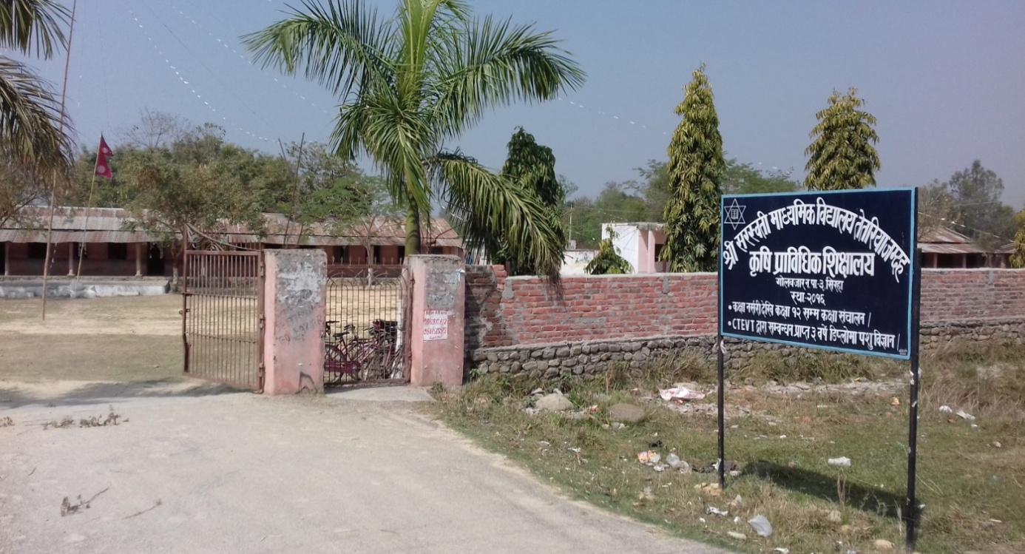
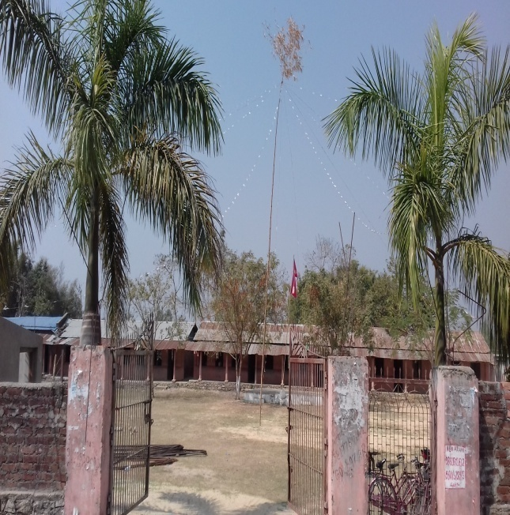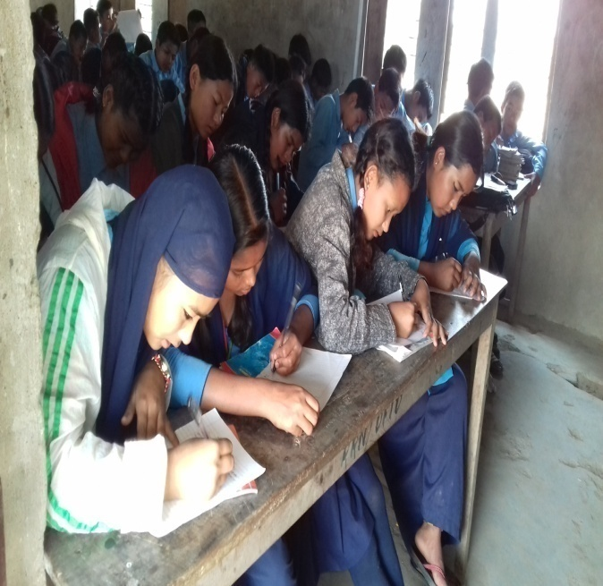

— >L ;/:jtL df= lj= t]t/Lof hDbxsf du/efifL ljBfyL{x? dWo] pTs[i6 /rgf .

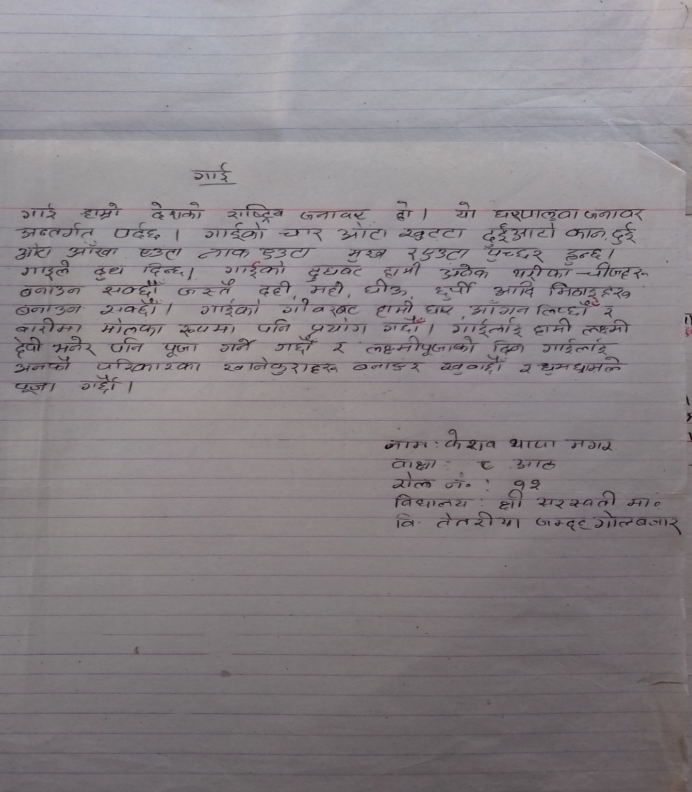

-v_ >L hgtf df= lj= uf]njhf/sf ljBfno / ;xefuL du/efifL ljBfyL{x? .

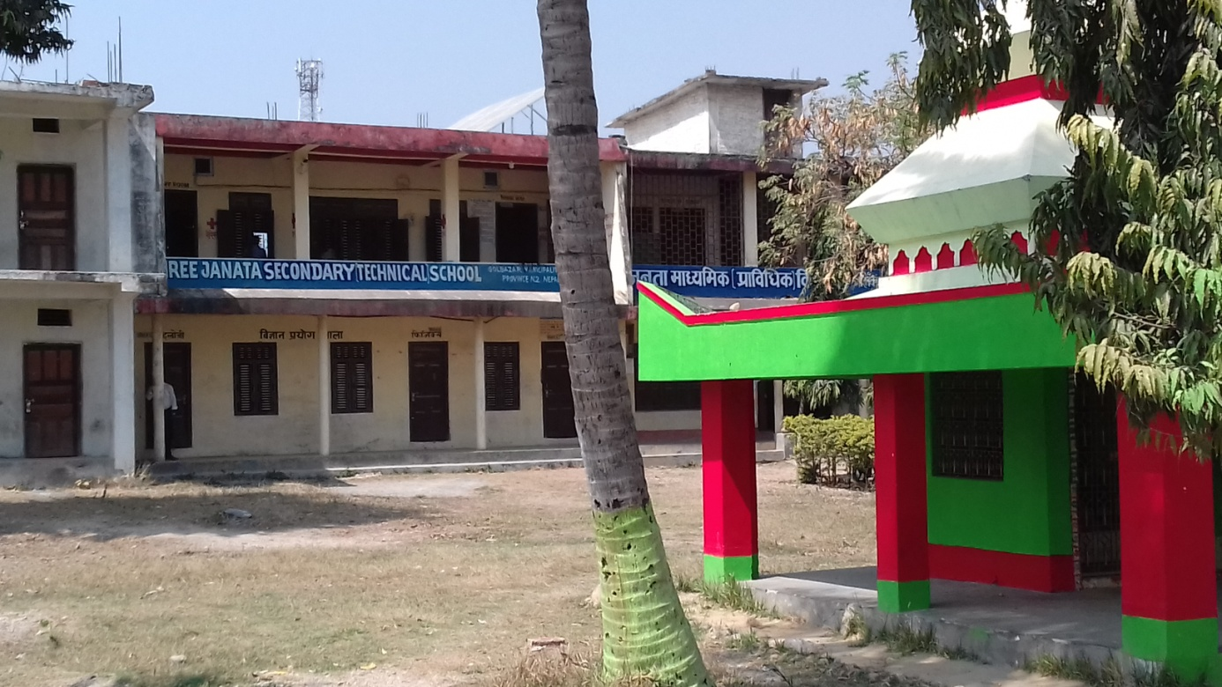
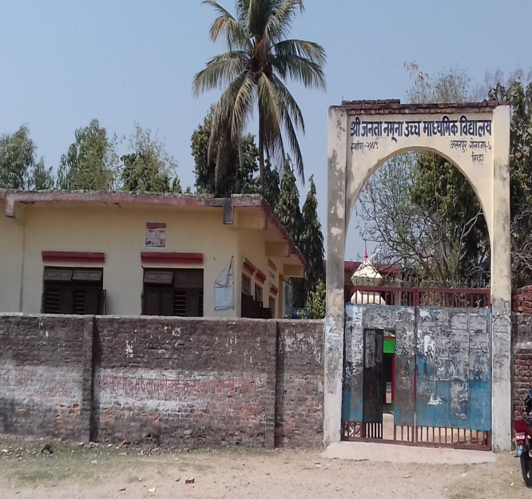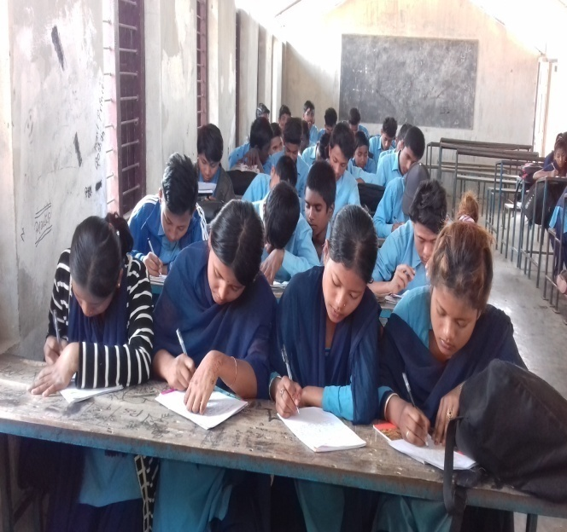

-u_ >L hgtf df= lj= rGb|f]bok'sf ljBfno / ;xefuL du/efifL ljBfyL{x? .

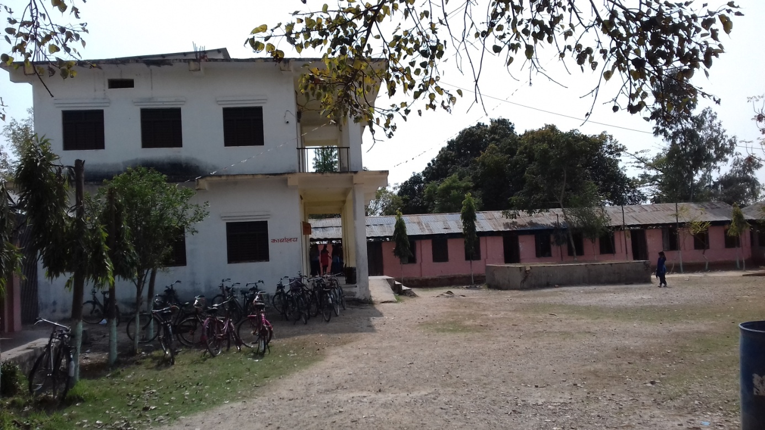
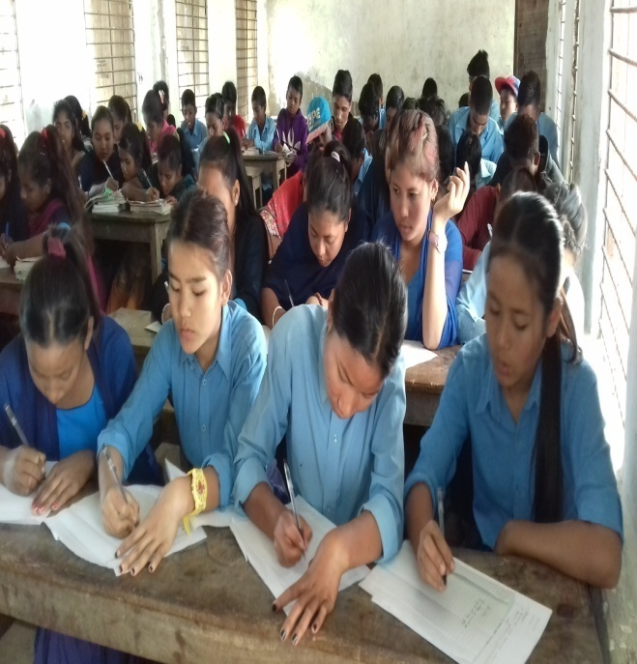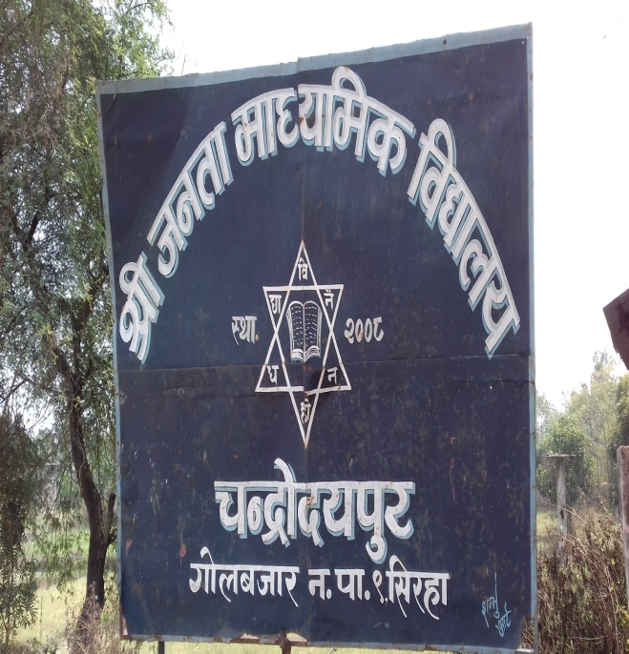

— >L hgtf df= lj= rGb|f]bok'/sf ;xefuL du/efifL ljBfyL{x? dWo] pTs[i6 /rgf .

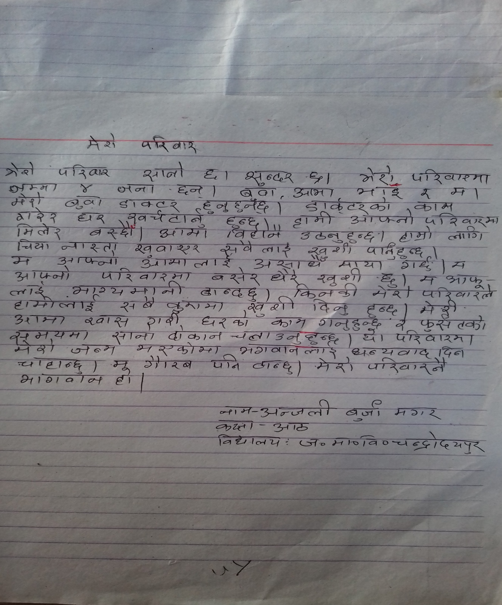

-3_ >L hgtf cfwf/e"t lj= nfnk'/ 6f]8s]sf ljBfno / ;xefuL du/efiffL ljBfyL{x? .

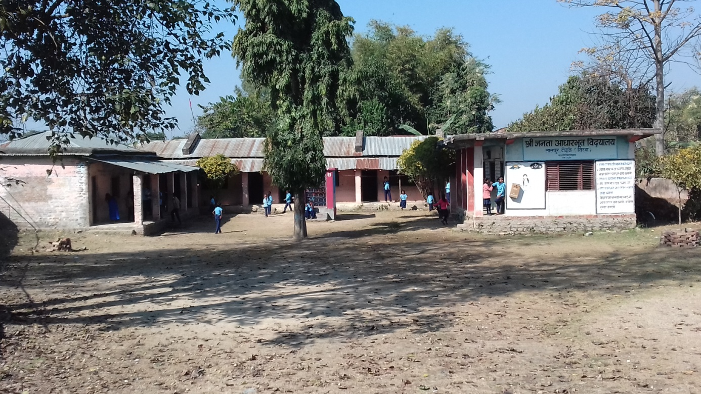

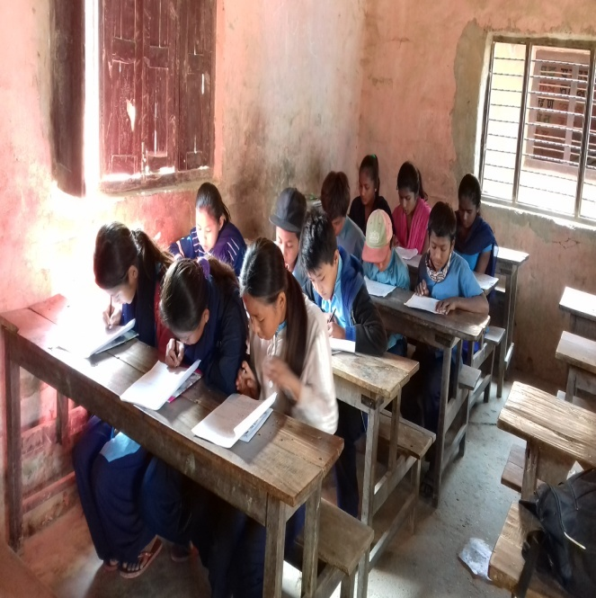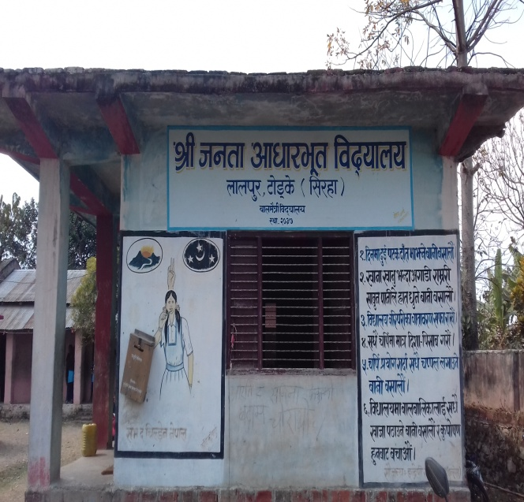

— >L cfwf/e"t ljBfno nfnk'/ 6f]8s]sf du/efifL ljBfyL{x? dWo pTs[i6 /rgf .

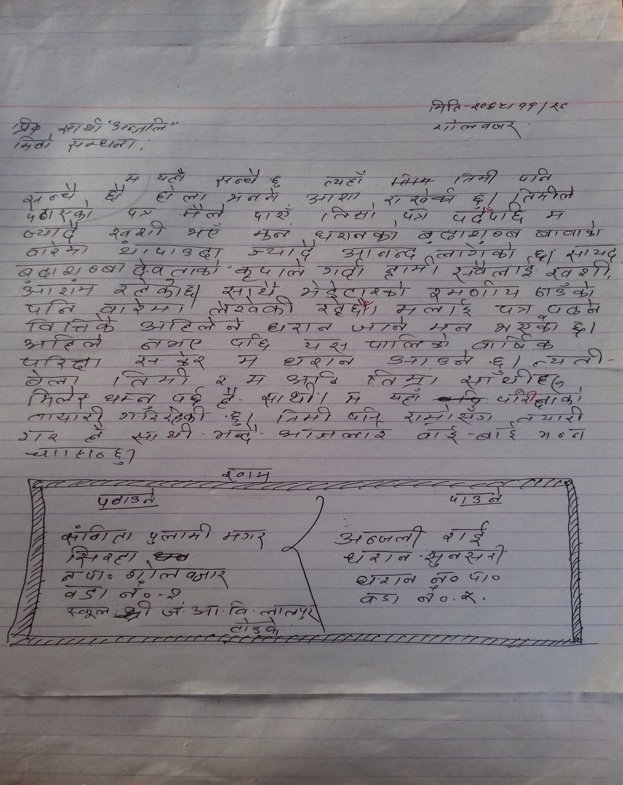

-ª_ >L cfwf/e"t ljBfno u'?wfdsf ljBfno / ;xefuL du/efifL ljBfyL{x? .

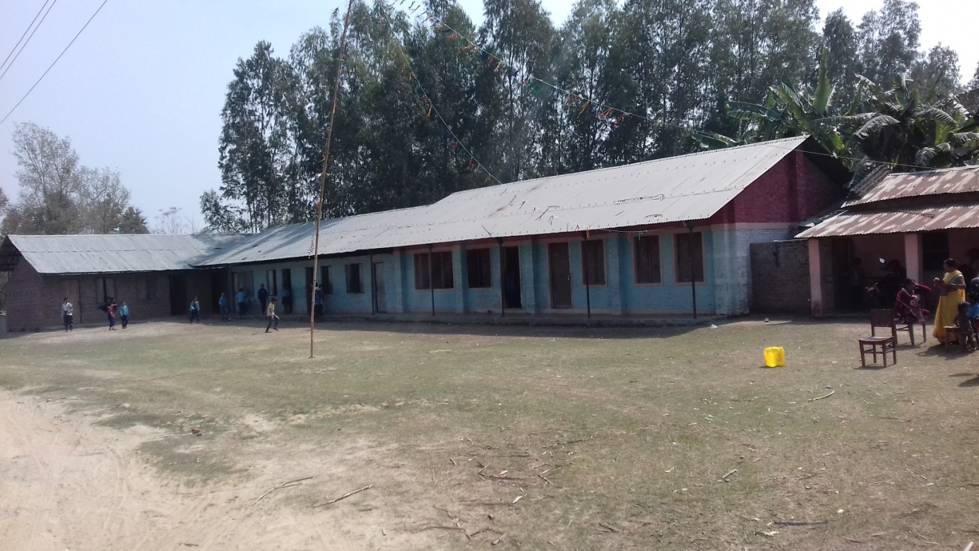

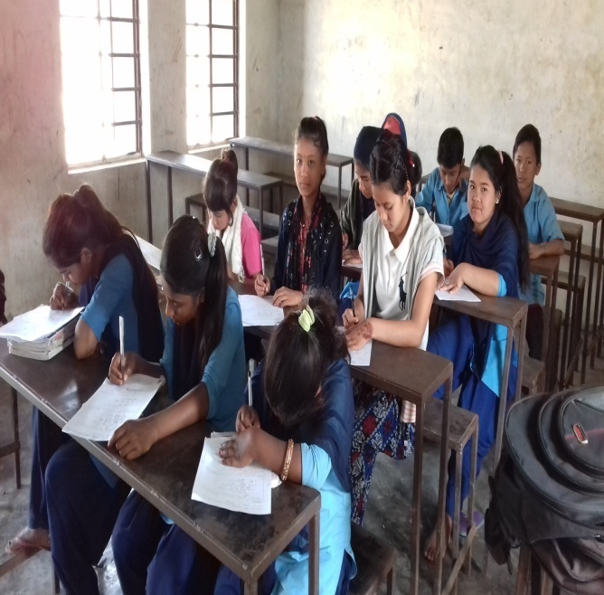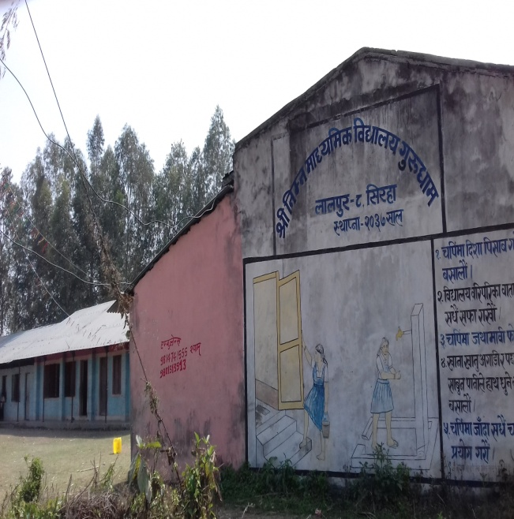

— >L cfwf/e"t ljBfno u'wfdsf du/efifL ljBfyL{x? dWo] pTs[i6 /rgf .

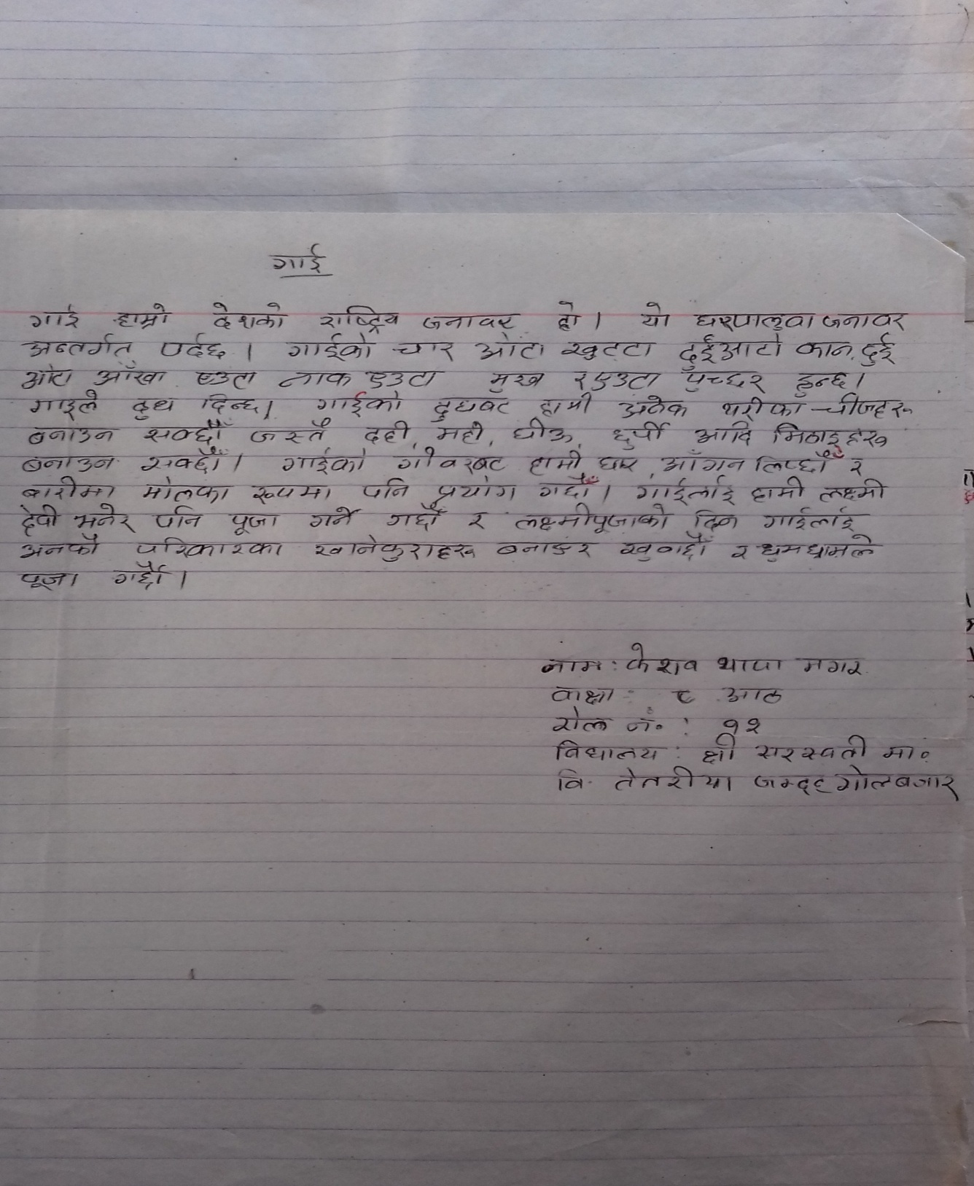

kl/lzi6 – Ps
;fdu|L ;ª\sngsf qmddf pkof]u ul/Psf ljifout / :jtGq n]vg k|Zgx?

gfd M
ljBfnoM

ljifout k|Zgx? M
!= lnª\u
pbfx/0f x]/L tnsf jfSox?nfO{ k'lnª\u eP :qLlnª\ / :qLlnª\u eP k'lnª\udf kl/jt{g ug{'xf]; .
h:t}, dfdf jhf/ hg'x'G5 .
dfO{h" jhf/ hfg'x'G5 .
-s_ sfsf vtdf sfd ug'{x'G5 .
================================================== .
-v_ efO km6jn v]N5 .
================================================== .
-u_ ;Ltf ljBfno hfG5] .
================================================== .

@= jrg
pbfx/0fdf b]vfP h:t} tnsf jfSox?nfO{ Psjrg eP jx'jrg / jx'jrg eP Psjrgdf kl/jt{g ug'{xf]; .
h:t}, r/f ?vaf6 p8\of] .
r/fx? ?vaf6 p8] .
-s_ d g]kfnL jf]N5' .
=================================================== .
-v_ 5f]/f] ljBfno uof] .
=================================================== .
-u_ pgLx? g]kfnL x'g\ .
=================================================== .
#= k'?if
pbfx/0fdf lbP h:t} sf]i7s ;ª\s]tsf] cfwf/df jfSox?nf]O{ kl/jt{g ug'{xf]; .
h:t}, pm ljBfno hfG5 .
ltdL ljBfno hfG5f} .
-s_ d efOnfO{ k9fpF5' . - låtLo k'?if _
================================================== .
-v_ xfdL jhf/ hfG5f}F . - t[tLo k'?if _
================================================== .
-u_ pgLx? l;g]df x]g{ hfG5g\ . - k|yd k'?if _
=================================================== .

$= sfn
tn lbOPsf jfSox?nfO{ sf]i7s ;ª\s]tsf] cfwf/df jfSox? kl/jt{g ug{xf]; .
-s_ xfdLn] k"hf u¥of}F . - ;fdfGo jt{dfg _
================================================= .
-v_ d :s"n hfg]5' . - ;fdfGo e"tsfn _
================================================== .
-u_ ch'{g v]Nb} 5 . - ;fdfGo elj:osfn _
================================================== .
-3_ d}n] eft vfPF . - k"0f{ jt{dfg _
================================================== .

%= cfb/fyL{
tn lbOPsf jfSox?nfO{ sf]i7s ;ª\s]tsf cfwf/df jfSox? kl/jt{g ug'xf]; .
-s_ pgL ljBfno hfG5 . - cgfb/ _
=================================================== .
-v_ ltdL ljBfnodf k9fpF5f} . - cgfb/ _
=================================================== .
-u_ tF km'6jn v]N5;\ . - dWod cfbf/ _
========================================================= .
^= j0f{ ljGof;
-c_ kbof]u / kbljof]u
pbfx/0fdf b]vfP h:t} tn lbOPsf jfSox?nfO{ kbof]u jf kbljof]u agfpgF' xf]; .
-s_ Zofd nfO{ Ö ==============================================
-v_ /fd sf] nflu Ö ==============================================
-u_ /fh b/jf/ Ö ===============================================
-3_ 3/sf]cufl8 Ö ================================================
-ª_ 3/sf]dflns Ö ================================================

-cf_ lz/ljGb' / rGb|ljGb'
sf]i7sdf lbOPsf pko'Qm zAbx? 5gf}6 u/L jfSo k'/f ug'xf]; .
-s_ xfdLx? ljBfno hfb} ==================== . - lyof], lyof}, lyof}F _
-v_ s[i0fsf] dfdf =================== lyof] . - s+z, sFz _
-u_ d jhf/ ======================= -uP, uPF , uof] _

-O_ o / P
sf]i7sdf lbOPsf ;xL zAbx? 5gf}6 u/L jfSo k'/f ug'{xf]; .
-s_ /fdn] ================ lstfj lsGof] . - op6f, Pp6f _
-v_ d}n] vfgf ======================= .

-O{_ a / j
sf]i7sdf lbOPsf ;xL sAbx? 5gf}6 u/L jfSox? k'/f ug'{xf]; .
-s_ d ====================== n]V5' . - lgjGw, lgaGw _
-v_ xl/of] =================== g]kfnsf] wg . - ag, jg _
-u_ xfdL ===================== hfG5f}F . - ljBfno, laBfno _
-3_ /fdsf] ==================== Zofd;Fu . -;DjGw, ;DaGw _

-p_ z, if, ;
sf]i7sdf lbOPsf pko'Qm zAbx? 5gf}6 u/L tn lbOPsf jfSox? k'/f ug'{xf]; .
-s_ Zofd j8f sfof{nosf ================= x'g\ . - zlrj, ;lrj _
-v_ sfof{nox? ========================== aGb x'G5 . - zlgaf/, ;lgaf/ _
-u_ 8fS6/sf] ;Nnfxf cg';f/ ================= k|of]u u/ . - cf};lw, cf}iflw _

-pm_ x«:j / bL3{
sf]i7sdf lbOPsf pko'Qm zAbx? 5gf}6 u/L tn lbOPsf jfSox? k'/f ug'xf]; .
-s_ lbbL / =================== ljb]z hfg' eof] . - legfh" , legfh' _
-v_ piff /fdsL ===================== x'g . - alxgL , alxlg _
-u_ Zofd w]/} ===================== s]6f] xf] . - bofn' , bofn" _
-3_ /fd lzIff tyf :j:Yo ================ x'g\ . - dlGq, dGqL _

:jtGq n]vg k|Zgx? - s'g} Pp6f dfq _
!= jflif{s k/LIffsf] k"j{ tof/L] jf/]df w/fg j:g] ;fyLnfO{ Pp6f lr7L n]Vg'xf]; .
@= s'g} Ps ljifodf !)) zAb ga9fO lgaGw n]Vg'xf]; .
-s_ ljBfno
-v_ ufO{

kl/lzi6 – b'O{
zf]w cWoog ul/Psf ljBfnox?

!= >L ;/:jtL dfWolds ljBfno t]t/Lof hDbx .
@= >L hgtf dfWolds ljBfno uf]njhf/ .
#= >L hgtf dfWolds ljBfno rGb|f]bok'/ .
$= >L hgtf cfwf/e"t ljBfno nfnk'/ 6f]8s] .
%= >L cfwf/e"t ljBfno u'?wfd .

