
TRIBHUVAN UNIVERSITY
INSTITUTE OF ENGINEERING
DEPARTMENT OF ARCHITECTURE
PULCHOWK CAMPUS, PULCHOWK

ECO-RESORT

SUBMITTED BY

KISHOR CHAUDHARY
(073-BAE-218)

A THESIS SUBMITTED TO
THE DEPARTMENT OF ARCHITECTURE
IN PARTIAL FULFILLMENT OF THE REQUIREMENT FOR THE
DEGREE OF BACHELOR OF ARCHITECTURE

DEPARTMENT OF ARCHITECTURE
PULCHOWK. LALITPUR, NEPAL

MAY 2023

CERTIFICATE

This is to certify that this thesis entitled – “Eco-resort” submitted by Mr. Kishor Chaudhary (073/BAE/218) has been examined and it has been declared successful for the partial fulfillment of the academic requirement towards the completion of the degree of Bachelor of Architecture.

_______________________
Prof. Ramlaxmi Tamrakar
(Thesis Supervisor)
Date: ___________________
Tribhuvan University
Department of Architecture
Institute of Engineering
Pulchowk Campus

DECLARATION

I declare that this dissertation has not been previously accepted in substance for any degree and is not being concurrently submitted in candidature for any degree. I state that this dissertation is the result of my own independent work/investigation, except where otherwise stated. I hereby give consent for my dissertation, if accepted, to be available for photocopying and understand that any reference to or quotation from my thesis will receive an acknowledgment.

___________________
Mr. Kishor Chaudhary (073/BAE/218)
Date:2023/05/25

ACKNOWLEDGEMENT

This is the thesis project in Bachelors of Architecture, which was very exciting. It has given be a pride to acknowledge each people who have directly or indirectly helped me in the completion of my Thesis Project “Eco-Resort” at Kanchnapur.
Department of Architecture, Pulchowk Campus, Lalitpur has made it possible for me to complete this thesis work and thereby graduate as an architect. so I am grateful to department and all the staffs and teachers of the department.
I wish to express my sincere gratitude to my thesis supervisor Assistant Prof. Ramlaxmi Tamrakar for his invaluable suggestions, guidance and kind co-operation during the preparation of this dissertation.
I express my profound feeling of appreciation to our regarded and learned aides for their profitable help and direction. I am grateful for the consolation they have given us in finishing the undertaking. I am additionally appreciative to regarded Ass. Prof. Dr. Sanjay Uprety (HOD, Department of Architecture) for allowing us to use all the important offices of the organization. I am likewise grateful to the various workforce and staff individuals from our specialization for their co-activity and help.
Finally, I want to express our profound thankfulness towards our cohorts and our obligation to our folks for giving us the ethical help and support. I would like to express my appreciation to everyone who have lent their help directly or indirectly during this project.

Kishor Chaudhary
073-BAE-218
Department of Architecture
Pulchowk Campus, Pulchowk
TABLE OF CONTENTS

1. INTRODUCTION 8
1.1 BACKGROUND 8
1.2 TOURISM AND RESORTS IN THE CONTEXT OF NEPAL 9
1.3 PROBLEM STATEMENT 16
1.4 OBJECTIVES 17
1.5 JUSTIFICATION 17
1.6 LIMITS 18
1.7 METHODOLGY 19
1.7.1 LITERATURE REVIEW 19
1.7.2 CASE STUDIES 19
1.7.3 SELF EVALUATION AND ANALYSIS 19
1.7.4 PROGRAM FORLULATION 20
1.7.5 PRELIMINARY DESIGN/CONCEPT 20
1.7.6 DESIGN FINALIZATION 20
2. LITERATURE REVIEW 21
2.1 INTRODUCTION TO RESORT 21
2.2 PLANNING IN RESORT 22
2.3 RESORT SCENARIO IN NEPAL 23
2.4 TOURISM IN NEPAL 27
2.5 HISTORY OF RESORT 29
2.6 RESORT SCENARIO IN NEPAL 30
2.7 COMPONENTS OF A RESORT 31
2.7.1 ACCESSIBILITY AND CIRCULATION 31
2.7.2 PUBLIC SPACE DESIGN 33
2.7.3 GUEST ROOM UNIT 34
2.7.4 KITCHEN, RESTAURANT, DINING AND BAR 38
2.7.5 EMPLOYMENT FACILITIES 41
2.7.6 LAUNDRY AND HOUSEKEEPING 41
2.7.7 TECHNICAL AREAS 41
2.7.8 CONFERENCE AND SEMINAR 42
2.7.9 RECREATIONAL FACILITIES 42
2.7.10 DESIGN CONSIDERATION IN RESORT 51
2.8 INTERNAL ENVIRONMENT 52
2.9 ENVIRONMENTAL REQUIREMENT 53
2.10 SAFETY AND SECURITY 54
2.11 PARKING FACILITIES 55
2.12 IMPORTANT FACTORS IN PLANNING OF THE RESORT 56
2.13 BYE LAWS 57
2.14 NEPAL TOURISM BOARD GUIDELINE FOR RESORT PLANNING 57
2.15 FACILITIES REQUIRED FOR A 5 STAR HOTEL/RESORT 57
2.16 FIRE SAFETY CONSIDERATIONS 60
3. ENERGY SUFFICIENT AND SUSTAINABLE APPROACHES IN BUILDINGS 62
3.1. INTRODUCTION 62
3.2. ENERGY CONSUMPTION 63
3.3. ENERGY CONSUMPTION IN A TYPICAL BUILDING(HOTEL/RESORT) 65
3.4. NEED OF SUSTAINABLE BUILDINGS- INTRODUCTION OF GREEN ARCHITECTURE 65
3.5. MAJOR ISSUES OF GREEN DESIGN 66
3.6. TYPICAL GREEN BUILDING GUIDELINES 67
3.7. ELEMENTS OF GREEN SUSTAINABLE DESIGN GUIDELINES 68
3.3.1 FORM COMPOSITION AND ORIENTATION 69
3.3.2 PASSIVE SOLAR DESIGN 70
A. Day Lighting 71
B. Passive cooling 71
D. Microclimates 72
E. Passive heating 72
4. CASE STUDY 77
A. DHULIKHEL MOUNTAIN RESORT 77
B. GODAVARI VILLAGE RESORT 82
C. LAVA HOMES 89
5. ADDITIONAL LITERATURE 94
5.1. LIBRARY 94
5.2. DINING AND KITCHEN 95
5.3. BEDROOMS 96
5.4. BATHROOM 98
5.5. PARKING 99
• Turning and parking 99
5.6. UNIVERSAL DESIGN 102
• Type of Disabilities 103
• RECOMENDATIONS: 104
• RANGE OF REACH: 104
5.7. Building Bye Laws and Policies 105
• National Urban Policy, 2007 105
• Building Bye laws for Housing and Apartment 105
5.8. Climate-responsive design in Vernacular Houses of Terai 106
• Settlement pattern 106
• Building form and orientation 107
• Building stories and internal space arrangement 107
• Walls 107
• Roof 107
• Foundation, floor and ceiling 108
• Openings 108
• Conclusion 108
5.9. Passive Design 108
• What Is A Passive House? 109
• What Are The Benefits of A Passive House? 109
5.10. ORIGIN OF THARU 111
5.11. THARU VILLAGE 111
5.12. THARU HOUSE 112
Ghari (cattle shed) 113
• Bahari (entrance hall) 113
• Dwelling area 113
5.13. THARU HOUSE BUILT ENVIRONMENT AND ITS SURROUNDING 114
5.14. TOOLS AND EQUIPMENTS 115
• Agricultural implements and iron tools: 115
Fishing tools and goods: 115
Household goods and equipments: 116
• Musical instruments: 116
• Dress and ornaments: 117
5.15. FESTIVALS 117
5.16. CONSTRUCTION TECHNOLOGY 118
• Working of Bamboo 118
Bamboo building system 118
6 SITE STUDY AND ANALYSIS 125
1. INTRODCUTION 125
2. Physical Dimension 126
a. Architecture 126
b. Road 127
c. Electricity 127
d. Forest 128
e. Communication 128
f. Drainage 129
g. Water Supply 129
h. Sewer Lines 129
i. Topography 129
3. Environmental 129
a. Grazing Land 129
b. Irrigation 129
4. Climatology analysis 130
a. Temperature 130
b. Sun Hours 131
c. Rainfall 131
• Wind 131
d. Site Analysis 132
5. SWOT Analysis 134
134
6. Site location 135
7. CONCEPT AND DESIGN DEVELOPMENT 136
7.1 INITIATION 136
7.2 IDENTIFICATION OF ISSUES 136
7.3 INFLUENCE OF SITE AND SURROUNDING 137
7.4 DESIGN APPROACH 137
SITE DESIGN 137
7.5 MASTER PLAN AND DESIGN APPROACH 137
7.6 ELEMENTS OF GREEN DESIGN 139
7.7 DIFFERENT RESORT UNITS 141
7.8 BUILDING SERVICES 143
8 CONCLUSION 147
9 BIBLIOGRAPHY 148

TABLE OF FIGURES
Figure 1: Methodology Chart 20
Figure 2: Tourist arrival in Nepal 2010- 2019 24
Figure 3: Tourist purpose of visit 2019 26
Figure 4: Ramp ratio 32
Figure 5: Nawwor Hotel 36
Figure 6: Double bedroom 36
Figure 7: Bathroom arrangement 36
Figure 8: Parallel tables 38
Figure 9: Minimal seating 39
Figure 10: Regular seating 39
Figure 11: production in line 40
Figure 12: Cafeteria, meal servey area requirement 40
Figure 13: Space distribution in kitchen 40
Figure 14: Section of an infinity pool 44
Figure 15: Sauna with jacuzzi 48
Figure 16: Exercising machines 49
Figure 17: Layout for meditation hall 50
Figure 18: Dimensions of vehicles 55
Figure 19: Turning radius 55
Figure 20: Residential 65
Figure 21: Hotel/Resort 65
Figure 22: Solar path in building 69
Figure 23: Dimension of Open Access Shelf 95
Figure 24: Glare and veiling reflection 95
Figure 25: Seating space requirements 95
Figure 26: size of place sitting 96
Figure 27: Leaving the table 96
Figure 28: Passage behind chairs 96
Figure 29: Sapce flow in Dining hall: 96
Figure 30: Primary bedroom 97
Figure 31: Primary bedroom 97
Figure 32: Primary bedroom without crib 97
Figure 33: Double occupancy bedroom 97
Figure 34: Elevation space requirements 98
Figure 35: Plan of a bathroom 98
Figure 36: Dimensionss of Vehicles 99
Figure 37: Turning radius of car 100
Figure 38: Turning radius of different vehicles 100
Figure 39: Various parking layouts 101
Figure 40: Disabilities 103
Figure 41: Typical wheel chair 104
Figure 42: Tharu House 112
Figure 43: Built-in environment of Tharu House 114
Figure 44: Pharhwa 115
Figure 45: Fishing instrument 116
Figure 46: Dhehri 116
Figure 47: Bhauka 116
Figure 48: Madal 116
Figure 49: Manjira 116
Figure 50: Rattan connection 120
Figure 51: Connection with bamboo strips 120
Figure 52: Rattan connection through dril holes 120
Figure 53: Bamboo mortise and tenon connection 120
Figure 54: Spacetruss with centre steel box element 121
Figure 55: Wood core connection systems 121
Figure 56: Fixing detail of bamboo post into plinth masonry 122
Figure 57: Filling the gaps with sand 122
Figure 59: Foundation with brick pedestal 123
Figure 58: Plinth with brick pedestal 123
Figure 60: Composite bamboo/concrete column 123
Figure 61: Location map of Mahendranagar 130
Figure 62: Avg. Temp. Graph of Kanchanpur 130
Figure 63: Sun Hours of Kanchanpur 131
Figure 64: Avg. Rainfall. Graph of Kanchanpur 131
Figure 65: Wind rose diagram of Kanchanpur 132
Figure 66: Table of Avg. temp, rainfall, humidity 133

INTRODUCTION

BACKGROUND
Nepal comprises only 0.1% of the land area in a global scale but is endowed with disproportionately rich diversity of flora and fauna; heart seizing scenic beauty; diverse culture; ethnic etiquettes. Nepal’s diverse and magnificent environment along with the country’s hospitable and pleasant people has made her one of the major tourist destinations
and variation in culture, tradition, built forms, and socio-economic pattern is a uniqueness of Nepal. One can experience scorching heat to freezing cold within 4-5 day trek, with a great natural and cultural variance, which is almost hard to get anywhere in any other part of the world as the climate here varies from Tropical to Arctic.

Globalization has narrowed the boundaries between countries and people’s curiosity is dragging them here and there creating new from of social language, Tourism. Touring is a historic concept but it has not been half a century, it developed as industry and gained its pace to highly advanced state. Now, if we stare on present trend, tourism has been an essential part of local as well national economy. Countries like Switzerland, Thailand, Maldives, China, South Africa etc well known for tourism industry whose national economy rely in it. Dubai has forecasted 2030 A.D ⁽¹⁾to be the time when its all oil resources exhaust. Thus, it has planned to make it world’s prominent tourist destination by 2015 and creating architectural oasis with tones and tones of money on constructing marvelous, iconic buildings like Burz Dubai, Burz- al-Arab, Palm Island so that people all around fly there to enjoy the charm of modern architecture. Thailand is well known for mall tourism, where foreigner goes for shopping, tourist goes Switzerland for ski, Africa for wild safari and so on.

Nepal has also huge potential in this sector, as tourism is one of the major sources of foreign exchange earner for the country and accounts for more than 17.11 % of the total GDP. The potential Culture and Nature tourism, which needs no extra infrastructural investment like in sports tourism and the trend of tourism in Nepal is also what I have mentioned here.

There are two forms of economic growth caused by tourism, one is local which is due to internal tourism, and other is national due to international tourism. The current trend of internal tourism is so charming that few places like, Malekhu in Dhading, Ghale Gaun in Lamjung, Chisapani in Kathmandu are blooming due to internal tourism. But, at the same time if there is a point to upgrade the national economy, it has to be focused on international tourism where people around the world travel miles and spent thousands of dollars to feel the scenic and cultural beauty abroad.

Planner and economist have realized that economy of Nepal can be flourished through tourism and with this fact, we are celebrating tourism year targeting to receive 1 million tourists by the end of 2011. The number is high in terms of accommodation that is available in current situation, hence, it can be understood that to meet this target in 2011 or some years later, it is very necessary to create sufficient space with proper facilities. There are very less number of resorts as compared to hotels and lodges and so, resort tourism is not so flourished in Nepal. Resort can provide versatile functions and amenities and we are not being able to have masterpiece resort to advocate all the demands, though some attempts made so far are insufficient.

TOURISM AND RESORTS IN THE CONTEXT OF NEPAL
The development of hotel and resort started along with the inflow of international tourists in our country. According to World Tourism Organization, tourist are the people who travel to and stay in places outside their usual environment for not more than one Consecutive year for leisure, business, recreation and other. Tourists Visit Nepal mainly for three purposes.

Entertainment: Most of the tourists come here for spending their leisure time to enjoy with the nature and relief from their casual daily work. Nepal itself has the natural scenario along with the diversity of cultures, traditions, languages and so on that is enough for the attraction to the tourists.

Business: Tourist visiting for official or business work and sometimes may extend their visit to see some places.

Religious Purpose: Tourist from neighbouring country like India and China visits mostly for religious purposes for annually, twice or thrice a year for the spiritual and self-satisfaction.

Other Purposes: some times, students have to go in the foreign countries for the exhibitions, competitions, and so on.

Major tourist come for pleasure, thus, resort could be a best possible arena to provide pleasing facilities and space for them. According to Nepal's Ministry of Tourism, major tourist activities include wilderness and adventure activities such as mountain biking, bungee jumping, rock climbing and mountain climbing, trekking, bird watching, flights, paragliding and hot air ballooning over the mountains of Himalaya, exploring the waterways by raft, kayak or canoe and jungle safaris especially in the Terai region.
In the past, tourism was pursued with only shortsighted goals in mind. Tourism today needs to focus on long-term growth and prosperity, balancing economics with people, culture and the environment all with the assistance of governments. Meanwhile during this process, various problems may occur along with pace of time. At the time when global warming is gradually affecting the climatic order, countries like Nepal need to take an additional care. Slogan for the Tourism Year 2013 reminds us as to how countries like Nepal need to preserve water, along with promoting tourism. Conservation of water is essential for the survival of culture, life and ecology and natural beauty of the Himalayas.

Nepal Tourism Policy 2009 identifies tourism sector as an important vehicle for economic and social development. Following directions set by the policy effort has been put for development and expansion of tourism activities, quality improvement of tourism services, increasing revenue and expansion of employment opportunities to improve the living standard of Nepalese people.

Vision 2020 of tourism envisions increasing tourist arrival to two million and tourism related employment to one million. Trend of tourist arrival was in increased order up to 2012 which declined thereafter. Year 2016 seems remarkable improvement in tourist arrivals. Tourist arrivals increased by 40 percent compared to 2015.

Out of total tourist arrivals, excluding Indian citizens arrived through land transportations; five countries occupy more than 50 percent. The proportion of tourists from these countries are: India (16%), China (14%), Sri Lanka (8%), USA (7%), and United Kingdom (6%). Higher number of arrival is observed in October following general trend but sharply declined in June contradicting to the past. By sex male (53%) and by age category 31-45 (30%) are following pas trend of higher share.

FACT SHEET 1

Indicators | 2019 | 2020 | % Change
Tourist Arrivals by:
Air | 995884 | 183130 | -81.6
Land | 201307 | 46955 | -76.7
Total | 1197191 | 230085 | -80.8
Average Length of Stay | 12.7 | 15.1 | 18.9
Sex:
Male | 626866 | 124048
Female | 570325 | 106037
By Age groups:
0-15 years | 57523 | 9768
16-30 years | 254399 | 43403
31-45 years | 383155 | 67829
46-60 years | 305651 | 61874
60⁺ years | 176872 | 47211
Not Specified | 19591 | 0
Top Five Country of Nationality:
Rank 1 | India | India
Rank 2 | China | Myanmar
Rank 3 | USA | Thailand
Rank 4 | United Kingdom | China
Rank 5 | Srilanka | USA
Purpose of Visit:
Holiday/Pleasure | 778173 | 139202 | -82.1
Pilgrimage | 197786 | 28530 | -85.6
Trekking & Mountaineering | 171937 | 35893 | -79.1
Others | 49301 | 26460 | -46.3

NEPAL TOURISM STATISTICS 2020

FACT SHEET 2

Indicators | 2019 | 2020 | % Change
Tourist Arrivals by Major Five Airlines:
Rank 1 | Nepal Airlines | Nepal Airlines
Rank 2 | Qatar Airways | Qatar Airways
Rank 3 | Fly Dubai | Himalaya Airlines
Rank 4 | Air India | Fly Dubai
Rank 5 | Air Arabia | Air Arabia
Mountaineering Expedition:
Total Team | 1921 | 153 | -92.0
Total Person | 8202 | 447 | -94.6
Royalty to Government (Rs.' 000) | 568269 | 149790 | -73.6
Revenue from Tourism:
Total Earning(US$ ' 000) | 724337 | 217007 | -70.0
Average expenses  per Visitor per day ( US$) | 48 | 65 | 35.4
Tourism Related Enterprises :
Hotel (star) | 138 | 142 | 2.9
Hotel ( Non star) | 1151 | 1171 | 1.7
Beds (total) | 43999 | 45850 | 4.2
Travel Agencies | 3680 | 3743 | 1.7
Trekking Agencies | 2764 | 2797 | 1.2
Tourist Guide | 4200 | 4241 | 1.0
Trekking Guide | 17625 | 17766 | 0.8
NEPAL TOURISM STATISTICS 2020

FACT SHEET 3

 | 2019 | 2020 | % Change
Places Visited:
National Parks and Wildlife Reserve | 429764 | NA
Pashupati Area(excluding Indian) | 171937 | 25400 | -85.2
Lumbini (excluding Indian Tourists) | 173083 | 45469 | -73.7
Manaslu Trekking | 6070 | 360 | -94.1
Mustang Trekking | 3739 | 62 | -98.3
HumlaTrekking | 8670 | 22 | -99.7
Lower Dolpa Trekking | 1360 | 12 | -99.1
Kanchanjunga Trekking | 911 | 55 | -94.0
Upper Dolpa Trekking | 530 | 1 | -99.8
International Airlines Movement:
Arrival | 16212 | 5135 | -68.3
Departure | 16213 | 5121 | -68.4
Total | 32425 | 10256 | -68.4
NEPAL TOURISM STATISCICS 2020

TOURIST ARRIVALS BY COUNTRY, 2016-2020

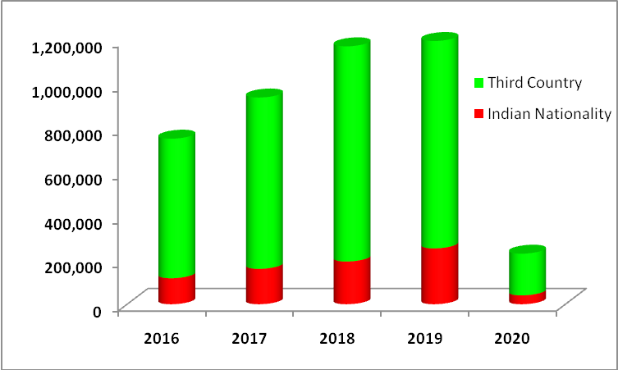

TOURIST ARRIVALS BY SEX, 2011-2020

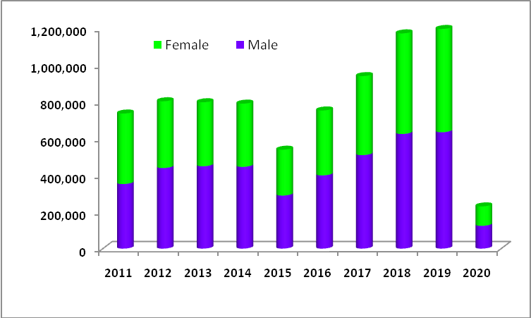

TOURIST ARRIVALS BY AGE GROUP, 2016-2020

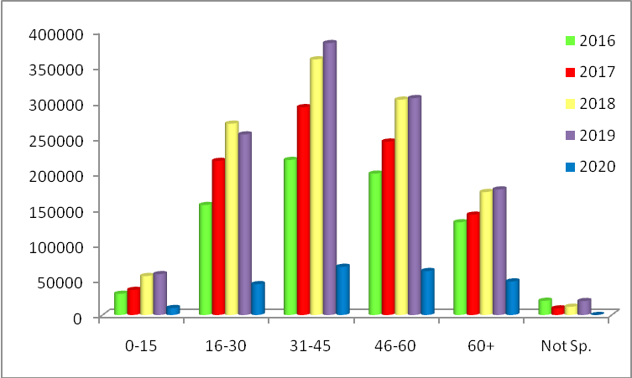

TOURIST ARRIVALS BY MONTH, 2016-2020

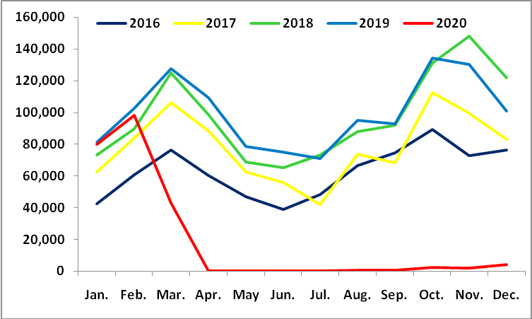

GROSS FOREIGN EXCHANGE EARNINGS FROM TOURISM, FY 2067/68 to 2076/77

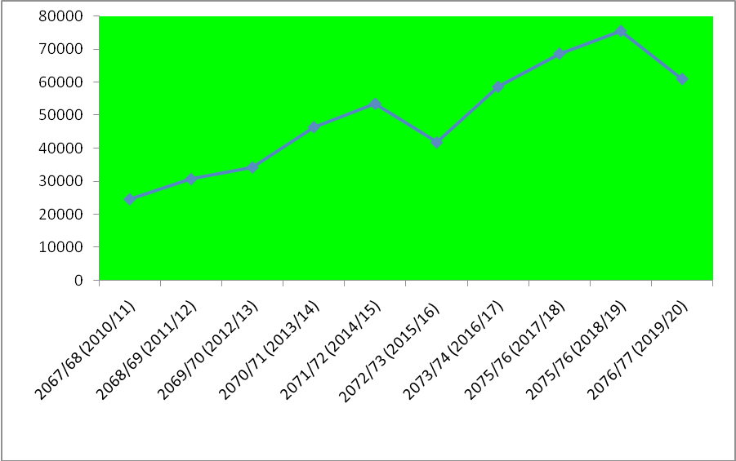

CHART 4.1: TOURIST ARRIVALS BY PURPOSE OF VISIT, 2020

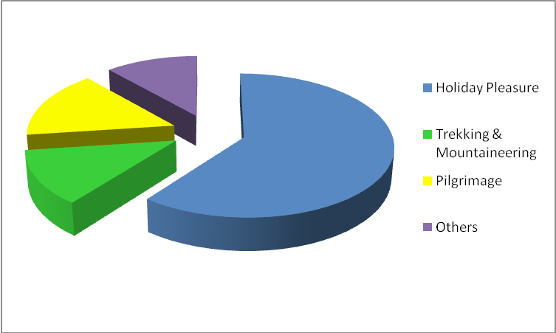
NEPAL TOURISM STATISTICS 2020

PROBLEM STATEMENT
In present context, tourism in Nepal holds a great potential to establish itself as a significant means of economy. This sector has a great potentiality to generate foreign revenue, which can bring about immediate socio-economic benefit from small investments. A well-synchronized and planned resort, which caters the modern amenities as per the requirement of the visitors, is a present need.
Tourism has become one of the biggest industry nowadays and it is gaining more and more importance around the world. From one perspective, in order to get more economical benefits from tourism, people working in this field are not always concerned about the environment they are penetrating and exploitation and excessive use of natural and social resources, especially in developing countries, are common issues.
In far western Nepal, there are few resorts which does not provide each and every facilities and luxury to its customers. Those resorts lack proper services and provide poor room facilities. Customers are not satisfied with the personnel’s attitude, high price with low quality and disappointed with the services.

OBJECTIVES
This research aims in designing a sound, functional, secure and aesthetically pleasing eco-resort. Further. Thus, this study will be guided by the following objectives:
- To provide hospitality for both domestic and foreigner tourists and promote tourism ultimately.
- To respond to climatic and energy consumption issues raised by present day architecture through eco-sensitive design.
- To make analytical study of the functional requirements of resort and implement efficient design to carry out the functions smoothly.
- To design a eco resort incorporating the local architecture style of the area which promotes local and international tourism.
- To provide arena for recreational and relaxation far away from the polluted area in the natural setting.
- To provide diverse facilities and functions to reduce the people's psychological
stress and rejuvenate their lifestyle.
- To provide a space for the official meetings and seminars in well facilitated and quite natural surroundings.
- To help in uplifting economy of neighborhood site and as a whole, GDP of nation.
- To give positive response to globally arising issues like climatic change and energy consumption through appropriate architectural process like eco-sensitive designs

JUSTIFICATION
In present context, tourism in Nepal holds a great potential to establish itself as a significant means of economy. This sector has a great potentiality to generate foreign revenue, which can bring about immediate socio-economic benefit from small investments.
A well-synchronized and planned resort, which caters the modern amenities as per the requirement of the visitors, is a present need. We can find many resorts here and only few of which are fulfilling these needs. In addition, most of the resorts are oriented to limited service focusing only foreigners and paying very little attention to urban haves. The multifunctional resorts are still absent in Nepal and this proposed resort will be one of the iconic resort with all resort facilities which will ultimately promote resort tourism.
The fact that, Nepal is still deficient of required hotel rooms comparing to tourists inflow, it is said that, the present number of hotel can only hold up to half a million visitors in a year. The tourist estimated to visit in tourism year 2011 is far more that the holding capacity of available accommodation. Thus, if we are really upon the promotion of tourism, we may receive more than 1 million visitors a year, if not this year then probably the next, so there is still need of huge numbers of hotels, resorts, lodges, home stays etc.
Viewing the present scenario of the world, the issue of eco-sensitive and sustainable architecture must be raised by the architects and we as a architect can alter the landscape and built form for which we need to understand and be responsible for its far-reaching consequences. The future is hard to predict but some things are certain. There will be rise in urban population in developing economies and an increase in levels of income. This project will pay its attention towards the global energy crisis and climate change though it is a worthless effort to give impact in global scale, but it will certainly create an example and impact locally as there is saying, think locally, impact globally. This proposed resort could be the masterpiece of all resort that are functioning today and will approach to give it global identification.
The most important part is socio-economic impact. The society has changed a lot from traditional to modern and still in the stage of metamorphosis, from modern to post modern and Sanskritization through global interchange has not kept Nepalese society untouched. The economic influence of tourism in Nepal is noteworthy as is has established itself as a prominent foreign exchange earner. Before 1960’s Pokhara was accessible only by foot, but now the economy has boosted and people around the country are being pulled there.. Thus, tourism plays an important to upgrade local as well as national economy so resort proposed is commercially acceptable.
The creation of unique resort in a built form will be the landmark of valley and even of Nepal so that, it becomes place to visit. Resort tourism is well flourished in Maldives, and people go there just dwell around the resort area. Likewise, this proposed resort will be leisure resort with recreational activities, which could provide space for both internal and external tourist.

LIMITS
This study have following limitations:
- It will not focus on social survey, research since this is an academic project, and this does not fall under the primary constraint.

- The project is concerned with the built form so; there will be limited research and study on feasibility of project and detailed site suitability will not be analyzed.

METHODOLGY
For theoretical understanding, the study of literature, library consult and communication with experts will be done. For this, data and information from a number of sources will be collected, analyzed and the ones suitable will be incorporated in the design. The study will be a mixed study following analysis of part qualitative data and part quantitative data.
Following process will be adopted for the completion of the project:

LITERATURE REVIEW
The part will comprise guidelines to be considered while structuring any built forms. In this, essential national and international standards related architectural books of standards will be consulted and applied in the project design. Further, to comprehend the various viewpoints and the value of the project books, articles, project works, documents etc. related to the project will be studied. The literature will also guide the findings in case studies.

CASE STUDIES
In this step, the cases that are built up for the same purpose are studied in order to understand the functions and space requirements. The collection of data is accomplished with the study of various national and international projects.
National case studies
- Gokarna Resort, Gokarna
- Dhulikhel Mountain Resort, Kavre
- Godavari Village Resort, Lilitpur
Regional case study:
- Waghoba Ecolodge Resort, India
International case studies:
- Lava Homes, Portugal

SELF EVALUATION AND ANALYSIS
The findings from literature review and case studies will be compared and analyzed. A framework to guide the design phase shall be generated through elevation and analysis of collected data and philosophy.

PROGRAM FORLULATION
After careful analysis and evaluation, a proper program will be developed. The program will include all the functions and space requirements of the Homestay.

PRELIMINARY DESIGN/CONCEPT
The spaces will be determined and organized carefully in systematic manner. The integration and skillful arrangement of the enclosed space is the preliminary design phase. The spaces will be arranged in single line diagram.

DESIGN FINALIZATION
The design will be finalized and evaluated under the supervisor and backed by the guidelines provided by the literature review and case studies.
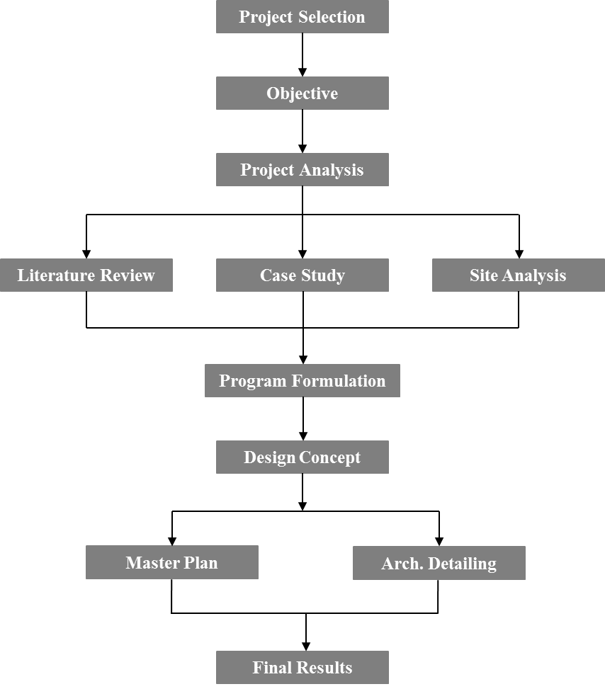

Figure 1: Methodology Chart

LITERATURE REVIEW

INTRODUCTION TO RESORT
“Comfort and convenience, freedom and f fantasy, exclusivity and exoticity are the hallmarks of hospitality sector ."
According to Wikipedia, resort is defined as “a self-contained commercial establishment that tries to provide most of a vacationer’s wants, such as food, drink, swimming, lodging, sports, entertainment, and shopping, on the premises. The term resort may be used for a hotel property that provides an array of amenities, typically including entertainment and recreational activities. Resort is a place where accommodation, reorientation is involved and most important in a place for enjoyment which drives the mind of a visitor with its diversified activities. The resort has a physical as well as physiological impact on the minds of the people. Traffic development and industrialization had led to the urbanization, which has stolen the mental peace of the human created resort to quench his theist for the peace. Resort is one of the few places that offer a break from the strain of hectic life style a completely different world engulf the visitor by taking a walk along the lonely pathways or playing on the lawns and feeling the concept of given under the feet or taking boat ride or plunging into the swimming pool or pending a quite evening and recharging for the week ahead.A resort can function as a conference center, as a meeting center, as a banquette, as a restaurant, as a health club, recreational centre and various functions. A resort could be day and night serving and it provides the cuisine service. It is a place for spending complete holding on a serene and scenic atmosphere away from the maddening crowd of the city and enjoys the beauty of nature in pleasant atmosphere and landscape. There are numerous forms of resort like:
- Sports resort
- Adventure resort
- Nature resort
- Eco resort
- Agro- resort
- Health resort
- Island resort
- Lake resort
- Luxury resort
- Tropical resort
- Mountain resort
- Beach resort

PLANNING IN RESORT
Resorts are basically divided into two parts: front of house and back of house. The front house includes reception area and public rooms or the areas where guests gather to dine or socialize. The back of the house where food is prepared and the guest services amenities are taken care of. There should be no mingling between these two parts for the smooth functioning of a resort. At no times should the guests be aware of services taking place at the back of the house but at the same time the smooth operation of the front of the house is always dependent upon the back of the house.
These two functions thus must be kept separately yet interrelated that both function smoothly, efficiently and economically.
FRONT OF HOUSE
This is the area with direct guest contact and services. Thus 1t should be planned to provide convenience and comfort of the guest. Major component of front of house are.
- Main entrance
- Parking
- Reception
- Lobby
- Cashier
- Guest room
- Dining hall/bars

BACK OF HOUSE

This is the area, which must not be seen by the guests yet is the key factor in the smooth running of the resort. It controls the tasks in the resort and should be efficient.
It is usually located away from the main center of the resort but needs close interaction with other departments.
The major components of the back of house are:
- Laundry
    - House keeping
    - Food and beverage
    - Kitchen
    - Storage
    - Security
    - Maintenance

OUTDOOR/RECREATIONAL AREA
This is more informal area. These areas may include any or all of the following: guest activity, transportation, recreation and sports, casino, spa, parlor, golf course, outdoor recreational facility.

RESORT SCENARIO IN NEPAL
The concept of resorts originated in Nepal with the promotion of the tourism development. Resorts in Nepal have come a long way in a short period. Nepal owes many resorts of different types. Despite the resorts sites of Nepal are not of International lines, they more often cater to specific themes such as Mountain viewing, Wildlife safaris, Village resorts and scenic panoramas. Resort literally means a place whose purpose is to provide visitors recreation and relaxation.
Today, more function has been added to its utility like outdoors sports, conference and exhibitions, a venue for physical fitness, hospitality units such as guest rooms and cottages etc. Most of the resorts are also influenced of nearby ethnic culture and architecture. The price of basic amenities such as food, lodging and services available vary with the range of the local resorts. Resort cannot be built in urban areas, there should be some special feature on the location or on remote area with scenic view, in context of Nepal too has required some specific location. Resort is concerned more in informal activities than formal. The services system in resort should be efficient and sophisticated and the entire area should be planned in aesthetic way. Resorts in Nepal are being popular as a good business enterprise. On one hand, this business is helping in improvement of economy level of the whole country and the people of the same area. And on the hand our traditional culture, skills architectural heritage, and spirit are being conserved, making the people close to the nature. Seeing present need resort should also cater all types of people, national and international tourist and the locals.
Tourist are the people who travel for recreational, leisure or business purpose. According to world tourism organization, tourist are the people who travels to and stay in places outside their usual environment for not more than one consecutive year for leisure, business and other purposes. Nepal has short history of receiving formal tourist and it has not been more than half a century.
Year 2018 and 2019 seems remarkable improvement in tourist arrivals. Tourist arrivals increased by 25 percent in 2018 compared to 2017 and increased by 2.05 percent in 2019 compared to 2018. Out of total tourist arrivals, five countries occupy almost 50 percent. The proportion of tourists from these countries are; India (21.2%), China (14.2%), USA (7.8%), Srilanka (4.7%) and United Kingdom (5.1%) respectively in 2019. Similar seasonality exists in tourist arrivals as in previous year. The highest number of arrivals is observed in November followed by March. There is no major change in sex and age group of tourist arrivals. By sex male (53%) and female (47%) and about highest percentage of arrivals were of age category 31-45 (32%) in year 2019.
Figure 2: Tourist arrival in Nepal 2010- 2019
Source: Department of Immigration, Nepal

Year | total |  | By air |  | By Land |  | average Length of Stay
Year | Number | Growth Rate (%) | Number | Percent | Number | Percent | average Length of Stay
2010 | 602,867 | 18.2 | 448,800 | 74.4 | 154,067 | 25.6 | 12.67
2011 | 736,215 | 22.1 | 545,221 | 74.1 | 190,994 | 25.9 | 13.12
2012 | 803,092 | 9.1 | 598,258 | 74.5 | 204,834 | 25.5 | 12.16
2013 | 797,616 | -0.7 | 594,848 | 74.6 | 202,768 | 25.4 | 12.60
2014 | 790118 | -0.9 | 585981 | 74.2 | 204137 | 25.8 | 12.44
2015 | 538970 | -32 | 407412 | 75.6 | 131558 | 24.4 | 13.16
2016 | 753002 | 40 | 572563 | 76 | 180439 | 24 | 13.4
2017 | 940218 | 25 | 760577 | 81 | 179641 | 19 | 12.6
2018 | 1173072 | 25 | 969287 | 82.63 | 203785 | 17.37 | 12.4
2019 | 1197191 | 2.05 | 995884 | 83.19 | 201307 | 16.81 | 12.7
Table 1: Tourist arrival in Nepal by air and land 2010-2019
Year | Sex |  |  |  | total
Year | Male | % | Female | % | total
2010 | 361,611 | 60.0 | 241,256 | 40.0 | 602,867
2011 | 352,059 | 47.8 | 384,156 | 52.2 | 736,215
2012 | 439,270 | 54.7 | 363,822 | 45.3 | 803,092
2013 | 449,058 | 56.3 | 348,558 | 43.7 | 797,616
2014 | 445,627 | 56.4 | 344,491 | 43.6 | 790,118
2015 | 289,158 | 53.7 | 249,813 | 46.4 | 538,970
2016 | 399,091 | 53.0 | 353,911 | 47.0 | 753,002
2017 | 509,585 | 54.2 | 430,633 | 45.8 | 940,218
2018 | 624,928 | 53.3 | 548,144 | 47.7 | 1,173,072
2019 | 634,392 | 53.0 | 562,799 | 47.0 | 1,197,191
Table 2: Tourist arrival in Nepal by sex 2010-2019
Source: Department of Immigration, Nepal

Year | Holiday Pleasure | trekking & Mountaineering | Business | Pilgrimage | Official | Conv./ Conf. | others | Not Specified | total
2007 | 217,815 | 101,320 | 24,487 | 52,594 | 21,670 | 8,019 | 78,644 | 22,156 | 526,705
2007 | (41.4) | (19.2) | (4.6) | (10.0) | (4.1) | (1.5) | (14.9) | (4.2) | 100.0
2008 | 148,180 | 104,822 | 23,039 | 45,091 | 43,044 | 6,938 | 99,634 | 29,529 | 500,277
2008 | (29.6) | (21.0) | (4.6) | (9.0) | (8.6) | (1.4) | (19.9) | (5.9) | 100.
2009 | 140,992 | 132,929 | 22,758 | 51,542 | 24,518 | 9,985 | 87,134 | 40,098 | 509,956
2009 | (27.6) | (26.1) | (4.5) | (10.1) | (4.8) | (2.0) | (17.1) | (7.9) | 100.0
2010 | 263,938 | 70,218 | 21,377 | 101,335 | 26,374 | 9,627 | 52,347 | 57,651 | 602,867
2010 | (43.8) | (11.6) | (3.5) | (16.8) | (4.4) | (1.6) | (8.7) | (9.6) | 100.0
2011 | 425,721 | 86,260 | 17,859 | 63,783 | 24,054 | 10,836 | 37,311 | 70,391 | 736,215
2011 | (57.8) | (11.7) | (2.4) | (8.7) | (3.3) | (1.5) | (5.1) | (9.6) | 100.0
2012 | 379,627 | 105,015 | 24,785 | 109,854 | 30,460 | 13,646 | 48,540 | 91,165 | 803,092
2012 | (47.3) | (13.1) | (3.1) | (13.7) | (3.8) | (1.7) | (6.0) | (11.4) | 100.
2013 | 437,891 | 97,309 | 30,309 | 40,678 | 39,881 | 15,952 | 62,214 | 73,381 | 797,616
2013 | (54.9) | (12.2) | (3.8) | (5.1) | (5.0) | (2.0) | (7.8) | (9.2) | 100.0
2014 | 395,849 | 97,185 | 24,494 | 98,765 | 32,395 | 13,432 | 53,728 | 74,271 | 790,118
2014 | (50.1) | (12.3) | (3.1) | (12.5) | (4.1) | (1.7) | (6.8) | (9.4) | 100.0
2015 | 3,86,065 | 9,162 | 20,876 | 14,996 | 21,479 | 9,038 | 77354 |  | 538,970
2015 | 71.63 | 1.70 | 3.87 | 2.78 | 3.99 | 1.68 | 14.35 |  | 100.0
2016 | 489,451 | 66,490 | 24,322 | 82,830 | 21,310 | 12,801 | 55,797 |  | 753,002
2016 | 65.0 | 8.83 | 3.23 | 11.0 | 2.83 | 1.7 | 7.41 |  | 100
2017 | 658,153 | 75,217 | na | 141,033 | na | na | 65,815 |  | 940,218
2017 | 70.0 | 8.0 |  | 15.0 |  |  | 7 |  | 100
2018 | 703,843 | 187,692 | na | 169,180 | na | na | 112,357 |  | 1,173,072
2018 | 60.0 | 16.0 |  | 14.4 |  |  | 9.6 |  | 100
2019 | 778173 | 197786 | na | 171937 | na | na | 49301 |  | 1,197,191
2019 | 65.0 | 16.52 |  | 14.36 |  |  | 4.12 |  | 100


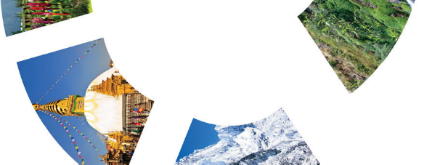
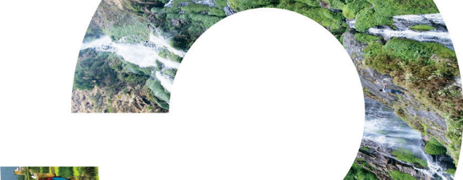

Table 3: Tourist arrival by purpose of visit 2007-2019
Source: Department of Immigration, Nepal

Figure 3: Tourist purpose of visit 2019

There are three major purpose of tourism:
-For pleasure: Pleasure means to enjoy, relax and have satisfaction from the leisure time. People coming for holidays, trekking, mountaineering, rafting and adventure are form of pleasure.
-For business: People coming for pure official or business work falls in this category. However, we should note that, these tourists also require proper accommodation, cuisine and facilities along with pleasing hospitality.
-For mix purpose: Some tourist may come for private business or official work and extend their stay to visit some of the important places around.

TOURISM IN NEPAL
Tourism is the largest industry in Nepal, and the largest source of foreign exchange and revenue. Possessing 8 of the 10 highest mountains in the world, Nepal is a hotspot destination for mountaineers, rock climbers and people seeking adventures. Nepal is the country where Mount Everest, the highest mountain peak in the world, is located. Mountaineering and other types of adventure tourism and ecotourism are important attractions for visitors. Nepal is famous destination for pilgrimage due to its prominent, glorious and prideful historical and sacred places. Lumbini, being birth place of Lord Buddha and Pashupatinath, a centre of faith for Hinduism is major among many important places. Lumbini is found as most visited pilgrimage by foreigners. It was visited by 1,779,086 persons out of them 78.76% were Nepalese while 11.51% Indians and 9.73 % from other countries. Similarly, the 171,937 visitors form third country visited the Pashupatinath during the year 2019.
Source: http://tourism.gov.np/
According to Nepal's Ministry of Tourism, major tourist activities include wilderness and adventure activities. Some of major tourism attractions are:
- Mountain Climbing:
The 800 km stretch of Nepal Himalayan is the greatest in the world with eight peaks that rise above 8000m including the highest in the world, Mt. Everest. Ever since the country opened its peaks to climbers in 1994, the Nepal Himalayas has become the great theatre of mountaineering activities that provides impetus to thousands of men and women to meet the ultimate challenges.
- Trekking
The best way to experience Nepal’s unbeatable combination of natural beauty and culture riches is to walk through them. One can walk along the beaten trials or virgin tracks, making it an experience for a life time. Along with forests of Rhododendron, isolated hamlets and small mountain villages, birds, animals, monasteries and breathtaking landscapes, one will encounter friendly people of different cultures offering a fascinating glimpse of traditional rural life.
- Bird watching
Nepal is a paradise for bird lovers with over 646 species (almost 8% of the world total) of birds, and among them almost 500 hundred species are found in Kathmandu Valley alone. The most popular bird watching spots in Kathmandu are Phulchoki, Godavari, Nagarjun, Bagmati river, Taudaha and so on. Get your binoculars and look forward to a rewarding experience.
- Paragliding
Paragliding in Nepal can be a truly wonderful and fulfilling experience for the adventure seeking. A trip will take you over some of the best scenery on earth, as you share airspace with Himalayan griffins‟ vultures, eagles, kites and float over villages, monasteries, temples, lakes and jungle, with a fantastic view of the majestic Himalayas.
- Rafting/Kayaking/Cannoning
Rafting is one of the best ways to explore the typical cross section of natural as well as ethno- cultural heritage of the country. There are numerous rivers in Nepal which offer excellent rafting or cannoning experience. You can glide on calm jade waters with munificent scenery all about or rush through roaring white rapids, in the care of expert river-men employed by government authorized agencies. One can opt for day of river running or more. So far, the government has opened sections of 10 rivers for commercial rafting. The Trisuli River (Grade 3+) is one of the most popular of Nepal’s raft able rivers. The Kali Gandaki (5-5+) winds through remote canyons and deep gorges for five days of intense rapids. The Bhote Koshi (4-5) is 26km of continuous white water and the raging Marshyanghi is four days of uninterrupted white water. The Karnali River (4-5) provides some of the most challenging rapids in the world. The Sun Koshi (4-5), 7km, requiring 8-10 days to complete, is a big and challenging river. Adventurers are provided with world-class services by rafting agents. Agencies here provide life jackets, camping and the standard rafting paraphernalia needed by world-class rafting. An extremely popular sport in Europe, cannoning is now available in Nepal. Cannoning gives you the freedom to explore some of the most ruggedly beautiful, yet forbidden places in the world.
- Bungee Jumping
The ultimate thrill of a bungee jump can now be experienced in Nepal at one of the best sites that this sport can boast of anywhere in the world. Nepal’s first bungee jumping site is situated 160m, over the Bhote Koshi River, inviting you to experience the ultimate adrenaline rush in the
- Jungle Safari
National Parks located specially in the Terai region in Nepal attract visitors from all over the world. A visit to these parks involves game- stalking by a variety of means-foot, dugout canoe, jeep, and elephant back. One is bound to sight a one – horned rhino or two at every elephant safari. Besides the rhinos, wild boars, samburs, spotted deer, sloth bear, four-horned antelope are also usually seen. A Royal Bengal tiger may surprise you by his majestic appearance.
Source: https://trade.welcomenepal.com/
Major Tourism Site
- Kathmandu
- Bhaktapur
- Patan
- Dhulikhel
- Pokhara
- Lumbini
- Chitwan
- Muktinath and jomsom

HISTORY OF RESORT
The origin of resorts starts back from the 2nd century B.C. as a public baths of Rome. The first baths small, modest and separated the genders. Eventually, became larger, more elaborate were large buildings built at the public’s expense. They were much like resorts of today because of all the amenities offered included gyms, libraries, snack bars, restaurants, shops, lounges, taverns, museums, theatres. The facilities were used for health and social purposes.

RESORT SCENARIO IN NEPAL
The development of hotel and resort start along with the inflow of international tourists in our country. There are altogether 257 number of them. According to World Tourism Organization, tourist are the people who travel to and stay in places outside their usual environment for not more than one consecutive year for leisure, business, recreation and other. Tourists visit Nepal mainly for three purposes.
      - For pleasure: pleasure means to feel joy, happy and satisfaction from leisure time through spending money. Tourist visiting for mountaineering, rafting, bungee jump, trekking are for pleasure.
      - Business: tourist visiting for official or business work and sometimes may extend their visit to see some places.
      - Mix purpose: Tourist from neighboring country like India visit mostly for religious purposes whereas some comes for the scientific or archaeological research and many others.

NEEDS:
- It brings about a desire for community and helps in returning luster of vibrant local architecture.
- These are all reasons given for the popularity of resort developments, a place to relax, enjoy, and refresh oneself.
- Resort developments reflect a response to provide hospitality to the tourists and enjoy their stay without difficulties.

BENEFITS:
The benefits of a Resort can be judged in the economic front.
- Better accommodation to tourists
- Sharing of Services
- Employment Opportunities
- Maximum Open Space on the Ground

CHALLENGES:
Resort projects are at a risk and can be dangerous if not properly carried out. The common challenges that can be faced are:
- Maintaining privacy
- Structural Difficulty
- Control of Density (People , Service, Materials)
- The overall functioning of the Building as a whole

COMPONENTS OF A RESORT
A resort consists of various leisure activities and amenities.
    - Accommodation 50-60%
    - Reception, Lounge 4-7%
    - Restaurant/Bar 4-8%
    - Banqueting/Meeting 4-12%
    - Kitchen , Stores 9-14%
    - Administration 1-2%
    - Maintenance 4-7%
    - Leisure (Sport/Shops) 2-10%

ACCESSIBILITY AND CIRCULATION
Two key issues that are important to the guests' arrival at the site are visibility of the entrances and appropriate signage. This can be accomplished by any of several means, including sight lines, road widening, lighting, divided highways , planting, and graphics. But the entrance to the site, and specially, the location and number of curb cuts, must be coordinated with the city or highway department. Once the guest has arrived on site, the major objectives are to separate vehicular and pedestrian routes and to conceal service circulation. Resorts design requires careful study and design to project the ambience of the locale from being overwhelmed by the vehicles. All projects need to design the access to the service areas, primarily loading, trash, and employee entrance, for maximum efficiency, while avoiding cross circulation or inconvenience to guests.
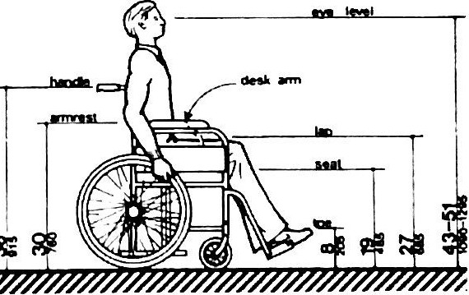
UNIVERSAL DESIGN
Consider spaces
      - Corridorspaces
      - Parking area
      - Bathroom
      - Sitting space
General consideration
      - Ramp surfaces should be fireproof and non-slip
      - Ramps should be no longer than 20 ft.
      - 5 ft-6 in ample rest space need for
      - longer ramps
      - Recommended width for a one-way ramp is 3 ft. between handrails.
      - At least 6 ft. should be provided for two-way circulation.

Figure 4: Ramp ratio

PUBLIC SPACE DESIGN
Entry and Lobby
Main entrance of the resort has to be designed so that it attracts the view of the visitors. It is said that first impression is last one so the designing of main entrance is important factor to be considered. It is necessary to provide entrance plaza from where welcoming and farewell is done. "All lobbies should establish contact with the shops, bar, and restaurants, and enable a guest to feel like he's in the heart of hotel".
The architectural aspects of building are:
      - Approach to the front entrance
      - Details of site
      - Exterior design- the landscaping, the night illumination, the entry drive and canopy

The designer should access the relative need for the following entrances
      - Main hotel entrance
      - Ball room/banquet entrance
      - Restaurant/bar/night club/casino entrance
      - Tour bus/airport bus entrance
      - Suite or apartment entrance

The planning objectives are as follows:
- Entrances: consider additional exterior entrances for main lobby, restaurants health club, or other high traffic areas.
- Front desk location: visible to hotel guest; in addition, have the front desk staff visually oversee access to the passenger elevator
- Office access: Provide entrance to the front office, safe deposit area, executive office, and sales and catering offices
- Seating area: Provide a seating area near the desk and main entrance; the area may also contiguous with lobby bar.
- Circulation: Establish clear path to the front desk, elevators, restaurants and bars, meeting and banquet areas; where possible, separate hotel guest traffic from purely convention traffic.
- Retail areas: Provide lease space convenient to the guest circulation areas
- Bellman/luggage: Position bellman station near front desk, elevators, and front entrance, with separate rooms for baggage, carts, and locked storage.
- Support function: Locate toilets, coats, house phones, public phones, directory, and assistant manager's desk conveniently in relation tom the other areas.

GUEST ROOM UNIT
The main aim of a hotel is essentially directed towards the letting of guestrooms. The guest rooms in resorts are quite different from the main block either in separate low rise buildings or scattered condominium buildings. Often these units are provided with kitchen, drawing room and bathrooms in expandable module and it is compulsory to provide attach bathroom to the bedroom. Also the resort rooms are larger in size than the hotel rooms due to longer period of stay, more luggage and higher chances of double occupancy. Usually different types of bedrooms like twin, double, deluxe etc are present. Work area is somewhat reduced while spaces for other activities like seating, dining and storage are emphasized. Bedrooms are often sophisticated with all the luxurious facilities. The corridor must be 6 m² per room with 1.50 to 1.80 m wide.
View
Once the guests arrive in their hotel room, among the first things that they do is to open the drapes and look out of the window to check the view. This natural instinct speaks volume a bou t the importance of this feature. Dealing with the guestrooms views is crucial in selecting the site, orienting the buildings, developing the building form, and designing the pattern of windows or fenestration . Not every building is a high rise, not every site is blessed with 360-degree views, so something must be done to compensate the guest. The site designer may create interesting feature or manipulate the terrain in ways to enhance the views. These may be as simple as designing small gardens or pleasant landscape vistas, or directing views across the swimming pool or tennis court or into interior atrium. Where there is a truly special view, of mountains or the beach, for instance, the building must be constructed as a single loaded corridor scheme, with rooms only on the view side and the hallway on the other.

Providing outdoor terraces or balconies for each room can enhance the resort setting. Guest may take full advantage of it for having good views from their units. One should keep in mind while providing these balconies that they should have enough space to accommodate a set of chair and table so that one can relax with some kind of drinks according to time. For those resorts which are focused on views rather than towards solar angle. If views or scenery is not primary consideration then it is better to orient the room towards N-S direction with solar radiation trapping system or with solarium.
- 65 to 85 % of the total hotel area represents the guest room floor area
- Major planning goal is to, maximize the area for the guest room and keep to a minimum tor the circulation and supporting areas
- Orientation of the building and plan configuration selected not only to enhance views but to reduce energy expenses for heating and air conditioning
- Minimize the impact of lateral wind loading on the structure
- Reduce the walking distances for both guest and the house keeping staff
- Adequate number of linen storage and vending areas, and small electrical and phone equipment rooms
- Plan types range in shape from long, double-loaded corridor plans, to compact vertical towers, to flamboyant atrium structures or a large lobby space so that some of the rooms look into the hotel interior
- Choice of a plan type is the result of a balanced consideration of site, environment, and space requirements
- Maximize the percentage of floor area devoted to guest room and keep to a minimum amount of circulation and service space
- Some configuration yield more efficient solutions than other, the choice of one configuration over another can mean a saving of 20% in gross area of the guest room tower and of nearly 15% in the total building. Example the three principal plan alternatives-the double loaded slab, the rectangular tower, and the atrium using the same net guestroom dimensions, will vary from 460 to 575 gross square feet per room
- The following sections contain a description, for each of the basic guestroom configuration, of the planning decisions that have the most influence on creating and economical plan i.e. no. of rooms per floor, location of the elevator core
- In general, the most efficient configurations are those where circulation space is kept to a minimum with either double-loaded corridors or compact center-core towers.
Figure 5: Nawwor Hotel
Type of room | Width (m) | Length (m)
Economy | 3.0-3.3 | l.2-l.5
Standard | 3.3-4.0 | 1.3-l.6
Executive | 4.0-5.0 | l.5-1.9
Deluxe | 5.0 | 1.6-2.5
Type of bed | Width (m) | Len2th (m)
Single | 0.77 | 2.13
Twin | 1.0 | 2.13
Double | 1.27 | 2.13
Queen | 1.52 | 2.13
King | 1.83 | 2.13

Figure 6: Double bedroom

Figure 7: Bathroom arrangement

Sizes of Rooms and Beds
The guestroom should have dimensions of 3.6 to 3.9 m (12 to 13 ft.) wide and 4.8 to 6 m (16 to 20 ft.) long, measuring from bathroom to exterior wall or 7.3 to 9.1 m (24 to 30 ft.) long including the bath and entry zone. The minimum guest room area is of 211 square meter s (228 sq. ft.). The minimum width should not be less than 3.6 m (12 ft.) and 3.9 m (13 ft.) in length measured from bathroom to exterior wall.

The bathroom size depends largely on bathroom requirements with inclusion of bathtub or its exclusion. Mainly the bathtub requires considerable space compared to shower fixture. The bathroom size range from 1.5 to 1.8 m (5 to 6 ft.) in width, 2.4 to 3 m (8 to 10 ft.) in length.
For handicapped, 1-2% of room should be provided in ground floor. The ratio of ramp should be 1:20. The corridor should be 915 mm wide. Lobbies should be provided 460 mm wider than door on latch side. In bathroom, the turning space should be 1.52 m of width 2.75 m, vanity top 860 mm high, knee space of 685 mm. Space between bed and furniture must be 910 mm. The height of bed must be 450-500 mm and dressing table at height 1.07-1.37m. According to guideline of Nepal Tourism Board a hotel room should be minimum 250 Sq. Ft. including attach bathroom. The minimum number of bedroom is 70 for a five star resort or hotel. The objectives of guest room floor planning according to their orientation/sitting.
- Consider solar gain, generally N/S preferable to E/W exposures
- Analyze wind loading
- Study the potential for guestroom views
- Access the relative visual impact and construction cost of various guest-room plan configuration

KITCHEN, RESTAURANT, DINING AND BAR
The provision of restaurant and other dining facilities in resort must be based on detailed analysis of market considerations and economic feasibility. Entry to a restaurant should be through a reception lounge or foyer. Bar may be planned separate or may be kept aside without disturbing the flow of guest in restaurant.
Figure 8: Parallel tables
The layout in restaurant should be according to the features of the room, external vistas and internal displays, entertainment facilities provided or the circulation pattern of customers or staffs. These areas require sophisticated environmental control. Depending upon the location and use, windows may be provided to take advantage of the view or attract the outside attention. Resort dinning is mostly oriented towards view perhaps landscaped rounds, recreational features or more often distant vista. To accommodate good views, designer should arrange seating areas giving a better sight opportunity for guests seated towards the rear side. Steps are minimized to resist any fall or spillage especially in dining areas. Semi private alcoves are provided to eliminate the sense of large or institutional dining hall. Certain sport focused dining outlets add more beauty and greater idea of dining in different idea in resort.
Eating Space arrangement:
The eating space should be arranged generally with 8sq.ft of the floor area for each in dining area . The Dining areas should designed with thumb rule of 15 sq.ft /seat.

Figure 9: Minimal seating

Figure 10: Regular seating

In primary space planning, the rule for determining the area requirement of a restaurant is:

Kitchen:
Kitchen may be designed with open plan arrangement or with separate rooms or bays for different types of separation. Preparation equipment and work benches should be designed to facilitate easy cleaning and are usually of stainless steel or aluminum.
Secondary kitchen may be used for coffee shop or room services. Floor in kitchen should be laid to fall for drainage (typically 1 in 100) to grating covered channels and sealed outlets. Walls are usually glazed tiles whereas exposed surfaces subjected to wide temperature fluctuations, the construction must include thermal insulation and water vapour barriers.
Figure 11: production in line
Figure 12: Cafeteria, meal servey area requirement
Figure 13: Space distribution in kitchen
Main Kitchen (total of the following)
6 sq. ft (0.6 sq. m) |  | restaurant seat
2 sq. ft. (0.2 sq. m) |  | ball room and banquet seat
1 sq. ft. (0.1 sq. m) |  | cocktail lounge seat
1 sq. ft. (0.1 sq. m) |  | hotel guestroom
Storage Area |  | Percent
Dry food storage |  | 30
Refrigerated food storage |  | 25
Frozen food storage |  | 10
Beverage storage |  | 15
Refrigerated beverage |  | 5
Non-food storage (cutlery) |  | 15

EMPLOYMENT FACILITIES
The employees need facilities for smooth functioning of the service rendered. The employee's requirements include personnel offices, lockets (one per employee), changing rooms, showers and toilet with separate facilities for men and women. This also includes employee or staff dining which should be near the main restaurant for easy service and access.
Lucury 1.8 m²/room
High-Mid Grade 1.1 m²/room
Budget 0.5 m²/room

LAUNDRY AND HOUSEKEEPING
Collection of soiled laundry may be by trolley or chute. In small or economy hotels most laundry is contracted out. A standard laundry room for a 200 room hotel takes up about 160 square meters, plus separate linen storage and housekeeping areas of 80 square meters.
Housekeeping areas are 0.4 square meter per room Separate areas may be sewing work, uniform and guest valet services.

TECHNICAL AREAS
The technical space provision needs to provide for housing various technical equipments and their main tenance . These are housed at the back of th e hou se. roof or mounted or/ and external to the building. The requirements include engineers' ottices , security office, elE::ctncal transformers, standby generators, telephone exchange equipment room, water storage , treatment and pumping equipment, boiler plant, air condition plant, swimming pool trea tmen t plant and equipment stores. The various spaces required for various types of hotels are as follows:
High-Grade 1.8 m²/room
Mid-Grade 1.2 m²/room
Budget 0.6 m²/room

CONFERENCE AND SEMINAR
The recreational activities may be reserved past time during breaks in meeting. The surrounding spots oriented atmosphere pervades the entire facility. The circulation of conference or meeting hall allows easy access to the terrace and outdoor areas for tea and coffee or lunch breaks and other informal gatherings at least from break areas if not from certain meeting rooms.
Standard requirement of conference and seminar area are as follows:
• Separate access must be provided in case of large room.
• Separate access for guests and service desirable.
• One medium sized room for meeting, for cultural show, video or hosting reception.
Space plan:
Banquet style seating: 1.1 - 1.3 m²/P
Meetings: Table groups: 0.9-1.1 m²/P
Threater style seating: 0.5- 0.6 m²/P

RECREATIONAL FACILITIES
Most of resorts focused in providing recreational facilities are to be oriented itself towards huge range of recreational activities. Besides touring, trekking, mountaineering and sightseeing, people go to resort or hotel l for swimming, playing golf, tennis, bowling, fitness, spa, sauna etc. Further recreation can be categorized into two parts:
- Site Specific: bungee jumping, rafting, lake / river activities (bolling, swimming, fishing), Mountain View, sight see, rock climbing. canoeing, ski, safari, etc.
- Non site Specific: health and fitness facilities, outdoor and indoor sports, landscapes, casino, etc.
- Location: The recreational complex at the end of the guestroom wing totally removed from the public facilities offers opportunity to accept outside business during the day. Other common arrangement is to locate the recreational facilities centrally near the lobby or where guestrooms join the public areas. Often, these areas are located on lower level to separate them somewhat from the public circulation.

Recreational Facilities by Hotel Type
Down town | Pool, health club, jogging track
Motel, roadside | Pool, game room
Sub urban, airport | Pool, game room, health club
Resort | Varies depending on location(beach, mountain, desert)
Convention hotel | Pool, game room, health club, racquet sports
Casino | Pool, health club
Conference hotel | Pool, health club, racquet sports, golf
All-suite | Pool, health club
Condominium | Pool, health club
Mixed-use | Varies
Mega hotel | Pool, health club, game room, racquet sports

SWIMMING POOL
"Water is the most interesting object in a landscape and the happiest circumstance in retired recess; captivates the eye at a distance, invites approach and is delightful when near; it refreshes an open exposure and enriches the most crowded view; in form, in style and in extent, may be made equal to the greatest composition." Pools were important in society during these ages and used here for many public and social activities but during this time pools were just as important in homes as well. Both Roman and Greek emperors had huge ornate pools with live fish in them. In fact, the word "pool" comes from, "piscine" meaning fish. The first Jacuzzi style custom pool was designed and ordered by Gaius Maecenas, one of Augustus Cesar’s political advisors sometime around 8 BC. This pool was supposedly magnificent with waterfalls, lush gardens, overlooking terraces, libraries, villas and other incredible luxurious décor.
It is outdoor or indoor space can be used for gathering of socializing space for peop le of all age groups. Outdoor pools are used for leisure activities. The location of shaded area, view and proximity of other spaces like lawn, cafe can affect the location of people around pool. The kid's pool is preferred to be located beside the adult pool as the young ones could be within the sight of their elders. The screening of pool is another aspects which can be done through plantation or other means to maintain privacy. The supporting facilities like toilet, changing rooms, showers, cafe should be in close proximity. Seating arrangement around pool would facilitate gathering of people in groups or isolated such that their personal space is not disturbed by close movement.
The pool area can be one of the main visual and recreational focuses for the conference center and it needs to be a special space. The deck spaces, seating areas, bars, food displays and allow to movement of people around the pool area if it is to be developed as social gathering space.
Lanes | Pool width(m) | Pool width(m)
6 | 16.66 | 25
6 | 16 | 50
8 | 21 | 50
10 | 25 | 50

INFINITY POOL
A swimming pool whose positioning gives the impression that it merges into the surrounding landscape. A true infinity edge pool (also named negative edge, zero edge, infinity pool, disappearing edge, or vanishing edge pool) is a reflecting or swimming pool where the water flows over one or more edges, producing a visual effect of water with no boundary.
An infinity pool or negative edge pool has to be built on sloped ground; this is because the water level along one or two sides of the pool will flow over these edges into a weir or secondary pool. Most commonly installed overlooking another body of water such as the sea or a lake, making the pool appear to extend to "infinity", a term described in the Oxford Dictionary as forever, or the Greek symbol '8'. An infinity pool edge should not be confused with a deck level pool or overflow pool where the water edge is the same level as the deck or patio and flows into a grate around the perimeter.
Figure 14: Section of an infinity pool

Design Considerations
- Natatorium: A large clear span room with adequate heating, ventilation, humidity control which houses an indoor swimming pool. Sufficient width for adequate deck around the pool has to be present.

- Location: place the pool so that guest can reach it from guestroom elevators without passing through the lobby; provide some guestrooms with views of the pool; screen any exterior views towards the pool.

- Orientation: position the pool so that it receives unobstructed sunlight from mid­ morning to late afternoon.

- Size and shape: A rectangular pool with vertical side walls is recommended with deep water at one end and shallow water at the other recommended sizes are 60' x 5', 75' x 30 ', 75 ' x 35', 75 ' x 42 ', 82.5' X 42'.

- Depth: The depth of water at the shallow end must be at least 3' but not exceeding 3'6" expect for special purpose pools. For water depth less than 5', bottom slope shall not exceed 1 in 12 while water depth greater than 5', bottom slope shall not exceed 1 in 3.1.

- Support functions: Provide toilets, lockers where required, towel issue area, snack bar or vending, equipment room, and furniture storage

- Safety: A diving board should not be provided; include slip free deck surface Depth markings, under water lighting, safety or "pool rules" signage.

- Material: All material used must be inert, stable, no- toxic, water tight and enduring Sand and earth bottoms are not permitted.

- Finishes: Ceramic tile finishes Vitreous Square edged to permit smooth tile grout.

- Pool ladder and entrance steps: they should be recessed 1 side walls only, adjacent to deep and shallow ends.
- Overflow system: Wide choice fully recessed of semi-recessed gutters, roll out, rim­ flow, or deck level system, surface skimmers, and pre- fabricated steel semi recessed gutters. Adequate surge tank capacity whose function is to provide storage area for large volumes of overflows or gutter water that are likely to accumulate at the rates faster than the circulating pump can accommodate.
VIEWING DECK
Visitors can enjoy in a Peaceful and quiet environment in such a relaxing area.
- Basically built with lightweight materials like wood etc.
- The decks can be created in roofs and terrain lands to give the beautiful scenery to the guest.

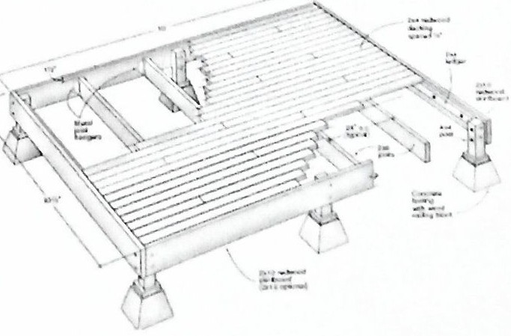

SAUNA
A sauna section can be a social affair in which the participants disrobe and sit or recline in temperature of over 80’ C (176’ F) This includes relaxation and promotes sweating Good heat 1nsulat1on 1s necessary for enclosing walls since the heat d1tterence between inside and outside temperature 1s very high Dark wooden lining on ceiling and walls or solid wooden walls of soft wood are constructed to reduce the heat radiation
Sauna sizes vary from a 3’ x 4’ closet size sauna room for one person to larger 8’ x

10' sauna room sizes for home, family or res1dent1al sauna use. A commercial sauna room range from 6' x 6' size to one as large as a 10' x 14 ' size . The best sauna height 1s 7’ high on the inside with a 2- level bench layout. The 7' sauna celling height reduces the heater warm­ up time to a minimum and prevents heat from rising into the unused space above the sauna. If sauna height is less than 80”, lower the entire sauna bench set a few inches to compensate.
The design and size of the sauna room will depend on
- The number of persons using it at one time
- Bench layout - 2 benches, 3 benches or 4 benches
- Benches to be regular 2 tier or L-shape
- Sauna door location
- The heater or stove location, its size and specification.
Design consideration/ analysis
- Relative humidity above 100% is required.
- Temperature should be maintained 43̊ C to 46̊ C (110̊ F- 116̊F) range
- Steam should be permanently present.
- Materials such as marbles should be used all over the room.
- Separate shower rooms must in proximity with steam room
- For cooling, plunge pool or tube is required.
JACUZZI
Jacuzzi in real meaning is a company whirlpool bathtubs and spas. Its first product was a bath with massaging jets. Jacuzzi is a water where the airflow circulation is provided throughout the water. It is used for the massage of the body.
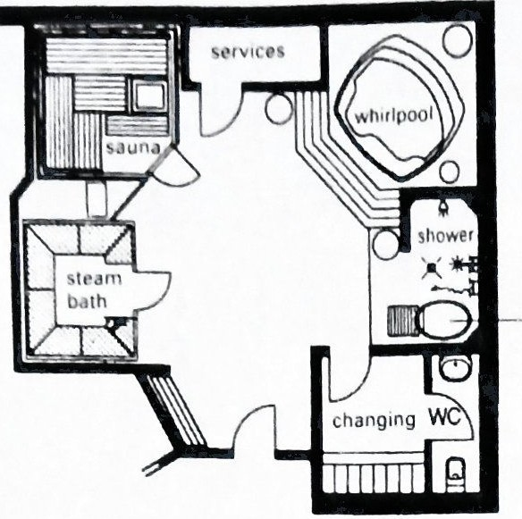
Figure 15: Sauna with jacuzzi

FITNESS ROOM
It consists of a big hall with mechanical exercising machines that help to improve the fitness of the body. The flooring of fitness room should be levelled with the absorbent flooring so as to reduce the mechanical noise produced by the machine. The walls are provided with the glass panel.
Sufficient natural day lighting and sufficient ventilation should be provided. Artificial lighting is arranged that it does not produce glare by reflecting through the glass panel clad on the wall surface. Big glass windows are used for the enclosing material as per the site condition to gain the natural or external environment.
For 40-45 users a room size of at least 200 m2 is needed. Clear room height for all room should be 3 m for an optimum double row arrangement of machines; the room should be at least 6 m wide. To allow clear supervision of all training the room length needs to be 15 m or less. The minimum room size of 40 sq. m for 12 users.
Figure 16: Exercising machines

GAME ROOM
Billiard Room
It is also known as a royal game. The billiard or snooker is table game with heavy and colorful small balls. The size of the table is 1.9 m x 3.7 m and height is .074 m with focusing light .075 m above the table. The clear spacing of 2 m around the table is desirable.

MEDITATION /YOGA
For Yoga, generally outdoor space is preferred and if it has to be planned for indoor. then rectangular room is preferred with area of 2.1 m x 2.1 m per person . Meditation is preferred indoor and its covers minimum of 0.9 m x 0.9 m of space
Figure 17: Layout for meditation hall
Space Required
The calculation of space needed for meditation hail is calculated on the basis of the posture a med1tator use while meditating. As cross-legged posture is best for doing meditation mostly this posture is used. The person sits upright, back straight, and with their head and spine in alignment in this posture Hands may rest in any position.
The seating should be provided in front of the meditation hall for teachers and there should be entry for them. Service rooms should be provided near the entry of teachers. Meditation space for male and female should be separated in meditation hall.
Color
The color of the interior is much more influenced by the technique of meditation. Bright colors like white, color for meditation hall. Orange increases oxygen supply to the brain.
Yoga hall
Yoga hall is healing system for mind and body. It is technique of controlling the body and mind through disciplined method to attain goal of a healthy physical and mental state. It was practiced for more than 5000 years. It is a combination of breathing exercises, physical postures and meditation. It comes from the Sanskrit word "yuj” which means union or to join.

Requirements
There are certain requirements that must be fulfilled in yoga hall which are as follows:
- Considering the movement of hands in all direction, the standards of mat of yoga is taken as 7'-0"•3'-0"
- Additional space should be provided in between two mats.
- Proper light and ventilations is required with clean and peaceful environment

DESIGN CONSIDERATION IN RESORT
Variety of spaces: landscape helps to heal the social health of people provision of space for group and single person should be allocated in landscape garden It would be better to provide variety in landscape rather than monotonous as the user does not bear same kind of perception.
Prevalence of green material: Hard surface has to be minimized and it is preferred to have large scale of greenery with varieties of trees, herbs and shrubs with soft land finish Maximum 1\3rd of total landscaped land can have hard surface.
Encourage exercise: Garden should encourage walking as a form of exercise to improve physical as well as mental health.
Minimize intrusion: Negative factors like smoke, dust, noise and dry bushes /trees are avoided and promoting natural lights, winds, greenery, which is positive factors of landscapes.
Minimize ambiguity: Abstract environment is not preferred. Clearly identifiable features and garden elements should be incorporated. Entrance to the garden should invite and embrace the guest.
Sensory stimulants: Factors that created stimuli in our sense organs. This can be achieved through considering following:
Sound: Generated by whistle of plants, wind flow, water flow, wild animal, birds, etc. Sound is limited by the amount of background noise- this can be partially screened by a barrier of noise absorbing trees of fencing, but never removed totally.
Water: Flowing water- it requires electricity for pumping if there is no presence of down water stream in site. Water generates different sounds if it come and hit across baffles and obstruction and by varying the speed of water flow. Clean and fresh water is always attracting. The sensation of getting wet is very powerful particularly for people who might otherwise rarely get wet in an outdoor situation.
Air: Moving air can generate soothing sounds as it blows through trees, bamboo or grasses. A man-made chime of different materials makes different sounds.
Wild Life: Wildlife should be encouraged because it is vital aspect of life in the garden. Most people appreciate the presence of birds in a garden consider installing bird boxes Try to encourage songbirds, such as thrushes, warblers, etc. Presence of deer, musk, rabbit, etc is desirable.

INTERNAL ENVIRONMENT
Interior of hotel or resort have to meet certain level of lighting, color and texture, acoustics and noise and particle level. Interior has to be well designed and attractive to the visitors so that it could attract them.
Well harmonized color combination with internal surroundings help to create psychological comfort to users. Pure colours are more dramatic in their effect than tints or shades and color combination from different areas of spectrum must be carefully chosen and balanced.
Lighting in Resort
Lighting is important factor in resort architectural and interior designing. Generally, diffuse light is preferable for background illumination and in work areas. Spot lamps are most effective in illustrating features, works or arts and notices. Some of the recommended lighting in resort spaces is given below in table:

Also considerations for noise produces should be made· High level of noise which is generated in lobby, public areas, and work areas like kitchen, machinery room etc. should be reduced through proper planning, insulation or absorption. Such noise may prove to be sensitive to some areas like guest units, meeting rooms or other areas, which require clarity. By zoning, separation and screening it is possible to plan layouts, which minimize the effects of one area on other. This applies particularly to the separation of guest room from public areas and to the grouping and screening of work areas.

ENVIRONMENTAL REQUIREMENT
Clean and pollution free environment is main requirement inside the resort. Sufficient recreational facilities help to provide choices to visitor and this ultimately provides a stress free environment as one can find whatever they need. Environment with charming landscape or amusement parks acts as an attractive feature. If one feels like never to leave the resort premises then we should understand that the resort environment is good.
Landscape
Resort has its services scattered and generally designed in large area of land. Due to its large area, it has high potential of landscape design. Landscape acts as an extension to the indoor facilities through of the use of elements like deck, lawn, terraces. Landscape is also required to enhance the appearance of the building. Not only as a visually pleasing feature it can also use for functional purpose like screening work areas, loading bays, refuse stores, etc. To reduce the effect of wind, solar heat and exposure, plantings may also be necessary part of pround drainage or stabilization. Landscape is not only plants and ornamental trees and flowers, it also includes sitting areas, covered pergolas, water bodies, gazebo, walkways (hard paved and unpaved) etc. Moving water body could also be introduced which creates a point of interest. This may be associated with swimming pools with sprays and fountains of when nature’s components and landscape helps to create this.
Administration and service area
Wise and controlled operation of services through efficient administration helps to maximize the profit of resort. Administration blocks should have good co relation between the levels of staff. This area covers office, accounting sections, managerial staff rooms, executive officers room, meeting halls, staff cubicles and office store. Parking area should be first service area while entering the resort which should be at least 25% per bedroom. Generator service should be provided in such a way that the service in the resort might not fade while there is not electricity line also. Stores should be at the point where there won’t be any difficulty in bringing any type of good. Area of water treatment and sewerage treatment has to be allocated within resort boundary. Service area includes laundry section, HVAC control room, generator room, maintenance department, storage, kitchen and supplementary areas, staff facilities, etc. views most of resorts lie in the natural setting offering the panoramic views, so nature’s stay could be better theme. Resort in natural setting could be designed in such a way that guest may enjoy the view from every possible way. Resort often consists of number of buildings within the boundary, so the positioning of buildings relating to each other should be considered so that they do not obstruct the views.

SAFETY AND SECURITY
Design and efficient planning is not only tactors which govern safety but rather it depends on regular inspection, maintenance and careful handling of equipment and machineries which are vulnerable to accidents. Safety in building may be categorized in two cases: first seismic safety which is maximized by structural strengthening and second is fire safety for which area prone to high risk of fire should be separated where the fire is likely to cause particular hazards.
Active protection against fire automatic detection of fire or smoke, warning and fire fighting equipment of various kinds should be installed at regular intervals. The code has specified the requirement of fire escapes in resort which should not be far than 100m from end point.
Fire alarm should be visible and glowing all the time and fire extinguisher has to be provisioned at every 25m distance. Smoke detector is compulsory in every guest bedroom while along with sprinkler is desirable in every area except kitchen where smoke is continuously generated. Emergency exist sign should be clearly visible in all common circulation space.
Security is another important factor which is concerned with the protection and control of property, safeguarding of guests and their assets. For large scale resort which may encompass extensive grounds and multiple small units, the overall protection of the site is significant requirement. Proper enclosure and barriers are required to provide privacy. It is better to provide emergency alarm in every guest rooms.

PARKING FACILITIES
Surface parking often is the single largest site component of a hotel development. Of course, Tight urban site may have no on-site parking, yet alternative arrangements must be considered, Including valet service, and expensive on site underground parking may be necessary. It is Necessary to consider the importance of proximity of parking to the lobby and guestrooms, And how often guests may use their cars ranging from several trips per day in rural and suburban sites to infrequent use in urban locations.
Figure 18: Dimensions of vehicles
Figure 19: Turning radius
The following are some of the FHA standards for parking
- Paved parking areas and courts must be provided to meet the needs of the people and their guests without interference with normal traffic
- Dimensions of parking areas and courts must be adequate for convenient use for vehicular parking where necessary to provide for bumper clearance and suitable screen planting
- Parking facilities must not be nearer than 5 feet to any street, property line of project facility
- Driveways must have two traffic lanes for their entire; usually 18 feet in addition to any parking space, except that a single lane may be used for short, straight service driveways where two way traffic is not anticipated

IMPORTANT FACTORS IN PLANNING OF THE RESORT
- Visual linkage should be provided between indoor and outdoor spaces.
- Privacy should be maintained in the guest units.
- Outdoor spaces should be well planned incorporating natural elements circulation provided concerning the flow of people and services.
- Circulation pattern must be clear, it should not create confusion in the flow of the people.
- Creation of a healthy environment within the resort is important.
- Facilities , services along with good quality of food are also important.
- Special concern should be provided for children, elderly people and disabled.
- Secured and fearless environment within a resort is necessary through a provision of tight security.
- Zoning of spaces to cut off the disturbances from the public areas and service areas are to be maintained to achieve a peaceful environment in the private areas.

BYE LAWS
- The area of bedroom must be at least 22.5 sq m. and the furniture must be 5 sq. m.
- The access road should be 4 m from main road.
- Green area must be 10% of plinth area, for additional floor it must add 5% of floor area.
- Min. 25% bedroom attached to bathroom and for remaining rooms for every three rooms there must be one common bathroom and for star rated hotels and resort, every bedroom should have attach bathroom.
- Parking must be 25% of accommodation
- Soak pit should be in owner's property and cover of septic tank should be concrete.

NEPAL TOURISM BOARD GUIDELINE FOR RESORT PLANNING
- Possess creative and professional landscape and control of insects
- Architecture should be in harmony with local art, architecture, culture and building technology and safe from natural calamities like wind, storm and rain.
- Wooden members to be well treated with chemical and varnishes to be free from insect, termites, ant attacks and weathering effects.
- All room should be well ventilated naturally or artificially with standard carpets, curtains and fabrics.
- All room must be denoted with individual numbers.
- Flag post for at least 24 countries.
- Safety deposit locker should be provided.

FACILITIES REQUIRED FOR A 5 STAR HOTEL/RESORT
(Source: Nepal Tourism Board)
- Landscaping
- Covered pathways with lights to accommodation units from the building
- Benches or chair and cables on terrace areas and in the garden
- Garden mature well-kept with flowering plants and suiting and walking area for guests
- Architecture
Stunning and impressive architecture that is harmonious to the surroundings preserves the historical nature of the property and culture of the area
- Parking and Entry
- Parking area must be at least 25% of guest room accommodation
- Ample lighted paved parking area Cut parking attendant and security men on duty by the entrance and exit

- Public Areas
- Lobby
- Spacious and professionally designed
- Exceptional quality carpet with attractive pattern and/or wood floors have high quality area rugs and/or ceramic tile, marble or slate flooring
- Bell desk 24 hour services
- Separate business center
- Separate check, in/out
- Separate group check in
- Information desk
- Travel desk
- Fresh cut flower display
- Daily newspaper available
- Brochure stands
- Library lounge in addition to lobby lounge for resident and their guests

- Front office
- Green trees plants well maintained in brass or earthenware pots on both sides and the door or planted by the entrance area
- Reception
- Cashier
- Reservation and sales
- Telephone operator
- Babysitting service
- Tourist information service

- Corridor and Floor Coverings
- Ceilings are painted plasterboard or textured
- Lift corridor; Stairs minimum 1.6 meter wide
- Service stairs separate from Guest stairs and Exit stairs

- Elevator
- At least 1 guest lift for hotels with more than 3 stories up to 100 rooms
- Thereafter 1 guest lifts for extra 50 rooms

- Restroom
- Sundries and other shops
- Shopping arcade
- Minimum requirements of shopping facilities
- Hair dressing Salon and Barbershop
- Beauty Salon

- Recreational Facilities
- 24 hours coffee shop
- At least two specialty restaurants
- Large pool
- Children pool
- Swimming pool and surrounding sunbathing area separate and protected from public areas by fancy plants
- Changing room with shower room and toilet separately for men and women lockers.
- Outside shower and footbath
- Sunbathing stretchers with mattress
- Changing room with lockers
- Toilets
- Sport facilities
- Fitness center with receptionist
- Tennis court
- Fitness center/Health center with minimum following facilities
  - Gymnasium with body building equipment
  - Sauna , steam room
  - Massage
  - House doctor/Nurse on call
- Bed Rooms
- Minimum number of rooms 70
- Minimum room size of 250 sq. ft. including bathroom

- Back of house
- Separate laundry room for the hotel
1 Toilets 7.5 - 9 litres/flush
2 Sinks 3 - 6 litres/event
3 Showers 30 - 60 litres/even•t
4 Baths 50 - 170 litres/event
5 Dishwasher 20 - 40 litres/event
6 Laundry(washing machine) 60-100litres/event)
8 Garden 8 - 10 htres/minute
9 Employee(full-time with canteen) 40 - 90 litres/day/person)

FIRE SAFETY CONSIDERATIONS

Max travel distance with escape, possible In one direction only- 12.2 m except for on the
ground and 1st floors when it may be 30.5m if the following requirements are met
- Opening in all offices 840 mm X 535 mm minimum
- Lower level of opening light not more than 3800mm above ground and 915mm above floor level
- Ground beneath window free of obstruction for 1830 mm from building
- Maximum travel distance with escape possible in alternative direction- 46m, with no point in an office more than 12.2 m to nearest exit door unless second exit door provided
- Maximum distance between two adjacent exits from a storey- 61 m
- Fire fight stair- at least one fire-fighting stair is required in building with floors over 18.3 m above ground level which should Be continuous throughout building
- Have access at ground level direct to open air
- Have operable windows at each landing level
- Have permanent venti lation at the top enclosure of min 5% of enclosed area
- Have protected and ventilate lobby at each floor
- Fire exhaust fans become very important in case of atrium buildings
- Fire detection

ENERGY SUFFICIENT AND SUSTAINABLE APPROACHES IN BUILDINGS
  - INTRODUCTION
“The idea of sustainability can imply there is one perfect, unchanging future, if only we could work out how to get there. Resilience might be more useful, In that it assumes a dynamic environment and that perfection is impossible. You need to design systems to accommodate failure rather than eliminate it. By trying to be perfect, many visions of sustainability are quite brittle”
- Jamais Cascio, writer and ethical futurist (article in 'Green Futures', January 2010
Sustainable Development is important for the environmental stability of our Mother Earth. The main focus of Sustainable Development is to preserve the natural resources and use them very cautiously so that we can protect our Mother Earth from devastation.
The definition is based on two concepts:
- The concept of needs, comprising of the conditions for maintaining an acceptable life standard for all people, and
- The concept of limits of the capacity of the environment to fulfil the needs of the present and the future, determined by the state of technology and social organization.
Architecture and Sustainability Factors
Architecture presents a unique challenge in the field of sustainability. Construction projects typically consume large amounts of materials, produce tons of waste, and often involve weighing the preservation of buildings that have historical significance against the desire for the development of newer, more modern designs.
Sustainable construction is defined as "the creation and responsible management of a healthy built environment based on resource efficient and ecological principles". Sustainably designed buildings aim to lessen their impact on our environment through energy and resource efficiency.
A sustainable building or green building is one which concentrate on increased efficiency of resource use energy, water and materials also at the same time reducing impacts on human health and also on the built environment during its life cycle through better sitting, design, construction, operation, maintenance and even removal. Green building should be designed and operated to reduce overall impact of built environment on human health and natural environment by the following main three points:
- Efficiently using energy, water and other resources
- Protecting occupant’s health and improving enployee productivity
- Reducing waste, pollution and environmental degradation.
“We no longer build buildings like we used to, nor do we pay for them in the same way. Buildings today are life support systems, communication terminals, data manufacturing centers, and much more. They are incredibly expensive tools that must be constantly adjusted to function efficiently. The economics of building has become as complex as its design.” An architecture which can dissolve in nature after its successful demolition is true green Architecture but in modern context, due to requirement of varieties of spaces, it is not possible in every case. So, attempts have been made to make building more efficient and eco-friendly by application of passive solar technologies and construction technologies. Zero effect on nature is quite impossible but reduction of carbon emission to nearly zero can be initiated by reducing use of petroleum energy and replacing with PV cells and wind turbines.
Eco-friendly building refers to both a structure and the using of processes that are Environmentally responsible and resource-efficient throughout a building’s life-cycle: from siting to design, construction, operation, maintenance, renovation, and demolition. In other oords, eco-friendly building design involves finding the balance between homebuilding and the sustainable environment. This requires close cooperation of the design team, the architects, the engineers, and the client at all project stages. The Eco-friendly Building practice expands and complements the classical building design concerns of economy, utility, durability, and comfort.
Eco-friendly building emphasizes the energy-efficient performance of materials and maximum se of natural daylight. Energy requirements of living accommodation can be reduced by around 50% in comparison to other buildings.
  - ENERGY CONSUMPTION
The major energy users in a hotel are:
- Space Heating
It accounts for 1/3rd of the energy consumption. It is done using boiler. As the different areas (guest rooms, meeting rooms) have variable, and not simultaneous periods of occupation, the time during which they are in use is the most important factor with regards to energy consumption. When occupied, a guest room can be heated to 20°, but when unoccupied, the standby heating should be lower (16-18°C). This system can save energy up to 20-30%.
- Air conditioning and Ventilation
As the occupation of the various hotel areas is different, the comfort level required and the HVAC installment is different. Some typical applications are:
Guest rooms: Comfort level requirements at night are lower than by daytime, so this has to be taken into account in setting the HVAC parameters
Meeting rooms: used only during office hours
Restaurant: almost continuously occupied, except during the nigh
Inside swimming pool, sauna and wellness area: Comfort level is at a higher temperature than guest rooms, but occupancy hours is different.
- Domestic Hot Water
It accounts for 17-32% of the total energy consumption. A five-star hotel requires around 150 liters per guest per day. Hot water is mainly used for baths and showers in the guest rooms, for services (cleaning) and in the kitchens.
- Lighting
Lighting is one of the largest electrical energy consumers (12 -37%). Lighting installations must provide adequate levels of illumination for each activity. Aesthetics and comfort level are also important for lighting inside hotels, depending on the area where lighting is required.
- Other applications
Cooking (food preparation) and other equipment use an important amount of energy in a hotel.

  - ENERGY CONSUMPTION IN A TYPICAL BUILDING(HOTEL/RESORT)
Hotels and restaurants represent some 9% of total energy consumption in the utility buildings sector. Utility buildings are offices, shops, hotels, restaurants, educational establishments and care institutions. Resort/Hotel has various utility sector, having its own requirements and consumption of energy.
Figure 20: Residential
Figure 21: Hotel/Resort

  - NEED OF SUSTAINABLE BUILDINGS- INTRODUCTION OF GREEN ARCHITECTURE
Du e to witnessed technological achievements, population growth, and corresponding increases in resource use. This has been creating a lot of side effects: pollution, landfills at capacity, global warming, resource and ozone depletion and deforestation. These are straining the limits of the Earth's carrying capacity and its ability to regenerate the resources.. The built environment is one clear example of the impact of human activity on resources.
The buildings of the future must address the environmental consequences - resource efficiency, health, and productivity. This approach, known as green or sustainable building, considers a building 's total economic and environmental impact and performance, from material extraction and product manufacture to product transportation building design and construction, operations and maintenance and building reuse or disposal.
The potential for creating sustainable buildings has developed since the 1960 s. Improvements in construction techniques and advances in building services have contributed to the potential to make greener and more people-friendly buildings i.e. Environmental sustainability or "GOINGGREEN".

  - MAJOR ISSUES OF GREEN DESIGN
Sustainability of site and responding to surrounding
- Promote efficient movement network and transport
- Control and reduce noise impacts
- Optimize natural lighting and ventilation
- Design for green space and landscape
- Minimize disturbance to natural ecosystem
- Enhance community values
Energy Efficient Design
- Minimize thermal loads and energy requirements
- Optimize window design and fabric thermal storage
- Energy efficient lighting design and control
- Efficient mechanical and electrical systems
Use of renewable energy
- Solar photovoltaic panels (solar energy)
- Water conservation
- Reduce water consumption
- Rain water collecting and recycling
- Waste water treatment
Use of materials
- Made from environmentally attractive materials
- Reduce environmental impacts during construction, renovation and demolition
- Reduce environmental impacts of building operation
- Contribute to a safe, healthy indoor environment

Indoor air quality
- Pollutants may build .in an enclosed space which effects health and productivity
- Good ventilation, appropriate plantation and building control help maintain IAQ.
- Assessing materials to avoid health hazards
Use of greenery
- Horizontal and vertical greening
- Green wall, roof garden, and indoor vegetation

  - TYPICAL GREEN BUILDING GUIDELINES
Energy efficiency and renewable energy
- Building orientation to take advantage of solar access, shading, and natural lighting
- Effects of micro-climate on building
- Thermal efficiency of building envelope and fenestration
- Properly sized and efficient heating, ventilating, and air-conditioning (HVAC) system
- Alternative energy sources
- Minimization of electric loads from lighting, appliances, and equipment
- Utility incentives to offset costs
Direct and indirect environmental impact
- Integrity of site and vegetation during construction
- Use of integrated pest management
- Use of native plants for landscaping
- Minimization of disturbance to the watershed and additional non-point-source pollution
- Effect of materials choice on resource depletion and air and water pollution
- Use of indigenous building materials
- Amount of energy used to produce building materials
Resource conservation and recycling
- Use of recyclable products and those with recycled material content
- Reuse of building components, equipment, and furnishings
- Minimization of construction waste and demolition debris through reuse and recycling
- Easy access to recycling facilities for building occupants
- Minimization of sanitary waste through reuse of gray water and water-saving devices
- Use of rainwater for irrigation
- Water conservation in building operations
- Use of alternative wastewater treatment methods
Indoor environmental quality
- Volatile organic compound content of building materials
- Minimization of opportunity for microbial growth
- Adequate fresh air supply
- Chemical content and volatility of maintenance and cleaning materials
- Minimization of business-machine and occupant pollution sources
- Adequate acoustic control
- Access to daylight and public amenities
Community issues
- Access to site by mass transit and pedestrian or bicycle paths
- Attention to culture and history of community
- Climatic characteristics as they affect design of building or building materials
- Local incentives, policies, regulations that promote green design
- Infrastructure in community to handle demolition-waste recycling
- Regional availability of environmental products and expertise.

  - ELEMENTS OF GREEN SUSTAINABLE DESIGN GUIDELINES
The appropriate orientation and sensitive response to the natural features and microclimate of the site should be kept in account in construction of building including exposure ratio, shelter, natural shading, interaction, solar access, atmospheric pollution, water and drainage, and noise gradients across the site. The design should reflect the patterns of life and culture of the place and its climate. This involves an understanding of the spatial modalities of the people; the way they work, the way culture arranges privacy and community. This can be reflected in the plan configuration, the building’s depth, the position and layout of entrances and exits. the means of movement through and between spaces, the orientation and views as interpreted in the plan. The plan should also reflect air movement through the spaces and the provision of sunlight into the building.
Spaces should have some degree of humanity, some degree of interest and some use of scale. Large sky courts and terraces might function as communal spaces as well as means of ventilation for the upper parts of the building. The ground floor should preferably be open to the outside and naturally ventilated. The relationship of the ground floor to the street is also important. Planning and landscaping should be used not only for their ecological and aesthetic benefits, but also to cool buildings. Planting should be introduced as vertical landscaping to patios, inner courts or roofs of the buildings.
      - FORM COMPOSITION AND ORIENTATION
Path of sunlight and local wind direction is taken into consideration when composing and orienting a form. The sunlight orientation ensures day lighting, passive energy heating and electric power generation. The local wind direction and air flow distribution for ventilating and cooling purposes.
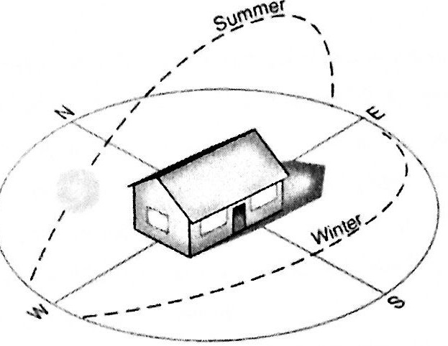
Through carefully study on basic micro climatic condition, we can ensure the most suitable orientation and composition that furthest utilize the potential of natural climate in the site. Designing with climate would result in a reduction of the overall energy consumption of the building by the use of passive (non-mechanical) structural devices. The lowering of energy consumption would further reduce overall emission of waste heat, thereby cutting the overall heat-island effect on the locality. The energy demand in buildings can be saved substantially by proper designing of walls and roofs, windows and lighting. Improved insulation of walls and roof can reduce the heating and cooling load by 25%. Improved multi pane windows can reduce the air conditioning heating load significantly.
Figure 22: Solar path in building
Arranging the building with its main and broader openings facing north and south gives the greatest advantages in reducing insolation and air conditioning load. Deep recesses may provide shade on the building's hot sides. A window can be totally recessed to form a balcony or small sky court that can serve a number of functions besides shading. Large transitional spaces may be provided in the central and peripheral parts of the building as air spaces and atriums. These serve as in-between zones located between the interior and the exterior. Atriums should not be totally enclosed but should be placed in between space. Their tops could be shielded bt louvered roof to encourage wind flow through the inner areas of the building.
      - PASSIVE SOLAR DESIGN
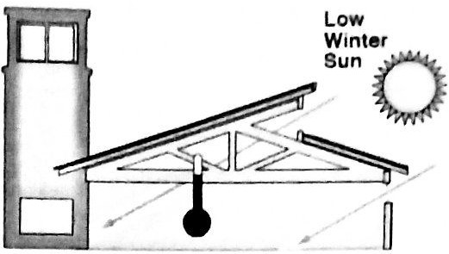
Passive solar design minimize building energy consumption by integrating conventional energy­ efficient devices with passive design elements, such as building siting, an efficient envelope, appropriate amounts of fenestration, increased day lighting design, and thermal mass. It balances all aspects of the energy use in a building: lighting, cooling, heating, and ventilation. The objectives are to control the entrance of sunlight and air flows into the building at appropriate times and to store and distribute the heat and cool air so it is available when needed. Many passive solar design options can be achieved at little or no additional cost. Passive solar buildings use 50 percent less energy than conventional energy.

Passive solar buildings offer many benefits including:
- Comfort: Greater thermal comfort, less reliance on mechanical systems, solid construction (more thermal mass), sunny interiors, and open floor plans
- Productivity : Increased day lighting, higher quality lighting systems, and reduced glare can increase worker productivity and reduce absenteeism
- Low Maintenance : Reduced building maintenance costs resulting from less reliance on mechanical systems
- Environmental: Reduced energy usage

Day Lighting
Effective transmission of natural light and balanced distribution is the key. The value of day lighting is universal to good architecture. The atrium concept allows the innovative exploration of day-lighting by bringing natural light into the centers of building, thus eliminating deep, dark spaces. The generated interior facades, in tandem with the exterior facades, serve to balance the distribution of daylight within the occupied zones. The use of day-lighting, a free energy source, can offset the cost of electricity.

Passive cooling
Most atrium buildings are thermally heavy (high internal heat gains). This makes cooling a very important concern. Cooling requires a higher level of energy expenditure per degree of temperature reduction than does heating per degree of temperature increase. There are potentially four passive cooling techniques available for use in atrium buildings.
- Control of solar heat gain through shading
- Use of thermal mass
- Radiative cooling
- Convective cooling based on stack effect

- Ventilation
Cross-ventilation and vertical, both natural and mechanically is important to maintain required indoor air quality and convective cooling. Exhaust vents should always be at the highest point in the atrium, on the leeward side. Raising the roof of the atrium above the surrounding roofs gives a location for these vents and creates a hot air reservoir which is above the occupied zones. The cool-air intake should be as low as possible and approximately one-third to one­ half the area of the exhaust vent.

D. Microclimates
Controlling the microclimates at the occupied levels can produce cooling effects. Plants and trees absorb heat and light. Tree canopies produce shade and hold cool air near the ground. Water features such as pools and fountains produce evaporative and cooling. There is also the psychological effect, the associations between greenery and water and cool gardens or courtyards.

E. Passive heating
The atrium can contribute to the heating function of the building it serves through passive solar heating. An atrium must have south facing glazing in order to contribute to passive solar heating. Skylights are not optimal for they favor the high-angled summer sun. Besides, sunspace can be most effective mode of passive solar heating in the design of atria.

    - SOLAR PHOTOVOLTAIC
Photovoltaic (PV) materials convert sunlight into useful, clean electricity. Building integrated photovoltaic systems (BIPV) offer additional design options, allowing electricity to be generated by windows, shades and awnings, roofing shingles, and PV-laminated metal roofing, for example. BIPV options can be used in retrofits or new construction. Commercial cell performance can range from 50-50 W/m² of the PV area depending upon the type of cell and PV cell density to allow the transmission of daylight.
Solar Panel Calculation
Normally, 4-6 hours of maximum sunlight of daytime is considered for the calculation as there time period may vary on days. The electrical power is stored into batteries, similar to the one used in automobiles.
In general, the dwelling units of 1415 sq.ft. requires 28 convenience receptacles and 10 luminaries rated 100W each.
Now,
      - Total general lighting, VA= 1415 sq.ft. x 3 VA= 4245 VA (3VA per sq.ft. for dwelling units)
      - Small appliance and minor other loads 1000 VA x 3 = 3000 VA
      - Cooktop , disposal, water heater= 6000+9000+4500= 11400 VA
      - Therefore, total loads= 4245+3000+11400= 18645 VA
      - Total loads= 18645 x 1.2 + 22374 VA (1.2 to compensate for battery charge/ discharge loss)
Step 2
Average sun hours per day= 4-6 hours = average 5 hours Step 3
Amp hour (Ah) output required per hour from solar= 5/2 = 2.5 Ah per day Step 4
Total watt hour (Wh) = 2.5 x 4 = 10 Wh closed to 12 Wh= 12 Wh (taken)
Step 5
Average Wh output: 12/0.5= 6 Wh (actual predicted Wh output of Panels.
PV Potential
The application can be significant for high-rise buildings since they provide an opportunity for a clear path of direct sunlight above other buildings. PV panels can collect energy in diffuse light, although distances between buildings, clustering and shadows will affect their efficiency. Nepal, due to its location, has potential for solar light energy.
PV remains a genuine energy generator. The best orientation for PV panels is south with a tilt angle of 27°.
The optimum tilt depends upon the season. Location and the height of the sun on a month by month basis. Typically the panels should be facing south with optimum angles for effective output. The performance of the solar system can be maintained throughout the year, if the angles of the photovoltaic panels can be adjusted.

Optimum tilt of a panel
JAN | FEB | MAR | APR | MAY | JUN | JULY | AUG | SEP | OCT | NOV | DEC
46 | 54 | 6 2 | 70 | 78 | 86 | 78 | 70 | 62 | 54 | 46 | 38
Source : solar electricity handbook.com
Note: On the 21st December, the sun rises 78 degrees of the due south and set 78 degree of due south. On the 21st March/21st September, the sun rises 91 degree of the due south and set 91 degree of due south. On the 21st June, the sum rises 104 degrees of the due south and set 104 degree of due south.
Architectural Design with PV

    - U-VALUE CALCULATION
U-value is also called air to air transmittance. It is the measurement of heat flow per unit area of wall or roof, per centigrade difference in temperature, taking the resistance provided by the thin layers of air inside and outside into considerations.
The resistance (R-value) of the material of thickness b, in meters, is given by R=b/k, where k is conductivity of materials.
For multi-layered building element, the overall total R value is given by,

Rtot = Rso + R1 + R2 + R3 + ………Rn + Rsi
1/fo + b1/k1 + b2/k2 + b3/k3 +.... .. .... ....Rn+ 1/fi
Where,
Rso= external surface resistance
Rsi= internal surface resistance
R1= resistance of material 1
Rn= resistance of material n
Now
U= 1/Rtot (W/m2 °C)

CASE STUDY

DHULIKHEL MOUNTAIN RESORT

Objective of study
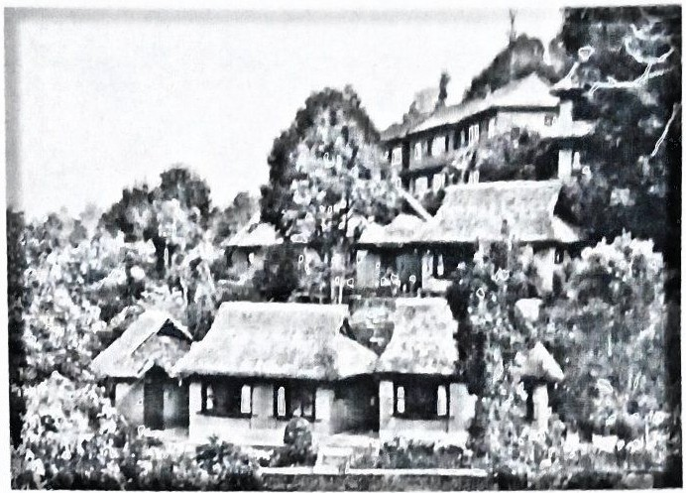
- To understand the use of vernacular architecture
- To play with natural landscape
Information
- Location:- Khawa, Dhulikhel, Kavre
- Area:- 200 ropanies
- Ground coverage: - 45 ropanies (37.5%)
General Introduction
Dhulikhel mountain resort is foreseen to serve for the accommodation , recreation, seminar venue for visitors from abroad as well as from inside the country. Only some 34 km from Kathmandu, the site provides visitors with a unique panorama of the northern hills. The promoter being an experienced person on the tourism business has all capacities to run this resort hotel in a profitable manner.

The Site
The resort is located at Khawa, Dhulikhe,l Kavre-palanchowk district. It is adjacent to the Kodari Highway. The site provides a wide range of panoramic views of Himalaya s as well as the beautiful views of the valley of Kavrepalnachowk district.
Architectural style
- Vernacular architecture of Dhulikhel
- Red brick with thatch roof in traditional style
Materials
- Maximum use of indigenous materials
- Mud mortar and bricks wall
- Thatch and bamboo roof

Accomodation
- 43 rooms in bungalows, all with attached bathrooms and all with sitting rooms
- Single storied building (individual units)
- Size- 8'X20'
- Type twin bedded room
- Double storied building
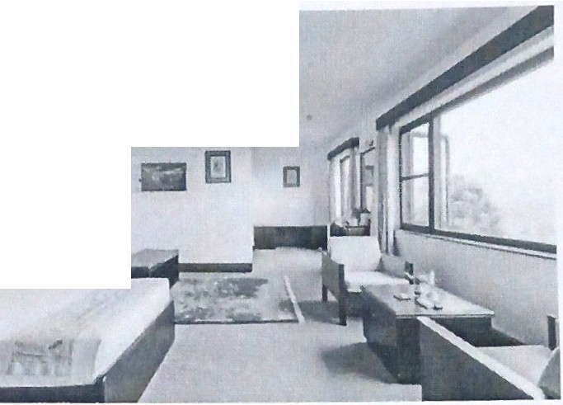
- Individual building with individual staircase
- Connected building with common staircase
Rooms
Rooms are arranged are arranged in a cluster, 43 rooms are provided in the resort and all rooms are of type deluxe. Use of carpet in bedroom floor and tile in bathroom is observed.

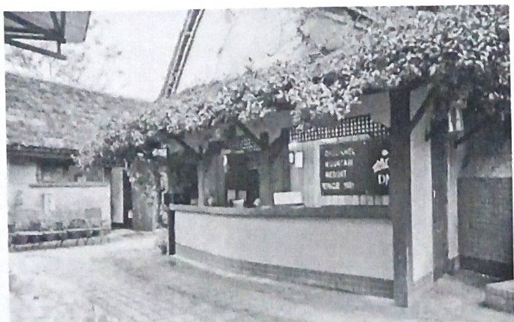
Entry and Lobby
Entrance is visible clearly from the road. Impressive and spacious lobby which can hold up to 40 guests at a time. Dining is done in lobby and there is provision of magazines and newspapers. Group briefing space is also provided in the lobby.

Restaurant
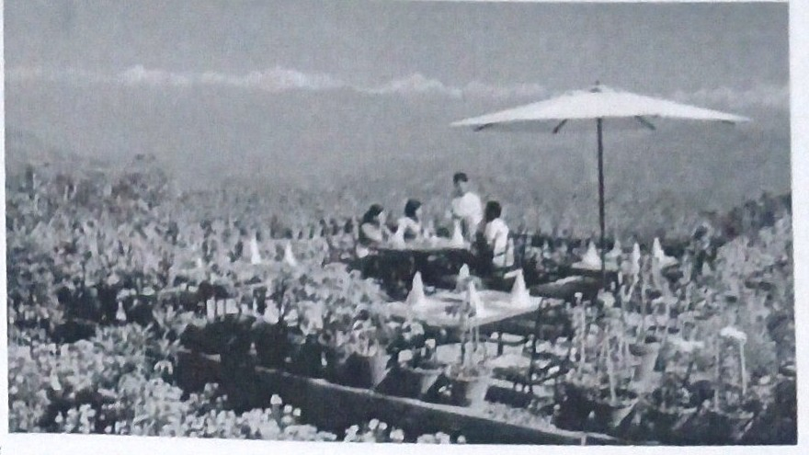
- Indoor restaurant 80 people
- Bar
- Open terrace restaurant- 350 people
- Toilets
- Kitchen- 16'X6' with floor height of 6'
It Is located near the reception area. The capacity of the inner hall of the restaurant is 85 people and outdoor of the restaurant can accommodate 250 people. Telia bricks is used as flooring with natural lighting.
Parking
- about 5 vehicles
- There is no proper planning of parking facilities.
- Insufficient area
- absence of boundary or barrier between highway and parking space
Conference hall/Seminar hall
- about 20'X28'
- capacity of 20 people
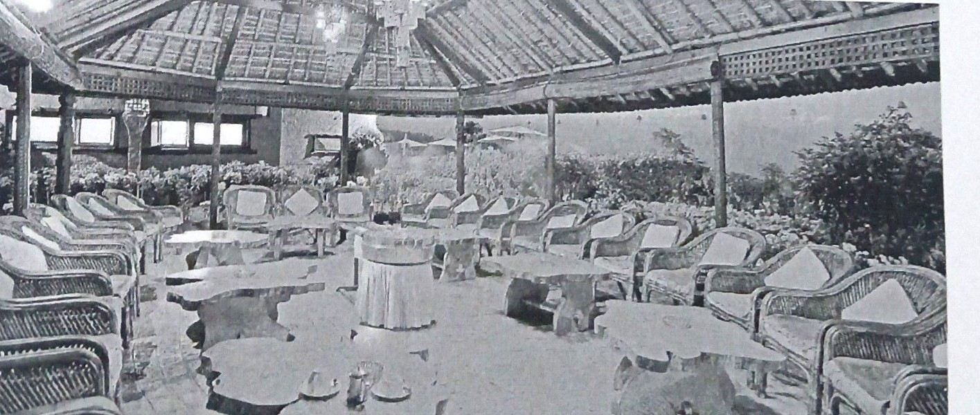
General Technical Specifications
- Type of Structure: The building is constructed in RCC frames with filler walls orb rci k or concrete block in portions not visibl e .
- Building Materials: machine made bricks and prefab. Outside of the buildings have exposed prefab brick works with lime pointing. Boundary fencing done with stone blocks in combination with machine made bricks. Brickwork done in (1:6) cement-sand mortar. Partition walls constructed in cement-sand (1:4) mortar. Stone works done in cement-sand (1:6) mortar.
- Foundation: Soil tests carried out at construction site. After the load bearing capacity of the soil was positively verified, the foundation had been constructed with RCC beds and brickworks in 1:6 cement mortar. Similarly, for other minor structures, foundations were built with PP beds and stone works in 1:6 cement mortar
- Plaster: The inside of the buildings have been provided with 1:5 cement plaster on the walls and 1:3 cement plaster on the ceilings. Some of the plastered surfaces have been applied with a coating of Plaster of Paris to achieve smooth finish and some other wallpapers of appropriate make and pattern.
- Doors and Windows: Doors, windows, frames, panels and glazed shutters have been constructed out of sal, sisam or teak wood. The shutters have been provided with necessary fittings of brass such as locks and bolts. Flushed doors are made of teak or ply wood as per necessity.
- Painting: The walls have been painted internally with plastic emulsion paint, synthetic enamel paint and water-proof cement powder. Outside walls are not painted so as not to conceal its natural look. Doors and windows have been painted with synthetic enamel or with French spirit polish following the design proposal.
- Flooring: Floors are constructed in RCC. The finishing of the bedroom and living room floor areas are done in carpet. The flooring is done in PCC followed by 1:6 cement base and 1:1 cement punning over it. Main public areas, guestroom toilets and public toilets are provided with marble flooring. Kitchens and corridors have marble or terrazzo depending upon the requirement of flooring. Glazed tiles are provided on walls at kitchens and bathrooms.
- Roofing: In order to give the building typical 'Nepali', the roofs are constructed with inclined RCC slabs. Following requirements, the load-bearing elements are built in RCC. Above the RCC slabs, thatched roof will be provided.
Organic Farming
seasonal vegetables 1nclud1ng spinach, celery, garlic, cabbage, coriander, etc are grown organically in the resort premises.
Water Supply
water supply is maintained by deep well boring. A test bore hole is made to ascertain the quality of water available underneath.
Supply of hot water is continuous in the guest rooms, kitchens, toilets and other areas
wherever necessary. This is maintained through the installation of solar heaters boosted with individual boilers.
Electrification
The main connection of electricity supply to the sites is tapped from the existing line nearby. Besides this , a standby diesel generator with an automatic charger over switch is provided , keeping in mind the possible cuts in the electricity supply of the town.
Inference
- Building orientation offers best view of Himalayas
- Using vernacular architecture reflecting traditional architecture
- Calm and peaceful environment in and around the complex
- Existing landform should be maximum utilised.

GODAVARI VILLAGE RESORT
Objectives:
- To understand the planning relationship between front and back of the house and to study the setting of different types of recreational facilities.

- Location : Godavari VDC, ward no. 1
- Site Area: 135 ropanis
- Ground Coverage: 22-25% of site area
- Owner: Shreedhar Pd. Acharya
- Programs : Guest accommodations, reception/waiting , dining hall, bar and kitchen, conference hall, administration block, recreational block with spa, steam jacuzzi, parlor, billiard, gym, lawn tennis, etc.
Set on the bank of meandering stream amidst a lush green terraced valley, with the magnificent backdrop of the mighty Himalayan snow-clad peaks, the Godavari Resort offers the finest traditions of Nepalese hospitality combined with international standards of luxury and personalized service.
Within the setting are 68 well-appointed ad spacious rooms including 4 suites for the ultimate luxurious comfort. The recreational facilities include a swimming pool, tennis courts, billiard room, skittle alley, fitness centre, Jacuzzi, sauna and massage as well as mountain biking and arranged walking tours for more adventures.

Land form and orientation:
The site has contoured land sloping towards west. Site is surrounded by lush green terraced valley, with view of mountain at south, west and north. It is east oriented hence is very sunny site. Surrounding has 1-2 storied buildings that do not block which acts as sun to the site. Level of the resort descends slowly from the reception block. The level of the ground has been maintained and the steps and paths leading down have been paved. All the blocks of the resort are constructed on contoured land sloping downwards allowing a good view of the mountains and hills in the south direction.
Architectural Expression
The resort is designed in the concept of village architecture. The buildings reflect the newari architecture of the valley through exposed bricks and pitched jhingati roof. The resort is located on a terraced land offering incomparable landscape with diverse panoramic view. A wide variety of material is used in the resort. But most used material is brick which is used in the entire building facade and also in the paths and steps Concrete paving has been used in children playground.
Planning of resort:
It is a well-planned resort with separation of front of house, back of house and outdoor recreational area. Entrance to site is from east with parking near entrance at east. Front of the house including reception, dining hall, guest units at middle of the site to east guest flow. Back of house is at north direction at the back of administration and dining block which acts as visual barrier between front and back of house.
Recreational area is at western part, noise from recreational area is buffered using natural vegetation .
On entering the main gate, along with a roughly managed parking are, we can view a double height circular reception. The central space in the reception block is used as a passage with reception on lobby on its either sides. The undulation of the ground is an exclusive feature of the resort that adds to its pleasant appearance. The traditional buildings compliment the landscape offered.
There are 12 blocks out of which 6 are named after gods i.e. Bijaya, Shiva, Medina, Achala , Ananda, Basundhara and the rest are Sumeru and garden restaurants, Vaijanta and so on. All these guest units are placed as an individual blocks separated from each other, giving different access to each of the blocks. This provides privacy in each of the accommodation units.

Landscape Characteristics
Landscape of the resort is an important part to enhance its outdoor aesthetics. The landscape must be properly planned and designed to get a good result. But in this particular resort, the landscape was not done through systematic planning. Hard and soft landscaping can be observed in the resort.
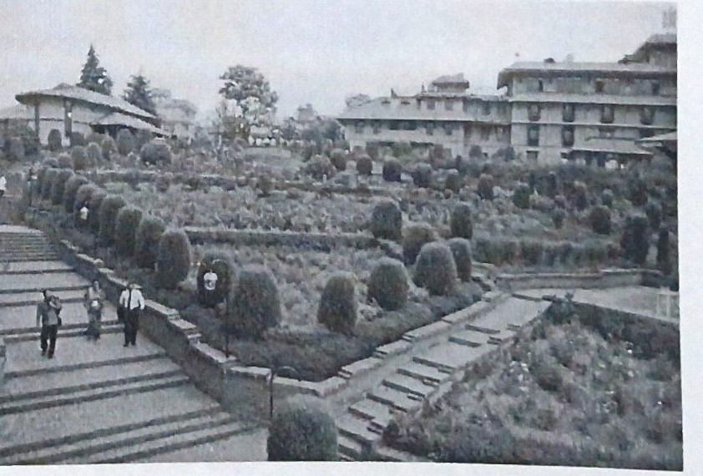

All the steps and paths have been paved with brick. Besides this, the parking area has also been covered with gravel. The swimming pool area, tennis court and children playing area have also been finished with hard landscape.
The garden on the either side of the paths and steps form the soft land scape of the resort The natural vegetation like trees, plants, colourful flowers are beautifully planted flowers to the aesthetic of the resort.
Natural Vegetation
Natural vegetation is enhanced in this resort. Natural vegetation is enhanced in this resort. Most of the plants belong to tl1e native land. Different types of plants such as cactus, shrubs and trees of various types, colourful flowers comprise the vegetation part of the resort. The trees are planted in an organized manner.
Artificial Elements
Various artificial elements for landscaping have been used in the resort besides natural elements. Pati, sitting area, water bodies, ponds with fountain, artificial lighting has been used in the resort.
Water Bodies
Water is the most interesting object in a landscape and the happiest circumstance in retired recess; captivates the eye at a distance, invites approach and is delightful when near; it refreshes and open exposure and enriches the most crowded view; in form, in style and in extent, may be equal to the greatest composition.
Water bodies may be in still or flowing form. In the case of this resort, no flowing water bodies can be found. Only still water bodies like ponds on either side of the path and tile swimming pool are the major element of landscape under water body.
Sitting Areal Pati
This forms a part of artificial landscaping. These sitting area are found in front of the garden restaurant where guests can sit enjoying the nature or protecting themselves from sun or rain.
Artificial Lighting
Artificial lighting is used in the resort in landscape are for the purpose of adequate lighting in the night time. These lightings complementthe landscaping features during night.
Children's Play Area
Playing area for children are located below the pool area. This area has various playing facilities for children, the facilities include slides, swings, monkey climb, skittle alley, etc. this part has few plantations only along the periphery of the playing area. Circular sitting area made of bricks is provided.
Swimming pool
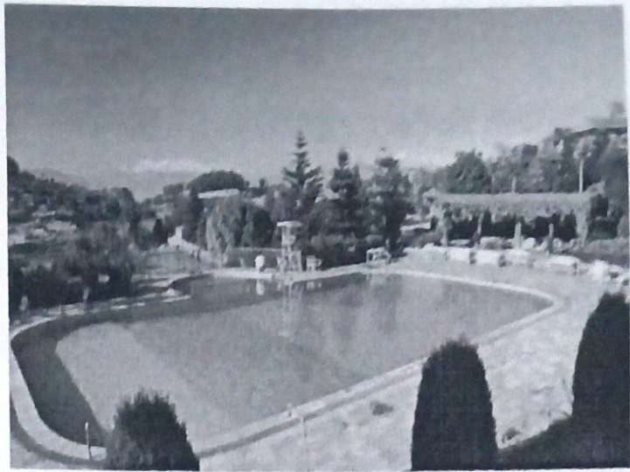
The swimming pool is another important landscape element of a resort which serves also as a gathering area. The pool is in geometric form with rectangular shape and semi-circular portion on one side. The depth vanes up to 3'-7' with attached semi-circular children pool. The area for sunbathing around the pool adds more life to the pool area. Children's playground is besides the swimming pool.

Clay Tennis Block
Tennis court is situated to the side of the children play area and below swimming pool. Hard landscaping of clay material is used in the court. The clay material is used in the court is from aluminous silicate rocks. It is generally plastic when wet but hard when dry
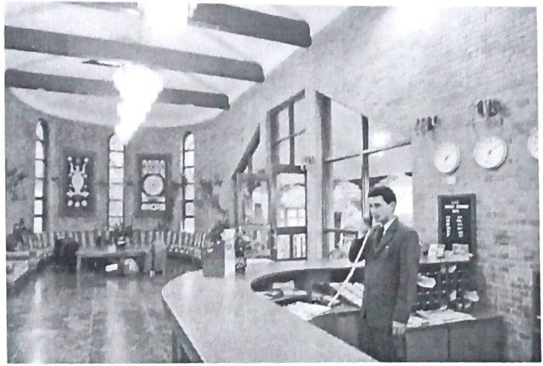
Reception
Reception is single storied block with double height. Brick exposed façade with slope concrete roof (Jhingati tiles). Roof supported with carved wooden pillars. Narrow tall windows at circular ends with flooring of mosaic tiles. Wooden furniture with warm coloured cushion.
Recreational Block
It is designed at the low land of the site. It houses facilities like gym, sauna, Jacuzzi, parlor, souvenir shop and changing room. The block is two storied with flat roof and skirt flooring with swimming pool at front.
Guest unit
The total of 69 units are present in 6 different block of Godavari Village Resort.
- Each block with separate access
- Two storied with traditional doors, windows frame, exposed brick fa9ade and slope roof with tiles supported by struts.
- Main building (Sumeru) -17 rooms
- Old Kailash - 16 room
- New Kailash - 12 rooms
- Cottage (total 6) - 29 rooms (1 cottage - 4 rooms, 5 cottage - 5 rooms each)
- Club house - 4 rooms
Short comings
- Parking is not specified.
- Separate service entry is not designed.
- Guest Units placed above dining hall gets disturbed by service area.
- No provision of ramps for disables.
- Conference hall does not have spill out area.
- Mix use of building is not desirable
Inferences
- Maintaining the natural contour of the land makes the landscape more interesting
- Although more green areas are preferred in landscape, hard landscape also plays an important role in landscaping.

LAVA HOMES
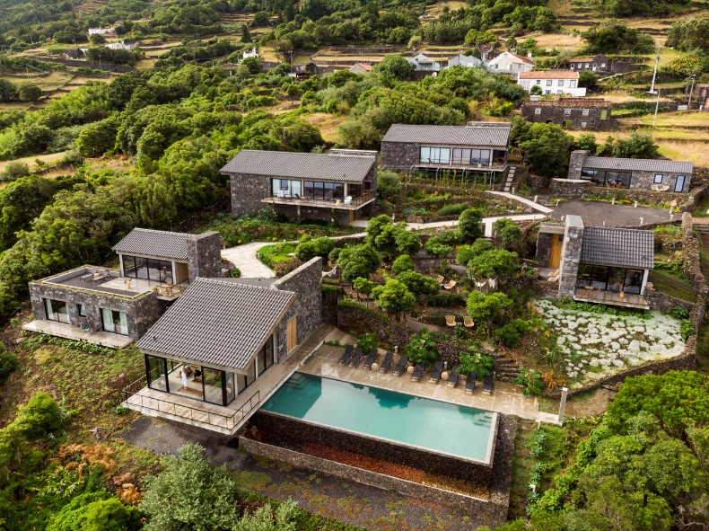
INTRODUCTION
- Architects: Diogo Mega Architects
- Area : 18944 ft²
- Year : 2019
- Lead Architects : Diogo Mega
- Country: Portugal

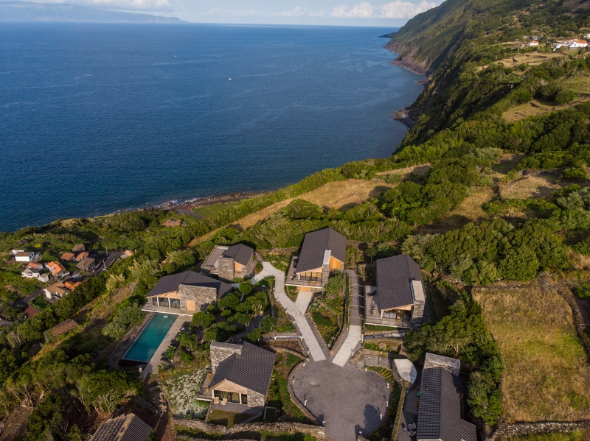
With a unique landscape, cultural heritage and environmental surroundings, where calm and tranquility predominate on the natural environment. A home away from home, in a lost paradise.
The parish of Santo Amaro, located on the north coast of the island, is 20 km away from the county main village. It has a population of around 300 inhabitants, known for its hospitality and well-being, attracts more and more tourists every year.
The view to the West allows to observe the whole bay of Santo Amaro, and allows to see the top of the mountain of Pico, in day of little cloudiness.The grounds were chosen for their natural beauty, flora and the existence of several ruins, which give a picturesque tone to the enterprise. The development is crossed longitudinally by a canada - Way of the Voltas - that belongs to the Railings of the Azores - Pico. The canada was kept untouched, with the integral preservation of the floor and the walls. On the grounds were two ruins of old houses, as well as some ruins of animal pens.
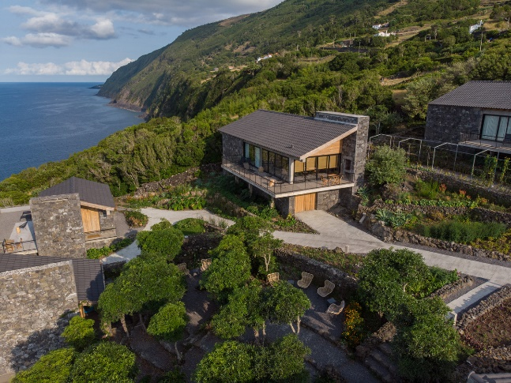
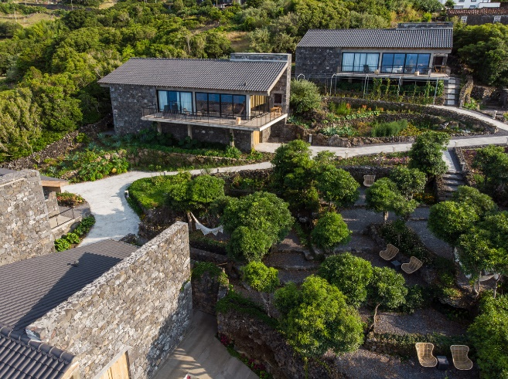
Our positioning is based on the conservation of nature, environmental quality and the safeguarding of the historical-cultural heritage and local identity. All housing units are equipped with photovoltaic panels, heating is done by salamanders to pellets, cooling is done by natural ventilation, water tanks have been kept for use in the irrigation, and the drinking water served is filtered local water by an active carbon system.
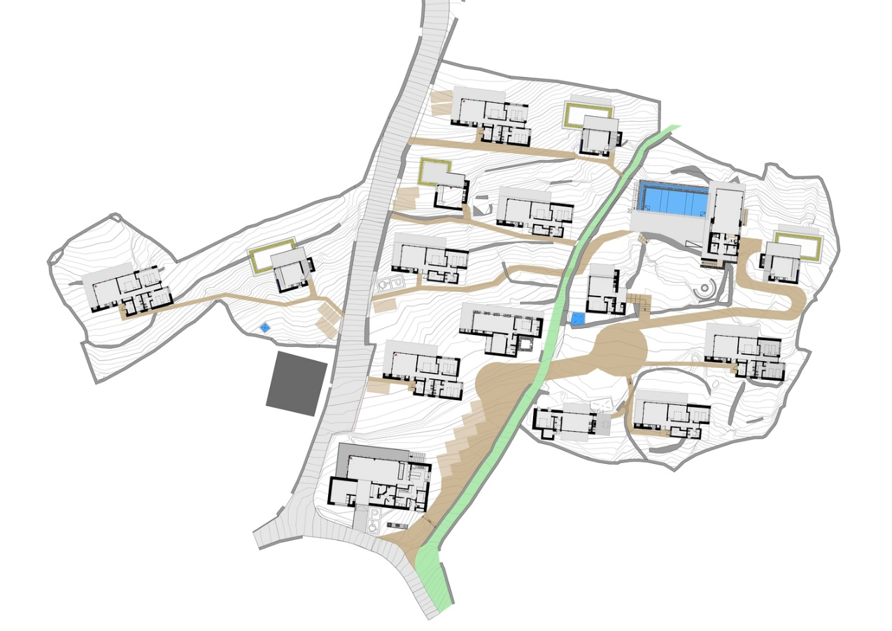
The Resort is made up of fourteen accommodation units:
- Three of typology T1 - A bedroom, a toilet and living room with kitchenette;
- Eight typology T2 - Two bedrooms (one with double bed, the other with two beds that can be joined), a bathroom and living room with kitchenette;
- Three of typology T3 - Three bedrooms (one with double bed, one with two beds that can be joined and a suite also with two beds that can be joined), a separate toilet for service of the first two bedrooms and living room with kitchenette.
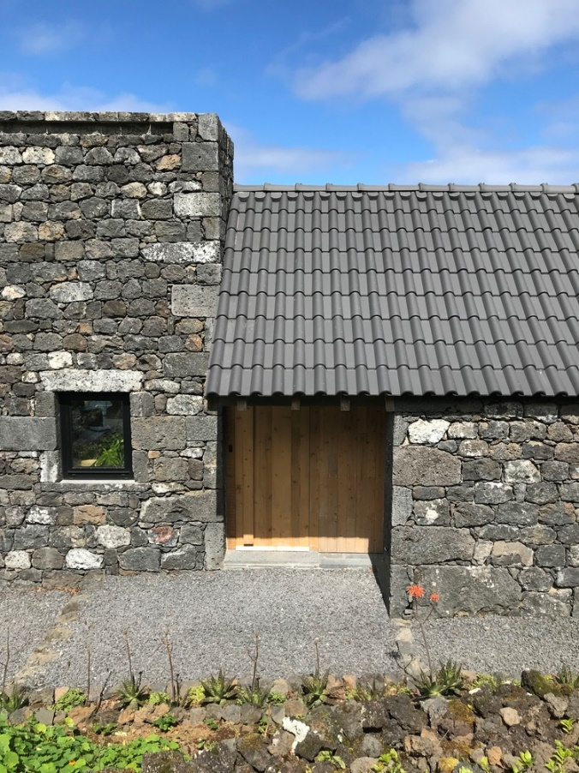
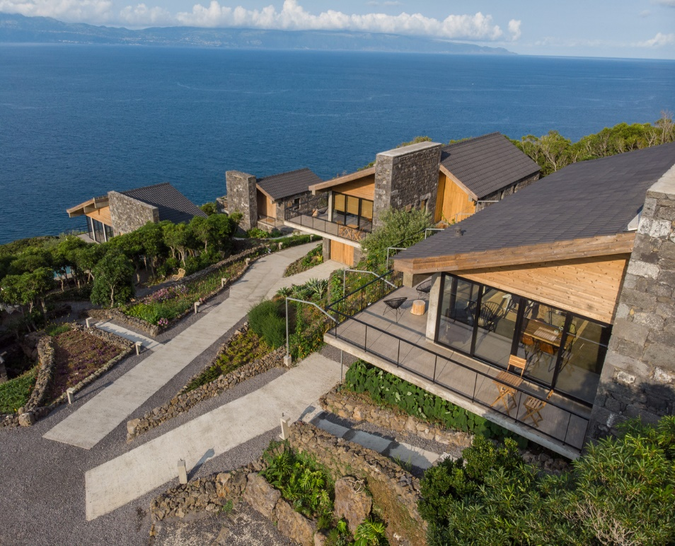
With the dimensional characteristics of the lots and the steep slope, terraces, the ruins, as well as the new proposed houses, will all have privacy as well as a large surrounding green area and still full and panoramic sea views, both for the Canal and the Island of São Jorge, as well as the bays of the island of Pico, beautiful sea recesses along the parishes of Santo Amaro, Praínha and São Roque.

SUSTAINABILITY
The project was designed to alter as little as possible the topography of the land, so that the integration of the houses was as harmonious as possible.

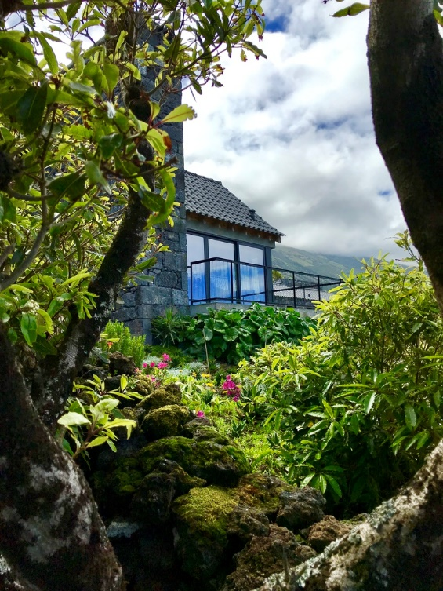
MATERIALS
In the design of the resort local materials were used, namely the stone and the wood of criptoméria, in the interiors and exteriors (ceilings, facades, some furniture).
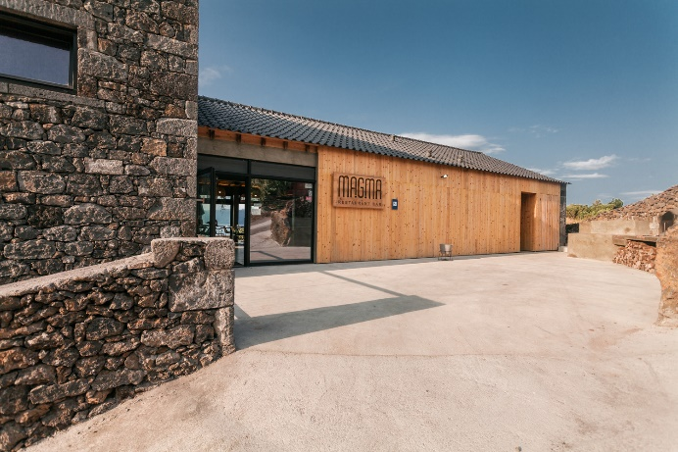
Materials were used that allow the thermal and acoustic insulation of all houses. All windows and glass doors of the development are double-glazed.

LANDSCAPE
In the gardens, we introduced local plants, many of which were endemic, and preserved the species that existed initially.
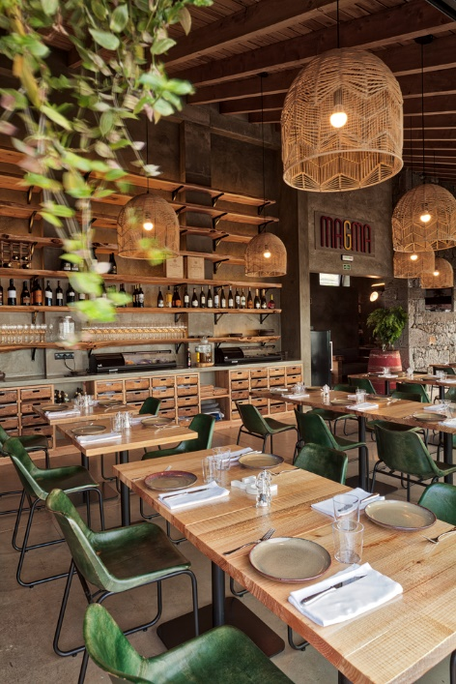
RECYCLING
They do the total separation of the garbage for recycling. They kept the old tanks (cisterns), with use of rainwater for irrigation.
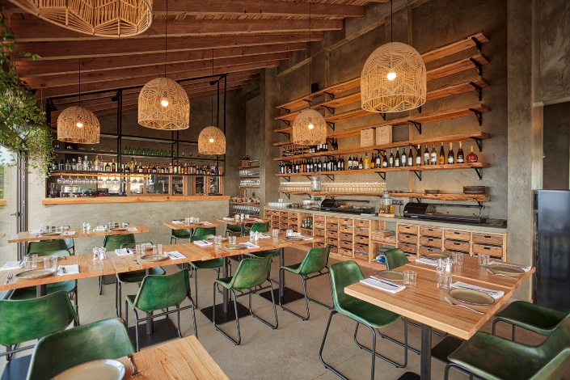

The heating of water is made using energy-efficient heat pumps, coupled to photovoltaic panels that will potentiate them, minimizing energy consumption and preserving the environment. The heating of the houses is done through pellets stoves, a clean and renewable energy.

In the lighting of the whole project were used led lamps and some have a motion sensor (for example, in the bathrooms of the restaurant). The lights of our houses are connected by card so that they are not lit during the absence of guests.

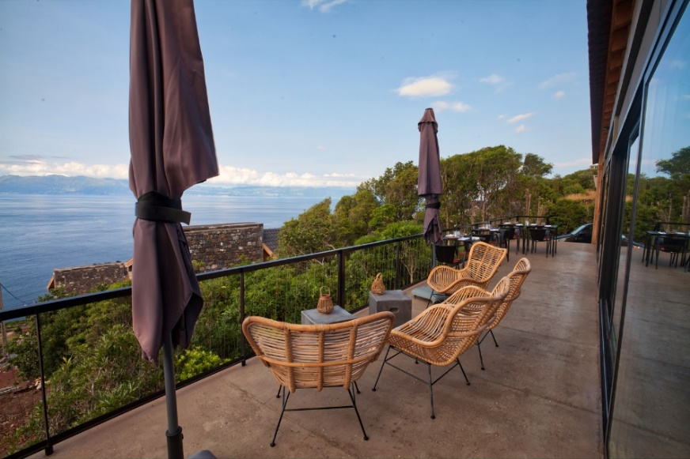
Most of the products used in our restaurant (meat, fish, honey, jams, vegetables, fruit, eggs, cheese, butter, etc.) are produced on the island.

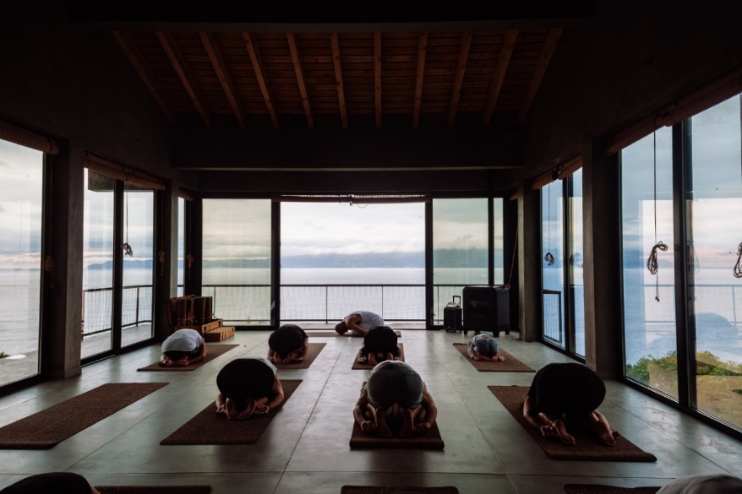

ADDITIONAL LITERATURE

LIBRARY
Libraries can be of different types such as academic libraries, public libraries, specialist libraries, etc. So, the type of library depends upon the aims of the library. In the homestay, library though is a small unit but it plays a vital role. The spaces required for the library are reading space, space for stacking the books, office area, toilets, pantry, waiting area, magazine and newspaper section, storage, browsing space etc. The main assets of library are its books, so consideration should be made to protect the book. Security against theft, fire, light, humidity, etc should be considered. Proper ventilation should be provided. The number of bookshelves depends on the type of organization, accessibility for the users, type of shelving, its method of installation, the structural grids, etc. Illumination level required for the different spaces are given below:
- Non- work rooms- 100-300 lux.
- Stacks- 150-300 lux.
- Offices and administration block- 250-500 lux.
- Reading and catalogue rooms- 300-850 lux.
Reading area should be easily accessible. There should be a clear directional system with easily read signs giving directions to the services and the bookshelves. Reading space can be of combined type or single booth system can also be provided. Circulation space should be well designed in reading area and also in the shelves area. Avoid offset levels, as it will obstruct for transporting the books and the movement of disable people. Staircase and lifts should be provided for the transportation of books and for the disable people. For the security reasons, only one entry and exit should be provided. For the functional reasons, the control gates should be near the lending desk or central information desk. Workspaces should preferably in daylight area. Crossing and overlapping of routes for users, staff and book transport should be avoided.
Space requirement:
- Structural grids of > 7.2 m x 7.2 m have been found to be suitable owing to the flexibility they allow in fitting out.
- Room height should be greater or equal to 3m.
- The shelf height must not exceed 2.25 m.
- Circulation routes should be > 1.2m wide, and clear space between shelves at least 1.3 -1.4 m wide.
- The area required for a simple reading and working place is 2.5 m², for a PC or individual work place greater or equal to 4 m² is needed.
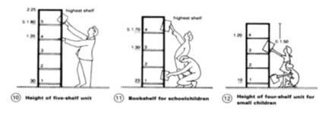
- Reading table must be minimum 1mx 0.70 m in size. Minimum width of 0.60 m should be left between the reading tables.
Figure 23: Dimension of Open Access Shelf

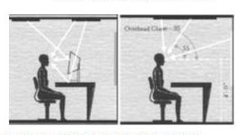
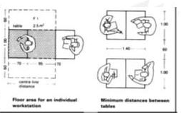
Figure 24: Glare and veiling reflection
Figure 25: Seating space requirements

DINING AND KITCHEN
The principal factors to be considered in planning the dining area area as follows:
- Number of persons to be seated
- Space used at the table
- Space for chairs and for passage behind them
- Seating arrangement
- Size and type of furniture and
- Storage space for china, glassware, silver and linen
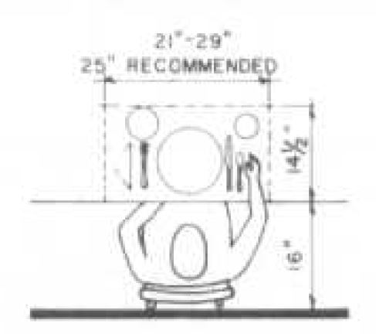
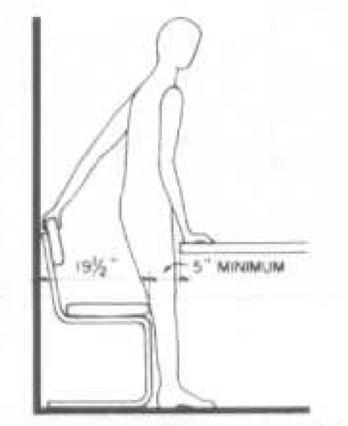
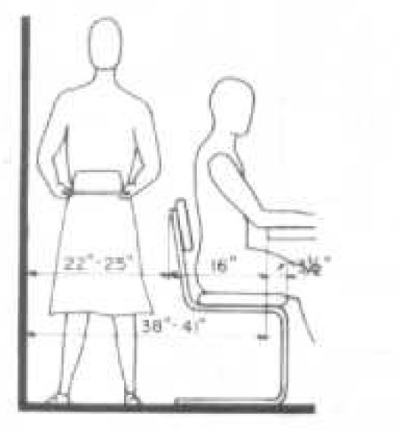
Figure 26: size of place sitting
Figure 27: Leaving the table
Figure 28: Passage behind chairs
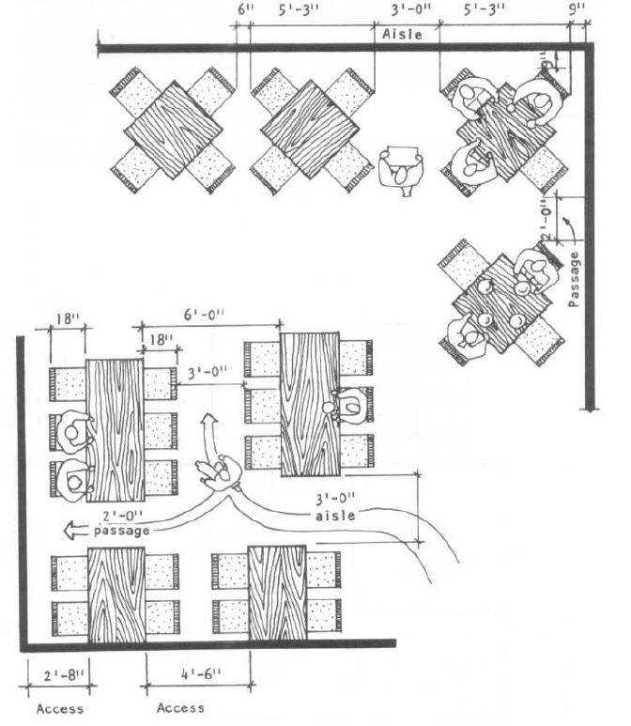

Figure 29: Sapce flow in Dining hall:

BEDROOMS
To assure adequate space for convenient use of furniture in the bedroom, not less than the following clearances should be observed:
- 42” in at one side or foot of bed for dressing 6” in between side of bed and side of dressser or chest
- 36” in front of dresser, closet and chest of drawers
- 24” for major circulation
- 22” on one side of bed for circulation
- 12” on least used side of double bed. The least used side of a single or twin bed can be placed against the wall except in bedrooms for the elderly.
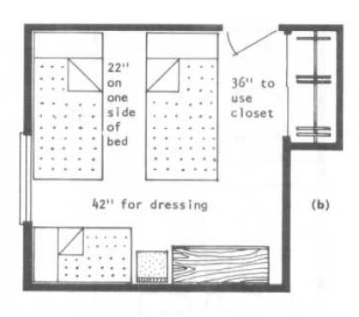
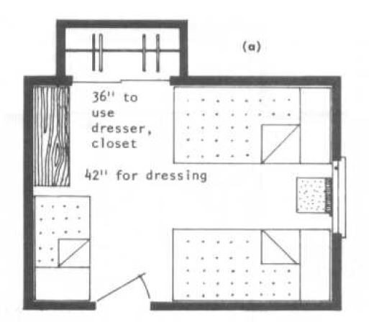
Figure 30: Primary bedroom
Figure 31: Primary bedroom

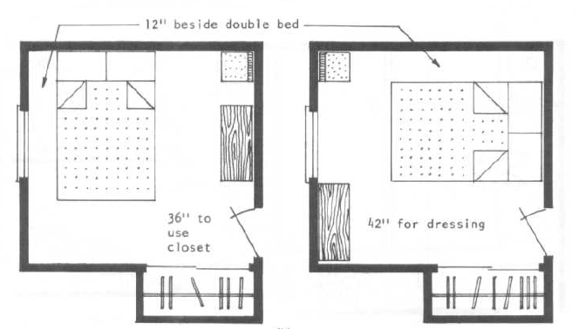
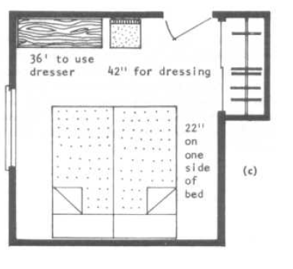
Figure 32: Primary bedroom without crib
Figure 33: Double occupancy bedroom

BATHROOM
Activities commonly performed in the bathroom include washing of hands, face and hair, bathing, elimination and grooming and also such activities as hand laundering and infant care. Often it is also used as a dressing room. Major problems in bedroom design includes planning for optimum convenience and privacy of all bathroom functions for all members of the household, adequate provision for storage of supplies and equipment, and ease of cleaning.
Some general planning guides that need to be considered are:
- Arrangement
- Illumination
- Ventilation
- Sound control
- Auxiliary heat
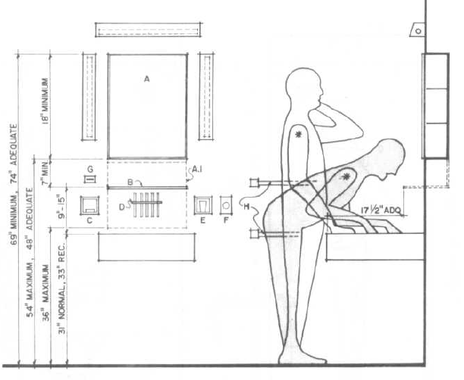
- Materials
Figure 34: Elevation space requirements
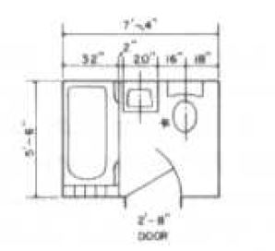
Figure 35: Plan of a bathroom

PARKING
Vehicles dimensions
In the Homestay design, the different kinds of vehicles should be considered for proper design of parking spaces. Vehicles, its types, size plays an important role in design of roads and related functions. Vehicles are available in different size and the variety, so it is necessary to know the standard sizes of the vehicles and can be applied to all of them. Bicycle, motorcycle, cars, van, etc has to be considered.
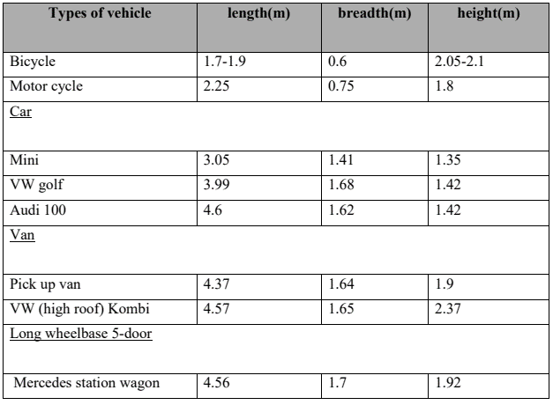
Figure 36: Dimensionss of Vehicles

Turning and parking
Width and quality of the road is governed by the size of the vehicle, number of vehicles. Beside these turning area and radius are also equally important for proper design of roads and parking spaces. Turning can be providing through various means such as loop, hammerhead turning space, etc. Adequate clear area should be provided along the outer edge of the road for the safety purpose. Hammerhead turning is mainly suitable for the turning of cars and the vehicles below its size. The turning circles for the vehicles are given below:
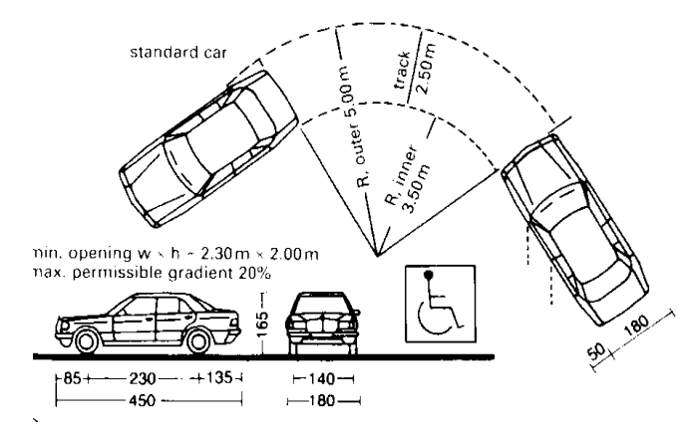
Figure 37: Turning radius of car
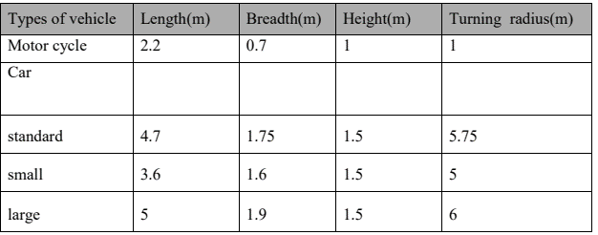
Figure 38: Turning radius of different vehicles
Parking can become a big issue if properly not designed. In the parking area different factors have to be considered such as the demarcation of the area for the vehicle to park or the parking limits. For this paints and guide rails can be used. Signs or barriers can be provided to guide proper parking of the vehicles. Parking can be done in various ways; some of them are as follows:
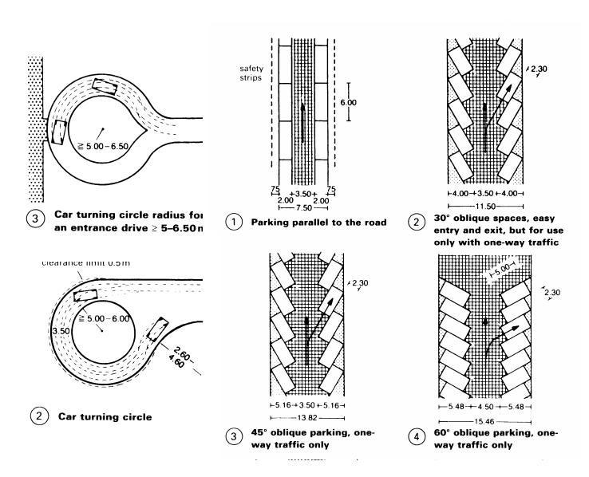
Figure 39: Various parking layouts
- 0° or parallel to road- entry and exit to the parking area difficult so this type of parking is suitable for the narrow streets.
- 30° parking- easy entry, exit, and use there where large parking space can be provided.
- 45° parking- good entry and exit, normal type of layout and small space is used.
- 60° parking-this type is often used, good entry and exit can be achieved in less area.
- 90° parking – (Parking space 2.5m)-sharp turn needed for entry and exit
(Parking space 2.3m)-less area needed, ideal for compact planning and is used frequently.
Parking area for the vehicles is determined by the size of the vehicle. Length, breadth and height of any vehicles determine the area needed for the parking space as shown in figure 5. To achieve organized and safe parking area few things have to be considered such as;
- Parking spaces should be outlined by white or yellow colored painted lines.
- Stop rails or buffers should be provided
- Guide rails can be provided.
The gradient of the ramp in the parking area should not exceed 15%. Parking spaces can be sunken and planting can be provided. Planting not only enhances the look of the area but also provides shade and good environment by absorbing dust.

UNIVERSAL DESIGN
Barrier Free Environment is one which enables people with disabilities to move about safely and freely and to use the facilities within the built environment. The goal of barrier free design is to provide an environment that supports the independent functioning of individuals so that they can get to, and participate without assistance, in everyday activities such as procurement of goods and services, community living, employment, and leisure. The fundamental principles which have been followed in developing standards / norms for various facilities to meet disabled people’s standards for safety, convenience and usability. Barrier free design standards should satisfy anyone who is hampered in his mobility or functioning (as compared with a nondisabled person) as a result of obstacles put in his way by the design of a building, the choice of hardware and equipment, and the arrangement of outside space. The physically disabled benefits everyone. The main purpose is to integrate disabled and elderly persons fully into the society. The presumption that all elderly is handicapped, or that all handicapped are elderly, is an over simplification of the needs of both groups and is a disservice to both. Building types to which the recommendations may be applied for are residential buildings other than domestic buildings, commercial buildings, industrial buildings, health care institutions, educational establishments, community and religious centers agricultural and transport facilities. The guide lines have also indicated the minimum access provisions required in various types of buildings. The primary objective of this report is to frame guidelines for non-ambulant (chair bound), semi-ambulant (lower limb impairments), visual, and hearing disabled persons. This construction and maintenance standard should be followed in all categories of buildings and facilities used by the public for making accessible to and functional for physically disabled persons. Although the recommendations are concerned exclusively with the requirements of disabled people but the facilities will invariably make buildings more convenient for elderly persons and persons suffering from any kind of physical ailments. A safer, easier environment for Builders, designers, and architects and architects are ultimately the users of this standard to ensure the specific environment created by them are suitable for all categories of people. The standard also indicates that barrier free design can be achieved without economic burden to the client, builder, designer, and the architect. It will help to provide framework for developing policies to ensure a barrier free environment and eliminate the lack of awareness in both the public and private sectors to the problem of accessibility. This standard shall be a valuable document to exchange comments between disabled consumer architects and others interested in an environment which does not exclude disabled people. This may also generate research activities to provide required knowledge base.

Type of Disabilities

Various, disabilities which have been considered while preparing the guidelines for barrier free built environment are broadly classified under four categories
Figure 40: Disabilities
1. Non-Ambulatory: Impairments that, regardless of cause or manifestation, for all practical purposes, confine individuals to wheel & chairs.
2. Semi-Ambulatory: Impairments that cause individuals to walk with difficulty or insecurity. Individual using braces or crutches, amputees, arthritics, spastics &those with pulmonary & cardiac ills may be semi-ambulatory.
3. Sight: Total blindness or impairments affecting sight to the extent that the individual functioning in public areas is insecure or exposed to danger.
4. Hearing: Deafness or hearing handicaps that might make an individual insecure in public areas because he is unable to communicate or hear warning signals.
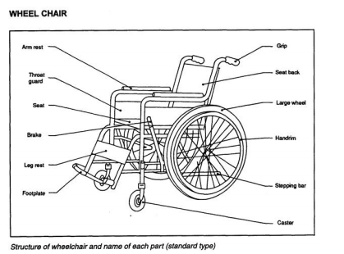
Figure 41: Typical wheel chair

RECOMENDATIONS:
- Adequate space for persons using mobility devices
- Adequate space should be allocated for persons using mobility devices, e.g. wheelchairs, crutches and walkers, as well as those walking with the assistance of other persons.
- The range of reach (forward and side; with or without obstruction) of a person in a wheelchair should be taken into consideration
- Attention should be given to dimensions of wheelchairs used locally. Standard size of wheel chair has been taken as 1050mm x 750mm (as per ISI).

RANGE OF REACH:
- A wheelchair user’s movement pivots around his or her shoulders. Therefore, the range of reach is limited, approximately 630 mm for an adult male.
- While sitting in a wheelchair, the height of the eyes from the floor is about 1190 mm for an adult male.
- A wheelchair has a footplate and leg rest attached in front of the seat. (The footplate extends about 350 mm in front of the knee). The footplate may prevent a wheelchair user from getting close enough to an object.
- Manually operated equipment must be designed to be easily accessible from a wheelchair.
- Make sure that the coin slots of vending machines etc. are located no higher than 1200 mm.
- Allow a space at least 350 mm deep and 700 mm high under a counter, stand, etc.

Building Bye Laws and Policies

National Urban Policy, 2007
Nepal's main document for guiding urban development is the National Urban Policy. Among
the goals of the policy are:
- A balanced urban structure is achieved by diverting investment to underdeveloped areas.
- Increased resistance to environmental shocks and stress, as well as tapping local economic growth potentials, are key to the establishment of safe and affluent urban areas.
- Effective urban management requires the development of local government capability (Bhadari et al., 2017).

Building Bye laws for Housing and Apartment
The major points in building bye laws for housing and apartment are as follows:
- Minimum land area should be 2 ropani.
- Maximum ground coverage for the cities of mountain, terai and Kathmandu valley region should be 50% of the total.
- FAR excluding old cities area should be:
  - Terai: 1.5
  - Mountain: 2
  - Kathmandu: 3
- The main access road should have minimum width of:
  - 4m for 4 housing units
  - 4.5m for 10 housing units
  - 6m for 50 housing units and
  - 8m for more than 50 housing units.
- The radius of the driving curve should be 9m and the intersection curve of two roads should have minimum radius of half the width of the road.
- Open space for the provision of water sewage to the ground for city areas of Terai, mountain and Kathmandu valley region should be 20%.
- Open space for other purpose for city areas of:
  - Terai region: 40%
  - Mountain region: 30%
  - Kathmandu valley: 30%
- The distance between two blocks in the city areas of Terai, Mountain and Kathmandu Valley region should be 6m.
- Minimum parking area for a housing units of area 80m2 or more should have a space for 1 car, 2 motorbikes, 2 bicycles and for every 4 housing units of areas less than 80m2 should have space for 1 car, 4 motorbikes, 4 bicycles (Bhadari et al., 2017).

Climate-responsive design in Vernacular Houses of Terai
The analysis of vernacular architecture in Nepal’s subtropical climate refers to the following houses: Tharu houses in Chitwan , Traditional Tarai houses, Rana Tharu/Tharu house in Kanchanpur district of Far-western region, Dangaura Tharu house in Dang district of Mid-western Region and Eastern Kochila Tharu in Morang and Sunsari of Eastern Nepal. Due to the dominating tropical monsoon climate houses have to protect from heat and heavy rainfall. Local materials mainly used are cane, timber and thatch. They lead to the design of a comfortable ‘breathing’ house that means the building envelope is rather permeable and enhance natural ventilation.
    - Settlement pattern
The traditional settlement pattern in sub-tropical climate of Nepal is rather loose than dense. Tharu houses are either loosely situated along the road or they create clusters of semi-closed compounds. Rana Tharu houses are arranged around a courtyard that is open to at least one side so that breezy winds can flow through the settlement. In the Dangaura Tharu village the long houses are arranged in one single row along the road with a wide open yard in front of each house. This facilitates easy penetration of air through the houses.

Building form and orientation
The buildings have rectangular floor plans that are enclosed with low walls, sometimes no higher than 75 cm. Dangaura and Eastern Kochila Tharu houses are found to be typical Longhouses while Rana Tharu houses have a more compact floor plan. The longer axis of Dangaura Tharu houses is more than twice of the shorter axis. The longer facade is typically oriented north-south which reduces the exposure to the sun.

Building stories and internal space arrangement
Most vernacular houses in Tarai have only one single floor or, like Rana Tharu houses, a ground floor with a mezzanine that is used as storage. They have high ceilings for enhancing permanent ventilation that is strongly needed in this hot and humid climate. However, due to increasing urbanization and higher settlement density one of the Tharu studied houses in the Eastern Nepal was found to be of two-story. The spaces in the studied houses are organized more in a horizontal manner. The internal space is almost undivided and, thus, enhances a continuous natural circulation of cool air coming from the shaded area below the eaves. The studied Longhouses have only one division that does not reach the roof so that air can freely circulate. In Rana Tharu/Tharu houses big vessels, which store grain, are used for dividing the space. In all Tharu houses semi-open spaces in form of a veranda are occupying a large part of the floor plan. The verandas are shaded by the roof overhang and provide an additional comfortable space for daily activities. Having two story houses, the Eastern Kochila Tharus use the second floor mainly as sleeping rooms and storage. One third of the second floor plan consists of a veranda that provides a breezy semi-open sleeping space for hot and humid summer months.

Walls
The walls of traditional Tarai houses are rather light and mostly made of wattle and daub. The upper portion of the exterior wall is observed to be of bamboo strips that are loosely woven into an open mesh which provide day lighting and permanent ventilation. Unplastered walls of wood or reed have random gaps. External walls might also be made of thin woven cane mats tied onto a timber frame, rendered with mud plaster and white washed.

Roof
Most traditional roofs in Nepal’s subtropical climate are made of thatch in form of a pitched roof. The triangular opening at either end and the low windows ensures the permanent inflow of air from the shaded area below the eaves that leads to inside temperatures that are usually much lower than outside temperatures. Dangaura and Kochila Tharu houses have also light, well insulating thatch roofs. The wide roof overhang protects walls from direct sun radiation. Verandas are formed by extending the roofs and provide a comfortable place to work and even sleep at night.

Foundation, floor and ceiling
Typically, Tharu houses are found on a plinth made of stone or earth to protect the interior from flooding during raining season. Some houses are built on wooden piling from 90 to 300 cm for the same reason. The elevation from the ground by piling as well as high ceilings enhance air circulation within the building. Floors are made of compacted earth, clay tiles or locally available stones that are possibly covered by cement plaster.

Openings
Buildings have very few and low windows that together with an opening in the roof enhance the air circulation to provide comfort during hot and humid summer months. Shading of the windows is provided through roof overhangs and the planting of trees around the buildings.

Conclusion
It can be said that settlements are arranged by a loose pattern that allows air penetration – a typical design strategy for hot and humid climates. Rectangular building form and horizontal space arrangement in one story is dominant. Wall and roofing materials are rather light than heavy and are often permeable to air. The high and almost undivided interior space together with the openings in wall and roof enhances the natural ventilation within the building. In some houses openings are located in such a way to foster stack ventilation. Wide roof overhangs including the provision of shaded veranda space reduces the direct solar gain through walls and openings.

Passive Design
Passive design is a system or structure that directly uses natural energy such as sunlight, wind, temperature differences or gravity to achieve a result without electricity or fuel. The term passive design is most often used with respect to architecture and infrastructure. For example, a building may have wide windows that automatically let in more light when the building needs heat and automatically shade when the building is too hot.
Most devices and infrastructures have an active design as they use electricity. The term is typically only used in comparison to passive design. For example, solar panels that produce electricity are often referred to as active solar as a comparison to using solar passively for heat or to grow plants.

What Is A Passive House?
A passive house is a construction concept and a building standard that is truly energy-efficient, comfortable, affordable, and ecological. It is heated primarily by the sun, but unlike houses that use solar panels (sometimes solar roof shingles) to generate electricity, a passive house also makes use of the sun’s heat. And with the design and construction of the passive house, the interior climate can be maintained without active heating and cooling systems.
- Passive designs are often valued for their simplicity and aesthetic appeal. They also tend to have zero operational costs. As they often contain no moving parts, passive designs potentially last for centuries.
- Electrical components are valued for their accuracy and functionality but may need to be regularly maintained and replaced. They may also have a higher operational cost and environmental impact.
The first passive house was reported to have been built in Darmstadt, Germany back in 1991. Technically, even in the 1970s and 1980s, there were already houses that employed a somewhat passive solar design to collect heat from the sun. But it was only in the 1990s when designers took that idea and made it even better by adding superior insulation, airtight construction, energy-efficient windows, and carefully controlled ventilation. In other words, it was only in the 1990s when the passive house standard was born.

What Are The Benefits of A Passive House?
Comfort
As you can see from the characteristics of a passive house, comfort is obviously one of the primary goals of this design. The climate inside the house will be exactly what you want it to be, without the use of heating and cooling systems. So, in other words, even if the weather outside is too cold or too hot, you’ll still be snug and comfortable inside your house.
Quality
Passive houses incorporate a high level of insulation and airtight design, and for that, they are constantly praised. Additionally, passive houses implement the “thermal bridge free design,” which means that insulation is applied without any “weak spots” around the whole building. The primary purpose of this principle is to eliminate cold corners and excessive heat losses. With this quality, it is no wonder that the comfort of passive houses is unmatched.
Energy Efficient
The design of passive houses allows them to be highly energy efficient. In fact, passive houses have the potential to use up to 90% less energy than the current building stock while still performing the same functions as traditional buildings. Sometimes even, passive houses can perform way better.
Basically, with the design of passive houses, fuel bills will be significantly lower because of the reduced energy consumption. This would then be extremely beneficial to the end-user since they can save money as well as help to alleviate fuel poverty.
Eco-Friendliness
From the definition of a passive house, you can tell that it is definitely eco-friendly. After all, it uses natural energy from the sun, so it only uses little primary energy. And using only little primary energy will definitely leave sufficient energy resources for all future generations without causing any significant harm to the environment. So, basically, building a passive house is definitely one way to help protect our environment.
Affordability
In the long run, passive houses will definitely save you money, but aside from that, they are actually affordable in the first place. It is a surprising fact, but it is a fact all the same. The investment in higher quality building components required by the Passive House Standard is reduced by the elimination of expensive heating and cooling systems. Plus, many countries offer additional financial support, thus making it more feasible to build passive houses.
Versatility
The Passive House Standard is suitable for all kinds of buildings and in all kinds of climate zones. That would then mean that any competent architect out there can definitely design a passive house.
Because of the versatility of this kind of structure design, the utilization of the Passive House Standard has gone beyond the residential buildings. Before, only residential houses made use of this standard, but right now, other kinds of buildings have started to implement this too. You can definitely see so many schools, office buildings, factories, and even swimming pools that made use of the Passive House Standard. With this, you can definitely say without a doubt that this standard has no limitations on construction methods or materials. In other words, the Passive House Standard is, indeed, versatile.

ORIGIN OF THARU
There is considerable controversy about the origin of Tharus thus; we find different opinions
of different scholar in this context. According to the legend indicating their Indian
origin from the Thar Desert of Rajasthan in North- West India. When Mohammendan
invaders captured Rajputans and murdered the men, the royal women fled away to the
forest of the terai taking their servant as new husband. Thus, the offspring of Rajput women
and their low cast servant became Tharus. Similarly, Crooke and Nesfield have described
Tharus as “wine bibber" and "man of the forest".
All these studies were based on only observation rather than anthropometrics or blood group evidence. D.N. Majumdar, for the first time, carried out an anthropometrics and blood groups survey in association with some other scholar in 1941. On the basis of this blood group-test and their physical features, Majumdar described that the Tharus to be Mongoloid. S.K. Shrivastav also describes "Tharus" as Mongoloid people. However, the new researchers have different opinions. Kurtz W. Meyer and Pamela Deual describe that the Tharus are not one tribe but serval tribes who have been brought together by a common fate over period of a thousand year or more.
According to historian Tek Nath Rijjal" Tharu were defeated several times from Lumbini area by Hindus and other religious groups toward other parts of the terai since they were followers of Gautam Buddha". He also adds that Gautam Buddha also was a Tharu though the opinions of various scholar about origin of Tharus are different the latest Version is more reasonable because the Tharus are found throughout the terai in various groups with diversity in language, culture and Architecture.

THARU VILLAGE
Traditional Tharu villages follow strong social and religious norms. Tharu village are situated at a distance about 1 to 2 km from each other and are connected by network of mud path. The villages are generally closed on all side with tall bamboo hedge, which are extensively used for various purposes. The house lies on the either side of village lane, oriented north south and running across the entire length of the settlement. As they fix the north direction with respect to the location of the hill, the direction may be different from exact north -south direction. The number of houses varies from 15-30 and the construction pattern is identical i.e. long and low (single storied) houses with an adjoining kitchen garden. Normally, a village comprises of single row of houses on either side of road, but some villages consist of several rows of houses too. The width of the village remains more or less the same whereas the length varies according to the number of houses. Only a few villages were found with along axis east west, but the house form, orientation and all things same as that of the villages with along axis north south.(Guneratne,1994)
A Tharu village represents a closely-knit society, the units of which have developed a bond of fellowshipness and corporate life through mutual obligations and co-partnership. Tharu village are located at the distance of I to 2 km from each other. Ecological factors are the main considerations while setting up the new village.

THARU HOUSE
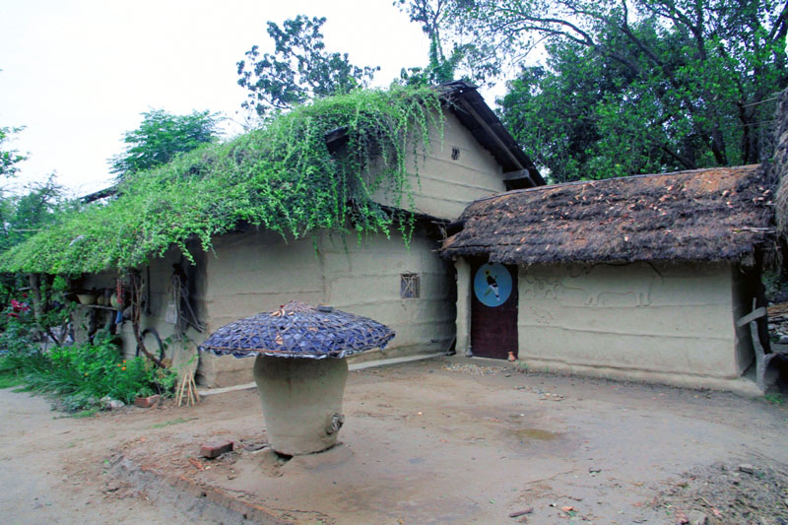
Traditional Tharu houses are identical in design and the pattern of construction is same though the building sine can vary according to the number of inhabitant or following the scheme i.e. panchabala or satebala plan. The houses are constructed parallel to the village road, towards north-south direction and thus they are facing either east or west. The house is single storied rectangular in plan with two-side slope roof. The width satbala (seven post), naubala (nine post) and the length vanes according to the number of kotha (bay), normally 4, 6, 8 bays. Although, the Tharus follow the joint family system, there is a trend to break away the joint family. In such case, we can find the building is also divided as required. The plan of the house form can be divided into mainly three section, which have different function.
Figure 42: Tharu House
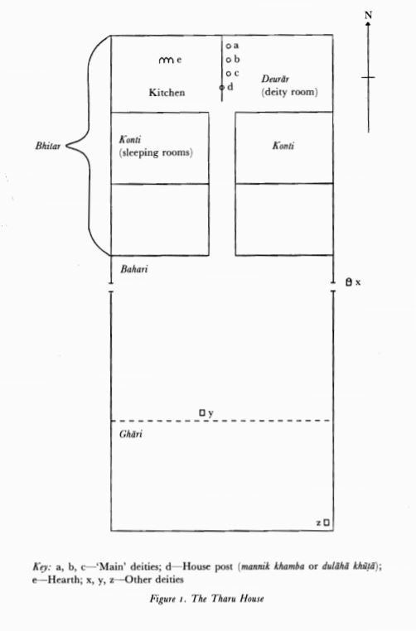
Ghari (cattle shed)
The southern section of the house is called ghari, which is used as cattle shed. It has separate door from the front face of the house. In the new construction, the cattle shed are separately built from the main dwelling house. Generally, frame of timber is erected to separate it from entrance.

Bahari (entrance hall)
Bahari covers a single bay of the building, which serves as the entrance hall and is situated between the cattie shed and dwelling area. It has two doors, absolutely opposite to each other open into the exterior. One is entrance door faces the road and open to the courtyard and another leads the back of the building. Except in case of some richer and larger family with longer houses, almost all Tharu houses have only two doors. The upper part of the bahari, below the roof, look like an exhibition of Tharu art and artifacts. Various types of bucket, straw, cushions, nets, traps, arts, chhatris, machyas, agricultural tools, packet of herbs and medicine, seeds, bunches of garlic and leaf cups are stored there, either tied or hanging from ropes below the beams of the roof.

Dwelling area
The dwelling area is separate from the bahari either by half partition wall or by Dehries (earthen pots to keep grains). There is double leaf door at the center of north part of bahari to access it. It has central corridor (north-south) with room on two sides.

Konti (sleeping room)
The room is accessed from the corridor and not all partition exceeds 6 feet to 10 feet leaving a lot of space beneath the roof. This allows good ventilation and keeps the place cool during the hot summer. The room receives little light from the small window at perimeter or holes made from the façade walls. The rooms are generally used for sleeping purposes by the other family members. Each couple is given room of its own and its privacy is respected by all. Several large baskets (bhaukas) are hung up in the room and these are used for keeping their clothes and personal objects.

Bhansa kotha (Kitchen room)
There is kitchen at the North West house except the house. In the kitchen room, there are no windows and only small holes let some light pass into this dark room. The kitchen has generally 2-5 horse shoe type of chulha(chulo) at the center facing south. At the loot of the western wall of the kitchen there is a pit hole for draining out a wastewater after washing the small utensils.

Deurar (deity room)
Deurar is at the north-east of house except the house of ultahwa (opposite man). In the deurar room, there are no windows and only small holes let some light pass into this dark room. Their deity statues are kept here according to their clans types (dahit, baidh, targaiya, etc.)

Aangna(Aangan)
All Tharu houses has courtyard (aangan) in the front of the house and this links the building to the road. A portion of the space reserved for the cattle & the area is delimited with the help of wooden post. The area is also used for drying of grains and vegetable products and various other activities. The aangan also plays vital role in social gathering and have cultural and religious importance (Meyer, K. W. and P. Deuel, 1999).

THARU HOUSE BUILT ENVIRONMENT AND ITS SURROUNDING
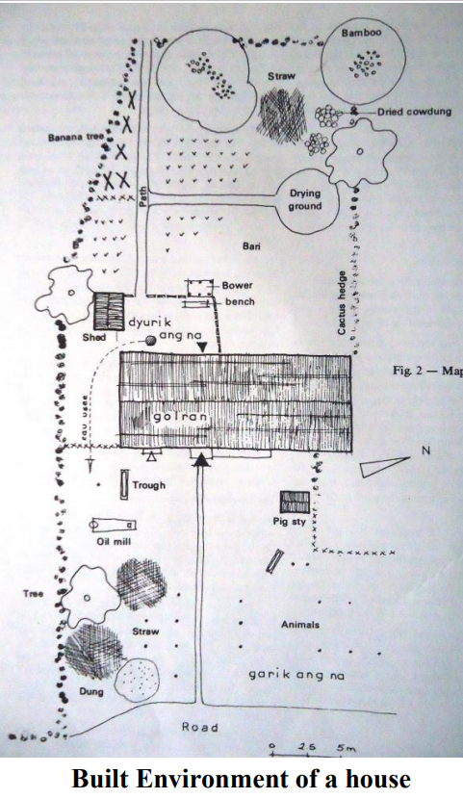
In the case of all the dwelling units of 'Tharu consist of three district zones, a building which includes the cattle shade and inhabitation area, separate activities are assigned to each zone.
The main construction is preceded by an open space separated partially on all side by a cactus hedge. The "Gharik-ang-na" covers an area of 3.20 sq.m and a rectangular passage running across it links the building to the road. A portion of the space is reserved for the
animals and the area is delimited with the help of wooden posts. It also includes a pigsty as pig is not allowed to stay under the family roof. Straws and dung are stocked in the Gharik-angna, a part of the area is used for the drying of grains and vegetable products. The oil crusher “Kad” 1s placed near the space reserved for the animals.
The second space outside the dwelling unit is situated at the back of the main building. It
forms a small courtyard enclosed by a partition made of branches. Access to the kitchen
garden is possible by the means of a narrow passage allowed for in the barrier. The
courtyard is used to perform domestic tasks requiring an abundant supply of water such as
washing of large vessels, cleaning with ash, personal washing (for this purpose a basin is
dug in the earthen floor to collect the rain water) and for the preparation and shorting of vegetable picked from the kitchen garden; also for temporary activities such as a basketwork, weaving, manufacture of ropes, 1ishing nets and alcohol. Next to the courtyard is a store "Chapra" where wood, agricultural and fishing implements and vessel for distillation are stored.
The kitchen garden “Baari” is enclosed by hedge. A path running through it connects the
house to the fields. The family garden is used for growing vegetables for daily consumption: peas, yellow lentils, radish, gourd, onions, and chilies. Banana and guava trees are also planted. A rice husk grinder, "Paira" is placed close to the bamboo. The dried dung cakes “Guitha” are also piled up nearby. A circular earthen surface is used for the drying of pottery wear and vegetables products.
The dwelling building is located in the center of the settlement on the right and left hand side of the main road coming from the north. Running parallel to the road, its longitudinal axis is oriented north-south as in the case of all the village construction. Traditionally, one
of the facades under the roof should face the east or west looking at the main road
(source Man and his House in Himalayas: A Tharu Houses in The Dang Valley: Camille
Milliet-Mondon, Edited by Gerard Toffin)
Figure 43: Built-in environment of Tharu House

TOOLS AND EQUIPMENTS

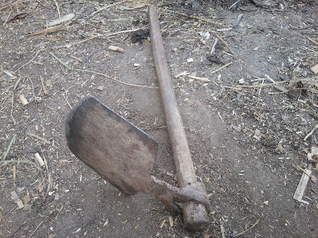
Agricultural implements and iron tools:
Figure 44: Pharhwa
Agriculture is the main profession of Tharu. Though they use modern tools and techniques these days they had their own traditional system of farming and farming tools such as Chhittwa, Banthi, Pistur, Chhatri, Farhwa, Supa etc.
Fishing tools and goods:
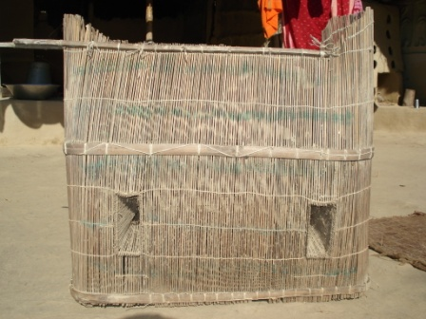
Fishing is a major activity in the spare time between agricultural activities. And the different type of fishing tools used by them are Jal, Mahajal, Tapi, Dharya, Helka, Delya, khongya, etc.
Figure 45: Fishing instrument

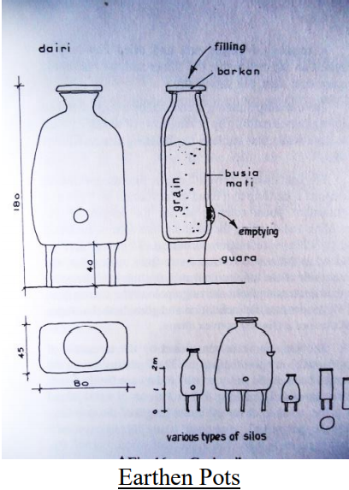
Household goods and equipments:
Tharu generally prepare their household goods by themselves but some of them are also purchased from the market. The materials used are bamboo, seeds, and grass. Household goods and furnitures used by Tharus are Bhauka, Bhauki, Siratta, Thakra, Beli, Dehri, Bhakri, Dhakan, Berri, Patki gondri, Tukki, Bhokti, Hanri, Khapri, Delwa, Hukka etc.
Figure 46: Dhehri

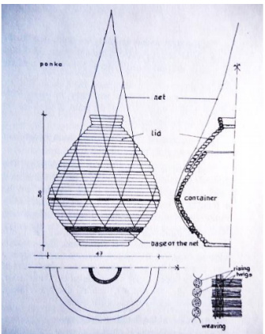
Musical instruments:
Figure 47: Bhauka
Jhali, Majaira, Kastar, Latthi, Mandra, Basiya,etc.
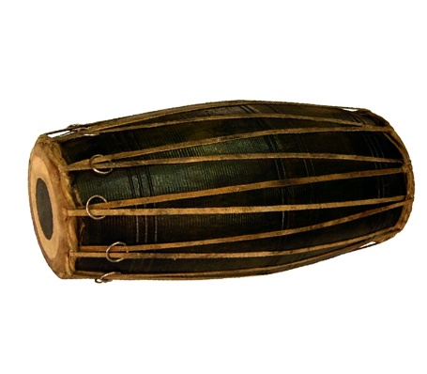
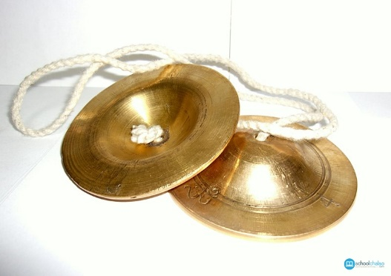
Figure 48: Madal
Figure 49: Manjira

Dress and ornaments:
Bhegwa, Bhoti, Bahwaha, Jhulwa and 1opi are the main dresses of Tharu men, whereas Gonya, Cholya, Farya, and Daineha jhulwa are of Tharu women. They have different types of ornaments like Sutya, Tainti, Paisa ko mala, Thosya ra Kukunna Ko Mala, Dhongri ko Mala, Chhetaur, Tarya, Mundri, Kakani, Gurya, Majha, Panhuchari, Dhal etc. Tharus worship different deities on different festivals and rituals. They sing diffent kind of songs on different months such as Baramasa song, Chhamasa song, Chaumasa song. Tinmasa song, Malar song, Chanchar song, Basant song, Chautawor song, Sajana song, etc.

FESTIVALS
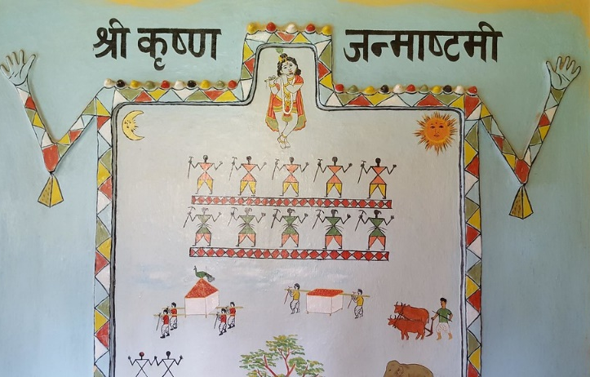
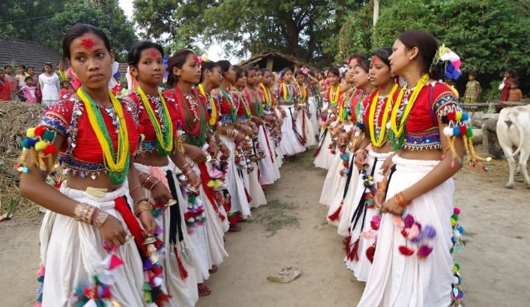
Maghi: Maghi is the most important festival observed in the month of Magh. The first day of Magh is also celebrated in the Terai by the Tharu community as Maghi or New Year. It is a weeklong festival celebrated by getting together as a family and friends, attending community get together or mela, dressing up in the traditional Tharu wear, eating, drinking and making merry.
Dashain: Tharu also observe Dashain by worshiping goddess Durga and among some Tharus. Tug of war is held and they held feast drink Jad, Rakshi, sing and dance for 10 days.
Diwali: It is the festival where the brothers gather to be worshipped by their sisters & they give the gifts.
Vasanta panchami & holy: It is also observed amidst feasts and festivity during Chaitra. Tharu women and men observe it with joy.
Ghattu: It is celebrated for 15 days, they make clay gods & worship it with flowers and sing and dance. On the last day they drown the god amidst singing & dancing to pig, goat, sheep etc.
Astimki: Krishna Janmashtami, also known simply as Janmashtami or Gokulashtami, is an annual Hindu festival that celebrates the birth of Krishna, the eighth avatar of Vishnu. It is celebrated by Tharu community by drawing the paintaing of Krishna on the wall. It is then later worshipped by women turn by turn at evening.

CONSTRUCTION TECHNOLOGY
In the design process, the construction technology used for construction plays a vital role. In the construction of Tharu Homestay Village, Bamboo as a main construction material would be used. For the construction, working of bamboo and bamboo building system need to be known.

Working of Bamboo
Splitting: The cane is split in halves and quarters and then driven apart by a wedge. It can also be split with a knife frame into four or eight segments. By means of splitting you get halved canes, strips and battens. To get planks, all the nodes are smashed and the wall of the pole is split over its entire length and forced open until the wall of the pole lies flat. Up to the age of 18 months, the canes can be peeled. The strips can be used as ties or be woven to make strings and ropes.

Shaping: Bamboo available in nature is usually circular in cross section. But if bamboo is made to grow in a box of square shape it attains the shape of that box, so that it can be better used for making connections.

Bending: Freshly cut, bamboo can be bent by heating and will keep this shape after drying. When heated above 150° C, bamboo starts changing its shape and remains as such after it goes cold.

Bamboo building system
Just like every building material bamboo has its own positive and negative sides and requires special treatment while applying to building structure.

Requirements
Before bamboo clum can be used in a building industry as a structure is has to go through certain
demands, starting from harvesting and grading selected steams to treatment and application.
- Bamboo clums cannot be harvested when they are younger than 3 years.
- Cannot be cut lover than second node or higher then 30mmm above the ground.
- All bamboo clums should be as straight as possible.
- Change in diameter over length should be kept minimum. Maximum taper of 10mm per meter is acceptable for length up to 3 m.
- Columns and roof members should be a minimum of 70-100mm in diameter at thin ends.
- Wall thickness not less than 10-12 mm
- Distance between nodes should not exceed 300-600mm (they are the strongest points in the clum)
- While processing it should be set out to dry for around 2-3 months to evaporate 90% of it’s natural moisture content
- There should be non- toxic treatment applied
- It is better no to use nails and screws due to the danger of splintering between longitudinal fibers.

Once we have our material prepared, we can start use them in a construction. With modern technologies it is possible to combine bamboo clum with steel and concrete, but first of all it is crucial to know how to bind clums to each other.

Joinery
Joining bamboo members to transfer load are the basic and the most important part in the building process as their function it to transfer load equally down to the foundations. We can divide bamboo connections into two types:
- Low-technology connection
- High-technology connection
The basic difference between those types is that the Low-technology requires cheap and simple connection system and also doesn’t expect specialized labor. High-technology joints include using components such as steel plates and bolds. It is usually used for connecting more than 4 bamboo clums or for the difficult details. The most common ways of joining members are: parallel, orthogonal and angle joints. We can easily join 4, 5 or even more bamboo clums following special technologies.

Low construction connection:
- Friction-tight rope connection
It is the basic connection, usually used with natural materials such as: cocos/asgo palm fiber, bast, strips of bamboo or rattan or more industrial materials: iron wire and plastic ropes. Lashing can also have variations of complexity. Bamboo pieces can be cut and attached to each other or can be lashed with pre-drilled holes in each of the piece and the rope tied through them.
Figure 50: Rattan connection
Figure 51: Connection with bamboo strips
Figure 52: Rattan connection through dril holes

- Plug-in connection
Figure 53: Bamboo mortise and tenon connection
Connections are very similar to those in wood with mortise and tenon and are quite seldom used in bamboo connections. However, bolds and consoles you can find very often. The bamboo pieces are appropriately cut and in between, them the plug is inserted (preferably wood block). An additional fastening with rope is required to prevent from unplugging and slipping the beam.

- Connection with steel tension clamp
Still considered as low technology connection, steel element is used. With this attachment, more connections are possible, but we should avoid those places where forces are going vertically to the cane axis-they may destroy bamboo clum.

High-technology connection
- Interlocking connections
Those connections involve gluing or shedding of members that are in or around bamboo. For instance, a wood core connection is based on applying a wood piece in the inner surface of bamboo and gluing it. We should be careful and made two slots in the bamboo steam to prevent it from cracking while applying the wood block. This member can be later attached to the steel plate and those can be welded together forming steel box.
Figure 54: Spacetruss with centre steel box element
Figure 55: Wood core connection systems

- Bamboo-Tech
This is an innovative invention by Bruno Huber for those bamboo clums that are slightly oval in a section, so that they are a bit harder to bind with. This method eliminates weak pints in bamboo cane. It is based on having the bamboo cut at certain lengths and having both ends with artificial caps (can be synthetic, steel or aluminum). Caps are hold to the bamboo thanks to the circular notches on the inside of the cap so that there is strong friction connection between cap and bamboo. Sometimes they are welded too.

Foundation
Bamboo is basically an above-ground material. Unless undergoing proper treatment it can last about 2-3 years underground. It is impossible to put bamboo post directly to the ground, however the bamboo clum can be embedded into the foundation or plinth. Of course there are several regulations for bamboo for foundations:
- Bamboo canes should not touch soil, since they should not be exposed to the moisture.
- Height of the plinth in which bamboo is set in should be above the flood water line or min 350 mm above ground level.
- Minimum diameter of bamboo posts at thinner shall not be less than 70 mm.
- The highest post can be up to 3m, if the height is greater, the post should be supported by horizontal tie/beam.
- Use only mature Bambusa Balcoa for structural and main beams

Foundation Plinth:
To install bamboo post into foundation, a 300mm deep and 100mm diameter hole should be made in the plinth beam. Before inserting post, bamboo must undergo Tar or Creosote treatment at the bottom. Then the spaces between clum in the hole must be filled with the sand.
Figure 56: Fixing detail of bamboo post into plinth masonry
Figure 57: Filling the gaps with sand

Foundation plinth with anchor bolts:
Other possibility allows fixing bamboo post and foundation with bolts and steel brackets and anchor bolts. At this point bolts should be embedded at appropriate place at the same time of casting plinth beam.

Foundation with brick pedestal:
This kind of foundations are earthquake resistant and can be use even for brick wall houses. After soling bricks on the ground level, we pour and spread the concrete and mark center for vertical bamboo post. Then going up to the ground level, bricks should be put in such a way to make 120x120mm gap inside to fill with the concrete. After creating foundation plinth, the reinforcement and pipes can be put on the top as the final foundation layer.

Bamboo concrete column:
An innovative development includes the casting of a concrete extension to bamboo post using plastic tube of the same diameter. The result is a bamboo post with extended, durable foundation.
Figure 59: Foundation with brick pedestal

Figure 58: Plinth with brick pedestal
Figure 60: Composite bamboo/concrete column

Walls
There are many possibilities for bamboo usage in the wall constructions. The major elements such as posts and beams are part of structural framework and has to carry self-weight, load from the building and external impacts (such as weather). To complete the wall the infill between framing members is required to protect against rain and wind and ensure overall stability. This can be vertical or horizontal bamboo clum, flattened bamboo, bajareque,wattle or woven bamboo with or without plaster.

- Whole or halved bamboo
Preferred orientation is vertical as it increases shear resistance and is better for the rainfalls. Vertical beams can be driven directly into the ground with or without battens.
- Split or flattened bamboo
Boards can be stretched or covered by wire mesh to provide good surface for plastering.

- Bajareque
Type of construction commonly used in Latin America that is based on horizontal bamboo strips tied or nailed to both sides of the posts. The space between is filled with mud or stones. This construction is strong and massive and earthquake resistant.

- Wattle bamboo
Commonly used in India, Peru and Chile. Thick woven panels of bamboo strips are attached to bamboo supporting beam and covered with plaster.
- Woven bamboo
The same type a wattle bamboo wall but the bamboo strips are arranged closer and thicker which don’t require external plastering.

SITE STUDY AND ANALYSIS

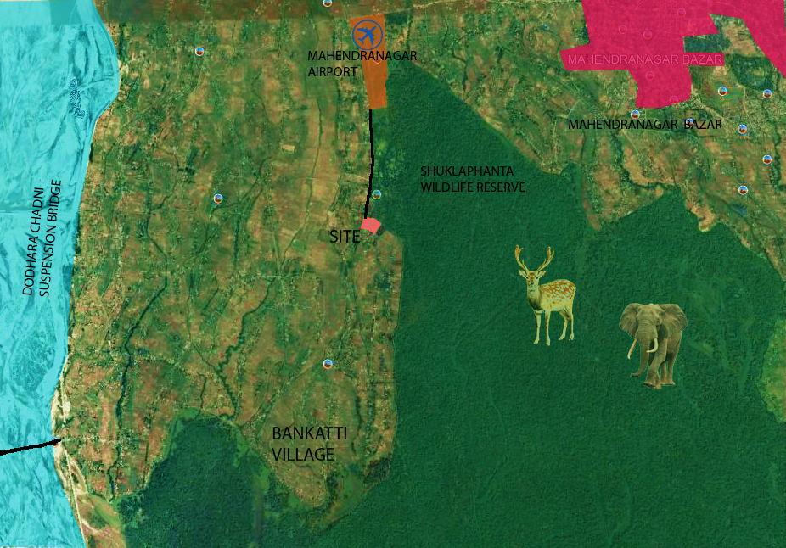
INTRODCUTION
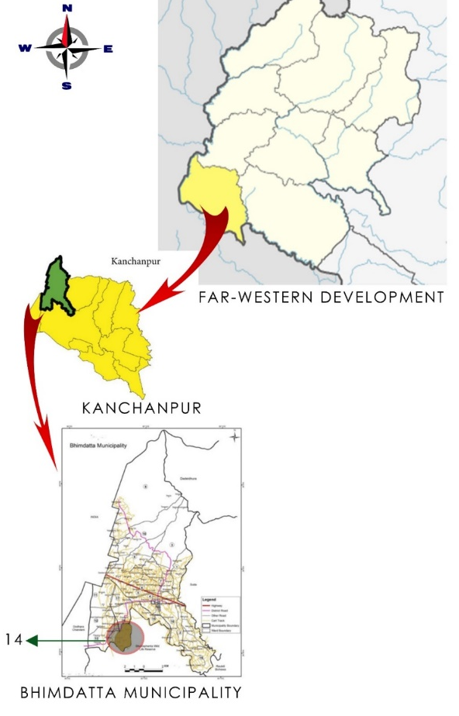
Naya Gaun is a village situated in the Bhimdatta Municipality of Kanchanpur district of Nepal. Tharus and Pahadis are the main inhibit of it. There are more than 150 houses in the village. There is 24 hour electricity. The service of internet has been reached there and expanding rapidly. It can be reached from Kathmandu through Mahendra Highway to Manhendranagar and 30 min of walk from there leads to Naya Gaun Village, which is on the way to Dodhara Suspension Bridge. The village is accessed via pitch road from Mahendranagar Bazar. It is situated in the Terai region with Hot climate.
Location: Naya Gaun, Ward no. 14, Bhimdatta Municipality
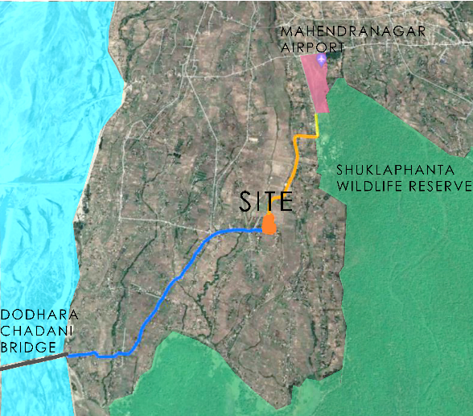
Area: 41 Ropani
Topography: Flat land
Access: Mahendra Highway, Mahendranagar Airport , Dhangadhi Airport
Climate: Hot climate
Major places: Shuklaphanta Wildlife Reserve, Dodhara Suspension Bridge,

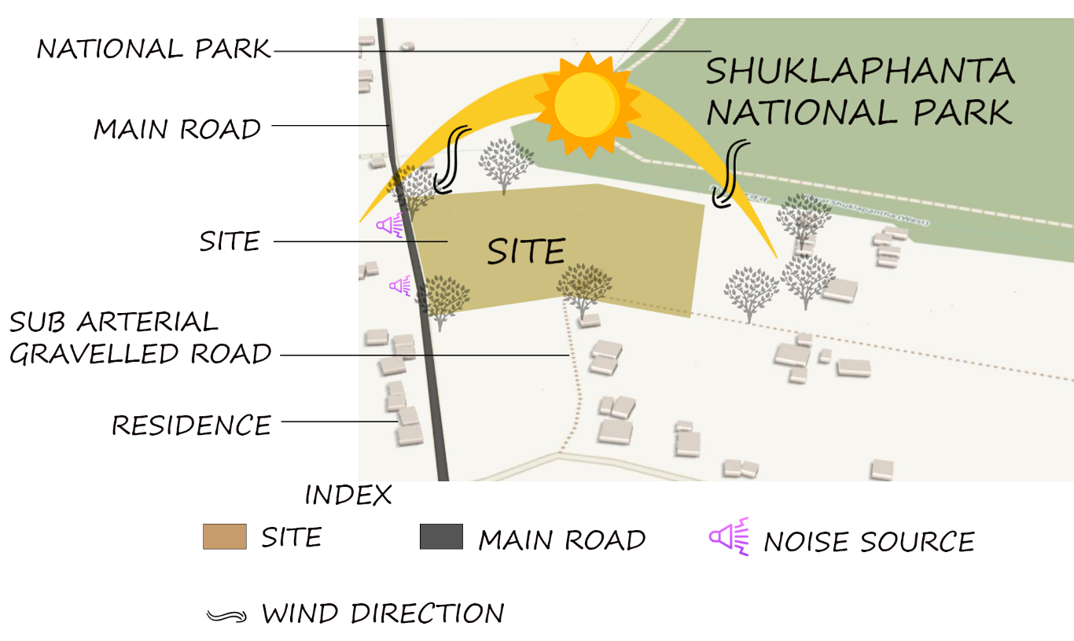

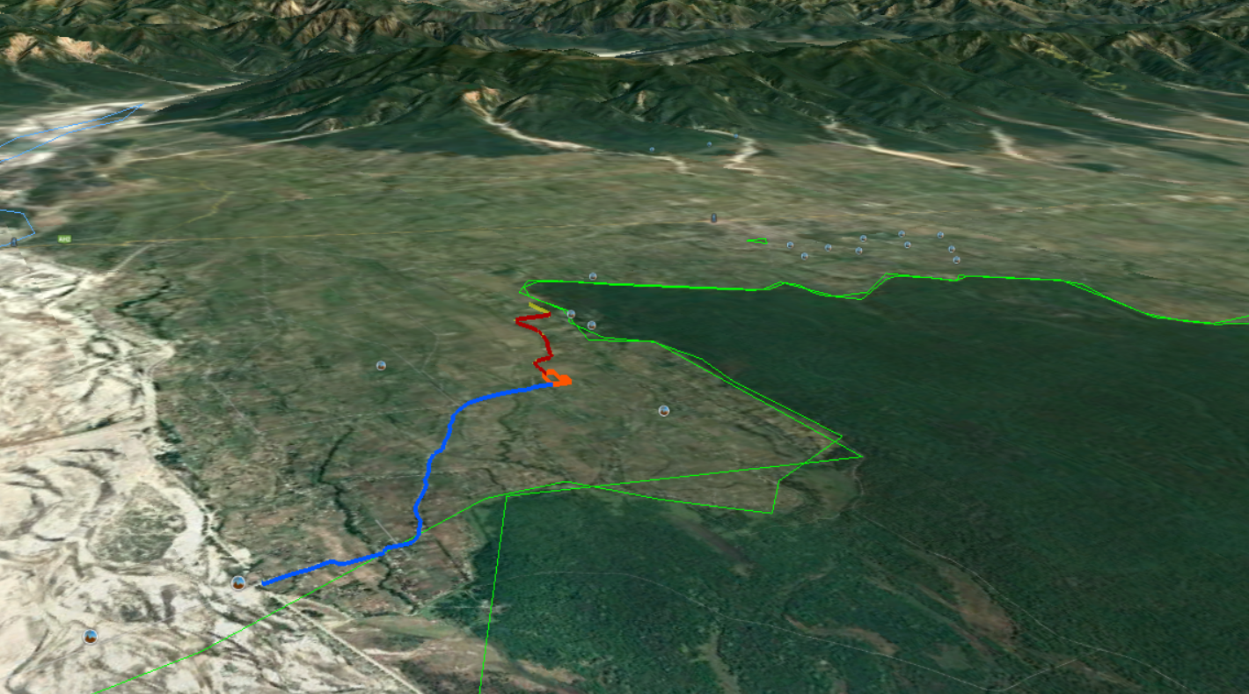
Shuklapahanta Wildlife Reserve
Site
Dodhara Suspension Bridge
Mahendranagar Bazar

Physical Dimension

Architecture
- The architecture of the houses is according to the land structure i.e. flat land.
- More use of local materials like wood, bamboo, tiles, mus, khar, CGI sheets, bricks etc
- Houses are either facing east or west.
- Houses are parallel to the highways.
- The residence has living room, bedroom, and kitchens.
- Open spaces(aangan) has been paved with the mud only.
- Mostly slanted roofs are found in residences.

Road
One can come up to Mahendranagar via Public Vehicle and Airplanes. From Mahendranagar Bazar one can either take public vehicle to reach Naya Gaun. The 2 lane Pitched Highway has reached the Naya Gaun Village. The houses are accessed from the open space “Aagan” which serves as road as well routine activities space.

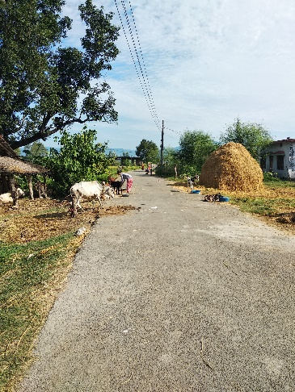

Electricity
The site is accessed by hydroelectricity grid of NEA.
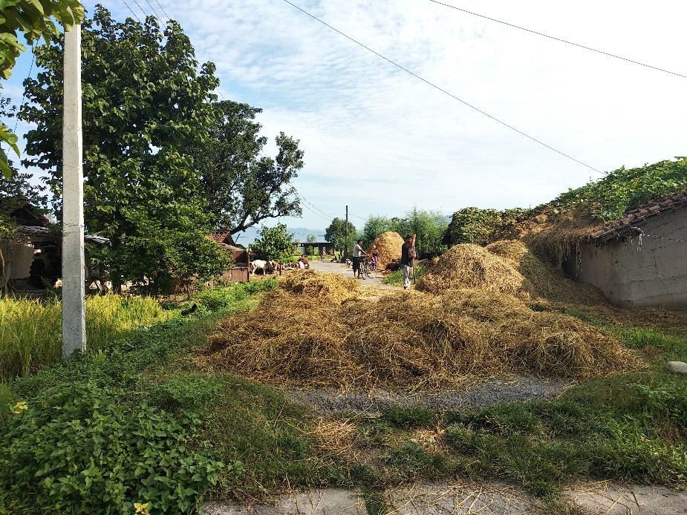

Forest
The site is near the Shuklaphanta Wildlife Reserve. The Consumers use it when the committee of Wildlife Reserve open for them. They use it for various purpose.

Communication
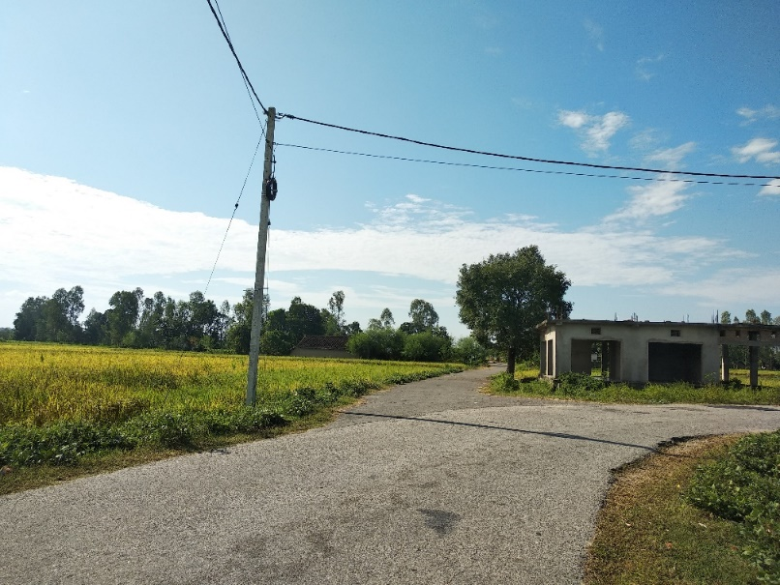
There are ISPs of many Internets like NTC, Worldlink, Supernet, etc. Beside ISPs, NTC and Ncell provide mobile network coverage in this area.

Drainage
The site lacks the drainage system, the waste water is poured in their own fields and make the field fertile. Now these days the gutters construction in going on.

Water Supply
The Village has access to water supply through the pipelines from the Mahendranagar Bazar. The hand pump water is also being used for the drinking purpose since hand pump gives pure and clean water in Terai.

Sewer Lines
Now a days, almost all the houses have toilets with ventilated improved pit latrine system and some of them have safety tank.

Topography
The site is in Terai so it has flat land.

Environmental

Grazing Land
Open Fields are there for the grazing of Cows, Buffalos, Goats, Sheeps, etc

Irrigation
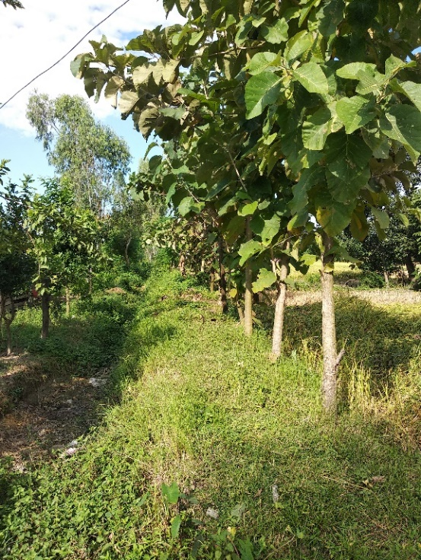
Irrigation is mainly done through Canals, Nahars and In case of no water in these systems then Boring system is used for irrigation.

Climatology analysis
The Nearest climate station for the Naya Gaun Village was Mahendranagar Bazar and hence the data has been adopted from Mahendranagar via https://www.worldweatheronline.com/mahendranagar-weather/np.aspx
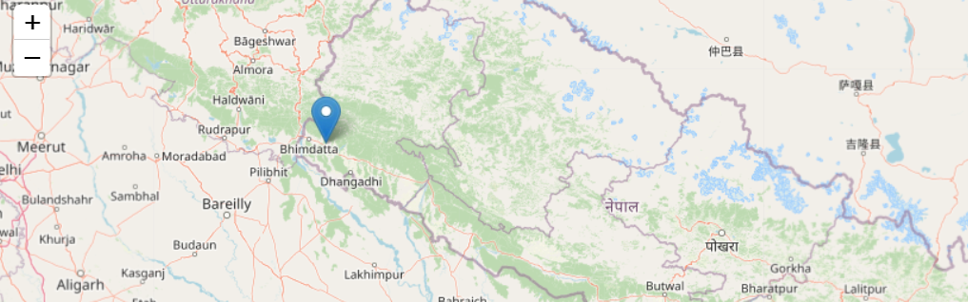
Figure 61: Location map of Mahendranagar

Temperature
The average monthly temperature is found to be increasing from 14°C in January to 37°C in April then decreasing to 16°C in December. Generally, in winter, the place is found to be colder and in summer, it is hotter.
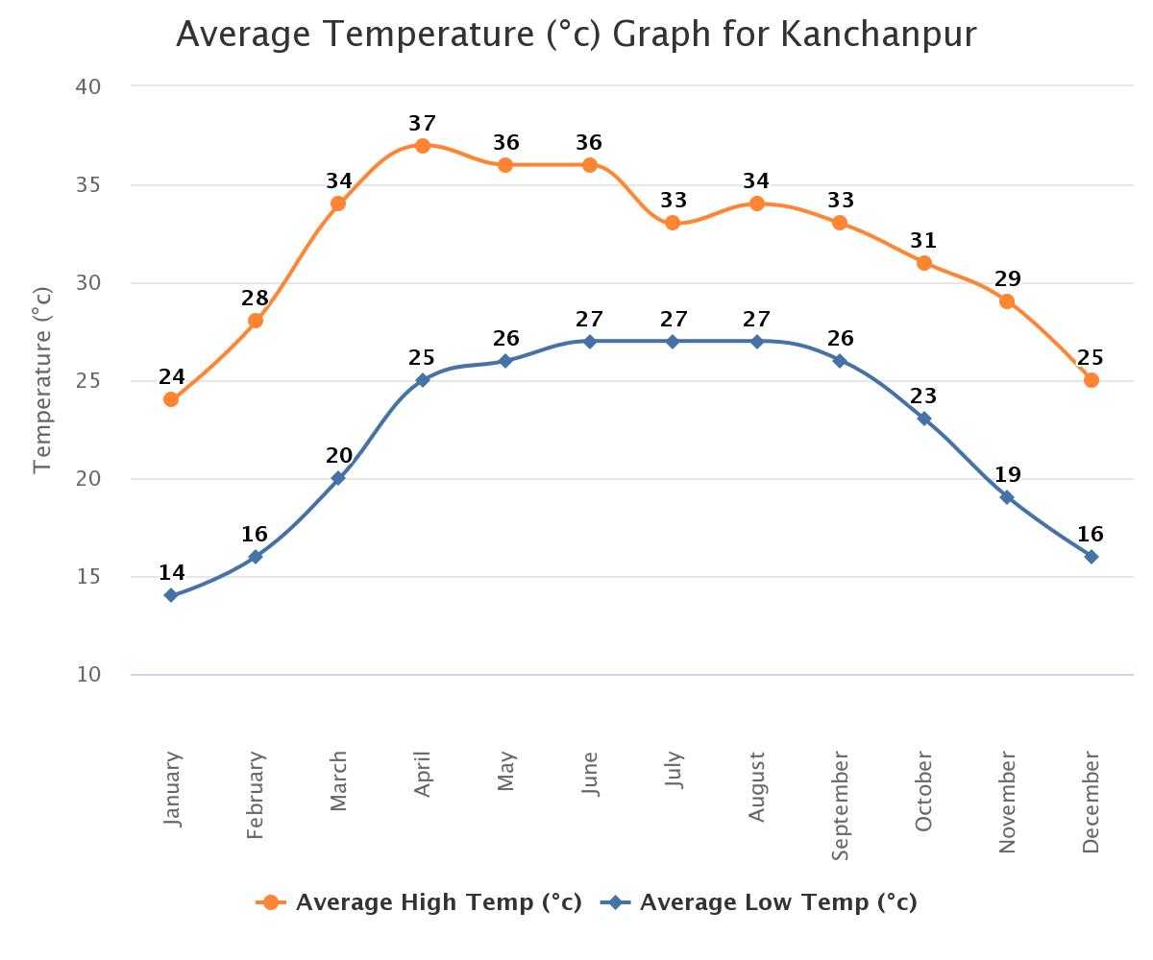

Figure 62: Avg. Temp. Graph of Kanchanpur

Sun Hours
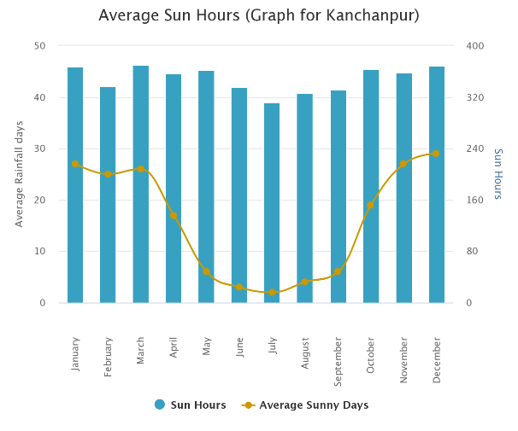
The average sun hour and average sun days is high from Nov. to March and low from April to October.

Figure 63: Sun Hours of Kanchanpur

Rainfall
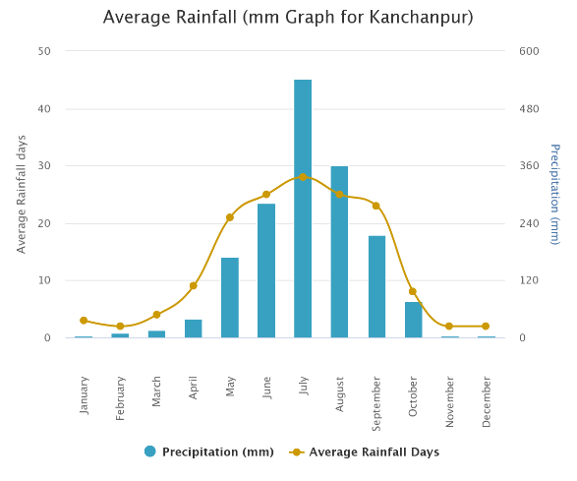
The rainfall is found to be high during July and August(>360 mm) and low during Nov, Dec, Jan, Feb and Mar (<39 mm).

Figure 64: Avg. Rainfall. Graph of Kanchanpur

Wind
The wind flows mostly from North to South Direction.
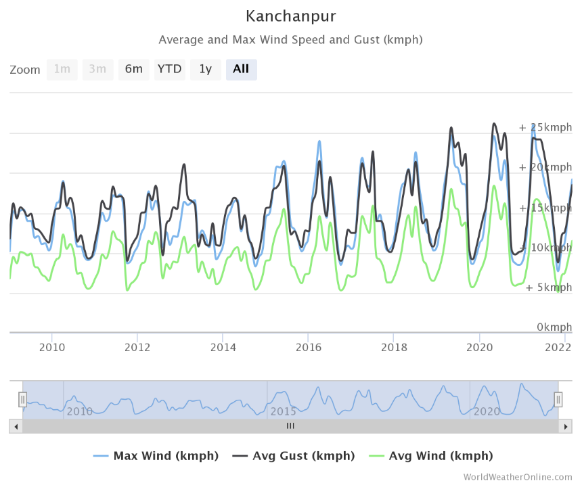

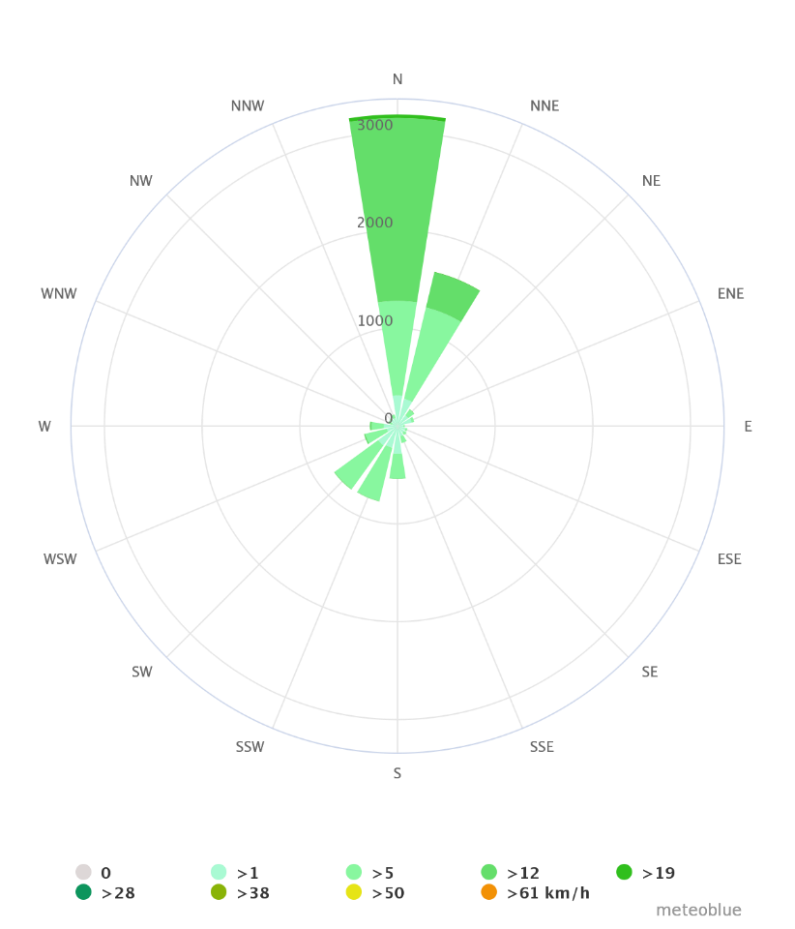
Figure 65: Wind rose diagram of Kanchanpur

Site Analysis
Site Access
- 8.5km from Mahendranagar bazar
- 3.45km from Dodhara Suspension Bridge
Road
- Pitched road
- Main road of two lane runs near the site
- Two lane sub-arterial road runs across the site
Climate
- Generally Hot climate
- Cold during winter
Socio-economic
- Agriculture: Rice, Millet, Potato, Barley, Maize, Sugarcane, Vegetables,
- Animal Husbandry
- Knitting
- Fishing
Culture
- Main festivals: Maghi, Dashain, Tihar
- Traditional Dress and Dance
Major Places
- Jungle Safari of Shuklaphanta Wildlife Reserve
- Trip to Dodhara Suspension Bridge
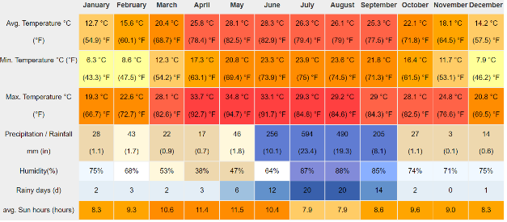
- Visit to different Religious places like Siddhababa temple, Bishnu mandir, Shiv mandir, and Bhankeni Sham.
Figure 66: Table of Avg. temp, rainfall, humidity

SWOT Analysis

Site location
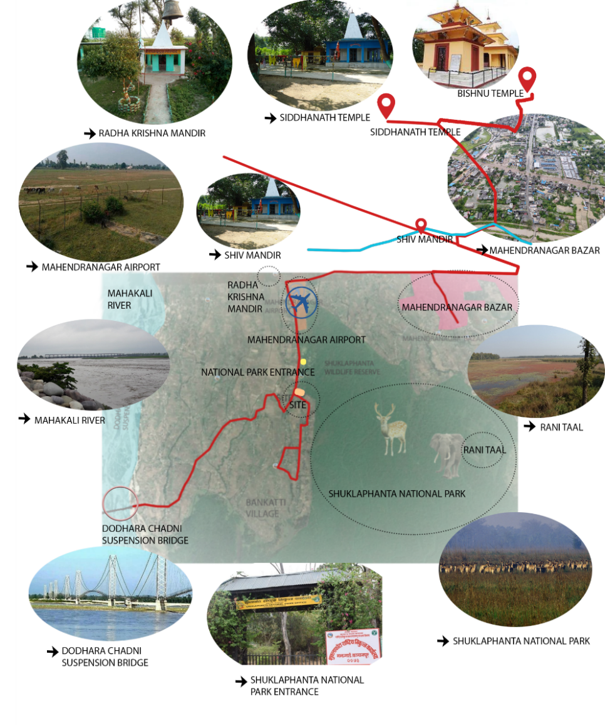

CONCEPT AND DESIGN DEVELOPMENT

INITIATION

Initially, some things about the resort relating to its characters and features along with the type and nature of the resort are kept in mind. Some of them are listed below.
- Resort is one of the projects that needs maximum energy and food throughout the day.
- The views and sceneries visible from the resort are another major part
- The character of the resort along with its type and nature.
- Location for this type of resort is also one of the major part, which includes how the local surrounding will respond and how this project influences the surrounding environment.

With the initiation, how this project will sustain in that location is also one of the major remarkable questions that needs to be tackled. This project is unique in comparison to other resorts since this is an Eco-village resort. The main focus of this project is to minimize energy consumption as much as possible along with promoting and eco-friendly environment following the principles of eco-tourism. It should also be able to provide the essential facilities and ambience desired by the visitors.

IDENTIFICATION OF ISSUES
Issues whose solutions guides the project are listed out as follows:
- Eco-Design
- Essence of Eco-Resort and identity
- Site location on flatland and linkage with different facilities
- Enlisting abundance of vegetation and natural scenic Vistas

INFLUENCE OF SITE AND SURROUNDING
Influence of surrounding is one of the major things that will have a distinct impact on the Project. Kanchanpur is known for its scenic beauty (Shuklaphanta NP), relaxing environment and agriculture. Its local architecture is a major influence on the design of the Resort. Pesticide-free organic farming can be developed as a major tourist attraction for this resort considering the agricultural background of the site surrounding. These things have been taken into prime consideration while designing the resort.

DESIGN APPROACH
A free-style approach has been adopted for the design of the resort to resemble the natural and gradual development of a traditional vernacular Nepali settlement in Terai region. Since this project is all about promotion of eco-features, it focuses on natural aspects such as natural scenery, local environment along with features like accommodation, relaxation, public spaces and so on.

SITE DESIGN
The site consist of a flat land. The access road for the site is towards the west side of the site.

MASTER PLAN AND DESIGN APPROACH
Master planning is the creation of a framework in which massing, landscaping, height relationships of blocks, circulation and pathways are all designed in cooperative ways.
ZONING OF THE SITE
First, the zoning has been done of the site as per possible site natural scenario and environment. Simply, zoning is done as public, semi-public as active zone and private zone as Passive Zone. Where, active zone includes the frequently flow of tourist's maximum time like administration, restaurant, multipurpose hall, recreational block, pool, and so on. Passive zone includes where flow is quite low like private villas, back of the house, Staff quarters and others.
PLANNING
The planning starts from the potential of the site. The main entrance is at west and secondary entrance is at south. The building blocks have been designed and placed to complement the orientation of the site and the surrounding existing structures and its natural surrounding.
Parking spaces of varying capabilities are provided at both entrances. As we enter the resort through the main gate, the main plaza space comes into sight along with the mother unit. The pedestrians can see multipurpose hall along with restaurant on the southern part.
CONCEPT
Concentric in cooperation with Tharu architecture is the concept approached for the design of the site which links site from the entrance to each and every corner of the site. The concentric approach, often called spiral, is a way of organizing a curriculum by laying out basic concepts, covering other related material, and then circling back around to the basic concept and filling in more complexity and depth.
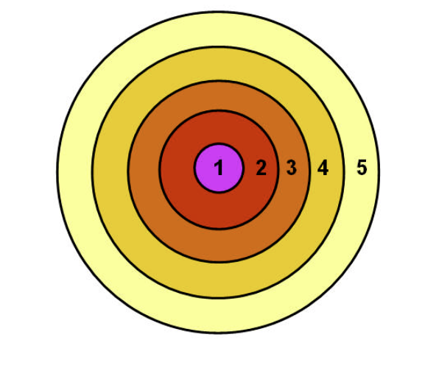
      - Mother unit
      - Open
      - Recreational unit
      - Couple unit
      - Family villas

ARCHITECTURAL DESIGN CONCEPT
Design development is done in a way which suits the natural surroundings. Building structures has been designed in the same levels since the site is in the plain land. The blocks are designed in such a way that the energy required for heating , cooling, lighting and ventilation is minimized as far as possible. Tharu architecture and building techniques are known for its comfort, sustainability and cost effective with the climate of this region. The techniques and aesthetics have been put to use in order to create an entirely vernacular ambience to be experienced by the visitors.
BUILDING DESIGN, LANDSCAPING AND USE OF MATERIALS
The buildings in the resorts reflect the Tharu vernacular architecture of the surrounding i.e. of Kanchanpur. The structures are developed with the timber, mud and Khar. The roof style is sloped with the thatched roof along with structures of wooden and bamboo for creating essence of Tharu vernacular architecture to the visitors. The load bearing walls have been designed as per need of functional approach. But all of the structures are exposed with the mud as it is are available and aesthetic materials of Tharu Residence. Along with that, bamboo is also locally available materials; its use can have been done in different parts of the buildings. Some like vertical louvers i.e. vertical partitions, some like cladding and others. The internal layout also tries to meet the vernacular style not like modern architecture as resort try to meet the its aim. Internally, the bamboo cladding is used in the building to essence the vernacular style as well as somewhere for vertical garden.
Roofing system is sloping with thatched roof with highly treated wooden used. Use of local materials, which makes one of the green buildings. The shape of the buildings structures is highly geometric shape i.e. rectangle and circular but the landscape part is irregular, circular and organic design is used.

ELEMENTS OF GREEN DESIGN
The building is designed with the principle of green sustainable initiatives in mind. Nowadays, it is not an option, but a vital requirement that any new project should approaches, to save the environment and provide sustainable development for the future. Buildings should try to minimize their impact on the environment as much as possible, along with trying to be self-dependent, in terms of the energy required. A project is deemed successful only if it fits the environment on which it is built upon.
So, the project is conceived to be both climatically and socially reactive. It has a vision to use green design, technology and material to build and operate the structure. It has also tried to use in generation of energy through solar and biogas utilizations.
PASSIVE SOLAR DESIGN
Passive solar design minimize building energy consumption by integrating conventional energy-efficient devices with passive design elements. Passive solar buildings offer many benefits including comfort, low-maintenance, productivity and reduced energy use.
Heating: the east orientation of the site’s major slope allows maximum solar heat gain throughout the day during winter. Mud walls provide insulation against the heat gain.
Cooling: use of natural mud assists in insulation against summer heat. Shade from the roof and trees are adequate to block sunlight during summer.
Ventilation: appropriate positioning of fenestrations and use of large windows ensures adequate ventilation.
Microclimate: Deciduous trees around the buildings ensures that sunlight is blocked from entering during summer months while allowing winter sun and preventing cold breeze from entering.
USE OF GREEN BUILDING MATERIALS
In building, environmentally friendly materials (also known as green building materials) are those in which, for their production, placing and maintenance, actions of low environmental impact have been performed.
The proposed resort primary notion is the expression of Tharu vernacular architecture and lifestyle and since mud and bamboo are readily available, the buildings are built from mud and bamboo. The floor and roofs are built from treated and cured timber along with thatch. Bamboo furniture, partitions and bridges have been used in interiors and landscaping. Pathways and parking lots have been paved with natural stone, which allows water to seep through the joints to aid the process of ground water recharging. The buildings’ design and façade along with their construction technology and use of materials conforms to the traditional ways of building houses, which ensures that the building is well suited to the atmosphere of Terai area.
ORGANIC FARMING
Organic farming is a technique, which involves cultivation of plants and rearing of animals in natural ways. This process involves the use of biological materials, avoiding synthetic substances to maintain soil fertility and ecologically balanced agricultural principles like crop rotation, green manure, organic waste, biological pest control, mineral and rock additives. Organic farming makes use of pesticides and fertilizers if they are considered natural and avoids the use of various petrochemical fertilizers and pesticides. Since energy and food are one of the basic requirements of a resort, approximately 2064.43 sq. m. of land is separated for the purpose of organic farming. Tourists will be served with locally and organically grown food that will help the resort in becoming self-sustainable in a way. The guests will also have the option of participating in the farming themselves and prepare food for themselves using the farm’s produce. The management of waste is done by the separation of bio-degradable and non- biodegradable substances.
Advantages:
- Organic foods contain high amount of nutrients and are free from harmful pesticides and fertilizers. The guests are benefitted by toxin free organic meals prepared in the resort.
- Use of bio-degradable organic waste products which are free from artificial chemicals boosts the fertility of the soil.
- Instead of poison-containing pesticides and fertilizers, organic manure is used to enrich the soil.
- Organic food is considered to taste better than commercial food.
BIOGAS PRODUCTION
Waste management is the collection, transportation and disposal of garbage, sewage and other waste products. Waste management is the process of treating solid wastes and offers variety of solutions for recycling items that don’t belong to trash. Here, the waste products are separated and the degradable and non-degradable and these degradable products are used in the organic farming as mentioned earlier.

DIFFERENT RESORT UNITS
GUEST UNITS
The distribution of guest units in the site resembles the formation and development of traditional settlement around existing pathways, which can be observed in Tharu villages. Different secondary pathways have been diverged from the central axis of connection( Mother Unit) running across the length of the site. Ribbon development is demonstrated via the pathways, which further diverges into tertiary pathways leading into individual units.
A total of 14 cottages have been designed to accommodate a maximum of 90 guests. The quest units have been categorized into 3 types including 5 family units, 5 group bedroom units and 4 couple units.
Family Units: The family cottages consist of a living room, master bedroom, children bedroom, kitchen cum dining area, and a common bathroom. Master bedroom consisting of a double bed whereas the children’s bedroom consist of bedroom two twin beds. A single family unit can serve a total of 4 guests.
Group Units: Group unit consist of 2 separate rooms of 3 beds in each room along with living room, dining and attach bathrooms. A single unit can serve total of 12 guests.
MOTHER UNIT
Mother unit is located at the centre of the site and is straight forward from the entrance. Mother unit is designed in a semi-circular plan so the whole site plan is planned on the periphery of this mother unit.
Mother unit is accessible through the entrance directly. It consist of reception, lobby and open hall at the centre where they can see the artifacts of Tharu People. Right side of the hall, there is waiting area with account office, administration room, managers room and secretary room. On the left side there is mini dining for the visitors who can see the souvenir shop while having tea and coffee.
RECREATIONAL BLOCK
The recreational unit is situated at the back side of swimming pool. It provides office area, waiting area, changing room for both male and female, store room and chess playing room in the ground floor. In the first floor, it consist of gym hall, carom, table tennis, snooker room and relaxing area. Large windows have been used up so that more light can be gained inside the hall. The block is made from the mud walls with thatched roofs.
RESTAURANT
The restaurant has the capacity of 50 guests. The block has spaces for reception, kitchen, storage, dishwashing and serving area, a bar, indoor, semi-open and outdoor dining area. The building is made from mud walls, timber floors, and thatch roof. Elements such as bamboo furniture, wooden struts and fenestrations add to the vernacular aesthetic of the building. This restaurant has been place at a southern position of the side.
MULTIPURPOSE HALL
The multipurpose hall lies at the south-west corner. The hall is used for activities such as conference, exhibitions, workshops and other programs. It has a capacity of 100 people and consists of spaces for lobby, hall, stage, backstage, projector room, storage, changing roos and toilets. The building is made from bamboo walls and thatch roof supported by timber components.
STAFF QUARTER AND SERVICE BLOCK
Staff quarter is situated at the north side of the site. It placed near to the organic farming so that the staffs living there can supervise for the farming done in organic farming. Its ground floor consist of kitchen, dining, store room, toilet, laundry, drying room and machine room. In the first floor there is managers room, supervisors room, naturalist room, dormitory room and have terrace too.
OPEN AIR THEATRE
The open air theatre is situated at the back of mother unit. The space os oriented in such a way that the audience face east side. OAT is placed as a landscape . The theatre is paved with stone. It has a capacity of 80 users.
MEDITATION HALL
Mediation Hall is situated at the silent zone i.e. it is placed near the Shuklaphanta National Park and a bit away from the accommodation unit. Mediation hall consist of office, changing room, meditation room for individual mediation and one open hall for combined meditation.

7.8 BUILDING SERVICES
WATER SUPPLY AND STORAGE TANKS
Water is obtained from the water boring and is collected in the water tanks below the ground, which is used for drinking, cleaning and other various purposes.
Calculation of Water tank capacity
Water required by guests = $110 ×250=27500 litres$
Water required by staffs = $30 ×130=3900 litres$
Water requirement per day = 31400 lit = 31.4 cu.m.
Risk period = 10 days
Tank size:
Water required = $31400 ×10 lit=314000 lit$
Volume of tank = 31.4 m³
Tank size = $3.2 ×10 ×10 m^{3}$
Two tanks of the same size band capacity will be used so that the water supply is not obstructed when one of the tanks is out of order.

SEWERAGE AND SOLID WASTE DISPOSAL
Sewerage from bathrooms shall be connected to PVC pipes of appropriate diameter. After primarily treatment, it will be discharged to soak pits. Soil pipes are connected to w/cs and waste pipes are connected to all sinks, wash basins and showers. The waste pipes are directly connected to soak pits whereas the soil pipes are connected to biogas plants. All the solid waste from the kitchen shall be collected and separated into the organic and non-organic is converted into gas and liquid fertilizer. The fertilizer will be used in the organic farm whereas the gas produced will be sent to the kitchens.
Calculation for fixed
Feedstock
= $140 ×0.2\frac{kg}{day}of bio-waste$
= 28 kg/day wet waste
Total solid = 20%
Mixing with water to create slurry,
= $28+2 ×28=84 lit$
Retention time = 30 days
=$84\frac{lit}{day} ×30 days=2520 lit=2.5 m^{3}$
Feedstock quality
= $28\frac{kg}{day}×20\% TS$
= 5.6 kg dry matter
80% volatile solid $×5.6 kg$
= $\frac{80}{100}×5.6$
= 4.48 kg VS/day per 84 lit
= $\frac{4.48}{84}×1000$
= 53.33 VS/m³
Organic Loading rate
= $\frac{flow rate ×concentration }{reactor volume}$
= $\frac{0.084 ×53.33}{2.5}$
= 1.791 kg/m³
Amount of gas
Biogas yield for vegetable waste = 0.67 m³/kg VS
= $1.8 ×0.67 ×2.5=\frac{3.015m^{3}}{day}$
= Biogas stove = 0.4 m³/hr
Therefore, the plant can provide bio-gas to the kitchen for 7.53 hours per day.
Total volume of unit= 75% slurry + 25% gas holder
= 2.5 m³ slurry + 1.8 m³ gas holder
= 4.3 m³
Volume of cylinder = $πr^{2}h$
4.3 = $π ×1 ×h$
h = 1.36 m

SOLAR PV Panel calculation
Sunlight is one the best sources of alternative energy and since the site’s topography favours the maximum utilization of solar energy, 4991 sq.m. of land has been allocated for installing solar PV panels. Electricity generated will be stored and transmitted to the entire resort for lighting purposes.
Individual solar cells are interconnected and encapsulated on various materials to form a module. Modules are strung together in an electrical series with cables and wires to form a PV array. The slope of the modules is 30° south. Direct or diffuse light (usually sunlight) shining on the solar cells includes the photovoltaic effect, generating unregulated DC electric power. This DC power is fed into an inverter that transforms and synchronizes the power into AC electricity.
Solar garden lamps will be used in landscaping which will collect and store the required solar energy during daytime to illuminate the pathways at night
Slope of Module- 30° towards South
Unregulated Dc Power > Inverter > Ac Electricity
Solar PV Panel Calculation
Total energy required by the building
Assuming that 1 sq. m. requires 0.05 kwh/day
Total area = 3685 m² + 1306 m²
= 4991 m²
Total energy required = $4991 ×0.05$ kwh/day
= 249.55 kwh/day
= 250 kwh/day
1 m² of solar PV provides $\left(65W ×4.15 hrs sunshine\right)$= 0.27 kwh/day
Total energy generated by Solar PV
= $0.27 ×80\% of available area for solar farm(1210 sq. m)$
= $0.27 ×968$
= 261 kwh/day
which covers the daily electricity demand of the resort.

CONCLUSION
This thesis report “Eco-resort”, is a thoughtful planning and perspective development of leisure, functional and exotic spaces. After the study from different literature from books, reports and articles have given the proper planning guide on how to develop the design of the resort. The case studies on national and international have also help in understanding of spaces. We learn from what we see. The literature guide us on standards data for better design while the case studies give the vision on developing the project tacking the problems faces in certain aspects. The Eco-Resort at Kanchanpur is a new proposal in the Scenario of Nepal and the main aspect of the project is to give a traditional Tharu vernacular experience to the guests.
From the comparison of the literature and case studied gave the idea for planning the resort and preparing the program formulation for the design. The site is the main aspect in designing the resort and the site visit also gave a proper idea on how to work on the existing site. So, after the study of the national and international scenario of existing resort, the Eco-Resort uses local materials which will make the resort Eco-friendly and self-sustaining.
The resort is designed in such a way that it minimizes the energy consumption as much as possible along with providing a complete vernacular experience to tourists. Overall, the project is an attempt at creating art in the form of design and architecture that not only creates functional spaces but also spiritual satisfaction through the resort’s ambience.

BIBLIOGRAPHY
STANDARDS
- Baiche, B. and Walliman, N. Architects’ Data. 3rd ed.
- Time Saver Standards for Building types Second Edition
- Ernst and Peter Neufert, Architects’ Data, Third Edition
- Francis D.K. Ching, Architecture: Form, Space and Order
REFERENCES
- Ministry of Culture, Tourism and Civil Aviation, (2017) 2016. Planning & Evaluation Division, Research & Statistical Section. Singha Durbar, Kathmandu: Government of Nepal.
- Contributor, G. (2013). top 5 eco-friendly building material. (online) Available at:
- Maniatidis, V and Walker, P. (2003). A Review of Rammed Earth construction. 1st. (Pdf] Bath: http://people.bath.ac.uk/abspw/rammedearth/review.pdf
- Chiara,J. And Callender, J. 3rd Edition 1990, Time saver standard for building type, McGraw-Hill International Editions.
- Chiara,J. And Callender, J. 4th Edition 1990, Time saver standard for building type, McGraw-Hill International Editions.
- Neufert, Ernst, Peter Neufert, Bousmaha Baiche, and Nicholas Walliman 2002 Neufert's Architects' Data
- A Textbook of Building Construction and Construction Materials, G.S. Birdie, T.D. Ahuja

