EXPLORING BASIC MATHEMATICAL UNDERSTANDING
OF TAMANG COMMUNITY: AN ETHNOGRAPHIC STUDY

A
THESIS
BY
RAM TAMANG

IN PARTIAL FULFILMENT FOR REQUIREMENTS OF THE MASTER DEGREE MATHEMATICS EDUCATION

SUBMITTED
TO
DEPARTMENT OF MATHEMATICS EDUCATION
CENTRAL DEPARTMENT OF EDUCATION
TRIBHUVAN UNIVERSITY
KATHMANDU, NEPAL

2021
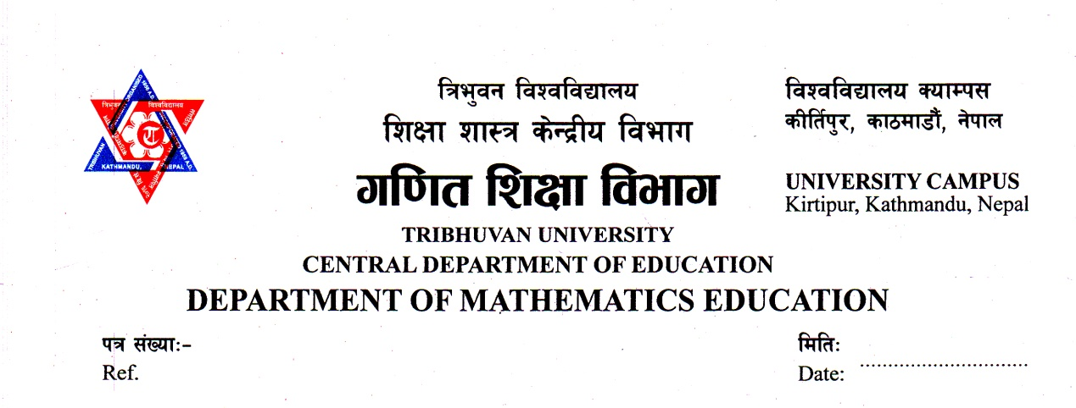

Letter of Certificate
This is to certify that Mr. Ram Tamang, a student of academic year 2072/073 with Exam Roll No. 7228368, T.U. Regd. No. 9-2-278-951-2012 and Thesis No. 1626 has been completed his under my supervision during the period prescribed by the rules regulation of Tribhuvan University, Nepal. The thesis entitled "Exploring basic Mathematical under standing of Tamang community: an ethnography study
embodied the result of his investigation conducting the period 2021 at the Department of Mathematics Education, Central Department of Education, University Campus, Kirtipur Kathmandu. I hereby, recommended and forward that his thesis be submitted for the evaluation as the partial requirement to as award the Degree of Masters of Education.

Date: Aug 1, 2021 ………………………………..
Prof. Dr. Bed Raj Acharya
Head

Letter of Approval
This thesis entitled "Exploring basic Mathematical understanding of Tamang community : an ethnographic study" submitted by Mr. Ram Tamang in partial fulfillment of the requirements for the Master's Degree in Education has been approved.

Viva-Voce Committee Signature
Prof. Dr. Bed Raj Acharya ………………..
(Chairman/Supervisor )

Prof. Dr. Bishnu khanal . .........................
(External)

Shiva Dawadi
(Member) ………………..

Date: Aug 1, 2021

Recommendation for Acceptance
This is to certify that Mr. Ram Tamang has completed his thesis entitled "Exploring basic Mathematical understanding of Tamang community : an ethnographic study " under my supervision during the period prescribed by the rules and regulation of Tribhuvan University, Kirtipur, Kathmandu, Nepal. I Recommend and forward his thesis to the Department of Mathematics Education to organize final viva- voice.

Date: ………………………..……….
Prof. Dr. Bed Raj Acharya
(Supervisor)
©2021

Copyright
By
Ram Tamang
This document is copyright material under law; no part of this document may be
Reproduced without the expressed permission of the researcher.
Defense Date: ………………
All right reserved.

Declaration
This thesis contains no material which has accepted for the award of other degree in any institutions. To the best of knowledge and belief, this thesis contains no material previously published by any other except due acknowledgement has been made.
.
Date: …………………………….
Ram Tamang

Dedication
This thesis is dedicated to my parents who spent their whole life to make me what I am today.

Acknowledgements
I would like to express my sincere gratitude to my thesis supervisor and head of department of mathematics education Prof. Dr Bed Raj Acharya for his invaluable guidance, constructive suggestions, co-operation, constant encouragement and continuous inspiration from the beginning to the end.
I would also like to extend my sincere gratitude to Ass. Prof. Laxmi Narayan Yadav, Department of Mathematics Education and for his constant support. I am equally grateful to Prof. Dr. Eka Ratna Acharya, Department of Mathematics Education for his guidance and valuable suggestions.
I am equally grateful to Prof. Dr. Binod Dhakal, and Shiva Dawadi, for their continuous guidance and support. Similarly, I am highly thankful to administrators, teachers and students for providing me their valuable time and authentic data to accomplish this study.
I would like to express my deepest gratitude to my father Dhan Bahadur Tamang and mother Ram kumari Tamang who's blessing, constant encouragement and help have been the sole source of inspiration throughout my life; my brother Deepak Tamang and sisters Rita and Numaa who continuously encouraged and supported me for my study.
Finally, I am very much grateful to my colleagues; Lachhu Tamang Sarita Lama Som kumar Rai and Rita Tamang who continuously encouraged and helped me to complete this study.
………………
Ram Tamang

Abstract
The present study is on the, "Exploring basic Mathematical understanding of Tamang community : an ethnographic study ". The main objective of the study was to find the counting and measuring system of Tamang community. I used qualitative research with ethnographic study. Mainly, Interview, Photographs, observations were used as techniques to generate data from the participations. The study was conducted and analyzed based on the conceptual understanding on which information and data were garnered. The research design of the study included survey design. The researcher used two tools to collect data. They were interview and photographs.
This study consists of five chapters. Chapter one includes background of the study, statement of the problem, objective of the study, significance of the study, delimitation of the study,Research question, and definitions of the key terms. Next, chapter two deals with the review of relevant literature and the conceptual framework of the research. Chapter three deals with the research method and proceducers Design of the study,Sample of the study,Tools of data collection,Data collection procedure,Method of data analysis . Chapter four contains Data analysis and interpretation of the data. Chapter five deal with the findings, conclusion and Implicationd of the study.

Table of Contents
Letter of Certificate ii
Letter of Approval iii
Recommendation for Acceptance iv
Copyright v
Dedication vii
Acknowledgements viii
Abstract ix
Table of Contents x
List of Tables xiii

Chapter I : INTRODUCTION 14
Background of the Study 14
Statement of the Problem 15
Significance of the Study 17
Objectives of the Study 18
Research Questions 18
Delimitation of the Study 18
Definitions of The key Terms 19

Chapter II: REVIEW OF RELATED LITERATURE 20
Empirical Review of the Study 20
Theoretical Review of the Study 22
Conceptual Framework of the Study 29

CHAPTER III: METHODS AND PROCEDURES 32
Design of the Study 32
Area of the Study 32
Sample of the Study 33
Tools of Data collection 33
Data collection Procedure 34
Data Analysis Procedures 34
Method of Data Analysis 35

CHAPTER IV: DATA ANALYSIS AND INTERPRETATION 37
Number Concept and Counting Process 37
Addition Process 41
Multiplication Process 44
Division Process 45
Measurement System 47
Measurement of Length and Distance 47
Area Measurement 49
Area Estimation for House Plan 50
Measurement of Land for Farming 50
Volume Measurement 51
Money Counting and Their Units 54
Concept of Ordinals 55
Concepts of Times and Units 56
Time or Conditions 57
Week, Month and Lekur 59
Concept of Fractions 61
Different Geometrical Concepts: Daily Use Materials of Tamangs 62
Dhyangro( Ngaa) 62
Janto (Randa) 63
Madal 64
Nanglo (Nakhle) 64
Dhiki (Lang) 65
Theki 65
Doko (Chhang) 66
Some Results from Observation 67
ChungiKhel 68

CHAPTER V: FINDINGS CONCLUSIONS AND IMPLICATIONS 69
Finding of the Study 69
Conclusion 70
Implications 70

REFERENCES 72
APPENDICES

List of Tables
Table 1: Number Counting in Tamang Language 38
Table 2: Number Counting More than Hundred 40
Table 3: Place Value Number System of Tamang 40
Table 4: Expression of Brothers and Sisters in Tamang 56
Table 5: Day Counting 58
Table 6: Days of Week 59
Table 7: Express of Twelve Months in Tamang 59
Table 8: Years of the Lekur 60

Chapter I
INTRODUCTION

Background of the Study
Nepal, the land of multi Cultural, multilingual and multi-religious like Brahmin Chhetri, Baisya and Shudra are scattered all over the country. So Nepal is a multiethnic country having many tribes, castes with different language, customs social cultural lives. In the beginning more Tamangs were inhabited in ancient Nepal (Now KTM), but gradually they were by passed by the other castes. They were inhabited around Kathmandu valley.
Tamangs are mainly found in the districts of Rasuwa, Kavarepalanchok, Nuwakot, Dhading, Dolkha, Sindhuli, Ramechhap, Kathmandu, Lalitpur and Bhaktapur. The census of 1991 place their population at 4.9% of the national total. The Tamang language, cultural and traditions are rich. They celebrate with equal such diverse religious occasions as Lhosar, MagheSankranti, BaisakhPurnima. Their dance culture is equally rich and varied. There are many Tamang subgroup. Their population according to census 2001 is 1,282,304. The Tamang used as early as the 30th century to denote an ethnic group, following the expansion of the Gorphali Kingdom the use of the world was prohibited.
The Tamang have a system of six types of societal leaders: TambamBondo, Ganba, Labonbo, Lama and Choho to keep the Tamang society continuously alove and dynamic. The six have their respective and important roles to play in the development of tamang society. The lama carries out death rites (Ghewa) and under takes activities related to the Buddhist religion.
The labbanbo (Laptapa) keeps alive the history o the dan and lineage through the worship of dan deities as each thar or sub group, has its own phola or clan deoity, there are different labanbos for each and every subgroup. There are more than 70 subgroups within the tamang and inter – marriage does not occur within the same subgroup. Although inter-marriage can occur between a boy, say belonging to the yonjan subgroup and a girl belonging to the moktan subgroup. If the mother of both the boy and girl belong to the same subgroup, however marriage between them is not possible since they are socially since they are socially recognized as the son and daughter of the same mother. In Nepal most of the people are involved in agriculture field. Tamangpeople's main occupation is also same as agriculture. But these day divers occupation they follow. Most of the tamang young are involve in Tourism industry. Some people follow local and international business, driving, teaching, official job, medical field.
The counting system is based on fingers and toes (10 + 10) using almost in every part of the world. The measuring system is based on HaatmAmal, Bitta, mana, pathi, muripala, Anjuli, oharni, Bisaui, Kilo, kuruwaetc are using in an ancient society of Nepal. In the ancient time, people used numbers of bases on 10 was used by the ancient Babylonians and is still used when measuring time and angles in minutes and seconds.
Today we symbolized structured and systematic mathematics. The symbols helped to develop math processes which utilize positional representation of numbers. This made the math process such as addition, subtraction, multiplication and division simple enough for common use the math processes we are using today is very simple and perfect.

Statement of the Problem
Nepal is the country of cultural variety.people of different ethnic group live here.Each ethnic group has its own culture, traditional and religion.Thus, Nepal is a country with culture diversity.But people having faith in a particular religion do not know much of other cultures.In a multi –culture society it is important for people to understand each other culture and respect each others culture values.Their culture activities have own type of important role in the national culture.Their cultural activities are different from the other castes.Ethnomathematics is hidden mathematics in culture in which people practice and use mathematical knowledge, skills,ideas,symbols,shape and national directly and indirectly in their own activities.
This study was concerned with the study of mathematical knowledge and concepts practiced by Tamang people in Bhojpur district.people use mathematical ideas and knowledge in their activities formally and informally.people learn and acquire mathematical knoeledge from social activities and individual practices in their culture and social environment through experience and interaction with social elements.
Tamang culture has measuring, calculating and doing basic mathematical process.So it is important to know the mathematical concept and process and endeavor of this ethnic group of Nepal.No studies have been conducted dealing with ethnomathematics of Tamang community of Bhojpur district.Therefore,the researcher intended to study the elementary mathematical concept and process used by Tamang community.
This study was not for the solution of my kind of series problem but its main purpose wasto find the ethnomathematical concept,ideas and knowledge of Tamang people in their culture.
This study intended to know about the hidden mathematics in Tamang community.Mostly the statement of selected problem is to reflect about the
- Measurement system practiced by Tamangs.
- Nature of counting system used by Tamangs.

Significance of the Study
- The study would reflect the indigenous mathematics knowledge and skills. This study helped the teachers, students, and their parents to use the knowledge to environment. The rational of this study was to know what they know and how they learn mathematical knowledge in their every activity. This study would focus on the counting, measurement system, locating designing, playing explaining and how they link to formal education system. This study would be the study of indigenous counting and measurement system of Tamang people. The main objective of this study is to find the counting and measuring system of Tamang community.This rational of this study was to know what Tamang know and how they learn mathematical knowledge in their everyday activities and this study has focused on the mathematics education research should be linked to these mathematical ideas,traditional knowledge and notations practiced by the Tamangs.I believethat this study is important because the indigenous math skills, concept and process enovle from direct of the people with their environment.They reflect the need of people and are essentially relevant to their practice life.Tis study would help the teacher,students and their parents to find the soluation of ‘Are the maths concepts and knowledge taught in school of communities’ relevant to their local environment and daily need?’.I think this study would be fruitful for the ethnomathematical researcher to identify the mathematical skills and concept of different cultural ethnic groups,
- Promote the ethnomathematical research.
- Make easy to learn mathematics by relating the culture hidden mathematics
I think this study is unique because this is the first and its kind in Nepal no other studies are done to analyze the local mathematical concept and knoeledge under Tamang community in Nepal.
- This study would help to know the nature of counting system and algorithm of basic mathematical operation practiced by Tamang.
- This study would help to explore four fundamental operations practiced by Tamang people.
- This study would help to identify the measurement system of Tamang.

Objectives of the Study
The main objectives of the study are:
- To find the counting and measuring system of the Tamang community.
- To explore four fundamental operations practiced by Tamang people.

Research Questions
This study is focused on the following research questions:
- In what ways do the people of Tamang community practising the counting system?
- In what ways do the people of Tamang community practising the measurement system?
- How do they perform the four fundamental operations (addition, subtraction, multiplication and division) in their real life?

Delimitation of the Study
The following are the delimitation of the study
- The study concerns only the mathematical concepts of counting and measuring.
- This study has been carried out in Tamang community in Bhojpur district.

Definitions of The key Terms
Measurement system : It has been used to indicate the length, volume, weight
Counting system : It has been used to indicate the number count.
Tamang : Tamang is an ancient and measure indigenous group of Nepal, they are mainly found in the districts of Dhanding, Dolkha.
Ethnic group : A type of group contained within the national boundaries defined by race, religion or national origin.
Basic mathematical concept : The mathematical concepts which are used in every day life are taken as basic mathematical concepts, like as addition, subtraction, multiplication and division.
Community : Community is everybody adults and children, social and non social persons, living in a certain territory where all share mode of lite, but not all conscious of its organization or purpose community is the smallest territorial group that can embrace all aspect of social life.
Practices : Systematics use by repetition is behavior in this study practices means what types of activities do in their everyday activities. Specially in counting system, measurement system.

Chapter II
REVIEW OF RELATED LITERATURE
Literature review is one of the essential aspects of my research. The related studies construct the plate – form standing to the research of the subject which gives theoretical and conceptual framework support for the study. Different researches have dome the study on mathematics and numeration system of different community with ethno mathematics. But no studies have been done on exploring basic mathematical understanding of Tamang community.

Empirical Review of the Study
Shrestha (2003) studied "The measurement system in Newar Civilization" with the objective to identify the numerical system and its trends o gradual development. His research was based on primary and secondary data, consisting of the study profiles, consulting with resource persons and the study of related journals, books, micro files etc. He found that all the numerals of Newar Civilization were found as developed from the Brahmin. The ciphered numeral system was used furring the Lichhavee period. This study has not showed the preset mathematics practices in real life as Newar.
Subedi (2009) did the research on mathematical concept used by dicker worker" This was qualitative types study. The main objectives of this study were to find the mathematical concepts and idea of wicker worker. He found that wicker worker used different mathematical concepts in their work and they get mathematical concepts and ideas from practice and from their culture.
Panta (2007), did a research entitled "Basic Mathematical Concept that the numeration system of Darai" is base to expect other. They have their own script for numerals, own math process for mathematical operations. Also they have their own traditional system of measurement for length they measured with hand. Similarly the area is measured which plugging time or grain yielded from the land, volume is measured with mana, pathi, muri etc.
Dhakal (2008), has studied on Basic Mathematical Concept and process used by Raji Ethnic Community." She concluded that ethnic group has been base 10 (younger) literate people) and Base 20 (traditional people) practiced in their own community. They have not their own symbols for native names of numbers their own counting system measurement system and operation system. Nowadays, literate and younger also use Hindu- Arabic counting system and they use short cut method to solve mathematical problems.
CERID / 1990), Conducted research entitled on o Elementary process of learning mathematics Concepts I and process of RasuwaTamang? In this research focused on identify the basic mathematical concept used by Tamang adults with no formal Mathematic education, to identify traditional Tamang method of Mathematical operation and to find out the implication of Tamang process and tone up to the present learning situation. This research conclude that Tamangs have their Town system of measurements contenting and Their own mathematical processes,
Chaudhary, (2017) conducted a research entitled on Mathematical practices in Tharu community! This study focus on to find out the mathematics practices in thane community and to explore the pedagogical implication of Mathematics practice in thane community. The research designed is qualitative with ethnography approach. Delwa (mujela) is conical shape, we can use this figure as a teaching material while teaching Cone and tessellations. Tharu Community chils practice and uses in their daily life.
The review of above literatures motivated the researcher to study the understanding Basic Concepts of mathematics by Tamang Community.
Lama , (2012). Did a study on "undarstanding Basic concept of mathematics by Tamang community." The objective of this study were to find how the tamang pople learn basic concept of mathematics and to find how the tamang people learn basic concept of mathematics and to find counting and measurement system used by tamang community . This study has been circled around the mathematical knowledge and hidden mathematical activities used by Tamang people in their daily life

Theoretical Review of the Study
Theoretical literature is those literatures which provide theoretical knowledge and philosophical base for research. In qualitative research, there are so many theoretical ideas and principles which are used to make the research meaningful and they guide the research for the analysis and interpretation over his /her own study area.
Constructivism
It is basically a theory based on observation and scientific study about how people learn. It is a new approach in education. It is a child -centric approach which says that learner construct their own understanding and knowledge of the world through observations, experiments, heal life problem solving etc. It says that people construct their own understanding of the knowledge of the world through experiencing things and reflecting on those experiences. Constructivist teachers encourages Student by constantly assess how the activity is helping them to gain understanding. In the constructivist classroom environment, students become "expert learners" Within a planned classroom environment, student learn how to learn". Constructivism is based on the concept that learning is the result of "mental construction". In constructivism classroom, children learn more and rather than passive listeners. In constructivist classroom, the teacher functions none as a facilitator who coaches, mediated, Prompts and helps students to develop and assess their understanding and learning.

Social Constructivism
L.S. Vygotsky was famous scholar who emphasizes on the social constructivism. Social constructivism is a theory among several theories on constructivism. I used Vygotsky's theory for this study that knowledge is socially constructed and children learn when they get contact with outer environment either verbally or observantly. Vygotsky's theory is one of them that regard social interaction between peers and adults as important aspects in certain meaning making sense and conveying culture within the heard context. Knowledge is being constructed in social situation of negotiations, rather than bringing the reflection of the objective reality, which is termed as social constructivism. Social construction believes on the multiple constructions of the world. In social constructivist theory, each human being makes sense of the world in unique way Vygotsky argue that the child's development can't be understood by studying the individual that it needs to examine the external world.
According to social constructivist Vygotsky knowledge is constructed in two ways in the social context. Firstly social interactions influence on the nature of knowledge that is constructed and processes of individual use to construct that knowledge. Thus the constructions are socially centered n value, process of understanding, constricting meaning and making sense. The construction of knowledge on children to fain of knowledge is a process of observing, reflection of thinking, performing, practicing and creation to fulfill each and every mathematical need applied mathematical concepts knowingly or unknowingly.
Tamang has lived with their culture, environment and society. As a rule of nature, there is an interaction among society, culture and environment. According to sical constructivism people gained knowledge from the interaction among society, culture and environment. They have to fulfill their needs to solve problem, which they faced during life process. They get knowledge and concept from experience and practice used their knowledge and concept from experience. Their knowledge and concepts are transformed on junior persons. these processes of learning of mathematical concepts become a system after a period of time so that this theory is applicable in my study (Pandit, 2014).
Vygotsky Socia l Constructivism
According to the social constructivism, knowledge is the best constructed when learning collaborate together. Vygotsky states "Every functions in the child's cultural development appears twice, first on the social level and later on individual level: first between people (interpsychological) and then inside the child (inrtapsychological). This applied equally to voluntary, attention, to logical memory and to the formulation of concepts. All the higher functions originate as actual relations between human individuals".
In social constructivism, there are three main things which are presented in below:
Making meaning
Learners built up any things meaning from the society. So, there is great role of society in learning.
Tools for Cognitive Development
Culture, language and ancestors are the tools of knowledge from them a learner can get a lot of knowledge in learning their mobilization and their nature towards education affects the learning.
The Zone of Proximal Development (ZPD)
ZPD means the difference between capacity of solving problem by learners themselves and solving problem from the supports of others. The full development of the ZPD depends upon social interaction, in that the range of skill can be developed with social guidance or collaboration, thus it often exceeds what can be attained alone. To ensure development in the ZPD, the assistance given must have certain features and they are inter- subjectivity, scaffolding and guided participant (Acharyam 2015).
Ethno mathematics
Ethno mathematics is the study of mathematics, which takes into consideration, the culture in which mathematics arises.We all have some notions of what ethno mathematics is, but it be influencing school mathematics? An important change I mathematical instruction needs to take place in order to accommodate the change in the demographics of studenys.Tearchers and supervisor need to be instructed in gearing education more towards student of different cultures.This study desceibes why and how ethno mathematics should influence mathematics.It emphasizes what etho mathematics is important in mathematics education and focuses on the way the culture plays an important role in a child’s life ethno mathematics is the application of mathematical ideas and practice to problems that confronted people in the past or are encountered in present contemporary culture.Much of what we call modern mathematics came about as exploitation,communication and other problems solving techniques that arose from specific communities.
D' Ambrosio (1990) describes ethno mathematics as: the prefix 'ethno' is today accepted as a very broad term that refers to the socio-cultural context, and therefore includes language, jargon and codes of behavior, myths and symbols. The derivation of 'Mathema' is difficult but tends to mean to explain, to know, to understand and to do activities such as ciphering, measuring, classifying, ordering, inferring and modeling the suffix 'tics' is derived from 'techne' and has the same root as art and technique. In this case ethno refers to groups that are identified by cultural traditions, codes, symbols, myths. Mathematics is therefore more than counting, measuring classifying and modeling.
Ethno-mathematics forms the intersection set between cultural anthropology and institutional mathematics and utilizes mathematical modeling to solve world problem and translate them into modern mathematical language system. Ethno-mathematics can be shown as in the intersection of the three disciplines as shown below:
Ethno-mathematics

Source: http//www.csus.edu/indiv/o/orgyd/
Most of the countries in the world are multicultural, multilingual and Multi-religious. Mathematics is now considered as social creation. Culture is the contributing factor for the development of mathematics. Mathematics plays a vital role in the development of culture and civilization since ethnomathematics refers to the mathematics practiced in cultural group. It is different from one cultural group to another cultural group. Ethnomathematics is recognized as set of mathematical practices which are known to culturally differentiated groups. Although mathematics is considered as a universal language, the way of teaching and learning mathematics such as simple operations, counting, estimating, calculation, measuring etc are culturally dependent and therefore are different
Ethno-mathematics is a contemporary global pedagogical trend in education. Thesis approach has allowed a number of mathematician and educators to criticize ethno-mathematics and express feelings that this trend may represent a pulling away from certain cultural norms even though some social realities underlie the need for many multicultural or to reformcurricula. Ethno-mathematics poses important characteristics of being able to help to develop the concept of mathematics. In other words ethno mathematics may be seen as a transformational endeavor because it transforms, what mathematics really is? Thus a possible purpose of the analysis of an ethno-mathematics perspective as an addition the school curriculum could be tracing the development of transformations of mathematical ideas practices throughout history.
Ethno-mathematics also develops the study of mathematical ideas and practices of socio-cultural groups, but how this is realized in the class room is still problematic because much of ethno-mathematical research and investigations identify ethno-mathematical forms of mathematics but do not continue to develop the pedagogical actions for this program. Classroom research about ethno-mathematics and its role is a crucial aspect of this perspective because this program should be implemented in classrooms. Ethno-mathematics emphasizes the communal and tends to connect mathematics with its context. If these two components are to be brought together then ethno-mathematics may be conceived as an overarching aspect of the curriculum because mathematics may be humanized, that is ethnomathematics may be viewed as a philosophical, contextual and affective approach to curriculum (Eves. H., 1083).
Shirley, Lawrence (1989) pointed out that “culture can determine the students' feeling towards participation in the classroom discussion, initiating question, acceptance of authority, memorization of fact, seeking innovative ways and understanding and many other aspect of classroom education”. He also added that “Ethno-mathematics is the heart of instructional methodology. According to Encyclopedia, “ethno-mathematics” is used to express this relationship between culture and mathematics. It is a new idea of studying mathematical representation from multi-cultural perspectives.

Conceptual Framework of the Study
This section deals about the conceptual framework for the research. This conceptual framework was established based on research topic areas to fulfill the objective of theoretical framework for the study of exploring basic mathematical understanding of Tamang community:an ethnographic study. After studying various literatures the researcher come up with the design of the study has been shaped as qualitative in query about everyday mathematics of Tamang. I have drawn my conceptual framework here under.

Exploring basic mathematical understanding of Tamang community
Data Analysis
Data Collection
Photographs
Culture
Direct Observation
Unstructured open interview
Observation
Interview
Theoretical Base
Tamang Artifacts
Constructivism/ Social constructivism / Vygotsky'sConstructivision

Figure : Conceptual Framework
Mathematics was originated along with the human civilization. Human beings themselves created mathematics in the field for application for counting and measuring in relation to both of quantities as well as special objectives. Mathematics, culture and community are interrelated; mathematics is developed in the culture. People culture from the community there can be found counting, measuring and calculating which the parts of mathematics are. These activities can be found by observation and interview. In the above figure Tamang Mathematics practiced is the main issue in this study depicted.

Chapter III
METHODS AND PROCEDURES
Methods and procedures are very crucial of the research study. It one follows appropriate methodology and procedures, I obtain the objects very easily. Method and procedures help me to go in a right direction in my research study. This chapter includes design of the study, sample of the study, tools for data collecting, observation,in-depth interview, photographs, data collecting procedure and data analysis and interpretation.

Design of the Study
The design of the study is qualitative in nature through ethnography approach. The researcher tries to explore the mathematical concept, measuring system, counting system and geometrical knowledge of own traditional equipment by Tamang ethnic groups. My research design was qualitative because it helps me for systematic and scientific study of socio-culture of the Tamang community. So, qualitative research methodology guides me to click and every moments of in my study. "Qualitative research is multi method in focus, involving an interpretative, naturalistic approach to its subject matter" (Creswell, 2004). This study lays in the observation of natural behavior in a real life sitting, free from the constraints of more conventional research procedures.

Area of the Study
This ethnographic case study research aims to find the counting and measuring system of the Tamang community. The research area of this study is based on the Sadananda Municipality in Bhojpur district.
There are many Tamang communities in Bhojpur District. Even in test,
Lama village is the village where I live, so it is easy for me to understand the way of life of saskarsaskriti. Since there is no research on the mathematical content of the Tamang in my ematically. It determines every steps of the whole research process to be follow. This study is qualitative in natural and ethnography approach.

Sample of the Study
This research is ethnography study.. This research was qualitative research. I was use purposive sampling for my study. This study was an ethnographic based qualitative inquiry. For this I selected four Tamang people of the sample of the study.

Tools of Data collection
There are so many methods in qualitative research, which are different kinds of procedures to get information during the research. There are different methods for collecting primary and secondary data. I was collect secondary data from different books, journal, articles and other published and unpublished documents. I used the observation, interview and photographs to get primary data. The research tools that I described below briefly.
Observation
To cstudy area. I was taken some information about the environment, cultural, customs, profession and economic condition of that Tamang community by the help of senior person. I noted information on my note book, and some pictures. I was observed and identify their mathematical activities on the basic number system .
Interview
In my research study interview is an important method in data collection. Interview is the process of data collection from face to face with interaction. There are many types of interview: I was applied guide line approach. It is a data collection procedure including verbal communication between the researcher and respondent by face situation. For this I prepare the interview's guideline the interview schedule on the basis of the suggestion from supervisor and the study of research book. I was taken interview with selected person on the basis of interview schedule. The interview would taken to collect data about mathematical concept and practicing, counting number system, measuring system .
Photographs
Photographs are important tools for my research study. I was taken some photographs of Tamang activities. Specially, making dalo , nanglo, mandro etc. their are life style.

Data collection Procedure
There are many approaches for the qualitative research to get the information from the people about their ideas, experiences, believes, histories, skill and so on. It was easy for me because the social environment is not new for me. Therefore, I didn't need to adjustment time with people where sample of the study more accessible. I was visited their house, forms, workplace, etc for detail information. At that time I was taken some photo and some made field note. Also I would discuss with the Tamang leaders, farmers, senior students, educators and adults.

Data Analysis Procedures
Data analysis involves reducing and organizing the data, synthesizing searching for significant patterns, and discovering what is important. Regarding data analysis and interpretation, I was helped me to develop a detail description of their behavior, cultural setting, I was translated audiovisual and recorded data in written form. The foundation of ethnography analysis is the belief that information has cultural knowledge. By systematically examination an informants words and environment, one can see the relationship among the parts. It is the examination of these parts the helps the researcher to understand the overall culture of informants" (leech & Onwuebuzie 2008). Cross match and triangulation would adopt to maintain the reliability and validity of the information. I was analyzed the data by linking with different theories and literatures described in literature review section.

Method of Data Analysis
I was use the data analysis as Suggested by Crewell (2012). The first steep step was to organize and prepare the data for analysis. Second, transcribing the states that means concerting audio tape recording on file notes in to the next data to gain a general sense of the information and reflection of the overall meaning third conducting the analysis was based on the specific theoretical approach segments of data into categories. Fourth in order to generate a description of the setting or people and identify themes from the coding to search theme connection, lastly finally I was interpret the extensive meaning of the data and report. I will attempt to get the entire information by listening to the audio record, video record of the interview and other field notes. Those audio video and photograph Hay Here the most significance tools to know the cultural mathematics in Tamang community. Hence I will collect the entire data by visiting the field and I was also transcribe the entire freed data then I was separate those data in different forms.
Quality Standards
A quality standard quality standard is necessary to my research. A quality standard is a set of criteria that is assume to be observe in a research which he / she claims to be very effective my research is a based on interpretive research study. The key quality standard include trust worthiness and authenticity as it is a qualitative research focuses on contextual meaning making I was consider the main my research as credibility and trustworthiness.
Credibility
Credibility means how much time to spend on doing your research in your field. I was have spent three weeks my time during is the process of the collecting of field data. I was have strongly maintained the credibility in this research. I was attempt to find authentic documents which are related to Tamang community.

Chapter IV
DATA ANALYSIS AND INTERPRETATION
In this chapter I presented the answer of the research question as I wished to exploring basic mathematical understanding of Tamang community:an ethnographic study of Bhojpur district. Here I have presented the Number concepts and counting process, measurement systems, money counting and units, concepts of time and units, concepts of fractions embedded in the Tamang Community of Bhojpur district.

Number Concept and Counting Process
Through the observation and interview, I found that Tamang people use positive real number in their everyday life. In counting process, they used their own native name for counting which was shown in the following table 1. The following table glimpse of a comparison made in two main language i.e English and Nepali to Tamang in number counting. The researcher found the Tibetan script as a native script. But their counting is influenced by Nepali counting. Tamang children were used their own language to count the less than 10 and were used Devnagari number system for the numbers greater than 10. I found that the BhojpurTamangs were used base 10 number system. However, RasuwaTamangs were used base 20 number system as I reviewed the research done by CERID (1990).

Table 1: Number Counting in Tamang Language
English | Nepali | Tamang (pronunciation)
One | Ek | Kee
Two | Dui | Ngee
Three | Teen | Som
Four | Char | Bhlee
Five | Panch | Ngaa
Six | Chha | Dhu
Seven | Sat | Nis
Eight | Aath | Bhre
Nine | Nau | Ku
Ten | Das | Chyooi
Due to the base ten numeration system they add 'se' for more than ten counting numbers. Beyond these above mentioned numbers, more than hundred numbers have been counting as the similar pattern.
For instance,
11 = Chyooikeesekee
12 = Chyooikeesengee
13 = Chyooikeesesom
20 = Chyooingee
21 = Chyooingeesekee
22 = Chyooingeesengee
30 = Chyooisom
31 = Chyooisomsekee
32 = Chyooisomsengee
40 = Chyooibhlee
41 = Chyooibhleesekee
42 = Chyooibhleesengee
50 = Chyooingaa
The numbers up to hundred were presented in the Appendix-b.
In, Tamang tongue, they pronounced by adding 'Aa' suffix in the Nepalilanguage. Also they used ‘Bha' in order to say 'ba' and 'Dha’ in order to say 'da'sound. As shown in table 1, they can count from one to ten easily but some of themone can count from one to hundred completely. But they use “Dh' for 'da', 'Bh' for'ba' and 'Aa' for 'a' as the end sound of the word. It is one of the distinctive featuresof them. They have base ten numeration system it is called “Chyooi' and theyperformed their mathematical activities on the basic of Chyooi’. For instance, chyooikee = 10, ChyooiNgee = 20, ChyooiSom = 30, ChyooiBhlee = 40....By seeing thesepatterns I have found that they used base ten numeration system. They counted byadding pre-word Chyooi, in each counting numbers more than. 10.
The Tamang people pronounced ‘pa' for ‘paa' and 'paa' for “pa. And theyadd pre-word 'Gyarja' in the counting number, which is presented in table. No 2clearly. For instance, Gyarjakee = 100, GyarjaNgee = 200, GyarjaSom = 300,GyarjaBhlee = 400 ... and so on.

Table 2: Number Counting More than Hundred
English | Nepali | Tamang language
One Hundred | EkSaya | Gyarjakee
Two Hundred | Dui Saya | Gyarjangee
Three Hundred | Thin Saya | Gyarja son
Four Hundred | Char Saya | Gyarjabhlee
Five Hundred | PanchSaya | Gyarjangaa
Six Hundred | ChhaSaya | Gyarjadhu
Seven Hundred | Sat Saya | Gyarjanis
Eight Hundred | AathSaya | Gyarjabhre
Nine Hundred | NauSaya | Gyarjaku
Thousand | Hajar | Tong
Table 3: Place Value Number System of Tamang
English | Nepali | Tamang language
1 | Ek | Kee
10 | Das | Chyooi
100 | Saya | Gyaarja
1000 | Hajar | Tong
10000 | Das hajar | Chyooi Tong
Bu the researcher cannot get the place of number more than 10,000.*9999
Basic Mathematics Operation
The process of basic operation used by Tamang is oral. The math process for solving numerical are exclusively based on counting and cumulating. All the mathematical work is done mentally using grain, stones, hand fingers. Most of the Tamang people use positive real numbers. The researcher presented the processes of adding, subtracting, multiplying and dividing practiced by Tamang people in their daily life.

Addition Process
The mathematical processes for solving numerical problems are based on counting and cumulating process. To add two numbers together, the Tamang people counted first number from initial level of counting to top level of that number and the top level of first number made initial level for the second. And they concluded that the second number on the top level is the result. For addition, most of the Tamang people used finger, grain or stone etc. to add two small numbers together, they first made two sets of stones of given two numbers separately, then the first counted the first set of stone and from the top number of first set, they started to count second set of stone and at the ending of counting of stone of the second set, found the last counting number of second set as required sum of given numbers. But some of them put these two sets of stones together and counted total set. For smaller number, they calculated mentally, when the researcher asked a question related to addition to BirBahadurBholan (54 yrs.) as in the following ways:
How do you add 15 stones to 24 stones? Then A Tamang people calculated theaddition by performing the activities as in the following ways.
First of all, I keep a set of stone in a pot, then the counted stones upto 15 atfirst separately and he counted stones up to 24 separately. Then I mix up the set of first counted stones with the set of second counted stones one by one. At that time, I also count the mixed stones starting from 25 until finishing the 15 stones. Then after finishing the counting of 15 stones, the result is 39.
By looking this process, the literate and young people commented over this process and said that the method used by A Tamang people was more time consuming. And the young and literate people used the formal system of addition. For instance.
Similarly, they calculated the carrying over addition as in the following ways.
(By seeing the place of numbers) That is, 4 tens and 5 tens is equal to 9 tensand 5 ones and 8 ones is equal to one, ten and three ones. Then, the one ten and 9 tensis equal to 10 tens (i.e 100) and three one and zero ones is equal to three ones.
Subtraction Process
According to the elder Tamang, subtraction is more difficult than addition. Byconsuming more time some people subtracted by reverse counting. They used fingers.stones, or grains for subtraction. The subtraction of very small numbers is subtractedorally. But A Tamang people felt more difficult to subtract greater number. Theyunderstand money and have to denote positive number. As their response, theresearcher found that they understand negative numbers as money to pay other (Afarmer MailaTamang said to the researcher that the negative number is theexpenditure of money. Tamang person is unknown with the formal subtracting system. And they did not know subtraction means to remove some number or things from the set of whole things. The researcher asked a question related to the subtraction to a farmer Sanu Maya Tamang (45yrs.) as, if you have 29 pigeons and you have to sell 13 pigeons, then how many pigeons you have now? The elder Tamang performed the activities for the subtraction as;" If I have 29 pigeons and I have to sell 13 pigeons, first I will count 13 pigeons starting from 1,2.......up to 13 and sell them, after selling these pigeons, I will be start to count the remaining pigeons from one to the last, then the last number is the required number of pigeons." Some of elder Tamang used the fingers for subtraction. But the younger people and literate people followed the rule of formal system. For instance;
Similarly, they calculated the carrying over subtraction as in the following ways.
(By the help of the place of numbers)
The subtraction methods were different in elder and younger Tamang. Literategroup had seen the effectiveness of formal rule whereas elder group remained totallyon traditional ways. Thus, when the subtraction problem of large number arises them,they consult the literate people.

Multiplication Process
Most of Tamang people had no concept of multiplication. They know that addition and subtraction are only the mathematical processes. Even the Tamang students had no concept of “repeated addition is multiplication”. The researcher questioned “How do you compute the result of multiplication by the help of addition”. Then the two respondents Kumari and Alisha of grade IX answered, “we are familiar only the 'two one za two process". And they questioned to the researcher as, "but how can we find the multiplication by addition”. And the researcher cleared them.According to their mathematical process, multiplication is also the form of addition.The elder Tamang did not find multiplication by the formal rule but the literate peopledid. The researcher asked a question, which was solved by an innovative farmer LalBahadurWaiba as follows:
Q: How many Chickens are there if every five hen has 13 chicken?
A: First of all, I kept 13/13 stones in five different place. Then I mixed them in oneplace. Then I start to count all stones and found the solution.
The literate people do multiplication the formal term of multiplication as in thefollowing ways:

Division Process
According to the Tamang people, division means to divide into different partsThey have practiced three methods for division. One is volume, second is countingnumbers and the other is division money. For volume, they divided by using pot. For instance, while they have to divide millet, Barley, potato, or corn they use pot. They measure these things in pot and divided among them, if the things remain few in the pot, they divide randomly. For counting number, to divide bananas, oranges, mangoes etc. They divide one by one to each person till the things remain. If there comes remainder then they divide randomly. Here the divisions of counting numbers indicate the one to one correspondence. Now, for division of money, they decompose the total amount of money into different groups, such as groups, of 10, 20, 50,100,500 etc. After dividing the groups they divide the remainders and make result. Mainly the group of 100, 500 are used only in economic transaction. Most of the Tamang people felt division is the most difficult mathematical process than addition, Subtraction and multiplication. The researcher asked to the Som Bahadur Tamang (49yrs.) “If five persons earn Rs. 500 from a work and they have to divide it equally, then how much money would each of them get?” Som Bahadur Tamang performed activities as in the following ways:
"I divided 500 into 5 equal parts that is I got five 100s. Then each of the workers get one-one hundred"..
The researcher also asked a question related to division to the students of Grade Nine as "If 4 persons earn Rs.1000 from a work and they have to divide it equally, how much money would each of them get and how do you solve it?
The two students: Numaa Lama and Rita Tamang answered that“1000 is equal to 10 hundreds and again, 800 is equal to 8 hundreds each gets two/two hundreds and two hundred gets equal to 4 fifty from 4 fifties each gets one/one fifty. This altogether each gets two hundred and fifty."
The literate do the division problem as the formal system of division as in the following ways.
- 1000÷4
1000 = 100 +100 + 100 + 100 + 100 + 100 + 100 + 100 + 100 + 100
= 200+200+200+200+200
So, 800 = 200+200+200+200
And 200 = 50+50+50+50

200 + 50
200 + 50
200 + 50
200 + 50

4 persons

200 + 50
200 + 50
200 + 50
200 + 50

4 persons

Measurement System
Through the observation and interview I found the following systems of measurement in their daily works.

Measurement of Length and Distance
Almost every Tamang people had been adopting traditional system of measurement. The literate Tamangs use modern system of measurement tools to measure length and distance. To measurement the length of any things, they used their hands from elbow to the tip of the middle fingers as units. And they called the measurement ‘Haat'. For the shorter length, they measured by the distance between the tip of the thumb to the tip of the little finger. And they called the measurement Bitta which are similar to our Nepali language.
Moreover, they measured the shorter length than that of Bitta by kuret. A kuret is the distance between the tip of the thumb to the tip of the index finger, when the plam is stretched. Again, the length of very short things is measure by the number of fingers which they called Angul/Amal. An AngullAmal measured in terms of fingers width.
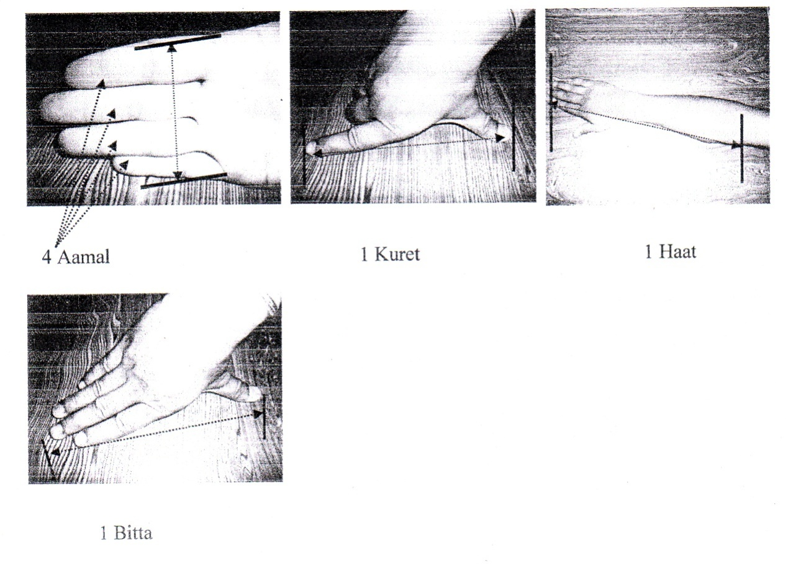
They have been using the length conservation system as mentioned below:
2 ½ cm= 1 Angul/Ammal = 1 inch
8 inch = 1 kuret
1 kuret + 2 inch = 1 Bitta
1 Bitta + 2 inch = 1 pit.
1 pit + 8 inch = 2 Bitta = 1 Haat
2 Haat + 10 cm= 1 meter.
1000 meter = 1 kilometer [ 5 kilometer = 1 kosh] 1. foot = 12 inch = 30cm
These measurement units have been followed by all people of the Lama Gaau and PataleGaal municipality. So these are the standard measurement units to measure the things. Some other area of Nepal is also being used these measurement units which helps to make the units are valid and reliable.
These are the measurement units to measure the lengths and breadths of house, land, plough and Juwa etc. To construct the house, plough (Halo) and in many works which are related to length. They use these units of length 'Haat is the most useful measurement units of length in the Tamang community. Centimeter, Meter, Kilometer were not used by everyone. They are unfamiliar about the unit of distance which is kilometer. And some Tamang people are using 'Kosh' as a unit of distance measurement.
The researcher asked to the elder Tamang that “How long is the distance from Mahakali Temple to Kathmandu?" The respondent Mrs. ManamayaTamang (58 years) answered that it is about 10 "kosh”. But she was unknown about kilometer.

Area Measurement
To measure the area, they measured by estimating of any thing. Most of them are constructed house, farmland goth, khor, baranda, bhar, nanglo, doko, mat, chakati, madra etc. by their own traditional estimation. They made house by 8x14 Haat. Goth and khor are made by looking the size of pet animals. They made mat, chakati and mandro by the size of another appropriate chakati in consideration of the place which it has to cover. They tie a lengthen rope in a parallel form to make upto top.
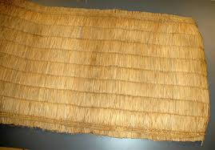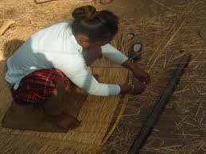
Gundri (Mat) Making Gundri

Area Estimation for House Plan
It is found that most of the houses of Tamang people are in rectangular base. In the construction of houses, they estimate the 'Ghaderi' by estimating length and breadth stretching the rope to the required size. The rope is prepared according to the Haat measurement units. For example, they say 14\8 Haat. It means the length and breadth of the house are 14 haat and 8 haat respectively. Thus, the Tamang people estimate the area of any house shape by measuring the lengths and breadth with the hand as standard i.e. rope of fixed measurement of lengths and breadths with hands are made which are used to measure length of ground. Most of the houses are made of stone, mud, wood and straw etc.
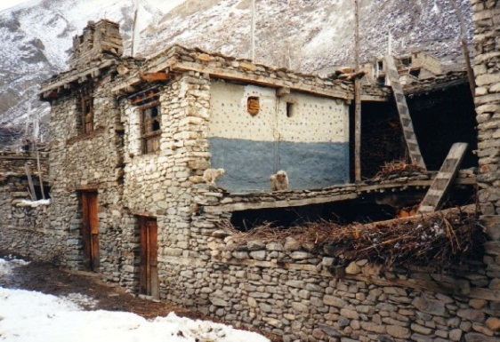
A House Construction in Progress

Measurement of Land for Farming
The measurement of land is measured in terms of grain seed required and ploughing time. Mana' and 'Pathi’ is the unit of seed wise measurement of farm land. Here, their bigger unit is pathi and smaller unit is mana. The researcher asked A Tamang people that “How do you have your farmland area?”. “A Tamang Mr. Suryaman Dong (64 years) immediately replied that “I have peddy land of six pathis and corn land of bisamana”. Both the mana and pathi are the units of volume 1 pathi = 8 mana. One mana of peddy seed is shown is a land area of 50 square meters and at the same space intervals (approx). This unit is fairly accurate as all people show seeds almost in the same way
Ploughing is done with the help of oxen size of their land area is measured with a ploughing in a day as the measurement unit. The land which could be ploughed in one day vary, the variation depending upon their structure capacity of ploughman and oxen. But it is customary for the farmers, to express the size of their land with a "ploughing day” as the measurement unit. Generally, One 'Hal is the ploughed in one day at normal ploughing speed and is 1500 square meter (approx).
They also used 'muri' as a measuring unit besides ploughing. Grain yielded land is measured in muri and unirrigated land is measured in ploughing time. Ropanis, Anna, Dam, Paisa are the land measuring units in the hilly regions of Nepal. One Hal is equal to two ropani and four matomuris is equal to one ropani (approx).
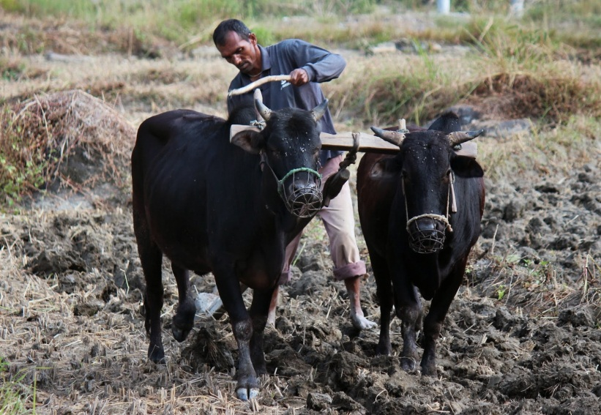
Ploughing by EkHalkoGoru

Volume Measurement
Volume measurement is mainly used to measured ghee, Milk, wine, rice, peddy corn, what, cereals, etc. They used mana and pathi even to measure the tomato. The units of volume measurement widely used are. Chakanchi, Muthi, Chauthai, Pala, Mana, Kuruwa, Pathi, and Muri. The smaller unit of measurement is chakanchi and the bigger is muri besides these units they used 'dalo' as a volume measurement to measure rice, corn, cereal etc. They made 'dalos' are different measures. Some of them (dalo) contains 2 pathi, some contains 4 pathi, some contains 5 pathi etc.
The conservation system of volume as shown below:
2 chakanchi = 2 ½ muthi = 1 chauthai
4 Chauthai = 2 pala = 1 mana (10 muthi)
2 mana = 1 kuruwa
4 kuruwa = 1 pathi
20 pathi = 1 muri
The other unit of volume measurement is "fam’. They used the fam as an alternative measure of pathi. They kept the grain in ‘Fam' at the top circumference of the fam but they kept the grain in ‘Pathi' in the conic way. But there is a quite difference between “Pathi' and 'Fam' according to their shape, size and measuring system.
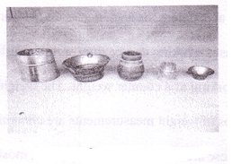
Liquid Measurement Tools
They have casted pots into different sizes. Most of them used pachpathekharkudo, Teen mane Bhaddu, mane lota, Duimanelota, mane butuka, mane gilas etc. The units of casted pots are established with the help of mana and pathi. The other units of volume measurement are chimti and Anjuli have been using by the Tamang people atLamaGaau and PataleGaau municipality of Bhojpur district.
Other Units
Chimti
A chimti means “a pinch”. It is the volume of salt, sugar, etc held between three fingers- thumb, index and middle.
Anjuli
An anjuli is the volume of water, rice etc. held between the two palms ofhands) joined together to form a bowlike shape.
Measurement of Weights
To weight the food grains they had been using ‘Tulo' (Umal) which is shownin figure below. The measurement unit to weight meat, Tomato, Potato etc. isDharani, Tulo (Umal) is an instrument made of iron bar (or wooden bar) and has afixed blob of mass on one side of that bar. The other side carries a horizontal iron barto balance the weight. The blob of iron bar, suspended by strings. The suspensioncould be shifted at different measure marks on the iron bar to balance the weight. Th eblob of iron mass is working as a counter weight. Different measures marks on theiron mass are working as a counter weight. The weight is expressed according to thenumber of phulos of weight measurements are chhatak, pau, Bisauli, Dharni, Pathar,Aathpol, etc. These are still used but now a days, most of the young and literatepeople used gram and kilogram to measure the weight. They imported goods with the help of formal measurement system. But they exported goods with their own measurement system.

They have been using the conservation of weights as shown below:
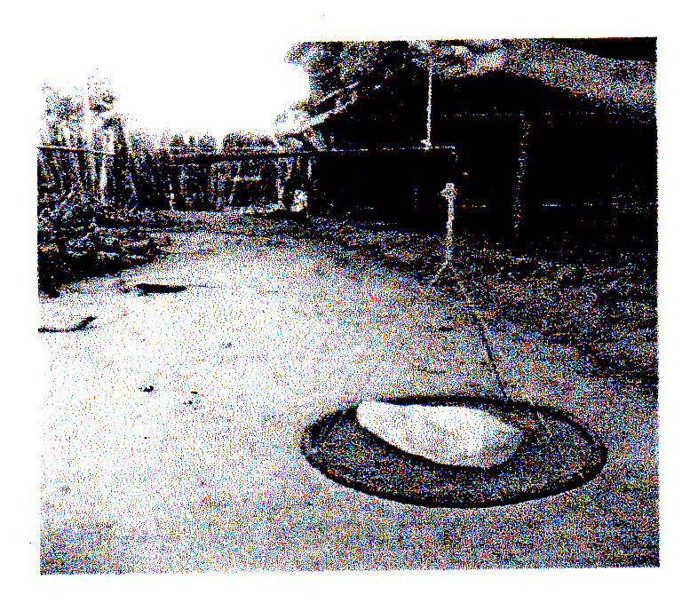
1 chhatak = 50 gram
200 gram = 1 pau
3 pau = 1 aathpol 1 aathpol+ 2 pau = 1 kilogram.
6 Pau = 1 Bisauli
2 Bisauli = 1 dharni = 1 Path
Umal (Tulo)

Money Counting and Their Units
In business transaction, the counting of money is more frequent than the counting of other commodities. Money counting is not a problem to the people because it is counted in terms of units. The official money units in Nepal and their Tamang synonyms are as follows:

Nepali names Tamang synonyms
1 paisa Tangakee
2 paisa TangaNgee
1 ana (= 4 paisa) TangaBhlee
5 paisa TangaNgaa.
10 paisa Tangachyooi
1 suka (= 25 paisa) Tangachyooingeesengaa.
1 mohar (= 50 paisa) Tangachyooingaa
1 rupaiya (= 100 paisa) Sikakee
2 rupaiya Sikangee
5 rupaiya Sikangaa
10 rupaiya Sikachyooi
20 rupaiya Sikachyooingee
50 rupaiya Sikachyooingaa
100 rupaiya SikaGyarja
500 rupaiya SikaGyarjangaa
1000 rupaiya Sika Tong

Concept of Ordinals
The ordinal words are used only in ranking brothers and sister. For other uses,Nepali ordinals have been adopted.
Table 4: Expression of Brothers and Sisters in Tamang
Nepali Expression |  | Tamang Expression |  | Ordinals
Brothers | Sisters | Brothers | Sisters | -
Jetha | Jethi | JaTheba | Jamethuli | 1st
Maili | Maila | JaParang | Jememaili | 2nd
Saila | Saili | JaSanji | Jamesaili | 3rd
Kaila | Kaili | Ja Kaila | Jamekaili | 4th
Antare | Anthari | JaAntare | JameAntari | 5th
Jantare | Jantari | JaJantare | JaemJantari | 6th
Mantare | Mantari | JaMantare | JameMantari | 7th
Kanchha | Kanchi | JaChyangba | JameChyangba | Last

Concepts of Times and Units
The time concepts are based on the routine events in environment and the units of time are fixed out and used with reference to these events. Days, Week, Month and years are important units of the time. They express time on the basis of
- Observable changes in environment.
- Cock crowing.
- Location of sun, moon, stars and constellations.
- Movement of creatures.
- Listening to radio and watching clocks.
Morning, Day, Evening and Night are called Syo, Dini, Ngyase and Munag respectively in their native tongue.

Time or Conditions
English Tamang
Today Tini
Tomorrow na:msyo
Yesterday tila
Day after tomorrow reni
Day before yesterday dangsya
Before some day Ongye
After three day Somcekunu
A year ago Tiyung
Before two year Neyung
This year Tiding
Coming year Guring
After two year Reding
Next time dersye
Oldage time dangbo
Day time dini
Midday dinigun
Sun set time dingigalbakyor
Sun rise time dingiphyapakyor
In evening ngyase
Night munchhe/Munag
Mid night munagungri
In early morning mimarngyampakyor
Morning syo
They have concept that the days, month and Lekur in a cyclic order. Common people in Bhumesthan and Tasarpu record long time intervals with reference to useful and memorable events such as childhood, youth, marriage, death, catastrophic earthquake of 1990 B.S. and 2045 B.S. Political changes such as 2007, 2046, 2063 B.S. is good references for the most elderly people who had an experience of them.
Table 5: Day Counting
English | Tamang
One day | Tiret
Two day | Ngiret
Thrice day | Somret
Fourth day | Bliret
Fifth day | Ngaret
Sixth day | Duret
Seventh day | Ngisret
Weekly | Ngisretla
Daily | Re-rela
Half monthly | La-Detla
Monthly | La-gila
Two monthly | Langila
Tri-monthly | La-Somla
Half-yearly | La-Dula
Yearl | Lola
Iron age | Jyotipadui
Brass year | Chayangidengi dui
Silver age | Somdengi dui
The golden age | Jogdengidui

Week, Month and Lekur
Like any other calendar in common use in Nepal, the Lama calendar has 7days for a week. Similarly, a month is of 30 days. It is interesting to note that theLama calendar also divides time into 12 year periods. Each 12 year period is calledlekur. The lekur is represented pictorially and the picture, called shippakholo, isconsidered sacred. Each year in a lekur has a particular name.In Nepal, a 12-year period is considered important by other communities aswell. Many socio-cultural occasions are celebrated every twelve years. The names ofthe days, months and year in the Lama calendar have aesthetic meaning and symbolicvalues. The names of the days, months and year are as follows.
Table 6: Days of Week
Name of the seven days | Tamang expression
Sunday | Ngimare
Monday | Daware
Tuesday | Mimgmare
Wednesday | Lakpare
Thursday | Phurbaare
Friday | Pasangre
Satudray | Pembare
As English date January to December and Nepali date Baisakh to ChaitraTamang people too have their own name of 12 months whjich starts from Dugu to Namdong.

Table 7: Express of Twelve Months in Tamang
English | Nepali | Tamang
April-May | Baisakh | Dugu
May-Jun | Jestha | Dwaphre
Jun-July | Aasadh | Byalbo
July-August | Shrawan | Gonde
August-September | Bhadra | Yande
September-October | Ashoj | Mhening
October-November | Kartik | Sorati
November-December | Mangsir | Boitapa
December-January | Poush | Tapa
January-February | Magh | Kherla
February-March | Falgun | Nawa
March-April | Chaitra | Namdong
Lama calendar divides time into 12 years periods. Each 12 years period is called Lekur which is shown below in table no. 8.
Table 8: Years of the Lekur
English | Nepali | Tamang
Musa | Mouse | Namyung-Lho
Gai | Cow | Mhe-Lho
Bagh | Tiger | Chyan-Lho
Biralo | Cat | Tawar-Lho
Garud | Thunder | MulaPukhri-Lho
Sarpa | Snake | Sola Pukhri-Lho
Ghoda | Horse | Ta: -Lho
Bheda | Sheep | Guy-Lho
Bandar | Monkey | Maker-Lho
Chara | Bird | Name-Lho
Kukur | Dog | Nagi-Lho
Sungur | Pig | Dhwa-Lho
The Lama New Year's Day is called Lhosar. It is big event which is eagerly awaited and celebrated whole-heartedly by the Tamang people in Dhading. Most Tamangs in this district know when Lhosar "is coming".
The people recognize a year by its name. The lekur system helps people to keep records of their age. Many people remember how many lekurs they have already lived through and in which years of the calendar and on what days they were born.
The Lama calendar is used mostly for religious and social occasions and rituals. It is not used for routine activities of the day. Most people find that they do not have any idea about the importance of calendar days. When necessary, they consult lamas. One important aspect of the Tamang tradition is that a new-born baby is given the name of the day on which it was born. Therefore, many Tamangs of rural Dhading have for their names the names of the days. Nima, Dawa, Mingma, Lkhapa, Phurpa, Pasang and Pemba.

Concept of Fractions
A fraction is a straight division of a full measure. Most of the people in that VDCs use positive real numbers. 'Tet is the native word used to denote half of anything. But the common people can't write it in symbol (1/2). The people who are carpenters, sawyers and who have the knowledge of time on the basis of watch use the fractional words such as Paune, Shandhe,Saba, Tet etc. The concept of fractions is given in volume measurement of solid. The concept of fractions can easily be seen in weight measurement. These words indicate the concept of fractions.
Tet = ½
Fedang = ¼
Kodang = ¾
Bosom = 1/3
Bopli = ¼
The fractional expressions were based on the practical needs of the people. Complex fractional expressions were not found in use.
In this chapter, the researcher included that the Tamang had full of different mathematical concepts in their daily activities. Tamang people use different geometrical concepts in their works. Similarly in this chapter the researcher deals about their indigenous game which is linked to the traditions of a cultural group.

Different Geometrical Concepts: Daily Use Materials of Tamangs
Through the observation and informal interview, I found the Tamang people use different geometrical concepts/ ideas in their works. They have based their geometrical concepts on the shapes and patterns of the physical objects existing around them. Different geometrical ideas were found in weaving and constructing of different objects. The concepts of geometry are directly related to real physical objects and practical utility. Ideas of geometry is used in building of houses, in sawing logs, in knitting different objects made of choya and Bas etc.

Dhyangro( Ngaa)
This is a musical instrument. This instrument is made of wood and leather of goat. The wood is circular in shape and the leather is woven along the wood by using metal/wooden pins. The whole instrument looks circular in shape. It was made in this shape that it gives sonorous and hollow sounds when required. They beat this instrument and chant tantra-mantra so as to chase away devil sprits and please their gods and goddesses.
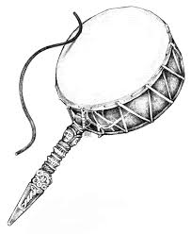

Janto (Randa)
It is a kind of traditional domestic tool used as alternate to a mill. To construct this tool, two Hemi-spherical stones are connected by a wooden stick or metal rod. The lower part is fixed on the ground and a wooden handle is inserted on the edge of the upper part so that they can move round. On the whole it looks spherical in shape. This machine is designed in spherical shape so that they can move it round easily and grind cereals and crops.
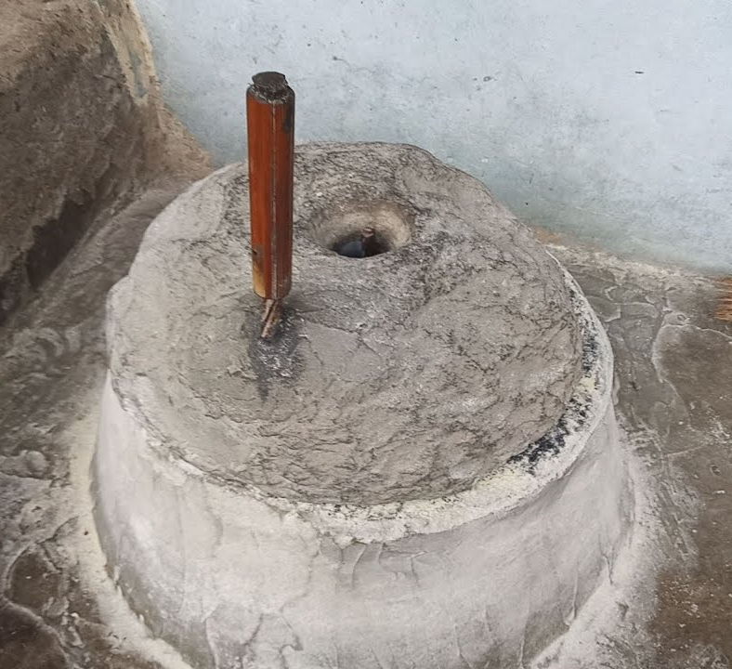

Madal
This is also a musical instrument. This instrument is made hollow and leather strips of goat It looks circular in both ends and the middle part is cylindrical. A leather belt is attached in both ends so that they can hang the instrument in their legs and beat the ends with their hands. It is mostly used in their festivals to produce melodious sound and sing folk songs. It was made in such a shape so that it becomes handy and mobile.
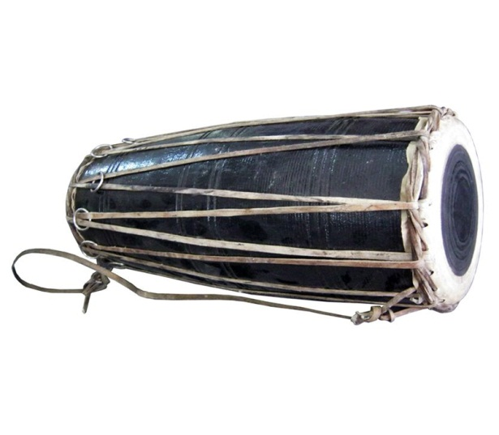

Nanglo (Nakhle)
It is a traditional household material made of strips of bamboo by knitting each other. The edge of Nakhle is also made of bamboo stick. It is circular in shape. They use it for threshing cereals and crops. This household appliance was constructed in such a shape so that separation of grains of rice, wheat, etc. becomes faster and easier.
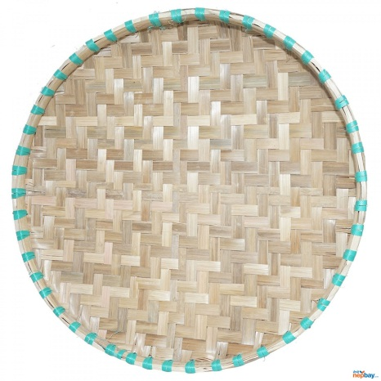

Dhiki (Lang)
This is a traditional machine used as an alternate to a mill. To construct this machine; two wooden poles are buried parallel, being mutually perpendicular with the land. The distance of the two poles is about one foot. Between the two poles rectangular prism is connected to make circular hole, so that one foot is left behind the poles. In the front part of the poles a rectangular prism is connected being perpendicular with the wood. In another part of wood, a small motor (okhal) is buried for pounding (okhal) crops like paddy, maize, buckwheat etc. While beating the crops, a spherical cloth object is used connected with a stick, the whole machine is constructed by the combination of perpendicular and parallel poles. This domestic is made in such a share so that it can be used for beating paddy, maize, wheat, buckwheat etc.
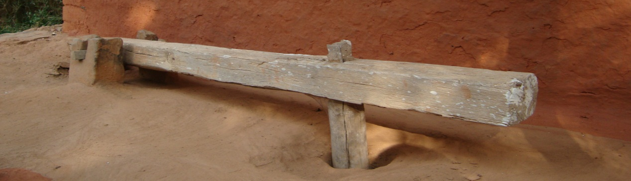

Theki
It is also household material made of daar wood. The bottom and top parts are circular in shape and the central (body) part is cylindrical. The upper part is cut in a neck shape. It does not have other parts, rather is made of waving a single log. It is used for freezing milk, making curd and processing the curd to make ghee. This domestic appliance was made in such a shape so that a processing of the curd into ghee becomes faster and easier, and the liquid cannot leak out.
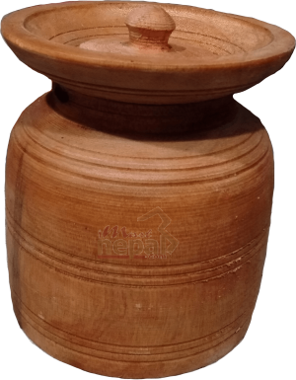

Doko (Chhang)
It is also an object made of bamboo strips. The strips are knitted each other. The upper part wider and circular in shape. The lower part is narrower and four bamboo legs are attached at the bottom. The whole construction is conical in shape. It is used for carrying household commodities, fruits and grass. It was constructed in such shape so that it is easy to hold things.
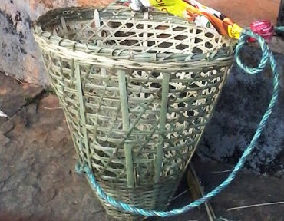

Tamang people used different types of geometrical concepts for constructing their cultural materials. They focused mainly lines, angles etc as geometrical properties by the help of this properties they used different geometrical shapes like circle, sphere, semi-sphere, cylinder, cone, rectangle, prism, square, parallelogram and frustum etc.

Some Results from Observation
In this section, the researcher has attempted that what type of mathematics isused in the activities of Tamang. Completion of any type of work is impossiblewithout using mathematics in our daily life activities. But they are unknown aboutuses of mathematics.
In Sadananda municipality of Bhojpur district, I tried to observe the mathematicalpractices in Tamang community. It was not so easy like collecting the stones out ofthe grains of rice to collect the mathematical practices in the local community. Theevidences were not readymade so that I could not ask the people and dig the placewhere the objects were hidden. It was like diving into an Ocean to discover a pearl.
Even I knew that the people were not ready to try to explain their practices because it was difficult for them to define their day to day works into a formula. Though they used different mathematical concepts invented by themselves and their ancestors. They had no idea what exact pattern or system they have been using. Even they had difficulty to recall the day to day activities and other social norms where they use certain mathematical rules and patterns. Since they use their knowledge instantly whenever they required- They never kept any account of the knowledge they used in their life. They didn't have any system of collecting skills they frequently required, their mind worked as the dictionary of everything. So I needed to plan and study their way of life and social and cultural reality before I actually could start my research.
However as I observed their activities and I found their using many mathematical concepts carefully and successfully without actually knowing the formula On the process of collecting data, I reached one Tamang's home. A Tamang women prepared local alcohol Jad for me and her family member. I saw that she could make appropriate proportion of water and chokra (raw material to prepare local alcohol Jad) while they prepared Jad to give for guests. This demonstrated that they had a good idea of proportion between raw material and water.
Mathematical Concept in the Game

ChungiKhel
Chungi is very interesting and favourable game for the children. It is very useful game both mentally and physically. The children can learn to count from one up to fifty, hundred, five hundred etc. The researcher found that BirBahadur, SomBahadur and their friends formed a group of four children and made two teams. Each team had two children and started to play the game. The competition went on by counting the hits to the chungi by the foot without touching floor by chungi. In that game the target was fixed by 200, the half is 100. First SomBahadur's team got the half number; 100 and they rested for a moment and started to another half. Finally his team won the game by getting 200 first. So to play the game the player must know to count the number. From this game the player can learn two concepts, one is counting and the other is divided by two to any targeted numbers.
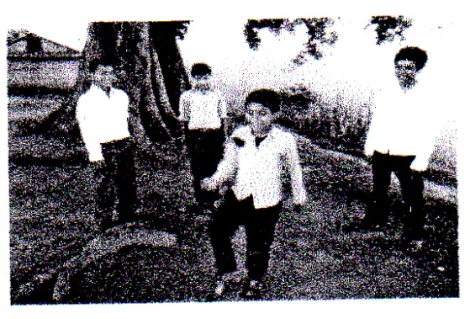
Playing ChungiKhel

.

Chapter V
FINDINGS CONCLUSIONS AND IMPLICATIONS

Finding of the Study
On the basis of analysis and interpretation of data, the major findings of this study were as follows.
- They measured length and breadth a by using hands and fingers like as; Ammal ,Bitta, Haat are the measuring units of length and breadth.And the kosh is the mwesuring right units of distance.
- To add two numbers togrther,they count the first number on the top of the first number they started the count second number by making first as initial number and find result. For these activities they used small stones.
- To multiply the number, they added times of number by repetitive technique of addition.
- To divide the number, they decomposed the numbers into groups and divide for each other.
- To subtract the number, they started to count the top level of the number which has to be subtracted up to the level of the number from which the number is to be subtracted.
- The counting system of Tamang has gone by adding ‘se’ suffix from each base 20 numbers after twenty.
- The mathematical process is based on traditional practice and they use it through physical objective of the environment in practical situations.
- The units of weight measurement are pau, bisauli,aathpol,K.G. etc.
- The units of volume measurement are muthi,pala, mana,kuruwa,pathi,and muri.

Conclusion
Among the various ethno group, all have their own traditional mathematical ideas.But only a few ethno groups mathematical ideas had been studies.It has still remained to discover the mathematical ideas of some ethno groups.This study is concerned with mathematical ideas and measurement system of Tamang people.The present study of Tamang community has found that they used own typea of counting and measurement system.The Tamang of Bhojpur have their own traditional systems of measurement.The system were locally developed in the post when there was no need to standardizing measurement units and no pressing needs of the use numbers.The felt upon these systems as appropriate for their daily life needs.So the system seems to be of practical utility in their life,Tamang use their own system of counting and measurement as well as mathematical process for their normal day to day activities.People learned these stems in their own communities through normal activities.The system were simple enough to learn and for practical utility.The simplicity and practical usefulness of the systems are evident from the fact that in other communities of Nepal use their own native counting and measurement technique which are more or less similar to them.Tamang people need to learn formal school mathematical concept in the initial level has difficulty to learn.Therefore, they have to expose at their level to modern mathematical concept and processes.So,this research facilitates to understanding modern mathematics in the school level mathematics curriculum.

Implications
Due to this study was limited in several aspects,so the findings of this study may have covered in limited area.Thus,on the basis of this study,the recommendations have been made as follows:
- This study is limited to counting system,measurement system (length, volume,area,weight) and mathematical processes (addition,subtraction,multiplication,division) of whole numbers similar study can be done by extending to geometrical concept and other mathematical concepts.
- Due to the restrictions,this study had been conducted in a short period.But,this sort of this study has to be done intensively.
- School may be applied practical knowledge based activities which can promote their previous experience.
- This study was limited to one municipality of Bhojpur district.According to the Tamang people of that area, there is another large Tamang settlement in different municipality of Bhojpur district.They have different language,culture and system tham that of the Tamang of Bhojpur district.So, the ethno mathematics of Tamang can be studies in Bhojpur district.

REFERENCES
CERID, (1990) The elementary process of learning mathematics Concept and process of RasuwaTamang. Kathmandu.
Chaudhary, D.K. (2017). Mathematical practices in Tharu community. TU.
Dhakal, P.K. (2008).Basic Mathematical Concepts and processes of Rai Ethnic Group. Unpublished Master thesis T.U. Kathmandu
Kim, B. (2001). Social constructivism. In M. Drey (Ed), Emerging perspectives on learning, teaching and technology, unpublished master's Degree Thesis, Department of Mathematics Education, T.U. Kirtipur, Kathmandu
Lamichhane , (2008). Mathematical Concept used by out of School children. (An unpublished Master's Degree thesis) Department of Mathematics Education, T.U.
Panta, K.N. ( 2007). Basic Mathematical Concepts and processes practiced by Darai in Tanahun District. Unpublished Master's Thesis, Department of Mathematics Education, T.U. Kirtipur.
Shrestha, (2003). The measurement system in Newar Civilization.. (An unpublished Master's Degree Thesis). Department of Mathematics Education, T.U.
Subedi , (2009). Mathematical concept used by dicker worker," (An unpublished Master's Degree thesis) Department of mathematics Education, T.U.)
Vygotsky, L.S. (1992), learning and mental development at school age, In B. Simon and J. Simon (Eds), psychology in the U.S.S.R. (PP- 21-34). London: Routledge&Kegan Paulo (originally published 1934).
Yonjan,amrit (2056),Tamang Byakaran
Yonjan,amrit(2056),Tamang sangkya pranali
Lama, (2012). A study in understanding Basic concept of mathematics by Tamang Karki,R.(2017). Basic mathematical concepts practiced by Hayu community. Unpublished Master's Degree Thesis, Department of Mathematics Education, T.U. Kirtipur, Kathmandu community . An unpublished master thesis, T.U kirtipur

Appendix A
Number Counting in Tamang Language
English | Nepali | Tamang (Pronunciation)
One | Ek | Gee
Two | Dui | Ngee
Three | Thin | Som
Four | Char | Blee
Five | Panch | Ngaa
Six | Chha | Du
Seven | Sat | Nees
Eight | Aath | Bre
Nine | Nau | Ku
Ten | Das | Chyooi
Eleven | Aghara | Chyooi Gee
Twelve | Barha | Chyooi Ngee
Thirteen | Terha | Chyooi Som
Fourteen | Chauda | Chyooi Blee
Fifteen | Pandra | Chyooi Ngaa
Sixteen | Sorha | Chyooi Du
Seventeen | Satra | Chyooi Nees
Eighteen | Athara | Chyooi Bre
Nineteen | Unnais | Chyooi Ku
Twenty | Bees | Bogal Gee (Ngee Chyooi)
Twenty One | Akkais | Bogalgeese Gee

Twenty Two | Bais | Bogalgeese Ngee
Twenty Three | Teis | Bogalgeese Som
Twenty Four | Chaubis | Bogalgeese Blee
Twenty Five | Pachchis | Bogalgeese Ngaa
Twenty Six | Chhabis | Bogalgeese Du
Twenty Seven | Sattais | Bogalgeese Nees
Twenty Eight | Athtahis | Bogalgeese Bre
Twenty Nine | Unantis | Bogalgeese Ku
Thirty | Tis | Bogalgeese Chyooi Gee (Chyooi Som)
Thirty One | Ektis | Bogalgeese Chyooi Gee
Thirty Two | Battis | Bogalgeese Chyooi Ngee
Thirty Three | Tettis | Bogalgeese Chyooi Som
Thirty Four | Chautis | Bogalgeese Chyooi Blee
Thirty Five | Paitis | Bogalgeese Chyooi Ngaa
Thirty Six | Chhattis | Bogalgeese Chyooi Du
Thirty Seven | Saitis | Bogalgeese Chyooi Nees
Thirty Eight | Artis | Bogalgeese Chyooi Bre
Thirty Nine | Unanchalis | Bogalgeese Chyooi Ku
Forty | Challis | Bogal Ngee (Chyooi Blee)
Forty One | Ekchalis | Bogalngeese Gee
Forty Two | Bayalis | Bogalngeese Ngee
Forty Three | Trichalis | Bogalngeese Som
Forty Four | Chawalis | Bogalngeese Blee
Forty Five | Paitalis | Bogalngeese Ngaa

Forty Six | Chhaylis | Bogalngeese Du
Forty Seven | Sarchalis | Bogalngeese Nees
Forty Eight | Archalis | Bogalngeese Bre
Forty Nine | Unanchas | 13ogalngeese Ku
Fifty | Pachas | Bogalngeese Chyooi
Fifty One | Ekaunna | Bogalngeese Chyooi Gee
Fifty Two | Baunna | Bogalngeese Chyooi Ngee
Fifty Three | Tripanna | Bogalngeese Chyooi Som
Fifty Four | Chaunna | Bogalngeese Chyooi Blee
Fifty Five | Pachpanna | Bogalngeese Chyooi Ngaa
Fifty Six | Chhapanna | Bogalngeese Chyooi Du
Fifty Seven | Santaunna | Bogalngeese Chyooi Nees
Fifty Eight | Anthaunna | Bogaingeese Chyooi Bre
Fifty Nine | Unanshathi | Bogalngeese Chyooi Ku
Sixty | Shathi | Bogal Som
Sixty One | Eksaththi | Bogalsomse Gee
Sixty Two | Baisaththi | Bogalsomse Ngee
Sixty Three | Trisaththi | Bogalsomse Som
Sixty Four | Chausaththi | Bogalsomse Blee
Sixty Five | Paisaththi | Bogalsomse Ngaa
Sixty Six | Chaisaththi | Bogalsomse Du
Sixty Seven | Sarsaththi | Bogalsomse Nees
Sixty Eight | Arsaththi | Bogalsomse Bre
Sixty Nine | Unansattari | Bogalsomse Ku

Seventy | Sattari | Bogalsomse Chyooi
Seventy One | Elchattar | Bogalsomse Chyooi Gee
Seventy Two | Bahattar | Bogalsomse Chyooi Ngee
Seventy Three | Tihattar | Bogalsomse Chyooi Som
Seventy Four | Chauhattar | Bogalsomse Chyooi Blee
Seventy Five | Pachahattar | Bogalsomse Chyooi Ngaa
Seventy Six | Chaihattar | Bogalsomse Chyooi Du
Seventy Seven | Satahattar | Bogalsomse Chyooi Nees
Seventy Eight | Athahattar | Bogalsomse Chyooi Bre
Seventy Nine | Unanasi | Bogalsomse Chyooi Ku
Eighty | Asi | Boal Bee
Eighty One | Ekasi | Bogableese Gee
Eighty Two | Bayasi | Bogableese Ngee
Eighty Three | Triyasi | Bogableese Som
Eighty Four | Chaurasi | Bogableese Blee
Eighty Five | Pachasi | Bogableese Ngaa
Eighty Six | Chhayasi | Bogableese Du
Eighty Seven | Satasi | Bogableese Nees
Eighty Eight | Athasi | Bogableese Bre
Eighty Nine | Unnanabbe | Bogableese Ku
Ninety | Nabbe | Bogableese Chyooi
Ninety One | Ekanabbe | Bogableese Chyooi Gee
Ninety Two | Bayannabbe | Bogableese Chyooi Ngee
Ninety Three | Trinannabbe | Bogableese Chyooi Som

Ninety Four | Chaurannabbe | Bogableese Chyooi Blee
Ninety Five | Pachaimabbe | Bogableese Chyooi Ngaa
Ninety Six | Chhayannabbe | Bogableese Chyooi Du
Ninety Seven | Santannabbe | Bogableese Chyooi Nees
Ninety Eight | Anthannabbe | Bogableese Chyooi Bre
Ninety Nine | Unansaya | Bogableese Chyooi Ku
Hundred | Saya | Bogal Ngaa (Ghyarja Gee)

Source: by teacher Chasung Lama

Appendix B
Number Counting More than Hundred
English | Nepali | Tamang (Pronunciation)
One Hundred | Ek Saya | Gyarja Gee
Two Hundred | Dui Saya | Gyarja Ngee
Three Hundred | Thin Saya | Gyarja Som
Four Hundred | Char Saya | Gyarja Blee
Five Hundred | Panch Saya | Gyarja Ngaa
Six Hundred | Chha Saya | Gyarja Du
Seven Hundred | Sat Saya | Gyarja Nees
Eight Hundred | Aath Saya | Gyarja Bre
Nine Hundred | Nau Saya | Gyarja Ku
Thousand | Hajar | Gyarja Chyooi

Source: Yonjan, Amrit (2056). Tamang Sankhya Pranali

Appendix C
Place Value Number System of Tamang
English | Nepali | Tamang Language
1 | Ek | Gee
10 | Das | Chyooi
100 | Saya | Gyaarja
1000 | Hajar | Tong
10000 | Das hajar | Chyooi Tong
100000 | Lalch | Gyaarja Tong
1000000 | Das Lalch | Ming
10000000 | Karod | Chyooi Ming
100000000 | Das Karod | Gyaarja Ming
1000000000 | Arab | Tong Gyaarja Ming

Source: Yonjan, Amrit (2056). Tamang Sanglchya Pranali

Appendix D
Interview Format for Teacher
Date of interview : ................... Sex : ................................. Age : ....................
Name : ..................... Religion : ............................... Qualifications : ...........
Experience in teaching : ..................... Address : ............................................
Total No. of student : ....................... V.D.C. / municipality : ............................
The interview with mathematics techer will take in the following basis :
- Problem of teaching mathematics for Tamang student ,
- Relations between teacher and Tamang student ,
- Teaching strategies of the Tamang student .

Appendix E
Interview Format for Students
Date of interview : ................... Sex : ................................. Age : ....................
Name : ..................... Religion : ............................... Class: .......................
V.D.C/ Municipality : ............................ Adress : ......................................

The interview with student will take in the following basis :
- Mathematics in their community ,
- Interest in subjective ,
- Domain of using mathematics.

Appendix F
Interview Format for Farmers
Date of interview : ................... Sex : ................................. Age : ....................
Name : ..................... Religion : ............................... Qualifications : ........... Address : ..................... V.D.C. / municipality : .......................

The interview with faremers will take in the following basis :
- Understanding mathematicis ,
- Daily life in mathematics ,
- Preparing concrete material .

