

TRIBHUVAN UNIVERSITY
INSTITUTE OF ENGINEERING
PULCHOWK CAMPUS

THESIS NO: G008/074

Analysis of Bearing Capacity of Strip Foundation on Cohesive Soil with Soil Patch of Different Property Using FEM

by

Kushal Bijukchhe

A THESIS
SUBMITTED TO THE DEPARTMENT OF CIVIL ENGINEERING
IN PARTIAL FULFILLMENT OF THE REQUIREMENTS FOR THE
DEGREE OF MASTER OF SCIENCE IN
GEOTECHNICAL ENGINEERING

DEPARTMENT OF CIVIL ENGINEERING
LALITPUR, NEPAL

SEPTEMBER, 2021

COPYRIGHT
The author has agreed that the library, Department of Civil Engineering, Pulchowk Campus, Institute of Engineering may make this thesis freely available for inspection. Moreover, the author has agreed that permission for extensive copying of this thesis for scholarly purpose may be granted by the professor(s) who supervised the work recorded herein or, in their absence, by the Head of the Department wherein the thesis was done. It is understood that the recognition will be given to the author of this thesis and to the Department of Civil Engineering, Pulchowk Campus, and Institute of Engineering in any use of the material of this thesis. Copying, publication, or the other use of this thesis for financial gain without approval of the Department of Department of Civil Engineering, Pulchowk Campus, Institute of Engineering and author’s written permission is prohibited.
Request for permission to copy or to make any other use of the material in this thesis in whole or in part should be addressed to:

………………………………………..
Head of the Department
Department of Civil Engineering,
Institute of Engineering, Pulchowk Campus,
Pulchowk, Lalitpur, Nepal

TRIBHUVAN UNIVERSITY
INSTITUTE OF ENGINEERING
PULCHOWK CAMPUS
DEPARTMENT OF CIVIL ENGINEERING
PULCHOWK, LALITPUR

APPROVAL PAGE
The undersigned certify that they have read, and recommended to the Institute of Engineering for acceptance, a thesis entitled, "Analysis of Bearing Capacity of Strip Foundation on Cohesive Soil with Soil Patch of Different Property by Using FEM" submitted by Mr. Kushal Bijukchhe (074/MSGtE/008) in partial fulfillment of the requirement for the degree of Master of Science in Geotechnical Engineering.

..…..…………………………………………
Program Coordinator and Supervisor,
Dr. Santosh Kumar Yadav
Department of Civil Engineering
Institute of Engineering, Pulchowk Campus

..…..…………………………………………
External Examiner
Er. Abhay Kumar Mandal
Geotechnical Engineer, AVIC International

September 2021

ABSTRACT
Soil in its natural form is a non-homogeneous mass, with possibilities of consisting more than one layer and pockets of heterogeneity. The pocket of heterogeneity explicitly includes the presence of void and the presence of soil of contrasting properties. Such pockets or patches of discontinuity in the soil may cause unfavorable and unpredictable performance of the foundation build over them. In that case, such pockets of soil should be studied thoroughly before construction over or near its vicinity.
The present study deals with the determination of bearing capacity of surface strip foundation resting over cohesive soil with continuous square soil patch of different consistency than that of parent soil. The analysis was made using the finite element software in which the soil was modelled as an elastic perfectly plastic material. The soil domain was discretized using 15-noded plane strain triangular elements. The parametric study includes the effect of vertical and horizontal position of square shaped soil patch with respect to foundation, effect of size of the soil patch and effect strength characteristics of soil patch on the bearing capacity and deformation behavior of the soil beneath the surface strip foundation.
The results of the study indicates that there is a critical zone of influence under the foundation. The performance of the foundation will be significantly influenced due to existence of the soil patch in the parent soil layer only when it is located within this region. The size of this zone of influence depends on various factors as soil property of the parent soil and soil patch and the size of the foundation and soil patch. When the soil patch is located within the critical zone, the bearing capacity of the foundation varies considerably with the location of the soil patch. It is also observed that, severity of the effect of soil patch on the performance of the foundation is directly proportional to the size of the soil patch and inversely proportional to the strength of the patch soil.

ACKNOWLEDGEMENT
Foremost, I would express my sincere gratitude to my respected thesis supervisor as well as program coordinator Dr. Santosh Kumar Yadav for his exceptional guidance, advice, patience, knowledge, support and willingness to allow me to conduct a study on analysis of bearing capacity of strip foundation over cohesive soil with soil patch of different property, which has remained as a valuable asset for the research work. His helpful guidance and valuable suggestion made me work harder than I ever could.
I would like to acknowledge all the faculty members of Department of Civil Engineering for the knowledge and concepts they gave me during my study at IOE, Pulchowk Campus.
I am equally thankful to my friends MSGtE/074 batch for their cooperation and intellect suggestions. My sincere thanks also goes to all those who gave valuable support, critical comments, suggestions and advice on different stages of my research work.
Last but not the least, I would like to start off by thanking my parents including my sister for their persuasion and continuous support throughout my academic perseverance. They were always there cheering me up and stood by me through good and bad times, which motivated me to overcome the difficulties and led to this stage of my thesis

Kushal Bijukchhe
074/MSGtE/008
September 2021

TABLE OF CONTENT
COPYRIGHT i
APPROVAL PAGE ii
ABSTRACT iii
ACKNOWLEDGEMENT iv
TABLE OF CONTENT v
LIST OF FIGURE vii
LIST OF TABLE x
ABBREVIATION AND SYMBOLS x
1. INTRODUCTION 1
1.1 Outline of study 1
1.2 Background information 1
1.3 Statement of Problem 2
1.4 Objective of study 2
1.4.1 General objective 2
1.4.2 Specific objective 2
1.5 Scope and Limitation of study 3
1.6 Organization of Dissertation 3
2. LITERATURE REVIEW 5
2.1 Introduction 5
2.2 Shallow foundation 5
2.3 Bearing capacity of footing 6
2.4 Bearing capacity failure theories 6
Shear failure of a soil mass supporting a foundation will typically occur in one of three modes: general shear, local shear, or punched shear. (Das, 1977). 6
2.4.1 General shear failure 6
2.4.2 Punching shear failure 7
2.4.3 Local shear failure 8
2.5 Bearing Capacity Theories 9
2.6 Bearing Capacity of footings on Multi-layered soil profile 10
2.7 Bearing Capacity of footings on Non-Homogeneous Soil 13
2.8 Numerical modeling by PLAXIS 2D 14
3. METHODOLOGY 17
3.1 Material Model 19
3.1.1 Soil Constitutive Model 19
3.1.2 Acquisition of Soil Parameters 20
3.1.3 Acquisition of Foundation Parameters 22
3.2 Geometric model 22
3.2.1 Geometrical parameter 22
3.2.2 Optimization of model for analysis 23
3.2.3 Mesh convergence analysis 23
3.2.4 Boundary condition 24
3.3 Numerical modeling 25
3.4 Test Procedure 25
3.5 Application of load to models 26
3.6 Output 26
4. RESULT AND DISCUSSION 28
4.1 Introductions: 28
4.2 Calibrations: 28
4.2.1 Width and Depth calibration 28
4.2.2 Mesh convergence analysis: 30
4.3 Parametric studies 30
4.3.1 Effect of position of soil patch 30
4.3.2 Effect of size of soil patch 36
4.3.3 Effect of soil patch consistency 40
4.4 Effect of presence of soil patch 44
4.5 Comparison of work 54
4.5.1 Validation of model 54
5. CONCLUSIONS AND RECOMMENDATIONS 57
5.1 Conclusion 57
5.2 Recommendation 58
REFERENCES 59
ANNEX A LOAD SETTLEMENT CURVE 62
ANNEX B RESULTS IN TABULAR FORM 82

LIST OF FIGURE
Figure 2.1: General shear failure concept after Vesic (1973) & Das (1977) 7
Figure 2.2: Load settlement curve for general shear failure after Vesic (1973) & Das (1977) 7
Figure 2.3: Punching shear failure and its load settlement curve after Vesic (1973) & Das (1977) 8
Figure 2.4: Local shear failure and its load settlement curve after Vesic (1973) & Das (1977) 8
Figure 2.5: Bearing capacity approximation on two-layered clay profile after Chen (1975) 11
Figure 2.6: Punching shear models on layered soil after Meyerhof (1974) & Das (1977) 12
Figure 3.1: Algorithm for the methodology applied for the completion of the study 18
Figure 3.2: Schematic view of footing and single square soil patch system 23
Figure 3.3: Typical mesh for numerical analysis 24
Figure 3.4: Geometrical model of strip footing resting on cohesionless soil 25
Figure 3.5: Schematic diagram showing numerical models with different geometric and material parameters for parametric analysis 26
Figure 3.6: Load-settlement curve 27
Figure 3.7: Deformation behavior of soil under the foundation; (a) Displacement of soil elements, (b) Shear strain of soil under the foundation 27
Figure 4.1: Width calibration 29
Figure 4.2: Depth calibration 29
Figure 4.3: Mesh convergence (b=2m, W=40m and D=20m) 30
Figure 4.4: Bearing capacity of foundation with variation of soil patch depth (y) for different eccentricity of soil patch (x) and size of, (a) w=2m, (b) w=1m, (c) w=0.5m and (d) w=0.25m. 32
Figure 4.5: Bearing capacity of foundation with variation of eccentricity of soil patch (x) for different soil patch depth (y) and size of, (a) w=2m, (b) w=1m, (c) w=0.5m and (d) w=0.25m. 35
Figure 4.6: Bearing capacity of foundation with variation of size of soil patch (w) for different eccentricity of soil patch (x) and at depth, (a) y=0m, (b) y=0.5m, (c) y=1m, (d) y=1.5m, (e) y=2m, (f) y=4m and (g) y=6m. 39
Figure 4.7: Bearing capacity of foundation with variation of undrained shear strength property of soil patch (c2) for different eccentricity of soil patch (x) and at depth, (a) y=0m, (b) y=0.5m, (c) y=1m, (d) y=1.5m, (e) y=2m, (f) y=4m and (g) y=6m. 42
Figure 4.8: Soil Displacement and Shear Strain Behavior of soil under foundation with variation of eccentricity of soil patch (x) as, (a) x=0m, (b) x=0.5m, (c) x=1m, (d) x=1.5m, (e) x=2m, (f) x=4m and (g) x=6m. 46
Figure 4.9: Soil Displacement and Shear Strain Behavior of soil under foundation with variation of depth of soil patch (y) as (a) y=0m, (b) y=0.5m, (c) y=1m, (d) y=1.5m, (e) y=2m, (f) y=4m and (g) y=6m. 49
Figure 4.10: Soil Displacement and Shear Strain Behavior of soil under foundation with variation of size of soil patch (w) as (a) w=2m, (b) w=1m, (c) w=0.5m, (d) w=0.25m 51
Figure 4.11: Soil Displacement and Shear Strain Behavior of soil under foundation with variation of size of soil patch (w) at critical depths as (a) w=2m, (b) w=1m, (c) w=0.5m, (d) w=0.25m 53
Figure 4.12: Typical mesh of the model as of Kiyosumi et al. (2007) 54
Figure 4.13: Relationship between loading pressure and footing settlement for no void. 55
Figure 4.14: Relationship between loading pressure and footing settlement for void 56
Figure A.1: Stress Load-Settlement Curve for a soil patch of width, w=2m and undrained shear strength of soil patch, c2=5kPa for variation in the eccentricity of soil patch (x) at depth of soil patch (y) as (a) y=0m, (b) y=0.5m, (c) y=1m, (d) y=1.5m, (e) y=2m, (f) y=4m and (g) y=6m 64
Figure A.2: Stress Load-Settlement Curve for a soil patch of width, w=2m and undrained shear strength of soil patch, c2=5kPa for variation in the depth of soil patch (y) for eccentricity of soil patch (x) as (a) x=0m, (b) x=0.5m, (c) x=1m, (d) x=1.5m, (e) x=2m, (f) x=4m and (g) x=6m 66

LIST OF TABLE
Table 3.1: Parameter for Mohr-Coulomb model 20
Table 3.2: Equations for stress-strain modulus E_{s} (Bowles, 1997) 20
Table 3.3: Value range for Poisson’s ratio, ν (Bowles, 1997) 21
Table 3.4: Parameters considered in soil model 21
Table 3.5: Foundation Material Properties 22
Table 3.6: Model geometry 22
Table 4.1: Calculation of Bearing capacity with Different Nc for φ=0 º 28
Table 4.2: Bearing capacity of foundation with variation of soil patch depth (y) for different size of soil patch (w) irrespective of soil patch eccentricity (x) 32
Table 4.3: Bearing capacity of foundation with variation of soil patch eccentricity (x) for different size of soil patch (w) irrespective of soil patch depth (y) 35
Table 4.4: Bearing capacity of foundation with variation of size soil patch (w) irrespective of position of soil patch. 39
Table 4.5: Minimum bearing capacity of foundation with variation of soil patch consistency (undrained shear strength, c2) irrespective of position of soil patch. 43
Table 4.6: Material properties used as of Kiyosumi et al. (2007) 54
Table 4.7: Geometric properties used as of Kiyosumi et al. (2007) 55
Table B.1: Ultimate Bearing capacity at different location of soil patch with consideration of soil patch of 2m width 82
Table B.2: Ultimate Bearing capacity at different location of soil patch with consideration of soil patch of 1m width 83
Table B.3: Ultimate Bearing capacity at different location of soil patch with consideration of soil patch of 0.5m width 84
Table B.4: Ultimate Bearing capacity at different location of soil patch with consideration of soil patch of 0.25m width 85

ABBREVIATION AND SYMBOLS

FE Finite Element
FEA Finite Element Analysis
FEM Finite Element Method
2D Two Dimensional
3D Three Dimensional
φ Angle of internal friction
ψ Dilatancy angle
q Load per unit area
V Load per unit length
q_{u}, q_{ult} Ultimate bearing capacity
$N_{c}, N_{q}, N_{γ}$ Bearing capacity factors
$σ_{z}$ Overburden stress
$σ_{u}$ Ultimate Bearing Capacity
c, c_{u} Cohesion
s_{u} Undrained Shear Strength
c1 Undrained Shear Strength of parent soil
c2 Undrained Shear Strength of soil patch
$γ$ Unsaturated unit weight of soil
μ Poisson’s ratio
E Modulus of elasticity of soil
b, B Width of foundation
Df Depth of foundation
W Width of soil domain
D Depth of soil domain
w Width of soil patch
x Eccentricity of soil patch
y Depth of crest of soil patch from the base of foundation
σ_{t} Tensile Strength of soil

INTRODUCTION

Outline of study
The main goal of this thesis is to conduct a thorough investigation on the behavior of strip footings, or those with an infinite length to width ratio, on cohesive soil with patches of heterogeneous soil. This study attempts to produce the result that investigates the real life scenario of shallow foundation over non-homogeneous cohesive soil. The outcomes are presented in such a manner that it will reveal the effect of presence of pocket of soil with different property than that of the surrounding soil layer. Commercially available 2D finite element analysis has been used to create a sequence of models for this assignment with consideration of large number of parameters. These models will then be utilized to provide qualitative foundation problem results. Firstly, the model of foundation over homogeneous cohesive soil will be analyzed. Secondly, the model of identical geometry and foundation over cohesive soil with pockets of heterogeneous soil considering various parameters will be analyzed. The results, as well as their impact, are described in this dissertation, which is a complete study aimed at evaluating the impacts of soil heterogeneity in the behavior of shallow foundation

Background information
In nature, discrete layers of soil deposits are found. Hence, multi-layered soil commonly supports footings, and the foundation's carrying capacity is determined by the qualities of the soil layers. The foundation's ultimate bearing capacity is assessed using a variety of deterministic methodologies developed over time on both homogeneous and stratified soil (e.g. Brown and Meyerhof, 1969; Meyerhof, 1974; Chen, 1975; Hanna and Meyerhof, 1980). Traditional approaches are based on uniformity assumptions, which presume that the soil in each layer is uniform and homogeneous. However, because of the mechanism through which soil is formed, it is essentially anisotropic in nature. Although horizontal layers of soil are widespread, their features are neither random nor discrete. The soil layer's properties alter on a semi-regular basis. The inherent spatial variability of soil qualities has been shown to have a significant impact on foundation performance. (Griffiths & Fenton, 2001). This present study, however focuses on the effect of pocket or patch of soil that is inconsistent than that of the primary soil layer on the performance of foundation, which includes the carrying capacity and deformation behavior of footing over pocket of different strength than that of surrounding soil, size and position.

Statement of Problem
Looking at the history of formation of soil, they are produced from parent rocks through the processes of weathering and natural erosion. The eroded particles are carried away from the parent materials via different media and deposited. The extent and type of soil particle deposited over time governs the soil profiles at that location. The soil deposits are often formed in discrete layers. The layer of soils are usually horizontal but such horizontal soil layers are not ideal in nature. Because of the way they are deposited, natural soil deposits are naturally anisotropic. The non-homogeneity of soil formed in layers is quite common but is not always the case. Due to natural or artificial processes, the formation of pocket of soil with extensively different characters can be found within a soil layer. Such pockets or patches of discontinuity in the soil may cause unfavorable and unpredictable performance of the structures build over them. In that case, such pockets of soil should be studied thoroughly before construction over or near its vicinity.
Over the course of a century, various studies have been made all around the world to anticipate the behavior of foundation through various theories and experiments. The approximate solutions for the bearing capacity of shallow foundation on layered soil have been purposed for a number of commonly encountered non-homogeneous soil profiles. In the past few decades, the effect of underground voids on the stability of foundation has been studies abundantly. But the study of performance of shallow foundation in the presence of soil patch of extensively different character is scarce. Since, there are various effects that the presence of such soil patch can result in the behavior of foundation, analysis based on this circumstance was found to be necessary.

Objective of study

General objective
The performance of foundations is considerably affected by the inherent spatial variability of the soil properties. The objective of the research is the Analysis of Bearing Capacity of Strip Foundation on Cohesive Soil with Soil Patch of Different Property by Using FEM.

Specific objective
The specific objective of this research work are as follows:
- To construct FE model representing the problem using commercially available 2D finite element software.
- To compare the effect of soil patch of inconsistent property on the performance of foundation with that of homogeneous soil.
- Parametric study of bearing capacity and deformation behavior of shallow foundation.

Scope and Limitation of study
The construction of building and other structure may require to establish footing over non-homogeneous soil. Since this thesis encompass the effect of heterogeneous patch of cohesive soil with consideration of various parameters like shear strength, size and position of soil pocket in the form of the graph which provide the meaningful estimation of bearing capacity and deformation pattern for the design of structures.
The research is limited to the cohesive soil only, which is not favorable for wide range of soil type present in nature. Some of other limitation are listed below:
- Although the inconsistent soil pocket is assumed to be square in shape for the study, such regular heterogeneity is impracticable in nature
- Only plain strain condition is applied for the study of the model
Apart from these, study is restricted to the limited range of parameters, which may not take account to actual problems in field.

Organization of Dissertation
Considering the scope of work and objective of this research, the dissertation is presented in six chapters to explain the details of previous relative research, work done and the main outcomes of this research. A comprehensive layout of the dissertation is as follow.
- Chapter 1 is an introduction to this dissertation which briefly explains the synopsis of this research. The typical geotechnical problems, objectives and aims as well as the scope of work and limitations are described to reveal the research curriculum.
- Chapter 2 gives a brief review on different aspects of bearing capacity of shallow foundation. The understanding of failure mechanism of soil is presented in this chapter. Literature review on the bearing capacity of homogeneous and non-homogeneous soil are briefed. The existing studies on the strength and deformation characteristics of foundation soil are also discussed. Finally, a brief review the finite element analysis software PLAXIS has been made.
- Chapter 3 gives a detailed information of the means and methods used to meet the aims and objectives of this research. It includes, the description of the material, geometrical and numerical model used to conclude the dissertation.
- Chapter 4 contains the result and discussion of the analysis portrayed in efficient, structured manner. This chapter helps to draw conclusions from the study and analysis performed.
- Chapter 5 includes the conclusion of the study and recommendations.

LITERATURE REVIEW
This section includes a brief review of previous studies and literature that has been conducted and published required to understand the basic foothold for the study. The literature review focuses on recent contributions related to the study of behavior of foundation over non-homogeneous soil. Forepart of this section includes the basic definitions and theories regarding the study whereas the subsequent part includes the review of previous research studies.

Introduction
Foundation is an interface structure to transfer the load from superstructure to the ground. Soil is a relatively weak substance, the load must be distributed into larger volume and area to avoid overstressing the soil. Shallow and deep foundations are the two basic types of foundations; however, due to the scope of this project, only shallow foundations will be explored. When constructing a shallow foundation, it's critical to have sufficient permissible bearing capacity and compute a reasonable factor of safety that will keep the structure from settling. Isolated spread footings, combination footings, strip footings, and mat footings are the four primary forms of shallow foundations, but isolated footings are the most prevalent for a building construction. The foundations are designed to meet three key design criteria: ultimate bearing capacity (i.e. strength), total and differential settlements (i.e. serviceability), and economic feasibility (i.e. economic feasibility).

Shallow foundation
According to Terzaghi (1943), a shallow foundation is placed at depth, Df, not greater than width B of the foundation, i.e. Df/B ratio less than or equals to 1. Also, in this type of foundation, depth of foundation is within 3m from the surface. Moderate Deep foundations have Df/B ratio greater than 1 and less than 15. The load is fully transmitted to the base of the foundation. The construction of a shallow foundation is fully visible and there is minimal disturbance of soil during loading. Shallow foundations are classified into various types according to their shape, size and general configuration such as spread footing, strip or continuous or wall footing, combined footing, mat or raft foundation and floating foundation.

Bearing capacity of footing
The foundation is responsible for transferring loads from a structure to the soil beneath it. The shear strength and dead weight of the underlying and surrounding soil support their load. The load per unit area of the foundation at which soil shear failure occurs is known as the bearing capacity of the foundation (Terzaghi, 1943).
Consider a footing that rests on the soil's surface. As the foundation load increases, the foundation settles. A rapid failure in the soil occurs when the load per unit area equals the bearing capacity of the footing. The failure surface may extend to the ground surface, and it is frequently accompanied by a significant increase in footing settlement (Das, 1977).

Bearing capacity failure theories

Shear failure of a soil mass supporting a foundation will typically occur in one of three modes: general shear, local shear, or punched shear. (Das, 1977).

General shear failure
General shear failure is defined as a downward movement of the side edges of the footing into the soil structure, followed by an upward movement to the ground surface, caused by a diagonal slip surface movement of a well-defined wedge beneath a foundation. Figure 2.1 depicts general shear failure, which can be defined as follows: Zone II is pushed laterally by the soil wedge immediately beneath the footing (an active Rankine zone functioning as part of the footing). Zone II moves horizontally, causing Zone III (a passive Rankine zone) to travel higher. Although bulging of the ground surface on both sides of the footing may be visible at stress levels below failure, failure usually occurs on just one side of the footing (Das, 1977), resulting in some tilting. A structure that prevents a footing from rotating can raise structural moments, perhaps leading to collapse or excessive settlement. General shear failure is more likely to occur in soils having a brittle stress-strain relationship.
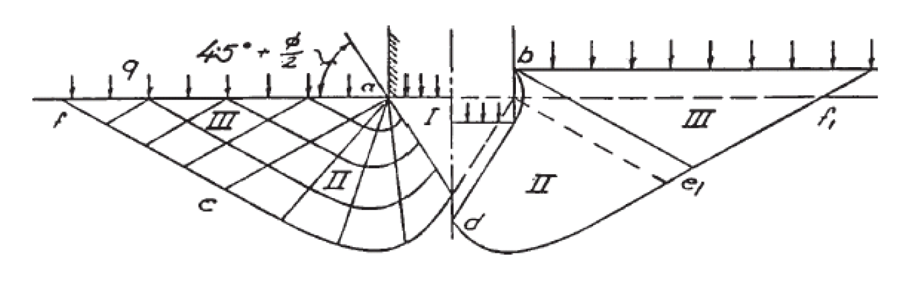
Figure 2.1: General shear failure concept after Vesic (1973) & Das (1977)
Figure 2.2 also depicts the variance in foundation settlement and load per unit area, q. The settling increases as the load per unit area increases during the early loading period. An abrupt failure in the earth supporting the foundation will occur at a specific point, i.e. when the load per unit area equals qu. This load per unit area is commonly referred to as the ultimate bearing capacity of foundation.
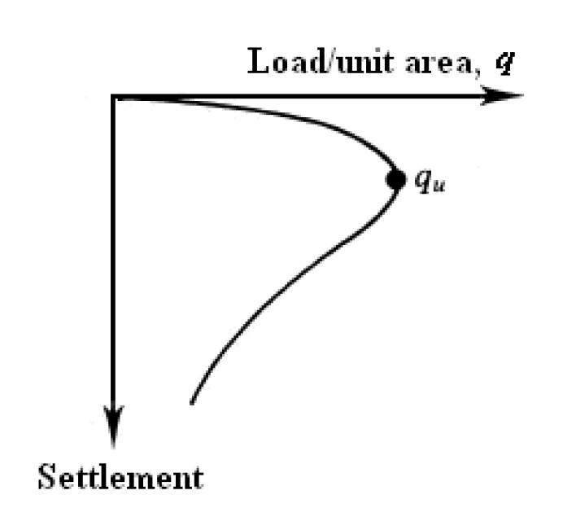
Figure 2.2: Load settlement curve for general shear failure after Vesic (1973) & Das (1977)

Punching shear failure
A well-defined wedge of soil beneath a foundation is subjected to a large amount of compression as well as vertical shearing beneath the foundation, which is known as punching shear failure. Because the soil on either side of the foundation only has minor effects and the collapse happens predominantly in soil compression immediately beneath the footing, there is little, if any, ground surface evidence of failure. During failure, footing stability (i.e. no rotation) is usually maintained (Das, 1977). The load settlement plot will be essentially linear beyond the ultimate failure load, qu, as shown in Figure 2.3. This is a predominant type of collapse in soil constructions with an extremely flexible stress-strain relationship and poorly defined shearing planes.
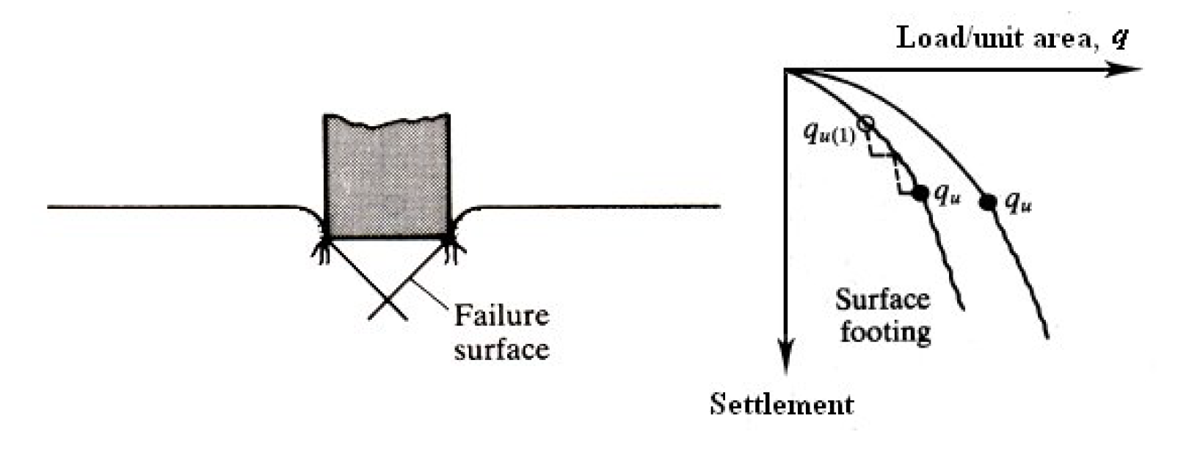
Figure 2.3: Punching shear failure and its load settlement curve after Vesic (1973) & Das (1977)

Local shear failure
Local shear failure is defined as a well-defined wedge of soil beneath a foundation being subjected diagonally downwards, but the depth of the downward movement is increased, causing the slip surfaces within the soil structure beyond the foundation edges to fade before they are visible at ground level, similar to general shear failure. This failure mode causes only a small swelling of the ground surface, therefore it can go undetected. This failure mode exhibits a transitional failure mode between general and punching shear failure due to the behavior of strong soil compression directly beneath the foundation and upward movement of the soil surrounding the foundation. The foundation movement will be accompanied by sharp jerks as the load per unit area on the foundation equals q_{u(1)} (refer to load settlement plot in Figure 2.4). The first failure load is known as q_{u(1)} (Vesic, 1973), and it is lower than the final failure load per area, q_{u}. This is the most typical type of failure in soil constructions having a plastic stress-strain relationship.
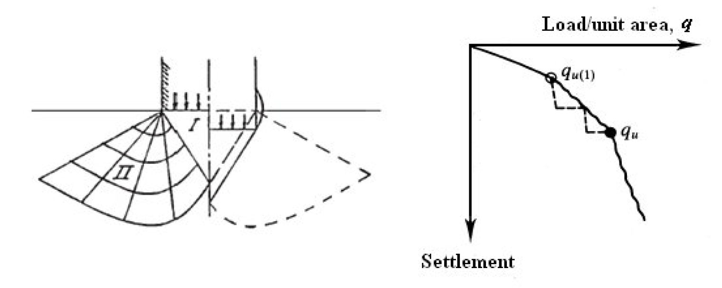
Figure 2.4: Local shear failure and its load settlement curve after Vesic (1973) & Das (1977)

Bearing Capacity Theories
In practice, the general shear failure situation is typically investigated because the other failure modes are implicitly accounted for in settlement calculations (Coduto, 2001). Terzaghi (1943) proposed a reasonable approach to predicting a foundation's bearing capability, which is as follows:
For a square footing:
$$q_{u}=1.3cN_{c}+σ_{z}N_{q}+0.4γBN_{γ}$$
For a strip footing:
$$q_{u}=cN_{c}+σ_{z}N_{q}+0.5γBN_{γ}$$
Where, c is the soil cohesion; $σ_{z}$ is the vertical stress at the base of the foundation; $γ$ is the unit weight of soil; B is the width of the foundation; $N_{c}$, $N_{q}$ and $N_{γ}$ are non-dimensional bearing capacity factors, which can be derived from following relationships:
$$N_{q}=e^{πtanφ}\tan^{2}\left(45+\frac{φ}{2}\right)$$
$$N_{c}=\frac{N_{q}-1}{tanφ}$$
Where $φ$ is the angle of internal friction of the soil
However, there have been major variations in the proposed numbers for $N_{γ}$ (Poulos, Carter, & Small, 2001). Although a rigorous closed form equation for $N_{γ}$ has yet to be found, various writers have provided the following approximations:
$N_{γ}≈1.8\left(N_{q}-1\right)tanφ$ (Hansen, 1970)
$≈\left(N_{q}-1\right)tan⁡(1.4φ)$ (Meyerhof, 1963)
$≈{0.0663e}^{9.3φ}$smooth (Davis & Booker, 1971)
$≈{0.1054e}^{9.6φ}$rough (Davis & Booker, 1971)
$≈2\left(N_{q}+1\right)tanφ$ (Vesic, 1975)
Hjiaj et al. (2005)and Makrodimopoulus et al. (2005) used numerical finite element limit analysis to derive and report quasi-exact results for $N_{γ}$. The rigorous answers derived using the theory of plasticity for a rigid plastic body were compared to the approximate values proposed by Terzaghi (1943), and the comparison clearly demonstrated that Terzaghi's approximation can overestimate the bearing capacity by factors as big as three (Davis & Booker, 1971).

Bearing Capacity of footings on Multi-layered soil profile
Most naturally existing soils are developed in distinct layers as a result of weathering and sedimentation processes; hence, most footings are built on layered soil. According to Bowles (1997), there are three general cases of footings on a two-layered soil:
Case 1. Footing on layered clays.
a. Upper layer weaker than underlying layer (c1 > c2)
b. Upper layer stiffer than underlying layer (c1 < c2)
Case 2. Footing on layered c-φ soils
a. Upper layer weaker than underlying layer (c1 > c2)
b. Upper layer stiffer than underlying layer (c1 < c2)
Case 3. Footing on layered sand and clay soil.
a. Upper sand layer overlying clay layer
b. Upper clay layer overlying sand layer
Soils are frequently deposited in multiple layers, and the boundary between two formations is frequently ambiguous.
The properties of uppermost layer alone is sufficient to accurately determine the bearing capacity and settlement behavior of foundation over layered soils, if the thickness of the uppermost soil layer is remarkably greater than the width of the foundation. On the other hand, if the width of the foundation is comparable to the thickness of uppermost soil layer, the effect of lower soil layers within the foundation's zone of influence must be considered for reliable estimation of bearing capacity (Poulos, Carter, & Small, 2001).
Most theoretical research into the bearing capacity problem, up until recently, were limited to plane-strain circumstances, as shown in Figure 2.5. A strip footing with width B sits on an upper layer of clay with undrained shear strength, c_{u1}, and thickness, H, in this problem. Another clay layer with undrained shear strength, c_{u2} ≠ c_{u1}, and indefinite thickness lies beneath this one. This problem's bearing capacity will be determined by two ratios: H / B and c_{u1} / c_{u2}.
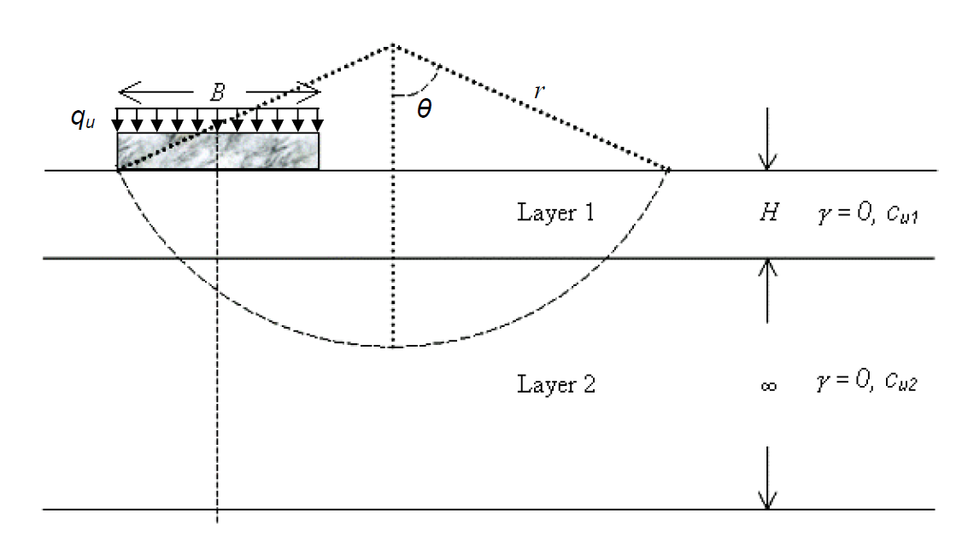
Figure 2.5: Bearing capacity approximation on two-layered clay profile after Chen (1975)
In the absence of surcharge, the bearing capacity of a strip footing on a single clay layer is commonly expressed in the form:
$$q_{ult}=c_{u}N_{c}$$
Where, $q_{ult}$ is the ultimate bearing capacity of footing, $c_{u}$ is undrained cohesion and $N_{c}$ is the bearing capacity factor, as previously stated. It is easier to rewrite the above equation in the form given below by Merifield et al. (1999) and Poulos et al. (2001) for the case of a two-layered soil profile:
$$N_{c}^{*}=\frac{q_{ult}}{c_{u1}}$$
Where $N_{c}^{*}$is a modified bearing capacity factor that is a function of both parameters H / B and $c_{u1}$/$c_{u2}$. $N_{c}^{*}$ is equal to the well-known Prandtl solution of (2+π) =5.14 for a homogeneous profile, where$c_{u1}=c_{u2}$ (Prandtl, 1921).
The limit equilibrium method can be used to solve the problem of a shallow foundation's bearing capacity on a two-layered clay profile. In geomechanics, the use of such a method in determining bearing capacities is frequent. The assumption of a simple semi-circular failure surface is usually made in limit equilibrium analysis, and simple static equations are applied by equating the applied and resultant forces, allowing the determination of bearing capacity. Button (1953) and Chen (1975) were the first to do so, using a circular arc to calculate the upper bound value for the bearing capacity factor, $N_{c}^{*}$, for a strip footing supported on a two-layered clay profile (as illustrated in Figure 2.5). The limit equilibrium method was used by Reddy et al. (1967) to obtain results using a similar failure mechanism.
In addition to the use of model foundations, almost no experimental verification of any of the above-mentioned numerical methods has been carried out. Research examples based on many model experiments, such as Brown et al. (1969) and Meyerhof et al. (1978). Using a combination of theoretical analysis and model testing, Brown et al. (1969) provided approximate solutions of Nc for the following situations and basic types:
For strip footing:
$N_{c}^{*}=1.5\left(\frac{H}{B}\right)+5.14\left(\frac{c_{2}}{c_{1}}\right)≤5.14$ for $\left(\frac{c_{2}}{c_{1}}\right)≤1$
For circular footing:
$N_{c}^{*}=1.5\left(\frac{H}{B}\right)+6.05\left(\frac{c_{2}}{c_{1}}\right)≤6.05$ for $\left(\frac{c_{2}}{c_{1}}\right)≤1$
Where diameter of the circular footing is denoted by B.
Semi-empirical methods developed by Meyerhof (1974) and Meyerhof et al. (1978) are widely used. In such conditions, where the thickness of topmost layer is fairly small in comparision to the width of the foundation, punching shear failure generally occurs in the topmost layer, and the lower soil layer undergo general shear failure, as illustrated in Figure 2.6.
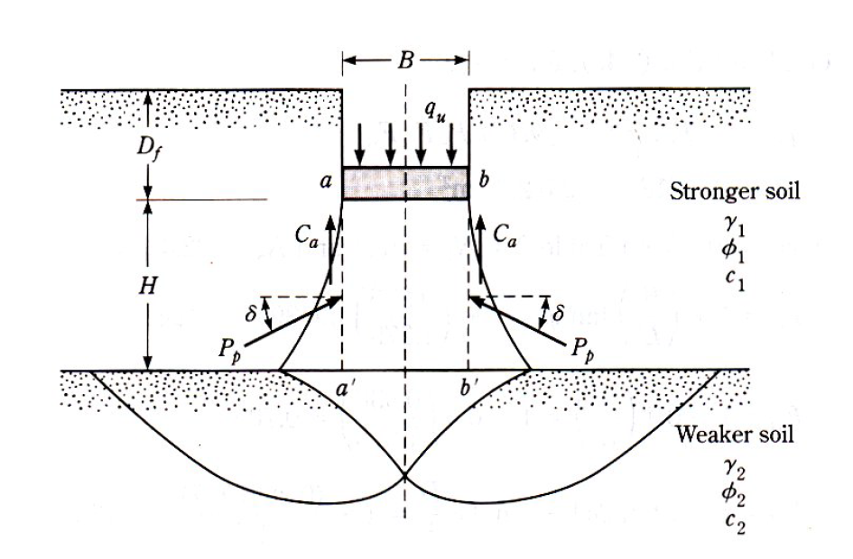
Figure 2.6: Punching shear models on layered soil after Meyerhof (1974) & Das (1977)
The parametric study including the effect of strength ratio and layer thickness on bearing capacity of surface square footing over two layered clay deposit shows the strength ratio of the strong layer and weaker layer can cause significant variation in the behavior of foundation of layered cohesive soil (Pusadkar & Baral, 2015).

Bearing Capacity of footings on Non-Homogeneous Soil
As mentioned earlier, Complex natural and artificial processes result in formation of heterogeneous soil materials whose engineering properties vary from point to point. Due to the uncertainties associated with the variability and inadequate data from site exploration, soil properties may be considered as random variables. Therefore, it is necessary to recognize and take into account the effect of spatial variability of geotechnical properties during the process of engineering analysis and design (Griffiths & Fenton, 2001). In recent years, the effects of non-homogeneous soil property performance of the foundation have been studied by a number of researchers. Fenton et al. (2003) investigated the effect of spatially random c - φ soil on the bearing capacity of a strip foundation using finite element analysis, when the soil properties become indiscriminate, the failure surface progresses through weak zones or trails a path of small energy in the soil underneath the footing, which exhibits bearing failure. Fenton et al. (2003) established that, when the geometrical mean of cohesion and angle of internal friction of the soil, c and φ are applied to Terzaghi’s equation, better estimates of the bearing capacity are obtained for a spatially random soil. A harmonic average lying in between the arithmetic and harmonic means favors low strength areas more than the geometric average. A worst-case correlation length should be used which is nearly equal to the foundation width, in absence of site specific data to provide conservative estimate of bearing failure probability (Fenton & Griffiths, 2003).
In the recent years, Zhu et al. (2010) studied carrying capacity of rectangular footing resting on layered clay using finite element analysis ABAQUS 3D. The soil was modeled as an elastic-perfectly plastic material satisfying Tresca failure criterion. It was also observed that values of Young’s Modulus, E and Poisson’s ratio μ does not influence the ultimate bearing capacity. Due to presence of weak clay layer beneath strong clay layer the bearing capacity is reduced. The bearing capacity of the layered soil is affected due to the strength ratio of the layers and thickness ratio of upper soil layer to the width of the foundation. Raman et al. (2012) studied the settlement behavior of square footing altering sand and clay layered soil and concluded that the bearing capacity of the soil can be improved using different layers of soil. Verma et al. (2013) developed an equation for predicting the ultimate bearing capacity of the soil based on plate load test on layered granular soil. It was observed that the effective depth factor defined as the multiplication factor based on the width of the foundation gives the total thickness of the soil under the foundation affected by the application of load. Khanal (2013) used hardening soil model in PLAXIS 2D to carry out back-calculation of the plate load test. The soil properties and profiles were based on the laboratory test results of the soil and in-situ test findings respectively. An equivalent circular footing was modelled for axisymmetric condition for a square footing and found that the plate load test results are in a good agreement with that of numerical model results. Paul (2014) compared the bearing capacity of shallow footing resting over layered clay using PLAXIS 3D Foundation with conventional methods of Terzaghi’s theory, Hansen’s method, Meyerhof’s method and method specified in the IS Code. The results of PLAXIS 3D showed a maximum of 5 to 10 % variation in results with that of theoretical results.
Baus et al. (1983) and Badie et al. (1984) investigated investigated the bearing capacity of strip footing located above silty clay with a continuous void using finite element method. The study concluded that, there exists a critical region in the soil underneath the foundation and the performance of the foundation is significantly affected by the existence of void only when it is located within this region. Also, the shape of the void has minimal effect on the settlement and bearing capacity behavior of the soil (Baus & Wang, 1983).
Mohamed (2012) investigated the effect of a underground buried rock on the stress and settlement of a strip foundation through a series of numerical simulation. The study investigated the effect of position and depth of a buried rock on contact stresses, under the strip footing resting on sand using finite element technique. The final results indicated that the stresses under the footing increased by up to 40% and the stresses under footing had altered when the buried rock lies away from middle footing reaching to the instability of the footing.

Numerical modeling by PLAXIS 2D
Numerical modeling uses mathematical models to describe the physical conditions of geotechnical problems. PLAXIS 2D is a powerful and user friendly finite element package which can address a wide range of geotechnical problems, such as deep excavations, foundations, tunnels, and earth structures (for example, retaining walls and slopes). It can be used for both design and research purpose. It is commercial software using finite element method to solve series of differential equations in order to find an approximate solution for complicated problems.
The Finite Element Analysis (FEA) is the simulation of any given physical phenomenon using the numerical technique called Finite Element Method (FEM). Finite Element Method (FEM) is a numerical technique for solving problems, which are described by partial differential equation or can be formulated as functional minimization. The basic concept behind FEM is that a body or structure is divided into smaller elements of finite dimensions called ‘finite elements’. The original structure is then considered as an assemblage of these elements at a finite number of joints called ‘nodes’.
The properties of the elements are formulated and combined to obtain the solution for the entire structure. The shape functions are chosen to approximate the variation of displacement within an element in terms of displacement at the nodes of the element. The strains and stresses within an element will also be expressed in terms of the nodal displacement. The principle of virtual displacement is used to derive the equations of equilibrium for the element and the nodal displacement will be the unknowns in the equations.
The boundary conditions are imposed and the equations of equilibrium are solved for the nodal displacement. From the values of the nodal displacement for each element, the stresses and strains are evaluated using the element properties. Thus instead of solving the problem for the entire structure in one operation, in this Finite Element Method attention is mainly devoted to the formulation of properties of the constituent elements.
The FEM has many advantages of its own. Some of them are given below:
- Various types of boundary conditions are automatically handled in the formulation.
They are systematically enforced just before the solution, for the nodal values of the field, variables are obtained.
- Material anisotropy and in homogeneity can be treated without much difficulty.
- Any type of loading can be handled.
- Higher order elements may be implemented with relative ease.
- The method can efficiently be applied to cater irregular geometry.
- Spacing of nodes need not follow a pattern or rule.

METHODOLOGY
In this section a brief overview of the methodology applied for the completion of the analysis along with the presentation of the results is presented. The overall procedure may be explained in brief using a flow chart as shown in Figure 3.1 which is presented below.
The study was carried out in different phase
a. Literature review and data acquisition: In this phase of the study the primary objective was to acquire necessary data required for input in FE software which includes properties of fine grained soil along with literature review to find necessary correlations for the processing of the acquired data to make the data input ready. In this section a brief literature review of the previous study on similar conditions were also done.
b. Processing of data for input: In this section all the data acquired from step a, with consideration of the empirical relation as well as mathematical relation from different books and literatures was processed and soil made the data modelling input ready
c. Input data: Data from literatures and published articles which were processed in step b, along with other necessary data acquired through the mathematical and empirical relation were used to model the problem in FE software.
d. Run the model: A number of numerical models were produced with different variables in consideration and the model were run to carry out a parametric study.
e. Output data: After the successful execution of the model in FE software, output data such as ultimate bearing capacity, settlement, deformation and stress in the soil were obtained.
f. Processing of the output data: This is the final step of the study, in this step all the outputs obtained from step e, are organized processed such that they are in presentable manner along with the necessary verification required so that the results can be validated. The results are then compiled and compared with different parametric results.

Start

Literature Review and Data Acquisition

Numerical Modeling

Parametric Analysis
Geometric Model
Material Model

Development and Analysis of Model

Output Data (Ultimate Bearing Capacity,
Settlement, Deformation and Stress)

Processing Of the Output Result And
Verification

Presentation of Final Data

Stop

Figure 3.1: Algorithm for the methodology applied for the completion of the study

Material Model

Soil Constitutive Model
Soil is a complicated material that behaves non-linearly and often shows anisotropic and time dependent behavior when subjected to stresses. Generally, soil behaves differently in primary loading, unloading and reloading. It exhibits non-linear behavior well below failure condition with stress dependent stiffness. Soil undergoes plastic deformation and is inconsistent in dilatancy. Soil also experiences small strain stiffness at very low strains and upon stress reversal. These general behaviors were not possibly being accounted for in simple elastic-perfectly plastic Mohr-Coulomb model, although the model does offer advantages which makes it a favorable option as soil model.
There are five basic aspects of soil behavior. Briefly, the first aspect discussed on the influence of water on the behavior of the soil from the effective stresses and pore pressures. Second aspect is the factor which influences the soil stiffness such as the stress level, stress path (loading and unloading), strain level, soil density, soil permeability, consolidation ratio and the directional-dependent stiffness (stiffness anisotropy) of the soil. The third aspect highlighted the irreversible deformation as a result of loading. Fourth aspect discussed on soil strength with its influencing factor includes loading speed of the tested specimen, age and soil density, undrained behavior, consolidation ratio and directional dependent shear strength (strength anisotropy). Other aspects of soil behavior that should be considered also include factors such as compaction, dilatancy and memory of pre-consolidation stress.
In addition to soil behavior, its failure in three-dimensional state of stress is extremely complicated. Numerous criteria have been devised to explain the condition for failure of a material under such a loading state. Among these three-, four-, and five-parameter model, Mohr Coulomb model is a two-parameter model with criterion of shear failure and can also be a three-parameter model with criterion of shear failure with a small tension cut-off. There exist a large variety of models which have been recommended in recent years to represent the stress-strain and failure behavior of soils. All these models inhibit certain advantages and limitations which largely depend on their application.

Mohr-Coulomb model
Mohr-Coulomb model is an elastic-plastic model which involves five input parameters, E and ν for soil elasticity, ϕ and c for soil plasticity and ψ as an angle of dilatancy. This model represents a first-order approximation of the soil or rock behavior, besides above stated five model parameters initial soil condition play an essential role in most soil deformation problems. Initial soil stresses have to be generated by selection Ko – values.
Basic parameters for Mohr- Coulomb model
The Mohr-coulomb model as stated earlier requires total of five parameters which can be obtained from basic laboratory tests. The parameters with their standard units are listed below.
Table 3.1: Parameter for Mohr-Coulomb model
Symbol | Description | Unit
E | Young’s Modulus | kN/m²
ν | Poisson’s Ratio | -
φ | Friction Angle | °
c | Cohesion | kN/m²
ψ | Dilatancy Angle | °

Acquisition of Soil Parameters
The values for E, ν, ϕ, c and ψ are calculated and extracted using mathematical relations as proposed by different writers through time.
Table 3.2: Equations for stress-strain modulus E_{s} (Bowles, 1997)
Clay and Silt | I_{p} > 30 or organis | E_{s} = (100 to 500)s_{u}
Silty or Sandy Clay | I_{p} < 30 or stiff | E_{s} = (500 to 1500)s_{u}
Of general application in clays is | E_{s} = K s_{u}  Where K is defined as, | K = 4200-142.54I_{p}+1.73I_{p}²-0.0071 I_{p}³
Where, s_{u} is the undrained shear strength of soil
I_{p} is the plasticity index
Considering the undrained behavior of soil, the modulus of elasticity for the soft to very soft clay is taken as, E_{s} = (1000)s_{u}. Where, s_{u} is the undrained shear strength of clay.
Table 3.3: Value range for Poisson’s ratio, ν (Bowles, 1997)
Type of soil | ν
Clay, saturated | 0.4 – 0.5
Clay, unsaturated | 0.1 – 0.3
Sandy clay | 0.2 – 0.3
Silt | 0.3 – 0.35
Sand, gravelly sand | 0.3 – 0.4

For undrained condition, the value of poisson’s ratio is taken as 0.5 and the angle of internal friction tends to zero, i.e. φ = 0°.
The dilatancy angle ψ, is specified in degrees. Apart from heavily-consolidated layers, clay soil tends to show little dilatancy. The dilatancy of the sand depends on both the density and on the friction angle. For ϕ value greater than 30° dilatancy angle may be calculated using Ψ = φ - 30°,
Whereas, for sands with φ < 30 the dilatancy angle is mostly zero.
The soil parameters as per the requirement of study are considered as tabulated below:
Table 3.4: Parameters considered in soil model
Parameters | Parent Soil | Soil Patch
Unsaturated unit weight of soil (kN/m³) | 18 kN/m² | 18 kN/m²
Saturated unit weight of soil (kN/m³) | 19 kN/m² | 19 kN/m²
Friction angle of soil, φ | 0 º | 0 º
Undrained Shear Strength of soil, s_{u} (kN/m²⁾ | 25 | 5, 10, 15, 20
Young‘s modulus of elasticity (kN/m²⁾ | 1000* s_{u} | 1000*s_{u}
Poisson's ratio | 0.5 | 0.5
Failure criteria | Mohr-Coulomb | Mohr-Coulomb
Type of material model | Undrained condition | Undrained condition

Acquisition of Foundation Parameters
The foundation was modeled as continuous weightless surface footing with plain strain, elastic and isometric behavior.
Table 3.5: Foundation Material Properties
Parameter | Values
Normal Stiffness (EA) kN/m | 1.5*10⁷
Flexural Rigidity (EI) kN/m²/m | 3.13*10⁵
Equivalent Thickness, m | 0.5
Poisson’s Ratio | 0.15

Geometric model
The geometrical parameters along with the optimization of problem model size, mesh convergence analysis and boundary condition in accordance with different literatures are taken into account and the following parameters are used in this study.

Geometrical parameter
The geometrical parameters of the numerical model is expressed below.
Table 3.6: Model geometry
Geometrical Parameters | Values
Width of footing (b) | 2 m (B)
Width of analysis soil (W) | 20B (40m)
Depth of analysis soil (D) | 10B (20m)
Size of soil patch (w) | 0.25, 0.5, 1.0 and 2.0 m
Vertical position of soil patch (y) | 0.0, 0.5, 1.0, 1.5, 2.0, 4.0 and 6.0 m (from the base of footing to crest of patch)
Horizontal position of soil patch (x) | 0.0, 0.5, 1.0, 1.5, 2.0, 4.0 and 6.0 m (from the center of foundation to the center of patch)

Figure 3.2: Schematic view of footing and single square soil patch system

Optimization of model for analysis
The study model is optimized for size i.e. width and depth in order to obtain good performable model for further analysis of models. It was done by varying the model with different dimension of model until the results does not changes noticeably.

Mesh convergence analysis
A typical engineering design involves the prediction of deflections/displacements, stresses, natural frequencies, temperature distributions, etc. These parameters are used to iterate on material parameters and/or geometry to optimize their behavior. Traditional methods, like hand calculations, involved idealization of physical models using simple equations to obtain solutions. However, these approximations oversimplify the problem, and an analytical solution can only provide conservative estimates. Alternatively, FEM and other numerical methods are meant to provide an engineering analysis that takes into account much detail something that would be impractical with hand calculations. FEM divides the body into smaller pieces, enforcing continuity of displacements along these element boundaries so as to ensure that the result from FEA does not affect by changing the size of mesh.
Different mesh density in the soil model are generated during analysis and closeness of the results found to be with number of elements over 3000. Meshing is done by 15 noded triangular element with same mesh density of medium element distribution as shown in Figure 3.3 but the coarseness factor of the elements near the vicinity of the foundation and the soil patch of different consistency was taken to be 0.1 and 0.25 for those far away as shown in Figure 3.4. This was done in order to acquire sensitive data near the direct influence of the foundation and the soil patch, which is shown in figure below:
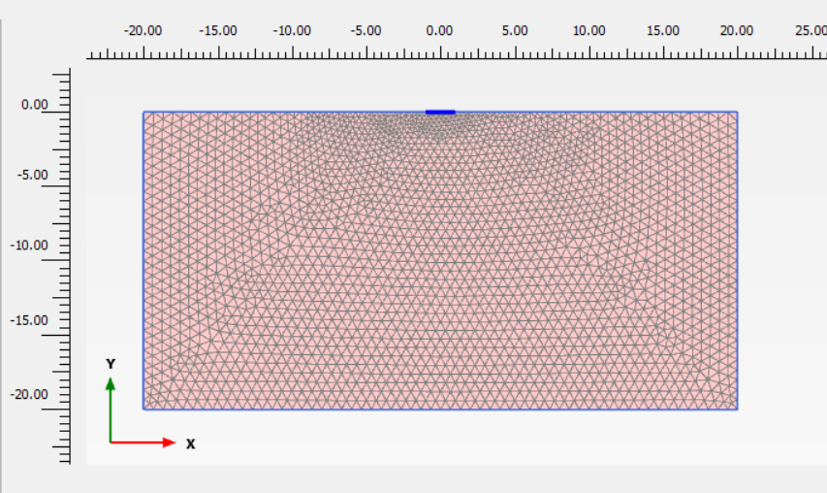
D=20m
W=40m
Figure 3.3: Typical mesh for numerical analysis

Boundary condition
The boundary condition of the model is provided to be compatible with the real soil condition, which is done by restraining the horizontal and vertical displacement on the bottom boundary and the vertical boundaries are restrained normally. The upper soil boundary are set free to analyze the behavior of ground surface on different parametric variation.

Numerical modeling
Finite element based software (PLAXIS 2D) was used for analyzing the bearing capacity for cohesive soil. The present investigation is focused to study the ultimate bearing capacity of strip footing resting on cohesive soils with continuous square soil patch of inherent property underneath. The geometry of the finite element soil model adopted for the analysis was 20B x 10B. The soil domain was discretized with 15-noded plane strain triangular elements. Strip footing considered is rigid. Hence, all the nodes on the footing is under uniform settlement. This is acquired through uniform prescribed displacement for static analysis. The strip footing of width 2m was taken. The soil field was modeled of width of 40m and depth of 20m in order to eliminate the boundary effect due to loading. Geometric model used in analysis is shown in Figure 3.4.
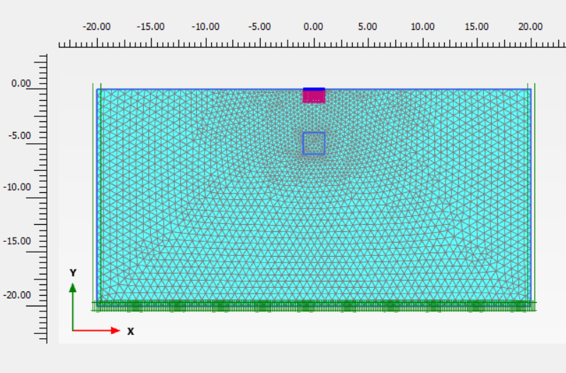
20m
Soil Patch
40m
Standard fixities
Prescribed displacement
Figure 3.4: Geometrical model of strip footing resting on cohesionless soil

Test Procedure
The parameters like vertical and horizontal position of soil patch, size of soil patch and the consistency of soil patch are input data of the numerical model. For parametric analysis, total 4 sets of different soil patch size models with 49 sets of different horizontal and vertical location of the soil patch with respect to the foundation has been considered. For each numerical model, different values of the shear strength of the soil patch has been taken. These values were based on the strength ratio of the soil with respect to the parent soil i.e. c2/c1, which was assigned to 5, 10, 15, 20 and 25 kPa. Figure 3.5 shows the schematic diagram of models performed for parametric analysis.
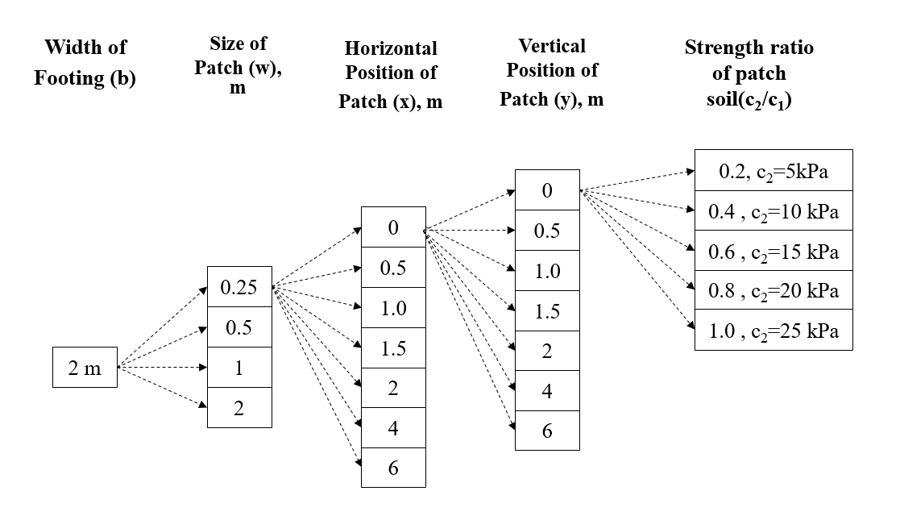
Figure 3.5: Schematic diagram showing numerical models with different geometric and material parameters for parametric analysis

Application of load to models
Application of load to model was done through prescribed displacement and calculations was made with loading input as staged construction and plastic analysis as calculation type for static analysis.

Output
Output results are analyzed and load settlement curves are generated. From the load-settlement curves, the ultimate bearing capacity is obtained as shown in Figure 3.6. The deformation of soil under the foundation is observed from the result of FE simulation showing the settlement and displacement characteristics of soil and the shear straining of soil caused by the application of load as shown in Figure 3.7 (a) and (b) respectively.
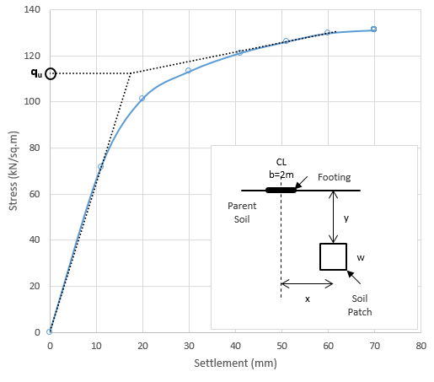
Figure 3.6: Load-settlement curve
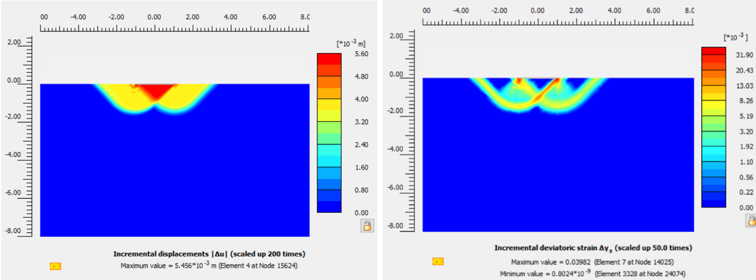
(a) (b)
Figure 3.7: Deformation behavior of soil under the foundation; (a) Displacement of soil elements, (b) Shear strain of soil under the foundation

RESULT AND DISCUSSION

Introductions:
The results of simulations are presented and discussed in this section. Firstly, the theoretical value of bearing capacity for homogeneous soil was calculated as given in Table 4.1 and calibration was performed in order to find the optimization of the mesh density and dimension of soil model. Thereafter the analysis was performed for strip footing on the parent cohesive soil with soil patch of varying size and strength properties situated at various locations.
This study includes 785 FE models with different material and geometrical parameters, which are mentioned in Table 3.4, 3.5 and 3.6. The model output (load settlement curve) is used for the determination of ultimate bearing capacity of each model, which are presented in ANNEX A. Also, the ultimate bearing capacity of each model are tabulated and presented in ANNEX B.
In this part, the equations $q_{ult}=c_{u}N_{c}$ for strip footing over homogeneous soil is used for computation of bearing capacity as per study required and the bearing capacity factor Nc is listed below in table.
Table 4.1: Calculation of Bearing capacity with Different Nc for φ=0 º
Solution | Nc | q_{ult},kN/m² | V,kN/m
Terzaghi | 5.7 | 142.5 | 285
Hansen | 5.14 | 128.5 | 257
Vesic | 5.14 | 128.5 | 257

Calibrations:
There are numerous effects on the result of the software due to different mesh density or element numbers and domain size in FE. So, it is required to calibrate the result with different mesh density and domain size of the model. General overview of soil behavior for different volume sizes are presented below.

Width and Depth calibration
In order to find the optimum size of the soil domain, different trial and error analysis have been performed. This calibration is a procedure to find the minimum depth and width of the soil domain in which the boundary effects are prevented. For this purpose, different widths from 10 to 50 meter and different depths from 5 to 25 meter by using the calibrated mesh density is simulated. The result are presented in figures below:

Figure 4.1: Width calibration
It is clearly seen from the Figure 4.1, beyond 10 meter of width the initial and ultimate stiffness are approximately identical for all value of width. For the purpose of analysis of the problem, 40 m width of soil domain is chosen.

Figure 4.2: Depth calibration
In addition, it is illustrated from Figure 4.2, that after 5 meter depth the changes in initial stiffness is minimal and can be neglected. Therefore, the 20 meter depth is chosen as the final depth of soil domain.

Mesh convergence analysis:
With the optimization of soil model size, soil models are applied with different mesh density and results are compared to the theoretical value.

Figure 4.3: Mesh convergence (b=2m, W=40m and D=20m)
As it can be seen from Figure 4.3, it is obvious that the software is completely sensitive to number of elements or mesh density and by increasing the number of elements, the bearing capacity decreases and reaches to theoretical value asymptotically but on the other hand the computation time increases exponentially. Hence, soil domain with medium mesh density is chosen.

Parametric studies
Parametric study has been carried out by varying the position and size of the soil patch and strength property of the patch soil.

Effect of position of soil patch
The performance of the foundation primarily depends in the location of the soil patch with respect to the foundation. Different conditions has been analyzed by simulating the soil patch at various locations in the soil domain below the foundation. These models has been analyzed and bearing capacity has been determined from output i.e. load settlement curve.

Effect of patch depth (y)
In order to investigate the extent of influence of vertical position of the soil patch or the depth of soil patch below the base of foundation, FE models with soil patch at various depths has been simulated. Further, ultimate bearing capacity as perceived from the load settlement curve at different depth of soil patch keeping the strength parameter of soil patch constant (i.e. c2=5kPa) are shown in Figure 4.4 (a), (b), (c) and (d). The minimum value of bearing capacity for a specified soil patch width and depth irrespective of eccentricity of soil patch are shown in Table 4.2.
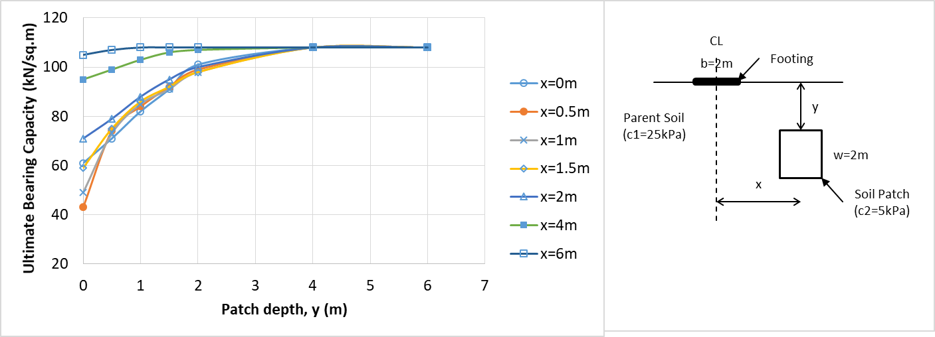
(a)
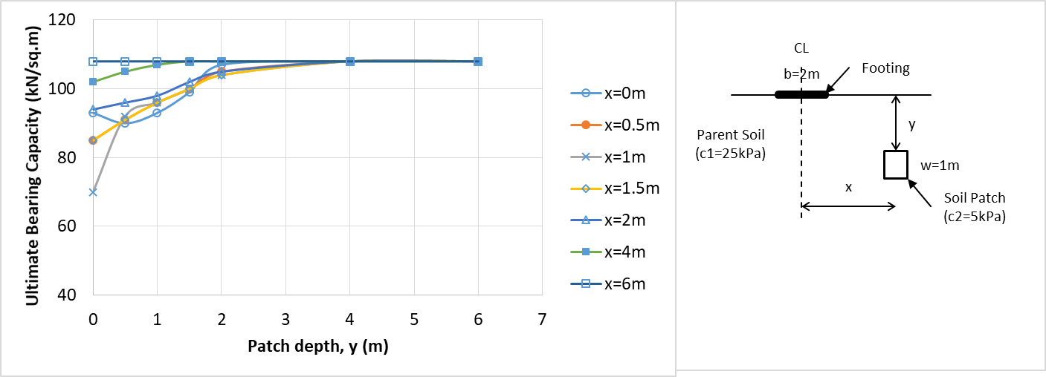
(b)
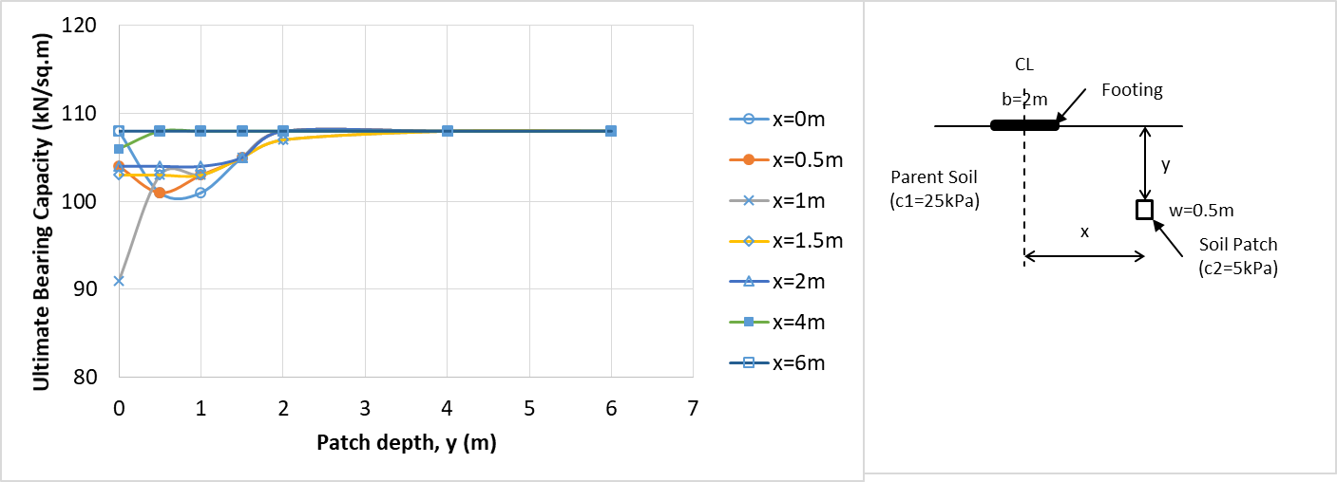
(c)
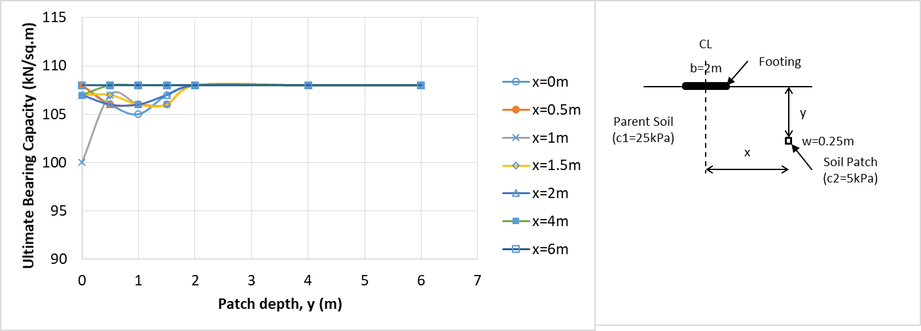
(d)
Figure 4.4: Bearing capacity of foundation with variation of soil patch depth (y) for different eccentricity of soil patch (x) and size of, (a) w=2m, (b) w=1m, (c) w=0.5m and (d) w=0.25m.
Table 4.2: Bearing capacity of foundation with variation of soil patch depth (y) for different size of soil patch (w) irrespective of soil patch eccentricity (x)
The results indicate that the ultimate bearing capacity decreases with a decrease in the distance of footing from crest of soil patch and maximum reduction of bearing capacity is obtained when the soil patch of weaker consistency lies just below the base of the footing. Further when the soil patch is moved away to greater depths from the base of the footing, the effect of soil patch diminishes. This occurs at a depth greater than 2 times the width of the foundation (i.e. from y=4 m, for this study) depending on the size of the soil patch which may be due to the reason that the failure surface propagates only up to the effective depth below the foundation as shown in Figure 4.4 (a), (b), (c) and (d). Below which there is minimal influence of the soil on the performance of the foundation. Hence, the result of the analysis indicates that there is a critical region under the footing. Only when the soil patch of weaker consistency is located within this region, the footing performance be significantly affected by its presence.
From the Figure 4.4 (a), (b), (c) and (d) it can be clearly observe that the reduction in bearing capacity is not uniform with respect to the depth of the soil patch. From Table 4.2 we can clearly observe that, as the size of soil patch decreases, the consequence of its presence also decreases. Also it can be perceive from the results that the horizontal position of the soil patch with respect to the foundation plays prime role in the performance in the foundation along with its depth. When the soil patch is just below the edge of the foundation (i.e. at y=0m and x=1m), greatest influence of its presence can be seen on the bearing capacity. This may be due to stress concentration at the edge of the foundation which when lies in the weaker soil patch causes detrimental effect on the performance of the foundation.
On the other hand, it can be seen that the bearing capacity for the size of soil patch smaller than that of the size of the foundation is greater when the soil patch is just below the base of foundation (i.e. at y=0m and x=0) than that when it is at certain depth inside the effective depth (i.e. at y=0.5m to 1m) and around the foundation (i.e. at x=0.5 to 2m). This may be due to the reason that, when the soil patch is inside the triangular failure wedge where there is minimal shear and its effect is nominal in compared to when the failure surface lies inside or just above the soil patch causing greater shear in the weak soil patch which in turn lowers the ultimate bearing capacity.

Effect of eccentricity of patch (x)
To investigate the extent of influence of horizontal position of the soil patch with respect to the center of foundation in the performance of foundation, the soil patch at various eccentricities from the center of the foundation has been simulated. Further, ultimate bearing capacity as perceived from the load settlement curve at different position of soil patch keeping other the strength parameter of soil patch constant (i.e. c2=5kPa) are shown in Figure 4.5 (a), (b), (c) and (d). The minimum value of bearing capacity for a specified soil patch width and eccentricity irrespective of depth of soil patch are shown in Table 4.3.

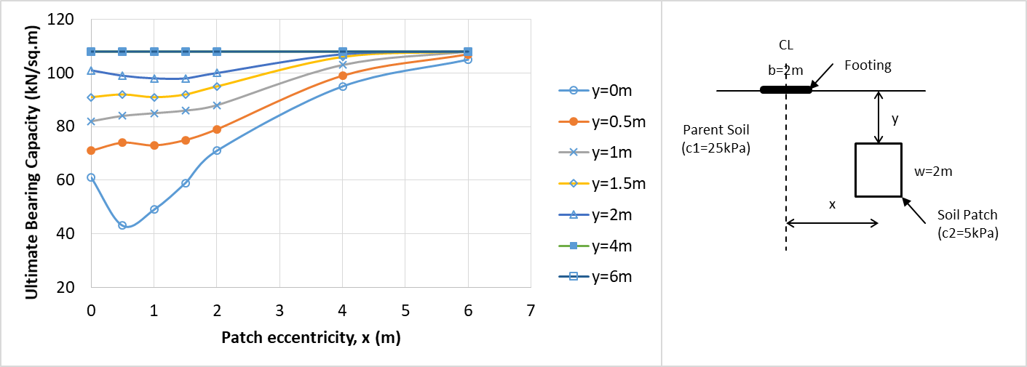
(a)
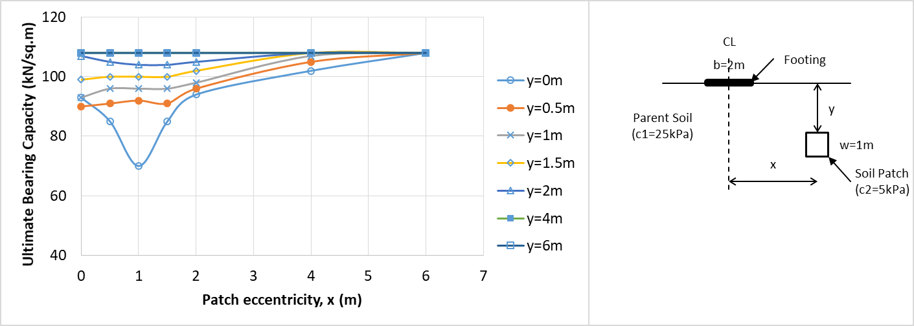
(b)
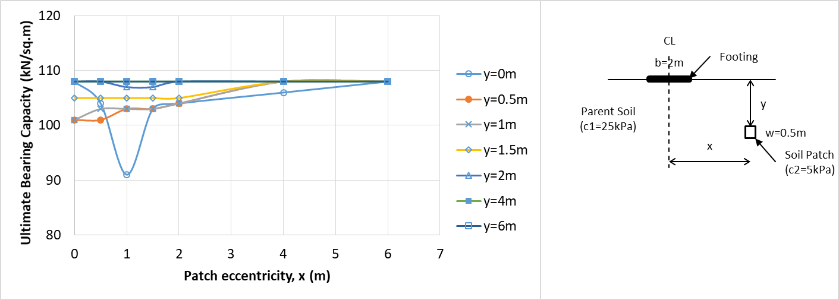
(c)
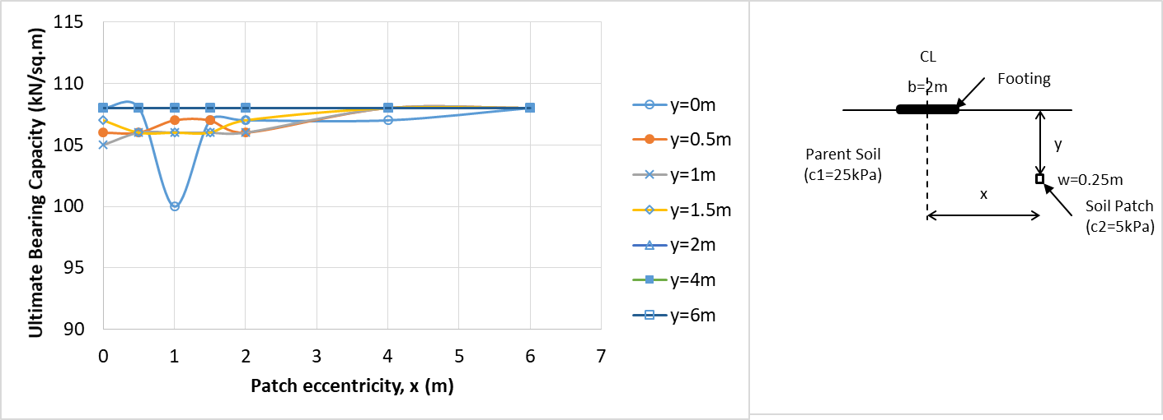
(d)
Figure 4.5: Bearing capacity of foundation with variation of eccentricity of soil patch (x) for different soil patch depth (y) and size of, (a) w=2m, (b) w=1m, (c) w=0.5m and (d) w=0.25m.
Table 4.3: Bearing capacity of foundation with variation of soil patch eccentricity (x) for different size of soil patch (w) irrespective of soil patch depth (y)
The results indicates that the ultimate bearing capacity decreases with a decrease in the distance of footing from soil patch and maximum reduction of bearing capacity is obtained when the soil patch is near the vicinity of the footing. Precisely, the greatest influence if the soil patch on the performance of the footing is observed when the center of soil patch of weaker consistency coincides the edge of the footing. As from Table 4.3 we can clearly observe the lowest values of bearing capacity at an eccentricity of 1m. This is due to non-uniform distribution of load under the footing and stress concentration in the soil patch below the edge of the footing causing reduction in the bearing capacity. Further when the soil patch is moved away to greater distance from the center of the footing, the effect of soil patch diminishes. This occurs at a clear distance between the foundation and the soil patch greater than 2 times the width of the foundation as shown in Figure 4.5 (a), (b), (c) and (d) depending on the soil property which may be due to the reason that the failure surface progresses outward in the horizontal direction up to the edge of Rankine’s passive zone. Hence, the result of the analysis indicates that there is a critical region around the footing. Only when the soil patch of weaker consistency is located within this region the footing performance be significantly affected by its presence.
From the Figure 4.5 (a), (b), (c) and (d) it can be clearly observe that the reduction in bearing capacity is not uniform with respect to the eccentricity of the soil patch. As the size of soil patch decreases, the consequence of its presence also decreases. Also it can be perceive from the results that the vertical position of the soil patch in the soil domain plays prime role in the performance in the foundation along with its horizontal position. When the soil patch is at the surface or at the level of base of footing (i.e. at y=0m), greatest influence of its presence can be seen on the bearing capacity. This may be due to the reason that the soil around the foundation is responsible to provide passive earth pressure and the failure surface extends to greater distance at the surface and tends to lie inside or just at the edge of the soil patch causing greater shear in the weaker soil patch which in turn lowers the ultimate bearing capacity. This effect is seen to have nominal effect when the soil patch lies at any other depths (i.e. at y>0m).
On the other hand, it can also be seen that the bearing capacity for the size of soil patch smaller than that of the size of the foundation is greater when the soil patch is just below the base of foundation (i.e. at y=0m and x=0) than that when it is at certain depth inside the effective depth (i.e. at y=0.5m to 1m) and around the foundation (i.e. at x=0.5 to 2m). This may be due to the reason that, when the soil patch is inside the triangular failure wedge where there is minimal shear and its effect is nominal in compared to when the failure surface lies inside or just around the soil patch causing greater shear in the weak soil patch which in turn lowers the ultimate bearing capacity.

Effect of size of soil patch
A square shaped soil patch of various sizes has been simulated in order to investigate extent of influence of the size of the soil patch in the performance of foundation. Further, ultimate bearing capacity as perceived from the load settlement curve for different size of soil patch keeping other the strength parameter of soil patch constant (i.e. c2=5kPa) are shown in Figure 4.6 (a), (b), (c), (d), (e), (f) and (g). The minimum value of bearing capacity for a specified soil patch width irrespective of position of soil patch are shown in Table 4.4.

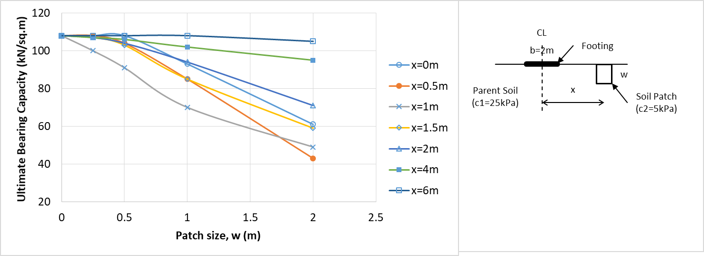
(a)
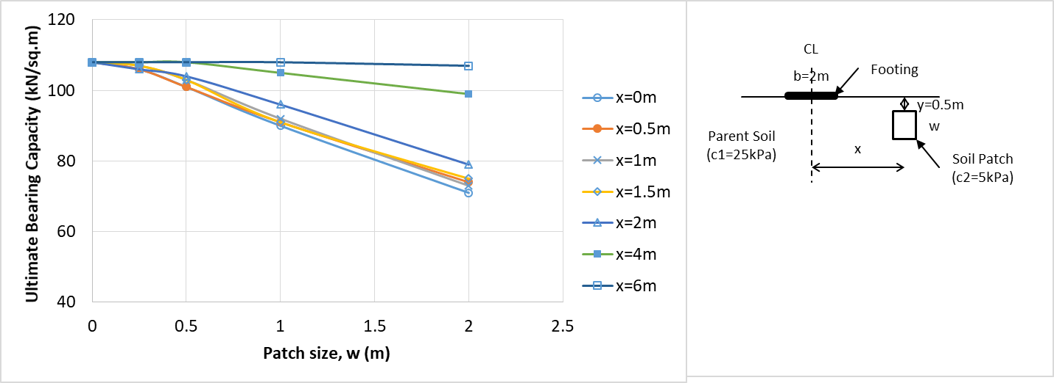
(b)
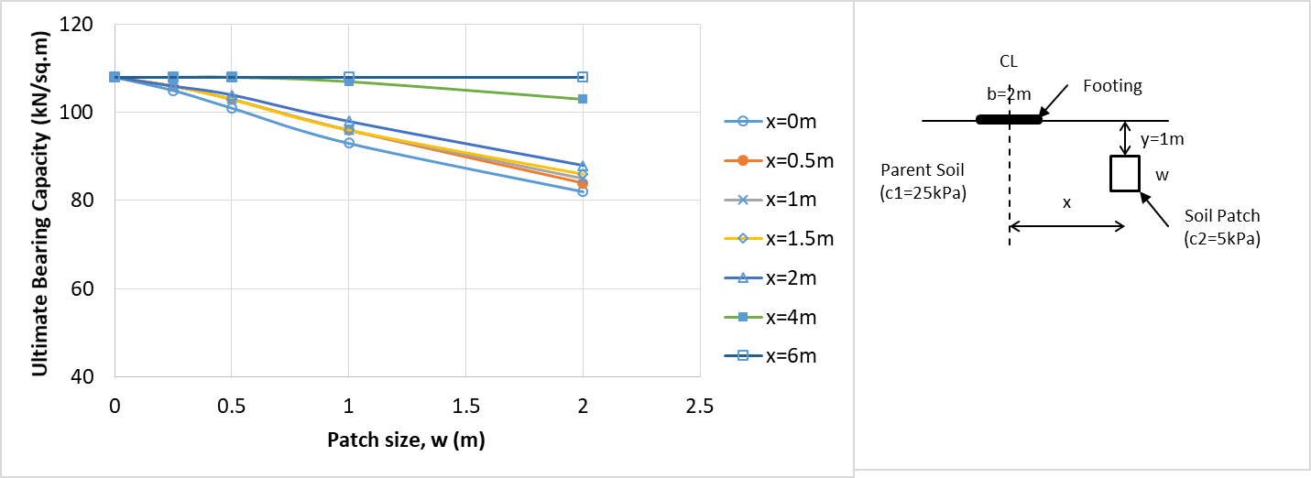
(c)
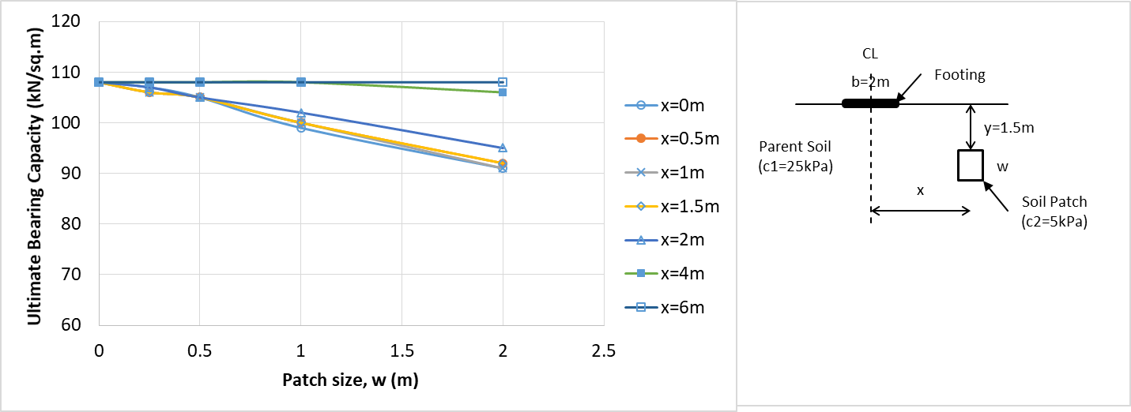
(d)

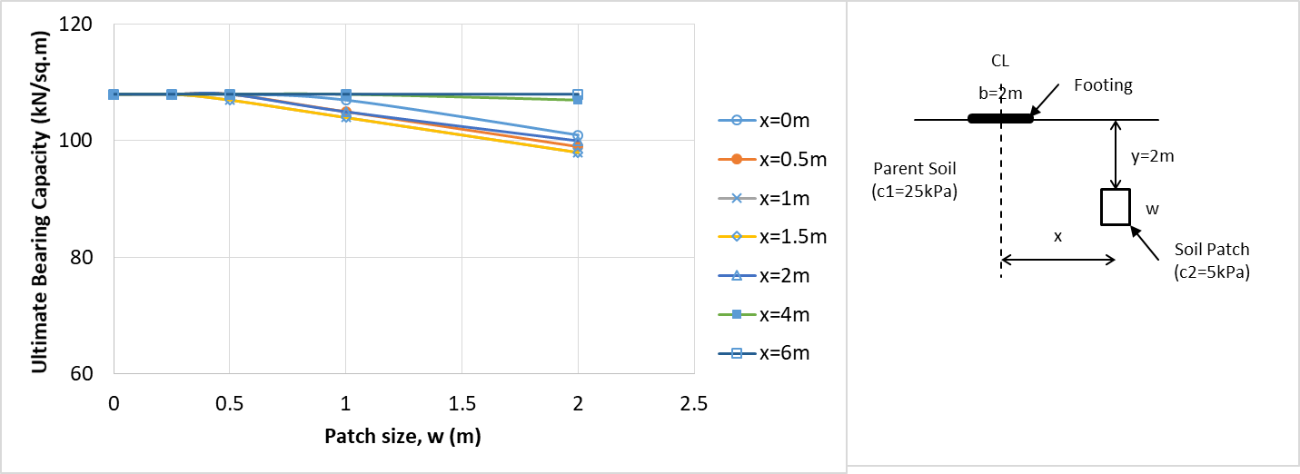
(e)
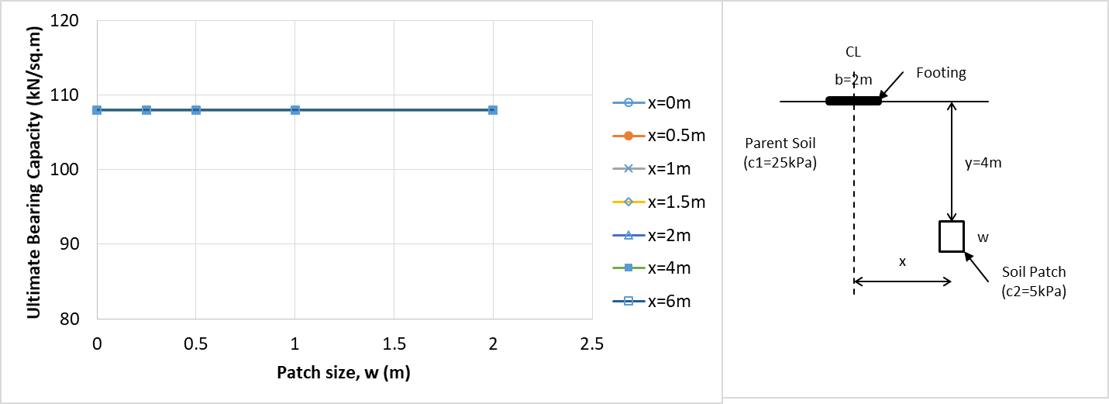
(f)
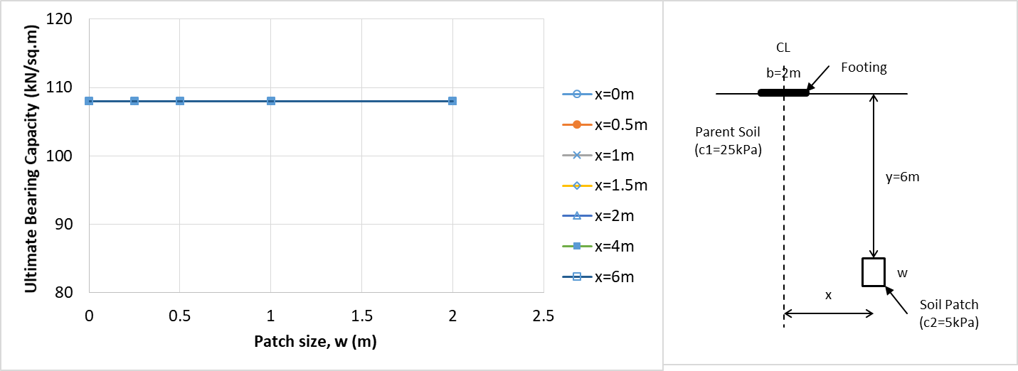
(g)

Figure 4.6: Bearing capacity of foundation with variation of size of soil patch (w) for different eccentricity of soil patch (x) and at depth, (a) y=0m, (b) y=0.5m, (c) y=1m, (d) y=1.5m, (e) y=2m, (f) y=4m and (g) y=6m.
Table 4.4: Bearing capacity of foundation with variation of size soil patch (w) irrespective of position of soil patch.
The results indicates that the ultimate bearing capacity decreases with an increase in the size of soil patch and maximum reduction of bearing capacity is obtained for the largest soil patch as observed in Table 4.4. In this study, the size of the largest soil patch is limited to a square of side 2m, but the trend of bearing capacity with respect to the size of soil patch clearly shows declining pattern of ultimate bearing capacity with an increase in the size of soil patch of weaker consistency. Further when the size soil patch is reduced, the effect of soil patch diminishes. Hence, the result of the analysis indicates that there is a critical size of the soil patch and when the size of soil patch of weaker consistency exceeds this critical dimension the footing performance be significantly affected by its presence based on its location below the foundation.
From the Figure 4.6 (a), (b), (c), (d), (e), (f) and (g) it can be clearly observe that the reduction in bearing capacity is not uniform with respect to the size of the soil patch. It can be perceive from the results that the position of the soil patch with respect to the foundation in the soil domain plays prime role in the performance of the foundation, as closer the soil patch is located to the foundation, greater will be its influence. When the soil patch is at greater distance than the critical region around the foundation, the effect of its presence is negligible. As from Figure 4.6 (f) and (g), when the soil patch is at a depth greater than the critical depth, no influence of its presence can be seen on the bearing capacity for any size and position of soil patch. This may be due to the reason that the failure surface and stress only extends to a certain region around the foundation (i.e. critical region) beyond which the presence of soil patch has no influence in the performance of the foundation.

Effect of soil patch consistency
In this study, the effect of stiffness property of the soil patch on the performance of the foundation has been investigated. In order to investigate extent of influence of the strength of the soil patch in the performance of foundation, the soil patch of varying undrained shear strength from 20% to 100% of that of the parent soil has been taken into consideration in the models. Further, ultimate bearing capacity as perceived from the load settlement curve for different size of soil patch keeping the size of soil patch constant (i.e. w=1m) are shown in Figure 4.6 (a), (b), (c), (d), (e), (f) and (g). The minimum value of bearing capacity for a specified soil patch width and undrained shear strength irrespective of position of soil patch are shown in Table 4.5.
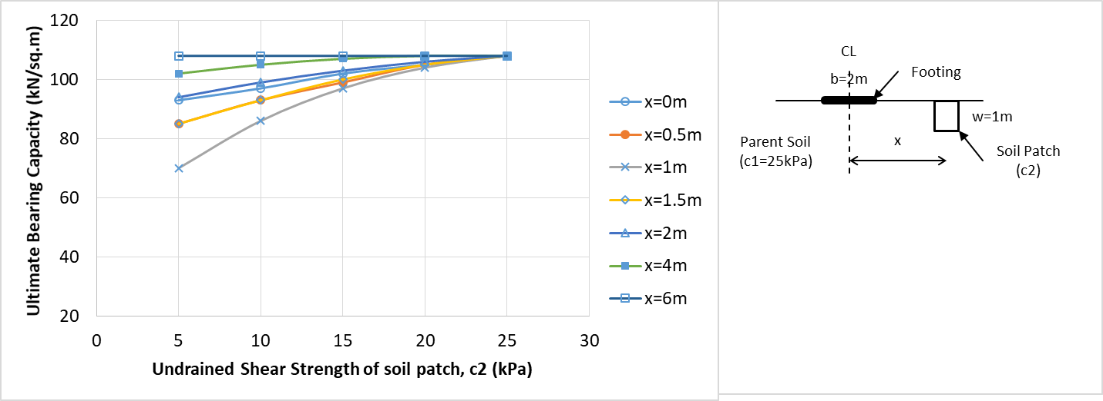
(a)
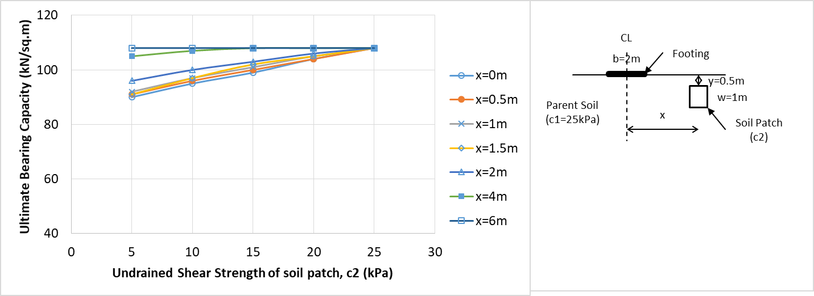
(b)
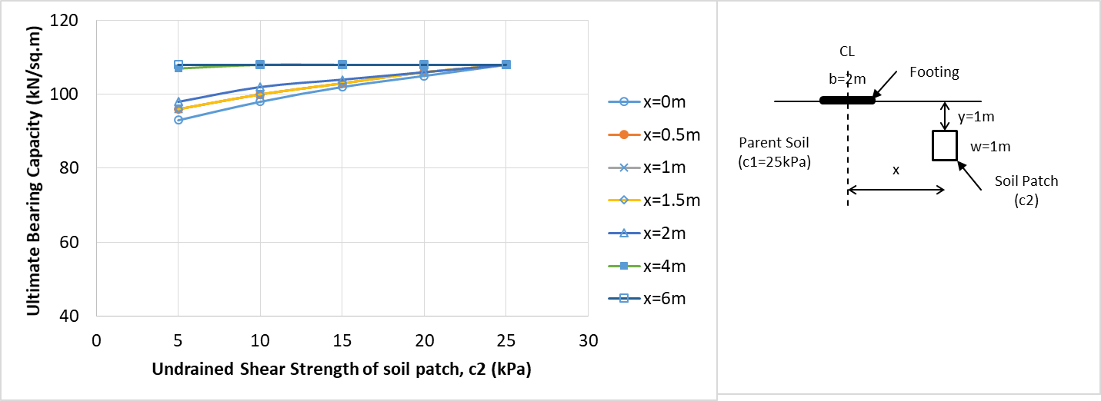
(c)
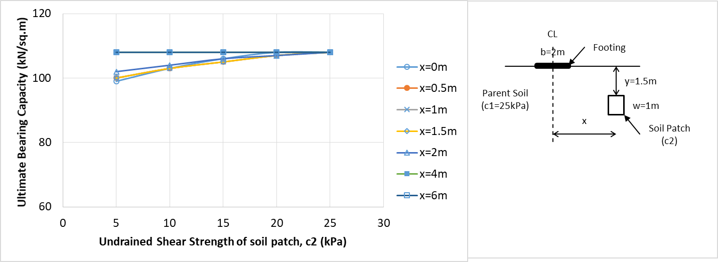
(d)

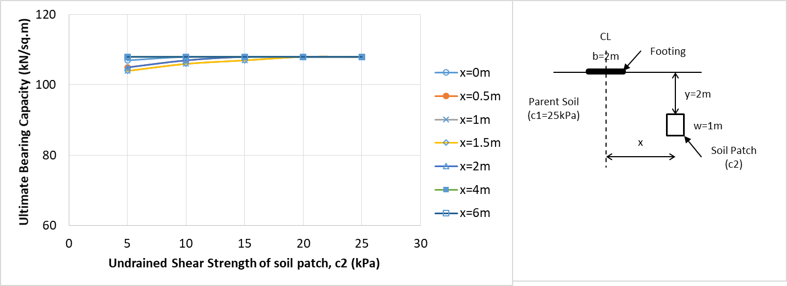
(e)
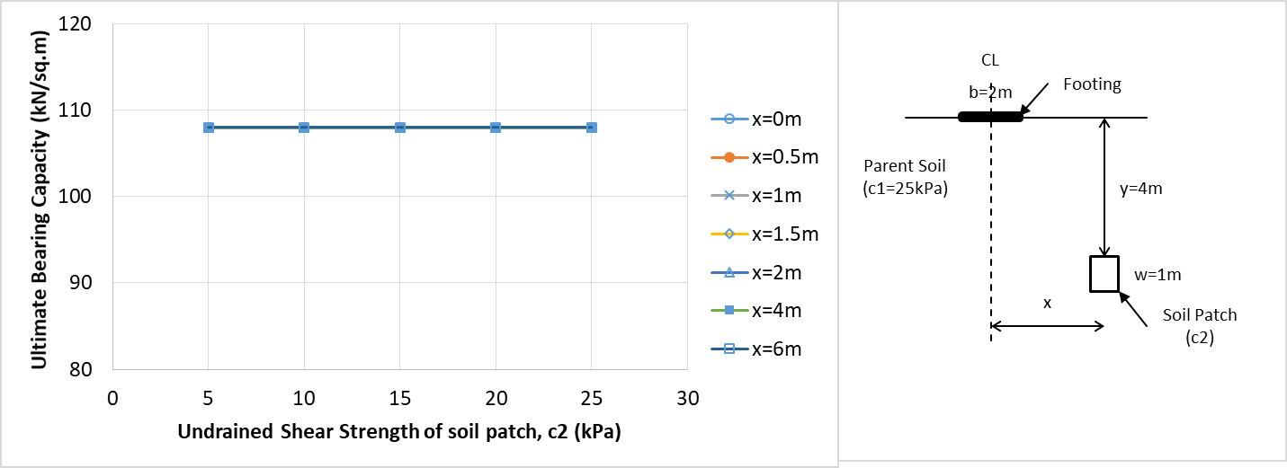
(f)
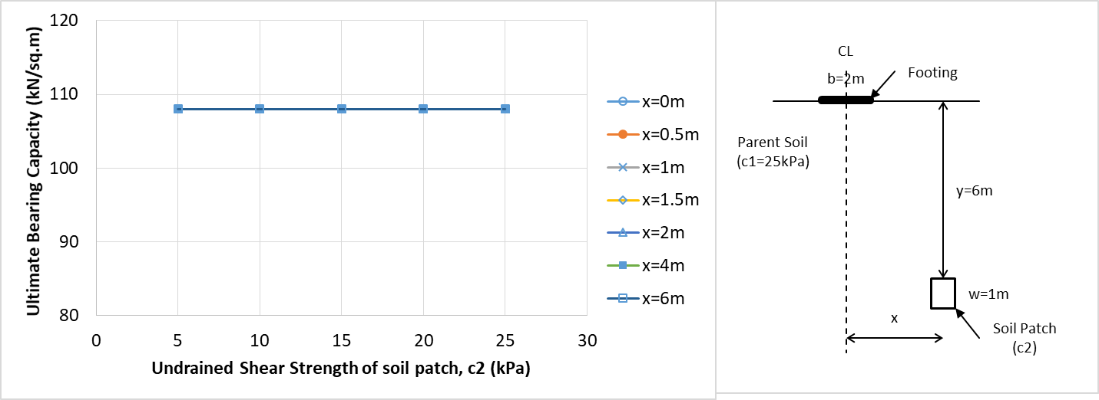
(g)

Figure 4.7: Bearing capacity of foundation with variation of undrained shear strength property of soil patch (c2) for different eccentricity of soil patch (x) and at depth, (a) y=0m, (b) y=0.5m, (c) y=1m, (d) y=1.5m, (e) y=2m, (f) y=4m and (g) y=6m.

Table 4.5: Minimum bearing capacity of foundation with variation of soil patch consistency (undrained shear strength, c2) irrespective of position of soil patch.
The results indicates that the ultimate bearing capacity decreases with decrease in the shear strength of the soil patch. This may be due to the reason that the failure surface progresses through weak zones or trails a path of small energy in the soil underneath the footing. This effect in performance of the foundation diminishes as the consistency of soil patch is near the consistency of the parent soil. From Table 4.5, it can be observed that the shear strength property of the soil patch plays primary role in lowering the ultimate bearing capacity of the foundation. This may be due to the incapability of the weaker soil patch with lower shear strength than that of the parent soil to withstand the shear stresses developed by the foundation.
From the Figure 4.7 (a), (b), (c), (d), (e), (f) and (g) it can be clearly observe that the reduction in bearing capacity is not uniform with respect to the shear strength of the soil patch. It can be perceive from the results that the position of the soil patch with respect to the foundation in the soil domain plays secondary role in the performance of the foundation, as closer the soil patch is located to the foundation, greater will be its influence. When the soil patch is at greater distance than the critical region around the foundation, the effect of its presence is negligible. As from Figure 4.7 (f) and (g), when the soil patch is at a depth greater than the critical depth, no influence of its presence can be seen on the bearing capacity for any size and position of soil patch. This may be due to the reason that the failure surface and stress only extends to a certain region around the foundation (i.e. critical region) beyond which the presence of soil patch has no influence in the performance of the foundation. It can be observed that the effect of strength property of soil patch is negligible as the patch of soil moves out of the critical region even when the soil patch consistency is very low.

Effect of presence of soil patch
The parametric analysis of the effect of soil patch shows that its presence can cause unfavorable and unpredictable reduction in the bearing capacity of the foundation when the foundation soil consists of soil patch of weaker consistency beneath or near the vicinity of the foundation. This circumstance can be supported by or reasoned with the displacement and deformation behavior of soil under the foundation. The effect of such patch of soil on the strains and settlement behavior of soil under the foundation are discussed below.
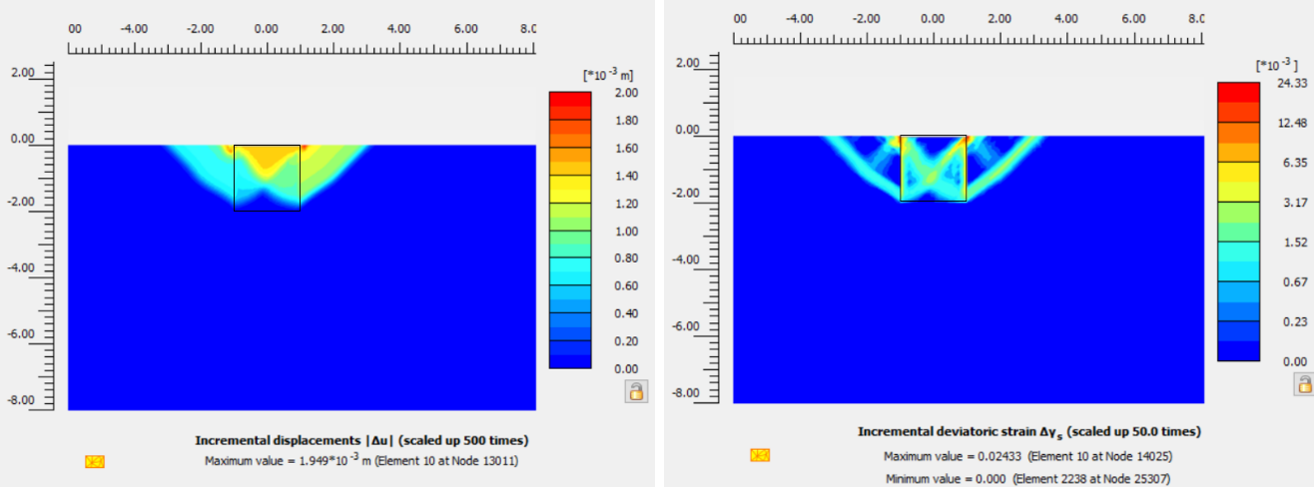
(a)
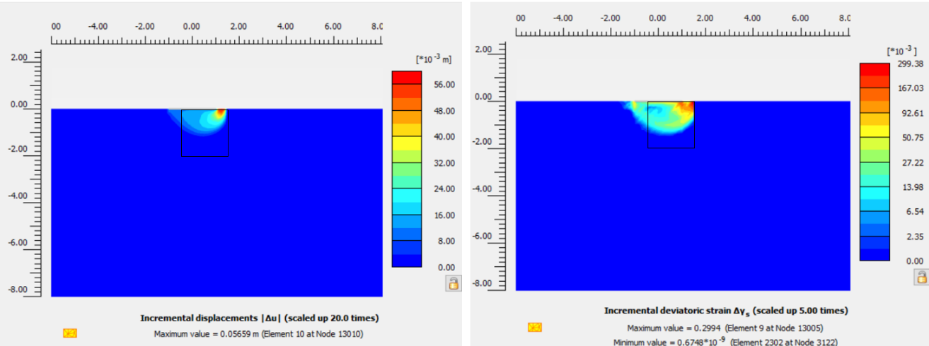
(b)
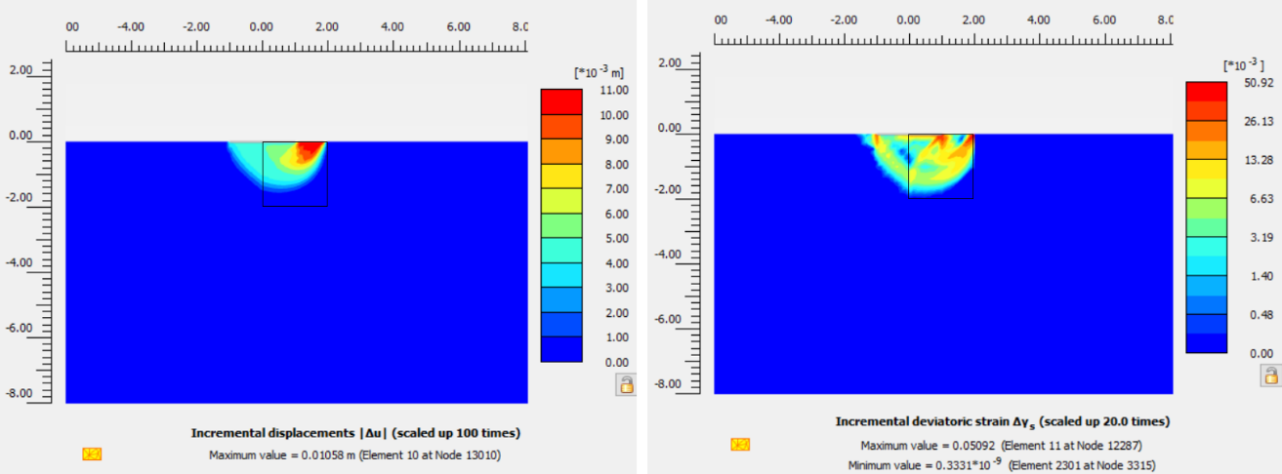
(c)
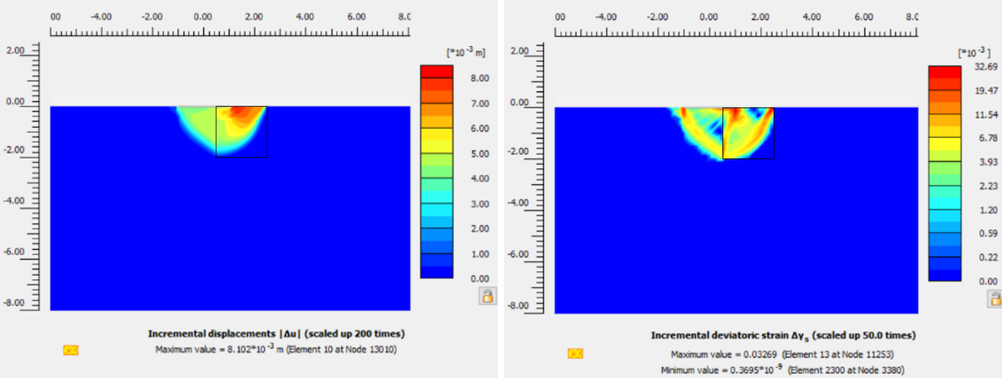
(d)
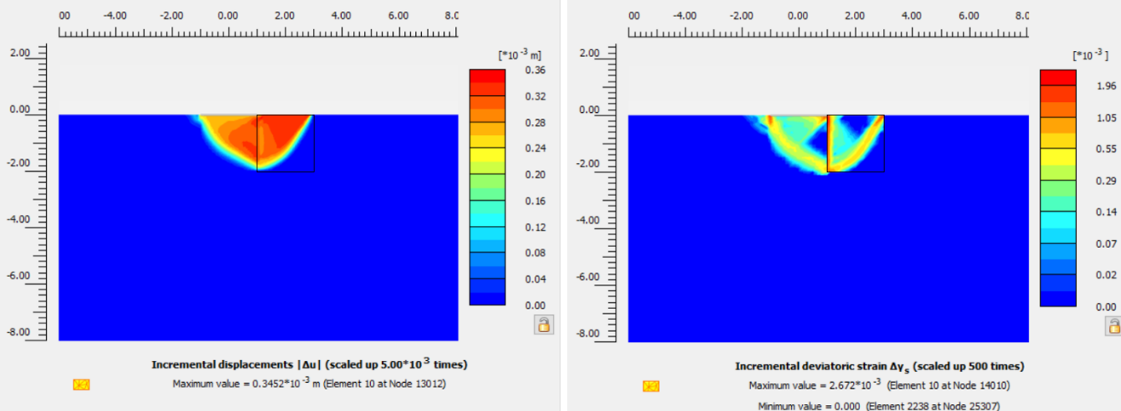
(e)
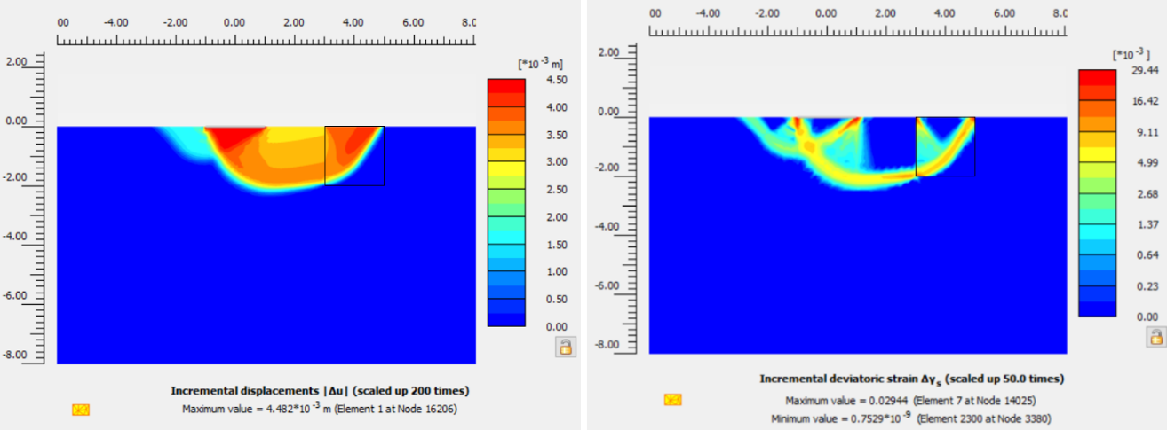
(f)
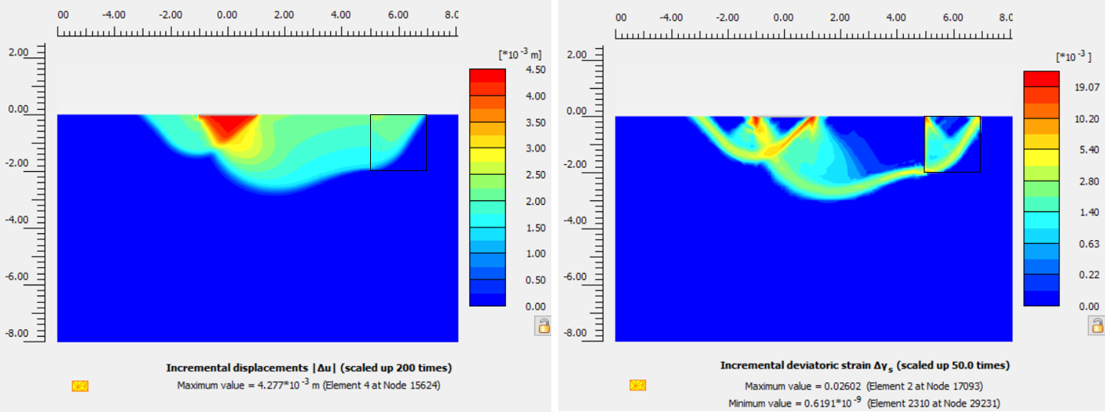
(g)
Figure 4.8: Soil Displacement and Shear Strain Behavior of soil under foundation with variation of eccentricity of soil patch (x) as, (a) x=0m, (b) x=0.5m, (c) x=1m, (d) x=1.5m, (e) x=2m, (f) x=4m and (g) x=6m.
From the Figure 4.8 (a), (b), (c), (d), (e), (f) and (g) the effect of soil patch eccentricity on the behavior of foundation can be clearly observed. For no eccentricity condition (i.e. at x=0m) with reference to Figure 4.8 (a), uniform settlement of foundation and uniform displacement of surrounding soil can be observed along with distinct failure surfaces similar to that with homogeneous soil case. But additional failure surface can be observed on the vertical walls of the soil patch which may be due to shearing of weaker soil of the soil patch upon the application of load.
As the position of the soil patch becomes eccentric to the foundation, the behavior of the foundation drastically changes. It can be perceived that due to the eccentricity of the soil patch, there is non-uniform settlement of soil under the foundation. Also, the weaker soil of the soil patch can be observed being uplifted which may be due to the lack of shear strength of the soil and inadequate confinement to bear the induced stress in the soil patch resulting in the instability of the foundation and reduced ultimate bearing capacity as observed from Figure 4.8 (a), (b), (c), (d) and (e). This effect can be found to be decreasing as the soil patch eccentricity increases. With reference to Figure 4.8 (f) and (g), as the eccentricity of soil patch increases such that, it is located at a distance away from the edge of foundation, the non- uniform settlement and non-uniform displacement of surrounding soil starts deceasing until the soil patch is beyond the critical region of the foundation which depends on the properties of parent soil, size of foundation and size of soil patch.
(a)
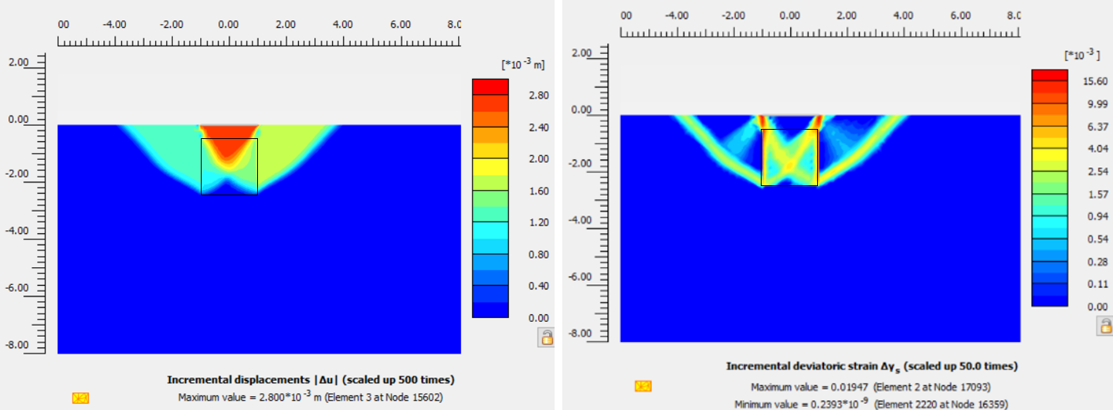
(b)
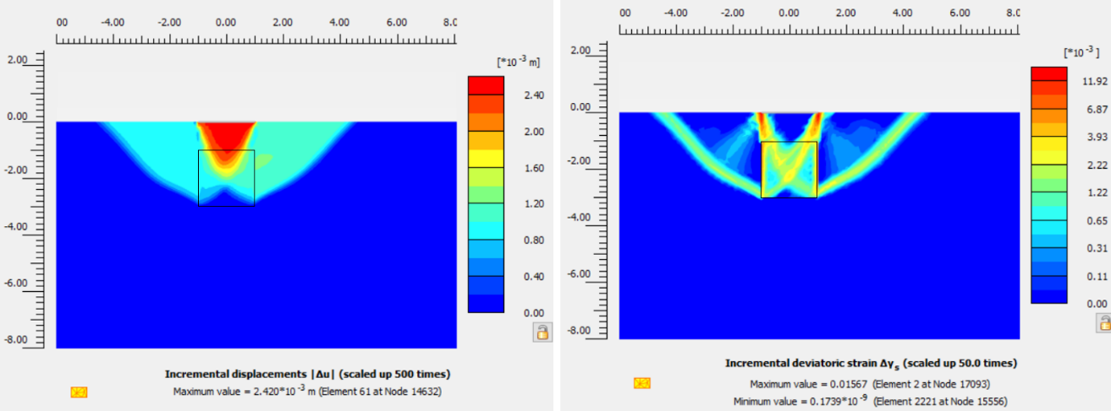
(c)
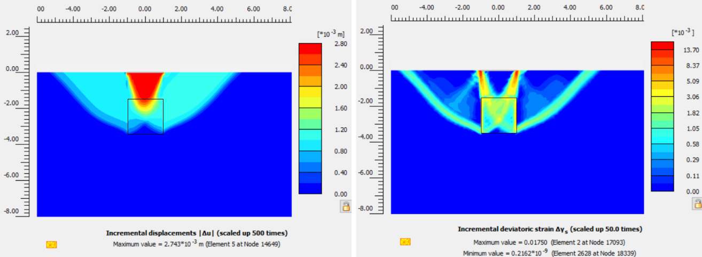
(d)
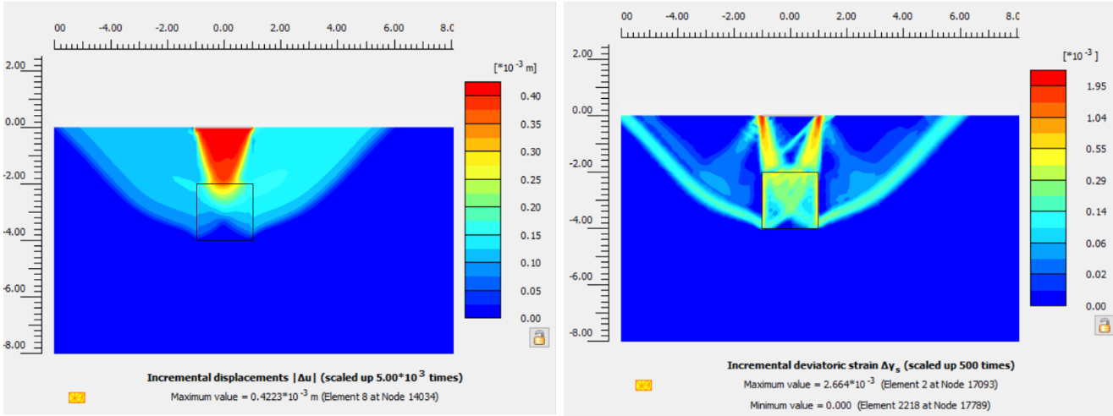
(e)
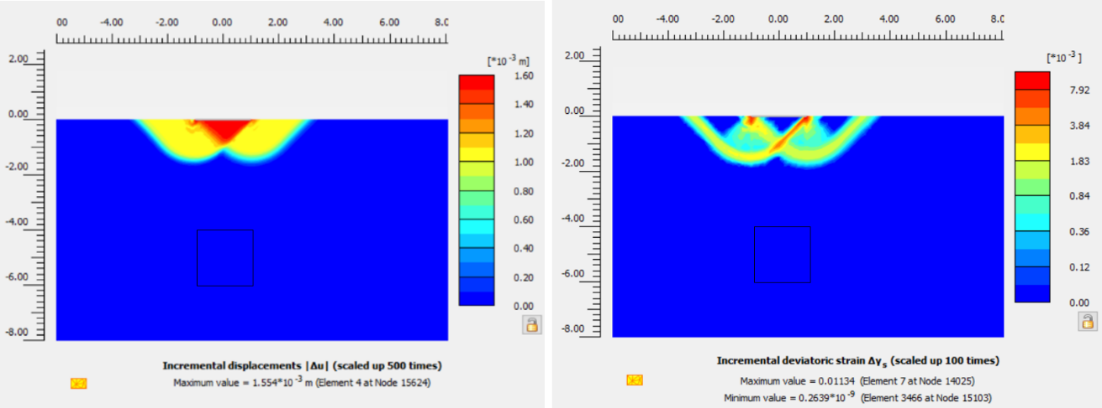
(f)
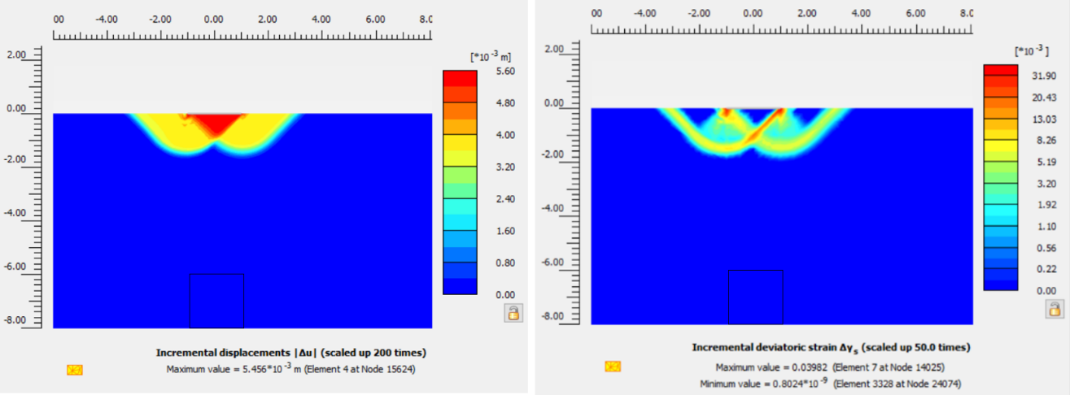
(g)
Figure 4.9: Soil Displacement and Shear Strain Behavior of soil under foundation with variation of depth of soil patch (y) as (a) y=0m, (b) y=0.5m, (c) y=1m, (d) y=1.5m, (e) y=2m, (f) y=4m and (g) y=6m.
From the Figure 4.9 (a), (b), (c), (d), (e), (f) and (g) the effect of soil patch depth on the behavior of foundation can be clearly observed. For soil patch just below the base of foundation (i.e. at y=0m) with reference to Figure 4.8 (a), uniform settlement of foundation and uniform displacement of surrounding soil can be observed along with distinct failure surfaces similar to that with homogeneous soil case. But additional failure surface can be observed on the vertical walls of the soil patch which may be due to shearing of weaker soil of the soil patch upon the application of load.
As the depth of the soil patch increases, the behavior of the foundation changes. It can be perceived that as the depth of the soil patch increases (i.e. as y>0m) there comes a layer of parent soil in between the foundation and the soil patch. Such that the failure wedge punches through the parent soil strata and the failure plane progresses in to the soil patch. This causes punching failure in the parent strata and general shear failure in the soil patch resulting in deeper penetration of stress in the soil domain as observed from Figure 4.9 (a), (b), (c), (d) and (e). Due to this phenomena the bearing capacity of the soil decreases and greater settlement is induced in the foundation. This effect can be found to be decreasing as the depth of soil patch increases. With reference to Figure 4.9 (f) and (g), as the depth of soil patch increases such that, it is located at a depth where the thickness overlaying parent soil is sufficient enough to bear the foundation pressure and undergo general shear failure with minimal to no stress transfer to the soil patch underneath. This causes the influence of soil patch in the performance of foundation to diminish and the respective depth beyond which there is no effect of soil patch may be called the critical depth which depends on the properties of parent soil, size of foundation and size of soil patch.
(a)
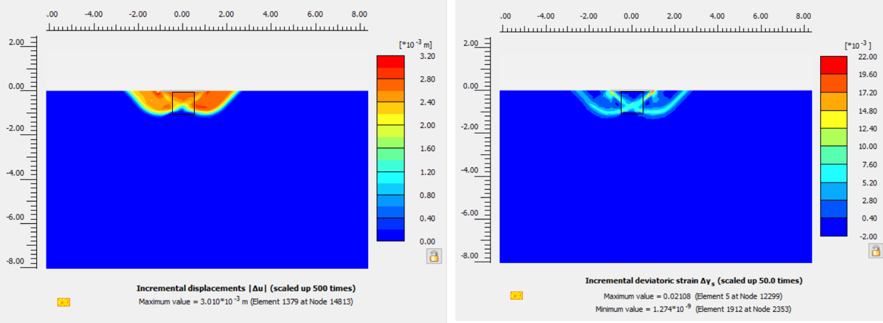
(b)
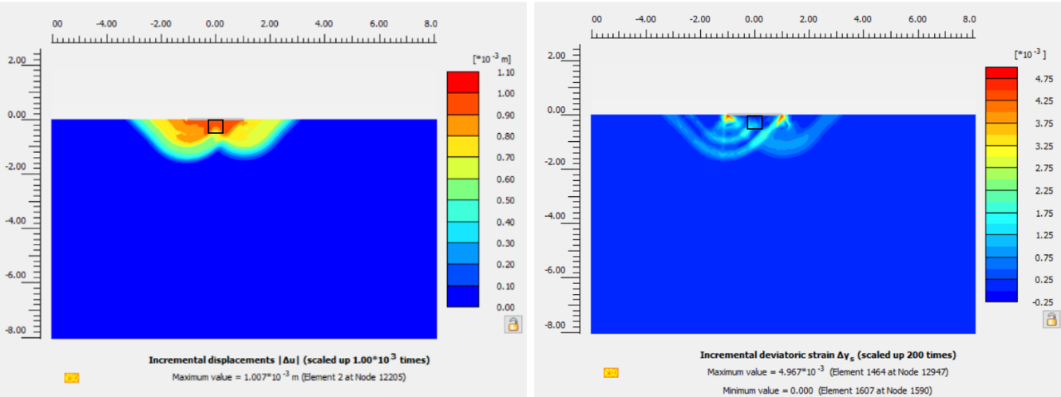
(c)
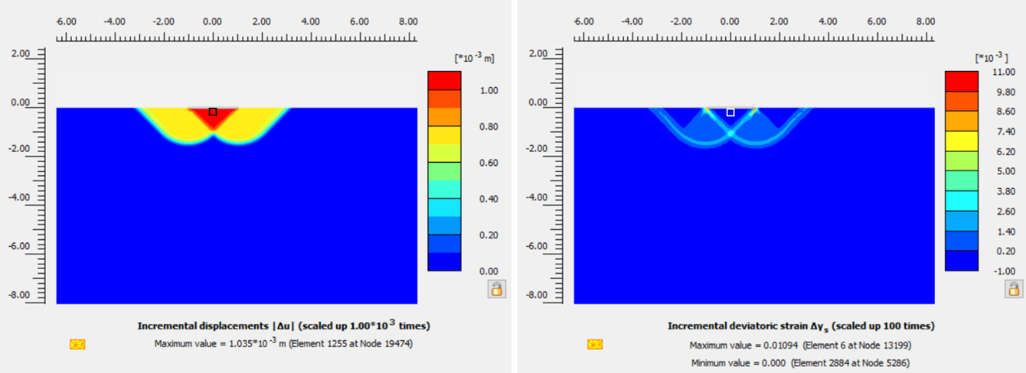
(d)
Figure 4.10: Soil Displacement and Shear Strain Behavior of soil under foundation with variation of size of soil patch (w) as (a) w=2m, (b) w=1m, (c) w=0.5m, (d) w=0.25m
From the Figure 4.10 (a), (b), (c) and (d) the effect of size of soil patch on the behavior of foundation can be clearly observed. For soil patch just below the base of foundation (i.e. at x=0m and y=0m) uniform settlement of foundation and uniform displacement of surrounding soil can be observed along with distinct failure surfaces similar to that with homogeneous soil case. But additional failure surface can be observed on the vertical walls of the soil patch. As the size of soil patch decreases this effect also decreases and when the soil patch size is smaller than the failure wedge and lies completely inside it, there is negligible effect of the presence of soil patch on the performance of the foundation.
(a)
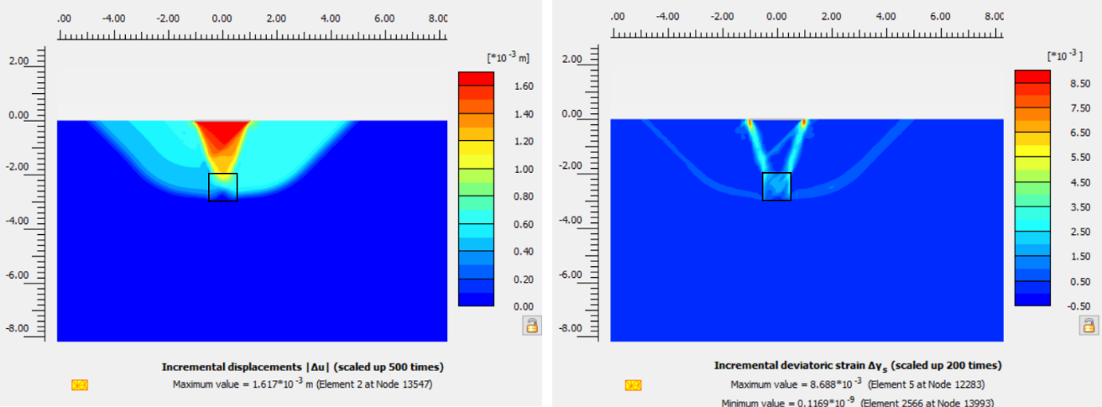
(b)
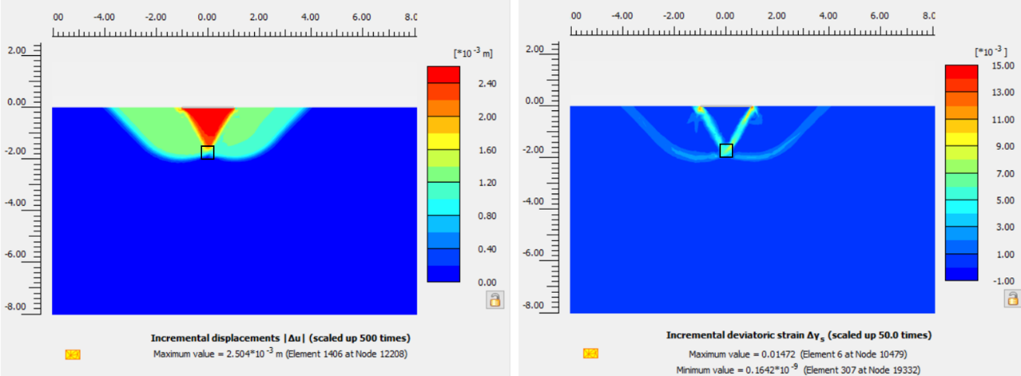
(c)
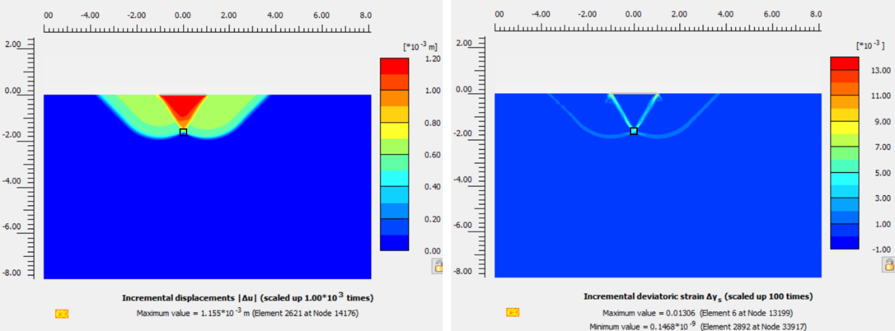
(d)
Figure 4.11: Soil Displacement and Shear Strain Behavior of soil under foundation with variation of size of soil patch (w) at critical depths as (a) w=2m, (b) w=1m, (c) w=0.5m, (d) w=0.25m
From the Figure 4.11 (a), (b), (c) and (d) the effect of size of soil patch on the behavior of foundation at critical depths can be clearly observed. It can be clearly observed from Table 4.2 and Figure 4.4 that the critical depth for soil patch is different with respect to the size of the soil patch. Figure 4.11 (a) and (b) shows that for soil patch of size 2m at a depth of 2m, there is significant influence of its presence on the performance of the foundation whereas, the influence is less for a soil patch of size 1m at same depth. Also Figure 4.11 (c) and (d) shows that for soil patch of size 0.5m at a depth of 1.5m more significant influence of its presence on the performance of the foundation whereas, the influence is less for a soil patch of size 0.25m at same depth.

Comparison of work
The results obtained from FE software is compared with various literatures.

Validation of model
The result of FE model used in this study is compared with the results of Kiyosumi et al. (2007) which presents the yielding pressure of spread footing above multiple voids. It elaborates the effect of square void under a strip footing and the failure mechanism of soil. A typical model similar to that of Kiyosumi et al. (2007) is modelled with a square void in place of a square soil patch as shown in Figure 4.12.
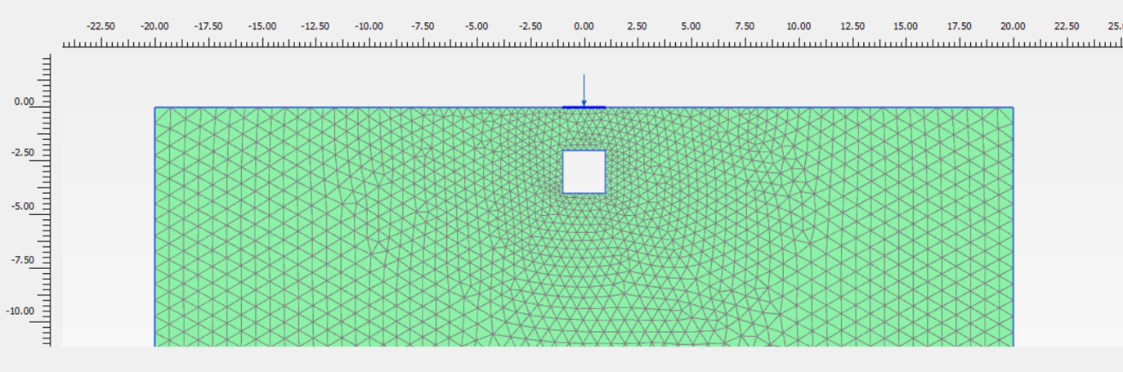
Figure 4.12: Typical mesh of the model as of Kiyosumi et al. (2007)
The material properties of soil and geometric properties of the model were used of that in the literature as given below.
Table 4.6: Material properties used as of Kiyosumi et al. (2007)
Physical properties | Value
Submerged unit weight, γ’ (kN/m³) | 9.0
Poisson’s Ratio, ν | 0.3
Young’s Modulus, E (kN/m²) | 49 x 10³
Cohesion, c (kN/m²) | 98
Internal friction angle, φ (deg) | 26.5
Dilatancy angle, ψ (deg) | 0
Tensile Strength, σ_{t} (kN/m²) | 49

Table 4.7: Geometric properties used as of Kiyosumi et al. (2007)
Geometric Property | Value
Width of Footing, B (m) | 2.0
Size of Void, W (m) | 2.0
Eccentricity of Void, Y (m) | 0.0
Depth of Void, Y (m) | 3.0

The relationship between the loading pressure and the footing settlement on the double logarithmic plot for no void condition and a square void of 2 m width at 3m depth from the base of footing were compared as below.

Figure 4.13: Relationship between loading pressure and footing settlement for no void.

Figure 4.14: Relationship between loading pressure and footing settlement for void
The relationship between the loading pressure and footing settlement for homogeneous soil condition is shown in Figure 4.13. Also, the relationship between the loading pressure and footing settlement for soil with square void of 2m width under the foundation at a depth of 3m is shown in Figure 4.14. The comparison made between the results output of the model of this study and that of Kiyosumi et al. (2007) for loading pressure versus displacement relationship from Figure 4.13 and 4.14 shows the agreement between the two is considerably excellent with slight deviations. The deviation acquired is small and the close agreement between the results of Kiyosumi et al. (2007) and the model of this study concludes the validation of the numerical model used in this study.

CONCLUSIONS AND RECOMMENDATIONS

Conclusion
This study was focused on the assessment of the effect of underground soil patch in the bearing capacity of surface strip foundation in cohesive soil. In this investigation parametric analysis has been performed in order to perceive the extent of effect of size, location and soil strength property of the soil patch in the bearing capacity and deformation behavior of the soil under foundation load. Some of the major conclusions drawn from this study are listed below:
- There is a critical depth below the foundation. When the soil patch of weaker consistency is present within or at this depth, the performance of the foundation will be significantly affected. The bearing capacity of the foundation is drastically reduces as the depth of soil patch of weaker shear strength from the base of the foundation decreases. The depth of the critical zone is twice the width of the foundation but this is dependent to the size of soil patch.
- There is a horizontal zone of influence around the foundation. When the soil patch of weaker consistency is present within or at this distance, the performance of the foundation will be significantly affected. The bearing capacity of the foundation is drastically reduces as the soil patch of weaker shear strength lies within this zone of influence. The clear distance between the foundation and the soil patch at which the effect of presence of soil patch is negligible is found to be twice the width of the foundation. A significant reduction in the bearing capacity of the foundation is observed when the soil patch is eccentric to the foundation and lies below the edge of the foundation.
- Hence, we can conclude that, there is a critical zone below and around the foundation. When the soil patch of weaker consistency is located within or at this region the footing performance be significantly affected by its presence. The extent of this critical zone in two directions (i.e. in vertical and horizontal direction) depends on various factors like size of foundation, size of soil patch, soil strength property of soil patch and parent soil itself.
- The size of the soil patch greatly influence the bearing capacity and the deformation behavior of the sub-soil. The bearing capacity of the soil decreases as the size of soil patch increases and vice versa. The effect of soil patch is prominent for larger soil patch than that for smaller ones for the respective position of the soil patch.
- Remarkable decrease in the bearing capacity of soil can be observed for a soil patch with weaker strength characteristics than that for soil patch with stronger strength characteristics. The influence of soil patch on the performance of the foundation is directly proportional to the variance of strength characteristics of the soil patch and the parent soil.
- The results of a series of numerical model analysis have shown that the bearing capacity, settlement and deformation behavior of the soil vary according to the closeness of the soil patch to the foundation. The settlement and deformation of soil is greater in the presence of soil patch than the homogeneous case but causes turbulence when it lies away from middle footing reaching to the instability of the footing and greater reduction in bearing capacity.

Recommendation
This research is not absolute in itself and consists of many limitations. Some recommendation for future work are listed as below:
- This study is limited to a single layered cohesive soil only, which is not favorable for wide range of soil type present in nature. Hence similar study can be carried out for cohesion less soils with multiple layers.
- Although the inconsistent soil pocket is assumed to be continuous square in shape and in a single location at a time for the study, such regular heterogeneity is impracticable in nature. So irregular shape of soil patch at random multiple locations at a time can be carried out.
- The research is confined to continuous strip foundation. Therefore similar study can be carried out for other footing types. Moreover, 3-dimensional approach can be engaged with the presence of multiple soil patch of different shapes at various random 3D locations.
- Apart from these, study is restricted to the study of bearing capacity and deformation behavior of soil. So the effect of soil patch on the deformation behavior and contact stresses on the foundation can be studied.

REFERENCES
Badie, A., & Wang, M. C. (1984). Stability of spread footing above void in clay. Journal of Geotechnical Engineering, 1591-1605.
Baus, R., & Wang, M. (1983). Bearing Capacity of strip footing above void. Jpurnal of Geotechnical Engineering, 1-4.
Bowles, J. (1997). Foundation Analysis and Design. Singapore: The McGrawHill Companies. Inc.
Brown, J. D., & Meyerhof, G. G. (1969). Experimental Study of Bearing Capacity in Layered Clays. Proceeding of the 7th International Conference on Soil MEchanics and Foundation Engineering, II, pp. 45-51. Meico.
Button, S. J. (1953). Bearing Capacity of Footing on Two-Layer Cohesive Subsoil. Proceedings of the 3rd International Conference on Soil Mechanics abd Foundation Engineering, I, pp. 332-335.
Chen, W. F. (1975). Limit Analysis and Soil Plastcity. Elsevier, 638.
Coduto, D. P. (2001). Foundation Design and Practices. Prentice Hall.
Das, B. M. (1977). Foundation Analysis and Design (4th ed.). Pws Publication Co.
Davis, E. H., & Booker, J. R. (1971). The bearing capacity of strip footings from the standpoint of plastic theory. Proceeding of 1st Australia-New zealand Conference on Geomechanics, (pp. 276-282). Melbourne (Australia).
Fenton, G. A., & Griffiths, D. V. (2003). Bearing capacity prediction of spatially random c-φ soil. Canadian Geotechnical Journal, 54-65.
Griffiths, D. V., & Fenton, G. A. (2001). Bearing Capacity of Spatially Random Soil. In The Undrained Clay Prandtl Problem Revisitied (pp. 351-359). Geotechnique.
Hanna, A. M., & Meyerhof, G. G. (1980). Design Charts for Ultimate Bearing Capacity of Foundations on Sand Overlaying Soft Clay. Canadeian Geotechnical Journal, 17, 300-303.
Hansen, J. B. (1970). A revised and extended formula for bearing capacity. Bulletin of the Danish Geotechnical Institute, 3-11.
Hjiaj, M., Lyamin, A. V., & Sloan, S. W. (2005). Numerical limit analysis solutions for the bearing capacity factor Nγ. International Journal of Solution and Structures, 1681-1704.
Khanal, S. (2013). Back Calculation of Plate Loading Tests using PLAXIS 2D and the Hardening Soil Model. Master Thesis, Department of Civil and Transport Engineering Norwegian University of Science and Technology.
Kiyosumi, M., Kusakabe, O., Ohuchi, M., & Peng, F. L. (2007). Yeilding pressure of spread footing above multiple voids. Journal of Geotechnical and Geoenvironmental Engineering, 1681-1695.
Makrodimopoulus, A., & Martin, C. M. (2005). Limit Analysis using Large-Scale SOCP optimization. Proceeding of 13th National Conference of UK ACME, (pp. 21-24). Sheffield.
Merifield, R. S., Sloan, S. W., & Yu, H. S. (1999). Rigorous Solution for the Bearing Capacity of Two Layered Clay Soils.
Meyerhof, G. G. (1963). Some recent research on the bearing capacity of foundations. Canadian Geotechnical Journal, 16-26.
Meyerhof, G. G. (1974). Ultimate Bearing Capacity of Footings on Sand Layer Overlying Clay. Canadian Geotechnical Journal, XI, 223-229.
Meyerhof, G. G., & Hanna, A. M. (1978). Ultimate Bearing Capacity of Foundations on Layered Soils under Inclined Load. Canadian Geotechnical Journal, XV, 565-572.
Mohamed, A. K. (2012). Numerical study for the behaviour of strip footing on sand in the existance of buried rock. Journal of Engineering Sciences, 1611-1624.
Paul, A. (2014). Ultimate Bearing Capacity of Shallow Footings on Layered Cohesive Soil. Kolkatta: Master Thesis, Jadavpur University.
PLAXIS 2D. (2016). Reference Manual.
PLAXIS 2D. (2016). Tutorial Manual.
Poulos, H. G., Carter, J. P., & Small, J. C. (2001). Foundation and Retaining Structures - Research and Practise (theme Lecture). Proceeding the 15th International Conference on Soil Mechanics and Geotechnical Engineering, IV, pp. 2527-2606. Istanbul, Turkey.
Prandtl, L. (1921). Uber die Eindringungs-festigkeit (Harte) plastischer Baustoffe und die Festigkeit von Schneiden. Zeitschrift fur Angewandte Mathematik und Mechanik, 15-20.
Pusadkar, S. S., & Baral, S. M. (2015). Behaviour of square footing resting on two layered clay deposits. Indian Geotechnical Conference. Pune, India.
Raman, K. V., Dayakar, P., & Raju, K. V. (2012). Study on Settlement Behaviour of Layered Soil. International Journal of Biotech Trends and Technology, II(4), 40-45.
Reddy, A. S., & Srinivasan, R. J. (1967). Bearing Capacity of Footing on Layered Clays. Journal of Soil Mechanics and Foundation Division, ASCE, 96, 1951-1965.
Terzaghi, K. (1943). Theoritical Soil Mechanics. New York: John Wiley & Sons.
Verma, S. K., Jain, P. K., & Kumar, R. (2013). Prediction of Bearing Capacity of Granular Layered Soil by Plate Load Test. International Journal of Advance Engineering Research and Studies, II(3), 142-149.
Vesic, A. S. (1973). Analysis of ultimate loads of shallow foundations. Journal of Soil Mechanics & Foundation, 99(1), 45-73.
Vesic, A. S. (1975). Bearing Capacity of Shallow Foundation. In Foundation Engineering Handbook (pp. 121-147). Van Nostrand Reinhold.
Zhu, M., & Michaosli, R. L. (2010). Bearing Capacity of Rectangular Footing on Two layer Clay. American Society of Civil Engineers, 997-1000.

ANNEX A LOAD SETTLEMENT CURVE
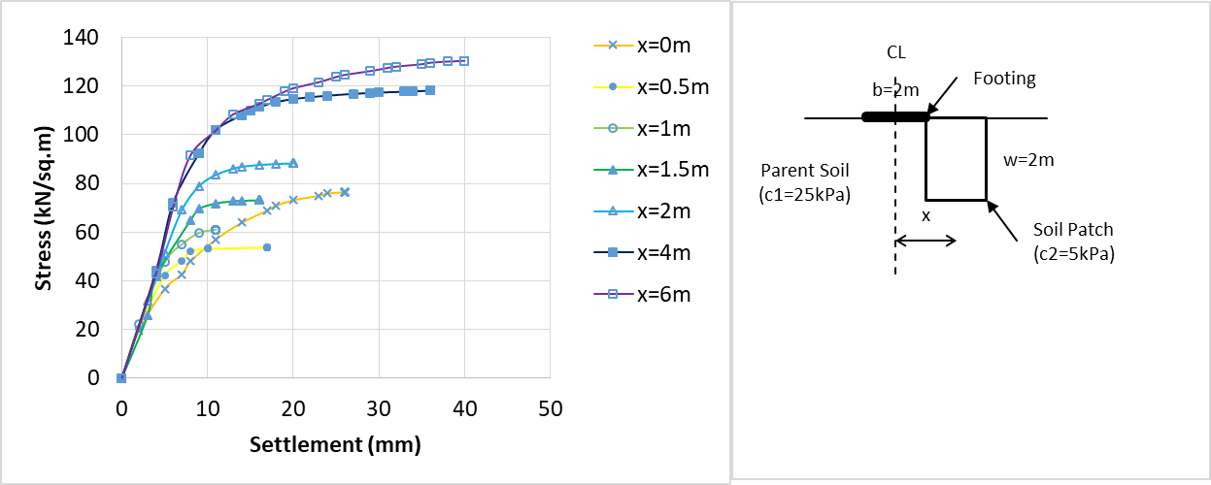
(a)
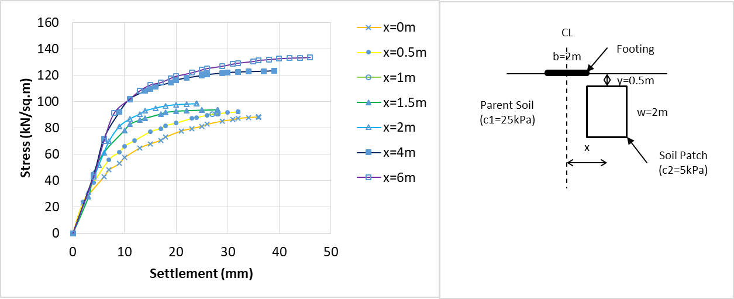
(b)
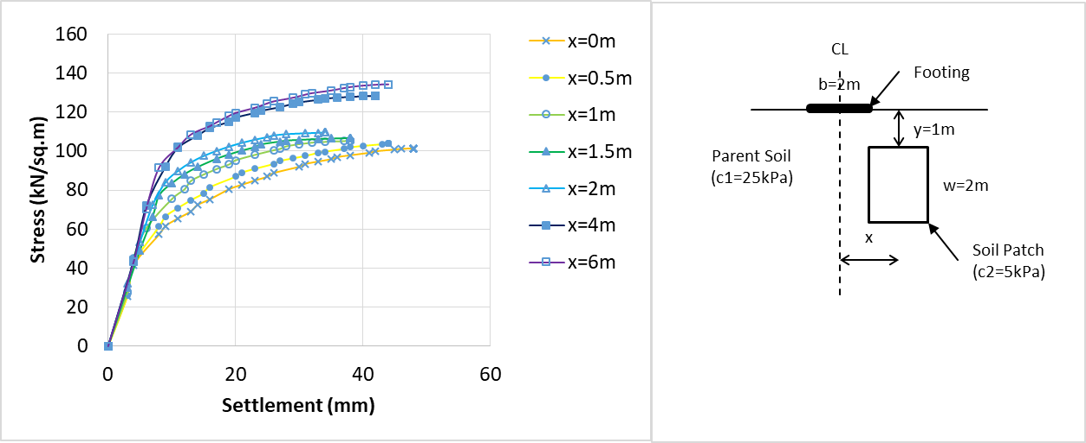
(c)
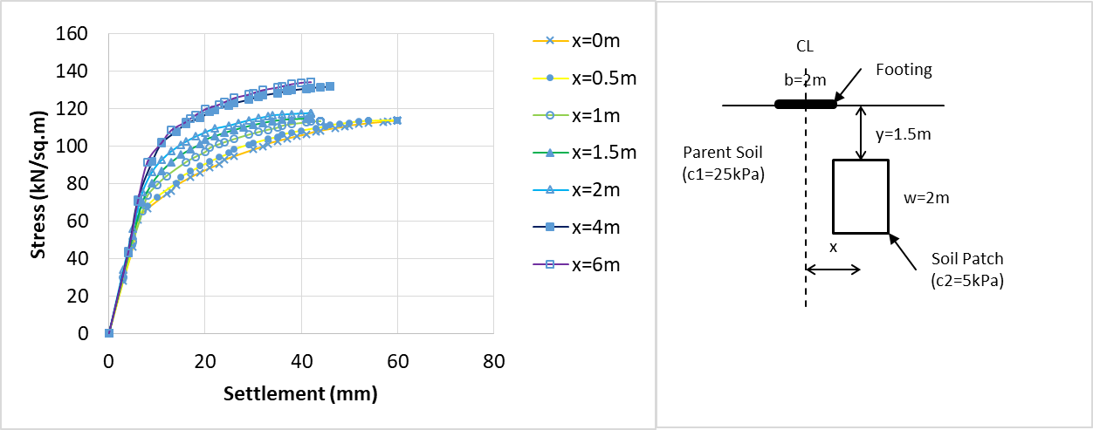
(d)
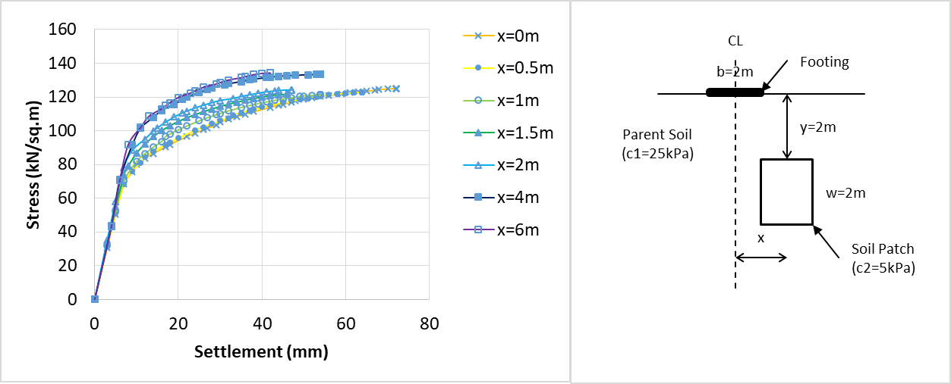
(e)
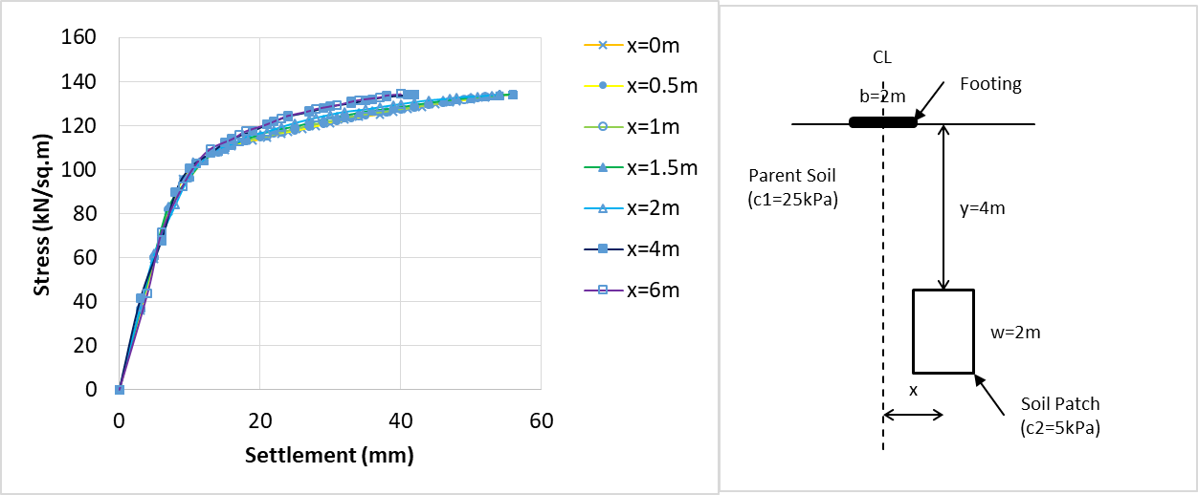
(f)
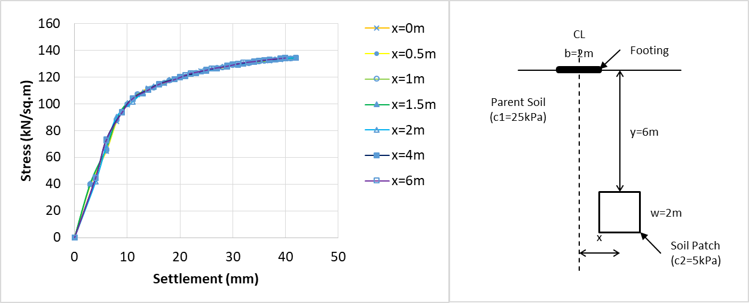
(g)
Figure A.1: Stress Load-Settlement Curve for a soil patch of width, w=2m and undrained shear strength of soil patch, c2=5kPa for variation in the eccentricity of soil patch (x) at depth of soil patch (y) as (a) y=0m, (b) y=0.5m, (c) y=1m, (d) y=1.5m, (e) y=2m, (f) y=4m and (g) y=6m
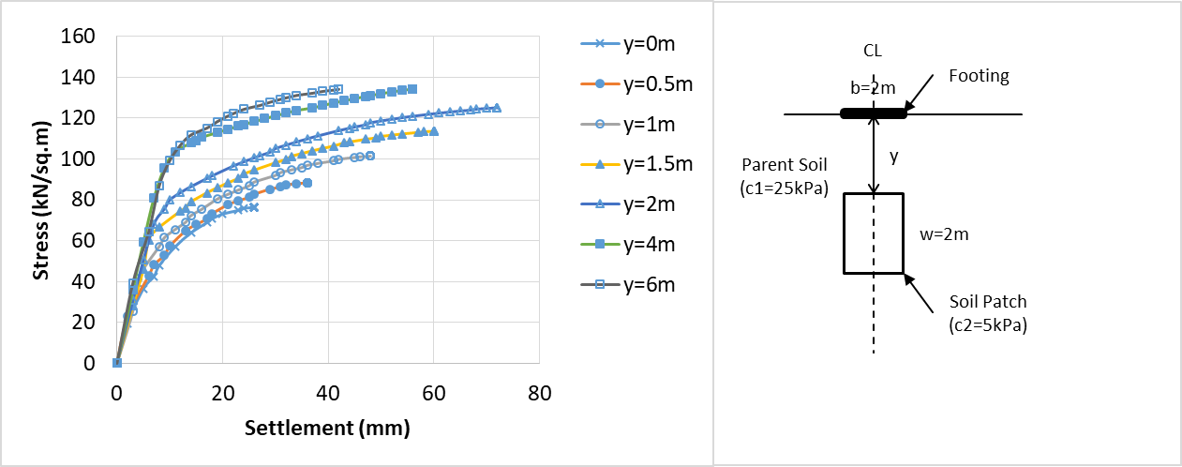
(a)
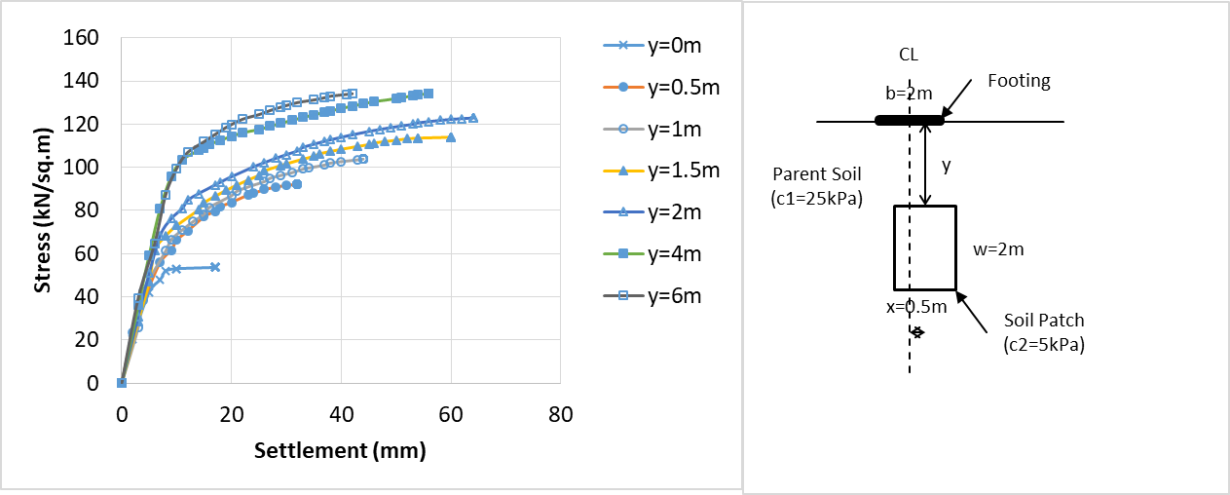
(b)
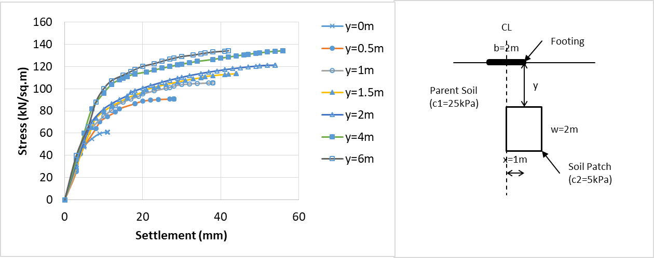
(c)
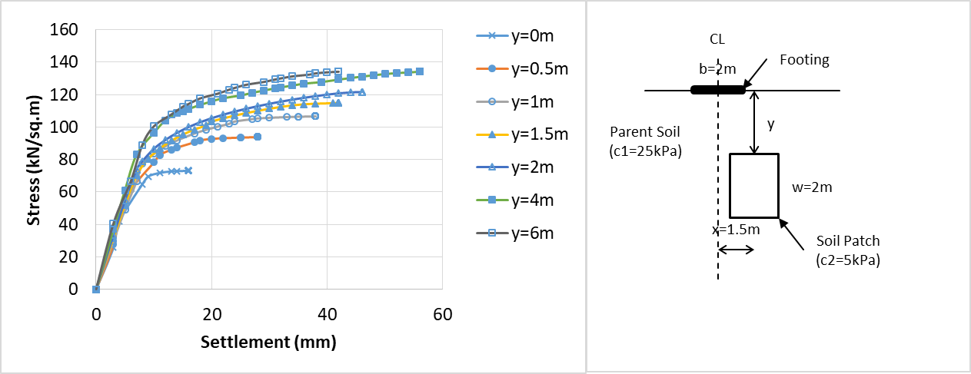
(d)
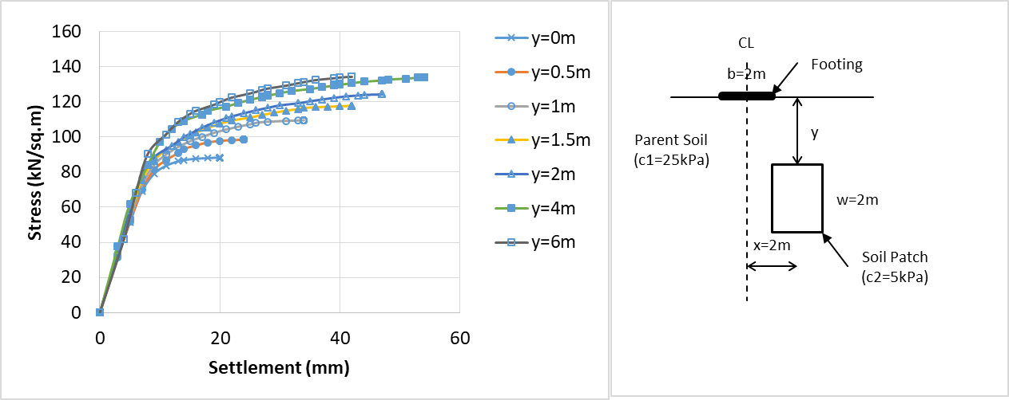
(e)
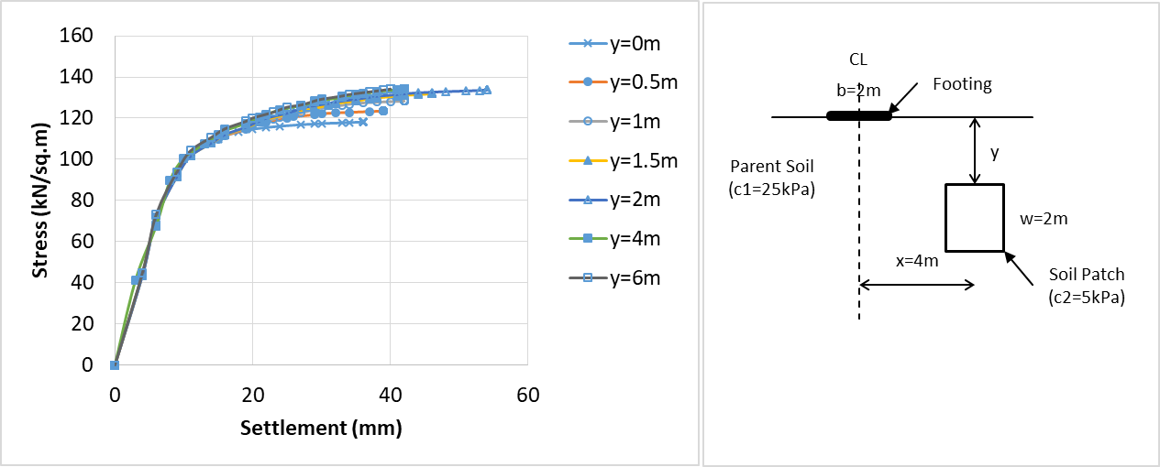
(f)
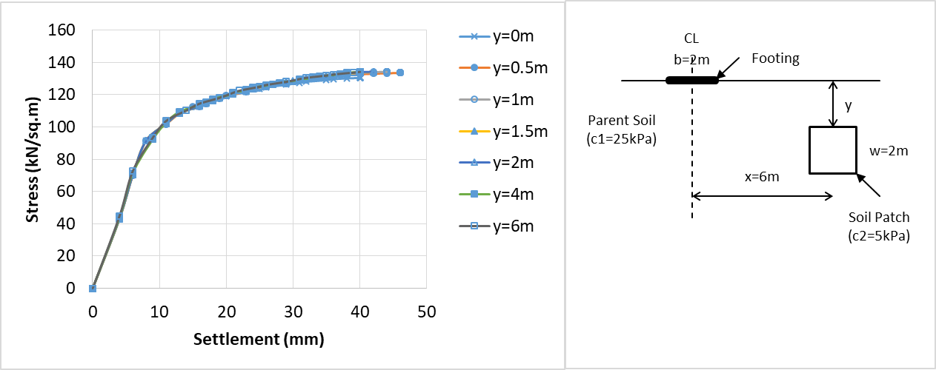
(g)
Figure A.2: Stress Load-Settlement Curve for a soil patch of width, w=2m and undrained shear strength of soil patch, c2=5kPa for variation in the depth of soil patch (y) for eccentricity of soil patch (x) as (a) x=0m, (b) x=0.5m, (c) x=1m, (d) x=1.5m, (e) x=2m, (f) x=4m and (g) x=6m

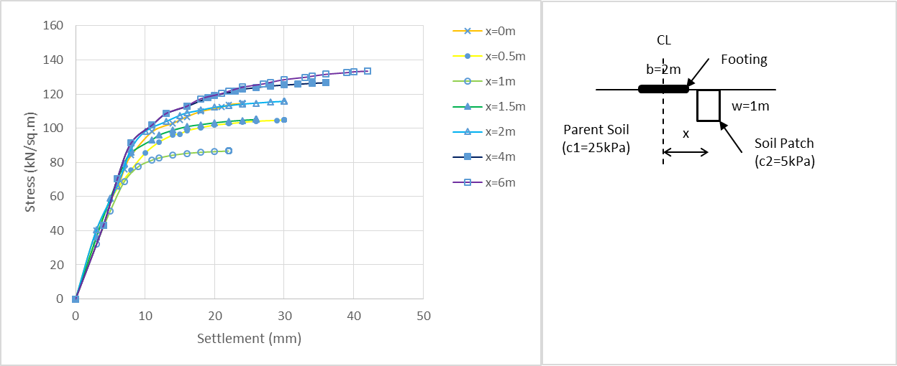
(a)
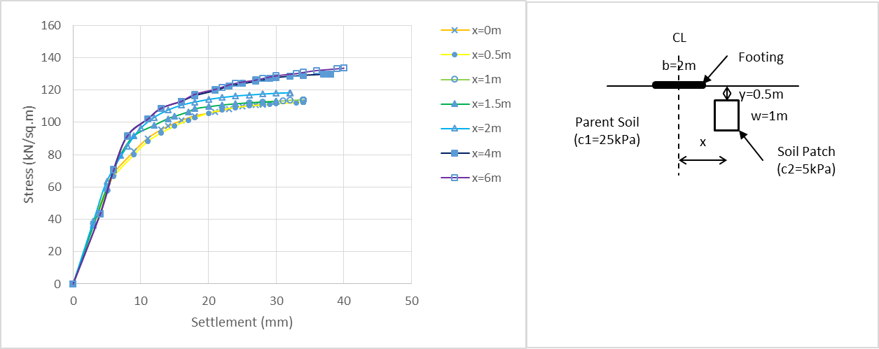
(b)
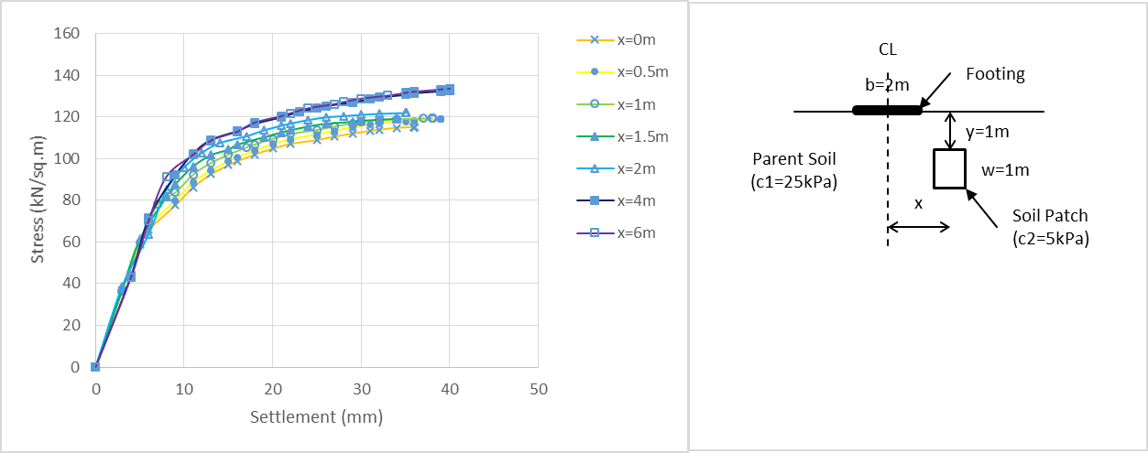
(c)
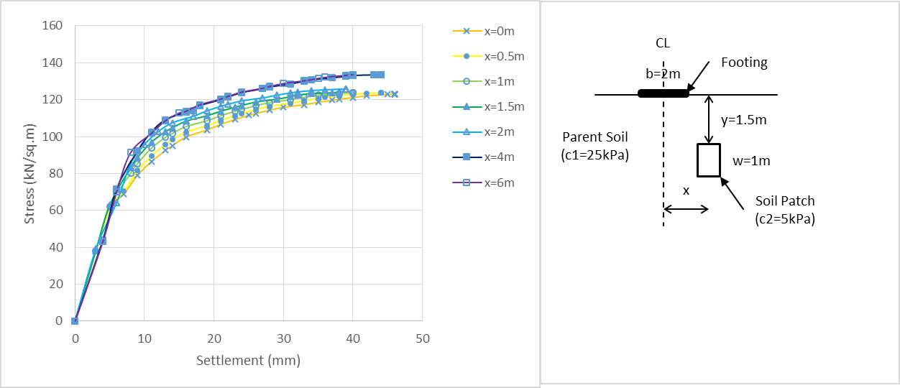
(d)
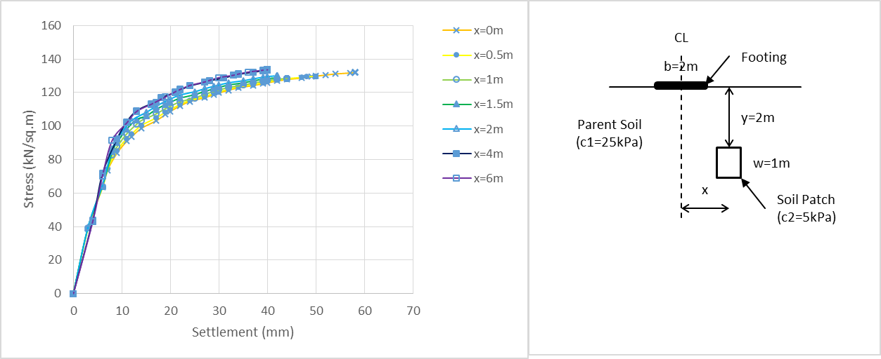
(e)
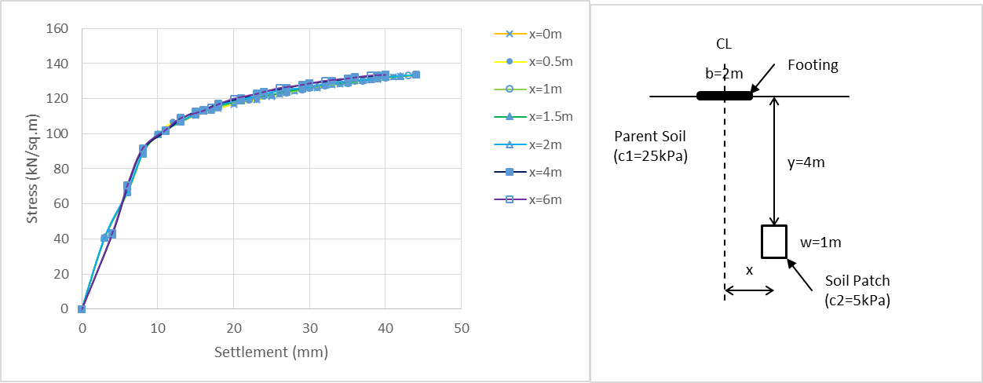
(f)
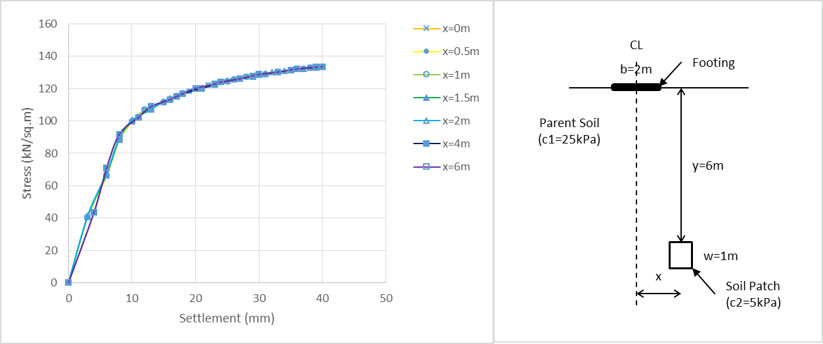
(g)
Figure A.3: Stress Load-Settlement Curve for a soil patch of width, w=1m and undrained shear strength of soil patch, c2=5kPa for variation in the eccentricity of soil patch (x) at depth of soil patch (y) as (a) y=0m, (b) y=0.5m, (c) y=1m, (d) y=1.5m, (e) y=2m, (f) y=4m and (g) y=6m
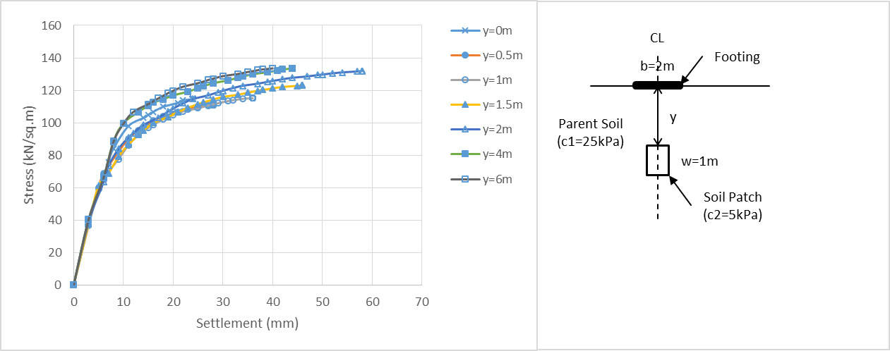
(a)
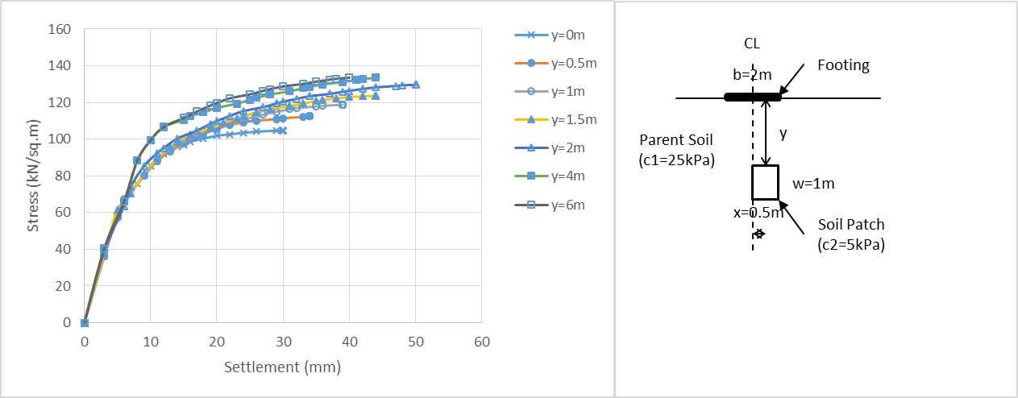
(b)
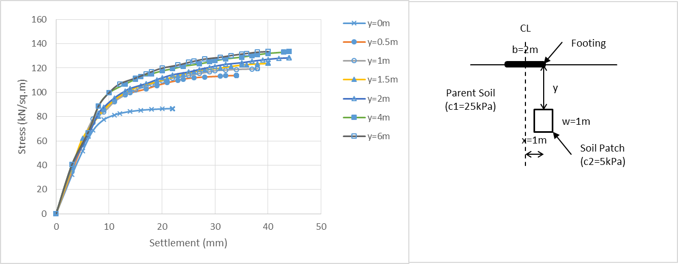
(c)
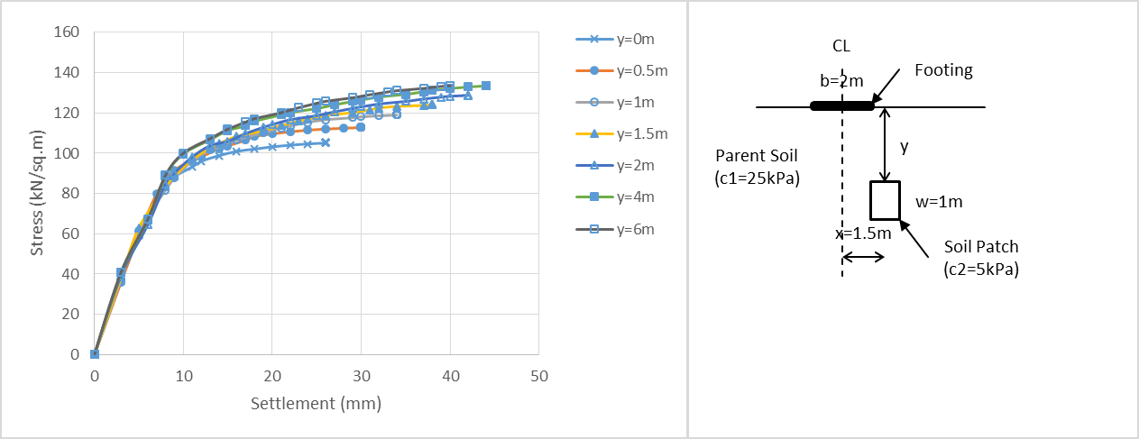
(d)
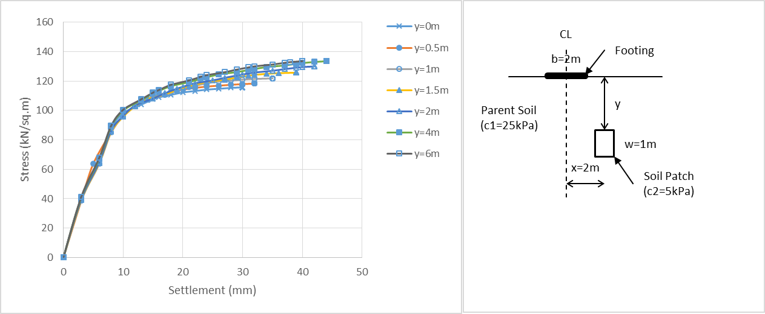
(e)
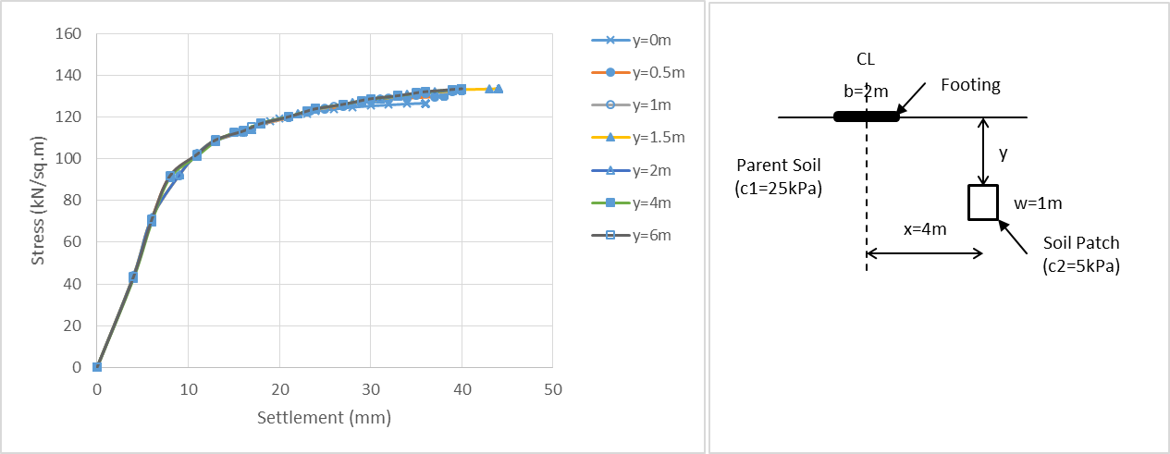
(f)
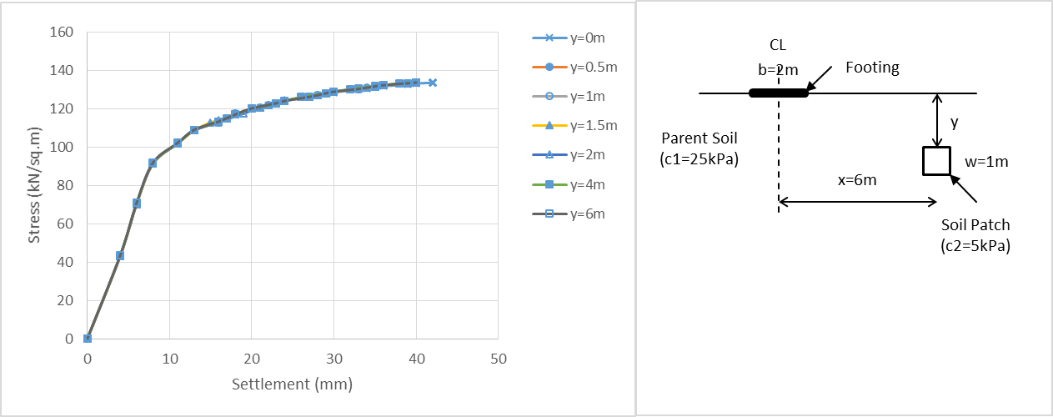
(g)
Figure A.4: Stress Load-Settlement Curve for a soil patch of width, w=1m and undrained shear strength of soil patch, c2=5kPa for variation in the depth of soil patch (y) for eccentricity of soil patch (x) as (a) x=0m, (b) x=0.5m, (c) x=1m, (d) x=1.5m, (e) x=2m, (f) x=4m and (g) x=6m

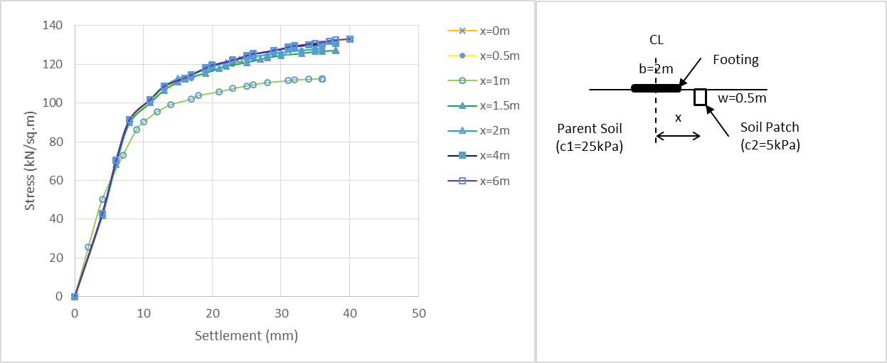
(a)
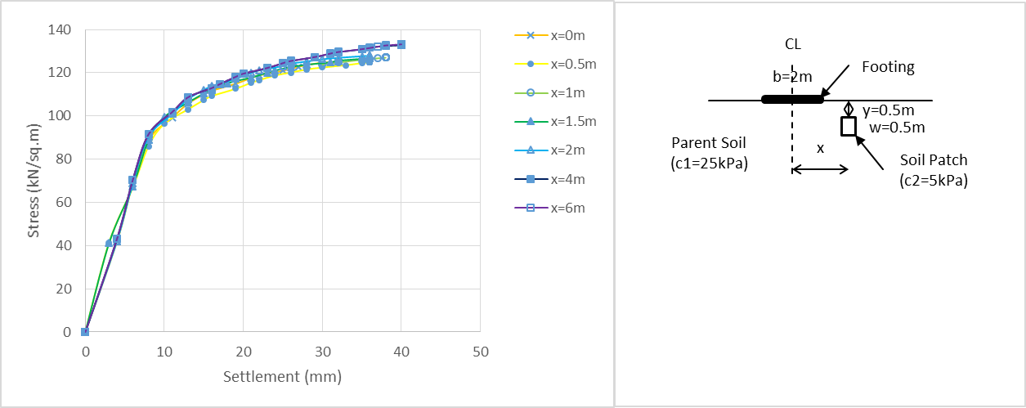
(b)
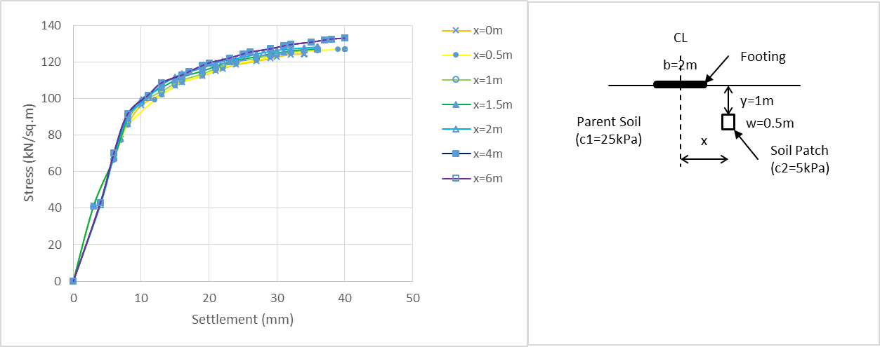
(c)

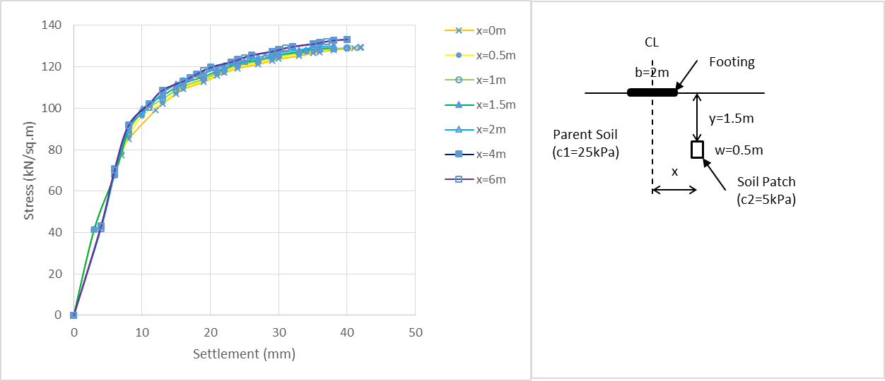
(d)
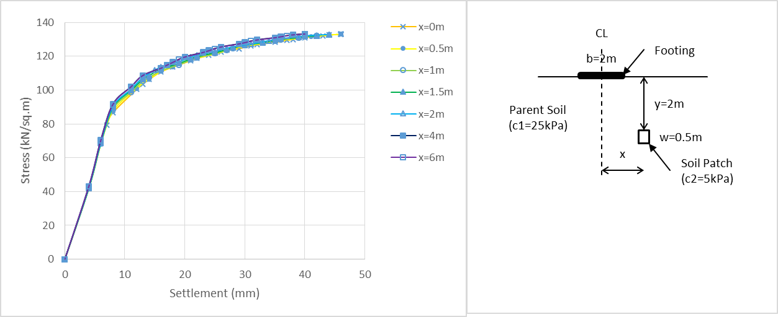
(e)
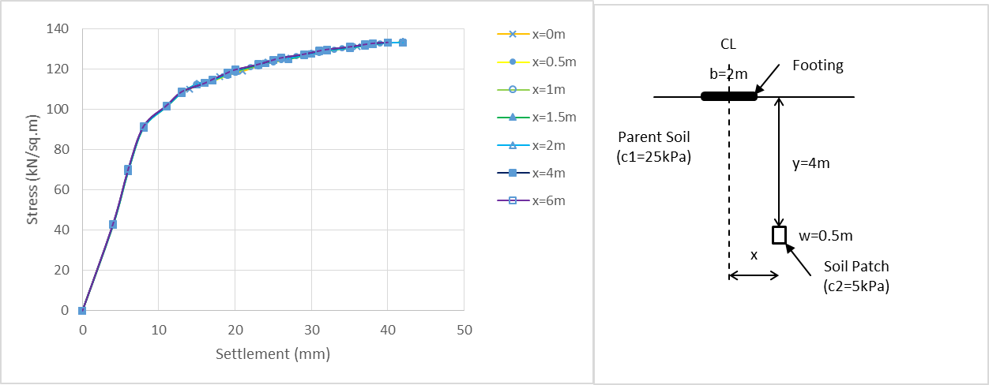
(f)
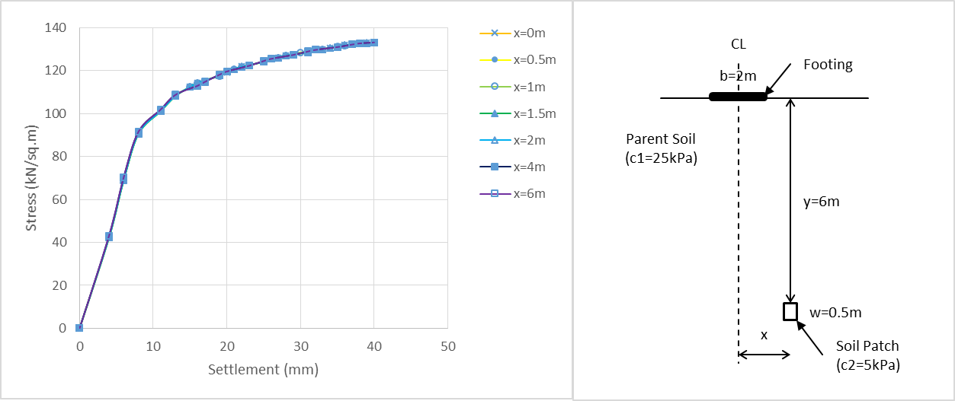
(g)
Figure A.5: Stress Load-Settlement Curve for a soil patch of width, w=0.5m and undrained shear strength of soil patch, c2=5kPa for variation in the eccentricity of soil patch (x) at depth of soil patch (y) as (a) y=0m, (b) y=0.5m, (c) y=1m, (d) y=1.5m, (e) y=2m, (f) y=4m and (g) y=6m
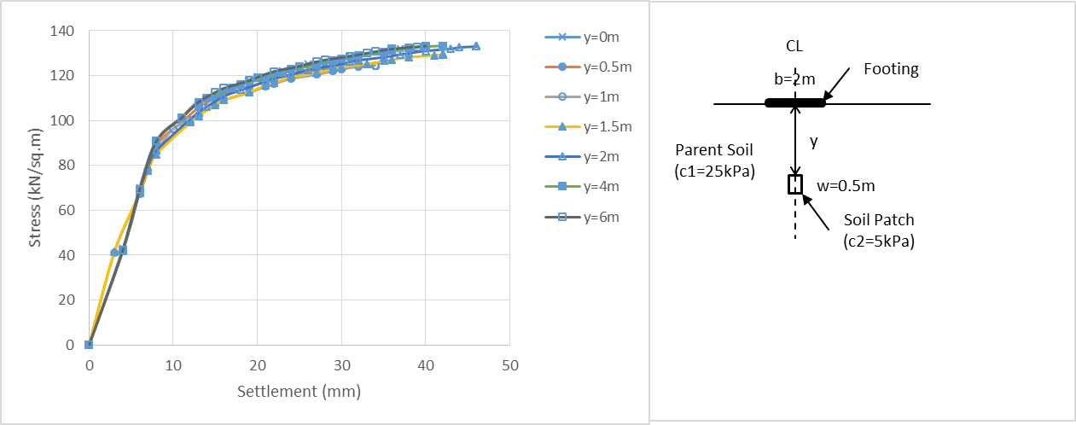
(a)
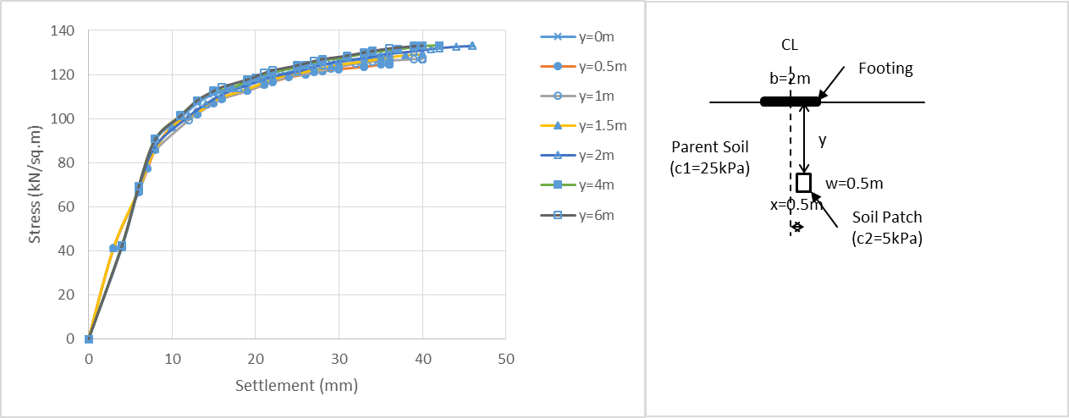
(b)
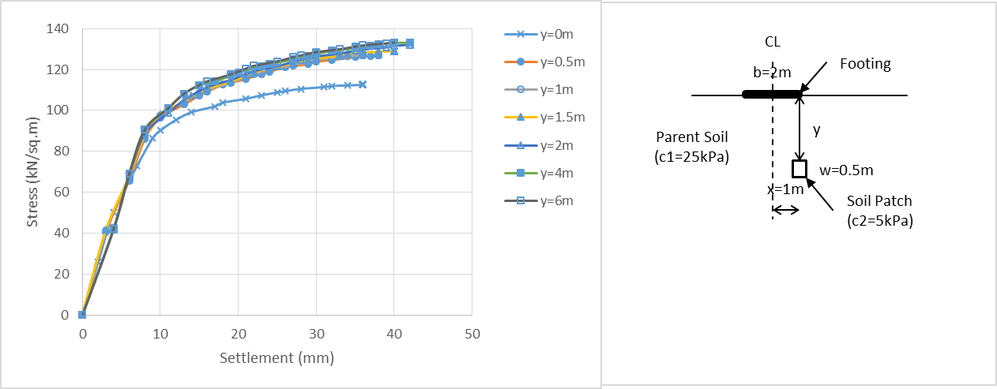
(c)
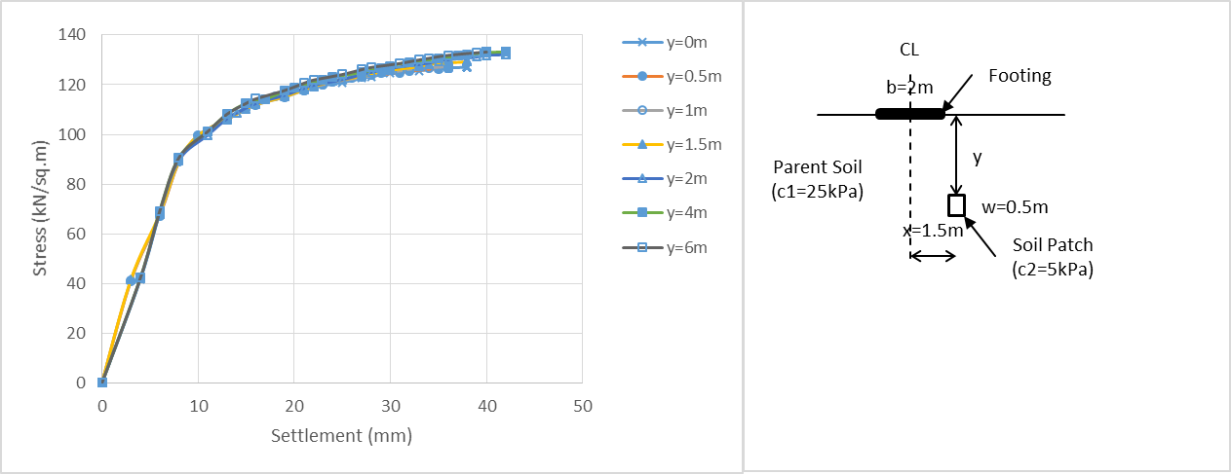
(d)
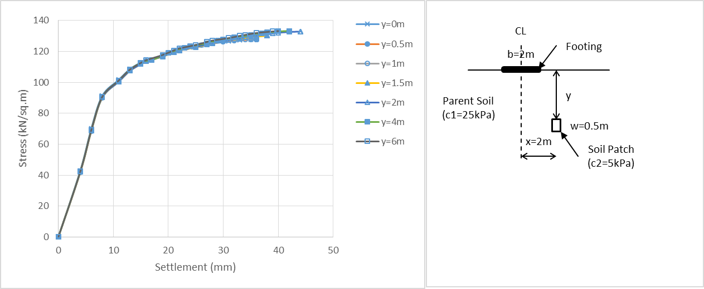
(e)
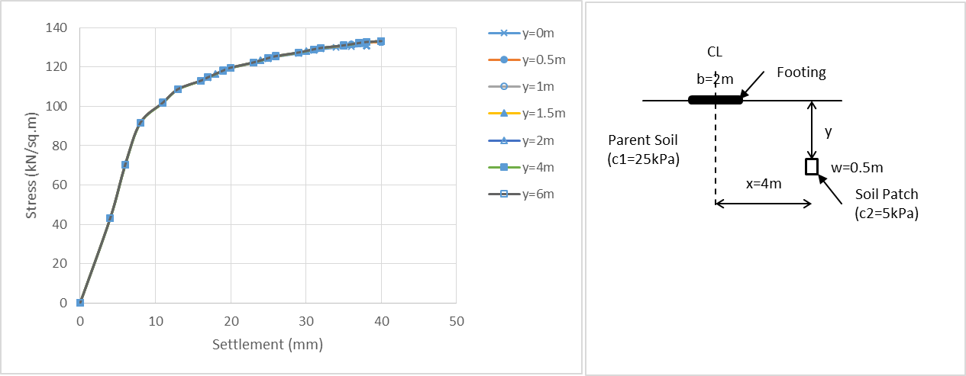
(f)
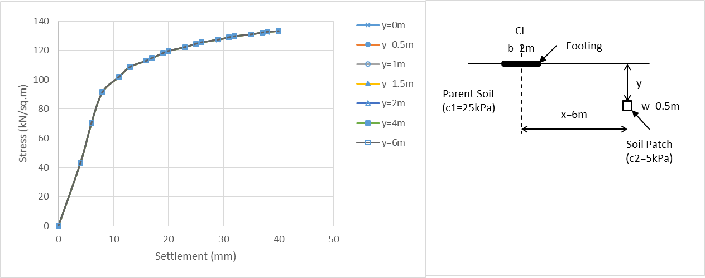
(g)
Figure A.6: Stress Load-Settlement Curve for a soil patch of width, w=0.5m and undrained shear strength of soil patch, c2=5kPa for variation in the depth of soil patch (y) for eccentricity of soil patch (x) as (a) x=0m, (b) x=0.5m, (c) x=1m, (d) x=1.5m, (e) x=2m, (f) x=4m and (g) x=6m

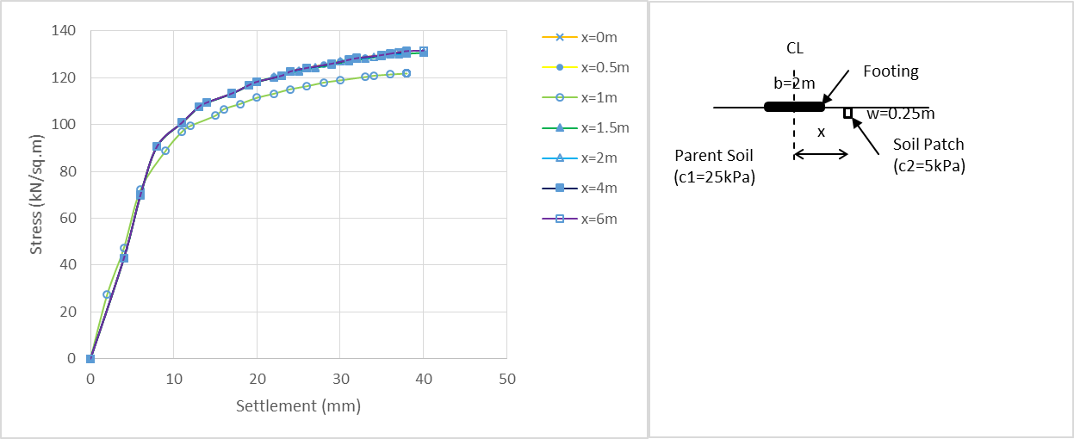
(a)
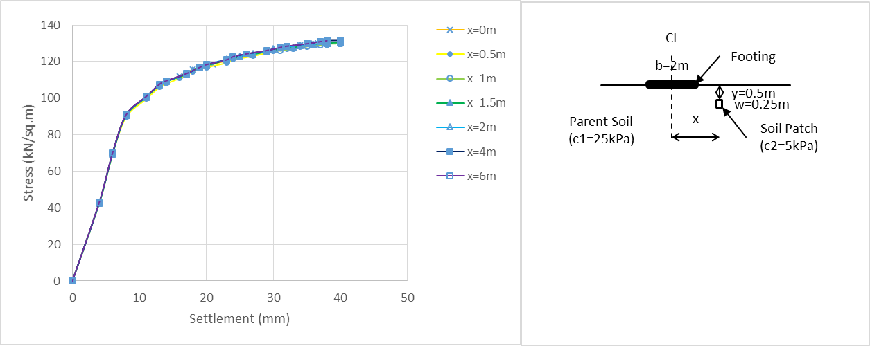
(b)
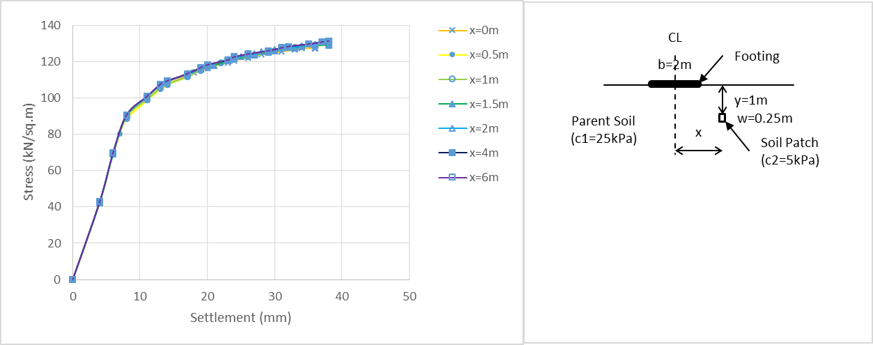
(c)
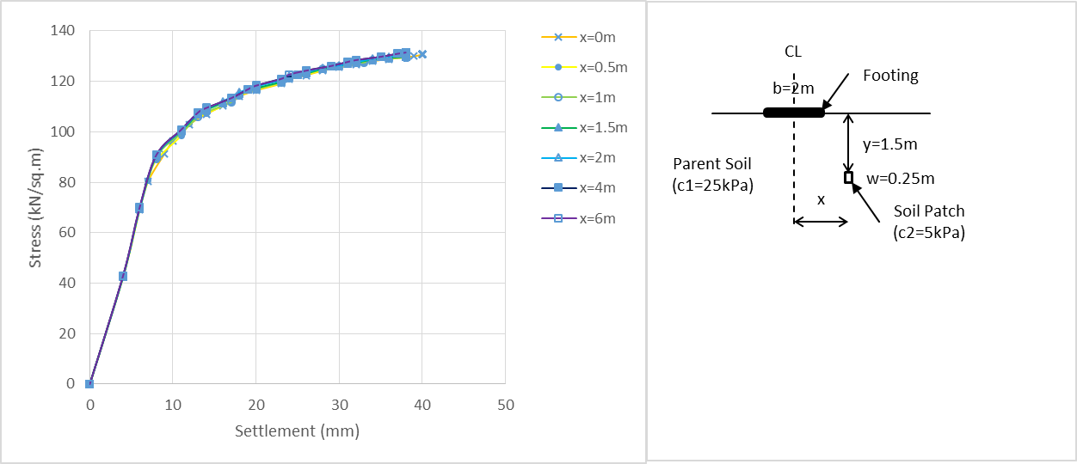
(d)
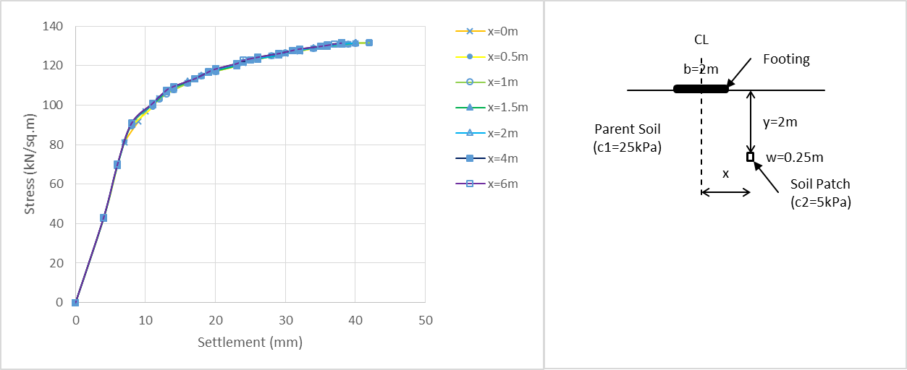
(e)
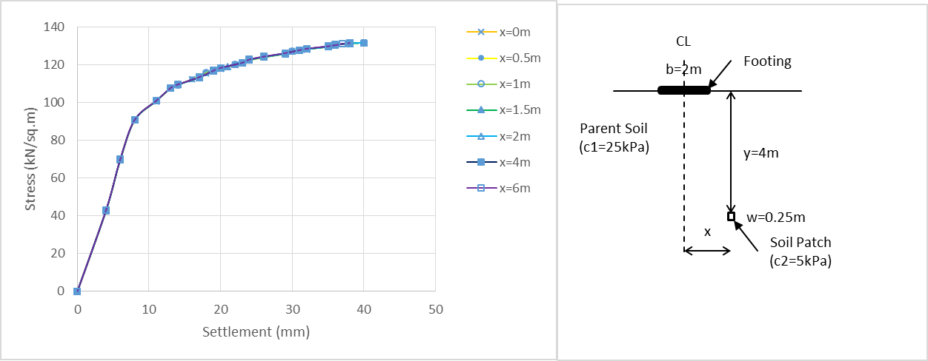
(f)
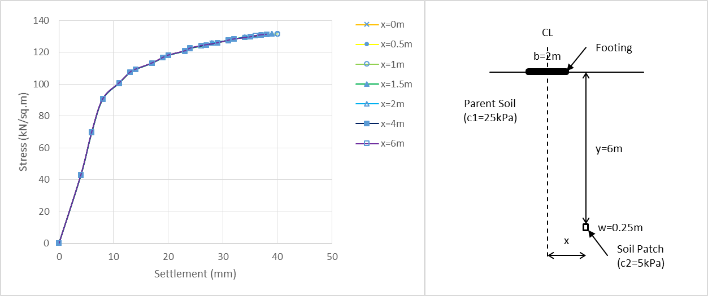
(g)
Figure A.7: Stress Load-Settlement Curve for a soil patch of width, w=0.25m and undrained shear strength of soil patch, c2=5kPa for variation in the eccentricity of soil patch (x) at depth of soil patch (y) as (a) y=0m, (b) y=0.5m, (c) y=1m, (d) y=1.5m, (e) y=2m, (f) y=4m and (g) y=6m
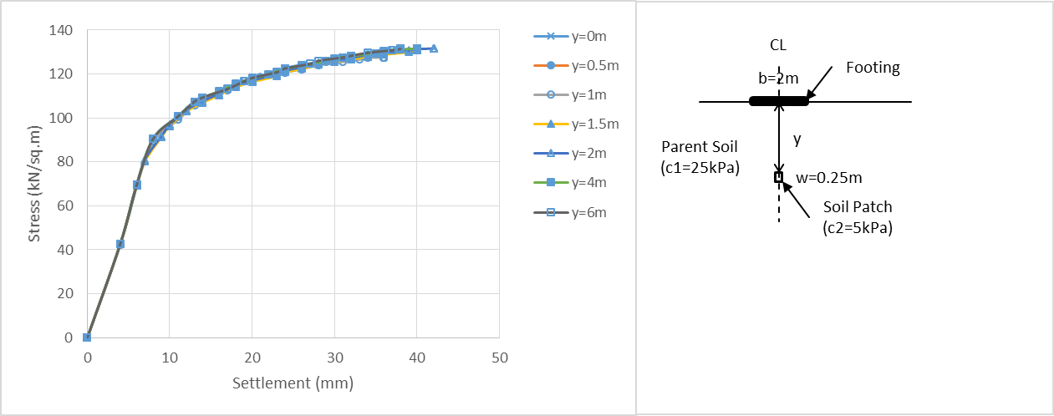
(a)
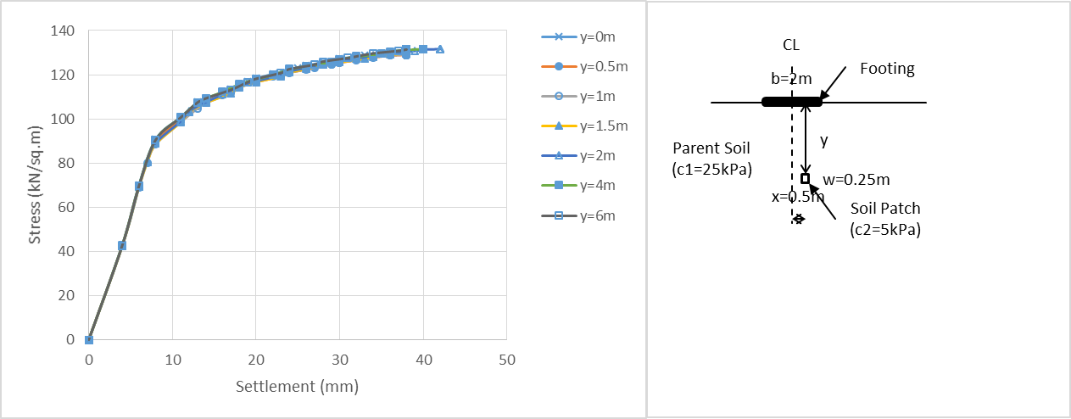
(b)
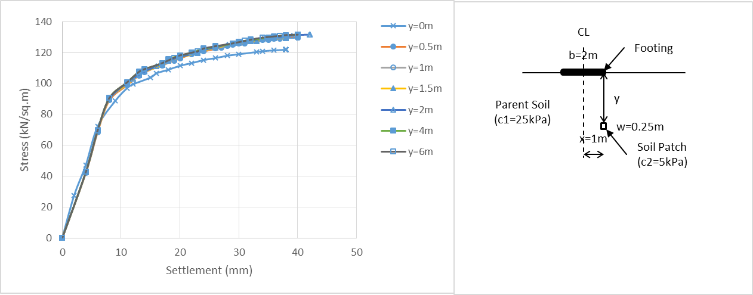
(c)
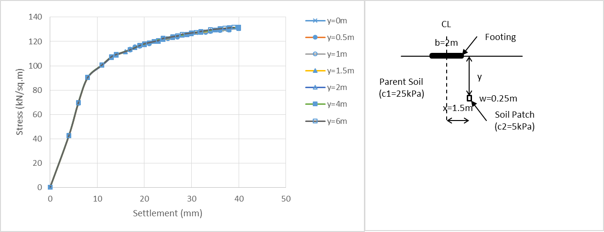
(d)
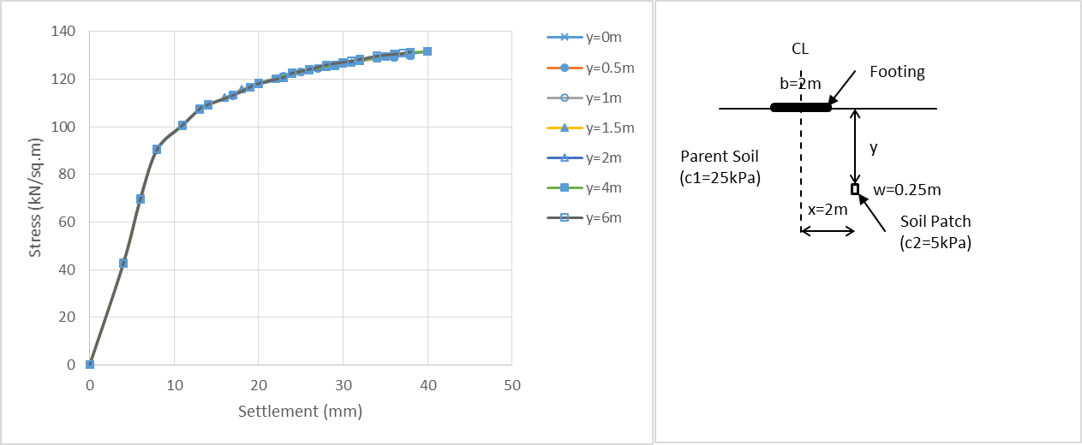
(e)
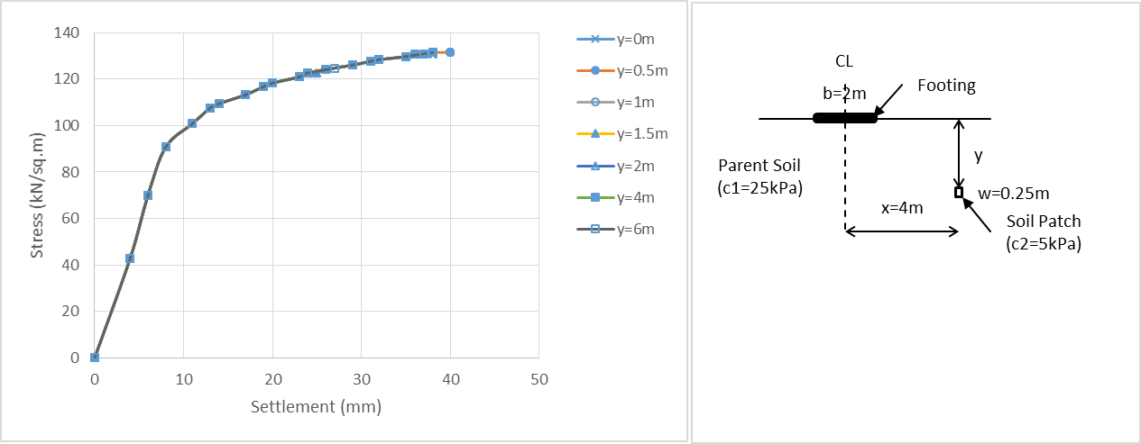
(f)
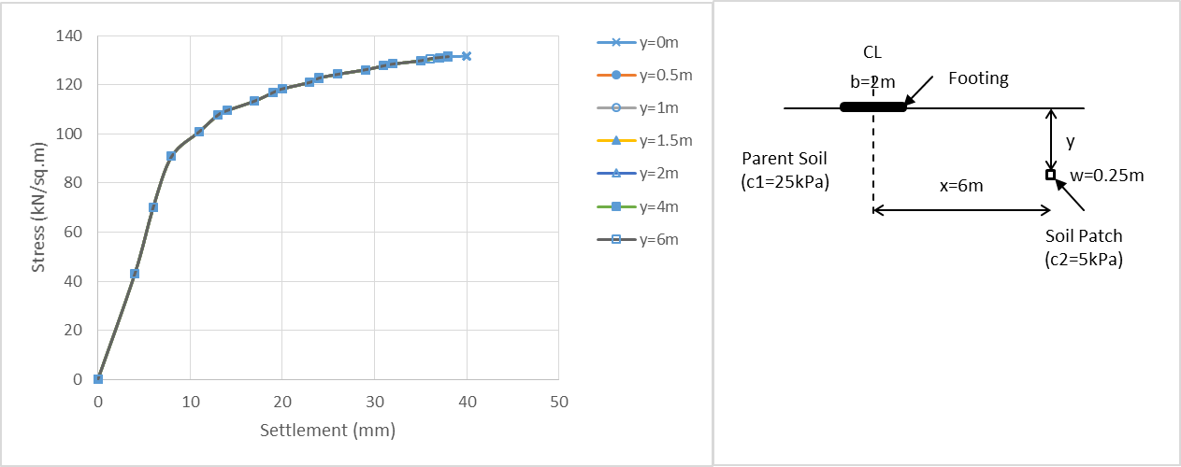
(g)
Figure A.8: Stress Load-Settlement Curve for a soil patch of width, w=0.25m and undrained shear strength of soil patch, c2=5kPa for variation in the depth of soil patch (y) for eccentricity of soil patch (x) as (a) x=0m, (b) x=0.5m, (c) x=1m, (d) x=1.5m, (e) x=2m, (f) x=4m and (g) x=6m

ANNEX B RESULTS IN TABULAR FORM
Table B.1: Ultimate Bearing capacity at different location of soil patch with consideration of soil patch of 2m width

Table B.2: Ultimate Bearing capacity at different location of soil patch with consideration of soil patch of 1m width

Table B.3: Ultimate Bearing capacity at different location of soil patch with consideration of soil patch of 0.5m width

Table B.4: Ultimate Bearing capacity at different location of soil patch with consideration of soil patch of 0.25m width

