
TRIBHUVAN UNIVERSITY
INSTITUTE OF ENGINEERING
PULCHOWK CAMPUS
DEPARTMENT OF CIVIL ENGINEERING
M.Sc. Program in Structural Engineering

Thesis No:-SS00137

SEISMIC PERFORMANCE ASSESSMENT OF TYPICAL RESIDENTIAL RC FRAMES OF KATHMANDU WITH BEAM TO BEAM
CONNECTIONS

MAHESHWOR POKHAREL

April, 2010


TRIBHUVAN UNIVERSITY
INSTITUTE OF ENGINEERING
PULCHOWK CAMPUS
DEPARTMENT OF CIVIL ENGINEERING
M.Sc. Program in Structural Engineering

Thesis No:-SS00137

SEISMIC PERFORMANCE ASSESSMENT OF TYPICAL RESIDENTIAL RC FRAMES OF KATHMANDU WITH BEAM TO BEAM CONNECTIONS

A thesis submitted by
MAHESHWOR POKHAREL

In the partial fulfillment of the requirement for the degree of

MASTER OF SCIENCE
IN
STRUCTURAL ENGINEERING

April - 2010

COPYRIGHT

The author has agreed that the library, Department of Civil Engineering, Institute of Engineering, Pulchowk Campus may make this thesis freely available for the inspection.
Moreover, the author has agreed that the permission for extensive copying of the thesis for scholarly purpose may be granted by the professor who supervised the thesis work recorded herein or in his absence by the head of the department or concerning M.Sc. program coordinator or the dean of the institute of engineering. It is understood that the recognition will be given to the author of this thesis and to the Department of Civil Engineering, Institute of Engineering, and Pulchowk Campus in any use of material in this thesis. Copying or publication or other use of the thesis for financial gain without approval of the Department of Civil Engineering, Pulchowk Campus and the author’s written permission is prohibited.
Request for permission to copy or to take any other use of the material in this thesis in whole or part should be addressed to:

………………………….
Head of the Department
(Department of Civil Engineering)
Institute of Engineering
Pulchowk, Campus
Kathmandu, Nepal

CERTIFICATE

It is certified that the work contained in this thesis entitled “Seismic Performance Assessment of Typical Residential RC Frames of Kathmandu with Beam to Beam Connections”, in partial fulfillment of the requirements for the degree of Master of Science in Structural Engineering, as a record of research work, has been carried out by Mr. Maheshwor Pokharel (064/MSS/r/105) under our supervision and guidance in the Institute of Engineering, Pulchowk Campus, Lalitpur, Nepal. The work embodied in this thesis has not been submitted elsewhere for a degree.

……………………………… ……………………………….
Dr. Prajwal Lal Pradhan Dr. Roshan Tuladhar
(Department of Civil Engineering) (Department of Civil Engineering)
Institute of Engineering Institute of Engineering
Pulchowk Campus Pulchowk Campus
Lalitpur, Nepal Lalitpur, Nepal

ACKNOWLEDGEMENT
I wish to express my profound gratitude to my supervisors Dr. Prajwal Lal Pradhan and Dr. Roshan Tuladhar for their guidance, advice, suggestion and support. Without their support, it would be difficult to perform this research and reach up to this stage.
I would like to express my deep sense of gratitude to the M.Sc program in Structural Engineering, Department of Civil Engineering, and Pulchowk campus for the financial assistances provided for the tour to the IIT-Kanpur at the initial stage of research work.
I am grateful to IIT Kanpur for really golden opportunity to get exposed to the precious literatures at IIT- Kanpur and the inspirational environment thereof including the interaction with respected professors: Prof. Dr. D.C. Rai and other faculty members. Also, I am grateful to Prof. Koichi Maekawa, university of Tokyo, Tokyo, Japan for providing COM3 nonlinear software.
I would like to extend my appreciation to all my teachers who have brought me to this stage. I can never forget the contribution of respected expertise of structural engineering of the Department of Civil Engineering, Pulchowk campus; especially Prof. Dr. P.N Maskey, Dr Hikmat Raj Joshi and Prof. Dr. Akal Shrestha for their valuable suggestions and encouragement at different stages of this research work.
My sincere thanks goes to my seniors and colleagues of structural engineering and all other helping hands for their kind cooperation during this research work. I would also like to thank Mr. Rajesh Sapkota and Dr. Marco Di Ludovico for their help in the collection of data and papers.
I am also very grateful to my family for supporting me throughout this entire process. Special thanks go to my mother, father, and brothers for all their support, encouragement and loved which helped me every step of way. Without their understanding, encouragement and support, I could not have reached on this stage. Finally, I would like to thank my wife Samjhana, for all the support, patience and love.
Maheshwor Pokharel

ABSTRACT

Nepal is located in one of the world’s most seismically active zone and predicted that big earthquake occurred within certain repetition of time. It is predicted that if the earthquake of 6 Richter scale happened in Kathmandu, minimum death will be 69,000 which is due to declining construction practices, uncontrolled urban planning and violating building codes. Thousands of the concrete houses have been constructing every years with/ without proper engineering design. Among them beam to beam connection without column is one of them. This type of connection occurred when the column under crossing of the beams get removed. Some of them are occurred during the design due to architectural requirement of rooms, land shapes and closeness of two columns where as some of them occurred by removing close column during construction. In order to know the influence of beam to beam connections, 150 building drawings of KMC-16 which were sanctioned from KMC in fiscal year 2063/2064 B.S. (2005/2006 AD) were collected and analyzed. It is found that 67 percentages of those buildings have beam to beam connection and most of them have connection at center. Then, the plan of beam to beam connection at the center is taken and from that other four different models are made by adding and removing beams and columns. All these buildings are firstly modeled in SAP2000 for pushover analysis and then to COM3 for nonlinear dynamic analysis by using Kobe Earthquake. From the analysis from COM3, it is found that beam to beam connection at the center have large top displacement, low base shear, maximum internal stresses (BM, and SF) and damage occurred in minimum strain in comparison to other model which shows that beam to beam connection without column deteriorate the strength of building and should be avoided as far as possible.

Table of Contents
COPYRIGHT i
CERTIFICATE ii
ACKNOWLEDGEMENT iii
ABSTRACT iv
LIST OF ABBREVATIONS vii
LIST OF TABLES viii
LIST OF FIGURES ix
1. INTRODUCTION 1
1.1 General 1
1.2 Problems and issue: 3
1.3 Objectives 6
1.4 Scope and limitations of the study 7
1.5 Methodology 7
1.6 Organization of the thesis 9
2. LITERATURE REVIEW 10
2.1 General: 10
2.2 Experimental Study: 10
2.3 Analytical Study: 11
2.4 Finite element modeling of RC element 14
3. DATA COLLECTION 29
3.1 Beam to beam connection: 29
3.2 Storey of buildings: 31
3.3 Sizes of beams and columns: 31
3.4 Reinforcement: 32
3.5 Slab thickness: 35
3.6 Materials: 36
3.7 Model finalization: 36
4. MODELING OF THE STRUCTURE 38
4.1 Verification of SPEAR model: 38
4.2 Beam to beam connection model 42
4.2.1 Beam to beam connection at the center (BBCC): 45
4.2.2 Beam to beam connection without side column and beam (BBCWSB): 47
4.2.3 Model without Middle Right Beam (MWMRB) 47
4.2.4 Model without central column (MWCC) 48
4.2.5 Regular building Model (RBM): 49
5. RESULTS AND DISCUSSION 50
5.1 Result of beam to beam connection at center: 50
5.2 Result of beam to beam connection without side column & beam: 51
5.3 Result of model without Middle Right Beam: 53
5.4 Result of Model without central column: 54
5.5 Result of Regular building Model: 55
5.6 Comparison of Base Shear and top displacement: 57
5.7 Comparison of AF, SF and BM in damage column portion: 60
5.8 Comparison of Strain and stress: 60
5.9 Comparison of Position of Damage: 62
5.10 Comparison of Axial force in columns and Total weight: 63
5.11 Comparison of stress and strain in corner reinforcement: 63
6. CONCLUSIONS: 68
7. RECOMMENDATIONS 71
References: 72
Annex A 74
Annex B 109

LIST OF ABBREVATIONS

CNN Cable News Network
AFP Augusta Free Press
NSET Nepal National Society for Earthquake technology
SPEAR Seismic PErformance Assessment and Rehabilitation
SAP Structural Analysis Program
COM3 Concrete Model for 3Dimensional Program
RC Reinforced Concrete
B-B Beam to beam
KMC Kathmandu Metropolitan City
CM Center of mass
CS Center of stiffness
WCOMD Concrete Model for in plane Wall under Dynamic loads
EPF Elasto-Plastic and Fracture Model
FEM Finite Element Method
EW East West
NS North South
BS Base shear
BBCC Beam to beam connection at center
BBCWSB beam-beam connection without side column and beam:
MWMRB model without Middle Right Beam
MWCC Model without central column
RBM Result of Regular building Model:
PsD Pseudo dynamic

LIST OF TABLES

Table 4-1 Dead Load of First and Second Storey 39
Table 4-2 Dead Load of third Storey 40
Table 4-3 Live load of First, Second and Third Storey 40
Table 4-4 Lengths of beams 46
Table 5-1Base Shear & Top Displacement of model in BBCC 50
Table 5-2 Axial Force, Shear Force and Bending Moment at G.P. 2 51
Table 5-3 Base Shear and Top Displacement of B-B connection without side column and mid beam 52
Table 5-4 Axial Force, Shear Force and Bending Moment of C6 at G.P. 2 53
Table 5-5 Base Shear & Top Displacement of model without Middle Right Beam 53
Table 5-6 Axial Force, Shear Force and Bending Moment of Damage Column C6 at G.P. 2 54
Table 5-7 Base Shear and Top Displacement of model without central column 55
Table 5-8 Axial force, shear force & Bending Moment in beam-column 94 gauss point2: 55
Table 5-9 Base Shear and Top Displacement of the Regular Model 56
Table 5-10 Axial force, shear force and Bending Moment in beam-column 94 gauss point2: 57
Table 5-11Comparision of Base Shear and Displacement 57
Table 5-12 Comparison of Base Shear, Displacement (Normalized by Regular model) 58
Table 5-13 Comparison of AF, SF and BM in damage column 60
Table 5-14 Comparison of the damage position 62
Table 5-15 Comparison of axial force in first storey 63

LIST OF FIGURES
Figure 1:1Beam to beam connection without column [5] 2
Figure 1:2 Common beam to beam connections in Kathmandu 4
Figure 1:3 Drawings having beam to beam connections in Kathmandu 5
Figure 1:4 Torsional Cracks [5] 6
Figure 1:4 Flow Chart of Methodology 9
Figure 2:1Plan and elevation of SPEAR building 10
Figure 2:2 Fiber Model [15] 15
Figure 2:3 Timoshenko Beam [15] 16
Figure 2:4 Concept Elasto-plastic and damage model a) definition b) Scheme of formulation 17
Figure 2:5 Schematic representation of elasto-plastic and damage concept [15] 18
Figure 2:6 Scheme of multi-directional fixed crack model [16] 21
Figure 2:7 Concrete constitutive relationships under a) compressive forces b) tensile forces [15] 23
Figure 2:8 Steel constitutive relationships [15] 24
Figure 2:9 Steel strain diagrams [15] 25
Figure 2:10 Zoning of section of fiber element [15] 26
Figure 2:11 Gauss points of fiber element [15] 26
Figure 2:12 Damage Criteria [15] 27
Figure 3:1Percentage of beam to beam connection 29
Figure 3:2Percentages of different numbers of beam to beam connection 30
Figure 3:3Percentages of beam to beam connections at different positions 30
Figure 3:4Percentages of beam to beam connections in the middle of plan 30
Figure 3:5 Distributions of different storey buildings 31
Figure 3:6 Different sizes of Column 31
Figure 3:7 Types of columns 32
Figure 3:8 Different sizes of beams 32
Figure 3:9 Percentage of steel used in Column 33
Figure 3:10 Percentage of Steel used in Beam at support 33
Figure 3:11 Percentage of Steel used in beam at center 34
Figure 3:12 Area of Stirrups of beam at support (mm2) per unit length (m) 34
Figure 3:13 Area of Stirrups of beam at center (mm2) per unit length (m) 35
Figure 3:14 Area of Stirrups of column at center (mm2) per unit length (m) 35
Figure 3:15 Area of Stirrups of column at support (mm2) per unit length (m) 35
Figure 3:16 Thickness of Slab 36
Figure 3:17 Shape of building plan having Beam to Beam connection at the Edge 36
Figure 3:18 Shape of building plan having beam to beam connection in the middle/center 37
Figure 3:19 Shape of building plan having beam to beam connection at the corner 37
Figure 4:1 Plan and elevation of SPEAR building 39
Figure 4:2 SPEAR building in COM3 40
Figure 4:3 Montenegro Herceg Novi 1979 41
Figure 4:4 Damages in SPEAR model 41
Figure 4:5 Kobe Earthquakes 44
Figure 4:6 Cells of the column 45
Figure 4:7 Typical Plan of building having beam to beam connections at center 46
Figure 4:8 Beam to beam connection at center modeled in a) SAP & b) COM3 46
Figure 4:9 Plan of beam to beam connection without side column and beam 47
Figure 4:10 Model with beam to beam connection without side column and beam 47
Figure 4:11 Plan of model without middle right beam only 48
Figure 4:12 Model without Middle Right Beam in SAP and COM3 48
Figure 4:13 Plan of model without central column 48
Figure 4:14 Model without central column in SAP and COM3 49
Figure 4:15 Plan of regular building 49
Figure 4:16 Regular Building Model in SAP and COM3 49
Figure 5:1 Formation of hinge and damage by using pushover analysis in BBCC 50
Figure 5:2 Gauss point 2 of bottom portion of C6 51
Figure 5:3 Formation of hinge & damage by using pushover analysis in BBCWSB 52
Figure 5:4 Gauss point 2 of bottom portion of C5 52
Figure 5:5 Formation of hinge & damage by using pushover analysis in MWMRB 53
Figure 5:6 Gauss point 2 of bottom portion of C6 54
Figure 5:7 Formation of hinge & damage by using pushover analysis in MWCC 54
Figure 5:8 Gauss point 2 of bottom portion of C6 55
Figure 5:9 Formation of hinge & damage by using pushover analysis in RBM 56
Figure 5:10 Gauss point 2 of bottom portion of C6 56
Figure 5:11 Graphical representation of normalized displacement at X-direction 58
Figure 5:12 Graphical representation of normalized max displacement at Z direction 59
Figure 5:13Graphical representation of maximum Base Shear at X-direction 59
Figure 5:14 Graphical representation of maximum Base Shear at Z-direction 59
Figure 5:15 Graphical representation of minimum base shear at X direction 60
Figure 5:16 Graphical representation of minimum Base Shear at Z direction 60
Figure 5:17 Comparison of maximum bending moment 61
Figure 5:18 Comparison of maximum shear force 61
Figure 5:19 Comparison of maximum axial force 61
Figure 5:20 Gauss point 2 having different cells 64
Figure 5:21 Concrete stress strain diagram of cell 17 64
Figure 5:22 Steel Stress Strain diagram in cell 64
Figure 5:23 Concrete Stress strain curve in cell 29 65
Figure 5:24 Steel Stress strain curve in cell 29 65
Figure 5:25 Concrete Stress strain curve in cell 197 65
Figure 5:26 Steel Stress strain curve in cell 197 66
Figure 5:27 Concrete Stress strain curve in cell 209 66
Figure 5:28 Steel Stress strain curve in cell 209 66
Figure 5:29 Concrete Stress strain curve in cell 225 67

INTRODUCTION

General
Nepal is located in one of the world’s most seismically actives Zones. From the past record, many experts predicted that one of the big earthquake happened in the period of about 75 years. In 1934, such a big earthquake had happened and killed 8,515 lives and more than 80,000 houses were destroyed. If such types of earthquake which had occurred in 1934 happened in near future 70 percentage of building will be collapsed in the valley and 80 percentages of casualties will be occurred by crushing such buildings [1]. So, the new buildings should be designed and constructed by using the building code as well as quality control.
After the Haiti earthquake 2010, international medias (CNN, AFP etc) and local media (The Himalayan Times) had published the news based on the study done by Geo-Hazard international (2001) that a 6 Richter scale earthquake would cause tens of the thousands of deaths in developing world. Among those, Kathmandu is on the top and the minimum death in Kathmandu will be 69,000. Those higher death tolls and the greater destruction will be due to exponential population growth, increasing poverty, corruption, negligent or non-existing building code and geology. [2][3]
Haiti and Nepal are more similar in unorganized and unplanned capital city, poverty, unstable politics and hit by regular natural hazards. So, 8.3 magnitude earthquakes which had occurred in Nepal in past (1934) and recent earthquake occurred to Port-Au-Prince can again hit Kathmandu. Geologist believed that it is at risk from the earthquake with a magnitude around 8 which will be 10 times more powerful than Haiti shocks that killed more than 212,000. [1][3]
In 2003, the government introduced the building codes to improve the standards in construction [3]. However, Nepal National Society for Earthquake technology (NSET) report showed that nearly 6000 concrete houses were build every year and mostly without proper engineering and seismic force considerations. Those houses are at the risk of earthquake due to declining construction practices, uncontrolled urban planning and violating building codes which leads the huge economic and lives loss [4].
In Kathmandu, most of buildings do not obey metropolitan building law and even authorized department are failed to regulate building law and enforced building code. During the study, it was found that some building approved up to 2-3 storied but in reality they were built more than that. Even some of the building approved in one shape and in field they constructed in another shape. And, most crucial thing is that some buildings had necessary columns in map but during construction, owners had not constructed close columns during construction of house to save cost of construction of the column as well as building which may reduce the strength of building.
Many buildings in Kathmandu valley have beam to beam connection without column. Some of those buildings are even sanctioned from the Kathmandu Metropolitan city and others are sanctioned as buildings without beam to beam connection (i.e. normal building). But, during construction, owner/contractor omits the column and as a result beam to beam connections are formed.
In many codes, provisions of beam to beam connection without column are not mentioned. From that, we can imagine either buildings with beam to beam connection have not been constructed in many countries or they haven’t done much research in this subject. But, from the various papers, we can found that these types of buildings have been built in South Asian region, Turkey and even southern part of the Europe.
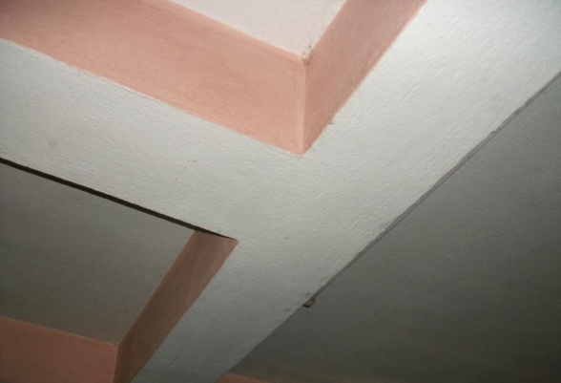
Figure 1:1Beam to beam connection without column [5]

Beam-to-beam connection is also discontinuation of both column and beam or only column. These joints are due to architectural design, land shape, and owner necessity. At this joint, vertical deflection is high as well as torsion in main beam due to off-grid beam during cyclic earthquake loading.
Many researches done in beam-column joints but about beam to beam connection no researches have been found. However, in Europe, full scale test of irregular building named SPEAR building (Seismic Performance Assessment and Rehabilitation of Existing Buildings) having irregular configuration, weak column-strong beam and beam to beam connection had been done by joint research council of European union in order to strengthening of existing buildings.
In order to do linear analysis of building with beam to beam connection, SAP 2000 (Structural analysis Program) software will be very useful and for nonlinear analysis, COM3 (Concrete Model for 3Dimensioinal problems) software is powerful. It can do dynamic nonlinear analysis of any spatial RC structures or RC component using a fiber model and also perform nonlinear analysis of reinforcement concrete structures under static and dynamic loads based on RC constitutive model.

Problems and issue:
Buildings are constructed or designed should be serviceability and safety against collapse. Safety of building depends upon many factors such as location, soil conditions; types of structure; shape and size of buildings; materials properties; shape, size and location of structural elements; and so on. Among these important factors, shape and size of the buildings; shape, size and location of structural elements are also most crucial factors which affect the stability as well as safety of building. In one word, appropriate structural system distributes stresses more or less uniformly in all members and inappropriate structural system localizes stresses in some elements/sections.
However, due to many practical problems and constraints, it may not be always possible to design building having regular configuration and regular alignment of beams and columns. Land shape and sizes, architectural as well as owner requirements are main governing factors which lead designer to design the irregular configuration buildings. Sometime, in regular configuration building, beam or column or both may be discontinue which shift center of mass and center of stiffness leading building to torsion. These types of buildings are more vulnerable in earthquake rather than regular configuration buildings.
Beam to beam connection is formed due to discontinuity of beam or column or both. In Nepal and other many part of world these types of connection are found in building configuration. The typical types of connections found in some urban areas of Kathmandu Valley are shown in the plan figure 1.2.
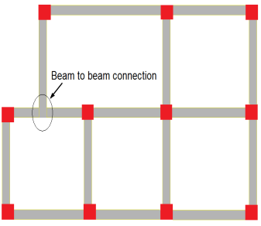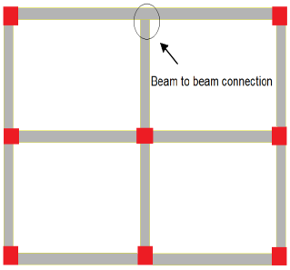
a) Joint at corner b) Joint at Edge
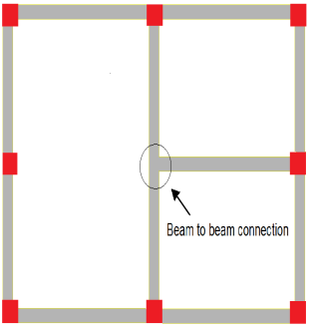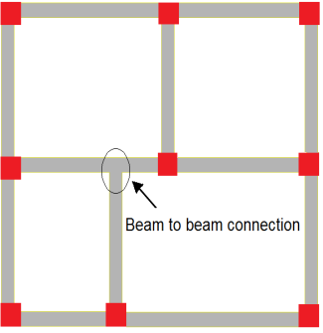
c) Joint in Middle
Figure 1:2 Common beam to beam connections in Kathmandu

Beam to beam connection as shown in figure 1:2(a) are due to inappropriate land area or due to requirement of balcony at west side in first floor so that designer or architect compelled to remove the column under beam to beam connection for economical design. Beam to beam connection at edge are shown in figure 1:2(b) are due to need of large void area without disturbance of column. Similarly, beam to beam connections are formed in figures 1:2(c) are due to requirement of large room. In order to increase room size, designer has shifted the one beam and one column toward right side. These types of joints are found in many residential building in Kathmandu Valley. Even, nowadays, these types of joints are also found in high rise buildings which increase torsion of building.
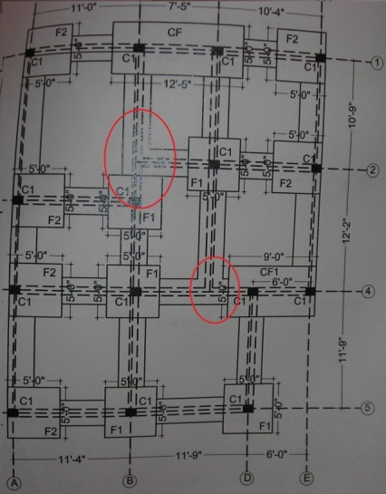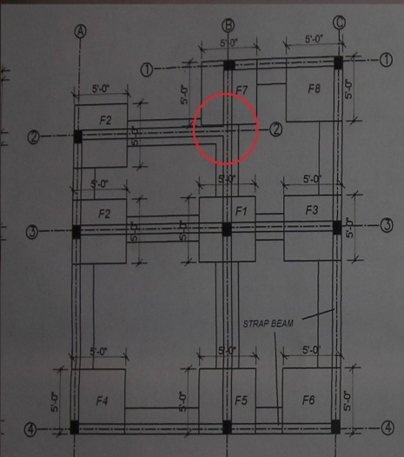
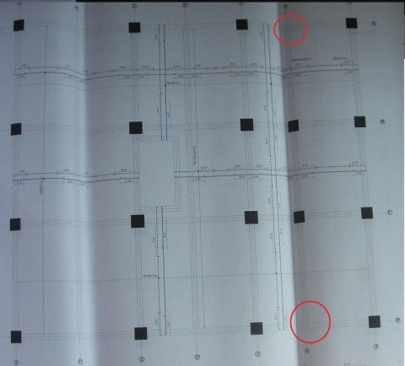
Figure 1:3 Plan having beam to beam connections

In beam to beam connection, due to discontinuity of beam and column, vertical load gets concentrated and as a result large deflection take place. Here, concentrated load are due to dead load as well as live load. Even during earthquake loading, due to off grid beam there is possibility of torsion in main beam. This effect is shown in figure 1:4 which is obtained from the full scale test of the SPEAR structure.
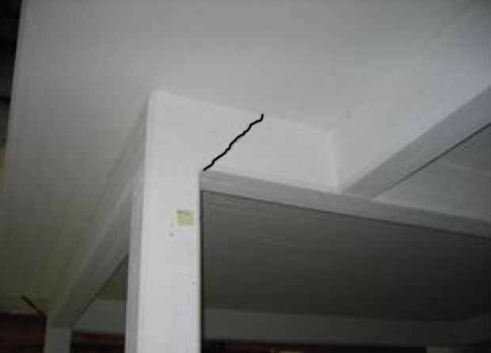
- Cracks at North face of beam B4 caused by off-grid beam of SPEAR structure in first floor.
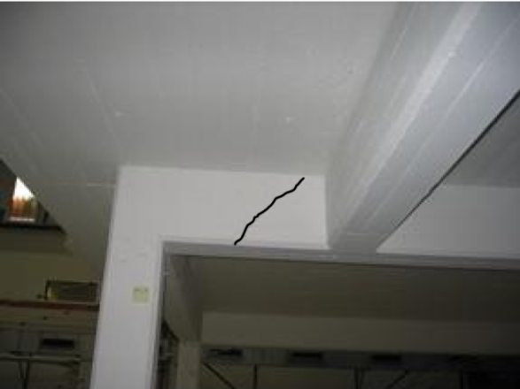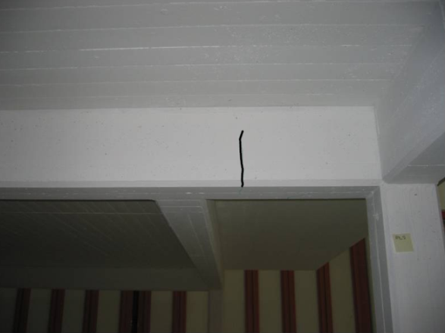
- Crack on beam B4 caused by off-grid beam of SPEAR structure in second floor
Figure 1:4 Torsional Cracks [5]
Here, from figure it is clear that there is effect on main beam due to off grid beam. The inclined crack shows that deformation in main beam B4 is due to torsion. Therefore, there should be provision of additional reinforcement in order to prevent beam from torsion.

Objectives
The overall objective of this research work is to evaluate the performance of typical beam to beam connection in the building under extreme seismic action with introduction of material nonlinearities.
The specific objectives of this research work are:
- To create database of building having beam to beam connection in certain location of Kathmandu valley sanctioned by Kathmandu Metropolitan city in certain financial years and typicalize them for further investigation into them.
- To compare the performance of beam to beam connection buildings with the regular configuration building
- To compare the critical stressed portion of column of beam to beam connection building with that of regular configuration building.
- To find out the effect of torsion in main beam due to off-grid beam under strong ground motion

Scope and limitations of the study
The performance of beam to beam connection was assessed by using nonlinear software COM3, developed at the concrete Laboratory, Tokyo University, Japan. The scopes of this research are:
  - Position of beam to beam connection will be determined from data collection from Kathmandu Metropolitan City (KMC). Typical critical configurations will be developed for further investigation from primary data.
  - Sizes of beam, column, slab and reinforcement will be used from the typicalized samples.
  - Loads will also be used as practice in KMC.
  - Buildings taken for study will be residential type with 3 stories. The grade of concrete and steel will be M25 and Fe415.
  - Kobe earthquake will be used for the nonlinear dynamic analysis.

Methodology
Nonlinear dynamic analysis is done by using COM3 in order to find out the effect beam to beam connection in building and compare them with the regular configuration building. In order to achieve the above mentioned objectives, the following tasks have been performed.
- Collection and review of drawings of available research papers on irregular configurations of building due to beam to beam connection and other relevant materials.
- Collection of different drawings of buildings having beam to beam connection at different location of the plan.
- Simplification of complex drawings into simple drawings and categorized them according to the position of beam to beam connection and fixing the dimension by taking concurrent length.
- Selection and modeling of the most repeated simple model in SAP2000 for linear analysis and COM3 for nonlinear analysis.
- Modeling of different model after rearranging beam and column in SAP2000 and COM3 and compared them to find the influence of beam to beam connection.
- Verifying the performance of COM3 by modeling SPEAR structure in COM3 using Montenegro Herceg Novi earthquake and comparing that results with the results obtained from full scale test.
Comparison of results of SPEAR from full scale test with result obtained from COM3 software
Simplification of complex drawings and grouping them according to the position of beam to beam connection
Modeling of SPEAR model in COM3 in order to verify the software with full scale test
Data collection of beam to beam connection of specific place from the Kathmandu Metropolitan city (KMC)

Collection of Literature related to beam-to-beam connection

Beam to beam connection at edge of plan
Beam to beam connection in middle other than center
Beam to beam connection at corner of plan
Beam to beam connection at center of plan
Selection of typical plan from above types according to the maximum repetitive sample

Selection of sizes of beam, column, slab, size and no of reinforcement, material properties based on data

Modeling of typical beam to beam connection building in SAP (Pushover) & COM3 software and nonlinear dynamic analysis to be performed

In order to find out influence of beam to beam connection, different models are modeled in SAP and COM3.

Comparison of beam to beam connection model with the other modified model in base shear, top displacement, strain and damage position

Conclusion: Whether beam to beam connection are safe than regular building?

Figure 1:5 Flow Chart of Methodology

Organization of the thesis
The thesis will be organized in following chapters:
- In chapter 1, Introduction on the subject matter of the study, discussion on the problems and issues, objectives of the study, and methodology adopted for the study are presented.
- In chapter 2, Literatures reviews related to the proposed study of the SPEAR model as well as theory used in the software are presented.
- In chapter 3, Data collection from the Kathmandu Metropolitan city and the data analyzing are presented.
- In chapter 4, Modeling of the beam to beam connection as well as SPEAR structures is presented.
- In chapter 6, Results and Discussions are presented.
- In chapter 7, Conclusions is presented
- In chapter 8, Recommendations is presented.

LITERATURE REVIEW

General:
It is difficult to find literatures related to beam to beam connection of reinforced concrete frame. Many literatures implicitly related to it through plan irregularities in consideration for seismic effect can be found.

Experimental Study:
Joint Research Center, Ispra, Italy (2005) had done the full scale test of irregular shaped building named ‘Seismic Performance Assessment and Rehabilitation (SPEAR)’ having beam to beam connection in middle and at the side of the plan. The model was three storied designed for gravity load to represent old constructions built in southern Europe without earthquake provision. That model was regular in elevation having 3m height and irregular in both directions spanning from 3 to 6 meters.
Figure 2:1Plan and elevation of SPEAR building
In order to find out the performance of building in dynamic loading, 0.2g of Montenegro Herceg Novi 1979 earthquake was applied in both directions. As a result, base shear and top displacement, position of damage were obtained.
Therefore, this model is appropriate for the verification of COM3 software. After nonlinear dynamic analysis of the SPEAR structure in COM3 software, we can compare base shear, displacement and position of damage with results obtained from full scale test of the SPEAR model. [5]
Marco Di Ludovico (2005) had done doctorial thesis on comparative assessment of seismic rehabilitation techniques on the full scale SPEAR structure in which comparison of as-built building, FRP wrapping in column and joint RC jacketing of SPEAR building under full-scale tests were carried. The earthquake used in those experiments was Montenegro Herceg Novi 1979. [6]
E. Mola and P. Negro (2005) had done Full scale PsD testing of the torsionally unbalanced SPEAR structure in as-built and retrofitted configurations. Experimental activity carried out at the ELSA Laboratory in framework of the SPEAR research project was presented. It consists of bi-directional PsD testing of a full-scale RC frame structure representative of older European design and construction practice. Structure first underwent tests in the ‘as-built’ configuration; after that, it underwent two different retrofitting interventions ( first one consisting in FRP wrapping of columns and joints, second one in RC jacketing of selected vertical elements), after each of which it was tested again.
In this paper, outcomes of three rounds of tests were presented and a comparison on the performance of the retrofitting intervention was made, with reference to the open issues related to the importance of torsional effects in seismic response of plan-wise irregular existing buildings.[7]

Analytical Study:
Seong-Hoonjoeng and Amr S. Elnashi (2004) had done analytical assessment of an irregular RC Full Scale 3D test structure. This is the analytical method for analysis of SPEAR structure which correlates with full scale test of the SPEAR structure. He had modeled SPEAR structure in finite element analysis nonlinear program ZeusNL by using Montenegro Herceg Novi 1979. From his model, all the important parameters considered during the modeling of SPEAR structure are taken to model that SPEAR structure in COM3 software. [5]
P.Fajfar, M.Dolšek, D.Marušić, and A.Stratan had done a research on pre- and post-test mathematical modeling of the SPEAR building. They stated that mathematical modeling of existing RC frame structures which is not designed for earthquake loading proved to be a difficult task. During severe ground motion slippage of reinforcement bars due to insufficient anchorage and joint shear distortion will occur and these phenomena should be considered in a mathematical model. In investigating the building, pre-test predictions were only partially successful. Knowing the structural response during the tests, it was possible to obtain a good simulation of the test results by adapting some parameters of the simple pre-test model, based on one-component member models with concentrated plasticity. The simple model, appropriate for practical applications, proved to be robust and efficient. Engineering judgment, needed in mathematical modeling of complex existing RC structures, can be easily exercised. [8]
N. Ile and J. M. Reynouard (2005) had done post-test nonlinear analysis of the SPEAR test building. In this paper, modeling considerations to correctly represent the seismic response of the SPEAR test structure are presented. Analysis results of two different numerical models are compared with measured data from the test. Based on the results, it is found that a) the model that assumed no slippage of reinforcement resulted in overestimation of stiffness and strength b) the model that approximately considered the fixed-end rotation due to bond slip estimated the global response more closely to the measured one c) for a strong-beam weak-column system, the effect of fixed-end rotation due to bond slip should not be neglected and d) refined models for beam column connection are needed to calibrate macro models for efficient time-history analysis. [9]
Elisa Lumantarna, Nelson Lam, Bidur Kafle, and John Wilson (2008) had published paper on displacement controlled behavior of asymmetrical buildings. In this paper, they have concluded that a seismic assessment of asymmetrical structures in regions of low to moderate seismicity has been developed based on the concept of displacement-controlled behavior. The potential seismic performance of a structure can be assessed by comparison of the displacement demand with the displacement capacity of the structure. Parametric studies based on non-linear time history analyses of single degree of freedom systems revealed that the highest point on the displacement response spectrum can provide conservative predictions of the maximum displacement demand of the structure. Further studies on an asymmetrical single-storey building model resulted in a simple analytical model which can be used to estimate the torsional effect on asymmetrical buildings. One interesting finding is that the peak drift demands were found to be insensitive the torsional resistance of the building and its eccentricity. The proposed mathematical model can be extrapolated to estimate the peak drift demands of multi-storey buildings in which different levels could have varying torsional resistance and eccentricity. [10]
Edoardo Cosenza, Gaetano Manfredi and Roberto Realfonzo (2000) had done research on torsional effects and regularity conditions in RC buildings. The discussion of results from the studies suggests that for one-storey and multi storey buildings if the values of e/B>0.1 the old clauses of EC8 allows the application of the static analysis only for structures characterized by very large values of the stiffness radius which is over conservative and the systems having ρK greater than 0.3 and e/B less than 0.3 usually show good or satisfactory inelastic torsional response. They also suggest that further studies are necessary to evaluate the general effectiveness of these conclusions. In fact the majority of the researchers have analyzed buildings with rectangular plan and ratio between the plan dimensions close to 2.5 and others researches are needed to validate these results varying the plan shape. Furthermore, the studies on the torsional response of multi-storey buildings are very few and more analyses are necessary. [11]
Khaled Zaky Soliman (2006) had done research on the influence of principal axes on dynamic behavior of irregular structures. In his research, he concluded that the current seismic codes recommend that dynamic analysis should be performed in the principal directions for irregular structures to avoid the relatively weak structural design in one direction. He stated that the developed formulae obtain accurate values if a three dimensional dynamic analysis has been applied for the structure and relative geometric aspect ratios of the structure could affect the dynamic behavior. Again, the natural time period of the structure in the preliminary design case can be determined by substituting in the developed equations with geometric aspect ratios of the structure. And, identification of the principal axis using the proposed equations in the study allows the structural engineer finding the angle of excitation to be taken into consideration while performing the dynamic analysis process. There is a significant effect of entering the angle of excitation in the dynamic analysis procedure on the values of base shear forces that affect on the structure.[12]
Jui-Liang Lin and Keh-Chyuan Tsai (2009) had published the paper on evaluation of the seismic energy demand for asymmetric-plan buildings subjected to bi-directional ground motions. In this paper, they concluded that the seismic behaviors of two-way asymmetric-plan buildings under bi-directional ground motions are much more complicated than those of symmetric-plan buildings under single-directional ground motions. [13]

Finite element modeling of RC element
Finite element analysis is a method to solve simultaneous differential equations numerically and can be applied to a differential continuum. However, reinforced concrete is not a continuum since it has cracks. To describe cracks, many considerations have been done. Microscopic discrete crack modeling and macroscopic smeared crack modeling are mostly used for this purpose ( Maekawa, H. and Okamura). Also, reinforced concrete is a composite material consisting of reinforcement and concrete whose individual behavior is distinctly different from each other. At the macro scale, composite materials are typically modeled as homogenous, and isotropic. This is the case of plain concrete and for fiber reinforced concrete. In reinforced concrete the mechanical behavior of its two constituents is very different, and the distribution of reinforcement is non-uniform so, a homogenous description of reinforced concrete is rarely used, and if so, only regions where the reinforcement is uniformly distributed (Comite Euro-International Du Beton). Instead, the two materials are usually modeled individually. Such a separate representation of two materials which fits very well with the finite element method rests on the assumption that the sum of the two constituent materials describes reliably and the behavior of the actual composite. [14]

Models for the individual materials, concrete and steel, for their interaction through bond and for the behavior of their interface, can be used as building blocks to construct fairly sophisticated models of reinforced concrete at the micro level (Comite Euro-Intenational Du Beton). The constitutive equations, which are mathematical expressions of the constitutive law or general concept regarding the sources of material non-linearity, are to be implemented in the structural analysis program. The physical and conceptual figures on the constitutive law of reinforced concrete are recognized to be indispensible as a basic of the powerful computational modeling of reinforced concrete with wide applicability and theoretical consistency. The constitutive models of reinforced concrete under different stress conditions have been experimentally derived by different researchers. [14]
Fiber Model used in COM3:
A fiber element is designed to model the three dimensional reinforced concrete components in the RC structures. Its cross-section can be edited in a divided cell form according to the real distribution of steel and concrete in the axial direction. The section during the forced state is assumed to keep a plane, and the average strain and average stress in each cell of the section obey the corresponding constitutive relationship of concrete or steel materials. [15] The force and moment acting on the section are obtained by integrating on the section as shown in the below.
$ε=\overline{ε}+y∅_{x}+x∅_{y}$ (2.1)
$N=\int_{A}{σ(ε\left(x,y\right))dA}$ (2.2)
$M_{x}=\int_{A}{σ\left(ε\left(x,y\right)\right)ydA}$ (2.3)
$M_{y}=\int_{A}{σ\left(ε\left(x,y\right)\right)xdA}$ (2.4)
where,
ε =Average sectional stress
$∅_{x}$, $∅_{y}$ = Section curvature in the x and y directions
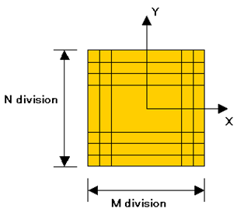
Figure 2:2 Fiber Model [15]

The section is then condensed to a point on the fiber element, which can be treated as a frame beam element in the analysis of complete structure. Timoshenko Beam theory is used to consider shear deformation which is assumed not large enough due to presumed large shear stiffness. [15] The geometrical nonlinear can be taken into consideration by selecting mode settings for the frame's P-delta effects.
Timoshenko Beam in COM3:
When the length of beams is much longer than the scale of beam section, it is enough that the beam vibration is analyzed only by considering bending deformation. However when the section scale is enough large comparing to the length of beams, the shear deformation in the beams has to be taken into consideration. The cross-sectional rotation angle will include the angle by the bending transverse-displacement and angular by the shear distortion
$\frac{∂w}{∂x}=θ+∅$ (2.5)
where,
θ: rotating angle of section due to bending
$∅$: rotating angle of section due to shear
The bending moment and shear force can be expressed as the following formula.
$M=-EI\frac{∂θ}{∂x}$ (2.6) $S=kAG∅$ (2.7)
where,
EI: Flexural stiffness
KA: Effective shear section area
G: Shear modulus
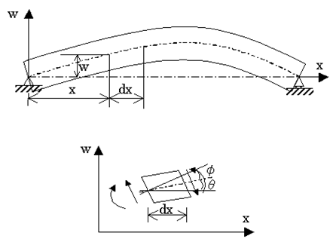
Figure 2:3 Timoshenko Beam [15]
Modeling of concrete prior to generation of crack in COM3:
a) Elasto-Plastic and Fracture Model
The elasto-plastic and fracture (EPF) model is used to model the behavior of concrete before cracking occurs. The model idealizes uncracked concrete as combining plasticity and continuum fracture, which represents the permanent deformation and loss of elastic strain energy absorption capacity respectively. The basic concept of EPF model is shown in figure 2.4. Concrete is represented by an assembly of several microelements connected in parallel. Each micro element is composed of an elastic spring and a slider connected in serial chain. The elastic spring represents the internal stress bearing mechanism and the energy absorption capability while the slider represents the permanent plastic deformation. The continuum damage is modeled by tube fracture of the elastic spring, which leads to the loss of overall stiffness. The strength of each microelement is assumed different stochastically. [15]

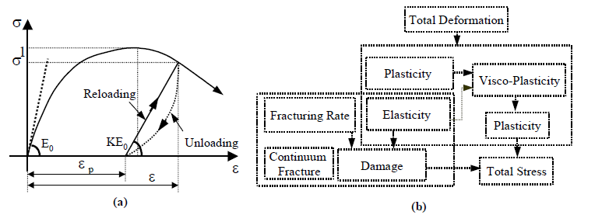

Figure 2:4 Concept of Elasto-plastic and damage model a) definition b) Scheme of formulation

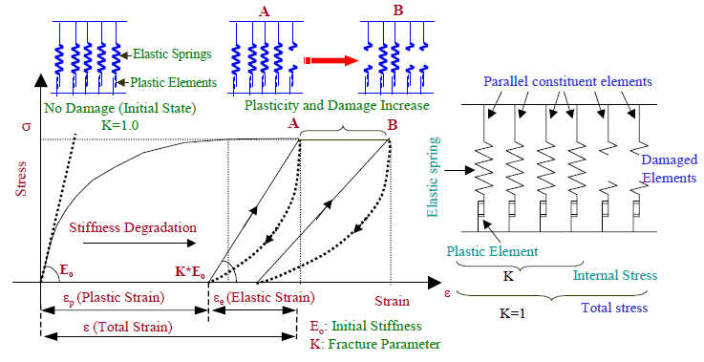
Figure 2:5 Schematic representation of elasto-plastic and damage concept [15]

Cracking Judgment of Concrete in COM3:
The concrete state in a fiber element is judged by the plane stress state in each cell. The crack occurrence can be judged by the following formula in the cell. [15]
$σ_{1}{/(R_{f}f}_{t})=1.0$ for the compressive and tensile state (2.8)
[$σ_{1}{/(R_{f}f}_{t})]+0.26(σ_{2}/σ_{1})=1.0$ for tensile and tensile state (2.9)
in which,
$σ_{1}{,σ}_{2}$ = maximum and minimum principal stress respectively
$f_{t}$=concrete tensile strength in one direction test;
$R_{f}$=decrease factor of concrete tensile strength.
Smeared Crack Approach in COM3:
In this approach, cracks and reinforcement bars are idealized as being distributed or smeared over the whole element. The nonlinearity of a cracked RC element is primarily due to cracking, reinforcement plasticity and bond interaction between concrete and reinforcement. Although the local stress and strain distribution within the cracked RC element is not uniform physically, such locality needs to be explicitly considered in structural analysis. The smeared crack modeling deals macroscopically with cracks and reinforcing bars distributed in two or more directions. In Smeared crack modeling, generation and propagation of an individual crack is considered in average within a finite region. Figure 2.6 show the structural modeling of an in plane RC element of finite control volume. Total stress carried by RC is the sum of the averaged stresses of cracked concrete and reinforcement at equilibrium. The concrete stress mechanism is assumed to comprise the stresses parallel and normal to cracks, and shear stress transfer along cracks on an averaged basis. In the same manner, the averaged stress of reinforcement is derived from its averaged strain developed in an RC element. The smeared crack approach can be divided into fixed crack approach and rotating crack approach in COM3.[15]
The fixed crack concept regards a crack as being geometrically fixed as once generated and anisotropy is inherently taken into account by the normal and the shear stress transfers model independently. In that case, the principal stress vector need not coincide with that of principal strain, and the modeling of crack is geometrically close to reality.
The rotating smeared crack approach assumes that the crack direction coincides with the principal direction of average strain. Accordingly, the crack direction can be changed or rotated following the stress condition. Since shear stress vanishes on the continually updated principal planes, no shear transfer model is needed. Only normal stress-strain relations in the direction normal and parallel to the crack axis are needed. In the step-by-step computation, one crack is considered and the previous cracks are erased from the memory. The primary assumption of this approach is that the principal stress vector always coincides with that of the principal strain. Due to this inherent coaxiality, the rotating crack approach does not explicitly treat shear slip and shear stress transfer due to aggregate interlock, but this assumption greatly simplifies computation and is reasonably accurate under both monolithic and cyclic loading paths where the principal stress does not rotate so much.
Although the rotating crack method seems more attractive in terms of simplicity and reasonably accurate in many cases, it lacks since it considers just updated crack at any moment. Thus, it scarcely accounts for strong anisotropy and non-orthogonal multi-cracking interaction in shear. The fixed crack approach to treat crack direction as a path-dependent factor has a wider range of applicability, especially for the multi-directional cracking conditions experienced under seismic loads or under couple mechanical external forces and ambient actions.
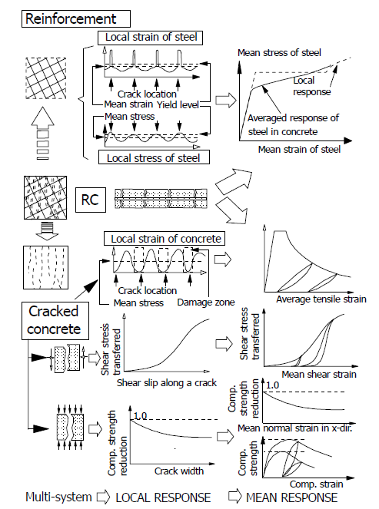
a.
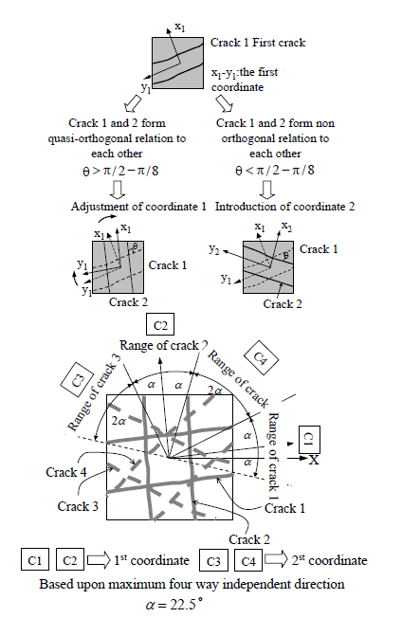
b.
Figure 2:6 Scheme of multi-directional fixed crack model [16]

Constitutive relationship of concrete in COM3:
The path-dependent nonlinear constitutive models of the concrete and the reinforcing bars based on the smeared crack model are applied in COM3. The unloading and the reloading processes are taken into consideration.
Two state constitutive models of concrete under compression and tension are used respectively to define the relationship of average strain and average stress in each cell. The formula for these models are listed below and the following two figures are the example results of concrete stress-strain relationship computed by COM3 (Fiber). [15]
1) Compressive State
$σ^{'}=ωKE_{0}[ε^{'}-{ε^{'}}_{p}\left(ε_{max}^{'}\right)]$ (2.10)
$K=exp⁡\{-0.73{ε^{'}}_{max}[1-exp⁡(-1.25{ε'}_{max⁡}$)] (2.11)
in which,
$σ^{'}$= average compressive stress
$ε^{'}$= average compressive strain
$ω$= fracture parameter reducing factor (=1)
K = fracture factor
$E_{0}$ = initial stiffness ( $2{f'}_{c}/ε_{peak}$)
${ε^{'}}_{p}$= plastic strain by compressive loading
$ε_{max}^{'}$ ₌ maximum compressive strain
2) Tensile State:
$σ=R_{f}f_{t}{(ε_{tu}/ε)}^{c}$ (2.12)
in which,
$R_{f}$=decrease factor of tensile strength (K3=)
$f_{t}$=tensile strength
$ε_{tu}$= cracking strain
c = tension stiffness/softening factor
=2.0 for plain concrete cell
=0.4 for RC cell (using bar reinforcement)
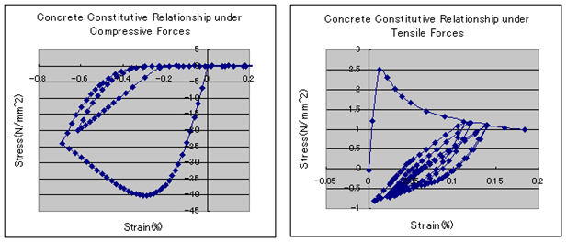
Figure 2:7 Concrete constitutive relationships under a) compressive forces b) tensile forces [15]
The parameters of concrete such as tensile strength${ f}_{t}$, compressive peak strain${ ε}_{peak}$ and cracking strain $ε_{tu}$ are expressed as the functions of its uni-axial compressive strength ${f'}_{c}$ (N/mm²) which is obtained based on experiments [15]
Tensile strength (N/mm²) ,
$f=0.23{{f'}_{c}}^{2/3}$ (2.13)
Compressive peak strain:
${ ε}_{peak}=447.2{{f'}_{c}}^{1/2}x{ 10}^{-6}$ (2.14)
Cracking strain:
$ε_{tu}=102.9{f'c}^{1/6}x{10}^{-6}$ (2.15)
Constitutive Relationship of Steel in COM3:
The Shima's constitutive model of average stress and average strain is used for steel in the concrete. The localization of plastic strain at the crack position and the breaking action are considered in this model and a multi-linear performance can be shown. Though the yield strain obtained by this model is lower than that by bare bars before yielding, the stiffness of steel after yielding is comparable with the stiffness of bare bars. The average yielding stress is calculated by considering the average tensile performance of concrete as below. [15]
$f_{y0}+{σ_{x}}/p$=$f_{yt}$ (2.16)
in which,
$f_{y0}$=Average yield strength of steel in concrete (N/mm2)
$σ_{x}$=Average tensile stress of concrete (N/mm2)
p=Reinforcement ratio
$f_{yt}$=Yield strength of bare steel (N/mm2)
For the unloading and reloading operations, the Kato's model is employed for the constitutive relationship of steel for its agreement with experimental results. The Bauschinger effect can be demonstrated very well by this model too. However, due to too many parameters are used in the Kato's model, the same precise, effective multi-plastic-element numerical model is used instead. The steel is assumed to be constituted by tiny element sets and all the elements is offered the same negative strength in the plastic performance. Therefore, the Bauschinger effect can be modeled.
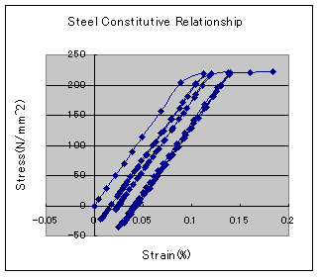
Figure 2:8 Steel constitutive relationships [15]

Reinforced concrete members hold higher tensile stiffness than bare steel bars even after cracking because the concrete continues to support a part of the tensile force transmitted from the reinforcing bars through the bond action. At that time, it has been verified that the average yield strength (f_{y'}) of steel bars in reinforced concrete members becomes lower than that of bare bars (f_{y}).The decline rate is determined by the tension stiffening/softening factor(c)and effective reinforcement ratio in each element (Pe).
The effective reinforcement ratio Pe is calculated by the steel area and RC Zone area which takes the bond effect of concrete and steel.
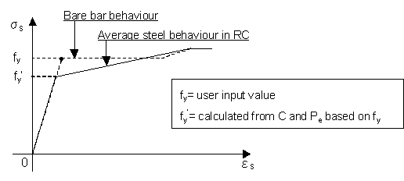
Figure 2:9 Steel strain diagrams [15]
Zoning Method in COM3:
In real response of RC structures, crack occurrence of concrete in the plain concrete field is different from that in steel bar peripheral field due to its adhere characteristics. The different concrete constitutive relationships, especially for the tension stiffening/softening factor C, should be applied to two fields. Therefore, according to A_{n}, the RC structure is divided into RC zone with an adhesive behavior and PL zone without an adhere behavior to compute respectively. In the RC zone, the concrete strain-stress relationship after cracking is affected by its bond effect to steel bar and presents a tension stiffening property. In the PL zone the concrete strain-stress relationship after cracking decrease sharply in the crack normal direction because no steel bar restriction and present a tension softening property. [15]
Zoning Method raises the precision of RC structural analysis for its distinguishing the tension stiffening or softening characteristics of concrete after cracking. In addition, the Zoning Method make the larger RC structure analysis more rapid under the same precision target for no tiny mesh division is need in the PL zone.
In general, adhere action is considered in the fields of the covering scale 2 times (5 times of steel diameter). Therefore, the field from steel center to the covering distance is set to RC or RC (No steel). The steel-involved cells are RC and no-steel-involved cells are RC (No steel). The other fields due to no adhere action are set to Plain cells, that is PL Zone.
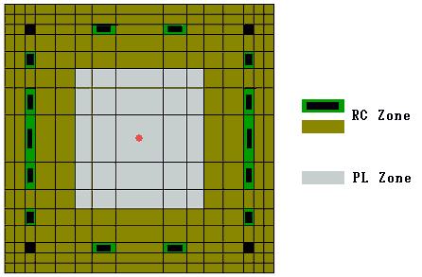
Figure 2:10 Zoning of section of fiber element [15]
Gauss Point:
Gauss point refers to the representing point of function for gauss numerical integral. When the element stiffness matrix is formed, the gauss point values with gauss parameters are used instead for the complicated integrating computation. The element internal forces at gauss points can be calculated easily too after global equations are solved. Two gauss points of fiber element in COM3 (Fiber) are defined as below
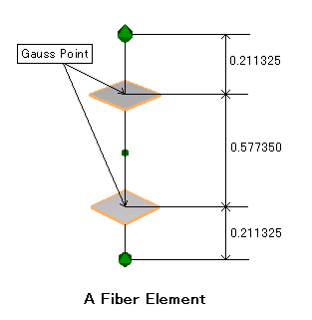
Figure 2:11 Gauss points of fiber element [15]
Damage Criteria:
The damage judgment of fiber element according to computation results is conducted on the normal strain of cell section at gauss points. Three kinds of states are defined to the section for the whole forced process according to the maximum history strain of steel and concrete. They are given as below.
No Damage: The maximum steel strain is under steel yield strain.
Light Damage: The maximum steel strain is more than steel yield strain (εy).
Damage: The maximum compressive strain of concrete is more than the assumed compressive strain level (εc') and/ or the maximum tensile strain of concrete is more than the assume tensile strain level (εt)
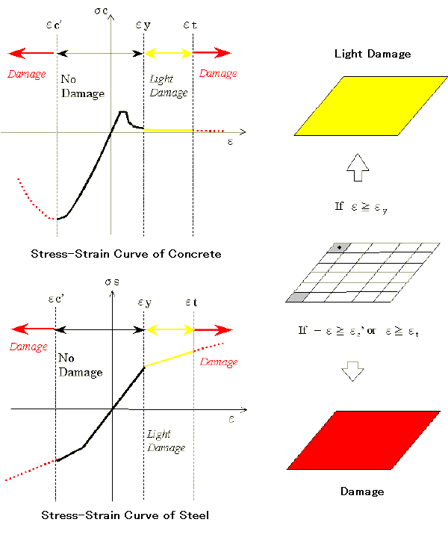
Figure 2:12 Damage Criteria [15]
Nonlinear Dynamic Calculating Procedure in COM3:
The nonlinear FEM dynamic equation of RC structures under external forces can be written as
$\left[M\right]\{\ddot{X\}}+\iiint_{v}{{[B]}^{T}\left\{σ\left(ε,t\right)\right\}dV=\{F\}}$ (2.17)
[M]: Mass matrix
{X}: Acceleration Vector
[B]: Strain displacement matrix
{F}: External Force Vector
The Newmark-ß method is employed to solve the dynamic equation in the time steps and the geometrical and material nonlinear iteration use the Newton-Raphson method.
The computing flowing chart can be summarized as below:
Step 1: Begin iteration by setting i=0
Step 2: Begin predictor phase in which we set
${{\{X\}}^{i}}_{n+1}$=${\{X,\}}_{n+1}={\{X\}}_{n}+{\{\dot{X\}}}_{n}∆t+\left(0.5-β\right)\{\ddot{X_{n}}\}∆t²$ (2.18)
${{\{\dot{X}\}}^{i}}_{n+1}={\{\dot{X,}\}}_{n+1}={\{\ddot{X}\}}_{n}+(1-γ){\{\ddot{X}}_{n}\}∆t$ (2.19)
${{\{\ddot{X}\}}^{i}}_{n+1}={(\{\dot{X,}\}}_{n+1}-{\{X,\}}_{n+1})/(β∆t)²$ (2.20)
Step 3: Evaluate error vector
${{\{R\}}_{n+1}}^{i}={\{F\} }_{n+1}-\left[M\right]{\{{\ddot{X}}_{n+1}\}}^{i}-{{\{P\}}_{n+1}}^{i}$ (2.21)
Step 4: If required, form the effective stiffness matrix
${[K]}_{e}=\left[M\right]/(∆t^{2}β)+[K]$ (2.22)
Step 5: Solve for displacement vector
${{\{R\}}_{n+1}}^{i}={[K]}_{e}{\{∆X\}}^{i}$ (2.23)
Step 6: Error corrector phase
${\{X\}}_{n+1}^{i+1}$= ${\{X\}}_{n+1}^{i}$+{${∆X\}}^{i}$ (2.24)
$\ddot{{\{X\}}_{n+1}^{i+1}}={(\{X\}}_{n+1}^{i+1}-{\{X,\}}_{n+1})/(β∆t)²$ (2.25)
$`\dot{{\{X\}}_{n+1}^{i+1}}={\{\dot{X\}}}_{n+1}+γ{\{\ddot{X\}}}_{n+1}^{i+1}∆t$ (2.26)
Step 7: Check convergence, if not satisfied, set i=i+1 and go to step 3, otherwise continue.
Step 8: Set
${\{X\}}_{n+1}{=\{X\}}_{n+1}^{i+1}$ (2.27)
${\dot{\{X\}}}_{n+1}={\{\dot{X\}}}_{n+1}^{i+1}$ (2.28)
$\ddot{{\{X\}}_{n+1}}=\ddot{{\{X\}}_{n+1}^{i+1}}$ (2.29)
Step 9: Set n=n+1 and begin next time step

DATA COLLECTION
In order to find out actual buildings having beam to beam, survey was carried out in Kathmandu Metropolitan City (KMC), ward no 16. For that, 150 buildings maps were taken which were sanctioned from KMC in the fiscal year 2063/2064 (2005/2006). From those maps, following important data are taken and presented below.

Beam to beam connection:
From total 150 buildings maps, it is found that 67 buildings i.e. 45% of buildings have beam to beam connection without column (figure 3:1). Out of those 67 beam to beam connection buildings, 21 buildings (31%) have 2 number of beam to beam connection per floor, 9% have 3 beam to beam connection per floor, 2 % building have 4 beam to beam connection per floor and rest have 1number of beam to beam connection per floor (figure 3:2). Similarly, 53% of buildings have beam to beam connection in middle of plan, 43% at corner and 4% at edge of building (figure 3:3). Moreover, among those beam to beam connection in the middle of plan, about 60% are exactly in the center of plan and 40% located other than center of plan (figure 3:4).

Figure 3:1Percentage of beam to beam connection

Figure 3:2Percentages of different numbers of beam to beam connection

Figure 3:3Percentages of beam to beam connections at different positions

Figure 3:4Percentages of beam to beam connections in the middle of plan

Storey of buildings:
From 67 beam to beam connection buildings, it is found that 70% of those buildings are 2.5 to 3 storied i.e. 22 buildings are of 2.5 storey and 25 are of 3 storey. Similarly, building with 2storey, 3.5storey, 4storey, and 5 storey are 8,3,5,4 in number respectively as shown in figure 3:5.

Figure 3:5 Distributions of different storey buildings

Sizes of beams and columns:
Most of building (93%) used 9” x 12” column where as only 7% used other size of columns. Among them, 63 buildings used same sizes of columns while 4 buildings used different sizes of column in same buildings (figure 3:6 & 3:7). Similarly, about 57% of building used 9”X17” size beam , 21% used 9” X 13” and 22% buildings used other sizes of beams (figure 3:8).

Figure 3:6 Different sizes of Column

Figure 3:7 Types of columns
Figure 3:8 Different sizes of beams

Reinforcement:
Here reinforcements are categorized into two groups. The reinforcements used along the length of frame element are grouped into longitudinal reinforcements and the reinforcements used across the length are grouped into shear reinforcements.
a) Longitudinal reinforcements:
In column, 47 buildings used 1.8% of steel in longitudinal direction which is a combination of 4-16mm and 4-20mm reinforcement. Similarly, 6 buildings used 1.47% and 5 buildings used 2.3% of steel in longitudinal directions which are combination of 4-16mm-2-12mm and 8-16mm reinforcement respectively (figure 3:9).

Figure 3:9 Percentage of steel used in Column
At support of beam, 18 buildings used 0.86% (i.e. combination of 4 number of 16 mm) and 13 buildings used 0.67% (i.e. combination of 2 number of 16mm and 2 number of 12mm) of reinforcement at tension part where as 34 buildings used 0.43% and 10 buildings used 0.58% of reinforcement at compression side which is shown in figure 3:10.

Figure 3:10 Percentage of Steel used in Beam at support
On the contrary, at compression side of the center of beam 35 buildings used 0.43% and 12 used 0.58% of reinforcement where as at tension side 23 buildings used 0.86% and 9 used 0.67% of steel.( figure 3:11)

Figure 3:11 Percentage of Steel used in beam at center
b) Shear Reinforcements:
Stirrups used in buildings are of 8mm and 7mm of diameters. Figure 3:12 shows that 32 buildings used 770mm² per meter and 28 buildings used 1000mm² stirrups per meter at support while figure 3:13 shows that 33 buildings used 510 mm² per meter and 28 building used 670 mm² per meter at the center of beam.
Similarly, figure 3:14 shows 33 buildings used 1030 mm² stirrups per meter and 23 buildings used 1340 mm² stirrups per meter at the support of column while figure 3:15 shows that 32 building used 1540 mm² per meter and 23 buildings used 2010 mm² stirrups per meter at the center of column.

Figure 3:12 Area of Stirrups of beam at support (mm2) per unit length (m)

Figure 3:13 Area of Stirrups of beam at center (mm2) per unit length (m)

Figure 3:14 Area of Stirrups of column at center (mm2) per unit length (m)

Figure 3:15 Area of Stirrups of column at support (mm2) per unit length (m)

Slab thickness:
Most of the buildings i.e. 45 buildings used 5inches (250mm) thick slab where as 15 buildings used 4” (100mm) slab as shown in fig.3.16.

Figure 3:16 Thickness of Slab

Materials:
Materials used by almost all buildings are concrete of grade M20 and M25 and reinforcement used are Fe 415 except few.

Model finalization:
After simplification of collected drawings, five types of simple model were formed. They are 1) Building with beam to beam connection at edge (BBCE), 2) Building with beam to beam connection at center (BBCC), 3) Building with beam to beam connection at middle other than center (BBOC), 4) Building with beam to beam connection at corner with large span (BBCLS), and 5) Building with beam to beam connection at corner (BBCSS). Similarly, their outer dimension also fixed from the above data.

Figure 3:17 Shape of building plan having Beam to Beam connection at Edge
Figure 3:18 Shape of building plan having beam to beam connection in middle/center
Figure 3:19 Shape of building plan having beam to beam connection at corner
These are the models representing the majority of buildings having beam to beam connection at different locations of plan. Size of columns taken for entire model is 9” x12” and longitudinal reinforcement used in column is a combination of 4-16mm and 4-12mm of diameter. And, also stirrups selected are of 8mm diameter placed at 4” distance at support and 6” at middle of column. Similarly, size of beams taken for all model is 9” x17”. Longitudinal reinforcements taken in the beam are a combination of 2-16mm-2-12mm at tension side and 2-16 mm in compression side at center and support. Similarly, reinforcements taken for stirrups are of 8mm diameter provided at the spacing of 4” at support and 6” at center.
Materials selected for above model are M25 grade of concrete and Fe415 of reinforcement.

MODELING OF THE STRUCTURE
Seismic Performance Assessment and Rehabilitation of Existing Building (SPEAR) model is modeled in COM3 software in order verify its result with the result obtained from full scale test of the SPEAR model. Here, damage locations, base shear, top displacement etc. from the full scale test are compared with those results obtained from COM3 software. After verification, different model of beam to beam connections are modeled in SAP 2000 and COM3 software in order to find out the influence of beam to beam connection in buildings.

Verification of COM3 using SPEAR model:
SPEAR structure:
SPEAR structure represents a three-storey RC structure typical of old constructions built in southern European Countries without specific provisions for earthquake resistance. Its design aimed at obtaining a gravity load designed. It is non symmetric in plan and regular in elevation with a storey height of 3 meters. In both horizontal directions, it have 2-bay frames spanning from 3 to 6 meters. Thickness of slab is 150 mm with bi-directional 8 mm smooth steel rebar at 100, 200 or 400 mm spacing. The structure has same size of reinforcement in beams and columns of each storey. Cross-sections of the beams are 250 mm wide and 500 mm deep. Reinforcement used in those beams are of 12 and 20 mm smooth steel bars, both straight and bent at 45 degrees angles; and 8 mm smooth steel stirrups used at 200 mm spacing. Eight columns have 250mm by 250 mm cross-section and ninth column (C6) has a cross-section of 250mm by 750 mm, makes building stiffer and stronger along Y direction. Longitudinal reinforcements used in all columns are 12 mm sizes (4 bars at corners of square columns, 10 bars along the perimeter of rectangular one). Longitudinal bars are lap-spliced over 400 mm at floor level. Reinforcement size of 8mm is used in column stirrups, spaced at 250 mm equal to the column width, having low confinement effect.

Modeling of SPEAR structure:
Dimension of the SPEAR structure for modeling are taken as shown in figure below. Materials used in the model are concrete of characteristic strength 25N/mm² and reinforcement of yield strength f_{y}=459 N/mm² for 12mm rod. Unit weight of the concrete is taken as 24.5KN/m³ and young’s modulus E is taken as 206000MPa. Similarly, load combination is taken as DL+0.3LL and for earthquake analysis mass is taken from the model as well as from load combination. ( Seong-Hoon Jeong and Amr S. Elnashai, 2004).
Figure 4:1 Plan and elevation of SPEAR building

Calculation of dead load and live load:
According to the requirement of software, slab load and finishing load are converted to uniform distributed load and assigned to beam. Here, slab load is calculated by using tributary area and its thickness and load due to finishing is taken as 0.5KN/m². Similarly, due to finishing load , load distribution in 1st and2nd storey beams and the 3rd storey beams are different.
Table 4-1 Dead Load of First and Second Storey

 | Length | Effective Length | Slab Area | Area of Cantilever | Total Area | Slab DL (KN) | UDL (KN/m) | Finishing (KN/m) | Total (KN/m)
Beam1 | 3.00 | 2.75 | 1.89 | 0.00 | 1.89 | 6.95 | 2.32 | 0.32 | 2.63
Beam 2 | 5.00 | 4.75 | 5.64 | 0.00 | 5.64 | 20.74 | 4.15 | 0.56 | 4.71
Beam 3 | 3.00 | 2.75 | 3.78 | 0.00 | 3.78 | 13.91 | 4.64 | 0.63 | 5.27
Beam 4 | 6.00 | 5.75 | 12.91 | 0.00 | 12.91 | 47.47 | 7.91 | 1.08 | 8.99
Beam 5 | 3.00 | 2.75 | 1.89 | 0.00 | 1.89 | 6.95 | 2.32 | 0.32 | 2.63
Beam 6 | 6.00 | 5.75 | 7.27 | 0.00 | 7.27 | 26.72 | 4.45 | 0.61 | 5.06
Beam 7 | 6.00 | 5.75 | 8.02 | 10.41 | 18.43 | 67.77 | 11.30 | 1.54 | 12.83
Beam 8 | 4.00 | 3.75 | 3.52 | 2.89 | 6.40 | 23.55 | 5.89 | 0.80 | 6.69
Beam 9 | 6.00 | 5.75 | 13.34 | 0.00 | 13.34 | 49.07 | 8.18 | 1.11 | 9.29
Beam10 | 4.00 | 3.75 | 8.16 | 0.00 | 8.16 | 30.00 | 7.50 | 1.02 | 8.52
Beam11 | 5.50 | 5.25 | 5.33 | 0.00 | 5.3 | 19.6 | 3.56 | 0.48 | 4.05
Beam12 | 5.00 | 4.75 | 4.64 | 0.00 | 4.6 | 17.1 | 3.41 | 0.46 | 3.88

Table 4-2 Dead Load of third Storey
 | Effective Length | Effect. Length | Slab Area | Area of Cantilever | Total Area | Slab DL (KN) | UDL (KN/m) | Finishing (KN/m) | Total (KN/m)
Beam1 | 3.00 | 2.75 | 1.89 | 0.00 | 1.89 | 6.95 | 2.32 | 0.00 | 2.32
Beam 2 | 5.00 | 4.75 | 5.64 | 0.00 | 5.64 | 20.74 | 4.15 | 0.00 | 4.15
Beam 3 | 3.00 | 2.75 | 3.78 | 0.00 | 3.78 | 13.91 | 4.64 | 0.00 | 4.64
Beam 4 | 6.00 | 5.75 | 12.91 | 0.00 | 12.91 | 47.47 | 7.91 | 0.00 | 7.91
Beam 5 | 3.00 | 2.75 | 1.89 | 0.00 | 1.89 | 6.95 | 2.32 | 0.00 | 2.32
Beam 6 | 6.00 | 5.75 | 7.27 | 0.00 | 7.27 | 26.72 | 4.45 | 0.00 | 4.45
Beam 7 | 6.00 | 5.75 | 8.02 | 10.41 | 18.43 | 67.77 | 11.30 | 0.00 | 11.30
Beam 8 | 4.00 | 3.75 | 3.52 | 2.89 | 6.40 | 23.55 | 5.89 | 0.00 | 5.89
Beam 9 | 6.00 | 5.75 | 13.34 | 0.00 | 13.34 | 49.07 | 8.18 | 0.00 | 8.18
Beam10 | 4.00 | 3.75 | 8.16 | 0.00 | 8.16 | 30.00 | 7.50 | 0.00 | 7.50
Beam11 | 5.50 | 5.25 | 5.33 | 0.00 | 5.33 | 19.60 | 3.56 | 0.00 | 3.56
Beam12 | 5.00 | 4.75 | 4.64 | 0.00 | 4.64 | 17.07 | 3.41 | 0.00 | 3.41

In order to calculate total live load, 2KN/m² live load is taken and only 30% the live load are taken for gravity load.

Table 4-3 Live load of First, Second and Third Storey
 | Length | Effective Length | Slab Area | Area of Canti | Total Area | LL (KN) | LL (KN/m) | 0.3 x LL (KN/m)
Beam1 | 3.00 | 2.75 | 1.89 | 0.00 | 1.89 | 3.78 | 1.26 | 0.38
Beam 2 | 5.00 | 4.75 | 5.64 | 0.00 | 5.64 | 11.28 | 2.26 | 0.68
Beam 3 | 3.00 | 2.75 | 3.78 | 0.00 | 3.78 | 7.56 | 2.52 | 0.76
Beam 4 | 6.00 | 5.75 | 12.91 | 0.00 | 12.91 | 25.81 | 4.30 | 1.29
Beam 5 | 3.00 | 2.75 | 1.89 | 0.00 | 1.89 | 3.78 | 1.26 | 0.38
Beam 6 | 6.00 | 5.75 | 7.27 | 0.00 | 7.27 | 14.53 | 2.42 | 0.73
Beam 7 | 6.00 | 5.75 | 8.02 | 10.41 | 18.43 | 36.86 | 6.14 | 1.84
Beam 8 | 4.00 | 3.75 | 3.52 | 2.89 | 6.40 | 12.81 | 3.20 | 0.96
Beam 9 | 6.00 | 5.75 | 13.34 | 0.00 | 13.34 | 26.69 | 4.45 | 1.33
Beam10 | 4.00 | 3.75 | 8.16 | 0.00 | 8.16 | 16.31 | 4.08 | 1.22
Beam11 | 5.50 | 5.25 | 5.33 | 0.00 | 5.33 | 10.66 | 1.94 | 0.58
Beam12 | 5.00 | 4.75 | 4.64 | 0.00 | 4.64 | 9.28 | 1.86 | 0.56

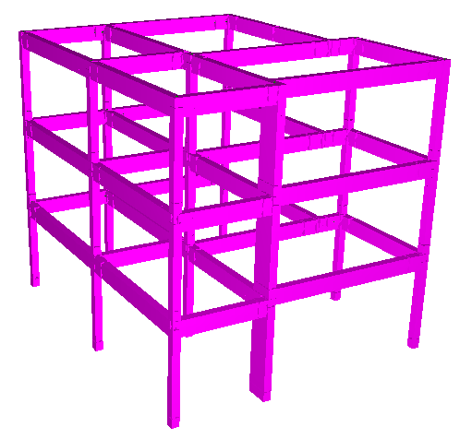Figure 4:2 SPEAR building in COM3
Montenegro Herceg Novi 1979 earthquake is taken for dynamic analysis of the SPEAR model. In order to compare with the results from the full scale test, 0.2g of that earthquake is applied.

Figure 4:3 Montenegro Herceg Novi 1979
Damage Results:
After nonlinear dynamic analysis by using 0.2g of Montenegro Herceg Novi 1979 earthquake, it is found that damage obtained from COM3 is similar to that from full scale is similar to the damage obtained from the COM3. Similarly, from this damage result, there are also cracks in beam B4 due to torsion (Torsional cracks in full scale test).
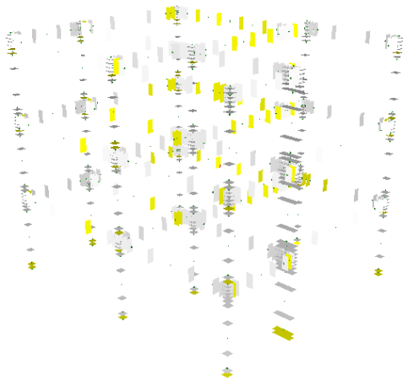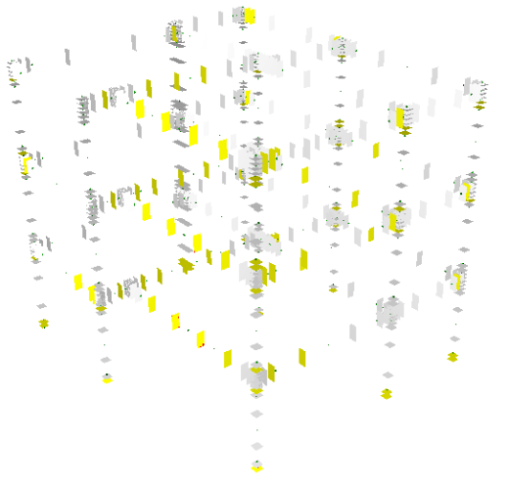
a) South-West view b) North-East view
Figure 4:4 Damages in SPEAR model
Here, maximum top displacement and maximum base shear in both directions obtained from COM3 are less than that of the full scale test.

Beam to beam connection model
After analyzing data, repetition of beam to beam connection at center (BBCC) is more in number. Therefore, building having connection at center is taken to find out the influence of beam to beam connection in building and the suitable dimensions of that plan is shown in figure 3:18 (a). In order to find out the influence of the beam to beam connection, five different buildings are modeled in SAP 2000 and COM3 by rearranging beams and columns. Similarly, materials properties, sizes of frames, sizes of reinforcements, thickness of slab, load are taken constant for all the models.

a) Modeling in SAP2000:
i) Sizes of beam, and column:
From the data collection, maximum buildings used beam size of 9” X 17” i.e. 0.23m X 0.43m and column size of 9” X 12” i.e. 0.23m X 0.3m. Therefore, in modeling of the building above mentioned dimension of beams and columns are used.

ii) Materials properties:
Strength of concrete used in modeling is M24 and that of reinforcement is Fe 415. Unit weight of the concrete is 24.5KN/m2. Similarly, modulus of elasticity of steel is 200KN/m2 and that of the concrete is taken as 5000√fck i.e. 25000N/mm2.

iii) Load:
In structural modeling, dead load of column has been automatically considered by program where as dead load of beam is applied in terms of unit weight by combining slab load, finishing load, load of plaster, wall load and live load. Finishing load is taken as 1KN/m2 and plaster load on ceiling is taken as 0.88KN/m2. Similarly, unit weight of wall is taken as 19 KN/m3 with 50% opening.
Slab load is distributed to nearest beam by considering trapezoidal areas.

iv.) Parameters for pushover analysis:
In order to perform pushover analysis, plastic hinges are defined in columns only. Degree of freedom is in P-M2-M3 direction and hinge type is selected from table 6-8 (Concrete column flexure) of FEMA 356. New analysis case for push over analysis is created in SAP in which nonlinear pushover analysis is done using nonlinear dead load. To find out initial hinge formation of column, displacement control multi step push over analysis is done by applying unit acceleration in both directions.

b) Modeling in COM3:
i) Sizes of beam, and column:
From data collection, maximum buildings used beam size of 9” X 17” i.e. 0.23m X 0.43m and column size of 9” X 12” i.e. 0.23m X 0.3m. Therefore, in modeling of building these dimension of beams and columns are used.

ii) Materials properties:
Strength of concrete which is used in modeling is M24 and reinforcement is Fe 415. Unit weight of the concrete is 24.5KN/m2. Similarly, modulus of elasticity of steel is 200KN/m2 and that of concrete is taken as 5000√fck i.e. 25000N/mm2.

iii) Load:
In structural modeling, dead load due to column has been automatically considered by program where as dead load of beam is applied in term of unit weight by combining of slab load, finishing load, load of plaster, wall load and live load. Finishing load is taken as 1KN/m2 and plaster load on ceiling is taken as 0.88KN/m2. Similarly, unit weight of wall is taken as 19 KN/m3 with 50% opening. Slab load is distributed to the nearest beam by considering trapezoidal areas.

iv.) Dynamic load:
For nonlinear dynamic analysis, Kobe earthquake was taken. EW direction of Kobe earthquake applied to X-direction and NS of the Kobe earthquake was applied to Z-direction of plan.

Figure 4:5 Kobe Earthquakes
v) Reinforcements:
Longitudinal reinforcements used in beams and columns are of 12mm and 16mm. In column, 4-16mm reinforcements are kept at corner and 4-12mm of them are kept at middle. Similarly, 4-16mm and 2-16mm reinforcement are placed at support in tension and compression side of beams respectively where as at center 2-16mm reinforcements are used at top and 4-16mm reinforcement are used at bottom. And, reinforcements used in shear are of 8mm diameter and spacing of stirrup near the support is 4” and middle is 6”.

vi.) Joint properties:
In order to prevent plastic hinge formation at the joint, non failure section is assigned at the crossing between beam and column.

vii) Zoning:
a) Cross section:
In plastic hinge region, cross sections of frame elements are divided into 15 X 15 cells and at other zone they are divided into 10 X 10 cells.
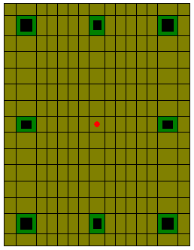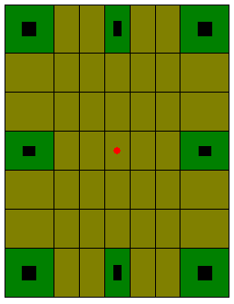
Figure 4:6 Cells of the column
b) Longitudinal:
Frame sections are divided into different parts according to plastic hinge length. The plastic hinge length can be calculated from given formula:
L_{pl} =α_{flex} .L_{v} + α_{shear}.h +α_{slip}.d_{bl}.f_{y} [6] (3.1)
Where, L_{v} = Shear span
h = Cross section depth
d_{bl} = Diameter of longitudinal bars
f_{y}, f_{ck} = Average strength of steel and concrete
α_{flex} =0.1
α_{shear} =0.17
α_{slip} =0.24/√(fck)
In longitudinal direction, frames are divided into five parts (2 parts for non crack, 2 parts for plastic hinge length and 1 part rest normal region).
viii) Modeling Setting:
For model analysis, geometric nonlinearity with 12 maximum numbers of iteration and secant iterative stiffness is considered. Similarly, 0.20% of steel yield strain is considered as light damage, 1% of compressive strain and 2% tensile strain are taken as damage.

Beam to beam connection at the center (BBCC):
i) Dimension:
Outer shape of model is rectangular which is symmetrical in NS direction and there are two bays in each direction. Length of the model is 7.4m in EW and width in NS direction is 4.8m (figure 4:7).
Figure 4:7 Typical plan of building having beam to beam connections at center

ii) Geometrical Modeling:
Modeling of building is done in SAP 2000 for pushover analysis and COM3 (Concrete Model for 3Dimensional problems) in order to perform nonlinear dynamic analysis. Beams and columns of different lengths are modeled and slab is omitted. Lengths of beams are tabulated below and that of column is taken as 3 meter. And, the thickness of a slab is taken as 125mm.
Table 4-4 Lengths of beams
Beam | Span (m)
B1 | 4.00
B2 | 3.40
B3 | 4.00
B4 | 4.00
B5 | 3.40
B6 | 2.40
B7 | 2.40
B8 | 2.40
B9 | 2.40
B10 | 4.80
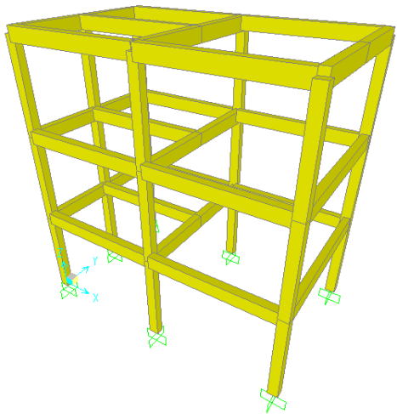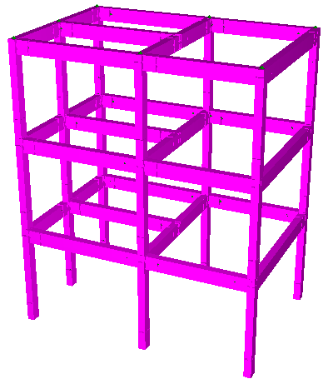
a) In SAP b) in COM3
Figure 4:8 Beam to beam connection at center modeled in a) SAP & b) COM3

Beam to beam connection without side column and beam (BBCWSB):
i) Dimension:
Outer dimension of this model is also same as above but central column (C8) is added which make model more rigid.
Figure 4:9 Plan of beam to beam connection without side column and beam

ii) Geometrical Model:
Lengths of beams and columns used in this model are also same as above value tabulated in table.
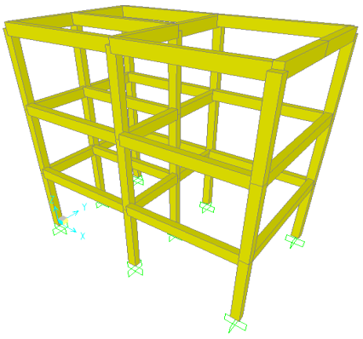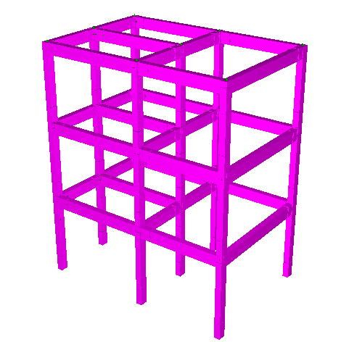
a) In SAP b) in COM3

Figure 4:10 Model with beam to beam connection without side column and beam

Model without Middle Right Beam (MWMRB)
i) Dimension:
Model consists 9 columns; four of them are at the corner, four at the middle of perimeter and one at the center. Dimension of all beams are same as above but beam B10 having length 4.8m get divided into two part of B10 and B11of length 2.4m.
Figure 4:11 Plan of model without middle right beam only

ii) Geometrical Model:
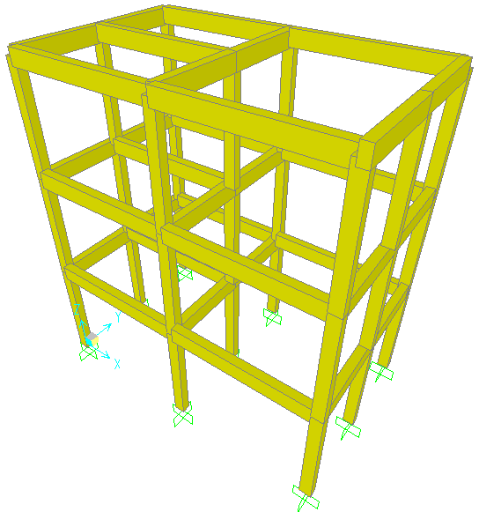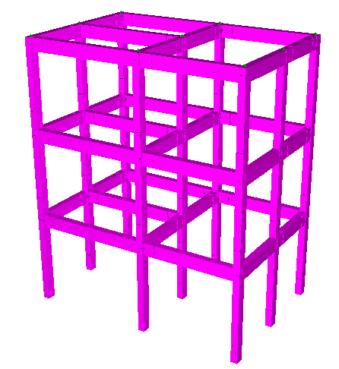
a) In SAP b) in COM3
Figure 4:12 Model without Middle Right Beam in SAP and COM3

Model without central column (MWCC)

i) Dimension:
Model consists of 8 columns, four at the corner and four at the middle of edge of building. There is no central column and dimension of all beams and columns are same as above.
Figure 4:13 Plan of model without central column

ii) Geometrical Model:
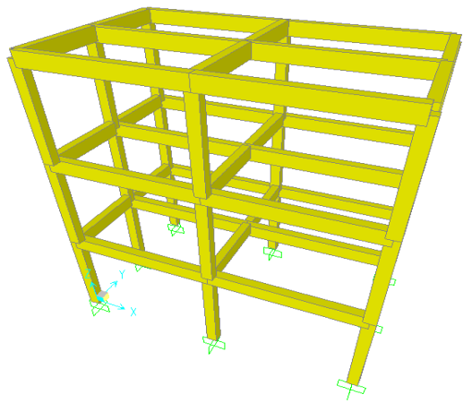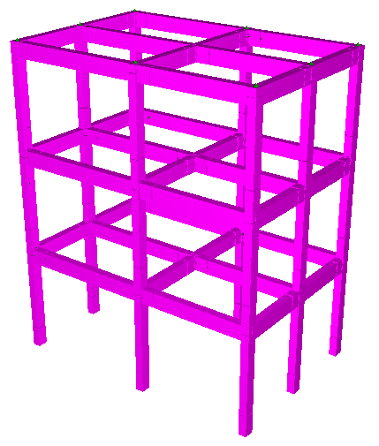
a) In SAP b) in COM3
Figure 4:14 Model without central column in SAP and COM3

Regular building Model (RBM):
i) Dimension:
Regular building has 9 columns and 12 beams and their dimensions are as mentioned in above table.
Figure 4:15 Plan of regular building
ii) Geometrical Model:
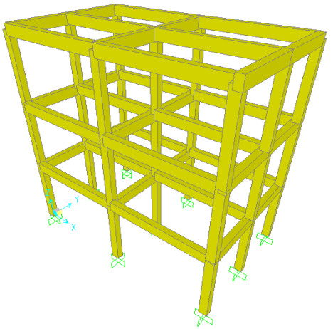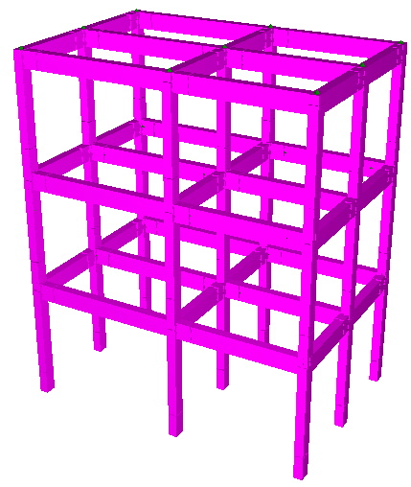
a) In SAP b) in COM3
Figure 4:16 Regular Building Model in SAP and COM3

RESULTS AND DISCUSSION
In order to find out the influence of beam to beam connection in buildings, five different models are modeled in SAP 2000 and COM3.In SAP2000, pushover analysis is done to find out initial hinge formation where as using COM3 maximum base shear, average top displacement, strain and damage in the column of all five models are obtained. Results obtained from both SAP2000 and COM3 and comparisons made in between five different models are presented below:
- Result of beam to beam connection at center:
SAP:
From the pushover analysis, it is found that when there is no column in center, no column right middle grid, and no beam at right center then initially hinge is formed at the bottom portion of column C6. Also, damages are occurred in column C6 and nearest other columns from C6.

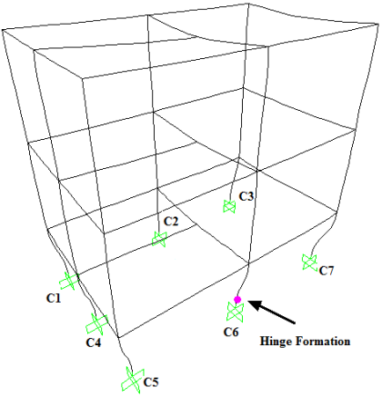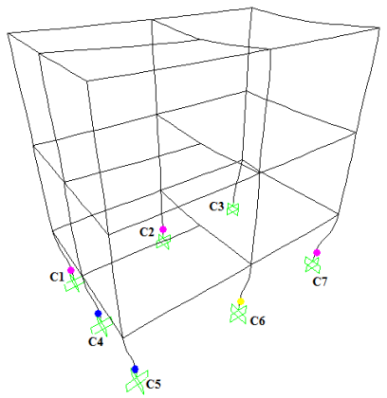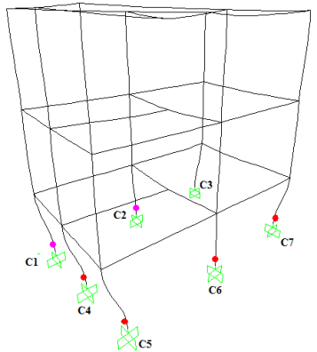
Step-1 Step-2 Step-3
Figure 5:1 Formation of hinge by using pushover analysis in BBCC

COM3:
From nonlinear dynamic analysis using COM3, results of base shear in both X and Z directions as well as average top displacement when concrete reached maximum stress of beam to beam connection at center are presented in table 5-1.
Table 5-1Base Shear & Top Displacement of model in BBCC
Beam to beam connection at center
 |  | X | Z
Base Shear (KN) | Max | 200.70 | 376.60
Base Shear (KN) | Min | -286.10 | -323.30
Displacement (mm) | Max | 97.32 | 58.99
During nonlinear dynamic analysis, compression failure due to normal strain has taken place in bottom part of column C6 in first storey. That failure has been occurred in cell no. 225 which is at the corner of column of top gauss point. Similarly, at same time, damage occurred in cell no 101 and light damage occurred in cell no 95.
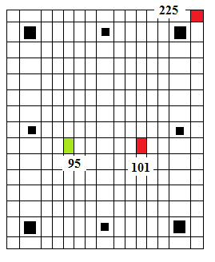
Figure 5:2 Gauss point 2 of bottom portion of C6

The below table shows axial force, shear force and bending moment at top gauss point (gauss point 2) of damage column of column C6.

Table 5-2 Axial Force, Shear Force and Bending Moment at G.P. 2

Beam to beam connection at center
Bending Moment (KNm) | Max | 81
Shear Force (KN) | Max | 150
Axial Force (KN) | Max | 436
Average Strain |  | -0.03434
Average Steel Strain |  | -0.03433
Average Concrete Stress | N/mm² | -6.87871
Average Steel Stress | N/mm² | -247.325

- Result of beam to beam connection without side column & beam:
SAP:
After addition of central column in model having beam to beam connection at center, model BBCWSB formed. During pushover analysis, initially hinge gets formed in bottom portion of column C6. Then, in next step hinges get formed in other nearest columns. Hinge formation due to push over analysis are shown in figure below.

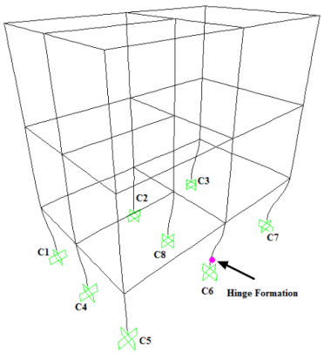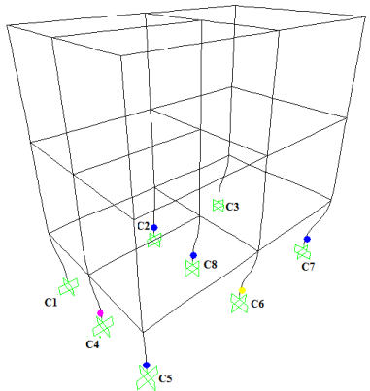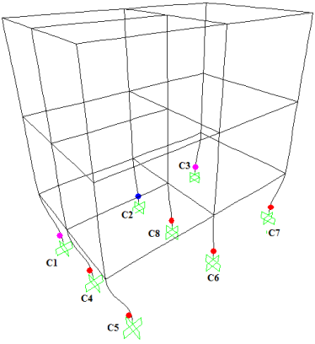
Step-1 Step-2 Step-3
Figure 5:3 Formations of hinge & damage by using pushover analysis in BBCWSB

COM3:
Base shear and average top displacement (when concrete reached maximum stress) of model having beam to beam connection are shown in table 5-3. During analysis, failure occurred in the cell no 225 of gauss point 2 of the column C5 and in order to compare with other model the axial force, shear force and bending moment at gauss point of C6 are shown in table 5-4.

Table 5-3 Base Shear and Top Displacement of B-B connection without side column and mid beam

Beam to beam connection without S Col and mid beam
 |  | X | Z
Base Shear (KN) | Max | 187.57 | 396.23
Base Shear (KN) | Min | -304.77 | -311.30
Displacement (mm) | Max | 86.23 | 52.53

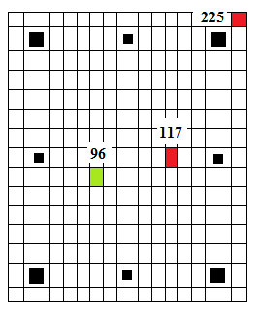
Figure 5:4 Gauss point 2 of bottom portion of C5

Table 5-4 Axial Force, Shear Force and Bending Moment of C6 at G.P. 2
Beam to beam connection without Side Column and mid beam
Bending Moment (KNm) | Max | 67.60
Shear Force (KN) | Max | 327
Axial Force (KN) | Max | 261
Average Strain |  | -0.02483
Average Steel Strain |  | -0.02483
Average Concrete Stress | N/mm² | -6.44564
Average Steel Stress | N/mm² | -215.738

- Result of model without Middle Right Beam:
SAP:
Adding side column in the model BCCWSB, model MWMRB formed. During pushover analysis, initial hinge formed at column C2 which is opposite to column C6.
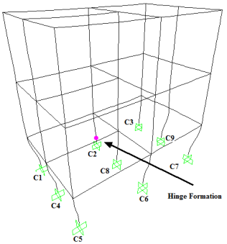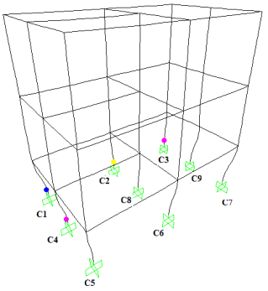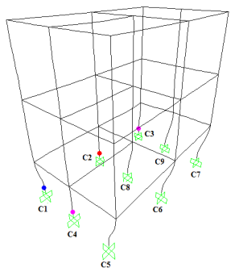
Figure 5:5 Formation of hinge & damage by using pushover analysis in MWMRB

Base shear and average top displacement of model without middle right beam are shown in table 5-5. During analysis, failure occurred in cell no 225 of gauss point 2 of column C6 and axial force, shear force and bending moment of that gauss point are shown in table 5-6.
Table 5-5 Base Shear & Top Displacement of model without Middle Right Beam
Model without Middle Right Beam
 |  | X | Z
Base Shear (KN) | Max | 199.68 | 441.21
Base Shear (KN) | Min | -328.72 | -381.11
Displacement (mm) | Max | 81.74 | 48.01
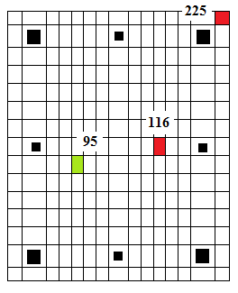
Figure 5:6 Gauss point 2 of bottom portion of C6
Table 5-6 Axial Force, Shear Force and Bending Moment of Damage Column C6 at G.P. 2

Model without Middle Right Beam
Bending Moment (KNm) | Max | 70.40
Shear Force (KN) | Max | 328
Axial Force (KN) | Max | 360
Average Strain |  | -0.02352
Average Steel Strain |  | -0.02352
Average Concrete Stress | N/mm² | -6.48026
Average Steel Stress | N/mm² | -205.5

- Result of Model without central column:
SAP:
After addition of beam at right center in above model, location of initial hinge formation shifted to column C4. However, critical hinges occurred in column C2 and C6.
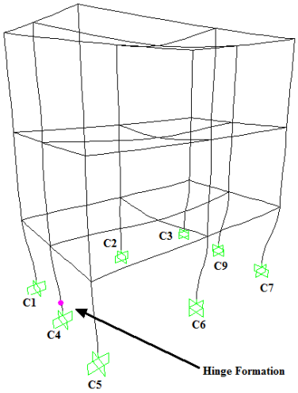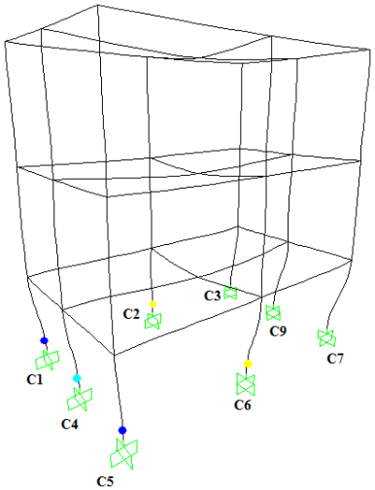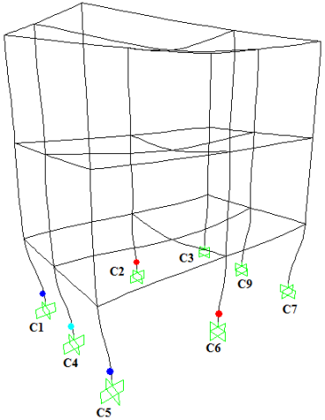
Figure 5:7 Formation of hinge & damage by using pushover analysis in MWCC
Base shear and average top displacement of model without central column are shown in table 5-7. During analysis, failure occurred in cell no 225 of gauss point 2 of column C6 and axial force, shear force and bending moment of that gauss point are shown in table 5-8.
Table 5-7 Base Shear and Top Displacement of model without central column
Beam to beam connection without central Column
 |  | X | Z
Base Shear (KN) | Max | 169.29 | 402.86
Base Shear (KN) | Min | -303.16 | -339.97
Displacement (mm) | Max | 91.44 | 51.41

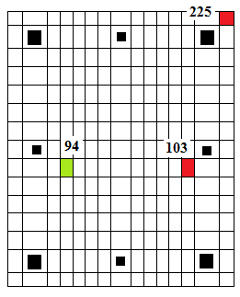
Figure 5:8 Gauss point 2 of bottom portion of C6

Table 5-8 Axial force, shear force & Bending Moment in beam-column 94 GP2:

Beam to beam connection without central Column
Bending Moment (KNm) | Max | 81.20
Shear Force (KN) | Max | 296
Axial Force (KN) | Max | 404
Average Strain |  | -0.02976
Average Steel Strain |  | -0.02976
Average Concrete Stress | N/mm² | -6.7742
Average Steel Stress | N/mm² | -222.575

- Result of Regular building Model:
SAP:
After addition of central column in above model, initial hinges formed at central column and column C2. And, critical hinges also occurred in those columns.
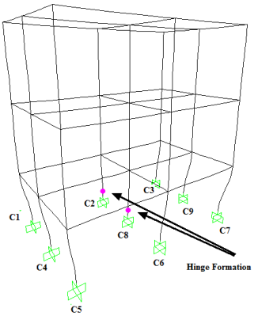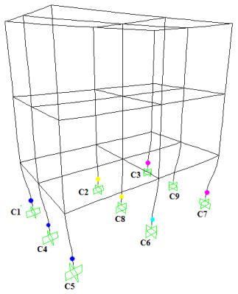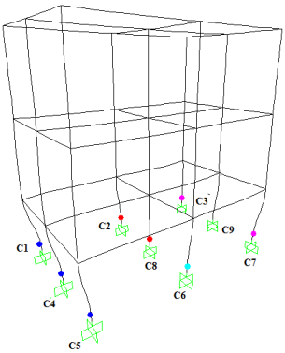
Figure 5:9 Formations of hinges by using pushover analysis in RBM

COM3:
Base shear and average top displacement of regular building are shown in table 5-9. During analysis, failure occurred in cell no 210 of gauss point 2 of column C6 and axial force, shear force and bending moment of that gauss point are shown in table 5-10.

Table 5-9 Base Shear and Top Displacement of Regular Model

Regular Model
 |  | X | Z
Base Shear (KN) | Max | 212.99 | 436.12
Base Shear (KN) | Min | -347.65 | -377.33
Displacement (mm) | Max | 77.82 | 48.42

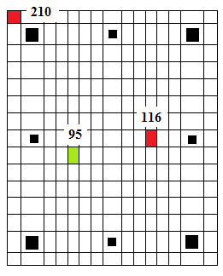
Figure 5:10 Gauss point 2 of bottom portion of C6
Table 5-10 Axial force, shear force and Bending Moment in beam-column 94 gauss point2:

Regular Model
Bending Moment (KNm) | Max | 69.70
Shear Force (KN) | Max | 296
Axial Force (KN) | Max | 355
Average Strain |  | -0.02405
Average Steel Strain |  | -0.02405
Average Concrete Stress | N/mm² | -6.37401
Average Steel Stress | N/mm² | -212.688

- Comparison of Base Shear and top displacement:
Results of different models are tabulated and compared with result of regular building are presented in table 5-11 and 5-12.

Table 5-11Comparision of Base Shear and Displacement

Figure |  | 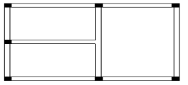 |  | 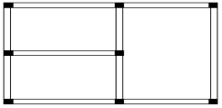 |  | 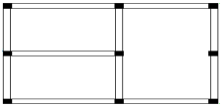 |  | 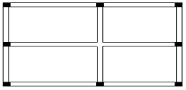 |  | 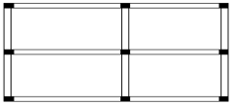
Designation |  | 1  Model with B-B connection at the center |  | 2  Model without side column & Middle Rt. beam |  | 3  Model without Middle Rt. Beam only |  | 4  Model without central column |  | 5  Model with regular configuration
 |  | X | Z | X | Z | X | Z | X | Z | X | Z
Base Shear | Max | 200.69 | 376.58 | 187.57 | 396.23 | 199.68 | 441.21 | 169.29 | 402.86 | 212.99 | 436.12
Base Shear | Min | -286.07 | -323.34 | -304.77 | -331.30 | -328.72 | -381.11 | -303.16 | -339.97 | -347.65 | -377.33
Disp | Max | 97.32 | 58.99 | 86.23 | 52.53 | 81.74 | 48.01 | 91.44 | 51.41 | 77.82 | 48.42

Table 5-12 Comparison of Base Shear, Displacement (Normalized by Regular model)

Designation |  | 1  Model with B-B connection at the center |  | 2  Model without side column & Middle Rt. beam |  | 3  Model without Middle Rt. Beam only |  | 4  Model without central column |  | 5  Model with regular configuration
 |  | X | Z | X | Z | X | Z | X | Z | X | Z
Base Shear | Max | 0.94 | 0.86 | 0.88 | 0.91 | 0.94 | 1.01 | 0.79 | 0.92 | 1.00 | 1.00
Base Shear | Min | 0.82 | 0.86 | 0.88 | 0.88 | 0.95 | 1.01 | 0.87 | 0.90 | 1.00 | 1.00
Disp | Max | 1.25 | 1.22 | 1.11 | 1.08 | 1.05 | 0.99 | 1.18 | 1.06 | 1.00 | 1.00

Again, comparison of top displacement and base shear of different models are presented in graph are shown in figure 5:11 to 5:16. Figure 5:11shows the comparison of top displacement in X-direction. From this comparison it is found that top displacement in 1 to 4 models are more than model 5.

Figure 5:11 Graphical representation of normalized displacement in X-direction

From figure 5:12, maximum top displacement at Z of model 1 is more in comparison to other models. Similarly, that value of models 2, 3, 4 and 5 are similar.

Figure 5:12 Graphical representation of normalized max displacement in Z direction

From figure 5:13 and 5:14, base shears in both x and Z direction of regular building have more value than other models.

Figure 5:13Graphical representation of maximum Base Shear in X-direction

Figure 5:14 Graphical representation of maximum Base Shear in Z-direction

From figure 5:15, and 5:16, base shears in regular building have more than other models in both negative x and negative Z direction.

Figure 5:15 Graphical representation of minimum base shear in X direction

Figure 5:16 Graphical representation of minimum Base Shear in Z direction

- Comparison of AF, SF and BM in damage column portion:
Table 5-13 Comparison of AF, SF and BM in damage column
Designation | 1  BBCC | 2  BBCWSB | 3  MWMRB | 4  MWCC | 5  RBM
BM (KNm) (max) | 81 | 67.60 | 70.40 | 81.20 | 69.70
SF (KN) (max) | 150 | 327 | 328 | 296 | 296
AF (KN) (max) | 436 | 261 | 360 | 404 | 355

Graphical representations of above results are as shown below. From figure 5:17, 5:19 it is shown that maximum bending moment and maximum axial force occurs when there is no central column i.e. model with beam to beam connection at center.

Figure 5:17 Comparison of maximum bending moment

Figure 5:18 Comparison of maximum shear force

Figure 5:19 Comparison of maximum axial force

- Comparison of strain and stress:
Table 5-14 Comparison of strain and stress
Designation | 1  BBCC | 2  BBCWSB | 3  MWMRB | 4  MWCC | 5  RBM
Average Strain | -0.03434 | -0.02483 | -0.02352 | -0.02976 | -0.02405
Av. Steel Strain | -0.03434 | -0.02483 | -0.02352 | -0.02976 | -0.02405
Av. Concrete Stress | -6.87871 | -6.44564 | -6.48026 | -6.7742 | -6.37401
Av. Steel Stress | -247.325 | -215.738 | -205.5 | -222.575 | -212.688

From comparison of average strain, average concrete stress and average steel stress, BBCC have more strain and stress in comparison to other building models. After that MWCC have more strain and stress and RBM have less strain and stress in comparison to different five models.

- Comparison of Position of Damage:

Table 5-15 Comparison of the damage position
Designation | 1  BBCC | 2  BBCWSB | 3  MWMRB | 4  MWCC | 5  RBM
Damaged column | C6 | C5 | C6 | C6 | C6
Gauss point | 2 | 2 | 2 | 2 | 2
Compression failure Cell | 225 | 225 | 225 | 225 | 210
Normal strain at time of failure | -0.10006 | -0.10038 | -0.10129 | -0.10036 | -0,10036
Damage Cell | 101 | 117 | 116 | 103 | 116
Light Damage cell | 95 | 96 | 95 | 94 | 95

Table 5-15 shows the comparison of damage in column of different models where bottom portion of column C6 of four models get damaged during nonlinear dynamic analysis. However, in model having beam to beam connection without side column and beam get damaged in column C5 which may be due to torsion of building. All the damage takes place in gauss point 2. Similarly, cracks due to normal strain occur in cell number 225 (top right corner of cross section of column) in four models while cracks in regular building model occurred at cell number 210 (top left corner of cross section of column).
Similarly, damaged occurred in all columns are at the middle of cross section of column and light damage occurs just below that damages.
- Comparison of Axial force in columns and Total weight:
Table 5-16 Comparison of axial force in first storey

Designation | 1  BBCC | 2  BBCWSB | 3  MWMRB | 4  MWCC | 5  RBM
C1 | 128.781 | 132.047 | 133.37 | 134.233 | 131.86
C2 | 360.230 | 245.568 | 244.137 | 352.382 | 239.145
C3 | 194.701 | 184.561 | 122.534 | 116.925 | 114.522
C4 | 228.358 | 203.959 | 204.626 | 238.615 | 197.908
C5 | 128.791 | 132.047 | 133.37 | 134.233 | 131.939
C6 | 360.230 | 245.568 | 244.137 | 353.069 | 240.028
C7 | 194.701 | 184.561 | 122.534 | 118.17 | 115.483
C8 | - | 283.049 | 278.627 | - | 340.614
C9 | - | - | 143.609 | 223.337 | 175.039
Total | 1595.792 | 1611.36 | 1626.944 | 1670.964 | 1686.54

From table 5-16, when there is central column; maximum axial forces are resisted by that central column while if there is no central column, maximum axial forces are resisted by side columns. Similarly, failure occurred at those columns having higher axial force.

- Comparison of stress and strain in corner reinforcement:
In order to compare stress and strain at damage portion of column in five different models, results from reinforcements at corners are taken. Figure 5:20 shows the cross section of column with different cells. Cell no 17, 29, 197 and 209 are corner reinforcements.

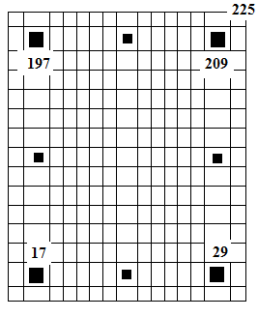
Figure 5:20 Gauss point 2 having different cells

Results in cell 17:

Figure 5:21 Concrete stress strain diagram of cell 17

Figure 5:22 Steel Stress Strain diagram in cell

Results in cell 29:

Figure 5:23 Concrete Stress strain curve in cell 29

Figure 5:24 Steel Stress strain curve in cell 29

Results in cell 197:

Figure 5:25 Concrete Stress strain curve in cell 197

Figure 5:26 Steel Stress strain curve in cell 197

Results in cell 209:

Figure 5:27 Concrete Stress strain curve in cell 209

Figure 5:28 Steel Stress strain curve in cell 209

From above stress- strain graph, strain in beam to beam connection at center have higher value in compression in cell no 17 and cell no 209 which are along the diagonal.
Results in cell 225:

Figure 5:29 Concrete Stress strain curve in cell 225

This graph shows the comparison of concrete stress-strain of cell 225 in which BBCC attains more normal strain than other in same stress level.

CONCLUSIONS:
Summary:
Beam to beam connections without column are widely used in Nepal. In order to find out influence of beam to beam connection, literatures were collected and studied. However, literature related to sole beam to beam connection could not found. In Europe, one experimental study (i.e. study of SPEAR building) was done in irregular plan building which is regular in elevation, unsymmetrical in plan and having beam to beam connection.

Modeling of SPEAR structure was done in COM3 nonlinear software in order to compare results obtained from full scale test. From that comparison, it was found that damages position from COM3 were similar to that from the full scale test, however, in first storey damages were more due to soft storey of building. Similarly, base shear and top displacement were low in compared to full scale test.

In order to find out condition of beam to beam connection in Kathmandu Metropolitan City, 150 building drawings were collected which were sanctioned from KMC in fiscal year 2063/64. Out of those 150 buildings, 67 buildings had beam to beam connection at different locations. From those drawings, different plan were finalized according to the position of connection. They are a) building having beam to beam connection at edge, b) building having beam to beam connection in middle/center and c) building having beam to beam connection at corner. Due to more repetition of beam to beam connections, building having connection at center was selected for study. Similarly, parameters such as storey of building, frame sections, thickness of slab, material properties etc were also taken from the collected drawings and load were taken as KMC practice. Also, the Kobe Earthquake was taken in order to do nonlinear dynamic analysis.

After selection of appropriate plan, five new models were made by adding and removing beams and columns. Models which were formed from selected plan were a) beam to beam connection at center b) beam to beam connection without side column and beam, c) Model without middle right beam, d) model without central column and e) regular building model. In order to find out position of hinge formation and critical portion of the column, pushover analysis was done by using SAP2000. Again, those models were modeled in COM3 and nonlinear dynamic analysis was done by using Kobe earthquake. The results obtained from analysis were tabulated and compared in order to find out influence of those connections.
Conclusion:
Based on results obtained from analysis following conclusions can be drawn:
1) Building having beam-beam connection at center (BBCC) has maximum top displacement at both X and Z directions compared to other model. Similarly, the model without central column (MWCC) also has also greater top displacement than other model except BBCC. These are due to absence of central column in both models which signify that the central column is important to resist large displacement. So, the building having beam to beam connection at center seems more flexible than other buildings having beam to beam connection at other locations.

2) Building having beam to beam connection at center (BBCC) and model without central column (MWCC) has lowest base shear in both directions compared to other models. These values show that BBCC and MWCC resist low horizontal forces than other models.

3) From comparison of bending moment, shear force and axial force in damage portions of five different models, it is found that bending moment and axial force of model having beam to beam connection are more than that having column and vice versa in the case of shear force. From this result, we can say that other building models are better than building having beam to beam connection.

4) From comparison of axial forces in all columns of different five models and damage occurred in column, it is found that model without central column get failed at the column subjected to large axial force. With the addition of column in center, axial force get maximum at central column and damage occurred in other columns. From this result, we can say that buildings with beam to beam connection at center are weaker than other configuration.
4) From comparison of strain, average concrete stress and average steel stress, BBCC have higher strain and stress which signify building having connection at center get earlier damaged in comparison to other buildings.

4) From stress-strain diagram of cell no 17 and cell no 209, tensile strain of beam to beam connection building is maximum than other building and building get damage in less compressive strain which signify that beam to beam connection building are less safer than other models.

5) From concrete stress-strain diagram of 225 cells, it is found that BBCC has maximum strain in same stress level than other models which signify than cracks in BBCC occurs earlier than other building models. Therefore, buildings with beam to beam connection at center get damaged earlier than others.

6) Critical section of model from pushover analysis and nonlinear dynamic analysis are same however in MWMRB and RBM damage in Column C6 shift to Column C2 (opposite column to C6). These signify that building having unsymmetrical distribution of columns get damaged due to torsion.

7) From this study, it can be concluded that buildings having beam to beam connection at any positions are dangerous in earthquake loading than regular configuration building.

RECOMMENDATIONS
On the basis of conclusions, following recommendations can be made.
1) Beam to beam connection at any position of building should be avoided during designing of the building. From result, beam to beam connection at center seems more critical than other so connection in the center should be avoided.
Recommendation for future works
In this thesis, only building having beam to beam connection at center is taken and further analysis are done based on that plan only. But, there are still other plans which need to be analyzed to find out the exact influence and position of beam to beam connection. Similarly, there are other buildings more than 3 storied and fewer reinforcements which are more vulnerable need to be analyzed. The followings are the recommendations for future works:
1) Beam to beam connection at other positions also can be analyzed in order to find out the critical locations of beam to beam connection.
2) There are few buildings which have more storeys and less reinforcement which may be vulnerable can be taken for further study.

References:

[1] Jeevan Karki, “Earthquakes Know no boundaries: Nepal must brace up”, The Himalayan Times” 21th February, 2010
[2] “Indian, Pakistan Capitals Vulnerable in Major Earthquakes”, South Asia Investor Review, 9th Febraury, 2010
[3] Tiffany M.Luck and Dan Bigman, “After Haiti”, Forbes.com, 8th Febraury, 2010.
[4] IRIN Asia/Nepal, “NEPAL: Density-populated Kathmandu facing increased earthquake risk”, 29th march, 2010.
[5] Jeong, Seong-Hoon and Elnashai, Amr.S, 2004 “Analytical assessment of an irregular RC Full Scale 3D Test structure” Mid-American Earthquake Center
[6] Ludovico, Marco Di, “Comparative assessment of seismic rehabilitation techniques on the full scale SPEAR structure”, University of Naples Federico II
[7] Mola E., and Negro, P. “Full scale PsD testing of the torsionally unbalanced SPEAR structure in the ‘as-built’ and retrofitted configurations”, SPEAR Workshop – An event to honour the memory of Jean Donea – Ispra, 4-5 April 2005
[8] Fajfar, P., Dolšek, M., Marušić, D. and Stratan, A. “Pre- and post-test mathematical modelling of the SPEAR building” SPEAR Workshop – An event to honour the memory of Jean Donea – Ispra, 4-5 April 2005
[9] Ile, N., and Reynouard, J. M., “Post-test nonlinear analysis of the SPEAR test building” SPEAR Workshop – An event to honour the memory of Jean Donea – Ispra, 4-5 April 2005
[10] Lumantarna, Elisa; Lam, Nelson; Kafle, Bidur; and Wilson, John “Displacement Controlled Behaviour of Asymmetrical Buildings”, Australian Earthquake Engineering Society Conference 2008, Ballarat, VIC
[11] Cosenza, Edoardo; Manfredi, Gaetano; and Realfonzo, Roberto, “Torsional Effects and Regularity Conditions In RC Buildings” 12th WCEE 2000.
[12] Soliman, Khaled Zaky, “The Influence Of Principal Axes On Dynamic Behavior Of Irregular Structures” HBRC Journal, Vol 2. No. 1, January 2006.
[13] Lin , Jui-Liang; and Tsai, Keh-Chyuan “Evaluation of the Seismic Energy Demand for Asymmetric-Plan Buildings “
[14] Sharma, Ravi lal “Nonlinear finite element analysis of reinforced concrete beam column joints subjected to reversed cyclic loading”, Thesis no SS00116, February 2008.
[15] Forum8, “Theoretical Note”. http://www.forum8.com/english/uc-win/com3-help/theoritical-e.htm
[16] Koichi Maekawa, Kukrit Toongoenthong, Esayas Gebreyouhannes and Toshiharu Kishi “Direct path integral scheme for fatigue simulation of reinforced concrete in shear” Journal of Advanced concrete technology Vol4, No1, 159-177, February 2006

Annex A

Output Table:
Forces in X direction of BBCC model
time | Node 1 | Node 2 | Node 3 | Node 10 | Node 14 | Node 19 | Node 22
0 | 1.519 | 5.057 | 1.519 | -1.679 | -1.68 | -2.368 | -2.367
0.02 | 1.481 | 5.021 | 1.481 | -1.716 | -1.718 | -2.405 | -2.404
0.04 | 1.31 | 4.852 | 1.318 | -1.886 | -1.897 | -2.575 | -2.567
0.06 | 0.91 | 4.453 | 0.938 | -2.295 | -2.329 | -2.98 | -2.951
0.08 | 0.456 | 4 | 0.523 | -2.766 | -2.848 | -3.445 | -3.375
0.1 | 0.277 | 3.82 | 0.398 | -2.95 | -3.095 | -3.64 | -3.512
0.12 | 0.56 | 4.146 | 0.74 | -2.618 | -2.829 | -3.366 | -3.175
0.14 | 1.267 | 4.986 | 1.501 | -1.799 | -2.069 | -2.655 | -2.408
0.16 | 2.207 | 6.127 | 2.486 | -0.711 | -1.03 | -1.7 | -1.409
0.18 | 3.204 | 7.293 | 3.522 | 0.459 | 0.091 | -0.686 | -0.354
0.2 | 4.118 | 8.276 | 4.492 | 1.595 | 1.153 | 0.245 | 0.64
0.22 | 4.812 | 8.938 | 5.29 | 2.576 | 2.01 | 0.965 | 1.464
0.24 | 5.077 | 9.115 | 5.706 | 3.168 | 2.426 | 1.258 | 1.907
0.26 | 4.729 | 8.656 | 5.535 | 3.12 | 2.181 | 0.937 | 1.758
0.28 | 4.001 | 7.784 | 4.973 | 2.585 | 1.464 | 0.216 | 1.2
0.3 | 3.411 | 7.043 | 4.508 | 2.079 | 0.826 | -0.381 | 0.724
0.32 | 3.343 | 6.897 | 4.501 | 2.044 | 0.732 | -0.457 | 0.705
0.34 | 3.822 | 7.448 | 4.97 | 2.534 | 1.251 | 0.03 | 1.172
0.36 | 4.592 | 8.389 | 5.648 | 3.258 | 2.09 | 0.815 | 1.858
0.38 | 5.262 | 9.181 | 6.141 | 3.785 | 2.814 | 1.496 | 2.359
0.4 | 5.538 | 9.407 | 6.151 | 3.806 | 3.127 | 1.775 | 2.376
0.42 | 5.382 | 9.022 | 5.656 | 3.266 | 2.961 | 1.613 | 1.879
0.44 | 4.943 | 8.266 | 4.83 | 2.332 | 2.452 | 1.161 | 1.041
0.46 | 4.451 | 7.477 | 3.933 | 1.287 | 1.844 | 0.647 | 0.126
0.48 | 4.012 | 6.858 | 3.121 | 0.311 | 1.273 | 0.19 | -0.704
0.5 | 3.536 | 6.35 | 2.356 | -0.642 | 0.636 | -0.308 | -1.494
0.52 | 2.936 | 5.843 | 1.607 | -1.605 | -0.155 | -0.933 | -2.274
0.54 | 2.405 | 5.458 | 1.089 | -2.321 | -0.876 | -1.495 | -2.823
0.56 | 2.122 | 5.333 | 0.982 | -2.547 | -1.288 | -1.802 | -2.95
0.58 | 2.111 | 5.493 | 1.272 | -2.259 | -1.321 | -1.817 | -2.661
0.6 | 2.181 | 5.743 | 1.703 | -1.738 | -1.191 | -1.737 | -2.215
0.62 | 1.995 | 5.691 | 1.862 | -1.467 | -1.302 | -1.906 | -2.037
0.64 | 1.428 | 5.151 | 1.558 | -1.702 | -1.839 | -2.464 | -2.33
0.66 | 0.662 | 4.298 | 0.947 | -2.31 | -2.64 | -3.234 | -2.943
0.68 | -0.105 | 3.402 | 0.244 | -3.057 | -3.475 | -4.01 | -3.657
0.7 | -0.834 | 2.607 | -0.448 | -3.819 | -4.293 | -4.752 | -4.364
0.72 | -1.495 | 1.998 | -1.036 | -4.506 | -5.076 | -5.431 | -4.965
0.74 | -1.968 | 1.675 | -1.349 | -4.942 | -5.693 | -5.928 | -5.295
0.76 | -2.048 | 1.817 | -1.186 | -4.874 | -5.898 | -6.041 | -5.152
0.78 | -1.627 | 2.537 | -0.471 | -4.165 | -5.508 | -5.634 | -4.446
0.8 | -0.759 | 3.727 | 0.649 | -2.957 | -4.555 | -4.762 | -3.321
0.82 | 0.289 | 4.99 | 1.804 | -1.647 | -3.362 | -3.715 | -2.147
0.84 | 1.221 | 5.942 | 2.661 | -0.626 | -2.255 | -2.768 | -1.268
0.86 | 1.907 | 6.412 | 3.062 | -0.093 | -1.407 | -2.071 | -0.846
0.88 | 2.338 | 6.447 | 3.006 | -0.072 | -0.855 | -1.644 | -0.892
0.9 | 2.56 | 6.197 | 2.588 | -0.466 | -0.559 | -1.43 | -1.304
0.92 | 2.493 | 5.663 | 1.811 | -1.271 | -0.593 | -1.499 | -2.078
0.94 | 1.831 | 4.562 | 0.466 | -2.714 | -1.283 | -2.165 | -3.429
0.96 | 0.329 | 2.653 | -1.587 | -4.973 | -2.918 | -3.677 | -5.499
0.98 | -1.942 | 0.042 | -4.18 | -7.858 | -5.438 | -5.957 | -8.129
1 | -4.654 | -2.904 | -6.895 | -10.951 | -8.445 | -8.641 | -10.931
1.02 | -7.141 | -5.574 | -9.11 | -13.689 | -11.361 | -11.187 | -13.235
1.04 | -8.603 | -7.1 | -10.281 | -15.41 | -13.499 | -12.877 | -14.542
1.06 | -8.85 | -7.06 | -10.201 | -15.799 | -14.368 | -13.355 | -14.63
1.08 | -8.029 | -5.541 | -8.971 | -14.889 | -13.925 | -12.638 | -13.506
1.1 | -6.659 | -3.219 | -7.12 | -13.098 | -12.758 | -11.372 | -11.755
1.12 | -5.22 | -0.89 | -5.167 | -11.095 | -11.43 | -10.028 | -9.877
1.14 | -4.065 | 0.897 | -3.543 | -9.327 | -10.278 | -8.94 | -8.267
1.16 | -3.582 | 1.716 | -2.563 | -8.156 | -9.659 | -8.415 | -7.231
1.18 | -4.05 | 1.267 | -2.506 | -7.915 | -9.995 | -8.826 | -7.109
1.2 | -5.505 | -0.394 | -3.45 | -8.736 | -11.386 | -10.261 | -8.01
1.22 | -7.426 | -2.787 | -5.061 | -10.321 | -13.321 | -12.269 | -9.6
1.24 | -9.183 | -5.126 | -6.723 | -12.028 | -15.159 | -14.119 | -11.267
1.26 | -10.437 | -6.84 | -7.981 | -13.358 | -16.541 | -15.288 | -12.581
1.28 | -11.121 | -7.742 | -8.688 | -14.155 | -17.32 | -15.955 | -13.363
1.3 | -11.096 | -7.747 | -8.703 | -14.262 | -17.324 | -15.857 | -13.435
1.32 | -10.087 | -6.705 | -7.838 | -13.359 | -16.189 | -14.776 | -12.537
1.34 | -7.893 | -4.41 | -5.948 | -11.415 | -13.71 | -12.557 | -10.662
1.36 | -4.872 | -1.163 | -3.381 | -8.631 | -10.136 | -9.504 | -8.19
1.38 | -1.42 | 2.561 | -0.628 | -5.42 | -6.06 | -5.947 | -5.491
1.4 | 2.262 | 6.369 | 2.095 | -2.175 | -1.803 | -2.176 | -2.637
1.42 | 5.849 | 9.767 | 4.594 | 0.827 | 2.3 | 1.447 | 0.003
1.44 | 8.81 | 12.355 | 6.608 | 3.272 | 5.821 | 4.459 | 2.138
1.46 | 10.669 | 13.754 | 7.728 | 4.776 | 8.191 | 6.388 | 3.351
1.48 | 11.273 | 13.8 | 7.796 | 5.131 | 9.207 | 7.086 | 3.531
1.5 | 10.868 | 12.799 | 7.108 | 4.616 | 9.081 | 6.822 | 2.914
1.52 | 9.949 | 11.363 | 6.134 | 3.724 | 8.326 | 5.94 | 1.962
1.54 | 8.836 | 9.814 | 5.062 | 2.732 | 7.272 | 4.844 | 0.91
1.56 | 7.62 | 8.308 | 4.017 | 1.741 | 6.029 | 3.665 | -0.135
1.58 | 6.499 | 7.127 | 3.283 | 0.981 | 4.804 | 2.616 | -0.885
1.6 | 5.752 | 6.599 | 3.189 | 0.853 | 3.949 | 1.907 | -0.975
1.62 | 5.458 | 6.801 | 3.763 | 1.473 | 3.614 | 1.692 | -0.304
1.64 | 5.399 | 7.478 | 4.719 | 2.484 | 3.528 | 1.706 | 0.728
1.66 | 5.293 | 8.293 | 5.708 | 3.441 | 3.259 | 1.587 | 1.696
1.68 | 4.803 | 8.866 | 6.418 | 3.981 | 2.459 | 1.04 | 2.289
1.7 | 3.41 | 8.536 | 6.345 | 3.699 | 0.708 | -0.314 | 2.127
1.72 | 0.864 | 6.686 | 4.922 | 1.95 | -2.465 | -2.858 | 0.768
1.74 | -2.917 | 3.167 | 1.933 | -1.567 | -7.364 | -6.769 | -2.096
1.76 | -7.771 | -1.956 | -2.526 | -6.798 | -13.797 | -11.83 | -6.322
1.78 | -12.793 | -8.268 | -8.267 | -13.163 | -20.737 | -17.263 | -11.434
1.8 | -16.825 | -14.219 | -13.56 | -19.671 | -26.857 | -22.355 | -16.766
1.82 | -20.485 | -19.019 | -17.506 | -25.546 | -32.192 | -27.023 | -21.677
1.84 | -24.169 | -23.021 | -20.669 | -30.588 | -37.141 | -31.363 | -26.09
1.86 | -27.589 | -26.503 | -23.911 | -34.893 | -41.356 | -34.866 | -29.806
1.88 | -30.017 | -29.432 | -27.035 | -37.458 | -44.278 | -37.726 | -32.856
1.9 | -31.847 | -31.642 | -29.655 | -39.163 | -46.228 | -39.642 | -34.97
1.92 | -31.969 | -33.311 | -31.881 | -39.232 | -46.086 | -40.354 | -36.097
1.94 | -31.717 | -33.312 | -32.529 | -38.572 | -44.943 | -40.494 | -36.686
1.96 | -30.975 | -32.711 | -32.309 | -36.312 | -43.061 | -39.703 | -35.973
1.98 | -30.376 | -31.417 | -32.07 | -33.481 | -41.07 | -38.62 | -34.437
2 | -30.074 | -29.955 | -31.39 | -30.313 | -38.915 | -37.007 | -32.513
2.02 | -30.035 | -28.652 | -30.469 | -27.11 | -37.263 | -35.335 | -30.247
2.04 | -29.721 | -27.643 | -29.696 | -24.381 | -35.911 | -34.046 | -27.961
2.06 | -29.664 | -27.185 | -29.349 | -22.65 | -35.265 | -33.161 | -26.4
2.08 | -29.975 | -27.609 | -29.77 | -22.449 | -35.72 | -33.077 | -26.072
2.1 | -29.994 | -27.967 | -30.342 | -23.308 | -35.662 | -33.449 | -26.919
2.12 | -27.761 | -26.094 | -28.411 | -22.285 | -33.699 | -31.745 | -25.689
2.14 | -23.637 | -22.407 | -24.211 | -18.642 | -29.714 | -28.197 | -22.031
2.16 | -17.69 | -16.604 | -17.541 | -12.424 | -23.525 | -22.31 | -15.714
2.18 | -11.684 | -10.399 | -10.061 | -5.339 | -16.681 | -15.403 | -8.284
2.2 | -6.044 | -4.697 | -3.062 | -0.332 | -10.647 | -8.657 | -2.032
2.22 | -1.926 | -2.057 | 1.899 | 3.089 | -6.53 | -4.568 | 2.602
2.24 | 1.078 | 2.931 | 6.647 | 6.109 | -1.773 | -1.486 | 5.905
2.26 | 9.274 | 12.195 | 13.649 | 14.092 | 7.4 | 2.509 | 10.836
2.28 | 15.135 | 15.684 | 20.731 | 23.093 | 16.129 | 12.222 | 20.328
2.3 | 17.708 | 17.522 | 25.592 | 30.061 | 20.891 | 19.299 | 25.938
2.32 | 17.65 | 15.817 | 27.823 | 31.689 | 20.511 | 23.377 | 29.59
2.34 | 14.999 | 13.743 | 28.312 | 31.48 | 20.044 | 24.172 | 30.053
2.36 | 13.09 | 11.921 | 28.408 | 29.587 | 17.763 | 23.787 | 29.967
2.38 | 10.735 | 10.668 | 27.83 | 27.909 | 14.229 | 21.341 | 29.652
2.4 | 9.159 | 10.067 | 26.862 | 25.816 | 10.137 | 18.44 | 29.252
2.42 | 7.578 | 9.234 | 25.181 | 22.806 | 5.721 | 16.066 | 28.079
2.44 | 6.016 | 8.455 | 23.161 | 20.021 | 2.006 | 13.228 | 25.742
2.46 | 5.767 | 8.006 | 20.805 | 15.995 | -0.353 | 10.465 | 23.22
2.48 | 6.414 | 7.061 | 19 | 11.583 | -1.471 | 8.384 | 19.492
2.5 | 7.443 | 7.19 | 17.425 | 6.873 | -1.869 | 6.077 | 14.58
2.52 | 9.06 | 7.333 | 16.568 | 4.25 | -2.49 | 3.361 | 9.814
2.54 | 10.639 | 7.727 | 16.211 | 2.606 | -2.877 | 0.759 | 6.225
2.56 | 11.73 | 7.965 | 15.562 | -0.092 | -3.5 | -0.626 | 3.781
2.58 | 12.185 | 8.19 | 14.791 | -2.402 | -4.207 | -1.839 | 0.827
2.6 | 12.77 | 8.189 | 14.235 | -5.224 | -5.481 | -2.622 | -0.323
2.62 | 13.632 | 8.721 | 14.762 | -7.343 | -7.214 | -4.648 | -2.112
2.64 | 14.56 | 9.48 | 15.484 | -8.798 | -9.335 | -6.618 | -4.222
2.66 | 14.53 | 9.446 | 14.787 | -9.335 | -11.273 | -8.816 | -5.936
2.68 | 12.684 | 6.894 | 11.951 | -11.869 | -13.141 | -11.163 | -8.798
2.7 | 8.61 | 1.776 | 6.796 | -17.518 | -17.514 | -14.35 | -12.979
2.72 | 3.058 | -4.703 | 0.629 | -23.209 | -23.69 | -20.102 | -19.035
2.74 | -1.979 | -10.121 | -4.715 | -26.072 | -27.992 | -25.84 | -23.575
2.76 | -5.7 | -13.546 | -8.883 | -27.053 | -30.936 | -29.206 | -26.378
2.78 | -7.603 | -15.028 | -11.694 | -27.359 | -31.996 | -30.222 | -27.479
2.8 | -8.354 | -15.099 | -13.537 | -27.53 | -30.832 | -29.352 | -27.818
2.82 | -7.831 | -13.977 | -14.123 | -26.987 | -29.663 | -26.931 | -27.414
2.84 | -6.599 | -12.093 | -13.936 | -26.834 | -26.922 | -23.818 | -26.273
2.86 | -5.585 | -10.256 | -13.517 | -26.648 | -24.007 | -20.382 | -24.306
2.88 | -4.849 | -9.364 | -12.922 | -26.393 | -21.349 | -17.321 | -22.391
2.9 | -3.823 | -9.435 | -11.924 | -26.265 | -18.836 | -15.152 | -20.03
2.92 | -2.388 | -9.315 | -10.691 | -25.362 | -16.649 | -13.549 | -18.141
2.94 | -0.57 | -8.819 | -10.041 | -23.751 | -13.837 | -12.71 | -16.067
2.96 | 1.66 | -7.478 | -8.18 | -19.942 | -10.247 | -9.63 | -13.109
2.98 | 5.194 | -4.716 | -5.394 | -15.186 | -5.361 | -6.081 | -8.881
3 | 9.655 | 0.422 | -2.182 | -11.07 | 0.438 | -0.811 | -5.168
3.02 | 14.986 | 6.276 | 0.319 | -8.769 | 6.311 | 4.617 | -2.989
3.04 | 19.61 | 10.664 | 2.327 | -7.492 | 11.182 | 9.175 | -2.916
3.06 | 20.917 | 12.068 | 4.315 | -6.719 | 14.597 | 12.641 | -3.867
3.08 | 19.717 | 11.654 | 4.298 | -7.042 | 15.006 | 14.501 | -4.184
3.1 | 16.365 | 9.201 | 3.09 | -8.22 | 12.367 | 14.052 | -3.425
3.12 | 10.415 | 4.745 | 1.316 | -10.789 | 7.903 | 12.035 | -2.854
3.14 | 2.918 | -0.655 | 0.197 | -12.587 | 1.465 | 9.097 | -3.525
3.16 | -2.832 | -4.281 | -0.476 | -12.492 | -4.401 | 4.521 | -4.679

Forces in Z direction of BBCC model
Time | Node 1 | Node 2 | Node 3 | Node 10 | Node 14 | Node 19 | Node 22
0 | 1.403 | 0 | -1.403 | -9.556 | 9.557 | 5.271 | -5.271
0.02 | 0.856 | -0.587 | -1.947 | -10.106 | 9.004 | 4.726 | -5.813
0.04 | -0.188 | -1.766 | -2.979 | -11.228 | 7.859 | 3.669 | -6.86
0.06 | -1.223 | -3.003 | -4.015 | -12.553 | 6.537 | 2.579 | -7.94
0.08 | -1.741 | -3.685 | -4.534 | -13.478 | 5.686 | 2.033 | -8.498
0.1 | -1.833 | -3.89 | -4.632 | -13.78 | 5.513 | 1.974 | -8.596
0.12 | -2.02 | -4.164 | -4.82 | -13.745 | 5.637 | 1.848 | -8.759
0.14 | -2.417 | -4.648 | -5.21 | -13.629 | 5.72 | 1.474 | -9.14
0.16 | -2.719 | -5.015 | -5.504 | -13.511 | 5.716 | 1.122 | -9.487
0.18 | -2.568 | -4.865 | -5.346 | -13.239 | 5.853 | 1.144 | -9.459
0.2 | -1.888 | -4.104 | -4.665 | -12.638 | 6.359 | 1.609 | -8.991
0.22 | -0.974 | -3.042 | -3.752 | -11.773 | 7.157 | 2.24 | -8.364
0.24 | -0.066 | -1.942 | -2.84 | -10.812 | 8.048 | 2.815 | -7.815
0.26 | 0.731 | -0.937 | -2.033 | -10.006 | 8.78 | 3.221 | -7.439
0.28 | 1.329 | -0.137 | -1.425 | -9.631 | 9.118 | 3.395 | -7.279
0.3 | 1.733 | 0.435 | -1.019 | -9.743 | 9.053 | 3.415 | -7.272
0.32 | 1.912 | 0.74 | -0.842 | -10.242 | 8.649 | 3.34 | -7.368
0.34 | 1.9 | 0.793 | -0.855 | -10.844 | 8.106 | 3.277 | -7.449
0.36 | 1.746 | 0.632 | -1.006 | -11.256 | 7.648 | 3.314 | -7.41
0.38 | 1.376 | 0.187 | -1.373 | -11.431 | 7.346 | 3.407 | -7.301
0.4 | 1.005 | -0.31 | -1.745 | -11.193 | 7.497 | 3.762 | -6.931
0.42 | 0.927 | -0.504 | -1.827 | -10.371 | 8.334 | 4.602 | -6.094
0.44 | 1.337 | -0.136 | -1.425 | -8.899 | 9.886 | 5.997 | -4.719
0.46 | 1.997 | 0.556 | -0.774 | -7.133 | 11.742 | 7.57 | -3.17
0.48 | 2.172 | 0.77 | -0.607 | -6.009 | 12.94 | 8.457 | -2.297
0.5 | 1.641 | 0.208 | -1.145 | -6.06 | 12.973 | 8.352 | -2.406
0.52 | 0.629 | -0.907 | -2.165 | -7.323 | 11.831 | 7.454 | -3.301
0.54 | -0.482 | -2.152 | -3.284 | -9.355 | 9.94 | 6.195 | -4.56
0.56 | -1.403 | -3.216 | -4.213 | -11.493 | 7.916 | 4.916 | -5.837
0.58 | -2.155 | -4.102 | -4.968 | -13.33 | 6.113 | 3.642 | -7.092
0.6 | -2.588 | -4.645 | -5.397 | -14.447 | 4.927 | 2.614 | -8.086
0.62 | -2.474 | -4.579 | -5.276 | -14.562 | 4.684 | 2.16 | -8.51
0.64 | -1.724 | -3.778 | -4.519 | -13.637 | 5.516 | 2.451 | -8.211
0.66 | -0.518 | -2.431 | -3.312 | -11.925 | 7.246 | 3.347 | -7.328
0.68 | 0.776 | -0.942 | -2.023 | -9.933 | 9.333 | 4.433 | -6.263
0.7 | 2.066 | 0.565 | -0.74 | -8.013 | 11.351 | 5.506 | -5.212
0.72 | 3.307 | 2.035 | 0.498 | -6.484 | 12.956 | 6.404 | -4.332
0.74 | 4.384 | 3.339 | 1.572 | -5.598 | 13.904 | 6.962 | -3.786
0.76 | 5.213 | 4.381 | 2.401 | -5.422 | 14.168 | 7.126 | -3.634
0.78 | 5.625 | 4.979 | 2.811 | -6.018 | 13.686 | 6.815 | -3.964
0.8 | 5.577 | 5.057 | 2.765 | -7.217 | 12.51 | 6.143 | -4.657
0.82 | 5.196 | 4.721 | 2.394 | -8.645 | 10.959 | 5.409 | -5.405
0.84 | 4.708 | 4.207 | 1.914 | -9.801 | 9.582 | 4.999 | -5.809
0.86 | 4.376 | 3.808 | 1.589 | -10.134 | 9.068 | 5.308 | -5.485
0.88 | 4.243 | 3.59 | 1.455 | -9.426 | 9.737 | 6.38 | -4.419
0.9 | 4.03 | 3.27 | 1.241 | -8.031 | 11.203 | 7.775 | -3.06
0.92 | 3.45 | 2.531 | 0.662 | -6.641 | 12.66 | 8.921 | -1.946
0.94 | 2.447 | 1.308 | -0.336 | -5.921 | 13.395 | 9.471 | -1.408
0.96 | 1.127 | -0.279 | -1.655 | -6.283 | 13.061 | 9.308 | -1.584
0.98 | -0.387 | -2.081 | -3.165 | -7.761 | 11.737 | 8.45 | -2.469
1 | -1.804 | -3.787 | -4.557 | -9.813 | 9.962 | 7.163 | -3.726
1.02 | -2.814 | -5.122 | -5.499 | -11.739 | 8.309 | 5.799 | -4.941
1.04 | -3.494 | -6.102 | -6.189 | -13.287 | 6.97 | 4.475 | -6.112
1.06 | -4.333 | -7.203 | -7.066 | -14.799 | 5.7 | 2.944 | -7.606
1.08 | -5.378 | -8.423 | -8.174 | -16.398 | 4.327 | 1.158 | -9.428
1.1 | -5.853 | -8.961 | -8.628 | -17.489 | 3.361 | -0.078 | -10.738
1.12 | -5.144 | -8.26 | -7.947 | -17.522 | 3.355 | -0.293 | -11.05
1.14 | -3.534 | -6.551 | -6.413 | -16.457 | 4.42 | 0.248 | -10.589
1.16 | -1.73 | -4.476 | -4.709 | -14.732 | 6.174 | 0.885 | -9.986
1.18 | -0.013 | -2.405 | -3.037 | -12.776 | 8.134 | 1.42 | -9.453
1.2 | 1.675 | -0.357 | -1.352 | -10.942 | 9.917 | 1.953 | -8.91
1.22 | 3.007 | 1.39 | 0.102 | -9.787 | 10.955 | 2.335 | -8.51
1.24 | 3.651 | 2.401 | 0.879 | -9.741 | 10.951 | 2.257 | -8.598
1.26 | 3.901 | 2.908 | 1.213 | -10.423 | 10.313 | 1.946 | -8.915
1.28 | 4.508 | 3.728 | 1.852 | -10.778 | 9.99 | 2.224 | -8.611
1.3 | 5.858 | 5.392 | 3.223 | -9.866 | 10.83 | 3.701 | -7.051
1.32 | 7.39 | 7.3 | 4.77 | -7.841 | 12.754 | 5.924 | -4.751
1.34 | 8.199 | 8.484 | 5.63 | -5.685 | 14.865 | 7.886 | -2.714
1.36 | 8.385 | 8.925 | 5.79 | -3.925 | 16.527 | 9.468 | -1.154
1.38 | 8.507 | 9.042 | 5.786 | -2.708 | 17.568 | 11.153 | 0.35
1.4 | 8.377 | 8.693 | 5.569 | -2.108 | 17.901 | 12.744 | 1.807
1.42 | 7.462 | 7.497 | 4.698 | -2.237 | 17.465 | 13.734 | 2.724
1.44 | 5.708 | 5.466 | 3.037 | -2.985 | 16.402 | 13.87 | 2.923
1.46 | 3.894 | 3.342 | 1.263 | -3.869 | 15.225 | 13.692 | 2.856
1.48 | 2.48 | 1.565 | -0.161 | -4.571 | 14.315 | 13.582 | 2.846
1.5 | 0.956 | -0.266 | -1.636 | -5.523 | 13.235 | 13.094 | 2.382
1.52 | -1.26 | -2.821 | -3.837 | -7.457 | 11.308 | 11.367 | 0.723
1.54 | -3.969 | -6.027 | -6.628 | -10.413 | 8.472 | 8.706 | -2.013
1.56 | -6.455 | -9.099 | -9.218 | -13.734 | 5.246 | 5.908 | -5.03
1.58 | -8.453 | -11.644 | -11.268 | -16.826 | 2.174 | 3.229 | -7.884
1.6 | -10.281 | -14.098 | -13.191 | -19.68 | -0.647 | 0.153 | -11.008
1.62 | -12.057 | -16.702 | -15.206 | -22.312 | -3.313 | -3.441 | -14.523
1.64 | -13.313 | -18.807 | -16.785 | -24.407 | -5.579 | -6.823 | -17.661
1.66 | -13.715 | -19.782 | -17.412 | -25.701 | -7.025 | -9.135 | -19.937
1.68 | -13.401 | -19.707 | -17.16 | -26.266 | -7.57 | -10.553 | -21.521
1.7 | -12.545 | -18.942 | -16.417 | -26.548 | -7.704 | -11.792 | -22.979
1.72 | -11.492 | -17.862 | -15.451 | -26.789 | -7.795 | -13.067 | -24.566
1.74 | -10.291 | -16.609 | -14.308 | -26.997 | -7.674 | -13.93 | -25.846
1.76 | -8.755 | -15.236 | -13.099 | -27.065 | -7.008 | -14.277 | -26.575
1.78 | -6.937 | -13.35 | -11.75 | -26.802 | -6.004 | -14.264 | -26.84
1.8 | -6.012 | -11.746 | -10.543 | -26.491 | -5.598 | -14.5 | -27.101
1.82 | -6.384 | -11.594 | -10.623 | -27.022 | -6.427 | -15.625 | -27.956
1.84 | -7.88 | -12.927 | -11.982 | -28.987 | -8.48 | -17.482 | -29.681
1.86 | -10.167 | -15.452 | -14.395 | -32.145 | -11.183 | -19.268 | -31.729
1.88 | -12.687 | -18.742 | -17.581 | -34.451 | -13.957 | -21.149 | -33.688
1.9 | -16.059 | -22.567 | -21.117 | -36.291 | -16.743 | -22.581 | -35.368
1.92 | -19.452 | -27.019 | -25.39 | -36.875 | -19.121 | -24.034 | -36.305
1.94 | -22.768 | -31.073 | -29.243 | -37.307 | -21.377 | -25.713 | -37.303
1.96 | -26.055 | -35.384 | -33.336 | -36.857 | -23.321 | -27.465 | -37.959
1.98 | -28.982 | -38.754 | -36.618 | -35.773 | -24.502 | -28.881 | -37.972
2 | -30.981 | -41.084 | -38.812 | -33.622 | -24.844 | -29.849 | -36.993
2.02 | -31.079 | -42.34 | -39.632 | -30.92 | -24.057 | -30.206 | -35.378
2.04 | -30.926 | -42.501 | -39.715 | -28.059 | -22.597 | -29.557 | -32.849
2.06 | -30.141 | -41.587 | -38.609 | -25.117 | -20.567 | -28.251 | -30.425
2.08 | -29.356 | -40.302 | -37.009 | -22.501 | -18.009 | -26.845 | -28.377
2.1 | -25.652 | -35.969 | -33.014 | -18.484 | -12.288 | -24.472 | -25.871
2.12 | -18.587 | -26.917 | -24.868 | -10.513 | -3.712 | -18.119 | -19.368
2.14 | -8.974 | -14.625 | -13.984 | 0.856 | 6.924 | -9.155 | -10.117
2.16 | 1.968 | 0.107 | -1.109 | 14.026 | 19.092 | 1.507 | 0.975
2.18 | 13.112 | 14.868 | 11.468 | 25.736 | 30.87 | 12.481 | 11.95
2.2 | 23.434 | 27.911 | 22.486 | 33.394 | 39.591 | 22.865 | 21.068
2.22 | 32.841 | 38.867 | 30.004 | 38.732 | 46.134 | 30.224 | 27.666
2.24 | 41.148 | 52.202 | 35.087 | 41.835 | 52.506 | 38.382 | 31.728
2.26 | 52.865 | 60.143 | 37.124 | 46.108 | 58.831 | 46.059 | 34.845
2.28 | 57.065 | 57.709 | 37.326 | 43.86 | 57.362 | 51.232 | 35.768
2.3 | 55.247 | 54.356 | 37.295 | 39.788 | 51.264 | 49.101 | 33.626
2.32 | 50.627 | 49.871 | 37.063 | 33.942 | 42.374 | 45.834 | 31.859
2.34 | 42.437 | 45.577 | 36.634 | 31.295 | 33.22 | 41.616 | 31.364
2.36 | 34.532 | 40.378 | 35.961 | 27.936 | 23.872 | 37.967 | 31.5
2.38 | 26.344 | 35.111 | 34.773 | 24.794 | 16.68 | 34.214 | 31.991
2.4 | 20.295 | 29.775 | 32.96 | 21.7 | 11.552 | 29.338 | 32.699
2.42 | 16.41 | 24.945 | 30.825 | 19.263 | 8.531 | 24.563 | 33.193
2.44 | 13.056 | 20.942 | 27.57 | 16.98 | 6.768 | 20.69 | 33.57
2.46 | 11.374 | 18.249 | 24.614 | 16.286 | 7.003 | 19.163 | 33.745
2.48 | 10.247 | 16.646 | 21.511 | 16.684 | 7.878 | 18.642 | 34.474
2.5 | 8.695 | 13.713 | 18.459 | 17.619 | 8.904 | 18.283 | 34.591
2.52 | 7.385 | 12.006 | 15.67 | 16.842 | 9.534 | 18.775 | 33.845
2.54 | 6.416 | 10.797 | 12.993 | 14.735 | 9.558 | 19.007 | 32.228
2.56 | 5.751 | 8.437 | 10.564 | 11.431 | 9.275 | 18.437 | 28.739
2.58 | 4.794 | 6.189 | 8.23 | 7.341 | 8.542 | 17.246 | 25.027
2.6 | 3.646 | 4.664 | 5.92 | 5.038 | 6.955 | 15.182 | 21.111
2.62 | 2.262 | 3.165 | 4.029 | 2.832 | 4.851 | 12.836 | 18.056
2.64 | 0.65 | 0.895 | 2.254 | 1.449 | 2.461 | 10.555 | 15.841
2.66 | -2.638 | -3.082 | -1.361 | -1.683 | -0.792 | 8.703 | 14.382
2.68 | -7.578 | -8.872 | -5.775 | -6.49 | -6.601 | 6.327 | 13.005
2.7 | -13.877 | -16.119 | -11.687 | -14.594 | -15.433 | 0.439 | 7.993
2.72 | -20.962 | -24.098 | -18.172 | -23.265 | -25.368 | -9.705 | -0.525
2.74 | -26.48 | -29.797 | -23.018 | -29.164 | -31.451 | -20.102 | -9.987
2.76 | -30.268 | -33.857 | -26.793 | -33.567 | -35.584 | -26.652 | -17.399
2.78 | -32.986 | -37.002 | -29.679 | -36.875 | -38.061 | -30.286 | -21.754
2.8 | -35.261 | -39.624 | -32.713 | -38.312 | -38.474 | -32.724 | -24.844
2.82 | -37.643 | -41.882 | -35.386 | -38.553 | -39.966 | -34.921 | -27.289
2.84 | -40.292 | -44.217 | -38.136 | -38.412 | -39.853 | -37.026 | -29.992
2.86 | -41.95 | -46.303 | -40.158 | -38.296 | -40.603 | -39.046 | -33.203
2.88 | -42.708 | -47.366 | -41.752 | -37.108 | -40.513 | -41.197 | -35.56
2.9 | -43.203 | -47.276 | -43.152 | -35.966 | -41.4 | -41.862 | -38.7
2.92 | -43.302 | -46.942 | -43.867 | -33.111 | -41.69 | -42.736 | -39.981
2.94 | -43 | -46.434 | -42.19 | -30.086 | -41.311 | -41.75 | -39.592
2.96 | -42.049 | -45.43 | -39.506 | -27.595 | -40.061 | -41.115 | -37.87
2.98 | -39.583 | -42.163 | -34.262 | -25.279 | -37.921 | -38.879 | -35.648
3 | -35.521 | -36.301 | -28.068 | -22.526 | -33.991 | -37.798 | -32.325
3.02 | -29.634 | -28.095 | -21.304 | -19.163 | -28.822 | -35.437 | -28.808
3.04 | -22.127 | -19.504 | -13.505 | -15.049 | -22.633 | -30.691 | -24.539
3.06 | -15.634 | -12.069 | -7.52 | -11.286 | -16.724 | -24.891 | -19.604
3.08 | -9.964 | -7.47 | -3.804 | -7.551 | -11.207 | -19.876 | -15.137
3.1 | -5.151 | -2.515 | -1.51 | -3.191 | -6.839 | -14.425 | -11.198
3.12 | 0.348 | 3.632 | 2.658 | 1.015 | -3.466 | -10.232 | -7.185
3.14 | 6.303 | 11.134 | 8.464 | 3.829 | -0.464 | -6.929 | -3.74
3.16 | 10.395 | 15.277 | 14.075 | 6.23 | 2.166 | -4.833 | -1.107

Top Displacement at X direction of BBCC model
Node 1 | Node 2 | Node 3 | Node 10 | Node 14 | Node 19 | Node 22
2.061 | 2.062 | 2.461 | 2.047 | 2.046 | 2.037 | 2.037
2.071 | 2.072 | 2.471 | 2.057 | 2.056 | 2.046 | 2.047
2.123 | 2.123 | 2.523 | 2.108 | 2.108 | 2.098 | 2.099
2.269 | 2.268 | 2.669 | 2.253 | 2.254 | 2.244 | 2.243
2.503 | 2.496 | 2.9 | 2.481 | 2.488 | 2.478 | 2.471
2.711 | 2.686 | 3.099 | 2.671 | 2.695 | 2.685 | 2.662
2.78 | 2.716 | 3.151 | 2.701 | 2.764 | 2.754 | 2.692
2.69 | 2.552 | 3.031 | 2.538 | 2.673 | 2.663 | 2.529
2.473 | 2.222 | 2.77 | 2.208 | 2.456 | 2.446 | 2.2
2.142 | 1.741 | 2.378 | 1.727 | 2.125 | 2.114 | 1.719
1.684 | 1.115 | 1.845 | 1.101 | 1.667 | 1.656 | 1.092
1.102 | 0.37 | 1.179 | 0.356 | 1.085 | 1.074 | 0.347
0.458 | -0.407 | 0.449 | -0.421 | 0.441 | 0.431 | -0.43
-0.12 | -1.072 | -0.207 | -1.086 | -0.136 | -0.146 | -1.095
-0.55 | -1.539 | -0.703 | -1.553 | -0.566 | -0.576 | -1.562
-0.902 | -1.878 | -1.099 | -1.893 | -0.917 | -0.926 | -1.902
-1.276 | -2.194 | -1.491 | -2.209 | -1.291 | -1.3 | -2.219
-1.664 | -2.475 | -1.858 | -2.491 | -1.678 | -1.687 | -2.501
-1.966 | -2.622 | -2.092 | -2.638 | -1.98 | -1.989 | -2.648
-2.079 | -2.537 | -2.089 | -2.553 | -2.093 | -2.102 | -2.563
-1.934 | -2.166 | -1.792 | -2.182 | -1.948 | -1.957 | -2.191
-1.54 | -1.54 | -1.233 | -1.556 | -1.554 | -1.563 | -1.565
-0.987 | -0.773 | -0.528 | -0.788 | -1.002 | -1.012 | -0.797
-0.388 | 0.009 | 0.195 | -0.005 | -0.404 | -0.414 | -0.014
0.193 | 0.733 | 0.863 | 0.719 | 0.177 | 0.167 | 0.711
0.763 | 1.41 | 1.485 | 1.396 | 0.746 | 0.736 | 1.387
1.346 | 2.075 | 2.1 | 2.061 | 1.33 | 1.32 | 2.052
1.883 | 2.676 | 2.662 | 2.661 | 1.868 | 1.858 | 2.652
2.25 | 3.09 | 3.054 | 3.075 | 2.235 | 2.226 | 3.066
2.403 | 3.258 | 3.226 | 3.243 | 2.388 | 2.379 | 3.233
2.413 | 3.223 | 3.235 | 3.207 | 2.398 | 2.389 | 3.197
2.418 | 3.088 | 3.197 | 3.073 | 2.403 | 2.394 | 3.063
2.531 | 2.95 | 3.205 | 2.935 | 2.515 | 2.506 | 2.926
2.75 | 2.818 | 3.253 | 2.803 | 2.734 | 2.724 | 2.794
3.008 | 2.665 | 3.288 | 2.651 | 2.991 | 2.981 | 2.642
3.296 | 2.546 | 3.337 | 2.532 | 3.28 | 3.269 | 2.524
3.651 | 2.562 | 3.484 | 2.548 | 3.634 | 3.624 | 2.54
4.042 | 2.736 | 3.74 | 2.721 | 4.026 | 4.016 | 2.712
4.367 | 2.988 | 4.027 | 2.973 | 4.352 | 4.343 | 2.964
4.531 | 3.216 | 4.245 | 3.2 | 4.517 | 4.508 | 3.19
4.493 | 3.348 | 4.335 | 3.331 | 4.479 | 4.471 | 3.321
4.285 | 3.376 | 4.295 | 3.358 | 4.272 | 4.263 | 3.348
3.969 | 3.324 | 4.158 | 3.306 | 3.956 | 3.948 | 3.295
3.57 | 3.194 | 3.924 | 3.177 | 3.557 | 3.549 | 3.165
3.067 | 2.963 | 3.56 | 2.945 | 3.054 | 3.045 | 2.935
2.451 | 2.631 | 3.06 | 2.614 | 2.437 | 2.429 | 2.604
1.794 | 2.276 | 2.498 | 2.26 | 1.78 | 1.771 | 2.25
1.29 | 2.086 | 2.078 | 2.071 | 1.275 | 1.266 | 2.061
1.195 | 2.304 | 2.068 | 2.289 | 1.179 | 1.17 | 2.28
1.677 | 3.075 | 2.645 | 3.06 | 1.661 | 1.651 | 3.051
2.77 | 4.4 | 3.837 | 4.385 | 2.754 | 2.744 | 4.377
4.419 | 6.186 | 5.576 | 6.172 | 4.402 | 4.392 | 6.163
6.442 | 8.211 | 7.661 | 8.196 | 6.426 | 6.416 | 8.188
8.542 | 10.145 | 9.775 | 10.131 | 8.526 | 8.516 | 10.122
10.484 | 11.749 | 11.669 | 11.735 | 10.468 | 10.457 | 11.726
12.172 | 12.962 | 13.251 | 12.948 | 12.155 | 12.145 | 12.939
13.53 | 13.765 | 14.455 | 13.751 | 13.515 | 13.504 | 13.742
14.408 | 14.059 | 15.137 | 14.047 | 14.393 | 14.383 | 14.038
14.705 | 13.791 | 15.204 | 13.78 | 14.692 | 14.682 | 13.771
14.503 | 13.068 | 14.741 | 13.057 | 14.49 | 14.479 | 13.049
13.956 | 12.065 | 13.909 | 12.055 | 13.944 | 13.933 | 12.047
13.161 | 10.899 | 12.822 | 10.89 | 13.151 | 13.141 | 10.882
12.166 | 9.642 | 11.559 | 9.635 | 12.158 | 12.148 | 9.626
11.067 | 8.426 | 10.263 | 8.419 | 11.062 | 11.052 | 8.409
10.053 | 7.462 | 9.159 | 7.454 | 10.048 | 10.039 | 7.444
9.275 | 6.908 | 8.416 | 6.899 | 9.27 | 9.261 | 6.888
8.715 | 6.725 | 8.019 | 6.716 | 8.711 | 8.702 | 6.706
8.224 | 6.726 | 7.808 | 6.716 | 8.219 | 8.211 | 6.706
7.68 | 6.748 | 7.64 | 6.738 | 7.674 | 7.666 | 6.728
7.026 | 6.712 | 7.42 | 6.702 | 7.019 | 7.011 | 6.692
6.149 | 6.499 | 6.994 | 6.487 | 6.141 | 6.133 | 6.477
4.878 | 5.936 | 6.155 | 5.923 | 4.87 | 4.862 | 5.912
3.144 | 4.943 | 4.81 | 4.93 | 3.136 | 3.128 | 4.919
1.058 | 3.597 | 3.048 | 3.584 | 1.05 | 1.042 | 3.573
-1.182 | 2.034 | 1.038 | 2.023 | -1.189 | -1.198 | 2.012
-3.42 | 0.332 | -1.082 | 0.323 | -3.426 | -3.435 | 0.312
-5.534 | -1.465 | -3.201 | -1.473 | -5.542 | -5.551 | -1.483
-7.32 | -3.2 | -5.114 | -3.207 | -7.329 | -7.339 | -3.218
-8.499 | -4.604 | -6.531 | -4.611 | -8.508 | -8.519 | -4.621
-8.906 | -5.489 | -7.265 | -5.495 | -8.916 | -8.926 | -5.504
-8.569 | -5.842 | -7.307 | -5.847 | -8.578 | -8.589 | -5.855
-7.582 | -5.713 | -6.715 | -5.718 | -7.593 | -7.603 | -5.725
-5.991 | -5.107 | -5.513 | -5.111 | -6.002 | -6.013 | -5.118
-3.826 | -4.032 | -3.747 | -4.037 | -3.84 | -3.851 | -4.043
-1.199 | -2.585 | -1.557 | -2.59 | -1.214 | -1.226 | -2.596
1.772 | -0.865 | 0.918 | -0.872 | 1.756 | 1.743 | -0.877
5.061 | 1.143 | 3.663 | 1.135 | 5.042 | 5.029 | 1.129
8.698 | 3.54 | 6.746 | 3.53 | 8.678 | 8.663 | 3.524
12.698 | 6.422 | 10.229 | 6.41 | 12.677 | 12.663 | 6.404
17.04 | 9.849 | 14.133 | 9.835 | 17.019 | 17.004 | 9.828
21.711 | 13.871 | 18.482 | 13.855 | 21.69 | 21.675 | 13.846
26.718 | 18.524 | 23.312 | 18.508 | 26.699 | 26.684 | 18.497
32.107 | 23.843 | 28.679 | 23.826 | 32.089 | 32.074 | 23.814
37.923 | 29.829 | 34.617 | 29.812 | 37.906 | 37.892 | 29.8
44.179 | 36.427 | 41.115 | 36.411 | 44.162 | 44.148 | 36.399
50.852 | 43.547 | 48.112 | 43.53 | 50.835 | 50.821 | 43.519
57.873 | 51.053 | 55.499 | 51.038 | 57.855 | 57.841 | 51.028
65.123 | 58.785 | 63.118 | 58.775 | 65.109 | 65.095 | 58.767
72.397 | 66.503 | 70.727 | 66.498 | 72.389 | 72.375 | 66.493
79.469 | 73.946 | 78.078 | 73.946 | 79.468 | 79.453 | 73.943
86.164 | 80.901 | 84.989 | 80.904 | 86.17 | 86.155 | 80.904
92.295 | 87.142 | 91.255 | 87.147 | 92.306 | 92.29 | 87.151
97.438 | 92.219 | 96.429 | 92.225 | 97.452 | 97.435 | 92.231
101.03 | 95.555 | 99.919 | 95.56 | 101.04 | 101.02 | 95.567
102.7 | 96.795 | 101.36 | 96.799 | 102.71 | 102.69 | 96.806
102.32 | 95.819 | 100.63 | 95.823 | 102.33 | 102.31 | 95.83
99.735 | 92.507 | 97.603 | 92.511 | 99.749 | 99.73 | 92.518
94.725 | 86.677 | 92.089 | 86.681 | 94.741 | 94.723 | 86.689
87.1 | 78.205 | 83.944 | 78.207 | 87.12 | 87.103 | 78.215
76.871 | 67.182 | 73.229 | 67.185 | 76.896 | 76.879 | 67.191
64.269 | 53.945 | 60.228 | 53.947 | 64.298 | 64.282 | 53.949
49.633 | 38.953 | 45.323 | 38.951 | 49.663 | 49.647 | 38.945
33.294 | 22.669 | 28.875 | 22.662 | 33.321 | 33.305 | 22.645
15.484 | 5.44 | 11.175 | 5.431 | 15.507 | 15.491 | 5.401
-3.595 | -12.468 | -7.5 | -12.469 | -3.562 | -3.575 | -12.506
-23.694 | -30.809 | -26.906 | -30.798 | -23.638 | -23.645 | -30.833
-44.41 | -49.246 | -46.732 | -49.23 | -44.33 | -44.332 | -49.259
-65.336 | -67.484 | -66.631 | -67.467 | -65.248 | -65.246 | -67.488
-86.113 | -85.295 | -86.212 | -85.28 | -86.027 | -86.019 | -85.293
-106.36 | -102.45 | -105.07 | -102.43 | -106.28 | -106.27 | -102.44
-125.74 | -118.68 | -122.9 | -118.67 | -125.66 | -125.65 | -118.67
-143.86 | -133.64 | -139.39 | -133.64 | -143.8 | -143.79 | -133.64
-160.36 | -146.91 | -154.22 | -146.92 | -160.3 | -160.3 | -146.92
-174.85 | -158.12 | -167.04 | -158.14 | -174.81 | -174.81 | -158.15
-187.15 | -167.14 | -177.68 | -167.17 | -187.12 | -187.13 | -167.18
-197.17 | -174.04 | -186.07 | -174.07 | -197.15 | -197.16 | -174.09
-204.9 | -178.96 | -192.25 | -178.99 | -204.89 | -204.91 | -179.02
-210.39 | -182.08 | -196.33 | -182.12 | -210.4 | -210.43 | -182.15
-213.77 | -183.55 | -198.46 | -183.59 | -213.78 | -213.83 | -183.64
-215.18 | -183.49 | -198.82 | -183.53 | -215.2 | -215.26 | -183.59
-214.81 | -181.93 | -197.52 | -181.98 | -214.83 | -214.9 | -182.05
-212.82 | -178.85 | -194.69 | -178.91 | -212.85 | -212.92 | -178.99
-209.37 | -174.22 | -190.42 | -174.29 | -209.42 | -209.49 | -174.38
-204.63 | -168.1 | -184.84 | -168.18 | -204.69 | -204.77 | -168.28
-198.85 | -160.74 | -178.18 | -160.83 | -198.93 | -199.01 | -160.93
-192.36 | -152.55 | -170.83 | -152.66 | -192.45 | -192.54 | -152.77
-185.56 | -144.05 | -163.22 | -144.17 | -185.66 | -185.75 | -144.28
-178.75 | -135.68 | -155.72 | -135.81 | -178.85 | -178.96 | -135.93
-172.08 | -127.7 | -148.48 | -127.83 | -172.19 | -172.3 | -127.95
-165.57 | -120.27 | -141.6 | -120.39 | -165.68 | -165.8 | -120.52
-159.2 | -113.53 | -135.17 | -113.65 | -159.31 | -159.43 | -113.78
-153.06 | -107.78 | -129.35 | -107.88 | -153.16 | -153.27 | -108.01
-147.35 | -103.41 | -124.45 | -103.5 | -147.44 | -147.54 | -103.61
-142.4 | -100.87 | -120.79 | -100.94 | -142.46 | -142.56 | -101.04
-138.55 | -100.48 | -118.65 | -100.53 | -138.58 | -138.67 | -100.62
-136.13 | -102.38 | -118.3 | -102.41 | -136.14 | -136.21 | -102.48
-135.48 | -106.61 | -119.96 | -106.62 | -135.47 | -135.52 | -106.67
-136.94 | -113.13 | -123.83 | -113.12 | -136.91 | -136.93 | -113.15
-140.79 | -121.92 | -130.06 | -121.9 | -140.75 | -140.75 | -121.9
-147.28 | -133.05 | -138.82 | -133.01 | -147.22 | -147.2 | -132.99
-156.52 | -146.62 | -150.23 | -146.58 | -156.46 | -156.42 | -146.54
-168.56 | -162.83 | -164.41 | -162.78 | -168.49 | -168.44 | -162.72
-183.32 | -181.78 | -181.34 | -181.73 | -183.24 | -183.18 | -181.66
-200.51 | -203.33 | -200.8 | -203.28 | -200.43 | -200.37 | -203.2
-219.63 | -227.02 | -222.29 | -226.97 | -219.56 | -219.49 | -226.89
-240.01 | -252.07 | -245.1 | -252.04 | -239.94 | -239.87 | -251.96
-260.98 | -277.66 | -268.5 | -277.63 | -260.92 | -260.85 | -277.56
-281.98 | -302.99 | -291.8 | -302.97 | -281.92 | -281.86 | -302.91
-302.59 | -327.55 | -314.53 | -327.53 | -302.53 | -302.48 | -327.49
Top Displacement at Z direction of BBCC model
Node 1 | Node 2 | Node 3 | Node 10 | Node 14 | Node 19 | Node 22
0.007 | -0.004 | 0.001 | 0.042 | -0.036 | 0.017 | -0.014
0.101 | 0.09 | 0.096 | 0.137 | 0.058 | 0.111 | 0.08
0.386 | 0.375 | 0.381 | 0.422 | 0.342 | 0.397 | 0.365
0.798 | 0.787 | 0.792 | 0.838 | 0.758 | 0.814 | 0.783
1.205 | 1.194 | 1.199 | 1.269 | 1.189 | 1.243 | 1.212
1.556 | 1.544 | 1.55 | 1.691 | 1.611 | 1.651 | 1.619
1.885 | 1.873 | 1.879 | 2.164 | 2.083 | 2.085 | 2.054
2.202 | 2.191 | 2.196 | 2.694 | 2.611 | 2.558 | 2.527
2.446 | 2.435 | 2.44 | 3.177 | 3.093 | 2.991 | 2.96
2.543 | 2.532 | 2.537 | 3.479 | 3.392 | 3.291 | 3.26
2.446 | 2.434 | 2.44 | 3.511 | 3.421 | 3.396 | 3.366
2.142 | 2.131 | 2.136 | 3.261 | 3.171 | 3.291 | 3.26
1.651 | 1.64 | 1.645 | 2.777 | 2.687 | 2.985 | 2.954
1.009 | 0.998 | 1.003 | 2.118 | 2.027 | 2.495 | 2.465
0.306 | 0.295 | 0.3 | 1.363 | 1.272 | 1.883 | 1.853
-0.34 | -0.351 | -0.346 | 0.605 | 0.512 | 1.237 | 1.207
-0.834 | -0.844 | -0.839 | -0.073 | -0.167 | 0.643 | 0.613
-1.114 | -1.124 | -1.119 | -0.584 | -0.679 | 0.173 | 0.144
-1.162 | -1.172 | -1.167 | -0.859 | -0.955 | -0.131 | -0.161
-0.977 | -0.987 | -0.982 | -0.848 | -0.945 | -0.242 | -0.271
-0.6 | -0.611 | -0.605 | -0.575 | -0.671 | -0.182 | -0.211
-0.152 | -0.162 | -0.157 | -0.169 | -0.266 | -0.055 | -0.085
0.234 | 0.224 | 0.229 | 0.208 | 0.111 | 0.019 | -0.011
0.479 | 0.469 | 0.474 | 0.451 | 0.353 | -0.019 | -0.049
0.628 | 0.617 | 0.623 | 0.579 | 0.481 | -0.11 | -0.14
0.752 | 0.741 | 0.747 | 0.636 | 0.538 | -0.179 | -0.209
0.856 | 0.845 | 0.85 | 0.603 | 0.505 | -0.223 | -0.253
0.938 | 0.927 | 0.932 | 0.486 | 0.388 | -0.24 | -0.269
1.019 | 1.007 | 1.013 | 0.358 | 0.26 | -0.195 | -0.224
1.124 | 1.113 | 1.118 | 0.339 | 0.24 | -0.037 | -0.066
1.254 | 1.243 | 1.249 | 0.512 | 0.411 | 0.252 | 0.223
1.356 | 1.345 | 1.35 | 0.851 | 0.749 | 0.624 | 0.595
1.373 | 1.362 | 1.368 | 1.259 | 1.156 | 1.009 | 0.98
1.287 | 1.275 | 1.281 | 1.625 | 1.522 | 1.36 | 1.331
1.095 | 1.084 | 1.089 | 1.852 | 1.749 | 1.641 | 1.612
0.766 | 0.754 | 0.76 | 1.835 | 1.731 | 1.783 | 1.753
0.252 | 0.241 | 0.247 | 1.494 | 1.389 | 1.694 | 1.664
-0.43 | -0.441 | -0.436 | 0.834 | 0.728 | 1.343 | 1.313
-1.218 | -1.229 | -1.223 | -0.067 | -0.172 | 0.75 | 0.721
-2.006 | -2.017 | -2.011 | -1.07 | -1.175 | -0.007 | -0.035
-2.657 | -2.668 | -2.662 | -1.997 | -2.102 | -0.797 | -0.825
-3.059 | -3.07 | -3.064 | -2.699 | -2.805 | -1.495 | -1.521
-3.162 | -3.174 | -3.167 | -3.102 | -3.212 | -2.023 | -2.048
-2.985 | -2.997 | -2.991 | -3.203 | -3.316 | -2.361 | -2.385
-2.593 | -2.604 | -2.598 | -3.04 | -3.154 | -2.523 | -2.547
-2.024 | -2.036 | -2.03 | -2.631 | -2.745 | -2.505 | -2.53
-1.296 | -1.307 | -1.301 | -1.996 | -2.112 | -2.295 | -2.32
-0.448 | -0.459 | -0.454 | -1.21 | -1.326 | -1.921 | -1.946
0.452 | 0.441 | 0.447 | -0.382 | -0.499 | -1.437 | -1.463
1.345 | 1.334 | 1.339 | 0.408 | 0.292 | -0.882 | -0.907
2.138 | 2.128 | 2.133 | 1.092 | 0.975 | -0.309 | -0.335
2.717 | 2.707 | 2.712 | 1.611 | 1.494 | 0.206 | 0.181
3.046 | 3.035 | 3.04 | 1.988 | 1.871 | 0.656 | 0.631
3.225 | 3.213 | 3.219 | 2.349 | 2.233 | 1.142 | 1.118
3.368 | 3.356 | 3.362 | 2.791 | 2.674 | 1.757 | 1.733
3.451 | 3.438 | 3.444 | 3.249 | 3.13 | 2.443 | 2.42
3.356 | 3.342 | 3.349 | 3.579 | 3.455 | 3.063 | 3.04
3.04 | 3.026 | 3.033 | 3.727 | 3.597 | 3.547 | 3.525
2.544 | 2.529 | 2.536 | 3.731 | 3.597 | 3.905 | 3.884
1.887 | 1.872 | 1.88 | 3.583 | 3.446 | 4.099 | 4.078
1.063 | 1.048 | 1.056 | 3.2 | 3.062 | 4.039 | 4.018
0.156 | 0.142 | 0.149 | 2.57 | 2.431 | 3.724 | 3.702
-0.658 | -0.671 | -0.664 | 1.809 | 1.669 | 3.272 | 3.25
-1.308 | -1.321 | -1.314 | 0.995 | 0.855 | 2.735 | 2.712
-1.914 | -1.925 | -1.919 | 0.077 | -0.064 | 2.002 | 1.978
-2.606 | -2.617 | -2.612 | -0.996 | -1.137 | 0.96 | 0.936
-3.335 | -3.346 | -3.34 | -2.11 | -2.252 | -0.316 | -0.34
-3.911 | -3.922 | -3.916 | -3.066 | -3.207 | -1.62 | -1.643
-4.23 | -4.241 | -4.236 | -3.794 | -3.936 | -2.829 | -2.851
-4.308 | -4.32 | -4.314 | -4.369 | -4.511 | -3.93 | -3.953
-4.138 | -4.15 | -4.144 | -4.815 | -4.957 | -4.875 | -4.896
-3.675 | -3.688 | -3.682 | -5.055 | -5.197 | -5.555 | -5.576
-2.943 | -2.956 | -2.95 | -5.025 | -5.168 | -5.927 | -5.948
-2.084 | -2.097 | -2.09 | -4.759 | -4.902 | -6.064 | -6.085
-1.24 | -1.253 | -1.247 | -4.323 | -4.466 | -6.052 | -6.074
-0.37 | -0.383 | -0.377 | -3.651 | -3.794 | -5.803 | -5.826
0.696 | 0.684 | 0.69 | -2.587 | -2.73 | -5.107 | -5.13
1.999 | 1.988 | 1.994 | -1.119 | -1.263 | -3.884 | -3.908
3.392 | 3.382 | 3.387 | 0.584 | 0.439 | -2.25 | -2.274
4.756 | 4.746 | 4.751 | 2.403 | 2.256 | -0.301 | -0.326
6.106 | 6.098 | 6.102 | 4.379 | 4.232 | 1.987 | 1.963
7.461 | 7.452 | 7.456 | 6.567 | 6.418 | 4.618 | 4.594
8.678 | 8.669 | 8.673 | 8.827 | 8.677 | 7.405 | 7.382
9.548 | 9.539 | 9.543 | 10.902 | 10.752 | 10.074 | 10.052
9.992 | 9.981 | 9.986 | 12.628 | 12.477 | 12.466 | 12.446
10.072 | 10.06 | 10.066 | 13.982 | 13.83 | 14.561 | 14.544
9.835 | 9.822 | 9.828 | 14.942 | 14.788 | 16.321 | 16.307
9.257 | 9.243 | 9.25 | 15.419 | 15.263 | 17.626 | 17.614
8.356 | 8.34 | 8.349 | 15.355 | 15.198 | 18.39 | 18.378
7.279 | 7.261 | 7.271 | 14.828 | 14.672 | 18.647 | 18.635
6.272 | 6.253 | 6.263 | 14.061 | 13.906 | 18.568 | 18.555
5.622 | 5.602 | 5.613 | 13.383 | 13.228 | 18.413 | 18.401
5.585 | 5.565 | 5.577 | 13.129 | 12.974 | 18.458 | 18.447
6.35 | 6.33 | 6.341 | 13.569 | 13.415 | 18.941 | 18.931
8.052 | 8.031 | 8.042 | 14.916 | 14.761 | 20.074 | 20.065
10.787 | 10.765 | 10.777 | 17.344 | 17.188 | 22.064 | 22.056
14.586 | 14.564 | 14.577 | 20.971 | 20.81 | 25.074 | 25.067
19.438 | 19.416 | 19.428 | 25.85 | 25.684 | 29.222 | 29.216
25.262 | 25.241 | 25.253 | 31.917 | 31.744 | 34.528 | 34.522
31.791 | 31.772 | 31.783 | 38.858 | 38.68 | 40.769 | 40.766
38.512 | 38.496 | 38.507 | 46.086 | 45.901 | 47.444 | 47.447
44.84 | 44.829 | 44.84 | 52.95 | 52.759 | 53.957 | 53.967
50.186 | 50.182 | 50.193 | 58.845 | 58.647 | 59.719 | 59.737
53.892 | 53.894 | 53.904 | 63.117 | 62.91 | 64.064 | 64.09
55.293 | 55.3 | 55.31 | 65.11 | 64.894 | 66.316 | 66.347
53.927 | 53.934 | 53.945 | 64.345 | 64.123 | 65.993 | 66.027
49.61 | 49.617 | 49.628 | 60.602 | 60.379 | 62.879 | 62.913
42.36 | 42.367 | 42.378 | 53.82 | 53.598 | 56.903 | 56.937
32.275 | 32.283 | 32.294 | 43.979 | 43.759 | 48.021 | 48.054
19.477 | 19.483 | 19.495 | 31.061 | 30.842 | 36.166 | 36.199
4.093 | 4.093 | 4.106 | 15.058 | 14.842 | 21.274 | 21.304
-13.478 | -13.493 | -13.478 | -3.8 | -4.011 | 3.523 | 3.546
-32.346 | -32.363 | -32.352 | -24.763 | -24.972 | -16.383 | -16.375
-51.419 | -51.41 | -51.422 | -46.67 | -46.895 | -37.389 | -37.378
-69.786 | -69.732 | -69.781 | -68.268 | -68.517 | -58.426 | -58.377
-86.969 | -86.876 | -86.953 | -88.589 | -88.86 | -78.735 | -78.62
-102.69 | -102.58 | -102.67 | -106.93 | -107.23 | -97.781 | -97.621
-116.7 | -116.57 | -116.67 | -122.9 | -123.21 | -115.25 | -115.06
-128.67 | -128.55 | -128.64 | -136.39 | -136.71 | -130.95 | -130.75
-138.37 | -138.25 | -138.33 | -147.54 | -147.86 | -144.73 | -144.52
-145.64 | -145.53 | -145.61 | -156.58 | -156.91 | -156.45 | -156.24
-150.58 | -150.47 | -150.55 | -163.75 | -164.06 | -166.08 | -165.88
-153.53 | -153.44 | -153.51 | -169.25 | -169.56 | -173.83 | -173.63
-155.08 | -155.01 | -155.07 | -173.35 | -173.65 | -180.06 | -179.88
-155.9 | -155.85 | -155.89 | -176.31 | -176.59 | -185.21 | -185.04
-156.45 | -156.44 | -156.46 | -178.35 | -178.62 | -189.6 | -189.45
-156.93 | -156.95 | -156.95 | -179.63 | -179.86 | -193.36 | -193.25
-157.31 | -157.37 | -157.35 | -180.33 | -180.52 | -196.58 | -196.5
-157.48 | -157.58 | -157.53 | -180.68 | -180.85 | -199.32 | -199.29
-157.3 | -157.41 | -157.35 | -180.95 | -181.1 | -201.7 | -201.7
-156.65 | -156.77 | -156.71 | -181.29 | -181.46 | -203.83 | -203.85
-155.51 | -155.64 | -155.58 | -181.79 | -181.95 | -205.75 | -205.78
-153.93 | -154.06 | -154 | -182.3 | -182.47 | -207.43 | -207.47
-151.91 | -152.05 | -151.98 | -182.55 | -182.71 | -208.75 | -208.79
-149.32 | -149.47 | -149.41 | -182.1 | -182.25 | -209.36 | -209.41
-145.86 | -146.01 | -145.95 | -180.44 | -180.57 | -208.8 | -208.85
-141.09 | -141.26 | -141.19 | -177.06 | -177.18 | -206.55 | -206.6
-134.68 | -134.86 | -134.79 | -171.6 | -171.71 | -202.13 | -202.19
-126.45 | -126.64 | -126.56 | -163.87 | -163.98 | -195.21 | -195.27
-116.43 | -116.63 | -116.54 | -153.87 | -153.96 | -185.57 | -185.63
-104.76 | -104.96 | -104.87 | -141.6 | -141.69 | -173.12 | -173.19
-91.623 | -91.831 | -91.728 | -127.13 | -127.22 | -157.98 | -158.05
-77.281 | -77.476 | -77.377 | -110.65 | -110.76 | -140.46 | -140.54
-62.127 | -62.297 | -62.21 | -92.653 | -92.772 | -121.2 | -121.28
-46.764 | -46.899 | -46.831 | -73.938 | -74.08 | -101.12 | -101.18
-31.895 | -31.994 | -31.945 | -55.462 | -55.631 | -81.206 | -81.247
-18.295 | -18.358 | -18.328 | -38.165 | -38.368 | -62.371 | -62.374
-6.646 | -6.675 | -6.661 | -22.761 | -23.007 | -45.211 | -45.157
2.516 | 2.517 | 2.519 | -9.74 | -10.031 | -30.068 | -29.957
8.828 | 8.853 | 8.847 | 0.6 | 0.278 | -17.135 | -16.977
12.039 | 12.082 | 12.069 | 8.009 | 7.678 | -6.641 | -6.453
11.99 | 12.044 | 12.027 | 12.262 | 11.93 | 1.095 | 1.303
8.557 | 8.616 | 8.598 | 13.084 | 12.753 | 5.617 | 5.837
1.651 | 1.709 | 1.692 | 10.159 | 9.827 | 6.407 | 6.628
-8.799 | -8.746 | -8.76 | 3.146 | 2.817 | 3.038 | 3.253
-22.819 | -22.778 | -22.787 | -8.209 | -8.531 | -4.689 | -4.489
-40.376 | -40.357 | -40.356 | -23.92 | -24.229 | -16.67 | -16.496
-61.224 | -61.236 | -61.223 | -43.562 | -43.849 | -32.436 | -32.301
-84.902 | -84.939 | -84.922 | -66.283 | -66.543 | -51.223 | -51.138

Stress strain in cell 17 of BBCC model
Step | Strain _{()} | _{c} _{(N/mm}2₎ | _{s} _{(N/mm}2₎
 | 0 |  | 
1 | -316.9 | -6.655 | -63.37
2 | -323.7 | -6.789 | -64.74
3 | -343 | -7.167 | -68.59
4 | -370.5 | -7.7 | -74.09
5 | -394.3 | -8.155 | -78.86
6 | -404.5 | -8.348 | -80.9
7 | -401.1 | -8.269 | -80.21
8 | -389.7 | -8.002 | -77.94
9 | -374 | -7.638 | -74.81
10 | -354 | -7.177 | -70.79
11 | -328.7 | -6.607 | -65.74
12 | -300.6 | -5.983 | -60.12
13 | -276 | -5.444 | -55.2
14 | -262.4 | -5.15 | -52.49
15 | -262.7 | -5.156 | -52.53
16 | -269.7 | -5.313 | -53.93
17 | -273.5 | -5.399 | -54.69
18 | -270.5 | -5.334 | -54.09
19 | -263 | -5.17 | -52.59
20 | -256.7 | -5.035 | -51.34
21 | -255.2 | -5.003 | -51.04
22 | -256.3 | -5.028 | -51.27
23 | -255 | -4.998 | -50.99
24 | -250 | -4.893 | -50
25 | -250.2 | -4.894 | -50.03
26 | -265.1 | -5.229 | -53.01
27 | -295.7 | -5.914 | -59.14
28 | -332.9 | -6.746 | -66.58
29 | -364 | -7.442 | -72.79
30 | -382.8 | -7.865 | -76.57
31 | -390.1 | -8.027 | -78.01
32 | -388.9 | -8 | -77.79
33 | -382.5 | -7.85 | -76.51
34 | -372 | -7.606 | -74.41
35 | -358.7 | -7.297 | -71.74
36 | -345.4 | -6.993 | -69.07
37 | -335 | -6.757 | -66.99
38 | -328.2 | -6.604 | -65.64
39 | -322.1 | -6.467 | -64.41
40 | -314.7 | -6.302 | -62.94
41 | -307.1 | -6.133 | -61.42
42 | -301.7 | -6.013 | -60.33
43 | -298.9 | -5.952 | -59.78
44 | -295.4 | -5.875 | -59.09
45 | -287.3 | -5.697 | -57.47
46 | -276.6 | -5.463 | -55.33
47 | -272.5 | -5.374 | -54.51
48 | -286.9 | -5.699 | -57.38
49 | -328.3 | -6.63 | -65.66
50 | -396.5 | -8.169 | -79.3
51 | -480.1 | -9.747 | -96.02
52 | -563.4 | -11.21 | -112.7
53 | -630.3 | -12.34 | -126
54 | -669.7 | -12.96 | -134
55 | -682.2 | -13.16 | -136.4
56 | -673.5 | -12.93 | -134.7
57 | -646.5 | -12.26 | -129.3
58 | -604.7 | -11.23 | -120.9
59 | -558.8 | -10.15 | -111.8
60 | -523.8 | -9.356 | -104.7
61 | -508.8 | -9.022 | -101.8
62 | -514 | -9.147 | -102.8
63 | -535.8 | -9.667 | -107.2
64 | -563.1 | -10.32 | -112.6
65 | -577.8 | -10.67 | -115.5
66 | -564.7 | -10.36 | -113
67 | -520.1 | -9.329 | -104
68 | -452.4 | -7.843 | -90.48
69 | -376.3 | -6.268 | -75.25
70 | -304.2 | -4.857 | -60.84
71 | -240.7 | -3.664 | -48.13
72 | -191 | -2.756 | -38.21
73 | -159.6 | -2.19 | -31.92
74 | -147.6 | -1.975 | -29.52
75 | -152.8 | -2.085 | -30.57
76 | -175.1 | -2.55 | -35.01
77 | -216.9 | -3.424 | -43.37
78 | -275 | -4.641 | -55.01
79 | -339.4 | -5.989 | -67.87
80 | -399.4 | -7.245 | -79.88
81 | -449 | -8.283 | -89.8
82 | -487.9 | -9.097 | -97.58
83 | -515.2 | -9.668 | -103.1
84 | -530.9 | -10 | -106.2
85 | -540.1 | -10.19 | -108
86 | -556.4 | -10.53 | -111.3
87 | -594.9 | -11.34 | -119
88 | -665 | -12.81 | -133
89 | -771.5 | -14.51 | -154.3
90 | -916 | -16.49 | -183.2
91 | -1097 | -18.6 | -219.5
92 | -1314 | -20.61 | -262.8
93 | -1567 | -22.31 | -313.5
94 | -1870 | -23.54 | -373.9
95 | -2355 | -24.08 | -374.5
96 | -2948 | -23.15 | -375.1
97 | -3677 | -20.79 | -375.8
98 | -4590 | -17.26 | -376.8
99 | -5682 | -13.26 | -377.9
100 | -6992 | -9.368 | -379.1
101 | -8409 | -6.291 | -380.6
102 | -9828 | -4.154 | -382.1
103 | -1.11E+04 | -2.833 | -383.3
104 | -1.21E+04 | -2.12 | -384.2
105 | -1.25E+04 | -1.852 | -384.7
106 | -1.24E+04 | -1.8 | -374.4
107 | -1.20E+04 | -1.433 | -296.1
108 | -1.13E+04 | -0.8982 | -152.9
109 | -1.03E+04 | -0.3777 | 60.25
110 | -8835 | -0.06346 | 345.7
111 | -6795 | 0.02462 | 379.3
112 | -4425 | 0.01009 | 385.9
113 | -1707 | 0.007608 | 393.5
114 | 1128 | 0.006421 | 401.5
115 | 4810 | 0.005537 | 411.8
116 | 8751 | 0.004938 | 420.8
117 | 1.21E+04 | 0.00457 | 427.8
118 | 1.51E+04 | 0.004312 | 434
119 | 1.78E+04 | 0.00412 | 439.6
120 | 2.04E+04 | 0.003963 | 444.8
121 | 2.28E+04 | 0.003831 | 449.9
122 | 2.51E+04 | 0.003717 | 454.7
123 | 2.75E+04 | 0.003612 | 459.7
124 | 2.99E+04 | 0.003516 | 464.7
125 | 3.24E+04 | 0.003426 | 469.8
126 | 3.48E+04 | 0.003345 | 474.9
127 | 3.68E+04 | 0.003283 | 479.1
128 | 3.81E+04 | 0.003246 | 481.7
129 | 3.89E+04 | 0.003224 | 483.4
130 | 3.94E+04 | 0.003211 | 484.4
131 | 3.96E+04 | 0.003204 | 484.8
132 | 3.96E+04 | 0.0032 | 483.9
133 | 3.95E+04 | 0.003115 | 462
134 | 3.92E+04 | 0.002873 | 399.5
135 | 3.85E+04 | 0.002375 | 266.5
136 | 3.74E+04 | 0.001622 | 53.38
137 | 3.59E+04 | 0.000636 | -154
138 | 3.39E+04 | -0.00052 | -248.9
139 | 3.15E+04 | -0.00168 | -298.2
140 | 2.89E+04 | -0.00272 | -323.6
141 | 2.62E+04 | -0.00359 | -339.7
142 | 2.34E+04 | -0.00431 | -351.1
143 | 2.04E+04 | -0.00488 | -357.1
144 | 1.75E+04 | -0.00528 | -362.8
145 | 1.46E+04 | -0.00556 | -367.5
146 | 1.18E+04 | -0.00574 | -370.3
147 | 9159 | -0.00585 | -372.9
148 | 7076 | -0.00591 | -375
149 | 5851 | -0.00593 | -376.3
150 | 5354 | -0.00594 | -376.8
151 | 5361 | -0.00594 | -375.3
152 | 5566 | -0.00589 | -334.4
153 | 5951 | -0.00578 | -257.2
154 | 6464 | -0.00565 | -154.8
155 | 7129 | -0.00547 | -21.63
156 | 8026 | -0.00523 | 151.1
157 | 9516 | -0.00483 | 294
158 | 1.18E+04 | -0.00421 | 377
159 | 1.49E+04 | -0.00339 | 421
Stress strain in cell 29 of BBCC model
Step | Strain (m) | sc (N/mm2) | ss (N/mm2)
 | 0 | 0 | 0
1 | -265.6 | -5.628 | -53.11
2 | -271.5 | -5.747 | -54.29
3 | -285.8 | -6.036 | -57.16
4 | -300.5 | -6.33 | -60.1
5 | -307.3 | -6.464 | -61.45
6 | -309 | -6.499 | -61.8
7 | -315.5 | -6.628 | -63.11
8 | -330.7 | -6.926 | -66.14
9 | -350.1 | -7.305 | -70.01
10 | -367.6 | -7.644 | -73.51
11 | -379.2 | -7.867 | -75.83
12 | -383.6 | -7.953 | -76.73
13 | -380.3 | -7.874 | -76.05
14 | -367.8 | -7.583 | -73.56
15 | -350.8 | -7.191 | -70.17
16 | -339.6 | -6.935 | -67.92
17 | -341.6 | -6.982 | -68.32
18 | -354.9 | -7.288 | -70.97
19 | -370.9 | -7.657 | -74.17
20 | -382.1 | -7.918 | -76.42
21 | -381.9 | -7.913 | -76.38
22 | -365.5 | -7.53 | -73.1
23 | -333.9 | -6.806 | -66.78
24 | -295.5 | -5.945 | -59.09
25 | -264.6 | -5.266 | -52.92
26 | -249.7 | -4.945 | -49.95
27 | -249.5 | -4.939 | -49.9
28 | -261.3 | -5.204 | -52.26
29 | -283.6 | -5.706 | -56.72
30 | -312.1 | -6.345 | -62.42
31 | -337.2 | -6.91 | -67.44
32 | -346.9 | -7.126 | -69.37
33 | -334.3 | -6.837 | -66.86
34 | -304 | -6.151 | -60.8
35 | -267 | -5.331 | -53.41
36 | -230.3 | -4.533 | -46.06
37 | -197.2 | -3.827 | -39.44
38 | -174.2 | -3.342 | -34.84
39 | -168.1 | -3.214 | -33.62
40 | -181.6 | -3.512 | -36.33
41 | -211.8 | -4.175 | -42.36
42 | -248.7 | -4.986 | -49.74
43 | -279.1 | -5.655 | -55.82
44 | -292.5 | -5.949 | -58.5
45 | -285.2 | -5.782 | -57.04
46 | -262.8 | -5.278 | -52.56
47 | -235.1 | -4.664 | -47.02
48 | -207.4 | -4.061 | -41.47
49 | -179.9 | -3.474 | -35.98
50 | -154.5 | -2.936 | -30.89
51 | -133.1 | -2.49 | -26.62
52 | -113.4 | -2.082 | -22.68
53 | -99.23 | -1.79 | -19.85
54 | -107.6 | -1.971 | -21.52
55 | -143.3 | -2.744 | -28.66
56 | -188 | -3.714 | -37.6
57 | -222.7 | -4.464 | -44.53
58 | -240.7 | -4.856 | -48.15
59 | -243.2 | -4.91 | -48.65
60 | -226.8 | -4.538 | -45.37
61 | -190.4 | -3.728 | -38.08
62 | -146 | -2.772 | -29.2
63 | -112 | -2.058 | -22.4
64 | -94.82 | -1.702 | -18.97
65 | -83.44 | -1.467 | -16.69
66 | -65.52 | -1.1 | -13.1
67 | -46.18 | -0.7051 | -9.237
68 | -46.18 | -0.705 | -9.236
69 | -69.59 | -1.208 | -13.92
70 | -102.9 | -1.924 | -20.58
71 | -143 | -2.784 | -28.6
72 | -190.6 | -3.806 | -38.11
73 | -241.2 | -4.894 | -48.25
74 | -281.3 | -5.756 | -56.26
75 | -299.9 | -6.154 | -59.98
76 | -306 | -6.286 | -61.2
77 | -320.8 | -6.603 | -64.16
78 | -351.1 | -7.254 | -70.22
79 | -387.1 | -8.019 | -77.41
80 | -423.6 | -8.708 | -84.72
81 | -468.6 | -9.539 | -93.72
82 | -528.8 | -10.61 | -105.8
83 | -596.7 | -11.78 | -119.3
84 | -652.2 | -12.69 | -130.4
85 | -683.7 | -13.19 | -136.7
86 | -690.9 | -13.3 | -138.2
87 | -673.6 | -12.86 | -134.7
88 | -621.9 | -11.56 | -124.3
89 | -529 | -9.403 | -105.8
90 | -397.5 | -6.623 | -79.5
91 | -232.6 | -3.476 | -46.52
92 | -37.82 | -0.01825 | -7.564
93 | 172.8 | 1.652 | 34.57
94 | 376.2 | 1.26 | 75.24
95 | 607.6 | 1.054 | 121.5
96 | 850.2 | 0.9281 | 170
97 | 1096 | 0.8417 | 219.2
98 | 1281 | 0.7922 | 256.1
99 | 1334 | 0.7797 | 266.9
100 | 1240 | 0.514 | 248.1
101 | 1058 | 0.1344 | 211.6
102 | 838.6 | -0.14 | 167.7
103 | 6.55E+02 | -0.2629 | 131
104 | 5.37E+02 | -0.3075 | 107.4
105 | 5.67E+02 | -0.2662 | 113.5
106 | 7.06E+02 | -0.07659 | 141.2
107 | 8.54E+02 | 0.1241 | 170.7
108 | 9.67E+02 | 0.2793 | 193.5
109 | 1.00E+03 | 0.3258 | 200.3
110 | 892.7 | 0.09816 | 178.5
111 | 810.1 | -0.03222 | 162
112 | 798.6 | -0.04782 | 159.8
113 | 1091 | 0.404 | 218.2
114 | 1812 | 0.692 | 362.4
115 | 3043 | 0.5641 | 377.3
116 | 4022 | 0.5051 | 380
117 | 4.39E+03 | 0.4881 | 381
118 | 4.34E+03 | 0.4535 | 371.6
119 | 4.06E+03 | 0.2714 | 316.5
120 | 3.65E+03 | 0.05943 | 234.4
121 | 3.16E+03 | -0.1173 | 136.5
122 | 2.68E+03 | -0.229 | 40.25
123 | 2.33E+03 | -0.2813 | -26.77
124 | 2.18E+03 | -0.2981 | -52.66
125 | 2.12E+03 | -0.3035 | -61.68
126 | 2.11E+03 | -0.3048 | -63.96
127 | 1.89E+03 | -0.3216 | -94.33
128 | 1.18E+03 | -0.3495 | -171.3
129 | 3.14E+01 | -1.035 | -249.6
130 | -1.02E+03 | -17.71 | -293.5
131 | -1.85E+03 | -23.48 | -319.1
132 | -2.55E+03 | -23.93 | -336.5
133 | -2.86E+03 | -23.37 | -342.6
134 | -2.88E+03 | -23.32 | -343
135 | -2.84E+03 | -22.24 | -334.6
136 | -2.82E+03 | -21.75 | -330.8
137 | -2.87E+03 | -23.14 | -341.8
138 | -3.17E+03 | -22.52 | -348.9
139 | -3.77E+03 | -20.46 | -360.8
140 | -4.56E+03 | -17.37 | -373.4
141 | -5.55E+03 | -13.71 | -374.5
142 | -6.85E+03 | -9.728 | -375.8
143 | -8.60E+03 | -5.958 | -377.6
144 | -1.06E+04 | -3.264 | -379.6
145 | -1.31E+04 | -1.552 | -382.1
146 | -1.60E+04 | -0.6201 | -385
147 | -1.92E+04 | -0.2147 | -388.3
148 | -2.25E+04 | -0.07377 | -391.6
149 | -2.55E+04 | -0.02791 | -394.6
150 | -2.83E+04 | -0.01096 | -397.5
151 | -3.11E+04 | -0.00425 | -400.3
152 | -3.43E+04 | -0.00147 | -403.5
153 | -3.79E+04 | -0.00044 | -407.2
154 | -4.19E+04 | -0.00012 | -411.2
155 | -4.61E+04 | -2.88E-05 | -415.5
156 | -5.04E+04 | -7.06E-06 | -419.7
157 | -5.41E+04 | -2.06E-06 | -423.5
158 | -5.69E+04 | -7.96E-07 | -426.4
159 | -5.89E+04 | -4.08E-07 | -428.4

Stress strain in cell 197 of BBCC model
Step | Strain _{()} | _{c} _{(N/mm}2₎ | _{s} _{(N/mm}2₎
 | 0 |  | 
1 | -159.7 | -3.439 | -31.93
2 | -154.2 | -3.319 | -30.84
3 | -141.2 | -3.03 | -28.24
4 | -128.7 | -2.756 | -25.75
5 | -124.3 | -2.659 | -24.87
6 | -124.6 | -2.664 | -24.92
7 | -120.1 | -2.566 | -24.03
8 | -107.5 | -2.289 | -21.5
9 | -90.62 | -1.92 | -18.12
10 | -75.11 | -1.583 | -15.02
11 | -64.73 | -1.357 | -12.94
12 | -60.28 | -1.261 | -12.05
13 | -62.19 | -1.302 | -12.43
14 | -71.79 | -1.513 | -14.36
15 | -85.41 | -1.811 | -17.08
16 | -93.45 | -1.988 | -18.69
17 | -88.63 | -1.882 | -17.73
18 | -73.18 | -1.544 | -14.63
19 | -55.85 | -1.166 | -11.17
20 | -44.39 | -0.9169 | -8.878
21 | -45.75 | -0.9466 | -9.15
22 | -64.5 | -1.357 | -12.9
23 | -98.98 | -2.111 | -19.79
24 | -139.9 | -3.007 | -27.98
25 | -172.4 | -3.706 | -34.47
26 | -187.6 | -4.025 | -37.51
27 | -187.2 | -4.015 | -37.43
28 | -173.9 | -3.72 | -34.77
29 | -150.1 | -3.194 | -30.03
30 | -120.7 | -2.55 | -24.14
31 | -95.64 | -2.003 | -19.13
32 | -87.25 | -1.821 | -17.45
33 | -102 | -2.146 | -20.41
34 | -134.9 | -2.867 | -26.98
35 | -174.1 | -3.728 | -34.82
36 | -212.1 | -4.534 | -42.41
37 | -244.7 | -5.203 | -48.94
38 | -265.6 | -5.628 | -53.11
39 | -268.4 | -5.686 | -53.68
40 | -251 | -5.292 | -50.2
41 | -216.9 | -4.531 | -43.38
42 | -176.7 | -3.648 | -35.34
43 | -144.4 | -2.948 | -28.88
44 | -131 | -2.661 | -26.2
45 | -139.8 | -2.853 | -27.96
46 | -164.2 | -3.39 | -32.83
47 | -194.1 | -4.05 | -38.82
48 | -224.5 | -4.718 | -44.89
49 | -254.5 | -5.378 | -50.89
50 | -283 | -5.979 | -56.59
51 | -308.7 | -6.493 | -61.74
52 | -330.1 | -6.915 | -66.02
53 | -339.9 | -7.107 | -67.97
54 | -328 | -6.833 | -65.6
55 | -293.5 | -6.049 | -58.7
56 | -250.9 | -5.1 | -50.18
57 | -219.4 | -4.413 | -43.88
58 | -208.1 | -4.168 | -41.61
59 | -215.2 | -4.327 | -43.03
60 | -237.5 | -4.825 | -47.5
61 | -273.4 | -5.625 | -54.68
62 | -313 | -6.508 | -62.61
63 | -340.3 | -7.115 | -68.06
64 | -350.1 | -7.306 | -70.01
65 | -355.2 | -7.404 | -71.03
66 | -368.5 | -7.663 | -73.71
67 | -384.7 | -7.974 | -76.94
68 | -387.9 | -8.035 | -77.58
69 | -369.5 | -7.604 | -73.89
70 | -336.2 | -6.841 | -67.24
71 | -294.8 | -5.913 | -58.96
72 | -245.4 | -4.838 | -49.08
73 | -193.2 | -3.726 | -38.63
74 | -152.4 | -2.874 | -30.48
75 | -134 | -2.494 | -26.8
76 | -129.1 | -2.394 | -25.83
77 | -117.3 | -2.15 | -23.46
78 | -90.83 | -1.607 | -18.16
79 | -59.57 | -0.9705 | -11.92
80 | -29.93 | -0.3684 | -5.987
81 | 6.417 | 0.3887 | 1.284
82 | 58.62 | 1.504 | 11.73
83 | 122.2 | 1.867 | 24.45
84 | 177 | 1.81 | 35.41
85 | 206.2 | 1.709 | 41.25
86 | 209.3 | 1.699 | 41.85
87 | 190.7 | 1.229 | 38.14
88 | 140.3 | 0.3777 | 28.06
89 | 53.26 | -0.2189 | 10.65
90 | -53.31 | -0.9633 | -10.66
91 | -153.7 | -3.031 | -30.73
92 | -231.9 | -4.702 | -46.39
93 | -278.7 | -5.703 | -55.74
94 | -284.6 | -5.827 | -56.92
95 | -228.7 | -4.547 | -45.73
96 | -149.8 | -2.839 | -29.97
97 | -16.73 | 0.004963 | -3.346
98 | 123.3 | 1.097 | 24.65
99 | 246.7 | 1.597 | 49.34
100 | 313.4 | 1.456 | 62.68
101 | 295 | 1.151 | 59
102 | 177.7 | 0.02625 | 35.55
103 | -3.23E+01 | -0.8642 | -6.455
104 | -2.90E+02 | -5.95 | -58.07
105 | -5.41E+02 | -10.83 | -108.2
106 | -7.79E+02 | -14.62 | -155.7
107 | -1.05E+03 | -18.03 | -209
108 | -1.34E+03 | -20.83 | -268.1
109 | -1.63E+03 | -22.6 | -324.9
110 | -1966 | -23.77 | -374.1
111 | -2282 | -24.09 | -374.4
112 | -2468 | -24.01 | -374.6
113 | -2320 | -20.06 | -345.1
114 | -1782 | -9.589 | -237.4
115 | -979.3 | -2.208 | -76.92
116 | -77.94 | 0.7792 | 103.4
117 | 5.36E+02 | 0.5198 | 226.1
118 | 7.56E+02 | 0.4788 | 270.1
119 | 7.25E+02 | 0.4135 | 263.8
120 | 5.62E+02 | 0.1473 | 231.3
121 | 2.42E+02 | -0.1193 | 167.4
122 | -1.06E+02 | -0.2664 | 97.72
123 | -5.03E+02 | -0.9056 | 18.39
124 | -9.98E+02 | -6.71 | -80.73
125 | -1.60E+03 | -13.81 | -201.3
126 | -2.28E+03 | -21.76 | -336.4
127 | -3.43E+03 | -21.69 | -374.9
128 | -5.09E+03 | -15.38 | -376.7
129 | -6.76E+03 | -9.973 | -378.3
130 | -8.29E+03 | -6.502 | -379.9
131 | -9.40E+03 | -4.717 | -381
132 | -1.01E+04 | -3.877 | -381.7
133 | -1.02E+04 | -3.697 | -381.8
134 | -1.01E+04 | -3.478 | -361.5
135 | -1.00E+04 | -3.283 | -342.6
136 | -9.98E+03 | -3.205 | -334.9
137 | -9.93E+03 | -3.105 | -324.7
138 | -9.83E+03 | -2.9 | -303.4
139 | -9.70E+03 | -2.663 | -277.2
140 | -9.58E+03 | -2.457 | -253.4
141 | -9.45E+03 | -2.255 | -228.7
142 | -9.40E+03 | -2.169 | -217.6
143 | -9.39E+03 | -2.156 | -215.9
144 | -9.32E+03 | -2.052 | -202.1
145 | -9.29E+03 | -2.008 | -196.2
146 | -9.29E+03 | -2.002 | -195.3
147 | -9.27E+03 | -1.97 | -191
148 | -9.03E+03 | -1.65 | -144.2
149 | -8.46E+03 | -1.024 | -30.81
150 | -7.75E+03 | -0.4924 | 111.5
151 | -7.04E+03 | -0.1877 | 253.2
152 | -6.54E+03 | -0.0736 | 353.6
153 | -6.24E+03 | -3.53E-02 | 374.5
154 | -6.26E+03 | -4.78E-02 | 371.9
155 | -6.59E+03 | -3.52E-01 | 305.8
156 | -7.24E+03 | -9.52E-01 | 175.5
157 | -8.05E+03 | -1.70E+00 | 12.66
158 | -8.90E+03 | -2.49E+00 | -127.1
159 | -9.77E+03 | -3.28E+00 | -222.8

Stress strain in cell 209 of BBCC model
Step | Strain _{()} | _{c} _{(N/mm}2₎ | _{s} _{(N/mm}2₎
 | 0 |  | 
1 | -108.3 | -2.349 | -21.67
2 | -102 | -2.208 | -20.39
3 | -84.07 | -1.815 | -16.82
4 | -58.81 | -1.262 | -11.76
5 | -37.33 | -0.793 | -7.466
6 | -29.13 | -0.6143 | -5.827
7 | -34.6 | -0.7339 | -6.92
8 | -48.45 | -1.038 | -9.69
9 | -66.63 | -1.436 | -13.33
10 | -88.69 | -1.918 | -17.74
11 | -115.2 | -2.495 | -23.04
12 | -143.3 | -3.093 | -28.66
13 | -166.5 | -3.581 | -33.29
14 | -177.1 | -3.806 | -35.43
15 | -173.5 | -3.726 | -34.71
16 | -163.4 | -3.501 | -32.68
17 | -156.8 | -3.355 | -31.36
18 | -157.6 | -3.372 | -31.52
19 | -163.8 | -3.509 | -32.75
20 | -169.8 | -3.644 | -33.97
21 | -172.4 | -3.702 | -34.49
22 | -173.6 | -3.728 | -34.73
23 | -177.9 | -3.822 | -35.58
24 | -185.4 | -3.979 | -37.07
25 | -186.8 | -4.007 | -37.35
26 | -172.2 | -3.683 | -34.44
27 | -140.9 | -2.993 | -28.18
28 | -102.4 | -2.15 | -20.47
29 | -69.77 | -1.444 | -13.95
30 | -49.98 | -1.016 | -9.993
31 | -42.78 | -0.8612 | -8.556
32 | -45.17 | -0.9135 | -9.034
33 | -53.77 | -1.101 | -10.76
34 | -66.87 | -1.388 | -13.38
35 | -82.47 | -1.729 | -16.49
36 | -97.03 | -2.047 | -19.41
37 | -106.9 | -2.263 | -21.39
38 | -111.6 | -2.365 | -22.32
39 | -114.4 | -2.427 | -22.89
40 | -118 | -2.505 | -23.59
41 | -121.6 | -2.584 | -24.33
42 | -123.8 | -2.631 | -24.75
43 | -124.6 | -2.649 | -24.92
44 | -128.1 | -2.724 | -25.61
45 | -137.7 | -2.934 | -27.53
46 | -150.4 | -3.212 | -30.07
47 | -156.7 | -3.351 | -31.34
48 | -144.9 | -3.089 | -28.99
49 | -106.1 | -2.234 | -21.22
50 | -40.95 | -0.8219 | -8.19
51 | 38.3 | 0.8942 | 7.66
52 | 119.9 | 1.903 | 23.98
53 | 191.2 | 1.826 | 38.24
54 | 234.1 | 1.686 | 46.82
55 | 245.4 | 1.655 | 49.07
56 | 234.6 | 1.4 | 46.92
57 | 204.4 | 0.8214 | 40.88
58 | 155.9 | 0.2254 | 31.19
59 | 100.4 | -0.1087 | 20.07
60 | 59.47 | -0.2864 | 11.9
61 | 45 | -0.3343 | 9.001
62 | 55 | -0.2199 | 11
63 | 83.52 | 0.1065 | 16.7
64 | 118.2 | 0.4587 | 23.63
65 | 139.2 | 0.6569 | 27.85
66 | 130.6 | 0.5097 | 26.12
67 | 89.17 | 0.01852 | 17.84
68 | 18.3 | -0.3937 | 3.659
69 | -62.81 | -1.308 | -12.56
70 | -134.9 | -2.879 | -26.99
71 | -197.1 | -4.223 | -39.42
72 | -245 | -5.209 | -48.99
73 | -274.8 | -5.814 | -54.96
74 | -286.1 | -6.042 | -57.22
75 | -281 | -5.926 | -56.21
76 | -260.1 | -5.452 | -52.01
77 | -221.2 | -4.586 | -44.24
78 | -166.9 | -3.401 | -33.38
79 | -107.3 | -2.124 | -21.45
80 | -54.15 | -1.038 | -10.83
81 | -13.22 | -0.08237 | -2.644
82 | 17.67 | 0.2584 | 3.533
83 | 40.78 | 0.4011 | 8.155
84 | 55.74 | 0.4935 | 11.15
85 | 62.68 | 0.5363 | 12.53
86 | 74.8 | 0.6112 | 14.96
87 | 112 | 0.8405 | 22.39
88 | 183.4 | 1.282 | 36.68
89 | 295.8 | 1.517 | 59.15
90 | 465.2 | 1.27 | 93.04
91 | 710.8 | 1.074 | 142.2
92 | 1044 | 0.9216 | 208.9
93 | 1461 | 0.8062 | 292.3
94 | 1961 | 0.7171 | 374.2
95 | 2734 | 0.6281 | 376.4
96 | 3648 | 0.5598 | 378.9
97 | 4756 | 0.5035 | 382.1
98 | 5995 | 0.459 | 385.5
99 | 7264 | 0.4251 | 389
100 | 8546 | 0.3983 | 392.7
101 | 9762 | 0.3778 | 396.1
102 | 1.08E+04 | 0.3622 | 399.1
103 | 1.17E+04 | 0.3511 | 401.6
104 | 1.23E+04 | 0.3445 | 403.2
105 | 1.25E+04 | 0.3421 | 403.7
106 | 1.24E+04 | 0.3084 | 373.7
107 | 1.19E+04 | 0.2026 | 271.5
108 | 1.10E+04 | 0.04682 | 91.98
109 | 9.64E+03 | -0.122 | -122.6
110 | 7762 | -0.2692 | -243.8
111 | 5323 | -0.3531 | -309.9
112 | 2756 | -0.3758 | -343
113 | 478.1 | -1.07 | -361.6
114 | -1098 | -18.61 | -370.3
115 | -2746 | -23.6 | -372
116 | -4807 | -16.42 | -374
117 | -7.22E+03 | -8.81 | -376.5
118 | -1.00E+04 | -3.903 | -379.3
119 | -1.30E+04 | -1.566 | -382.4
120 | -1.61E+04 | -0.585 | -385.5
121 | -1.94E+04 | -0.2058 | -388.7
122 | -2.26E+04 | -0.0725 | -392
123 | -2.57E+04 | -0.02588 | -395.1
124 | -2.88E+04 | -0.00934 | -398.2
125 | -3.19E+04 | -0.00332 | -401.4
126 | -3.50E+04 | -0.00118 | -404.5
127 | -3.84E+04 | -0.00038 | -408
128 | -4.20E+04 | -0.00011 | -411.7
129 | -4.56E+04 | -3.42E-05 | -415.3
130 | -4.87E+04 | -1.24E-05 | -418.4
131 | -5.09E+04 | -5.98E-06 | -420.6
132 | -5.22E+04 | -3.81E-06 | -422
133 | -5.26E+04 | -3.38E-06 | -422.3
134 | -5.22E+04 | -2.78E-06 | -344
135 | -5.14E+04 | -1.79E-06 | -183.8
136 | -5.02E+04 | -8.43E-07 | 40.36
137 | -4.87E+04 | -1.96E-07 | 216.6
138 | -4.69E+04 | -2.87E-09 | 300.7
139 | -4.50E+04 | -7.42E-09 | 346
140 | -4.31E+04 | -4.70E-09 | 371.3
141 | -4.12E+04 | -2.09E-09 | 389.2
142 | -3.97E+04 | 1.82E-10 | 398.8
143 | -3.84E+04 | 1.98E-09 | 404.9
144 | -3.74E+04 | 3.34E-09 | 407.7
145 | -3.70E+04 | 4.02E-09 | 408.9
146 | -3.71E+04 | 3.49E-09 | 389.9
147 | -3.77E+04 | 4.25E-10 | 267.7
148 | -3.86E+04 | -3.20E-09 | 78.75
149 | -3.98E+04 | -6.16E-09 | -115.6
150 | -4.14E+04 | -8.36E-09 | -243.5
151 | -4.35E+04 | -9.32E-09 | -322
152 | -4.64E+04 | -6.32E-08 | -372.8
153 | -5.01E+04 | -2.06E-06 | -405.4
154 | -5.46E+04 | -1.69E-06 | -424.6
155 | -5.99E+04 | -2.97E-07 | -429.9
156 | -6.56E+04 | -4.36E-08 | -435.8
157 | -7.16E+04 | -5.90E-09 | -441.8
158 | -7.76E+04 | -7.92E-10 | -447.9
159 | -8.36E+04 | -1.09E-10 | -453.9

Annex B

Output graphs:

Graph of base shear and top displacement of X and Z direction

Strain and stress curve with respect to time

Strain in Cell 17 w. r. t time

Concrete Stress in Cell 17 w. r. t time

Steel Stress in Cell 17 w. r. t time

Strain in Cell 29 w. r. t time

Concrete Stress in Cell 29 w. r. t time

Steel Stress in Cell 29 w. r. t time

Strain in Cell 197 w. r. t time

Concrete Stress in Cell 197 w. r. t time

Steel Stress in Cell 197 w. r. t time

Strain in Cell 209 w. r. t time

Concrete Stress in Cell 209 w. r. t time

Steel Stress in Cell 209 w. r. t time

Montenegro 1979 Herceg Novi acceleration of 1g:

