Copyright
The author has agreed that the library, Department of Civil Engineering, Pulchowk Campus, Institute of Engineering may make this thesis freely available for inspection. Moreover, the author has agreed that permission for extensive copying of this thesis for scholarly purpose may be granted by the professor(s) who supervised the work recorded herein or, in their absence, by the Head of the Department wherein the thesis was done. It is understood that the recognition will be given to the author of this thesis and to the Department of Civil Engineering, Pulchowk Campus, Institute of Engineering in any use of the material of this thesis. Copying or publication or the other use of this thesis for financial gain without approval of the Department of Civil Engineering, Pulchowk Campus, Institute of Engineering and author’s written permission is prohibited. Request for permission to copy or to make any other use of the material in this thesis in whole or in part should be addressed to:

________________________
Head
Department of Civil Engineering
Pulchowk Campus, Institute of Engineering
Lalitpur, Kathmandu
Nepal

Approval page
TRIBHUVAN UNIVERSITY
INSTITUTE OF ENGINEERING
PULCHOWK CAMPUS
DEPARTMENT OF CIVIL ENGINEERING

The undersigned certify that they have read and recommended to the Institute of Engineering for acceptance, a final thesis entitled “The Study of Effects of the Overheated Bitumen on the Binder Content and the Marshall Properties of the Asphalt Concrete” submitted by Samir Baidya in partial fulfillment of the requirements for the degree of Master of Science in Transportation Engineering, Nepal is a record of works carried out by him under my supervision and guidance.

_______________________________________
Supervisor: Prof. Gautam Bir Singh Tamrakar
Professor
Pulchowk Campus, Nepal

_______________________________________
External Examiner: Dr. Biswa Ranjan Shahi
Consultant

_______________________________________
Committee Chairperson: Anil Marsani
Programme Coordinator:
M.Sc. in Transportation Engineering
Department of Civil Engineering

_______________________________________
Date

Acknowledgement
I would like to acknowledge for a number of people who has helped me for completing my work. I would like to express my gratefulness to Department of Civil Engineering, Institute of Engineering, Pulchowk Campus for giving me this opportunity to carry out with the thesis work.
I am very grateful to my supervisor Professor Gautam Bir Singh Tamrakar for his all the supports and guidance throughout the period of my work. I would also like to express my gratitude to Program Coordinator of Transportation Engineering Er. Anil Marsani for believing me and giving me opportunity to carry out with my research work.
I would like to acknowledge for all the staffs of Heavy Lab, Pulchowk Campus and Quality Research and Development Center, DoR, Pulchowk for the support and helping me conducting the Laboratory tests. I would also like to express my gratefulness to Mr. Jay Syantang of Central Lab, DoR for helping me for conducting the Laboratory tests for my thesis work.
I would also like to express my gratitude to Mr. Abiral Aashish for his valuable suggestions and his efforts for helping me completing my research. Finally, I would also like to thank all my colleagues and friends for all their valuable supports.

Samir Baidya
072/MST/263
December, 2019

Abstract
Road Transport is the major mode of transportation in context of Nepal due to its difficult geographical and geological terrain and also due to the need of huge cost of construction of the infrastructures for the other modes of transportation. Too high temperature acting on an asphalt mixture is destructive, mainly to bituminous binders, which can impact pavement durability. The heating of the binder may cause oxidation and stiffening of the binder, increase of viscosity and softening temperature. So, it is necessary to study the influence of overheating on the properties of the bitumen and its impact of the strength of the asphalt concrete. The bitumen binder is heated at different temperatures 185⁰c, 195⁰c, 205⁰c, 215⁰c, and 225⁰c for 3-4 hours in an oven and mix design is prepared for each sample at respective temperatures. The study shows that the Marshall Stability value goes on decreasing at increased temperature. Similarly, the OBC and VFB increases as the bitumen becomes less viscous when heated at higher temperature and the aggregate minerals are coated thickly and more voids is filled. The penetration of the overheated bitumen decreases with increase in temperature and the softening point and viscosity of the overheated bitumen also increases as the bitumen is overheated it loses the volatile materials and oxide with oxygen to become stiffer. The Penetration index of the bitumen is found to be more at 215⁰C. So, the properties of the bitumen changes at higher temperature and will become more brittle and the asphalt mix will be more prone to cracking.

Key words: Overheated Bitumen, Marshall Stability, OBC, Air Voids, Penetration Index

Table of contents
Copyright………. i
Approval page ii
Acknowledgement iii
Abstract……………. iv
Table of contents v
List of figures vi
List of tables…………. viii
List of abbreviations ix

CHAPTER 1 INTRODUCTION 1
1.1 Background 1
1.2 Statement of problems 2
1.3 Research questions 3
1.4 Research objectives 3
1.5 Scope of work 3
1.6 Assumptions and limitations 4

CHAPTER 2 LITERATURE REVIEW 5
2.1 Introduction 5
2.2 Aggregate Properties 7
2.3 Binder Properties 7
2.4 Binder Aggregate Interaction 8
2.5 Asphalt Mixture 8

CHAPTER 3 METHODOLOGY 9
3.1 Material 10
3.1.1 Selection of Aggregate 10
3.1.2 Aggregate Gradation 12
3.1.3 Bitumen 14
3.2 Mix Design 15
3.2.1 Laboratory Equipment 15
3.2.2 Preparation of Test Specimen 16
3.2.3 Test Procedures 16

CHAPTER 4 RESULTS, ANALYSIS AND DISCUSSION 22
4.1 Overheating of the Bitumen 22
4.1.1 Effect on Properties of Bitumen 22
4.2 Effect on Properties of Asphalt Concrete 25
4.2.1 Maximum Density 25
4.2.2 Optimum Binder Content 29

CHAPTER 5 FINDINGS AND CONCLUSIONS 34
CHAPTER 6 REFERENCES 35
APPENDIX -I: SIEVE ANALYSIS 37
APPENDIX -II: AGGREGATE TESTS 40
APPENDIX -III: BITUMEN TESTS 44
APPENDIX -IV: MARSHALL TESTS 45
APPENDIX -V :CERTIFICATION 71

List of figures
Figure 3.1 Schematic representation of research methodology 9
Figure 3.2 Stripping Test and Specific Gravity Test of sample 11
Figure 3.3 AIV and FI test of Samples 11
Figure 3.4 Limiting grading curve and combined gradation 13
Figure 3.5 Sieve Analysis and Sample Preparation for LAA Test 13
Figure 3.6 LAA Test conducted for Study 13
Figure 3.7 Bitumen Tests Samples (Ductility and Softening Point) 15
Figure 3.8 Bitumen Tests (Viscosity and Loss on Heating) 15
Figure 3.9 Sample Preparation 16
Figure 3.10 Marshall Testing Equipment and Sample Preparation 17
Figure 3.11 Marshall Stability Vs Bitumen Content 18
Figure 3.12 Flow Value Vs Bitumen Content 19
Figure 3.13 Bulk Unit Weight Vs Bitumen Content 19
Figure 3.14 VMA Vs Bitumen Content 20
Figure 3.15 VTM Vs Bitumen Content 20
Figure 3.16 VFB Vs Bitumen Content 21
Figure 4.1 Penetration Value Vs Overheating Temperature of Bitumen 23
Figure 4.2 Softening Vs Overheating Temperature of Bitumen 23
Figure 4.3 Absolute Viscosity Vs Overheating Temperature of Bitumen 24
Figure 4.4 Penetration Index Vs Overheating Temperature of Bitumen 25
Figure 4.5 Stability Vs Overheating Temperature of Bitumen 26
Figure 4.6 Flow Vs Overheating Temperature of Bitumen 27
Figure 4.7 Air Voids Vs Overheating Temperature of Bitumen 27
Figure 4.8 OBC Vs Overheating Temperature of Bitumen 28
Figure 4.9 Bulk Unit Weight Vs Overheating Temperature of Bitumen 28
Figure 4.10 VFB Vs Overheating Temperature of Bitumen 29
Figure 4.11 VMA Vs Overheating Temperature of Bitumen 29
Figure 4.12 Stability Vs Bitumen content at different overheating temperatures 30
Figure 4.13 Flow Vs Bitumen content at different overheating temperatures 31
Figure 4.14 Bulk Density Vs Bitumen content at different overheating temperatures 31
Figure 4.15 VTM Vs Bitumen content at different overheating temperatures 32
Figure 4.16 VFB Vs Bitumen content at different overheating temperatures 32
Figure 4.17 VMA Vs Bitumen content at different overheating temperatures 33

List of tables
Table 3.1 Physical tests for Coarse aggregate 10
Table 3.2 Physical tests for Fine aggregate 11
Table 3.3 Combined Gradation of Aggregate 12
Table 3.4 Standard tests of bitumen 14
Table 3.5 Marshall Stability and Flow Value of Bituminous Specimen 18
Table 3.6 Volumetric Analysis of Bituminous Specimen 18
Table 3.7 Determination of Optimum Binder Content 21
Table 3.8 Marshall Values at OBC 21
Table 4.1 Properties of different samples of bitumen 22
Table 4.2 Marshall properties of bituminous mixes at different temperatures 25
Table 4.3 Marshall Properties of bituminous mixes at different temperatures 26
Table 4.4 Marshall Properties at Binder content 5.22 % at different temperatures 30

List of abbreviations
AC Asphalt Concrete
OBC Optimum Binder Content
VG Viscosity Grade
DoR Department of Roads
VFB Voids Filled with Bitumen
VMA Voids in Mineral Aggregate
VTM Voids in Total Mix
G Specific gravity/Unit weight
AV Air Voids
SBS Styrene-butadiene-styrene
HMA Hot Mix Asphalt
UV Ultra Violet
Lab Laboratory
RTFOT Rolling Thin Film Oven Test
PAV Pressure Ageing Vessel
AC-WC Asphalt Concrete Wearing Course

CHAPTER ONE:

Introduction

Background
Road Transport is the major mode of transportation in context of Nepal due to its difficult geographical and geological terrain and also due to the need of huge cost of construction of the infrastructures for the other modes of transportation. The road network provide the greater utility in transport in hauling the commodities and passengers over short and long distances. In context of Nepal, there is huge construction projects undergoing in the development, upgrading of the highways and feeder roads connecting each and every places all around the country. There are various types of flexible pavement constructed over the country depending upon the traffic volume, durability, design life, maintenance, cost of construction etc. Recently the government has been upgrading the major highways and the feeder roads to the asphalt concrete, so the construction of the asphalt concrete has been widely increased throughout the country. Since the asphalt concrete is more costly than other types of flexible pavement, various factors should be taken into the consideration during the construction work.
Asphalt concrete is the composite material consisting of the coarse, fine and the mineral filler binding with the bituminous mixture commonly used for the paving of the road surface, highways, runways, taxiways and parking lots. The AC shall provide the waterproof surface with good resistance against the deformation, rutting and will provide good smooth surface with good skid resistance. For the good AC it should have sufficient resistance to plastic deformation and cracking when subjected to the expected traffic loading, should have acceptable grading and strength of aggregate with sufficient air voids to avoid bleeding and should be workable for efficient laying and compaction. The mineral aggregate comprises the huge bulk of the composite mixture about 90~ 95 % of the HMA mix by weight and hence provide the significant role in the engineering properties of the mixture. The properties of AC is mainly influenced by the quality and the strength of the aggregate and the bitumen as it comprises.
In context of Nepal the temperature variation ranges from cold in the mountainous to the hot in Terai areas. For laying the asphalt works on the cold region the temperature drop is quick so the temperature prior to laying of asphalt concrete should be checked and should not drop below 145⁰c. So, if the transportation distance is long the asphalt concrete may need to be heated beyond the temperature of 165⁰c. It is necessary to have the information regarding the effect of overheating in the properties of the asphalt concrete. Too high temperature acting on an asphalt mixture is destructive, mainly to bituminous binders, which can impact pavement durability. The heating of the binder may cause oxidation and stiffening of the binder, hardening of the binder, increase of viscosity and softening temperature. The rheological properties of the binder will be changed if the binder is heated beyond the certain limit temperatures. The environmental factors such as temperature, air, and rain water can have a profound effect on the durability of asphalt concrete mixtures. In mild climatic conditions, the deterioration may be due to traffic loading, and the resultant distress manifests as fatigue cracking, rutting and raveling. However, in a severe climate the rain water and the moisture content are key elements in the degradation of asphalt concrete pavements. The in percolated moisture through the crack and fissures at the surface from the underneath layer of base and sub base will cause the loss of adhesion at the bitumen aggregate interface which is also called stripping of the asphalt concrete. The damage of the asphalt pavement due to the water may be due to various causes as poor gradation, gap graded aggregates, excess void contents, binder type, traffic loadings, material type and other several factors. In this study the effects of overheating the binder to the strength of asphalt concrete as well as the effect in the void contents and the binder content of the asphalt concrete will be studied.

Statement of problems
The overheating of the bitumen will change the rheological properties of the bitumen and makes it stiffer, less viscous and harder. In context of Nepal the bitumen are heated in the boiler prior to the pavement works and in the bitumen distributor for the flexible pavement works (surface dressing, penetration macadam, otta seal, priming works etc). Since the bitumen are more often heated in higher temperature and are frequently heated, the properties of the bitumen will be changed and will have serious impact on the strength of the flexible pavement. At higher temperature, the asphalt softens and will cause the permanent deformation of the pavement. As the higher temperature hardens the bitumen, the development of cracks is more prone when the load is applied on it and will be more susceptible to the water damage. So, it is necessary to study the influence of overheating on the properties of the bitumen and its impact of the strength of the asphalt concrete.

Research questions
The research questions set for the purpose of investigations of research are:
- What are the effects of higher temperature on the properties of the bitumen?
- How does the OBC vary with the increasing temperature of bitumen in the asphalt mix?
- What are the effects of the overheated bitumen on the Marshall Properties of the Asphalt Mixes?

Research objectives
In order to study the effects of the overheating on the properties of the bitumen and its effect on the strength and binder content of the asphalt concrete, the study has been conducted to achieve the following objectives:
Specific objectives:
- To study the effects of heating temperature on the properties of the bitumen.
- To find out the optimum binder content at various temperature with overheated bitumen on the asphalt concrete.
- To study the effects of the overheated bitumen on the Marshall Properties of the asphalt concrete.

Scope of work
The study is mainly focused on the effect of the overheated bitumen on the asphalt concrete of the wearing course. The source of the asphalt aggregate was Tika Bhairav, Kathmandu and the bitumen used for the study was Durapave VG 30 of Indian Oil. The Marshall tests were carried out to identify the optimum binder content at various temperatures and the properties of the bitumen were also been studied by heating the bitumen at several temperatures 185⁰c, 195⁰c, 205⁰c, 215⁰c, and 225⁰c. The research will help to study the effect of the bitumen temperatures on the asphalt concrete and could help for the recommendations regarding the effects of overheated bitumen on the asphalt concrete during the paving works.

Assumptions and limitations
The assumptions of research works are listed below:
- The proportion of the aggregates used for preparing each sample resembles the similar gradation is assumed.
- The aggregate used for sampling from the same source resembles the uniform characteristics is assumed.
- The heating of the aggregate mix in the gas is assumed to be uniformly heated.
The limitations of the research work are:
- Various types of bitumen tests should be done to determine the effect of overheated bitumen on its rheological properties. (Only penetration, softening and viscosity has been carried out.)
- The effect of overheated bitumen on Marshall Properties of asphalt concrete has only been tested and properties other than Marshall need to be tested to determine the effect on various properties of asphalt concrete.

CHAPTER TWO:

Literature review

Introduction
Overheating of the bitumen will change the durability of the asphalt pavement and also change in the visco-elastic properties of the binder. The penetration test of the bitumen gives the binder consistency in average operating temperature at 25⁰c and indicates the degree of hardness, the softening point and viscosity test gives the binder consistency in a high operating temperature and indicates the degree of flow resistance. Selection of Bitumen grades should be based on high and low pavement temperatures as VG 30 can be used in high temperature zones as it has good thermal susceptibility so, use of VG-10 would not provide good rutting resistance. The bitumen content of the asphalt mixture varies upon the gradation types, specific gravity and other aggregate properties. Generally, binder and the wearing course of the asphalt concrete is carried out in major highways of Nepal.
Michal Sarnowski presented the study on the impact of elevated process temperatures exceeding 240⁰c on the properties of non-modified bitumen and SBS polymer modified bitumen heated at different temperatures of 200⁰c, 250⁰c, 300⁰c, for 1 hour and the asphalt mixtures were heated at the same temperatures. It was concluded that the SBS polymer modified bitumen was higher overheating sensitivity and when the bitumen were heated above the temperature of Overheating Degradation index, loss of viscoelastic properties occur which causes loss of resistance to fatigue cracking. The study shows that the penetration value of the non-modified bitumen decreases up to 250⁰c and increases at 300⁰c and the softening and viscosity value increases up to 250⁰c and decreases at 300⁰c. Similarly for modified bitumen the penetration value decreases at 200⁰c and then increase at 250⁰c and 300⁰c and the softening point increases at 200⁰c and decreases at 300⁰c. (Michal Sarnowski, Karol J. Kowalski, Jan B. Krol and Piotr Radziszewski, 2019).
Carole Gueit and Michel Robert studied to evaluate the impact of overheating in the mixing plant on the state of ageing of the binder immediately after coating and subsequent impact of this ageing on its durability. The study is carried out RTFOT ageing at two different temperatures 163⁰c and 230⁰c depicting the temperatures of bitumen normally used while mixing and overheating. The result shows that RTFOT at 230⁰c leads to more ageing than RTFOT at 163⁰c followed by a PAV test. Similarly if the bitumen has low sensitivity to ageing, the overheating of the bitumen has only moderate effect than to that of greater sensitivity (Carole Gueit, Michel Robert).
A study was conducted for a samples of bitumen with SBS modified stored in sealed aluminum tubes at different temperatures 150⁰c, 180⁰c and 210⁰c for 21 days and the result shows that the properties of the bitumen doesnot change when stored at 150⁰c but significant erosion in conventional and rheological propeeties occur at temperature exceeding 180⁰c (Sumit K. Singh, Yogesh Kumar, Sham S. Ravindranath).
Senja Rum Harnaeni concluded in the study that the temperature changes influence bitumen stiffness, asphalt mix stiffness and fatigue life asphalt mix. The higher the temperature, the lower the bitumen stiffness and asphalt mix stiffness and the higher the fatigue life asphalt mix. At the same temperature, asphalt mix stiffness of dense graded mixture is higher than gap graded mixture (Senja Rum Harnaeni, F. Pungky Pramesti, Arif Budiarto and Ary Setyawan, 2018).
The bitumen in the asphalt mix coats all the mineral aggregates and holds all the aggregates in position. The load is transferred by the aggregate mass through the contact points. So, the optimum binder content is necessary for the stability of the mix but when the binder content exceeds the OBC then the air voids starts to fill up with the excess bitumen and the contact of aggregate may start to lose resulting the load transfer by the hydrostatic pressure through the bitumen reducing the strength of the mix (Marshall design and analysis, School of Engineering, Cochin University of Science and Technology).
A paper was presented the result of experimental research and analysis of the effects of the exposure of high temperature for short period of time on the behavior of bitumen and the asphalt mixture used for installation of water proofing layers and bridge deck surface course. The result shows that the temperature of 250⁰c was found to be the limit above which the bituminous binder permanently lose their viscoelastic properties resulting irrecoverable damage of pavement (Piotr Radziszewski, Jerzy Pilat,Michal Sarnowski, Karol J, Kowalsi and Jan B. Krol, 2015).
M Mustafa Kamal etal studied the bitumen samples collected from the mixing plant and quarry and the result shows that the viscosity, penetration and the softening point of the bitumen samples collected from quarry exhibited lesser viscosity and softening point with higher penetration point than that of mixing plant (M Mustafa Kamal etal, 2017).
When the mixing temperature of the asphalt mixture is below or above the standard temperature the marshall stability and density of AC-WC will be reduced. When the temperature of the asphalt mix reaches 160⁰c the stability reaches the optimum point. So, when the temperature increases upto 165⁰c and decreases to 155⁰c the stability value slight decreases and the VMA also decreases. When the asphalt mixture reaches the high temperature, the asphalt will be more liquid and will easily fill the aggregate voids and will have higher flow value (Woro Partini Maryunani, Evi Puspitasari, Muhammad Amin and Dwi Sat Agus Yuwana).

Aggregate Properties
The properties of the aggregate used in the construction of road pavement differ in their composition, shape and the physical properties. Aggregates found in the nature are heterogeneous mix comprising the limestones, granites, gravels having composed of variety of minerals. The aggregate composition and type have a much stronger influence on the adhesion and bonding of the asphalt to the surface than does the asphalt (Christine W. Curtis, Keith Ensley and Jon Epps, 1993). A well-graded, crushed aggregate should be used to provide the highest-quality asphalt concrete. Uncrushed aggregates such as natural sands and uncrushed gravels produce mixtures with lower stability and decreased durability, whereas a well-graded aggregate fits together more tightly during compaction, resulting in a lower required asphalt content and improved stability and durability (E. Brown, J. McRae, and A. Crawley, 1989). Randolph C. Ahlrich has found that the percentage of crushed coarse particle decreased, the rutting potential of the HMA mixtures increased and the increase in the natural sand content has an adverse effect on the laboratory permanent deformation properties (Randolph C. Ahlrich, 1996).

Binder Properties
The bitumen used in Nepal are generally specified in terms of their penetration grade but nowadays the viscosity grade bitumen are widely used which provides the accurate method of specifying the binder consistency and is more temperature susceptible. The VG 30 bitumen is primarily used for the construction of pavement works with high traffic loads and in the hot climatic areas. Aging in bitumen normally resulted from the weathering of the binder due to oxidation (Kishan K. Vachhani, Prof. C.B. Mishra, 2014). The hardening of the bitumen occurs during production phase, transportation, paving works and finally in the service life with traffic load and environmental factors. The ageing mechanism of bituminous mixtures consists of the volatilisation, oxidation and steric hardening (Ivica Androjic, 2016 ). The volatisation of the bitumen occurs during production, transportation and placing works when the bitumen comes in effect of temperature. The oxidation of bitumen occurs due to reaction from the atmospheric oxygen and UV radiation and the Steric hardening occurs due to the rearrangement of the inter molecules of the binder.

Binder Aggregate Interaction
There are three types of bonding between the aggregate and binder in the HMA mixtures. The mechanical adhesion is due to the penetration of binder into the irregular surfaces of the aggregate and will be higher if the surface is rough than smooth (Stefan Vansteenkiste, Hilde Soenen and Gerhard Eberl, 2015). Interfacial bonding among asphalt binder and aggregates plays a significant role in asphalt concrete performance and potential for moisture damage (Lorena Garcia Cucalon, Amit Bhasin, Emad Kassem, 2017). The study showed that the binder aggregate adhesive bond is reduced with increasing temperature.

Asphalt Mixture
The rheological properties of the bitumen affect the properties of the asphalt mixtures. The age hardening of the bitumen is induced by the physical and the chemical changes that occurs during production, transportation, laying and service life. The ageing of the bitumen will induce the failure of the asphalt pavement with developing the cracking, rutting and raveling. Ageing of binder may be of two types : short term ageing and long term ageing. The following factors leads to the ageing of the bituminous binder. Oxidation occurs when the organic constituent of the bitumen reacts with the atmospheric oxygen and UV radiations. The oxidation results in the surface hardening, development of cracks and makes the bitumen more brittle. Volatilization leads to the evaporation of the lighter particles of the bitumen when the bitumen is heated during production works in the asphalt plant. It will leads to increase in the bitumen viscosity, stiffness of the mix and thus leads to the failure of the asphalt pavement. Polymerization occurs when the like molecules attract each other to form the larger molecules. Steric Hardening of the bitumen occurs over the period of time during its service life. The asphalt pavement which deforms much and has high flow value will be more susceptible to bleeding and rutting and the mix which is too stiff is susceptible to cracking.

CHAPTER THREE:

Methodology
The study starts with first stating the problems and then followed by specific set of objectives with relating all the literatures and the past studies. After that the work will be commenced with the collection of the materials from the source, sorting and sampling of the appropriate samples, necessary testing and data collection. The result and outputs are analyzed and then presented in necessary graphs and final outcomes are concluded.
The research methodology comprises the following steps as shown below.
Figure 3.1 Schematic representation of research methodology
- Statement of the Problem
- Setting measurable Objectives
3. Literature Review
4. Preparation of Methodology
5. Sample Preparations & Laboratory Tests
6. Data Collection & Analysis
7. Conclusion and Recommendation
L
L
L
L
L
L

Material
The materials that are used for the study comprises of the coarse aggregate, fine aggregate, mineral filler and the bitumen of VG 30. The sampling of the material from the quarry meeting the required specification has been discussed below as:

Selection of Aggregate
The aggregate for the study comprises the coarse and fine aggregate which have been collected from the asphalt plant of World Wide Construction Company at Sunakothi, Nakhu Khola Corridor, Kathmandu. The source of the aggregate is Tikabhairav. Aggregate is the major component of the asphalt mix which transfers the wheel load to the subsequent layers so, it should be well graded, durable and strong to make the pavement act as a monolithic layer. The selection of the aggregate with their physical tests as per specification of Standard Specification for Road and Bridge works, 2073 published by DoR has been described in below section.
Coarse Aggregate
Coarse aggregate is the particle that is retained by 4.75 mm sieve and is entirely crushed, clean and free from all deleterious materials. The physical test conducted for the coarse aggregate has been listed below:
Table 3.1 Physical tests for Coarse aggregate
S.No. | Test Descriptions | Specification Limit | Test Result | Standard
1 | Los Angeles Abrasion | Maximum 30% | 15.36% | IS 2386 Part IV
2 | Aggregate Impact Value | Maximum 24% | 10.83% | IS 2386 Part IV
3 | Water Absorption Test | Maximum 2% | 0.54% | IS 2386 Part III
4 | Specific Gravity Test |  | 2.67 | IS 2386 Part III
5 | Stripping Test | More than 95% | >95% | IS 6241
6 | Flakiness Index | Maximum 25% | 23.39% | IS 2386 Part I
7 | Elongation Index | Maximum 25% | 24.16% | IS 2386 Part I

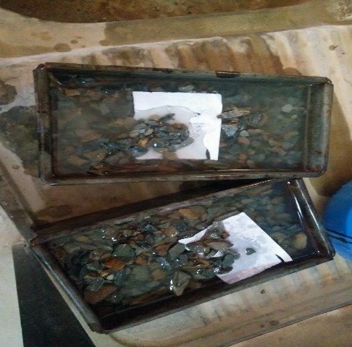
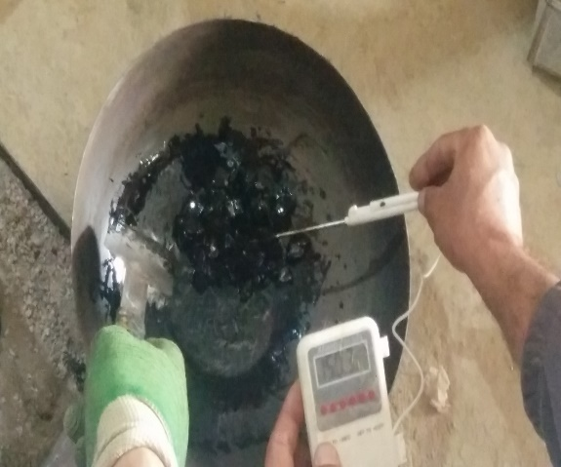
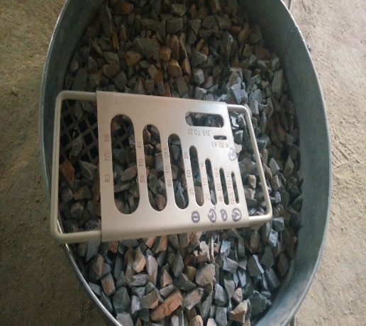
Figure 3.2 Stripping Test and Specific Gravity Test of sample
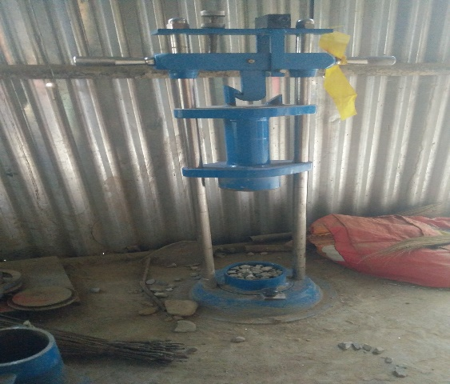
Figure 3.3 AIV and FI test of Samples
The value of LAA is found less which shows the aggregate particle is strong and durable enough to withstand the wear and tear of vehicle load. For the conformity of the lab test, the boulder is collected from the quarry site and crushed manually to required sizes and the LAA test was conducted in the laboratory.
Fine Aggregate
Fine aggregate is the particle that passes the 4.75 mm sieve and is entirely clean and free from all deleterious materials, clay and organic impurities. The physical test conducted for the fine aggregate has been listed below:
Table 3.2 Physical tests for Fine aggregate
S.No. | Test Descriptions | Specification Limit | Test Result | Standard
1 | Specific Gravity Test |  | 2.616 | IS 2386 Part III

Aggregate Gradation
The gradation of the aggregate is the major factor that should be considered for the design of any asphalt pavement in order to maintain the required air voids in the asphalt aggregate mixture. Firstly, the gradation of each aggregate types is carried out individually and is blended in the required proportion so as to meet the required specification. The aggregate is classified into three groups based on the particle size. The blending of aggregates are carried out by trial and error of the different percentage of the aggregate types until meet the required specification as specified in Standard Specification for Road and Bridge works, 2073. The combined gradation curve which satisfies the given limit of specification is shown in Table 3.3 and Figure 3.4.
Table 3.3 Combined Gradation of Aggregate
Sieve Size (mm) | Cumulative % by weight of total aggregate passing |  |  | Combined Gradation | Specification Limit
Sieve Size (mm) | 20mm (40%) | 10mm (14%) | Stone dust (46%) | Combined Gradation | Specification Limit
20 | 40 | 14 | 46 | 100 | 90-100
13.2 | 16.76 | 13.58 | 46 | 76.34 | 59-79
10 | 8.69 | 11.94 | 46 | 66.63 | 52-72
4.75 | 3.04 | 2.42 | 39.04 | 44.49 | 35-55
2.36 | 2.24 | 1.64 | 28.33 | 32.21 | 28-44
1.18 | 0 | 0 | 22.14 | 22.14 | 20-34
0.6 | 1.09 | 0.58 | 16 | 16.00 | 15-27
0.3 | 0 | 0 | 11.99 | 11.99 | 10-20
0.15 | 0 | 0 | 9.21 | 9.21 | 5-13
0.075 | 0.33 | 0.07 | 6.10 | 6.50 | 2-8

Figure 3.4 Limiting grading curve and combined gradation
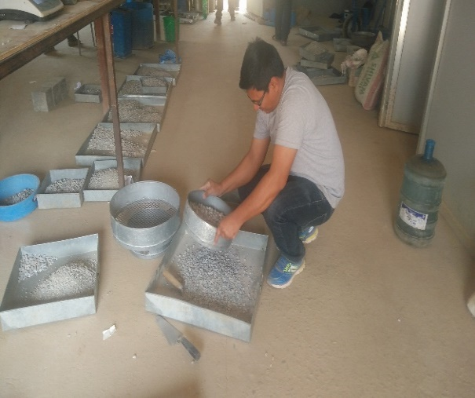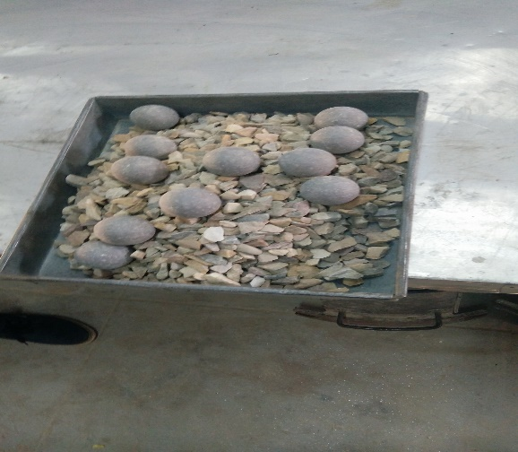
Figure 3.5 Sieve Analysis and Sample Preparation for LAA Test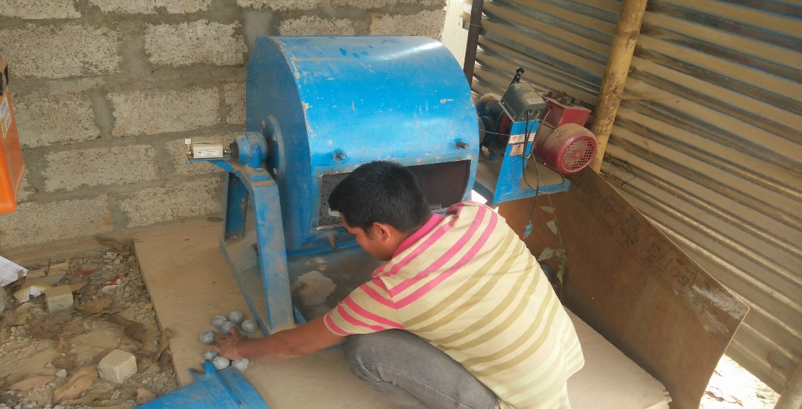
Figure 3.6 LAA Test conducted for Study

Bitumen
The bitumen used for the study is Viscosity Grade VG 30 of Durapave of Indian oil. The different tests of bitumen has been carried out which has been summed up in Table 3.4.
Table 3.4 Standard tests of bitumen
S.N | Characteristics | Method of Test |  | Value | Specification Limit
i | Penetration at 25°C, 100 g, 5 s, 0.1 mm, Min | IS 1203-1978 |  | 59.33 | Minimum 45
ii | Absolute viscosity at 60 °C, Poises | IS 1206 part 2 |  | 2522 | 2400-3600
iii | Kinematic Viscosity at 135 °C Cst | IS 1206: (Part 3) |  | 359 | Minimum 350
iv | Softening point (R & B) °C, | IS 1205-1978 |  | 48.6 | Minimum 47
v | Solubility in Trichloroethylene | IS 1205-1978 |  | 99.5 | 99
vi | Flash Point, Cleveland open cup, °C | IS 1209 |  | 280 | 220
vii | Fire Point °C | IS 1209 |  | 318
viii | Loss on Heating for 5 hours at 163 °C |  |  | 0.263% | < 0.5 %
ix | Ductility at 25 °C, cm | IS 1208 |  | >100 | >100
x | Specific gravity | IS 1202 |  | 1.032

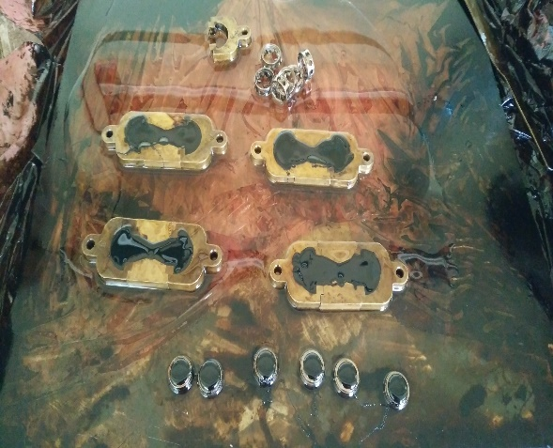
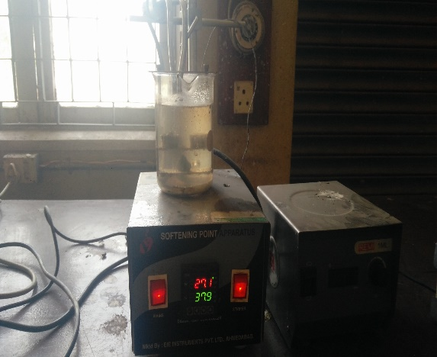
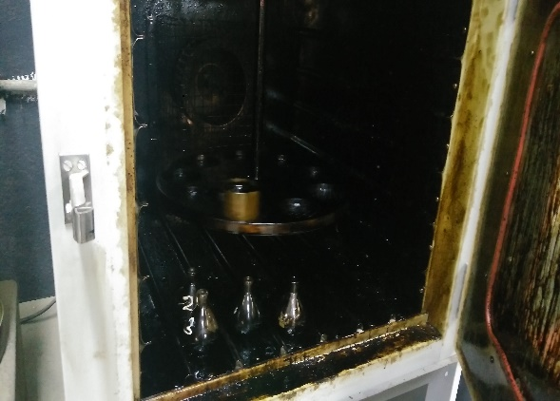
Figure 3.7 Bitumen Tests Samples (Ductility and Softening Point)
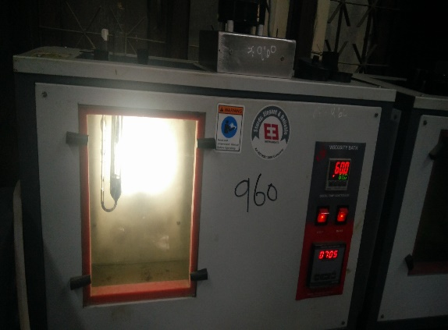
Figure 3.8 Bitumen Tests (Viscosity and Loss on Heating)

Mix Design
The mix design of the asphalt concrete is carried out by testing the five different asphalt contents for a single selected aggregate gradation to obtain the optimum binder content considering the various volumetric and the strength using the Marshall method. For determining the design asphalt content of the mix the series of test specimens is prepared with the increment of asphalt content by 0.5% in order to obtain the well-defined relationship of the data curves.

Laboratory Equipment
The following apparatus has been used for the Marshall test as listed below:
- Hot air Oven
- Balance sensitive to 0.1g for weighing
- Flat bottom metal pans with gas stove for heating
- Thermometer capable of showing temperature more than 300⁰C
- Water bath
- Specimen Extractor
- Compactor with mechanical hammer and compaction mould
- Marshall stability apparatus
- Vernier Calliper

Preparation of Test Specimen
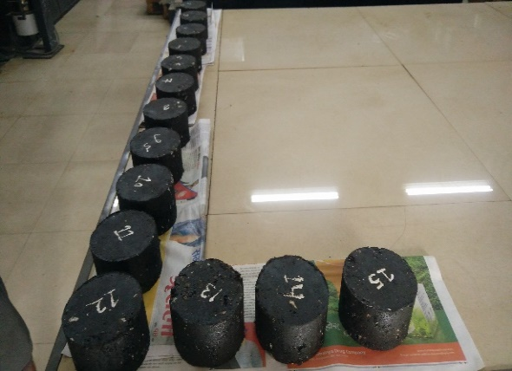
The required weight of the different sizes of aggregate as per the proportion in the combined gradation curve is calculated and weighed separately and blended together and the bitumen content for the mix design is varied by 0.5% increasing from 4% of the weight of the aggregate mix is heated at the temperature of 165⁰C in the hot air oven. The aggregate is first heated to the temperature exceeding 150 ⁰C to 155⁰C and is blended with the preheated bitumen. The total weight of the mixture is kept 1200 gm. The mixture is then again thoroughly heated upto 165⁰C and uniformly mixed before placing in the preheated mould. The mix is then compacted by the standard rammer with height of drop of 457 mm by applying 75 blow on either side. The sample is allowed to cool down and is then extruded carefully from the mould with the help of sample extruder. For each bitumen content minimum of three samples are prepared.
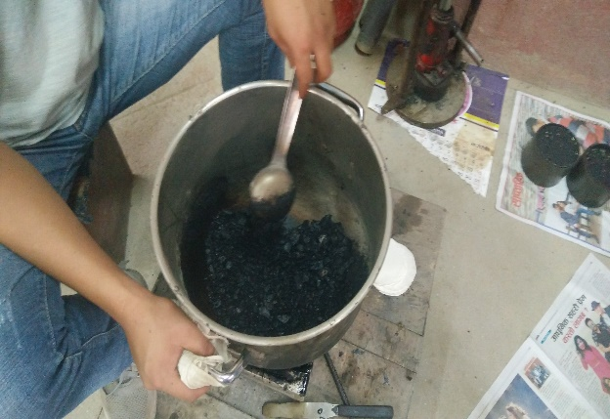
Figure 3.9 Sample Preparation

Test Procedures
The sample prepared is allowed to cool down in the room temperature for 24 hours. The thickness of each sample is taken at three equal distances to calculate the mean thickness of the sample. The weight of the sample in air is taken and the sample is soaked in water for more than 15 minutes. The weight of specimen in water and with saturated surface dry condition is taken to measure the density of the specimen. Then the specimen is kept in the water bath for 30-40 minutes at constant temperature of 60⁰C. Finally the specimen is taken out from water bath and kept in the Marshall testing machine and a constant load was applied at the constant deformation rate of 50.8 mm per minute. The maximum value of the load and corresponding flow value was recorded for further analysis. The obtained value of Marshall Stability is corrected using correction value chart for the specimen having the mean thickness greater or less than 63.5mm. All the Marshall tests were performed in Quality Research and Development Center, DoR, Pulchowk. The testing values obtained are used to calculate the following parameters for finding the optimum binder content of the asphalt mix.
- Marshall stability
- Flow value
- Bulk unit weight (G)
- Maximum Specific Gravity (G_{m})
- Percentage of air voids (AV)
- Voids in Mineral Aggregate (VMA)
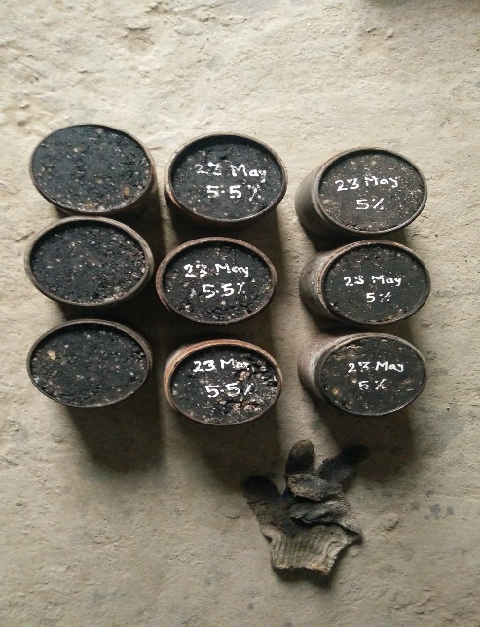
- Voids Filled with Bitumen (VFB)
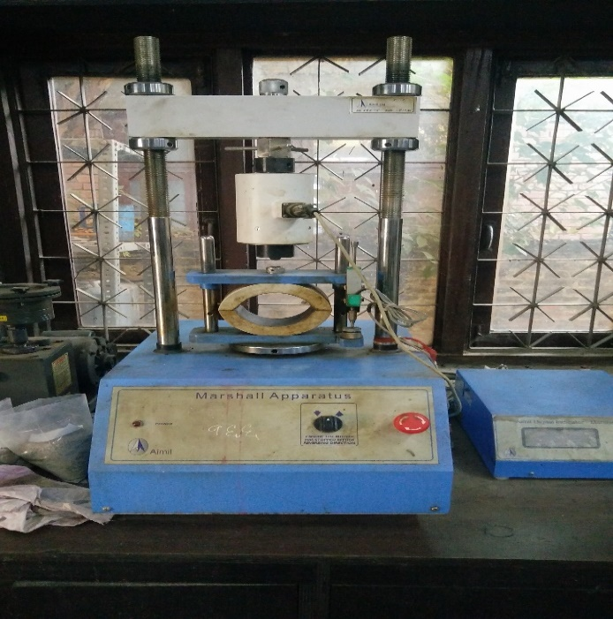
Figure 3.10 Marshall Testing Equipment and Sample Preparation

The corrected Marshall Stability and Flow value of bituminous mixture for determining the OBC are shown in Table 3.5 and other volumetric properties as air voids, VFB, VMA are shown in table 3.6.

Table 3.5 Marshall Stability and Flow Value of Bituminous Specimen
S.N | Bitumen Content (%) | Average Flow Value (mm) |  | Corrected Marshall Stability (KN)
1 | 4 | 2.11 |  | 11.57
2 | 4.5 | 2.39 |  | 13.46
3 | 5 | 2.59 |  | 15.54
4 | 5.5 | 2.74 |  | 14.7
5 | 6 | 2.86 |  | 13.49
6 | 6.5 | 3.00 |  | 9.36

Table 3.6 Volumetric Analysis of Bituminous Specimen
S.N | Bitumen Content (%) | Bulk Unit Weight (gm/cc) | VTM (%) | VMA (%) | VFB (%)
1 | 4 | 2.339 | 7.18 | 16.24 | 55.81
2 | 4.5 | 2.384 | 4.71 | 15.10 | 68.84
3 | 5 | 2.397 | 3.48 | 15.09 | 76.92
4 | 5.5 | 2.408 | 2.30 | 15.13 | 84.80
5 | 6 | 2.412 | 1.44 | 15.45 | 90.71
6 | 6.5 | 2.400 | 1.18 | 16.29 | 92.78

Figure 3.11 Marshall Stability Vs Bitumen Content

Figure 3.12 Flow Value Vs Bitumen Content

Figure 3.13 Bulk Unit Weight Vs Bitumen Content

Figure 3.14 VMA Vs Bitumen Content

Figure 3.15 VTM Vs Bitumen Content

Figure 3.16 VFB Vs Bitumen Content
The optimum binder content of the bituminous mix is calculated by taking the average value of the bitumen content at maximum stability, maximum density and 4% air voids which is shown in table 3.7.
Table 3.7 Determination of Optimum Binder Content
S.N | Description | Binder Content (%)
1 | Bitumen Content at Maximum Density | 5.90
2 | Bitumen Content at Maximum Stability | 5.10
3 | Bitumen Content at 4% Air Voids | 4.67
4 | Average Bitumen Content | 5.22
The optimum binder content of the asphalt mix has found to be at 5.22% bitumen content. The corresponding value of the other parameters at OBC has been shown in Table 3.8.
Table 3.8 Marshall Values at OBC
S.N | Description | Binder Content (%)
1 | Marshall Stability | 15.5
2 | Flow Value | 2.70
3 | Air Voids | 3.0
4 | Bulk Density | 2.40
5 | VFB | 80
CHAPTER FOUR

Results, analysis and discussion

Overheating of the Bitumen
The bitumen is heated in the hot air oven at constant temperature of 185⁰C, 195⁰C, 205⁰C, 215⁰C and 225⁰C for about 3-4 hours and the physical properties of all the heated bitumen samples were tested. When the bitumen is heated at higher temperature the rheological properties of the bitumen get changed and the ageing of the bitumen occurs which has direct effect on the strength of bituminous mixes.

Effect on Properties of Bitumen
The various properties as penetration, softening point and absolute viscosity of different samples of bitumen heated at various temperatures 185⁰C, 195⁰C, 205⁰C, 215⁰C and 225⁰C were tested and the results obtained are shown in table 4.1 below.
Table 4.1 Properties of different samples of bitumen
S.N | Temperatures | Penetration Value (mm) | Softening Point (⁰C) | Viscosity (Poise) | Penetration Index
1 | 165 ⁰C | 59.33 | 48.6 | 2522 | -1.17
2 | 185 ⁰C | 56 | 48.8 | 2589 | -1.25
3 | 195 ⁰C | 53.33 | 49.1 | 2664 | -1.29
4 | 205 ⁰C | 50.33 | 49.3 | 3031 | -1.37
5 | 215 ⁰C | 47 | 51.3 | 4209 | -1.03
6 | 225 ⁰C | 40.33 | 52.5 | 4430 | -1.07

The penetration value of the bitumen decreases with the increase in the overheating temperature of bitumen. The results are shown in graph below:

Figure 4.1 Penetration Value Vs Overheating Temperature of Bitumen
The softening point of the bitumen increases with increasing temperature of the overheated bitumen. The results are shown below:

Figure 4.2 Softening Vs Overheating Temperature of Bitumen
The absolute viscosity of the bitumen increases with increasing temperature of the bitumen. We can see that when the bitumen is overheated it is more viscous because of the loss of the volatile materials and the occurrence of oxidation and ageing which makes bitumen stiffer. The results are shown below:

Figure 4.3 Absolute Viscosity Vs Overheating Temperature of Bitumen

Penetration Index of the bitumen is the quantitative measure of the bitumen to the given temperature. It should have the value ranging from -2 to +2. When PI is low, the bitumen becomes very brittle at lower temperature and when PI is high it has more resistance to permanent deformation. As the result shows that the PI value decreases with increase in temperature but at temperature 215⁰C the PI value increases. Hence when the bitumen is heated beyond the temperature the brittleness of the asphalt concrete increases which will result in cracking and low durability. The PI of the bitumen is calculated by the formula:

$$\text{PI} \text{=}\frac{\text{1952-500}\text{log}{\text{pen-20 softening point}}}{\text{50}\text{log}{\text{pen-softening point-120}}}$$
Where,
PI = Penetration Index
Pen= Penetration Value
(John Read, David Whiteoak, 2003)

Figure 4.4 Penetration Index Vs Overheating Temperature of Bitumen

Effect on Properties of Asphalt Concrete
The Marshall mix design is carried out for each sample of bitumen heated at different temperatures 185⁰C, 195⁰C, 205⁰C, 215⁰C and 225⁰C to find out the optimum binder content and the change in other volumetric measures. For each variations in the temperature the optimum binder content is calculated and the corresponding values of VMA, VTM, VFB, Marshall stability, flow and density is computed.

Maximum Density
The density of the asphalt mix at higher temperature continuously increases sharply and after certain binder content the curve gently increases. So considering the binder content at maximum density, maximum stability and 4% air voids the results thus obtained has been shown in table 4.2 and 4.3.
Table 4.2 Marshall properties of bituminous mixes at different temperatures
S.N | Temperatures | OBC (%) | Stability (KN) | Flow (mm)
1 | 165 ⁰C | 5.22 | 15.5 | 2.70
2 | 185 ⁰C | 5.33 | 13.7 | 2.74
3 | 195 ⁰C | 5.37 | 13.6 | 2.74
4 | 205 ⁰C | 5.42 | 13.3 | 2.75
5 | 215 ⁰C | 5.57 | 13.2 | 2.82
6 | 225 ⁰C | 5.40 | 11 | 2.82

Table 4.3 Marshall Properties of bituminous mixes at different temperatures
S.N | Temperatures | OBC (%) | Bulk Unit Weight (gm/cc) | VTM (%) | VMA (%) | VFB (%)
1 | 165 ⁰C | 5.22 | 2.40 | 3.0 | 15.1 | 80
2 | 185 ⁰C | 5.33 | 2.40 | 2.90 | 15.3 | 81
3 | 195 ⁰C | 5.37 | 2.405 | 2.70 | 15.2 | 82.5
4 | 205 ⁰C | 5.42 | 2.415 | 2.20 | 14.8 | 85
5 | 215 ⁰C | 5.57 | 2.418 | 1.80 | 14.9 | 87
6 | 225 ⁰C | 5.40 | 2.42 | 1.90 | 14.7 | 87

The Marshall Stability value decreases with the increase in the temperature of the overheated bitumen. When the bitumen is overheated the bitumen will be less viscous and hence makes sufficient coating of the aggregate and the filling the excess voids in the mix. At the same time the rheological properties of the bitumen also changes due to which durability of the mix decreases. So, the bulk density, OBC, flow value and VFB increases with the increases of temperature and VTM and VMA decreases with the increase in the temperature of bitumen which has been shown in graph below:

Figure 4.5 Stability Vs Overheating Temperature of Bitumen

Figure 4.6 Flow Vs Overheating Temperature of Bitumen

Figure 4.7 Air Voids Vs Overheating Temperature of Bitumen

Figure 4.8 OBC Vs Overheating Temperature of Bitumen

Figure 4.9 Bulk Unit Weight Vs Overheating Temperature of Bitumen

Figure 4.10 VFB Vs Overheating Temperature of Bitumen

Figure 4.11 VMA Vs Overheating Temperature of Bitumen

Optimum Binder Content
As the binder is overheated the OBC increases but taking consideration to the OBC of the original sample of the bitumen which is not overheated which is at 5.22%, the Marshall Stability, Flow Value and VTM decreases with the increase in temperature and VFB increases with the increasing temperature. The results has been shown in the table and graph below:
Table 4.4 Marshall Properties at Binder content 5.22 % at different temperatures
S.N | Temperatures | Stability (KN) | Flow (mm) | Bulk Unit Weight (gm/cc) | VTM (%) | VFB (%) | VMA (%)
1 | 165 ⁰C | 15.5 | 2.70 | 2.40 | 3.0 | 80 | 15.1
2 | 185 ⁰C | 14.0 | 2.60 | 2.40 | 3.0 | 80 | 15.3
3 | 195 ⁰C | 14.0 | 2.60 | 2.4 | 3.0 | 80 | 15.3
4 | 205 ⁰C | 13.30 | 2.60 | 2.41 | 2.7 | 82 | 14.75
5 | 215 ⁰C | 13.30 | 2.58 | 2.41 | 2.7 | 82 | 15
6 | 225 ⁰C | 11.50 | 2.58 | 2.40 | 2.7 | 82 | 15

Figure 4.12 Stability Vs Bitumen content at different overheating temperatures

Figure 4.13 Flow Vs Bitumen content at different overheating temperatures

Figure 4.14 Bulk Density Vs Bitumen content at different overheating temperatures

Figure 4.15 VTM Vs Bitumen content at different overheating temperatures

Figure 4.16 VFB Vs Bitumen content at different overheating temperatures

Figure 4.17 VMA Vs Bitumen content at different overheating temperatures

CHAPTER FIVE:

FINDINGS AND CONCLUSIONS
From the study the following conclusion could be done:
- The penetration of the overheated bitumen decreases with increase in temperature and the softening point and viscosity of the overheated bitumen increases with the increase in temperature. This is obvious that when the bitumen is overheated it loses the volatile materials and oxide with oxygen to become stiffer.
- The Penetration index of the bitumen is found to be less at 215⁰C. So, the properties of the bitumen changes when heated at higher temperature and will become more brittle and the asphalt mix will be more prone to cracking.
- The OBC of the asphalt mix with the overheated bitumen is found to increase with the temperature. Similarly, the air voids decreases and VFB increases as the bitumen becomes less viscous when heated at higher temperature and the aggregate minerals are coated thickly and more voids is filled.
- The Stability of the mix decreases by about 30% than the original value with the increase in the temperature of overheated bitumen.
- The unit weight of the mix increases due to thicker coating of the aggregate minerals and more voids are filled with increase in temperature of bitumen.
- Taking the consideration of the OBC of the original mix, the Stability value of the mix is found to be decreased by 25% and the flow value decreased by about 5%. So, during the construction works the temperature of the bitumen should be carefully checked and should not be overheated. The overheating of the bitumen will decrease the strength of the mix and make bitumen more brittle.

REFERENCES
- Michal Sarnowski, Karol J. Kowalski, Jan B. Krol and Piotr Radziszewski, 2019, “Influence of Overheating phenomenon on Bitumen and Asphalt Mixture Properties” Faculty of Civil Engineering, Warsaw University of Technology, 00-637 Warsaw, Poland.
- Senja Rum Harnaeni, F. Pungky Pramesti, Arif Budiarto and Ary Setyawan, 2018, “The Effect of Temperature Changes on Mechanistic Performance of Hotmix Asphalt as Wearing Course with Different Gradation Types”, AIP Conference Proceedings 1977, 030026.
- Marshall design and analysis, School of Engineering, Cochin University of Science and Technology, Chapters, 4, p.53.
- Christine W. Curtis, Keith Ensley and Jon Epps, 1993, “ Fundamental Properties of Asphalt-Aggregate Interactions including adhesion and absorption”, Strategic Highway Research Program, National Research Council, Washingon DC
- E. Brown, J. McRae, and A. Crawley, 1989,” Effect of Aggregates on Performance of Bituminous Concrete”, in Implication of Aggregates in the Design, Construction, and Performance of Flexible Pavements, ed. H. Schreuders and C. Marek (West Conshohocken, PA: ASTM International).
- Randolph C. Ahlrich, 1996, “Influence of aggregate gradation and particle shape/ texture on Permanent Deformation of Hot Mix asphalt pavement”, US Army Corps of Engineers, Technical Report GL-96-1
- Kishan K. Vachhani, Prof. C.B. Mishra, 2014, “Assessing the impact of VG30 grade bitumen with and without additive (EVA) on short term aging”, IOSR Journal of Mechanical and Civil Engineering (IOSR-JMCE) e-ISSN: 2278-1684, p-ISSN: 2320-334X, Volume 11, Issue 6 Ver. V , P, 36-40.
- Ivica Androjic, 2016, “ Ageing of Hot mix asphalt”, University of Rijeka.
- Stefan Vansteenkiste, Hilde Soenen and Gerhard Eberl, 2015, “ Functional durability- related bitumen specification (FunDBitS), Corelations between bitumen and asphalt properties”, CEDR Transnational Road Research Programme Call 2013: Energy Efficiency- Materials and Technology.
- Lorena Garcia Cucalon, Amit Bhasin, Emad Kassem, 2017, “Physicochemical characterization of Binder-Aggregate adhesion varying with temperature and moisture”, Journal of Transportation Engineering, Part B: Pavements/ Volume 143 Issue 3.
- Standard Specifications for Road and Bridge work 2073, Government of Nepal, Ministry of Physical Infrastructure and Transport, Department of Roads.
- Carole Gueit, Michel Robert, A5EE-337, “Durability of a bitumen in a hot mix asphalt; Consequences of Overheating at the mixing plant”, Colas Campus for Science and Techniques, Road Chemistry Service, Magny-les-Hameaux, France
- Sumit K. Singh, Yogesh Kumar, Sham S. Ravindranath, “Thermal Degradation of SBS in bitumen during storage: Influence of temperature, SBS concentration, Polymer type and Base Bitumen, Department of Polymer and Process Engineeering, Indian Institute of Technology Roorkee, Uttarakhand, India.
- Piotr Radziszewski, Jerzy Pilat,Michal Sarnowski, Karol J, Kowalsi and Jan B. Krol, 2015, “Influence of high temperature on properties of materials used in bridge asphalt pavement structures”, Road and Bridges- Drogi I Mosty, 14,3,2015, 175-191.
- M Mustafa Kamal etal, 2017, “Comparative Study of the modified bitumen binder properties collected from mixing plant and quarry”, Conf. Ser. Mater. Sci. Eng. 271 012010, 2017 IOP.
- Woro Partini Maryunani, Evi Puspitasari, Muhammad Amin and Dwi Sat Agus Yuwana, “ The study of temperature changes on asphalt concrete wearing course (AC-WC) mixing process on Marshall Characteristics”, Civil Engineering Department, Tidar University, Jl. Kapten S. Parman no. 39 Magelang, Indonesia.
- John Read and David Whiteoak, 2003, “The Shell Bitumen Book” PP 135-138.

APPENDIX -I: SIEVE ANALYSIS
- Coarse Aggregate (Size 20mm- 10mm)
Sieve Size (mm) | Weight Retained (gm) | % Retained | Cumulative Weight % Retained | Cumulative Weight % Passing | Remarks
20 | 0 | 0.00% | 0.00% | 100.00%
16 | 2899 | 34.39% | 34.39% | 65.61%
13.2 | 1998 | 23.70% | 58.09% | 41.91%
9.5 | 1702 | 20.19% | 78.28% | 21.72%
4.75 | 1191 | 14.13% | 92.41% | 7.59%
2.36 | 167 | 1.98% | 94.39% | 5.61%
0.6 | 243 | 2.88% | 97.27% | 2.73%
0.075 | 160 | 1.90% | 99.17% | 0.83%
Pan | 70 | 0.83% | 100.00% | 0.00%
Total weight | 8430

- Coarse Aggregate ( Size 10mm – 4.75 mm)
Sieve Size (mm) | Weight Retained (gm) | % Retained | Cumulative Weight % Retained | Cumulative Weight % Passing | Remarks
16 | 100 | 0.90% | 0.90% | 99.10%
13.2 | 234 | 2.12% | 3.02% | 96.98%
9.5 | 1294 | 11.71% | 14.73% | 85.27%
4.75 | 7514 | 67.99% | 82.72% | 17.28%
2.36 | 618 | 5.59% | 88.31% | 11.69%
0.6 | 832 | 7.53% | 95.84% | 4.16%
0.075 | 406 | 3.67% | 99.51% | 0.49%
pan | 54 | 0.49% | 100.00% | 0.00%
Total weight | 11052

- Stone Dust
Sieve Size (mm) | Weight Retained (gm) | % Retained | Cumulative Weight % Retained | Cumulative Weight % Passing | Remarks
9.5 | 0 | 0.00% | 0.00% | 100.00%
4.75 | 92.32 | 15.14% | 15.14% | 84.86%
2.36 | 141.98 | 23.28% | 38.42% | 61.58%
1.18 | 82.1 | 13.46% | 51.88% | 48.12%
0.6 | 103.5 | 16.97% | 68.85% | 31.15%
0.3 | 30.99 | 5.08% | 73.93% | 26.07%
0.15 | 36.85 | 6.04% | 79.97% | 20.03%
0.075 | 41.37 | 6.78% | 86.75% | 13.25%
pan | 0.36 | 0.06% | 86.81% | 13.19%
Total weight | 529.47
Total weight before washing | 609.9

APPENDIX -II: AGGREGATE TESTS
- LOS ANGELES ABRATION TEST
S.No. | Description | Unit | Quantity | Remarks
1 | Grading Used | No. | B
2 | No. of Sphere Used | No. | 11
3 | No. of Revolution | No. | 500
4 | Original Weight of Test Sample (W) | gm | 5000
5 | Wt. Retained on 1.70mm IS Sieve (W1) | gm | 4232
6 | LAA (W-W1)/Wx100 | % | 15.36%

- AGGREGATE IMPACT VALUE TEST
S.No. | Description | Unit | Quantity | Remarks
1 | Weight of Mould and Compacted Sample | gm | 2319.9
2 | Weight of Mould | gm | 1846.2
3 | Weight of Compacted Sample | gm | 473.7
4 | Weight of Sample Passing Through 2.36mm Sieve | gm | 51.3
5 | Aggregate Impact Value | % | 10.83%

- SPECIFIC GRAVITY TEST
- Coarse Aggregate (20mm- 10mm)
S.No. | Description |  | Unit | Quantity | Remarks
1 | Wt. of pan + Saturated surface dry sample | A1 | gm | 2308.5
2 | Wt. of pan | A2 | gm | 404.8
3 | Wt. of saturated surface dry sample | A=A1-A2 | gm | 1903.7
4 | Wt. of basket + sample in water | B1 | gm | 1737.3
5 | Wt. of basket in water | B2 | gm | 547.7
6 | Wt. of sample in water | B=B1-B2 | gm | 1189.6
S.No. | Description |  | Unit | Quantity | Remarks
7 | Wt. of pan oven dry sample | C1 | gm | 2280.72
8 | Wt. of pan | C2 | gm | 404.8
9 | Wt. of oven dry sample | C=C1-C2 | gm | 1875.92
 | Bulk gravity (Oven dry) = C/(B-A) |  |  | 2.63
 | Bulk gravity (SSD)= B/(B-A) |  |  | 2.67
 | Apparent Gravity= C/(C-A) |  |  | 2.73

- Coarse Aggregate (10mm- 4.75mm)
S.No. | Description |  | Unit | Quantity | Remarks
1 | Wt. of pan + Saturated surface dry sample | A1 | gm | 2038.4
2 | Wt. of pan | A2 | gm | 408.7
3 | Wt. of saturated surface dry sample | A=A1-A2 | gm | 1629.7
4 | Wt. of basket + sample in water | B1 | gm | 1562.5
5 | Wt. of basket in water | B2 | gm | 547.7
6 | Wt. of sample in water | B=B1-B2 | gm | 1014.8
7 | Wt. of pan oven dry sample | C1 | gm | 2004.73
8 | Wt. of pan | C2 | gm | 408.7
9 | Wt. of oven dry sample | C=C1-C2 | gm | 1596.03
 | Bulk gravity (Oven dry) = C/(B-A) |  |  | 2.60
 | Bulk gravity (SSD)= B/(B-A) |  |  | 2.65
 | Apparent Gravity= C/(C-A) |  |  | 2.75

- Stone Dust
S.No. | Description |  | Unit | Quantity | Remarks
1 | Wt. of Pycnometer + water (Full) | A | gm | 680.9
2 | Wt. of Pycnometer empty and dry | B | gm | 154.9
3 | Temperature of Water | T1 | °C | 25
4 | Wt. of Pycnometer + Oven dry sample | C | gm | 465.1
5 | Wt. of Oven dry sample | D=C-B | gm | 310.2
6 | Wt. of Pycnometer + Sample + Water (Full) | E | gm | 872.9
7 | Temperature of Water | T2 | °C | 25
8 | Relative Density of Water at temperature T2 | Gw |  | 0.997
 | Specific gravity = Gw x D/(D+A-E) |  |  | 2.616

- FLAKINESS INDEX
Flakiness Slot Size Identification | Wt. Retained on flakiness plate (Grams) | Wt. Passing on flakiness plate (Grams) | Total Weight Tested | Remarks
mm | A | B | C=A+B
25 to 19 | 0 | 0 | 0
19 to 16 | 394 | 100 | 494
16 to 12.5 | 570 | 146 | 716
12.5 to 9.5 | 530 | 206 | 736
9.5 to 6.3 | 380 | 120 | 500
Total | 1874 | 572 | 2446
Flakiness Index | B/C | 23.39%
- ELONGATION INDEX
Elongation Slot Size Identification | Wt. Retained on elongation plate (Grams) | Wt. Passing on elongation plate (Grams) | Total Weight Tested | Remarks
mm | A | B | C=A+B
25 to 19 | 0 | 0 | 0
19 to 16 | 116 | 374 | 490
16 to 12.5 | 168 | 548 | 716
12.5 to 9.5 | 132 | 424 | 556
9.5 to 6.3 | 70 | 180 | 250
Total | 486 | 1526 | 2012
Elongation Index | A/C | 24.16%

- WATER ABSORPTION TEST
S.No. | Description |  | Unit | Quantity | Remarks
1 | Wt. of pan + Saturated surface dry sample | A1 | gm | 5987.7
2 | Wt. of pan | A2 | gm | 408.7
3 | Wt. of saturated surface dry sample | A=A1-A2 | gm | 5579
4 | Wt. of pan oven dry sample | B1 | gm | 5957.7
5 | Wt. of pan | B2 | gm | 408.7
6 | Wt. of oven dry sample | B=B1-B2 | gm | 5549
 | Water Absorption | (A-B)/B | % | 0.54

APPENDIX -III: BITUMEN TESTS
- SOLUBILITY TEST
S.No. | Description | Unit | Quantity | Remarks
1 | Wt. of Sample + Filter Paper (A) | gm | 2.575
2 | Wt. of Filter Paper (B) | gm | 0.575
3 | Wt. of Sample (C=A-B) | gm | 2.000
4 | Wt of Filter paper + Residue D | gm | 0.585
5 | Wt of Insoluble E= (D-B) | gm | 0.010
6 | Solubility 100-E/Cx100 | % | 99.5

- SPECIFIC GRAVITY
S.No | Description |  | Unit | Quantity | Remarks
1 | Wt. of Pycnometer | (a) | gm | 33.99
2 | Wt. of Pycnometer + Distilled water | (b) | gm | 84.737
3 | Wt. of Pycnometer + Sample | (c) | gm | 59.518
4 | Wt of Pycnometer + Sample+ Water | (d) | gm | 85.533
5 | Sp. Gravity 25º C (c-a)/(b-a)-(d-c) |  |  | 1.032

- LOSS ON HEATING
S.No | Description |  | Unit | Quantity | Remarks
1 | Wt. of sample + Container before heating | (a) | gm | 99.538
2 | Wt. of Container + Sample after heating (5 hrs at 163º C) | (b) | gm | 99.394
3 | Wt. of loss (a-b) | (c) | gm | 0.144
4 | Wt of Container | (d) | gm | 44.705
5 | Loss on Heating % (c/a-d x 100) |  |  | 0.263

APPENDIX -IV: Marshall TESTS
- MIX DESIGN OF SAMPLE AT 165⁰C
Calculation of Marshall Stability and Flow Values
S.No. | % Bitumen | Thickness (mm) |  |  | Mean Thickness (mm) | Flow (mm) | Average Flow (mm) | Stability (KN) | Correction Factor | Corrected Stability | Average Stability (KN) | Remarks
1 | 4.0% | 65.2 | 65.3 | 65.4 | 65.3 | 1.98 | 2.11 | 11 | 0.96 | 10.52 | 11.57
2 | 4.0% | 62.8 | 63.7 | 62.8 | 63.1 | 2.24 | 2.11 | 12.5 | 1.01 | 12.63 | 11.57
3 | 4.5% | 62.6 | 62.3 | 63.7 | 62.9 | 2.44 | 2.39 | 13.7 | 1.02 | 13.92 | 13.46
4 | 4.5% | 62.5 | 63.1 | 62.4 | 62.7 | 2.39 | 2.39 | 14.6 | 1.02 | 14.90 | 13.46
5 | 4.5% | 64.2 | 64.3 | 64.5 | 64.3 | 2.33 | 2.39 | 11.8 | 0.98 | 11.55 | 13.46
6 | 5.0% | 61.9 | 61.4 | 60.5 | 61.3 | 2.53 | 2.59 | 14.1 | 1.06 | 14.94 | 15.54
7 | 5.0% | 63.2 | 62.7 | 62.6 | 62.8 | 2.67 | 2.59 | 16.1 | 1.02 | 16.37 | 15.54
8 | 5.0% | 62.8 | 63.4 | 62.6 | 62.9 | 2.57 | 2.59 | 15.1 | 1.01 | 15.31 | 15.54
9 | 5.5% | 62.8 | 62.2 | 62.2 | 62.4 | 2.69 | 2.74 | 14.1 | 1.03 | 14.49 | 14.70
10 | 5.5% | 62.3 | 62.7 | 62.1 | 62.4 | 2.84 | 2.74 | 15.6 | 1.03 | 16.04 | 14.70
S.No. | % Bitumen | Thickness (mm) |  |  | Mean Thickness (mm) | Flow (mm) | Average Flow (mm) | Stability (KN) | Correction Factor | Corrected Stability | Average Stability (KN) | Remarks
11 | 5.5% | 61.6 | 62.1 | 62.4 | 62.0 | 2.68 |  | 13.1 | 1.04 | 13.58
12 | 6.0% | 63.1 | 63.3 | 62.8 | 63.1 | 2.87 | 2.86 | 11.1 | 1.01 | 11.22 | 13.49
13 | 6.0% | 60.7 | 60.6 | 60.5 | 60.6 | 2.83 | 2.86 | 13.1 | 1.08 | 14.16 | 13.49
14 | 6.0% | 62.2 | 62.2 | 62.1 | 62.2 | 2.87 | 2.86 | 14.6 | 1.03 | 15.09 | 13.49
15 | 6.5% | 62.2 | 62.5 | 62.4 | 62.4 | 3.00 | 3.00 | 9.1 | 1.03 | 9.36 | 9.36

Calculation of Density of the Compacted Sample
S.No. | % Bitumen | Wt. of compacted A/C sample (gm) |  |  | Bulk density of compacted A/C mix in gm/cc | Average bulk density of compacted A/C mix in gm/cc | Remarks
S.No. | % Bitumen | Wt. of A/C comp. in air | Wt. of A/C comp. in water | Wt. of A/C comp. SSD in air | Bulk density of compacted A/C mix in gm/cc | Average bulk density of compacted A/C mix in gm/cc | Remarks
1 | 4.0% | 1190.3 | 688.3 | 1202.2 | 2.32 | 2.339
2 | 4.0% | 1175.1 | 689.1 | 1186.5 | 2.36 | 2.339
S.No. | % Bitumen | Wt. of compacted A/C sample (gm) |  |  | Bulk density of compacted A/C mix in gm/cc | Average bulk density of compacted A/C mix in gm/cc | Remarks
S.No. | % Bitumen | Wt. of A/C comp. in air | Wt. of A/C comp. in water | Wt. of A/C comp. SSD in air | Bulk density of compacted A/C mix in gm/cc | Average bulk density of compacted A/C mix in gm/cc | Remarks
3 | 4.5% | 1190.1 | 700.2 | 1196.1 | 2.40 | 2.384
4 | 4.5% | 1185.9 | 694.5 | 1191.2 | 2.39 | 2.384
5 | 4.5% | 1197.1 | 701.7 | 1208.1 | 2.36 | 2.384
6 | 5.0% | 1170.6 | 685.7 | 1173 | 2.40 | 2.397
7 | 5.0% | 1191.9 | 695.3 | 1196 | 2.38 | 2.397
8 | 5.0% | 1205.6 | 706.3 | 1207.2 | 2.41 | 2.397
9 | 5.5% | 1194.9 | 699.5 | 1196.7 | 2.40 | 2.408
10 | 5.5% | 1191.7 | 699.1 | 1193.3 | 2.41 | 2.408
11 | 5.5% | 1187.4 | 695.8 | 1188.6 | 2.41 | 2.408
12 | 6.0% | 1200.8 | 702.8 | 1201.7 | 2.41 | 2.412
13 | 6.0% | 1168.7 | 686.3 | 1169.5 | 2.42 | 2.412
14 | 6.0% | 1189.3 | 696.3 | 1189.9 | 2.41 | 2.412
15 | 6.5% | 1186.8 | 693.3 | 1187.7 | 2.40 | 2.400

Volumetric Analysis of Marshall Samples
S.No. | % Bitumen | Sp. Gravity of agg. Mix | Sp. Gravity of Bitumen | % Aggregate Mix | Density of compacted A/C mix in gm/cc | Max. sp. Gr | Air Voids % | VMA % | VFB % | Remarks
1 | 4.0% | 2.681 | 1.032 | 96.0% | 2.339 | 2.520 | 7.179% | 16.24% | 55.81%
2 | 4.5% | 2.681 | 1.032 | 95.5% | 2.384 | 2.501 | 4.705% | 15.10% | 68.84%
3 | 5.0% | 2.681 | 1.032 | 95.0% | 2.397 | 2.483 | 3.482% | 15.09% | 76.92%
4 | 5.5% | 2.681 | 1.032 | 94.5% | 2.408 | 2.465 | 2.301% | 15.13% | 84.80%
5 | 6.0% | 2.681 | 1.032 | 94.0% | 2.412 | 2.447 | 1.435% | 15.45% | 90.71%
6 | 6.5% | 2.681 | 1.032 | 93.5% | 2.400 | 2.429 | 1.177% | 16.29% | 92.78%

- MIX DESIGN OF SAMPLE AT 185⁰C
Calculation of Marshall Stability and Flow Values
S.No. | % Bitumen | Thickness (mm) |  |  | Mean Thickness (mm) | Flow (mm) | Average Flow (mm) | Stability (KN) | Correction Factor | Corrected Stability | Average Stability (KN) | Remarks
1 | 4.5% | 64.8 | 65.2 | 64.4 | 64.8 | 2.43 | 2.29 | 13.6 | 0.97 | 13.15 | 12.82
2 | 4.5% | 64.9 | 64.5 | 64.6 | 64.7 | 2.3 | 2.29 | 12.1 | 0.97 | 11.75 | 12.82
3 | 4.5% | 63.4 | 63.5 | 63.0 | 63.3 | 2.14 | 2.29 | 13.5 | 1.00 | 13.56 | 12.82
4 | 5.0% | 62.7 | 63.3 | 62.6 | 62.9 | 2.61 | 2.52 | 16.1 | 1.02 | 16.35 | 14.18
5 | 5.0% | 63.2 | 63.0 | 63.4 | 63.2 | 2.51 | 2.52 | 12.8 | 1.01 | 12.89 | 14.18
6 | 5.0% | 62.9 | 63.5 | 64.0 | 63.5 | 2.43 | 2.52 | 13.3 | 1.00 | 13.31 | 14.18
7 | 5.5% | 64.3 | 64.0 | 63.5 | 63.9 | 2.65 | 2.76 | 13.8 | 0.99 | 13.65 | 12.88
8 | 5.5% | 62.1 | 62.0 | 61.3 | 61.8 | 2.78 | 2.76 | 13.6 | 1.04 | 14.19 | 12.88
9 | 5.5% | 61.8 | 62.7 | 62.7 | 62.4 | 2.85 | 2.76 | 10.5 | 1.03 | 10.79 | 12.88
10 | 6.0% | 63.3 | 63.2 | 64.0 | 63.5 | 2.92 | 2.91 | 12.1 | 1.00 | 12.10 | 11.93
11 | 6.0% | 63.2 | 62.5 | 62.3 | 62.7 | 2.86 | 2.91 | 10.8 | 1.02 | 11.02 | 11.93
S.No. | % Bitumen | Thickness (mm) |  |  | Mean Thickness (mm) | Flow (mm) | Average Flow (mm) | Stability (KN) | Correction Factor | Corrected Stability | Average Stability (KN) | Remarks
12 | 6.0% | 63.6 | 61.9 | 61.4 | 62.3 | 2.95 |  | 12.3 | 1.03 | 12.67
13 | 6.5% | 61.8 | 61.4 | 60.8 | 61.3 | 3.46 | 3.27 | 10.3 | 1.06 | 10.90 | 10.79
14 | 6.5% | 64.5 | 63.7 | 63.5 | 63.9 | 3.13 | 3.27 | 10.8 | 0.99 | 10.69 | 10.79
15 | 6.5% | 62.3 | 63.0 | 62.0 | 62.4 | 3.22 | 3.27 | 10.5 | 1.03 | 10.78 | 10.79
Calculation of Density of the Compacted Sample
S.No. | % Bitumen | Wt. of compacted A/C sample (gm) |  |  | Bulk density of compacted A/C mix in gm/cc | Average bulk density of compacted A/C mix in gm/cc | Remarks
S.No. | % Bitumen | Wt. of A/C comp. in air | Wt. of A/C comp. in water | Wt. of A/C comp. SSD in air | Bulk density of compacted A/C mix in gm/cc | Average bulk density of compacted A/C mix in gm/cc | Remarks
1 | 4.5% | 1197.4 | 694.3 | 1205.8 | 2.34 | 2.362
2 | 4.5% | 1200 | 705.3 | 1209 | 2.38 | 2.362
3 | 4.5% | 1190.1 | 697.4 | 1201 | 2.36 | 2.362
4 | 5.0% | 1191.5 | 692.9 | 1193.7 | 2.38 | 2.392
S.No. | % Bitumen | Wt. of compacted A/C sample (gm) |  |  | Bulk density of compacted A/C mix in gm/cc | Average bulk density of compacted A/C mix in gm/cc | Remarks
S.No. | % Bitumen | Wt. of A/C comp. in air | Wt. of A/C comp. in water | Wt. of A/C comp. SSD in air | Bulk density of compacted A/C mix in gm/cc | Average bulk density of compacted A/C mix in gm/cc | Remarks
5 | 5.0% | 1186.3 | 696.5 | 1190.2 | 2.40 | 2.392
6 | 5.0% | 1182.2 | 692.5 | 1186.4 | 2.39 | 2.392
7 | 5.5% | 1217.7 | 706.6 | 1218.9 | 2.38 | 2.401
8 | 5.5% | 1178.2 | 694.8 | 1179.4 | 2.43 | 2.401
9 | 5.5% | 1175.8 | 688.5 | 1179.2 | 2.40 | 2.401
10 | 6.0% | 1216.1 | 713.4 | 1217.2 | 2.41 | 2.405
11 | 6.0% | 1187.3 | 692.6 | 1189.7 | 2.39 | 2.405
12 | 6.0% | 1183.9 | 694.8 | 1185.2 | 2.41 | 2.405
13 | 6.5% | 1176.1 | 689.5 | 1176.7 | 2.41 | 2.402
14 | 6.5% | 1215.7 | 707.2 | 1216.8 | 2.39 | 2.402
15 | 6.5% | 1177.7 | 689.6 | 1178.9 | 2.41 | 2.402

Volumetric Analysis of Marshall Samples
S.No. | % Bitumen | Sp. Gravity of agg. Mix | Sp. Gravity of Bitumen | % Aggregate Mix | Density of compacted A/C mix in gm/cc | Max. sp. Gr | Air Voids % | VMA % | VFB % | Remarks
1 | 4.5% | 2.681 | 1.032 | 95.5% | 2.362 | 2.501 | 5.569% | 15.87% | 64.90%
2 | 5.0% | 2.681 | 1.032 | 95.0% | 2.392 | 2.483 | 3.669% | 15.26% | 75.95%
3 | 5.5% | 2.681 | 1.032 | 94.5% | 2.401 | 2.465 | 2.568% | 15.36% | 83.29%
4 | 6.0% | 2.681 | 1.032 | 94.0% | 2.405 | 2.447 | 1.688% | 15.67% | 89.23%
5 | 6.5% | 2.681 | 1.032 | 93.5% | 2.402 | 2.429 | 1.108% | 16.23% | 93.18%

- MIX DESIGN OF SAMPLE AT 195⁰C
Calculation of Marshall Stability and Flow Values
S.No. | % Bitumen | Thickness (mm) |  |  | Mean Thickness (mm) | Flow (mm) | Average Flow (mm) | Stability (KN) | Correction Factor | Corrected Stability | Average Stability (KN) | Remarks
1 | 4.5% | 64.5 | 64.8 | 64.8 | 64.7 | 2.48 | 2.41 | 11.1 | 0.97 | 10.76 | 11.10
2 | 4.5% | 66.9 | 68.3 | 66.7 | 67.3 | 2.3 | 2.41 | 10.9 | 0.91 | 9.97 | 11.10
3 | 4.5% | 63.3 | 63.7 | 63.6 | 63.6 | 2.44 | 2.41 | 12.6 | 1.00 | 12.58 | 11.10
4 | 5.0% | 62.6 | 62.4 | 62.5 | 62.5 | 2.34 | 2.54 | 14.1 | 1.03 | 14.45 | 13.98
5 | 5.0% | 63.3 | 63.6 | 63.0 | 63.3 | 2.64 | 2.54 | 13.9 | 1.01 | 13.97 | 13.98
6 | 5.0% | 62.7 | 63.6 | 63.1 | 63.1 | 2.65 | 2.54 | 13.4 | 1.01 | 13.53 | 13.98
7 | 5.5% | 62.7 | 62.8 | 62.4 | 62.6 | 2.88 | 2.75 | 11.6 | 1.02 | 11.85 | 13.28
8 | 5.5% | 61.5 | 62.5 | 63.3 | 62.4 | 2.81 | 2.75 | 15.4 | 1.03 | 15.81 | 13.28
9 | 5.5% | 62.7 | 62.6 | 62.3 | 62.5 | 2.56 | 2.75 | 11.9 | 1.02 | 12.19 | 13.28
10 | 6.0% | 62.5 | 61.9 | 62.0 | 62.1 | 2.95 | 2.87 | 10.9 | 1.03 | 11.27 | 12.07
11 | 6.0% | 61.6 | 62.0 | 62.6 | 62.1 | 2.81 | 2.87 | 12.6 | 1.04 | 13.05 | 12.07
S.No. | % Bitumen | Thickness (mm) |  |  | Mean Thickness (mm) | Flow (mm) | Average Flow (mm) | Stability (KN) | Correction Factor | Corrected Stability | Average Stability (KN) | Remarks
12 | 6.0% | 63.3 | 63.7 | 63.6 | 63.6 | 2.84 |  | 11.9 | 1.00 | 11.88
13 | 6.5% | 61.9 | 61.3 | 61.6 | 61.6 | 3.26 | 3.15 | 11.6 | 1.05 | 12.17 | 11.67
14 | 6.5% | 60.6 | 61.7 | 62.2 | 61.5 | 2.98 | 3.15 | 10.9 | 1.05 | 11.48 | 11.67
15 | 6.5% | 62.8 | 61.7 | 62.2 | 62.2 | 3.22 | 3.15 | 11 | 1.03 | 11.35 | 11.67

Calculation of Density of the Compacted Sample
S.No. | % Bitumen | Wt. of compacted A/C sample (gm) |  |  | Bulk density of compacted A/C mix in gm/cc | Average bulk density of compacted A/C mix in gm/cc | Remarks
S.No. | % Bitumen | Wt. of A/C comp. in air | Wt. of A/C comp. in water | Wt. of A/C comp. SSD in air | Bulk density of compacted A/C mix in gm/cc | Average bulk density of compacted A/C mix in gm/cc | Remarks
1 | 4.5% | 1190.3 | 694.3 | 1199.2 | 2.36 | 2.348
2 | 4.5% | 1176.9 | 682.5 | 1189 | 2.32 | 2.348
3 | 4.5% | 1192.3 | 696.2 | 1200.9 | 2.36 | 2.348
S.No. | % Bitumen | Wt. of compacted A/C sample (gm) |  |  | Bulk density of compacted A/C mix in gm/cc | Average bulk density of compacted A/C mix in gm/cc | Remarks
S.No. | % Bitumen | Wt. of A/C comp. in air | Wt. of A/C comp. in water | Wt. of A/C comp. SSD in air | Bulk density of compacted A/C mix in gm/cc | Average bulk density of compacted A/C mix in gm/cc | Remarks
4 | 5.0% | 1190.9 | 698.3 | 1194.6 | 2.40 | 2.386
5 | 5.0% | 1194.2 | 697.9 | 1197.3 | 2.39 | 2.386
6 | 5.0% | 1181.2 | 688.5 | 1187.6 | 2.37 | 2.386
7 | 5.5% | 1196.9 | 699.2 | 1199.5 | 2.39 | 2.406
8 | 5.5% | 1193.7 | 700.2 | 1195.5 | 2.41 | 2.406
9 | 5.5% | 1186.3 | 697.3 | 1188.3 | 2.42 | 2.406
10 | 6.0% | 1182 | 691.6 | 1183.3 | 2.40 | 2.408
11 | 6.0% | 1181.9 | 692.7 | 1183.1 | 2.41 | 2.408
12 | 6.0% | 1220 | 715.5 | 1221.5 | 2.41 | 2.408
13 | 6.5% | 1193.5 | 696.1 | 1194.1 | 2.40 | 2.405
14 | 6.5% | 1170 | 685.9 | 1170.8 | 2.41 | 2.405
15 | 6.5% | 1201.3 | 702.8 | 1201.9 | 2.41 | 2.405
Volumetric Analysis of Marshall Samples
S.No. | % Bitumen | Sp. Gravity of agg. Mix | Sp. Gravity of Bitumen | % Aggregate Mix | Density of compacted A/C mix in gm/cc | Max. sp. Gr | Air Voids % | VMA % | VFB % | Remarks
1 | 4.5% | 2.681 | 1.032 | 95.5% | 2.348 | 2.501 | 6.143% | 16.38% | 62.49%
2 | 5.0% | 2.681 | 1.032 | 95.0% | 2.386 | 2.483 | 3.913% | 15.47% | 74.71%
3 | 5.5% | 2.681 | 1.032 | 94.5% | 2.406 | 2.465 | 2.377% | 15.20% | 84.36%
4 | 6.0% | 2.681 | 1.032 | 94.0% | 2.408 | 2.447 | 1.571% | 15.57% | 89.91%
5 | 6.5% | 2.681 | 1.032 | 93.5% | 2.405 | 2.429 | 0.972% | 16.12% | 93.97%

- MIX DESIGN OF SAMPLE AT 205⁰C
Calculation of Marshall Stability and Flow Values
S.No. | % Bitumen | Thickness (mm) |  |  | Mean Thickness (mm) | Flow (mm) | Average Flow (mm) | Stability (KN) | Correction Factor | Corrected Stability | Average Stability (KN) | Remarks
1 | 4.0% | 64.6 | 65.5 | 65.3 | 65.1 | 2 | 2.063 | 12.1 | 0.96 | 11.61 | 11.883
2 | 4.0% | 65.4 | 64.9 | 64.1 | 64.8 | 2.28 | 2.063 | 12.5 | 0.97 | 12.09 | 11.883
3 | 4.0% | 65.1 | 65.1 | 65.8 | 65.3 | 1.91 | 2.063 | 12.5 | 0.96 | 11.95 | 11.883
4 | 4.5% | 64.5 | 64.7 | 64.1 | 64.4 | 2.34 | 2.340 | 12.1 | 0.98 | 11.82 | 12.383
5 | 4.5% | 63.7 | 64.2 | 63.7 | 63.9 | 2.23 | 2.340 | 12.5 | 0.99 | 12.39 | 12.383
6 | 4.5% | 63.7 | 64.4 | 63.7 | 64.0 | 2.45 | 2.340 | 13.1 | 0.99 | 12.95 | 12.383
7 | 5.0% | 64.9 | 64.0 | 64.0 | 64.3 | 2.46 | 2.467 | 12.5 | 0.98 | 12.25 | 12.879
8 | 5.0% | 63.6 | 62.3 | 62.7 | 62.9 | 2.37 | 2.467 | 13.3 | 1.02 | 13.51 | 12.879
9 | 5.0% | 63.2 | 63.2 | 63.3 | 63.3 | 2.57 | 2.467 | 12.8 | 1.01 | 12.88 | 12.879
10 | 5.5% | 61.9 | 62.6 | 61.2 | 61.9 | 2.76 | 2.790 | 14.1 | 1.04 | 14.67 | 13.211
11 | 5.5% | 61.1 | 61.3 | 62.0 | 61.5 | 2.86 | 2.790 | 12.1 | 1.05 | 12.74 | 13.211
S.No. | % Bitumen | Thickness (mm) |  |  | Mean Thickness (mm) | Flow (mm) | Average Flow (mm) | Stability (KN) | Correction Factor | Corrected Stability | Average Stability (KN) | Remarks
12 | 5.5% | 62.8 | 60.6 | 61.0 | 61.5 | 2.75 |  | 11.6 | 1.05 | 12.22
13 | 6.0% | 60.7 | 61.4 | 61.5 | 61.2 | 3.19 | 3.083 | 11.8 | 1.06 | 12.53 | 11.492
14 | 6.0% | 65.4 | 64.7 | 65.3 | 65.1 | 2.98 | 3.083 | 11.8 | 0.96 | 11.32 | 11.492
15 | 6.0% | 61.7 | 62.5 | 62.5 | 62.2 | 3.08 | 3.083 | 10.3 | 1.03 | 10.63 | 11.492
16 | 6.5% | 64.5 | 63.7 | 62.6 | 63.6 | 3.15 | 3.257 | 9.8 | 1.00 | 9.78 | 10.389
17 | 6.5% | 63.5 | 62.5 | 61.8 | 62.6 | 3.24 | 3.257 | 10.7 | 1.02 | 10.94 | 10.389
18 | 6.5% | 62.5 | 63.8 | 62.5 | 62.9 | 3.38 | 3.257 | 10.3 | 1.01 | 10.45 | 10.389

Calculation of Density of the Compacted Sample
S.No. | % Bitumen | Wt. of compacted A/C sample (gm) |  |  | Bulk density of compacted A/C mix in gm/cc | Average bulk density of compacted A/C mix in gm/cc | Remarks
S.No. | % Bitumen | Wt. of A/C comp. in air | Wt. of A/C comp. in water | Wt. of A/C comp. SSD in air | Bulk density of compacted A/C mix in gm/cc | Average bulk density of compacted A/C mix in gm/cc | Remarks
1 | 4.0% | 1185.5 | 688.4 | 1197.6 | 2.33 | 2.335
2 | 4.0% | 1186.9 | 689.6 | 1197.3 | 2.34 | 2.335
3 | 4.0% | 1189.9 | 701.2 | 1209.7 | 2.34 | 2.335
4 | 4.5% | 1195 | 700.2 | 1203.7 | 2.37 | 2.364
5 | 4.5% | 1183.1 | 690.5 | 1190.8 | 2.36 | 2.364
6 | 4.5% | 1190.3 | 695.3 | 1201 | 2.35 | 2.364
7 | 5.0% | 1195 | 705.2 | 1202.9 | 2.40 | 2.393
8 | 5.0% | 1182.7 | 689.4 | 1188.5 | 2.37 | 2.393
9 | 5.0% | 1177.9 | 696.3 | 1185.6 | 2.41 | 2.393
10 | 5.5% | 1178.6 | 692 | 1180 | 2.42 | 2.422
11 | 5.5% | 1200.7 | 709.2 | 1202.4 | 2.43 | 2.422
S.No. | % Bitumen | Wt. of compacted A/C sample (gm) |  |  | Bulk density of compacted A/C mix in gm/cc | Average bulk density of compacted A/C mix in gm/cc | Remarks
S.No. | % Bitumen | Wt. of A/C comp. in air | Wt. of A/C comp. in water | Wt. of A/C comp. SSD in air | Bulk density of compacted A/C mix in gm/cc | Average bulk density of compacted A/C mix in gm/cc | Remarks
12 | 5.5% | 1163.5 | 684.2 | 1165.7 | 2.42
13 | 6.0% | 1166.1 | 684.6 | 1168.7 | 2.41 | 2.427
14 | 6.0% | 1253.7 | 739.4 | 1254.8 | 2.43 | 2.427
15 | 6.0% | 1200.8 | 709.5 | 1201.9 | 2.44 | 2.427
16 | 6.5% | 1186.1 | 697.6 | 1187.7 | 2.42 | 2.423
17 | 6.5% | 1193.7 | 702.8 | 1194.1 | 2.43 | 2.423
18 | 6.5% | 1203.5 | 706.3 | 1203.8 | 2.42 | 2.423

Volumetric Analysis of Marshall Samples
S.No. | % Bitumen | Sp. Gravity of agg. Mix | Sp. Gravity of Bitumen | % Aggregate Mix | Density of compacted A/C mix in gm/cc | Max. sp. Gr | Air Voids % | VMA % | VFB % | Remarks
1 | 4.0% | 2.681 | 1.032 | 96.0% | 2.335 | 2.520 | 7.338% | 16.39% | 55.22%
2 | 4.5% | 2.681 | 1.032 | 95.5% | 2.364 | 2.501 | 5.497% | 15.80% | 65.22%
3 | 5.0% | 2.681 | 1.032 | 95.0% | 2.393 | 2.483 | 3.637% | 15.23% | 76.11%
4 | 5.5% | 2.681 | 1.032 | 94.5% | 2.422 | 2.465 | 1.733% | 14.64% | 88.16%
5 | 6.0% | 2.681 | 1.032 | 94.0% | 2.427 | 2.447 | 0.823% | 14.93% | 94.49%
6 | 6.5% | 2.681 | 1.032 | 93.5% | 2.423 | 2.429 | 0.252% | 15.51% | 98.38%

- MIX DESIGN OF SAMPLE AT 215⁰C
Calculation of Marshall Stability and Flow Values
S.No. | % Bitumen | Thickness (mm) |  |  | Mean Thickness (mm) | Flow (mm) | Average Flow (mm) | Stability (KN) | Correction Factor | Corrected Stability | Average Stability (KN) | Remarks
1 | 4.5% | 64.9 | 65.7 | 64.5 | 65.0 | 2.17 | 2.30 | 12.6 | 0.96 | 12.12 | 12.28
2 | 4.5% | 64.5 | 64.9 | 64.3 | 64.6 | 2.42 | 2.30 | 12.6 | 0.97 | 12.26 | 12.28
3 | 4.5% | 65.3 | 63.9 | 63.5 | 64.2 | 2.3 | 2.30 | 12.7 | 0.98 | 12.46 | 12.28
4 | 5.0% | 63.0 | 63.7 | 63.0 | 63.2 | 2.5 | 2.56 | 11.8 | 1.01 | 11.88 | 12.91
5 | 5.0% | 63.6 | 62.8 | 63.5 | 63.3 | 2.79 | 2.56 | 13.1 | 1.01 | 13.18 | 12.91
6 | 5.0% | 61.6 | 62.5 | 63.1 | 62.4 | 2.39 | 2.56 | 13.3 | 1.03 | 13.67 | 12.91
7 | 5.5% | 61.5 | 60.4 | 61.4 | 61.1 | 2.76 | 2.81 | 11.8 | 1.06 | 12.56 | 13.64
8 | 5.5% | 63.7 | 64.0 | 64.2 | 64.0 | 2.81 | 2.81 | 14.1 | 0.99 | 13.94 | 13.64
9 | 5.5% | 63.0 | 63.4 | 62.2 | 62.9 | 2.85 | 2.81 | 14.2 | 1.02 | 14.43 | 13.64
10 | 6.0% | 63.0 | 64.7 | 63.0 | 63.6 | 2.82 | 2.91 | 10 | 1.00 | 9.99 | 10.84
11 | 6.0% | 61.5 | 61.6 | 61.9 | 61.7 | 2.97 | 2.91 | 11 | 1.05 | 11.51 | 10.84
S.No. | % Bitumen | Thickness (mm) |  |  | Mean Thickness (mm) | Flow (mm) | Average Flow (mm) | Stability (KN) | Correction Factor | Corrected Stability | Average Stability (KN) | Remarks
12 | 6.0% | 63.3 | 62.7 | 64.2 | 63.4 | 2.94 |  | 11 | 1.00 | 11.02
13 | 6.5% | 61.2 | 61.1 | 61.6 | 61.3 | 3.15 | 3.03 | 9 | 1.06 | 9.53 | 9.84
14 | 6.5% | 61.4 | 62.0 | 61.4 | 61.6 | 2.76 | 3.03 | 9.3 | 1.05 | 9.77 | 9.84
15 | 6.5% | 61.4 | 61.1 | 60.7 | 61.1 | 3.18 | 3.03 | 9.6 | 1.07 | 10.23 | 9.84

Calculation of Density of the Compacted Sample
S.No. | % Bitumen | Wt. of compacted A/C sample (gm) |  |  | Bulk density of compacted A/C mix in gm/cc | Average bulk density of compacted A/C mix in gm/cc | Remarks
S.No. | % Bitumen | Wt. of A/C comp. in air | Wt. of A/C comp. in water | Wt. of A/C comp. SSD in air | Bulk density of compacted A/C mix in gm/cc | Average bulk density of compacted A/C mix in gm/cc | Remarks
1 | 4.5% | 1186.2 | 690.6 | 1194.1 | 2.36 | 2.364
2 | 4.5% | 1191.3 | 697.2 | 1201 | 2.36 | 2.364
3 | 4.5% | 1190.6 | 695.1 | 1196.9 | 2.37 | 2.364
S.No. | % Bitumen | Wt. of compacted A/C sample (gm) |  |  | Bulk density of compacted A/C mix in gm/cc | Average bulk density of compacted A/C mix in gm/cc | Remarks
S.No. | % Bitumen | Wt. of A/C comp. in air | Wt. of A/C comp. in water | Wt. of A/C comp. SSD in air | Bulk density of compacted A/C mix in gm/cc | Average bulk density of compacted A/C mix in gm/cc | Remarks
4 | 5.0% | 1188 | 697.2 | 1192.6 | 2.40 | 2.393
5 | 5.0% | 1204.9 | 704.2 | 1208.1 | 2.39 | 2.393
6 | 5.0% | 1182.5 | 693 | 1188 | 2.39 | 2.393
7 | 5.5% | 1162.9 | 684.6 | 1164.8 | 2.42 | 2.415
8 | 5.5% | 1215.2 | 714.2 | 1216.9 | 2.42 | 2.415
9 | 5.5% | 1198.5 | 702.6 | 1200.7 | 2.41 | 2.415
10 | 6.0% | 1210.4 | 710.3 | 1211.9 | 2.41 | 2.422
11 | 6.0% | 1180.1 | 694.7 | 1181.2 | 2.43 | 2.422
12 | 6.0% | 1204.5 | 709.6 | 1206.1 | 2.43 | 2.422
13 | 6.5% | 1184 | 695.6 | 1184.5 | 2.42 | 2.424
14 | 6.5% | 1178.9 | 693.2 | 1179.5 | 2.42 | 2.424
S.No. | % Bitumen | Wt. of compacted A/C sample (gm) |  |  | Bulk density of compacted A/C mix in gm/cc | Average bulk density of compacted A/C mix in gm/cc | Remarks
S.No. | % Bitumen | Wt. of A/C comp. in air | Wt. of A/C comp. in water | Wt. of A/C comp. SSD in air | Bulk density of compacted A/C mix in gm/cc | Average bulk density of compacted A/C mix in gm/cc | Remarks
15 | 6.5% | 1170.4 | 688.8 | 1171.4 | 2.43

Volumetric Analysis of Marshall Samples
S.No. | % Bitumen | Sp. Gravity of agg. Mix | Sp. Gravity of Bitumen | % Aggregate Mix | Density of compacted A/C mix in gm/cc | Max. sp. Gr | Air Voids % | VMA % | VFB % | Remarks
1 | 4.5% | 2.681 | 1.032 | 95.5% | 2.364 | 2.501 | 5.480% | 15.79% | 65.29%
2 | 5.0% | 2.681 | 1.032 | 95.0% | 2.393 | 2.483 | 3.636% | 15.23% | 76.12%
3 | 5.5% | 2.681 | 1.032 | 94.5% | 2.415 | 2.465 | 2.016% | 14.88% | 86.46%
4 | 6.0% | 2.681 | 1.032 | 94.0% | 2.422 | 2.447 | 1.030% | 15.11% | 93.18%
5 | 6.5% | 2.681 | 1.032 | 93.5% | 2.424 | 2.429 | 0.220% | 15.48% | 98.58%

- MIX DESIGN OF SAMPLE AT 225⁰C
Calculation of Marshall Stability and Flow Values
S.No. | % Bitumen | Thickness (mm) |  |  | Mean Thickness (mm) | Flow (mm) | Average Flow (mm) | Stability (KN) | Correction Factor | Corrected Stability | Average Stability (KN) | Remarks
1 | 4.0% | 65.7 | 63.8 | 65.7 | 65.1 | 2.52 | 1.95 | 13.1 | 0.96 | 12.58 | 11.22
2 | 4.0% | 64.7 | 65.7 | 64.8 | 65.1 | 1.58 | 1.95 | 11.8 | 0.96 | 11.33 | 11.22
3 | 4.0% | 66.1 | 65.3 | 66.2 | 65.9 | 1.75 | 1.95 | 10.3 | 0.95 | 9.74 | 11.22
4 | 4.5% | 64 | 65.3 | 65 | 64.8 | 2.39 | 2.13 | 14.3 | 0.97 | 13.85 | 11.93
5 | 4.5% | 64.3 | 64.9 | 63.5 | 64.2 | 1.99 | 2.13 | 12.6 | 0.98 | 12.36 | 11.93
6 | 4.5% | 65.3 | 66.5 | 65.3 | 65.7 | 2 | 2.13 | 10.1 | 0.95 | 9.58 | 11.93
7 | 5.0% | 64.7 | 64 | 64 | 64.2 | 2.55 | 2.45 | 11.8 | 0.98 | 11.58 | 11.77
8 | 5.0% | 63.1 | 63.2 | 63 | 63.1 | 2.54 | 2.45 | 12.1 | 1.01 | 12.21 | 11.77
9 | 5.0% | 64.2 | 62.7 | 64.5 | 63.8 | 2.27 | 2.45 | 11.6 | 0.99 | 11.51 | 11.77
10 | 5.5% | 63 | 63.1 | 63.5 | 63.2 | 2.68 | 2.83 | 10.8 | 1.01 | 10.88 | 10.83
11 | 5.5% | 63.9 | 63.3 | 63.2 | 63.5 | 2.97 | 2.83 | 11.8 | 1.00 | 11.81 | 10.83
S.No. | % Bitumen | Thickness (mm) |  |  | Mean Thickness (mm) | Flow (mm) | Average Flow (mm) | Stability (KN) | Correction Factor | Corrected Stability | Average Stability (KN) | Remarks
12 | 5.5% | 63.3 | 63.5 | 63.7 | 63.5 | 2.85 |  | 9.8 | 1.00 | 9.79
13 | 6.0% | 63.3 | 62.5 | 63.3 | 63.0 | 4.08 | 3.04 | 10.5 | 1.01 | 10.63 | 10.53
14 | 6.0% | 62.3 | 62 | 63.8 | 62.7 | 2.54 | 3.04 | 10.1 | 1.02 | 10.31 | 10.53
15 | 6.0% | 62.6 | 62.7 | 63.5 | 62.9 | 2.51 | 3.04 | 10.5 | 1.01 | 10.65 | 10.53
16 | 6.5% | 64.3 | 63.4 | 62.5 | 63.4 | 3.18 | 3.13 | 9.3 | 1.00 | 9.32 | 9.88
17 | 6.5% | 61.5 | 61.8 | 63.5 | 62.3 | 3.07 | 3.13 | 9.8 | 1.03 | 10.10 | 9.88
18 | 6.5% | 66.5 | 64.8 | 62.5 | 64.6 | 3.15 | 3.13 | 10.5 | 0.97 | 10.21 | 9.88

Calculation of Density of the Compacted Sample
S.No. | % Bitumen | Wt. of compacted A/C sample (gm) |  |  | Bulk density of compacted A/C mix in gm/cc | Average bulk density of compacted A/C mix in gm/cc | Remarks
S.No. | % Bitumen | Wt. of A/C comp. in air | Wt. of A/C comp. in water | Wt. of A/C comp. SSD in air | Bulk density of compacted A/C mix in gm/cc | Average bulk density of compacted A/C mix in gm/cc | Remarks
1 | 4.0% | 1186.8 | 688.5 | 1192.5 | 2.35 | 2.339
2 | 4.0% | 1197.2 | 689.2 | 1205 | 2.32 | 2.339
3 | 4.0% | 1192.8 | 694.2 | 1203.5 | 2.34 | 2.339
4 | 4.5% | 1186.8 | 688.3 | 1192.7 | 2.35 | 2.362
5 | 4.5% | 1189.1 | 695.2 | 1195.9 | 2.37 | 2.362
6 | 4.5% | 1200.4 | 699.7 | 1208.6 | 2.36 | 2.362
7 | 5.0% | 1191.4 | 703.2 | 1199.4 | 2.40 | 2.386
8 | 5.0% | 1194.5 | 695.3 | 1198.5 | 2.37 | 2.386
9 | 5.0% | 1184 | 692.5 | 1189.4 | 2.38 | 2.386
10 | 5.5% | 1205.3 | 709.2 | 1208.7 | 2.41 | 2.424
11 | 5.5% | 1192.3 | 703.5 | 1195.1 | 2.43 | 2.424
S.No. | % Bitumen | Wt. of compacted A/C sample (gm) |  |  | Bulk density of compacted A/C mix in gm/cc | Average bulk density of compacted A/C mix in gm/cc | Remarks
S.No. | % Bitumen | Wt. of A/C comp. in air | Wt. of A/C comp. in water | Wt. of A/C comp. SSD in air | Bulk density of compacted A/C mix in gm/cc | Average bulk density of compacted A/C mix in gm/cc | Remarks
12 | 5.5% | 1191.2 | 705.2 | 1194.6 | 2.43
13 | 6.0% | 1195.4 | 704.5 | 1197.8 | 2.42 | 2.426
14 | 6.0% | 1185.9 | 705.6 | 1187.4 | 2.46 | 2.426
15 | 6.0% | 1204.5 | 703.5 | 1206.7 | 2.39 | 2.426
16 | 6.5% | 1195.4 | 705.6 | 1197.8 | 2.43 | 2.428
17 | 6.5% | 1185.9 | 705.6 | 1187.4 | 2.46 | 2.428
18 | 6.5% | 1204.5 | 703.5 | 1206.7 | 2.39 | 2.428

Volumetric Analysis of Marshall Samples
S.No. | % Bitumen | Sp. Gravity of agg. Mix | Sp. Gravity of Bitumen | % Aggregate Mix | Density of compacted A/C mix in gm/cc | Max. sp. Gr | Air Voids % | VMA % | VFB % | Remarks
1 | 4.0% | 2.681 | 1.032 | 96.0% | 2.339 | 2.520 | 7.181% | 16.25% | 55.80%
2 | 4.5% | 2.681 | 1.032 | 95.5% | 2.362 | 2.501 | 5.568% | 15.87% | 64.91%
3 | 5.0% | 2.681 | 1.032 | 95.0% | 2.386 | 2.483 | 3.911% | 15.47% | 74.72%
4 | 5.5% | 2.681 | 1.032 | 94.5% | 2.424 | 2.465 | 1.648% | 14.57% | 88.68%
5 | 6.0% | 2.681 | 1.032 | 94.0% | 2.426 | 2.447 | 0.845% | 14.95% | 94.35%
6 | 6.5% | 2.681 | 1.032 | 93.5% | 2.428 | 2.429 | 0.048% | 15.34% | 99.69%

APPENDIX – V: CERTIFICATION



