DEVELOPMENT OF NUMBER SYSTEM IN NEPAL

A
THESIS
BY
MINA KARKI

THE PARTIAL FULFILLMENT OF THE REQUIREMENT FOR THE DEGREE OF MASTERS OF EDUCATION

SUBMITTED TO
DEPARTMENT OF MATHEMATICS EDUCATION
CENTRAL DEPARTMENT OF EDUCATION
UNIVERSITY CAMPUS, KIRTIPUR
TRIBHUVAN UNIVERSITY
KATHMANDU
NEPAL
2022

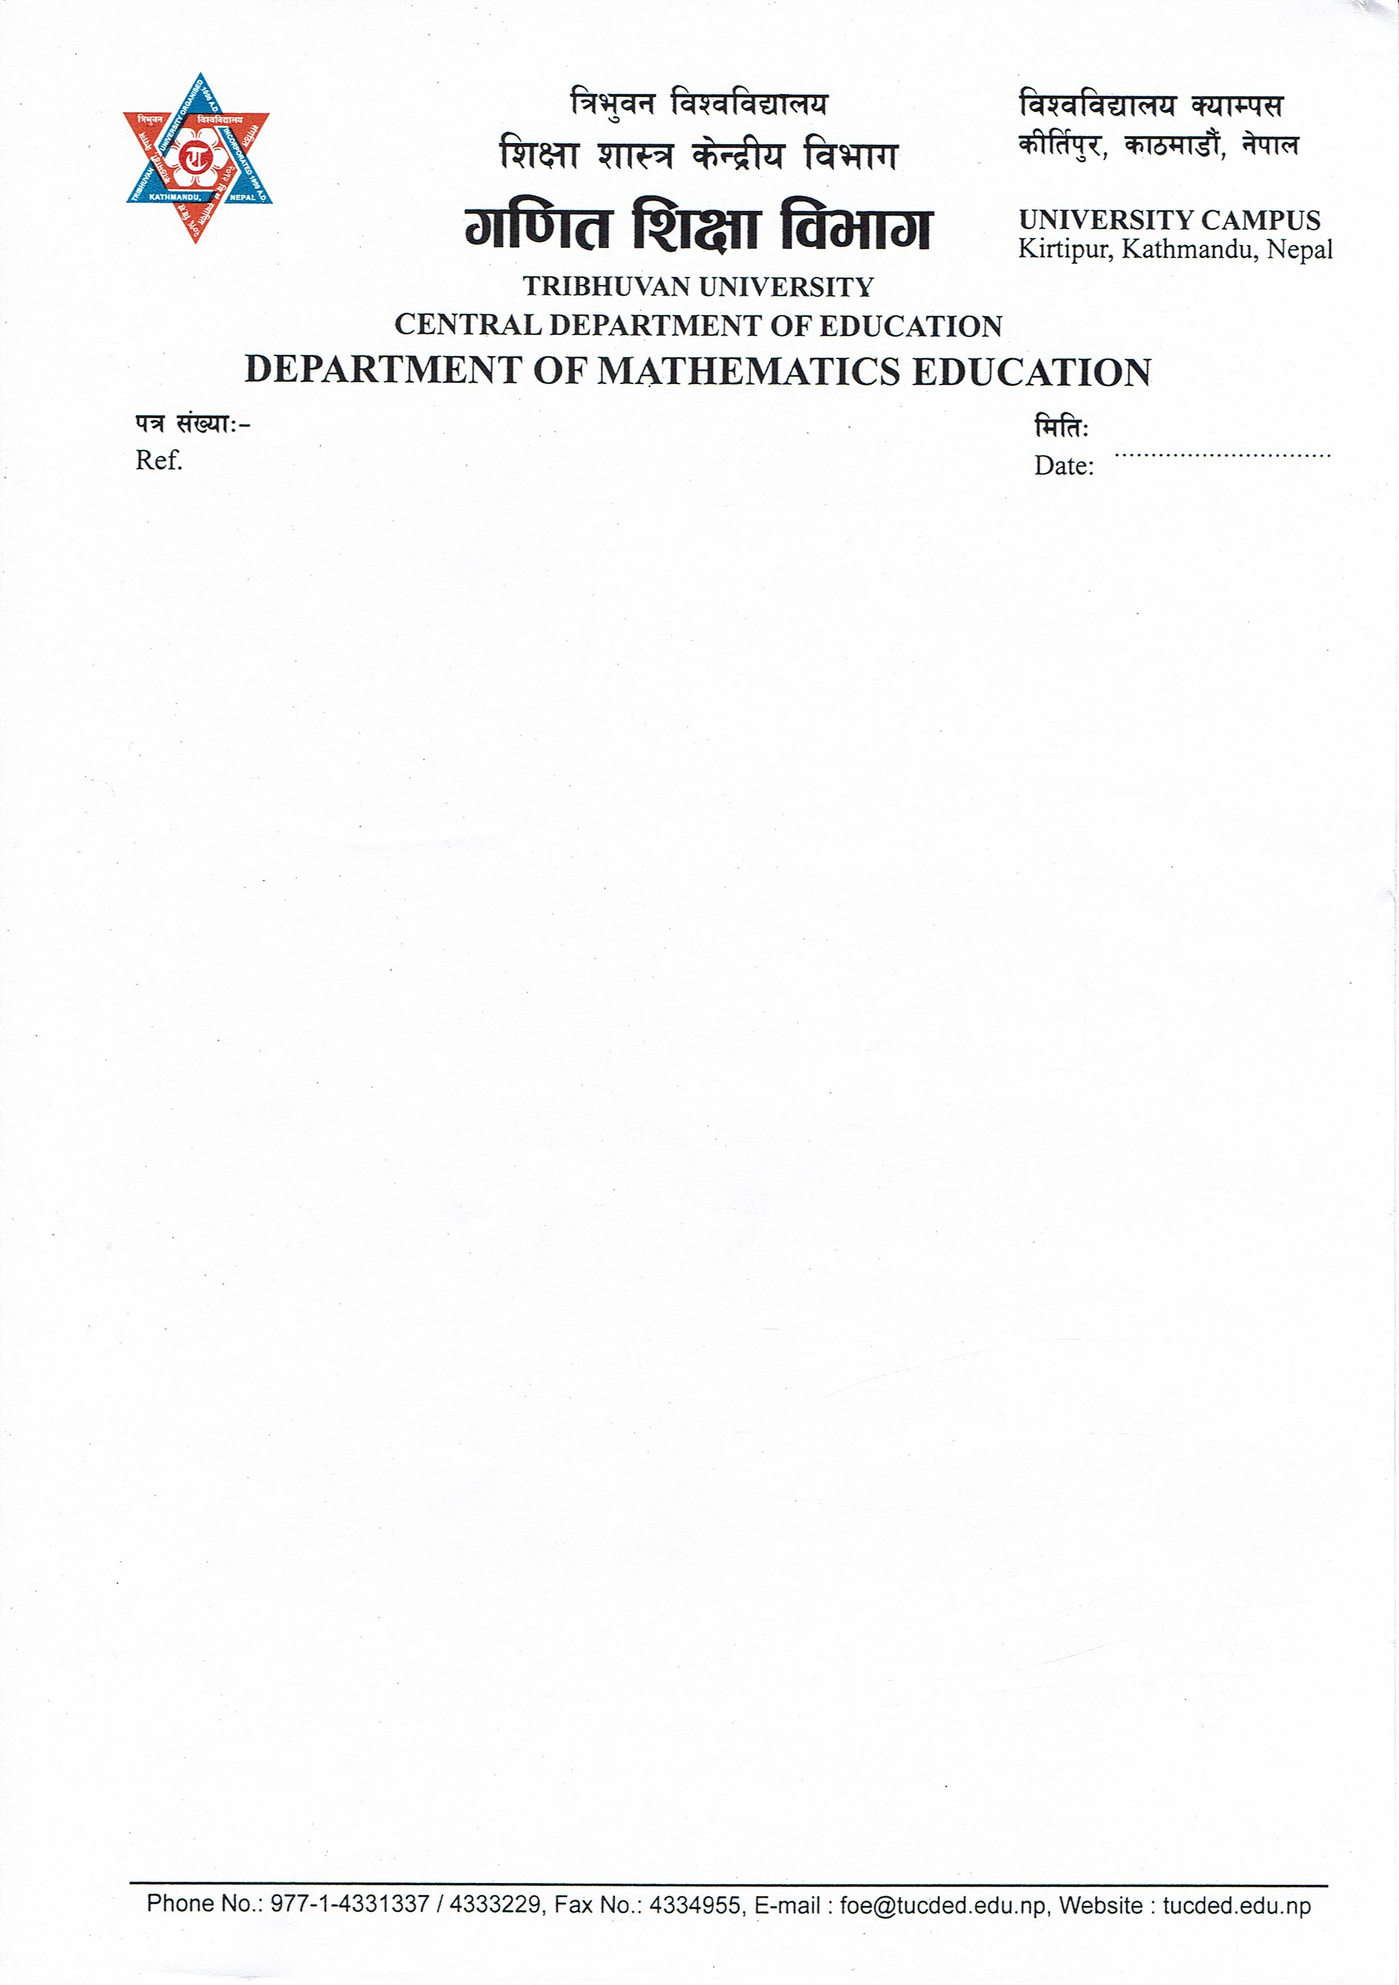

LETTER OF CERTIFICATE

This is to certify Mrs. Mina Karki, a student of the academic year 2018/2019 AD with thesis number 1729, Exam Roll No. 7428287,Campus Roll No. 252 and T.U. Regd. No. 9-2-0224-0040-2014 has completed her thesis under my supervision during the prescribed by the rules and regulations of T.U. Nepal. This thesis entitled "Development of Number System in Nepal" embodies the result of investigation conducted from 2021 to 2022 at the Department of Mathematics Education, University Campus, Tribhuvan University, Kirtipur, Kathmandu. I recommend and forward that her thesis is submitted for evaluation to award the Degree of Masters of Education.

…………………………...
Prof. Dr. Bed Raj Acharya
(Head)
Date: 2 August, 2022

LETTER OF APPROVAL

Thesis Submitted
By
Mina Karki
Entitled
"Development of Number System in Nepal" has been approved in partial fulfillment of the requirements of the
Degree of Master of Education.
Viva-Voce Committee Signature
Prof. Dr. Bed Raj Acharya……...................
(Chairman/ Supervisor)

Dr. Rajendra Kunwar ………………...
(External)

Mr. Krishna Prashad Bhatt………………...
(Member)

Date: 16 Aug, 2022

RECOMMENDATION FOR ACCEPTENCE

This is to certify that Mrs. Mina Karki has completed her M.Ed. thesis entitled "Development of Number System in Nepal" under my supervision during the period prescribed the rules and regulations of Tribhuvan University, Kirtipur, Kathmandu, Nepal. I recommend and forward her thesis to the Department of Mathematics Education to organize the final Viva-Voce.

.………………................
Prof. Dr.Bed Raj Acharya
(Supervisor)
Date: ………………….

DEDICATION
This thesis is dedicated to my father Mr.Indra Bahadur Karki and my mother Mrs.Khadga Maya Karki whose love, support and encouragement have enriched my soul and inspired me to purpose and complete this research.

DECLARATION
This dissertation contains no materials which has been accepted for this award of another degree in any institution. To the best of my knowledge and belief,this dissertation contains no materials previously published by any authors except due acknowledgment has been made.

©2022
Copyright by Mina Karki
This document is copyright materials. Under the law,no part of this a document may be reproduced without the expressed permission of the Researcher.
All Right Reserved.

ACKNOWLEDGEMENTS
First of all, I want to thanks the Department of Mathematics Education, Central Department of Education, T.U. Kirtipur for providing me support and opportunity to carry out this research work.I would like to express my deepest appreciation to my respected supervisor and the Head of the Department of Mathematics Education T.U kirtipur Prof. Dr. Bed Raj Acharya for his motivation, Patience, encouragement, guidance, suggestion and continuoussupport. This study has been successful only because of his constant advice and suggestion. I bow my head and express my gratitude for his immense support.
I would like to express my sincere gratitude to my respected teachers of Department of Mathematics Education Prof.Dr. Eka Ratna Acharya, Dr.Neelam Subedi Coordinator of Janamaitri Multiple Campus and Mr. Netra K. Manandhar for the valuable time and suggestion for complete my research and providing me resources for the data collection. Also, I would like to express deep thanks to the teachers of Department of Mathematics Education Dr. Ganesh Adhikari, Mr. Krishna Parsad Bhatta and Mr.Cholakanta Ghimire from the Department of Foundation of Education, T.U. Kirtipur.They have also contributed directly and indirectly to the success of this research.
And also, I would like to express deep thanks to my sister Lila Karki, who
helped,guided and motivated to complete this thesis. I would like to express thanks to all my friends and mathematics teachers who provided me their valuable time and information for this research. I would like to give special thanks to my dear friend Mrs. Sumitra Sapkota from English Education for her kind support and wonderful help. Finally, I wish to express my gratitude to those persons who may have contributed to this study directly and indirectly.

ABSTRACT
This study entitled "Development of Number System in Nepal" is based on the number system developed in Nepal.The main objectives of this research were to explore the numeral system developed in the context of Nepal and Nepalese society and also to analyzedthe contribution of Nepalese mathematicians in the development of numeral system. It is historical Qualitative research based on descriptive and analytical approach. Mostly the evidences and data werecollected through secondary data resources and unstructured interview with 3 resource persons. The collected data and evidences were interpreted in logical, analytical and descriptive and the evidences were presented in picture.
Research has found that the numbers and its symbolization were developed from the ancient human civilization. In the ancient period people were use the physical object and symbol on rocks and bones to count the object so, we can say that numbers and numerals are the foundation of all mathematics knowledge.In every civilization people were developed their own counting system and symbols then later it’s developed as numeral system. In the context of Nepal,there is mainly three numeral system were developed such as:Licchivi, Ranjana and Brahmi numeral system. These numeral system has own symbols for numeration. From this research I found that, Licchivi numeration system is closely related with Gupta script where Gupta script comes from the Gupta Empire of India and Ranjana numeral system comes from the Ranjana script which is calledNepal Bhasa as well as Newari language in Nepal. Similarly,Brahmi numeral system is based closely related to Devnagari Numeral System. There were many mathematicians in the Nepal among them mainly are: Gopal Pande, Laxmipati Pande, Naya Raj Panta, Chandrakala Devi Dhanajanya and Ram Man Shrestha so on mathematicians gives remarkable contribution on the development of numeral system as well as development of mathematics in Nepal. If we can preserve and explore our indigenous numeral system for the new generation then our indigenous mathematical knowledge also preserved and globalized.

TABLE OF CONTENTS

LETTER OF CERTIFICATE ii
LETTER OF APPROVAL iii
RECOMMENDATION FOR ACCEPTENCE iv
DEDICATION v
DECLARATION vi
COPYRIGHT vii
ACKNOWLEDGEMENTS viii
ABSTRACT ix
TABLE OF CONTENTS x
LIST OF ABBREVIATION xii
Chapters
I : INTRODUCATION 1-7
Background of the Study 1
Statement of the Problem 3
Objectives of the Study 4
Justification of the Study 4
Limitation of the Study 5
Delimitation of the Study 5
Operational Definition of Related Terms 6
II : REVIEW OF RELATED LITERATURE 8-13
Empirical Review 8
Theoretical Review 11
Conceptual Frameworks 12
Filling the Gap 13
III : METHODS AND PROCEDURES 14-17
Research Design 14
Source of Data 14
Area of the Study 14
Tools of the Study 15
Documentation Process 15
Document Analysis and Interpretation 16
Quality Standards 16
Ethical Considerations 17
IV : DOCUMENT ANALYSIS AND INTERPRATION 18-33
Section I: Development of Numeral System in Nepal 18
Section-II: Contributions of Nepalese Mathematician in the Development of Numeral system 29
V : FINDINGS, CONCLUSIONS AND RECOMMENDATIONS 34-37
Findings of The Study 34
Conclusions of the Study 35
Implications of the Study 36
Recommendations for the further research: 37
REFERENCES
Appendix-A
Appendix-B
Appendix-C
Appendix-D
Appendix-E
Appendix-F
Appendix-G

LIST OF ABBREVIATION

Era. = Eradicate
TU=Tribhuvan University
UN= United Nations
BS= Bikram Sambat
B.C= Before Crist
M.Ed.=Masters of Education
ICT=Information Communication Technology
C.E= Century
FOE=Faculty of Education

