COPYRIGHT
The author has given permission for this thesis to be made publicly available for examination by the library, the department of architecture, the Pulchowk Campus, and the Institute of Engineering. Additionally, the author has consented that the professor who oversaw the work documented in this thesis, or, in their absence, the head of the department where the thesis was completed, may provide permission for substantial copying of this thesis for academic purposes. It is assumed that credit will be provided to the project report's author and the Department of Architecture at the Institute of Engineering's Pulchowk Campus for any usage of the project report's content. This thesis may not be copied, published, or used in any other way for commercial benefit without the Department of Architecture, Pulchowk Campus, Institute of Engineering, and the author's prior consent. Please contact the following if you would want to duplicate or otherwise utilize any of the content in this thesis, in whole or in part:

Department of Architecture
Pulchowk Campus
Institute of Engineering
Pulchowk, Lalitpur
Nepal

CERTIFICATE
This is to certify that this thesis entitled "SIMARA SPORTS CENTER" at Simara, Bara submitted by Mr. Sushant Raj Bharati has been examined and has been declared successful for the partial fulfillment of the academic requirement for the completion of the Degree of Bachelors' in Architecture.

.........................................
Asst. Prof. Ritu Raj Rai
(Supervisor)
Date: ................................

DECLARATION

I declare that this dissertation has not been previously accepted in substance for any degree and is not being concurrently submitted in candidature for any degree. I state that this dissertation is the result of my own independent investigation/work, except where otherwise stated. I hereby give consent for my dissertation, if accepted to be available for photocopying and understand that any reference to or quotation from my thesis will receive an acknowledgement.

..........................................
Sushant Raj Bharati
(074/BAE/244)
Date: ................................

ACKNOWLEDGEMENT

I would like to express my sincere gratitude towards my thesis supervisor Asst.Prof. Ritu Raj Rai for accepting my thesis proposal topic "SIMARA SPORTS CENTRE". In addition, I would also want to express my appreciation for successfully guiding me through various stages of the thesis. I would also like to recall his continued support, guidance and supervision which helped me a lot to understand things better throughout the process of the research works, case study materials, design works and preparation of report. Knowledge is the greatest gift one can share and I have been blessed to get adequate of that under his supervision and guidance.
My sincere gratitude goes to Sambhu Singh Thakuri, Secretary of NJJYC Siamra for support and guidance from the beginning of the thesis especially for the identification of depth of the topic and ways to explore it by giving their important views during my interview.
Through the thesis that is presented here, I would like to extend my sincere thanks and gratitude to all those persons who have lent their help directly and indirectly during my thesis. And Mostly, the greatest thanks goes to my friends and family for everything.

Sushant Raj Bharati
074/BAE/244
Department of Architecture
Pulchowk Campus

ABSTRACT

“Sports serve society by providing vivid example of excellence.” – George Will

“Cultures and climate differ all over the world, but people are the same. They’ll gather in public if you give them a good place to do it” – Jan Gehl.

Architecture is such a part of society which has trapped all the aspects of the society itself. It seeks to find the harmony among the various societal aspects. Architecture, in the sense is called the art of place making.

The main goal of ‘Simara Sports Centre’ is to provide a friendly and productive environment for the people from different age groups where one can interact, play, enjoy and build their healthy life through sports and other recreational activities. This project especially focuses on creating a place as the center for sports tourism which will host national and international games and even create national and international players from the community level. This project also emphasize on making people realize the need of sports and recreation center at community level for the better healthy lifestyle of the people.

While designing a public building like sports and recreation center, where huge number of people gather, there are lot of things to be considered such as economy, utility, convenience, function, aesthetics, durability, safety, etc. such design issues and utmost consideration to be given for the safety and functionalism should govern the whole design.

TABLE OF CONTENTS
CHAPTER-ONE 11
1.1 INTRODUCTION 11
1.2 DEFINATION 11
1.3 BACKGROUND 11
1.4 PROBLEM STATEMENT 2
1.5 PROJECT JUSTIFICATION 4
1.3 OBJECTIVES 7
1.4 TARGET GROUP 8
1.6 RESEARCH METHODOLOGY 8
1.7 EXPECTED OUTPUT 10
1.8 TENTATIVE REQUIREMENTS 10
CHAPTER-TWO 10
2.1 LITERATURE REVIEW 10
2.2 INTRODUCTION 10
2.2 SPORTS 11
2.3 RECREATION 12
2.4 SPORTS & RECREATION 13
2.5 RECREATION, LEISURE, SPORTS & COMMUNITY 13
2.6 SOCIOLOGY OF SPORTS 15
2.7 Indigenous Sports 17
2.8 COMMERCIALIZATION OF SPORTS 19
2.9 SPORTS TOURISM 20
2.10 WHAT IS A COMMUNITY RECREATION AND SPORTS HUB? 25
CHAPTER-THREE 29
3.1 STANDARDS 29
3.2 LOCATION: 29
3.3 ORIENTATION 29
3.4 ZONING 30
3.5 HALL STANDARDS 31
3.6 DESIGN CONSIDERATIONS 37
3.7 AMENITIES 41
3.8 PITCHES 43
3.9 STRUCTURE 48
CLASSIFICATION OF LONG-SPAN STRUCTURE 49
2.15 SUSTAINABLE DESIGN 61
CHAPTER-FOUR 67
4.1 CASE STUDY 67
4.2 NATIONAL CASE STUDIES 67
DASHARATH INTERNATIONAL STADIUM 67
ANFA COMPLEX, SATDOBATO 76
BIRENDRA SPORTS COMPLEX 81
4.3 INTERNATIONAL CASE STUDIES 85
YAMUNA SPORTS COMPLEX 85
MONTGOMERY TOWNSHIP 91
COMMUNITY & RECREATION CENTER 91
CHAPTER- FIVE 95
5.1 SITE ANALYSIS 95
5.2 SWOT ANALYSIS 98
CHAPTER – SIX 100
6.1 PROGRAM FORMULATION AND DESIGN GUIDELINES 100
6.2 RECOMMENDED PLANNING & DESIGN PRINCIPLES FROM LITERARURE REVIEW & CASE STUDY 100
6.3 SPACE REQUIREMENT FORMULATION 102
CHAPTER – SEVEN 105
7.1 CONCEPT & DESIGN DEVELOPMENT 105
7.2 CONCEPT & DESIGN APPROACH 107
8 REFERENCE 114

LIST OF FIGURES
Figure 1 Roman Amphitheatre 1
Figure 2 Three star club vs Manang Marsyangdi Club Nepclassico 2059/60 BS 1
Figure 3 Spectators watching football at Simara Stadium, Bara 2
Figure 4 spectators present at 13th Jeetpur Simara Gold Cup 2079 2
Figure 5 Grassroot football in Simara by ANFA 3
Figure 6 youths playing cricket at Tinkune open ground 3
Figure 7 stadiums in Nepal 4
Figure 8 Jeetpur SImara Gold Cup 2079 organized under flood light 4
Figure 9 Taekwondo Players seen practicing on mud without mat at Simara Stadium 5
Figure 10 Jeetpur Simara Mayor (left) & Madesh Province member (right) facilitating the event 5
Figure 11 Figure Bara district with its sports popularity in different local government 6
Figure 12 Figure 15 Jeetpur Simara GC coverage on Medias 6
Figure 13 Research Methodology Working Process 9
Figure 14 recreational activities 12
Figure 15 two different societies with different means of recreation 14
Figure 16 activities during the Kushti gameplay 17
Figure 17 different emotions during a match 18
Figure 18 Nike sportswear with global soccer stars 20
Figure 19 Gammon and Robinson’s (2003) consumer classification of sport and tourism 24
Figure 20 Preferable orientation of stadium 29
Figure 21 Types of hall with their dimensions 31
Figure 22 4 court hall 32
Figure 23 6 court hall 33
Figure 24 8 court hall 34
Figure 25 9 court hall 35
Figure 26 12 court hall 36
Figure 27 comparison of different sizes court hall 36
Figure 28 Notional site layout 37
Figure 29 line of sight in view area 38
Figure 30 Notional layout of changing rooms 41
Figure 31 physiotherapy room 41
Figure 32 Car parking standards 42
Figure 34 Standard dimensions for 90⁰ parking for 2-way passage with parking width of 2.50m (left) and 2.30m. 42
Figure 34 45⁰angled parking for one-way traffic with vegetation included (right) and without vegetation 42
Figure 35 Football Court 43
Figure 36 Badminton Court 44
Figure 37 Basketball Court 44
Figure 38 futsal pitch 45
Figure 39 Volleyball court 45
Figure 40 Swimming pool 46
Figure 41 changing cubicles with clothes locker 46
Figure 42 Swimming pool piping layout 47
Figure 43 Gym hall layout 48
Figure 44 Canteen & dinning layout 48
Figure 45 Tent Structure 49
Figure 46 Pneumatic structure 49
Figure 47 Truss structure 50
Figure 48 Space Truss 50
Figure 49 Simple layer Grid 51
Figure 50 Double layer grid type 52
Figure 51 Triple layer space truss 52
Figure 52 Different types of nodes 53
Figure 53 Different designs for joints 53
Figure 54 cylindrical vault 55
Figure 55 Dome structure 55
Figure 56 Different Dome structures 56
Figure 57 Portal Frame 58
Figure 58 Folded plate structure 59
Figure 59 Dome structure 59
Figure 60 Different vaults 60
Figure 61 Aluminum roof covering details 64
Figure 62 Simulation of shading panel on a vertical fin pattern 65
Figure 63 Dasharath Stadium Masterplan 67
Figure 64 General Stand of Stadium 68
Figure 65 Dasharath Stadium, Kathmandu 69
Figure 66 Front view of covered hall 69
Figure 67 Ground Floor Plan of Covered Hall 70
Figure 68 Ground Floor Plan of Covered Hall 71
Figure 69 Parapets inside covered hall 71
Figure 70 Section of Covered Hall 72
Figure 71 Truss supporting the roof of the hall 73
Figure 72 Tennis Court 75
Figure 73 ANFA Complex 76
Figure 74 ANFA Academy Ground 77
Figure 75 ANFA House 78
Figure 76 ANFA House floor plans 78
Figure 77 ANFA hostel building 79
Figure 78 Parapets Normal & VIP 80
Figure 79 artificial football pitch 80
Figure 80 artificial turf of ANFA complex 80
Figure 81 Birendra sports complex Satdobato 81
Figure 83 Spectator area 83
Figure 84 Yamuna Sports Complex 85
Figure 85 Master Plan of Yamuna Sports Complex 85
Figure 86 Parking of Yamuna Sports Complex 86
Figure 87 Green & sustainable approaches 87
Figure 88 Vehicular & pedestrian flow 89
Figure 89 Masterplan of Yamuna Sports Complex 89
Figure 90 Montgomery site before construction 91
Figure 91 Montgomery front premises 91
Figure 92 Montgomery master plan with site 93
Figure 93 First floor plan 93
Figure 94 Ground floor plan 93
Fig, 95 Auraha Chowk just ahead of the site entrance 95
Figure 97 Existing underconstructon Simara ground 96
Figure 99 site surroundings 99
Figure 100 proposed site with surrounding information 99
Figure 101 proposed programs as per the requirements 100
Figure 102 Bubble Diagram 106
Figure 103 Zoning as per functions (left) & as per privacy (right) 108
Figure 104 in and out connection 108
Figure 105 Inference from the local Terai land fabric 109
Figure 106 Overall form of the complex 110
Figure 107 View of rest space and drinking water 110
Figure 108 Exhibition Spaces 111
Figure 109 View from the front plaza 111
Figure 110 Kushti Arena View 112
Figure 111 View from the NS Stretch 113

CHAPTER-ONE

INTRODUCTION
Sport and recreation has been to provide physical exercise and entertainment since time immemorial. People play games and sports due to various reasons i.e. health care, hobby, to reduce stress, for competitions, as profession and so on. Thus, sports and recreational activities keep us healthier, concentrate more, create better mental health, keeps us fit, proper utilization of free/leisure time in doing something good.
Sports and recreational activities are very essential things to maintain discipline within the people and society. It generates economy, tourism, employment and even produce national and international players who could represent the nation at global stage. Hence sports buildings are required to meet both the active and passive recreational needs of the population, either within the residential neighborhood (local sports building) or centrally located to serve a wider area (District Sport Building), Regional Sports Building at prominent location in the urban areas serves as the catchment area larger than that served by district and local sports building. Sports center are not only the place for organizing the sports events but also for other purposes like training and many more. Hence it should contain the necessary sports infrastructure.

DEFINATION
Sport is related to any form of competitive physical activity or game that aims to use, maintain or improve physical ability and skills while providing enjoyment to participants and, in some cases, entertainment to spectators.
Recreation means any sorts of activity done for the enjoyment when one is not working (leisure/free time).
Sports center is a large and expansive area that incorporates several fields or courts dedicated to a particular sport or series of sports which can often be used for tournaments and leagues because they can hold a significant amount of people to watch the teams play.
Recreation center is a building or a complex that is open to the public where meetings are held, sports are played, and there activities available for young and old people.

BACKGROUND
Sports and recreational activities have always been a part of human life style from the dawn of civilization. The history of building stadium started from as early as 331 BC with the building of the Athens stadium. The early construction began from the Greece and the pattern went all around

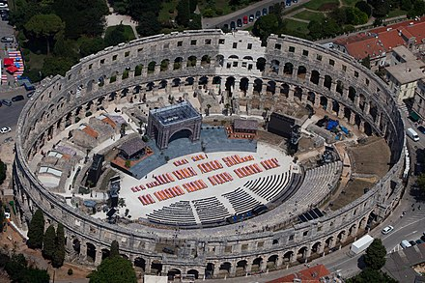
the world through Rome (Italy). The sport center as a building type saw a revival after the industrial revolution. There was the growing demand for mass spectator events from the public, there were entrepreneurs who wished to cater this demand and there were new structural technologies to facilitate the construction of sport center. The first Olympic games was recorded in 776BC in Olympia. With the revival of Olympic Games at the end of the nineteenth century, importance of construction in sport center became more significant.
Figure 1 Roman Amphitheatre

History of sports in Nepal
In Nepal, sports activities came in limelight during the mid of 20th century. Athletics & football were the prime games during that era. These types of sports gained popularity since no hard & fast rules were required and were also easily understandable. Football gained popularity even though Nepal didn’t have its national team. The entry and initial start of football game in Nepal happened during Rana Regime in 1921.
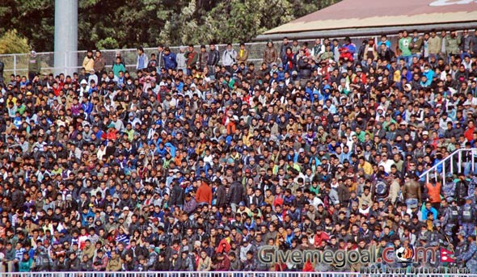
Football in Nepal was introduced by the young players who had learnt this game from other countries. This game was watched by a huge mass of audience and became very famous at that time. Later on government started forming various governing bodies to well execute sports activities in an efficient manner. As a result Nepal Sports Council was established in the 1960s to govern all the sports happening within the nation. Till now there are more than 123 sports related association and 6 federation affiliated under it. With the motto "sports for the health, sports for the nation" NSC falls under Ministry of Youth and Sports.
Figure 2 Three star club vs Manang Marsyangdi Club Nepclassico 2059/60 BS
With the establishment of Nepal Sports Council and Dasharath Stadium, various other games started being emerged in the country which had already gained popularity in the outer world. As a great intent and craze on sports activities, a proper facilitated sports complex was a prior need which resulted the construction of Dasharath International Stadium at Tripureshwor Kathmandu in 2026 BS. Nepal too started participating in various regional and international sports competition such as Olympic, Asian Games, South Asian Games (SAG) & SAFF Championship. Even various sports league has been organized within the country these days since lots of youths seems putting up their interest in the field of sports. Even the media viewership on the domestic football and cricket leagues like “Martyr’s Memorial A Division League”, “Everest Premier League” are rising up to millions of audience viewership per match. Such a wave of craze towards sports are fascinating various private sectors to invest in this field. Through a larger audience and viewership private companies are putting up a large sum of money for their branding and advertisements.

PROBLEM STATEMENT
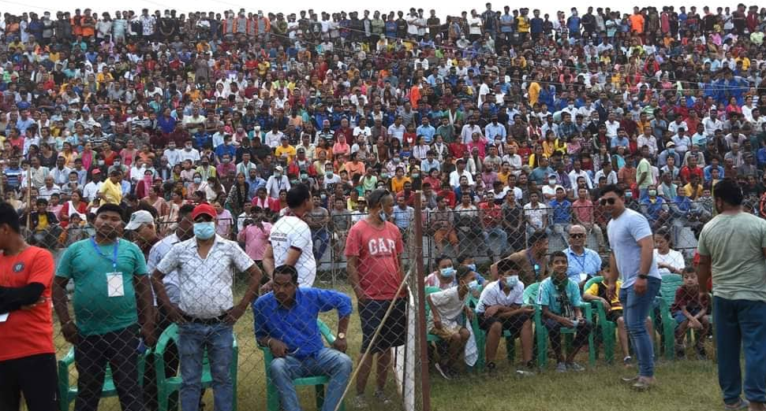
SPECTATORS AND CRAZE
Actually the sports craze in rural areas is insane, though we lack the sufficient facilities and play grounds for the sports enthusiast in rural belt. If we see the various national players almost 90% are from the rural areas. Their dedication & hard work under limited resources guided them to such a height.
Figure 3 Spectators watching football at Simara Stadium, Bara
To decentralize the recent trend of sporting activities even the Nepal sports council is shifting the 9th National games outside the Kathmandu to Gandaki Province, Pokhara. As a part of physical exercise and production of young talented & energetic players from the local level, a community sports center is today’s necessity. Sport, it’s not only related to the physical activities, it’s a perfect way to keep us within a discipline.
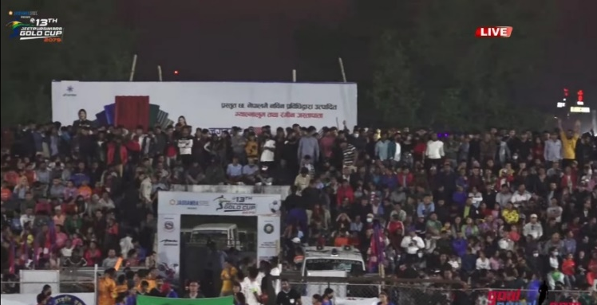
We see many local youths being diverted towards the misdeeds and drug addictions, it’s all because there’s nothing there in the community to get them engaged and involved. So it’s better to have sporting centers in each locality. Even in the case we are lacking the venues to organize regional and domestic games in the nation, creating a community sports centers in the local level could even mitigate the existing problems.
Figure 4 spectators present at 13th Jeetpur Simara Gold Cup 2079

GRASSROOT
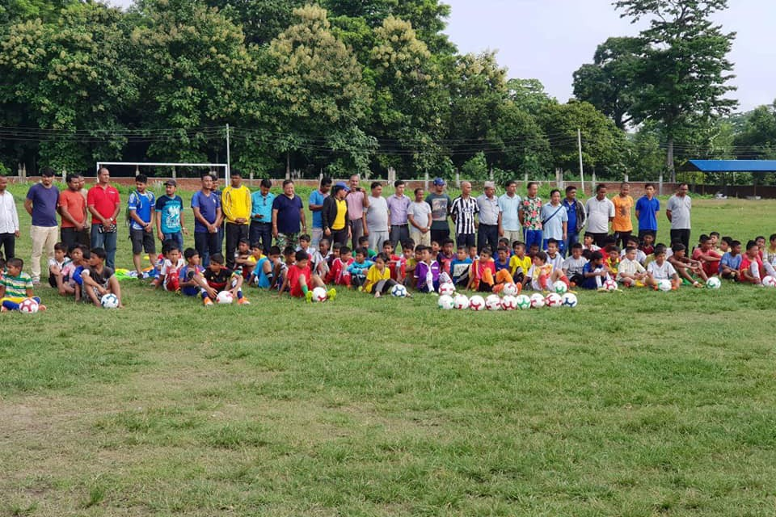
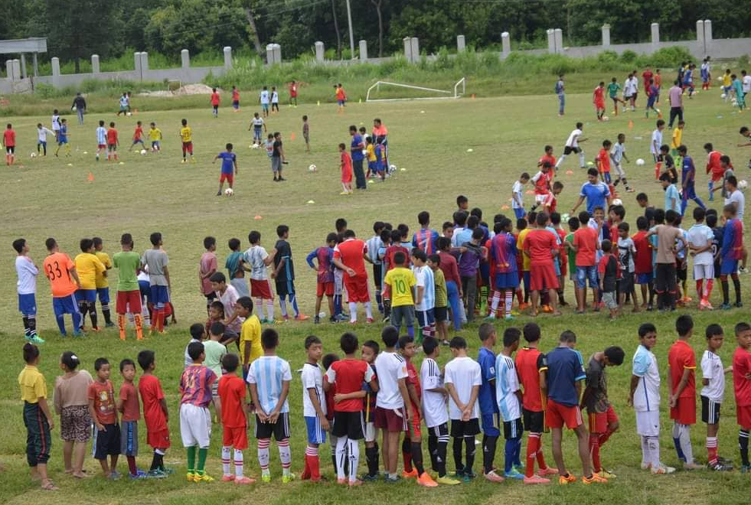
Many of the sports enthusiast youths in the rural area travel almost 20-25Km per day to play either football or cricket. If we could provide such sports facilities from the community level we could produce more & more potential players who could represent the nation in global context like Sandeep Lamichhane.
Figure 5 Grassroot football in Simara by ANFA
LACK OF RECREATIONAL SPACES
A community which comprises of different sorts of age groups, they seems gathering at the open spaces where they interact each other. Young & Adult group, they start playing various games and sports in the open spaces. But though we have such spaces left but we lack an organized spaces not even in the urban context but also in the local level.
Figure 6 youths playing cricket at Tinkune open ground

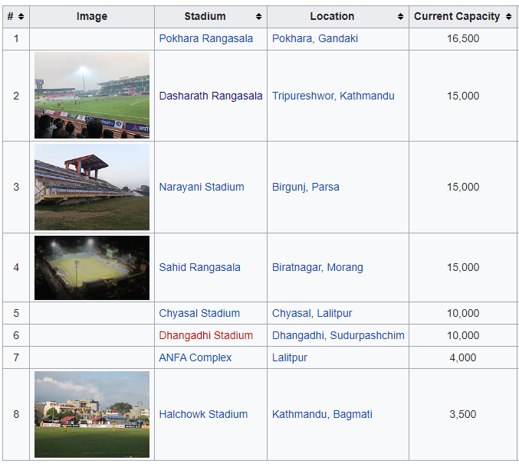
LIMITED STRUCTURES
In Nepal, though there are very few sports complexes they are town/city centric. Even in the capital we have only three complexes that could hold multiple sports facilities. While in other parts, some facilities are limited within the health clubs & academies, which are privately owned and costs expensive for common people.
Though there are some few infrastructures outside the valley they are solely for a specific purpose mainly for footballs.

Figure 7 stadiums in Nepal

PROJECT JUSTIFICATION
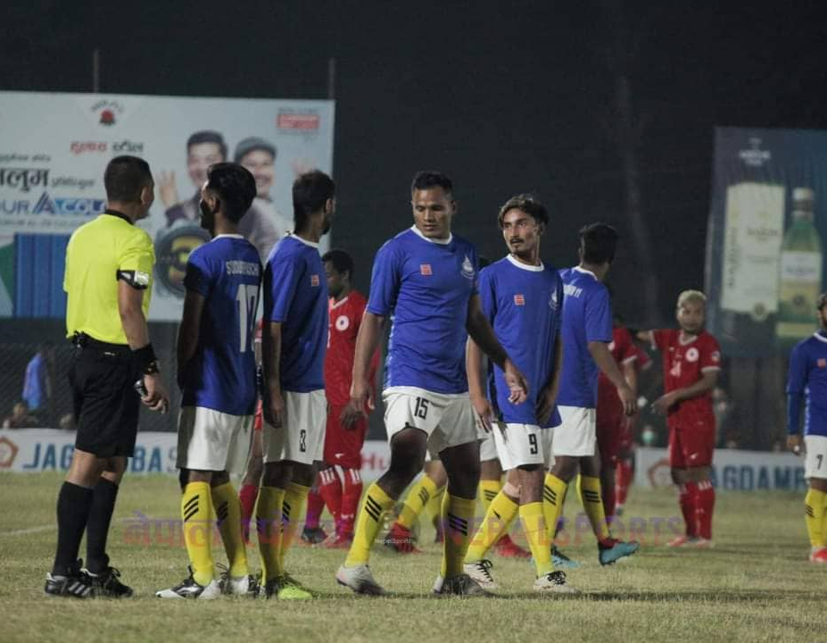
JEETPUR SIMARA GOLD CUP
Here in my thesis, I will be doing a community sports center at Simara, Bara ,located at a prime location of province no.2., which host one of the most popular domestic football competition “Jeetpur Simara Gold Cup” every year by NJJYC. Various cubs from Kathmandu and even Darjeeling, Sikkim & even Kolkata from India participate in this competition. The competition is being organized in Simara Stadium which hasn’t been a perfect venue since only during the time of gold cup temporary fencings are done. Though even the various grass root programs are undergoing to produce national players, we have been lacking an ample sports center where such programs could be conducted. Located at a just 600-700m from the domestic airport, it could be the best venue even to host the province level competitions on various sporting activities too.
Figure 8 Jeetpur SImara Gold Cup 2079 organized under flood light

Similar small level football tournaments (wada cup) is being organized in various regions mainly in the end of the year between Chaitra & Baisakh.
LACK OF PROPER SPACES FOR PRACTICE
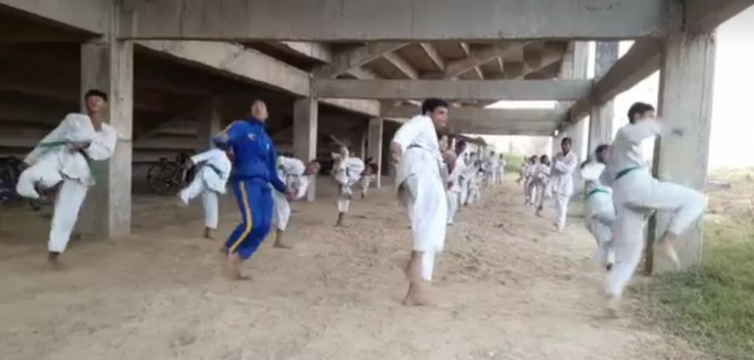
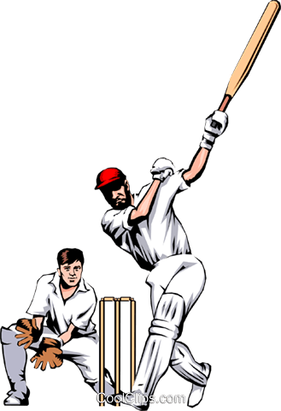
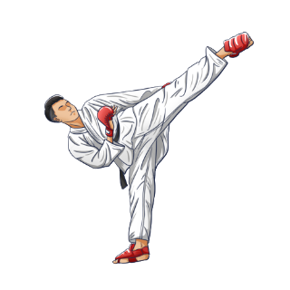
Aside of football, other games like Taekwondo is more popular and followed especially by the younger children in their school level in this area. These students practice outside under the scorching sun & even over the mud where there is no proper mat. Also for the competitions, they travelled long way to adjacent districts since we lack such facilities to conduct here. Providing them a proper space and provision for the training, could produce a good players who could represent our country in the Global stage.
Pic. Bara District Map

Figure 9 Taekwondo Players seen practicing on mud without mat at Simara Stadium

BANDEVI KUSHTI MELA
Phelwani also known as Kushti is one of the traditional sports mainly in the core Terai region of Nepal. Here in Jeetpur Simara Sub Metropolitan City too, in the occasion of every Ram Nawami Bandevi Kushti mela is being organized. The event is conducted in a open farm land with no proper space covered with tents.
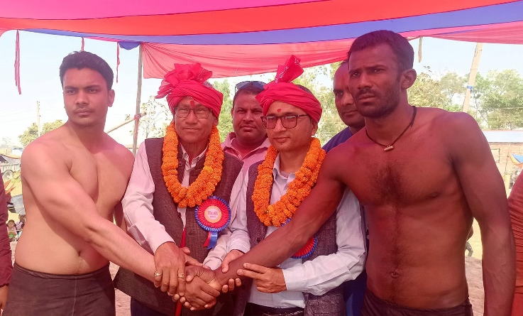
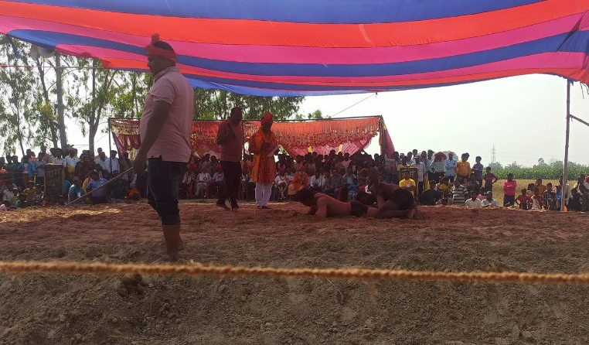
Figure 10 Jeetpur Simara Mayor (left) & Madesh Province member (right) facilitating the event

EMERGENCE OF NATIONAL PLAYERS
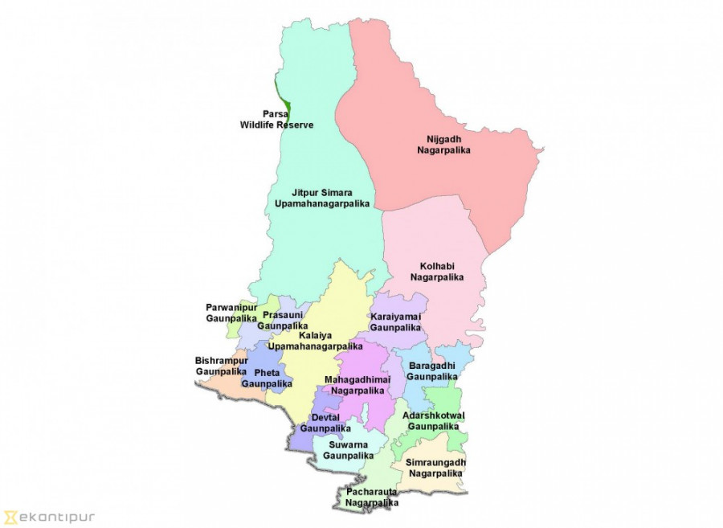
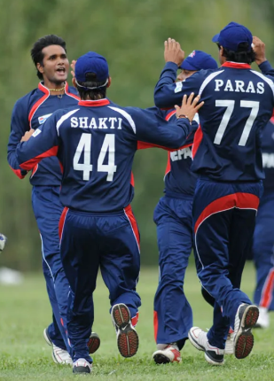
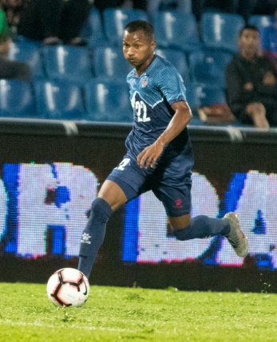
Bara district has always been a fertile land in producing national sports person from the beginning. Especially football, Karate & Cricket are the major three sports being played by a number of youths here in Bara District. Facilitating a sports triangle, sports and recreational center at Simara, which is already a prime center for its sporting activities could cater the existing as well as the upcoming need and necessities in the district.
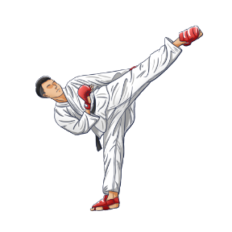

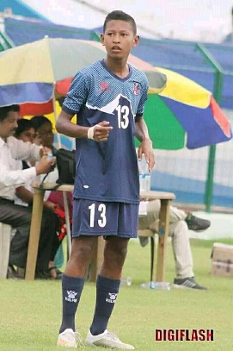
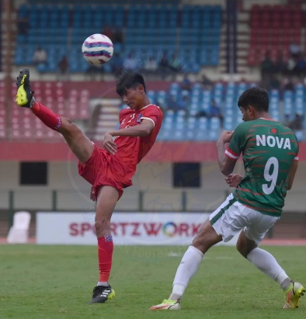
Binod Das (Cricket Ex Captain)
Ravi Paswan (Nepal)

Figure 11 Figure Bara district with its sports popularity in different local government
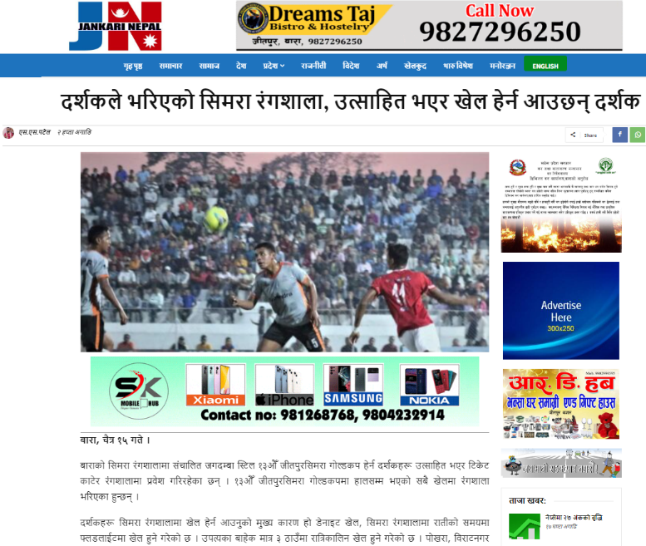
Janme Dhami (Nepal U23)
Ajay Chaudhary (Nepal U23)
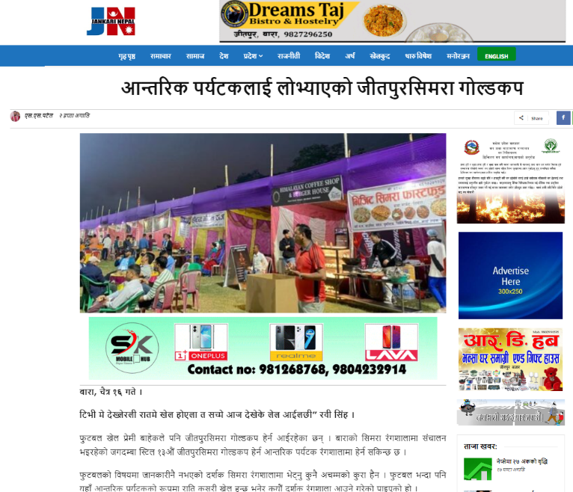
Figure 12 Figure 15 Jeetpur Simara GC coverage on Medias

1.3 OBJECTIVES
The purpose of the community sports and recreation center is to provide a well-designed venue for the sports enthusiast community people even the local government to host various both indoor and outdoor sports competitions. It also intends to promote the locality which also helps in the tourism activities during the various competitions.
With an aim to fulfill the following listed objectives, community sports and recreation center is conceived;
Tourism via sports
Hosting sports events draw people from nearby states. A few times a year, these tourists can help a community generate more cash.
Keeping People Healthy and Active
Many programs are available in sports complexes that are beneficial to both the body and the mind.
People who exercise daily have lower blood pressure and reduced diabetes development.

Highlighting Cultural Diversity
Participating in group activities can assist community members in becoming more cohesive. Moreover, many community recreation facilities offer programs that promote diversity and educate people of the community.

Producing players from local level
Enthusiastic players could get chances to improve their skills participating in local level competitions that will help in producing national players even from grass root.

Importance of research
- Create a space that could act as the community gatherings
- Understand the need and importance of sports for the development of youths and children
- To understand how efficient designing of spaces could create an interesting interactive spaces

1.4 TARGET GROUP
Local & regional (could be expandable to province) level games, every age groups of Simara Bara (includes children, youth, middle age and even old age)

RESEARCH METHODOLOGY
The following outlined methodology was followed for the thesis work.

- Theoretical Understanding and data collection
The required information for the project is gathered through the literature review of books, reports, articles, research works, surveys and other related documents regarding the data for the project. In the process of information collection required data are also revealed and analyzed. If needed survey work is also done for data collection. The theoretical understanding of the project is carried out to know related issues of the project. For such understanding the literature review and case studies helps a lot.

- Literature Review
To understand the different aspects and the value of the project book, articles, project works, documents etc. related to the project is studied carefully. From the study we understand what to know more from the case studies and what is required for the project.

- Case studies
The case studies in the different aspect of the project help to solve the problems in the project. There are different issues like landscape, form, spatial organization, structure and even sometime in these types of project the crowd which may be the major factors of the project can be studied to get the desired output for such a function. These issues would be dealt in case studies and literature review.

The proposed case studies for the projects are:
i.Understanding of different sports Spaces
ii.Crowd Management
iii.Long Span Structures
iv.Study of one identical building

- Project review and Requirement Analysis
In the process of requirement analysis the project is reviewed through the collected information and data. After certain case studies and literature review the requirement of the project is formulated.

- Site Selection and Analysis
Knowing the scope of the project and formulated requirements the proper site for the project is selected. If the site is already proposed then the site should be analyzed carefully that if the site meets its parameters according to the requirement or not. Besides this the feasibility of the site should be analyzed through the perfect study of site access, connectivity, orientation, views, services, present vegetation and site condition.

The following aspect of the site can be analyzed as required:
- Land use
- Physical Characteristics
Landform Soil
Soil
Vegetation
- Existing condition, boundaries and infrastructures
- Surrounding environment and views
- Access
- Historical Significance of the site (if any)
- Climatic Analysis
- Vernacular response

- Site Planning
In this process, zoning of the site should be done properly. What sort of landscaping feature is essential for the particular project should be incorporated in the site. Even the service network and the road layout in the site should be planned. While planning the site, by-laws must be addressed properly.

- Design Work
The functional layout of the building should be done while designing in the site. The circulation area inside the building should be conveniently designed and there should be a distinct entry and exit point in the building. Also the internal services should be considered.

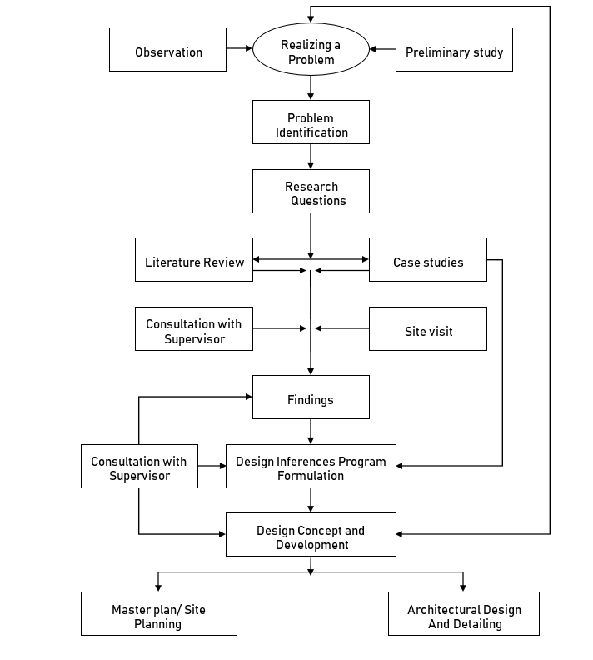
- Detailing
Detailed studies should be done regarding the materials, lighting features, particular detailing, acoustic and drainage facilities of the project.

- Final Drawing & Presentation
- Model of the building with site
- Necessary design drawings
- Functional plans, elevations, sections and other necessary sketches
- Project Report
Figure 13 Research Methodology Working Process

EXPECTED OUTPUT
Sports centers are the ornaments of nation which have a great contribution for the development of sporting culture and financial upliftment. This project will justify why sports recreational centers are needed in Nepal from the local level. Creating tourism via sports with the development of a sustainable, dynamic and economically viable community sports & recreation center which can also be a venue for various sports tournaments & competitions.
1.8 TENTATIVE REQUIREMENTS
- Administrative Block
Dry Sports Components
- Indoor multipurpose sports hall
- Futsal area
- Mini Football Stadium
- Table tennis hall
- Jogging Tracks
- Kushti Arena

- Recreational Spaces
Café/food and beverage area
Children playing areas
Concert/performance area (OAT)
Gaming an fun areas
Gyms & fitness

Reception
Account Sections
Meeting Hall

- General facility components
Parking areas
Retail stores
Public Toilets
Cleaner’s store
First aid rooms

- Sports Components
Aquatic Components
Swimming Pool
- Leisure Pool
- Toddlers Pool

CHAPTER-TWO

2.1 LITERATURE REVIEW

2.2 INTRODUCTION
This paper tries to review the existing literature on Sports and recreational facilities. The basic exploration of designs was done throughout the period of analysis and case studies. Literature review based on the need of community and its people, comfortable spaces, standards and required services are done.
Different examples of community sports and recreation centers were considered before making conclusion out of the buildings studied. The literature review is such a topic, which we could never stop learning in the design process. Thus this section is only limited to brief summary of the findings during the literature review.

2.2 SPORTS
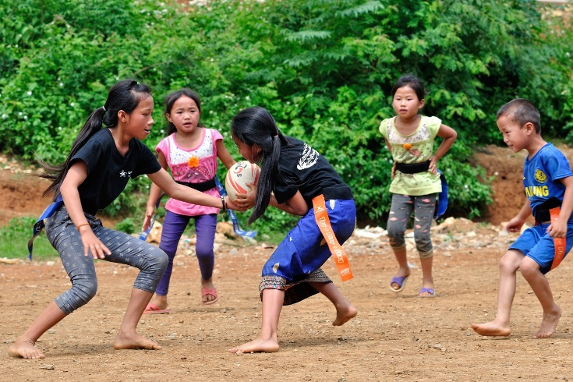
Sports are the any form of competitive physical activity or game that aims to use, maintain or improve physical ability and skills while providing enjoyment to participants and, in some cases, entertainment to the spectators. Actually they are the physical activities that use the large muscles of the body. Every sports have well defined rules and typically involve competition between individuals or teams.
Sports are the physical contests pursued for the goals and challenges they entail. Sports are part of every culture past and present, but each culture has its own definition of sports. The most useful definitions are those that clarify the relationship of sports to play, games, and contests. “Play,” wrote the German theorist Carl Diem, “is purposeless activity, for its own sake, the opposite of work.” Humans work because they have to; they play because they want to. Play is autotelic—that is, it has its own goals.
There are at least two types of play.
A. Spontaneous and unconstrained play
Children engage in spontaneous play when they engage with their surroundings, available resources, and others in their immediate vicinity without the direction or involvement of an adult. Children make choices about how and when the play will take place, as well as choices about how the play will develop.

B. Regulated play
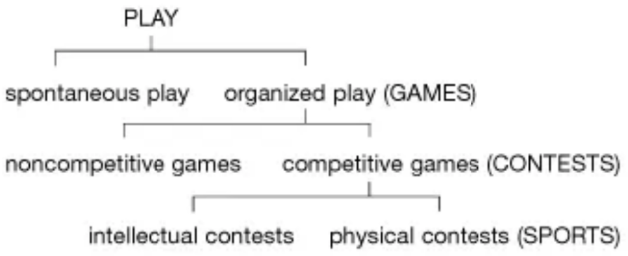
There are guidelines that specify what behaviors are acceptable and what behaviors are not. These regulations turn unstructured play into games, which are referred to as regulated or rule-bound play. Leapfrog, chess, "playing house," and basketball are all games, some with very straightforward rules and others with slightly more complicated ones. In reality, rulebooks for sports like basketball can run into hundreds of pages. Chess and basketball are unquestionably different games from playing house and leapfrog. While the second two games are not competitive, the first two are. It is possible to win a game of basketball, but it is absurd to inquire as to who the winner of a leapfrog match is. So chess and basketball are competitions.

A final distinction separates contests into two types:
- those that require at least a minimum of physical skill
- And those that do not
The first can be illustrated by shuffleboard, and the second by the board games, scrabble and monopoly. It goes without saying that even the most basic activities, like weightlifting, call for some level of mental work, while others, like baseball, demand a significant amount. Moreover, it must be acknowledged that shuffleboard doesn't even come close to measuring up to the sports that have most stoked spectators' and participants' passions for humanity.
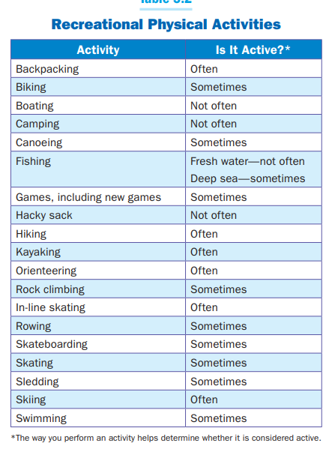
2.3 RECREATION
Recreation refers to all those activities that people choose to do to refresh their bodies and minds and make their leisure time more interesting and enjoyable. Examples of recreation activities are walking, swimming, meditation, reading, playing games and dancing.
Leisure is the spare time that people have to rest, relax, and enjoy life when away from their regular responsibilities (such as job and household duties). People engage in recreational and athletic pursuits in their free time.
Recreational activity are done for enjoyment when one is not working/leisure to recreate or to be refreshed. They include painting, enjoying music reading, acting and playing games such as cards or chess.

Breaking recreation down into various areas, classifications, or types might be done in numerous ways. The listing below represents one of the ways that recreation could be categorized for individuals, groups, or leaders planning programs. The listing is shown in random order and does not indicate any order of importance.
Figure 14 recreational activities

• Physical activities (sports, games, fitness, etc.)
• Social activities (parties, banquets, picnics, etc.)
• Camping and outdoor activities (day camps, resident camps, backpacking, float trips, etc.)
• Arts and crafts activities (painting, scrapbooking, ceramics, woodworking, etc.)
• Dramatic activities (plays, puppetry, skits, etc.)
• Musical activities (singing, bands, etc.)
• Cultural activities (art appreciation, music appreciation, panels, discussion groups, etc.)
• Service activities (fun in doing things for others)
Recreation also, of course, includes activities for all age groups (children, senior adults, etc.), as well as various special populations (physically handicapped, mentally retarded, etc.). However, most people in these groups could still relate too many of the types of activities mentioned in the list above.

2.4 SPORTS & RECREATION
Sports can be done as a form of recreation e.g. .one person might run across the country as a competitive sports, while another person might run long distances not for competition but as a form of recreation. Sports and recreational activities help to develop life skills, abilities, talents and improve the general health of the body. These activities may be used as sources of income, to have fun and to stay physically fit.
Sports & recreational facilities can be classified mainly into two categories.
- Indoor sports facilities
- Outdoor facilities
Indoor facilities
Indoor facilities are those materials and structures that can conveniently be constructed or enclosed in the four-wall of a building called gymnasium to facilitate learning program. These include: the building or the physical plant capable of enclosing a standard swimming pool, gymnasium, locker, shower and drying rooms, teaching stations and rooms, corridors and foyers, offices and laboratory or research rooms.
Outdoor facilities
Outdoor facilities are constructed outdoor or left in the open in order to serve physical education and sporting programs as we have in most of our primary and secondary school fields and other open fields. These will include: sports fields, courts and arenas for track and field athletics, football, basketball, handball, hockey, badminton, tennis and volleyball.

2.5 RECREATION, LEISURE, SPORTS & COMMUNITY
In many low-income countries where people work every day just to survive, the concept of leisure time is not always well understood and nor is it a priority. Indeed, many activities that are considered recreational in high-income countries are considered a means of livelihood in low-income countries, e.g. fishing and handicrafts.
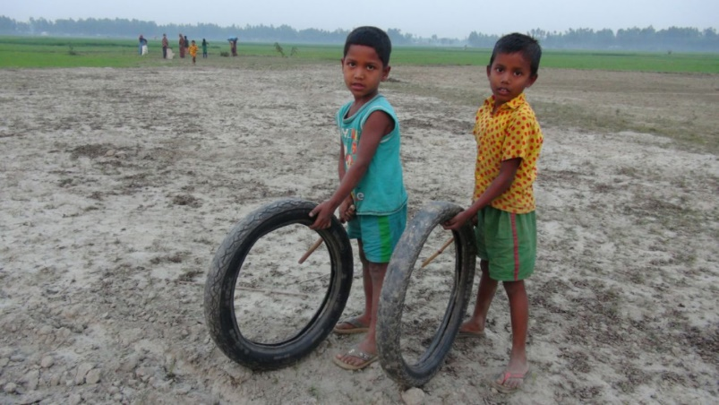
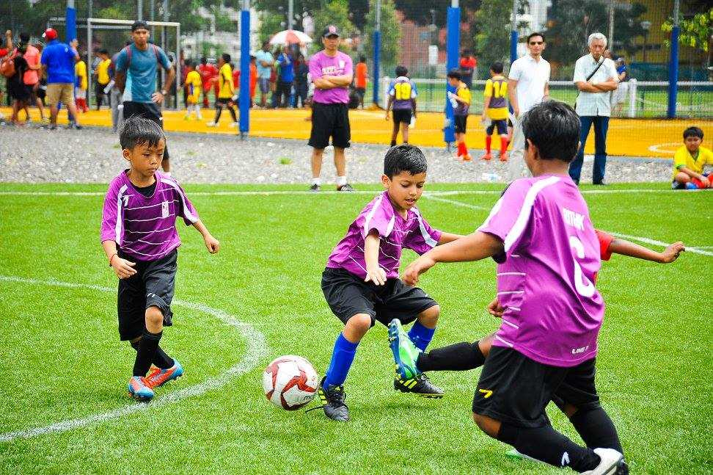
In most communities the type of recreational and sporting activities people participate in are determined by age, gender, local context (e.g. rural vs. urban) and socioeconomic status. For example, children in poor communities are likely to play games using natural materials, such as sticks or stones or using discarded manufactured items like tyres and rope. Leisure time is also related to festivals and events, and visiting entertainment troupes.
Figure 15 two different societies with different means of recreation
In many poor and rural communities there are no designated places for people to spend their leisure time, such as community centers and sports stadiums, so it is common for people to gather in places of worship, tea shops, houses and open spaces.
Communities in low-income countries often have pressing priorities and limited budgets. As a result the development of formal recreation and sports activities/programs is usually dependent on donors. It is important that external funding is carefully managed to ensure that the programs/activities introduced are appropriate to the local context.
The benefits of participation
Participation in recreation and sports activities can have many benefits for both the individual and community. These include:
- Health promotion and disease prevention – recreation and sports activities are an enjoyable and effective way to improve health and well-being; they can relieve stress, increase fitness, improve physical and mental health, and prevent the development of chronic diseases, such as heart disease;
- Skills development – physical and social skills are some of the many skills that can be developed through participation in recreation and sports activities;
- Awareness raising, reduction of stigma and social inclusion – recreation and sports activities are a powerful, low-cost means to foster greater inclusion of people with disabilities; they bring people of all ages and abilities together for enjoyment, and provide people with disabilities the opportunity to demonstrate their strengths and abilities, and promote a positive image of disability;
- International peace and development – sport is a universal language that can be used as a powerful tool to promote peace, tolerance and understanding by bringing people together across boundaries, cultures and religions
- Empowerment – recreation and sports activities can empower people with disabilities by positively influencing their self-confidence and self-esteem.

2.6 SOCIOLOGY OF SPORTS
The socialization into and through sports, sports and national identity, globalization and sports processes, elite sports systems, elite sports and labor migration, mass media and the rise of professional sports, commercialization of sports, violence and sports, gender and sports, race, ethnicity, and sports, as well as human performance and the drug use, are some of the topics that sports sociologists frequently look into.

Socialization into and through sports
The answer to several key questions about how people become socialized into sports? How precisely are young people socialized to take up and maintain their participation in sports? Why do some people stay actively involved in sports their entire life while others are happy to watch? When one considers how socialization into sports affects people, different issues come into play? What transpires when an athlete's athletic career is cut short by injury, aging, or loss of motivation? Why do some people see their primary identity as an athlete? What effect do sports have on a person's character, relationships, thoughts, and feelings more generally?

The Socialization process
Socialization is the process by which people become familiar with and adapt themselves to the interpersonal relationships of their social world. Through socialization, people develop ideas about themselves and about those with whom they interact. Inevitably, socialization is a two-way process that affects everyone to a greater or lesser degree. It takes place throughout one’s life, but it is during the early years that the most crucial phases occur. In these phases a person’s sense of self, social identity, and relationships with others are shaped.

Playing, taking part in games & competitions, have crucial and quite specific roles in the general socialization process. The sense of self is not natural; it develops through childhood socialization as a result of role-playing. Sociologists have identified two stages in childhood socialization: a "play stage" and a "game stage," which are influenced, among others, by George Herbert Mead and Jean Piaget.

The "play stage" (more precisely, the stage of noncompetitive games) is where children play the roles of a mother, a father, a teacher, a firefighter, or an athlete. Children are taught to distinguish between their true selves and the characters they play. Children go from noncompetitive games (like peekaboo and playing home) to competitions as they get older (such as footraces and ball games).The game stage (more accurately, the stage of competitive games) is where children come into stronger restrictions and regulations. They learn to view themselves as others do and create a reflective conception of the self and its relation to others. Children form their sense of self through socialization with "important people" and the "generalized other." They become self-conscious social actors.
In the majority of pre modern countries, families encouraged males to participate in sports that were thought to prepare them for their adult duties as workers and warriors, while encouraging girls to play noncompetitive games that were thought to prepare them for motherhood. In modern/contemporary civilizations, boys and young men still outnumber girls and young women competing in sports, but the gender gap has significantly shrunk. This has been true for both the interscholastic and intercollegiate teams that constitute a significant component of the North American sports landscape as well as the private clubs that oversee European sports.
The role of socializer into sports has been played by many actors, among them parents, older siblings, peers, teachers, coaches, and elite athletes appearing in the mass media. In the course of the 20th century, parents and older siblings became relatively less influential while coaches and elite athletes became more influential.
Due to the increased obligations and time demands of paid employment, parenting, and the physical deterioration of the body, sports participation tends to drop with age in both modern and premodern countries. The best indicator of long-term participation in sports is early indoctrination to sports. Sports haters are less likely to participate in them as adults than sports lovers, who are more inclined to play them all their lives. This may not apply to professional athletes. Children who are pressured to compete at the national and international levels as young athletes run the risk of burnout and quitting before they reach maturity.
Psychosocial Factors Influencing Outdoor Recreation during the COVID-19 Pandemic
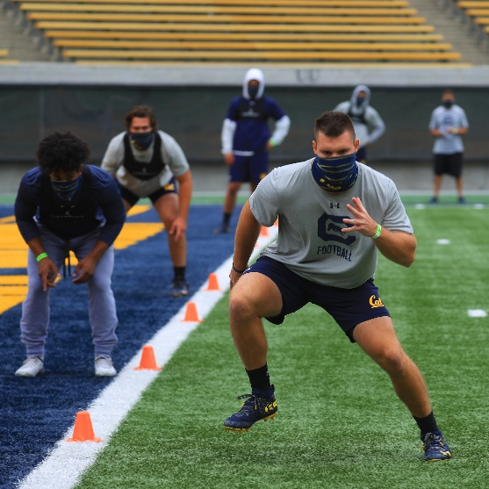
The COVID-19 pandemic has created an unprecedented disruption to daily life for large swaths of individuals and resulted in potentially widespread implications for individuals' health and wellbeing. This study utilized an online survey of avid outdoor recreationists to understand the psychosocial factors influencing recreationist behaviors during the COVID-19 pandemic across rural, urban cluster, and urban communities in the United States. Confirmatory factor analyses indicate that the five studied psychosocial factors–perceived risk, social norms, recommendations from authority, health benefits, and lifestyle adjustments–exist as unique constructs influencing individuals' outdoor recreation behaviors.
Repeated measures analyses suggest individuals rated seeking benefits to their general health as most important when making outdoor recreation decisions, followed by recommendations from authority, then perceptions of risk, with lifestyle adjustments and social norms rated as least important. Lastly, analysis across community types indicated individuals across the rural-urban gradient weighed perceptions of risk and recommendations from authority differently when making outdoor recreation decisions.

2.7 Indigenous Sports
Indigenous games are recreational activities that originated from a particular cultural group, community or people. These games are different from the mainstream sports, which are regulated by international federations, and have fixed rules. Conversely, indigenous games do not have internationally regulated rules for implementation; local organizers determine these according to the customs of the local participants. This creates many different versions of the same game.

Indigenous games are a very important part of a people’s heritage and culture. They preserve age- old traditions and stories of the people group. Indigenous games have an origin, which is the story behind the invention of the particular activity or game. When participating in indigenous games, one can begin to understand the social construct of a particular culture and history of the people who invented and continue to invent and participate in indigenous games. Here are some of the indigenous sports in Terai region of Nepal.
- Kushti
- Kabbadi
- Gilli Danda
Kushti or Phelwani
- Round /circular akhada/hoop width at least 14’
- Soil is dug pouring some lassi, oil & ochre mixed to make them red
- Soil id then sprinkled with adequate amount of water to make it soft
- Dangal is commenced after praying Hanuman Bajrang Bali
- Wrestler get inside court applying soil of akhada to their own body and forehead tilak
- No rounds last 25-30 min where duration can be increased
- One judge inside the circle, and two judges from watching outside
Figure 16 activities during the Kushti gameplay
- Wrestler try to force the opponent's back and waist to the surface which makes them victorious either by knocking out opponent or making him to surrender
Emotions and sports
Emotion, or the feelings that reflect athletes' self-evaluation or expectation of their performance and their perception of others' judgments and expectations, is another significant component of the experience of sports. Some of the emotions exhibited are eagerness to perform. Athletes are as accustomed to having "butterflies in the stomach" before a game as actors are to having stage fright. Other emotions emerge both during and following the performance.
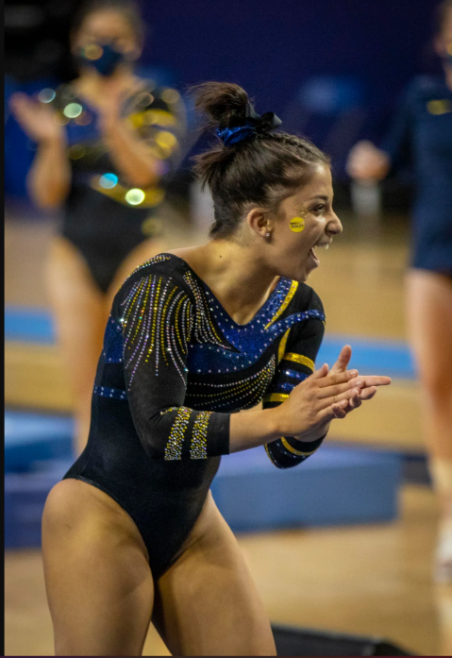
Figure 17 different emotions during a match

All these feelings are “scripted” by the subculture of the sport in question. These scripts, or “feeling rules,” guide athletes as they manage their emotions, prompting, for instance, appropriate behaviour during pregame renditions of national anthems or during postgame victory celebrations. Norms for the display of emotions vary widely among sports. Exhibition matches evoke less-intense feelings than football’s world cup games. The orchestration of emotions in sports begins with the arousal of expectations, provoking a diffuse emotional state that is then directed into a series of discrete and identifiable emotional displays. These emotions range from passionate identification with one’s representative team and with one’s fellow fans to hatred for the opposing team and its misguided supporters. Fans feel despair when an idolized player is injured; they feel ecstasy when a last-minute goal transforms humiliating defeat into triumphant victory.
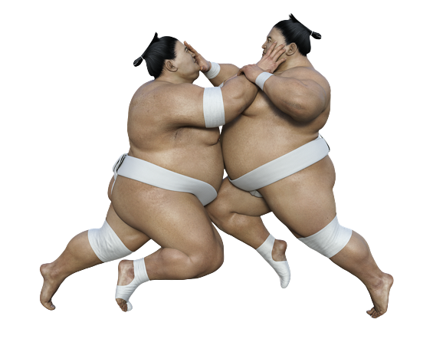
Sports and national identity
Each of these instances involved the invocation of a historical lineage, the accentuation of prior triumphs or travesties, and the actors' choice of whether to uphold or reject a set of made-up traditions. It is possible to go further with this connection between sports, national culture, and identity. Some sports are thought to embody every aspect of a country's character. Cricket, for instance, represents the virtues of fair play, courage, gracious behavior, and constancy in the face of difficulty in the value system of upper-class Englishmen. The game is a focal point of national identification in the feelings of upper-class males and is seen as representing the core of England. In addition, just as Englishness is portrayed as an elusive quality that is too subtle for outsiders to understand, so too are cricket's mysteries.

In a similar manner, bullfighting has been portrayed in the visual and the verbal arts as a material embodiment of the Spanish soul, Gaelic football is thought to be an expression of an authentic Irishness, and Sumo wrestling is said to represent the indefinable uniqueness of Japanese culture (which is why foreign-born sumo wrestlers are almost never elevated to the sport’s highest rank of yokozuna).

Sports and discipline
Any sport must have discipline as its base. It strengthens an athlete's character to enable them to focus their minds on tremendous accomplishments. Success in other spheres of life, aside from athletics, also depends on it. Children who play sports from a young age develop a disciplined mindset that lasts a lifetime. Young athletes need discipline instilled in them, and coaches in particular are crucial for this. This duty should be recognized by coaches, who should also demonstrate to their athletes the advantages of discipline. Athletes can gain the following advantages from having good discipline: discipline teaches the importance of hard work. There are no short cuts, as there always are. Any athlete, regardless of skill level, must put in a lot of effort to advance and fulfill their potential. No matter their skill level, athletes must put in a lot of effort if they want to advance and realize their full potential.
Discipline frequently entails limiting some items (alcohol, junk food, and drugs) that interfere with a person's ability to fully concentrate on the sport they love. To prevent your athlete from feeling overly repressed, consider implementing a "reward system" when they do something. A young athlete may find it challenging to cope at first, but with the correct support, they can realize that these sacrifices are required of them and expected of them. Successful athletes are adept at establishing both short- and long-term objectives. Discipline teaches athletes how to focus their efforts on achieving goals (learn a new skill? improve techniques?).Self-control makes it simpler for an athlete to understand the value of practice and preparation in achieving goals (as an individual or a team)

2.8 COMMERCIALIZATION OF SPORTS
Modern mass media and sports are both multimillion dollar industries. Without the support of the mass media for publicity and funding, elite sports cannot operate as they do. The massive market for sporting goods and team-related merchandise is largely supported by the media's 24-hour sports coverage, and a significant portion of the mass media's economic infrastructure depends on sports' ability to generate sizable, devoted cohorts of readers, listeners, viewers, and interactive consumers.
There are issues with this dynamic connection between sports and the media. Sports events are heavily influenced by the media, both in terms of how they are put on and when they happen. The media has undoubtedly exercised a level of power that was unimaginable during the time of Olympic founder Pierre de Coubertin when Olympic sprinters compete at 5 AM so that New Yorkers may see them in prime time, as was the case at the 1988 Summer Games in Seoul, South Korea. The advertising that frequently break up the action of sporting events carried by commercial television networks show that the media's financial interests come first. It is not surprising that there is occasionally opposition to the coexistence of sports and the media.
Figure 18 Nike sportswear with global soccer stars

One significant area where the "brand value" of sports is crucial to the interaction between the media and sports is corporate sponsorship. Corporate sponsorship, which has long since taken the place of the aristocratic patrons who once organized sporting events, has made it possible to finance sporting organizations and events while boosting the sponsors' brand recognition, identification, and loyalty. Naming-rights sponsorship for events and facilities and the prominent placement of the sponsors’ logos where spectators cannot help but see them are extremely valuable marketing tools for which sponsors are prepared to pay enormous sums.

2.9 SPORTS TOURISM
Sports tourism is the act of travelling from one locality to another, with the intention of being in some way involved with a sporting activity or event. Many people believe that sports tourism relates only to watching a sporting event. However, this is not correct. The sports industry is much more than this.

Sports tourism encompasses travelling for your own sporting purposes, such as a yoga teacher training course, a badminton competition or to learn to surf. Sports tourism includes attending sporting events such as a Formula One race or a Premiership football match. Sports tourism includes nostalgic visits to places of historical importance, such as the Olympic stadium in Barcelona or to see memorabilia related to your favorite sporting hero, such as the museum at the Maracanã football stadium in Rio de Janeiro.

There are, in fact, four main types of sport tourism. These types are known as:
- Sport Event Tourism
- Active Sport Tourism
- Nostalgia Sport Tourism
- Passive sports tourism
While sports tourism has not always been extremely popular, during the recent decade the amount of people attending out of area sporting events has drastically increased. People are now traveling far and wide just to attend their favorite events, and it is no wonder as to what has encouraged the sudden spike in popularity.

Sports tourism statistics
Today, sport is regarded as the world’s largest social phenomenon. And, tourism is predicted to become the world’s biggest industry early in the next century. So it doesn’t take a genius to work out that sports tourism is pretty big business! The sports tourism industry has grown considerably in recent years. In 2016 the sports tourism industry was worth $1.41 trillion and this figure is expected to increase to approximately $5.72 trillion by 2021. This is a whopping 41% growth in only four years!

Sport event tourism
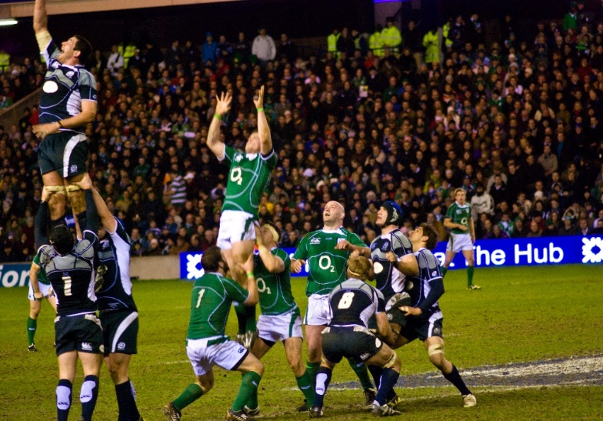
Sports event tourism is tourism which centers on a sporting event. Sporting events can be of any size and importance, however it tends to be the major sporting events which gain the most gravitas. Hallmark events, such as the Olympics or football World Cup, are important centers for sport event tourism, bringing millions of tourists to the host destination. Smaller events, such as the Henley Regatta in the United Kingdom or a national tennis competition also clarify as sport event tourism.
Six Nations Rugby Championships
Olympic Games 2020 Tokyo
An often overlooked example of sport event tourism are amateur sporting events. Events such as regional school competitions, youth sporting leagues and non-profit community based sport events are just a few examples. E.g. Wimbledon England (oldest tennis tournament in the world), Six Nations Rugby Championships (France, England, Ireland, Italy, Wales & Scotland).

Active sports tourism
Active sports tourism is when a person travels to actively participate in their chosen sport, or when they travel for other reasons, but taking part in sport is an important part of their tourism experience. Active sports tourists can be segregated into three classifications: The amateur sports tourist; the hobbyist sports tourist and the professional sports tourist.

There are a large number of active sports that a tourist may choose to get involved with around the world. Here are a few sports that one can get involved in as an active sports tourist:
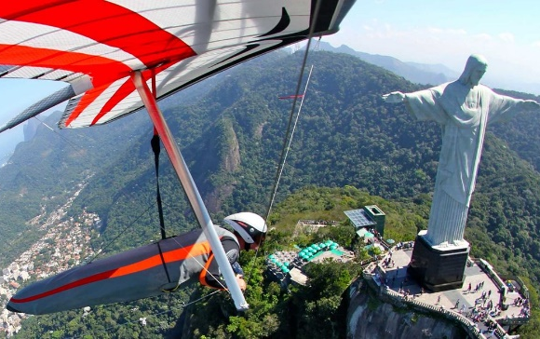
- Diving in the Galapagos
- Swimming at the Great Barrier Reef
- Playing tennis in Morocco
- Learning archery in Spain
- Going running in France
- Cycling in Amsterdam
- Taking yoga classes in Bali
- Learning tai chi in China
- Kayaking in Vietnam
- Sailing in Australia
Hand gliding in Rio de Janerio,Brazil
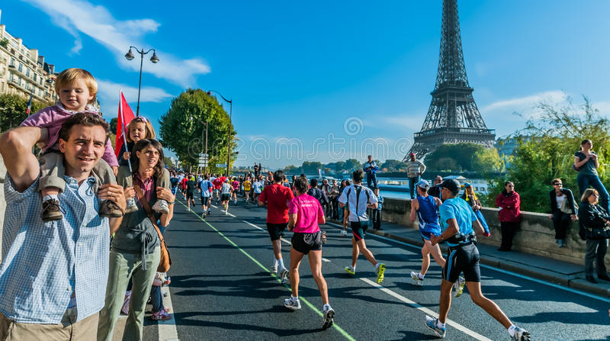
- Skiing in Argentina
- Surfing in Costa Rica
- Playing baseball in Boston
- Hand gliding in Rio de Janeiro
- Fishing in The Gambia
- Climbing in Thailand
- Horse riding in Ecuador
- Walking in Jeju
Fig. Olympic Games 2020 Tokyo
Fig. The Championships Wimbledon, England
Marathon runners at Paris Intl Marathon
Nostalgia sports tourism
Nostalgia sport tourism involves travelling to famous sport-related tourist attractions.
Nostalgia sports tourism may celebrate sports of the past or the present. It may include visiting museums or exhibitions, visiting sporting hall of fames or visiting sporting venues. The nostalgia sports tourist does not need to be actively participating in sport or to be spectating. They may simply want to learn more or to reminisce. E.g. Maracanã football stadium, Rio de Janerio, Barcelona Olympic Park, Chicago sports museum.
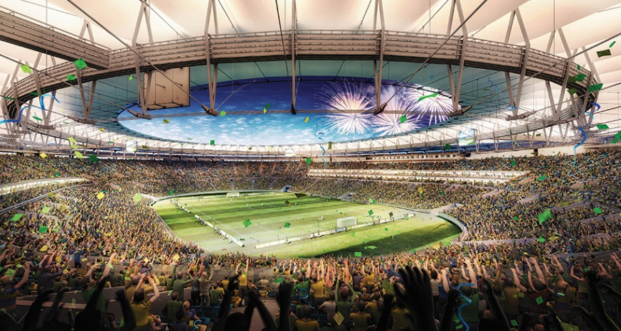
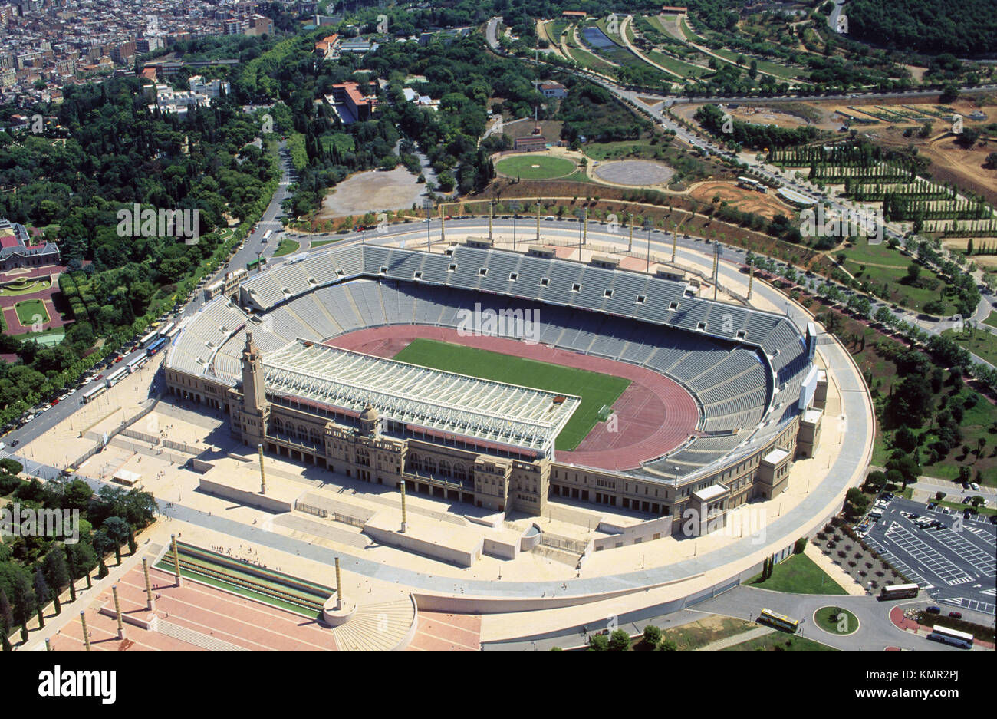
Maracanã football stadium

Maracana Stadium
Barcelona Olympic Park

Passive sports tourism
Lastly, it is important to recognize that whilst sport is inherently active, not all those who participate or who are involved with the sport are themselves active. In fact, passive tourists can actually contribute more to the sport than those who are active!

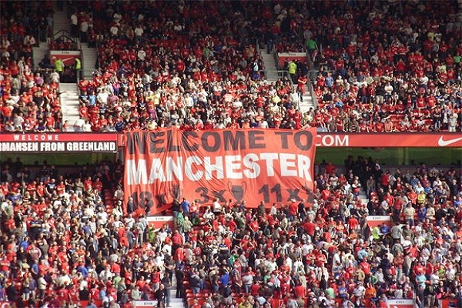
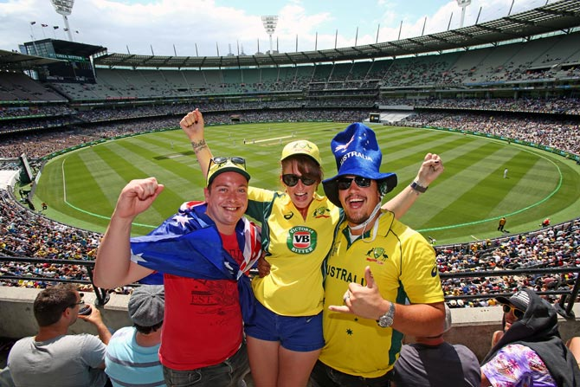
A passive sports tourist is a person who is not actively participating in the sport. They are spectators or fans. Passive sports tourism involves tourists watching sport being played. This could take place at a major sporting event (qualifying this also as sports event tourism), or they could simply be supporting a family member of friend. Most passive sports tourists are fans.
Football fans-Manchester United Spectators
Australian cricket fans

E.g. Football fans-Manchester United Spectators, Boxing fans-Anthony Joshua followers, British & Irish lion’s spectators, Australian cricket fans.

Benefits of sport tourism
As with any types of tourism, there are a range of benefits and advantages of sports tourism. Whilst the most obvious is perhaps the economic advantage of tourism, there are also positive social impacts as well as environmental impacts.
- Sports encourages tourists to visit the area
- Sports tourism creates economic growth through tourists booking hotel rooms, eating in restaurants and opening money in local shops
- Sports tourism helps to create exposure and enhances a positive image for the local community
- Many sports tourism infrastructures and facilities can also be used by members of the host community
- The development of sports tourism helps to build a sense of community
- Sports tourism has the potential to attract high-yield visitors and repeat visitors
- It can provide opportunity to develop new infrastructure in the area
- The media can help to promote the destination
- Sports tourism can improve overall tourist numbers
- Money made from sports tourism can be reinvested into the local economy
- Sports tourism creates jobs for local people
- Sports tourism which relies on the natural environment may result in better environmental management and preservation

Whilst there are many positive impacts of sports tourism, however, it is also important that there are a number of negative impacts too. Aspects such as environmental degradation when gold courses, employing foreign rather than local people for major sporting events and locals who feel that their cultural norms are being overlooked (such as not covering your shoulders in the Middle East, for example), are just a few example of negative impacts of sports tourism.
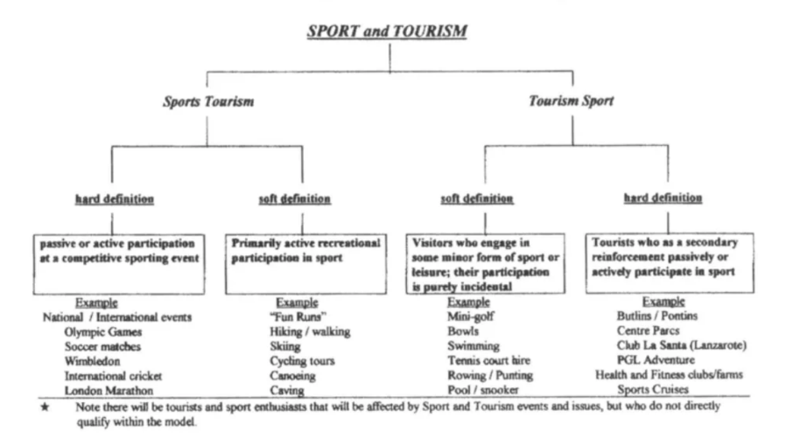
Sports tourism: Conclusion
Figure 19 Gammon and Robinson’s (2003) consumer classification of sport and tourism
It is clear that sports tourism is big business. Whether its events sports tourism, active sports tourism, nostalgic sports tourism or passive sports tourism, there is a huge market for tourists worldwide. However, as with any type of tourism, sports tourism must be carefully managed to ensure that it is sustainable.
Sports complex
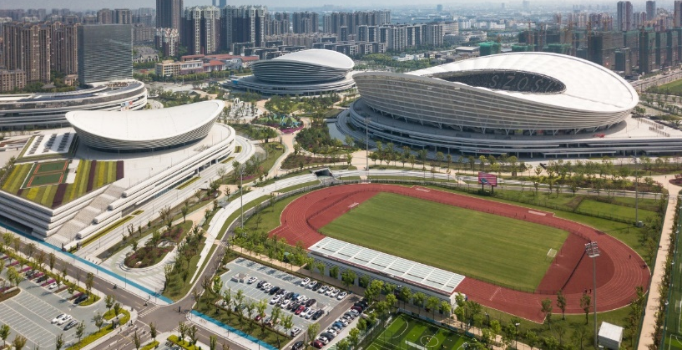
Sports complex are the places that offer a variety of different sports facilities, especially under one roof. They are the large and expansive area that incorporates several fields or courts dedicated to a particular sport or series of sports which can often be used for tournaments and leagues because they can hold a significant amount of people to watch the teams play.
Suzhou Sports Center, China

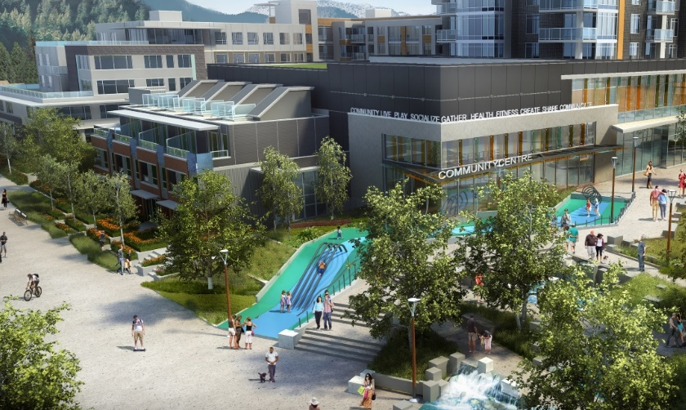
Recreation centers
Recreation centers are the buildings that are open to the public where meetings are held, sports are played, and also there are activities available for both young & old people. These are the facilities open to the public for leisure and recreation and activities. Recreation centers are usually administered by a municipal government agency where swimming, basketball, weightlifting, volleyball and kids’ play areas are very common.
New community recreation center, Vancouver Portland

2.10 WHAT IS A COMMUNITY RECREATION AND SPORTS HUB?
A Community Recreation and Sports Hub is a multi-use facility which has been designed and programmed to meet a broad range of outcomes. Although primarily designed to meet community recreation and sport outcomes, with considered planning and design hubs have the capacity to accommodate a broad mix of other community programs and services within the same location. This includes:
- Health Club (24/7 Gym)
- Childcare Centre
- Allied health services
- Education and training
- Toy/Sports library
- Youth/Other Community Services
- Retail
- Café
- Art, music and dance
- Community gardens
- Youth Centre
- Neighborhood House
- Sport administration offices
- Community events
- Conferences/Trade Shows
Importantly, hubs are places that are integrated, both in terms of the programs, activities and services they provide, and in terms of the physical relationship they have with surrounding locales such as shops, schools and importantly transport corridors and nodes. Under the hubs approach it may not be necessary to physically build completely new assets to meet demand.
To achieve the greatest range of benefits for local communities it is important to create flexible facility environments and manage these assets in a sustainable way. Greater value from recreation and sport can be achieved through co-location and management of facilities that not only provide a greater range of participation opportunities but also build stronger communities through a sense of connection.

GENERAL CHARACTERISTICS OF COMMUNITY SPORTS HUBS
HIERARCHY LEVEL | GENERAL CHARACTERISTICS
STATE / NATIONAL  Primary catchment attracting users and visitors from interstate and overseas | Provides for the highest level of sporting competition which may include International events and competitions, National League(s) and associated state and national team and squad training center(s).  High spectator numbers.  Are located at high profile sites with close links to major road networks and connections to public transport, cycling and pedestrian routes, community facilities or services.  Have the capacity to host major community events such as concerts.  May also provide a Headquarters for State or National Sporting Organization administration.  EXAMPLE: Adelaide Oval
REGIONAL  Primary catchment of local users with extended catchment across multiple local council areas, primarily for competition and events. | Integrates competition and recreational forms of participation and provides a broad range of sport and recreation activities and programs for a large number of participants across local and regional geographic catchments, generally beyond a single local council area.  Meet the standards required to host major state or regional level competitions, events and/or training.  Have the capacity to host major community events such as festivals.  Are located at high profile sites with close links to major road networks and connections to public transport, cycling and pedestrian routes, community facilities or services.  May also provide an administration base for volunteer clubs and associations.  EXAMPLE: Port Augusta Central Oval
DISTRICT  Primary catchment area of local communities and single local council areas.  Regional  State/National | Provides a focus for association competition as well as service a local catchment to provide a mix of recreational, competitive and program formats of participation.  Facilities may also provide a primary function as a local finals venue or a central venue that facilitates regular competition for multiple clubs / teams.  EXAMPLE: Flagstaff Hill Community Cent

General types of Sports center
- State/National
- Regional
- District

These are the categories of the sports & recreation center on the basis of their scale/size/area, location/catchment area, and level of facilities/programs.

BENEFITS OF COMMUNITY RECREATION AND SPORTS HUBS
KEYNOTES | BENEFITS
Strategic | Opportunity to integrate a variety of community services in one central accessible location for example recreation and sport, allied health services, community and social services, education, and arts.  Improved links and opportunities for collaboration between sports clubs, service providers, and other hub partners, for example schools to deliver targeted community programs.
Economic/Financial | Economies of scale in capital and revenue costs with the aim to reduce reliance on public sector subsidy in the longer term, leading to a financially sustainable community facility asset base.  Facilities shared by a number of different sports (indoor and outdoor) bringing economic benefits from sharing overheads and maintenance cost efficiencies.
Community/Recreation and Sport | Opportunities for integration of sports and recreation with other community, social and health services and organizations  Capacity to enhance social capital and community cohesiveness.  Improved knowledge sharing and efficiencies for local sports clubs through co-locating and sharing support services.  Increased opportunities for participation through diversity of facilities s, linking together clubs, public and private sector provisions.  Culture and provision can be more community focused and inclusive than traditional sports clubs by providing for all sections of the community

CHAPTER-THREE

3.1 STANDARDS

3.2 LOCATION:
Location plays a vital role in architecture of any structure. Architecture is determined by the surrounding materials, environment, local resources, micro climate etc. So selection of a good location for designated structure is very much important. Key points that should be considered while arranging an arena are described as follows:

- It should fit well with the local topography.
- It should not be in the core city. Events organized in the arena causes huge impact in the normal city life. Hence, it should be located in outskirts of city.
- There will be industrial zones in the outskirts so it mustn’t be near these areas as the environment of these areas are not so healthy.
- It should be designed with a good transportation facilities. There should be a good motorways to the arena from the city. Furthermore, there should be adequate public transport.
- It should have sufficient areas for future expansion. The requirement of arena will definitely grow with time, hence provision for future expansion is essential.
- It should be selected considering the microclimate. Construction of these huge structures may adversely affect local environment and microclimate. So these things should also be considered.

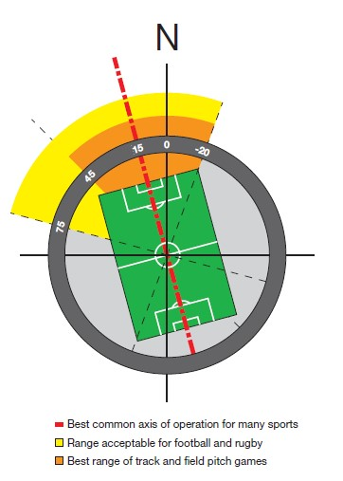
3.3 ORIENTATION
The orientation of a play field is essential as a bad oriented field creates problematic conditions while playing. Stadiums are designed in northeast to southwest orientation as to face the back of the spectators to the sun most of the time. In case of arena, there isn’t any fixed orientation. There are oriented as to reduce the sun’s glare.
The recommended orientation of a football pitch, according to FIFA, the world's governing body of football, should be between 0 and 45 degrees west of true north. With the north angle lying within this range, the goalposts would face somewhat west of true north.
Figure 20 Preferable orientation of stadium

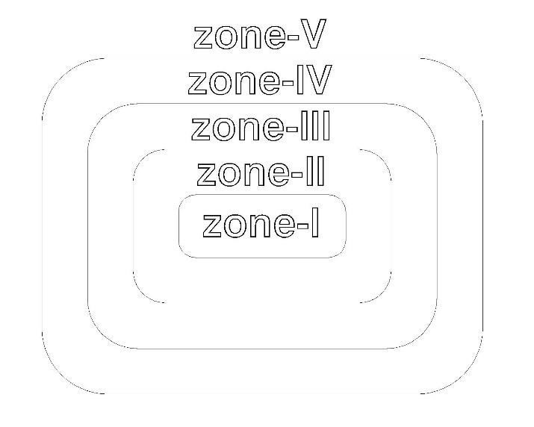
3.4 ZONING
Zoning is also a factor that should be considered for a better running arena. Programs will be in chaos if the zoning is not proper. Conduction of a program may not go properly if the interrelated zones and segregated zones are planned properly. For example; spectator’s zone and player’s zone should not be connected. There should be visual relation only. But player’s zone should be connected to official zones as they will have to encounter from time to time. If player’s zone and spectator’s zone are connected there may be problems during programs.

According to the use, zones of arenas can be fundamentally determined as follows:
Zone I
This zone is the center most zone. This includes play fields where the main event takes place. Spectators and officials have their eyes in this zone. This is the major zone among all. It should be segregated from other zones as no disturbance is tolerated here. Problems in other zones should not effect this area in any situation.

Zone II
This zone is the area that surrounds the play area. This zone includes spectators’ viewing area. This zone has uninterrupted visual connection with zone I but lacks people movement in between. In fact this zone is provided with different entrance than that of zone I.

Zone III
This zone is this zone consists of concourses required for the zone II. Concourses like café, souvenir shops and washrooms come under this zone. This zone surround zone II.

Zone IV
This zone is this zone. This zone surround the third zone. It consists of circulation that caters spectators’ zone. It plays vital role because improper designing of this zone may lead to chaotic pathways to the dedicated places. It should be systematically designed. It should be designed considering the emergencies. This particular zone separates entry point and the main arena.

Zone V
This zone is the outer most zone which consists of entry and parking lots. This the outer perimeter just outside the arena. It should have adequate space to cater all the people at a time because people exit the place at same time i.e. completion of match.

3.5 HALL STANDARDS
There are different types of hall determined by number of pitches they include. Generally there are four types of hall according to their sizes. They are determined by a group of 4 badminton courts which is 20’x44’ (6.1m x 13.4m). So a single hall consists of 4 badminton courts. Types of halls are listed below:
- Single : 4 badminton courts
- Double : 8 badminton courts
- Triple : 12 badminton courts
- Quadruple : 16 badminton courts

According to British standards for a sports hall there are 5 types of hall. Here the hall is measured in number of badminton courts as well. 5 different halls are listed below with their dimensions:
- 4 court hall : 33m x 18m x 7.6m
- 6 court hall : 33m x 27m x 7.6m
- 8 court hall : 37m x 33m x 7.6m/9.1m
- 9 court hall : 51m x 27m x 7.6m/9.1m
- 12 court hall : 54m x 33m x 9.1m
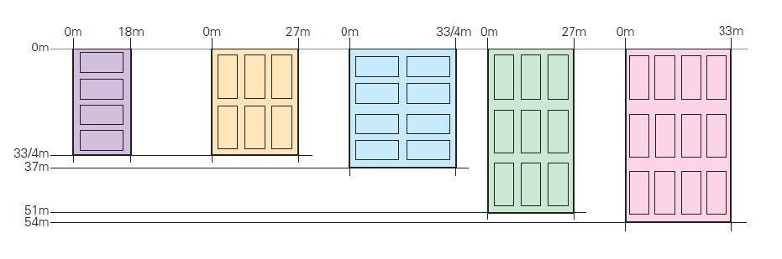
Figure 21 Types of hall with their dimensions

4 COURT HALL
The critical minimum dimensions for this most popular size of sports hall are 33 x 18 x 7.6m. Main structure must always be aligned between the badminton courts to create four bays. Extra width can be considered to enable cricket nets to be hung alongside rather than over the badminton courts and to provide an extended spectator zone. An extra 1.5m added to the length and 0.25m to the width allows for a full-size netball court with side and end margins.

Notes:
- A minimum height of 7.6m must be provided over the whole badminton court area and 7m minimum for most team games including basketball and volleyball.
- The 33 x 18m dimensions allow four doubles play badminton courts with a central division net.
- County standard badminton requires a length of 34.8m and a height of 9.1m.
- The 18m width is ideal for several of the smaller space sports. A full-length fencing piste, short mat bowls carpet and up to four table tennis tables can be accommodated across the width of the hall.
- Badminton courts can be central in the hall or offset to provide a narrow circulation zone to the entrance side of the hall.
- Bagged cricket and hall division netting can be stowed outside the critical play areas for most sports but for five-a-side football which utilizes the whole space nets must be hoisted above shoulder height.
- Basketball benefits from an increase in width to 19m to allow full side margins or, alternatively, the minimum margins plus officials’ space.

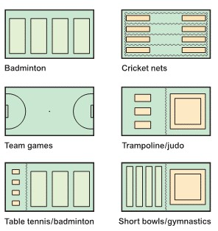
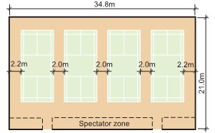

Figure 22 4 court hall

6 COURT HALL
The 33/34 x 27 x 7.6/8.4m hall creates two team sports zones or a competition play area aligned with spectator seating. The 3 + 3 badminton court arrangement is recommended in preference to the 4 + 2 layout originally used in this type of hall. The 34m length provides the required safety margin behind the badminton courts. Further increases in length will be required for county standard play.

Notes:
- Align structure between badminton courts to provide three full-span bays or introduce a primary beam across the center of the hall.
- Division netting is hung between the three rows of courts. It can also be considered between two end courts but this zone is usually designated for retractable seating.
- A height of 9.1m and extra length is required for county standard badminton.
- Two standard basketball courts or two reduced five-a-side football courts can be laid across the hall with modified ‘D’ end markings.
- Wider pitches for recreational handball, hockey and korfball are possible in the six court hall as well as more space for sports hall athletics.
- The 4 + 2 badminton court arrangement requires a four-bay structure to ensure that lighting and transverse netting accord with the four primary courts.
- In the 4 + 2 layout shown there is insufficient length to accommodate the full run-back to end-on courts in the 9m zone.

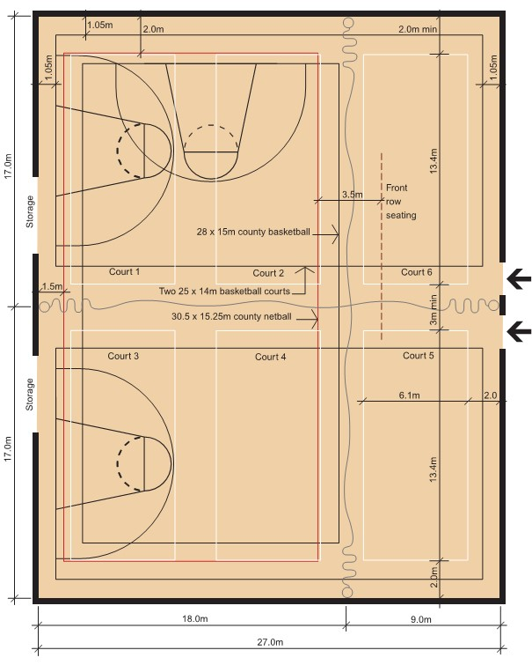
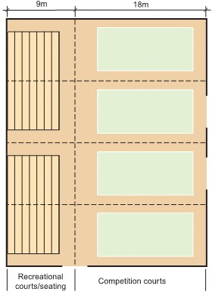

Figure 23 6 court hall
8 COURT HALL
The critical dimensions are 37 x 33/4 x 7.6 or 9.1m. This hall can be divided into two full-size play zones for most sports hall team games. Height requirements become more demanding as hall size increases and the environmental impact of extra high halls has to be weighed against more restricted use and possible ball damage in too low a hall.

Notes:
- This size is particularly suitable for county netball and top division basketball. For netball the court would be marked out to take advantage of the 37m dimension or, preferably, width would be increased.
- Align structure between badminton courts to provide four full bays or introduce a central primary beam.
- Four county standard badminton courts can be marked out or rolled down and require a clear height of 9.1m.
- To accommodate a minimum size indoor hockey pitch, handball or korfball, length must be increased to 39m.
- These halls can seat upwards of 1,000 spectators for a table tennis final or for other sports with limited space requirements. Escape routes from the hall must take this capacity into account.
- Invariably, eight-court halls are used for non-sports events and access for users and equipment requires extra consideration. An increase in overall area is sometimes justified.

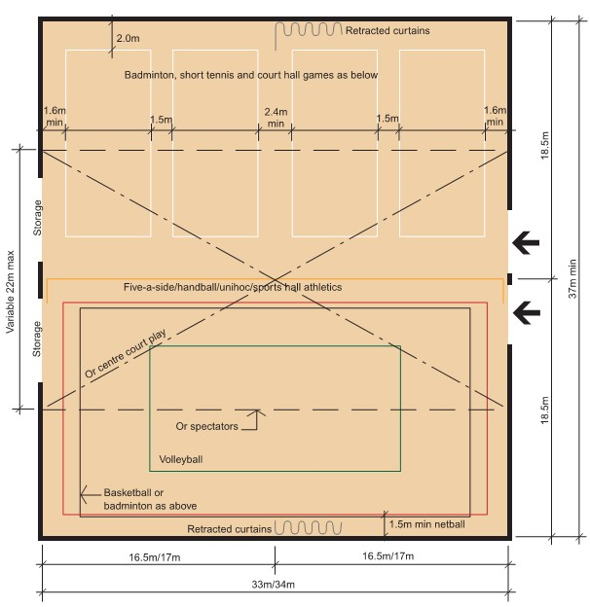
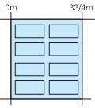
Figure 24 8 court hall

9 COURT HALL
This 51 x 27 x 9.1m high hall is suitable for club standard indoor hockey, handball, korfball and five- or six-a-side football. Its elongated dimensions also provide more scope for sports hall athletics and gymnastics. Spectator capacity within the hall is limited for long pitch games when extra width may be considered worthwhile. A smaller hall 47m in length would be suitable for a full-size indoor hockey pitch with 1.5m end run-outs but does not provide such a space efficient layout for badminton.

Notes:
- Hall area is 11% greater than the eight court hall but there is greater sports capacity and, essentially, space for the three long pitch games.
- Run main structure to divide the hall into three zones with secondary structure between badminton courts.
- It can provide three to six activity zones with good access from a circulation route down the length of one side of the hall.
- There is space for six county standard roll-down badminton courts with seating for approximately 500 spectators in the central zone.
- The 27m width does restrict flexibility in laying out the smaller team games and results in more courts being run lengthwise down the hall.
- Narrower dimensions than for the eight court hall can result in a more economical structural design.

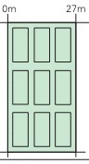
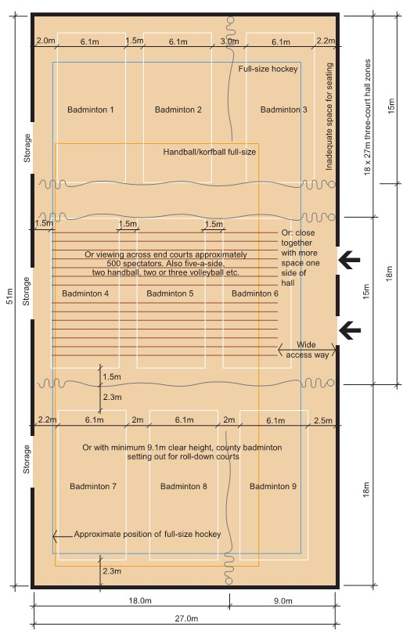

Figure 25 9 court hall

12 COURT HALL
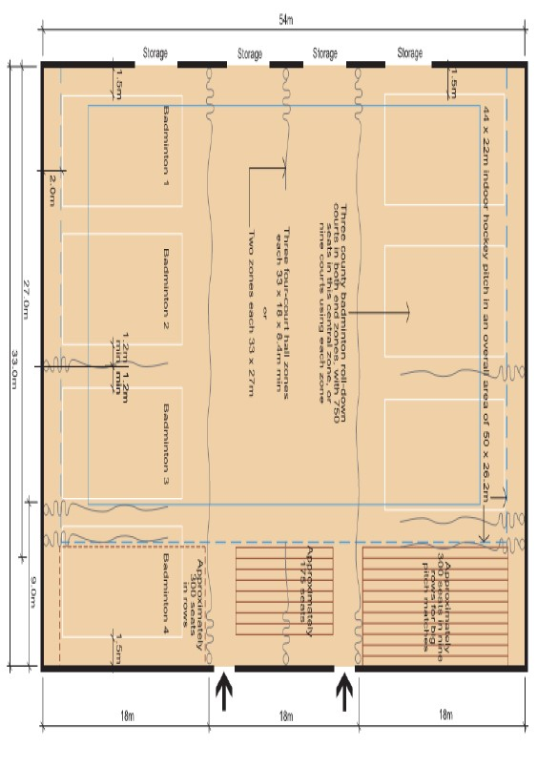
At 54 x 33 x 9.1m this size has the capacity of a small regional arena, a spectator venue for local and county level competition. It is a larger version of the nine-court layout.
Figure 26 12 court hall

Notes:
- Three modules of the four-court hall can be arranged by dividing the length into 18m (and variable) width zones or two six-court hall zones.
- Primary structure should run between these zones with secondary structure between badminton courts.
- Extra flexibility is provided by lengthwise subdivision.
- Over 700 seats can be aligned along one side of the hall for handball, hockey or korfball spectators and more for other sports or entertainment events.
- An increase in width permits banks of seating to each side and possibly also to each end of the competition pitch.
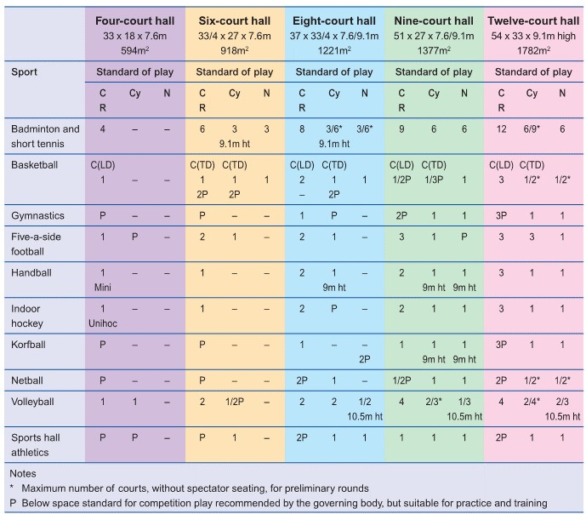

Figure 27 comparison of different sizes court hall

3.6 DESIGN CONSIDERATIONS
EXTERNAL PLANNING
For a public building like arena a lot of facilities should be considered as different kinds of people access it. Types of people include VIPs, differently able people, normal spectators, players etc. Hence provision should be made for:
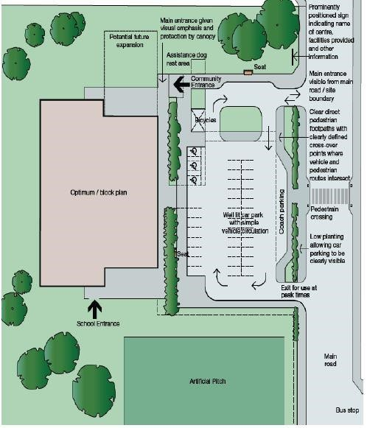
- Car and coach parking closely related to the main entrance
Figure 28 Notional site layout
- Emergency services like ambulance, police vehicle, fire fighters should have easy access
- Disabled parking bays with ramped curbs
- Drop off point adjacent to the entrance
- Appropriate bench seating along pathways
- Access and adequate turning provision for service vehicles
- Secure cycle standing located within sight of the office or reception
- Ramps, if there are changes in ground level, and additional hand railing
- Well-lit car parks and footpaths for safe access after dark
- Planned pedestrian routes

MAIN ENTRANCE

The design of the entrance should be warm and welcoming. The entrance foyer is the hub of the building and should have sufficient space and volume for people to circulate, view notices or wait for friends in comfortable surroundings. Design to provide:
- Views towards the sport hall and other main elements of the building
- Outer perimeter fence situated some distance from the stadium and first checks at this outer fence
- Second check point should be at the entrance to the arena
- Public amenities should be near entrance
- Same entrance should not be used for entry and exit simultaneously
- Convenient and secure store for pushchairs overlooked from reception
- Draught lobby to the main entrance doors
- Automatic operation of the main doors which is particularly helpful to wheelchair users and people with young children
- Space for the inclusion of security barriers. The management strategy will dictate foyer planning. Options for foyer design include:
- Reception close to the point of entry with sufficient space for queuing
SPECTATOR AREA

The spectator galleries are place where spectators seat or stand and view the event. Since there are different types of spectators different standards should be followed while designing. The numbers should be determined according to population or requirement
- Areas should be divided into sectors so that services like entry, exits, toilets, stairways, doors, passages etc. can be easily designed
- Spectators should have a clear view of events with good acoustics
- Preferred gradient for seating arrangement is 1:2
- At least 0.33 sq.m area should be allocated per person
- Passing path in front of each row is minimum 0.3m
- Seat width should be 45-50cm
- Seat depth should be at least of 35 cm

COMFORT

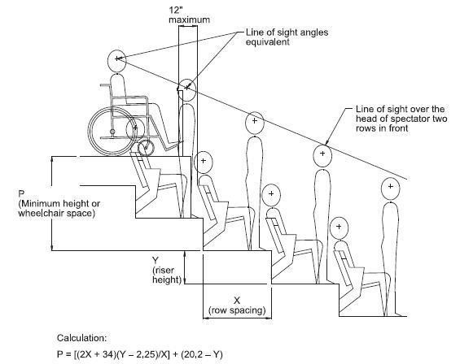
The main purpose of architecture is to provide comfort to the users of structure. The functions should be comfortable. It should have a good visual and acoustic relation between play area and view area. For comfort of the users following measures can be taken in consideration.

- All spectators should be seated
- Roof should be provided all over viewing area and field
- Sound visual connection to play area from view area
- Amenities provided should be adequate and hygiene should be maintained
Figure 29 line of sight in view area
STAIRCASE/PASSAGE/EXITS

Staircase is a very important part of design. Especially in such large public structure, staircases should be incorporated considering reliable data. It allows people to move in different levels. Staircases should be designed considering the time of emergencies, earthquakes, fire etc. Evacuation time should be 5-10 minutes. However, 8 minutes is preferable.

𝑠𝑡𝑎𝑖𝑟𝑐𝑎𝑠𝑒 𝑤𝑖𝑑𝑡ℎ (𝑚) = 𝑛𝑢𝑚𝑏𝑒𝑟 𝑜𝑓 𝑠𝑝𝑒𝑐𝑡𝑎𝑡𝑜𝑟𝑠

𝑒𝑚𝑝𝑡𝑦 𝑡𝑖𝑚𝑒 (sec) × 1.25

Maximum of 25 numbers of seats should be allotted in a row of seating as fire regulation specifies that maximum number of seats to be traveled should be 14. Each block of seats should be provided with more than one exit for emergencies. 750 number of seats should be provided with at least of one exit.
SAFETY

Safety is crucial in any structure. No life loss by structure is tolerated. Especially in such public buildings it is very important as there are many people using it at a time. Mishaps of any kind can cause huge losses. So safety is topmost issue.

Degree of luxury and comfort can be gained with amount of money available but safety cannot be compromised with money. At least minimum standard should be met. Arena should be safe and secure to all the users who use them.

ESCAPE DURING EMERGENCY

Among different factors regarding safety, escape during emergencies should be considered in first place. During emergencies all people should be evacuated to safe place or outdoors as soon as possible. For escape during emergencies three major things should be considered. They are discussed below:

A.ESCAPE TIME
During emergency the building has to be evacuated. Hence the total time required to empty the arena is known as escape time. It should be between 5 to 10 minutes. However 8 minutes is preferable.
- A person can travel 150m in 60 seconds in passages.
- A person can travel 30m in 60 seconds in staircase.

B.ESCAPE TRAVEL DISTANCE

Total distance that should be traveled from any seat to nearest safe point outdoors is known as escape travel distance. Maximum escape travel distance allowed is 32m.

C.ALERNATIVE ESCAPE ROUTE

For every block of seating at least two escape routes should be provided so that one can be used during failure of another route.

FIRE PREVENTION

Local fire authorities must approve the firefighting facilities available within the stadium and general fire precaution. Designing of firefighting system not just include active firefighting system like smoke detector, water sprinkler etc. It should be considered during the planning phase. The escape routes should be smoke free. There should be at least 2 escape route that takes from central activity part to safer outdoor space. Dry and wet firefighting systems should be incorporated as well to control the fire.

No part of the floor should be more than 6m from the hose nozzle when the hose reel is fully extended. There should be constant supply of water not less than 23lts. Per minute through nozzle of not less than 6.5 mm size for half an hour when three nozzle reels are operated.

HYDRANT SYSTEM

There are two types of hydrant system.

Dry Riser - In this system water is provided from fire brigade
Wet riser - They are fixed pipe installation within a building and permanently charged with water under pressure from available water source

HYDRANT STATION

It is provided to serve an area of 926-100sq.m. They are placed in fire resistant areas near fire escape, lobby and staircases. It comprises:
- first aid
- hose reel with 20mm diameter rubber hose with 63mm diameter landing valve
- Two 15m x 63mm diameter reinforced rubber lined hoses with coupling branch pipe with a 12mm nozzle for use by fire service personnel.

FIRE PUMPS

Pumping sets are required to enable water to reach the topmost floor and connected to fire tank.

SIGNPOST AND DIRECTIONS ON TICKET

All public direction signs inside and outside the stadium should be presented in internationally understandable sign language. It must be kept in mind that many of the people don’t understand local language hence signs are necessary. The signs should be clear and comprehensive so that they can be easily understood and memorized. Tickets should contain map to their respective seats.

3.7 AMENITIES
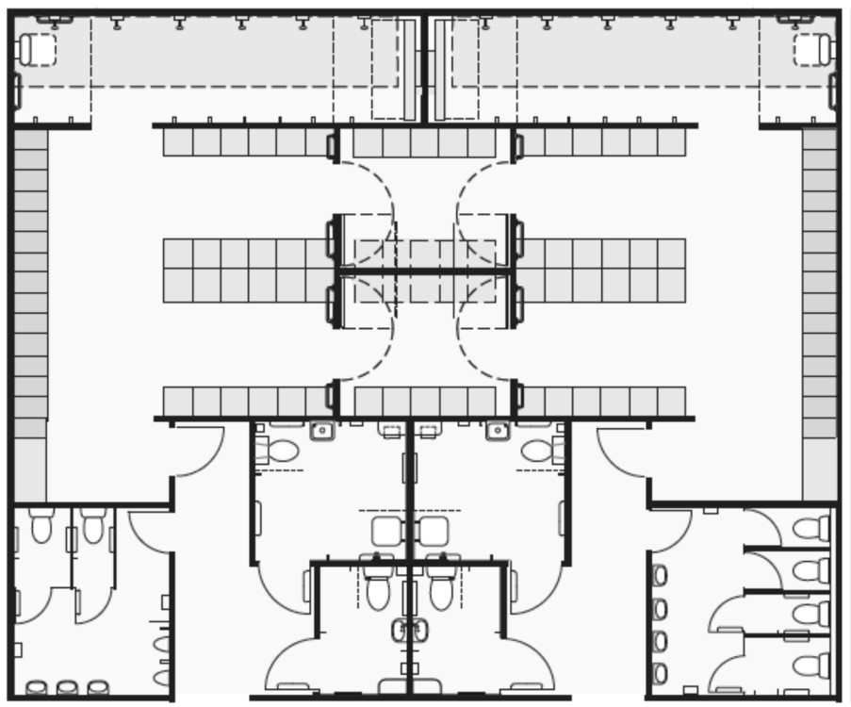
CHANGING ROOMS

Amenities for the players should be isolated from that of public and media. There should be at least 2 changing rooms for players of 150m2 each. Players’ lounge is essential for players to grab some foods and relax.

Figure 30 Notional layout of changing rooms

FIRST AID / PHYSIOTHERAPY ROOM
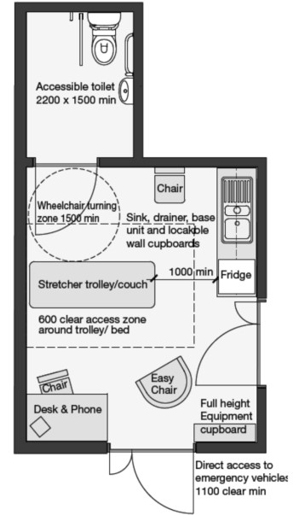
First aid and physiotherapy rooms should be near players changing room and lounge. It should be connected with wide passage for stretchers and wheelchairs. It should also have direct access to outside in case of emergency. Minimum area allotted for medical room is 24 sq.m.
Figure 31 physiotherapy room

REFEREE’S AMENITIES
Different amenities should be provided to the officials. It should also be inaccessible by public and media. Minimum of 40 sq.m should be allotted for official’s changing room, shower, washrooms, locker rooms etc.

DOPE CONTROL ROOM
These days Dope Control rooms have been mandatory in area sporting event. It check whether players are medically qualified or not. Dope test room also complies of a room with attached washroom. Moreover it shares all the feature of firs aid room.

MEDIA
Arenas should be designed to allow broadcasting of sporting event to millions of people around the world via media. Dedicated car park should be allotted for media people as they will have OB van for broadcasting. Park should be allotted near arena. Different access and space should be allocated for them than that of public. The media space should have good view of the play area.

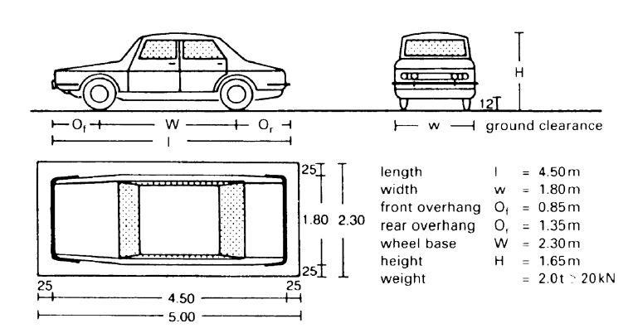
PARKING
Figure 32 Car parking standards
Ideally, all parking areas should be on site, giving spectators direct entrance to the stadium. Parking lot must be brightly lit with all sign post required. Parking should have direct access to the main access road. It should be near the stadia within periphery of 1500m. Adequate parking spaces should be provided considering the peak hour.

Separate parking for emergency vehicles like ambulance, fire brigade, police car etc. should be allocated. These lots should be near to arena and should have uninterrupted access to the main road.
- 8 buses per 1000 people
- 1 car per 3 people

Different layouts for parking can be adopted according to the space available. Signs should be provided in parking lot to avoid any possible accidents.

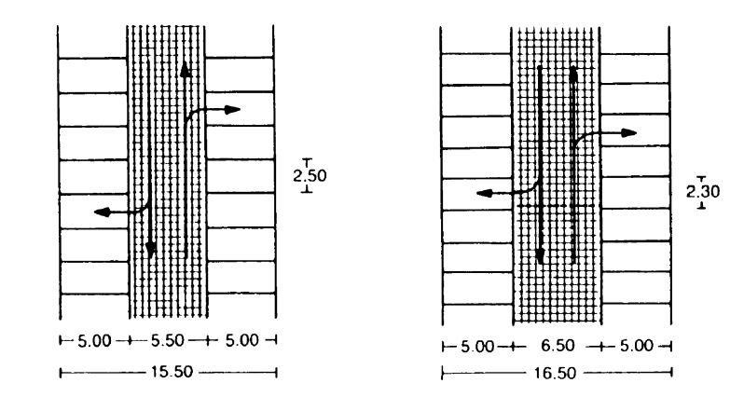
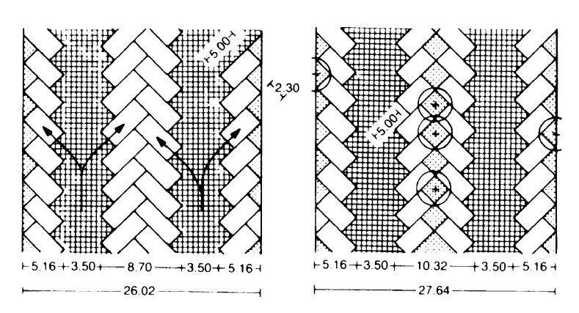
Figure 34 Standard dimensions for 90⁰ parking for 2-way passage with parking width of 2.50m (left) and 2.30m.
Figure 34 45⁰angled parking for one-way traffic with vegetation included (right) and without vegetation

3.8 PITCHES
FOOTBALL
Dimensions: Length (Touch line/horizontal) 90-120m Width (Goal line/vertical)45-90m

Field Marking
Circle with radius 9.15m marked around the center point>>all lines not more than 12cm

Goal Post: 7.32m x 2.4m
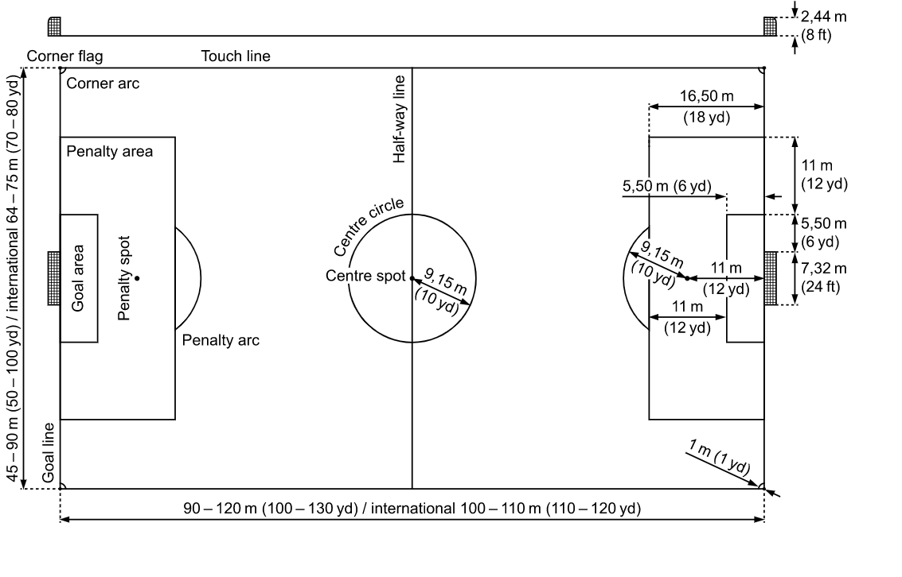

Figure 35 Football Court

BADMINTON
Court dimensions
The court is a rectangle and can be used for both singles and doubles. The court size for singles is 13.4m x 5.18m (playing area = 69.41m² including boundary lines) and 13.4m x 6.1m (playing area = 81.74m² including boundary lines). The lines are 40mm wide and colored white or yellow. It is desirable to have a wooden sprung floor together with approved non-slip court mats.

Space about court
There is at least 2m clear space surrounding all the outer lines of the courts. There is also a minimum requirement of 2m between any two courts marked out side by side.

Posts and nets
Posts are 1.55m in height from the surface of the court. The net is 760mm in depth and a minimum of 6.1m wide. The top of the net from the surface of the court is 1.524m at the center of the court and 1.55m over the sidelines for doubles. There is no gap between the end of the net and the post. If necessary, the full depth of the net at the ends is tied to the post.

Space over court
The minimum height from the floor over the full court for international competition is 12m. Club standard play is 9.14m. The required height is entirely free of all obstructions and light fittings over the area of the court.
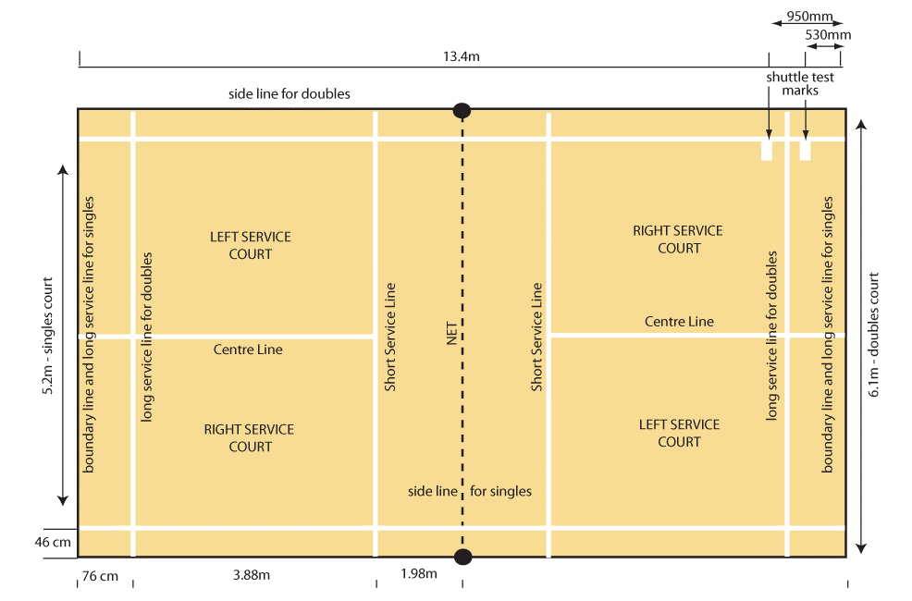

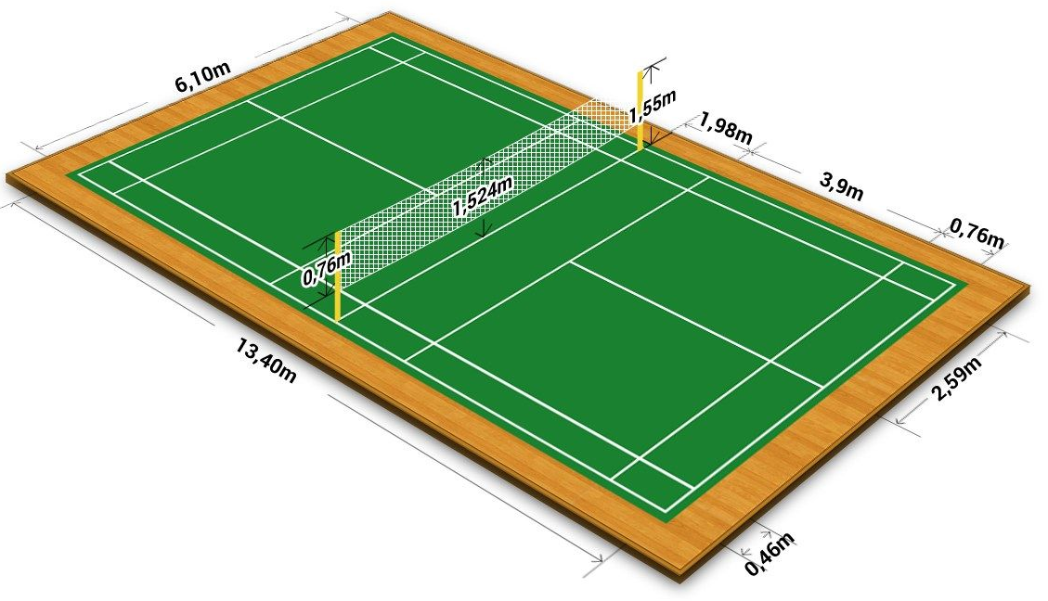

Figure 36 Badminton Court

BASKETBALL

Court dimensions
The playing court is a flat, hard surface free from obstructions with dimensions of 28m long by 15m wide, measured from the inside edge of the boundary line. The height of the ceiling or the lowest obstruction above the playing floor is at least 7m.

Lines
All lines are drawn in the same color (preferably white), 5cm in width and clearly visible.

Boundary line
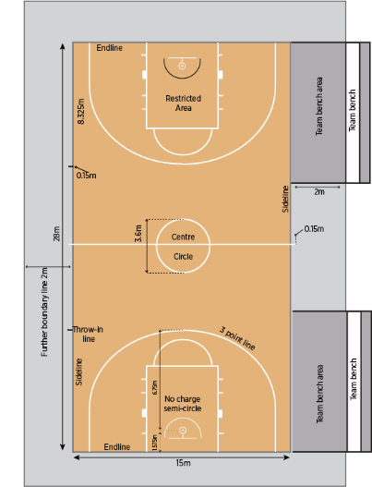
The playing area is limited by the boundary line, consisting of end lines and sidelines. These lines are not part of the playing court. The minimum space around the court for run-off is 2m. Any obstruction, including seated team bench personnel, must be at least 2m from the playing court.
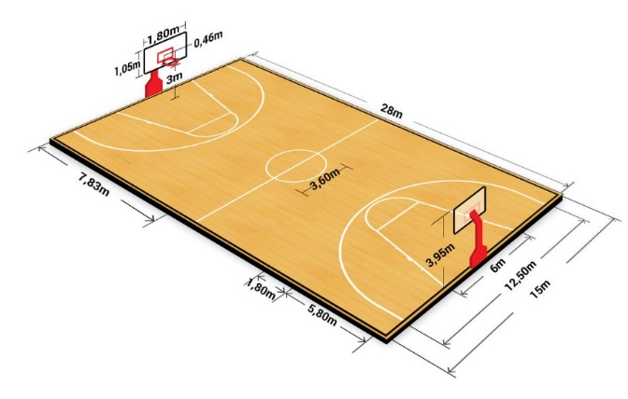

Figure 37 Basketball Court

FUTSAL
National Games

Length: minimum 25 m / maximum 42 m Width: minimum 15 m / maximum 25 m

International Games
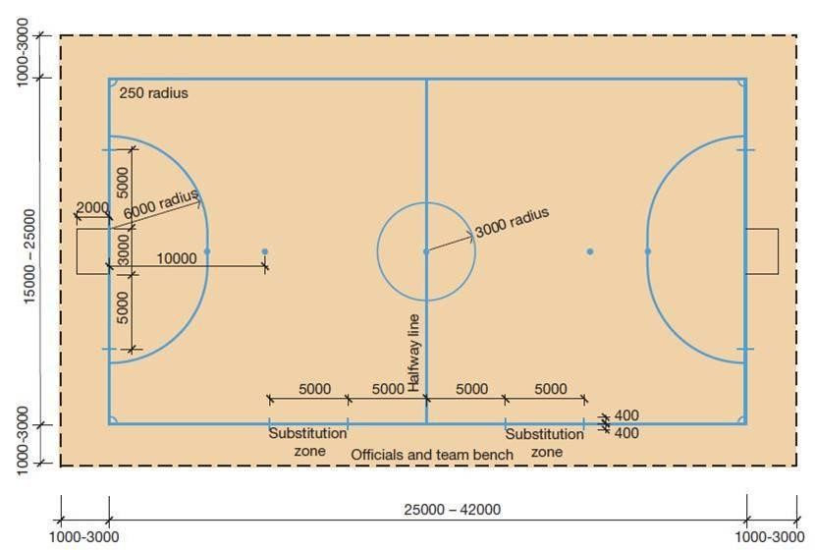
Length: minimum 38 m / maximum 42 m Width: minimum 18 m / maximum 22 m

The playing court is marked with lines. These lines belong to the areas of which they are boundaries. The two longer boundary lines are called touchlines. The two shorter lines are called goal lines. All lines are 8 cm. wide. The Playing Court is divided into two halves by the halfway line. The center spot is indicated at the midpoint of the halfway line. A circle with a radius of 3 m is marked around it.
Figure 38 futsal pitch

VOLLEYBALL
Dimensions: 18m x 9m>> free zone 3m wide on all side

Line Markings: lines are 5cm wide and light color different from floor

Posts: 2.43m (Male) 2.24m (Female)

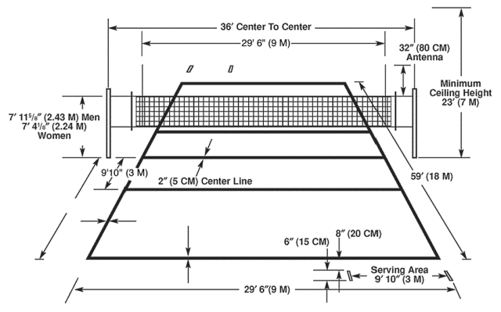
Figure 39 Volleyball court

SWIMMING POOL

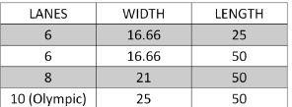
Pool size – 0.025 sq. m/inhabitant (low density) 0.01 sq. m/inhabitant (high density)

Plot size (without parking) 6-10 sq. m /sq. m of pool size

Minimum depth -1m -1.8 m (Olympic standard)

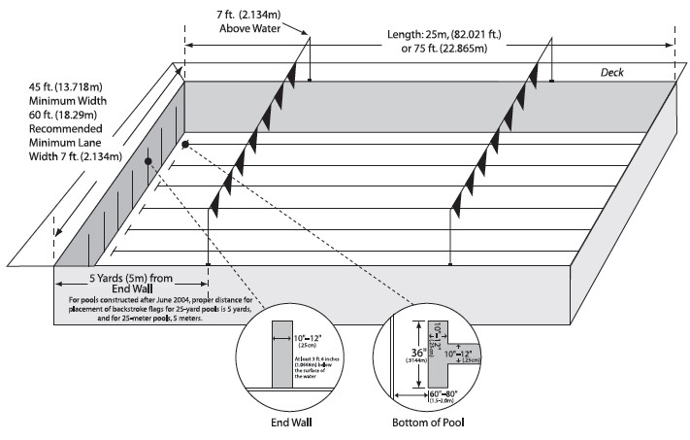
Ratio of changing room & locker is up to 1:8

- For disable people – 10%
- Changing room size -1x1.25 sq. m
- 1x2 sq. m (wheelchair user)
- swimming pool ladder at distance 23m
- One Lifeguard chair per 186 sq. m

Figure 40 Swimming pool

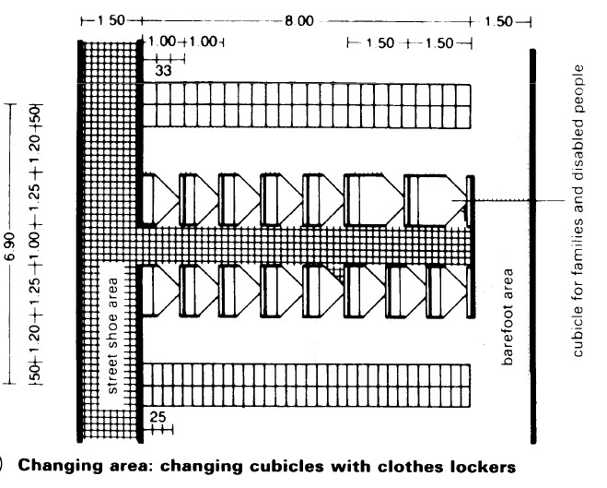
CHANGING AREA
Figure 41 changing cubicles with clothes locker
Separate sanitary area containing shower, dressing, locker, rest room must be provide for men & women. They should be positioned between the dressing rooms & pool area .Toilets are usually positioned in such a way that the pool user has to reenter the shower room before entering pool. Direct access to toilets from the pool area is not allowed. It is recommended that a direct route from the pool to the changing rooms be provided.

PLANT ROOM

Up to 1 sq. m /sq. m of pool area

Pool Water Treatment

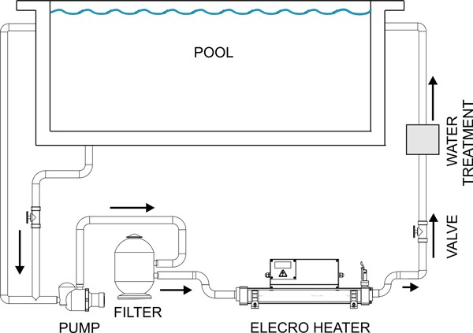
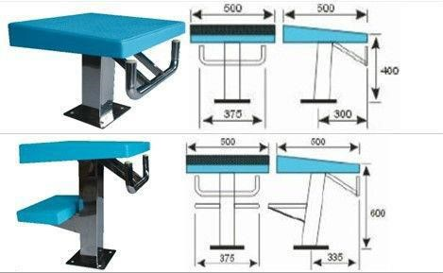
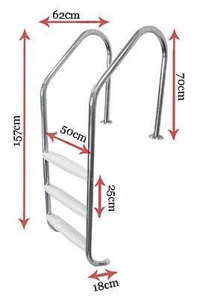
The pool water treatment is critical to the health and comfort of the bathers and this is particularly so when a pool is being used for long periods of intensive swimming such as that which might be undertaken by swimming club. The specification below is for plant and equipment, which if properly operated will give good conditions.

Temperature – 27/28 degrees C.
Turnover period – 3.0 hours.
Circulation – Level deck design with bottom outlet and wall and floor inlets.
Filtration plant – 2 No medium rate (24m/h), sand, pressure air scoured filters, 3 by half duty pumps and strainer boxes, flocculants dosing pump, necessary pressure gauges and flow meter. Disinfection equipment – chemical controller, chlorine (Calcium Hypo-chlorite) and pH correction (Carbon Dioxide or Hydrochloric Acid depending on source water) dosing pumps and storage tanks. Consideration may be given to the provision of UV as an addition to the water treatment.
Figure 42 Swimming pool piping layout

Pool water treatment plant room and chemical store to be at the deep end of pool adjacent to the balance tank and the filtration circulating pumps to be sited below the pool water level. Plant room and chemical store to have vehicular access.

Heating System

The criteria for the ventilation in the pool hall are that it should maintain a comfortable air temperature for the bathers ensure protection for the building fabric from condensation. provide a distribution of air which does not increase evaporation from the pool or cause draughts not contribute to a buildup of noxious compounds (tri-chloramines and tri- halomethanes) in the pool hall atmosphere and this may be summed up as requiring the air and water temperatures and space humidity to be balanced so that comfort is maximized and pool evaporation is minimized.

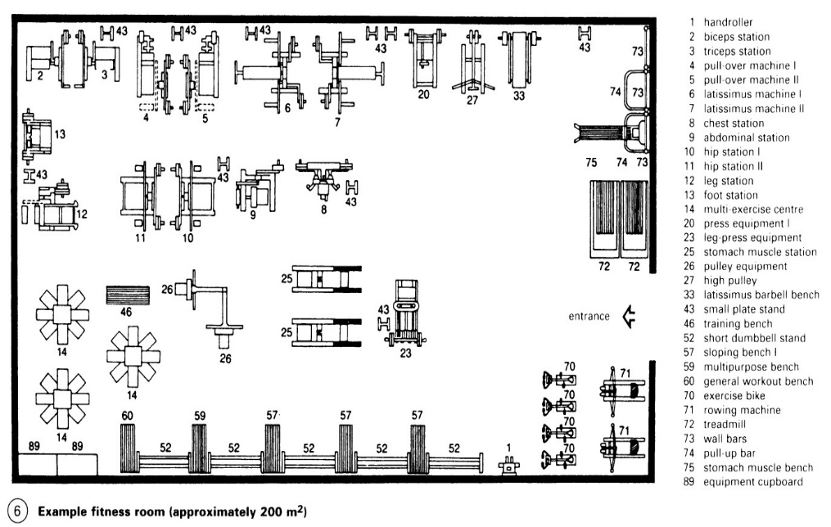
FITNESS ROOM
It consists of a big hall with mechanical exercising machines. The flooring of gym hall should be leveled with absorbent flooring so as to reduce the mechanical noise produced by machine. The wall is provided with the glass panel for max lighting.

- Depending on range of apparatus
- Min 20 sq. ft. / people
- Min room =40sq m /12 p
=200sq m /40 P
Figure 43 Gym hall layout
- Min clear height =3m.

CANTEEN
- Dining area = 60% of total area
- Kitchen, storage & preparation area=40-50% of total area
- Storage & ancillary= 1.5-2 times of kitchen Space per seat=1.5-2.15 sq.m

General layout is as follows.
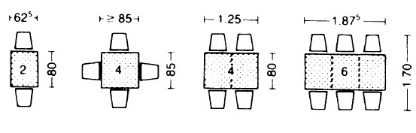
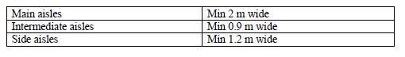
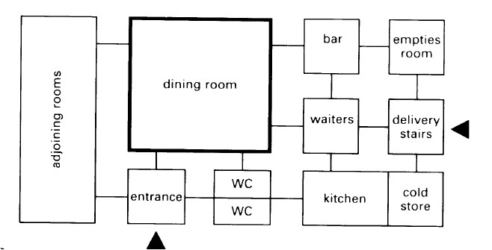
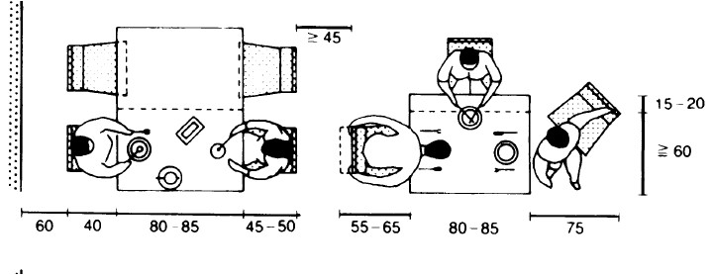

Figure 44 Canteen & dinning layout

3.9 STRUCTURE

CLASSIFICATION OF LONG-SPAN STRUCTURE

FORM ACTIVE STRUCTURE SYSTEMS

Form active structures are those structures in which load are taken by the form or the shape of the structure. They are non-rigid, flexible matter shaped in a certain way and secured at the ends, can support itself and span space. Only tensile and compressive stresses persist. These are mainly categorized into 4 types:-

- Tent structures
- Pneumatic structures
- Truss System
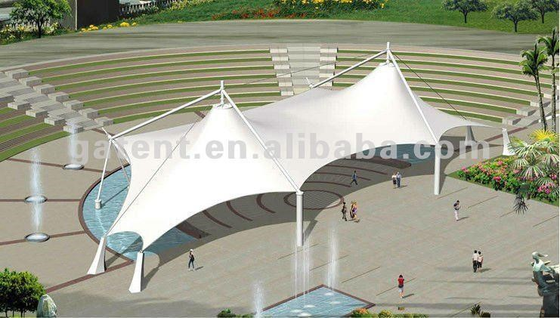
TENT STRUCTURE

A membrane structure pre-stressed by externally applied forces so that it is held completely taut under all anticipated load conditions. To avoid extremely high tensile forces, a membrane structure should have relatively sharp curvatures in opposite direction.
Figure 45 Tent Structure
PNEUMATIC STRUCTURE
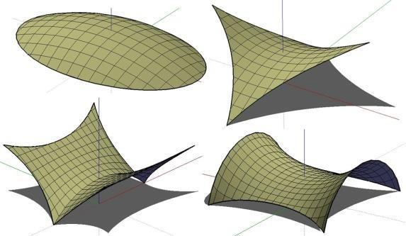
Membrane structure that is stabilized by the pressure of compressed air. Air supported structures are supported by internal air pressure. The air pressure within this bubble is increased slightly above normal atmospheric pressure and maintained by compressors. Air-inflated structures are supported by pressurized air within inflated building elements that are shaped to carry loads in a traditional manner. Pneumatic structures are perhaps the most cost-effective type of building for very long spans
Figure 46 Pneumatic structure

Its principle is the use of relatively thin membrane supported by a pressure difference. Through increasing the inside air pressure not only the dead weight of the space envelope is balanced. It consist of a double membrane supported by a small internal pressure difference. The internal volume of a building air is consequently at a pressure higher than atmospheric pressure.

VECTOR ACTIVE STRUCTURAL SYSTEMS (TRUSS SYSTEM)

A truss is a structure comprising one or more triangular units constructed with straight slender members whose ends are connected at joints referred to as nodes.

External forces and reactions to those forces are considered to act only at the nodes and result in forces in the members which are either tensile or compressive forces Trusses are composed of triangles because of the structural stability of that shape and design. A triangle is the simplest geometric figure that will not change shape when the lengths of the sides are fixed.. A planar truss is one where all the members and nodes lie within a two dimensional plane, while a space truss has members and nodes extending into three dimensions. The top beams in a truss are called top chords and are generally in compression, the bottom beams are called bottom chords and are generally in tension, the interior beams are called webs, and the areas inside the webs are called panels. Truss can be used in the 30 to 400 ft span range.

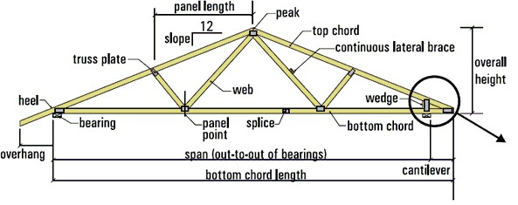
Figure 47 Truss structure

PITCHED TRUSS, OR COMMON TRUSS

It is characterized by its triangular shape. It is most often used for roof construction. Some common trusses are named according to their web configuration. The chord size and web configuration are determined by span, load and spacing.
L/D=8-16

PARALLEL CHORD TRUSS, OR FLAT TRUSS

It gets its name from its parallel top and bottom chords.
It is often used for floor construction.
A combination of the two is a truncated truss, used in hip roof construction.

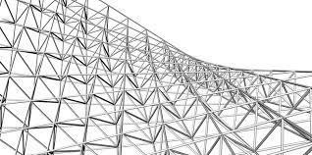
SPACE TRUSS
Figure 48 Space Truss
A space frame truss is a three-dimensional framework of members pinned at their ends. A tetrahedron shape is the simplest space truss, consisting of six members which meet at four joints .Length by depth ratio (L/D) =12.5-25
- theoretically economical in material
- joints difficult to realize and expensive

Different types of spatial truss systems are normally classified according to their general shape
Two dimensional grids
Cylindrical vaults

In each case it is advisable to distinguish between single and double or even triple layer grids. The number of layers depends on the span. A third characteristic lies in the geometry chosen for the system of members in the layers and possibly in the composition of the bracing of the layers.

TWO DIMENSIONAL GRIDS

SINGLE LAYER GRIDS
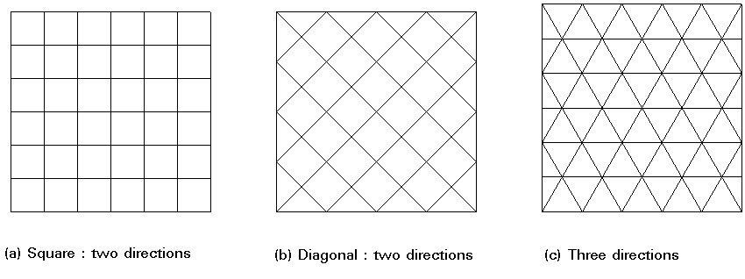
These grids are mentioned only as a reminder that these systems are beam grillages which work in bending and torsion, rather than under axial compression and tension. Depending on the directions assigned to the members, grids may be identified in two, or three directions .Grids in two diagonal directions are more rigid (beams follow the direction of the principal stresses of the equivalent plates) and are widely used. Utilization is restricted to about 10m of span.
Figure 49 Simple layer Grid

DOUBLE LAYER GRIDS
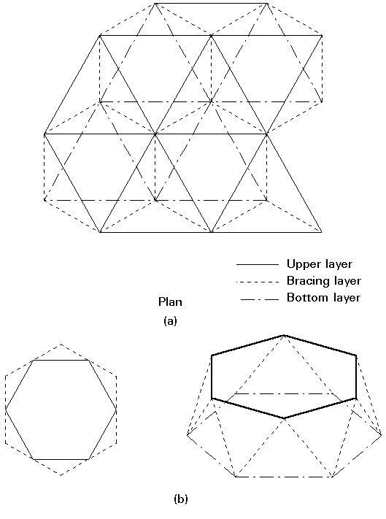
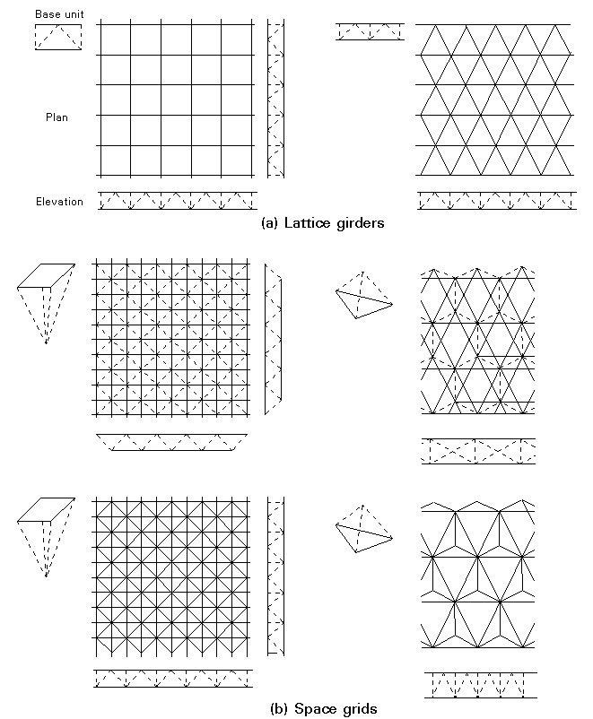
These grids comprise two systems of members on two parallel levels (upper and bottom layer). Both these systems are interlinked by bracing members (web members). Two types of double layer grids may be distinguished:
Figure 50 Double layer grid type

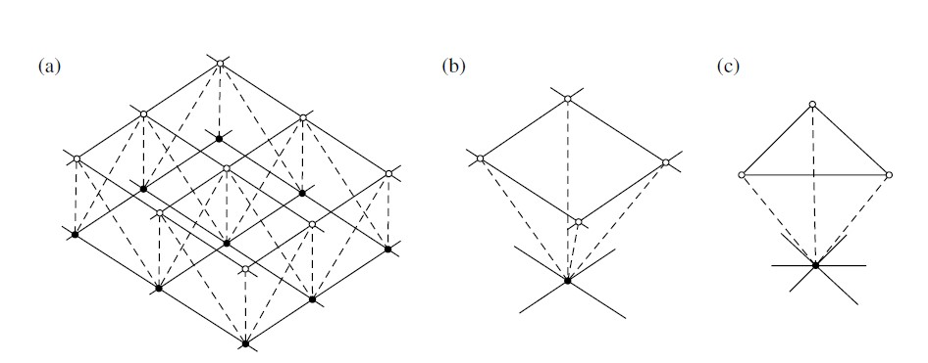
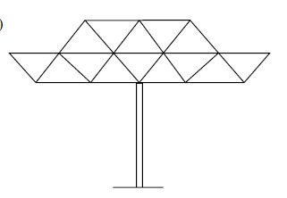
Figure 51 Triple layer space truss
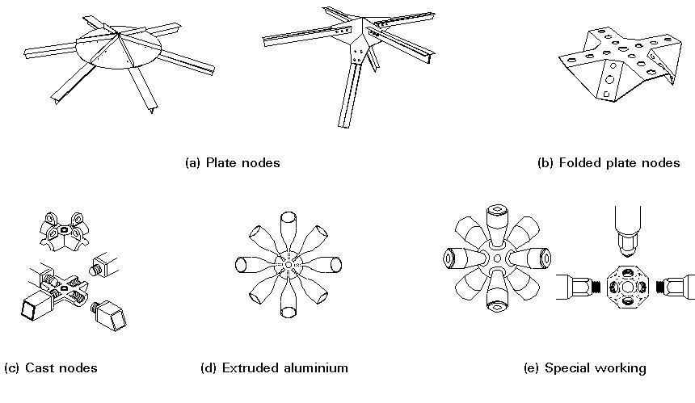
Figure 52 Different types of nodes

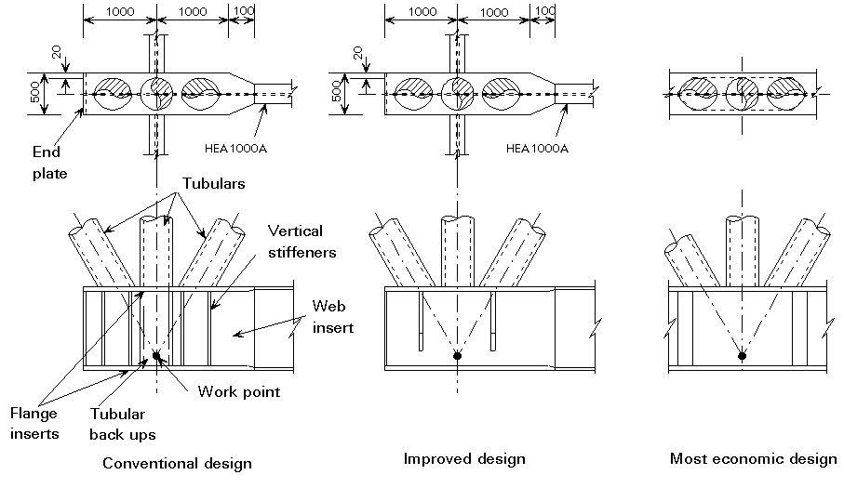
Figure 53 Different designs for joints

These systems are suitable for spans up to 100m. For greater spans, it is necessary to incorporate triple layer grids, to avoid long members otherwise necessary with the increased depth. The size of the constituent modules depends on several factors, principally: span, load, cladding system, type of node, transportation and erection facilities.

For spans of between 30 and 50m, member lengths of about 1.5m to 3m are acceptable.

- The advantages of double layer grids are numerous so I want to use this in my indoor sports hall.
- They are three dimensional structures which can withstand loads from any direction so feasible to make any shape of roof.
- Their rigidity minimizes deflections.
- They have a very good fire resistance.
- Their composition allows factory pre-fabrication in modular elements, which are easily transported. Fabrication precision ensures ease of assembly and erection.
- They allow a wide choice of support positions owing to modular construction.
- The space between the two layers may be used to install electricity, electrical and thermal piping, etc.
- Installation is carried out by bolting and may be done whatever the atmospheric conditions.
- They provide indisputable aesthetic qualities.

The tubular sections having lot of advantages compared to the other sections. The advantages are:

- The load carrying capacity increases because of increase in moment of inertia.
- Circular section may have as much as 30 to 40% less surface area than that of an equivalent rolled shape and thus reduces the cost of maintenance, cost of painting.
- There is no better section than the tabular one for torsional resistance.
- Tubes are of special interest to architect from an aesthetics viewpoint.
- The external surface of the tube does not permit the collection of moisture and dust thus reducing the possibility of corrosion.
- Under dynamic loading the tube has a higher frequency of vibration than any other cross section including a solid round bar.

CYLINDRICAL VAULTS

In the history of construction, cylindrical vaults appear as an evolution of arches. The use of metal has enabled construction to be carried out with factory prefabricated elements which may be assembled on site. The first example to recall is the Crystal Palace which was erected by Joseph Paxton for the Great Exhibition in 1851.This shape has proved to be suitable for roofs of halls, railway stations and sports facilities, e.g. in-door sports hall

Maximum efficiency may be attained for shapes with rectangular surfaces and a length/width ratio of between 1 and 2. The optimum shape (rise/span ratio) is in the region of 0.15 to 0.20

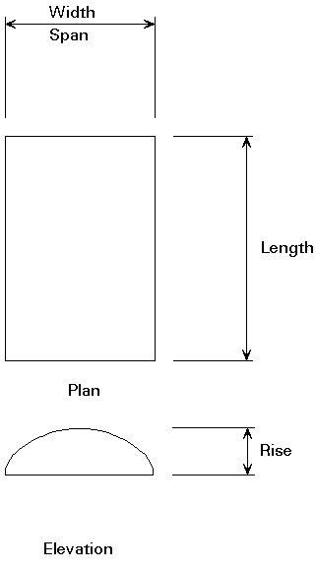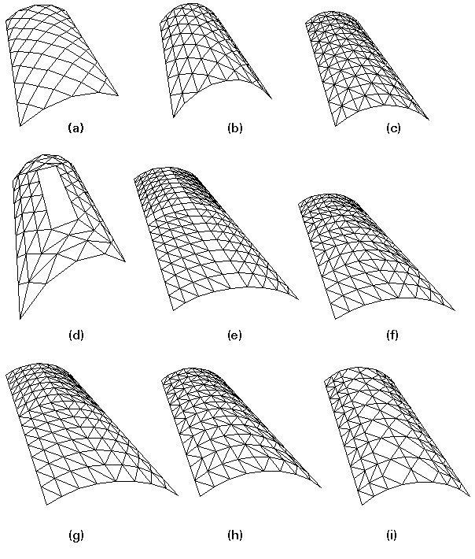
Figure 54 cylindrical vault
The sensitivity of these systems to asymmetrical actions, in particular to wind, should not be underestimated. Such actions can even bring about force reversal in the members, which is an additional reason for choosing a three directional geometry in which the length of all elements is identical. Economical spans for single layer vaults are in the region of 20m. Spans may be increased by inserting diagonal elements. They reach 60m for double layer systems, in some cases even more. Appropriate weights for double layer systems vary between 0,13 and 0,25kN/m2 depending on the intended shape, support conditions and on the geometry of the sheets (for a uniform load of between 0,75 and 1,50kN/m2).
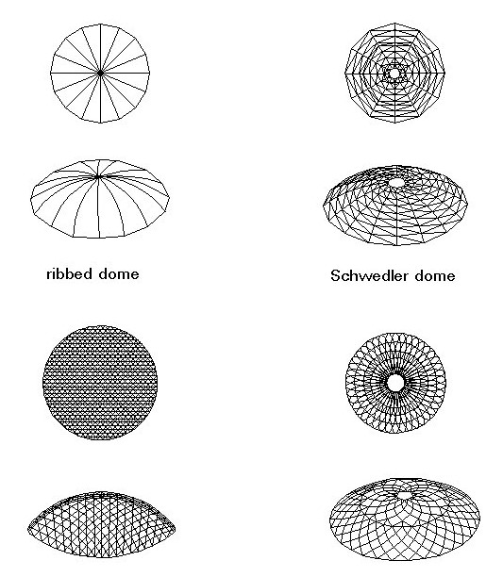
DOMES

Domes constitute one of the most ancient forms of construction. However big or small their size, the outline of the two-dimensional support is normally circular on plan.

Skeletal dome structures can be classified into several categories depending on the orientation and position of principal members. The four more popular types are: ribbed domes, Schwedler domes, three-way grid domes and parallel lamella domes.
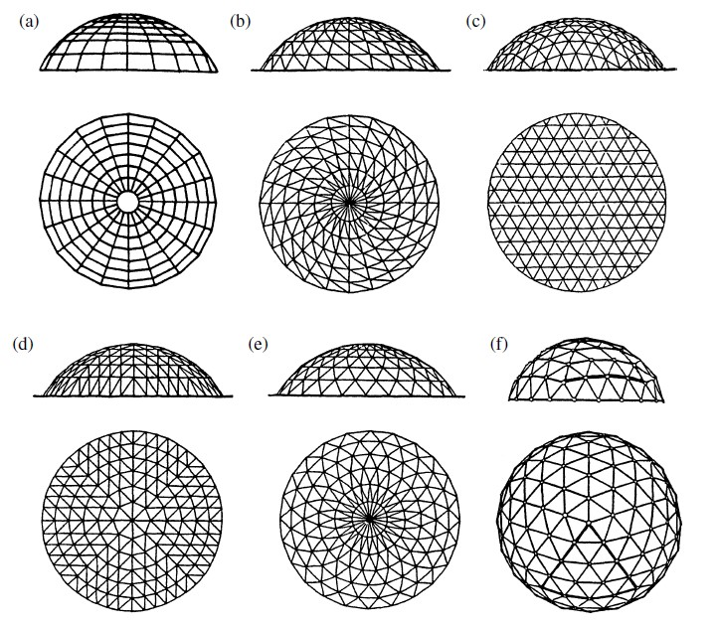
Domes are of special interest to architects and engineers because they provide the maximum enclosed volume for minimum surface area. In the last 25 years construction with steel sections has largely replaced reinforced concrete. The first two examples concern single and double layer systems. These systems permit spans of about 40m and more than 100m respectively. Some double layer solutions have encouraged 'record' spans of more than 200m.
Figure 55 Dome structure
Figure 56 Different Dome structures

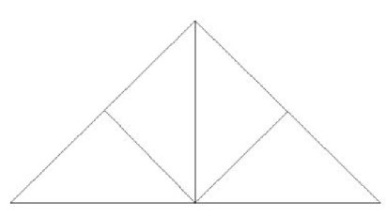
OTHER TYPES OF TRUSS
King Post Truss

- King Post Truss is a wooden truss.
- It can also be built of combination of wood and steel.
- It can be used for spans up to 8m.

Queen Post Truss

- Queen Post Truss is also a wooden truss.
- It can be used for spans up to 10m.

Howe Truss
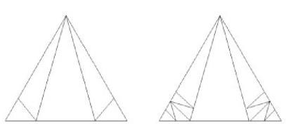
- It is made of combination of wood and steel.
- The vertical members or tension members are made of steel.
- It can be used for spans from 6-30m.

Pratt Truss

A Pratt truss includes vertical members and diagonals that slope down towards the center, the opposite of the Howe truss. The interior diagonals are under tension under balanced loading and vertical elements under compression. If pure tension elements are used in the diagonals then crossing elements may be needed near the center to accept concentrated live loads as they traverse the span. It can be subdivided, creating Y- and K-shaped patterns. The Pratt truss was invented in 1844 by Thomas and Caleb Pratt.

- Pratt Truss is made of steel.
- These are less economical than the Fink Trusses.
- Vertical members are tension and diagonal members are compression.
- Fink Trusses are very economical form of roof trusses.
- It can be used for spans from 15 to 45 m.

Fan Truss
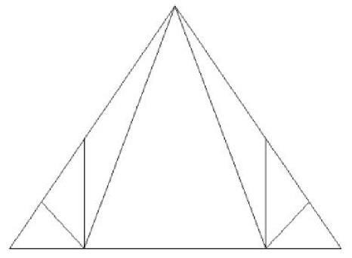
- It is made of steel.
- Fan trusses are form of Fink roof truss.
- In Fan Trusses, top chords are divided into small lengths in order to provide supports for purlins which would not come at joints in Fink trusses.
- It can be used for spans from 10-15m.

North Light Roof Truss

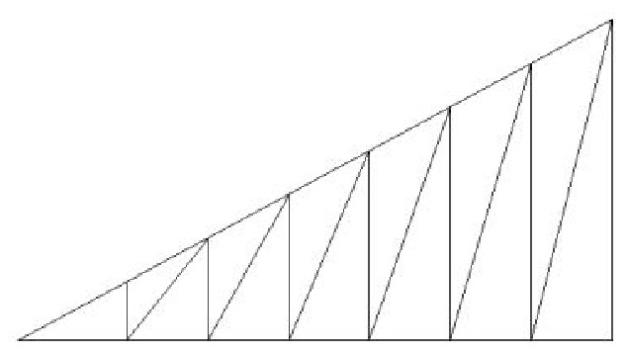
- When the floor span exceeds 15m, it is generally more economical to change from a simple truss arrangement to one employing wide span lattice girders which support trusses at right angles.
- In order to light up the space satisfactorily, roof lighting has to replace or supplement, side lighting provision must also be made for ventilation form the roof.
- One of the oldest and economical methods of covering large areas Lattice girder.
- This roof consists of a series of trusses fixed to girders. The short vertical side of the truss is glazed so that when the roof is used in the Northern Hemisphere, the glazed portion faces
- North for the best light.
- It can be used for spans from 20-30m.
- Used for industrial buildings, drawing rooms etc.

SECTION ACTIVE STRUCTURAL SYSTEMS

FRAME STRUCTURES

PORTAL FRAMES
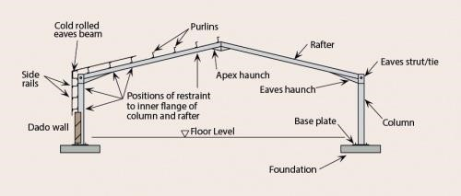
Various configurations of portal frames can be designed using the same structural concept. Portal frames are made in a variety of shapes and sizes. They are usually made from steel, but can also be made from concrete or timber. The portal structure is designed in such a way that it has no intermediate columns, as a result large open areas can easily be created within the structure. Portal Frames are generally used for single storey construction which require a large unobstructed floor space ie Factories, Shopping Centres, Warehouses etc. Portal frames are the most commonly used structural forms for single-storey industrial structures. The slopes of rafters in the gable portal frames vary in the range of 1 in 10 to 1 in 3. Generally, the centre-to-center distance between frames is of the order 6 to 7.5 m, with eaves height ranging from 6 -15 m.
Figure 57 Portal Frame

SURFACE ACTIVE STRUCTURAL SYSTEMS

FOLDED PLATE STRUCTURE

The usual folded plate structure has been constructed with two or three element folded plates, with slopes of slightly less than 45 degrees, and tied at the ends by frames and horizontal ties. A much more interesting system is to use plates with much less slope and use vertical columns for end support rather than the usual ties. The spans of the slab elements can be of relatively long, (25 to 30 feet), if the slabs are hunched. The optimum distance valley to valley would then be, say, 50 ft., and the span of the folded plates, 50 ft. with a height of 5 ft. The slope of the slabs is the ratio of 1 to 5. L/D (span/depth) ratio are equal to 8-16.

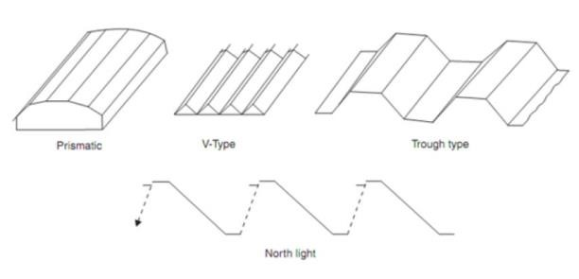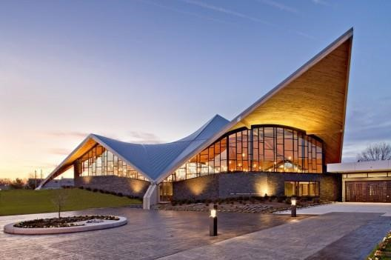
Figure 58 Folded plate structure

SHELL STRUCTURE

Shells belong to the family of arches. They can be defined as curved or angled structures capable of transmitting loads in more than two directions to supports’/D (span/depth) ratio are equal to 4-8.

DOMES

A shell with doubly curved surface is known as a dome (double curvature) A rounded roof, with a circular base, shaped like an arch in all directions is called Dome. First used in much of the Middle East and North Africa whence it spread to other parts of the Islamic world, because of its distinctive form the dome has, like the minaret, become a symbol of Islamic architecture. Dome has double curvature and the resulting structure is much stiffer and stronger than a single curved surface, such as a barrel shell.

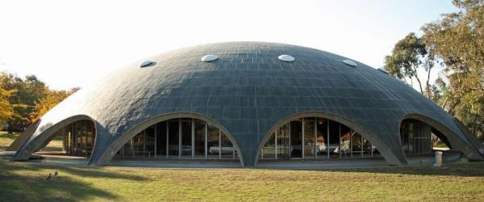
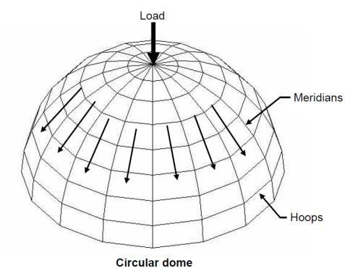
Constructions of spherical domes by using inflated membranes as forms have proven to be a viable solution to many problems. The largest shells constructed are now less than 300 feet in diameter. Some uses, such as sports facilities demand greater spans, perhaps as much as 1000 feet. The design and construction of such a shell is a challenge, and using inflatable forms and a uniform depth may not be possible. For very large spans, a grid constructed with pans is necessary so that the dome will be stiff enough and still weigh less than a uniform depth.
Figure 59 Dome structure

VAULTS
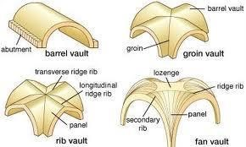
A shell with one curved surface is known as a vault (single curvature). A vault may be defined as a single barrel shell, supported on its side by walls or columns. The virtue of the vault is that half of the load on the shell is carried by the walls, and the other half is carried to the ends and at that point the usual arch and tie are required. The thickness of a shell can be much less that for a normal arch of the same span because the shell carries loads as a space structure.
Figure 60 Different vaults

This structural system can be used, for example, for sports facilities with widths up to 300 feet and lengths to 500 feet. These spans will require a ribbed structure created by pans or insulating blocks of foam set on the forms. Again ingenuity will be required for maximum economy.

2.15 SUSTAINABLE DESIGN

SOLAR PHOTOVOLTAIC

Photovoltaic (PV) materials convert sunlight into useful, clean electricity. Building integrated photovoltaic systems (BIPV) offer additional design options, allowing electricity to be generated by windows, shades and awnings, roofing shingles, and PV-laminated metal roofing, for example. BIPV options can be used in retrofits or new construction. Commercial cell performance can range from 50-50 W/m² of the PV area depending upon the type of cell and PV cell density to allow the transmission of daylight.

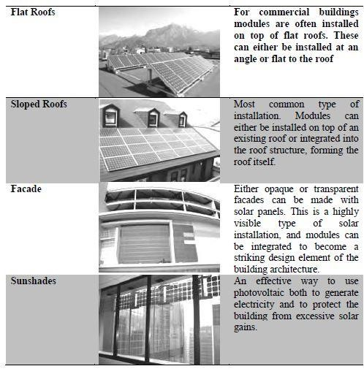
The application can be significant for high-rise buildings since they provide an opportunity for a clear path of direct sunlight above other buildings. PV panels can collect energy in diffuse light, although distances between buildings, clustering and shadows will affect their efficiency. Nepal, due to its location, has potential for solar light energy. PV remains a genuine energy generator. The best orientation for PV panels is south with a tilt angle of 27 degree.
RAIN WATER HARVESTING

Rain water harvesting (a step towards water conservation) is the technique of collection and storage of rain water at surface or in sub-surface aquifers, before it is lost as surface run-off. Rain water can further be used for artificial recharging of ground water. It is a process by which the ground water reservoir is augmented at rate exceeding that under natural conditions of replenishment. Rain water harvesting overcomes the inadequacy of waters, helps maintain water levels. It increases infiltration of rain water in the subsoil which has decreased drastically in urban areas due to paving of open area and improves ground water quality by dilution. Further, it improves ecology of the area by increase in vegetation cover.
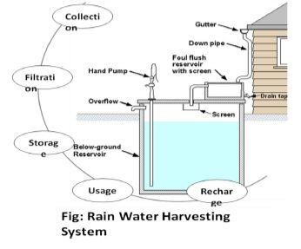
Annual average rain fall: x mm=x l/sq. m considering
-120 rainy days
Run-off coefficient: 0.5
Catchment area = y sq. m
Annual water harvesting capacity
= x x y x 0.5 =0.5xy liter per year

ALUMINUM ROOFING

In recent years, aluminum roofing has grown quickly in popularity because of the many advantages aluminum roofs offer to homeowners. Aluminum roofs are attractive, durable, energy-efficient, and increasingly affordable. In the past, aluminum was not a popular roofing material for cost reasons and because of concerns about the structural limitations of aluminum. Recent innovations have resolved the structural problems and decreased the cost of aluminum Benefits of Using Aluminum Roofing Aluminum is increasingly valued as a roofing material for many reasons. Aluminum is attractive and malleable and comes in a great variety of roofing types and designs, including standing seam, shake, shingle, tile, and slate. In many parts of the country, aluminum is offered in a wider range of gauges than steel. Aluminum can be formed into individual tiles or shingles or shaped into panels that mimic the look of shingles. It is also lightweight and easy to work with onsite, reducing labor costs for installation. Once installed, one of aluminum's most important advantages is its great durability. Aluminum roofing does not warp, crack, or burn and, unlike steel, it is extremely corrosion-resistant and does not rust-a significant advantage in coastal areas and areas with a great deal of precipitation or problems with acid rain.

The Environmental Benefits of Aluminum Roofing

Like other types of metal roofing, aluminum is also extremely energy-efficient. Studies have shown that metal roofs absorb 34% less heat than traditional asphalt shingles, reducing air-conditioning costs in summer, and, depending on the part of the country, homeowners who have switched to metal roofing have reported savings of up to 20% on heating and cooling bills. In addition, aluminum roofing is typically made up of 90% recycled material and is itself fully recyclable when necessary, making it one of the most environmentally sound building materials.

Aluminum Roofing - Costs Now vs. Costs Later

Aluminum's primary disadvantage is its cost. Aluminum's initial installation is more expensive than steel or more traditional roofing materials like wood or asphalt shingles. However, over its life cycle, aluminum has been shown to be extremely cost-efficient. Most traditional roofing materials must be replaced every 10-12 years. Aluminum roofing can last 50 years or more and is not subject to the corrosion problems of steel. If you install aluminum roofing, there is a very strong chance that you will never need to install a roof again.

Disadvantages to Aluminum Roofs

Aluminum is also less hail resistant than steel, especially on lower-grade roofs, but unlike some traditional roofing materials, it will not split or break. Finally, because of the recent rise in popularity of aluminum roofing, not all roofers are experienced with aluminum roofing installation.

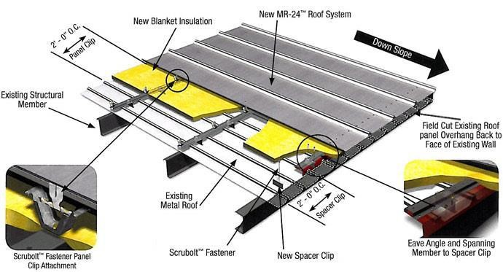
Conclusion
Figure 61 Aluminum roof covering details
- Attractive, Long lasting about 50 years, energy-efficient,
- Extremely corrosion-resistant
- Absorb 34% less heat,
- Reducing air-conditioning costs in summer by 20%
- Made up of 90% recycled material
- One of the most environmentally sound building materials.

LOUVER WALL

In the places like Terai region with hot climate, South and west light is very problematic. So to reduce such impact, vertical louvers are used to avoid South and West light and to allow east light.

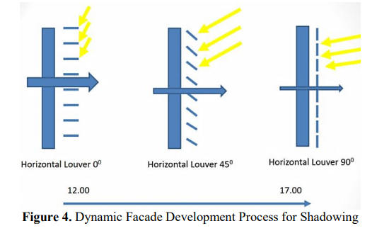
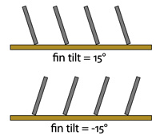
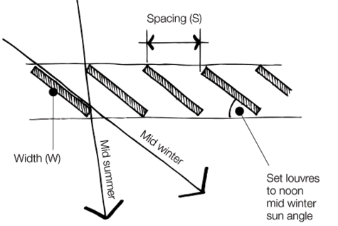

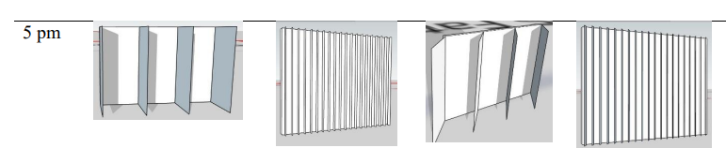
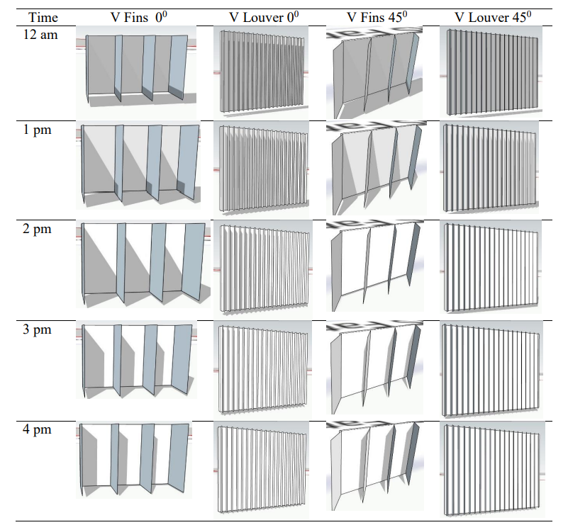
Figure 62 Simulation of shading panel on a vertical fin pattern
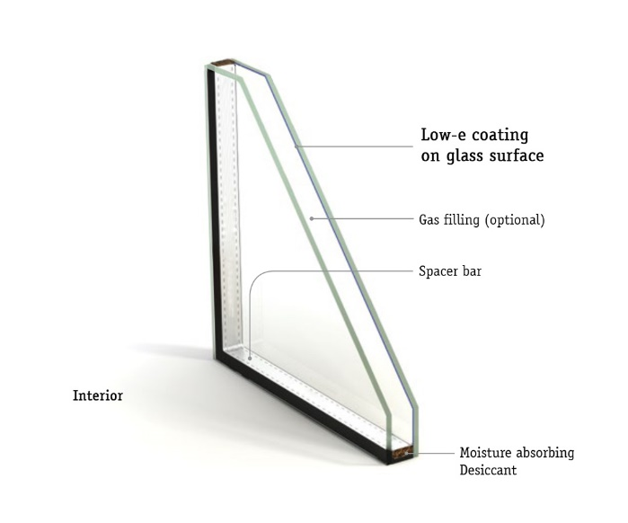
LOW E-GLASS (DOUBLE GLAZED FAÇADE)
Low-E, or low-emissivity, glass was created to minimize the amount of infrared and ultraviolet light that comes through your glass, without minimizing the amount of light that enters your home. Low-E glass windows have a microscopically thin coating that is transparent and reflects heat. The coating is even thinner than human hair! The Low-E coatings keep the temperature in your home consistent by reflecting the interior temperatures back inside.

According to the Vitro (formerly PPG) Glass Education Center, there are several factors used to measure the effectiveness of glass with Low-E coatings:
- Solar Heat Gain Coefficient (SHGC): This is the fraction of incident solar radiation that is admitted through the window. This can be either directly transmitted and absorbed or radiated inward.
- U-Value: This is the rating that is given to a window based on how much heat loss it allows.
- Visible Light Transmittance (VLT): The measure of how much visible light passes through the glass.
- Light to Solar Gain: The ratio between the window’s visible light transmittance and its Solar Gain Coefficient rating.

CHAPTER-FOUR

4.1 CASE STUDY
Case study is a research strategy, an empirical inquiry that investigates a phenomenon within its real-life context. Case study research can mean single and multiple case studies, can include quantitative evidence, relies on multiple sources of evidence, and benefits from the prior development of theoretical propositions. It helps to analyze the book standards (produced by different researchers) and the space actually built in. In case study, study of similar projects will help to gain the qualitative and quantitative understanding on the related project. It will assist in framing the conceptual and the further development of the vision on the particular subject with appropriate guideline.

Different National and International cases are studied. These studies help to generate required data and knowledge such as the space requirements, the spatial arrangement, positions and their interrelationship including the building forms and their impact upon the surrounding neighborhood units and places, which would guide to carry out the further phases of the project undertaken.

4.2 NATIONAL CASE STUDIES

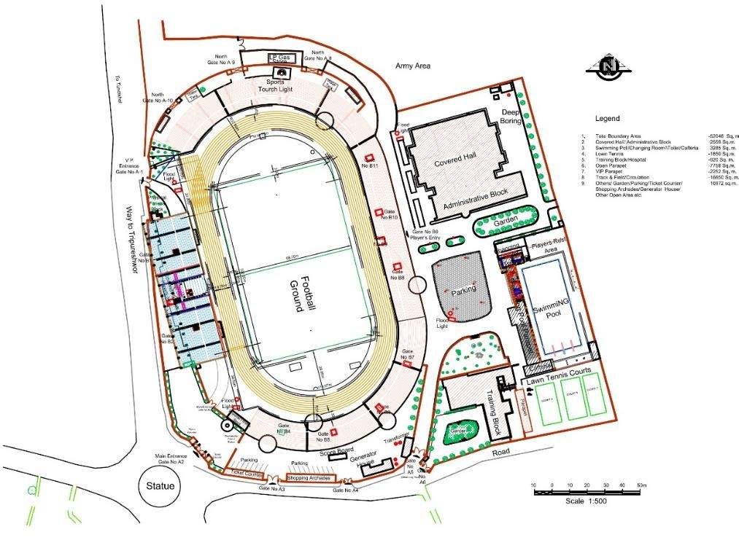
DASHARATH INTERNATIONAL STADIUM
Figure 63 Dasharath Stadium Masterplan

OVERVIEW
- Location: Tripureshwor Kathmandu
- Area: 110 Ropanis
- Complex type: Football & multipurpose stadium
- Architects: Er. Bhuwaneshwor & Ar. Ganga Dhar Bhatta
- Capacity: 15,000 spectators

INTRODUCTION
Dasharath Rangasala is a multi-purpose stadium in Tripureshwar, Kathmandu. It is named after Dasharath Chand, one of the four great martyrs of Nepal. The stadium is used mostly for football matches and cultural programmes. It has floodlights installed, to facilitate matches and events in the evenings. Most of Nepal's national and international tournaments are held in this stadium. Nepal's primary football division, Martyr's Memorial League, is also held on this ground every year. The stadium has also been the only host of the inaugural 2021 Nepal Super League season.

HISTROY & BACKGROUND
Dasharath Sports Complex is the biggest sport complex in Nepal with 15,000 spectator’s capacity (at present) built in 1956.But it has been renovated time after time as per the requirement.
Major renovations were done in 1998 for hosting the 1998 South Asian Games (SAG). In 2011, it was renovated again to host the 2012 AFC Challenge Cup.
As the Nepal's biggest stadium, Dashrath stadium has hosted many important events. The 2012 AFC Challenge Cup & the 2013 SAFF Championship were held here, alongside with the Halchowk Stadium hosting some of the matches as well. Numerous cultural festivals and musical events took place here as well. The 2011 concert of Bryan Adams was held in this stadium and was his first rock concert in Nepal.

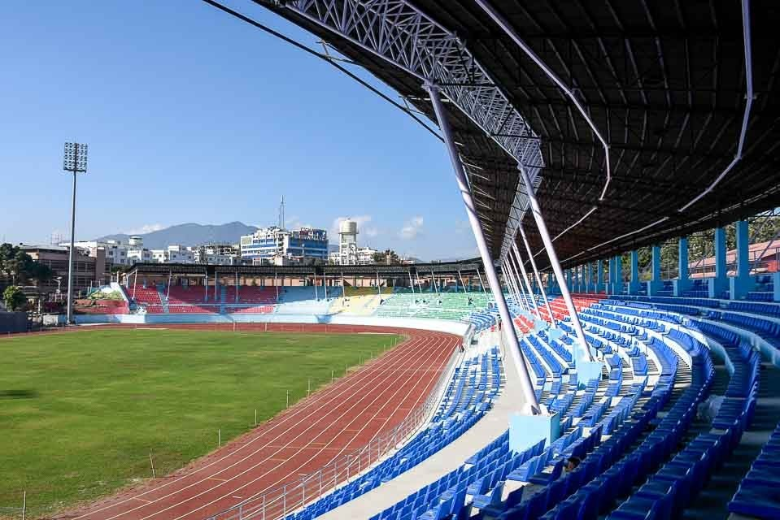
The stadium suffered damage from the April 2015 earthquake that hit Nepal. After the earthquake, the stadium was renovated for the third time and the opening was done again on 1 December 2019 for the 2019 South Asian Games. After the renovation the capacity of the stadium was reduced from 20,000 to 15,000.
Figure 64 General Stand of Stadium

Every year this complex hosts a lot of game events and various non-sporting events from time to time. The non-sporting events are musical concerts, social and cultural programs, political programs etc.

MAJOR SPORTS EVENTS:
- 1997 SAFF Football Championship (4-13 Sep 1997)
- 1999 South Asian Games
- 2012 AFC Challenge Cup (8-9 March 2012)
- 2013 AFC U-16 Championship (20-30 July 2013)
- 2013 SAFF Football Championship (31 Aug - 11 Sep 2013)
- 2019 South Asian Games (1-10 Dec)

MAJOR MUSIC & CULTURAL EVENTS
- Bryan Adams-live in concert by JPR events (19 Feb 2011)
- Atif Aslam-live concert (2013)

The sport complex includes following sports infrastructure:
- The main stadium with track and field facilities
- The covered hall
- The swimming pool
- Tennis courts
- Gymnastics hall
Besides, it houses the administration block and separate hostels for the players. The hostel has 24 rooms which can accommodate 50 to 60 people.
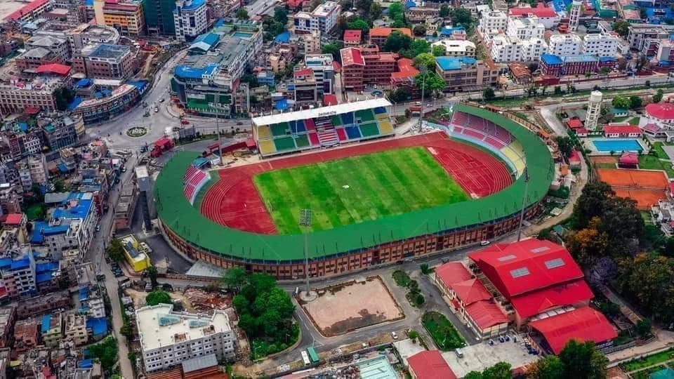
SURROUNDINGS
The Dasharath Sports Complex located at Tripureshwor, Kathmandu, Nepal.

Talking about the surrounding, it has an army headquarter to the north, private residential areas to the south, an army barrack to the east, and area of government offices to the west. It is approximately 5km apart from the only international airport of Nepal.
Figure 65 Dasharath Stadium, Kathmandu

COVERED HALL
The north– east of the stadium complex covering an area of about of about 5 ropanis with garden in front has a multipurpose covered hall and administration section of the Nepal Sports Council. The hall was designed by Ar. Ganga Dhar Bhatta which was renovated in 1997 for the 1999 SAF games by Ar. N. Sangache. The plan of the hall is simple and symmetrical.

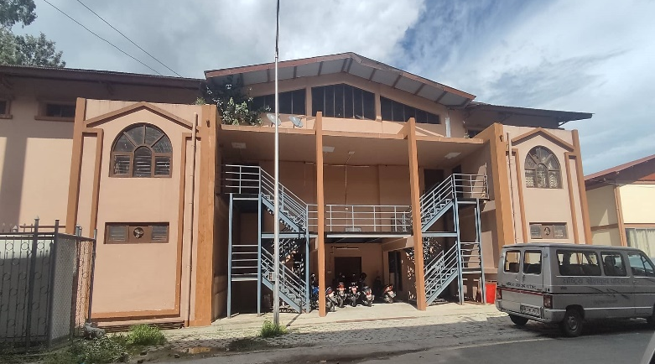
It contains double height lobby, electrical room, rooms for the offices and rest rooms for staffs. The general stand has a capacity of housing 1000 spectators. It has electrical room, rooms for the offices and rest rooms for staffs. VIP’s entry to the covered hall is also from the main entrance. The eastern and the western wing of the building have been used for gymnastic hall and Nepal Kyokushin Karate Do- Association respectively.
Figure 66 Front view of covered hall

Access to the covered hall
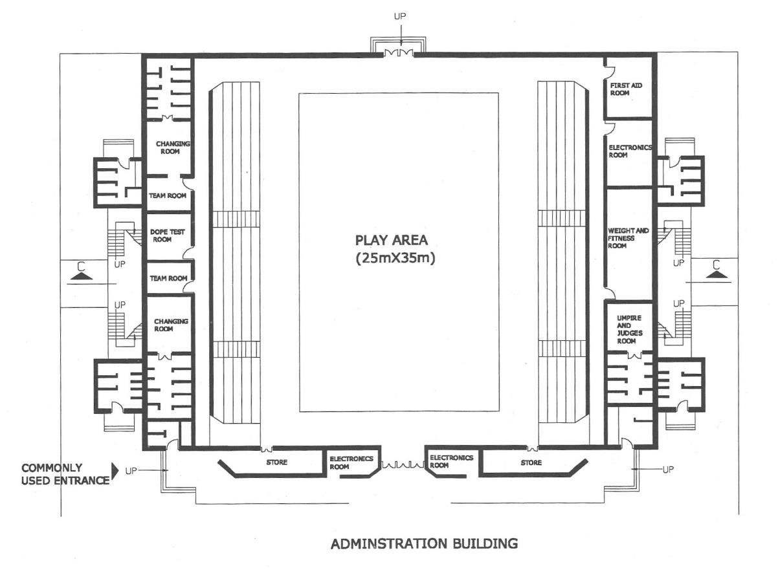
Here the access for the players and spectators has been clearly separated. The general seating can be directly accessed from indoor hall. Players enter directly from the ground floor, whereas the main
Figure 67 Ground Floor Plan of Covered Hall

ccess to the parapet for VVIP/VIP and other spectator is from the first floor. However, the entrance for the VVIP/VIP is from the covered hall.
The main drawback of this covered hall is, the access is not focused. The accesses are from sideways and there isn’t sufficient gap between the stadium and the covered hall. Therefore, the accesses are hidden.
The Spectators Seating
11 numbers of seating parapets are available in either sides of the court. The general spectator seating has capacity of 700 to 800 spectators. It is at the east and west longitudinal wing of the hall. The VIP has capacity of around 125 spectators. It is at the southern wing of the hall. Also a control room is provided at the eastern wing.

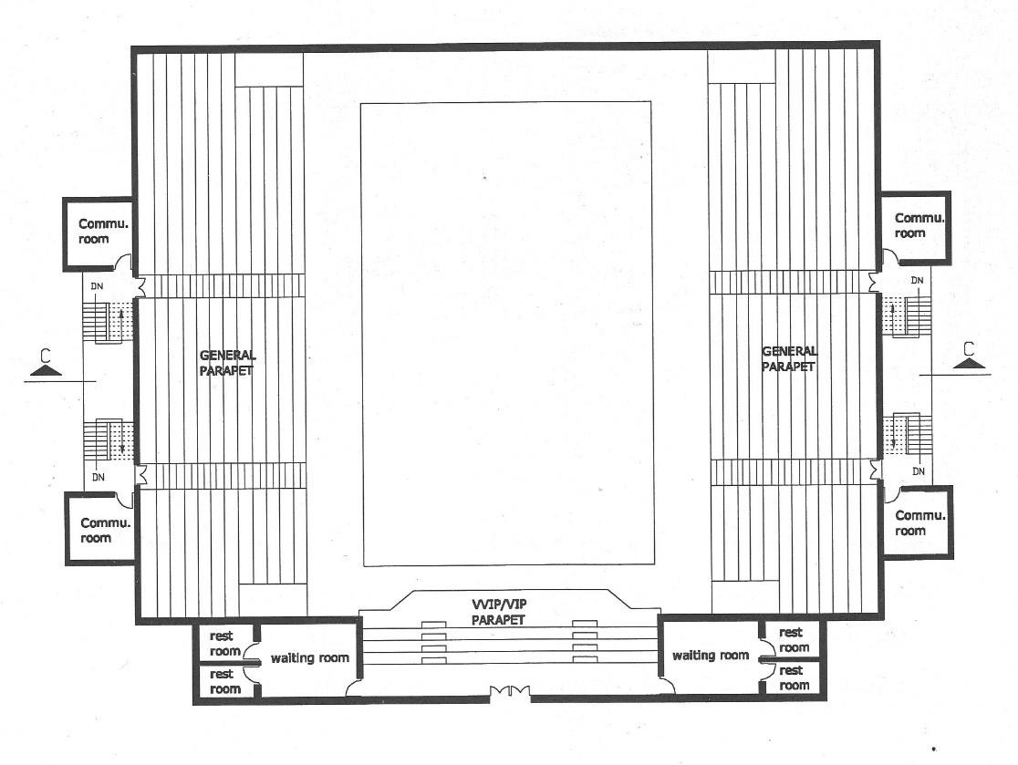

Figure 68 First Floor Plan of Covered Hall
Parapet
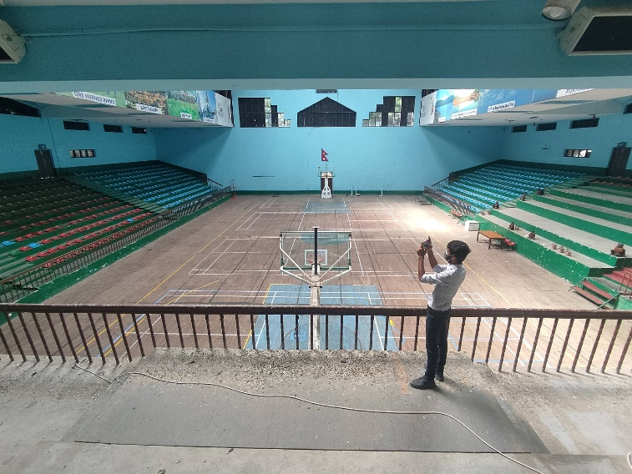
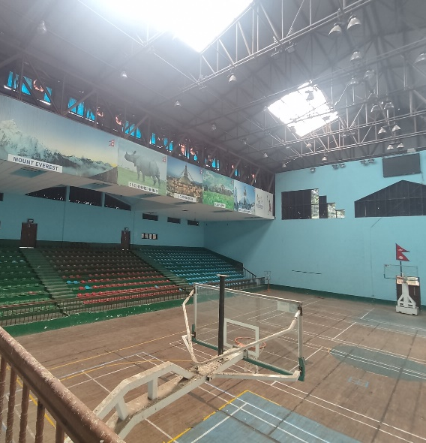
The stand for general spectator is aligned along the longitudinal axis so it provides a good view of the events. The total capacity of the hall is 2000 and the number of steps in parapet is eleven on left and eleven on right with length of 101’9”. And for the VVIP/VIP four steps with the provision of chair and its length are 59’. The capacity of VVIP/VIP parapet is 100. And the width provided is 2ft. The parapet is finished with cement plaster and at the time of events plastic chairs are provided at the parapet.
Figure 69 Parapets inside covered hall
The Playing Field

The main indoor hall is of 25m x 35 m (play area) size with wooden batten floor with laminated surface and has 8.35m height. This hall can organize a basketball, volleyball and 3 badminton games at a time. It is used for various indoor games like Judo, Karate, and Boxing etc. and also for martial art tournament.

Lighting
For the lighting purpose, the ribbon windows are provided on the longitudinal wall of the hall but they are painted blue to avoid the glare. Therefore, the source of the natural light in the hall is through the transparent sheet provided for roofing. However, the natural lighting is sufficient for all the events. There is also good provision of artificial light fixtures.

Clearance
Figure 70 Section of Covered Hall
Around the basketball court there is clearance of minimum 3m. From the standard minimum height clearance required is 41ft. And the height of the hall is 48 ft.
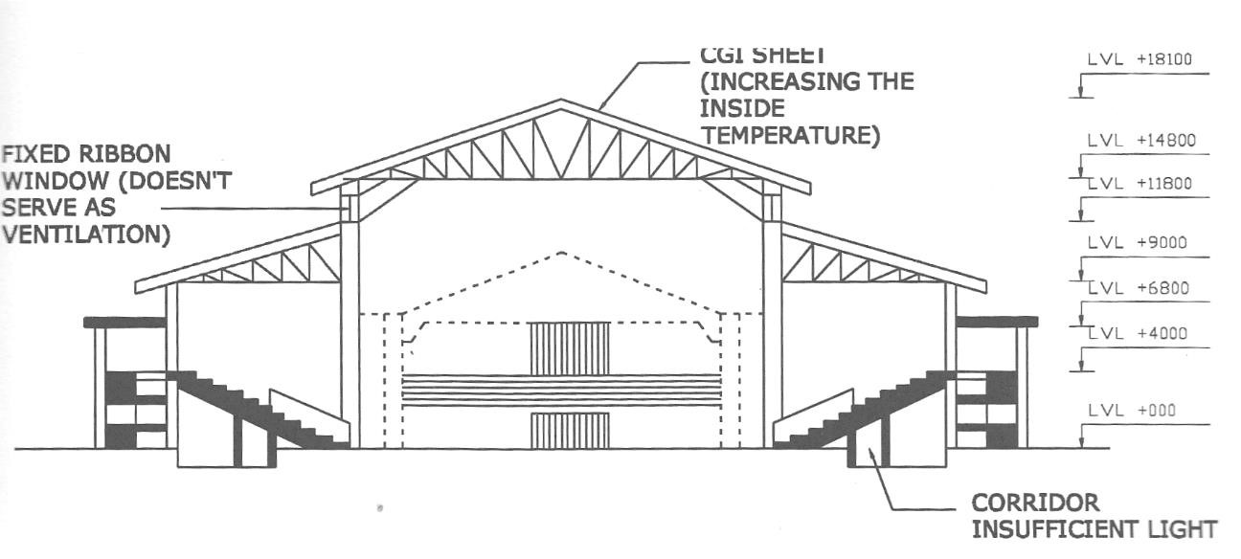

Construction
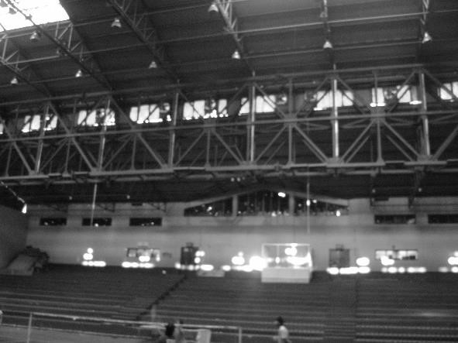
The hall is in R.C.C. frame structure. The main columns of the structure are 18”x 18” however the exterior columns are of 9”x 25”. Some of the portions of hall are in load bearing. Beam size is mainly of 18”x24”.
Figure 71 Truss supporting the roof of the hall
The covered hall has steel truss roofing structure with combination of CGI sheets interspersed with semi-transparent corrugated sheets. Two heavy trusses of 7’x3’ support the roof covering over the huge span. Ribbon windows are provided.

Covered hall has following spaces:
S.N | Description | Nos. | Area (Sq. m.)
1 | Team room  Changing Room  Rest Room  WC  Shower  Basin  Urinal | 2  4  1  3 | 15.12  22.67  22.67
2 | Dope Testing Room |  | 17.67
3 | Store | 2 | 24.40
4 | Electronic Room |  | 13.55
5 | Announcing Room |  | 13.55
6 | First Aid Room |  | 19.33
7 | Weight And Fitness Room |  | 47.00
8 | Umpires And Judges
 | Changing Room  Rest Room  WC  Shower  Urinal | 1  1  1  3  3 | 21.33  18.00
9 | Rest Room For Spectator  Gents  WC  Urinal  Basin  Ladies  WC  Basin | 3  7  4  7  4 | 26.80
10 | Communication Media Room |  | 16.67
11 | Commentator Room |  | 15.02
12 | V.V.I.P. Room | 2 | 45.60
13 | WC |  | 14.00

Evacuation
Door width for the entrance for spectators= 4’6”
Door width for the entrance for VVIP/VIP= 8’
Width of staircase= 6’so, time of escape, as per “Architects Data” the formula giving the width of the staircase that is necessary to allow a certain numbers of spectators to leave the stadium in a given time is:

Number of spectators
Staircase width (m) =
Emptying time(s) X 1.25
Using this formula, the emptying time can be calculated which is 3 minutes and it is considered appropriate time.

Positive points:
- Well facilitated covered hall in Nepal with all required facilities are provided that are necessary for any indoor hall sport event.
- General, VIP and players routes are separate.
- Spectators and facilities corridor are separated.
- Clearance provided around the sports field is sufficient i.e. 3m.
- Sufficient entry and exit for all the users.
- Height of the hall is required for any indoor event is sufficient.
- Enough lighting from the ribbon windows and the transparent sheet provided in the roofing for the hall.
- Enough number of staircases provided.

Negative points:
- Floor finish has not been maintained.
- Capacity to hold spectator is not enough.
- Entrance doors are not focused.
- No proper ventilation has been provided. The ribbon windows are just for lighting purpose.
- The CGI roof creates uncomfortable temperature inside the hall.
- Provided ribbon window produced glaring effects.
- Narrow and dark corridor with improper ventilation. So for lighting necessity of artificial lights at the day time too.
- The railing of the parapet obstructs the view for the spectators.
- Travelling distance from the player’s changing to the main hall is bit far.
- Announcement room is not properly positioned. It is placed at low viewing position to the hall.
- Lack up warm up hall or practice hall during events. However, it is now under construction.
- Only 19 no. of exhaust fans are used in hall which is not sufficient for large hall.
- The acoustic is not proper, the sound from the whistle blowing and cheering is painful to ear.
- The paint marks for different sports on the court creates confusion.

TENNIS COURT
Features
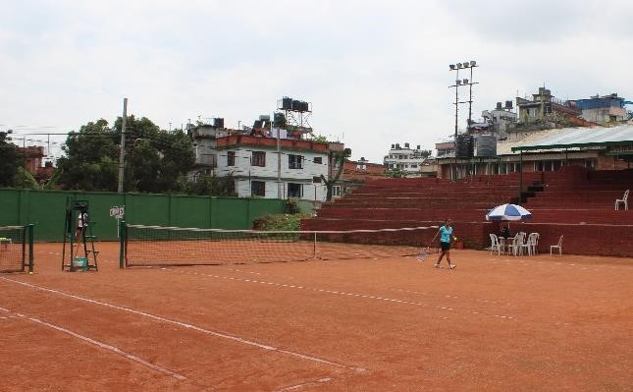
Tennis court is located at the southern part of the swimming pool. The tennis court has only one entrance and it is at the northern side of the court. It occupies 1,650m² area of the complex. There are 3 clay double courts with 3m clearance around the courts. There is a provision for viewing the tennis games. At the west side of the court, there is a raised parapet having capacity of 300 spectators. It is divided into two seating sections. It doesn’t have any provision of VIP or VVIP seating.
Figure 72 Tennis Court

Positive points:
- Appropriate for training purpose and national matches.
- Association office id attached with the court compound.
Negative points:
- Lack of basic facilities for international matches, even for national matches also.
- The starting step of the parapet is around 6ft. High from the court ground but no safety railings are provided.
- No proper maintenance of court and parapet.
- Lack of changing facilities for players.
- Lack of toilet facilities.

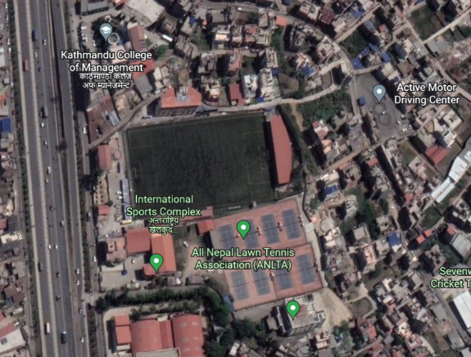
ANFA COMPLEX, SATDOBATO

OVERVIEW
- Location: Satdobato, Lalitpur
- Area: 26.1 ropanis
- Inaugurated: 2007 AD
- Complex type: football academy
- Owned by: All Nepal Football Association
Figure 73 ANFA Complex
INTRODUCTION
All Nepal Football Association is the leading governing body of football in Nepal. In the year 1951 ANFA was founded solely for the love of football. Since it became affiliated with FIFA in 1972 and has actively been responsible for both the national team as well as club competitions.

ANFA ACADEMY
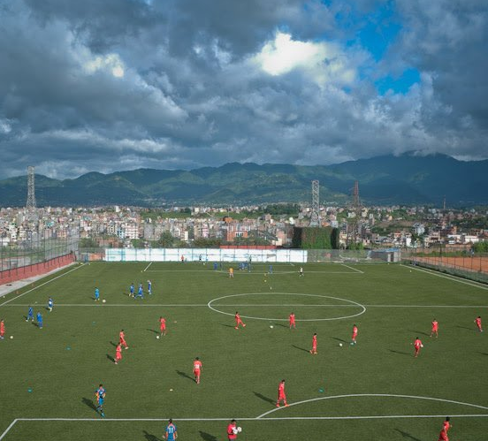
Football Academy of ANFA is located at Satdobato, Lalitpur alongside the head office of the ANFA itself. The academy was opened about 15 years ago under the GOAL project of FIFA itself. Initially built as an office and hostel for youth-level players, a ground was constructed alongside the facility in order to train the players on site. The ground was then later renovated to include artificial turf for pitch durability due to Nepal's climate requiring constant pitch maintenance. In 2015, parapets were constructed and the ground was inaugurated as a national stadium in time for the 2015 SAFF U-19 Championship. Currently, ANFA boasts its five-storied hostel, the ground and other infrastructures proudly as the best academy of football in Nepal.
Figure 74 ANFA Academy Ground

CONTEXT
The Academy is located alongside the ring road at heavily crowded area of the city. The complex is about 5 to 10 minutes’ walk away from Satdobato Chowk. National swimming complex and National Sports Council Office lie in the southern side of the complex. Residential areas are on the other premises of the complex. The crowded city and the road may not be perfect setting for the academy to run however.

ANFA HOUSE
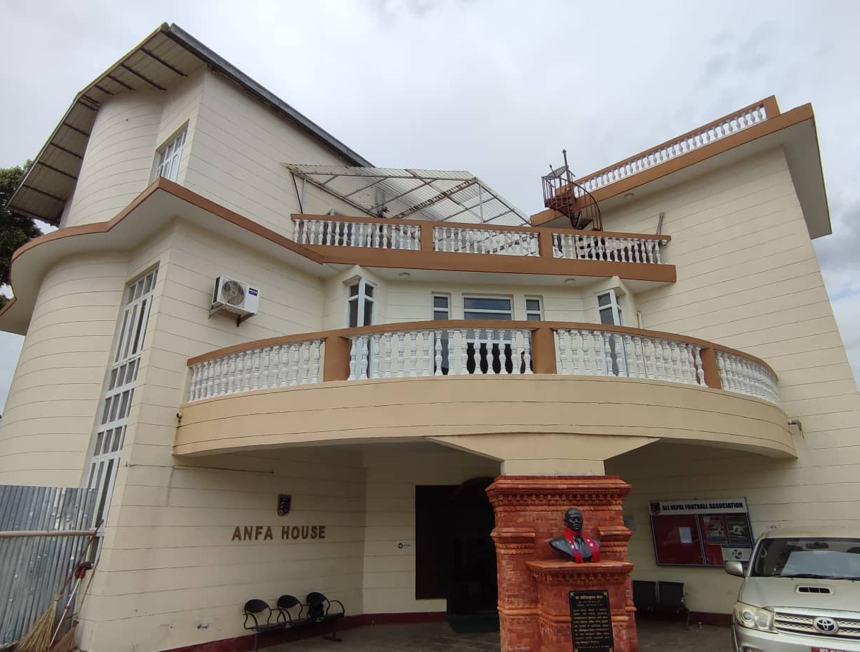
ANFA House Is National Head Office for A.N.F.A. Representatives Around the Country From 40 Districts Elect Their Representatives to Run Governing Body of A.N.F.A. This Building is approached from the entry via secondary road running parallel to the ring road. Being an Administrative Building It Is Placed close to the entrance and gives access to the hostel and play ground. Stone paved court in front of the building provide parking space for the bisitors. The R.C.C building painted phite and with G.I sheet roofing appear to glance carefully to the playground with Its huge cantilevered terrace space in the South. The total plinth area is 3270 sq. ft.
Figure 75 ANFA House

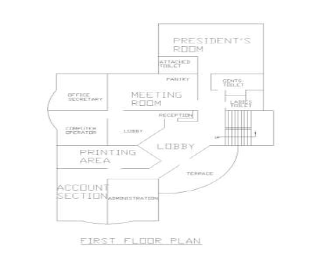
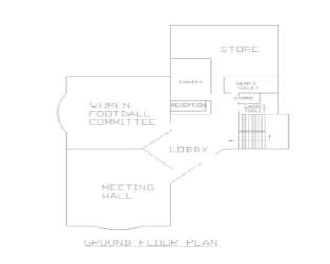
In the Ground Floor
Figure 76 ANFA House floor plans
- Waiting Room.
- Women’s Football Committee.
- Rest Room.
- Reception.
- Meeting Hall

In the First Floor
- Waiting Room.
- Rest Room.
- Reception.
- Meeting Hall.
- Computer and Printing Area.
- President’s and Another Official’s Room.

In the Second Floor
- Waiting Room.
- Auditorium
HOSTEL BUILDING
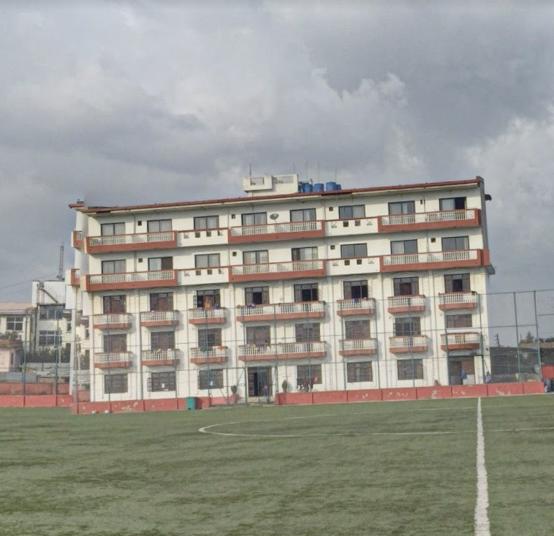
Both national team players and many aspiring Nepalese footballers call the ANFA hostel building, which is next to the field, home. The five-story structure was constructed during two phases. First, a three-story hostel was constructed, and on October 4th, 2012, two additional storeys were erected to serve as VIP rooms for national players.
Figure 77 ANFA hostel building

The building's ground floor provides space for the academy's support services. As you enter the building, the office is on your left side. A TV room, medical room, dining room, study area, and kitchen are also available. The dining room is 31'*19', which appears spacious for the 30 individuals that are now residing there. The kitchen is close to the dining room.

The academy's inhabitants in grades U-14 and U-16 have space on the first and second floors. Students live in and spend their time in 16 rooms that can accommodate 4 students each when they are not on the field. The room was 12' by 18'8 and featured four beds that were roughly 2'6" wide. The youngsters have access to a communal cupboard. There is a balcony on the room's southern side, where one may enjoy the view of the landscape. Along the 92-foot long corridor, rooms are arranged in a line. Each floor of the restrooms next to the stairs has 6 toilets, 3 showers, and 2 wash basins. During their close camp, the National team players have exclusive use of the third and fourth floors. Three players occupy a room that is the same size as the rooms below. The participants are given access to a fridge, television, and attached bathroom. Additionally, each participant receives a shared closet of their own. On the top floor, there are additional conference rooms and meeting rooms available. There are 10 of these VIP rooms.

PARAPETS
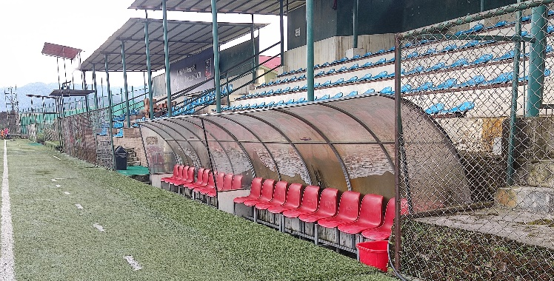
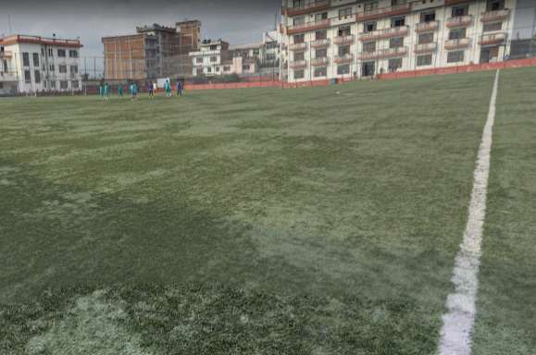
The ground/filed is flanked by surrounded with parapets on the three sides. Eastern parapet stretching 54m are for the normal spectators made off RCC structure. The western parapet just front of the ANFA house, is of temporary steel structure of 30m stretch also for the normal spectators. Meanwhile the western parapets are provide with both VIP and normal spectators which stretches 50m. The complex can accommodate a total of 3,000 spectators at once.
Figure 78 Parapets Normal & VIP
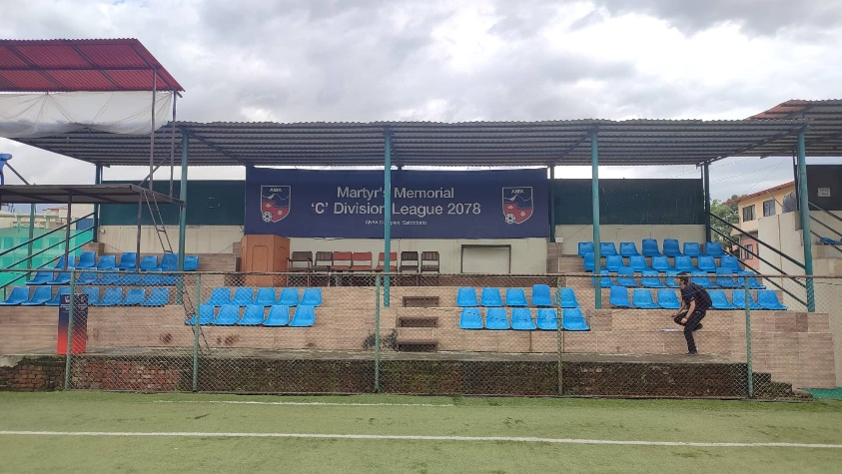
THE FOOTBALL GROUND

The playing surface of the ANFA ground is one of the kind. The ground is made up of artificial turf to tackle the adverse effects of climate on grass surface. On May 2014 the artificial turf was inaugurated with the game between ANFA and Nepal Sports Journalist Forum. The match kicked off after Sports minister Purushottam Paudel handed over the match ball to the referee. The artificial turf at ANFA complex Satdobato is under third Goal Project by FIFA in Nepal.
Figure 79 artificial football pitch
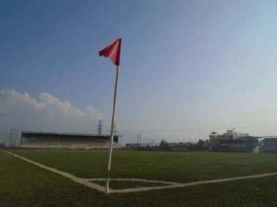
Similarly, Sports minister Purushottam Paudel also added the first brick for 3000 capacity parapets in the ground. The total budget of the project which will last for 8 months’ time frame will be over 4 crores, the then ANFA president Ganesh Thapa informed. (Dipendra, 2014). Parapets are constructed on southern and eastern side of the ground. Total capacity of the ground is up to 3-4 thousand in total.
Figure 80 artificial turf of ANFA complex

The ground was developed as mini stadium in Aug 2015 as the main stadium of Nepal was destructed due to earthquake. First U-19 SAFF championship was hosted on the venue. Changing rooms are provided below the parapets of southern side. VIP seating is provided on the southern side. According to the ANFA the turf is exported from Italy. Average age of the turf is 10 years subjected to proper maintenance. Currently the turf is 10 years old and is in good condition.

TRANSPORTATION

ANFA now has two buses for the purpose of transporting children to school. In addition, ANFA owns an ambulance for hospitals. The administrative buildings are close to parking facilities.

BIRENDRA SPORTS COMPLEX

INTRODUCTION
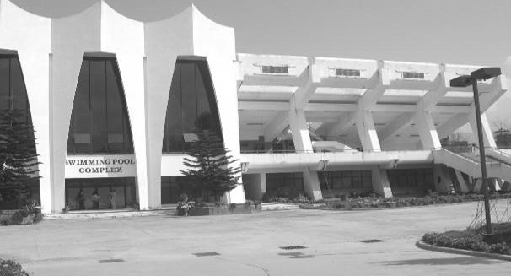
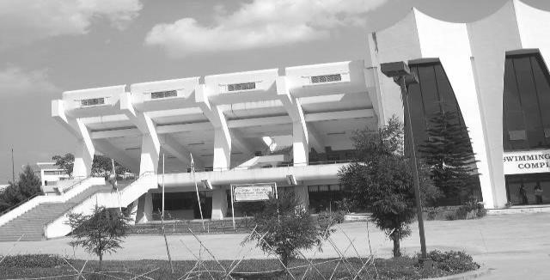
Located at Satdobato Lalitpur District of Kathmandu valley, the complex is attached with Kathmandu ring road and lies outside the ring road on the eastern side. Only 100m apart from the center line of the ring road, it covers around 138 Ropanis of area. In this complex they had planned to construct swimming, pool, shooting range and diving pool but the construction was done of swimming pool and shooting range only.
Figure 81 Birendra sports complex Satdobato
HISTORY & BACKGROUND

This complex was built for the 5th SAG and started construction in 1 99 7 Al) and was completed in 1090 AD. This complex was constructed by a joint venture between the Government of Nepal and China South West Architectural Design and Research Institute, the company of China, responsible for organizing the shooting and swimming events for the 8th SAG.

SWIMMING POOL
The international standard swimming pool was constructed for the 8th SAG held in Kathmandu in 1999 AD. Swimming pool is in modern design form located at the south-west part of the International Sports Complex and covers approximately 30 ropanies of land. The swimming pool is at level of the first floor since the designer located it on the raised hump instead of leveling it off. This pool stand has symmetric front facade with triangular elements covered with blue glass.
This pool has a swimming pool of international competition standard size of 50mx25m with uniform depth of 6.5ft. The 50m pool is used to conduct the international and national matches. This pool has 8 competition lanes with floodlights at various points and one electric mono-digital score board.
This pool is opened for public in day time when the twining, of the national and other swimming players are not practicing. This pool collects revenues from the public who conies to visit to enjoy the swimming.

THE SPECTATOR SEATINGS:
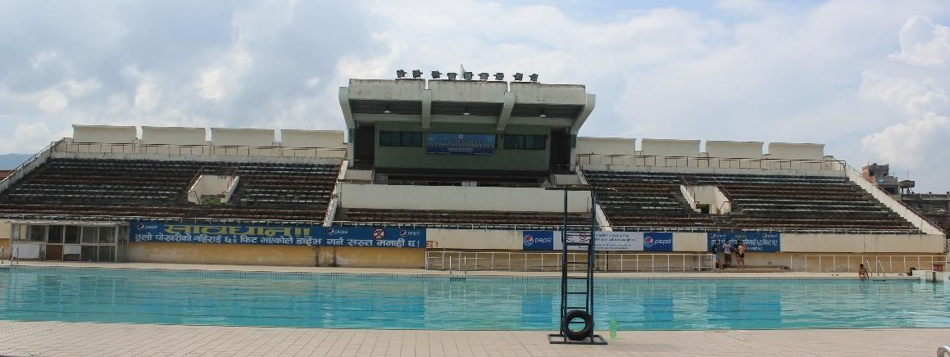
It has spectators viewing parapet of 1.000 seating capacity with VIP, VVIP seating. The spectators are separated into two sections by the mid VIP/VVIP seating section. The general sections are accessed from two staircases from the ground of 3.76m and 1.64m width. These two sections have separate toilet facilities.
Figure 83 Spectator area
OTHER FACILITIES

Below the spectators seating there are different rooms occupied by Swimming Association, Nepal Sports Council and the pool water treatment plant. There is walking line at side of pool which is about 3.6 m wide and the around 13m space separates the pool and the canteen area. At the time of competition the canteen is used to as a dope control room. The swimming complex has 4 towers of floodlight and one floodlight is at top of the VIP/VVIP parapet roof.
Each tower contains 8 halogen lights and each lamp is of 1000W capacity. The swimming pool has an electronic score board at southern side of the pool. And one ramp approximately 3m wide is provided from the eastern side of the pool as access for handicaps and for ambulance.

S.N. | Description | Area (Sq.m)
A | Parapet
1 | Administration  President Room  Secretary Room | 14.84  26.40  30.29

 | Meeting Room  Toilet  Office for training section | 41.16  32.76  32,76
2 | Gym | 44.34
3 | Table Tennis | 41.34
4 | Filter Plant | 220
5 | Chemical Room | 10
6 | Store | 10
7 | VVIP/VIP Area  Lounge  Store  WC  VVIP Room  WC for VVIP  VIP Room  WC for VIPs | 79.50  28.80  2.42  30  1.2  40 27
8 | Spectator  Spectator lobby  Gents toilet  Ladies toilet | 100  33  33
B | Northern Block
1 | Canteen | 100
2 | Flood light control Room | 20
3 | Generator Room | 20
4 | Chemical Room | 20
5 | Changing Room  Gents  Ladies | 126.75  126.75

CONCLUSION & INFERENCES
Positive aspects:
- Only 100m distance apart from ring road.
- Well maintained warm-up and competition pools.
- Suitable for international swimming events.
- Adequate seating facilities for VVIP, VIP.
- Filtration plant is working properly.
- Canteen facilities provided.
- Sufficient changing and shower. Separate changing for male and female.
- Staircases are adequately provided for spectators seating parapet.
- Well-designed circulation. Spectators are prohibited from the swimming area during different swimming events.
- Direct access from sports facilities rooms placed under the spectators seating area. But now, these rooms are being used by Nepal Sports Council as their office. During 8th SAG these were used as official space for swimming event.
- Adequate parking facility provided.
- Ramp from the road level to the pool level is provided for emergency treatment for players but it is normally kept closed.
- Also open for public as well as recreational and training purposes.
- Well-designed building forms.
- Outlook of building is visually pleasing and aesthetically appealing.

Negative aspects:
- Dope testing room is being used as a canteen. So no dope testing room for international competition.
- Uses of the electric score board is during swimming tournaments only.
- Deep boring has stopped working.
- Current condition of the adjacent facilities, not suitable for international swimming competition.

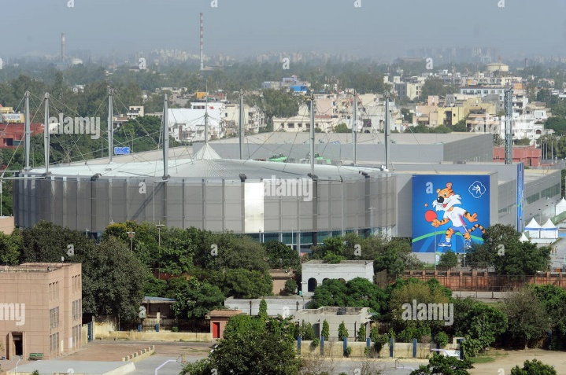
4.3 INTERNATIONAL CASE STUDIES
Figure 84 Yamuna Sports Complex
Yamuna Sports Complex, New Delhi, India

YAMUNA SPORTS COMPLEX
- Location –Ananda Vihar, New Delhi, East Zone
- Site – 62.7 acres
- Plinth Area- 43765 sq. m.
- Inaugurated in 1999
- Designed by Peddle Thorp
- Owned by Delhi Development Authority

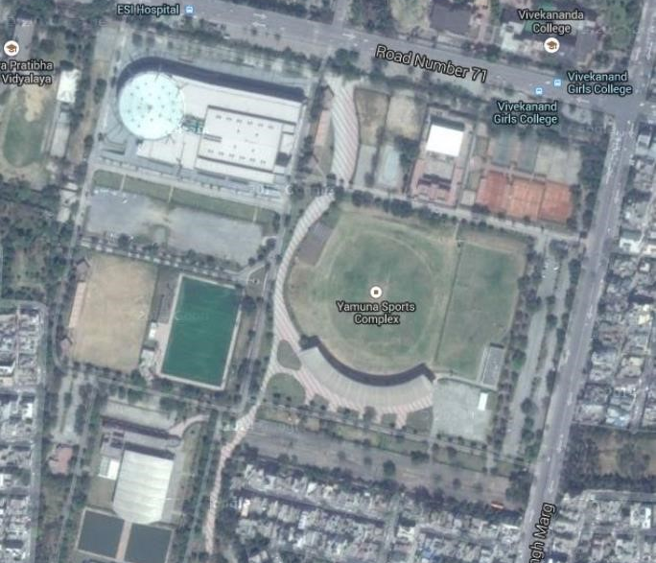
OVERVIEW
INTRODUCTION
The Yamuna Sports Complex is a sports complex located in New Delhi, India. Inaugurated in
1999, it hosts table tennis, Rugby 7's, Boxing, Wrestling. It is owned by the Delhi Development Authority and was a venue for the 2010 Commonwealth Games.

This complex is widely known all over India because of it Archery filed. The very archery ground has produced lots of gold medalist Indian Archers. Yamuna sports complex is located near the posh locality of Yojana Vihar, near Vivek Vihar & Shahdara localities.
Figure 85 Master Plan of Yamuna Sports Complex

ORIENTATION:
The football fields and the hockey fields are oriented in E-W direction.

ENTRY:
The main entry is through the Southern gate which is the Gate No. 1. There are other four entrances on the sides of the complex. To get inside the one needs to get the tickets or be a member of the complex.

OFFICE SPACES:
The office spaces are located in the main Administration building. The Administration Building is located on the southern side of the complex which is near the main entrance.
The Administration block contains:
- Reception
- Lounge
- Manager’s office
- Secretary office
- Other office spaces
- Security block

TRANSPORT ACCESS:
The complex can be easily accessed by the public transport. Public transport may be in the form of buses, rickshaw, taxis and the metro. The nearest metro station to the complex is the Jhilmil Metro Station.

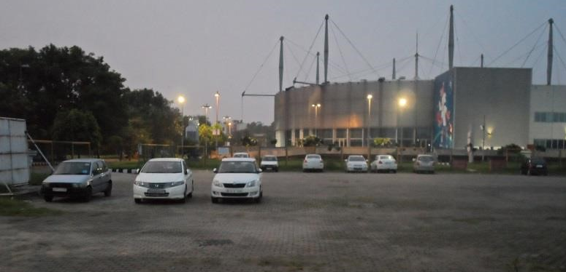
PARKING:
The parking facility in the complex had been decentralized. It does not have all the parking in one place. It has distributed the parking facility according to the need and requirement of the sports facility available in a place. It has the capacity of 500 car parking.

PLAYING FACILITY:
Figure 86 Parking of Yamuna Sports Complex
The complex provides the facility for the following sports:
- Tennis, Synthetic Tennis Courts(2), Clay-5, Cement-3,
- Tennis Practice Wall,
- Table Tennis,
- Badminton,
- Fitness Centre, Ladies Gym.
- Carrom, Chess, Billiards / Snooker / Pool,
- Basket Ball, Volley Ball,
- Gymnastics Hall,
- Skating, Aerobics,
- Taekwondo, Jogging Track,
- Artificial Climbing Wall,
- Cricket Practice Pitches,
- Football, Hockey,
- Squash, including one glass back wall court,
- Olympic size Swimming Pool,
- Toddlers Pool,
- Sports Shop & Snack Bar

SPECIAL FEATURES OF THE COMPLEX
The complex as a whole has a sporting environment. All the streets and paths inside the complex are used as the jogging track. To get the entry to the complex one must be a member of the complex and for non-members they must get a ticket which is available counter at the administration block.

Green Initiatives
- Orientation – North
- Rain water harvesting
- Effluent treatment plant
- CFL lighting
- Solar tubes are used for inside illumination of galleries, etc.
- Solar cells
- Fly ash bricks are using to disposed the powerhouse fly ash
- Heat Insulation through:
- Walls with hollow concrete blocks/cavity walls
- Glazing with double Insulated glass
- Thermal insulation on roof and wall
- Conservation of water through: Use of recycled water for flushing and horticulture
Figure 87 Green & sustainable approaches
- Dual knob flushing cisterns

CONCLUSION & INFERENCES

Positive aspects:
- Proper ramps provided
- Sprinklers and fire detectors provided
- Special provision made for physically challenged people-Stadiums with retractable seating.
- Sufficient parking space.
- Battery operated cars to move inside the premises of sports complex.

Negative aspects:
- Only one basketball court
- Parking far from venues
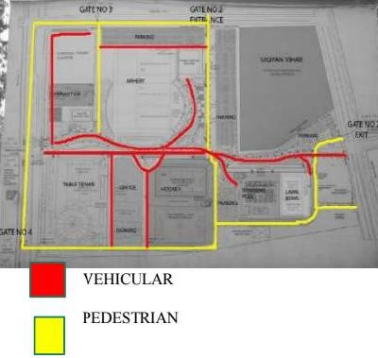
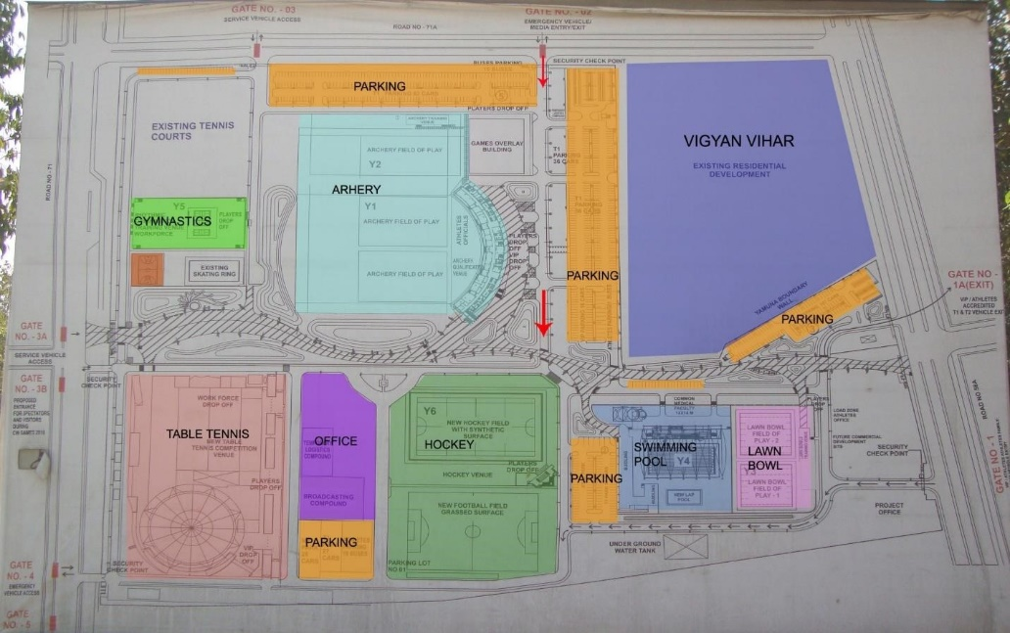
- Distance between two stadiums was lar
VECHILE
PEDESTERIAN
Figure 88 Vehicular & pedestrian flow
Figure 89 Masterplan of Yamuna Sports Complex
COMPLEX PHOTOGRAPHS:

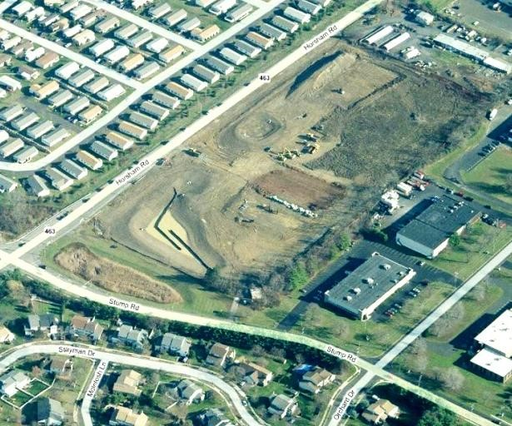
MONTGOMERY TOWNSHIP

COMMUNITY & RECREATION CENTER

OVERVIEW

- Location –Horsham Rd, Montgomeryville
- Site – approx. 40,000 sq.ft
- Commenced on - July 8,2013AD
- Designed by Kimmel Bogrette
- Owned by- Montgomery township
Figure 90 Montgomery site before construction
INTRODUCTION

Montgomery recreation center is a community based recreation center based in Pennsylvania, USA. It was built with the motive of providing the recreational facilities to the people of Montgomery area. Catering the every age groups of people, Montgomery has become a hub for a children, adults, teens, youths & even seniors to hang out and learn fitness lessons.

REQUIREMENTS & AMENTIES APPROACH

Montgomery center was made with the suggestions of the people of that community where series of public talks were made to know the actual need and necessity for the people.

First Step – Public Input
What do the residents want in their new community center? Public Meeting held July 11
• Residents voiced their opinions on community center amenities.

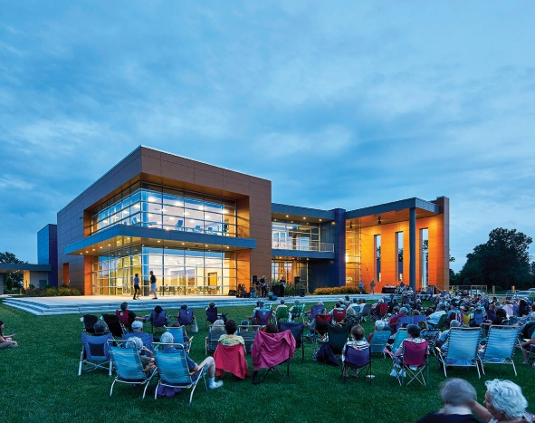
Many ideas were expressed including:
• Indoor Basketball Courts, Community Rooms, Multi-Purpose Rooms
• Running Track, Indoor Pool, Skate Park
• Teen Center, Library, Multi-Purpose Fields, Kitchen
• Weight and Exercise Rooms, Stage

- The residents also expressed general thoughts and concerns
- The new building should be as “Green” as possible to be a good steward of the environment
Figure 91 Montgomery front premises
- The new building should be as flexible as possible to allow for all types of activities.
- The new building should serve all ages and interests.
- The Township should have a firm understanding of operations and financial cost of running a community center

The building program

Based on the public input, Township requests, market study and focus groups KBA developed 3 possible building programs for what the new community center could be.

PROGRAMS
Events
- Annual autumn festival
- Community forestry workshop

Youth
- Arena flag football league
- Basketball skills and drills
- Color with cop
- InDi Studios (pottery, clay, jewelry, design and more)
- Kids night out
- Kids Yoga
- Mad science
- Paint Party
- Safe Sitter Course with CPR
- Soccer skills and drills
- Story time with North Wales Library
- Super star sports
- Young Rembrandts
- Tennis program with fundamental tennis

Pre School
- Color with cop
- Get up & move toddler
- Kids Yoga
- Messy Art
- Story time with North Wales library
- Superstar Sports
- Young Rembrandts
- Soccer shots
Teen
- Fitness class
- InDi Studios (pottery, clay, jewelry, design and more)
- Paint Party
- Safe Sitter Course with CPR
- Young Rembrandts
- CPR certification classes
- Tennis program with fundamental tennis

Facilities available
- a gymnasium with 2 basketball courts
- suspended running track
- cardio / weight room
- exercise studios
- community room, seniors / classroom
- youth lounge
- catering kitchen
- child watch
- Administration suite.
- Suspended running track
- Lounge
- Studio/Multipurpose, Cardio/weight room

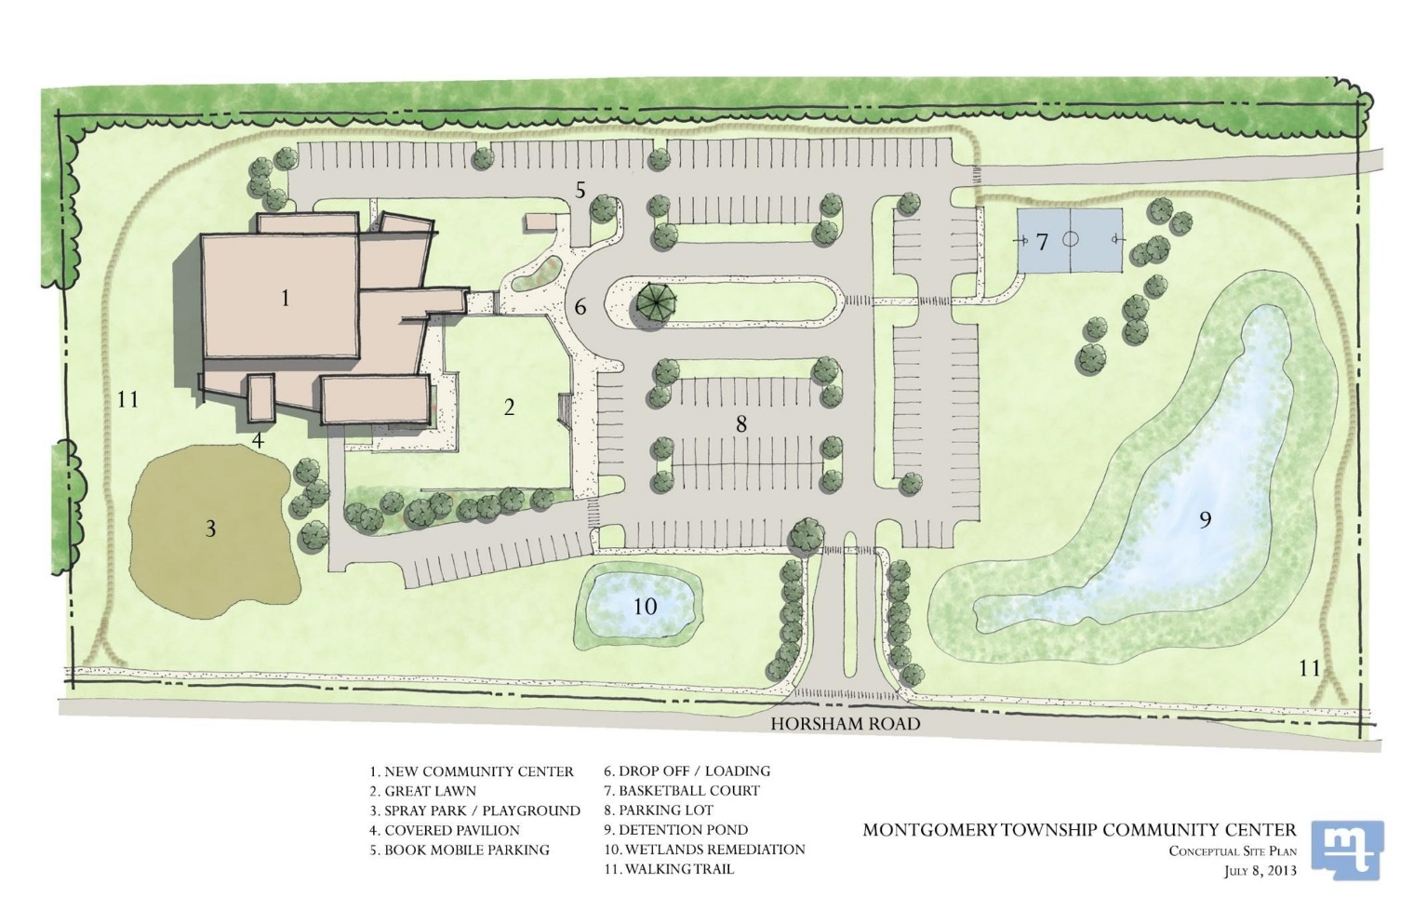
Figure 92 Montgomery master plan with site
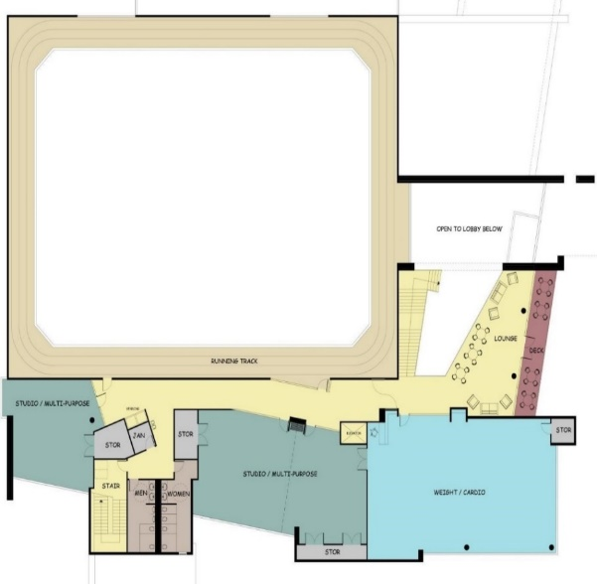
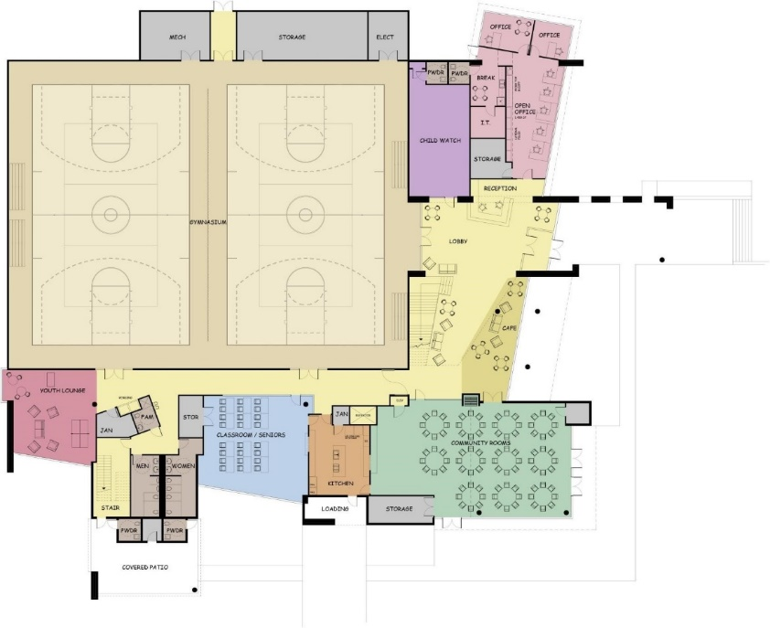
Figure 93 First floor plan
Figure 94 Ground floor plan

CONCLUSION & INFERENCES
Positive aspects
- Inclusive design i.e. from child too young to adult to old
- Multiple use of spaces (viability)
- Integration of facilities under a single unit

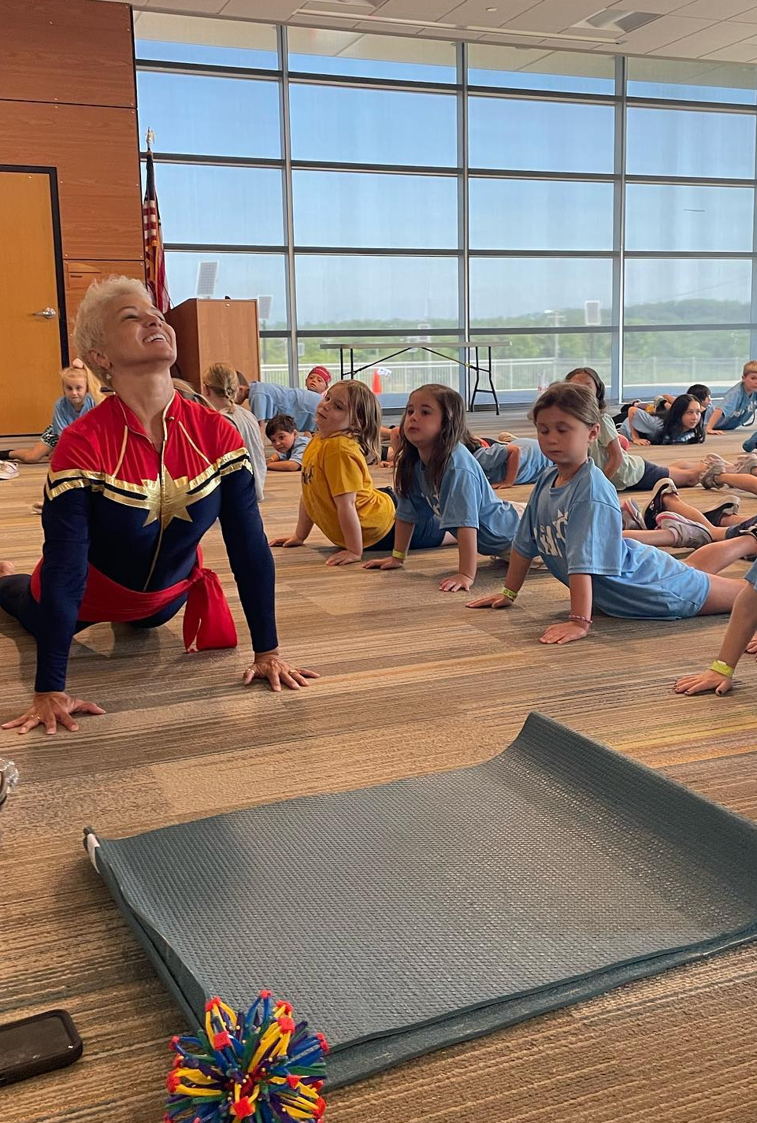
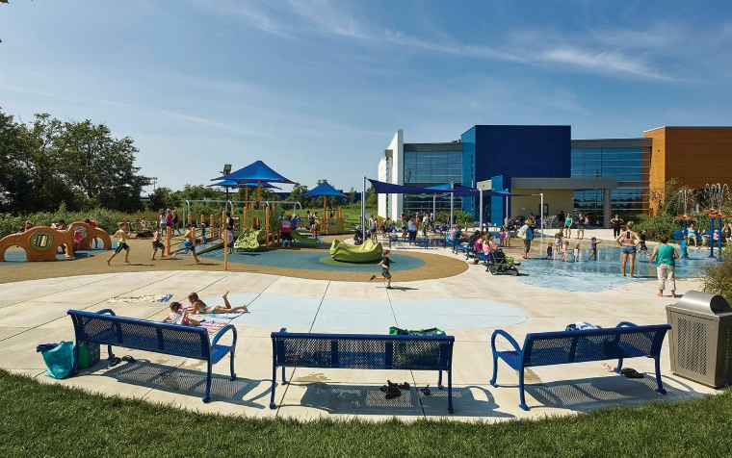
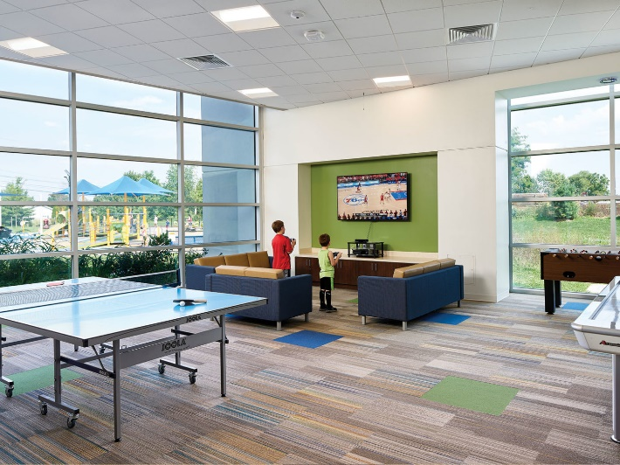
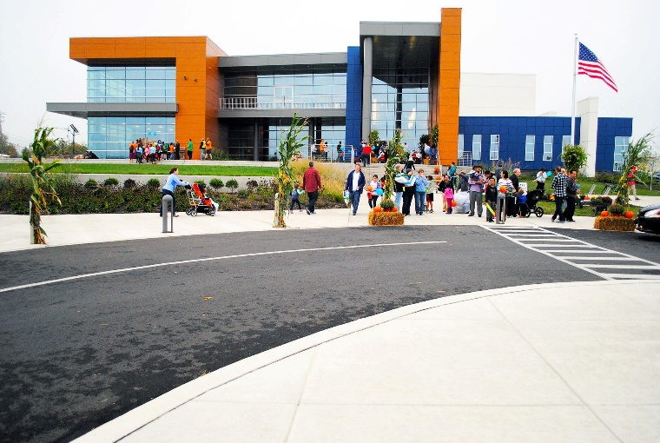
COMPLEX PHOTOGRAPHS:
GAMING ZONE
COMPLEX FRONT

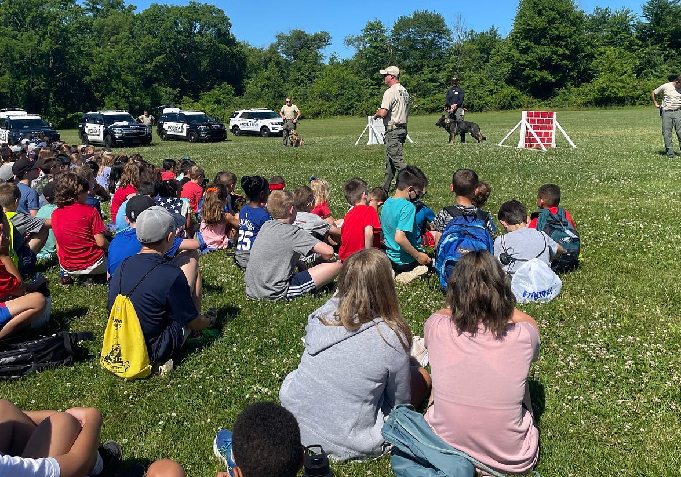
YOGA CLASS
SPRAY PARK/GROUND
CPR TRANNING CLASS

CHAPTER- FIVE

5.1 SITE ANALYSIS
The proposed site for the proposed thesis is located in the sub urban area of Simara, Bara. The main behind the selection of this site is the prime location it stands, just near the domestic airport. Also far from the urban fabric, the site is itself a sustaining sports venue of one of the most successful football tournament named “Jeetpur Simara Gold Cup”.

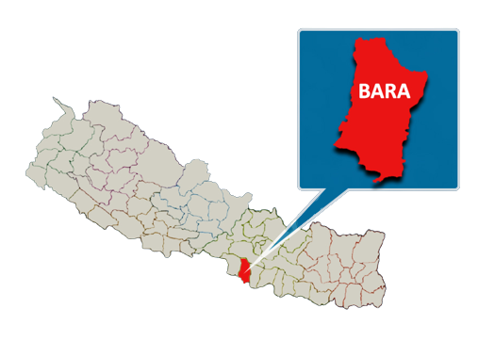
The sports enthusiast people around the site also demands a better facilitated sports & recreation center. The site thus makes it viable for hosting games & make interested players engaged in their respective sports to pursue their dream of representing Nepal in international stage.

Project: Jeetpur-Simara Sports & Recreation Center
Site location: Simara Bara
Site Area: 118 ropanies/60,410 sq.m
Land owned by: NJJYC
Terrain: Flatland, Terai
Latitude: 27º 09’55” N
Longitude: 84º 59’1” E
Altitude: 450 feet (137m) above the sea level

Access and Approaches
The major approach road to the site is from the Simara-Birgunj industrial corridor. A secondary road leads us to towards the site from the Simara Chowk to the east. The major route is about 10 m wide and has black topped surface

The main access of the site will be taken from the primary approach i.e. the Simara-Birgunj road connecting the airport road. Also the site has access from the north via 5m wide road.

Fig, 95 Auraha Chowk just ahead of the site entrance
Features of site:
- Prime location connected to the ringroad university area with green belt
- Sloping land
- Paranomic mountain view from the site

Site Surroundings:
North: Residential area, South: Simara Airport, East: Thanimai Forest, West: Agricultural land
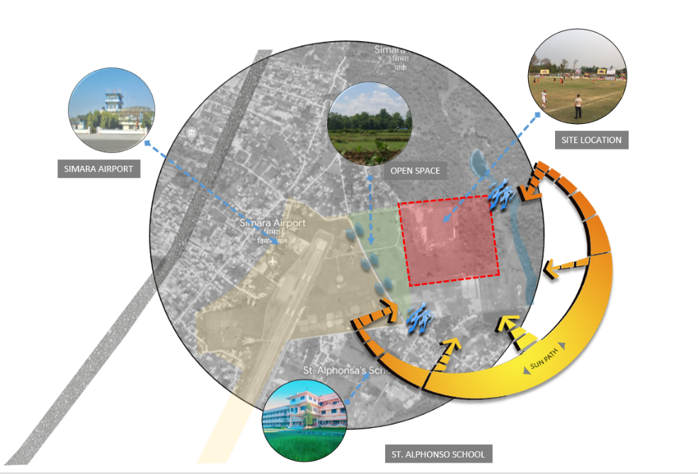

Figure site surroundings
Figure Bara District Map

CHARACTERISTICS
Topography: Flat
Climate: Hot & humid

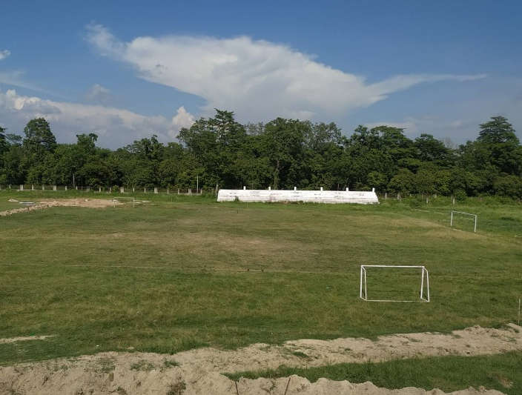
SOCIO-CULTURAL ASPECTS
Figure 97 Existing underconstructon Simara ground
The site is located just adjacent to the residential area. Though Simara is an industrial area, the site is quite far from the zone with its own environment adjacent to the forest greenery. Also the hospital is just within 1km from the site which is a good distance for the sports center.
PHYSICAL ASPECTS
Landscape Scenario: Flatland
Street Scape: Airport road stretching in front of site
Built Up and Open Spaces: Open at S, E, airport at west

Infrastructure:
Road facilities (highway), Water (Boring available)
Electricity (NEA)
Communication: Lines available
Drainage: Municipality, Sewerage: no public sewer lines
ECOLOGICAL ASPECTS
Greenery in the site, surroundings has plenty of trees to the east (Thanimai Forest)
Water body (pond) present near the site (Thanimai Pond)

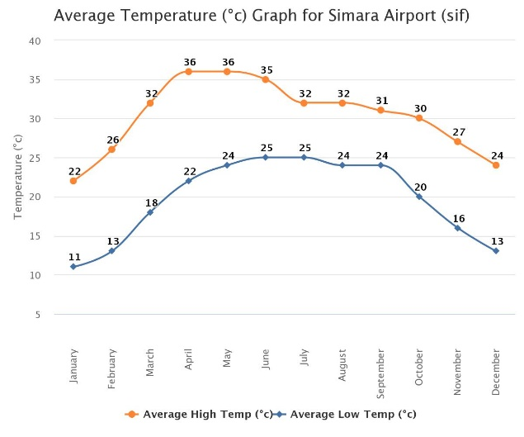
LEGAL ASPECTS
Municipality: Jeetpur-Simara Sub-Metropolitan city
Zone: Semi- residential zone
Sub-Zone: Agricultural Zone

CLIMATIC ANALYSIS
The first process of climatic design is to analyze the available climatic data thoroughly. The assembling of climatic step in the data over a considerable period of time could only define the climate. The data should relate to the period of at least 10 years, since shorter period will exhibit variations from the long term average. However, a five year period, although less reliable may still provide useful information if no other data is available.
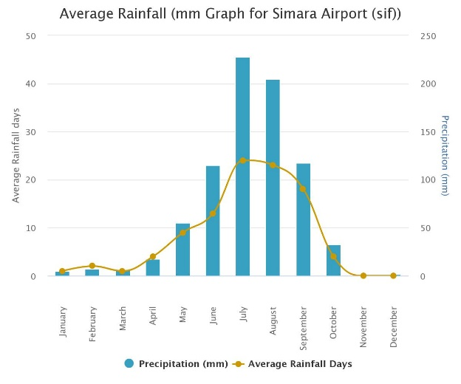
According to Department of hydrology and Meteorology, the climatic data of Simara is as follows.
- The mean maximum temperature is 36_{o}C.
- The mean minimum temperature is 25_{o}C.
- The absolute extreme temperature maximum is 38.5_{o}C.
- The average annual rainfall is 230 mm.
The prevailing wind direction is generally from west to east and southwest to northeast. The wind velocity is maximum in March which records 4.44kmph.

Bylaw analysis
Proposed site lies in semi residential zone. Further it lies in agriculture sub-zone. Bylaws for this area are as follows:
- GCR : 40% of total site
- FAR : 2.50
- Minimum Parking Area : 15% of total land

5.2 SWOT ANALYSIS
STRENGTH
- Proper location of site
- Regular topography
- Site is adjoining the main road
- enough land for accommodating all facilities
- Excellent scenic beauty
- Accessible through air to

WEAKNESS
- Hot & harsh climate
- Possibility of disturbance due to Airplane noise

OPPORTUNITY
- Scope for extending the area as local tourist attraction
- Platform for displaying the sports loving nation
- Use of vernacular architecture, natural resources (wind, sun, rain) to create energy efficient
- Chances of making a provincial sports landmark

THREAT
- Security
- Political instability

Airport rules and regulatory

The distance between a sports facility and a domestic airport might differ based on a number of variables, including regional laws, security needs, and the airport's and sports complex's exact locations. The minimum distance between an airport and other structures, including sports complexes, is often prescribed by aviation authorities in order to maintain safety and prevent potential risks.

For instance, the Federal Aviation Administration (FAA) in the United States advises a minimum separation of 3,000 feet (or 0.91 kilometers) between the end of the runway and the closest location of any sporting facility. However, this distance may change based on elements including the runway's length, the approach and departure trajectories, and regional laws.

It's crucial to keep in mind that these are only basic recommendations and that local laws, regions, or other jurisdictions may have different standards. To ascertain the precise needs for a sports complex's location in relation to a domestic airport, it is critical to confer with the necessary municipal authorities, aviation authorities, and stakeholders. In order to avoid any disputes or safety problems, this will ensure adherence to rules and safety requirements.
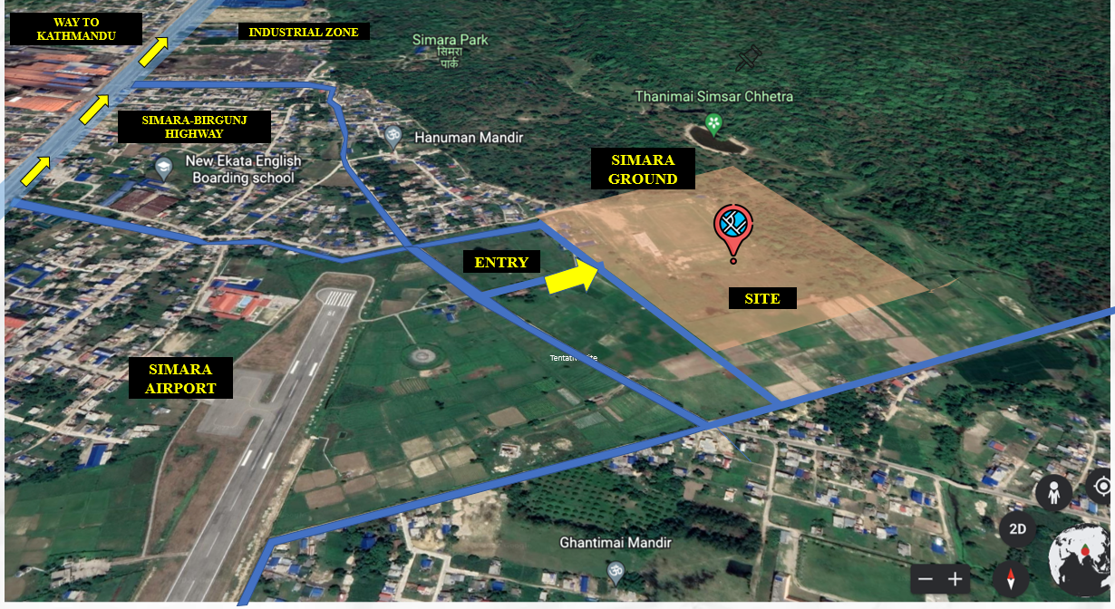
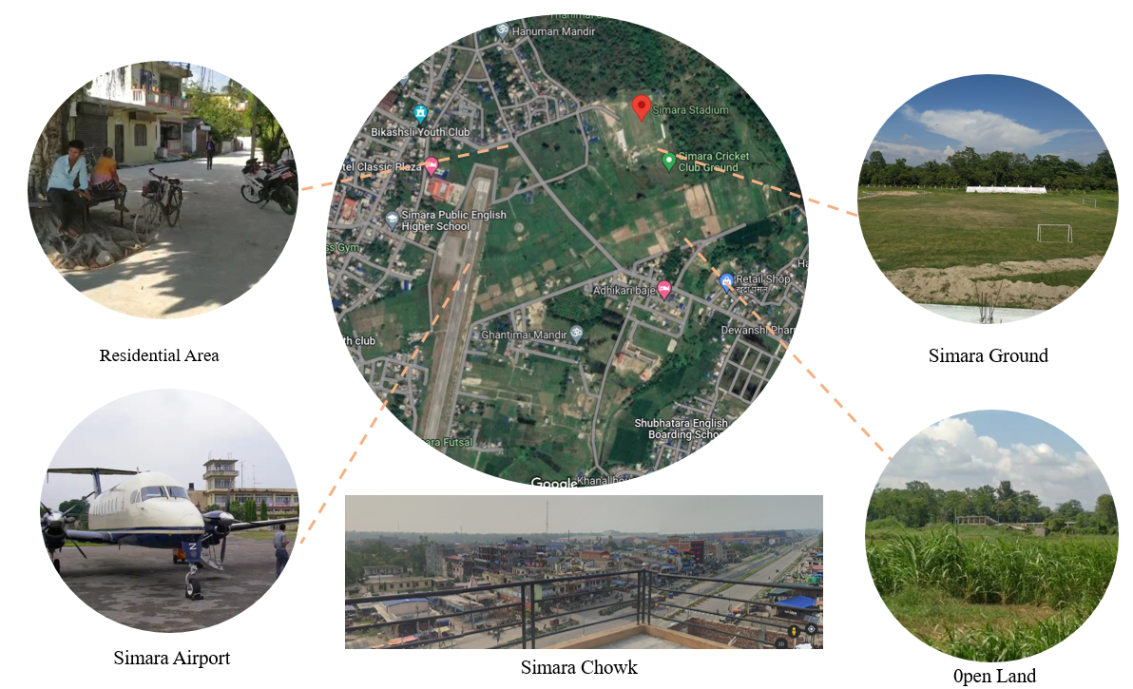
SITE SURROUNDINGS & PHOTOGRAPHS:
Figure 99 site surroundings
Figure 100 proposed site with surrounding information

CHAPTER – SIX

6.1 PROGRAM FORMULATION AND DESIGN GUIDELINES
PROGRAMES INCLUDES
• Outdoor activities
❖ Mini football ground
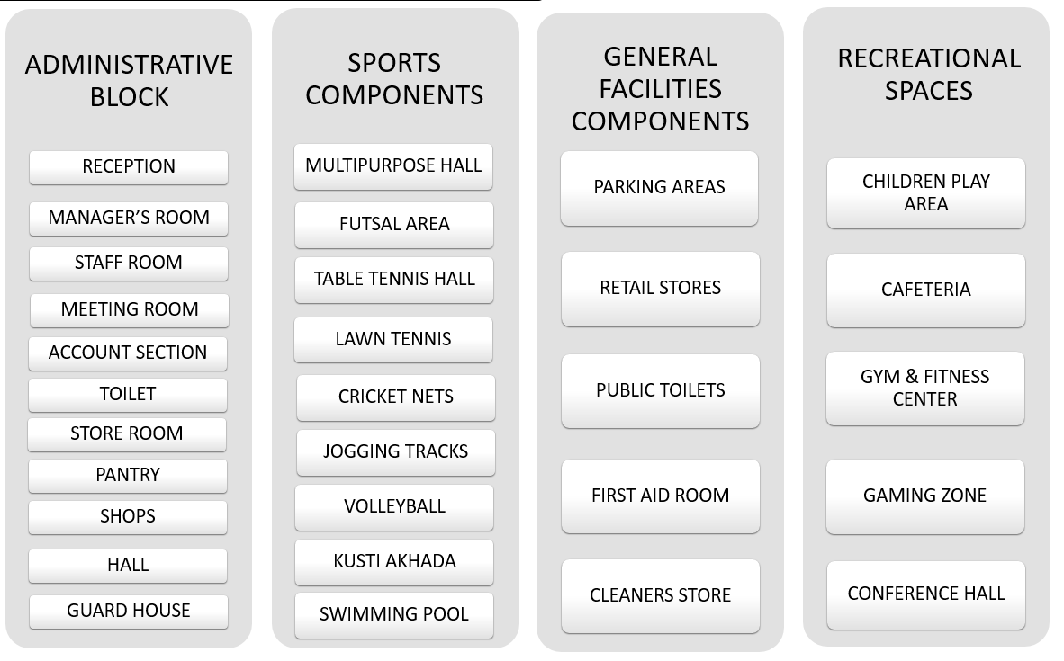
❖ Futsal ground
❖ Volleyball
❖ Cricket nets

Indoor activities
  - Multi sporting venue ( Layout)
  - Swimming pool
  - Basket Ball
  - Table tennis
  - Badminton
  - Swimming
  - Kushti Akhada
  - Gymnastic and other indoor games
Figure 101 proposed programs as per the requirements
  - Indigenous sports

- Recreation & Leisure amenities
  - Administrative Block ( Layout)
  - Concert/cultural programs stage
  - Gym & fitness
  - Child play area
  - Parks & open spaces
  - Jogging tracks
  - Conference hall

6.2 RECOMMENDED PLANNING & DESIGN PRINCIPLES FROM LITERARURE REVIEW & CASE STUDY
- Location should be chosen in such a way that it should not create any problems or damage to the social-cultural value of community, biological and physical value, environmental importance of the locality etc.
- Location should be accessible and have lots of option to approach.
- For any sports activities flat topography would be very appropriate for multiple events than contour topography.
- Security zoning and connection between different activities should be done according the standard zoning concept.
- Sufficient distance should be maintained between two different buildings which may create great visual access.
- Entrances should be welcoming type and should have power of attracting the focus and differently appeared at the time of entry.
- In the modern context, the provision for disables and physically challenged person is a must. So, these people need special kind of treatment in circulation or movement, access, parking, seating and toilet provisions.
- Adequate parking spaces should be located inside the site for different type of people involved to different activities. And these must be provided with standard feasible for Nepal.
- Sport enhances the cultural and social dimension so these must be considered during design development.
- Refreshment area should be provided for the public and they should be placed in such a way that can easily visible from the general public circulation and movement area.
- Different facilities like generator room electrical house, heating and cooling plant should be in separate place so that can be easily access to the operator and difficult to public for safety reasons.
- Circulation within the structure should be formal and simple so that the public doesn’t get confused and different signage, guidance must be properly provided.
- Every build forms should be legible to public.
- The site and building should have higher potentiality.
- The complex should be adaptable for future extensions projects.
- Provided flexibility in the planning of halls and outdoor spaces so that they have multiple uses during concert, community program, etc.
- Identify the nature of each activity so that similar natures of activities are being placed together. Gymnastics hall should be placed along with martial art rather than with basketball court.
- Some facilities like training halls of martial arts, gymnastics, changing rooms keep on expanding due to the increase in the number of the user and the change in equipment’s. So the spaces should be considered.
- Every game has different nature of activities. While designing their completion hall or training their nature should be considered.
- Changing rest room should be provided for almost all the sports in the sport. They should be provided for every indoor and outdoor venue as well as every training space.
- Adequate parking area should be provided for general public, and staff of the complex. Separated provision of VIP and media should be provided.

6.3 SPACE REQUIREMENT FORMULATION
- The case studies and the literature review provided the guidelines to frame the requirements. The calculation done with appropriate conversion for current requirement of Nepal.
- Several additional facilities can be provided to up-lift the sports complex.
- The requirements are on the favor of the provision of comfort to the every single person visiting the sports complex from the players to the VIPs, officials and spectators.

Design Data Requirement for Sports Complex Design

A | Covered Hall (Gymnastic Size)
S.No. | Description | Nos. | Area (sq.m.)
1 | Sporting area | 1 | 30 m x 56 m=1680
2 | Seating area
 | General (0.45 sq.m/seat) | 1300 | 585
 | VIP/VVIP (1.0 sq.m/seat) | 100 | 100
3 | Equipment room/Store | 2 | 300
4 | Entrance ( Reception and lobby) | 1 | 100
5 | Medical Section
 | Medical examination room | 1 | 30
 | Dope testing room | 1 | 15
 | Treatment and recovery room | 1 | 12
 | Store room | 2 | 30
6 | Players
 | Team room | 2 | 80
 | Changing room | 6 | 300
 | Toilet and shower | 20 | 100
7 | Instructors /Coach room | 2 | 50
8 | Referee room | 1 | 20
9 | Match officials | 1 | 20
10 | First aid room | 1 | 25
11 | Maintenance room | 2 | 40
12 | Sports shop | 4 | 150
13 | Media room | 2 | 100
14 | General Toilet (70:30-M:F assumption) | 8 | 400
15 | Other Amenities |  | 2819
Sub-Total 6956

B Swimming Pool
1 | Event pool ( 50m) | 1 (51 m x26m) | 1,350
2 | Seating area
 | General (0.45 Sq.m./seat) | 320 | 144
 | VIP/VVIP(1 Sq.m./ seat) | 40 | 40
3 | Water treatment plant | 1 | 300
4 | Lockers & Changing rooms | 6 | 630
4 | Different Functions | 1 | 50
5 | General toilet (60:40-M:F assumption) | 20 | 140
6 | Technical room( control, media, technical) | 3 | 60
7 | Technical Assistant Room | 1 | 30
8 | Medical section | 2 | 100
9 | Store Room | 2 | 12
10 | Other Amenities | 1 | 1668
Sub-Total 4524

C | Parking Area (x3)
1 | Cars (120+60) /18 sq.m | 200 | 3240
2 | Motorcycle /2 sq.m | 400 | 800
3 | Bus | 8 | 800
4 | Cycle | 300 | 150
 |  | Sub-Total 5,000

D | OTHER AMENTIES
1 | Administration | 1 | 400
2 | Cafeteria (300 capacity) | 1 | 1400
3 | Gym | 1 | 377
4 | Library | 4 | 300
 |  | Sub-Total 2477

e | foyer
1 | Entrance | 1 | 150
2 | Lobby space | 1 | 777
3 | Hall of fame | 1 | 310
4 | Ticket Room | 2 | 40
 |  | Sub-Total 1277

f | outdoor play
1 | Track & filed | 1 | 24792
2 | Open play area | 1 | 8839
 |  | Sub-Total 33631

B aMENETIES
1 | Parking | 1 | 22m x 85 m
2 | Track & field | 1 | 196m x 94 m
3 | Multipurpose indoor hall | 1 | 94m x 74m
4 | Admin | 1 | 24 m x 12 m
5 | Swimming Pool | 1 | 78m x 58m
6 | Cafeteria | 1 | 45m x 24m
7 | Kushti Arena | 1 | 78m x 32m
8 | Open outdoor play area | 1 | 45m x 137m
9 | Surface Parking | 1 | 86m x 69m
10 | Outdoor Toilets & drinking water | 4 | 4m x 16m

Total site area: 176.41 ropanies
Total Built-up Area: 24,307 sq.m./47.47 ropanies (27%)
Parking Area: 13,048 sq.m./ 25.65 ropanies

CHAPTER – SEVEN

7.1 CONCEPT & DESIGN DEVELOPMENT
7.1.1 PROJECT VISION
The main objective of this project is to provide space for the players where they could train themselves & even the complex can conduct some regional level games. Also this will help in the development of the surrounding communities as well as the neighboring settlements. The project will surely boost of the sporting culture of the nation through the maximum engagement of youths in games and sports. With this large numbers of players can be produced through the local level who could represent Nepal in the international stage through sports.
7.1.2 DESIGN GOAL
The complex is aimed to cater the need and requirements of the youth and players of Simara helping them to provide ample facilities for various sporting activities. The site is already proposed for a football stadium by the local club Nawa Jana Jagriti Yuwa Club through the local government. In the entire Bara district there are no any multipurpose sports center till now to cater these necessities. Located in the outskirt of main industrial & up growing urban fabric of Simara, this project is even near to the domestic airport which are the important factors to make this project sustainable.
The site is 307m x 292m with three sides’ road access to the North, South & West.
The entire project is broadly classified into two categories of sporting activities: Indoor & Outdoor facilities. Multipurpose indoor sports hall, Indoor Swimming Pool, Indoor Sports hall are the major indoor facilities. Meanwhile the Mini Football Stadium, which is already in the proposed site has been included on the other half as the outdoor facility with the addition of futsal, volleyball & basketball.
Football is the most popular sports in Simara as every year one of the biggest gold cup is hosted by the city. Moreover Taekwondo & futsal are also the emerging sports in the area.

7.1.3 KEY PRINCIPLES IN DESIGN
SUSTAINABILITY: Environmentally & economically sustainable with the use of renewable energy like solar energy that helps in the reduction of carbon footprint.
MULTIUSE: Includes the multiplicity of uses of the spaces as per the necessity.
COMMUNITY BASED: Serves the need of the local community promoting the social interactions among the people which overall contributes to the well-being of the community
ACCESSIBILITY: Accessible to all age groups from any standards of life, inclusive design with disable friendlies facilities like ramps, elevators
HEALTH & WELLNESS: Provision of outdoor recreational spaces and facilities
CULTURAL INTEGRATION: Inclusion of local culture creating the spaces that celebrate the communities’ unique identity eg. Kushti Akhada for the occasional fights are provided in the complex
NATURAL ENVIRONMENT: The project is within & around the natural environment enhancing the local ecosystem.
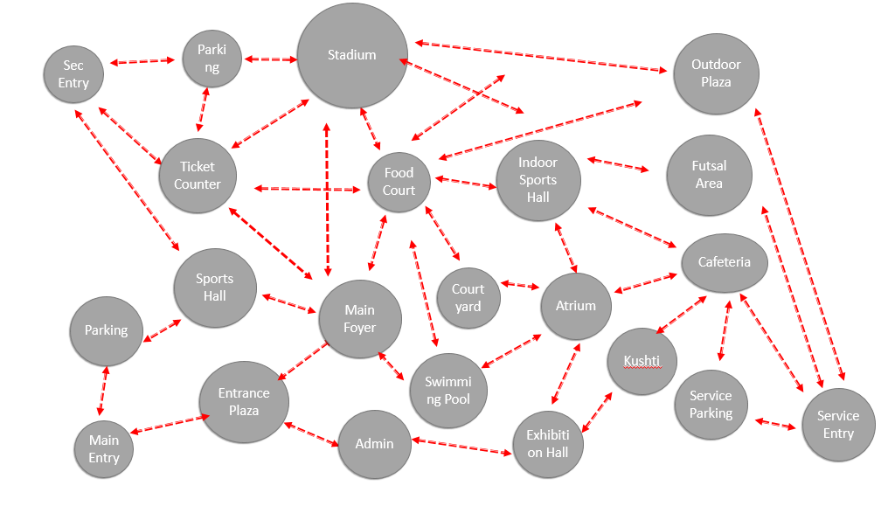
BUBBLE DIAGRAM:
Figure 102 Bubble Diagram

7.2 CONCEPT & DESIGN APPROACH

MASTER PLANNING AND ACCESSIBILITY

7.2.1 AXIS
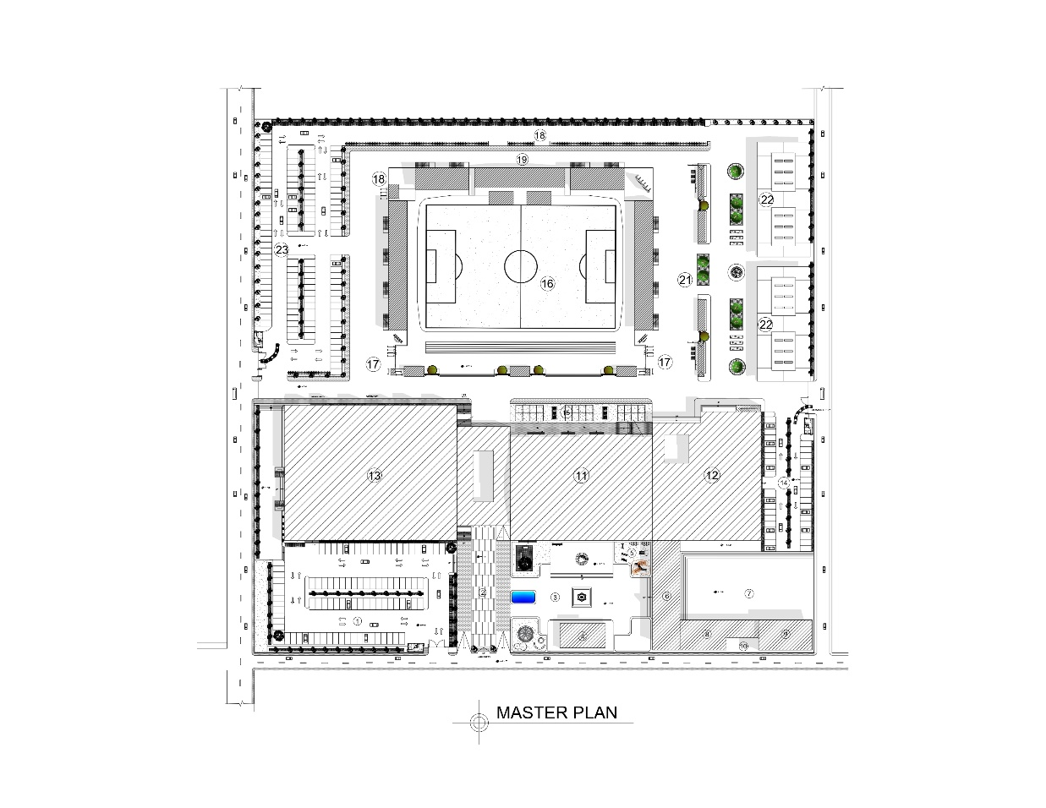
Minor Axis
Major Axis
The planning of the entire complex is guided by the axes as a major tool. Entire complex is planned strongly on 2 major axes.

Major axis:
- The long N-S stretch within the site is assumed as the main axis through which the site is divided into two portion such that a symmetrical form is formed.

- The three major elements of the complex are facilitated with the axis such that they are bounded under the same trial.
Figure 103 Axis of the site
Minor Axis:
- E-W vertical axis through the main entry of the complex is taken as the minor axis that acts as a linkage through the indoor complex opening out to the stadium.

7.2.2 ACCESSIBILITY
Service Entry
Sec. Entry

Multiple entries and exits

To ensure the arrival and departure of spectators and players, one primary spectator pedestrian entrance point and other secondary entrance point are proposed in the Sports complex player’s entry and all the guest.
Main Entry

Meanwhile one exit point/service entry is also proposed so that it would assist while managing traffic during peak hours.
Figure 104 Entry points of the site

7.2.3 FUNCTIONAL APPROACH
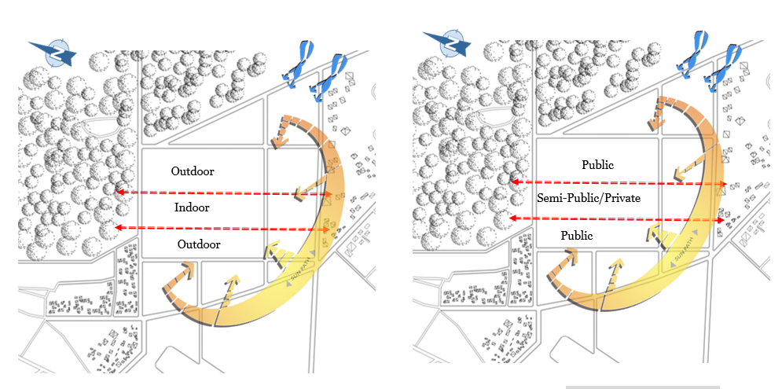
The entire whole complex is divided in to 3 fragments horizontally as per their functions & nature of the facilities. The central strip is loaded with all the indoor amenities creating an inbuilt environment along a linear axis which thus creates a more cohesive & functional space. Such form even allows better circulation & easier access to different facilities.

Figure 103 Zoning as per functions (left) & as per privacy (right)

7.2.4 IN & OUT CONCEPT / BALANCE OF THE NATURE
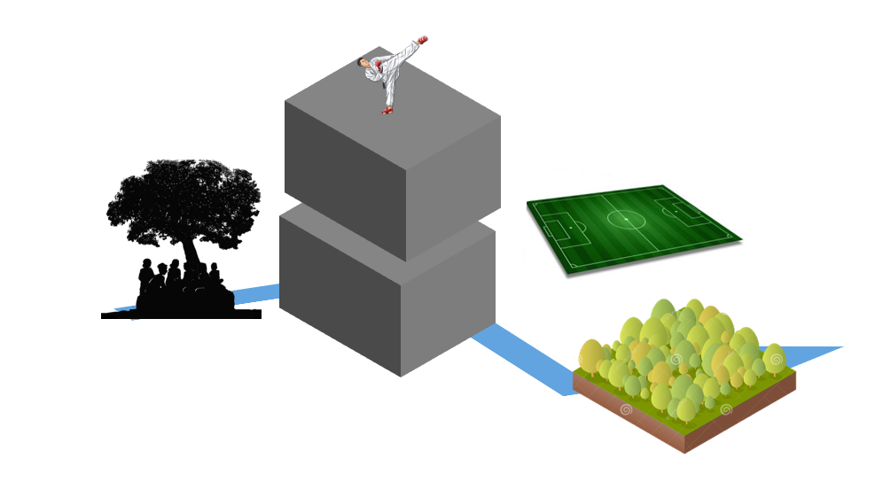
As the sports facilities can be classified mainly into two categories
- Indoor : which are played inside under the roof
- Outdoor: which are played outside under open sky
Here in this project the in and out concept is being incorporated in the design such that the indoor activities are facilitated by the outdoor recreational spaces to promote a both physical and healthy lifestyles together. Loading the whole built up structure to the middle balanced by open land on both remaining halves.
Figure 104 in and out connection

7.2.5 FORCES OF NATURE
The entire sports complex facilities are classified on the basis of their nature:
Sky: Indoor facilities; Stacked together up towards the sky
Earth: Outdoor facilities< Athletics, football ground, interacting directly with the ground
Water: Swimming pool & existing water bodies
Why forces of Nature?
Since the site is adjacent to the natural vegetation/forest area
Thanimai forest
forest
- Thanimai Forest to the east
- Thanimai wetland to the north
Respect & response to the nature.
SITE

The lamina of Terai
The linear planning has been inspired from the lamina of organic land form pattern in Terai belt of Nepal.
Linear Form:
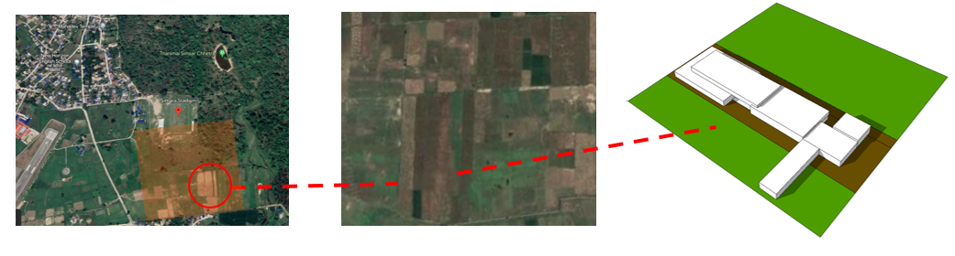
A long and narrow building are created placing different sports facilities along a linear axis to create more cohesive & functional space. Such type of planning allows better circulation & easier access to different facilities. The whole built up structure was loaded to the middle balanced by open land on both remaining halves
Figure 105 Inference from the local Terai land fabric

Clustered Design:
Buildings are interconnected & grouped together with various sports facilities which allows more efficient use of space & greater flexibility.
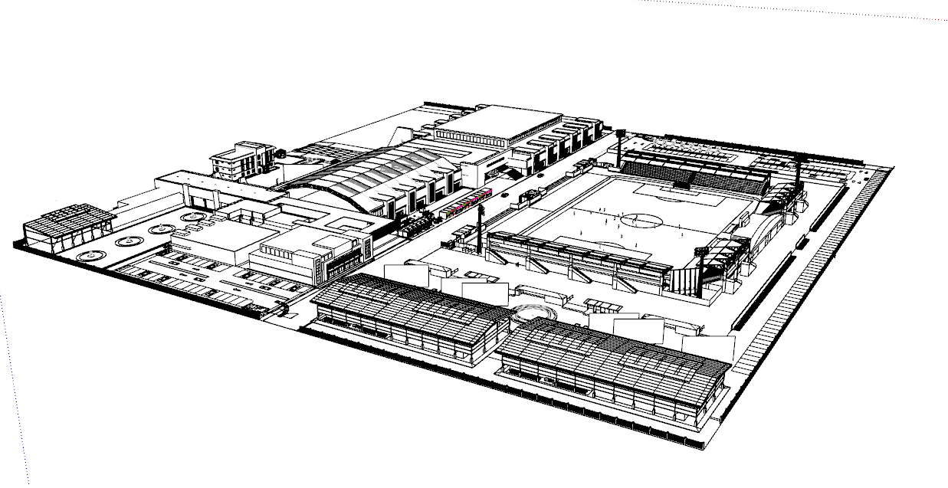
Kushti Akhada
Gallery & exhibition
Multipurpose Covered Hall
Swimming Pool
Track & Field
Futsal Area
Plaza
Indoor Sports Hall
Cafeteria
Parking
Parking
Admin
Parking
Plaza

Figure 106 Overall form of the complex

7.2.6 SERVICE FOR THE SPECTATORS
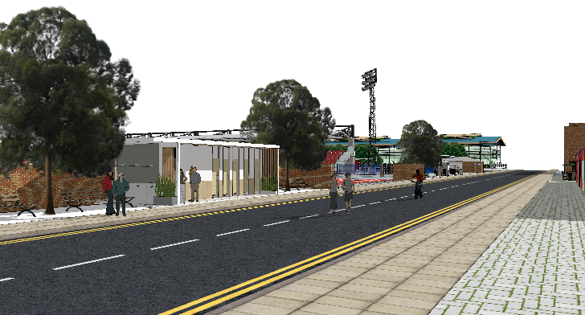
Figure 107 View of rest space and drinking water
Spectators are facilitated with various services like food courts, restaurants & other facilities. Multiple plazas, gardens, chautari & sitting areas are purposed to provide the visitors. A large community plaza is provided at the entry point of the complex where people could engage with each other.

The N-S stretch is loaded with the resting spaces and services like drinking water & public toilets. Drinking water services in the sense that the hot climate cause thirst to the spectators.

EXHIBITION SPACES

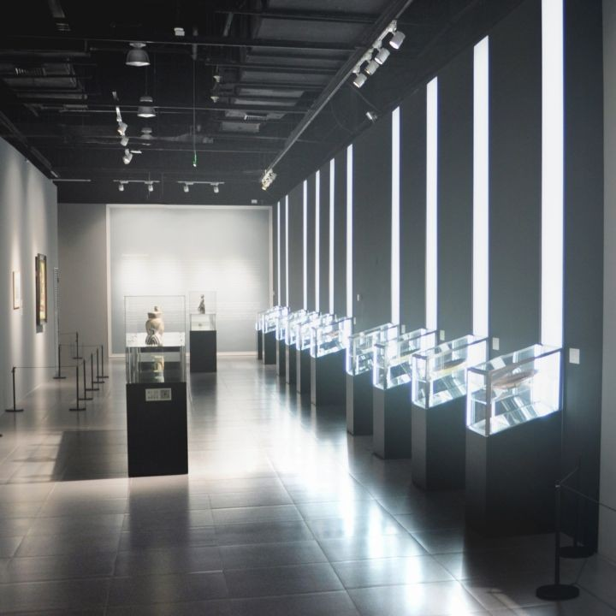
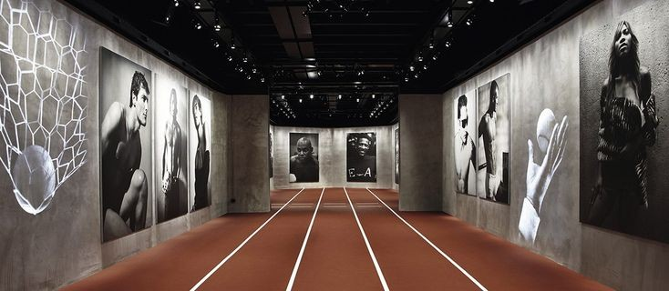
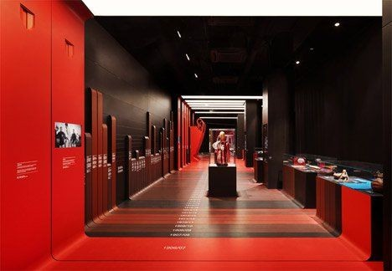
Also exhibition spaces are provided within the complex where spectators can have information on
Figure 108 Exhibition Spaces
Different sports related things are displayed.

Landscape design concept:
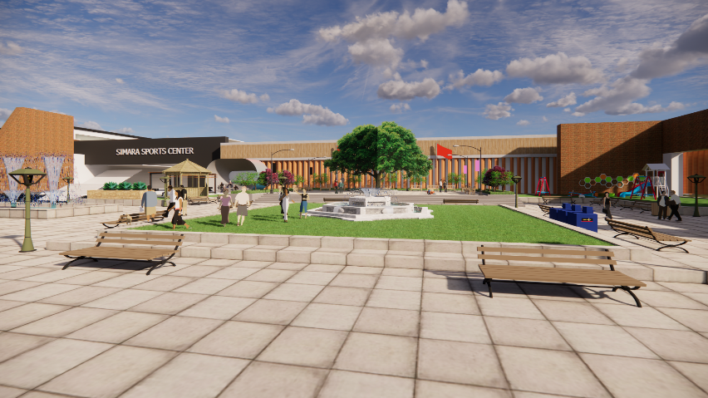
Imitation of the local scenarios
- Terai land plot division: the complex front is provided with a single unit landscape giving the essenece of terai grid land pattern
- Chowk chautaras & golghars are provided within the complex as landscape elements

Figure 109 View from the front plaza

INCLUSION OF INDIGENEOUS SPORTS: PEHLWANI KUSHTI
The complex is provided with one pf the traditional sports of terai, Kushti or Pehlwani to give the local vibes promoting the culture & diversity of Simara.
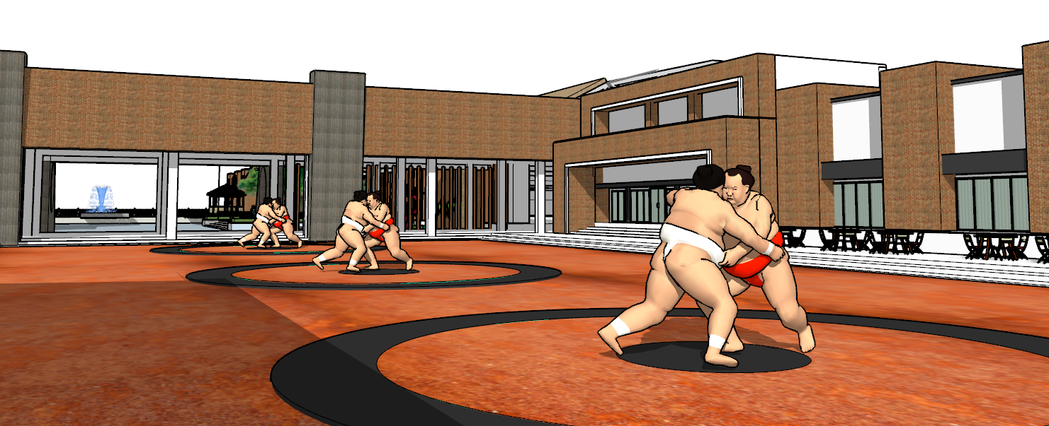
Figure 110 Kushti Arena View
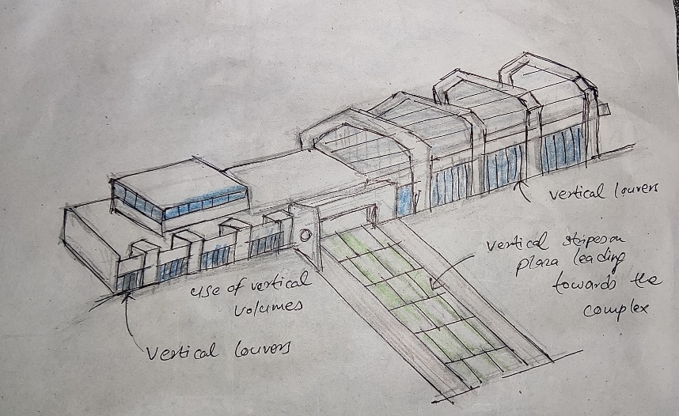
Façade Design Concept:
The more elongated and stretched elevations of the complex creates a monotony in the horizontality. So, to break it vertical volumes were introduced both functionally & aesthetically which overall balances the horizontality of the complex. Also the vertical louvers are used in the façade to avoid South and west light.

There is strong visibility of horizontal and vertical lines through elements like beams, posts, staircases, or even roof lines. Strips of lines in the form of ribbons can also which is commonly known as ribbon architecture.

FORM DEVELOPMENT

Form development is based on the modern architecture concept of building geometry. In this design, the volumetric form of the design is based on the modern architecture or has followed modern architecture on its expression.

Common themes of modern architecture include:
- the notion that "Form follows function", a dictum originally expressed by Frank Lloyd Wright's early mentor Louis Sullivan, meaning that the result of design should derive directly from its purpose
- simplicity and clarity of forms and elimination of "unnecessary detail"
- planes at 90 degrees to each other
- visual expression of structure (as opposed to the hiding of structural elements)
- the related concept of "Truth to materials", meaning that the true nature or natural appearance of a material ought to be seen rather than concealed or altered to represent something else
- use of industrially-produced materials; adoption of the machine aesthetic
- Particularly in International Style modernism, a visual emphasis on horizontal and vertical lines.

6.8 DESIGN ELEMENTS

- Regular geometry of the building
- Clean surface

Large windows

Large windows are provided for the sufficient lights inside the complex. Long strips of clerestory windows are also popular and brings in ample amount of light.

Exposed materials

The true nature of the material is exposed brick façade with concrete finish.
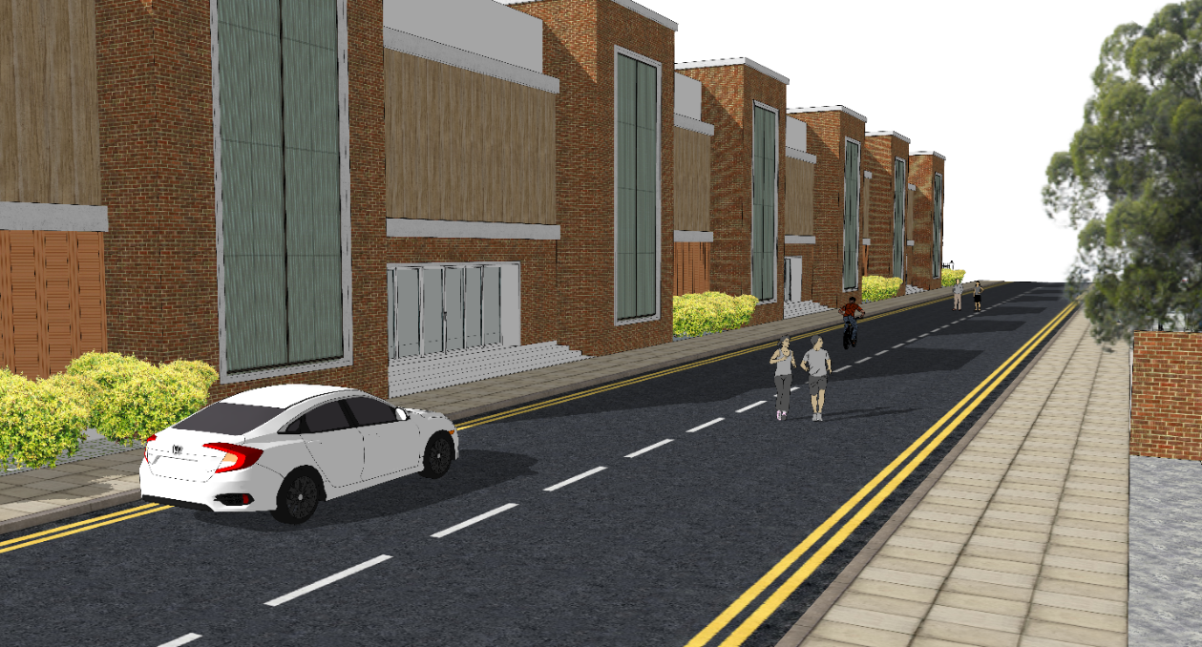
Figure 111 View from the NS Stretch

8 REFERENCE
Staff, C. (2019, November 18). Community Centres in canada - recreation, arts, sports and more. Canada International Student Magazine. Retrieved June 22, 2022, from https://www.mycism.com/2019/11/community-centres-in-canada-recreation-arts-sports-and-more/
Office for Recreation, Sport and Racing. (2022, February 15). How to plan for a community recreation and sports hub? Retrieved June 22, 2022, from https://www.orsr.sa.gov.au/places-and-spaces
Guttmann, A, Rowe, David Charles, Thompson, William N. and Maguire, Joseph Anthony (2021, September 16). Sports. Encyclopedia Britannica.
Majithiya, A. K., & Kosha Majithiya is ayoung architecture student. (2022, January 21). 10 things to remember while designing sports clubs - RTF: Rethinking the future. RTF | Rethinking The Future. Retrieved September 16, 2022, from www.re-thinkingthefuture.com
Team, S. (2019, January 17). Discipline in sport: Sportsnova UK. Sportnova UK. Retrieved September 16, 2022, from https://www.sportnova.co.uk/discipline-in-sport
Staff, C. (2019, November 18). Community Centres in canada - recreation, arts, sports and more. Canada International Student Magazine. Retrieved June 22, 2022, from https://www.mycism.com/2019/11/community-centres-in-canada-recreation-arts-sports-and-more/
Sports tourism explained: What, why and where. Tourism Teacher. (2022, May 24). Retrieved September 16, 2022, from https://tourismteacher.com/sports-tourism/
Mateer, T. J., Rice, W. L., Taff, B. D., Lawhon, B., Reigner, N., & Newman, P. (1AD, January 1). Psychosocial factors influencing outdoor recreation during the COVID-19 pandemic. Frontiers. Retrieved September 16, 2022, from https://www.frontiersin.org/article
Spma. (2020, March 18). Community relations in sport: An area to explore? SPort MAnagement (SPMA) Hub. Retrieved June 1, 2022, from https://sportmanagementhub.com/community-relations-in-sport/
Dyouthsports. (2021, December 7). What are the benefits of building a sports complex for the community? Post Pear. Retrieved June 1, 2022, from https://postpear.com/what-are-the-benefits-of-building-a-sports-complex-for-the-community
jumpsix2, P. by. (2022, January 26). Sport facility differences: Sports facilities advisory. Sports Facilities Companies. Retrieved June 2, 2022, from https://sportsfacilities.com/sports-facilities-advisory-differences-sports-complex-recreation-center
Kaamkura. (2022, May 30). Total budget of Nepal 2079/80 pdf " Budget of nepal 2079 80 " Kaamkura. Kaamkura. Retrieved June 2, 2022, from https://kaamkura.com/total-budget-of-nepal-2079-80-pdf/
Rich, K. A., Spaaij, R., & Misener, L. (1AD, January 1). Theorizing Community for Sport Management Research and Practice. Frontiers. Retrieved June 1, 2022, from https://www.frontiersin.org/articles/10.3389/fspor.2021.774366/full

