Tribhuvan University
Gender Role in Ghatu – Preeti Thapa May 2016

Gender Role in Ghatu

A Thesis Submitted to the Faculty of Humanities and Social Sciences, Central Department of English in the Partial Fulfillment of the Requirements
for the Degree of Master of Arts in English

By
Preeti Thapa
Roll No.: 445/067/068

Central Department of English
Kirtipur, Kathmandu
May 2016

Tribhuvan University
Central Department of English

Letter of Recommendation

Preeti Thapa has completed her thesis, entitled "Gender Role in Ghatu” under my supervision. She has carried out her research from September 2014 to April 2016. I hereby recommend her thesis to be submitted for viva voce.

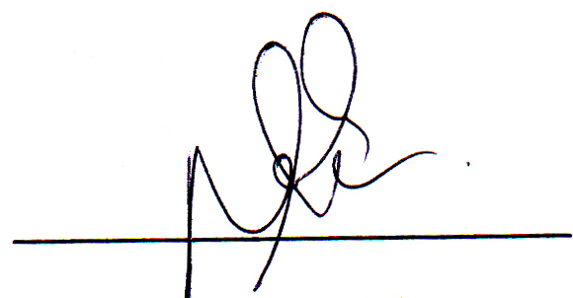

Bal Bahadur Thapa
Supervisor
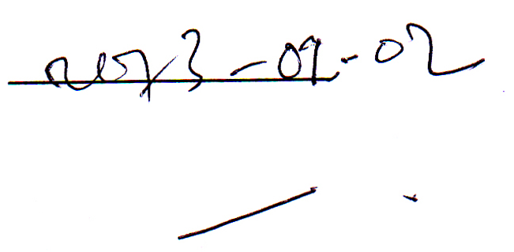
Date:

Tribhuvan University
Central Department of English

Letter of Approval
This thesis entitled "Gender Role in Ghatu” submitted to the Central Department of English, Tribhuvan University by Preeti Thapa has been approved by the undersigned members of the Research Committee.

Members of the Research Committee

_____________________ _____________________
Internal Examiner _____________________
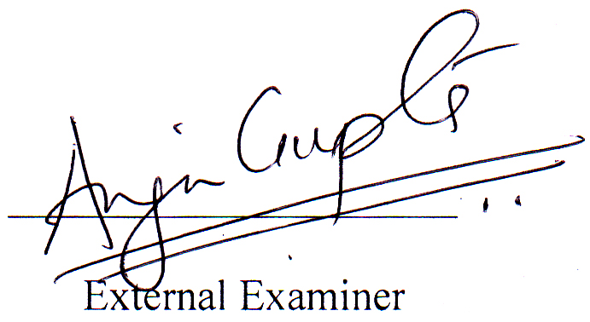
_____________________
_____________________ External Examiner
_____________________ _____________________
Head
_____________________ Central Department of English

_____________________ Date: ___________________

Acknowledgements
My sincere gratefulness goes to all those who assisted me for the completion of this dissertation.
First of all, I would like to extend my sincere honour to Mr. Bal Bahadur Thapa, Lecturer at the Central Department of English, Tribhuvan University for his valuable guidance and scholarly contribution.
Similarly, my sincere gratitude also goes to Min Shirish Magar, lecturer Mr. Raj Kumar Gurung, Ghatu Guruma Mrs. Shanti Maya Rana whose valuable suggestions have played a vital role in enhancing the quality of this research work.

May, 2016 Preeti Thapa

Abstract
The present work explores gender role as the most significant issue depicted in Ghatu performance by analyzing the use of different signs and symbols. It deals with its aesthetic taste, logic and politics behind the performance. Moreover, it attempts to explore communal way of living of Magar community, social and cultural integrity, religious beliefs, natural prominence and agricultural dedication. Ghatu, an oral form of culture, is a tribal festival that Magar community has adopted with religious, spiritual, communal and social artifacts. Ghatu is performed on different dates annually with its rites and rituals and the main and ultimate part is performed dating on Buddha Purnima of the month of Baisakh.
While analyzing the festival, it is found that Ghatu does not only show the continuity of ritual but also shows the gender performance in Magar community exploring the distinct and influential feature and strength of women in daily communal way of life. This explanation goes against the demarcation of superiority and inferiority between men and women in a society that defines and creates different stereotypes. This research work attempts to undercut the different stereotypes about women in the society analyzing the signs and symbols of Ghatu performance.

Contents
Page No.
Acknowledgements
Abstract
I. The Performance of Ghatu 1-14
II. Gender Role in Ghatu 15-37
III. Depiction of Femininity through Signs and Symbols in Ghatu 38-39
Works Cited

