Computation of Flow Hydrograph of the Highest Rainfall Data by Using HEC-HMS Model in JHIKHU KHOLA Waterhed Nepal

A dissertation submitted to the Central Department of Hydrology and Meteorology, Tribhuvan University, in the partial fulfillment of the requirements for
THE MASTERS OF SCIENCE IN METEOROLOGY.

BY
DIBAS SHRESTHA
September, 2008

The Central Department of Hydrology and Meteorology,
Tribhuvan University,
Kirtipur, Kathmandu
NEPAL

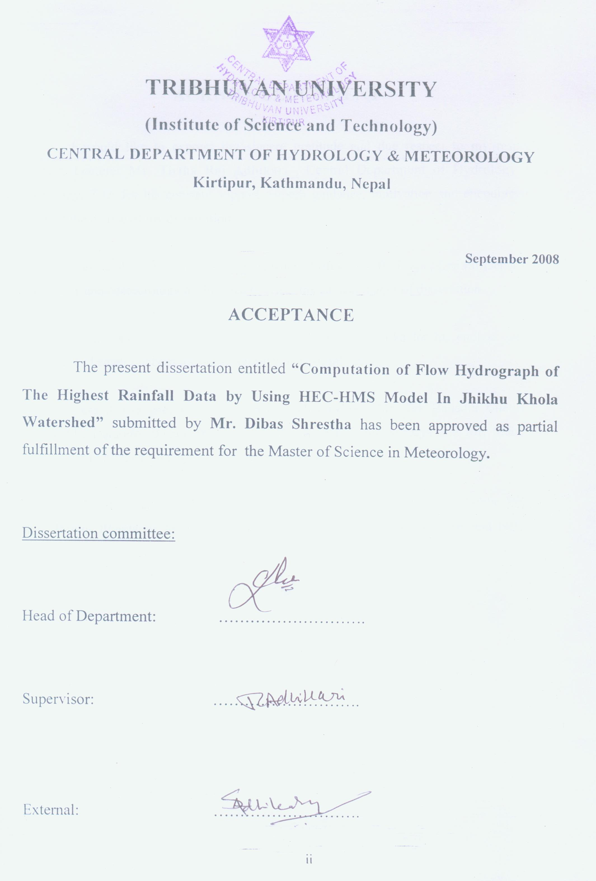
ACKNOWLEDGEMENT

I would like to express my sincere gratitude and due respect to my respected supervisor, Lecturer Mr. Tirtha Raj Adhikari , Central Department of Hydrology And Meteorology, T.U. for his constant support, superb guidance, motivation and encouragement throughout the course of my dissertation.

I am grateful towards my respected teacher, Professor K.B. Thapa, Central Department of Hydrology and Meteorology for his idea to select the subject matter of dissertation.

My special thanks goes to my colleague Mr. Netra Jit Khadka for his endless support, suggestions and eager concern for the accomplishment of this task.

My sincere thanks goes to my respected teacher Lecture Mr. Tek Bahadur Chettri my colleague Mr. Damoder Bagale, Mr. Santosh Regmi, Mr. Sunil Acharya and Mr. Mahendra Bhusal for their valuable suggestions and incouragement.

Finally, My heartily gratitude goes to all the school family of Precious Public English School, Balkot Bhaktapur for providing the time to complete the dissertation and technical support.

ABSTRACT

Computer simulation modeling is used as the tool in the present thesis work to model the Jhikhu Khola watershed. The event- base models simulate flood flow and determine volume peak and time to peak of flood flow generating by any storm event. HEC- HMS model have been selected to use for simulation. The HEC-HMS requires lumped or conceptual input parameter that is Unit Hydrograph parameters. Optimization of the parameters has been done to determine the hydrological parameters that can be used in the Jhikhu Khola and in the ungauged watershed with similar hydrological and meteorological environment.

Optimization was done from the gauged data of the rainfall and runoff with the trail initial values for all parameters. Through optimization options available in HEC-HMS different model parameters have been optimized and Clark’s Unit Hydrograph has been prepared. The parameters as that of unit hydrograph and base flow have been obtained. This value is used as input parameters to model the water shed. A hydrograph at the outlet, for eleven selected rainfall, event is obtained from the simulation of the rainfall runoff process by running the model. The validation of the obtained discharge with the observed is also carried out. A regression analysis is carried out between rainfall and base flow; rainfall and total excess; rainfall and total losses; Rainfall and Direct Runoff; constant rate of infiltration and rainfall, finally a comparison of observed, simulated discharge and constant loss of selected rainfall events has been done.
TABLE OF CONTENTS
I. List of figures: ………………………………………………………………………………..viii
II. List tables: …………………………………………………………………………………… ix
1 Introduction:…………………………………………………………………………………- 1-
1.1 Background of Study: - 1 -
1.2 Thesis Objectives - 2 -
1.3 Statement of problem - 2 -
1.4 Limitations of study - 3 -
2 Literature Review:………………………………………………………………………….- 4 -
2.1 Literature Review…………………………………………………………………………..- 4 -
3 Hydrological Model:………………………………………………………………………..- 5 -
3.1 General introduction of HEC-HMS - 5 -
3.2 Components provides by HEC-HMS for precipitation-runoff-routing simulation, - 6 -
3.2 HEC-HMS Representation of Runoff process - 7 -
3.4 Search Method - 8 -
3.5 Initial Values and Constraints - 8 -
3.6 Parameter optimization - 9 -
3.7 Hydrograph - 10 -
3.7.1 Unit Hydrograph - 11 -
3.7.2 Instantaneous Unit Hydrograph - 11 -
4 Study Area:………………………………………………………………………………...- 13 -
4.1 Study Area: - 13 -
5 Methodology:………………………………………………………………………………- 14 -
5.1 General - 14 -
5.2 Watershed representation - 15 -
5.3 Precipitation hydrograph: - 15 -
5.3.1 Users specified hyetograph: - 15 -
5.3.2 Weighted Precipitation Gauge: - 15 -
5.3.3 Inverse-distance-squared Method - 15 -
5.3.4 Grid based Precipitation: - 15 -
5.3.5 Frequency based design storm: - 16 -
5.4 Estimation of effective rainfall: - 16 -
5.4.1 Constant Loss Rate: - 16 -
5.4.2 Initial loss: - 16 -
5.4.3 Infiltration Loss - 17 -
5.5 Estimation of direct runoff: - 17 -
5.6 Estimation of Flood Flow - 17 -
5.6.1 Determination by means for Empirical formulae; - 18 -
5.6.1.1 The formulae involving drainage area only - 18 -
5.6.1.2 Formula Involving Drainage Area and its Shape. - 18 -
5.6.1.3 Formulae Involving Total Runoff and Drainage Area. - 18 -
5.6.1.4 Formula Involving Rainfall Intessity and Drainage Area. - 18 -
5.6.1.5 Formula Involving Drainage Area and Flood Frequency. - 18 -
5.6.2 Clark’s Model - 19 -
5.6.2.1 Translation: - 19 -
5.6.2.2 Attenuation: - 19 -
5.6.2.3 Determination of Clark’s UH Model parameters - 21 -
5.7 Estimation of base flow - 22 -
5.7.1 Exponential Recession Model - 22 -
5.8 Shakya B (2002) Formula - 24 -
5.9 Alternating Block Method - 24 -
6 Analysis:……………………………………………………………………………………- 25 -
6.1 Analysis
7 Result and Discussion:…………………………………………………………………….- 27 -
7.1 Model calibration: - 27 -
7.2 Model validation - 28 -
7.3 Relationship between rainfall and base flow: - 29 -
7.4 Relationship between rainfall and total excess - 30 -
7.5 Relationship between rainfall and total loss: - 31 -
7.6 Relationship Between Rainfall and Direct Runoff: - 31 -
7.7 Relationship between rainfall and constant rate of infiltration: - 32 -
7.8 Comparison of observed, simulated discharge and constant loss of selected rainfall events. …- 33 -

8 conclusion:………………………………………………………………………………….- 35 -
9 References:…………………………………………………………………………………- 36 -
Appendix (I) - 38 -
Appendix: (II) - 39 -
Appendix (III) - 40 -
Appendix (IV)………………………………………………………………………………...- 46 -

LIST OF TABLE
Table 3-1Summary of simulation methods included in HEC-HMS. - 5 -
Table 6-1. Unit Hydrograph Parameters for Jhikhu Kholo watershed - 25 -
Table 6-2. Major Rainfall events data used for model validation. - 26 -
Table 7-1 Computed values obtained using the simulation model. - 28 -
Table 7-2 Constant rate of infiltration and calculated infiltration of selected rainfall events. - 32 -
Table 7-3 Comparison of observed, simulated discharge and constant loss of selected rainfall events. - 34 -

LIST OF FIGURE
Figure 3-1 Representation of watershed runoff adopted by HEC HMS - 7 -
Figure 3-2:- A diagrammatic representation of runoff calculation in HEC-HMS - 8 -
Figure 4-1:- Study Area Jhiku Khola Watershed - 13 -
Figure 5-1:- Initial base flow recession - 23 -
Figure 5-2:- Base flow model illustration - 24 -
Figure 7-1 Clark’s Unit Hydrograph of the event in 10 July 1992 - 27 -
Figure 7-2:- Optimized hydrograph along with observed hydrograph for 10th July 1992.
………………………………………………………………………………………...- 28 -
Figure 7-3 The relationship between rainfall and base flow:…………………………- 29 -
Figure 7-4 The relationship between rainfall and total losses:………………………..- 30 -
Figure 7-5 The relationship between rainfall and total total loss:……………………- 31 -
Figure 7-6 The relationhhip between rainfall and direct runoff:……………………...- 32 -
Figure 7-7 The relationship between rainfall and constant rate of infiltration:………- 33 -
Figure 7-8 Relative different of measured and observed hydrograph characteristics. ………………………………………………………………………………………...- 34 -
Figure A-1: Hydrograph of peak discharge of major rainfall event in 1998:………...- 45 -
Figure A-2 Hydrograph of the event in 10 July 1992 - 46 -
Figure A-3:- Hydrograph of the event in 15 May 1998 - 46 -
Figure A-4:- Hydrograph of the event in 19 Aug 1998 - 46 -
Figure A-5:- Hydrograph of the event in 21 Aug 98 - 47 -
Figure A-6:- Hydrograph of the event in 21 July 98 - 47 -
Figure A-7:- Hydrograph of the event in 21 Jun 98 - 47 -
Figure A-8:- Hydrograph of the event in 26 Jun 98 - 48 -
Figure A-9 :- Hydrograph of the event in 26 may 98 - 48 -
Figure A-10:- Hydrograph of the event in 27 August 1998 - 48 -
Figure A-11:- Hydrograph of the event in 5 September 1998 - 49 -
Figure A-12:- Hydrograph of the event in 6 September 1998 - 49 -
Figure A-13:- Hydrograph of the event in 8 July 1998 - 49 -

