Socio-Economic Status of Women Participating in Tourism Industry

(A Case Study of Women of Lakeside-6, Pokhara)

A Dissertation

Submitted to the Faculty of Humanities and Social Sciences
Department of Sociology/Anthropology, Prithwi Narayan Campus, Pokhara
in Partial Fulfillment of the Requirement for the Master Degree in Anthropology

By:
Jamuna Pahari
Roll No. 260/059

Tribhuvan University
Department of Sociology/ Anthropology,
Prithwi Narayan Campus
Pokhara, Nepal
November, 2008
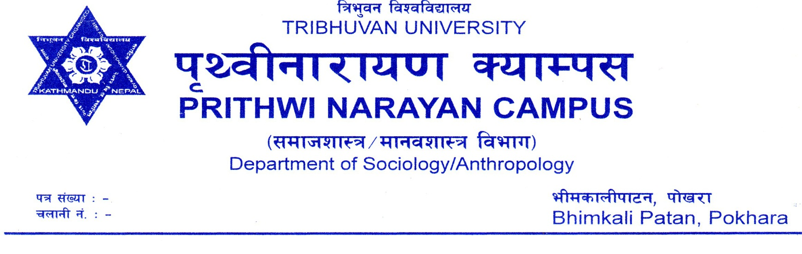

Letter of Recommendation

This is to certify that Mrs. Jamuna Pahari has prepared this dissertation entitled “Socio-Economic Status of Women Participating in Tourism Industry: A Case Study of Women of Lakeside-6, Pokhara” under my supervision and guidance. I, therefore, recommend this dissertation for final approval and acceptance.

__________________________________________
Hari Kumar Ojha
Asst. Lecturer
Department of Sociology/Anthropology
Prithwi Narayan Campus
Pokhara, Nepal

Date: November, 2008

Letter of Acceptance
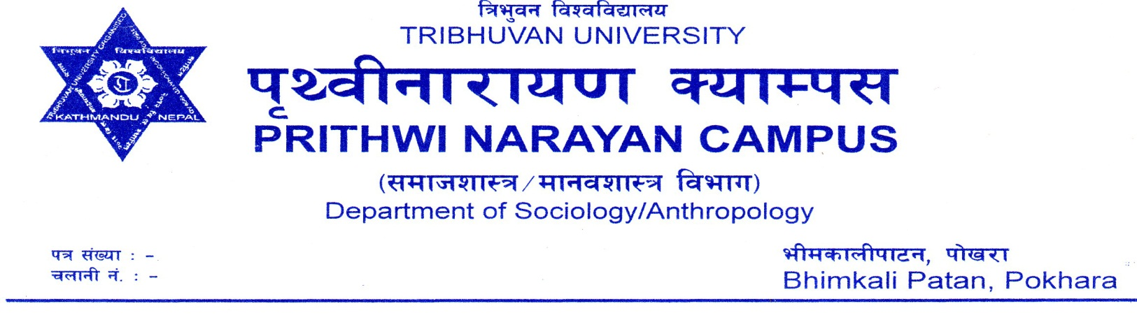
This dissertation submitted by Mrs. Jamuna Pahari entitled “Socio-Economic Status of Women Participating in Tourism Industry: A Case Study of Women of Lakeside-6, Pokhara” has been approved by the undersigned members of the Evaluation Committee.

Members of Evaluation Committee

____________________________
(Kedar Basnet,PhD)
External
__________________
(Hari Kumar Ojha)
Supervisor

____________________________
(Bishwo Kallyan Parajuli,PhD)
Head of Department
Sociology/Anthropology
Prithwi Narayan Campus

November, 2008

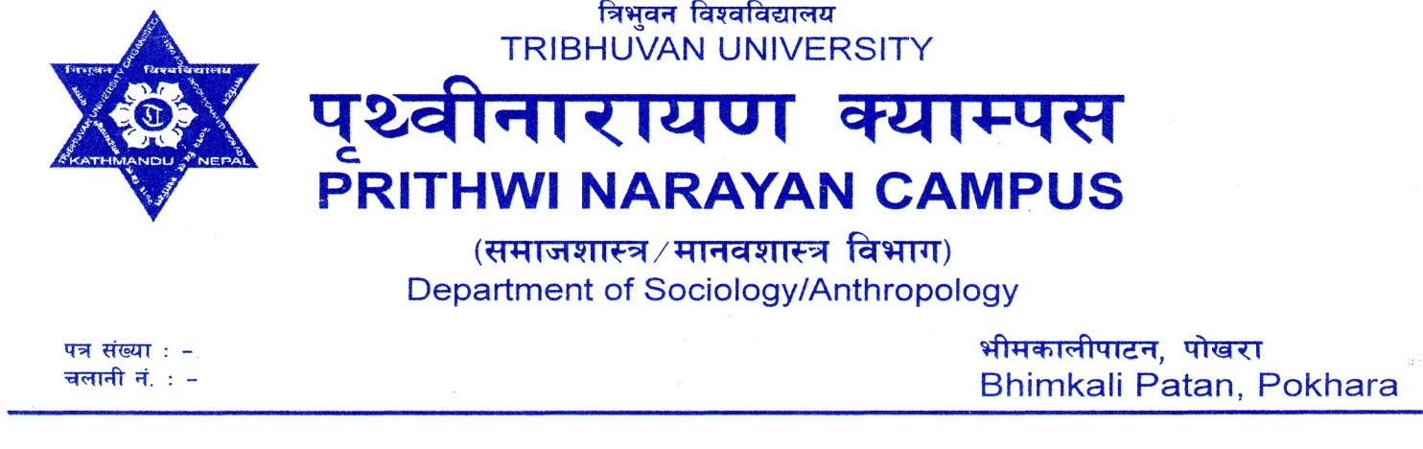
Letter of Recommendation by Editor

This is to certify that I have read through the Draft of Dissertation entitled “Socio-Economic Status of Women Participating in Tourism Industry: A Case Study of Women of Lakeside-6, Pokhara” by Mrs. Jamuna Pahari as Language Editor and made necessary corrections and improvements there in. I have been impressed by her intelligible presentation of the facts through the medium of plain and correct English.

_________________________
(Parmeshwor Baral)
Lecturer,
Prithwi Narayan Campus

Date: November, 2008

ACKNOWLEDGEMENT

This study would not have been possible to complete without the kind and helpful co-operation of many individuals. It is my pleasure to express my special respect, gratitude and appreciation to Dr. Bishwo Kallyan Parajuli, the Head of the Department of Sociology/Anthropology, Prithwi Narayan Campus, Pokhara, for granting me an opportunity to conduct a social science research work for the partial fulfillment of my Master Degree in Anthropology. I am indebted for his valuable suggestions and guidelines.

I express my gratitude to my supervisor Mr. Hari Kumar Ojha who showed great interest and provided excellent guidance during the whole research and dissertation writing period. My debt also goes to all the lecturers of the department of Sociology/Anthropology PNC for their valuable suggestions on my dissertation their greatly helped me to accomplish my research work.

I would also like to extend my special thanks to all those who have supported and enabled me to accomplish the difficult task. Special thanks also go to my friends Mr. Amrit Kumar Bhandari, Mrs. Bishnu Karki, Mrs. Durba Shrestha and all others for their encouraging supports throughout the research period. My warmest thank goes to all the respondents for their valuable time and the response. I would also like to express my thanks to Mr. Parsuram B.K. for entering data in SPSS program for analysis.

I am very grateful to my husband, Mr. Rameshwar Ghimire and my lovely son Arjan Ghimire, who gave lots of encouragements, financial support and love in completing the research work.

Last but not the least, my gratefulness goes to Mr. K. N. Baral (Suman) for his continuous support in selection of topic, data analysis, computer editing, layout and formatting of the final report. Finally special thank goes to my sister Mrs. Vijaya Laxmi Baral for helping me in my research work.

November, 2008 Jamuna Pahari
Abstract :

Socio-Economic Status of Women Participating in Tourism Industry
(A Case Study of Women of Lakeside-6, Pokhara)

Tourism can be a key to the success and sustainability of the socio-economic empowerment of women in Nepal. So women’s involvement in the tourism sector should be kept in mind as it is a fast growing industry and there are many opportunities for women within it.
The general objective of this study is to find out the “Socio-economic status of women participating in Tourism Industry of Fewa Lakeside of Pokhara city”. The specific objectives of this study are: to prepare a demographic profile of women working in tourism industry, to analyze the socio–economic status of women participating in tourism industry and to identify the problems faced by women involved in tourism industry.
This study is based on the “Gender Perspective.” The field of this study is the Fewa-Lakeside, located in the ward no 6 of Pokhara sub-metropolitan city, which is one of the largest tourist destinations in Nepal. The universe of this study is about 660 various business spots on the main road side of Fewa Lakeside. This universe has covered the area from the Kharare Chowk on the North to Fishtail Gate on the south of Main Street of Lakeside. For the sample size, 70 informants were selected purposively. The first sample was selected on the basis of first come first business spot where women were involved and others were selected then by selecting each 10th business spot from the previous spot where women were involved. Both primary as well as secondary data were used as the raw materials for research. Questionnaire schedule, observation and interview techniques were adopted for the collection of primary information and data. Secondary data were collected from various tourism related offices, organizations, published books, articles and internet websites. The analysis of data was performed by using popular computer software SPSS (11.0). Various tables, figures, charts and statistical techniques were used for the analysis and presentation of the data.
Among the total 70 respondents, the economically active age group (25 to 40 yrs) women were involved in tourism industry. In the study area there was the dominancy of migrated people. Among the respondents, most of them were found to be Hindu and Brahmins. Women who were involved in tourism industry were somehow literate. It was found that majority of married women involved in tourism industry. Among the respondents, most of them were from nuclear family. The participation of women with high fertility was found to be comparatively low.
The main income source of respondents' family was tourism. Most of the respondents involved in this sector were as family member because their male counterpart proprietor of this business. Women from family business spent more hours in their working place. Most of the respondents rented house for their business and most of them realized that the house rent was too much. Most of the respondents were not satisfied with their present business/job because of low income in recent year, long working hours and over load to work. This study shows the sufficiency level of income of the respondents that is generated from their business/job which is still low, so they had to manage the required economy from other sources like bank loan and previous stock. In this study some respondents wanted to close their business because of heavy loss in business. Women's involved in tourism industry, were found socially and politically backward in the study area.
Among the respondents, most of them were motivated in tourism industry for making money. The major problem faced by them was economic problem. Thus, women realized difficulties to play dual roles: household work and business/job together. Most of the respondents agreed that there was high gender discrimination in this field. Most of them realized that they had to work longer hours than men and felt that they had fewer opportunities in various fields. They were paid low salary and even faced sexual harassment or assault from tourists as well. People had both positive and negative insights towards women involved in this sector. Hence, women had very less decisive role in and outside the home.

table of CONTENTS

Letter of Recommendation i
Letter of Acceptance ii
Acknowledgement iii
List of Tables iv
List of Figures v
Acronyms vi
Abstract vii
CHAPTER – ONE 1-10
INTRODUCTION 1
1.1 Background 1
1.2 Statement of the Problem 5
1.3 Objectives of the Study 6
1.4 Rationale of the Study 6
1.5 Conceptual Framework 7
1.6 Definition of Key Terms 8
1.7 Limitations of the Study 9
1.8 Organization of the Study 10
CHAPTER – TWO 11-29
LITERATURE REVIEW 11
2.1 Theoretical Overview 11
2.2 Review of the Previous Studies 19
CHAPTER – THREE 30-33
RESEARCH METHODOLOGY 30
3.1 Rationale for the Selection of the Study Area 30
3.2 Research Design 31
3.3 Nature and Source of Data 31
3.4 The Sampling Procedure 32
3.5 Data Collection Techniques 32

3.5.1 Questionnaire Schedule 32
3.5.2 Interview with Key Informants 33
3.5.3 Observation 33
3.6 Analysis of Data 33
CHAPTER – FOUR 34-39
THE SETTINGS 34
4.1 History 34
4.2 Location 34
4.3 Access 35
4.4 Climate 35
4.5 Population 35
4.6 Culture/Religion 37
4.7 Pokhara and Tourism 38
4.8 Sightseeing Spots in Pokhara 39
CHAPTER – FIVE 40-46
DEMOGRAPHIC PROFILE 40
5.1 Age of Respondents 40
5.2 Caste/Ethnicity of Respondents 41
5.3 Place of Origin of Respondents 42
5.4 Religion of Respondents 42
5.5 Educational Status of Respondents 43
5.6 Marital Status of Respondents 44
5.7 Structure of Family of Respondents 45
5.8 Fertility of Respondents 46
5.9 Summary 46
CHAPTER – SIX 47-58
SOCIO-ECONOMIC STATUS OF WOMEN 47
6.1 Main Income Sources of the Respondents’ Family 47
6.2 Duration of Involvement in Tourism 48
6.3 Employment Situation of Women 49
6.4 Duration of Working Hours 49
6.5 Types of Employment and Duration of Working Hours 50
6.6 Ownership of Business Stall 51
6.7 Respondents’ Attitude towards House Rent 51
6.8 Satisfaction with Business/Job 52
6.9 Reasons for Not Satisfaction 52
6.10 Sufficiency of Income Generated from Business/Job 53
6.11 Management of Economy to run the Business and Household-task 54
6.12 Attitudes towards Continuation of Business/Job 55
6.13 Causes of Leaving Business/Job 55
6.14 Involvement of Women in Social Work 57
6.15 Women’s Participation in Politics 57
6.16 Summary 58
CHAPTER - SEVEN 59-68
PROBLEMS FACED BY WOMEN IN TOURISM INDUSTRY 59
7.1 Motivational Factors of Women’s Involvement in Tourism 59
7.2 Problems Faced by Women in Tourism Industry 60
7.3 Family Support 61
7.4 Running Business with Household Work 62
7.5 Gender Discrimination in Business/Job 63
7.6 Gender Discrimination Faced by Respondents 64
7.7 Problems Faced by Women with Tourists 64
7.8 Public Insights towards Women Participated in Tourism 65
7.9 Women’s Role in Decision-Making 66
7.9.1 Role of Women in Household Decision-Making 66
7.9.2 Role of Women in Outside Decision-Making 67
7.10 Summary 67
CHAPTER-EIGHT 69-76
SUMMARY, FINDINGS, CONCLUSIONS AND RECOMMENDATIONS 69
8.1 Summary 69
8.2 Conclusion 74
8.3 Recommendation 75
REFERENCES
appendices

List of Tables

Table No. | Title of Table | Page No.
Table 4.5.1 | Ward-wise Population in Pokhara Sub-metropolis | 36
Table 5.1 | Distribution of Respondents by Age | 40
Table 5.2 | Distribution of Respondents by Caste/Ethnicity | 41
Table 5.4 | Distributions of Respondents by Religion | 43
Table 5.6 | Distributions of Respondents by Marital Status | 44
Table 5.8 | Distributions of Respondents by Fertility | 46
Table 6.1 | Main Income Sources of the Respondents’ Family | 47
Table 6.2 | Duration of Involvement in Tourism | 48
Table 6.3 | Employment Types of Respondents | 49
Table 6.4 | Working Hours of Respondents | 50
Table 6.5 | Employment Situation and Working Hours of Respondents | 50
Table 6.8 | Business/Job Satisfaction of Respondents | 52
Table 6.9 | Reasons for Not Satisfaction of Business/Job | 53
Table 6.10 | Sufficiency of Income of the Respondents | 54
Table 6.11 | Management of Economy to run Business and Households | 54
Table 6.13 | Causes of Leaving Business/Job | 56
Table 6.15 | Women's Participation in Politics | 58
Table 7.1 | Motivational Factors | 59
Table 7.2 | Problems Faced by Women in Tourism Industry | 60
Table 7.3 | Family Supports in Business/Job | 61
Table 7.4 | Running Business with Household Work | 62
Table 7.6 | Gender Discrimination Faced by Respondents | 64
Table 7.7 | Problems Faced by Women with Tourist | 65
Table 7.9.1 | Women in Household Decision-Making | 67
Table 7.9.2 | Women in Outside Decision-Making | 67

List of Figures

Figure No. | Title of Figure | Page No.
Figure: 1.5.1 | Conceptual Frame-work | 8
Figure: 5.1 | Age Group of Respondents | 41
Figure: 5.3 | Origin of Respondents | 42
Figure: 5.4 | Religions of the Respondents | 43
Figure: 5.5 | Educational Status of Respondents | 44
Figure: 5.6 | Marital Status of Respondents | 45
Figure: 5.7 | Family Structures of Respondents | 45
Figure: 6.1 | Income Source of Respondents’ Family | 48
Figure: 6.6 | Ownership of Business Stall | 51
Figure: 6.7 | Attitudes towards House Rent | 51
Figure: 6.9 | Reasons for Not Satisfaction | 53
Figure: 6.12 | Attitudes towards Continuation of Business/Job | 55
Figure: 6.13 | Causes of Leaving Business/Job | 56
Figure: 6.14 | Women in Social Work | 57
Figure: 7.2 | Women’s Problems in Tourism Industry | 61
Figure: 7.5 | Gender Discrimination in Business/Job | 63
Figure: 7.8 | Public Insights towards Women in Tourism | 65

ACRONYMS:

ACAP : Annapurna Conservation Area Project
ADB : Agriculture Development Bank
CBS : Central Bureau of Statistics
CEDA : Center for Economic Development and Administration
GAD : Gender and Development
ERA : Equal Rights Amendment
ILO : International Labor Organization
NESAC : Nepal South Asia Centre
NOW : New Opportunities for Women
NRB : Nepal Rastra Bank
NTB : Nepal Tourism Board
NGO : Non-governmental Organization
PCCI : Pokhara Chamber of Commerce and Industry
SAARC : South Asian Association for Regional Co-operation
SLC : School Leaving Certificate
SPSS : Statistical Package for Social Science
UN : United Nation
UNDP : United Nations Development Programmme
USA : United States of America
WAD : Women and Development
WID : Women in Development
WTO : World Tourism Organization

