TRIBHUVAN UNIVERSITY
INSTITUTE OF ENGINEERING
PULCHOWK CAMPUS

Thesis No.: G017/070
Parametric Analysis Based Mitigation Charts of Chure Landslides
in Finite Element Framework

by
Sanjeev Bikram Shah

A THESIS
SUBMITTED TO THE DEPARTMENT OF CIVIL ENGINEERING IN PARTIAL FULFILLMENT OF THE REQUIREMENTS FOR THE DEGREE OF MASTER OF SCIENCE IN GEOTECHNICAL ENGINEEIRNG

DEPARTMENT OF CIVIL ENGINEERING
LALITPUR, NEPAL

November, 2016

COPYRIGHT

The author has agreed that the library, Department of Civil Engineering, Institute of Engineering, Pulchowk Campus, may make this thesis freely available for inspection. Moreover, the author has agreed that permission for extensive copying of this thesis for scholarly purpose may be granted by the professor(s) who supervised the work recorded herein or, in their absence, by the Head of the Department wherein the thesis was done. It is understood that the recognition will be given to the author of this thesis and to the Department of Civil Engineering, Pulchowk Campus, Institute of Engineering in any use of the material of this thesis. Copying or publication or the other use of this thesis for financial gain without approval of the Department of Civil Engineering, Pulchowk Campus, Institute of Engineering and author’s written permission is prohibited. Request for permission to copy or to make any other use of the material in this thesis in whole or in part should be addressed to:

Head of the Department
Department of Civil Engineering
Institute of Engineering,
Pulchowk Campus,
Lalitpur, Nepal.

TRIBHUVAN UNIVERSITY
INSTITUTE OF ENGINEERING
PULCHOWK CAMPUS
DEPARTMENT OF CIVIL ENGINEERING

The undersigned certify that they have read, and recommended to the Institute of Engineering for acceptance, a thesis entitled “Parametric Analysis Based Mitigation Charts of Chure Landslides in Finite Element Framework” submitted by Sanjeev Bikram Shah (070/MSG/817) in partial fulfilment of the requirements for the degree of Masters of Science in Geotechnical Engineering at Institute of Engineering, Tribhuvan University, Nepal.
Supervisor :______________________________
Dr. Ram Chandra Tiwari
Lecturer
M.Sc. Programme in Geotechnical Engineering
Department of Civil Engineering

External Supervisor:________________________
Prof. Dr. Akkal Bahadur Singh
M.Sc. Programme in Geotechnical Engineering
Department of Civil Engineering

Program Coordinator/ Supervisor:_____________
Dr. Indra Prasad Acharya
Lecturer
M.Sc. Programme in Geotechnical Engineering
Department of Civil Engineering
Pulchowk Campus, Lalitpur, Nepal
November, 2016

ABSTRACT

Chure region which lies south to main boundary thrust consists of large number of landslides and site specific analysis of each landslides is practically not possible. Hence the general form of solution is essential to address landslide mitigation in Chure region. Chure landslides mitigation models have been prepared in finite element framework. Finite element method which computes the strain and deformation of the elements by strain reduction technique has been used. Mitigation measures have been proposed in the forms of specific and general solutions. General mitigating charts have been developed with the model geometry proposed by Tiwari et al. (2013) and variations have been made in the cohesion, frictional angle and angle of slope in the soil ranges found in Chure landslide region. In addition, the general solution includes vegetation effect of effective root depth 1m and 2m along with retaining wall and slope modification have been made in different soil slope condition (dry, ground water table at surface, at 2m and 4m below the surface). Athuwa khola and Ahale landslides of Sindhuli District have been selected as the site specific solutions to validate the Chure mitigation models for general solutions. It has been found that the charts holds good for all slope and soil slope conditions. Thus, general solutions can be employed to explore the quick mitigation measures of Chure landslides.

ACKNOWLEDGEMENT
My most sincere appreciation goes to my supervisors Dr. Ram Chandra Tiwari and Dr. Indra Prasad Acharya. I am greatly indebted to them for their valuable advices and incredible support throughout my stay at Pulchowk Campus and during this study.
I am thankful to Department of Civil Engineering, Pulchowk Campus, and Staff of M.Sc. Program in Geotechnical Engineering for their support throughout my thesis work. I am also thankful to my colleagues from Geotechnical for their ideas and encouragement to successfully complete this work.
In addition, I would like to thank all the staff of Central Material Testing Laboratory (CMTL) of Central Campus, Pulchowk, and Lalitpur, Nepal for helping me in carrying out my experimental study.
I would like to extend further thanks to all individuals for their direct and indirect help.
At Last but not the least, I am grateful to my parents for their endless support and encouragement during my entire thesis study period. I owe all that I have accomplished up to this point of my life to them.

Sanjeev Bikram Shah
070/MSG/817
November, 2016

TABLE OF CONTENTS

COPYRIGHT ii
ABSTRACT iv
ACKNOWLEDGEMENT v
TABLE OF CONTENTS vi
LIST OF TABLES viii
LIST OF FIGURES ix
ABBREVIATION xii
CHAPTER ONE: INTRODUCTION 1
1.1 Background 1
1.2 Statement of Problem 3
1.3 Landslide location and details 3
1.4 Objective 8
1.5 Scope 8
CHAPTER TWO: LITERATURE REVIEW 9
2.1 Types of landslide 9
2.2 Slope Stability Methods 10
2.3 Mitigating measures 12
CHAPTER THREE: MATERIALS AND METHODS 13
3.1 Data Collection 13
3.2 Laboratory work 13
3.3 Finite Element Modelling 15
3.4 Materials and model 16
3.5 Back analysis 23
3.6 Interpretation of result 24
CHAPTER FOUR: OUTPUT AND RESULTS 25
4.1 Results 25
CHAPTER FIVE: VERIFICATION OF WORK 34
CHAPTER SIX: CONCLUSION AND RECOMMENDATION 37
6.1 Conclusions 37
6.2 Recommendation 38
REFERENCES 39
ANNEX A 41
ANNEX B 47
ANNEX C 50
ANNEX D 54
ANNEX E 62
ANNEX F 68

LIST OF TABLES
Table 1.1: Areal coverage of landslides in some districts of Chure area 3
Table 1.2: Distribution of landslides in some districts of Chure 3
Table 1.3: Classification of Mass movement by Varnes (1978) 9
Table 2.1: Mitigation table given by Popescu (2001) ......................................12
Table 3.1: Soil properties in the stability analysis of slope ......................................16
Table 3.2: Results from back analysis 24
Table 5.1: Comparison of factor of safety from FEM and LEM on Ahale slope....... 34
Table 6.1: Sieve analysis of soil sample from Attuwa khola landslide...................... 41
Table 6.2: Calculation of Atterberg limits of soil sample from Attuwa khola landslide 42
Table 6.3: Sieve analysis of soil sample from Ahale landslide 44
Table 6.4: Atterberg Limit calculation of soil sample from Ahale landslide 45
Table 6.5 SRF calculation of Ahale slope 51
Table 6.6: SRF calculation of Athuwa slope 52
Table 6.7: SRF calculation for ground slope 30 degree 62
Table 6.8: SRF calculation for ground slope 30 degree 62
Table 6.9: SRF calculation for ground slope 30 degree 62
Table 6.10: SRF calculation for ground slope 30 degree 63
Table 6.11: SRF calculation for ground slope 35 degree 63
Table 6.12: SRF calculation for ground slope 35 degree 63
Table 6.13: SRF calculation for ground slope 35 degree 64
Table 6.14: SRF calculation for ground slope 35 degree 64
Table 6.15: SRF calculation for ground slope 40 degree 64
Table 6.16: SRF calculation for ground slope 40 degree 65
Table 6.17: SRF calculation for ground slope 40 degree 65
Table 6.18: SRF calculation for ground slope 40 degree 65
Table 6.19: SRF calculation for ground slope 45 degree 66
Table 6.20: SRF calculation for ground slope 45 degree 66
Table 6.21: SRF calculation for ground slope 45 degree 66
Table 6.22: SRF calculation for ground slope 45 degree 67
Table 6.23: Calculation using LEM on slope of 30 degree 68
Table 6.24: Calculation using LEM on slope of 30 degree 68

LIST OF FIGURES
Figure 1.1: Map of Sindhuli district 4
Figure 1.2: Google image showing the Attuwa Khola slope 4
Figure 1.3: Slope failure near Atthuwa Khola 5
Figure 1.4: Bridge near the toe of the Landslide 5
Figure 1.5: Google image of Ahale site where eight slope failure can be seen 6
Figure 1.6: Ahale slope taken under study 7
Figure 1.7: Slope failure in Ahale 7
Figure 3.1: Profiel of the Ahale Landslide ................................................................ 18
Figure 3.2: Profile of Athuwa Khola landslide 18
Figure 3.3: Using vegetation on the slope of Ahale 18
Figure 3.4: Varying the ground water table 18
Figure 3.5: Model geometry used in the development of chart 19
Figure 3.6: Use of vegetation and ground water 20
Figure 3.7: Model with the application of retaining wall 20
Figure 3.8: Slope geometry modification Type 1 21
Figure 3.9: Slope geometry modification Type 2 22
Figure 3.10: Slope geometry modification Type 3 22
Figure 3.11: Combination of different mitigating measures 22
Figure 4. 1: Strain contour of Ahale landslide in dry soil condition.......................... 25
Figure 4.2: SRF vs displacement curve of Ahale landslide in dry soil condition 26
Figure 4.3: SRF vs displacement curve for Ahale landslide section with lowering of ground water table 26
Figure 4.4: Displacement contour of the slope of Attuwa slope in dry soil condition 27
Figure 4.5: SRF vs maximum displacement curve of Attuwa slope in dry soil condition 27
Figure 4.6: Graph of dry and fully saturated soil with variation in the height of retaining wall 29
Figure 4.7: Mitigation chart of slope modification only in Ground slope of 30 degree 30
Figure 4.8: Graph showing the SRF with the variation in the width of benching for Type 2 slope modification 31
Figure 4.9: Shear strain contour on slope 30 degree in dry soil condition 32
Figure 4.10: SRF vs displacement curve on slope of 30 degree in dry soil condition 32
Figure 4.11: Mitigation chart for the dry soil in ground slope of 30 ̊ 33
Figure 5.1: Comparison of SRF of FEM with Janbu Method (LEM technique).........35
Figure 5.2: Comparison of SRF of general mitigating work in FEM with LEM 36
Figure 6.1: Gradation curve of soil sample from Attuwa khola landslide...................41
Figure 6.2: Water content vs number of blows curve of soil sample from Attuwa khola landslide 42
Figure 6.3: Plot between stresses from the direct shear test result on the sample from Attuwa khola landslide 43
Figure 6.4: Gradation curve of soil sample from Ahale landslide 44
Figure 6.5: Water content vs number of blows of soil sample from the Ahale landslide 45
Figure 6.6: Plot of stresses on a soil sample from Ahale landslide from the direct shear test 46
Figure 6.7: Ahale landslide dry soil 47
Figure 6.8: Ahale landslide vegetation of ERD 1m dry soil condition 47
Figure 6.9: Ahale landslide vegetation of ERD 2m dry soil condition 47
Figure 6.10: Ahale landslide vegetation of ERD 3m dry soil condition 47
Figure 6.11: SRF vs displacement curve of the ahale landslide 47
Figure 6.12: SRF vs displacement curve of the ahale landslide with vegetation of ERD 1m 47
Figure 6.13: SRF vs displacement curve of the Ahale landslide with vegetation of ERD 2m 48
Figure 6.14: SRF vs displacement graph of Ahale landslide with vegetation of ERD 3m 48
Figure 6.15: Athuwa khola landslide dry soil condition 48
Figure 6.16: Athuwa khola landslide soil with vegetation of ERD 1m 48
Figure 6.17: Athuwa khola Landslide dry soil with vegetation of ERD 3m 48
Figure 6.18: Athuwa khola landslide dry soil condition 48
Figure 6.19: Athuwa khola landslide with vegetation of ERD 3m 49
Figure 6.20: Athuwa khola landslide with vegetation of ERD 1m 49
Figure 6.21: SRF vs displacement curve in Ahale slope 50
Figure 6.22: SRF vs displacement curve of Ahale landslide 50
Figure 6.23: SRF vs displacement curve 50
Figure 6.24: Mitigating Chart of dry soil condition 54
Figure 6.25: Mitigating Chart of dry soil condition 54
Figure 6.26: Mitigating chart for fully saturated soil 55
Figure 6.27: Mitigating chart for fully saturated soil 55
Figure 6.28: Mitigation chart for dry soil condition 56
Figure 6.29: Mitigating Chart for dry soil 56
Figure 6.30: Mitigating chart for fully saturated soil 57
Figure 6.31: Mitigating chart for fully saturated soil 57
Figure 6.32: Mitigation chart for water table reduction 58
Figure 6.33: Mitigation chart for application of vegetation in dry soil 58
Figure 6.34: Mitigation chart for application of vegetation in fully saturated soil 59
Figure 6.35: Mitigation chart for the application of retaining wall and slope modification in dry soil condition 59
Figure 6.36: Mitigation chart for the application of retaining wall and slope modification in fully saturated soil 60
Figure 6.37: Mitigation chart for the combined application of vegetation of ERD 2m, slope modification, retaining wall and water table reduction 60

ABBREVIATION
c′ Cohesion
CH clay of high plasticity
CL clay of low plasticity
CL-ML silt to clayey
CMTL Central Material Testing Lab
ERD Equivalent root depth
E′ Young’s modulus
FEM Finite Element Method
FS Factor of Safety
GS Ground surface
LEM Limit Equilibrium Method
Modi Modification
Ret Retaining wall
SC-CH Clayey sand with high plastic fines
SC-CL clayey sand many fines
SM Sitly Sand
SM-ML Silty sand with many fines
SM-SC Silty to clayey sand
USCS Unified Soil Classification System
Veg Vegetation
W/C Water Content
γ Unit Weight
ν′ Poisson’s ratio
ρ Field Density
ρ_{d} Dry Density
Ψ Dilation angle
Ф′ Friction angle

CHAPTER ONE: INTRODUCTION

Background
Nepal is a mountainous country located across the boundary of Indian and Tibetan plates. Rugged mountain topography, fragile geological structures, soft soil cover, high intensity rainfall in monsoon are causing landslides , debris flow and mass wasting phenomena. The steep gradients and swift water flows of the Himalayan rivers contribute to mass wasting. Gabet et al. (2004) shows, the slope angle control the daily rainfall and the regolith thickness determines the seasonal rainfall accumulation necessary for failure. David et al. (2007) complied and analyzed the data for the period 1978-2005 and found landslide in Nepal is increasing with time.
Natural landslides play a fundamental role in the evolution of the landscape. High intensity rains in the monsoon is the main factor causing mass movements. Dahal et al. (2008) have put forward the threshold of rainfall to be 144 mm per day which would cause landslide on mountain slope. Landslides are the most common problems induced either by earthquake or by water in Nepal. According to Nepal Disaster Report 2013 (MoHA, 2013), landslides affected 555,705 families and caused 4,511 deaths from 1971 to 2012. Human activities such as timber harvesting, overgrazing cattle, constructional activities are also inducing landslides. David et al. (2007) explored that the rural road building program enhancing the process of landslide.
The Chure lies in the Sub-Himalaya south of the Main Boundary Thrust. It is composed of the series dating from Miocene to lower Pleistocene period. Folding and faulting in this region is of early to middle Pleistocene age (Glansser, 1964). The younger beds outcrop towards the north and older in the south. The latter are less exposed due to overlay of recent deposits. The lower elevations on both sides of the chure range are covered with colluvial and alluvial deposits. The Chure consists of low ridges running from the east to the west in southern Nepal covering 33 districts. It makes up 13% of the country. The elevation ranges from 120 meters to 2000 meters.
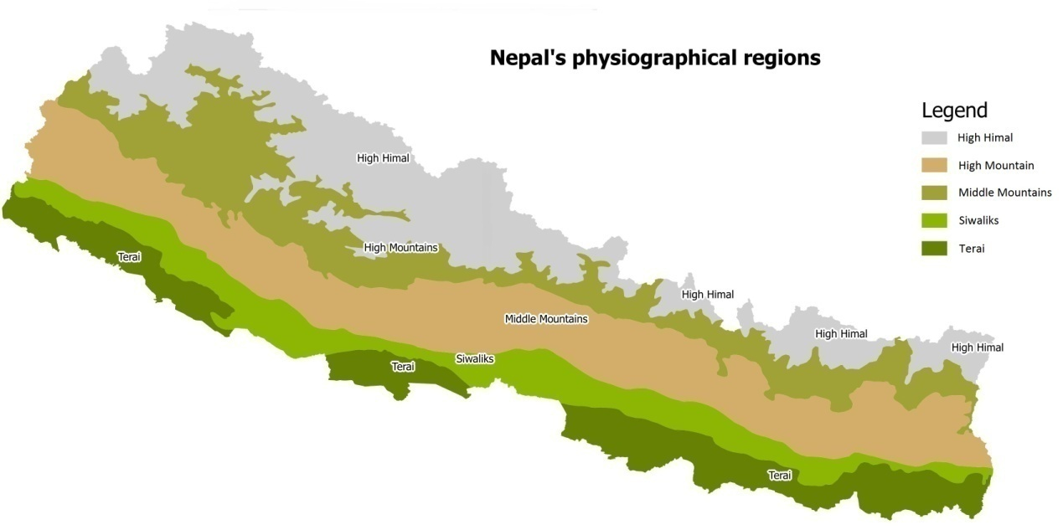
Figure 1.1: Map of Nepal showing physiographical regions

They rise from the Indo-Gangetic plains, and cover an area of about 1.35 million ha. It suffers from soil erosion that ranges between 780-20000 tones/km²/year (MoFSC, 2008) due to floods and landslides. There has been degradation in ecological, geographical and physical condition since last 32 years (Pokhrel, 2013). The degradation has started since 1950s, after the promulgation of nationalization act 1957 and enhanced by Land Tax axt, 1977 which encouraged people to cut down trees (Pokhrel, 2013). The Chure region has degraded heavily by deforestation, heavy amount of soil erosion due to road construction and cultivation on steep slopes (Pokhrel, 2013). According to President Chure Conservation Program, Six and half million cubic meter of gravel, stones and sands are legally extracted every year. There are a large number of landslides in this region. They pose a threat to human life and property. They cause natural resource degradation through the removal of soil, destruction of vegetation, and the sediments. In order to protect the Chure region Rastrapati Chure Conservation Board has been formed. Here are some of the information’s about the landslides in Chure region extracted from the progress report of the Central Department of Environmental Science (2016).

Table 1.1: Areal coverage of landslides in some districts of Chure area
Name of District | Total Area (km²) | Total no. of landslides | Total area of landslides ( m²)
Sindhuli | 1396.033 | 440 | 1877950
Sarlahi | 222.98 | 107 | 674681
Mahottari | 160.54 | 98 | 447901.3

Table 1.2: Distribution of landslides in some districts of Chure
Name of District | Total number of landslides | Landslides < 1000 m² | Landslides (1000 to 10000) m² | Landslides > 10000 m²
Sindhuli | 440 | 128 | 278 | 34
Sarlahi | 107 | 5 | 88 | 14
Mahottari | 97 | 5 | 83 | 9

The above data shows the figure of three districts. There are many such landslides in other districts of Chure Region. These are causing the loss of lives, property and vegetations. These need to be addressed as soon as possible to reduce the impact of it.

Statement of Problem
There are many landslides in the Chure region. These are causing the loss of lives, property and vegetations. These need to be identified, studied and analyzed. These need to be addressed and provided with some mitigating measures. For that site specific research can’t be possible due to restrain in time and resources. Hence there is a need to study some large landslides and derive general solutions for the region as a whole.

Landslide location and details
In this research two landslides of the Sindhuli district have been studied and analysed. Both the slope failure lies in the Chure region. According to survey carried by the Central Department of Environmental science, they have found rock failure in most of the slopes and then soil failure. Out of the 83 sites surveyed, they have found 29 toppling failure, 23 rock fall, 10 soil flow, 5 slides and others. They have enlisted the features and mechanisms of landslides in three region of Chure or Siwalik. There landslides occur in dry stream toe and most of them are fall and flow type. Chemical weathering in the post monsoon, ground water erosion, loose cementing of gravels are the causes in upper siwalik. In middle siwalik steeper topography with over loaded vegetation and differential weathering are causing landslides. In lower siwalik debris flow and mud flow are common and they have been enhanced by the road construction. According to them 38 failure have occurred in bed rock, 30 in residual soil, 10 in alluvial soil and 5 in colluvial soil. High slope angles are the other cause of landslides. They have found 65 out of 83 landslides in slope angle greater than 40 ̊, 11 landslides between slope angles of 30 ̊ to 40 ̊. Most of the landslides are facing towards SW and most of them are in the dry condition.
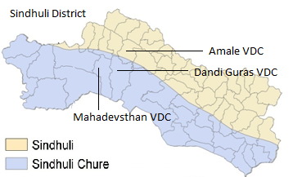
Figure 1.1: Map of Sindhuli district

Athuwa khola Landslide
Athuwa khola landslide is situated along Sindhuli-Kapilakot road section between the boundary of Dadigurase and Mahadevsthan VDC along and uphill side of Athuwa Khola. The debris flow is the main type of the failure seen there. It is located at 27⁰ 15’ 32”N and 85⁰ 48’ 9.2”E.
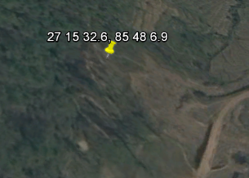
Figure 1.2: Google image showing the Athuwa Khola slope
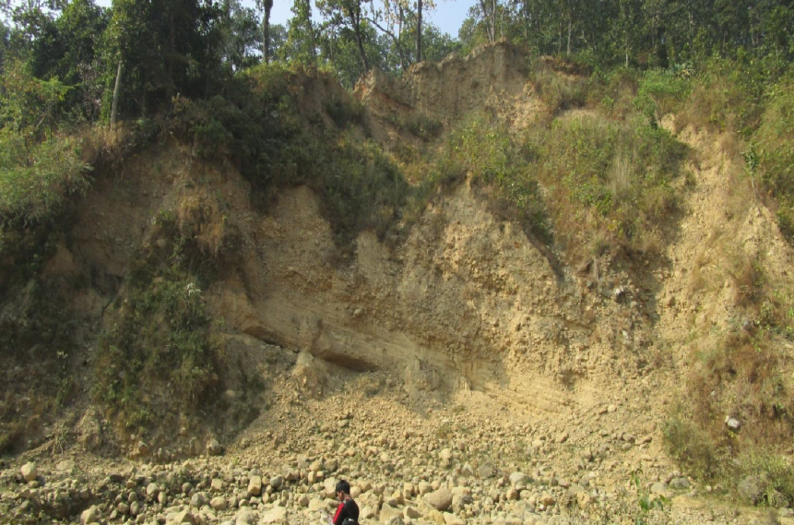
Figure 1.3: Slope failure near Athuwa Khola
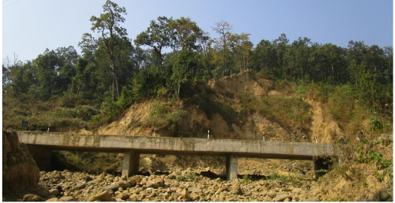
Figure 1.4: Bridge near the toe of the Landslide

Geological and Geomorphologic Condition
The study area lies at the lower Siwalik region of the Southern Nepal. The litho logy of this zone is sedimentary rock. Mostly mudstone and fine sandstone are present there. These are highly weathered. The soil found over there are residual and alluvial types. The land slopes towards South East. The direction of dip is SW and is 46 ̊.

Climate and Vegetation
Due to the variation in altitude from North to South the climate of Sindhuli district is mixed type. Tropical, subtropical and temperate climate found with temperature fluctuating between 5.3˚ C to 28.3˚ C within a year and the average rainfall recorded 1420 mm. Shorea robusta, Acatia catechu, Terminalia myriocarpa, Bombax sp Mallatous philipinensis Cleistocalyx operculatus are found in Dun valleys and in Terai area whereas, Castonopsis indica, Dalbergia latifolia, Alnus nepalensis, varieties of Pinus sp found when altitude rises.
Causes of landslide
Toe cutting by the river is the main cause. Along with this the mechanical weathering of the fine sandstone is enhancing landslide. There is a bridge near the toe of this site and it is in risk of being damaged.
Ahale landslide
Ahale landslide is situated in lower Siwalik area of Sindhuli. It is situated about 27⁰ 16’ 24.91”N and 85⁰ 45’ 18”E. The debris flow is the main type of the failure seen there. There are eight slope failures which can be seen in the Ahale.
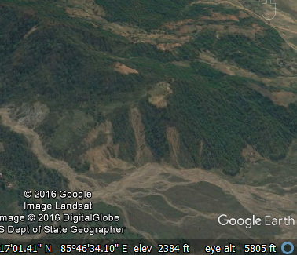
Figure 1.5: Google image of Ahale site where eight slope failure can be seen
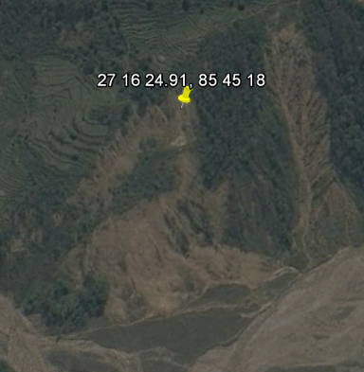
Figure 1.6: Ahale slope taken under study
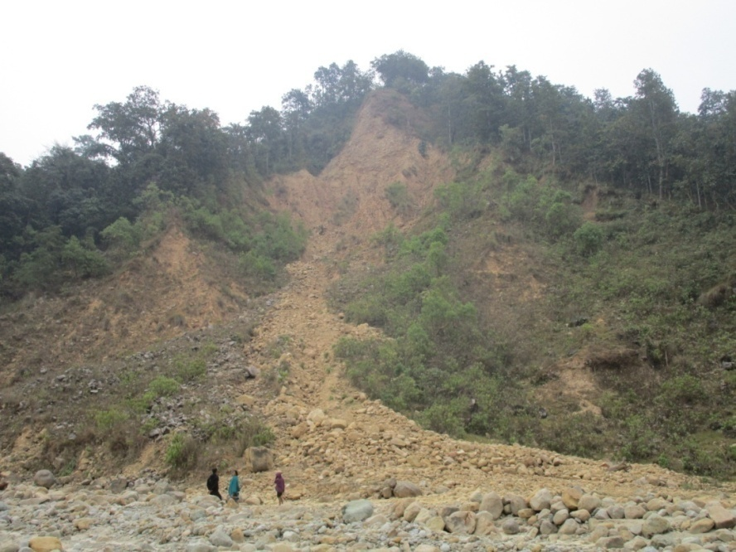
Figure 1.7: Slope failure in Ahale

Geological and Geomorphologic Condition
The study area lies at the lower Siwalik region of the Southern Nepal. The litho logy of this zone is sedimentary rock. Mostly mudstone and fine sandstone are present there. These are highly weathered. The soil found over there are residual type.
Causes of landslide
The cause of the landslide is the mechanical weathering of the mudstone.

Objective
The objectives of the study are:
- To study and perform the stability analysis of two slopes in Chure.
- To develop mitigating charts for the slopes.
- To compare the charts and the site specific work

Scope
This thesis work has been performed under two dimensional analyses considering homogeneous soil and the water table profile same as the ground surface. The finite element method has been used for calculation and verification has been performed using the limit equilibrium method. Phase2 (Rocscience, 2012) based on FEM and Slide6 based on LEM have been used. Further this work has been performed under the gravity loading only. For the development of the mitigating charts the model used by Tiwari et.al. (2013) has been used. Uniform meshing with 6 nodded triangle elements have been used. Mohr-Coulomb failure criteria with elastic properties given by the Griffiths and Lane (1999) have been used. While developing mitigating charts the data have been calculated varying cohesion in the interval of 5 KN/m² and frictional angle in the interval of 5 ̊. Similarly due to constrain in time, variation in the slope geometry and retaining wall have been eliminated. The use of retaining wall and the slope geometry modification is a complex thing and there may be many options in their application. Here only one simple and general model has been assumed. In site specific work domain has been selected by hit and trail. There may be other possibilities too.
Organization of Thesis:
The entire thesis is divided into six chapters along with the appendix included at the end of this. The first chapter consists of introduction, details of landslide, objective, scope of the thesis. The second chapter is about the review of the literature. The third consists of the methods followed in this work. Fourth includes the results and the outcome of the study. The fifth consists of the comparisons of our work from FEM to LEM. This is followed by the conclusion, recommendation and the appendices.

CHAPTER TWO: LITERATURE REVIEW
Landslide is a phenomenon in which the movement of the earth mass occurs. The movement occurs when the shear strength of the material is overcome by the shear stress. The movement occurs as fall, slides, flow and topples of rock and soil. Here are some of the factors (Popescu, 2001) causing landslide.
- Ground conditions
Plastic weak material, sensitive material, collapsible material, weathered material, sheared material, jointed or fissured material, adversely oriented mass discontinuities etc.
- Geomorphologic processes
Tectonic uplift, volcanic uplift, glacial rebound, erosion of the toe, vegetation removal, piping etc
- Physical processes
Intense rainfalls, rapid melt of snow, rapid drawdown, earthquake, volcanic eruption, breaching of lakes, shrinkage and swelling of expansive soil etc.
- Manmade processes
Vegetation removal, mining, artificial vibration, creation of dumps of very loose waste, irrigation etc

2.1 Types of landslide
There are many researches on landslide and different authors have classified the phenomenon differently. Some of the classifications are given by Campbell (1951), Hutchinson (1968, 1969, 1977), Sharpe (1938) and Varnes (1958, 1978). Varnes (1978) has classified the mass movement as
Table 1.3: Classification of Mass movement by Varnes (1978)
Type of movement |  |  | Type of material
 |  |  | Bedrock | Engineering soils
 |  |  |  | Predominantly fine | Predominantly coarse
Falls |  |  | Rockfall | Earth fall | Debris fall
Topples |  |  | Rock topple | Earth topple | Debris topple
Slides | Rotational |  | Rock slump | Earth slump | Debris slump
 | Translational | Few units | Rock block slide | Earth block slide | Debris block slide
 |  | Many units | Rock slide | Earth slide | Debris slide
Lateral spreads |  |  | Rock spread | Earth spread | Debris spread
Flows |  |  | Rock flow | Earth flow | Debris flow
 |  |  | Rock avalanche |  | Debris avalanche
 |  |  | (Deep creep) | (Soil creep)
Complex and compound |  |  | Combination in time and/or space of two or more principal types of movement

There are number of literatures published on landslides in Nepal Himalaya contributing the knowledge of its causes, processes and mechanism (Caine and Mool, 1982). But there are very few researches in the erosion and landslides of chure region. Ghimire (2011) studied three watersheds of the Chure region and found that the landslides are not random in distribution.

2.2 Slope Stability Methods
There are two methods for slope stability analysis: limit equilibrium method and finite element method.
Limit Equilibrium method
This method is based on the assumption that the falling soil mass can be divided into slices. It sums forces and moments related to an assumed surface passing through soil mass (Fredhmd and Krabn (1975); Fredhmd et al. (1981)). The direction of forces acting is assumed. It requires a continuous surface passing through the soil mass which is essential in calculating the minimum factor of safety against sliding. This method needs assumption of failure surface shape (circular, log-spiral, linear etc.) and does not utilize the stress versus strain characteristics of the soil. It is typically restricted to Mohr-Coulomb model. A detail review of equilibrium method of slope stability analysis is presented by Duncan (1996).
According to Janbu (1973) limit equilibrium exists when the mobilized shear stress is expressed as a fraction of the shear strength. At the moment of failure, the shear strength is fully mobilized along the failure surface when the critical state conditions are reached (Nash, 1987). There are various methods developed for the slope stability analysis. Fellenius (1936) introduced the first method known as Ordinary or the Swedish method used for a circular slip surface. Bishop (1955) gave another method. Janbu (1954a) developed a method for non circular failure surface dividing a mass into vertical slices. Some of the other methods used in limit equilibrium are Modified Swedish method, Spencer’s method, Wedge method and Infinite slope method.
Finite element method:
Limit equilibrium method is common and has been performed for more than a decade. But these days due to the advancement in the computing technologies use of finite element method in slope stability analysis is increasing. In this method there is no need to assume the shape or location of the failure surface, slice side forces and their directions. In this the geometry of a structure is divided into discrete portions called finite elements and connected at nodes. The collection of finite elements and nodes are called the mesh. This method can be used in complex slope configurations and soil deposits in two or three dimensions to model. Mohr-Coulomb and numerous others can be employed in soil material model. It computes the stresses and strains and the shear strength very accurately. The critical failure mechanism can be general and need not be simple circular or logarithmic spiral. Seepage induced failure can be used. Likewise the retaining walls, geo-textile, soil nailing and drains can be used. It is able to monitor progressive failure including overall shear failure (Griffiths and Lane, 1999). FEM offers a number of advantages over traditional limit equilibrium method (Griffiths and Lane, 1999) including:
- Elimination of assumption on the shape and location of failure surface
- Elimination of assumptions regarding the inclinations and locations of inter slice forces.
- Progressive failure
- Robustness
Finite element method has been in existence since 1950s (Ondruksa et al., 2011). The actual coining of the term “finite element” was by Clough in 1960 (Ondruksa et al., 2011). Zienkiewicz and Cheung (1965) applied this method to field problem. D.G. Fredlun (1999) reviewed the development of the finite element method and proposed this method for solving the slope stability problem. The overall factor of safety computed using finite element method shows good agreement with several limit equilibrium methods.
Krishna Prasad Aryal (2006) used limit equilibrium and finite element methods for slope stability analysis. He used SLOPE/W and SLIDE working on limit equilibrium method and PLAXIS working on FEM. He suggested the stress could be better computed even for a complicated problem and this is the advantage over limit equilibrium method.

2.3 Mitigating measures
The following mitigation measures can be used to protect the slope (Popescu, 2001)
Table 2.1: Mitigation table given by Popescu (2001)
S.N | Types of Mitigation measures
1 | Modification of Geometry | (i) Removing material and substituting with light weight material
(ii) Adding material to maintain stability
(iii) Reducing slope angle
2 | Drainage | (i) Surface Drain
 |  | (ii) Sub- surface drain
 |  | (iii) Vegetation
(iv) Drainage galleries
(v) Pumping
3 | Retaining Structures | (i) Gravity retaining walls
 |  | (ii) Crib block walls
 |  | (iii) Gabion walls
(iv) Cantilever R.C.C walls
(v) Reinforced earth wall
(vi) Passive pipe, pier, cassions
4 | Internal slope reinforcement | (i) Rock Bolts
 |  | (ii) Soil nailing
 |  | (iii) Geo-synthetics
/ |  | (iv) Anchors
 |  | (v) Grouting
 |  | (vi) Stone/gravel piles/ columns
 |  | (vii) Vegetation

CHAPTER THREE: MATERIALS AND METHODS
This work can be divided into two parts. One part is about the analysis of the two landslides and the other part is about the generation of the mitigating charts. The overall work follows nearly the same methods and tools with some additions.

3.1 Data Collection
Secondary data collection
Our work started with the desk study. Different literatures about the process, mechanism, estimation and mitigating mass wasting have been reviewed. Reports and laboratory processes have been thoroughly reviewed. Articles about the numerical modelling have also been gone through.
Primary data collection
A field visit was conducted to observe the geology of the area, plantations, soil or rock type, water seepage, cracks and slides Since the undisturbed sampling is tedious the disturbed but representative samples were collected in the field for the laboratory test. Disturbed samples were collected from the depth of about 30 cm below the ground surface. The amount of samples collected were about 3 kg per location.

3.2 Laboratory work
The soil samples collected from the field were tested in the Central Testing Laboratory of Institute of Engineering, Pulchowk, Lalitpur, Nepal. Different tests were performed to find the shear strength parameters and classify the soils. The laboratory was busy so that the samples had to be stored in a water bath to preserve the moisture condition.
Different tests performed
- Direct shear test for the determination of the soil strength parameters ( cohesion and internal friction angle)
- Grain size distribution ( sieve analysis)
- Liquid limit and plastic limit test
- Water content test
- Determination of specific gravity

1.Grain size analysis
Laboratory procedures given by Arrora have been followed. About 2000 gm of oven dried soil samples were sieved through the standard sieves of size (25.5 mm, 19.1 mm, 12.7 mm, 9.52 mm, 4.76 mm, 2 mm, 0.84 mm, 420 μm, 250 μm, 150 μm, 75 μm.
2. Atterberg limits
Atterberg limits are a measure of water contents of a fine grained soil. Liquid limit, plastic limit and shrinkage limit are its types.
Liquid limit
The liquid limit is the water content at which the clayey soil changes from plastic to liquid state. Cassagrande device, grooving tools are the tools used in this test. At first water was added to the soil and a paste was made. Then it was put on the cup of Cassangrande device and the surface was levelled to 1 cm thick at the middle of the sample. Grove was made using the Cassagrande grooving tool with thickness of 2 mm at the bottom, 11 mm at the top and depth of 8 mm. the cup was then repeatedly dropped from about 10 mm onto the hard rubber base at a rate of 120 blows per minute. Due to the impact, the grove closed up gradually. The number of blows for the groove to close was recorded. This was done four times varying the water content. The water content at 25 blows is the liquid limit of the given soil sample.
Plastic limit
Plastic limit is the water content at which the soil changes from semi solid to plastic or vice-versa. It is determined by rolling out a thread of the fine portion of the soil on a flat and non porous surface. A plastic soil retains its shape to a very narrow diameter. The soil sample was mixed with water and a paste was made. The sample was remoulded and the test was repeated. The sample was made to fail at diameter of 3 mm. The water content at that point is the plastic limit of the given soil sample.
3. Direct shear test
Direct shear test is the laboratory method of determining the shear strength parameter of soil. It consists of a mould to cut the soil sample to a size used in the shear box, shear box to apply loads on the soil, loading arrangements for both normal and shear force and graduated rings to measure the shear force and displacements.
At first the sample was prepared in a mould and then put in the shear box. Initial readings in the graduated rings were made zero. The vertical load was applied (5 kg, 10 kg and 15 kg) and horizontal displacements and corresponding horizontal forces were noted in regular interval for each load until the soil failed. These measurements were used to plot a curve between displacement vs. shear stress and maximum stress was found out. Results of different tests were plotted with normal stress in x- axis and shear stress in y- axis. A linear curve fitting was used. The slope of the line is the internal angle of friction of the soil and the y-ordinate of the line at zero abscissa gives the cohesion of the soil.
The detail about the laboratory test has been mention in the annex

3.3 Finite Element Modelling
Phase2
Phase2 (Rocscience, 2012) is a 2- dimensional elasto-plastic finite element program for calculating stresses and displacements on the soil and rock related problems. It can be used to solve a wide range of geotechnical and civil engineering problems. It can be used in excavation design, slope stability, ground water seepage, probabilistic analysis, consolidation and dynamic analysis. Complex multi stage models can be easily created and quickly analyzed. It can be applied in the modelling of shortcrete, concrete, steel systems, retaining walls, piles, geo textiles and so on. Mohr-Coulomb, Generalized Hooke-Brown and Cam-Clay can be used to model the materials. It can solve large and more complex models in shorter time. It works on slope stability analysis using strength reduction method
Finite element discretization and meshing
Two dimensional 6-noded triangles have been used to discretize across the slope profile, uniform meshing option has been used.
Boundary condition
The lateral sides and the base of the model have been assumed fixed and the upper face that is slope has been kept free.
Gravity loading
Finite elements have to be given both an initial stress and a body force (self-weight). The initial vertical stress is estimated from the weight of the material above the element. Phase2 automatically determines the ground surface above the element and the stress due to the material above the element. The horizontal to- vertical stress ratio σH /σV have been kept as 1.0 (Pal et al., 2012)
Factor of safety
The factor of safety of a slope is defined as the factor by which the original shear strength is divided to bring the slope to the verge of the failure. For Mohr–Coulomb material model, the factored shear strength parameters C_{f} and φ_{f} have been calculated as:
${ϕ_{f}}^{'}=\tan^{-1}(\frac{\tan{Φ'}}{SRF})$ and ${c_{f}}^{'}=\frac{C}{SRF}$
where SRF is the ‘‘strength reduction factor (SRF).’’ This method is referred to as the ‘‘shear strength reduction (SSR) technique’’ (Matsui & Sam, 1992). In the finite element formulation, the same factor is always used for both the terms. To find the true factor of safety, PHASE2 performs a systematic search for the value of SRF starting from SRF = 1 that will just cause the slope to fail. The final value obtained in the process is the FOS or SRF.

3.4 Materials and model
Site specific work
The soil strength parameters (cohesion(c) and frictional angle(Φ)) are used from the laboratory results. Mohr-coulomb failure criteria has been used and the elastic properties as according to Griffiths and Lane (1999).

Table 3.1: Soil properties in the stability analysis of slope
Landslide | c (KN/m²) | φ | unit weight (KN/m³) | E (Kpa) | Poisson’s ratio
Athuwa | 5 | 34 | 21 | 100000 | 0.3
Ahale | 7 | 32 | 21 | 100000 | 0.3
The dilation angle (Ψ) is taken as zero.
It was difficult to find the literatures about the elastic properties of the stone masonry so the property of the concrete which is nearly similar to the stone masonry has been used. P. Jimerez Montoya (1971) has given properties for the concrete as;
Angle of internal friction, ϕ = (35 to 54.9)
Cohesion, c = (365 to 513) KN/m²
Tensile strength = 450 to 750 KN/m²
Poisson’s ration = 0.2
Modulus of Elasticity = 2400000 KN/m²
In this research ϕ = 35 ̊, c = 380 KN/m², strength = 450 KN/m², Poisson’s ration = 0.2 and E = 24000 KN/m² have been used.
There exist a joint between the retaining structure and the surrounding soil. For joint, the stiffness coefficients have been according to Rocscience (2012). It has given two methods of estimating the stiffness:
- Stiffness estimated from rock mass properties
- Stiffness estimated from join infill properties
Here the second one has been used. In this the elastic properties i.e. modulus of elasticity and shear modulus of the joint material need to be known.
K_{n} = E_{o /}/ h
K_{s} = G_{o} / h, where K_{n} = joint normal stiffness
K_{s} = joint shear stiffness
E_{o} = Young’s modulus of infill material
G_{o} =shear modulus of infill material
h = joint thickness or aperture = 10 mm for brick masonry work (AS3700 Masonry code) but here it has to be provided between structure and the soil so h is greater than 10 mm. In this it has been taken as h = 5 cm and the filler material is the same as the surrounding soil.
G = E/ (2(1+ʋ) for an isotropic material based on representative volume element.
G = 0.4 E (Lekhnitskii, 1963) for isotropic material
Eurocode (1995) has suggested to take G = 0.4 E in the absence of more precise value.
A model generation is one of the important steps in the FE computational work. The profile of the landslide has been prepared using the Google Earth image. The domain selection is crucial and here it has been emphasized on the appropriate selection of the domain. Different domains have been worked out before coming to conclusion.
Following are the profiles and domain used.

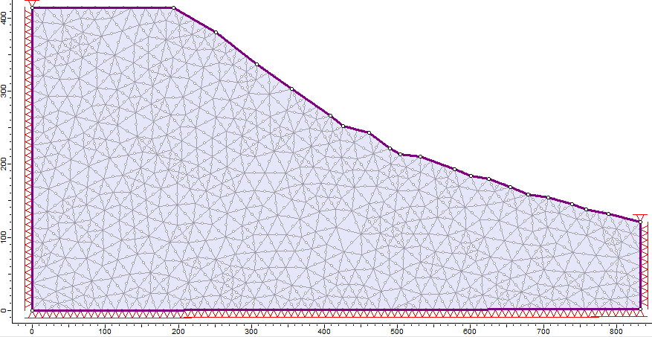
Figure 3.1: Profile of the Ahale Landslide
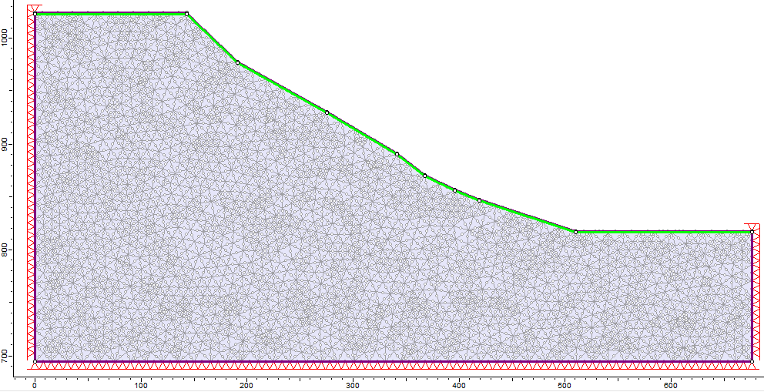
Figure 3.2: Profile of Athuwa Khola landslide

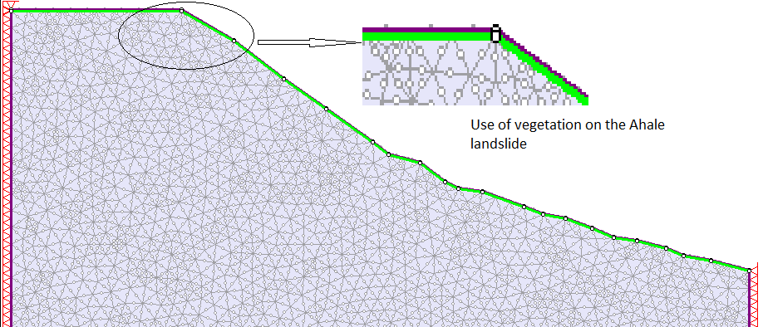
Figure 3.3: Using vegetation on the slope of Ahale
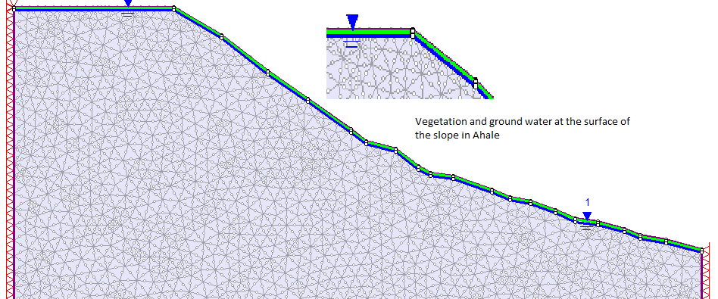
Figure 3.4: Varying the ground water table

The stability analysis on the site slope has been performed on dry soil condition, fully saturated condition and partially submerged condition considering the variation of ground water level. Further the slope with and without retaining wall have been worked out.

General solution
For second part of our work, the mitigating charts following models have been worked out. The model geometry is used as one used by Tiwari et.al. (2013). Here it has been used in 2D problem. In this research the H is taken as 10 meters and angle β is varied as 30 ̊, 35 ̊, 40 ̊ and 45 ̊. Different mitigations measures have been used in the analysis. Retaining wall, vegetation of ERD 1m and 2m, slope modification, water table variation and their combinations has been worked out. Dry soils, fully saturated soil, water table reduced by 2 meters and 4 meters have been worked out. A single slope modification model has been used.
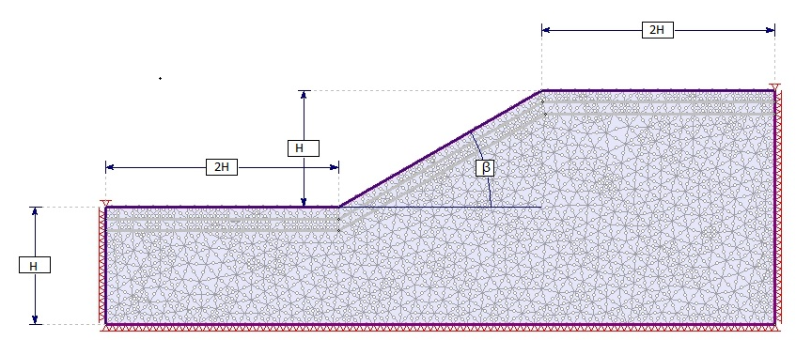
Figure 3.5: Model geometry used in the development of chart
According to Frank Graf et al. (2009) the difference between the frictional angle of the samples of pure soil at low dry unit weight and those of both compacted and planted soil is 5 ̊. The apparent root cohesion of the soil ranges from 1KPa to 17.5 KPa (Coppin and Richards, 1990). According to Tiwari et al. (2013) the grasses and small shrubs have a significant reinforcing effect down to a depth of 0.75 m to 1.5 m and trees can enhance the soil strength to a depth of 3m (Oloughlin, 1984).

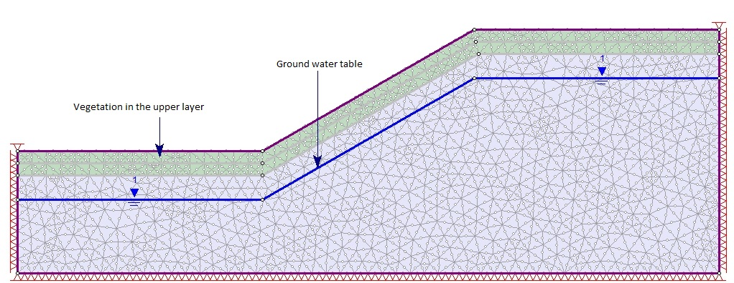
Figure 3.6: Use of vegetation and ground water
The retaining wall has been used in the toe o the slope. The selection of the retaining wall is not easier one. For general mitigating chat height of the wall has been taken as 0.3H. It has been further attempted to find out the stability of the slope with the variation of the size of the retaining wall. The different size of wall has been worked out for ground slope of 30 ̊. The different sizes taken are 0.1H, 0.2H 0.3H and 0.4H.
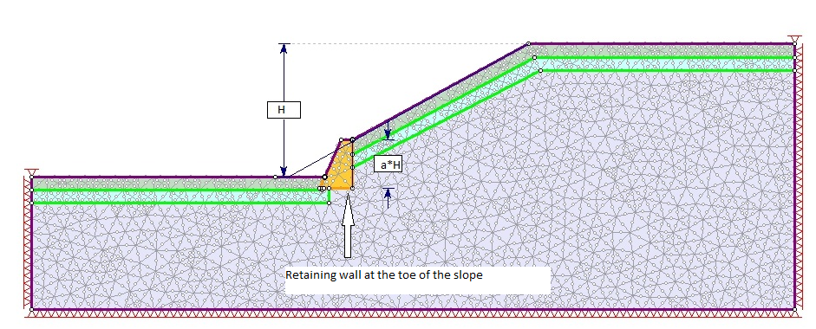
Figure 3.7: Model with the application of retaining wall
There are three methods of modification of slope geometry (Propescu, 2001)
- Removing material from the area driving the landslide
- Adding material to the area (fill or counter berm)
- Reducing general slope angle
Ground modification is a most efficient method particularly in deep seated landslides. However the success is determined by size or shape of the alterations and the position on the slope (Propescu et.al). Here all of the three ways have been tried to incorporate in a single model. The model has been developed by making a cut in the uphill side and filling in the toe and using a balance section in cut and fill. In additions benches have been provided to reduce the overall slope. The slope modification is not an easier task. There can be many ways to conduct it. Before general solution it has been further worked out to find how the height of cutting and filling and the benching width affects the stability of the slope. For that three models have been used on the ground slope of 30 ̊. These three are according to the depth of cut and depth of fill which are taken as H/2, H/3 and H/4. Further the variations have been made on the width of benching as B= 0.1 H, 0.2 H and 0.3 H. Hence total nine models of slope modification have been worked out in ground slope of 30 ̊. The nine models have been named as Type 1A, 1B, 1C, 2A, 2B, 2C, 3A, 3B and 3C. A denotes the model with benching width, B = 0.3 H
B denotes the model with benching width, B = 0.2H
C denotes the model with benching width, B = 0.1H
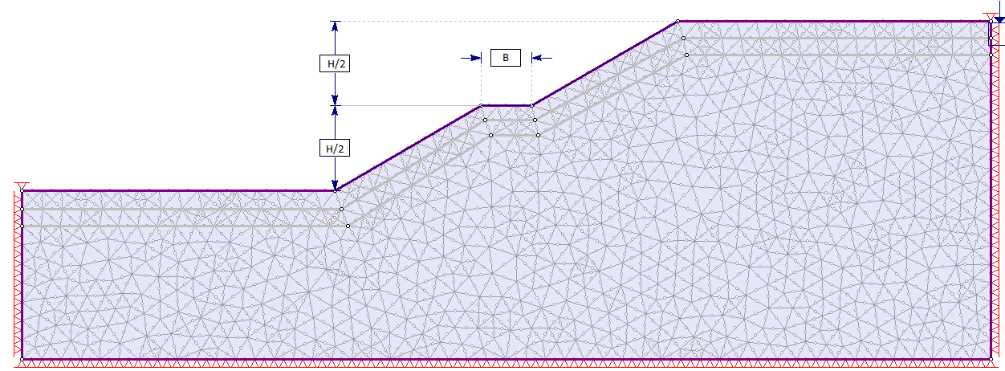
Figure 3.8: Slope geometry modification Type 1
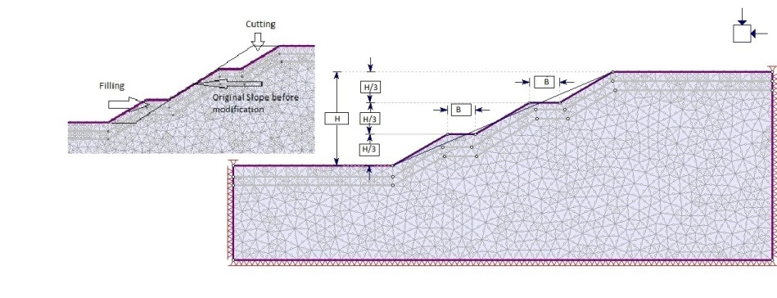
Figure 3.9: Slope geometry modification Type 2
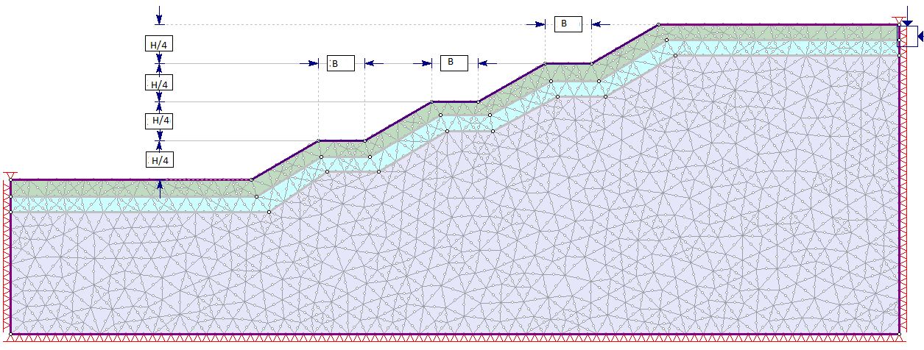
Figure 3.10: Slope geometry modification Type 3
For general mitigating chart Type 2 with B = H/3 has been used.
It has been tried to find out the effects of the combination of all the mitigation measures in a single model. The model is as shown below.
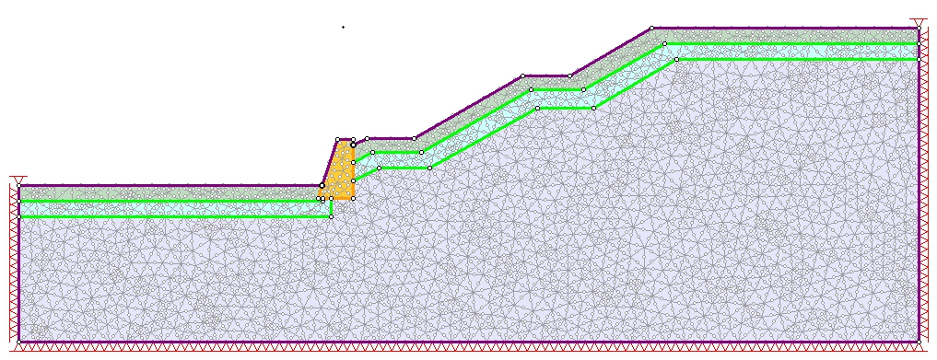
Figure 3.11: Combination of different mitigating measures

3.5 Back analysis
The soil sample collected is not representative sample due to the limitation of resources and the equipments of the laboratory. The shear strength parameters obtained from the laboratory is near to the site condition. So in order to check our work and make a correction in the laboratory work back analysis is necessary.
Back analysis is an approach used in geotechnical engineering to estimate material parameters. The results from the laboratory and in- situ tests do not accurately represent the soil profile. This needs to be accurately addressed. There have been many works done on this topic and many publications on it (Leroueil and Tavenas, 1981; Azzouz et.al., 1981; Leonards, 1982; Duncan and Stark, 1992; Gilbert et. al. 1998; Tang, et. al. 1998; Stark et. al. 1998). These publications describe the pitfalls of back analysis.
A conservative design assumption is unconservative when used in back analysis because the calculated strength in back analysis would be over estimated. Although this is one of the common approaches to estimate the shear strength but sometimes it may lead to misinterpretation of strength. Rick Deschamps et. al used examples from earth and concrete dams to show the interpreted strength could be in significant error. They further illustrated that it is reliable until the all the assumptions are reasonable and accurate.
Factors influencing the results of back analysis:
- Soil is heterogeneous and to accurately back-calculate the strength , the strength of all other materials must be known
- The slip surface analyzed and the actual rupture surface must be the same.
Here back analysis has been performed with the data obtained from the laboratory. Here the slope has been assumed to be in dry condition and variation made been made on the internal frictional angle of the soil with cohesion remaining constant. The result from back analysis is as:
Landslide | Cohesion, c (KN/m2) | Frictional angle | SRF
Athuwa | 5 | 34 | 1.01

Table 3.2: Results from back analysis
Landslide | Cohesion, c (KN/m2) | Frictional angle | SRF
Ahale | 7 | 32 | 1
Since the SRF due to the soil parameters obtained from the laboratory is nearly equal to one, the data needs no further back analysis. The laboratory data matches the field condition.

3.6 Interpretation of result
The output from the software Phase2 has been developed into charts with the help of another commercial tool, Tecplot.360

CHAPTER FOUR: OUTPUT AND RESULTS

4.1 Results
Laboratory work
Two samples from two sites Ahale and Attuwa khola have been tested in the CMTL. The details about the tests are shown in ANNEX A. Here is the summary of the laboratory test.
Table 4.1: Summary of Laboratory tests
Site | Cohesion (KN/m2) | Frictional angle (degree) | Specific Gravity | Liquid limit | Plastic limit | Soil Classification
Athuwa khola | 5 | 34 | 2.6 | 22 | 15.7 | SM-SC
Ahale | 7 | 32 | 2.64 | 32.5 | 19.45 | CL
The soil sample from Attuwa khola landslide is silty to clayey sand and that from Ahale is clayey silt according to the USCS soil classification by Wagner and Krahenbuhl.
Results of site specific work
The slope stability analysis has been performed with the help of SSR analysis provided in phase2. Stability of two landslide sections have been carried out in a dry soil condition, fully saturated soil condition and partially saturated condition with variation in ground water level. The output from the software is in the form of displacement contour, strain contour and SRF vs. maximum displacement plot. From these the Critical SRF and corresponding maximum displacement are the important data for us for the further analysis. The output of SSR analysis of dry condition of Ahale landslide is shown in figure below and remaining are mentioned in ANNEX B and ANNEX C.
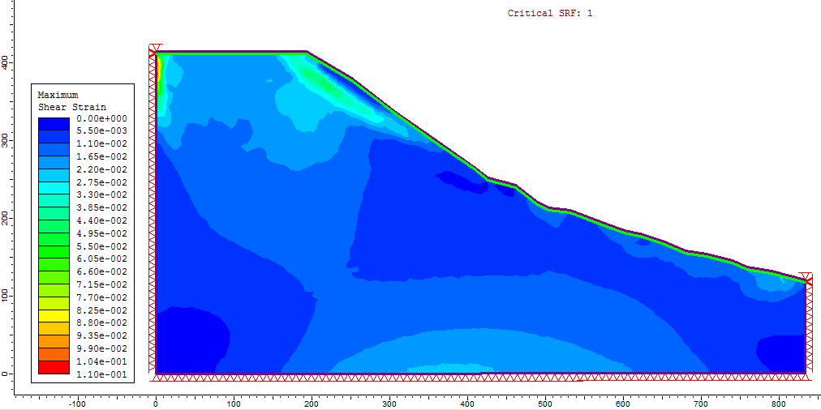
Figure 4.1: Strain contour of Ahale landslide in dry soil condition

Figure 4.2: SRF vs. displacement curve of Ahale landslide in dry soil condition
In figure 4.1 there is the contour of different magnitude of strains. Higher strain is just below the free surface which may be the region through which the slope fails. In figure 4.2 there is the plot between the strength reduction factor and maximum total displacement of the element. It also shows the critical SRF and the corresponding maximum displacement in the element. The maximum displacement of element is 6.9m. 6.9 m is a large value but this is possible according to the site condition, the height of the slope is larger around 200m.
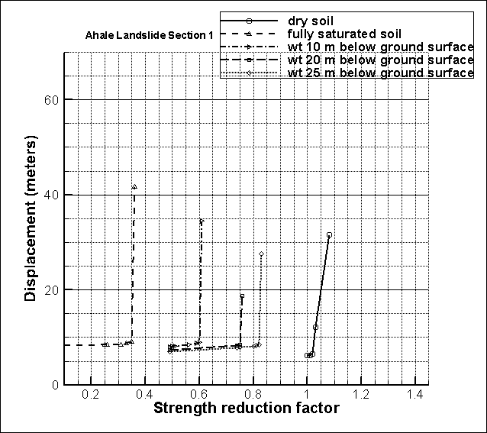
Figure 4.3: SRF vs. displacement curve for Ahale landslide section with lowering of ground water table
In figure 4.3 there is the plot between the SRF and maximum displacement in different soil conditions and with application of different mitigation measures. The SRF of dry soil is greater than one and in rest of the four soil conditions the SRF is much lower than one. This shows Ahale slope is most likely to fail when the ground water is up to about 25 m. Water table below 25m may be due to the height of the slope. We have assumed homogeneous soil mass with water table with same profile as the ground surface. These may have affected the result. The SRF vs. displacement graphs about different soil conditions with application of various mitigating measures are in ANNEX C
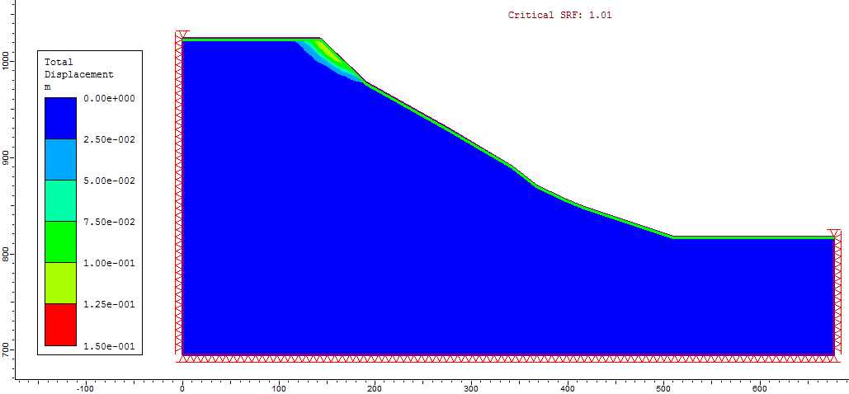
Figure 4.4: Displacement contour of the slope of Attuwa slope in dry soil condition
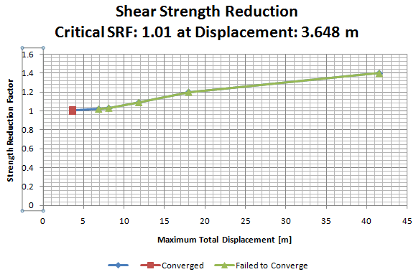
Figure 4.5: SRF vs. maximum displacement curve of Attuwa slope in dry soil condition
The displacement is higher in the uphill side of the slope in fig 4.4. Critical SRF is 1.01 and the corresponding displacement is 3.648 meter. This displacement is due to the large height of the slope.
The Critical strength reduction factors obtained from the computation of slopes with different mitigating measures have been shown in Tabular form in ANNEX C. From the computation with the application of the vegetation, retaining wall in different soil condition i.e. dry soil condition, fully saturated soil condition or partially saturated soil the CSRF has increased but the increment is very small. This may be due to the height of the slope. Both the domains have large height. The vegetation of 1 or 2 meter of reinforcing depth is not sufficient to protect the slope in critical condition. From the computation it shows water table around 30 meters deep may cause slope failure in both the cases. Water table 30 meters below is justifiable due to the height of the slope and assumptions made for this research such as homogeneous material, water table profile same as the profile of the ground.
Results from the analysis of retaining wall
It has been tried to find out the effect of height of the retaining wall on the stability of the slope. Four types of retaining walls have been taken in relation with the height of the model geometry of the slope. Those are 0.1H, 0.2H, 0.3H and 0.4H. Both dry soil and fully saturated soil in a ground slope of 30 ̊ have been taken into account. The output has been plotted in F/tan (ϕ) vs. c/ (ϒHtan (ϕ)) as used by Michalowski (1999). Here c, ϕ, ϒ are soil properties, H is the height of the slope and F is the SRF obtained from the Phase2.
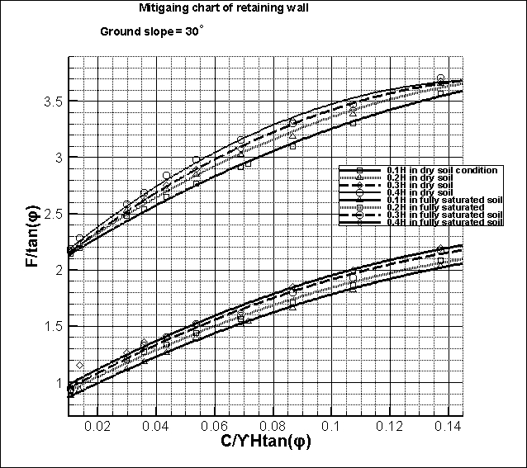
Figure 4.6: Graph of dry and fully saturated soil with variation in the height of retaining wall
Figure 4.6 shows with the increase in the h/H ratio there is also increase in the SRF in the proportion as shown above. The lower group of curves is the plot of soil in fully saturated soil condition and the upper group is the plot of soil in dry condition.
Results of the analysis of slope geometry modification
Three slope geometry modifications in cut and fill together with three variations in the width of benching have been worked out. The relation between the soil parameters and the slope parameters have been plotted as used by Michalowski (1999).
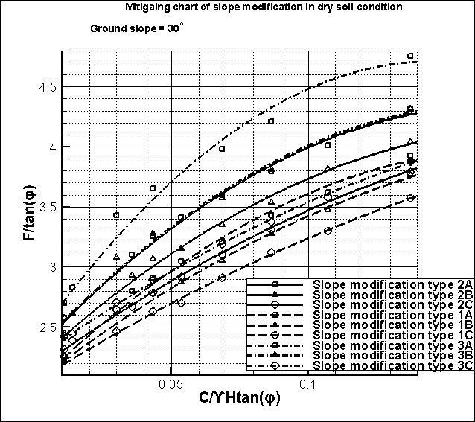
Figure 4.7: Mitigation chart of slope modification only in Ground slope of 30 degree

Figure 4.7 shows with the increment in ratio of depth of cutting or filling in relation to the height of slope i.e. h/H there is the decrease in the SRF in the proportion as shown in graph above. Similarly with the increase in the ratio of width of the benching to the height of the slope i.e. B/H ratio there is the increase in the SRF in a proportion as above chart.
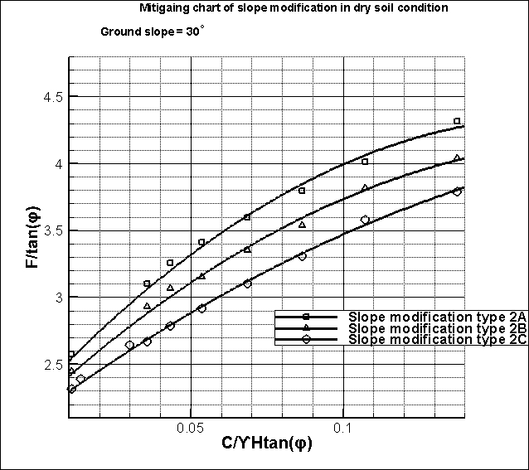
Figure 4.8: Graph showing the SRF with the variation in the width of benching for Type 2 slope modification

Results of the work for General Mitigation Chart
Similarly analysis has been performed on the sample slope models with the help of the phase2. Analysis of four different models (with angle of slope 30 ̊, 35 ̊, 40 ̊and 45 ̊) have been carried out in a fully saturated soil condition, dry soil condition and applying different methods for improving the stability of slope. The methods included are water table reduction by 2 meter and 4 meter, vegetation of slope by using the soil root depth of 1 meter and 2 meter, slope modification and using the retaining wall. These methods have been used singly as well as in combination. The outcomes of the computation have been presented in tabular form as shown in ANNEX E. The other outputs are the mitigation charts together with the displacement contour or strain contour and curve between the SRF and shear strain. The outputs for a ground slope of 30 ̊ at dry soil condition are shown below. The others are in ANNEX D.
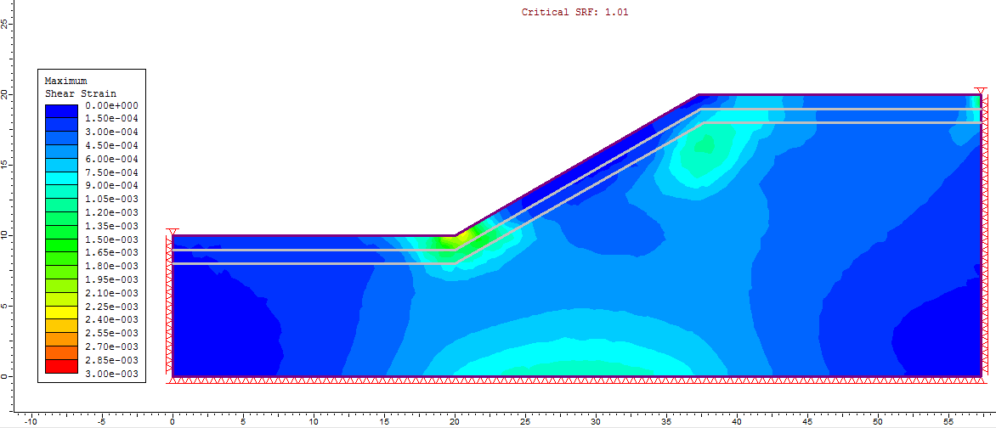
Figure 4.9: Shear strain contour on slope 30 degree in dry soil condition

Figure 4.10: SRF vs. displacement curve on slope of 30 degree in dry soil condition
The figure 4.9 shows the contour of strain in the slope model. The maximum strain is in the toe of the slope. The slope is gentle and is safe. The SRF is 1.01 and maximum displacement of the element is 0.016m.

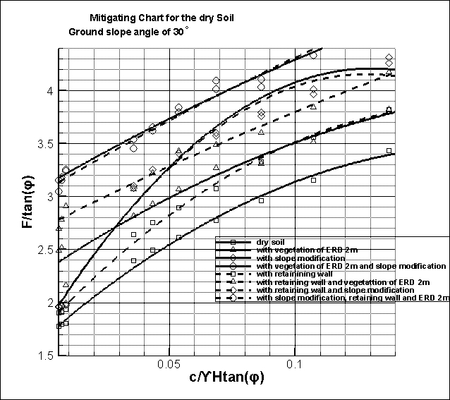
Figure 4.11: Mitigation chart for the dry soil in ground slope of 30 ̊
Figure 4.11 shows the mitigating chart for the dry soil condition in ground slope of 30 ̊. This plot shows the safety increases taking multiple mitigating measures in a proportion as in the graph. This plot has been prepared by the help of commercial software Tecplot 360. Doing hit and trial the polynomial fit showed good, hence polynomial fitting have been made. Following is the R² and R values for the slope with different mitigating measures for the above slope.
S.N | Soil with different mitigating measures | R² | R
1 | Normal | 0.994585 | 0.997289
2 | soil with slope modification | 0.983052 | 0.99149
3 | soil with retaining wall | 0.99613 | 0.998063
4 | slope modification and retaining wall | 0.981777 | 0.990847
5 | Vegetation | 0.997433 | 0.998716
6 | vegetation and slope modification | 0.99817 | 0.999085
7 | vegetation and retaining wall | 0.997757 | 0.998878
8 | Combined | 0.99521 | 0.997602

CHAPTER FIVE: VERIFICATION OF WORK
Verification of site specific work
Verification of Result of slope stability analysis by LEM based software.
The verification of the result of slope stability analysis is done with the help of LEM using Slide6 (Rocscience, 2012). The comparison between LEM and FEM has been done for the Ahale Landslide. The results are as follows:
Table 5.1: Comparison of factor of safety from FEM and LEM on Ahale slope
 |  | Water table | Phase2 FEM | Slide LEM verification
S.N |  | below ground surface | result | Bishop simplified method
1 | Normal Condition without vegetation
 |  | 0m | 0.32 | 0.351
 |  | 4m | 0.42 | 0.45
 |  | 10m | 0.56 | 0.605
 |  | 15m | 0.64 | 0.67
 |  | 20m | 0.73 | 0.765
 |  | 25m | 0.81 | 0.827
 |  | 30m | 0.87 | 0.885
2 | Vegetation of ERD 1m
 |  | 0m | 0.31 | 0.344
 |  | 4m | 0.43 | 0.451
 |  | 10m | 0.56 | 0.642
 |  | 15m | 0.66 | 0.67
 |  | 20m | 0.74 | 0.765
 |  | 25m | 0.81 | 0.822
3 | Vegetation of ERD 2m
 |  | 0m | 0.28 | 0.311
 |  | 4m | 0.44 | 0.462
 |  | 10m | 0.56 | 0.598
 |  | 15m | 0.66 | 0.71
 |  | 20m | 0.74 | 0.76
 |  | 25m | 0.81 | 0.832

 |  | water table | Phase2 FEM | Slide LEM verification
S.N |  | below ground surface | result | Bishop simplified method
4 | Vegetation of ERD 3m
 |  | 0m | 0.35 | 0.386
 |  | 4m | 0.46 | 0.495
 |  | 10m | 0.6 | 0.632
 |  | 15m | 0.68 | 0.695
 |  | 20m | 0.75 | 0.784
 |  | 25m | 0.82 | 0.832
 |  | 30m | 0.88 | 0.902
 |  | 35m | 0.92 | 0.943
 |  | 40m | 0.98 | 0.995

Figure 5.1: Comparison of SRF of FEM with Janbu Method (LEM technique)
The result shows the result of the FEM gives good agreement with LEM based technique. The correlation of Phase2 with Janbu method (LEM) obtained is 0.997.
Verification of work of general mitigating charts
Comparison of Result of slope stability analysis by LEM based software
The verification for the calculation of the mitigating charts has been performed with the help of same LEM from Slide6. The models computed in FEM are in large number and to compare it with other tools it is time consuming to compute all the models again. Hence the comparison has been done taking random samples. The calculation from LEM has been shown in the ANNEX E.

Figure 5.2: Comparison of SRF of general mitigating work in FEM with LEM
The result shows the result of the FEM gives good agreement with LEM based technique. The correlation of Phase2 with Janbu method (LEM) obtained is 0.975.

CHAPTER SIX: CONCLUSION AND RECOMMENDATION

6.1 Conclusions
There are a large number of landslides distributed over the Chure region and these need to be addressed. Site specific work of all landslides takes time and resources. Hence there is a need to study some large landslides and derive a general solution to the whole Chure area. In this thesis two landslides: Attuwa khola and Ahale have been analysed considering the homogeneous soil. The stability analysis has been done considering the mitigation measures such as retaining wall and vegetation with variation of ground water.
The result shows, for 30m depth of water table the Ahale slope is likely to fail where as the Athuwa slope may be safe. It shows one mitigation measure at a time doesn’t increase the stability of those slides. Hence the combination of different mitigating measures should be used. The water table reduction is the vital one.
There are researches in the stability of slope and their mitigation measures but there are negligible works on the Mitigating charts. Mitigating charts are useful to take some mitigation on the slopes liable to fail. The charts have been developed by considering the homogeneous soil and are for the plain strain or 2D conditions. The angles of slopes have been varied and different mitigating measures have been used. Different mitigating charts for different slopes have been developed.
These charts have been developed as a general solution for the slope failure in those areas. Comparing the problem of the site to the chart, it has shown the good correlation. Hence it can be concluded that the chart works for that region.
Another software Slide6 based on LEM has been used to compare the results from the Phase2 based on FEM. The correlation is good in the calculations of site specific stability analysis and the calculations for general mitigating charts.

6.2 Recommendation
Development of mitigating charts is quite cumbersome and demanding much more patience and resources. Complete sets of charts have not been developed due to the constraint in time and resources. Two landslides in Sindhuli district have been analysed. Landslide is not a simple thing to be analysed. There are many limitations on this work.
Following are some recommendations:
- There have been made many assumptions based on the literatures. Detail soil investigation and determination of soil strength parameters are recommended.
- Due to the limitation in the time this work has not been able to cover large variations in the parameters. It is recommended to use the variations in the slope angle, soil parameters in small intervals.
- This thesis uses four mitigating measures. It is recommended to try the other options such as Geo synthetics, check dam etc
- The 2D slope analysis has been performed in FEM. It is recommended to use 3D and other advanced tools.
- Three dimensional charts should be worked out for more precise results.
- The chart have been developed using the homogeneous soil condition without seismic loading. The other way should have to be worked out.

REFERENCES
Graf F., 2009, “Effect of vegetation on the angle of internal friction of a moraine”, Snow and Landscape Research, Vol. 82, No.1, pp. 61-77
Griffiths D. V. and Lane P. A., 1999, “Slope stability analysis by finite elements”, Geotechnique, Volume 49, No. 3, pp. 387-403
Pokhrel K.P., 2013, “Chure forestry conservation and management plan: A case study of Argakhanchi district, Nepal”, Journal of Geography and Regional Planning, Vol. 6(5), pp. 172-183
Michalowski, R.L., 2002, “Stability charts for uniform slopes”, Journal of Geotechnical and Geoenviromental Engineering, Volume 128, No. 4.
Central Department of Environmental Science, 2016, “Landslide Inventory, Characterization and Engineering Design for Mitigation works of Chure Area in Ten Districts” A Progress Report submitted to President Chure Conservation Board
Dahal R.K., 2005, “Geology for Technical Students”, Geological Framework of Nepal Himalayas, PP 198-206
Popescu, M. E., 2001. Engineering Measures for Landslide Disaster Mitigation
Ng S.M., 2014, “Back Analysis of Slope Failure Using Finite Element with Point Estimate Method (FEM_PEM)” School of Civil Engineering, Universiti Sains Malaysia, Engineering Campus, Pulau Pinang Malaysia
Tiwari R. C., Bhandary N.P. and Yatabe R., 2013, “3-D Elasto-Plastic SEM Approach for Pseudo-Static Seismic Slope Stability Charts for Natural Slopes”, Indian Geotech J, doi10.1007/s40098-013-0086.
Tiwari R. C., Bhandary N.P. and Yatabe R., 2013, “Evaluation of factor of safety for vegetated and barren soil slopes with limit equilibrium computations”, Geomechanics and Geoengineering: An International Journal, doi:10.1080/17486025.2012.7444101
Rocscience, 2012. A 2D finite element program for calculating stresses and estimating support around them. Geomechanics software and Research, Rocscience INC, Toronto, Canada.
Varnes, D. & Cruden, D. M., 1996. Landslide types and process. In "Landslides - Investigation and Mitigation". Transportation Research Board special Report n. 247, National Academy Press, Washington DC, 36-75.
Bhatt V.D., 2013, “Spatial Mapping of Landslides by using ArcGIS and Google Earth: A case study of Chure region in Kanchanpur district, Far-Western Nepal”, MSc. Thesis, Department of Environmental Science, Tribhuvan University, Nepal

ANNEX A
Laboratory test results
Athuwa Khola Landslide
Table 6.1: Sieve analysis of soil sample from Attuwa khola landslide
SIEVE ANALYSIS
Project: | Thesis work |  | Landslide: | Athuwa Khola
Location: | Sindhuli |  | Section:
Weight of sample taken |  |  | 3000 | gm
S.N | OBSERVATION |  | CALCULATION
 | sieve size, mm | soil retained (gm) | Percentage retained | Cumulative percentage retained |  | Percentage finer
1 | 24.5 | 372.3 | 12.41 | 12.41 |  | 87.59
2 | 19.1 | 119.2 | 3.97 | 16.38 |  | 83.62
3 | 12.7 | 145.4 | 4.85 | 21.23 |  | 78.77
4 | 9.5 | 198.6 | 6.62 | 27.85 |  | 72.15
5 | 4.750 | 212.2 | 7.07 | 34.92 |  | 65.08
6 | 2.000 | 311.3 | 10.38 | 45.30 |  | 54.70
7 | 0.840 | 417.3 | 13.91 | 59.21 |  | 40.79
8 | 0.420 | 267.3 | 8.91 | 68.12 |  | 31.88
9 | 0.250 | 198.4 | 6.61 | 74.73 |  | 25.27
10 | 0.149 | 97.6 | 3.25 | 77.99 |  | 22.01
11 | 0.075 | 78.4 | 2.61 | 80.60 |  | 19.40
12 | pan | 582 | 19.40 | 100.00 |  | 0.00
 |  | 3000 | 100.00

Figure 6.1: Gradation curve of soil sample from Attuwa khola landslide
From the above test
% retained on 4.75mm sieve = 34.92%
% passing through 4.75mm sieve = 65.08%
% passing through 0.75 mm sieve = 19.4%
% of fines = 19.4% > 12%

Table 6.2: Calculation of Atterberg limits of soil sample from Attuwa khola landslide
 |  | ATTERBERG LIMIT TEST
Location : |  | Attuwa Khola, Sindhuli
Landslide |  | Attuwa Khola Landslide
S.N | Description |  | Liquid Limit |  |  |  | Plastic Limit
1 | No of Blows |  | 40 | 33 | 18 | 15
2 | Wt of Container+Wet Soil gms |  | 38.86 | 36.50 | 42.19 | 42.32 | 27.90 | 26.43
3 | Wt of Container+Dry Soil gms |  | 36.46 | 33.58 | 37.45 | 36.32 | 25.89 | 25.30
4 | Wt of Water Present gms |  | 2.40 | 2.92 | 4.74 | 6.00 | 2.01 | 1.13
5 | Wt of Empty Container gms |  | 17.44 | 17.30 | 19.88 | 16.64 | 13.32 | 17.97
6 | Wt of Dry Soil gms |  | 19.02 | 16.28 | 17.57 | 19.68 | 12.57 | 7.33
7 | Moisture Content % |  | 12.62 | 17.94 | 26.98 | 30.49 | 15.99 | 15.42
8 | Liquid limit/Plastic limit (%) |  | 22. |  |  |  | 15.70

Figure 6.2: Water content vs. number of blows curve of soil sample from Attuwa khola landslide

From chart of liquid limit and number of blows
Liquid limit = 22%
Average plastic limit = 15.70%
Plasticity index = LL-PL = 6.3%
From equation of A line, PI of A line = 1.46% (since, PI = 0.73 (LL-20)) from chart)
Calculated PI from field data is greater than the PI from chart, hence the soil is clay. According to the USCS soil classification it is classified as SM-SC
From direct shear test following data were obtained
Figure 6.3: Plot between stresses from the direct shear test result on the sample from Attuwa khola landslide
S.N | Normal stress (kN/m²) | Shear Stress (kN/m²)
1 | 19.22 | 18
2 | 38.4 | 31
3 | 57.67 | 44
Cohesion, C(kN/m²) = |  | 5.01
Friction Angle (φ) = |  | 34

Table 6.3: Sieve analysis of soil sample from Ahale landslide
SIEVE ANALYSIS
Project: | Thesis work |  | Landslide: | Ahale Landslide
Location: | Sindhuli |  | Section:
Weight of sample taken |  |  | 2000 | gm
S.N | OBSERVATION |  | CALCULATION
 | sieve size, mm | soil retained (gm) | Percentage retained | Cumulative percentage retained |  | Percentage finer
1 | 9.5 | 168.42 | 8.42 | 8.42 |  | 91.58
2 | 4.750 | 72.3 | 3.62 | 12.04 |  | 87.96
3 | 2.000 | 63.6 | 3.18 | 15.22 |  | 84.78
4 | 0.840 | 90.2 | 4.51 | 19.73 |  | 80.27
5 | 0.420 | 112.34 | 5.62 | 25.34 |  | 74.66
6 | 0.250 | 167.4 | 8.37 | 33.71 |  | 66.29
7 | 0.149 | 160.5 | 8.03 | 41.74 |  | 58.26
8 | 0.075 | 130.4 | 6.52 | 48.26 |  | 51.74
9 | pan | 1034.84 | 51.74 | 100.00 |  | 0.000
 |  | 2000 | 100.00

Figure 6.4: Gradation curve of soil sample from Ahale landslide
From the above test
% retained on 4.75mm sieve = 12.08%
% passing through 4.75mm sieve = 87.96%
% passing through 0.75 mm sieve = 51.74%
Table 6.4: Atterberg Limit calculation of soil sample from Ahale landslide
 |  | ATTERBERG LIMIT TEST
Location : |  | Ahale, Sindhuli
Landslide |  | Ahale Landslide
S.N. | Description |  | Liquid Limit |  |  |  | Plastic Limit
1 | No of Blows |  | 36 | 28 | 21 | 16
2 | Wt of Container+Wet Soil gms |  | 40.72 | 38.10 | 35.67 | 35.43 | 24.51 | 22.31
3 | Wt of Container+Dry Soil gms |  | 34.63 | 32.67 | 29.54 | 28.91 | 23.18 | 21.32
4 | Wt of Water Present gms |  | 6.09 | 5.43 | 6.13 | 5.80 | 1.33 | 0.99
5 | Wt of Empty Container gms |  | 11.00 | 15.21 | 12.61 | 15.43 | 15.87 | 16.54
6 | Wt of Dry Soil gms |  | 23.63 | 17.46 | 16.93 | 14.20 | 7.31 | 4.78
7 | Moisture Content % |  | 25.77 | 31.10 | 36.21 | 40.85 | 18.19 | 20.71
8 | Liquid limit/Plastic limit (%) |  | 32.50 |  |  |  | 19.45

Figure 6.5: Water content vs. number of blows of soil sample from the Ahale landslide

From chart of liquid limit and number of blows
Liquid limit = 32.5%
Average plastic limit = 19.45%
Plasticity index = LL-PL = 13.05%
From equation of A line, PI of A line = 9.13% (since, PI = 0.73 (LL-20)) from chart)
Calculated PI from field data is greater than the PI from chart, hence the soil is clay. According to the USCS soil classification it is classified as CL
From direct shear test following data were obtained

Figure 6.6: Plot of stresses on a soil sample from Ahale landslide from the direct shear test
S.N | Normal Stress (KN/m²) |  | Shear Stress (KN/m²)
1 | 19.22 |  | 19.2
2 | 38.4 |  | 31.2
3 | 57.67 |  | 43.5
Cohesion, C (kN/m²) = |  |  | 7
Friction Angle (φ) = |  |  | 32

ANNEX B
Site specific analysis
Ahale Landslide

Figure 6.7: Ahale landslide dry soil
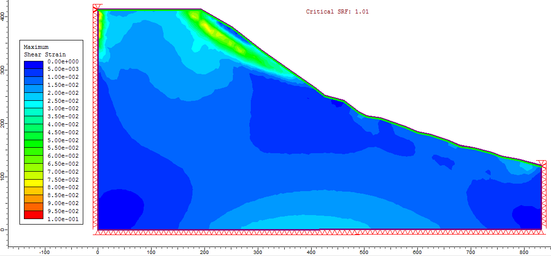
Figure 6.8: Ahale landslide vegetation of ERD 1m dry soil condition
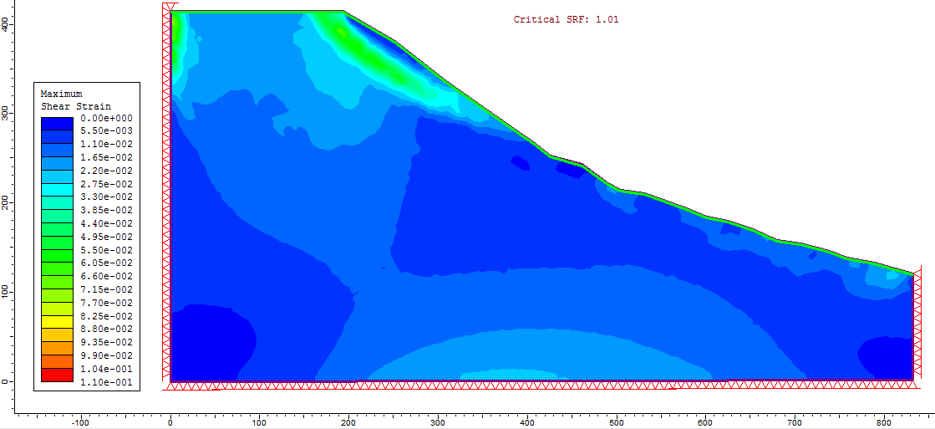
Figure 6.9: Ahale landslide vegetation of ERD 2m dry soil condition
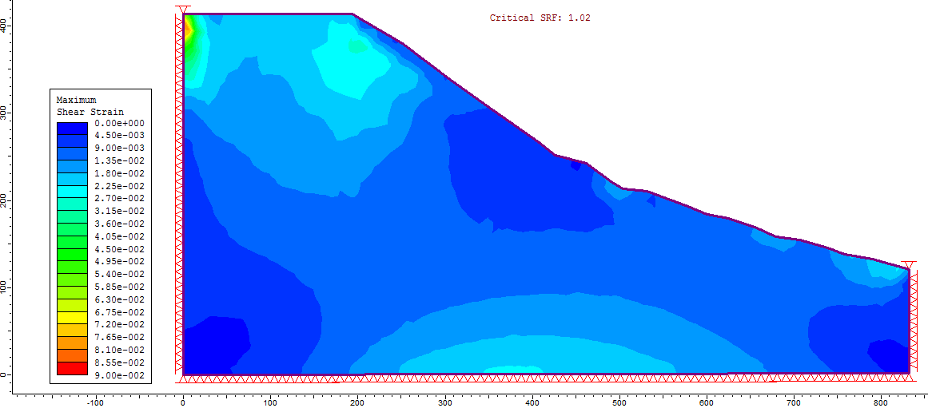
Figure 6.10: Ahale landslide vegetation of ERD 3m dry soil condition
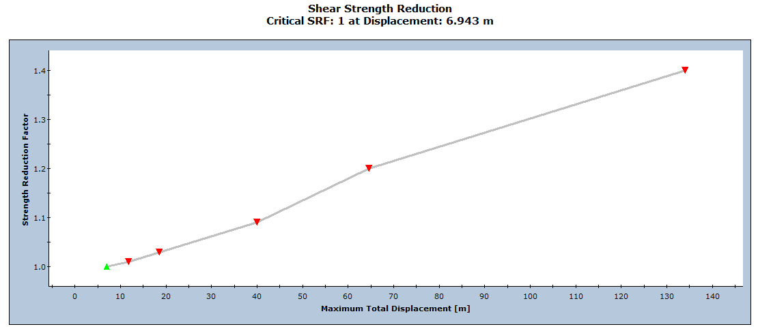
Figure 6.11: SRF vs. displacement curve of the Ahale landslide
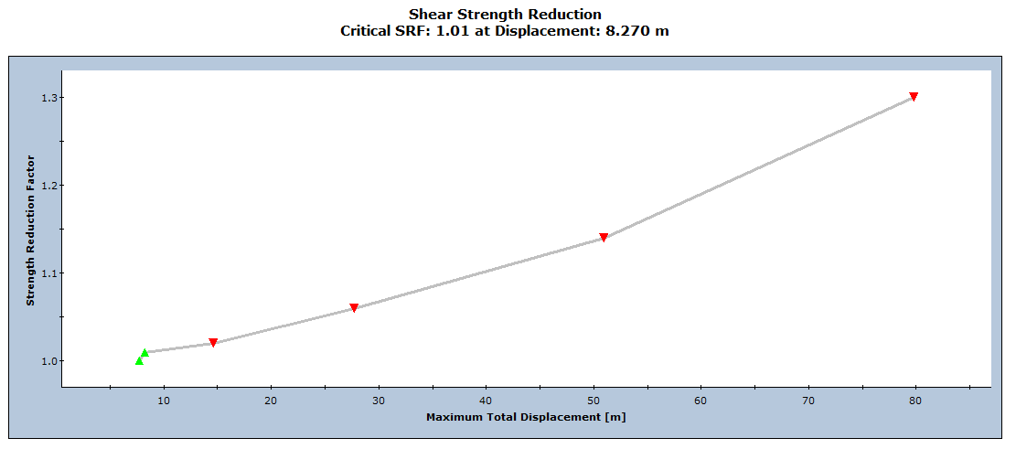
Figure 6.12: SRF vs. displacement curve of the Ahale landslide with vegetation of ERD 1m
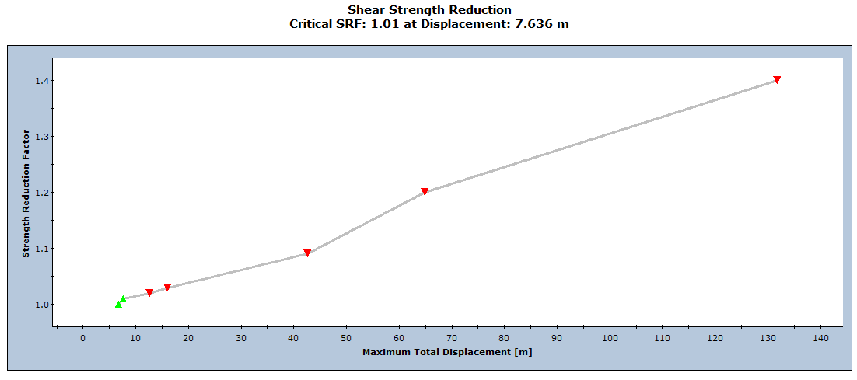
Figure 6.13: SRF vs. displacement curve of the Ahale landslide with vegetation of ERD 2m

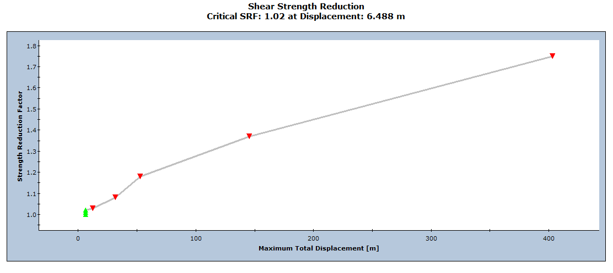
Figure 6.14: SRF vs. displacement graph of Ahale landslide with vegetation of ERD 3m

Athuwa khola landslide

Figure 6.15: Athuwa khola landslide dry soil condition
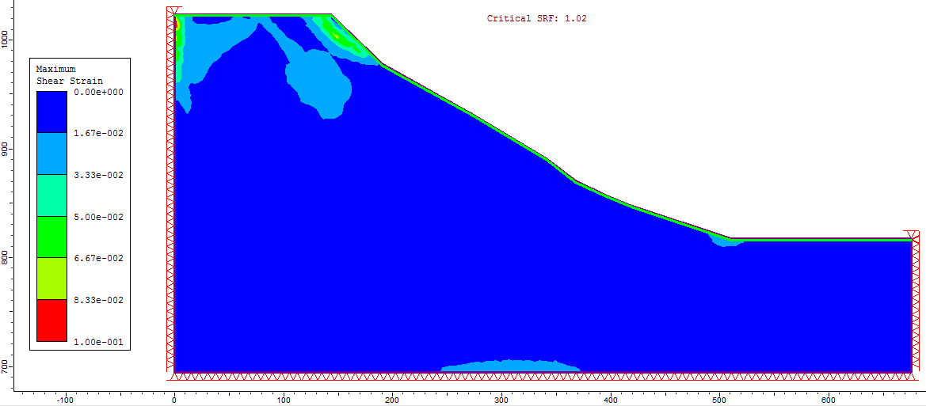
Figure 6.16: Athuwa khola landslide soil with vegetation of ERD 1m

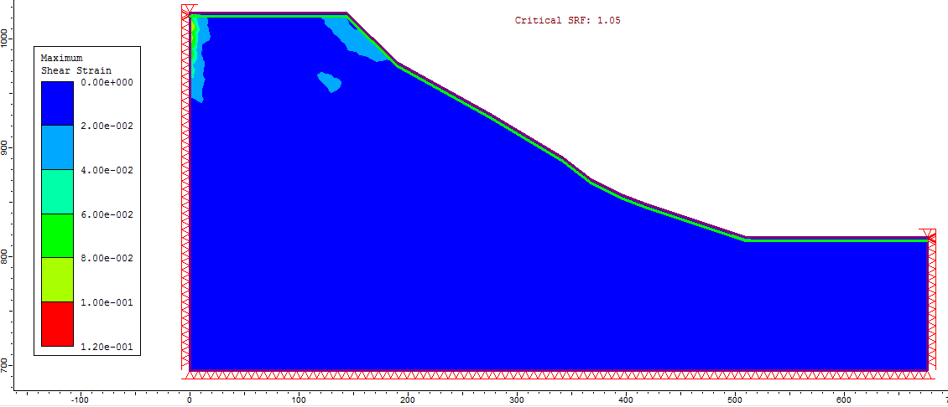
Figure 6.17: Athuwa khola Landslide dry soil with vegetation of ERD 3m
Figure 6.18: Athuwa khola landslide dry soil condition
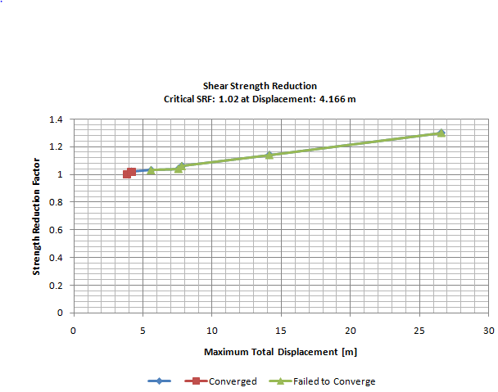
Figure 6.19: Athuwa khola landslide with vegetation of ERD 3m

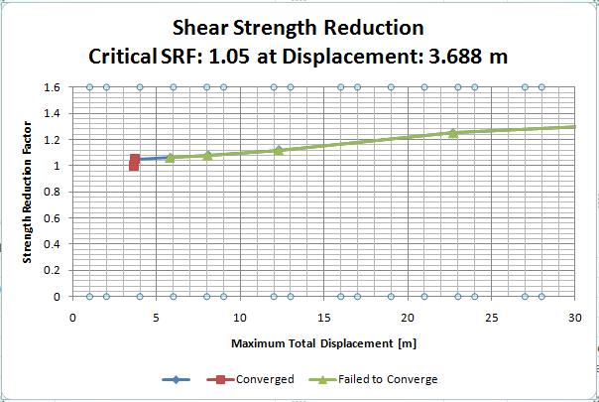
Figure 6.20: Athuwa khola landslide with vegetation of ERD 1m

ANNEX C
Results of site specific analysis

Ahale Landslide
Figure 6.21: SRF vs. displacement curve in Ahale slope
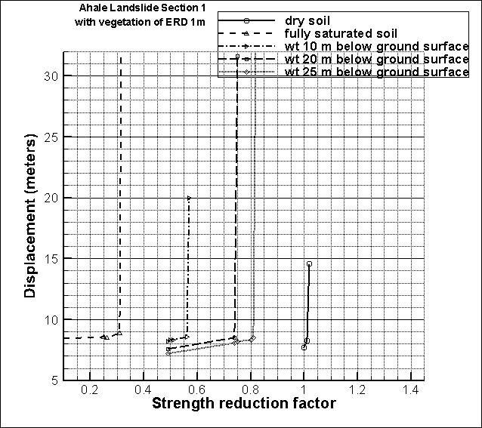
Figure 6.22: SRF vs. displacement curve of Ahale landslide

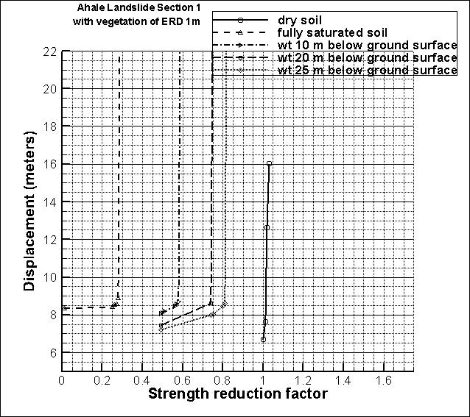
Figure 6.23: SRF vs. displacement curve

Ahale
Table 6.5 SRF calculation of Ahale slope
S.N. | Application of mitigation measures | WT condition | SRF
1 | Normal Condition without vegetation | Dry | 1
 |  | Fully saturated | 0.28
 |  | 4m below GS | 0.42
 |  | 10m below GS | 0.56
 |  | 15m below GS | 0.64
 |  | 20m below GS | 0.73
 |  | 25m below GS | 0.81
 |  | 30m below GS | 0.87
2 | Vegetation of ERD 1m | Dry | 1.01
 |  | Fully saturated | 0.31
 |  | 4m below GS | 0.43
 |  | 10m below GS | 0.56
 |  | 15m below GS | 0.66
 |  | 20m below GS | 0.74
 |  | 25m below GS | 0.81
3 | Vegetation of ERD 2m | Dry | 1.01
 |  | Fully saturated | 0.32
 |  | 4m below GS | 0.44
 |  | 10m below GS | 0.56
 |  | 15m below GS | 0.66
 |  | 20m below GS | 0.74
 |  | 25m below GS | 0.81
4 | Vegetation of ERD 3m | Dry | 1.02
 |  | Fully saturated | 0.35
 |  | 4m below GS | 0.46
 |  | 10m below GS | 0.6
 |  | 15m below GS | 0.68
 |  | 20m below GS | 0.75
 |  | 25m below GS | 0.82
 |  | 30m below GS | 0.88
 |  | 35m below GS | 0.92
 |  | 40m below GS | 0.98

Athuwa Landslide
Table 6.6: SRF calculation of Athuwa slope
S.N. | Application of mitigation measures | WT condition | SRF
1 | Existing | Dry | 1.01
 |  | Fully saturated | 0.28
 |  | 4m below | 0.42
 |  | 10 m below | 0.66
 |  | 20m below | 0.86
 |  | 30m below | 1
2 | Vegetation of ERD 1m | Dry | 1.01
 |  | Fully saturated | 0.29
 |  | 4m below | 0.43
 |  | 10 m below | 0.67
 |  | 20m below | 0.88
 |  | 25m below | 0.96
3 | Vegetation of ERD 3m | Dry | 1.02
 |  | Fully saturated | 0.3
 |  | 10 m below | 0.67
 |  | 20m below | 0.88
4 | Retaining wall 5m | Dry | 1.01
 |  | Fully saturated | 0.29
5 | Vegetation of ERD 1m retaining wall 5m | Dry | 1.02
 |  | Fully saturated | 0.29
6 | Vegetation of ERD 3m retaining wall 5m | Dry | 1.04
 |  | Fully saturated | 0.3
7 | Retaining wall 10m | Dry | 1.02
 |  | Fully saturated | 0.23
8 | Vegetation of ERD 1m retaining wall 10m | Dry | 1.04
 |  | Fully saturated | 0.29
9 | Vegetation of ERD 3m retaining wall 10m | Dry | 1.04
 |  | Fully saturated | 0.29
10 | Retaining wall 15m | Dry | 1.04
 |  | Fully saturated | 0.34
11 | Vegetation of ERD 1m retaining wall 15m | Dry | 1.06
 |  | Fully saturated | 0.35
12 | Vegetation of ERD 3m retaining wall 15m | Dry | 1.06
 |  | Fully saturated | 0.37

ANNEX D
Results of general work as mitigation charts
Figure 6.24: Mitigating Chart of dry soil condition
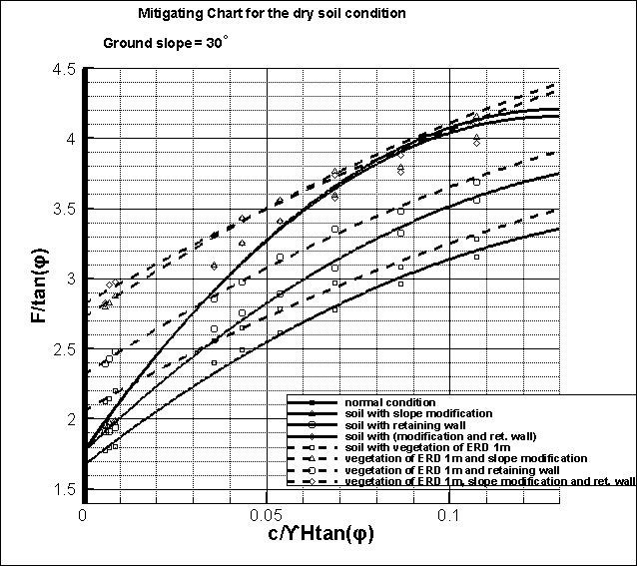
Figure 6.25: Mitigating Chart of dry soil condition

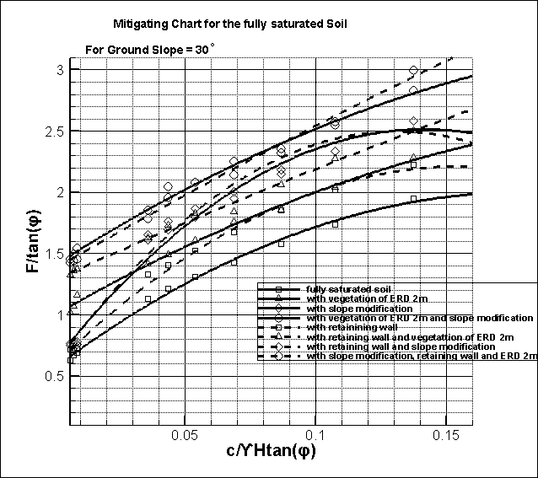
Figure 6.26: Mitigating chart for fully saturated soil
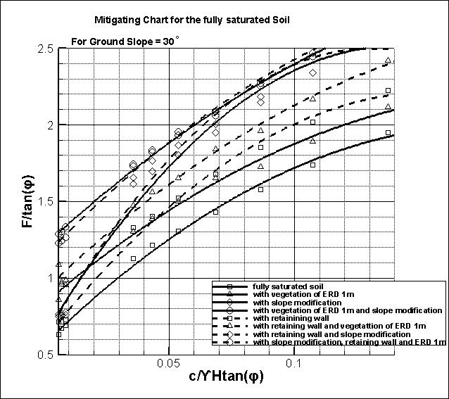
Figure 6.27: Mitigating chart for fully saturated soil
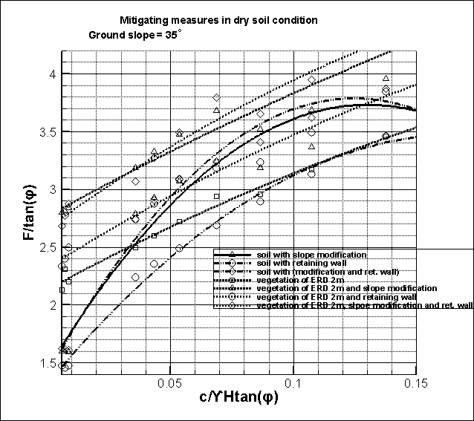
Figure 6.28: Mitigation chart for dry soil condition
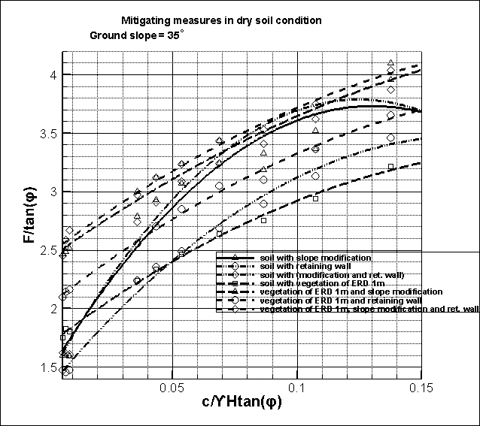
Figure 6.29: Mitigating Chart for dry soil

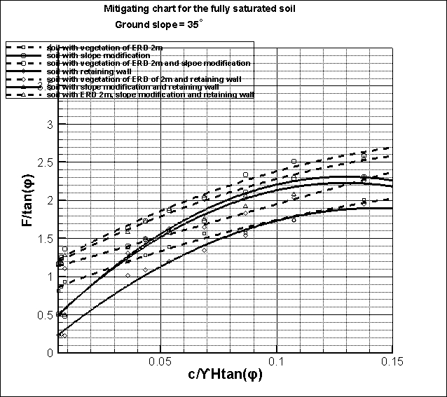
Figure 6.30: Mitigating chart for fully saturated soil
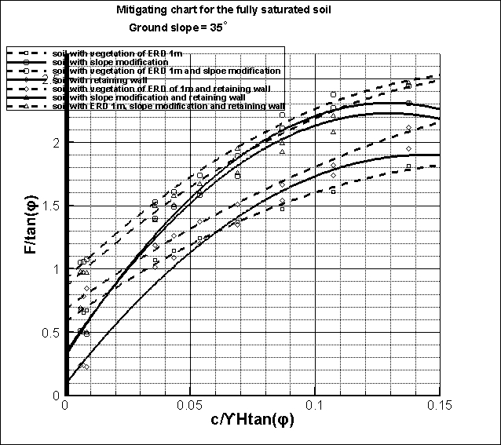
Figure 6.31: Mitigating chart for fully saturated soil
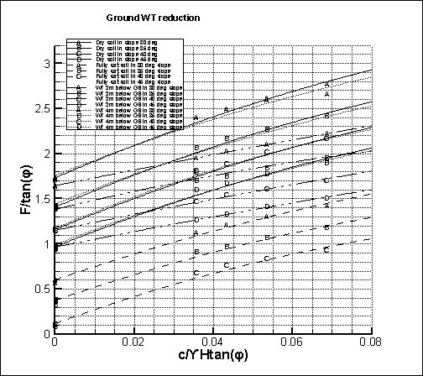
Figure 6.32: Mitigation chart for water table reduction
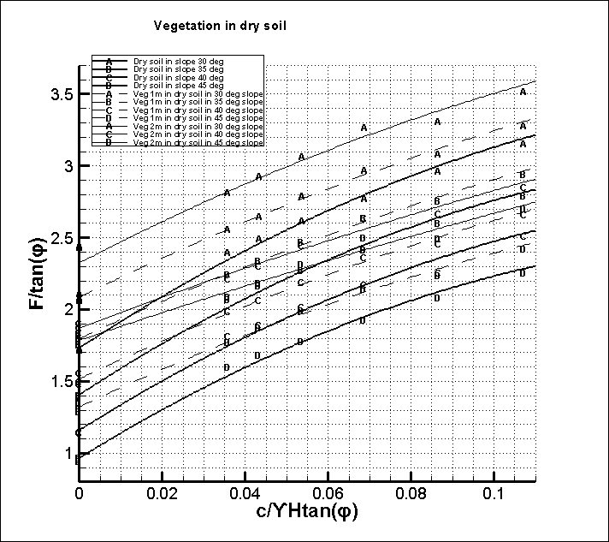
Figure 6.33: Mitigation chart for application of vegetation in dry soil
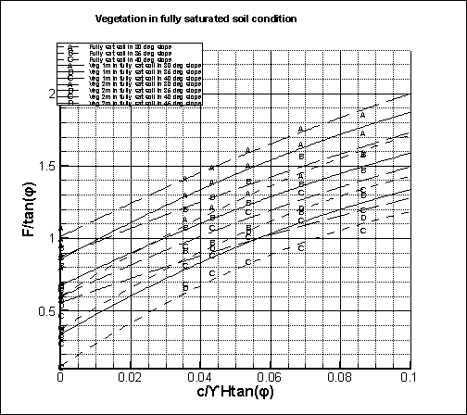
Figure 6.34: Mitigation chart for application of vegetation in fully saturated soil
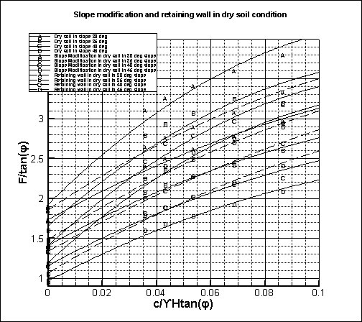
Figure 6.35: Mitigation chart for the application of retaining wall and slope modification in dry soil condition
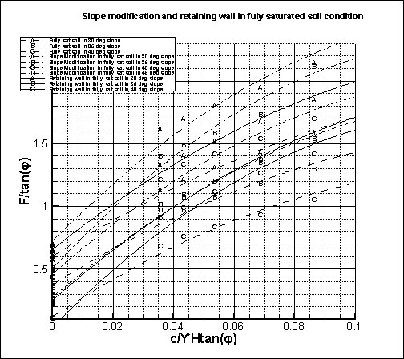
Figure 6.36: Mitigation chart for the application of retaining wall and slope modification in fully saturated soil
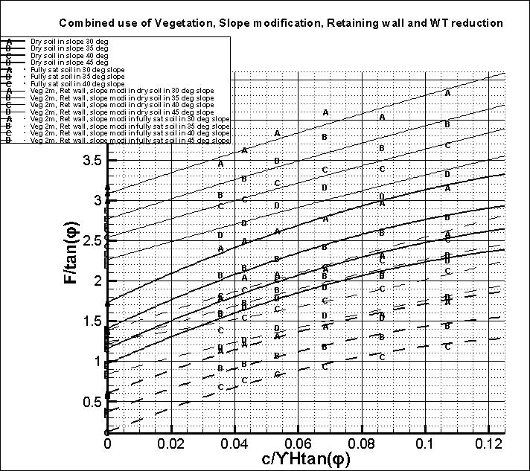
Figure 6.37: Mitigation chart for the combined application of vegetation of ERD 2m, slope modification, retaining wall and water table reduction
Use of Chart
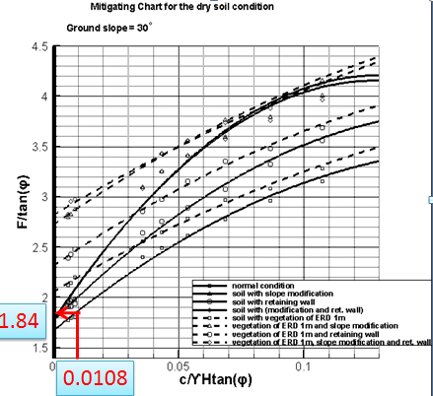
Let us take,
Cohesion = 5 KN/m2
Unit weight= 20 KN/m3
Height = 40 m
Frictional angle = 30
Then, c/rH tan (φ) = 0.0108
From curve of normal condition
Without any mitigation
F/tan (φ) = 1.84
F = 1.06
Hence the SRF of the slope is 1.06

ANNEX E
Results of general work in tabular form
Table 6.7: SRF calculation for ground slope 30 degree
Ground Slope 30 |  |  |  | SRF with variation of Water table and Vegetation
soil |  |  |  |  |  | Vegetation of ERD 1m |  |  |  | Vegetation of ERD 2m
c | phi | dry | 0m | 2m | 4m | dry | 0m | 2m | 4m | dry | 0m | 2m | 4m
0 | 30 | 0.99 | 0.35 | 0.95 | 0.99 | 1.22 | 0.5 | 1.03 | 1.22 | 1.42 | 0.62 | 1.12 | 1.41
0 | 35 | 1.21 | 0.42 | 1.15 | 1.21 | 1.45 | 0.58 | 1.24 | 1.45 | 1.71 | 0.7 | 1.35 | 1.7
0 | 40 | 1.44 | 0.48 | 1.38 | 1.44 | 1.73 | 0.67 | 1.48 | 1.69 | 2.04 | 0.8 | 1.61 | 2.02
5 | 20 | 1.01 | 0.52 | 0.81 | 0.97 | 1.08 | 0.6 | 0.86 | 1.03 | 1.19 | 0.64 | 0.93 | 1.13
5 | 25 | 1.22 | 0.61 | 0.98 | 1.21 | 1.3 | 0.7 | 1.04 | 1.27 | 1.43 | 0.75 | 1.12 | 1.35
5 | 30 | 1.44 | 0.7 | 1.17 | 1.44 | 1.53 | 0.8 | 1.24 | 1.51 | 1.69 | 0.86 | 1.33 | 1.61
5 | 35 | 1.68 | 0.79 | 1.37 | 1.68 | 1.79 | 0.91 | 1.45 | 1.79 | 1.97 | 0.99 | 1.56 | 1.9
10 | 20 | 1.25 | 0.71 | 1 | 1.2 | 1.3 | 0.77 | 1.05 | 1.24 | 1.39 | 0.83 | 1.11 | 1.29
10 | 25 | 1.47 | 0.81 | 1.17 | 1.41 | 1.53 | 0.88 | 1.23 | 1.46 | 1.64 | 0.95 | 1.3 | 1.53
10 | 30 | 1.71 | 0.91 | 1.36 | 1.65 | 1.78 | 0.995 | 1.42 | 1.71 | 1.91 | 1.07 | 1.51 | 1.79
Table 6.8: SRF calculation for ground slope 30 degree
Ground Slope 30 |  |  | SRF with application of slope modification and variation or WT depth and vegetation
 |  | slope modification
soil |  |  |  |  |  | Vegetation of ERD 1m |  |  |  | Vegetation of ERD 2m
c | phi | dry | 0m | 2m | 4m | dry | 0m | 2m | 4m | dry | 0m | 2m | 4m
0 | 30 | 1.14 | 0.45 | 1.11 | 1.14 | 1.66 | 0.77 | 1.4 | 1.66 | 1.87 | 0.89 | 1.49 | 1.82
0 | 35 | 1.38 | 0.54 | 1.36 | 1.38 | 1.98 | 0.91 | 1.69 | 1.89 | 2.23 | 1.045 | 1.79 | 2.19
0 | 40 | 1.64 | 0.64 | 1.61 | 1.64 | 2.35 | 1.08 | 2.01 | 2.35 | 2.65 | 1.22 | 2.12 | 2.6
5 | 20 | 1.31 | 0.71 | 1.02 | 1.23 | 1.37 | 0.75 | 1.06 | 1.27 | 1.46 | 0.82 | 1.13 | 1.34
5 | 25 | 1.59 | 0.84 | 1.25 | 1.53 | 1.66 | 0.91 | 1.31 | 1.59 | 1.77 | 0.97 | 1.37 | 1.65
5 | 30 | 1.88 | 0.98 | 1.49 | 1.83 | 1.98 | 1.05 | 1.56 | 1.91 | 2.11 | 1.13 | 1.64 | 1.98
5 | 35 | 2.17 | 1.13 | 1.79 | 2.18 | 2.32 | 1.21 | 1.86 | 2.27 | 2.48 | 1.3 | 1.95 | 2.35
10 | 20 | 1.57 | 0.94 | 1.22 | 1.45 | 1.63 | 0.98 | 1.27 | 1.52 | 1.7 | 1.03 | 1.33 | 1.59
10 | 25 | 1.87 | 1.09 | 1.46 | 1.71 | 1.94 | 1.14 | 1.53 | 1.82 | 2.02 | 1.19 | 1.61 | 1.89
10 | 30 | 2.19 | 1.24 | 1.71 | 2.03 | 2.26 | 1.3 | 1.77 | 2.11 | 2.37 | 1.36 | 1.83 | 2.18
Table 6.9: SRF calculation for ground slope 30 degree
Ground Slope 30 |  |  | SRF with application of retaining wall and variation or WT depth and vegetation
 |  | Retaining wall
soil |  |  |  |  |  | Vegetation of ERD 1m |  |  |  | Vegetation of ERD 2m
c | phi | dry | 0m | 2m | 4m | dry | 0m | 2m | 4m | dry | 0m | 2m | 4m
0 | 30 | 1.12 | 0.42 | 1.11 | 1.12 | 1.43 | 0.57 | 1.24 | 1.43 | 1.68 | 0.79 | 1.3 | 1.62
0 | 35 | 1.34 | 0.5 | 1.31 | 1.34 | 1.7 | 0.68 | 1.49 | 1.7 | 1.95 | 0.95 | 1.52 | 1.91
0 | 40 | 1.63 | 0.6 | 1.6 | 1.62 | 2.01 | 0.91 | 1.74 | 2.01 | 2.26 | 1.11 | 1.8 | 2.23
5 | 20 | 1.12 | 0.61 | 0.89 | 1.1 | 1.22 | 0.67 | 0.94 | 1.14 | 1.27 | 0.67 | 0.96 | 1.18
5 | 25 | 1.35 | 0.71 | 1.11 | 1.34 | 1.47 | 0.77 | 1.16 | 1.38 | 1.6 | 0.85 | 1.21 | 1.43
5 | 30 | 1.59 | 0.81 | 1.33 | 1.58 | 1.72 | 0.9 | 1.38 | 1.63 | 1.86 | 1 | 1.44 | 1.68
5 | 35 | 1.85 | 0.93 | 1.57 | 1.86 | 2 | 1.03 | 1.64 | 2 | 2.15 | 1.14 | 1.68 | 2.05
10 | 20 | 1.39 | 0.81 | 1.1 | 1.29 | 1.45 | 0.88 | 1.15 | 1.37 | 1.52 | 0.91 | 1.18 | 1.45
10 | 25 | 1.66 | 0.94 | 1.3 | 1.55 | 1.72 | 1.01 | 1.35 | 1.61 | 1.79 | 1.06 | 1.39 | 1.68
10 | 30 | 1.92 | 1.07 | 1.53 | 1.83 | 2.01 | 1.13 | 1.58 | 1.88 | 2.08 | 1.19 | 1.63 | 1.96
Table 6.10: SRF calculation for ground slope 30 degree
Ground Slope 30 |  |  | SRF with retaining wall, slope modification and variation or WT depth and vegetation
 |  | slope modification and retaining wall
soil |  |  |  |  |  | Vegetation of ERD 1m |  |  |  | Vegetation of ERD 2m
c | phi | dry | 0m | 2m | 4m | dry | 0m | 2m | 4m | dry | 0m | 2m | 4m
0 | 30 | 1.15 | 0.44 | 1.13 | 1.15 | 1.72 | 0.73 | 1.38 | 1.71 | 1.88 | 0.84 | 1.48 | 1.85
0 | 35 | 1.38 | 0.53 | 1.36 | 1.38 | 2.07 | 0.87 | 1.67 | 2.05 | 2.21 | 1.01 | 1.73 | 2.17
0 | 40 | 1.65 | 0.63 | 1.64 | 1.65 | 2.37 | 1.03 | 1.99 | 2.37 | 2.56 | 1.2 | 2.04 | 2.54
5 | 20 | 1.3 | 0.73 | 1.02 | 1.23 | 1.36 | 0.76 | 1.07 | 1.28 | 1.49 | 0.78 | 1.11 | 1.35
5 | 25 | 1.59 | 0.87 | 1.24 | 1.52 | 1.66 | 0.9 | 1.3 | 1.6 | 1.79 | 0.97 | 1.38 | 1.68
5 | 30 | 1.88 | 1.02 | 1.49 | 1.83 | 1.98 | 1.06 | 1.56 | 1.91 | 2.09 | 1.18 | 1.62 | 2
5 | 35 | 2.16 | 1.16 | 1.76 | 2.16 | 2.32 | 1.22 | 1.84 | 2.24 | 2.42 | 1.25 | 1.9 | 2.34
10 | 20 | 1.55 | 0.94 | 1.22 | 1.43 | 1.61 | 0.99 | 1.27 | 1.49 | 1.73 | 1.09 | 1.32 | 1.55
10 | 25 | 1.85 | 1.09 | 1.45 | 1.72 | 1.92 | 1.15 | 1.51 | 1.79 | 2.02 | 1.2 | 1.56 | 1.85
10 | 30 | 2.17 | 1.26 | 1.7 | 2.04 | 2.24 | 1.31 | 1.76 | 2.12 | 2.33 | 1.34 | 1.82 | 2.19
Table 6.11: SRF calculation for ground slope 35 degree
Ground Slope 35 |  |  |  | SRF with variation of Water table and Vegetation
soil |  |  |  |  |  | Vegetation of ERD 1m |  |  |  | Vegetation of ERD 2m
c | phi | dry | 0m | 2m | 4m | dry | 0m | 2m | 4m | dry | 0m | 2m | 4m
0 | 35 | 0.98 | 0.27 | 0.97 | 0.98 | 1.28 | 0.46 | 1.27 | 1.28 | 1.62 | 0.61 | 1.54 | 1.57
0 | 40 | 1.19 | 0.31 | 1.17 | 1.19 | 1.47 | 0.57 | 1.33 | 1.47 | 1.79 | 0.68 | 1.59 | 1.79
5 | 20 | 0.88 | 0.43 | 0.71 | 0.88 | 0.96 | 0.5 | 0.77 | 0.95 | 1.07 | 0.57 | 0.84 | 1.01
5 | 25 | 1.06 | 0.5 | 0.86 | 1.06 | 1.15 | 0.58 | 0.92 | 1.13 | 1.27 | 0.65 | 1 | 1.21
5 | 30 | 1.25 | 0.56 | 1.01 | 1.25 | 1.35 | 0.66 | 1.09 | 1.34 | 1.5 | 0.74 | 1.17 | 1.44
5 | 35 | 1.45 | 0.64 | 1.19 | 1.45 | 1.57 | 0.75 | 1.28 | 1.55 | 1.75 | 0.84 | 1.37 | 1.7
Table 6.12: SRF calculation for ground slope 35 degree
Ground Slope 35 |  |  | SRF with application of slope modification and variation or WT depth and vegetation
 |  | slope modification
soil |  |  |  |  |  | Vegetation of ERD 1m |  |  |  | Vegetation of ERD 2m
c | phi | dry | 0m | 2m | 4m | dry | 0m | 2m | 4m | dry | 0m | 2m | 4m
0 | 30 | 0.92 | 0.28 | 0.9 | 0.92 | 1.45 | 0.62 | 1.23 | 1.44 | 1.64 | 0.79 | 1.41 | 1.62
0 | 35 | 1.12 |  | 1.09 | 1.11 | 1.74 | 0.74 | 1.48 | 1.73 | 1.97 | 0.88 | 1.67 | 1.95
0 | 40 | 1.34 | 0.43 | 1.33 | 1.34 | 2.07 | 0.88 | 1.7 | 2.07 | 2.35 | 0.98 | 1.89 | 2.33
5 | 20 | 1.18 | 0.63 | 0.94 | 1.13 | 1.25 | 0.69 | 0.99 | 1.18 | 1.34 | 0.74 | 1.04 | 1.27
5 | 25 | 1.43 | 0.74 | 1.14 | 1.4 | 1.51 | 0.81 | 1.2 | 1.45 | 1.62 | 0.87 | 1.27 | 1.53
5 | 30 | 1.69 | 0.86 | 1.36 | 1.68 | 1.8 | 0.93 | 1.43 | 1.75 | 1.92 | 1 | 1.51 | 1.83
5 | 35 | 1.95 | 0.98 | 1.63 | 1.94 | 2.1 | 1.07 | 1.7 | 1.99 | 2.23 | 1.15 | 1.77 | 2.17
10 | 20 | 1.44 | 0.84 | 1.14 | 1.4 | 1.49 | 0.89 | 1.21 | 1.44 | 1.57 | 0.94 | 1.26 | 1.49
10 | 25 | 1.57 | 1.06 | 1.35 | 1.53 | 1.64 | 1.11 | 1.41 | 1.59 | 1.72 | 1.17 | 1.47 | 1.65
10 | 30 | 1.84 | 1.22 | 1.59 | 1.81 | 1.92 | 1.28 | 1.66 | 1.86 | 2.03 | 1.35 | 1.74 | 1.92

Table 6.13: SRF calculation for ground slope 35 degree
Ground Slope 35 |  |  | SRF with application of retaining wall and variation or WT depth and vegetation
 |  | retaining wall
soil |  |  |  |  |  | Vegetation of ERD 1m |  |  |  | Vegetation of ERD 2m
c | phi | dry | 0m | 2m | 4m | dry | 0m | 2m | 4m | dry | 0m | 2m | 4m
0 | 30 | 0.85 | 0.13 | 0.83 | 0.85 | 1.25 | 0.49 | 1.07 | 1.23 | 1.44 | 0.64 | 1.14 | 1.4
0 | 35 | 1.02 | 0.17 | 1 | 1.02 | 1.5 | 0.55 | 1.28 | 1.5 | 1.68 | 0.82 | 1.35 | 1.65
0 | 40 | 1.24 | 0.2 | 1.23 | 1.24 | 1.76 | 0.58 | 1.49 | 1.76 | 1.96 | 1 | 1.56 | 1.93
5 | 20 | 0.98 | 0.49 | 0.8 | 0.98 | 1.11 | 0.55 | 0.87 | 1.07 | 1.16 | 0.6 | 0.94 | 1.11
5 | 25 | 1.16 | 0.56 | 1 | 1.16 | 1.33 | 0.64 | 1.06 | 1.29 | 1.44 | 0.76 | 1.09 | 1.34
5 | 30 | 1.36 | 0.63 | 1.19 | 1.36 | 1.56 | 0.73 | 1.27 | 1.53 | 1.66 | 0.85 | 1.28 | 1.57
5 | 35 | 1.57 | 0.71 | 1.39 | 1.57 | 1.79 | 0.83 | 1.46 | 1.75 | 1.92 | 0.92 | 1.49 | 1.84
10 | 20 | 1.26 | 0.71 | 1 | 1.18 | 1.33 | 0.77 | 1.06 | 1.23 | 1.4 | 0.82 | 1.08 | 1.27
10 | 25 | 1.46 | 0.81 | 1.18 | 1.41 | 1.57 | 0.85 | 1.24 | 1.52 | 1.63 | 0.95 | 1.28 | 1.57
10 | 30 | 1.67 | 0.89 | 1.38 | 1.66 | 1.79 | 0.96 | 1.46 | 1.73 | 1.87 | 1.06 | 1.47 | 1.78
Table 6.14: SRF calculation for ground slope 35 degree
Ground Slope 35 |  |  | SRF with retaining wall, slope modification and variation or WT depth and vegetation
 |  | slope modification and retaining wall
soil |  |  |  |  |  | Vegetation of ERD 1m |  |  |  | Vegetation of ERD 2m
c | phi | dry | 0m | 2m | 4m | dry | 0m | 2m | 4m | dry | 0m | 2m | 4m
0 | 30 | 0.93 | 0.29 | 0.91 | 0.92 | 1.54 | 0.56 | 1.19 | 1.5 | 1.66 | 0.74 | 1.31 | 1.63
0 | 35 | 1.13 | 0.35 | 1.11 | 1.12 | 1.81 | 0.68 | 1.45 | 1.77 | 1.94 | 0.84 | 1.6 | 1.91
0 | 40 | 1.36 | 0.42 | 1.35 | 1.34 | 2.06 | 0.82 | 1.74 | 2.03 | 2.25 | 0.97 | 1.96 | 2.23
5 | 20 | 1.18 | 0.64 | 0.92 | 1.12 | 1.25 | 0.71 | 0.99 | 1.17 | 1.38 | 0.75 | 1.07 | 1.28
5 | 25 | 1.44 | 0.75 | 1.13 | 1.38 | 1.51 | 0.78 | 1.18 | 1.44 | 1.63 | 0.88 | 1.26 | 1.54
5 | 30 | 1.68 | 0.87 | 1.35 | 1.65 | 1.8 | 0.91 | 1.41 | 1.73 | 1.89 | 0.995 | 1.47 | 1.82
5 | 35 | 1.92 | 0.97 | 1.59 | 1.91 | 2.08 | 1.05 | 1.67 | 2.05 | 2.15 | 1.11 | 1.75 | 2.11
10 | 20 | 1.41 | 0.84 | 1.12 | 1.31 | 1.47 | 0.9 | 1.17 | 1.36 | 1.58 | 0.93 | 1.22 | 1.41
10 | 25 | 1.69 | 0.97 | 1.33 | 1.58 | 1.75 | 1.03 | 1.38 | 1.63 | 1.84 | 1.08 | 1.46 | 1.68
10 | 30 | 1.97 | 1.11 | 1.55 | 1.86 | 2.04 | 1.15 | 1.61 | 1.92 | 2.11 | 1.19 | 1.66 | 1.98
Table 6.15: SRF calculation for ground slope 40 degree
Ground Slope 40 |  |  |  | SRF with variation of Water table and Vegetation
soil |  |  |  |  |  | Vegetation of ERD 1m |  |  |  | Vegetation of ERD 2m
c | phi | dry | 0m | 2m | 4m | dry | 0m | 2m | 4m | dry | 0m | 2m | 4m
0 | 30 | 0.66 | 0.05 | 0.65 | 0.66 | 0.9 | 0.16 | 0.77 | 0.9 | 1.1 | 0.27 | 0.88 | 1.11
0 | 35 | 0.81 | 0.08 | 0.8 | 0.81 | 1.05 | 0.27 | 0.92 | 1.05 | 1.31 | 0.47 | 1.03 | 1.31
0 | 40 | 0.96 | 0.09 | 0.95 | 0.96 | 1.24 | 0.27 | 1.1 | 1.24 | 1.54 | 0.54 | 1.29 | 1.54
5 | 20 | 0.79 | 0.34 | 0.62 | 0.79 | 0.86 | 0.41 | 0.69 | 0.85 | 0.96 | 0.48 | 0.76 | 0.9
5 | 25 | 0.94 | 0.39 | 0.75 | 0.94 | 1.02 | 0.47 | 0.82 | 1.01 | 1.14 | 0.55 | 0.9 | 1.1
5 | 30 | 1.09 | 0.44 | 0.89 | 1.09 | 1.19 | 0.51 | 0.97 | 1.18 | 1.33 | 0.62 | 1.04 | 1.3
5 | 35 | 1.27 | 0.48 | 1.03 | 1.26 | 1.39 | 0.57 | 1.13 | 1.38 | 1.55 | 0.66 | 1.23 | 1.52
10 | 20 | 1 | 0.49 | 0.8 | 0.95 | 1.06 | 0.56 | 0.86 | 1.01 | 1.14 | 0.63 | 0.91 | 1.08
10 | 25 | 1.17 | 0.55 | 0.93 | 1.13 | 1.24 | 0.62 | 0.995 | 1.19 | 1.33 | 0.7 | 1.06 | 1.28
10 | 30 | 1.34 | 0.61 | 1.07 | 1.31 | 1.42 | 0.69 | 1.14 | 1.38 | 1.54 | 0.77 | 1.23 | 1.45

Table 6.16: SRF calculation for ground slope 40 degree
Ground Slope 40 |  |  | SRF with application of slope modification and variation or WT depth and vegetation
 |  | slope modification
soil |  |  |  |  |  | Vegetation of ERD 1m |  |  |  | Vegetation of ERD 2m
c | phi | dry | 0m | 2m | 4m | dry | 0m | 2m | 4m | dry | 0m | 2m | 4m
0 | 30 | 0.8 | 0.25 | 0.79 | 0.8 | 1.31 | 0.5 | 1.13 | 1.3 | 1.5 | 0.62 | 1.31 | 1.48
0 | 35 | 0.98 | 0.31 | 0.97 | 0.98 | 1.58 | 0.6 | 1.37 | 1.57 | 1.8 | 0.68 | 1.43 | 1.78
0 | 40 | 1.16 | 0.37 | 1.18 | 1.16 | 1.88 | 0.72 | 1.63 | 1.87 | 1.88 | 0.74 | 1.58 | 1.86
5 | 20 | 1.08 | 0.56 | 0.86 | 1.03 | 1.16 | 0.63 | 0.92 | 1.1 | 1.23 | 0.67 | 0.97 | 1.17
5 | 25 | 1.3 | 0.66 | 1.05 | 1.28 | 1.39 | 0.73 | 1.12 | 1.34 | 1.46 | 0.77 | 1.17 | 1.43
5 | 30 | 1.55 | 0.77 | 1.25 | 1.48 | 1.64 | 0.83 | 1.32 | 1.58 | 1.77 | 0.88 | 1.39 | 1.68
5 | 35 | 1.72 | 0.85 | 1.5 | 1.75 | 1.92 | 0.94 | 1.58 | 1.87 | 2.06 | 1.03 | 1.66 | 2
10 | 20 | 1.33 | 0.76 | 1.06 | 1.25 | 1.39 | 0.82 | 1.11 | 1.3 | 1.45 | 0.86 | 1.15 | 1.35
10 | 25 | 1.57 | 0.87 | 1.25 | 1.49 | 1.64 | 0.94 | 1.31 | 1.56 | 1.72 | 0.98 | 1.36 | 1.63
10 | 30 | 1.83 | 0.98 | 1.57 | 1.75 | 1.92 | 1.05 | 1.52 | 1.84 | 2 | 1.1 | 1.59 | 1.92
Table 6.17: SRF calculation for ground slope 40 degree
Ground Slope 40 |  |  | SRF with application of retaining wall and variation or WT depth and vegetation
 |  | retaining wall
soil |  |  |  |  |  | Vegetation of ERD 1m |  |  |  | Vegetation of ERD 2m
c | phi | dry | 0m | 2m | 4m | dry | 0m | 2m | 4m | dry | 0m | 2m | 4m
0 | 30 | 0.77 | 0.01 | 0.75 | 0.77 | 1.13 | 0.34 | 1.09 | 1.12 | 1.33 | 0.68 | 1.22 | 1.3
0 | 35 | 0.93 | 0.01 | 0.91 | 0.93 | 1.34 | 0.43 | 1.19 | 1.31 | 1.58 | 0.74 | 1.39 | 1.55
0 | 40 | 1.12 | 0.01 | 1.08 | 1.1 | 1.57 | 0.49 | 1.43 | 1.52 | 1.81 | 0.8 | 1.66 | 1.94
5 | 20 | 0.89 | 0.46 | 0.76 | 0.91 | 1.04 | 0.5 | 0.84 | 0.98 | 1.12 | 0.58 | 0.85 | 1.02
5 | 25 | 1.06 | 0.52 | 0.94 | 1.12 | 1.24 | 0.61 | 1.03 | 1.21 | 1.35 | 0.72 | 1.06 | 1.27
5 | 30 | 1.3 | 0.57 | 1.12 | 1.21 | 1.43 | 0.63 | 1.2 | 1.43 | 1.56 | 0.83 | 1.25 | 1.55
5 | 35 | 1.54 | 0.64 | 1.32 | 1.4 | 1.65 | 0.69 | 1.39 | 1.58 | 1.78 | 0.74 | 1.46 | 1.72
10 | 20 | 1.18 | 0.66 | 0.94 | 1.1 | 1.24 | 0.71 | 0.995 | 1.15 | 1.32 | 0.76 | 1.04 | 1.22
10 | 25 | 1.37 | 0.74 | 1.12 | 1.31 | 1.46 | 0.79 | 1.17 | 1.38 | 1.53 | 0.89 | 1.22 | 1.44
10 | 30 | 1.55 | 0.82 | 1.3 | 1.53 | 1.66 | 0.85 | 1.35 | 1.6 | 1.74 | 0.97 | 1.4 | 1.67
Table 6.18: SRF calculation for ground slope 40 degree
Ground Slope 40 |  |  | SRF with retaining wall, slope modification and variation or WT depth and vegetation
 |  | slope modification and retaining wall
soil |  |  |  |  |  | Vegetation of ERD 1m |  |  |  | Vegetation of ERD 2m
c | phi | dry | 0m | 2m | 4m | dry | 0m | 2m | 4m | dry | 0m | 2m | 4m
5 | 20 | 1.08 | 0.56 | 0.85 | 1.03 | 1.14 | 0.61 | 0.91 | 1.09 | 1.23 | 0.64 | 0.96 | 1.15
5 | 25 | 1.31 | 0.69 | 1.04 | 1.27 | 1.39 | 0.71 | 1.12 | 1.33 | 1.5 | 0.77 | 1.18 | 1.44
5 | 30 | 1.54 | 0.8 | 1.25 | 1.49 | 1.66 | 0.82 | 1.33 | 1.59 | 1.74 | 0.89 | 1.41 | 1.69
5 | 35 | 1.75 | 0.91 | 1.49 | 1.79 | 1.9 | 0.92 | 1.59 | 1.88 | 2.05 | 0.97 | 1.69 | 1.97
10 | 20 | 1.31 | 0.76 | 1.03 | 1.22 | 1.36 | 0.83 | 1.09 | 1.28 | 1.47 | 0.85 | 1.14 | 1.35
10 | 25 | 1.55 | 0.89 | 1.22 | 1.46 | 1.62 | 0.95 | 1.29 | 1.58 | 1.72 | 0.99 | 1.36 | 1.62
10 | 30 | 1.81 | 1.02 | 1.43 | 1.72 | 1.91 | 1.08 | 1.43 | 1.72 | 1.96 | 1.1 | 1.56 | 1.87

Table 6.19: SRF calculation for ground slope 45 degree
Ground Slope 45 |  |  |  | SRF with variation of Water table and Vegetation
soil |  |  |  |  |  | Vegetation of ERD 1m |  |  |  | Vegetation of ERD 2m
c | phi | dry | 0m | 2m | 4m | dry | 0m | 2m | 4m | dry | 0m | 2m | 4m
5 | 20 | 0.7 | 0.25 | 0.55 | 0.69 | 0.78 | 0.3 |  | 0.76 | 0.91 | 0.44 | 0.72 | 0.86
5 | 25 | 0.83 | 0.28 | 0.66 | 0.83 | 0.93 | 0.33 | 0.73 | 0.91 | 1.08 | 0.49 | 0.84 | 1.03
5 | 30 | 0.97 | 0.32 | 0.77 | 0.97 | 1.08 | 0.37 | 0.86 | 1.08 | 1.26 | 0.54 | 0.98 | 1.21
5 | 35 | 1.12 | 0.36 | 0.89 | 1.12 | 1.24 | 0.41 | 0.995 | 1.25 | 1.46 | 0.46 | 1.09 | 1.41
10 | 20 | 0.9 | 0.36 | 0.72 | 0.87 | 0.97 | 0.44 | 0.78 | 0.93 | 1.08 | 0.54 | 0.87 | 1.01
10 | 25 | 1.05 | 0.41 | 0.83 | 1.03 | 1.13 | 0.49 | 0.9 | 1.08 | 1.26 | 0.6 | 1 | 1.16
10 | 30 | 1.2 | 0.45 | 0.95 | 1.18 | 1.29 | 0.54 | 1.03 | 1.23 | 1.44 | 0.66 | 1.13 | 1.31
Table 6.20: SRF calculation for ground slope 45 degree
Ground Slope 45 |  |  | SRF with application of slope modification and variation or WT depth and vegetation
 |  | slope modification
soil |  |  |  |  |  | Vegetation of ERD 1m |  |  |  | Vegetation of ERD 2m
c | phi | dry | 0m | 2m | 4m | dry | 0m | 2m | 4m | dry | 0m | 2m | 4m
0 | 30 | 0.68 | 0.17 | 0.69 | 0.67 | 1.2 | 0.36 | 1.04 | 1.2 | 1.4 | 0.53 | 1.11 | 1.37
0 | 35 | 0.82 | 0.15 | 0.84 | 0.83 | 1.44 | 0.44 | 1.26 | 1.45 | 1.69 | 0.64 | 1.42 | 1.65
0 | 40 | 0.99 | 0.24 | 1 | 0.98 | 1.72 | 0.53 | 1.5 | 1.73 | 2 | 0.75 | 1.6 | 1.97
5 | 20 | 1 | 0.5 | 0.8 | 0.98 | 1.07 | 0.56 | 0.86 | 1.03 | 1.16 | 0.6 | 0.92 | 1.09
5 | 25 | 1.2 | 0.56 | 0.97 | 1.2 | 1.29 | 0.66 | 1.04 | 1.27 | 1.39 | 0.69 | 1.1 | 1.33
5 | 30 | 1.39 | 0.62 | 1.16 | 1.39 | 1.52 | 0.74 | 1.23 | 1.51 | 1.64 | 0.79 | 1.3 | 1.59
5 | 35 | 1.57 | 0.68 | 1.38 | 1.57 | 1.77 | 0.84 | 1.46 | 1.77 | 1.93 | 0.9 | 1.54 | 1.87
10 | 20 | 1.24 | 0.69 | 1 | 1.17 | 1.3 | 0.75 | 1.04 | 1.23 | 1.37 | 0.79 | 1.09 | 1.3
10 | 25 | 1.47 | 0.79 | 1.17 | 1.41 | 1.53 | 0.84 | 1.23 | 1.45 | 1.6 | 0.9 | 1.26 | 1.51
10 | 30 | 1.7 | 0.88 | 1.36 | 1.64 | 1.78 | 0.95 | 1.42 | 1.72 | 1.88 | 1 | 1.49 | 1.78
Table 6.21: SRF calculation for ground slope 45 degree
`Ground slope 45 |  |  | SRF with application of retaining wall and variation or WT depth and vegetation
 |  | retaining wall
soil |  |  |  |  |  | Vegetation of ERD 1m |  |  |  | Vegetation of ERD 2m
c | phi | dry | 0m | 2m | 4m | dry | 0m | 2m | 4m | dry | 0m | 2m | 4m
5 | 20 | 0.8 | 0.33 | 0.65 | 0.8 | 0.95 | 0.39 | 0.73 | 0.9 | 1.02 | 0.51 | 0.73 | 1
5 | 25 | 0.94 | 0.37 | 0.81 | 0.94 | 1.1 | 0.46 | 0.9 | 1.09 | 1.21 | 0.62 | 0.91 | 1.14
5 | 30 | 1.09 | 0.42 | 0.96 | 1.08 | 1.27 | 0.51 | 1.04 | 1.26 | 1.38 | 0.69 | 1.04 | 1.31
5 | 35 | 1.25 | 0.46 | 1.13 | 1.23 | 1.46 | 0.57 | 1.18 | 1.47 | 1.56 | 0.68 | 1.21 | 1.51
10 | 20 | 1.07 | 0.48 | 0.84 | 1.01 | 1.15 | 0.55 | 0.92 | 1.07 | 1.2 | 0.67 | 0.93 | 1.11
10 | 25 | 1.23 | 0.54 | 1.02 | 1.2 | 1.32 | 0.62 | 1.07 | 1.27 | 1.38 | 0.75 | 1.08 | 1.29
10 | 30 | 1.39 | 0.59 | 1.18 | 1.4 | 1.49 | 0.69 | 1.19 | 1.44 | 1.55 | 0.78 | 1.22 | 1.47

Table 6.22: SRF calculation for ground slope 45 degree
Ground Slope 45 |  |  | SRF with retaining wall, slope modification and variation or WT depth and vegetation
 |  | slope modification and retaining wall
soil |  |  |  |  |  | Vegetation of ERD 1m |  |  |  | Vegetation of ERD 2m
c | phi | dry | 0m | 2m | 4m | dry | 0m | 2m | 4m | dry | 0m | 2m | 4m
5 | 20 | 1 | 0.45 | 0.77 | 0.95 | 1.07 | 0.49 | 0.82 | 1.01 | 1.15 | 0.57 | 0.84 | 1.07
5 | 25 | 1.19 | 0.5 | 0.94 | 1.17 | 1.3 | 0.56 | 1.01 | 1.24 | 1.37 | 0.66 | 1.07 | 1.3
5 | 30 | 1.35 | 0.55 | 1.13 | 1.36 | 1.5 | 0.63 | 1.19 | 1.48 | 1.57 | 0.73 | 1.23 | 1.54
5 | 35 | 1.52 | 0.59 | 1.33 | 1.54 | 1.7 | 0.72 | 1.39 | 1.67 | 1.8 | 0.82 | 1.46 | 1.77
10 | 20 | 1.21 | 0.65 | 0.96 | 1.13 | 1.28 | 0.68 | 1.02 | 1.19 | 1.35 | 0.75 | 1.04 | 1.25
10 | 25 | 1.44 | 0.73 | 1.13 | 1.36 | 1.52 | 0.77 | 1.2 | 1.42 | 1.55 | 0.84 | 1.25 | 1.49
10 | 30 | 1.69 | 0.82 | 1.32 | 1.6 | 1.72 | 0.85 | 1.39 | 1.67 | 1.76 | 0.89 | 1.41 | 1.71

ANNEX F
Calculation using LEM
Table 6.23: Calculation using LEM on slope of 30 degree
From Slide
soil |  |  |  |  |  | bio 1m |  |  |  | bio 2m
c | phi | dry | 0m | 2m | 4m | dry | 0m | 2m | 4m | dry | 0m | 2m | 4m
5 | 20 | 1.011 | 0.547 | 0.812 |  | 1.059 | 0.58 | 0.843 | 1.026 | 1.144 | 0.63 | 0.9 | 1
5 | 25 | 1.216 | 0.634 | 0.985 | 1.221 | 1.277 | 0.67 | 1.018 | 1.254 | 1.373 | 0.729 | 1.1 | 1
5 | 30 | 1.436 | 0.726 | 1.171 | 1.443 | 1.508 | 0.77 | 1.208 | 1.5 | 1.625 | 0.834 | 1.3 | 2
10 | 20 | 1.249 | 0.758 | 1.003 |  |  |  |  |  | 1.354 | 0.821 | 1.1 | 1
10 | 25 | 1.472 | 0.887 | 1.178 |  | 1.514 |  | 1.208 | 1.442 | 1.6 | 0.93 | 1.3 | 1

Table 6.24: Calculation using LEM on slope of 30 degree
soil |  |  |  |  |  | bio 1m |  |  |  | bio 2m
c | phi | dry | 0m | 2m | 4m | dry | 0m | 2m | 4m | dry | 0m | 2m | 4m
5 | 20 | 1.341 | 0.743 | 1.035 | 1.253 | 1.368 | 1.45 |  |  |  | 0.814 | 1.1 | 1
5 | 25 | 1.613 | 0.877 | 1.264 | 1.549 | 1.665 | 0.91 | 1.303 | 1.591 | 1.754 | 0.964 | 1.4 | 2
5 | 30 | 1.916 | 1.02 | 1.512 | 1.854 | 1.984 | 1.06 | 1.555 | 1.901 | 2.086 | 1.117 | 1.6 | 2

