TRIBHUVAN UNIVERSITY
INSTITUTE OF ENGINEERING
PULCHOWK CAMPUS
THESIS NO: M-30-MSMDE-2018-2021
Experimental Investigation on the Performance of a CI Engine Fueled with Waste Cooking Oil Biodiesel Blends in Varying Compression Ratio
by
LOCHAN KENDRA DEVKOTA
A THESIS
SUBMITTED TO THE DEPARTMENT OF MECHANICAL AND AEROSPACE ENGINEERING IN PARTIAL FULFILLMENT OF THE REQUIREMENTS FOR THE DEGREE OF MASTER IN
MECHANICAL SYSTEMS DESIGN AND ENGINEERINNG

DEPARTMENT OF MECHANICAL AND AEROSPACE ENGINEERING
LALITPUR, NEPAL
MARCH, 2021

COPYRIGHT

The author has agreed that the library, Department of Mechanical and Aerospace Engineering, Pulchowk Campus, Institute of Engineering may make this thesis freely available for inspection. Moreover, the author has agreed that permission for extensive copying of this thesis for scholarly purpose may be granted by the professor(s) who supervised the work recorded herein or, in their absence, by the Head of the Department wherein the thesis was done. It is understood that the recognition will be given to the author of this thesis and to the Department of Mechanical and Aerospace Engineering, Pulchowk Campus Institute of Engineering in any use of the material of this thesis. Copying or publication or the other use for financial gain without approval of the Department of Mechanical and Aerospace Engineering, Pulchowk Campus, Institute of Engineering and author’s written permission is prohibited.
Request for permission to copy or to make any other use of the material in this report in whole or in part should be addressed to:

Head
Department of Mechanical and Aerospace Engineering
Pulchowk Campus, Institute of Engineering
Lalitpur, Kathmandu
Nepal

TRIBHUVAN UNIVERSITY
INSTITUTE OF ENGINEERING
PULCHOWK CAMPUS
DEPARTMENT OF MECHANICAL AND AEROSPACE ENGINEERING
The undersigned certify that they have read, and recommended to the Institute of Engineering for acceptance, a thesis entitled “Experimental Investigation on the Performance of a CI Engine Fueled with Waste Cooking Oil Biodiesel Blends in Varying Compression Ratio” submitted by Lochan Kendra Devkota, in partial fulfilment of the requirements for the degree of Master of Science in Mechanical Systems Design and Engineering.
_______________________________________
Supervisor,
Surya Prasad Adhikari, PhD
Associate Professor
Department of Mechanical and Aerospace Engineering
______________________________________
External Examiner,
Krishna Prasad Shrestha, PhD
Assistant Professor, DoME,KU, Associate Director, KUTTC
______________________________________
Committee Chairperson,
Nawaraj Bhattarai, PhD
Associate Professor
Department of Mechanical and Aerospace Engineering
______________________________________
Date:

ABSTRACT

Impressive consideration has been made to biodiesel production as an option in contrast to Petro diesel because of the environmental issues brought about by the utilization of petroleum products and its restrictions in not so distant future. Alternative diesel fuel arranged from home grown sustainable resources i.e., produced from vegetable oils and animal fats that are ecofriendly is Biodiesel. In this study, different performance parameters of a CI engine fueled with waste cooking oil biodiesel blends in different percentage volumes of 5% (W5), 10% (W10), 15% (W15) and 20% (W20) were tested experimentally. First, biodiesel was produced from waste cooking oil by the Transesterification process. The physical-chemical properties of biodiesel and W20 were tested. The tested properties of W20 were found to ASTM standards near diesel fuel. Subsequently, test of diesel and biodiesel blended fuels were carried out using 15:1, 17:1 and 18:1 compression ratio on Kirloskar Single Cylinder Compression Ignition Engine at 1500 rpm on varying loads of 1 kg, 3 kg, 6 kg, 9 kg and 12 kg. The engine performance parameters such as Indicated Power (IP), Brake Power (BP), Brake Mean Effective Pressure (BMEP), Brake Thermal Efficiency (BTE), Specific Fuel Consumption (SFC) and Mechanical Efficiency (ME) were verified. The experimental outcomes confirm that the IP and SFC of blended biodiesel were slightly superior to diesel. Correspondingly, BP and BMEP were also found comparable to diesel fuel. On the other hand, mechanical efficiency, Brake thermal efficiency and Specific fuel consumption were found to be comparable to diesel in higher compression ratio.

ACKNOWLEDGEMENT

First and foremost, I would like to express my sincere gratitude to my extremely devoted supervisor, Associate Professor, Dr. Surya Prasad Adhikari, Department of Mechanical and Aerospace Engineering, Pulchowk Campus, whose continuous help, encouragement and stimulating suggestions helped me throughout the research and even during writing this thesis. Second, I would like to thank Lecturer, Mr. Laxman Palikhel and Assistant Professor, Subodh Ghimire, Department of Mechanical Engineering, Thapathali campus for assisting me during the experimental testing. I would like to give credit to my friends Khem Raj Bhatta and Ishwor Joshi who assisted me throughout this research. Also, I would like to thank all previous researchers, academicians and organizations whose previous work helped to conduct this study.
Finally, I would like to mention those people who made it possible by their immense support and encouragement throughout the research work and I would like to appreciate each and every individual directly or indirectly involved in completion of this research.

Sincerely
Lochan Kendra Devkota

TABLE OF CONTENTS

COPYRIGHT 2
ABSTRACT 4
ACKNOWLEDGEMENT 5
LIST OF TABLE 8
LIST OF FIGURES 9
CHAPTER ONE: INTRODUCTION 13
1.1 Background 13
1.2 Problem Statement 14
1.3 Objective 15
1.4 Scopes and limitations 15
CHAPTER TWO: LITERATURE REVIEW 16
2.1 General 16
2.2 Process of Synthesizing Biodiesel 16
2.3 Research gap 17
2.4 Biodiesel production possibility in Nepal 18
2.5 Properties of Fuels 22
2.6 Performance Parameter 23
2.7 Study of past research 26
CHAPTER THREE: METHODOLOGY 28
3.1 Literature review 29
3.2 Collection of waste cooking oil 29
3.3 Biodiesel Preparation Process 29
3.4 FTIR of W20 and diesel 31
3.5 Characterization of biodiesel blend (W20) 31
3.6 Experimental Testing of Diesel and biodiesel blends 32
3.7 Performance Analysis 35
3.8 Validation 35
3.9 Documentation 35
CHAPTER FOUR: RESULTS AND DISCUSSIONS 36
4.1 Biodiesel Production Result 36
4.2 FTIR Result 36
4.3 Results of Properties of W20 37
4.4 Performance Results for different compression ratio 38
CHAPTER FIVE: CONCLUSION AND RECOMMENDATIONS 54
5.1 Conclusion 54
5.2 Suggestion for future 54
REFERENCES 55
PUBLISHER 58
APPENDIX A: PREPARATION OF BIODIESEL 59
A1: Crude oil measured for transesterification 59
A2: Mixing and heating of oil (Transesterification) 59
A3: layer separation of glycerin and methyl esters 60
A4: biodiesel after washing with distilled water 60
APPENDIX B: TESTING OF BIODIESEL BLENDS AND DIESEL 61
B1: Different blends 61
B2: Test Engine 61
B3: Test of Biodiesel blends and diesel in lab 62

LIST OF TABLE

Table 3-1: Properties of diesel 32
Table 3-2: Engine Test Ring Specifications 33
Table 4-1: Properties of W20 and Diesel 37

LIST OF FIGURES

Figure 1-1 Diesel Import rate of Nepal in different fiscal years 14
Figure 2-1Transesterification reaction 17
Figure 2-2 Schematic diagram representing different types of efficiency 24
Figure 3-1 Methodology Flow Chart 28
Figure 3-2 Biodiesel Manufacturing flow sheet from Waste Cooking Oil 29
Figure 3-3 Block diagram of test engine 34
Figure 4-1 FTIR Result 36
Figure 4-2 IP vs Load (CR15) 38
Figure 4-3 BP Vs Load (CR15) 39
Figure 4-4 BMEP Vs Load (CR15) 40
Figure 4-5 BTE Vs Load (CR15) 41
Figure 4-6 SFC Vs Load (CR15) 41
Figure 4-7 ME Vs Load (CR15) 42
Figure 4-8 IP Vs Load (CR17) 43
Figure 4-9 BP Vs Load (CR17) 44
Figure 4-10 BMEP Vs Load (CR17) 44
Figure 4-11 BTE Vs Load (CR17) 45
Figure 4-12 SFC Vs Load (CR17) 46
Figure 4-13 ME Vs Load (CR17) 46
Figure 4-14 IP Vs Load (CR18) 47
Figure 4-15 BP Vs Load (CR18) 48
Figure 4-16 BMEP Vs Load (CR18) 48
Figure 4-17 BTE Vs Load (CR18) 49
Figure 4-18 SFC Vs Load (CR18) 50
Figure 4-19 ME Vs Load (CR18) 51
Figure 4-20 BTE Vs Load on varying CR 51
Figure 4-21 SFC Vs Load on varying CR 52
Figure 4-22 ME Vs Load on varying CR 53

LIST OF ABBREVIATIONS

WCO Waste Cooking Oil
SFC Specific Fuel Consumption
BTE Brake Thermal efficiency
W20 Blend with 20% biodiesel
W100 Pure Biodiesel
BMEP Brake mean effective pressure
IP Indicated Power
BP Brake Power
CO Carbon Monoxide
CN Cetane Number
FFA Free Fatty Acid
FTIR Fourier Transform Infrared
HC Hydrocarbon
IC Engine Internal Combustion Engine
IR Infrared
NAST Nepal Academy of Science and Technology
NO_{x} Nitrogen Oxide
NOC Nepal Oil Corporation
So_{x} Sulphur oxide
BSFC Brake Specific Fuel Consumption
ISFC Indicated Specific Fuel Consumption
ºC degree Celsius
NO_{X} Nitrogen Oxide
EGR Exhaust Gas Recirculation
RPM Revolution Per Minute
% Percentage
ASTM American Society for Testing and Materials
mL milliliter
CN Cetane Number
NaCl Sodium Chloride
KOH Potassium Hydroxide
Vs Versus

CHAPTER ONE: INTRODUCTION

Background
Today’s world is facing different problems like sustainability of energy, rise of price of fuel, environmental hazards etc. Emission of toxic gases like sulphur dioxide, particulate matters, carbon dioxide and other different harmful gases are polluting the environment by the use of conventional fuels (Thirumarimurugan, 2012). Such problems have encouraged the researchers to do research in alternative fuels and renewable sources of energy (Shaema, 2013).
The time period for which petrol can be used is for next 46 years according to different research. So, tremendous research is carried on for substitution of petroleum products. The biodiesel has been found to provide the good quality performance in diesel engine. Due to the identical properties and renewable nature of biodiesel, it is good substitution for petroleum products (Dewulf, 2006).
Biodiesel outstands petroleum in combustion emission profile with lower emission of unburned hydrocarbons, particulate matter and carbon monoxide. The photosynthesis process contributes to the minimizing the greenhouse effect caused by the carbon dioxide emission. Biodiesel are easier to transfer due to their high flash point making it less volatile.
The lubricating property provided by biodiesel is good extending life cycle of an engine with reduction of wear and tear of an engine. As biodiesel is derived from biomass sources which are renewable sources, it represents about 78% of cycle of closed carbon dioxide. The added advantage of using biodiesel is its lower pollutant emission feature and no sulfur, no aromatics and contains 10-12% oxygen by weight. A significant obstacle in the commercialization of biodiesel from virgin oil in contrast with oil based diesel fuel is its expense of preparation, essentially the crude material expense. Utilized cooking oil is one of the conservative hotspots for biodiesel creation (Dalai, 2006).
The use of vegetable oils directly in diesel engine led to different problems like incomplete combustion, poor atomization and fuel filter clocking (Nagaraja, 2015). Such problems arise due to high density and high viscosity of vegetable oil (Jayaraj, 2004). The viscosities and density of the mixes rises with the increase of biodiesel fixation in the mix of fuel (Alptekin, 2008). On the other hand, there is threat on food supply system as majority of biodiesel are manufactured from vegetable oils and animal’s fats in the long run (Balat, 2011). The disposal problem of used oil is another issue as vegetable oil are consumed massively for the frying purpose. The recent technology heavily depends on the plants and animals for the biodiesel production. Hence, recent studies are concerned with waste cooking oil which also reduces the requirement of disposal for it (Chhetri, 2008). Pyrolysis, blending frying oils, micro-emulsion and Transesterification are the different techniques to reduce the viscosity of vegetable oil (Demirbaş, 2008; Debnath, 2009; Santos, 2017; Schuchardt, 1998).

Problem Statement
The import rate of diesel in Nepal is increasing every year which can be seen in the figure 1-1. The figure was taken from NOC. So, if we can minimize this import rate by any means, it will certainly save the economy of our country. Biodiesel from waste cooking oil can be a decent elective source of energy to save those fossils fuels.

Figure 1-1 Diesel Import rate of Nepal in different fiscal years

Objective

    - General objective
- To experimentally observe the performance of biodiesel from waste cooking oil.
    - Specific Objective
- To prepare biodiesel from used cooking oil.
- To mark different properties of biodiesel.
- To test the performance of biodiesel blends and diesel experimentally.
- To suggest best biodiesel blends.

Scopes and limitations
The scope and limitations of the project is associated with the performance of the diesel engine.
    - Scope of project:
- It gives the platform to reduce the cost of fuel and pollution caused by the emission of oxides of nitrogen gas through diesel engine.
- Different fuel blends test results are obtained for their optimum performance in engine simulator.
- Thermal efficiency, combustion features with emissions studies of the engine with bio-fuel/s blends are achieved.
- New engine with fuel adulteration can replace the available diesel engine.
    - Limitations of project:
- There is necessity of different properties like physical and thermodynamic in state of solid and liquid. But there are limitations of these data in available literatures.
- The project is focused on the performance analysis of the engine with fuel adulteration. Therefore, the engine modification is limited to the availability of provided resources.

CHAPTER TWO: LITERATURE REVIEW

General
Rudolf Diesel was the man behind the invention of first Diesel engine. Biodiesels are the alternative fuel that is manufactured from different renewable biological sources such as vegetable oils i.e. nonedible and edible both. According to ASTM, biodiesel is a fuel comprised of mono alkyl ester of long chain. There are several problems that are encountered while using biodiesel in comparison to petroleum products mainly occurred due to high viscosity of these oil. The higher viscosity results in poor atomization of fuel in spray that caused deposit causing coking in different parts like valves and injectors. Different chemical and physical process are carried out to decrease viscosity making it more compatible for CI engines.

Process of Synthesizing Biodiesel
    - Blending and Direct Use
This is the way toward utilizing the vegetable oil straightforwardly in the motor engines. The utilization of vegetable oil straightforwardly in diesel motor isn't appropriate due to various failings. In this way, some processing is needed to be utilized in motor to beat the failings. In spite of the fact that some diesel motor can run unadulterated vegetable oils, turbocharged direct injection motor, for example, trucks are skewed to different issues. During World War II this strategy was utilized because of deficiency of fuel.
    - Micro-Emulsion Process
Micro emulsion is descried as a scattering which is colloidal harmony between microstructures of optically isotropic liquid having measurements in the 1-155 nm range shaped from commonly two immiscible fluids and at least one non-ionic or ionic amphiphiles. The appropriate extents of various components structure the biodiesel micro emulsion like alcohol, diesel fuel, surfactant, vegetable oil and certain improver. The solution to the high viscosity caused to the process can be avoided by the addition of different kinds of solvents like 1-butanol, ethanol and methanol. Prolonged us of these micro-emulsified diesels can result in the problems like incomplete combustion, carbon deposit formation and injector needle sticking.

    - Pyrolysis
Pyrolysis is the method of modification of one substance into other by the action of heat in occurrence of catalyst like alkenes, aromatics, alkanes, alkadines and carboxylic acids or in the absence of air in different quantity are produced by the pyrolysis of vegetable oil. Need of fractional distillation for separating different compounds and cost of equipment required for process led this pyrolysis process to be disadvantageous.
    - Transesterification
It is the easiest and most-used method to prepare biodiesel. There is requirement of catalyst which is generally a strong base and are hydroxide and methylate of sodium and potassium. The function of addition of these compounds are improvements of reaction rate and yield. The nature of the reaction is reversible and surplus alcohol is used to shift the reaction to the product side. The alcohol that is generally used is methanol due to its physical and chemical properties and its low cost. The reaction of methanol with vegetable oil is fast and its easy dissolvent in NaOH. To complete this process stoichiometrically, generally molar ratio of alcohol required is 3:1. In practice, the ratio needs to be higher for better yield (Sarıbıyık, 2010). The end products are Glycerin and Alkyl esters. The main product having desired properties as fuels for use in CI engines are Alkyl esters and the byproduct is glycerin. The chemical reaction of the tri-glyceride in presence of catalyst with methyl alcohol is shown below (Ojolo, 2011).
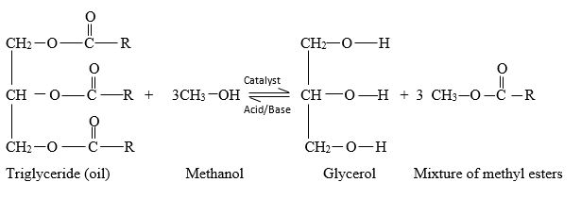
Figure 2-1Transesterification reaction

Research gap
In the context of Nepal, various sources of liquid bio-fuel have been recognized, which have several benefits such as the likelihood to be produced locally, environment friendly, less costly and skilled to perform identical to petroleum fuel. The energy specialists have carried out the extraction of bio-diesel from the Jatropha seeds. A number of plantation practices and engine test trials have been conducted across the world and also in Nepal, which have been effective to exhibit it as option in contrast to ordinary petroleum derivative. Since there is no quantitative analysis of the waste cooking oil biodiesel performance in Nepal, the research gap lies within it.

Biodiesel production possibility in Nepal
The scope of the bio-diesel is not to substitute petroleum products, but to find balance in energy policy to benefit the government of Nepal. Bio-diesel is an option for cleanliness of diesel engine and maximum usefulness of petroleum product. The explanation is to add to building an independent local area with bio-diesel creation model. This model has an added advantage to local economy, consumption of agricultural product and end consumer with fuels.
    - Easy to use
The greatest advantage of adoption of biodiesel in no requirement of modification that need to be done in the existing engines, vehicles and infrastructure. The handling of the biodiesel is similar to that of the other petroleum product like pumped, stored and burnt. Similarly, it can be used pure or in blend in with different petroleum product
    - Vehicles and Engines
All existing diesel and vehicles can incorporate biodiesel. Certain progression must be made in the older vehicles such as supplanting with natural rubber for fuel lines built before 1993. The replacement is requiring due to swell or crack caused due to biodiesel.
    - Switching and Blending
Bio-diesel can be used pure or in blend with various petroleum products. The pure biodiesel is represented by W100 and W## represent the biodiesel in the mixed fuel. Similarly, W20 represent 20% of biodiesel and 80% of diesel fuel. Since, fuel tank deposits can lead to fuel filter plugging by the use of biodiesel, there is option between biodiesel and petroleum as per requirement.
    - Availability, performance, power and economy
There are several options for the biodiesel, but their acceptability is highly questioned due to failure in providing similar features like petroleum counterparts. The horsepower, fuel mileage and torque provided by the pure or blended biodiesel is similar to that of the petroleum product. The bio-diesel has an energy content of 5-10 % which is comparatively lower than the petroleum diesel. There is variation in the energy content as likely as 15% from one supplier to another. There is reduction in the performance of the engine when the biodiesel is used in its pure form due to less energy content. The performance like mileage is highly affected. The B20 levels the energy change is less significant and the performance of the system isn’t affected much.
    - Superior lubrication for Engines
The property of fuel to lubricate its part mainly determined the injection system. The lubricity is the property by which the fuel provides proper lubrication. The problems that are caused by low lubricity is damage of injection system and reduced performance of the system. The lubricity property of biodiesel is high. With the inclusion of ultra-low and low Sulphur diesel fuel, the lubricating property of fuel have been removed. The lubricity of diesel of such low Sulphur content can be improved drastically with the introduction of biodiesel as less as 5%.
    - Bio-diesel in cold weather
Just like other diesel, bio-diesel can get in low temperatures. The right technique to utilize bio-diesel is to mix with winterized diesel fuel for using in colder months.
    - Clean alternative fuel.
The term “dirty” has been associated with the diesel engine. There are several new technologies regarding the new diesel engine like exhaust gas recirculation (EGR), clean diesel technology, particulate filters rapidly lower the emission levels. The blend of biodiesel in the existing and old engine decreases the level of the emission.
    - A closer look at emissions reduction
Studies on bio-diesel emanations have been led for just about 20 years. In that time bio-diesel has gone through the most careful testing of any elective fuel, having been the lone fuel to be assessed by the EPA under the Clean Air Act Section 211(b). This examination inspected the impact of a considerable lot of directed and non-controlled fumes discharges, just as the potential prosperity effects of these emissions.
    - Energy Balance and Security
The ratio of the energy generation and amount of energy released is called energy balance of a fuel. The processes that are involved are produce, refine and distribute the fuel. The renewable property of the fuel is highly determined by this ratio. The higher this ratio is the more renewable that fuel is and has lesser environmental impact. The biodiesel has higher ratio and provides 32 units of energy for the one unit of fossil fuel while units of energy provided by diesel fuel is 0.83.
    - Grown, produced and supplied locally
Energy is a hot topic that has been gathering attention worldwide. The functionality of every country depends on the imports of diverse type of oil. The energy is one of the necessary to ensure the functioning and economy of the country. Biodiesel improvises the security of energy in several ways:
    - Domestic energy crops
For the production of the biodiesel locally grown crops or seeds are used. For equivalent amount of local production of biodiesel, it reduces the amount of oil that needs to be imported. This clearly decreases the energy dependence on imports.
    - Improved refining ability
There are several refineries targeted for refining capacity that are locally available in biodiesel production which reduce the need of expensive refineries.
    - Difficult targets
The industry that uses local forces for production, distribution and usage is unlikely to be target of potential terrorist attack unlike different centralized system. The centralized system is more prone to these attacks and risk.
    - Safety
It is a rare occasion for an average individual to come in direct connection of fuel and its system. But there are instances of spill and it could have adverse effect on the lives of plants and animals, but biodiesel are safer options and have little impact on the environment. The biodiesel is bio-degradable and safer option for the environment.
    - Less toxic
Biodiesels are less harmful than table salt as they are prepared from the vegetable oils. Letha portion of biodiesel is more in comparison to sodium chloride. This implies biodiesel are multiple times more secure than ordinary table salt.

    - Aquatic impacts
In aquatic environment, bio-diesel is around 14 times less poisonous to various types of fish in contrast with diesel fuel.
    - Benefits from French Fry Fuel
In the context of Nepal, the oil used in French fry is used again and again by the hotel owners which effects the health of the customer. So, the oil used can be a source for biodiesel production which provides advantage to both the customer and the owner.
    - Bio-degradability
The degradation rate of biodiesel is four times faster than diesel fuel. Data represents that the 4/5 of the carbon is completely degraded in less than 28 days making it safer option for environment.
    - Stable fuel
The chance of having an inadvertent start is linked to some degree to the temperature at which the fuel will make sufficient fumes to touch off, known as the Flash point temperature. Bio-diesel is safer to manage than petroleum fuel as a result of its low instability. Because of the great energy content of every liquid fuel, there is an uncertainty and risk of incidental ignition when the fuel is being put away or moved. The lower is the temperature at which the fuel can form a burnable combination if the blaze point of the fuel is lower.
    - Recycling: recovering energy resources
Bio-diesel can be produced using a wide range of oils and fats, including many byproducts. Squander cooking oil typically discarded or utilized in creature feed combinations can be changed over to top notch bio-diesel utilizing a cycle utilized by organizations, for example, pacific bio-diesel innovations. The utilization of utilized cooking oils as a bio-diesel feedstock has expanded their worth altogether as of late, making appropriate assortment and reusing of these oils more financially savvy, and bringing down the volume of these oils bound for sewers and landfills. Other low worth oils and fats which can be made into bio-diesel incorporate yellow oil, unpalatable fat, and trap oil. In one illustration of the advantages of how bio-diesel creation can build reusing, the pacific bio-diesel creation offices in the Hawaiian Islands have redirected almost 190,000 tons of utilized cooking oil and oil trap squander since they started creation.
    - Economic development
Since bio-diesel is a fuel which can be prepare from locally approachable resources, it's creation and use can provide a large group of monetary benefits for locality networks. The people group based model of bio-diesel creation is especially advantageous. In this model, locally accessible feedstock is gathered, changed over to bio-diesel, at that point dispersed and utilized inside the local area. This model keeps energy dollars locally as opposed to sending them to unfamiliar oil makers and treatment facilities outside the local area. The fringe advantages of this kind of model are distinctive for each case, yet can incorporate:
- Addition of the tax of the nations from production operations of biodiesel.
- Occupations made for feedstock cultivating or assortment.
- pay for neighborhood feedstock makers and purifiers
- Skilled employment made for bio-diesel creation and dissemination.

Properties of Fuels
    - Cloud Point
The temperature at which paraffin, which is normally present in diesel fuel, starts to shape wax crystals is known as Cloud point. When the fuel temperature reaches the cloud point exactly, these wax crystals streaming with the fuel coat the component of filter and strongly decline the progression of fuel, starving the engine.
    - Flash Point
The lowest temperature at which a liquid (usually a petroleum based product) will form a vapor in the air near its surface that will “flash,” or briefly ignite, on exposure to an open flame is called flash point. The flash point is a general indication of the flammability or combustibility of a liquid. Beneath the flash point, adequate fume isn't accessible to help ignition. The temperature less than the ambient air temperature is the best conditions for flash point of fuel.
    - Cetane Number
Cetane number (or CN) is an opposite capacity of a fuel's start delay, the interval of time between the start of ignition and the primary recognizable pressure increases during burning of the fuel. The fuel having lower cetane number will have longer ignition delay periods than higher Cetane fuels in particular diesel engine. But if the CN is excessively higher, the ignition delay will be too short so that fuel cannot get spread in combustion chamber.
    - Viscosity
Viscosity of fuel is the property to resist the relative movement tendency due to intermolecular attraction. It is one of the important properties of engine fuel. The ease of starting of the engine, fuel air mixture combustion quality and spray quality, size of drops and penetration of injected jet are the factors that are influenced by viscosity (Canaski, 2009). The viscosity of the fuel has a limit. If the viscosity is too low, the drops have very low mass and speed with fine spray which led in formation of black smoke and insufficient penetration. On the other hand, blue smoke formation due to interruption in combustion, lower engine power, increase of deposits are the consequences if the viscosity is too high. Similarly, different operational problems occur at lower temperature due to change in viscosity of fuel with the change in temperature. Viscosity of fuel increases when temperature is decreased.
    - Density
The mass of a substance per unit volume is known as density. The factors that strongly influence density is temperature. So, the density at 15 ℃ is the quality standard for fuel. The density of fuel affects the standard of combustion and atomization. On the other hand, the density of fuel is a necessary factor to be considered in the design of manufacturing, storage, distribution, etc. Similarly, density affects other properties like cetane number, viscosity, heating value, etc.
    - Pour Point
Pour point is the lowest temperature at which the fuel can flow. The fuel tends to freeze or ceases to flow below the pour point (Canaski, 2009).

Performance Parameter
Power: Power is defined as rate of doing work and equal the product of angular velocity and torque or the product of linear velocity and force
Indicated Power: The power build up due to burning of fuel within the combustion chamber in an IC Engine is known as Indicated Power.
Brake Power: The power at the shaft output developed by an engine is called brake power. The sum of brake power and friction power is Indicated power.
Indicated power = Frictional power + Brake power
Thermal efficiency: The degree to which net work output is produced from energy added by heat is known as Thermal efficiency. Efficiency for fuel conversion is the other word given to thermal efficiency. It is known as the ratio of work obtained in a cycle to the amount of fuel energy supplied in that cycle that can be generated in the burning process. The part of the indicated work converted from heat added is shown by indicated thermal efficiency.
Indicated thermal efficiency (ITE): Indicated thermal efficiency is the ratio of energy in the indicated power to the fuel energy.
Brake thermal efficiency (BTE): A measure of overall efficiency of the engine is given by the brake thermal efficiency. Brake thermal efficiency is the ratio of energy in the brake power to fuel energy.
Mechanical efficiency (ME): Mechanical efficiency is the ratio of delivered power to the indicated power provided to the piston.
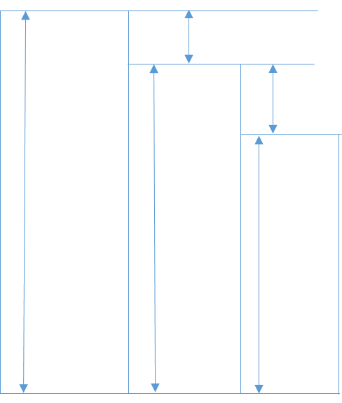
Brake Power (C)
Energy of fuel (A)
Indicated power (B)
Loss of energy in coolant, radiation and exhaust

Loss of energy in pumping and friction
Figure 2-2 Schematic diagram representing different types of efficiency

From figure 2-2,
ITE = B/A
BTE= C/A
ME = C/B
Volumetric Efficiency: Volumetric efficiency means that the 'breathing' capacity of the engine and is characterized as the proportion of the air really actuated at surrounding conditions to the swept volume of the motor. The engine yield is restricted by the greatest measure of air that can be pull in during the suction stroke, on the grounds that solitary a specific amount of fuel can be scorched successfully with a given amount of air. Practically, the motor doesn't actuate a total chamber brimming with air on each stroke, and it is helpful to characterize volumetric efficiency.
Fuel Consumption: The complete utilization of fuel by an engine under test conditions in a given time is dictated by estimating its volume or loads. The Specific fuel utilization is characterized as the complete fuel utilization each hour per KW created. At the end of the day, SFC is the pace of fuel utilization per KWh. SFC demonstrates how effectively an engine plant changes over chemical energy into mechanical energy. Afterburning consistently brings about an increment in explicit fuel utilization and is, subsequently, for the most part restricted to times of brief length. Extra fuel should be added to the gas stream to acquire the necessary temperature proportion. Since the rise in temperature doesn't happen at the peak of compression, the fuel isn't combusted as productively as in the burning chamber and results in higher specific fuel consumption.
Specific fuel consumption (SFC): Indicated specific fuel consumption and Brake specific fuel consumption, are the fuel consumptions on the basis of Indicated power and Brake power respectively.
Mean effective pressure: Mean effective pressure is characterized as a theoretical pressing factor, which is believed to be following up on the cylinder all through the power stroke. Hence, the power output can be estimated in terms of mean effective pressure for a given engine the power output
Indicated Mean Effective Pressure: If mean effective pressure based on indicated power it is called indicated mean effective pressure (IMEP).
Brake Mean Effective Pressure: If the mean effective pressure is based on brake power it is called brake mean effective pressure (BMEP)

Study of past research
Transesterification was conducted before first diesel engine became functional by scientist E. Duffy and J. Patrick. The first patent was granted for procedure for transformation of vegetable oils into fuels on August 31, 1937 to University of Brussels. The surge in the usage of biodiesel was actual an effect of energy crisis. The industrial production of biodiesel was invented in the year 1977 by the Brazilian scientist Expedito Parente. At current times, the production of biodiesel is from different types of crops such as Jojoba oil, soya bean oil, palm oil, sunflower, rice barn, sunflower, rapeseed and coconut. The major distinct characteristic between different types of edible oil is the kind of fatty acid that is attached in the triglyceride molecule which is the major reason in the distinctive yield percentage, FFA content, reaction temperature, and molar ratio.
The observation of transesterification reaction was made by Guo Y. and Leung D.Y.C and comparative analysis was observed between fresh canola and used frying oil. The comparison between the researches conducted by these two individuals was the variation in the reaction time of fresh and used oils. The reaction time was witnessed about 20 minutes for the used oil while 60minutes for the fresh canola oil (Leung, 2006). Similarly, Ling Feng Cui et al. produced the biodiesel from cottonseed oil with use of methanol. Different range of operation variables were used during the production like catalyst concentration (1-5 wt. %), methanol/oil molar ratio (6:1-18:1), catalyst type and temperature (50-68 ℃). During different criteria, best results were obtained during catalyst (4%), 65℃ of temperature and methanol/oil molar ratio of 12:1 with presence of catalyst Al₂O₃ (Lingfeng, 2007).
The performance of diesel engine with single cylinder at different injection rates was carried by Gerhard Vellguth. His finding was that the used of these oils as fuel oils can be used for short term for little loss in the efficiency. In the long run several problems incurred during his experimentation like ring sticking properties, carbon deposits and changes in the lubricating oil properties (Vellguth, 1985).
The need for processing of the vegetables due to massive energy content was discovered by Altin et al. The discovery was the result of the experiment conducted on a CI diesel engine with single cylinder to evaluate the exhaust emission and performance using different kinds of seeds like soybean, cotton, sunflower along with their methyl esters. The findings with neat oil were few power losses, less NO_{X} emission and high particulate emissions. The conclusion of the experiment was suitable in usage of vegetable oil with certain modifications and higher suitability of methyl ester of vegetable oils for diesel fuel (Altin, 2001).
Jajoo and Keoti conducted experiment on the diesel engine with single cylinder with different seeds oils like soybean and rapeseed along with methyl esters as fuel. The experiment concluded that the use of methyl esters is preferable because of their lower smoke formation and low viscosity (Jajoo, 1997).
Rice et.al (1997) conducted a project that demonstrate that acceptable biodiesel from material of low cost. But to be competitive in price with mineral diesel the complete removal of road excise is required. The bio-diesel of good quality can be prepared from waste cooking oil. A control framework is required at the receiving end to screen water content, polymer level of incoming materials and free fatty acid levels (Rice, 1997).
Yuh and Tohru (2005) performed an experiment on effects of various compression ratio on the two-stroke engines. The findings of experiment were that with the unit increase in the compression ration from 6.6 to 13.5 there was subsequent improvement in the fuel consumption ratio from 1 to 3 %. Along with fuel consumption ratio improvement there was also power output improvement but in practice there is limitation in maximum compression ratio due to increase in thermal load (Yuh, 2010).
Emmanuel I Bello et.al. (2016) did experiment on optimization for process parameter for biodiesel production. They found that the best temperature to yield at 58 degree Celsius, speed of magnetic stirrer to be 305.5 rpm and time for reaction is 3 hours (Bello, 2016).
Apurba Dahal and his team during their project work in Kathmandu University prepared biodiesel from waste cooking oil in 2018 but there is no quantitative analysis of performance in engine.

CHAPTER THREE: METHODOLOGY

Research Methodology flow chart is undermentioned in figure 3-1 and are explained below.
Start
Literature Review
Collection of WCO
Biodiesel Preparation process
FTIR Test
Characterization of Biodiesel
Experimental Testing
Analysis
Result Validation
Documentation
End
Yes

No

Figure 3-1 Methodology Flow Chart

Literature review
Exploring the articles and journal papers provide insights to the degree up to which any works or investigation or studies are progressed by the scholars from the past to the present. Various research paper has been studied considering the importance of transesterification process. The accuracy and acceptance of used methodology for transesterification reaction have been gone through.

Collection of waste cooking oil
The fuel blended is WCO which is collected from “Tama Restaurant” of Jawalakhel, Lalitpur. WCO of sunflower was collected.

Biodiesel Preparation Process
It is the process of converting triglycerides of oils in methyl esters. Considering different parameters of reaction, preparation of biodiesel process was done. Different laboratory works were conducted in NAST for preparation of biodiesel. The process for manufacturing of biodiesel is explained below and are illustrated in figure 3-2.
WCO
WCO Filtration and Heating
Transesterification Reactor
Filtered WCO + Catalyst
Phase Separator
Washing and Separator
Biodiesel
Glycerol
Water
Ester layer

Figure 3-2 Biodiesel Manufacturing flow sheet from Waste Cooking Oil

    - Filtration
Waste cooking oil contains different impurities. Before going through transesterification reaction, WCO was filtered by using filtering clothes to remove those impurities.
    - Transesterification
After the oil is filtered, 1.5 % KOH by weight of oil was mixed with alcohol (methanol).
The amount of oil taken = 750 ml.
Density of oil = 0.92 gm/ml
Weight of oil= $Density×Volume$
=7500.92
=690 gm
Weight of KOH=1.5% of oil weight
=0.15$×$690
=10.35 gm
Amount of methanol was calculated from stoichiometric formula in ratio of 6:1 of oil to methanol.
$weight of methanol=$150.83 gm
After the mixture of methanol and KOH is ready, the cooking oil is heated up to temperature of 60 degree Celsius. KOH and methanol mixture is added slowly to oil stirring at 300 rpm. During stirring, constant temperature of 60 degree Celsius was kept up (Aworanti, 2019).
    - Phase Separator
After the sufficient reaction time of about 90 minutes, heating and stirring was stopped. After about 10 minutes two layers was seen. The upper layer formed was methyl esters known as biodiesel and the lower layer was glycerin. The lower layer of glycerin was removed by using separating funnel and its weight was found to be 128 gm.

3.3.4 Washing Biodiesel with distilled water
It is a popular method for cleaning reacted biodiesel to ensure that all the contaminants have been properly washed out of the biodiesel. Water dissolves whatever interacts with. This incorporates soap, methanol, glycerin and different contaminants normally found in newly responded biodiesel. If it is properly done, it can clean the biodiesel extremely well. So, methyl esters after removing glycerin were washed with distilled water to eliminate the accompanying defiles:

      - Removing Methanol
Methanol bonds with water significantly more than it bonds with oils such as biodiesel. So when water is introduced, the methanol snares on it and as the water falls through the biodiesel, the water pulls the methanol directly with it.
      - Dissolving Soap extremely well
As we gently shower water over the product of transesterification reaction after removing glycerin, the soap will tie to the water molecules and fall out of the biodiesel significantly more quickly than simply settling alone.
      - Removing Additional Contaminates
Glycerine, excess catalyst, dirt and any other ionic impurities that are left after separation gets removed from the biodiesel when warm distilled water is used as means to clean the fuel. Since the catalyst used is basic in nature, washing is done till the PH level reaches to neutral value. i.e., 7.

FTIR of W20 and diesel
FTIR test was done to find out the presence of type of functional group in the compounds so that helps to compare the type of functional group present in biodiesel and diesel. After the preparation of biodiesel, biodiesel was sent for FTIR test to find the functional group of samples. After evaluation and comparison of FTIR test with pure diesel, biodiesel was blended with diesel. When Results of FTIR Test is not comparable with diesel, manufacturing process was repeated.

Characterization of biodiesel blend (W20)
The sample of biodiesel was blended with diesel in proportion of 1:5 by volume i.e.W20. The blend was sent to Fare Lab, Delhi, India for finding other different properties like kinematic viscosity, Cetane number, calorific value, density, flash point and pour point. This characterization helps to compare the properties of W20 and diesel. The properties of diesel and their test methods are shown in Table 3-1.
Table 3-1: Properties of diesel
Diesel property | Value | Method
Kinematic viscosity at 40 ºC | 1.9 - 4.1 Cst | ASTM D445
Calorific value | 43200 KJ/kg | ASTM D2382
Density at 15 ºC | 830 kg/m³ | ASTM D1298
Cetane Number | 30 - 65 | ASTM D613
Flash Point (Minimum) | 52 ºC | ASTM D3828

Experimental Testing of Diesel and biodiesel blends
When the physical-chemical of biodiesel blend of 20% by volume were found to be in the range of diesel, biodiesel blends of less than or equal to 20% by volume was tested. Biodiesel blends of W5, W10, W15 and W20 and diesel performance were tested in varying compression ratio of 15:1, 17:1 and 18:1 at varying load of 1kg, 3 kg, 6 kg, 9 kg and 12 kg. For this research, testing machine used was Kirloskar diesel Engine available in Thapathali Campus, Thapathali, Kathmandu.
    - Test Engine specification
      - Performance Parameters
- Fuel Type: Diesel
- Calorific Value of Fuel : 45000 kJ/kg
- Fuel Density : 720-775 kg/m³
- Diameter of orifice: 20 mm
- Discharge coefficient of Orifice: 0.60
- Length of arm of Dynamometer : 185 mm
- diameter of pipe of fuel : 12.40mm
- Ambient Temperature: 27 ºC
- Pulses Per revolution: 360
      - Engine Details
The test research Engine for testing biodiesel blends and diesel is the engine at Thapathali Campus, Thapathali, Kathmandu having following details:
Table 3-2: Engine Test Ring Specifications
S.N. | Features | Specifications
 | Make | Kirloskar diesel Engine
 | Type | Water cooled Diesel, Four strokes
 | Number of cylinders | 1
 | Method of starting | Electric motor cranking
 | Principle of combustion | Compression ignition
 | Loading | Eddy current dynamometer
 | Radius of Crank | 55mm
 | Range of Compression ratio | 15:1-18:1
 | Length of connecting Rod | 300mm
 | Maximum speed | 1500 rpm
      - Combustion Parameters:
- Number of Cycles: 10
- Smoothing 2
- TDC Reference: 0
- Specific Gas Constant: 1.00 kJ/kgK
- Density of air: 1.17 kg/m³
- Adiabatic Index: 1.41
- Polytrophic Index: 1.12
- Cylinder Pressure Reference: 1
Block diagram of engine showing different sensors is shown in figure 3-3.
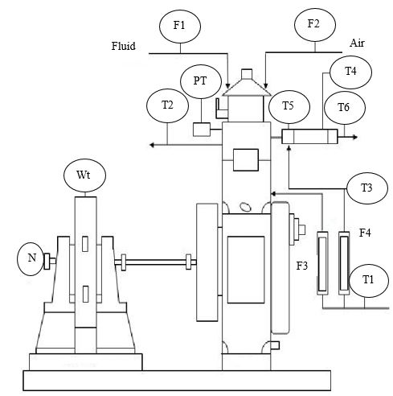
Engine
Dynamometer
Engine
Figure 3-3 Block diagram of test engine
The symbols in block diagram represent the following:
PT = Pressure Sensor
T = Temperature Sensor
F = Flow Sensor
N = RPM sensor
Wt = Load Sensor
    - Experimental Procedure
First of all, setup of engine was made to execute with diesel fuel tentatively 15 to 20 minutes for attaining stable working environment. The engine was then run with methyl esters of waste cooking oil blends after attaining stable working environment. It is important to note that the coolant i.e., water is circulated in the engine at a pressure of nearly 1atm, which can be read by the pressure gauge setup in the engine. The engine was loaded using an eddy current dynamometer with 1-12 (in kg) at an interval of 3kg i.e., 1 kg, 3 kg, 6 kg 9 kg and 12 kg at the constant speed of about 1500rpm. The rate of flow of biodiesel fuel was measured using a burette and stop watch setup in the engine where fuel consumed throughout the time of 60 second was noted. The proportion of biodiesel blends tested are W5, W10, W15 and W20 in compression ratio of 15, 17 and 18. Similarly, the test was also performed for diesel fuel to compare tested parameter with biodiesel blends.

Performance Analysis
Based on experimental results, analysis was done for suggesting best blends. Engine performance analyzed were IP, BP, BMEP, BTH, SFC and ME.

Validation
The obtained results were validated by comparing with different research that were done in the past.

Documentation
Final report has been prepared based on task as above.

CHAPTER FOUR: RESULTS AND DISCUSSIONS

Biodiesel Production Result
From transesterification reaction biodiesel was produced after washing the product with distilled water. The amount of biodiesel converted was found to be 710 ml. The total biodiesel yield was calculated by dividing total amount of biodiesel produced by the sample of crude oil originally taken.
After calculation biodiesel yield was found to be 94.67%.

FTIR Result
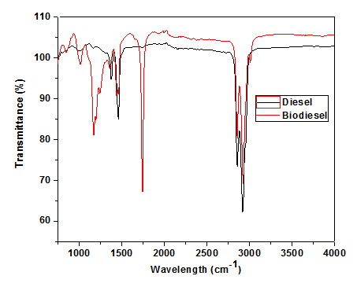
Figure 4-1 FTIR Result
Figure 4-1 demonstrates the FTIR spectrum of the diesel and biodiesel. The peak around 1195 cm⁻¹ of biodiesel indicates C-O/O-CH₃ is associated to ester group. Similarly, another sharp peak of biodiesel around 1745 cm⁻¹ indicates C=O of stretching vibration, which is allocated to an ester group (Lamichhane, 2019). The similar peaks of both biodiesel and diesel found around 1450 cm⁻¹ region corresponds to typical stretching mode of O-CH₃, which is related to methyl ester group. Consequently, some strong peaks of both found in the range of 2800-2950 correspond to typical stretching mode of CH₂ group which is associated with alkane groups (Popovicheva, 2015). Subsequently, it can be conformed that both biodiesel and petroleum diesel have the identical functional group of C–H. However, the petroleum diesel do not possess oxygen group, whereas biodiesel shows the presence of an oxygen as a functional group such as C-O around 1745 cm⁻¹. Thus, conventional diesel without C=O group produced more black smoke in comparison to diesel due to the incomplete burning, while biodiesel promotes cleaner and complete combustion due to the presence of oxygen.

Results of Properties of W20
Table 4-1: Properties of W20 and Diesel
Property | W20 | Diesel | Test Method
Density at 15°C, kg/m³ | 841 | 830 | ASTM D1298
Cetane Number | 51 | 30-65 | ASTM D613
Calorific value, KJ/kg | 39711 | 43200 | ASTM D2382
Kinematic viscosity at 40 ºC, Cst | 2.161 | 1.9 - 4.1 | ASTM D445
Flash Point (Minimum), º C | 47 | 52 | ASTM D3828
Pour Point, ⁰C | -9 | -11 | ASTM D97
The blended biodiesel prepared in the lab was tested as per the test method of ASTM D2382 standard for calorific value, ASTM D445 standard for kinematic viscosity, ASTM D3828 standard for flash point, ASTM D1298 standard for density and ASTM D97 standard for pour point. The outcomes of the test performed are shown in Table 4-1. The obtained numerical values of those physical-chemical properties of blended fuel were comparable to diesel with slight increment in density and loss in calorific value.

Performance Results for different compression ratio
    - For Compression ratio 15
      - Indicated power Vs Load in compression ratio 15

Figure 4-2 IP vs Load (CR15)
The energy in fuel is converted to IP but IP is less than energy of fuel due to different losses like heat loss from cooling water and cylinder walls. Figure 4-2 illustrates that the IP increases with load in diesel and all waste cooking oil blends. All blended biodiesel shows slightly higher indicated power at all load in comparison to the Among those, W5, W10 and W15 show comparatively higher power in all load and smooth increment in power with load. This increased IP for blended biodiesel may be due the higher oxygen content i.e., C=O as a functional group and better spray due to the lower viscosity of biodiesel in comparison to the diesel fuel. These verdicts are in accordance with (Adaileh, 2012).
      - Brake Power Vs Load in compression ratio 15
Figure 4-3 illustrates the variation of BP with load for diesel and all waste cooking oil blends. The value of BP increases with increase in load in all cases both for blend and diesel. The increment of BP is almost similar for diesel and biodiesel. BP of diesel and biodiesel increases on increasing load because of decrease of friction losses on increasing load. Brake power is always less than indicated power since the energy is lost in friction and pumping. BP is maximum at full load conditions for all the blends and diesel.

Figure 4-3 BP Vs Load (CR15)
      - Break Mean Effective Pressure Vs Load in compression ratio 15
The variation of BMEP for diesel and waste cooking oil blends is illustrated in figure 4-4. In all cases BMEP increases with increase in load. Waste cooking oil blends shows similar BMEP at all loading condition compared with diesel fuel. Brake mean effective pressure is maximum at full load conditions since brake power is maximum.

Figure 4-4 BMEP Vs Load (CR15)
      - Brake Therma Efficiency Vs Load in compression ratio 15
BTE is the indication of how effectively mechanical output is achieved from the fuel. BTE for all the blends and diesel increases up to certain load as shown in figure 4-5. This can be recognized to increase in power and decrease in heat loss with increase in load. All blended fuel has lower BTE at all load in comparison to diesel. This is because of the lower calorific value in comparison to diesel (Popovicheva, 2015). Among all those blended fuels, W15 and W20 shows higher BTE. Maximum BTE at 9 kg load for W20 and diesel was 17% and 18% respectively. BTE is decreasing after 9 kg load. This is because BTE is raised up to 80% of load but after 80% load, more quantity of fuel is induced into the burning chamber. Possibility of shorter ignition delay shorter ignition with deficiency of oxygen which may arise due to partial combustion be the reason for decrease in BTE after 9 kg load.

Figure 4-5 BTE Vs Load (CR15)
      - Specific Fuel Consumption Vs Load in compression ratio 15

Figure 4-6 SFC Vs Load (CR15)
The variation of SFC with different loading condition for diesel fuel and waste cooking oil blends is presented in figure 4-6. Fuel consumption of the engine changes rely upon the speed and stacking. Though, the measure of the fuel in volume taken into the ignition chamber in each cycle at a particular throttle valve position and load are equivalent, the distinction in densities of the fuels influences the measure of the fuel consumption. That is on the grounds that fuel utilization is characterized as the devoured fuel in mass per unit power.
Specific fuel consumption decreases on increasing load up to 9 kg for all the blend and diesel. SFC for W20 and diesel was 0.49 and 0.55 kg/KWh at a load of 6 kg. After 9 kg, SFC increases for all the blends. SFC for the biodiesel blend is higher for all the blends than diesel in all load. It is because of less calorific value of biodiesel than diesel. The higher the biodiesel blend content in blended fuel results in lower heating value, results in higher SFC (Muralidharan, 2011).
      - Mechanical Efficiency Vs Load in compression ratio 15

Figure 4-7 ME Vs Load (CR15)
Mechanical efficiency shows how much the power developed by fuel is really delivered as valuable power. Figure 4-7 demonstrates mechanical efficiency for all the blends of biodiesel and diesel increases as the load increases. Since, the increase in load causes brake power to be increased, mechanical efficiency also increases with increasing brake power for all the blends. The reason behind low efficiency in lower load is due to friction since losses due to friction are constant with respect to load. It tends to be seen that mechanical efficiency for W20 is superior to other blends (Nileshkumar, 2015). Mechanical efficiency for W20 and diesel at a load of 12 kg are 74.19% and 78.29% respectively which are comparable.
    - for compression ratio 17
      - Indicated Power Vs Load in compression ratio 17
Indicated power is more for all the waste cooking oil blends and least for diesel at almost all load which is illustrated in figure 4-8.

Figure 4-8 IP Vs Load (CR17)
      - Brake Power Vs Load in compression ratio 17
Figure 4-9 illustrates the variation of BP with load for diesel and all waste cooking oil blends in compression ratio of 17:1. The value of BP increases with increase in load in all cases both for blend and diesel as in the case of compression ratio 15. The increment of BP is almost similar for diesel and biodiesel.

Figure 4-9 BP Vs Load (CR17)
      - Brake Mean Effective Pressure Vs Load in compression ratio 17

Figure 4-10 BMEP Vs Load (CR17)
The variation of BMEP for diesel and waste cooking oil blends is illustrated in figure 4-10. In all cases BMEP increases with increase in load. Waste cooking oil blends shows similar BMEP at all loading condition compared with diesel fuel in compression ratio of 17:1.
      - BTE Vs Load in compression ratio 17
BTE for all the blends and diesel increases up to certain load. This can be recognized to decrease in heat loss and increase in power with increase in load. All blended fuel has lower BTE at all load in comparison to diesel, but all the blends and diesel has slightly higher BTE at all load than compression ratio 15:1. BTE Vs Load for different biodiesel blends and diesel are shown in figure 4-11.

Figure 4-11 BTE Vs Load (CR17)
      - SFC Vs Load in compression ratio 17
SFC is more for W20 and less for diesel as shown in figure 4-12. But incomparison to compression ratio of 15:1, SFC is lower for all the blends and diesel. SFC at 9 kg load for W5, W10, W15, W20 and diesel are 0.5, 0.54, 0.55, 0.58 and 0.39 kg/KWh respectively

Figure 4-12 SFC Vs Load (CR17)
      - Mechanical Efficiency Vs load in compression ratio 17

Figure 4-13 ME Vs Load (CR17)
Mechanical efficiency for all the blends is almost same at all loading conditions but slightly less than diesel on higher load. Mechanical efficiency increases sharply up to load 3 kg and increases slowly in increasing load. Figure 4-13 illustrates Mechanical efficiency Vs Load in compression ratio 17. At highest load of 12 kg mechanical efficiency were found to be 80.04%, 74.94%, 74.61%, 71.93% and 76.17% for diesel, W5, W10, W15 and W20 respectively. Mechanical efficiency is higher for W20 at all loading conditions in comparison to other blends. The difference in efficiency of diesel and W20 at highest load of 12 kg was 3.87%.
    - for compression ratio 18
      - Indicated Power Vs Load in compression ratio 18

Figure 4-14 IP Vs Load (CR18)
Indicated power for W5 and W10 is higher than diesel whereas almost same for W15 and W20 as shown in figure 4-14. This may be due to decrease in viscosity of the blends which led to incomplete combustion for higher blends.
      - Brake Power Vs Load in compression ratio 18
Brake power for compression ratio of 18:1 is illustrated in fig 4-15. Brake power increases as the load increases for all the used cooking oil blends and diesel. BP is higher on higher load.

Figure 4-15 BP Vs Load (CR18)
      - Brake Mean Effective Pressure Vs Load in compression ratio 18

Figure 4-16 BMEP Vs Load (CR18)
BMEP at a load of 12 kg for W5, W10, W15, W20 and diesel was found to be 4.13, 4.06, 4.11, 4.04 and 4.15 bar respectively which shows BMEP for all the blends and diesel was similar which are shown in figure 4-16.
      - Brake Thermal Efficiency Vs Load in compression ratio 18

Figure 4-17 BTE Vs Load (CR18)
Better brake thermal efficiency of W20 was found in comparison to other blends and diesel. But on increasing load after 9 kg BTE for W20 decreases more rapidly than others as illustrated in figure 4-17. At load of 9 kg, BTE for diesel and W20 is 18.64% and 18.23% respectively. This shows that BTE of diesel is higher by only 0.41% in comparison to W20. Better spray characteristics, better atomization, and better mixing of air and fuel which results in proper combustion may be the reasons for improved BTE of blends (Kataria, 2018). In general, efficiency of the engine increases on increasing compression ratio. The reason of improved BTE on higher compression ratio may be due to reduce in ignition delay (Mohammed, 2013).
      - Specific Fuel Consumption Vs Load in compression ratio 18

Figure 4-18 SFC Vs Load (CR18)
The pattern of SFC Vs load is same in compression ratio of 18:1 also. But specific fuel consumption is almost similar for all the biodiesel blends and diesel on increasing load. SFC is lower for B20 in copression ratio of 18:1 in comparison to other compression ratio. A relative better performance was achieved at higher compression ratio due to low volatility and higher viscosity. Figure 4-18 shows SFC vs Load at compression ratio of 18.
      - Mechanical Efficiency Vs Load in compression ratio 18
Mechanical efficiency of W20 was found to be better in comparison to other blends and diesel at load up to 9 kg. W5 and W10 gives less mechanical efficiency than diesel whereas W15 and W20 gives more mechanical efficiency. On higher load of 12 kg mechanical efficiency of W20 and diesel was 78.42 and 79.89 respectively as illustrated in figure 4-19. This result shows that mechanical efficiency of W20 is less by 1.47% only. W5 and W10 gives less mechanical efficiency than diesel whereas W15 and W20 gives more mechanical efficiency. Mechanical efficiency was found to be increasing on higher compression ratio (Muralidharan, 2011).

Figure 4-19 ME Vs Load (CR18)
    - Comparison in varying compression ratio
      - Brake Thermal Efficiency Vs Load on varying compression ratio for W20

Figure 4-20 BTE Vs Load on varying CR
BTE for W20 was highest at 9 kg load for W20 at compression ratio of 18. The highest BTE for every compression ratio is obtained at a load of 9 kg as shown in figure 4-20. BTE for W20 at 9 kg load was 17.22%, 18.11% and 18.23% respectively. This result shows that BTE is higher for higher compression ratio.
      - Specific Fuel Consumption Vs Load on varying compression ratio for W20

Figure 4-21 SFC Vs Load on varying CR
Specific Fuel Consumption of W20 at different load in varying compression ratio is shown in figure 4-21. From the graph we can conclude that SFC is lowest for W20 at compression ratio of 18. Specific fuel consumption is minimum for W20 at 9 kg load.
      - Mechanical Efficiency Vs Load on varying compression ratio for W20
Mechanical Efficiency for different compression ratio for W20 biodiesel blends are illustrated in fig 4-22. The graph shows increasing mechanical efficiency on higher compression ratio on increasing load. From the graph, it can be seen that Mechanical efficiency of W20 at highest load of 12 kg in compression ratio of 15, 17 and 18 are 74.19%, 76.17% and 78.42% respectively.

Figure 4-22 ME Vs Load on varying CR

CHAPTER FIVE: CONCLUSION AND RECOMMENDATIONS

Conclusion
- An ample study as an alternative fuel on the waste cooking oil has been carried out. Biodiesel of waste cooking oil was produced by transesterification process by reacting with methanol in presence of KOH as catalyst.
- The properties of biodiesel blended fuel were tested and tested data were comparable to diesel fuel.
- The IP and SFC of all blended biodiesel were obtained slightly higher than diesel. Consequently, BP and BMEP of all biodiesel were also found comparable to diesel fuel in lower compression ratio.
- Mechanical efficiency, BTE and SFC of blended biodiesel were found slightly lower than diesel fuel in case of compression ratio 15 and 17.
- In compression ratio of 18, BTE and ME of W20 was more on increasing load while SFC was decreasing. Among the different blends, W20 at higher compression ratio can be considered as best blends since both the mechanical efficiency and BTE is higher in comparison to lower compression ratio. Also, SFC was lower for higher compression ratio.

Suggestion for future
- In future, there is scope for research in WCO on other different compression ratio by varying load and injection pressure.
- Since, biodiesel contain oxygen group, emission analysis can be done.
- Similarly, combustion analysis and performance study for more than 20% of blend can be done.

REFERENCES

Adaileh, W. A. (2012). Performance of Diesel Engine Fuelled by a Biodiesel Extracted from a waste cooking oil. Energy Procedia, 18, 1317-34.
Alptekin, E. C. (2008). Determination of the density and the viscosities of biodiesel–diesel fuel blends. Renewable Energy, 33, 2623-30.
Altin, R. C. (2001). The potential of using vegetable oil fuels as fuel for diesel engines. Energy Conversion and Management, 42, 529-538.
Aworanti, O. A. (2019). Process Parameter Estimation of Biodiesel Production from Waste Frying Oil (Vegetable and Palm oil) using Homogeneous Catalyst. Journal of Food Processing & Technology(9).
Balat, M. (2011). Potential alternatives to edible oils for biodiesel production –. A review of current work. Energy Conversion and Management, 52, 1479-92.
Bello, E. O. (2016). Optimization of Process Parameters for Biodiesel Production Using Response Surface Methodology. American Journal of Energy Engineering, 4, 8-16.
Canaski, E. (2009). Characterization of the key fuel properties of methyl ester-diesel fuel blends. Fuel, 75-80.
Chhetri, A. (2008). Waste Cooking Oil as an Alternate Feedstock for Biodiesel Production. Energies, 3–18.
Dalai, M. G. (2006). Waste Cooking Oil-An Economical Source for Biodiesel: A Review. Industrial and Engineering Chemistry Research, 45, 2901-2913.
Debnath, S. V. (2009). Impact of blending of frying oils on viscosity and heat transfer coefficient at elevated temperatures. Journal of Food Process Engineering, 44-61.
Demirbaş, A. (2008). New liquid biofuels from vegetable oils via catalytic pyrolysis. Energy Edu Sci Technol, 1-59.
Dewulf, J. V. (2006). Renewables-based technology sustainability assessment.
Jajoo, B. K. (1997). Evaluation of vegetable oils as supplementary Fuels for diesel engine. Proceedings of the XV national conference on IC engines and combustion. Chhenai: Anna University.
Jayaraj, S. C. (2004). Use of vegetable oils as I.C. engine fuels. A review. Renewable Energy, 29, 727-42.
Kataria, J. M. (2018). Biodiesel production from waste cooking oil using heterogeneous catalysts and its operational characteristics on variable compression ratio CI engine. Journal of the Energy Institute, 1-13.
Lamichhane, G. K. (2019). Biofuel Production from Waste Cooking Oils and Its Physicochemical Properties in Comparison to Petrodiesel. Nepal Journal Of Biotechnology, 8, 87-94.
Leung, D. G. (2006). Transesterification of neat and used frying oil:Optimization for biodiesel production. Fuel Processing Technology, 883–890.
Lingfeng, C. G. (2007). Transesterification of Cottonseed Oil to Biodiesel by Using Heterogeneous Solid Basic Catalysts. Energy & Fuels, 21, 3740–3743.
Mohammed, E. M. (2013). Studying the effect of compression ratio on an engine fueled with waste oil produced biodiesel/diesel fuel. Alexandria Engineering Journal, 52, 1-11.
Muralidharan, K. V. (2011). Performance, emission and combustion characteristics of a variable compression ratio engine using methyl esters of waste cooking oil and diesel blends. Applied Energy, 88, 3959–3968.
Nagaraja S, Sooryaprakash K, Sudhakaran R. Investigate the Effect of Compression Ratio Over the Performance and Emission Characteristics of Variable Compression Ratio Engine Fueled with Preheated Palm Oil - Diesel Blends. . (n.d.). Procedia Earth and Planetary Scie.
Nagaraja, S. S. (2015). Investigate the Effect of Compression Ratio Over the Performance and Emission Characteristics of Variable Compression Ratio Engine Fueled with Preheated Palm Oil - Diesel Blends. Procedia Earth and Planetary Science, 11, 393-401.
Nileshkumar, K. J. (2015). Effect of blend ratio of plastic pyrolysis oil and diesel fuel on the performance of single cylinder CI engine. International journal of Science Technology and engineering, 1, 195-203.
Ojolo, S. O. (2011). Study of an Effective Technique for the Production of Biodiesel from Jatropha Oil. Journal of Emerging Trends in Engineering and Applied Sciences, 79-86.
Popovicheva, O. K. (2015). FTIR analysis of surface functionalities on particulate matter produced by off-road diesel engines operating on diesel and biofuel. Environmental Science and Pollution Research, 22:453.
Rice, B. (1997). Industrial possibilities of biodiesel based on used frying oil in Ireland. Valorisation of used frying oils and fats in the Benelux, 1-5.
Santos, I. M. (2017). Development of microemulsions to reduce the viscocity of crude oil emulsions. Fuel, 684-94.
Sarıbıyık, O. O. (2010). Biodiesel Production from Ricinus Communis Oil and Its Blends with Soybean Biodiesel. Journal of Mechanical Engineering, 811-816.
Schuchardt, U. S. (1998). Transesterification of vegetable oils: a review. . Journal of the Brazilian Chemical Society, 199-210.
Shaema, R. P. (2013). Production of biodiesel from waste cooking oil. Journal of Engineering Research and Applications, 3(6), 1629-1636.
Thirumarimurugan, M. S. (2012). Preparation of Biodiesel from Sunflower Oil by Transesterification. International Journal of Bioscience, Biochemistry and Bioinformatics, 2, 441-444.
Vellguth, G. (1985). Performance of Vegetable Oils and their Monoesters as Fuels for Diesel Engines. Renewable Energy Review Journal, 7, 16-32.
Yuh, M. a. (2010). The Effect of Higher Compression Ratio in Two-Stroke Engines. Yamaha Motor Co, Ltd.

PUBLICATION

Devkota, L. K. and Adhikari, S. P., (2020), ‘Experimental Investigation on the performance of a CI engine fueled with waste cooking oil biodiesel blends’, .Himalayan Journal of Applied Science and Engineering, ISSN 2738-9901(print)

APPENDIX A: PREPARATION OF BIODIESEL

A1: Crude oil measured for transesterification
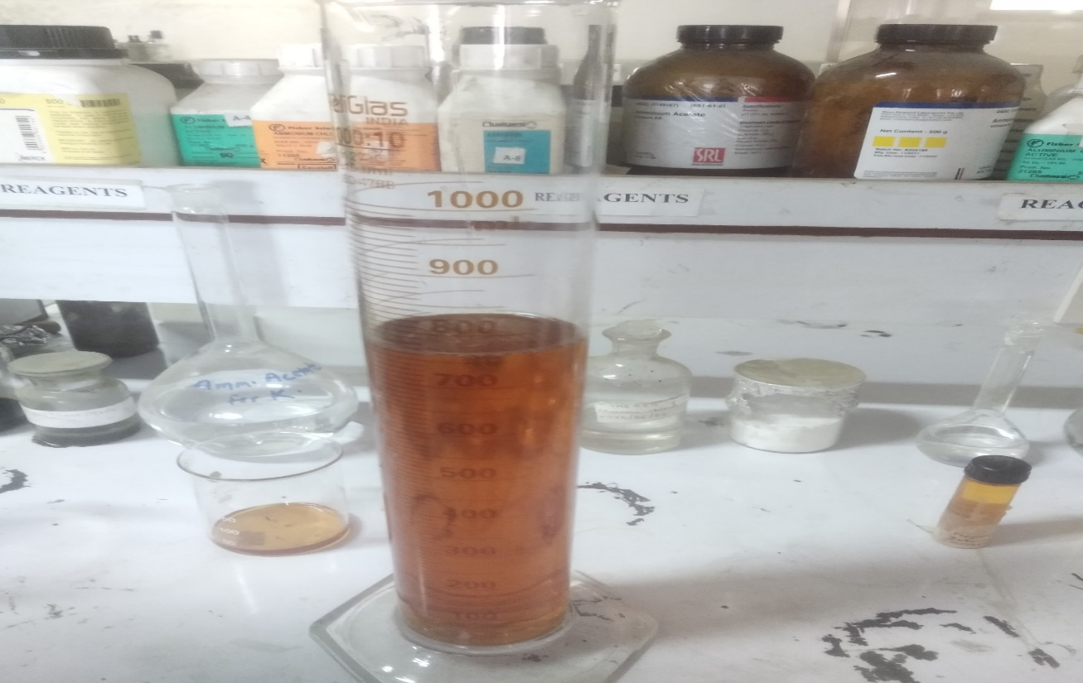

A2: Mixing and heating of oil (Transesterification)
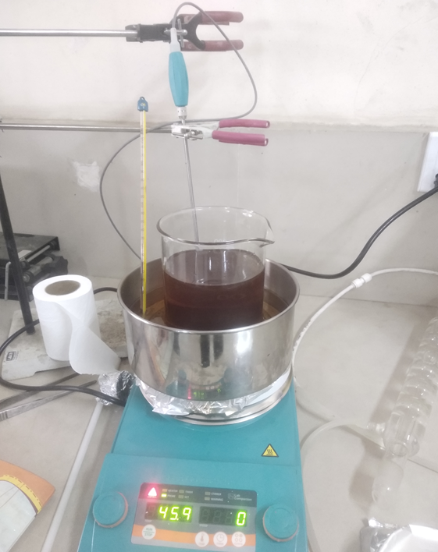

A3: layer separation of glycerin and methyl esters
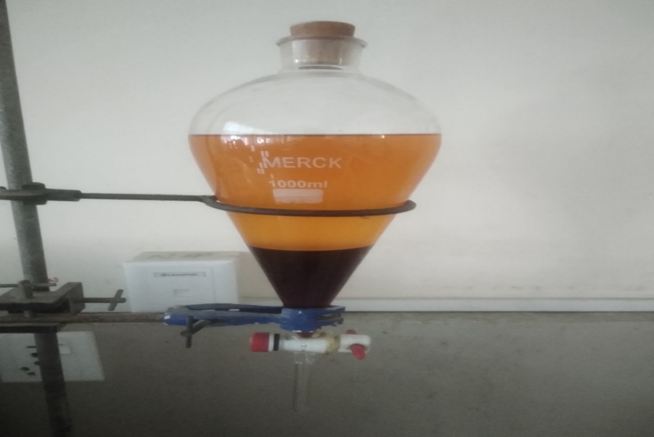

A4: biodiesel after washing with distilled water
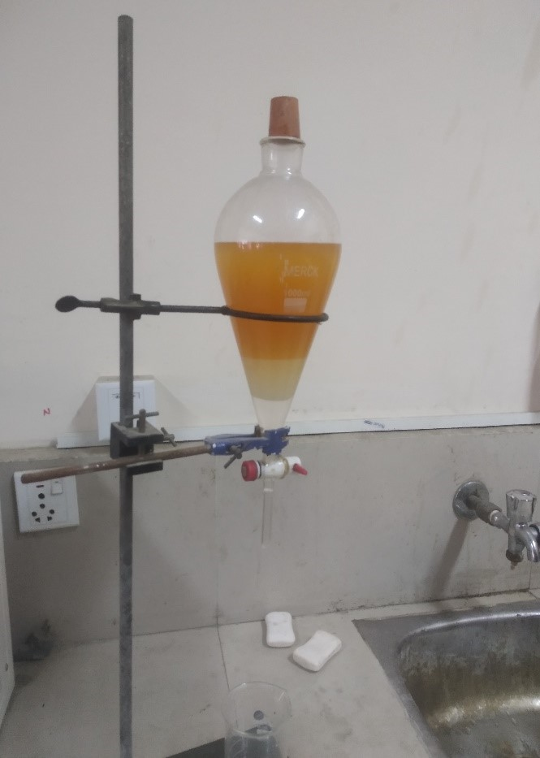

APPENDIX B: TESTING OF BIODIESEL BLENDS AND DIESEL

B1: Different blends
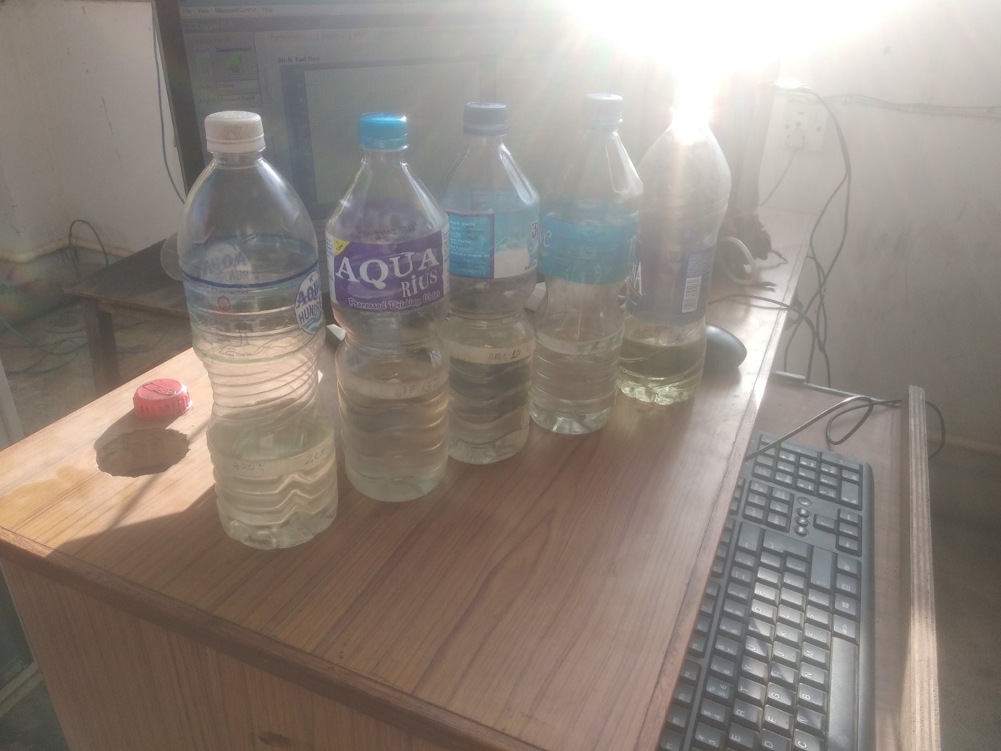

B2: Test Engine
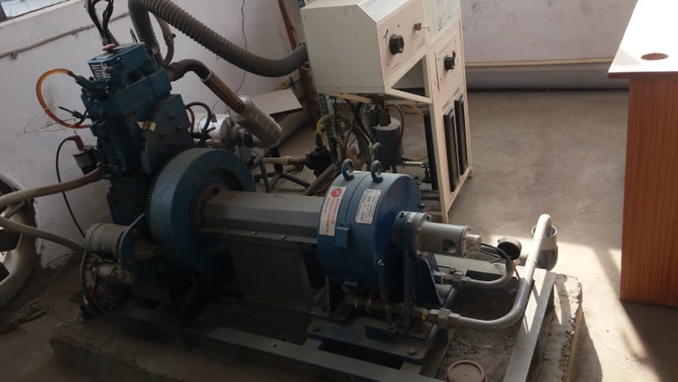

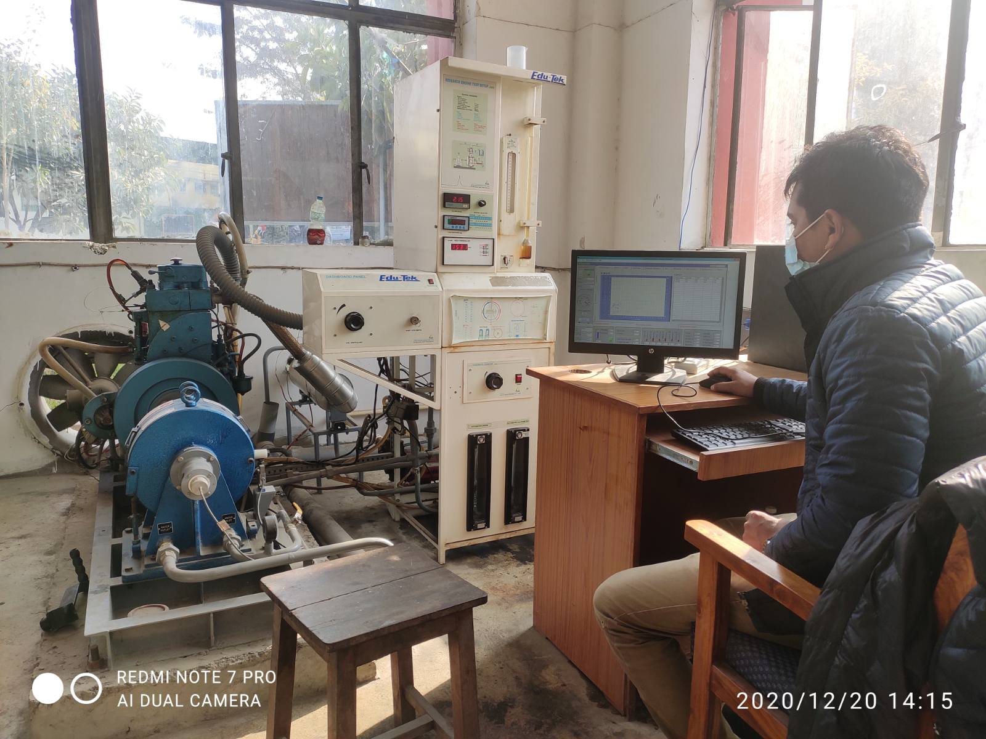
B3: Test of Biodiesel blends and diesel in lab

