TRIBHUVAN UNIVERSITY
INSTITUTE OF ENGINEERING
PULCHOWK CAMPUS

THESIS NO: M-39-MSMDE-2018-2021
Performance, Combustion and Emission Characteristics of a single cylinder 4-Stroke Varying Compression Ratio CI Engine Fueled with Jatropha Biodiesel Blends

by
KHEM RAJ BHATTA

A THESIS REPORT
SUBMITTED TO THE DEPARTMENT OF MECHANICAL AND AEROSPACE ENGINEERING IN PARTIAL FULFILLMENT OF THE REQUIREMENTS FOR THE DEGREE OF MASTER
IN MECHANICAL SYSTEMS DESIGN AND ENGINEERING

SEPTEMBER, 2021

COPYRIGHT
The author has agreed that the library, Department of Mechanical and Aerospace Engineering, Pulchowk Campus, Institute of Engineering may make this thesis freely available for inspection. Moreover, the author has agreed that permission for extensive copying of this thesis for scholarly purpose may be granted by the professor(s) who supervised the work recorded herein or, in their absence, by the Head of the Department wherein the thesis was done. It is understood that the recognition will be given to the author of this thesis and to the Department of Mechanical and Aerospace Engineering, Pulchowk Campus Institute of Engineering in any use of the material of this thesis. Copying or publication or the other use for financial gain without approval of the Department of Mechanical and Aerospace Engineering, Pulchowk Campus, Institute of Engineering and author’s written permission is prohibited.
Request for permission to copy or to make any other use of the material in this report in whole or in part should be addressed to:

Head
Department of Mechanical and Aerospace Engineering
Pulchowk Campus, Institute of Engineering
Lalitpur, Kathmandu
Nepal

TRIBHUVAN UNIVERSITY
INSTITUTE OF ENGINEERING
PULCHOWK CAMPUS
DEPARTMENT OF MECHANICAL AND AEROSPACE ENGINEERING
The undersigned certify that they have read, and recommended to the Institute of Engineering for acceptance, a thesis entitled “Performance, Combustion and Emission Characteristics of a single-cylinder 4-Stroke Varying Compression CI Engine Fueled with Jatropha Biodiesel Blends” submitted by Khem Raj Bhatta, in partial fulfillment of the requirements for the degree of Master of Science in Mechanical Systems Design and Engineering.

_______________________________________
Supervisor,
Surya Prasad Adhikari, PhD
Associate Professor
Department of Mechanical and Aerospace engineering
______________________________________
Supervisor,
Ajay Kumar Jha, PhD
Associate Professor
Department of Mechanical and Aerospace engineering

______________________________________
External Examiner
Krishna Prasad Shrestha, PhD
Assistant Professor, DoME, KU

______________________________________
Committee Chairperson,
Surya Prasad Adhikari, PhD
Associate Professor
Department of Mechanical and Aerospace engineering

Date: September 14, 2021

ABSTRACT
The Jatropha seed oil is nonedible, contains a high amount of oil, and is a less expensive feedstock. So, in this study, a methyl ester biodiesel was produced from Jatropha seed oil following a two-step transesterification process using methanol, sulfuric acid, and sodium hydroxide. The physical and thermal properties of 20% jatropha-biodiesel and 80% diesel (JB20) were tested on American Society for Testing and Materials (ASTM) standards and found to be within the standard. The effect of jatropha biodiesel blends in different percentage volumes of 10% (JB10), 15% (JB15), and 20% (JB20) and petroleum-based diesel on the performance and emission of four strokes, naturally aspired, water-cooled, and a direct injection diesel engine at five engine loads with a constant engine speed of 1500 rpm at varying compression were examined. The impact of varying compression ratio on the performance and combustion parameters were investigated and analyzed. In this study, different performance parameters of a CI engine fueled with Jatropha biodiesel blends in different percentage volumes of 10% (JB10), 15% (JB15), and 20% (JB20) were tested experimentally. At CR 17, IP of JB20 decreases by 8% at 50% loading, BTE increase by 8%at full load, mechanical efficiency (ME) increases by 8%, SFC increases by 4% while EGT decreases by 2% at full loading condition. At CR17, maximum cylinder pressure, Cumulative heat release, and Net heat release of JB20 decrease by 11.24%, 56.45%, and 4.01% respectively in comparison to diesel. On increasing CR from 15 to 17, JB20 shows a 13% increase in IP, 7.5% increase in ME, SFC decreases by 20%, EGT decreases by 13%, and NHR increases by 22.8% for JB20. The performance and combustion characteristics of Jatropha biodiesel were found to be improved by increasing CR. At low load CO₂ emission of diesel is 16% less than JB20 but at full load, diesel shows only 5% less CO₂ emission compared to JB20. At low load, HC emission of JB20 decrease by 15% compared to diesel and high load JB20 shows 5% lower HC emission compared to diesel. CO emission of JB20 decrease by 20% at low load while at high load its shows only 6% reduction of CO emission compared to diesel. From the fuel property, engine performance, and emission characteristics, it is concluded that Jatropha biodiesel up to 20% can be blended with diesel and can be used as an alternative fuel in existing diesel engines without any modification.

ACKNOWLEDGEMENT
First and foremost, I would like to express my sincere gratitude to my extremely devoted supervisor, Associate Professor, Dr. Surya Prasad Adhikari, and Dr. Ajay Kumar Jha, Department of Mechanical and Aerospace Engineering, Pulchowk Campus, whose continuous help, encouragement, and stimulating suggestions helped me throughout the research and even during writing this thesis. Second, I would like to thank Lecturer, Mr. Laxman Palikhel, and Assistant Professor, Subodh Ghimire, Department of Mechanical Engineering, Thapathali campus for assisting me during the experimental testing. I express my appreciation and gratefulness to ACME College for the chemistry lab support for biodiesel production. I would like to give credit to my friends Lochan Kendra Devkota, Gagan Singh Bist, and Rupesh Lal Karn who assisted me throughout this research. Also, I would like to thank all previous researchers, academicians, and organizations whose previous work helped to conduct this study.
Finally, I would like to mention those people who made it possible by their immense support and encouragement throughout the research work and I would like to appreciate each individual directly or indirectly involved in the completion of this research.

Sincerely
Khem Raj Bhatta

Contents
COPYRIGHT 1
ABSTRACT 3
ACKNOWLEDGEMENT 4
List of Tables 9
List of Figures 10
LIST OF ABBREVIATIONS 13
CHAPTER ONE: INTRODUCTION 14
1.1 Background 14
1.2 Problem Statement 15
1.3 Objectives 16
1.3.1 General Objective 16
1.3.2 Specific objectives 16
1.4 Limitations 16
CHAPTER TWO: LITERATURE REVIEW 18
2.1 Production Parameters 19
2.1.1 Alcohol 19
2.1.2 Catalyst 20
2.1.3 Catalyst Concentration 20
2.1.4 Reaction Temperature 21
2.1.5 Reaction Time 21
2.1.6 Mixing intensity 21
2.1.7 FFA content and molar ratio of Alcohol to oil 21
2.2 Properties of Fuels 22
2.2.1 Cetane Number 22
2.2.2 Calorific Value 23
2.2.3 Density 23
2.2.4 Viscosity 23
2.2.5 Water Content 24
2.2.6 Flash Point 24
2.2.7 Pour Point 24
2.3 Performance, combustion and emission Parameters 24
CHAPTER THREE: RESEARCH METHODOLOGY 26
3.1 Collection of Jatropha Oil 27
3.2 Biodiesel preparation Process and FFA Analysis 27
3.2.1 Filtration 28
3.2.2 FFA test 28
3.2.3 Base catalyzed Transesterification 28
3.2.4 Purification of Biodiesel 28
3.3 FTIR of JB10, JB15, JB20 and diesel 29
3.4 Characterization of Biodiesel 29
3.5 Testing of Performance and Combustion Characteristics 30
3.5.1 Indicated and Brake Power 30
3.5.2 Thermal Efficiency 30
3.5.3 Mechanical Efficiency 31
3.5.4 Volumetric Efficiency 31
3.5.5 Specific Fuel Consumption 31
3.5.6 Mean Effective Pressure 32
3.6 Experimental Testing of Diesel and biodiesel blends 33
3.6.1 Test Setup for Engine Performance and Combustion Characteristics 33
3.6.2 Test Setup for Emission Characteristics 35
3.7 Experimental Procedure 37
3.8 Performance and Combustion Analysis 38
3.9 Validation 38
3.10 Documentation 38
CHAPTER FOUR: RESULT AND DISCUSSION 39
4.1 Biodiesel production 39
4.2 FTIR result and Analysis 41
4.3 Comparison of Fuel Property of JB20 with diesel 43
4.4 Comparison of Performance characteristics of Various JB blends and diesel 44
4.4.1 Variation of Indicated Power of various JB Blends and Diesel with Brake Power 44
4.4.2 Variation of Specific Fuel Consumption of various JB Blends and Diesel with Brake Power 48
4.4.3 Variation of Mechanical Efficiency of various JB Blends and Diesel with Brake Power 52
4.4.4 Variation of brake thermal Efficiency of various JB Blends and Diesel with Brake Power 56
4.4.5 Variation of Exhaust gas Temperature of various JB Blends and Diesel with Brake Power 60
4.5 Comparison of Combustion characteristics of Various JB blends and diesel 64
4.5.1 Variation of Net heat release of various JB Blends and Diesel with Brake Power 64
4.5.2 Variation of Peak Cylinder Pressure of various Jatropha Biodiesel Blends and Diesel with Brake Power 68
4.5.3 Variation of Cumulative Heat Release of various Jatropha Biodiesel Blends and Diesel with Brake power 72
4.6. Emission Testing Analysis 76
4.6.1 HC emission 76
4.4.2 CO emission 76
4.4.3 CO₂ Emission 78
4.4.4. Smoke Opacity Test 78
CHAPTER FIVE: CONCLUSION AND RECOMMENDATION 80
5.1 Conclusion 80
5.2 Suggestion for future 81
REFERENCES 82
ANNEX 88

List of Tables
Table 3.1 Fuel Properties 29
Table 3.2 Test engine Specification 34
Table 3. 3 Opacity Meter Specification 37
Table 3. 4 Gas Emission Analyzer specification 37

Table 4. 1 Production of Biodiesel through Esterification and transesterification process 40
Table 4. 2 FTIR analysis of Diesel 41
Table 4. 3 FTIR analysis of JB20 41
Table 4. 4 Fuel Properties of JB20 and Diesel 43

List of Figures
Figure 1. 1 Import of Diesel in various fiscal year 16

Figure 3 1 Methodology Flow Diagram 26
Figure 3. 2 Biodiesel Production Process Flow 27
Figure 3. 3 Diagrammatic representation of various efficiencies 33
Figure 3 4 Block diagram of test Engine 35

Figure 4. 1 FTIR of Diesel and JB20 42
Figure 4. 2 Indicated power versus Brake Power at CR15 45
Figure 4. 3 Indicated power versus Brake power at CR16 45
Figure 4. 4 Indicated Power versus Brake power at CR17 46
Figure 4. 5 Relation of IP with BP of JB10 at various CR 46
Figure 4. 6 Relation of IP with BP of JB15 at various CR 47
Figure 4. 7 Relation of IP with BP of JB20 at various CR 47
Figure 4. 8 Specific fuel consumption versus Brake power at CR15 49
Figure 4. 9 Specific Fuel Consumption versus Brake power at CR16 49
Figure 4. 10 Specific Fuel Consumption versus Brake power at CR17 50
Figure 4. 11 Relation of SFC with BP of JB10 at various CR 50
Figure 4. 12 Relation of SFC with BP of JB15 at various CR 51
Figure 4. 13 Relation of SFC with BP of JB20 at various CR 51
Figure 4. 14 Mechanical Efficiency versus Brake power at CR15 53
Figure 4. 15 Mechanical Efficiency versus Brake power at CR16 53
Figure 4. 16 Mechanical Efficiency versus Brake power at CR17 54
Figure 4. 17 Relation of Mechanical efficiency with BP of JB10 at various CR 54
Figure 4. 18 Relation of Mechanical efficiency with BP of JB15 at various CR16 55
Figure 4. 19 Relation of Mechanical efficiency with BP of JB20 at various CR17 55
Figure 4. 20 Brake thermal efficiency versus Brake power at CR15 57
Figure 4. 21 Figure 18 Brake Thermal Efficiency versus Brake power at CR16 57
Figure 4. 22 Brake Thermal Efficiency versus Brake power at CR17 58
Figure 4. 23 Relation of Brake Thermal efficiency with BP of JB10 at various CR 58
Figure 4. 24 Relation of Brake Thermal efficiency with BP of JB15 at various CR 59
Figure 4. 25 Relation of Brake Thermal efficiency with BP of JB20 at various CR 59
Figure 4. 26 Exhaust Gas Temperature versus Brake power at CR15 61
Figure 4. 27 Figure 1 Exhaust Gas Temperature versus Brake power at CR16 61
Figure 4. 28 Exhaust Gas Temperature versus Brake power at CR17 62
Figure 4. 29 Relation of Exhaust Gas Temperature with BP of JB10 at various CR 62
Figure 4. 30 Relation of Exhaust Gas Temperature with BP of JB15 at various CR 63
Figure 4. 31 Relation of Exhaust Gas Temperature with BP of JB20 at various CR 63
Figure 4. 32 Net Heat Release versus Brake power at CR15 65
Figure 4. 33 Net Heat Release versus Brake power at CR16 65
Figure 4. 34 Net Heat Release versus Brake power at CR17 66
Figure 4. 35 Relation of Net Heat Release with crank angle of JB10 various CR 66
Figure 4. 36 Relation of Net Heat Release with crank angle of JB10 various CR 67
Figure 4. 37 Relation of Net Heat Release with crank angle of JB20 various CR 67
Figure 4. 38 Relation of Peak Cylinder Pressure and Brake power at CR15 69
Figure 4. 39 Relation of Peak Cylinder Pressure and Brake power at CR16 69
Figure 4. 40 Relation of Peak Cylinder Pressure and Brake power at CR17 70
Figure 4. 41 Variation of Cylinder Pressure of 10JB with change in crank Angle at Various CR 70
Figure 4. 42 Variation of Cylinder Pressure of various 15JB with change in crank Angle various CR 71
Figure 4. 43 Variation of Cylinder Pressure of various 20JB with change in crank Angle at various CR17 71
Figure 4. 44 Cumulative Heat Released versus Brake power at CR15 73
Figure 4. 45 Cumulative Heat Release versus Brake power at CR16 73
Figure 4. 46 Cumulative Heat Release versus Brake Power at CR17 74
Figure 4. 47 Relation of cumulative Net Heat Release with crank angle of JB10 various CR 74
Figure 4. 48 Relation of cumulative Net Heat Release with crank angle of JB15 various CR 75
Figure 4. 49 Relation of cumulative Net Heat Release with crank angle of JB20 various CR 75
Figure 4. 50 Relation of Hydrocarbon emission and Brake Power 76
Figure 4. 51 Relation of CO emission and Brake Power 77
Figure 4. 52 CO2 emission and Brake Power 78
Figure 4. 53 Relation of Opacimeneter value with JB blends 79

LIST OF ABBREVIATIONS
AEPC Alternative Energy Promotion Center
ASTM American Society for Testing and Materials
BMEP Brake mean effective pressure
BP Brake Power
BSFC Brake Specific Fuel Consumption
BTE Brake Thermal efficiency
CHR Cumulative heat release
CP Cylinder Pressure
CO Carbon Monoxide
CN Cetane Number
EGT Exhaust Gas Temperature
FFA Free Fatty Acid
FTIR Fourier Transform Infrared
GCMS Gas Chromatography and Mass Spectrometry
HC Hydrocarbon
IC Engine Internal Combustion Engine
IP Indicated Power
IR Infrared
JB Jatropha Biodiesel
JB20 Blend with 20% biodiesel
JB15 Blend with 15% Biodiesel
JB10 Blend with 10% Biodiesel
KOH Potassium Hydroxide
mL milliliter
NaCl Sodium Chloride
NAST Nepal Academy of Science and Technology
NO_{x} Nitrogen Oxide
NOC Nepal Oil Corporation
SO_{x} Sulfur oxide
SFC Specific Fuel Consumption
ºC degree Celsius
% Percentage

CHAPTER ONE: INTRODUCTION

1.1 Background
Bio-fuel is a solid, liquid, or gaseous fuel derived from renewable sources especially from biomass plant or algae material or animal waste, and treated municipal and industrial waste. In recent years, the energy demand is increasing day by day since the energy sector plays a vital role in the world economy. From crude oil, consumption of total primary energy is nearly 29.45% (Shirneshan A. , 2013) Global oil demand rose by 1.3% in 2018 (IEA, 2019) which shows that meeting energy demand is not possible from crude oil in near future. Increasing fossil fuel prices, energy security issue and climate change has driven and forced the engineers and scientists to develop alternative and renewable energy source. Besides that, it assures lesser emission of greenhouse gases. Excessive air pollution acting as an environmental and health risk leading to respiratory diseases in mankind. Pollution from vehicle engines is a major concern these days which sets strict standards for engine pollution. Research regarding an alternative solution for engine fuels that is available, technically feasible, economically viable, and environmentally acceptable, are carried out For several years by researchers around the world (Liaquate AM et. all, 2010).
As an alternative fuel, Biodiesel has an immense potential to reduce pollutant emissions and to be used in compression ignition engines and also is non-explosive, biodegradable, non-flammable, renewable, non-toxic as well as environment friendly. It can be blended with diesel fuel at any proportions due to its similar properties, can be used in a diesel engine without any modification, and does not contain any harmful substances producing less harmful emissions to the environment. Biodiesel is an alkyl ester of fatty acids and can be obtained through transesterification treatment of vegetable oils, animal fats, Jatropha oil, and restaurant greases. Among all the feedstocks, vegetable oils (both edible and non-edible) are the most promising feedstocks for biodiesel production since they can be produced on large scale. because of the prevailing food security issues and environmental hazards, the use of edible crops as a biofuel is highly contentious. This leads to the focus on researching non-edible oils as they are not suitable for human consumption as well. Due to the availability, sustainability and low cost, and accessibility, Jatropha curcas L., a multipurpose plant, contains a high amount of oil in its seeds compare to the other non-edible oil sources and is probably the highly promoted oilseed crop currently (Parawira, 2105). In addition, biodiesel can be used either pure or blended with fossil diesel fuel at any proportions and can be burnt in diesel engines without any alterations. The adaptation of Jatropha oil to the diesel engine could be done by using neat Jatropha oil by a dual tank approach, blending the Jatropha oil with diesel and producing methyl or ethyl esters through the transesterification process.
Nepal's altitude and rainfall favor the cultivation of Jatropha. The altitude of 0-500meter above sea level and 200-300 mm of rainfall are the favorable conditions for Jatropha Cultivation. Previous on 2009/2010. The government of Nepal focused on biodiesel production and took an aim to use the blending of 20% Jatropha with diesel. For this, the government collaborate with the Alternative Energy Promotion Center (AEPC) and launched a program “Jaibik Indhan Karyakram”. The collaborative study was focused on finding the possibility of Jatropha cultivation in Nepal. IT WAS FOUND THAT Neapla's climate favors the production of Jatropha. Farmers are encouraged to cultivate Jatropha as a commercial plant. Transesterificationplant was set up in Palpa.

1.2 Problem Statement
- Nepal is fully reliant on India for petroleum products spending millions of dollars to India to buy petroleum products. In the fiscal year 2074/75 and 2074/73 Nepal oil corporation imports 1588869.0 KL and 1319873.0 KL of diesel respectively, 488675.0 KL and 407270.0 KL of petrol respectively, 22337.0 KL and 19607.0 KL of kerosene respectively, (Nepal oil corporation limited, 2019). The import of diesel to Nepal is illustrated in figure 1.1
- The increasing consumption of petroleum product leads to the shortage of crude oil and there is uncertainty in the crude oil price in the international market which affect the national economy (STATISTICS, 2019)

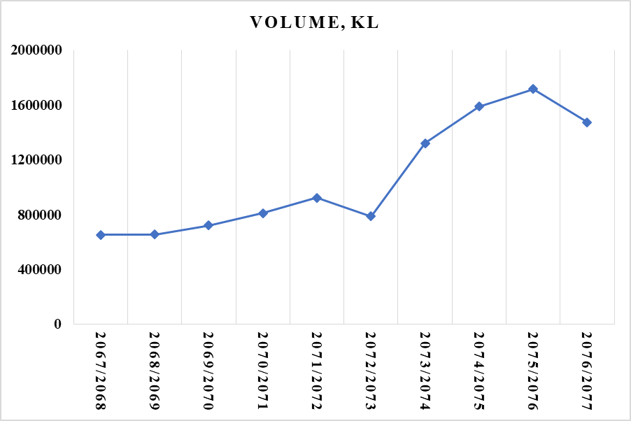
Figure 1. 1 Import of Diesel in various fiscal year

1.3 Objectives

1.3.1 General Objective
- To study performance, combustion, and exhaust emissions on 4-stroke IC engine with various Jatropha-diesel blends

1.3.2 Specific objectives
The specific objectives of the thesis work will be,
- To produce biodiesel from Jatropha curcas oil using transesterification process.
- To find the fuel properties of Jatropha biodiesel.
- To test and analyze the performance of biodiesel blends.
- To compare brake thermal efficiency, brake specific fuel consumption for various Jatropha-diesel blends by varying compression ratio.
- To perform emission testing of Jatropha biodiesel blend.

1.4 Limitations
- NO_{x} and SO_{x} emission tests cannot be performed due to the unavailability of a 6gas analyzer in Nepal
- A mileage test of blends of Jatropha biodiesel cannot be performed in the vehicle.
- FAME test and GCMS analysis cannot be performed.

CHAPTER TWO: LITERATURE REVIEW
Dr. Rudolf Diesel was the man behind the invention of the first Diesel engine in 1895 who used the only biofuel in his engine. He once quoted where he signifies the importance of oil in the future. Biodiesel is an alternative fuel that is manufactured from different renewable natural sources such as edible and nonedible vegetable oils. According to ASTM standards, biodiesel is a fuel comprised of the long chain of mono-alkyl ester. Several problems are encountered while using biodiesel in comparison to petroleum products. The problem is deposit causing coking in different parts like valves and injectors because of the high viscosity of biodiesel that causes poor atomization of fuel. Different chemical and physical processes are carried out to decrease viscosity making it more compatible with CI engines. Methods like pyrolysis, blending with ethanol or petroleum-derived diesel, transesterification, and micro-emulsification.
Transesterification was conducted before the first diesel engine became functional by scientists E. Duffy and J. Patrick. The first patent was granted for the methodology for the transformation of vegetable oils into fuels on August 31, 1937, to the University of Brussels.
The surge in the usage of biodiesel was actual an effect of the energy crisis. The industrial production of biodiesel was invented in the year 1977 by the Brazilian scientist Expedito Parente. At current times, the production of biodiesel is obtained from different types of crops such as Jatropha oil, soya bean oil, palm oil, sunflower, rice barn, and coconut. The major distinguishing characteristic between different types of edible oil is the kind of fatty acid that is attached to the triglyceride molecule which is the major reason for the distinctive yield percentage, reaction temperature, FFA content, and molar ratio.
The observation of transesterification reaction was made by Guo Y. and Leung D.Y.C and comparative analysis was observed between fresh canola and used frying oil. The comparison between the researches conducted by these two individuals was the variation in the reaction time of fresh and used oils. The reaction time was witnessed about 20 mins for the used oil while 60min for the fresh canola oil. Similarly, Ling Feng Cui et al. produced biodiesel from cottonseed oil with the use of methanol. Different range of operation variables was used during the production like catalyst concentration was varied from (1-5 wt.%), methanol/oil molar ratio was varied from (6:1-18:1), catalyst type and the temperature was varied from (50℃-68℃). During different criteria, best results were obtained during catalyst (4%), the temperature of 65℃ and methanol/oil molar ratio of 12:1 in presence of catalyst Al₂O₃.
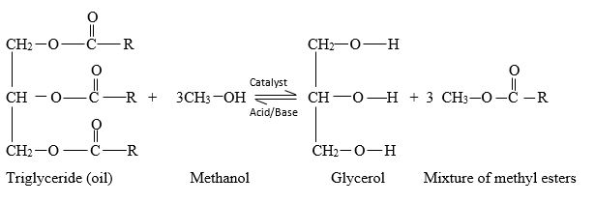
As noted by several researchers, the main factors that affect transesterification reaction are:
- Oil to alcohol molar ratio
- The catalyst is chosen and its concentration
- Reaction time and temperature
- FFA content
- Moisture content
Among these, the concentration of the catalyst and alcohol-oil mixture ratio showed greater stimulus on the reaction temperature and reaction time (Laugan, D. & Gyo, Y., 2006)
The production parameter is explained below:

2.1 Production Parameters

2.1.1 Alcohol
Alcohol base is used to displace the alcohol component from triglycerides to produce fatty acid alkyl esters. Methanol, ethanol, propanol, butanol, and amyl alcohol can be used as an alcohol base. Among these, methyl alcohol is most frequently used because of its lower cost and its physical and chemical advantages. Alkali catalyst is easily dissolved in methanol and Methanol can quickly react with triglycerides (Ma F , Hanna MA, 1999). Alcohol has a lower initial boiling point. The risk associated while using alcohol is high. So it should be handled carefully and exposure of alcohol to other chemicals should be monitored carefully.

2.1.2 Catalyst
For the production of biodiesel, mainly three categories of catalysts are used: enzymes, alkalis, and acids (Canaki M, Van Genper J. , 1999). Among these three catalysts, enzyme catalysts are much popular due to their advantage over no soap formation and simple purification process. The only problem with enzyme catalysts is their high cost and longer reaction time. So the use of enzyme catalysts on a commercial scale is very low. Acidic and basic catalysts are mostly used on a commercial scale for transesterification (Ma F , Hanna MA, 1999). Both homogeneous and heterogeneous alkali and acid catalysts can be used for transesterification. Alkali-catalyzed transesterification has a slower reaction time and the yield from this method is high in comparison to acid-catalyzed transesterification. So Alkali-catalyzed transesterification is used for the commercial production of Biodiesel. Among various alkali catalysts, NaOH and KOH are used because of their low cost and low boiling point. Alkali catalysts are hygroscopic so they can store water on improper storage (Laugan, D. & Gyo, Y., 2006) .
Alkali catalyst when used where the FFA content is high, they lead to soap formation. So for the biodiesel where the FFA value is high above 15, acid-catalyzed transesterification is preferred (Ma F , Hanna MA, 1999).

2.1.3 Catalyst Concentration
The yield of transesterified biodiesel largely depends upon the nature (acidic and basic) and concentration of catalyst used. The optimum concentration of sulfuric acid (acidic catalyst) is 1.5M- 2.25 M (Mether, L.C, et al, 2006). A basic catalyst has an advantage over an acidic catalyst as the reaction time of a basic catalyst is shorter than an acidic catalyst. Among the various basic catalyst, a higher conversion rate of up to 90% is shown by NaOH and KOH. For higher conversion, the Concentration of NaOH is 1.0 to 1.4 % (w/w), whereas that for KOH is 0.55 to 2.0 % (w/w) (Koh, M.Y. and T.I. Mohd. Ghazi., 2011).
The addition of catalyst above the optimum concentration does not affect the percentage conversion of biodiesel but leads to the addition of further steps in the conversion process. At the end of the conversion process, an excessively added catalyst needs to be removed. Basic catalysts when used in excess amount may also lead to soap formation.

2.1.4 Reaction Temperature
The conversion of crude Biodiesel to transesterified biodiesel largely depends upon the reaction temperature. The reaction temperature should be below the boiling range of alcohol. Higher reaction temperature leads to vaporize alcohol that affects the conversion percentage of biodiesel yield (Mether, L.C, et al, 2006) (Koh, M.Y. and T.I. Mohd. Ghazi., 2011). The optimum reaction temperature of biodiesel while using alcohol is 60⁰C (Koh, M.Y. and T.I. Mohd. Ghazi., 2011).

2.1.5 Reaction Time
Initially, the reaction starts slowly, owing to the time taken by alcohol to mix and disperse into the biodiesel. Once alcohol is mixed with biodiesel, the reaction proceeds rapidly, and under normal situations, maximum yield is obtained at a reaction time of fewer than 90 minutes. (Laugan, D. & Gyo, Y., 2006)
The reaction time of base-catalyzed transesterification is 120 minutes (Juan, J. C. et al., 2011) and for acid-catalyzed transesterification is 180 minutes (Juan, J. C. et al., 2011) minutes. Longer reaction times lead to soap formation (Koh, M.Y. and T.I. Mohd. Ghazi., 2011) . Factors affecting the transesterification process are water content, free fatty acids, rate and mode of stirring, mixing intensity, and purification of the final product (Balat, 2010).

2.1.6 Mixing intensity
As observed from the transesterification (ratio of methanol/oil 6:1, temperature 65⁰C, KOH 1%) at mixing intensities of 180, 360, and 600 rpm, the lowest yield was obtained for 180 rpm mixing intensity. An intensity of 360 rpm and 600rpm indicated similar results for a reaction time of 2 hours, indicating that mixing intensity promotes the homogenization of the reaction mixture, leading to a greater yield of biodiesel (Rashid, U. & Anwar, F., 2008)

2.1.7 FFA content and molar ratio of Alcohol to oil
Vegetable oils may contain some amount of FFA which in the case of alkali-catalyzed transesterification reaction results in soap formation due to soapnation reaction. The FFA content beyond 5% cannot be catalyzed effectively using an alkali catalyst. (Mether, L.C, et al, 2006). If FFA content is beyond 5%, the alkali catalyst cannot affect the reaction effectively. FFA content above 1% leads to soap formation in the sample and separation of the product becomes difficult and due to this recovery of transesterified biodiesel is low
In the case where FFA is above 1%, an alkali catalyst is not chosen as it leads to soap formation. Instead of an alkali catalyst, an acid catalyst can be chosen but the problem with the acid catalyst is its slow reaction rate (Crabbe, E. et. al, 2001). The two-step pretreatment process can be regarded as an optimum method that reduces the FFA of biodiesel without soap formation and recovery of transesterified biodiesel is compromised (Ghadge, S.V., Raheman, H., 2005).
In the Two-step pretreatment process, the volume of methanol, H₂SO_{4,} and NaOH are calculated by comparing with the weight of Jatropha. The volume of methanol, H₂SO_{4,} and NaOH are 0.60%w/w,1% w/w, and 0.24% w/w respectively (Hanny Johanes Berchamans, Shizako Hirata, 2008). In the first step, a reaction was made among methanol, H₂SO_{4,} and biodiesel in a magnetic stirrer set up for one hour reaction time at 50⁰C. after completion of the reaction, the mixture was allowed to settle down for 2hours. A two-layer of the mixture was formed and the lower layer is removed. In the second step, methanol and NaOH are allowed to react with the oil obtained from the first step in a magnetic stirrer set up for one hour reaction time at 65⁰C. The yield of biodiesel is obtained after 2hours respectively (Hanny Johanes Berchamans, Shizako Hirata, 2008).
The acid value is defined as the weight of KOH in mg needed for the neutralization of a gram of FFA present in the sample of oil taken.
The governing equation is given below:
Let the volume of KOH consumed during titration be V ml and the oil sample taken be W grams. Then,
$Acid Value(mg) = \frac{V * Normality of KOH * 56.1 }{W}$
The FFA value is half of the acid value.

2.2 Properties of Fuels

2.2.1 Cetane Number
Cetane number is the major fuel property of diesel which directly affects engine combustion. A higher cetane number leads to a shorter ignition delay. Shorter ignition delay leads to shorter pre-combustion duration and helps in the complete burning of air/fuel mixture which affects the emission characteristics. Jatropha has an advantage on cetane number. Jatropha has a higher cetane number. Blending of Jatropha with diesel when used in diesel engines improves the performance and combustion characteristics of diesel engines and reduces emission. The minimum cetane number based on BSIV and Euro grade 6 is 51 for diesel.

2.2.2 Calorific Value
Calorific value signifies how much heat energy is produced while burning the fuel. Higher calorific value is favorable for diesel engine/ Commercial diesel fuel has a calorific value of 45.5MJ/kg. Biodiesel has a lower calorific value in comparison to diesel this is because of the presence of higher hydrocarbon in biodiesel.

2.2.3 Density
The density of biodiesel has a direct influence on fuel properties such as heat value of the fuel, viscosity, and cetane number. The density of biodiesel is higher than diesel. Higher density of biodiesel leads to affect fuel atomization which harms engine combustion. Higher density affects the fuel burning in the combustion chamber. To improve the density of biodiesel, generally, fuel additives are added to biodiesel which lowers the density of biodiesel. Density was measured by a hydrometer method (ASTM D1298-99, 2005) (ISO 3675:1998, 1998). According to Euro grade 4, the range of density for diesel varies from 820-860 kg/m³.

2.2.4 Viscosity
The viscosity of fuel is characteristic of resistance to the relative motion between the fluid layers and influences how easily the engine starts, the droplet size, and the injected fuel droplet’s penetration. For a fuel, having a high viscosity means bigger droplet sizes which have a lower penetration capability, which can only lead to an increase in deposits in the chamber of combustion. Also, with the high viscosity of the fuel arises a need of increasing the pumping capacity of the fuel pump.
Biodiesel has a higher viscosity than diesel due to the presence of fatty acid content in them. Transesterification is a popular method to reduce the viscosity of biodiesel up to the limit of diesel. Higher viscosity fuel creates problems in fuel atomization, fuel mixing, and fuel atomization process.

2.2.5 Water Content
To maintain a diesel engine for reliable functioning, it is essential to check the water content in the biodiesel. If the amount of water is slightly more than 0.05% by volume, it becomes a contaminant for diesel fuel. Separation of water by sedimentation or coalescing filter must be done to maintain the water content.

2.2.6 Flash Point
Flashpoint is the lowest temperature at which the vapor of the fuel starts to burn i.e. the minimum temperature at which fuel starts to burn is the flash point. The lowest flashpoint for diesel is 125°F. The lowest flashpoint of Euro Grade 4 biodiesel is 50- 55°C.

2.2.7 Pour Point
Pour point is the temperature below which the fuel turns into resistance to flow is its pour point. It can be used to determine at what temperature range the oil or petroleum can be used.

2.3 Performance, combustion and emission Parameters
Several studies were conducted to investigate the performance, combustion, and emission characteristics of blends of Jatropha oil when used as a fuel for the CI engine. All studies concluded that blends of Jatropha up to 20% with diesel shows comparable performance and combustion characteristics as that of diesel. the emission of CO and HC are found lower than diesel but emission of NOx was found higher than diesel. (Mofijur, Masjuki, Kalam, & Atabani, 2013) (Nang Xuan Ho, et.al, 2020). Investigation on diesel engine when blends of Jatropha, when used as a fuel, showed that diesel engine can run with blends on Jatropha without engine modification (B.S. Chauhan, et al, 2012) (Nang Xuan Ho, et.al, 2020).
(Mofijur, Masjuki, Kalam, & Atabani, 2013) Investigated the performance of Jatropha in a single cylinder CI engine and found that Brake power of blends of Jatropha blends with diesel decreases with the rise of blending ratio and Specific fuel consumption increases with the rise of blending ratio. Emission of CO and HC was found lower than diesel when the blending ratio of Jatropha was up to 20% but NOx increases slightly up to blending ratio of 20%.
(Chauhan, Kumar, & Cho, 2012) Found that blends of Jatropha biodiesel have lower peak cylinder and ignition delay in comparison to diesel. Brake thermal efficiency of blends of Jatropha biodiesel was lower than diesel this was due to the lower calorific value of blends of biodiesel and BSFC of blends of Jatropha biodiesel was found higher than diesel. Exhaust gas temperature of blends of Jatropha was found lower than diesel. CO emission was lower for all blends of Jatropha but with the rise of blending ratio and load, NOx emission increases for Jatropha biodiesel blends (Spataru, A., C. Romig, 1995).
(Agarwal & Agarwal, 2007) Investigate performance, combustion, and emission of blends of Jatropha biodiesel where transesterified Jatropha is heated to 100⁰C before blending with diesel. They found that blends up to 30% show comparable engine performance and combustion as that of diesel. Blends above 30% show a higher difference in engine p-performance and combustion characteristics.
(Palash, et al., 2014) worked on reducing NOx in the CI engine when fueled with blends of Jatropha. They used antioxidant N, N0 -diphenyl1,4-phenylenediamine (DPPD) and found that NOx emission was reduced by 8.03%, 3.503%, 13.65%, and 16.54% for JB5, JB10, JB15, and JB20 when 0.15% DPPD was used in the blends of Jatropha. The addition of DPPD reduced bake power and increases the SFC of blends of Jatropha biodiesel but the HC and CO emission was below that of diesel.
Blends of Jatropha biodiesel have lower HC and CO emissions this is due to Jatropha biodiesel has a cetane number that leads to shorter ignition delay. As the time between the start of injection and start of combustion which is ignition delay is lower in blends of Jatropha biodiesel, complete burning of hydrocarbon occurred in the combustion chamber and as the amount of unburnt hydrocarbon is lower while using blends of Jatropha biodiesel, this leads to reduce the HC and CO emission (Ozsezen, A. N., & Canakci, M, 2010). (Astakov, 1995) Found that injection timing is one of the factors that affect NOx emission.
A literature review on blends of Jatropha biodiesel when used as fuel in CI engine showed that Jatropha possesses a higher possibility of using it as an alternative fuel for CI engine. Jatropha is a non-edible oilseed and recovery of transesterified Jatropha is higher. The only disadvantage while using blends of Jatropha as a fuel in the CI engine is its higher NOx emission than diesel. NOx emission can be reduced by using oxidants or by varying injection timing or by pre-heating the blends of Jatropha before injecting it in the CI engine.

CHAPTER THREE: RESEARCH METHODOLOGY

Not Satisfied
Start
Literature Review
Collection of Jatropha Oil
Biodiesel Preparation process
FFA Analysis
Production of Biodiesel
Performance and Emission Test of Jatropha-Biodiesel
Result Validation
Documentation
End
Satisfied

Not Satisfied

Satisfied

Characterization of Biodiesel

Figure 3 1 Methodology Flow Diagram

3.1 Collection of Jatropha Oil
The Jatropha oil sample for the testing was collected from AEPC, Lalitpur.

3.2 Biodiesel preparation Process and FFA Analysis
Triglycerides of oils in methyl esters were converted via transesterification considering different parameters of reaction. Different laboratory works were conducted in the Chemistry lab of Pulchowk Campus, IOE, and ACME Engineering College for the preparation of biodiesel. The process for preparing biodiesel is explained below and is illustrated in figure 3.2.
Collection of Jatropha Oil

Filtration
FFA Test

Acid Pretreatment of Jatropha Oil

FFA<2%

Yes
Transesterification

Purification of Biodiesel

End

Figure 3. 2 Biodiesel Production Process Flow
The production procedure followed during this thesis is described as follows

3.2.1 Filtration
Jatropha oil contains different impurities. Before going through transesterification reaction the crude Jatropha oil was allowed to pass through filtering clothes.

3.2.2 FFA test
The preliminary test for FFA was carried out by mixing oil with phenolphthalein and isopropyl alcohol. The mixture was then titrated with KOH having normality 0.1. In the lab, the FFA of the mixture prepared for testing was determined to be 2.805, which is greater than 2. This led to the acid pretreatment of jatropha oil which was done accordingly.
Acid pretreatment of Jatropha oil was done by mixing 1% (w/w) of acid catalyst H2SO4, to 0.6 w/w of methanol to oil, and the mixture was heated and stirred using a magnetic hot plate for 1 hour at 50 oC (Hanny Johanes Berchamans, Shizako Hirata, 2008). After the process, the FFA of the mixture was found to be reduced to an acceptable range.

3.2.3 Base catalyzed Transesterification
After the determination of FFA, in the presence of basic catalyst KOH transesterification of the sample was performed by mixing methanol with oil. The mixture was heated and stirred using a magnetic stirrer at a constant temperature of 60 ºC for one hour. to separate biodiesel and glycerol the mixture obtained was then poured into a separating funnel and leftover a night for sedimentation. The upper layer formed was methyl esters commonly known as biodiesel and the lower layer was called glycerin. The lower layer of glycerin was removed by using a separating funnel and weighted.

3.2.4 Purification of Biodiesel
All the contaminants in the reacted biodiesel were then cleaned with the distilled water. Water dissolves whatever interacts with it. This incorporates soap, methanol, glycerin, and different contaminants are basic contaminants that get dissolved in water and washed out with it and the biodiesel can be cleaned properly.
After removing glycerin, when water is properly poured into, the soap will tie to the water molecules and fall out of the biodiesel significantly more quickly than simply settling alone. For the left out impurities such as glycerin, excess catalyst, dirt, and any other ionic impurities that are left after separation, warm distilled water is used further to clean the fuel. Since the catalyst used is basic, washing is done till the pH level reaches a neutral value. i.e., 7. The biodiesel was then heated in an oven to remove the remaining dissolved water continuously for 4 hours at a temperature of 100 ºC. Pure biodiesel was obtained after the process gets completed.

3.3 FTIR of JB10, JB15, JB20 and diesel
FTIR test was done to find out the presence of various types of functional groups in the compounds and to compare the various types of functional groups present in biodiesel and diesel. After the preparation of biodiesel, biodiesel was sent Department of Plant Resources, Thapathali, Kathmandu for an FTIR test to find the functional group of samples. After evaluation and comparison of FTIR test of pure diesel with biodiesel blended i.e. JB10, JB15, JB20. When the results of the FTIR Test are not comparable with diesel, the process of transesterification is repeated.

3.4 Characterization of Biodiesel
The biodiesel thus obtained was then blended in different ratios with standard diesel. During our research work, the mixtures containing 10%, 15%, 20% of biodiesel were prepared namely JB10, JB15, and JB20 respectively. The required properties of biodiesel were then studied for further validation to compare with the standard of diesel. The properties studied are given below
Table 3.1 Fuel Properties
S.No. | Properties | Test Description
1 | Kinematic viscosity @ 40 ºC | ASTM D445
2 | Calorific value | ASTM D2382
3 | Density at 15ºC | ASTM D1298
4 | Cetane Number | ASTM D613
5 | Flash Point (Minimum) | ASTM D3828
6 | Total Acid Number | ASTM D664
7 | Total Water Content | ASTM D6304
8 | Copper Strip Corrosion | ASTM D130
9 | Hydrocarbon Analysis | ASTM D5291
10 | Pour Point | ASTM D97
11 | Distillation Recovery | ASTM D86

3.5 Testing of Performance and Combustion Characteristics
The performance characteristics of Biodiesel include measurement and calculation of Brake Power, Brake Thermal Efficiency, Mechanical Efficiency, Indicated Power, Indicated Thermal Efficiency, and Specific Fuel Consumption. The combustion characteristics of Biodiesel include measurement and calculation of Net heat release, Cumulative heat release, and peak cylinder pressure.

3.5.1 Indicated and Brake Power
The power that is obtained from burning fuel inside the cylinder of an engine is its indicated power. Thus, obtained power, when transmitted through the crankshaft, observes a loss when compared to the power that was obtained from the engine. This reduced power is referred to as the brake power and is the difference between indicated power and the power lost, which is mainly due to friction.
𝑃𝑜𝑤𝑒𝑟 = 𝑁𝑇/60000 𝑖𝑛 𝑘𝑊
Where,
T = Torque = WR
R = radius (m)

3.5.2 Thermal Efficiency
The thermal efficiency is sometimes called the fuel conversion efficiency. It is the measure of how efficiently the heat supplied by the burning of fuel to the engine cylinder is utilized. It measures how much work has been realized from the energy that is supplied in the form of fuel into the engine per cycle. It is the power produced with a unit rate of energy supplied in the form of fuel supplied when the power measured is indicated, the thermal efficiency becomes an indicated thermal efficiency.
$$ηith=\frac{Indicated Power}{Fuel Energy}$$
o𝑟, $$ηith=\frac{Indicated Power}{Fuel flow rate*Calorific Value}$$
=$\frac{60IP}{wf*H.V}$
Where,
wf is fuel supplied, kg/min
H.V. is the heating value of fuel, kJ/kg.
The brake thermal efficiency indicates the fraction of the heat supplied that is transformed into engine shaft work
For brake power, the thermal efficiency is brake thermal efficiency.
$$ηbth=\frac{Brake Power}{Fuel Energy}$$
𝑜𝑟, $$ηbth=\frac{Brake Power}{Fuel flow rate*Calorific Value}$$

3.5.3 Mechanical Efficiency
The amount of brake power obtained for a unit indicated power supplied is termed as mechanical efficiency.
$$ηith=\frac{Brake Power}{Indicated Power}$$
Here, BP/IP = Mechanical Efficiency
IP/Ef = Indicated Thermal Efficiency
BP/Ef = Brake Thermal Efficiency

3.5.4 Volumetric Efficiency
It is the measure of the volume of the charge that is drawn inside the cylinder in the suction phase for a sweep of a unit volume by the piston. It comes from the realization that an engine doesn’t intake a cylinder full of air in every intake stroke.
$$ηv=\frac{The volume of air taken in the cylinder }{Swept Volume}$$

3.5.5 Specific Fuel Consumption
It is the measure of the amount of fuel that goes into the engine for every unit of power outputted by that engine. Expressed in gm/kW-hr, SFC can be measured based on two terms:
• BSFC
• ISFC
$$ISFC=\frac{mass of fuel}{Indicated Power}$$
$$BSFC=\frac{mass of fuel}{Brake Power}$$

3.5.6 Mean Effective Pressure
It is a hypothesized pressure that acts on the piston of an engine throughout the power stroke. It is given by:
$$mep=\frac{Work of one cycle(W)l}{Displacement volume(Vd )}$$
Mean effective pressure can also be related to power as:
$$Power(in kW) =\frac{mep * L * A * N}{100 * n * 60 }$$ $in bar$
Where, L = Stroke length (m)
A = Area of piston (m²)
N = Speed of rotation of engine (rpm)
n = Number of revolutions per cycle
= 1 (for two stroke engine)
= 2 (for four stroke engine)
This gives the measurement of the output power in terms of mean effective pressure. If the output power obtained is brake power, then the pressure is brake mean effective pressure. Likewise, if the power output is indicated power, then we obtain indicated mean effective pressure.
Thus, the output power can be measured in terms of mean effective pressure. If indicated power (I.P) is used for measurement, then it is called indicated mean effective pressure (IMEP) and if brake power is used, it is called brake mean effective pressure (BMEP).
$$IMEP \left(bar\right)=\frac{Indicated Power (kW) × 60 }{L × A × ( N/n ) × 100 }$$
$$BMEP \left(bar\right)=\frac{Brake Power (kW) × 60 }{L × A × ( N/n ) × 100 }$$
The pressure that is obtained on subtracting the BMEP from IMEP is friction mean effective pressure (FMEP).
𝐹𝑀𝐸𝑃 = 𝐼𝑀𝐸𝑃 − 𝐵𝑀𝐸𝑃
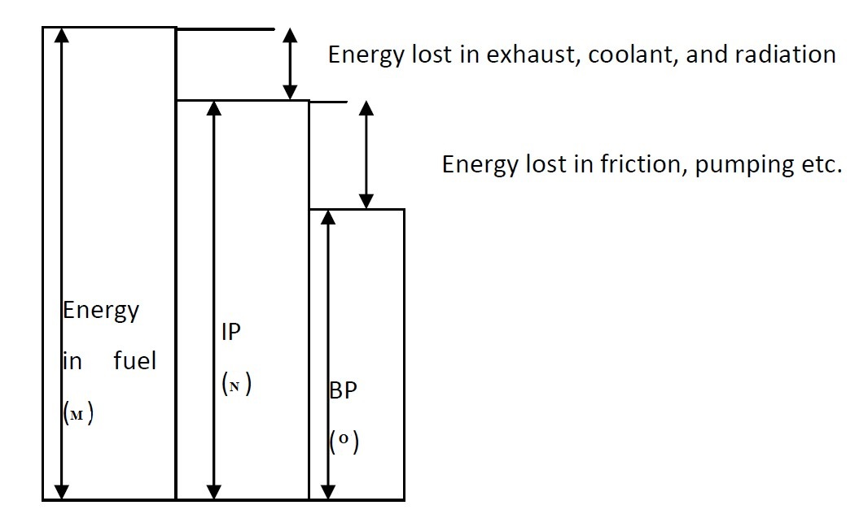
Figure 3. 3 Diagrammatic representation of various efficiencies
Indicated thermal efficiency = Indicate power / Energy in Fuel
Brake thermal efficiency = Brake power / Energy in Fuel
Mechanical efficiency = Brake Power/ Indicated power
Fuel Consumption: fuel consumption is the total volume of consumed fuel by an engine under test conditions in a given time
The specific fuel consumption (SFC): SFC is defined as the total fuel consumption per hr per kW power developed. In other words, SFC can be defined as the rate of fuel consumption per kWh.
Brake specific fuel consumption (BSFC) and indicated specific fuel consumption (ISFC) are the fuel consumptions based on Brake power and indicated power respectively.
Mathematically,
ISFC =$\frac{60w_{f}}{i.p.}=\frac{3600}{H.V.Ƞ_{i}}$, ${Kg}/{i.kWh}$
BSFC =$\frac{60w_{f}}{b.p}=\frac{3600}{H.V.Ƞ_{b}}$,${Kg}/{b.kWh}$

3.6 Experimental Testing of Diesel and biodiesel blends

3.6.1 Test Setup for Engine Performance and Combustion Characteristics
When the physical chemical of biodiesel blend of 20% by volume was found to be in the range of diesel, biodiesel blends of less than or equal to 20% by volume were tested. Biodiesel blends of JB10, JB15, and JB20 and diesel performance were tested in varying compression ratios of 15:1, 16:1, and 17:1 at a varying load of 1kg, 3 kg, 6 kg, 9 kg, and 12 kg. For performance and combustion analysis, the testing machine used was Kirloskar diesel Engine available in Thapathali Campus, Thapathali, Kathmandu was used having specifications as mentioned in Table 2.

Performance Parameters
- Fuel Type: Diesel
- Calorific Value of Fuel: 45000 kJ/kg
- Fuel Density : 720-775 kg/m³
- Diameter of orifice: 20 mm
- Discharge coefficient of Orifice: 0.60
- Length of an arm of Dynamometer: 185 mm
- diameter of pipe of fuel: 12.40mm
- Ambient Temperature: 27 ºC
- Pulses Per revolution: 360
Table 3.2 Test engine Specification
S.N. | Features | Specifications
1 | Make | Kirloskar diesel Engine
2 | Type | Water cooled Diesel, Four strokes
3 | Number of cylinder | 1
4 | Starting method | cranking by electric motor
5 | Principle of combustion | Compression ignition
6 | Loading | Eddy current dynamometer
7 | Radius of Crank | 55mm
8 | Range of Compression ratio | 15:1-18:1
9 | Length of connecting Rod | 300mm
10 | Maximum speed | 1500 rpm

Combustion Parameters:
- Number of Cycles: 10
- Smoothing 2
- TDC Reference: 0
- Specific Gas Constant: 1.00 kJ/kgK
- The density of air: 1.17 kg/m³
- Adiabatic Index: 1.41
- Polytrophic Index: 1.12
- Cylinder Pressure Reference: 1
Block diagram of engine showing different sensors is shown in figure 3-3.
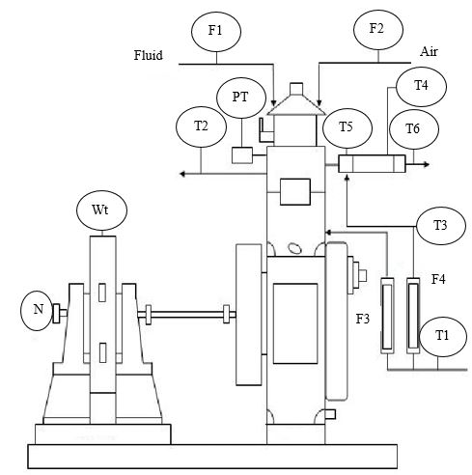
Dynamometer
Engine

Figure 3 4 Block diagram of test Engine

The symbols in the block diagram represent the following:
PT = Pressure Sensor
T = Temperature Sensor
F = Flow Sensor
N = RPM sensor
Wt = Load Sensor

3.6.2 Test Setup for Emission Characteristics
For smoke opacity test Bosch Emissions Analysis was used on VAAP engine having following specification and for exhaust gas emissions like CO, HC, and CO₂ Horiba Automotive Emission Analyser was used.

VAAP engine specification
- Model number: 2711E
- No of cylinder: 4
- Bore diameter: 107mm
- Stroke: 115mm
- Capacity: 4.150Lt
- Speed: 1250-2500 r.p.m 35
- Compression ratio: 15.5:1
- Firing Order: 1,2,4,3
- Max Torque B.S 649(lbs.ft):
- B.S Overload: 178 at 1600rpm.
- B.S rating: 160 at 1600rpm
- Max B.H.P B.S649
B.S Overload: 71 at 2500 r.p.m
B.S Rating: 64 at 2500 r.p.m
Opacimeter specification
- Model number: Opacimeter RTM 430.
- Measuring chamber length: 432 mm
- Power supply: via Emissions System Analysis (ESA), Bosch Emissions Analysis (BEA), or Emissions Analysis Tester (EAM)
- Application range: +2°C to +40°C
- Relative air humidity of ambient air: < 90 % without thawing
- Max. exhaust-gas temperature at device input: 200 °C
- Class of protection: IP 33 Dimensions: (W x H x D in mm) 594 x 203 x 151
- Weight: approx. 8 kg
- Noise emissions: < 70 dB(A)
- Electromagnetic compatibility (EMC): This product is a Class A product by EN 55022

Table 3. 3 Opacity Meter Specification
Measured variable | Display range | Measurement Range | Resolution
Degree of opacity | 0 - 100 % | 0 - 100 % | 0.1 %
Coefficient of absorption k | 0 - 9.9 m⁻¹ | 0.5 - 5.5 m⁻¹ | 0.01 m⁻¹

Exhaust Gas Emission Analyzer Specification
Table 3. 4 Gas Emission Analyzer specification
Model | MEXA-584L
Application | Exhaust gases in idling status from gasoline vehicle, LPG vehicle
Confirmed Standards | ISO 3930/OIML R99 (2000)
Measured parameters  HC  CO  CO2  LAMBDA | 0 ppm to 10000 ppm  0.00 % vol to 20.00 % vol  0.00 % vol to 20.00 % vol  0.00 to 9.99
Engine Speed | 0 rpm to 9990 rpm
Monitor Display | LCD
Input/outputs | Digital input/output: RS-232C, RS-485
Calibration gas | Mixed gases of CO and CO2 NO (for the instrument with NO analyzer, optional)
Response Speed within | Within 15 sec
Warm-up time | 5 min
Dimensions  Mass | 260 * 375 * 157 mm  Approx. 4kg

3.7 Experimental Procedure
The experiment was conducted on a single-cylinder, water-cooled constant-speed diesel engine at a variable load of 0.5kg, 3kg. 6kg, 9kg, and 12kg and a variable compression ratio. 0.5kg was regarded as low load and 12kg was regarded as high load. The engine was attached with an eddy current dynamometer. The fuel tank was bypassed. Before taking data of engine performance and combustion, the engine was allowed to run for 15minutes with the blends of Jatropha. While taking data, the fuel supplied to the cylinder chamber was measured for 1 minute. Engine performance such as indicated power, specific fuel consumption, mechanical efficiency, brake thermal efficiency, and heat balance sheet concerning load and combustion characteristics such as cylinder pressure, cumulative heat release, and net heat release with crank angle was shown by the engine software.
The obtained results were validated by comparing with different research that was done in the past. The exhaust gas parameters like CO₂, HC, and CO were analyzed using Gas analyzer available at NAST, Khumaltar, Lalitpur, and smoke opacity using an opacity meter available at Thapathali Campus, Kathmandu.

Performance and Combustion Analysis
Based on experimental results, analysis was done for suggesting the best blends. Engine performance analyzed were IP, BTH, SFC, ME, and EGT. Also, combustion parameters like Net Head Release, Peak Cylinder Pressure, and cumulative Heat Release were analyzed.

Validation
The obtained results were validated by comparing with different research that was done in the past.

Documentation
The documentation of all the Literature and results while undergoing the research will be documented and the report will be prepared and the paper will be published including all the findings.

CHAPTER FOUR: RESULT AND DISCUSSION

4.1 Biodiesel production
FFA test was primarily carried out at first. The result is given below:
The volume of Isopropyl alcohol: 10 ml Oil
The sample was taken: 2 gm.
The volume of 0.1N KOH consumed: 1 ml
10 drops of phenolphthalein
Acid Value = 5.24 mg KOH/g
From this, we obtain 𝐴𝑐𝑖𝑑 𝑉𝑎𝑙𝑢𝑒
FFA content = (Acid Value)/2
FFA content = 2.62% (< 1)
The value obtained was greater than one which then led to a two-step acid base-catalyzed transesterification process as per literature.
Step 1:
The volume of oil sample: 250 ml
Weight of oil sample: 211.08 gm
Then, the weight of methanol: gm (40% of wt. of oil)
The volume of acid (H2SO4): 1.875 ml (0.75% of the volume of oil)
The mixture was then heated and stirred continuously at 60 ºC for an hour. The resulting mixture was let down to settle for two hours and upped layer was removed. FFA test was again repeated and the result obtained was 0.503% which is in the proper range.
Step II:
The process of transesterification was repeated once again using the basic catalyst KOH.
Weight of methanol: 62.5 ml (25% of the weight of oil)
Weight of KOH: 2.11 gm (1% of the weight of oil)

Table 4. 1 Production of Biodiesel through Esterification and transesterification process
Batch | Step 1 |  |  |  | Step 2
 | Oil taken (gm) | Oil taken (ml) | Methanol (ml) | H₂SO₄ (ml) | Methanol (ml) | KOH (gm)
1st | 178.33 | 200 | 106.998 | 1.5 | 50 | 1.7833
2nd | 211.08 | 250 | 126.648 | 1.875 | 62.5 | 2.1108
3rd | 167.68 | 200 | 100.608 | 1.5 | 50 | 1.6768
4th | 166.83 | 200 | 100.098 | 1.5 | 50 | 1.6683
5th | 127.25 | 150 | 76.35 | 1.125 | 37.5 | 1.2725
6th | 190.16 | 210 | 114.096 | 1.575 | 52.5 | 1.9016
7th | 259.12 | 300 | 155.472 | 2.25 | 75 | 2.5912
8th | 128.5 | 150 | 77.1 | 1.125 | 37.5 | 1.285
The biodiesel production was carried out in 7 more batches following a similar procedure.
The total biodiesel yield is 1.11L which is nearly 70% of Jatropha oil. The transesterification process was followed by the separation of biodiesel and glycerol. After glycerol was separated, washing by lukewarm water early at 50⁰C was done to neutralize the pH. Then, to eliminate the excess water content, the solution was excited to over 100⁰ C in micro-oven for 4 hrs. About 20ml of the obtained biodiesel was taken for FTIR testing.

4.2 FTIR result and Analysis
Table 4. 2 FTIR analysis of Diesel
S.N. | Wavelength (cm-1) | Types of vibration | Functional group
1 | 2916.37 | Asymmetrical | C-H2 stretch Alkane
2 | 2854.65 | Symmetric | CH2 Stretch Alkane
3 | 1458.18 | Angular deformation | CH2 alkane, Aromatics
S.N. | Wavelength (cm-1) | Types of vibration | Functional group
4 | 1373.32 | rock | C-H alkane
5 | 725.23 | rock | C-H alkane

Table 4. 3 FTIR analysis of JB20
S.N. | Wavelength (cm-1) | Types of vibration | Functional group
1 | 2924.09 | Asymmetric Stretch | Methylene (=CH2)
2 | 2854.65 | Symmetric Stretch | Methylene (=CH2)
3 | 1759.08 | Three band stretch | Saturated ester (C=O)
3 | 1527.62 | Asymmetric Stretch | N-O nitro compound
4 | 1442.75 | Stretch | C-C, Aromatic
5 | 1381.03 | Rock | C-H , alkane
6 | 1172.72 | Stretch | C-O , Esters
7 | 101.7 |  | C-H, alkane
8 | 725.23 | stretch | C-Cl ,Aliphatic chloro compound

Figure 4. 1 FTIR of Diesel and JB20
Fig 4.1 shows the FTIR spectrum of the diesel and Jatropha biodiesel. The peak
of the wavelength of Jatropha blend 20% was present at the wavelength of 2924.09cm-1, 2854.65, 1759.08, 1527.62, 1442.75, 1381.03, and 1172.72 which shows the presence of asymmetric stretch methylene group, an asymmetric stretch of a methylene group, a three-band stretch of the saturated ester group, an asymmetric stretch of the nitro group, stretch C-C aromatic group, rock vibration alkane and stretch ester group respectively.

4.3 Comparison of Fuel Property of JB20 with diesel
The blended biodiesel prepared in the lab was tested as per the test method of ASTM D2382 standard for calorific value, ASTM D445 standard for kinematic viscosity, ASTM D3828 standard for flash point, ASTM D1298 standard for density, and ASTM D97 standard for pour point. The outcomes of the test performed are shown in Table 4.4. The obtained numerical values of those physical-chemical properties of blended fuel were comparable to diesel with a slight increment in density and loss in calorific value
Table 4. 4 Fuel Properties of JB20 and Diesel
Fuel Property | JB20 | Diesel  Bharat standard 4 | Test Method
Density at 15°C, kg/m³ | 840.6 | 820-860 | ASTM D1298
Cetane Number | 55 | 30-65 | ASTM D613
Calorific value, KJ/kg | 39750 | 43200 | ASTM D2382
Kinematic viscosity at 40 ºC, Cst | 2.32 | 1.9 - 4.1 | ASTM D445
Flash Point (Minimum), º C | 55.5⁰C | 52 | ASTM D3828
Pour Point, ⁰C | -6 | -11 | ASTM D97
Total Acid Number, mgKOH/g | 0.42 | 0.2 | ASTM D664
Total Water Content, ppm | 566.8 | 200 | ASTM D6304
Distillation Recovery at 360⁰C | 97% by volume | 95% by volume, minimum | ASTM D86
Copper Strip Corrosion | 1A | Not worse than 1 | ASTM D130

4.4 Comparison of Performance characteristics of Various JB blends and diesel

4.4.1 Variation of Indicated Power of various JB Blends and Diesel with Brake Power
The power that is obtained from the burning of fuel inside the cylinder of an engine is its indicated power. For the diesel engine generally, high indicated power is preferred. As the RPM of the engine was made constant, so with the rise of load, to maintain the same RPM piston has to move fast to overcome the load condition, and to do so the indicated mean effective pressure due to burning of the air-fuel mixture increases which increases the indicated power of the engine.
From figure 4.2, It can be seen that at CR 15, the IP of diesel varies from 1.89 kW at low load to 5.04 kW at high load. For JB10, JB15, and JB20 IP at low load, Indicated power varies from 1.62 kW, 1.79k W, and 1.58kW respectively to 4.69kW, 4.65 kW, and 4.36 kW at high load.
From figure 4.3, it can be seen that at CR 16, the IP of Diesel varies from 1.4 kW at low load to 4.61 kW at high load. For JB 10 IP was 1.45 kW at low load and 4.41 at high load. Similarly, JB 15 and JB 20 show indicated power at low load as 1.35 kW and 1.56 kW and 4.52 kW and 4.26 kW at high load respectively.
From figure 4.4, it can be seen that at CR 17, the IP of diesel was found to be 2.23 kW at the low lad and 4.76 kW at the high load. For JB10, JB 15, and JB20, at low load indicated power varies was1.94 kW, 2.21 kW, and 1.98 kW respectively and at high load, JB 10, JB15, and JB20 shows 4.81kW, 4.94 kW, and 4.85 kW respectively.
Jatropha biodiesel blends have lower indicated power than that of the diesel throughout the compression ratio, this is because of the low calorific value of Jatropha biodiesel blends. From figure 4.2. 4.3 and 4.4, it is found that Indicated Power of JB20 is lower than the other blends of Jatropha. From Figures 4.5, 4.6, and 4.7, it was found that indicated power at CR15 is lower than IP at CR16 and CR17. There is a small margin of difference in indicated power at CR15 and CR16. . For JB20, at low load IP was 1.24 kW, 1.58kW at CR16, and 1.98kW at CR17. Also at high load, IP was 4.26 kW at CR 15, 4.3 kW at CR 16, and 4.95 kW at CR 17. From Figure 4.7 it was concluded that IP increased by 13 % on increasing CR from 15 to 17 this is due to improve in combustion with an increase in compression ratio.

Figure 4. 2 Indicated power versus Brake Power at CR15

Figure 4. 3 Indicated power versus Brake power at CR16

Figure 4. 4 Indicated Power versus Brake power at CR17

Figure 4. 5 Relation of IP with BP of JB10 at various CR

Figure 4. 6 Relation of IP with BP of JB15 at various CR

Figure 4. 7 Relation of IP with BP of JB20 at various CR

4.4.2 Variation of Specific Fuel Consumption of various JB Blends and Diesel with Brake Power
Specific fuel consumption (SFC) is the measure of fuel that goes into the engine for every unit power output by the engine. Figure 4.8 to figure shows specific fuel consumption decreases with an increase in load. At low load, diesel has lower Specific fuel Consumption than biodiesel but on increasing load, SFC decreases load for all test fuels at the nearly same rate due to the lower calorific value of biodiesel.
At CR 15 Specific fuel consumption of diesel varies from 1.93 kg/kWhr at low load to 0.3 kg/kWhr at high load. For JB10, JB15 and JB20 vary from 2.84 kg/kWhr, 2.1 kg/kWhr, and 2.3 kg/kWhr respectively at low load and at high load all test fuel shows nearly equal SFC.
At CR 16 SFC of diesel varies from 1.97 kg/kWhr at low load to 0.29 kg/kWhr high load. At low load SFC of JB10, JB15 and JB20 were 1.97 kg/kWhr, 1.62 kg/kWhr, and 1.6 kg/kWhr respectively at low load.
AT CR 17 SFC of diesel varies from 1.55 kg/kWhr at low load to 0.32 kg/kWhr at high load. For JB10, JB15 and JB20 SFC vary from 1.91 kg/kWhr, 1.96 kg/kWhr, and 1.79 kg/kWhr respectively at low load to 0.32 at high load for all test fuel.
From figures 4.8, 4.9, and 4.10, it was seen that the SFC of diesel is lower at high load, and with the rise of load, the margin of difference between SFC of diesel and blends of Jatropha decreases. Lower SFC of diesel is due to the higher calorific value of diesel and with the rise of load, ignition delay of Jatropha blends is lower than diesel, which compensates the effect of the lower calorific value of blends of Jatropha biodiesel.
From figure 4.11 to 4.13, it was found that the SFC of blends of Jatropha biodiesel is higher at CR15, and the SFC of blends of Jatropha biodiesel is lower at CR17. JB20 has a lower SFC than other blends of Jatropha biodiesel blends up to 20%, this is because of the higher cetane number of JB20 which reduces ignition delay. . The other reason for lower SFC at high CR may be due to better combustion and lesser heat losses.

Figure 4. 8 Specific fuel consumption versus Brake power at CR15

Figure 4. 9 Specific Fuel Consumption versus Brake power at CR16

Figure 4. 10 Specific Fuel Consumption versus Brake power at CR17

Figure 4. 11 Relation of SFC with BP of JB10 at various CR

Figure 4. 12 Relation of SFC with BP of JB15 at various CR

Figure 4. 13 Relation of SFC with BP of JB20 at various CR

4.4.3 Variation of Mechanical Efficiency of various JB Blends and Diesel with Brake Power
The amount of brake power obtained for a unit indicated power supplied is termed as mechanical efficiency (ME). From the figure, it is shown that ME increases with load for both diesel and biodiesel blends. With increasing, load friction losses decreases and ME increases. As we increase the load, the friction plays a smaller role in overall efficiency because the piston moves faster to retain the same rpm at a high load. This thus results in higher mechanical efficiency at high loads as indicated by Figure. Fuel with high mechanical efficiency is generally desirable.
At CR 15 Mechanical Efficiency of diesel varies from 1.57% at lo load to 81.84% at high load. For JB10, JB15 and JB 20 ME varies from 7.9%, 8.1% and 8.7% at low load to 79.17 %, 79.92% and 85.17% at high load respectively.
At CR 16 ME of diesel varies from 8.05 % at low load to 77.98% at high load. For JB10, mechanical efficiency varies from 8.95% at low load to 83.89% at high load. For JB15, JB20 ME varies from 10.70 %, 81.99% at low load to 13.42% to 87.27 % at high load respectively.
AT CR17, mechanical efficiency varies for diesel from 9.41% at low load to 76.67% at high load. Similarly, for JB10, JB15, and JB20 ME varies from 9.82%, 9.3%, and 8.13% at low load to 76.99%, 87.01%, and 83.03% at high load respectively.
Since brake power increases on increasing load, mechanical efficiency also increases with a brake for all blends. JB20 shows better mechanical efficiency over other biodiesel blends and diesel. From figure 4.17 to figure 4.19, it can be seen that the mechanical efficiency of Jatropha biodiesel blends was higher at CR17. It can be seen that the mechanical efficiency of Jatropha biodiesel blends was higher at CR17. At a low high load for JB20 Mechanical efficiency increase by 6% on increase CR from 15 to 17.

Figure 4. 14 Mechanical Efficiency versus Brake power at CR15

Figure 4. 15 Mechanical Efficiency versus Brake power at CR16

Figure 4. 16 Mechanical Efficiency versus Brake power at CR17

Figure 4. 17 Relation of Mechanical efficiency with BP of JB10 at various CR

Figure 4. 18 Relation of Mechanical efficiency with BP of JB15 at various CR16

Figure 4. 19 Relation of Mechanical efficiency with BP of JB20 at various CR17

4.4.4 Variation of brake thermal Efficiency of various JB Blends and Diesel with Brake Power
Brake thermal efficiency is the ratio of energy in the brake power to the fuel energy. The variation of brake thermal efficiency with respect to brake power is shown in the figure. From experimental results, it is observed that with an increase in brake power brake thermal efficiency increases both for diesel and Jatropha biodiesel blends
From figure 4.20, it can be seen that at CR 15 Brake Thermal Efficiency of diesel varies from 2%at low load to 28.88% at high load. For JB 10, JB15, and JB20 BTE at low load was 1.93%, 1.88%, and 3.49% respectively and at high load are 27.65%, 28.53%, and 30% respectively.
From figure 4.21, at CR 16 BTE of diesel varies from 2.13% at low load to 30.65% at high load. For JB10, JB15 and JB20 BTE ranges from 2.8%, 3.12% and 3.24% at low load to 29.7%, 28.78% and 30.08% at high load respectively.
From figure 4.22, it can be seen that at CR 17 BTE of diesel varies from 2.15 % at low load to 28.51% at high load. For JB10, JB15, and JB20 at load was 3.34%, 3.22%, and 3.21% respectively and at high load, it varies from 27.87%, 24.49%, and 26.16 % respectively.
Brake thermal efficiency of Jatropha blends was lower than that of diesel at higher load however, at high load thermal efficiency of blends are very close to diesel. The possible reason for lower BTE is lower calorific value and increase in fuel consumption of Jatropha biodiesel as compared to diesel fuel.
From figure 4.23 to figure 4.23, it can be seen that the BTE of CR17 is comparatively better than the other compression ratio. For JB20 BTE increase by 7.5% on increasing CR from 15 to 17 at high load. This may be due to better air-fuel mixing and faster evaporation which leads to complete combustion at higher CR.

Figure 4. 20 Brake thermal efficiency versus Brake power at CR15

Figure 4. 21 Figure 18 Brake Thermal Efficiency versus Brake power at CR16

Figure 4. 22 Brake Thermal Efficiency versus Brake power at CR17

Figure 4. 23 Relation of Brake Thermal efficiency with BP of JB10 at various CR

Figure 4. 24 Relation of Brake Thermal efficiency with BP of JB15 at various CR

Figure 4. 25 Relation of Brake Thermal efficiency with BP of JB20 at various CR

4.4.5 Variation of Exhaust gas Temperature of various JB Blends and Diesel with Brake Power
The exhaust gas temperature is affected by the change in ignition delay. Higher ignition delay results in delayed combustion and higher exhaust gas temperature. Jatropha biodiesel have a slightly higher cetane number which may exhibit shorter delay periods and lower exhaust gas temperature
From figure 4.26. it can be seen that at CR 15 Exhaust Gas Temperature of diesel varies from 177.48⁰C at high load to 370.68⁰C at high load. For JB10 EGT varies from 142.18⁰C low load to 362.43⁰C at high load. For JB15, JB10 EGT varies from 176.81⁰C, 169.58⁰C to 358.31⁰C 368.61⁰C at high load respectively.
From figure 4.27, it can be seen that at CR 16 EGT for diesel varies from 181.07⁰C at low load to 397.36⁰C at high load. For JB10, JB15 and JB20 its shows 175.16⁰C, 178.10⁰C, and 172.39⁰C respectively at low load and high load EGT were 326.36⁰C, 346.44⁰C, and 361.36⁰C respectively for JB10, JB15, and JB20.
From figure 4.28, it can be seen that at CR 17 diesel shows 138.250C EGT at low load and 331.36⁰C at high load. For JB10, JB 15, and JB20 EGT varies from 189.5⁰C, 168.62⁰C, and 148.96⁰C at low load to 39.07⁰C, 334.32⁰C and 324.2⁰C at high load respectively.
Blends of Jatropha biodiesel have lower exhaust gas temperature than that of diesel, this is because of the higher cetane number of Jatropha biodiesel blends which leads to shorter ignition delay and presence of water content which helps in cooling inside the combustion chamber.
Figure 4.29 to figure 4.31 shows the effect of compression ratio on various blends of Jatropha biodiesel blends. It can be seen that at CR17, the exhaust gas temperature of all the blends of Jatropha biodiesel is lower.

Figure 4. 26 Exhaust Gas Temperature versus Brake power at CR15

Figure 4. 27 Figure 1 Exhaust Gas Temperature versus Brake power at CR16

Figure 4. 28 Exhaust Gas Temperature versus Brake power at CR17

Figure 4. 29 Relation of Exhaust Gas Temperature with BP of JB10 at various CR

Figure 4. 30 Relation of Exhaust Gas Temperature with BP of JB15 at various CR

Figure 4. 31 Relation of Exhaust Gas Temperature with BP of JB20 at various CR

4.5 Comparison of Combustion characteristics of Various JB blends and diesel

4.5.1 Variation of Net heat release of various JB Blends and Diesel with Brake Power
Figure 4.32 shows the variation of Net Heat Release of diesel and Jatropha biodiesel blends with Brake power at CR15. NHR of diesel varies from 20.19j/deg at low load to 68.90j/deg, 10JB varies from 15.46j/deg at low load to 47.78j/deg, 15JB varies from 15.32j/deg at low load to 41.34j/deg and 20JB varies from 45.02j/deg.
From figure 4.33, it can be seen that at CR16, NHR of diesel varies from 15.69j/deg at low load to 66.22j/deg at high load, 17.52j/deg at low load to 55.19j/deg at high load for 10JB, 16.69j/deg at low load to 60.37j/deg at high load for 15JB and 18.38j/deg at low load to 51.85j/deg at high load for 20JB.
From figure 4.34, it can be seen that at CR17, NHR of diesel varies from 17.83j/deg at low load to 55.52j/deg at high load, for 10JB varies from 15.65j/deg at low load to 5395j/deg at high load, for 15JB varies from 16.10j/deg at low load to 52.79j/deg at high load and for 20JB varies from 15.32j/deg at low load to 55.29j/deg.
NHR of diesel is found higher than other blends of Jatropha this is because of the higher ignition delay of diesel in comparison to other blends of Jatropha and comparatively higher calorific value of diesel.
From Figure 4.35 to figure 4.37, the variation of Net Heat Release of diesel and Jatropha biodiesel blends crank angle at various CR is shown. NHR at CR15 is lower than another compression ratio, this is due to reducing the pre-mixed burn reduces the spike in heat release, resulting in a more balanced burning of the fuel. Reduction in the pre-mixed burn is due to shorter ignition delay.

Figure 4. 32 Net Heat Release versus Brake power at CR15

Figure 4. 33 Net Heat Release versus Brake power at CR16

Figure 4. 34 Net Heat Release versus Brake power at CR17

Figure 4. 35 Relation of Net Heat Release with crank angle of JB10 various CR

Figure 4. 36 Relation of Net Heat Release with crank angle of JB10 various CR

Figure 4. 37 Relation of Net Heat Release with crank angle of JB20 various CR

4.5.2 Variation of Peak Cylinder Pressure of various Jatropha Biodiesel Blends and Diesel with Brake Power
For every crank angle, there is pressure acting on the piston head inside the combustion chamber. Relation of cylinder pressure with crank angle shows the pressure distribution on the head of the piston for each angle movement of the crank shaft. Maximum cylinder pressure is the maximum pressure exerted on the head of the piston inside the combustion chamber while burning the fuel.
From figure 4.38, at CR15 it can be seen that Peak cylinder pressure of diesel varies from 43.42 bar at low load to 70.84bar at high load, for 10JB varies from 32.37bar at low load to 56.69bar at high load, for 15Jb varies from 32.71bar at low load to 52.70bar at high load and for 20JB varies from 31.61bar at low load to 54.59bar at high load.
From figure 4.39, at CR16 Peak cylinder pressure increases with an increase in loads as shown in Figure. The maximum cylinder pressure of 38.14bar at low load to 66.00bar at high load, 37.22bar at low load to 59.19bar at high load for 10JB, 36.45bar at low load to 60.14bar at high load for 15JB and 37.76bar at low load to 57.66bar at high load for 20JB.
From figure 4.40, at CR17, the maximum peak cylinder of diesel varies from 42.88bar at low load to 72.48bar at high load. For 10JB varies from 41.71bar at low load to 65.25bar at high load, for 15JB varies 40.86bar at low load to 63.00bar at high load and for 20JB varies from 45.46bar at low load to 64.33bar at high load.
It can be observed that the peak cylinder pressure of diesel is higher than other blends of Jatropha biodiesel this is due to the prolonged pre-combustion duration of diesel. Diesel has a lower cetane number in comparison to Jatropha biodiesel blends which results in prolonged pre-combustion duration.
Figure 4.41, figure 4.42, and figure 4.43 show the pressure distribution with the crank angle of JB10, JB15, and JB20 at CR15, CR16, and CR17 respectively. It can be seen that the cylinder pressure of JB20 is lower than other blends of Jatropha biodiesel at CR17.

Figure 4. 38 Relation of Peak Cylinder Pressure and Brake power at CR15

Figure 4. 39 Relation of Peak Cylinder Pressure and Brake power at CR16
Figure 2

Figure 4. 40 Relation of Peak Cylinder Pressure and Brake power at CR17

Figure 4. 41 Variation of Cylinder Pressure of 10JB with change in crank Angle at Various CR

Figure 4. 42 Variation of Cylinder Pressure of various 15JB with change in crank Angle various CR

Figure 4. 43 Variation of Cylinder Pressure of various 20JB with change in crank Angle at various CR17

4.5.3 Variation of Cumulative Heat Release of various Jatropha Biodiesel Blends and Diesel with Brake power
Cumulative heat release is the cumulative sum of heat generated per degree crank angle in the combustion chamber. Figure 4.44 shows the variation of cumulative Heat Release with respect to Brake power for various Jatropha biodiesel blends and diesel at CR15. CHR of diesel varies from 0.40kJ at low load to 1.27kJ at high load for diesel, 0.43kJ at low load to 0.85kJ at high load for 10JB, 0.4kJ at low load to 0.80kJ at high load for 15JB, and 0.43kJ at low load to 0.80kJ at high load for 20JB.
From figure 4.45, it can be seen that at CR16 CHR of diesel varies from 0.43kJ at low load to 0.94 kJ at high load, 0.44 kJ at low load to 0.85kJ at high load for 10JB, 0.44kJ at low load to 0.88kJ at high load, and 0.47kJ at low load to 0.84kJ at high load for 20JB. In this compression ratio, CHR does not show any pattern.
From figure 4.46, it can be seen that at 17cr Cumulative heat release of diesel varies from 0.45kJ at low load to 1.40kJ at high load, for 10JB varies from 0.42kJ at low load to 0.92kJ at high load, for 15JB varies from 0.27kJ at low load to 0.58kJ at high load and for 20JB varies from 0.91kJ at low load to 0.61kJ at high load.
Cumulative heat release of diesel is higher than other blends of Jatropha biodiesel, this is because of the higher calorific value of diesel and higher ignition delay of diesel due to the lower cetane index of diesel in compression to Jatropha biodiesel blends.
Figure 4.47, Figure 4.48, and Figure4.49 show the relation of cumulative heat release with crank angle. It can be seen that the CHR of all blends of Jatropha biodiesel is lower at 17CR.

Figure 4. 44 Cumulative Heat Released versus Brake power at CR15

Figure 4. 45 Cumulative Heat Release versus Brake power at CR16

Figure 4. 46 Cumulative Heat Release versus Brake Power at CR17

Figure 4. 47 Relation of cumulative Net Heat Release with crank angle of JB10 various CR

Figure 4. 48 Relation of cumulative Net Heat Release with crank angle of JB15 various CR

Figure 4. 49 Relation of cumulative Net Heat Release with crank angle of JB20 various CR

4.6. Emission Testing Analysis
Emission test like CO, HC, and CO₂ was done at Compression ratio 17 as it has better performance over another compression ratio.

4.6.1 HC emission
The variation of HC with BP is shown in figure 4.50. Within the whole experiment Hydrocarbon Emission of diesel was found to be higher than Jatropha biodiesel blends At low load HC of diesel, JB10, JB15 and JB20 were 112.28 ppm, 92.25 ppm, 103.58 ppm, and 88.74 ppm respectively but HC emission increases at higher load for all test fuels. This is due to lack of oxygen resulting from engine operation at a higher equivalent ratio which can be shown in the SFC graph.

Figure 4. 50 Relation of Hydrocarbon emission and Brake Power

4.4.2 CO emission
The CO emission first decreases from low load to moderate load and then increases for the higher load as shown in figure 4.51. At lower load, CO emissions of Jatropha biodiesel are close to diesel and as load increases, CO emission of Jatropha Biodiesel decreases as compared to diesel this is because biodiesel is oxygenated fuel and contains oxygen which helps for complete combustion.
For diesel, JB10, JB15, and JB 20 CO emission was 0.09 vol %, 0.08 vol %,0.07 vol %, 0.07 vol % at low load whereas at high low all test fuel shows nearly equal CO emission. Of all test fuels, JB 20 shows lower CO emissions. The lower CO of jatropha biodiesel may be due to extra oxygen present in biodiesel which helps for complete combustion (B.S. Chauhan, et al, 2012)

Figure 4. 51 Relation of CO emission and Brake Power

4.4.3 CO₂ Emission

Figure 4. 52 CO2 emission and Brake Power
The Variation of CO₂ with an increase in BP is shown in figure 4.52. Diesel CO₂ varies from 2.21 vol % at low load to 6.59 vol % at high load. For JB10, JB15 and JB20 CO₂ at low load was 2.58 vol %, 2.6 vol % and 2.55 vol % and for high load it ranges to 6.41 vol %, 6.92 vol % and 6.89 vol % respectively. The CO₂ emission of diesel was found to be lower than Jatropha biodiesel blends throughout the whole operating range. Since the biodiesel contains oxygen element, the carbon element is relatively low in the same volume of fuel consumed at the same engine load which may be the reason for the lower CO2 emission of diesel compared to Jatropha biodiesel blends.

4.4.4. Smoke Opacity Test
ISO 11614 defines opacimeter terms and principles as opacimeters are portable, reliable, rugged, low cost, and easy to use instruments with a fast response. Their output is a single value (as opposed to, say, a number/size distribution) making opacimeters ideal for pass/fail indication when used for periodic in-service testing. Unit of K is m-1.
One of the main problems in a diesel engine is smoke opacity. Fig shows the variation of smoke opacity of diesel fuel and Jatropha biodiesel blends. It is observed that smoke density is reduced with the increase in biodiesel percentage compared to pure diesel. Lower smoke emissions are the indication of complete combustion of the fuel as additional oxygen is available on biodiesel fuel itself. The smoke opacity is reduced in the range from 23.26 % to 31.68% for Jatropha biodiesel blends than diesel fuel at full throttling condition

Figure 4. 53 Relation of Opacimeneter value with JB blends

CHAPTER FIVE: CONCLUSION AND RECOMMENDATION

5.1 Conclusion
In this report, a procedure for biodiesel production from Jatropha seed oil was presented and the effects of the biodiesel blends to diesel fuel on the performance and emission of a varying compression diesel engine were investigated and analyzed. The experimental results can be concluded as:
- Due to higher Free Fatty Acid concentration on Jatropha seed oil two-step transesterification process was selected for maximum yield of biodiesel.
- The physio-thermal properties of biodiesel were compared with ASTM standard and are found within limits. JB20 has a lower calorific value and higher cetane number, density, and viscosity are higher than that of diesel. The engine operates smoothly, did not show any starting problem, and no audible knock while running on jatropha biodiesel blends.
- CR 15, IP of JB 20 decreased by 13% at high load, Brake thermal Efficiency increase by 5%, Mechanical Efficiency increase by 4%, SFC increases by 6% while EGT increases by 1% compared to pure diesel.
- At CR15, maximum cylinder pressure, Cumulative heat release, and Net heat release of JB20 decreases by 23%, 37%, and 34.66% respectively in comparison to diesel
- At CR 16 IP of JB 20 decrease by 7% at high load, BTH decrease by 2%, Mechanical thermal Efficiency increase by 12%, SFC increase by 1% while EGT increase by 9% as compared to diesel.
- At CR16, maximum cylinder pressure, Cumulative heat release, and Net heat release of JB20 decreases by 22%, 13%, and 11% respectively in comparison to diesel
- At CR 17, IP of JB20 decrease by 8% at 50% loading, BTE increase by 8%at full load, MTE increase by 8%, SFC by 4% while EGT by 2% at full loading condition.
- At CR17, maximum cylinder pressure, Cumulative heat release, and Net heat release of JB20 decrease by 11.24%, 56.45%, and 4.01% respectively in comparison to diesel5.
- At low load CO₂ emission of diesel is 16% less than JB20 but at full load, diesel shows only 5% less CO₂ emission compared to JB20.
- At low load, HC emission of JB20 decrease by 15% compared to diesel and high load JB20 shows 5% lower HC emission compared to diesel.
- CO emission of JB20 decrease by 20% at low load while at high load its shows only 6% reduction of CO emission compared to diesel.

5.2 Suggestion for future
- In the future, there is scope for research in Jatropha biodiesel on another different compression ratio by varying load and injection pressure.
- NO_{X} emission analysis can be done.
- Similarly, combustion analysis and performance study for more than 20% of the blend can be done.

REFERENCES
Khatiwada, D., & Silveira , S. ( 2011). Greenhouse gas balances of molasses based ethanol in Nepal. Journal of Cleaner Production 19, 1471e1485.
Shirneshan , A. A. (2013). HC, CO, CO2 and NOx Emission evaluation of a diesel engine fueled with waste frying oil methyl ester. Procedia Soc Behav Sci.
Silveira , S., & Khatiwada, D. (2010). Ethanol production and fuel substitution in Nepal—Opportunity to promote sustainable development and climate change mitigation. Renewable and Sustainable Energy Reviews.
Abhishek Naik, Nagesh Naik, Edison Vaz, Abdul kareem. (2019). Automatic Solar Cleaning system. International Research Journal of Engineering and Technology.
Agarwal, D., & Agarwal, A. K. (2007). Performance and emissions characteristics of Jatropha oil (preheated and blends) in a direct injection compression ignition engine. Applied Thermal Engineering, 2314-2323.
AICC- Agriculture Information and Communication Centre, MOAC, Government of Nepal. (2009). Retrieved from www.aicc.gov.np/database/agriculture-statistics.
Astakov, I. (1995). Effect of design parameters of delivery manifold and characteristics of fuel on the velocity of propagation and reflection properties of pressure waves in the fuel system of a diesel engine. Energomash 5, 5-19.
ASTM D1298-99. (2005). Standard Test Method for Density, Relative Density (Specific Gravity), or API Gravity of Crude Petroleum and Liquid Petroleum Products by Hydrometer Method. ASTM International.
Aworanti, O. A. (2019). Process Parameter Estimation of Biodiesel Production from Waste Frying Oil (Vegetable and Palm oil) using Homogeneous Catalyst. Journal of Food Processing & Technology(9).
B.S. Chauhan, et al. (2012). A study on the performance and emission of a diesel engine fueled with Jatropha biodiesel oil & its Blends. Energy(37) , 616-622.
Balat, M. (2010). Potential Alternatives to Edible Oils for Biodiesel Production–A Review of Current Work. Energy Covers Manage, 1479–92.
Bayrakta, H. (2005). Experimenta and therotical investigation of using gasoline-ethanol blends in spark-ignition engines. Renewable energy 30.
Canaki M, Van Genper J. . (1999). Biodiesel production via acid catalyst. Trans Amsos Agric Eng, 1203-1210.
Celik, B. M. (2008). Experimental determination of suitable ethanol–gasoline. Applied thermal engineering, 396-404.
Chauhan, B. S., Kumar, N., & Cho, H. M. (2012). A study on the performance and emission of a diesel engine fueled with Jatropha biodiesel oil and its blends. Energy, 616-622.
Crabbe, E. et. al. (2001). Biodiesel production from crude palm oil and evaluation of butanol extractuin and fuel properties. Process Bio chmeistry 37, 65-71.
Deepak Agrawal, Avinash Kumar Agrawal. (2007). Performance and Emission characteristics of Jatropha oil (preheated and blends) in a direct injection compression engine . applied Thermal Engineering, 2314-2323.
Dipankar Deba, Nisarg L. Brahmbhattb. (2017). Review of yield increase of solar panels through soiling prevention, and a proposed water-free automated cleaning solution. Elsevier ltd.
Experimental and theoretical investigation of using gasoline–ethanol blends in spark-ignition engines. (2005). Renewable energy 30.
Gaofa He, Chuande Zhou, Zelun Li. (2010). Review of self cleaning methods for solar array. Elsevier.
Ghadge, S.V., Raheman, H. (2005). Biodiesel production from mahua (Madhuca indica) oil having high free fatty acids. Biomass Bioenergy 28, 601–605.
Gupta, A. M. (2019). IoT Based Framework: Mathematical Modelling and Analysis of Dust Impact. Cross Marks.
Gwandu B A L, Creasey D J. (1995). Humidity: a factor in the appropriate positioning of a photovoltaic power station. In Renewable Energy, Vol.6 (pp. 313-316,).
H. An, W.M. Yang , S.K. Chau, K.J. Chau. (2012). Combustion and emissions characteristics of diesel engine fueled by biodiesel at partial load conditions. Applied Energy, 363-371.
Hanny Johanes Berchamans, Shizako Hirata. (2008). Biodiesel production from crude Jatropha curcas L. seed oil with a high content of free fatty acids. Bioresource Technology, 1716-1721.
https://en.wikipedia.org/w/index.php?title=Infrared_spectroscopy_correlation_table&oldid=971042699. (n.d.).
Hussein A Kazem, Miqdam T Chaichan. (2015). Effect of Humidity on Photovoltaic Performance Based on Experimental Study. International Journal of Applied Engineering Research ISSN 0973-4562 Volume 10.
IEA. (2019). https://www.iea.org/geco/oil/.
ISO 3675:1998. (1998). Crude petroleum and liquid petroleum products — Laboratory determination of density — Hydrometer method. International Organization for Standardization.
Joshi, S. M., Krishna, R., Patil, B. A., & Gangal, A. C. (2015). Performance Evaluation of Petrol-Ethanol Blends and Testing on Multicylinder 4-Stroke SI Engine. Journal of Alternate Energy Sources and Technologies.
Juan, J. C. et al. (2011). Biodiesel Production from Jatropha Oil by Catalytic and Non-catalytic Approaches: An Overview. Bioresource echnology, 452–460.
K Shrestha, JR Ghimire & MB Gewali. (2013). biodiesel production from jatropha curcas (l.) oil of nepal by transesterification process. International journal of pharmaceutical, chemical and biological sciences, 603-609.
K.V.Vidyanandam, D. (2017). An Overview of Factors Affecting the Performance of Solar PV Systems. Energy Scan, A house Journal of corporate planning, NTPC ltd.
Koh, M.Y. and T.I. Mohd. Ghazi. (2011). A Review of Biodiesel Production from Jatropha Curcas Oil. Renewable and Sustainable Energy Reviews, 2240–2251.
Lamichhane, G. K. (2019). Biofuel Production from Waste Cooking Oils and Its Physicochemical Properties in Comparison to Petrodiesel. Nepal Journal Of Biotechnology, 8, 87-94.
Laugan, D. & Gyo, Y. (2006). Transtrification of neat and used frying oil: Optimization for biodiesel production. Fuel processing Technology, 883-890.
Liaquate AM et. all. (2010). Potential emissions reduction in road transport sector using biofuel in developing countries. Atmos Evniron.
Ma F , Hanna MA. (1999). Biodiesel production : A review. Bioresour Technol, 1-15.
Malay K. Mazumder, Mark N. Horenstein, Nitin R. Joglekar et all. (2017). Mitigation of dust impact on the solar collectors by water free cleaning with transparent electrodynamic films: Progress and Challenges. IEEE Journal of Photovoltaics.
Mether, L.C, et al. (2006). Technical Aspects of Biodiesel production by Transtrification- A review. Renewable & sustainable Energy reviews, 248-268.
Mofijur, M., Masjuki, H. H., Kalam, M. A., & Atabani, A. E. (2013). Evaluation of biodiesel blending, engine performance and emissions characteristics of Jatropha curcas methyl ester: Malaysian perspective. Energy, 879-887.
Mr. Rajendra L. Gaike1 , Prof. Sanjay Y Gadkari 2, Sachin S. Kangane. (2018). Design and development of the solar panel cleaning system. International Journal of Science and Engineering.
N. Usta , E. Ozturk, E.S Cankur, et all. ( 2005). Combustion of biodiesel fuel produced from hazelnut soapstock/waste sunflower oil mixture in a Diesel engine. Energy Conversion and Management , 46, 741–755.
Nang Xuan Ho, et.al. (2020). Experimental study on characteristics of the test engine fueled by biodiesel based Jatropha oil and traditional diesel. AIMS Energy, 8(6), 1143–1155.
Nasib Khadka, Binamra Adhikari, Aayush Bista, Ashish Shrestha. (2018). Solar panel cleaning Technology: A Review. Research Gate.
NOC. (2019, 1 3). Nepal oil corporation limited. Retrieved from import/sales: http://nepaloil.com.np
Ozsezen, A. N., & Canakci, M. (2010). The emission analysis of an idi diesel engine fueled with methyl ester of waste frying palm oil and its blends. Biomass and Bioenergy, 34(12) , 1870-1878.
Palash, S. M., Kalam, M. A., Masjuki, H. H., Arbab, M. I., Masum, B. M., & Sanjid, A. (2014). Impacts of NOx reducing antioxidant additive on performance and emissions of a multi-cylinder diesel engine fueled with Jatropha biodiesel blends. Energy Conversion and Management, 577-585.
Parawira, W. (2105). Biodiesel production from Jatropha curcus: A review. Scientific research and essays, 11796-1808.
Pascal Ndayishimiye, Mohand Tazerout. (2011). Use of palm oil-based biofuel in the internal combustion engines: Performance and emissions characteristics. Energy, 36, 1790-1796.
Popovicheva, O. K. (2015). FTIR analysis of surface functionalities on particulate matter produced by off-road diesel engines operating on diesel and biofuel. Environmental Science and Pollution Research, 22:453.
Rashid, U. & Anwar, F. (2008). Production of biodiesel through optimized alkaline-catalyzed transesterification of rapeseed oil. Fuel, 265-273.
RC, C., & Sodre, R. (2011). Compression ratio effects on an ethanol/gasoline fulled engine. Applied Thermal Engineering 31, 278-283.
Rizwanul Fattah et.al. (2014). Effect of antioxidant on the performance and emission characteristics of a diesel engine fueled with palm biodiesel blends. Energy Conversion and Management(79), 265-272.
Saidan, M., Albaali, A.G., Alasis, E., Kaldellis, J.K.,. (2016). Experimental study on the effect of of dust deposition on solar photovoltaic panels in desert environment. In Renewable Energy (pp. 495-505).
Shirneshan , A. A. (2013). HC, CO, CO2 and NOx Emission evaluation of a diesel engine fueled with waste frying oil methyl ester. Procedia Soc Behav Sci.
Shirneshan, A. (2013). HC, CO, CO2 and NOx Emission evaluation of a diesel engine fueled with waste frying oil methyl ester. Procedia Soc Behav Sci.
Shirneshan, A. A. (2013). HC, CO, CO2 and NOx Emission evaluation of a diesel engine fueled with waste frying oil methyl ester. Procedia Soc Behav Sci.
Shyamsundar , S., Mishra, P., & Bhandari, A. ( 2017). PERFORMANCE ON SPARK IGNITION ENGINE USING ETHANOL. International Journal of Research In Science & Engineering.
Silveira, S., & Khatiwada, D. (2010). Ethanol production and fuel substitution in Nepal—Opportunity to promote. Renewable and Sustainable Energy Reviews, 1644-1652.
Spataru, A., C. Romig. (1995). Emissions and engine performance from blends of soya and canola methyl esters with ARB#2 diesel in a DCC 6V92TA MUI engine”. SAE International, 952388.
(2019). Statistical information on Nepalese Agriculture. Kathmandu: Government of Nepal, Ministry of Agriculture and Livestock Devepolment.
STATISTICS, I. E. (2019, 1 1). INTERNATIONAL ENERGY STATISTICS. Retrieved from eia.gov: https://www.eia.gov/beta/international/data/browser/#/?c=4100000002000060000000000000g000200000000000000001&vs=INTL.44-1-AFRC-QBTU.A&vo=0&v=H&end=2016
Sudeep Ghimire and Zulkeer Naeen. (2017, 10 6). Renewable Energy: Huge Potentials. The Himalayan Times.
Szibist, J.P, et. al. (2005). Evaluation of formation strategies to eliminate the biodiesel NOx effect. Fuel processing Technology 86, 1109-1126.
Yuksel, F. a. (2003). The Use of ethanol-gasoline blend as fuel. Renewable Energy 29.
Yuksel, F., & Yuksel, B. (2003). The use of ethanol–gasoline blend as a fuel. Renewable Energy 29.

ANNEX
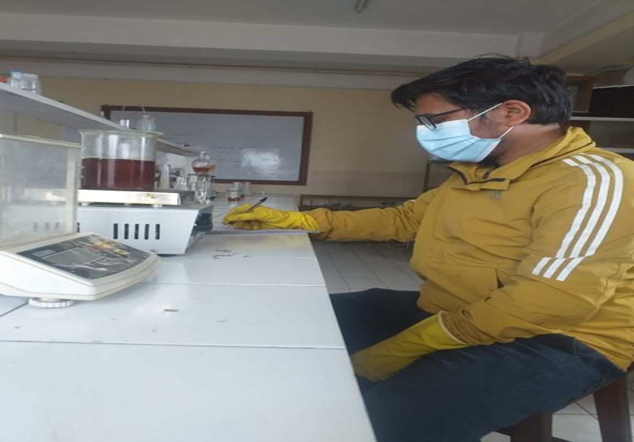
A1: Biodiesel Production
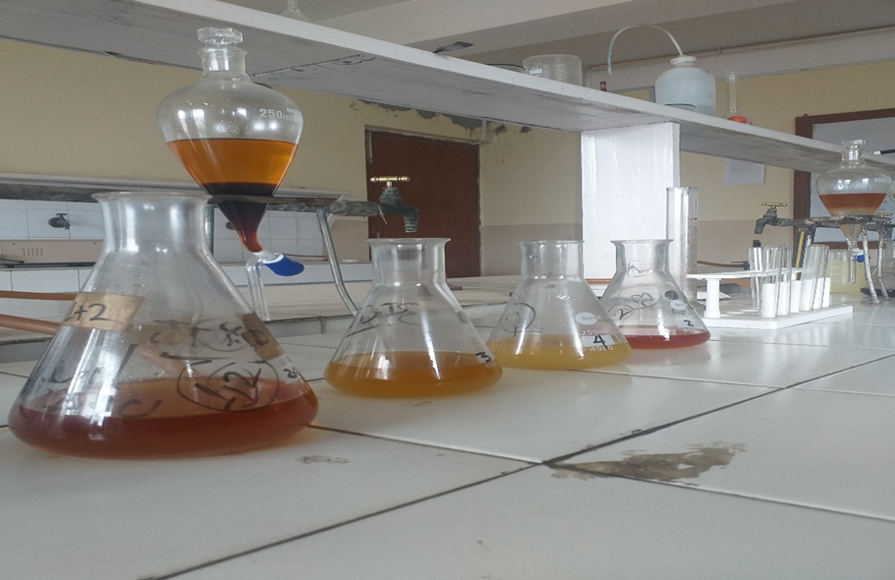
A2: Separation of biodiesel and Glycerol layer
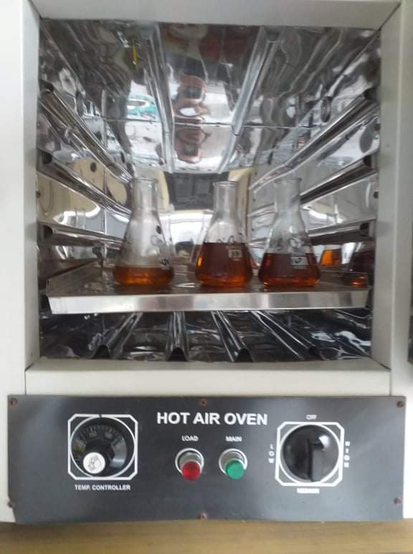
A3: Drying of Biodiesel to remove excess water using Hot air oven
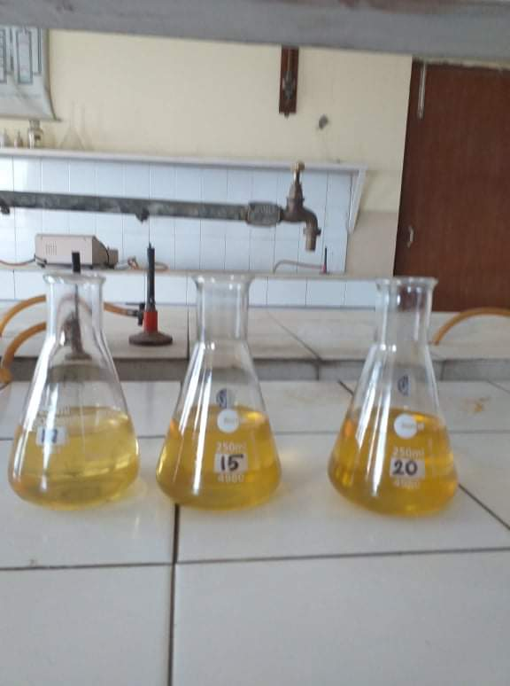
A4: Biodiesel sample after blending
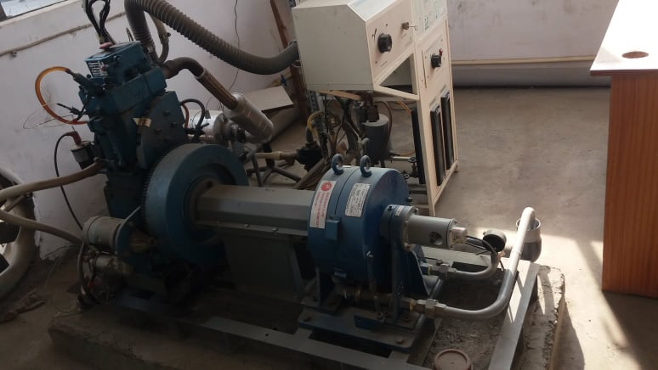
A5: Test Bench, Thapathali Campus
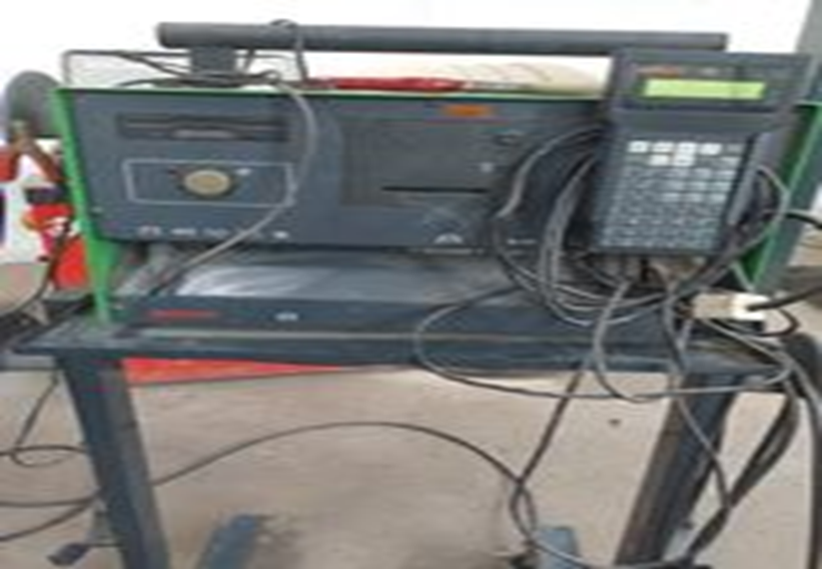
A6: Opacity Meter
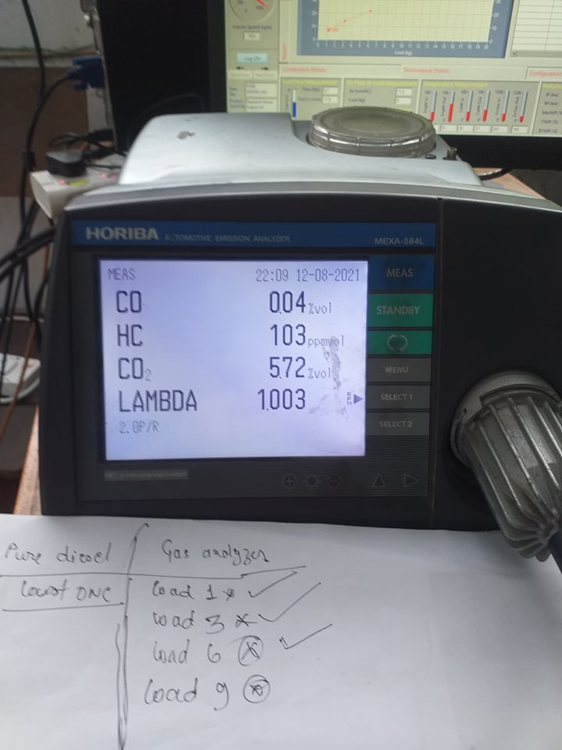
A7: Exhaust Gas Analyzer

