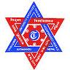

TRIBHUVAN UNIVERSITY

**INSTITUTE OF ENGINEERING**

Pulchowk Campus

Thesis No.: MSI/610/065

PERFORMANCE ANALYSIS OF COMP (COORDINATED MULTI POINT TRANSMISSION AND RECEPTION) IN LTE ADVANCED

By

Rajendra Dulal

(MSI/610/065)

Thesis

Submitted to

Masters of Science in Information and Communication Engineering,

Department of Electronics and Computer Engineering

November, 2012

**Performance Analysis of COMP (Coordinated Multi Point Transmission and Reception) in LTE Advanced.**

By

Rajendra Dulal

Thesis Supervisor (s)

Ast. Prof. Daysagar Baral

Prof. Mari Carmen Aguayo Torres.

A thesis submitted in partial fulfillment of the requirements for the degree of Master of Science in Information and Communication

Engineering

Department of Electronics and Computer Engineering

Institute of Engineering, Pulchowk Campus

Tribhuvan University

Lalitpur, Nepal

November, 2012

# 

# COPYRIGHT ©

The author has agreed that the library, Department of Electronics and Computer Engineering, Institute of Engineering, Pulchowk Campus, may make this thesis freely available for inspection. Moreover the author has agreed that the permission for extensive copying of this thesis work for scholarly purpose may be granted by the professor(s), who supervised the thesis work recorded herein or, in their absence, by the Head of the Department, wherein this thesis was done. It is understood that the recognition will be given to the author of this thesis and to the Department of Electronics and Computer Engineering, Pulchowk Campus in any use of the material of this thesis. Copying of publication or other use of this thesis for financial gain without approval of the Department of Electronics and Computer Engineering, Institute of Engineering, Pulchowk Campus and author’s written permission is prohibited.

Request for permission to copy or to make any use of the material in this thesis in whole or part should be addressed to:

Head

Department of Electronics and Computer Engineering

Institute of Engineering

Pulchowk Campus

Lalitpur, Nepal

# 

# Recommendation

The undersigned certify that they have read and recommended to the Department of Electronics and Computer Engineering for acceptance, a thesis entitled **“Performance Analysis of COMP (Coordinated Multipoint Transmission and Reception) in LTE Advanced”**, submitted by **Rajendra Dulal** in partial fulfillment of the requirement for the award of the degree of “**Master of Science in Information and Communication** **Engineering**”.

………………………………………………

**Supervisor: Asst. Prof. Daya Sagar Baral.**

……………………………………

**External Examiner: Senior Engineer Dilli Adhikari**

**Nepal Telecom**

# DEPARTMENTAL ACCEPTANCE

The thesis entitled **“Performance Analysis of COMP (Coordinated Multipoint Transmission and Reception) in LTE Advanced”,** submitted by **Rajendra Dulal** in partial fulfillment of the requirement for the award of the degree of “**Master of Science in** **Information and Communication Engineering**” has been accepted as a bonafide record of work independently carried out by him in the department.

-----------------------------------------------------------------

**Dr. Arun Kumar Timalsina**

Head of the Department

Department of Electronics and Computer Engineering,

Institute of Engineering,

Tribhuvan University

Pulchowk, Nepal.

# 

# ACKNOWLEDGEMENT

As This research is supported by Erasmus Mundus Mobility for Life 2010 scholarship program (sponsored by European Commission), I would like to thank Erasmus Mundus Mobility for life 2010 co-coordinator in University of Malaga and my supervisor Associate Prof. Marie Carmen Aguayo Torres for providing all the facilities and guiding the thesis work with immense encouragement. Credit also goes to the Mobile Research Team at the Department of Telecommunication, University of Malaga for the support in bringing out new concepts for the thesis.

I would like to thank my local supervisor Asst. Prof. Daya Sagar Baral, Institute of Engineering, TU, Nepal for his guidance and encouragement in this work. Beside this I am also indebted to Master Program Coordinator, IOE, Mr. Sharad Kumar Ghimire for his guidance.

Rajendra Dulal

# ABSTRACT

Third Generation Mobile standards are not sufficient to cater the ever increasing bandwidth demand of subscribers in the long run. LTE-Advanced being one of the contender for fourth generation Mobile network standard (IMT-Advanced), uses different techniques to enhance LTE in terms of throughput, coverage and latency. COMP (coordinated multipoint transmission and reception) is one of the key technologies, to be used in LTE-Advanced for better performance. In this thesis entitled “Performance simulation of COMP in LTE-Advanced”, I aim to measure the performance of COMP in LTE-Advanced in terms of better cell edge coverage and throughput.

TABLE OF CONTENTS

COVERPAGE……………………………………………………………………….i

TITLEPAGE………………………………………………………………………..ii

COPYRIGHT………………………………………………………………………iii

RECOMMENDATION..…………………………………………………………..iv

DEPARTMENTAL ACCEPTANCE……………………………………………...v

AKNOWLEDGEMENTS…………………………………………………………vi

ABSTRACT………………………………………………………………………vii

TABLE OF CONTENTS………………………………………………………...viii

LIST OF FIGURES………………………………………………………………..x

LIST OF TABLES………………………………………………………………..xii

LIST OF ABBREVIATIONS……………………………………………………xiii

Chapter 1: Introduction 1

**1.1 Background 1**

1.1 Objectives 3

1.2 Research Methodology 3

1.2.1 Literature Review. 3

1.2.2 Development of Model. 4

1.3 Organization of Report 6

Chapter 2: Literature Review 7

**2.1 Evolution of Mobile generation: Radio Access 7**

**2.2 Digital Modulation 10**

**2.3 OFDM/OFDMA 13**

**2.4 Channels 16**

2.4.1 Additive White Guassian Noise (AWGN): 16

2.4.2 Rayleigh Channel 17

2.5 Adaptive Modulation. 18

2.6 Scheduling in OFDM. 21

Chapter 3: Long Term Evolution 24

**3.1 LTE features: Radio Access 24**

**3.2 LTE Advanced. 26**

Chapter 4 :COMP (Coordinated Multi Point) 27

Chapter 5: Simulation and Results 30

**5.1 Data Collection 30**

**5.2 Assumptions 31**

**5.3 Algorithm for Simulation. 31**

**5.4 Result of Simulation. 34**

Chapter 6:Discussion and Conclusion 40

**6.1 Discussion 40**

**6.2 Limitations 41**

**6.3 Conclusion 41**

**6.4 Future Works. 42**

REFERENCES 43

# LIST OF FIGURES

1.1: Cell edge scenario………………………………………………………………………..2

2.1: Evolution of Mobile Communication from 1G to 4G…………………………………...9

2.2: Data Rates Evolution……………………………………………………………………10

2.3: Constellation Diagram a) QPSK, b) QAM-16 c) QAM-64…………………………….11

2.4: Constellation diagram a) BPSK b) QPSK…………………………………………….12

2.5: Constellation diagram a) 16 QAM b) 64 QAM………………………………………..13

2.6: Multi-carrier System……………………………………………………………………14

2.7: OFDM Transmitter……………………………………………………………………...14

2.8: OFDM Receiver………………………………………………………………………...15

2.9: AWGN Channel………………………………………………………………………...17

2.10: Fading in radio channel………………………………………………………………...18

2.11: BER Vs SNR for different Modulation scheme……………………………………….19

2.12: BER and Throughput in Adaptive modulation……………………………….. ………20

2.13: Tapped delay line for Frequency selective fading……………………………………..21

2.14: Scheduler for OFDM …………………………………………………………………..22

2.15: Inner and Outer Layer in different cells for ICIC……………………………………...23

3.1: Architecture of LTE…………………………………………………………………… 25

4.1: Coordinated scheduling/beam-forming………………………………………………....28

4.2: Joint transmission for COMP……………………………………………………….......28

4.3: Different types of Coordination………………………………………………………...29

5.1: BER Vs SNR Plot for different Modulation Scheme in OFDM

with AWGN channel.......................................................................................................35

5.2: BER vs. SNR curve for different modulation scheme

with Adaptive modulation in OFDM…………………………………………................36

5.3: Throughput Vs SNR for Adaptive OFDM system……………………………………...37

5.4: BER Vs SNR curve for OFDM with Rayleigh Channel………………………………..38

# 

# LIST OF TABLES

Table 3.1: LTE features……………………………………………………… 25

Table 5.1: Downlink OFDM Parameters…………………………………….. 30

Table 5.2: Power Delay Profile of a Rayleigh Channel……………………… 31

Table 5.3: OFDM physical parameters………………………………………. 31

Table 5.4: Modulation Scheme Decision level………………………………...36

Table 5.5: Comparison of simulation with COMP and without COMP……… 39

# 

# ABBREVIATIONS

3G Third Generation Mobile Communication Standard.

3GPP Third Generation Partnership Project

4G Fourth Generation Mobile Communication Standard

AWGN Additive White Gaussian Noise

BER Bit Error Rate

BS Base Station

CAPEX Capital Expenditure

CDMA Code Division Multiple Access

COMP Coordinated Multipoint Transmission and Reception.

CP Cyclic Prefix

eNB eNodeB or E-Utran nodeB or Evolved Node B, 4G BS.

E-UTRAN Evolved Universal Terrestrial Radio Access Network

FFT Fast Fourier Transform

GPRS General Packet Radio Service

HSPA High Speed Packet Access

ICIC Inter Cell Interference Coordination

IFFT Inverse Fast Fourier Transform

LTE Long Term Evolution

MIMO Multiple Input Multiple Output

OFDM Orthogonal Frequency Division Multiplexing

OFDMA Orthogonal Frequency Division Multiple Access

OPEX Operating Expenditure

QAM Quadrature Amplitude Modulation

QPSK Quadrature Phase Shift Keying

SAE System Architectural Evolution

SC-FDMA Single Carrier Frequency Division Multiple Access

SNR Signal to Noise Ratio

TDMA Time Division Multiple Access

UE User Equipment

**Chapter 1**

**Introduction**

**1.1 Background**

In the recent years, we witnessed the immense proliferation of Mobile networks with addition of millions of customers in a month. Also, the demand for mobile broadband has been increasing tremendously such that it is predicted that the number is going to be two third of the total mobile consumers by 2013. Though 3G and 3G+ technologies are being used to meet the demand, further evolution to 3G+ and 4G technologies is needed to take care of the issues like limitation of frequency spectrum, availability of network to each nook and corner, increasing bandwidth demand(throughput) and high OPEX & CAPEX for operators. Major requirements for Such Evolution are:

* Ubiquitous Availability of Mobile broadband.
* Enhancement of peak data rates/throughput.
* Better cell edge performance.
* Higher spectrum Efficiency.
* Backward compatibility with previous standards.

Above requirements are included in a next generation mobile technology standard named LTE Advanced which is officially recognized by ITU for fourth generation (4G) mobile communication. 3GPP’s continuous work for the new standard culminated in Release 10 (LTE Advanced) and they have been working continuously for the development of LTE Release 11 and beyond to develop more efficient technologies. Using newer technologies like Carrier Aggregation, COMP and relaying, LTE-Advanced outperforms the LTE (Long Term Evolution) in terms of high peak rates, throughput, coverage and latency.

Carrier Aggregation is a technique where multiple carriers are combined so as to provide huge bandwidth for supporting high data rate transmission. Also, the carriers to be aggregated can be continuous or non-continuous to provide the whole spectrum. Such 100 MHz bandwidth aggregation will allow peak target data rates in excess of 1 Gbps in the downlink and 500 Mbps in the uplink to be achieved [1]. Instead of using a separate BS, a Relay in LTE- Advanced can be used to extend the coverage and increase the throughput of an eNB like a simple repeater to decode and forward relay to demodulate and forward relay.

Coordinated Multi-point transmission and reception is another technique to coordinate the two different BS to provide service to a user in an efficient way. This concept came to existence as a UE in a cell edge experiences signal from multiple cell sites and the UE transmission may reach multiple sites. So, through some coordination between the sites, it is possible for either removal of the interference or transmission of same data from the coordinated sites. This coordination results in the coverage extension and the increase of the throughput in both uplink and downlink.

Figure 1.1: Cell edge scenario

Figure 1.1 shows an UE in the edge of three cells where it receives similar strength signals from each one of the three cell sites. It may be serviced by just one BS, but signal from other BS are interfering to it and degrading the performance. Hence if the other two BS are coordinated in some way to the serving BS, the performance will be better in terms of better Signal to noise ratio and higher throughput.

This thesis focuses on the study of such Coordination among different BS in this latest evolution of mobile standards. Also the performance measure of this already Field-proven technology is done which shows that the cell edge peak data rates and Bit error rate is better as compared to without COMP.

* 1. **Objectives**

This thesis mainly deals with the COMP architectures for LTE-Advanced and the procedures through which such coordination is possible for better performance. Coordinated scheduling, joint transmission/joint reception can be used to coordinate among sites. Also inter cell interference coordination (ICIC) procedure is there which uses resource management cooperation to reduce inter cell interference. Moreover the performance metrics are measured by simulating the COMP for uplink and downlink.

The main objectives of this thesis are:

* To analyze the key techniques for the evolution of LTE-Advanced from Release 8 LTE.
* To study the COMP technology and the implementation procedures for it.
* To simulate the COMP in some channels and measure the performance factors with it.
* To compare the performance metrics such as cell edge throughput and BER using COMP with that of not using COMP.
  1. **Research Methodology**

Methodologies for the Research are:

* + 1. **Preliminary study.**

Today many scholars and engineers are involved in developing different techniques that are a part of the fourth generation of mobile networks (IMT-Advanced). After the first release of LTE 3GPP release 8, scientists have continued their field and simulation tests on the accepted standards. After the setting up of IMT-Advanced requirements and the success records in LTE deployments and tests, engineers were encouraged to develop more spectrum efficient, high speed and further enhanced technology, through which 3GGP standardized it in 3GPP release 10, and 3GPP release 9 is just some enhancements in LTE and HSPA [2]. The various phases in 3GPP standardization process are gone through to understand the gradual process of standardization and the basis of adopting new technologies. Coordinated Multi-Point transmission/reception (COMP) is one of the candidate techniques for LTE-Advanced systems to increase the user throughput in both uplink and downlink [3], which is one of the requirements for IMT-Advanced. As this thesis is concerned with COMP in LTE-Advanced, various papers related to COMP have been gone through. Though it's not that easy to get the actual information from whole range of paper for a research that is not yet standardized, some good papers are gone through which are mentioned here. In a paper “Coordinated Multi-point Transmission for LTE Advanced Systems” by Qixing Wang et al., it is evaluated as how this scheme can bring significant gains to the cell edge user throughput [4]. Also similar simulation is studied as done by Mamoru Sawahashi, et al. in the paper “Coordinated Multipoint Transmission/Reception techniques for LTE-Advanced” [5]. And there was a successful field trial of COMP in Berlin which demonstrated that “Average throughput gains by factors 4 to 22 are observed when using COMP compared to interference-limited transmission while between 27 and 78% of the isolated cell throughput is measured in both cells simultaneously” [6]. Though it is speculated to include COMP in LTE release 10 and 11, it won't be incorporated till 3GPP Release 12 according to latest developments.

* + 1. **Development of Model.**

The simulation model started from the OFDM system whose efficiency is increased to make the transmission on the basis of the channel conditions. As the channel conditions vary according to the distance from the cell and the obstacles in between, proper scheduling algorithm are used to make the system most efficient. Such Algorithm assigns the resources to the user on the basis of the channel conditions measured on the Pilot channels. As the simulation is based on MATLAB software, several inbuilt functions for various mathematical modules are used which would have been otherwise rather cumbersome and complex.

In order to start the measurement for the BER and throughput, the modeling of the OFDM transmitter and the receiver is done for different modulation techniques. There are several assumptions made to simplify the modeling and the simulation procedure. The signal to be transmitted is generated randomly and having Gaussian distributed symbols. With the AWGN, Rayleigh and frequency selective channel, the simulation is performed for different modulation techniques and the BER is plotted for several values of SNR. Different curves resulted for different modulation technique of which lower constellation have low BER as compared to modulation schemes having higher constellation size.

FFT and IFFT modules are used that perform the complex mathematical operations of the symbols with the sinusoids and maintains the orthogonality of the sub carriers in the transmitter and receiver. Such orthogonality keeps the system immune to Intra cell interference or Inter symbol interference.

Gaussian distributed noise is used that are easy to generate, transmit and analyze with Gaussian distributed transmitted signal. The frequency selective nature of the channel is also taken for analysis along with the flat fading model, in which frequency response of the channel is constant with respect to the different subcarriers. Another important part is the equalization which is used to recover the original symbols that are faded by the channels. The channel behavior must be known in order to equalize which is taken straight from the transfer function for this case. After the simulation of the OFDM for different modulations in such channels, the model for the COMP is done by the joint transmission of the signal and such coordination results are given in terms of BER and throughput output from Worst SNR scenarios(i.e.. Cell edge regions).

* 1. **Organization of Report**

The thesis is outlined as follows:

**Chapter 1:**

This chapter introduces the thesis problem statement, thesis objectives and the research methodologies.

**Chapter 2:**

This chapter presents the various topics that are studied before starting the simulation work. This includes evolution of the next generation networks from 1G to OFDM, Adaptive Modulation and Scheduling.

**Chapter 3:**

Chapter 3 discusses the long term evolution (LTE) history to the fourth generation LTE Advanced features.

**Chapter 4:**

Chapter 4 introduces the COMP technique that is going be simulated in the thesis.

**Chapter 5:**

Chapter 5 presents the simulations and results of the OFDM in different modulation techniques, Adaptive Modulation and COMP.

**Chapter 6:**

Chapter 6 presents the discussion, conclusion of the thesis according to the result from the simulation. Future work is also recommended in this chapter.

**Chapter 2**

**Literature Review**

**2.1 Evolution of Mobile generation: Radio Access**

Within these last three decades, mobile technology has undergone lots of evolution to reach this present day next generation mobile technology. It was during the World War II era that the first mobile communication was envisaged but it was used then without cellular approach for radio links in the war. First cellular based mobile was developed only in the late 70's in Canada and other countries followed in early 80's having their own standard and operational frequency like 400MHz Aurora System in Canada, 800 MHz NTT's own system in Japan, 450MHz NMT in Nordic countries, 800MHz AMPS in America, 900 MHz TACS in UK. These are all analog systems based on Frequency division Multiple Access (FDMA) technology that means each user is given an unique frequency to communicate with the Base Station. With the development of such First Generation (1 G) Mobile network, the total mobile customers grew rapidly. But the different standards made it unable to use across different countries. So, the development of a global standard is sought to promote the interoperability and universality for manufacturing equipments, which can be found in GSM, a second generation digital mobile standard developed by ETSI (European Telecommunications Standards Institute) primarily mandated for the development of a standard to be used across Europe. GSM is based on the combination of FDMA and TDMA (Time Division Multiple Access) technology standardized in 1990, operated in 900/1800/1900 MHz frequency. US and Japan had their own Second Generation (2 G) TDMA based System D-AMPS (Digital-Advanced Mobile Phone System) and PDC (Personal Digital Cellular) System, of which PDC is still operational in Japan. Apart from universality of devices, high spectrum efficiency, data services and international roaming were offered by GSM. However, there was development of another Technology in United States with CDMA (Code Division Multiple Access) with the use of same frequency bandwidth for all users, distinguished by unique codes.

Over the years, the second generation Standard was developed to support higher data rates with 2.5 G technologies like GPRS (General Packet Radio Services), EDGE (Enhanced data rates in GSM Environment) which is significant for the development of packet radio used for data services in third generation (3 G) Mobile communication system. 3GPP developed a standard of third generation (3 G) mobile network with WCDMA as an air interface technology for UMTS (Universal Mobile Telecommunication System) compatible with GSM, which fulfils the requirements set by ITU-T including the support for services like Video call, Video on demand, MMS and Games. Meanwhile there was separate evolution of CDMA technology with CDMA2000 1X EVDO, also set for IMT-2000 fulfillment. But China developed its own version of third generation TD-SCDMA (Time Division Synchronous Code Division Multiple Access) which is a TDD version of UMTS i.e.. it uses TDMA in addition to CDMA. With CDMA as an air interface in 3G technologies, it is more power efficient, spectral efficient and supports much higher data rate than 2G technologies which enabled more multimedia contents to be used over mobile telephony.

With much focus in high data transfer rates, 3G technologies are enhanced with development of HSDPA (High Speed Downlink Packet Access), High Speed Uplink Packet Access (HSUPA) and HSPA+ (Evolved High Speed Packet Access) with the use of better modulation techniques, coding techniques. 3GPP continued to evolve from 3GPP release 99 (WCDMA), to Release 8 Long Term Evolution with much advancements in radio and Core network. OFDMA (Orthogonal Frequency Division Multiple Access), MIMO (Multiple Input Multiple Output), and Full IP core were incorporated in the LTE Release 8, also termed as 3G+ technology or even 3.9G Technology. Though 3GPP2 had its separate evolution for CDMA based technology, such higher data rates (100 Mbps), and high spectral efficient LTE technology made them halt their work to develop fourth generation Mobile standard based on CDMA technology. So Evolution from LTE will be the only upgrade for the further generation Mobile Communication standard, LTE Advanced being the fourth Generation Mobile Standard that fulfilled the IMT Advanced requirements set for 4G including the 1Gbps downlink data rate.

It was previously mentioned to include Coordinated Multi Point Transmission and Reception (COMP) in 3GPP Release 10 LTE Advanced but due to complexity, it won't be till Release 12 that full-fledged COMP will be made available in LTE-Advanced. Figure 2.1 below shows how an analog First Generation Mobile Communication evolved to an all IP next Generation Mobile Standard and all the other technologies in between.

2010's

2000's

1990's

1980's

>1Gbps

>100 Kbps

>10 Kbps

Analog

Digital

>100Mbps

>100Mbps

>100Mbps

>100Mbps

Figure 2.1: Evolution of Mobile Communication from 1G to 4G

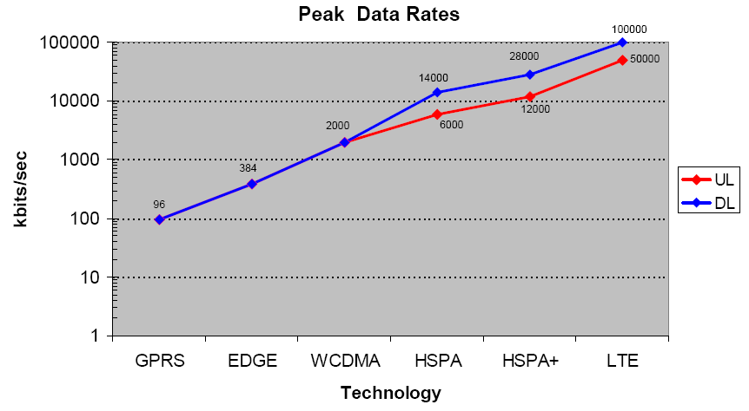

Figure 2.2: Data Rates Evolution.

## 2.2 Digital Modulation

Digital modulation is an important part of wireless or mobile communication system. New concepts and techniques are being used in latest technologies of wireless and mobile communication such as LTE, Wi-MAX (IEEE 802.16), Wi-Fi (IEEE 802.11) and LTE-Advanced. Also Digital Modulation is much better in terms of noise immunity, easier multiplexing, and security than analog Modulation. Some digital modulations include:

QPSK (Quadrature Phase Shift Keying)

QAM (Quadrature Amplitude Modulation)

MSK (Minimum Shift Keying)

FSK (Frequency Shift Keying).

System designers are challenged by various factors that influence the choice of modulation techniques. They are:

* Bandwidth efficiency
* Power efficiency
* Cost and Complexity
* Noise Immunity.

As the radio spectrum is a limited resource, the system must be able to use least bandwidth for more users to make room for the increasing demand. In order to increase the noise immunity, system must increase the signal power to maintain a certain BER but the level to increase also depends on the modulation scheme. But the digital modulation scheme is more noise immune to analog modulation. And the cost and complexity of the modulation technique plays crucial role while designing the system.

Digital modulation scheme are often represented in constellation diagram that shows the signal as a two dimensional scatter plot in a complex plane often referred as I-Q plane (In-phase -Quadrature Plane). The no of discrete points to which the data are mapped in the constellation diagram are known as constellation points.

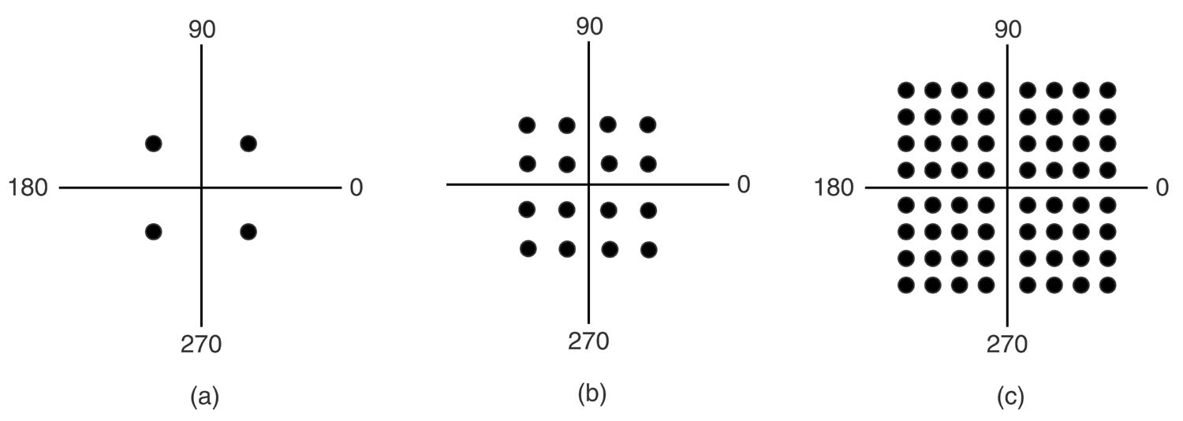

Figure 2.3: Constellation Diagram a) QPSK, b) QAM-16 c) QAM-64

PSK

PSK( Phase Shift Keying) conveys data by altering or modulating the phase of a reference signal i.e.. the phase of the carrier wave is altered to represent the original signal). A finite number of phases are assigned to denote the data. Each of the phases is assigned a unique pattern of binary bits of equal numbers. Each pattern of bits forms the symbol that is represented by the particular phase.

In PSK, the constellation points chosen are usually positioned with uniform [angular](http://en.wikipedia.org/wiki/Angle) spacing around a [circle](http://en.wikipedia.org/wiki/Circle). This gives maximum phase-separation between adjacent points and thus the best immunity to corruption. They are positioned on a circle so that they can all be transmitted with the same energy. In this way, the moduli of the complex numbers they represent will be the same and thus so will the amplitudes needed for the cosine and sine waves. Two common examples are "binary phase-shift keying" ([BPSK](http://en.wikipedia.org/wiki/Phase-shift_keying#Binary_phase-shift_keying_.28BPSK.29)) which uses two phases, and "Quadrature phase-shift keying" ([QPSK](http://en.wikipedia.org/wiki/Phase-shift_keying#Quadrature_phase-shift_keying_.28QPSK.29)) which uses four phases, although any number of phases may be used.

Binary Phase Shift keying (BPSK) is the simplest form of Phase Shift keying. It uses two phases which are separated by 180o. The constellation diagram for this modulation scheme is shown below where the two constellation points are positioned in the real axis, at 0o and 180o.

QPSK (Quadrature Phase Shift Keying) uses four phases for the modulation which are separated by 90o. The Constellation diagram is shown below for QPSK with 4 constellation points. Though QPSK has twice high data rates than BPSK, the QPSK system is more complex than the BPSK.

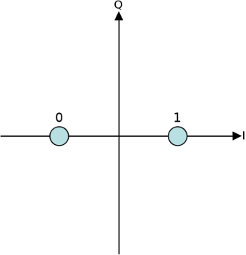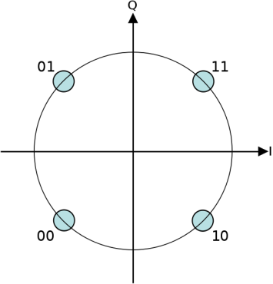

Figure 2.4: Constellation diagram a) BPSK b) QPSK

QAM

In QAM (Quadrature Amplitude Modulation), the digital data are conveyed by changing the amplitude of two carrier waves (which are 90o out of phase to each other) by using Amplitude Shift Keying. As the amplitude shift keying is done for two carrier waves that are out of phase with each other by 90o(i.e.. quadrature carriers), the modulation is termed as Quadrature Amplitude Modulation, hence the combination of PSK and ASK. QAM is one of the mostly used modulation scheme in Wireless Communications Systems.

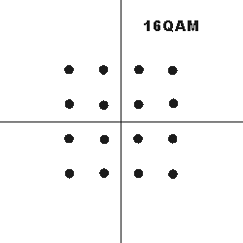 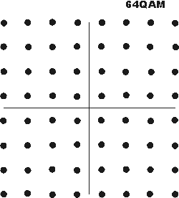

Figure 2.5: Constellation diagram a) 16 QAM b) 64 QAM

## 2.3 OFDM/OFDMA

OFDM (Orthogonal Frequency Division Multiplexing) is the modulation scheme behind the latest wireless communication standard. OFDM has been adopted in many wireless communication services such as DAB (Digital Audio Broadcast), HD Radio, DVB-T/DVB-H, Wi-Fi, WiMAX, LTE and LTE-Advanced. It has been much widely and successfully used in Wire-line Communication ADSL in the form of Discrete Multi Tone (DMT). OFDM is a multicarrier modulation technique where multiple data streams are transferred through a common medium in different channels also called sub-carriers. These Channels have different frequencies, and are orthogonal to each other such that they don’t interfere with each other, which permit the use of overlapping carriers (saving frequency from the guard band).



Figure 2.6: Multi-carrier System.

Figure above shows the block diagram of a Multi-carrier system where a high data rate signal *Sk ,l* is divided into no of low data rate signals which are assigned to the different subcarriers.

Figure 2.7 and Figure 2.8 gives the block diagram of OFDM system Model with OFDM Transmitter and Receiver.

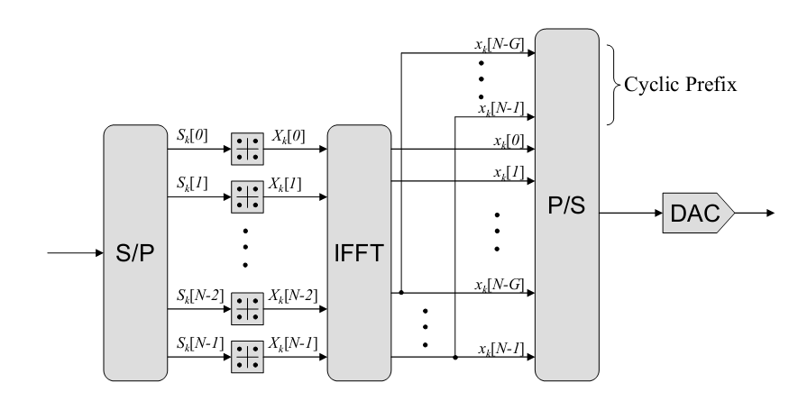

Figure 2.7: OFDM Transmitter [8].

In the Figure 2.7, OFDM Transmitter, data to be transmitted is first converted into number of parallel streams, that is less than or equal to the no of subcarriers. Then the streams are separately modulated to complex data and given to the IFFT (which converts the complex data in frequency domain to complex time domain). There are some Un-modulated Subcarriers if the Number of subcarriers is greater than the number of modulated streams. Cyclic Prefix, a copy of end part of an OFDM symbol is added to the output of IFFT so as to avoid the ISI (Inter Symbol Interference) with the dispersive nature of the channel. After the Parallel to serial conversion, the serial data is converted to Analog by DAC (Digital to Analog Converter).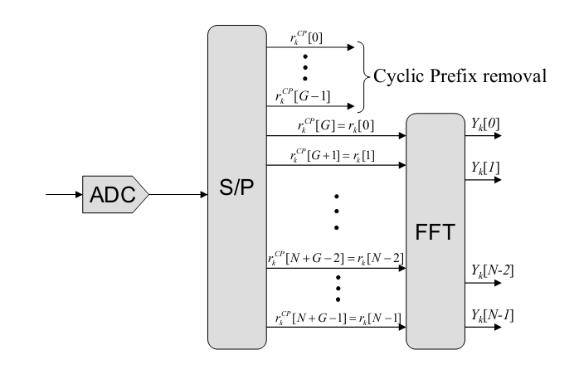

Figure 2.8: OFDM Receiver [8]

After passing through a Channel, the OFDM receiver as shown in the Figure 2.8 takes the signal in digital form from ADC (Analog to Digital Converter) and then converted into no of subcarriers plus the Cyclic Prefix (CP) taken out from the time domain data which is demodulated and then feed to FFT. FFT converts the time domain data into frequency domain from which required streams (modulated streams) are taken for further processing.

In the Figure 2.8, FFT and IFFT may be interchanged as it does not change the required operation for the OFDM System.

Advantages of OFDM

* Spectrum Efficient
* Higher resistance to frequency selective fading.
* Can eliminate ISI and ICI.
* Easy Channel equalization and coding.

Dis-advantages of OFDM

* High PAPR (Peak to Average Power ratio).
* More sensitive to carrier frequency offset and drift.

**2.4 Channels**

Channel is the physical path through which signals get transferred from one place to another for communication purpose. The signals carry information and are in the form of digital bits or unsensed analog data. Each channel has certain capacity to transmit information, which is often expressed by bandwidth in Hz and bit rate in bits per second (bps). These communication paths may be wired (Co-axial cable, twisted pair, or optical fibre), or wireless radio.

In simple terms, radio channels are modelled by random attenuation of the transmitted signal and the noise that gets added along. But for the robust design of mobile communication system, we should predict the precise charactersitics of the radio channel in the system. Precise simulation of There are many radio channels model of which Additive White Gaussian Noise (AWGN) and Rayleigh model are the most simple and popular ones.

**2.4.1 Additive White Gaussian Noise (AWGN):**

In this model, the received signal r(t) is simply given by the sum of the transmitted signal s(t) and a white Gaussian noise n(t) as r(t) = s(t) + n(t) where n(t) is the white Gaussian noise having zero mean and Power spectral density being constant wrt frequency.

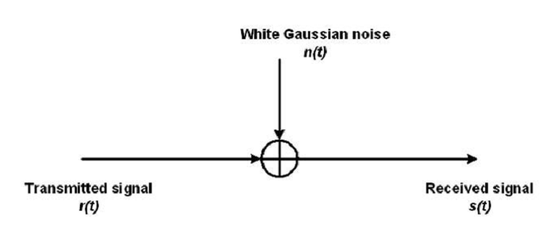

Figure 2.9: AWGN Channel.

Such a simple model is not enough to analyze the channel propagation effects like reflection, diffraction and scattering that causes the random fluctuation of signals at the receiver end, often referred to as fading. Obstacles in the communication channels often make multipath for the signals to reach the receiver, and such different copies of the original signal having different amplitude, phase and delay results in severe degredation of the signal due to destructive interference, such process is also known as Multipath Fading.

Fading can also be flat fading or frequency selective according to the bandwidth of transmitted signal. If the bandwidth of the channel is greater than the bandwidth of the transmitted signal, then all the frequency components undergoes same degredation or attenuation or gain, then such fading is termed as flat fading. Otherwise, if the bandwidth of the channel is less than the bandwidth of the transmitted signal, then the channel gain or attenuation for each freuency components is different hence the name frequency selective fading. The bandwidth of the channel is often given by the coherence bandwidth. Also the fading type can even be expressed in terms of period of the signal as if the period of the transmitted signal is greater than the mutlipath delay spread, then the signal varies as a flat fading channel which is also sometimes called narrow band channel.

**2.4.2 Rayleigh Channel**

Rayleigh flat fading channel is another simple radio channel model in which received signal is given by s(t)= x(t)*h(t) + n(t)

where the function h(t) is given by the vector sum of two uncorrelated Gaussian random variables which is same for all frequency components and n(t) – the white Gaussian noise.

In Frequency selective fading, different frequency components undergoes different fading hence the rayleigh function is different for different frequency components. Such fading rayleigh funtion can be modelled by FIR (Finite Impulse Response) filter, using tapped delay line. Tapped delay line consists of different paths resembling the multipath through which signal have passed to reach the receiver and each path having different independent tap coefficients as the paths are taken to have i.i.d (independently and identically distributed) fading.

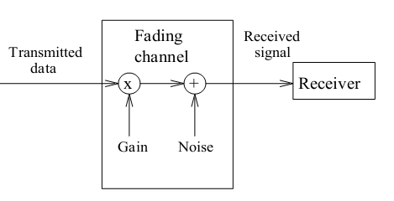

Figure 2.10: Fading in radio channel.

**2.5 Adaptive Modulation.**

There is Trade-off between throughput and BER( Bit error rate) for different constellation. As we go up the higher constellation, the throughput gets increased but at the expense of higher Bit Error Rate (BER) which means the BER is highest at the highest order modulation. Similarly, the BER is minumum for the lower order modulation, for which the throughput is also minimum. So for the requirement of higher data rates and to insure that BER is always below a maximum value, different modulation schemes can be used to give average throughput of the different modulation order and the attaiment of the targeted BER. Newer beyond 3G+ Mobile standards now use apaptive modulation and coding (AMC) that uses different higher order modulation schemes for increasing the data rates than previous technologies and so the spectral efficiency is also increased. The Modulation and Coding Scheme (MCS) level is chosen according to the channel state information based on the power measured in the pilot channel such that the throughput is maximised and lower retransmission due to erroneous bits.

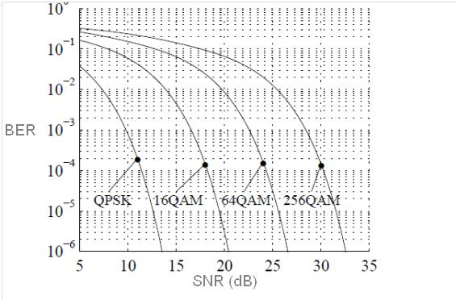

Figure 2.11: BER Vs SNR for different Modulation scheme.

Figure 2.11 shows the different BER Vs SNR curve for different modulation schemes in which QPSK has the lowest Bit error rate for a certain SNR value but the throughput ( log2(M) bits per sec where M is the modulation order) is higher for the higher order modulation i.e.. throughput for 256 QAM is the highest. Table 2.1 shows the throughput for the different modulation schemes.

|  |  |  |
| --- | --- | --- |
| S.N | Modulation scheme or Order (M) | Throughput = Log2M bits per sec. |
| 1 | QPSK, M=4 | 2 |
| 2 | 16 QAM, M=16 | 4 |
| 3 | 64 QAM, M=64 | 6 |
| 4 | 256 QAM, M= 256 | 8 |

Table 2.1: Throughput of different modulation scheme.

For higher data rates, higher order modulation is preferred but the erroneous bit rate is high so using multiple higher modulation schemes depending upon the channel state is the best solution, as termed as adaptive modulation, also sometimes referred as Adaptive Modulation and Coding (AMC).

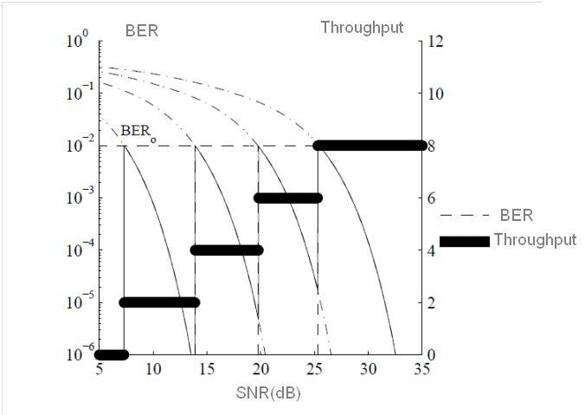

Figure 2.12: BER and Throughput in Adaptive modulation.

In the Figure 2.12, we could see the use of different modulation schemes for the different range of SNR. For SNR value till 10, there is no transmission as it is of no use if retransmission has higher probability. For other lower SNR values, lower order constellation are used so that probability for retransmission for erroneous bits will be low and for higher SNR, higher order modulation scheme is used to increase the throughput such that the BER will be always below the targeted maximum value.

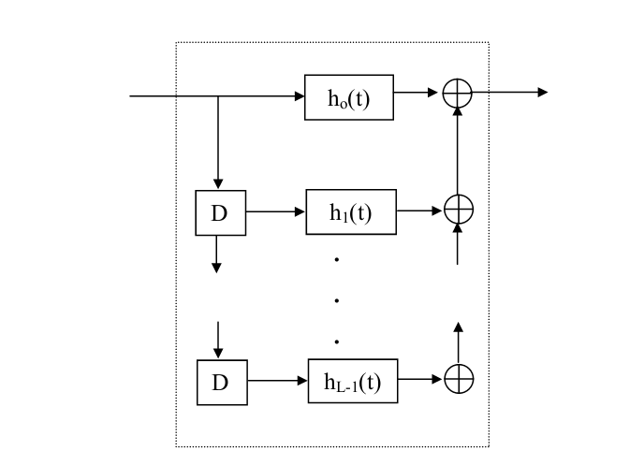Figure 2.13: Tapped delay line for Frequency selective fading.[8]

The impulse response of such fading channel from the Figure 2.13 of tapped delay line, is given by:

$h\left(t\right)=\sum_{j=0}^{L-1}{hj δ(t-jTc)}$…………………………………….Equation Number1

Where hj the fading coefficients for the jth path, L being the total number of paths and Tc the delay in each path.

### 2.6 Scheduling in OFDM.

Scheduling in OFDM refers to the dynamic allocation of physical resources be it subcarriers or the transmit power or the smallest resource blocks (RBs) for each users (UE) to fulfill optimum quality of Service (QoS) requirements. As different UEs have their own path from eNB to themselves, they have their own channels due to the path and the obstacles. And such allocation is based on the channel state information (CSI) measured either directly by the eNB or through feedback channels. Also different Modulation and Coding schemes may be used for the different allocated resources based on the same CSI. One more thing is the allocation not only satisfies the QOS requirements but also the spectrum efficiency condition.

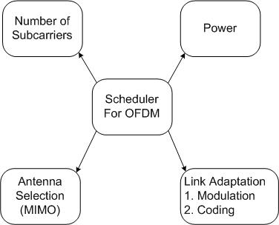

Figure 2.14: Scheduler for OFDM. [9]

In the Figure 2.14, we can see the scheduler considers the no of subcarriers, total transmit power, antenna selection and the modulation schemes in adaptive modulation so as to optimize the QOS requirements and the spectral efficiency. Also the scheduler needs to consider the latency involved in the assignment and selection of the resources that means the scheduling also needs to be performed with in some time frame.

There are many scheduling algorithms that assigns resources to the users in a spectral efficient manner, meeting the QOS requirements, being based on the channel conditions. Of which, two scheduling algorithms stand out, namely Fair and Opportunistic Scheduling and all other algorithms are in between these two algorithms.

In Fair Scheduling, resources are allocated to the users in a round robin manner, i.e. each subcarriers are being allocated to users. For example, for a total k users and N no of subcarriers (N>k), first k subcarriers are assigned to the k users and then again remaining are assigned to the users in a round robin. Here the assignment of the subcarriers is independent of the channel condition and there is equal chance for each subcarriers to be used, hence the name fair scheduling.

Opportunistic Scheduling instead of assigning subcarriers round robin wise, considers only the best channel and assigns subcarriers to them. So it takes into account that different users experience different channel condition operating at different frequencies and operating at different times. Hence the throughput of the whole OFDM will get increased due to the use of best channels. Here the best channels are determined by the channel state taken through feedback from the UE for that instant.

Another scheduler that takes into account the interference of a certain sub-bandwidth in a cell (some collection of subcarriers) in such a way that different cells are coordinated to schedule the subcarriers making the interference minimum especially at the cell edge regions. For that the total subcarriers are assigned to two parts inner and outer part of a cell coverage, so frequency reuse of 1 and less power can be used in the inner part whereas higher frequency reuse factor can be used at the outer part (cell edge region) such that such frequencies used in the outer part of one cell may not be used in other cell or may be used with less power being able to be used in the inner part only. Such coordination is also termed as Inter cell Interference Coordination (ICIC) and is only performed in frequency domain.

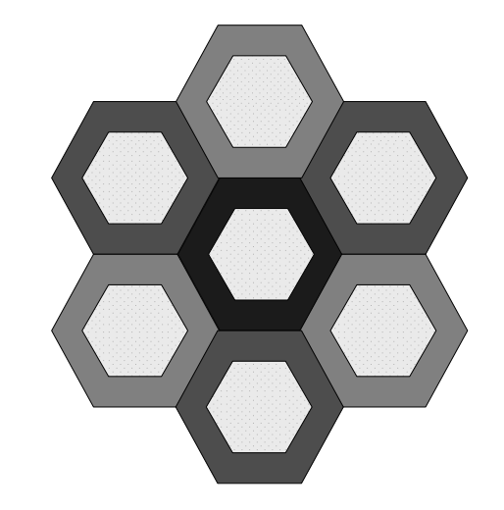

Figure 2.15: Inner and Outer Layer in different cells for ICIC. [8]

**Chapter 3**

**Long Term Evolution**

**3.1 LTE features: Radio Access**

Long Term Evolution (LTE) is the final version of the GSM compatible third generation Mobile Communication standard, often referred as 3.9 G by some. 3GPP has put the specifications for the LTE in Release 8 standard in which the core leads to Evolved Packet Core (EPC) and the new Radio Access Network (RAN) as Evolved Universal Terrestrial Radio Access Network (EUTRAN). 3GPP Release 9 incorporated the road to high performance and much efficient technology evolution that goes strongly from LTE with the OFDM and MIMO techniques.

Here are some of the features of LTE:

* + LTE can provide practical data rates of 100Mbps - downlink and 50 Mbps uplink (20 MHz Spectrum)
  + LTE uses OFDMA in the downlink and SC-FDMA in the uplink.
  + LTE can be both FDD (Frequency Division Duplex) and TDD (Time Division Duplex).
  + LTE supports all frequency bands so that it is being used in different frequency bands in different regions.
  + LTE has very high Mobility speed support.
  + LTE has very low latency.
  + LTE has high spectral efficiency.
  + Scalable bandwidth - 1.25, 1.6, 2.5, 5, 10, 15, 20 MHz.
  + Backward compatibility with previous networks.

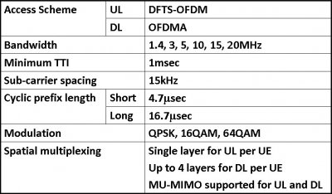

Table 3.1: LTE features.



Figure 3.1: Architecture of LTE [4]

Figure 3.1 shows the architecture of LTE with multiple eNB’s connected via X2 interface and MME/SAE provides Connection between the eNB’s and EPC (evolved packet core) through a S1 interface. The eNB’s route the user plane data between UE and SAE gateway. Scheduling, encryption are also done by the eNB. MME( Mobility Management Entity) is responsible for control signaling may be for mobility.

According to 3GPP TR 25.912, E-UTRAN is described as follows.

“The evolved UTRAN consists of eNB, providing the evolved UTRAN U-plane and C-plane protocol terminations towards the UE. The eNBs are interconnected with each other by means of the X2 interfaces. It is assumed that there always exist an X2 interface between the eNBs that need to communicate with each other, e.g., for support of handover of UEs in LTE_ACTIVE. The eNBs are also connected by means of the S1 interface to the EPC (Evolved Packet Core). The S1 interface supports a many-to-many relation between aGWs and eNBs.” [7].

As the growth of the first release LTE is accelerating with operators all over the world launching it, the research is now mainly focused on the Fourth Generation Mobile, termed as LTE Advanced which is the future of next generation mobile technology. With techniques like Carrier Aggregation, Relaying, COMP and higher order MIMO, LTE Advanced is going to turn out to be the winner among all the technologies for higher data rates, high spectrum efficiency and uniform coverage.

## 3.2 LTE Advanced.

LTE Advanced is the direct Evolution of the 3.9G LTE often referred as the first LTE(3GPP Release 8) and is the one of the ITU recognized IMT Advanced or 4G mobile technology, other being WiMAX 2(IEEE 801.16m). Developed by 3GPP, the Release 10 standard has major improvements to LTE and is currently in the verge of wide adoption all around the world.

Here are the major features of LTE Advanced

* 1 Gbps downlink and 300 Mbps uplink: peak data rate.
* Spectrum Efficiency: 30 bps/Hz.
* Discontinuous spectrum could be used due to carrier aggregation and scalability of bandwidth.
* Improved latency than LTE.
* Cell edge throughput better than LTE and use of relays for regeneration.
* Backward compatibility to LTE.
* Higher Order MIMO (8 *8).

**Chapter 4**

**COMP (Coordinated Multi Point)**

Coordinate Multipoint Transmission and Reception is one of the key techniques to be incorporated in LTE Advanced that improves the coverage of high data rates, the cell edge throughputs, and also to increase the system throughput [10]. The main feature of LTE Advanced being the high data rates possible so far, but is not consistent in all the coverage area of the eNodeB. Although it is easy to maintain the high data rates in the area near to the eNodeB cells, the data rates at long distance from the cell, i.e. the cell edge region, are not up to the standard and it is not only due to the low receive level but also the interference from the other neighboring cells is quite significant. Being an OFDM based technology, LTE is immune to intra cell interference but as the whole bandwidth is being used in all cells (frequency reuse factor of 1): inter-cell interference severely degrades the performance of the system for the cell edge region [4]. COMP is a tool that coordinates two neighboring cells such that cell average throughput and cell edge throughput is increased. Downlink COMP or downlink coordination between cells is of mainly two types:

* Coordinated Scheduling and/or beam-forming (COMP-CS)
* Joint Processing/transmission (COMP-JP). [4]

Coordinated scheduling/beam-forming works such that if a sub carrier or combination of sub carriers is being used from a cell to UEs in its edge then other neighboring cells are coordinated not to create much interference to it, either by not allocating those resources or transmitting it with less power. Such coordination is also termed as Inter-cell Interference Coordination (ICIC).

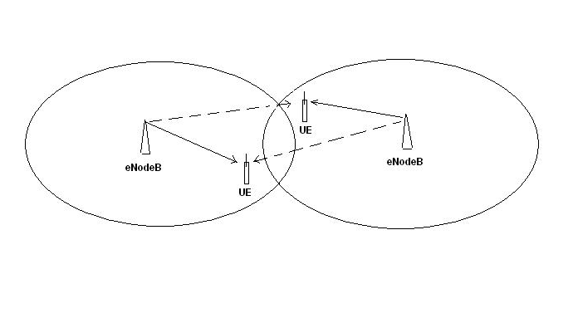

Figure 4.1: Coordinated scheduling/beam-forming.

Another class of COMP is joint transmission in which two eNodeB cells coordinate to transmit the same information to a single UE at the same time and using the same resource block then the Signal to Noise ratio gets improved increasing the throughput. Such cells can be from the same eNodeB or from different eNodeB. Here is a joint transmission done from cells of neighboring eNodeB's.

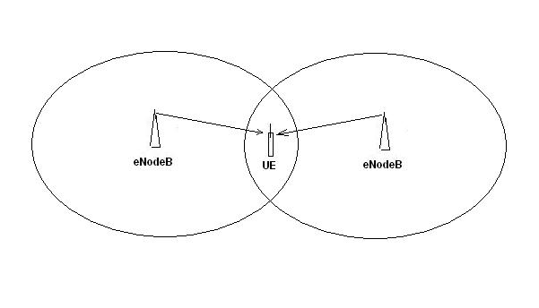

Figure 4.2: Joint transmission for COMP.

Such a requirement of coordination among cells of different eNodeB adds the complexity in having a separate backhaul design for the communication between eNodeB's which is provided by the X2 interface. Though the COMP technique adds up complexity to the overall system, the increase of good coverage and the throughput is worth the complexity.

In addition to the coordination in the same site and different site, the coordination can also be among the different Remote Radio Heads (RRH) of a single cell as deployed in a heterogeneous way which is now common in some of the networks.

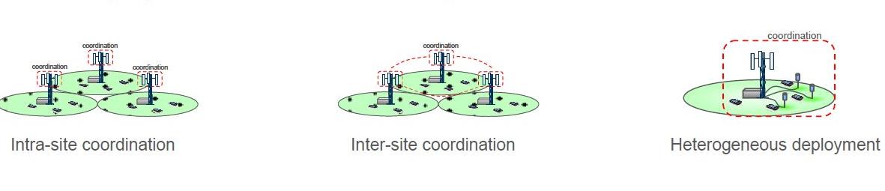

Figure 4.3: Different types of Coordination.

**Chapter 5**

**Simulation and Results**

**5.1 Data Collection**

Before going to the actual implementation of the different procedures for the thesis, some data that are needed for the simulation are presented in the Table 5.1 and Table 5.2 below.

Table 5.1 presents the different OFDM physical parameters where the FFT size needed increases according to Bandwidth as the no of subcarriers are increased with same subcarrier spacing.

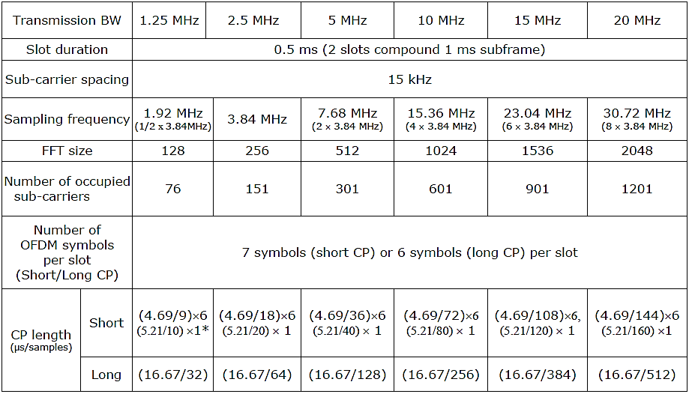

Table 5.1: Downlink OFDM Parameters.

As Rayleigh channel can be modeled by power delay profile or tapped delay line model, different tap coefficients are needed to get the impulse response of the channel. Table 5.2 below presents the coefficients (in dB normalized by that of first tap) according to the tap delay.

|  |  |  |
| --- | --- | --- |
| Tap | Excess tap delay (nanoseconds) | Relative power (dB) |
| 1 | 0 | 0 |
| 2 | 30 | -1 |
| 3 | 70 | -2 |
| 4 | 90 | -3 |
| 5 | 110 | -8 |
| 6 | 190 | -17.2 |
| 7 | 410 | -20.8 |

Table 5.2: Power Delay Profile of a Rayleigh Channel.

## 5.2 Assumptions

The different OFDM physical parameters for the LTE system is given in Table 5.3 below which are used in the simulation.

|  |  |
| --- | --- |
| Parameter | Value |
| IFFT Size | 512 |
| Number of subcarriers | 512 |
| Guard Time Duration | 128 |
| SNR | 1 to 30 dB |
| Modulation Schemes | MQAM, MPSK |
| Bandwidth | 5 MHz |
| Carrier Frequency | 2 GHz |
| Sampling Frequency | 5.4 MHz |

Table 5.3: OFDM physical parameters.

Noise in the simulation is taken to be Gaussian distribution for the different channels taken and Rayleigh channel is modeled with radial component of in-phase and Quadrature Gaussian distributed components.

Also the equalization at the receiver end is not considered which is actually done in the OFDM system with the channel estimation. In the simulation, as the channel is taken from the power delay profile, normal equalization is done but in real scenario, the estimation is done with the pilot channels

## 5.3 Algorithm for Simulation.

Before writing the actual code for the simulation, different inbuilt functions in MATLAB are studied to work out better for signal generation, processing and presentation. These MATLAB functions helped to generate operations and valuable signals according to the requirement. Arguments in the functions also determine the type of result and operations to be performed which is also a important thing to be taken care of. As the thesis is about a physical layer implementation of LTE, technologies for the transmission from eNB to UE are considered here i.e.. physical layer downlink.

OFDM transmission through a channel with sufficient Cyclic Prefix (CP) (which is a copy of end part of an OFDM symbol) avoids the ISI (Inter Symbol Interference) between the OFDM Symbols. After having thorough knowledge of LTE physical layer, OFDM system is simulated with the representation of modules in code. Using QPSK and different level of QAM modulation in OFDMA has different scenario with the throughput and BER (Bit Error Rate). QPSK has the lowest throughput along with low BER but as higher constellation size in different QAM is used, the data rate (throughput) increases along with the erroneous bits (BER). So, it is seen that to improve the spectrum efficiency, higher level of QAM i.e.. higher constellation size is needed but at the expense of higher BER. Also the FFT/IFFT size in OFDM system is to be chosen according to the no of subcarriers to be used. With the above considerations, OFDM system is simulated with MATLAB functions. It is also found that the OFDM transmission with QAM modulation from a AWGN Channel is equivalent to that of same data transmission with QAM modulation. As the requirement in LTE has high throughput, a technique is there to maximize the throughput but keeping acceptable BER. Adaptive modulation is the adaptive technique for throughput optimization. In this technique, the OFDM system chooses the modulation according to the Signal to Noise Ratio (SNR) in the channel, i.e. the actual channel conditions (length of the channel path, noise, interference) are considered. A pilot carrier may be used to know the channel conditions and feedback to the transmitter that determines which modulation scheme to use based on that information. When the channel condition is good i.e. high SNR, higher constellation size is chosen to have maximum throughput and if the SNR starts to degrade then a level less constellation size is used to meet the target bit error set. So, we can have a target BER in all channel conditions while increasing the spectrum efficiency. Hence, adaptive modulation system performs better for the varying channel conditions than that of fixed modulation schemes.

For Multiuser Bit allocation or Scheduling, Round Robin scheme is a simple, easy to use algorithm in which each user gets the fair share of the channel but it is less efficient as the system throughput will be decreased if the channel condition degrades. Instead of user taking turns to use a subcarrier, the resource can be assigned according to the channel conditions of the user. This is called priority scheduling where the user in good channel condition is assigned a sub carrier and it yields maximum throughput but is not fair enough.

The algorithm for the Adaptive OFDM simulation that has different modulation scheme according to the channel condition is shown below:

A) Define the parameters for simulation

* Number of symbols to be generated
* Size of each OFDM block
* Cyclic prefix length
* Size of IFFT/FFT
* Number of times simulation to be performed for each SNR
* Sampling time period for digitizing the channel
* Doppler frequency
* Vector of excess tap delay
* Vector of relative average power

B) Generate the frequency selective Rayleigh channel

C) Generate the test signal

D) Do the simulation for different SNR values

For each SNR loop for number of times defined and for each loop do

1. with test signal, estimate channel gain and find equivalent SNR
2. generate the symbols
3. do digital modulation or perform no transmission as per the effective SNR
4. normalize the modulation with scaling
5. do serial to parallel conversion.
6. do IFFT on the block of the data
7. insert cyclic prefix
8. do parallel to serial conversion
9. normalize the signal before going to channel
10. perform Rayleigh channel filtering on the signal
11. add AWGN noise
12. on the receiver side convert the serial data stream to parallel form
13. remove cyclic prefix
14. do FFT on the block of data
15. do equalization
16. convert parallel data to serial stream
17. de-normalize with proper scaling and demodulate it
18. compare the obtained bit with the transmitted bit and calculate bit error rate
19. record the bit error rate and throughput
20. continue the simulation until last loop
21. calculate the average bit error rate, SNR and throughput

E) Plot the figures of BER versus SNR and throughput versus SNR

## 5.4 Result of Simulation.

From the simulation of OFDM with different modulation schemes in AWGN channel, the BER vs. SNR plot gives different curves for different Modulations and also the BER decrease with the increase in SNR as there is less error if the signal level improves than the noise signal. This plot is exactly the same for individual modulation scheme acting without OFDM.

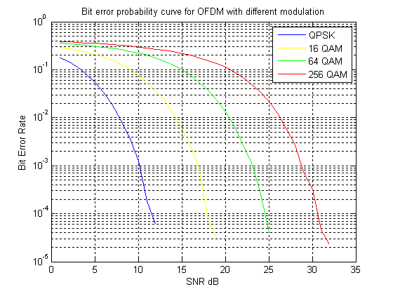

Figure 5.1: BER Vs SNR Plot for different Modulation Scheme in OFDM with AWGN channel.

In the Figure 5.1, the erroneous bit rate is found to be going down with the improvement in SNR. But the different Modulation scheme has different curves which show that BER for a SNR is highest for higher constellation i.e.. QPSK performs best with least erroneous bit rate than the 16, 64 QAM. In the Figure 5.1, at a fixed SNR value, the value of BER is seen higher at higher order modulation, so BER is maximum for 256 QAM. The Figure 5.1 for the OFDM with AWGN Channel is useful to set a target BER for Adaptive Modulation in OFDM. Suppose if a BER of 10-2is targeted, then the values of SNR that determines which modulation scheme to be used can be found by drawing a straight line for the BER=10-2and the point where it cuts in the curve gives the required SNR for each modulation. That is around 7 dB, 14 dB, 21 dB, 26 dB for QPSK, 16 QAM, 64 QAM, 256 QAM respectively. So for SNR less than 7 dB, there is no transmission due to the worst channel conditions and for SNR value from 7 to 14 db, QPSK modulation is implemented by the adaptive OFDM system and for other ranges, other modulation scheme are determined accordingly also shown in the Table 5.4

|  |  |  |
| --- | --- | --- |
| Modulation scheme | SNR (dB) | Bits/symbol |
| No transmission | SNR<7 | 0 |
| QPSK | 7<=SNR<14 | 2 |
| 16 QAM | 14<= SNR<= 21 | 4 |
| 64 QAM | SNR>21 | 6 |

Table 5.4: Modulation Scheme Decision level

These values are set in the simulation of Adaptive OFDM to get the maximum spectrum efficiency but always with the BER < 10-2­.

As the Adaptive OFDM system is simulated in matlab, the BER vs SNR plot is obtained for target BER of 10-1 as shown below.

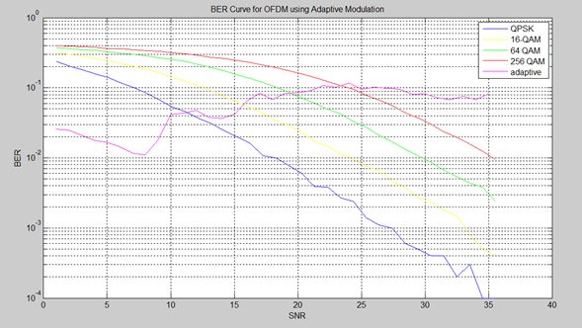

Figure 5.2: BER vs. SNR curve for different modulation scheme with Adaptive modulation in OFDM

Figure 5.2 above shows the BER vs. SNR curve for Adaptive OFDM system along with individual modulation scheme plot. As done earlier, target BER is set to 10-1, so it is seen in the plot that the BER is always less than that value no matter which modulation scheme is used adaptively for maximizing throughput (shown next) being different for all modulation scheme.

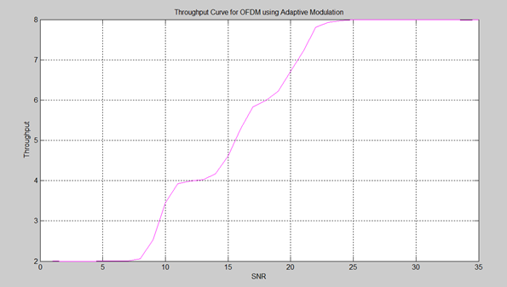

Figure 5.3: Throughput Vs SNR for Adaptive OFDM system.

Figure 5.3 above shows the performance of throughput for the adaptive modulation in OFDM, in which it seen that the throughput increases with the increase in the value of SNR. Here as the SNR improves, higher order modulation scheme is used for which the throughput is high but keeps the BER within the set target.

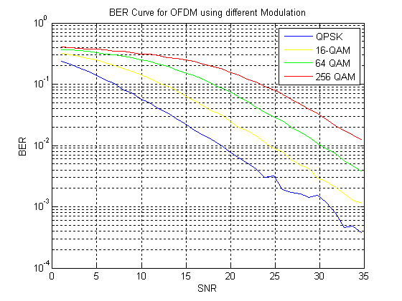

Figure 5.4: BER Vs SNR curve for OFDM with Rayleigh Channel.

Figure 5.4 above shows the BER curve w.r.t SNR for different modulation techniques from QPSK to 256 QAM. The curve looks similar to that of AWGN channel but the steepness of the curve for the different modulation is somewhat slow. That means the BER does not significantly reduce with the SNR, that is what the multipath propagation has effect on the system. So, for such system, SNR needs to be relatively high for better performance or for the retransmission not to occur.

Now, the coordination is done with simultaneous transmission of the same signal with two paths and channels from two eNodeB cells to the UE. So, two Rayleigh channels with the impulse functions h1(t) and h2(t) are taken for the two paths from both the cells to UE and the already generated OFDM signal is passed simultaneously over these two channels. Here the same subcarrier is assigned in both the transmission, and the combined signal is received to recover the original signal.

Since we are concerned with the cell edge region, worst SNR (longer distance of UE from the eNodeB cell) is taken to calculate the performance metric like the bit error rate and the spectral efficiency.

Hence the bit error rate from the simulation is taken for different SNR values as shown in the Table 5.5.

|  |  |  |  |  |  |
| --- | --- | --- | --- | --- | --- |
| Without COMP | | | With COMP | | |
| SNR | BER | Throughput | SNR | BER | Throughput |
| 5 | 0.013 | 1 | 9 | 0.006 | 2 |
| 6 | 0.009 | 1.2 | 15 | 0.0009 | 3.5 |
| 7 | 0.008 | 1.9 | 17 | 0.0003 | 5.4 |
| 8 | 0.002 | 2.2 | 18 | 0.00014 | 6.2 |
| 9 | 0.0008 | 2.8 | 21 | 0.0001 | 6.5 |

Table 5.5: Comparison of simulation with COMP and without COMP.

The above table is taken from the simulation of the OFDM in the Rayleigh channel with and without the coordination. From which, it can be seen that there is significant improvement in the performance in terms of BER and Throughput. Here the coordination between two cells can be extended to three or more, provided the mesh network between the different eNodeB's is available.

**Chapter 6**

**Discussion and Conclusion**

**6.1 Discussion**

As new and advanced techniques are being developed to standardize new technologies, they are getting more efficient and having fast data rates. And the future communication will be data only, making the traditional circuit switched services like voice, SMS to be able to be performed from much efficient data networks. With the enhancements in IP protocols and computer networking, those new technologies are best optimized to cater the ever soaring demands of speed and services in the people.

Major constraints in a wireless communication are the power and the bandwidth limitations. And the random channel even adds up the unpredictability of the original signal fading. No matter how high power the signal is being transmitted for good coverage, the noise is always there and the overall performance of the system is degraded by the interference that the signal creates. The situation is always worst in the cell edge region where all neighboring cells signal reach in almost equal levels interfering to each other.

The high requirement of the bandwidth and the availability of good coverage is always contradicted to each other. For greater bandwidth, higher frequency spectrum needs to be used and the use of such spectrum puts a big question mark in the good coverage due to the requirement of line of sight communication. The performance for such system where the frequency reuse factor is 1, even deteriorates with the inter cell interference from all neighboring cells.

Latency of the signal transmission and mobility support are also of equal importance for seamless and uninterrupted service to all different types of consumers. Scalability of the bandwidth with carrier aggregation makes the optimum use of sub carriers in the communication system whereas other techniques like relaying helps to boost the signal strengths and capacity in some coverage holes in contrast to what has been previously done by repeaters.

This thesis work explores the use of X2 interface between the two or more eNodeB's to jointly transmit the symbols to be transmitted to a UE lying in the cell edge region of currently serving eNodeB. Joint Transmission, being one of the process in coordinated multipoint transmission and reception, significantly improves the bit error rate and the throughput in the downlink direction. Similarly such technique can be applied to improve the performance in uplink side as well. The channel estimation is as important as the other elements in the thesis, as the overall usability of COMP is determined according to the SNR (worse) in the estimated channel, that means the COMP is activated only at the cell edge region.

## 6.2 Limitations

Some assumptions for the thesis are already discussed in the chapter 5. Moreover there are some limitations that are left uncovered either due to non feasibility in the current system or the complexity that the issue adds up in the system. The performance of the system is always dependent on the traffic load conditions. COMP performance gain is also not that significant under the heavy loading conditions which are not taken into consideration for this thesis. Proper traffic dimensioning needs to be maintained to have good gains in performance with the COMP.

Latency due to additional processing and data sent to other neighboring cells from a single point for coordination is not considered which may have effect in the overall performance of the system.

The thesis only evaluates the user level performance gain, the whole system performance analysis is very difficult to attain from this COMP focused thesis.

MIMO and coding levels are also not taken into considerations, which has other impacts on the system when performed together with COMP.

## 6.3 Conclusion

The objective of the thesis is mainly the simulation of the COMP in downlink direction by coordinating two cells from two eNodeB's and get the performance metrics measured. Starting from the OFDM transmission reception in different Channel and with different modulations, the relationship between Bit Error Rate (BER), Signal to Noise Ratio (SNR) and the throughput are analyzed. And those are evaluated in the coordinated scenario as well. With the simulation, results, analysis and discussions, COMP is a very good technique that yields a significant result in the coming next generation mobile networks. The complexity that adds in the system is worthy for the benefits that it brings with.

## 6.4 Future Works.

As this thesis only deals with the COMP in downlink direction, similar concepts can be used to perform such coordination towards the uplink. Similarly the combined effect of the COMP with relay and MIMO will have greater effect in the performance gains, such techniques can be taken as the continuation of this thesis work. Inter cell Interference coordination can also be analyzed taking the fractional reuse factor in the outer part of the coverage area. Even the variation of modulation and coding level can be analyzed for the effect in the performance metrics.

# REFERENCES

1. Rapeepat Ratasuk et al., “Carrier Aggregation in LTE-Advanced”, vehicular Technology Conference (VTC 2010-Spring), 2010 IEEE vol. 71, 16-19 May 2010
2. 3GPP TR36.913: "Requirements for Further Advancements for E-UTRA

(LTE-Advanced)".

1. A.Gosh et al., “LTE Advanced: Next Generation Wireless Broadband Technology”, IEEE Wireless Communications, vol. 17, number 3, June 2010.
2. Qixing Wang et al., “Coordinated Multi-Point Transmission for LTE-Advanced System”, Wireless Communications, Networking and Mobile Computing, Sep. 2009.
3. Sawahashi, M. et al., “Coordinated Multipoint Transmission /Reception techniques for LTE Advanced”, IEEE Wireless Communications, Volume 17, Issue 3, June 2010.
4. Heinrich hertz, “Field Trials using Coordinated Multi-point Transmission in Downlink”, 3rd International workshop in wireless distributed networks, Istanbul, 26 September 2010.
5. 3GPP TR 25.912, " Feasibility study for evolved Universal Terrestrial Radio Access (UTRA) and Universal Terrestrial Radio Access Network (UTRAN)
6. Stephania Sesia et al., "LTE- The UMTS Long Term Evolution: from Theory to Practice", UK, Wiley, 2009.
7. University of Surrey. *Wireless Communication System Emulator design* [Online], Available: http://www.ee.surrey.ac.uk/ccsr/research/ilab/mcan /projects.
8. 3GPP RP-101425: "Revised SID Proposal: Coordinated Multi-Point Operation for LTE", 2010.

TABLE OF CONTENTS

COVERPAGE……………………………………………………………………..i

TITLEPAGE……………………………………………………………………....ii

COPYRIGHT……………………………………………………………………..iii

RECOMMENDATION..………………………………………………………....iv

DEPARTMENTAL ACCEPTANCE……………………………………………..v

AKNOWLEDGEMENTS………………………………………………………...vi

ABSTRACT……………………………………………………………………...vii

TABLE OF CONTENTS………………………………………………………..viii

LIST OF FIGURES………………………………………………………………..x

LIST OF TABLES……………………………………………………………….xii

LIST OF ABBREVIATIONS………………………………………………...…xiii

Chapter 1: Introduction 1

1.1 Background 1

1.1 Objectives 3

1.2 Research Methodology 3

1.2.1 Preliminary Study 3

1.2.2 Development of Model. 4

1.3 Organization of Report 6

Chapter 2: Literature Review 7

2.1 Evolution of Mobile generation: Radio Access 7

2.2 Digital Modulation 10

2.3 OFDM/OFDMA 13

2.4 Channels 16

2.4.1 Additive White Gaussian Noise (AWGN): 16

2.4.2 Rayleigh Channel 17

2.5 Adaptive Modulation. 18

2.6 Scheduling in OFDM. 21

Chapter 3: Long Term Evolution 24

3.1 LTE features: Radio Access 24

3.2 LTE Advanced. 26

Chapter 4 :COMP (Coordinated Multi Point) 27

Chapter 5: Simulation and Results 30

5.1 Data Collection 30

5.2 Assumptions 31

5.3 Algorithm for Simulation. 32

5.4 Result of Simulation. 34

Chapter 6:Discussion and Conclusion 40

6.1 Discussion 40

6.2 Limitations 41

6.3 Conclusion 42

6.4 Future Works. 42

REFERENCES 43